LAB ASSIGNMENT-3

**Task1:**

Program in python to find the compound interest using functions.

CODE:

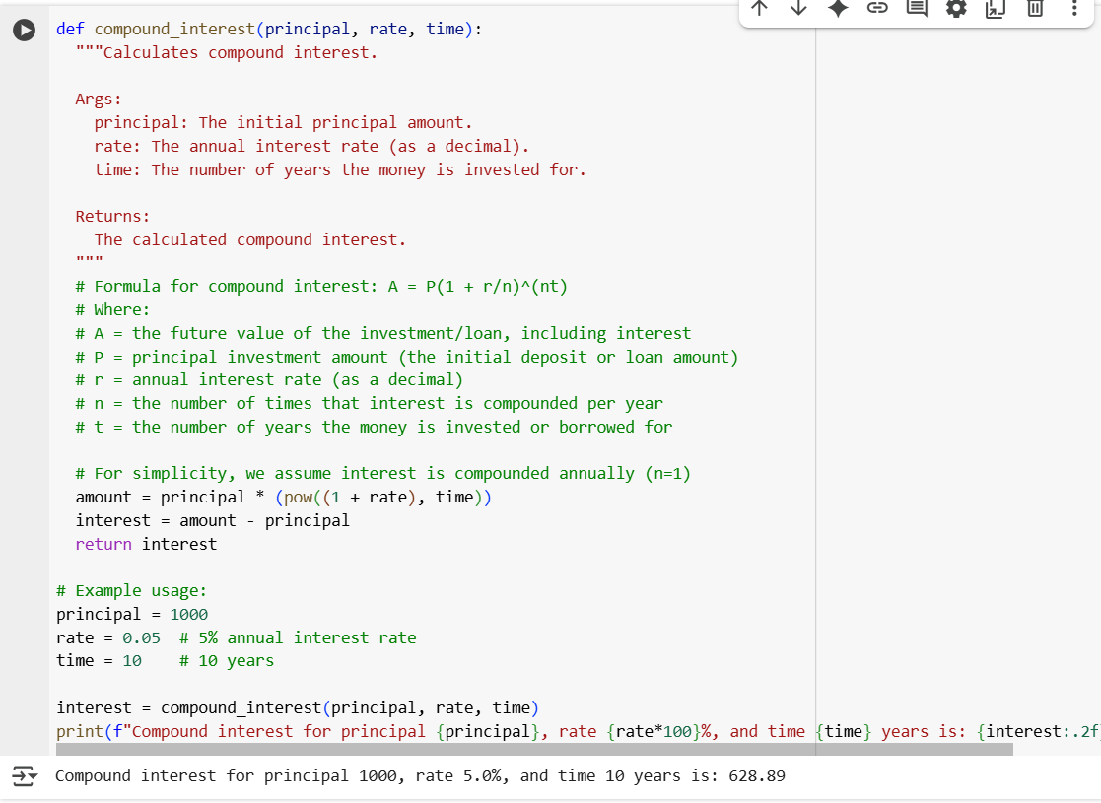

OUTPUT:



EXPLANATION:

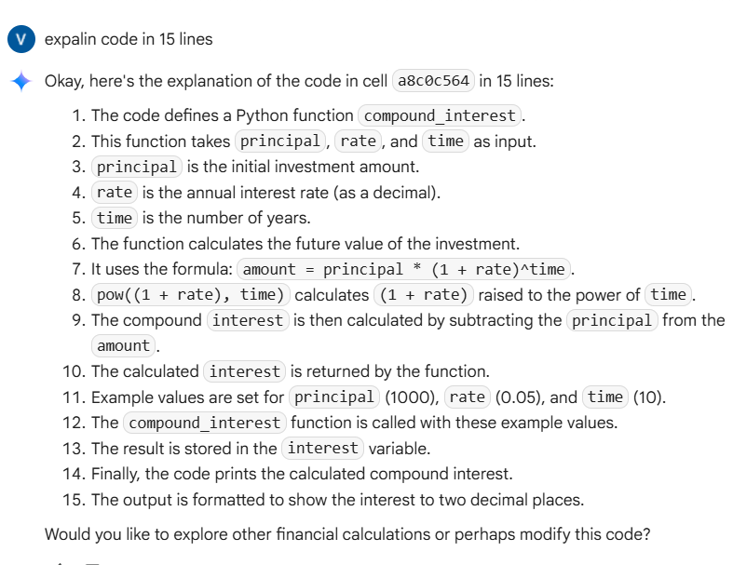

**Task2:**

Write a function to calculate average ,medianand mode of a list of numbers.

CODE:

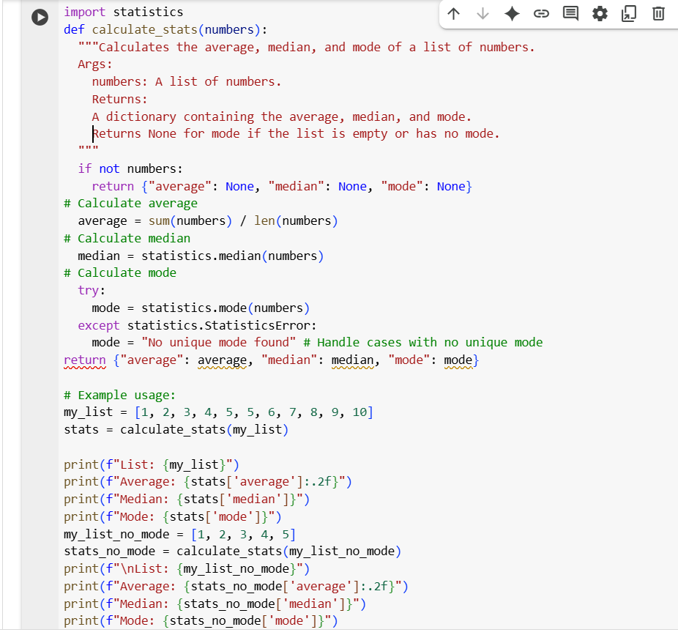

**OUTPUT:**

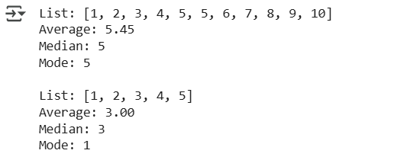

**EXPLANATION:**

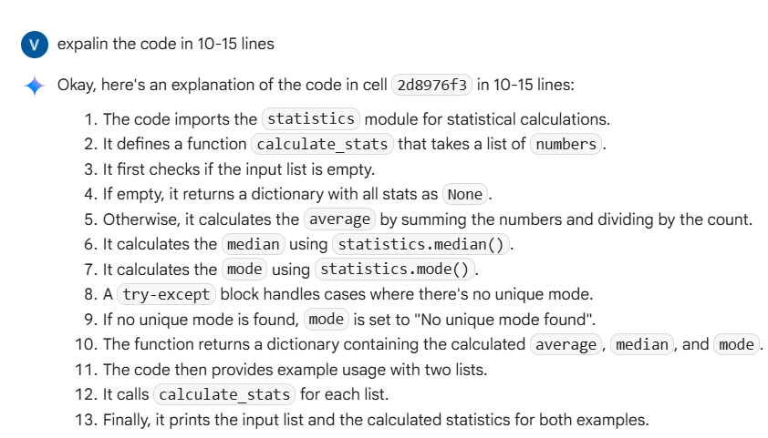

**Task3:**

Multiple examples of input-output toconverttobinary(num) function.

**CODE:**

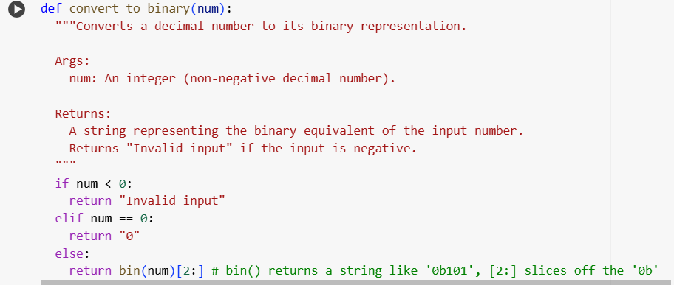

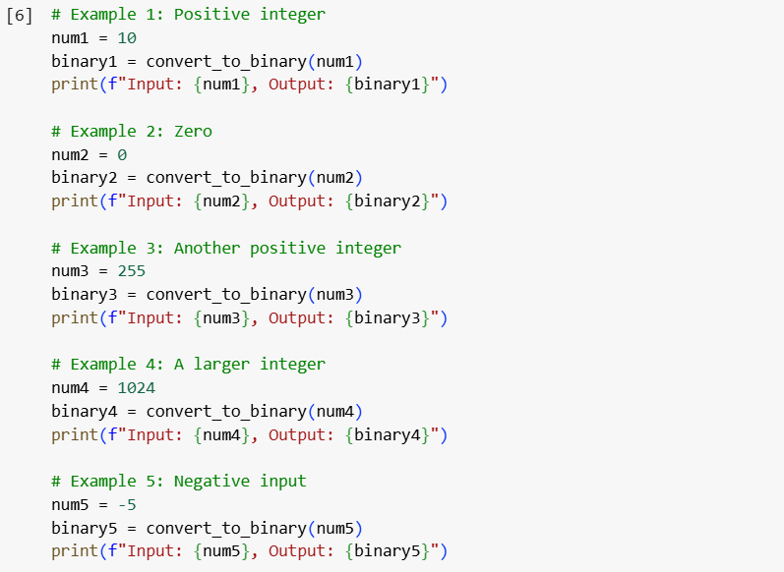

**OUTPUT:**

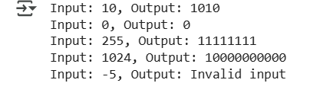

**EXPLANATION:**

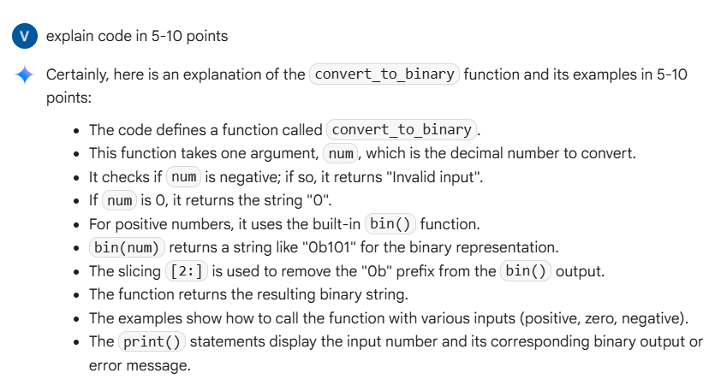

**Task4:**

An user interface for an hotel to generate bill based on customer requirements.

**CODE:**

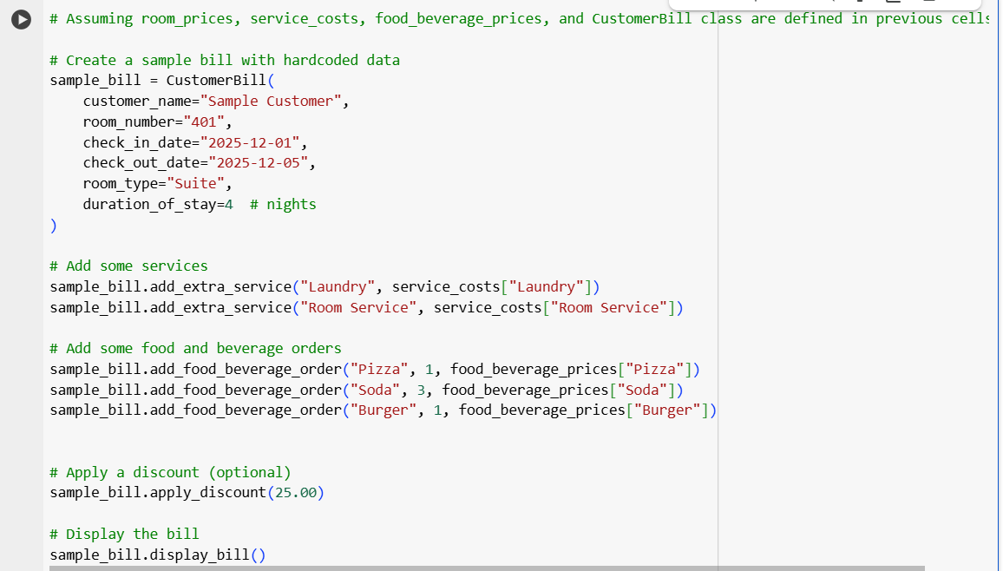

**OUTPUT:**

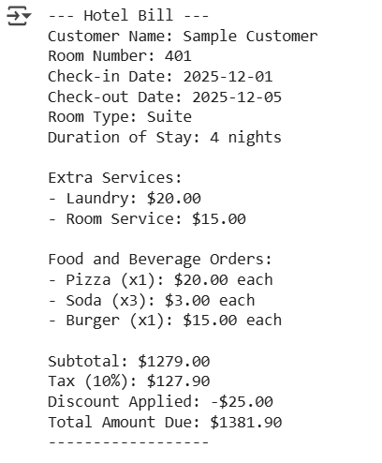

**EXPLANATION:**

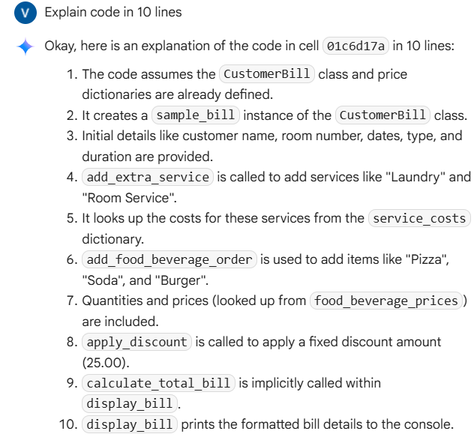

**Task5:**

**Conversion of Fahrenheit to Celsius:**

**CODE:**

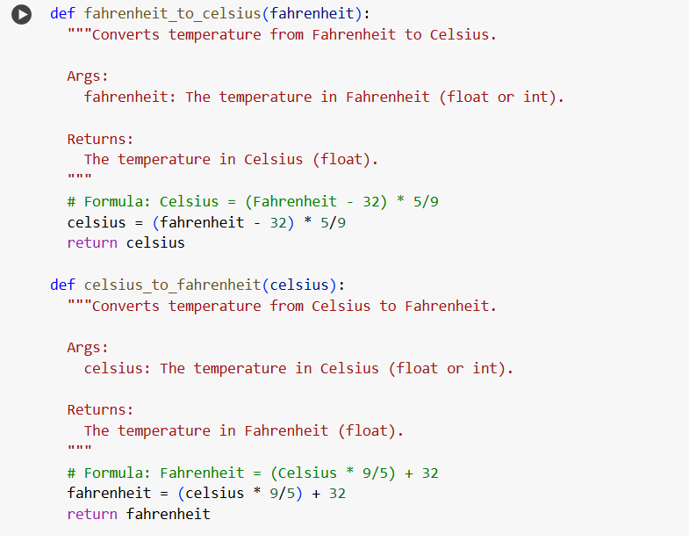

**OUTPUT:**

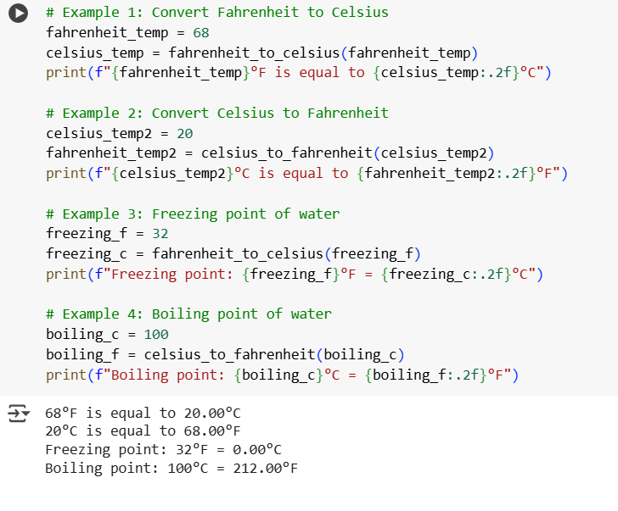

**EXPLANATION**