## NAME:DHEVULAPALLY RASHMITHA

## ENROLLMENT_NO:2403A51432

## BRANCH:CSE

## TASK 1:

SCREENSHOT:

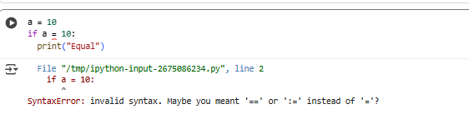

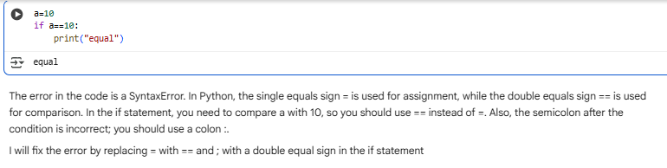

## TASK 2:

SCREENSHOT:

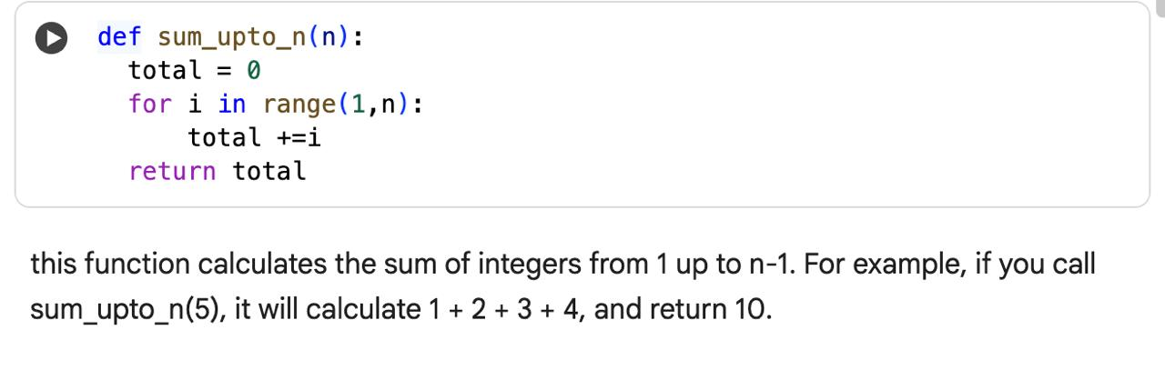

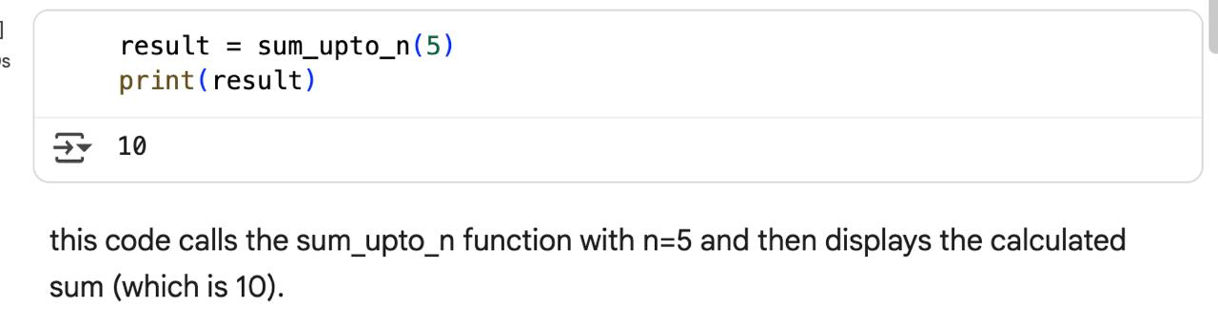

## TASK 3:

SCREENSHOT:

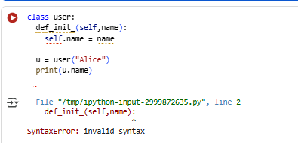

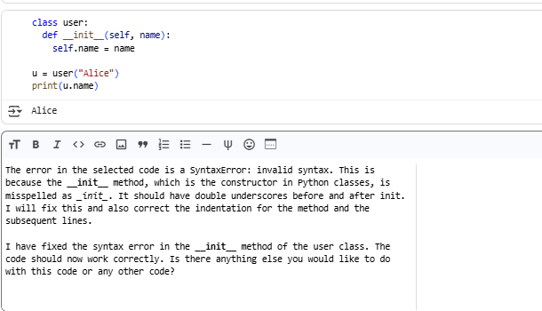

## TASK 4:

SCREENSHOT:

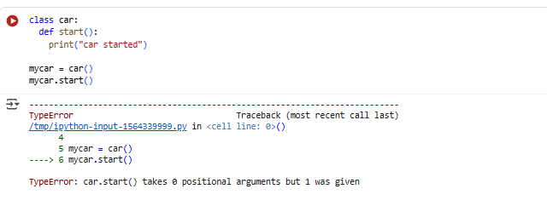

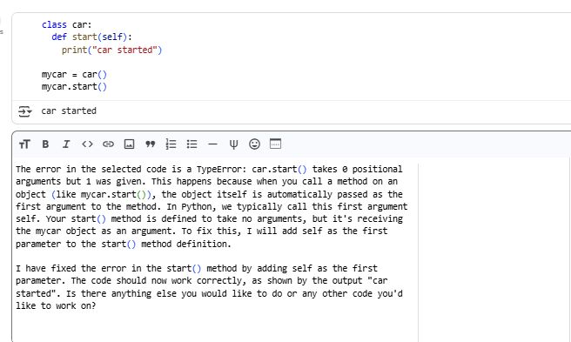

## TASK 5:

SCREENSHOT:

