SCHOOL OF COMPUTER SCIENCE AND ARTIFICIAL INTELLIGENCE |  |  |  |  | DEPARTMENT OF COMPUTER SCIENCE ENGINEERING
Program Name: B. Tech |  |  |  | Assignment Type: Lab |  |  | Academic Year:2025-2026
Course Coordinator Name |  |  |  | Venkataramana Veeramsetty
Instructor(s) Name |  |  |  | Dr. V. Venkataramana (Co-ordinator)  Dr. T. Sampath Kumar  Dr. Pramoda Patro  Dr. Brij Kishor Tiwari  Dr.J.Ravichander  Dr. Mohammand Ali Shaik  Dr. Anirodh Kumar  Mr. S.Naresh Kumar  Dr. RAJESH VELPULA  Mr. Kundhan Kumar  Ms. Ch.Rajitha  Mr. M Prakash  Mr. B.Raju  Intern 1 (Dharma teja)  Intern 2 (Sai Prasad)  Intern 3 (Sowmya)  NS_2 ( Mounika)
Course Code |  |  | 24CS002PC215 | Course Title |  | AI Assisted Coding
Year/Sem |  |  | II/I | Regulation |  | R24
Date and Day  of Assignment |  |  | Week6 - Thursday | Time(s)
Duration |  |  | 2 Hours | Applicable to  Batches
AssignmentNumber:12.1(Present assignment number)/24(Total number of assignments)
 | Q.No. | Question |  |  |  |  |  | Expected Time  to complete
 | 1 | Lab 12: Algorithms with AI Assistance – Sorting, Searching, and Optimizing Algorithms  Lab Objectives:  - Apply AI-assisted programming to implement and optimize sorting and searching algorithms.  - Compare different algorithms in terms of efficiency and use cases.  - Understand how AI tools can suggest optimized code and complexity improvements.  Task 1: Implementing Bubble Sort with AI Comments  - Task: Write a Python implementation of Bubble Sort.  - Instructions:  - Students implement Bubble Sort normally.  - Ask AI to generate inline comments explaining key logic (like swapping, passes, and termination).  - Request AI to provide time complexity analysis.  Output:  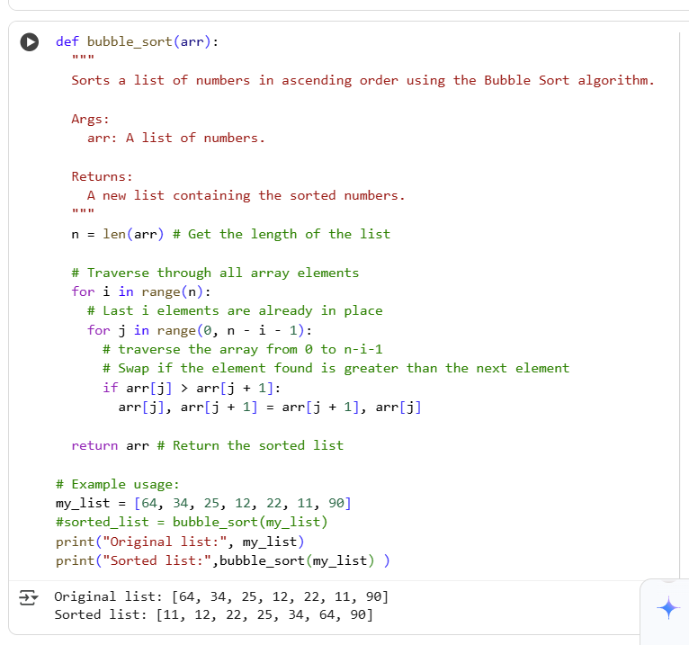  Explanation:  This Python code implements bubble sort to arrange a list of numbers in ascending order. It repeatedly steps through the list, compares adjacent elements, and swaps them if they are in the wrong order. The process continues until the list is fully sorted. Finally, the function returns the sorted list.  Task 2: Optimizing Bubble Sort → Insertion Sort  - Task: Provide Bubble Sort code to AI and ask it to suggest a more efficient algorithm for partially sorted arrays.  - Instructions:  - Students implement Bubble Sort first.  - Ask AI to suggest an alternative (Insertion Sort).  - Compare performance on nearly sorted input.  Output:  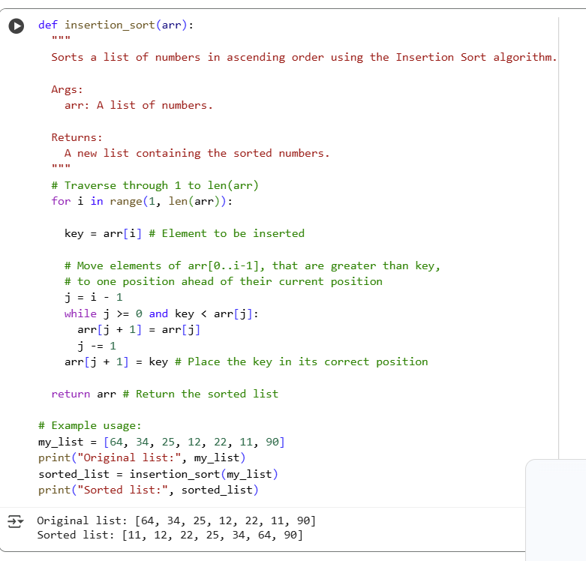  Explanation:  - Fewer swaps: In the best case, when the list is already sorted, insertion sort performs zero swaps, while bubble sort still goes through comparisons. In general, insertion sort tends to perform fewer swaps than bubble sort.  - Adaptive: Insertion sort is adaptive, meaning its performance improves when the input list is partially sorted. Bubble sort's performance is not significantly affected by the initial order of the elements.  - Simple implementation: While both are simple, insertion sort's inner loop shifts elements rather than swapping, which can be slightly more efficient in some implementations.  Task 3: Binary Search vs Linear Search  - Task: Implement both Linear Search and Binary Search.  - Instructions:  - Use AI to generate docstrings and performance notes.  - Test both algorithms on sorted and unsorted data.  - Ask AI to explain when Binary Search is preferable.  - Output:  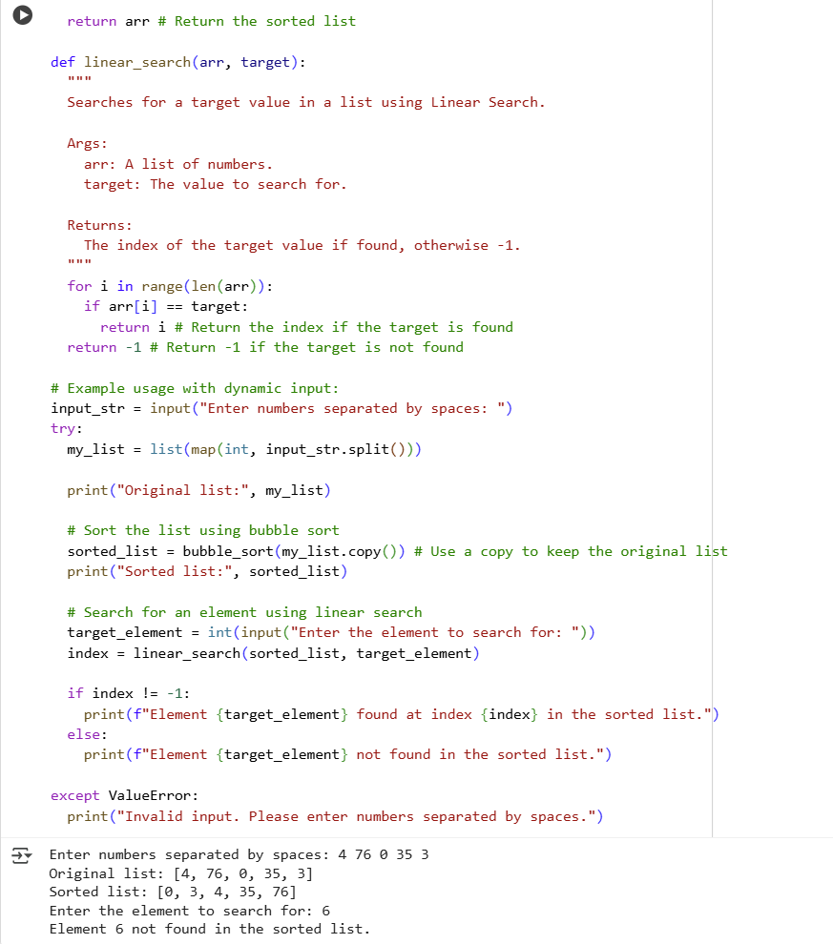  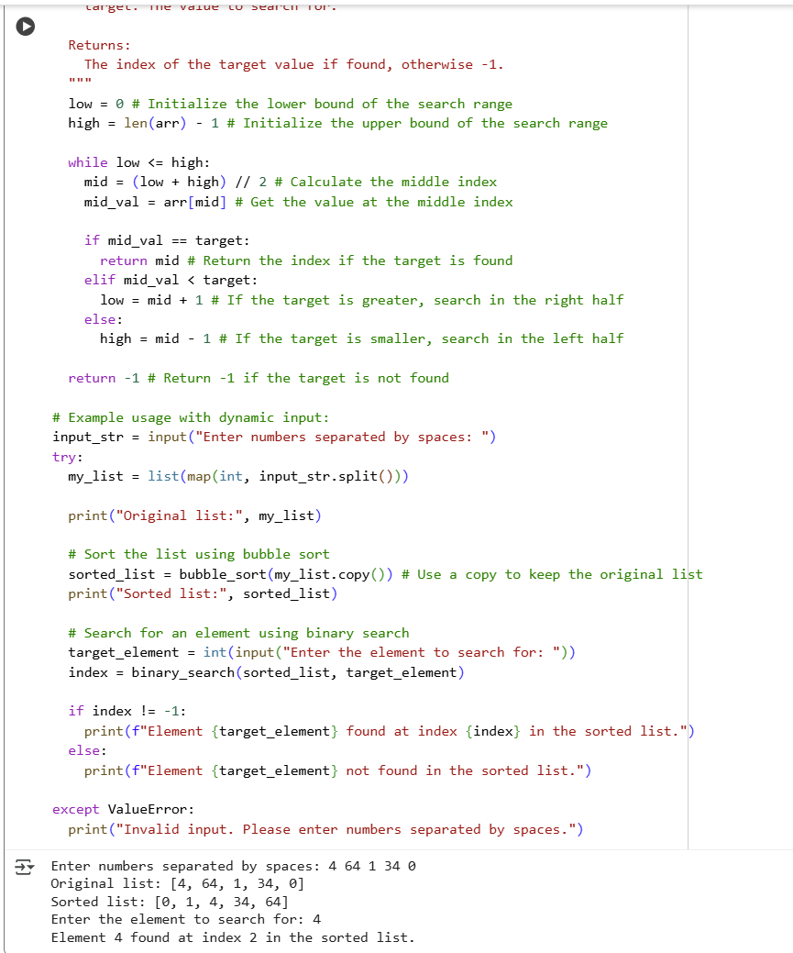  Explanation:  Feature Linear Search Binary Search  Requirement No specific requirement Requires a sorted list  Time Complexity (Average/Worst) O(n) O(log n)  Time Complexity (Best) O(1) O(1)  Space Complexity O(1) O(1)  Ease of Implementation Simpler Slightly more complex  Suitability Small datasets, unsorted lists Large datasets, sorted lists |  |  |  |  |  | Week6 - Thursday
Task 4: Quick Sort and Merge Sort Comparison
- Task: Implement Quick Sort and Merge Sort using recursion.
- Instructions:
  - Provide AI with partially completed functions for recursion.
  - Ask AI to complete the missing logic and add docstrings.
  - Compare both algorithms on random, sorted, and reverse-sorted lists.
- Output:
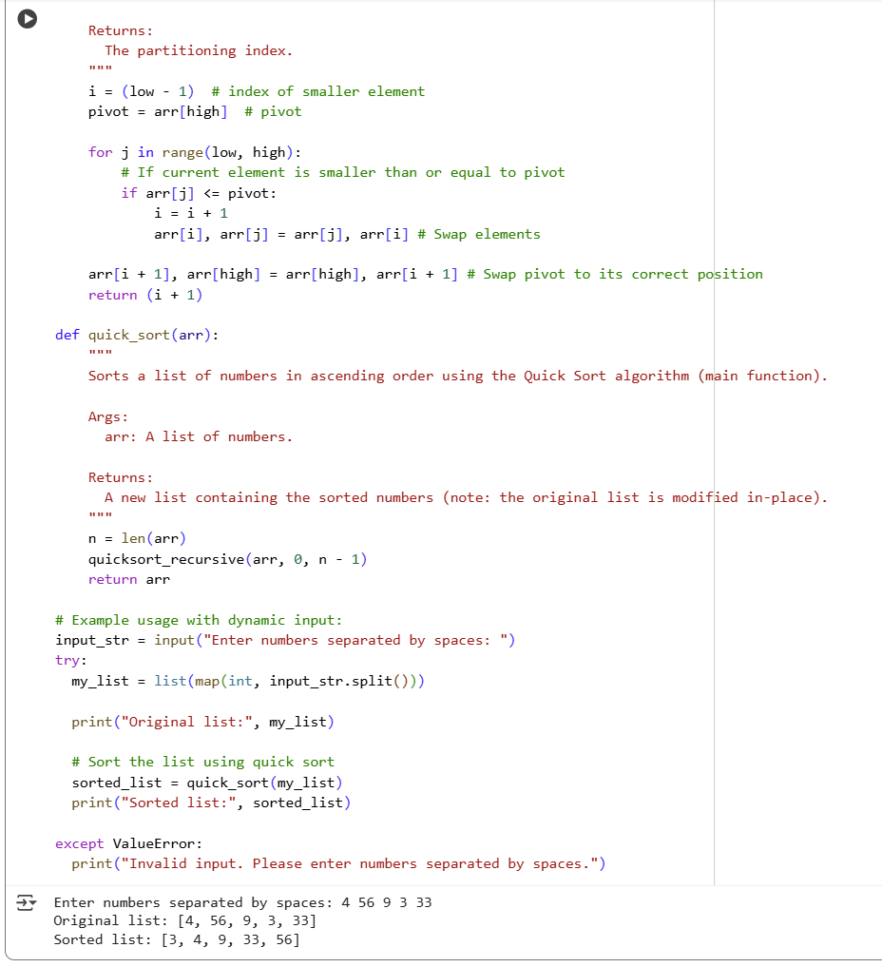

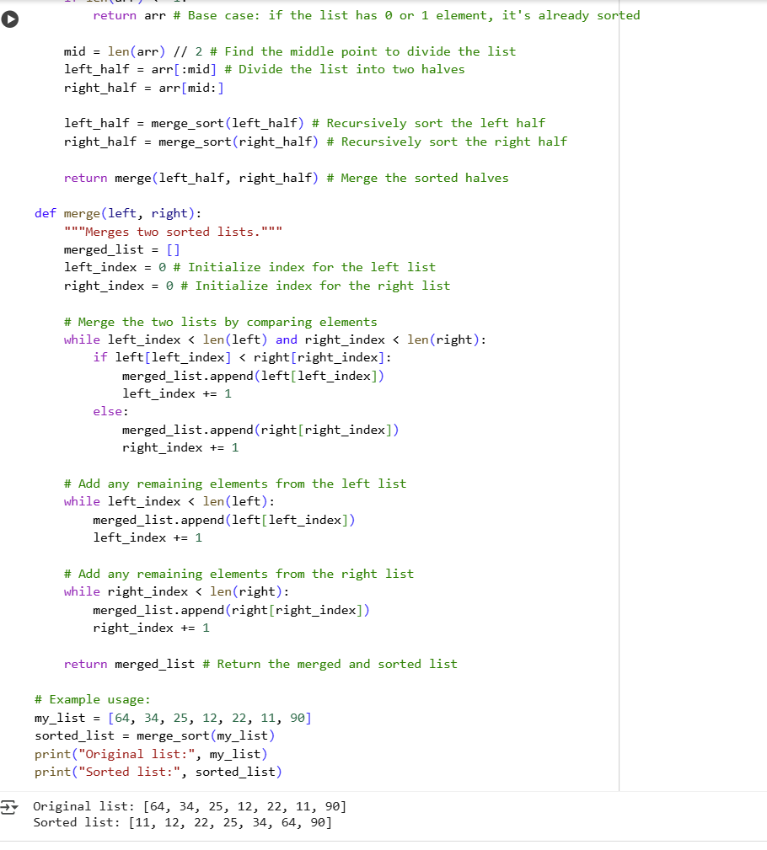
Explanation:
- Import necessary libraries: Import time and random for measuring time and generating random lists.
- Implement sorting algorithms: Ensure the functions for Bubble Sort, Merge Sort, and Quick Sort are available.
- Generate test lists: Create functions to generate random, sorted, and reverse-sorted lists of a specified size.
- Compare performance: Write a function to take a sorting algorithm and a list as input, measure the time it takes to sort the list, and return the time.
- Run comparisons and collect results: Iterate through the sorting algorithms and test list types, run the comparison function for each combination, and store the results.
- Present results: Display the results in a clear format, such as a table, showing the execution time for each algorithm on each list type.
- Analyze and summarize: Briefly summarize the findings from the performance comparison.
- Finish task: Put the findings from the earlier stages into a format that anyone can read.

Task 5: AI-Suggested Algorithm Optimization
- Task: Give AI a naive algorithm (e.g., O(n²) duplicate search).
- Instructions:
  - Students write a brute force duplicate-finder.
  - Ask AI to optimize it (e.g., by using sets/dictionaries with O(n) time).
  - Compare execution times with large input sizes.
- Expected Output:
- 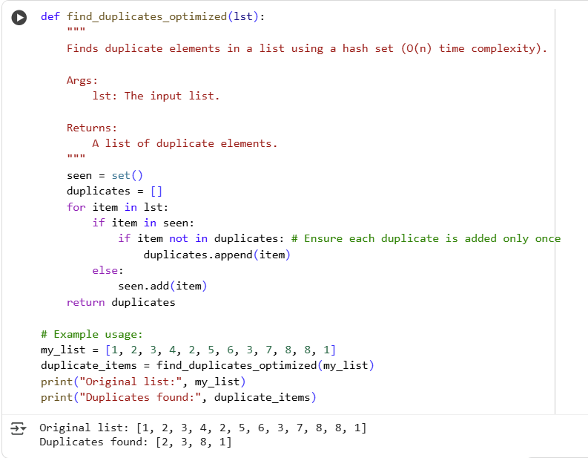

The brute-force method uses nested loops, comparing every element to every other element, resulting in O(n²) time complexity.
The optimized approach uses a set. Sets in Python provide average O(1) time complexity for checking if an element exists (item in seen) and adding an element (seen.add(item)).
By iterating through the list once and using the set to keep track of seen elements, we can identify duplicates in a single pass. This reduces the time complexity to O(n), making it significantly faster for larger lists compared to the brute-force method.

