ASSIGNMENT-8.2
Name : Dhevulapally Rashmitha
Hall ticket No: 2403A51432
Batch:16

Task 1:
Generate a python code to find the given number is prime are not using functions concept
Code:
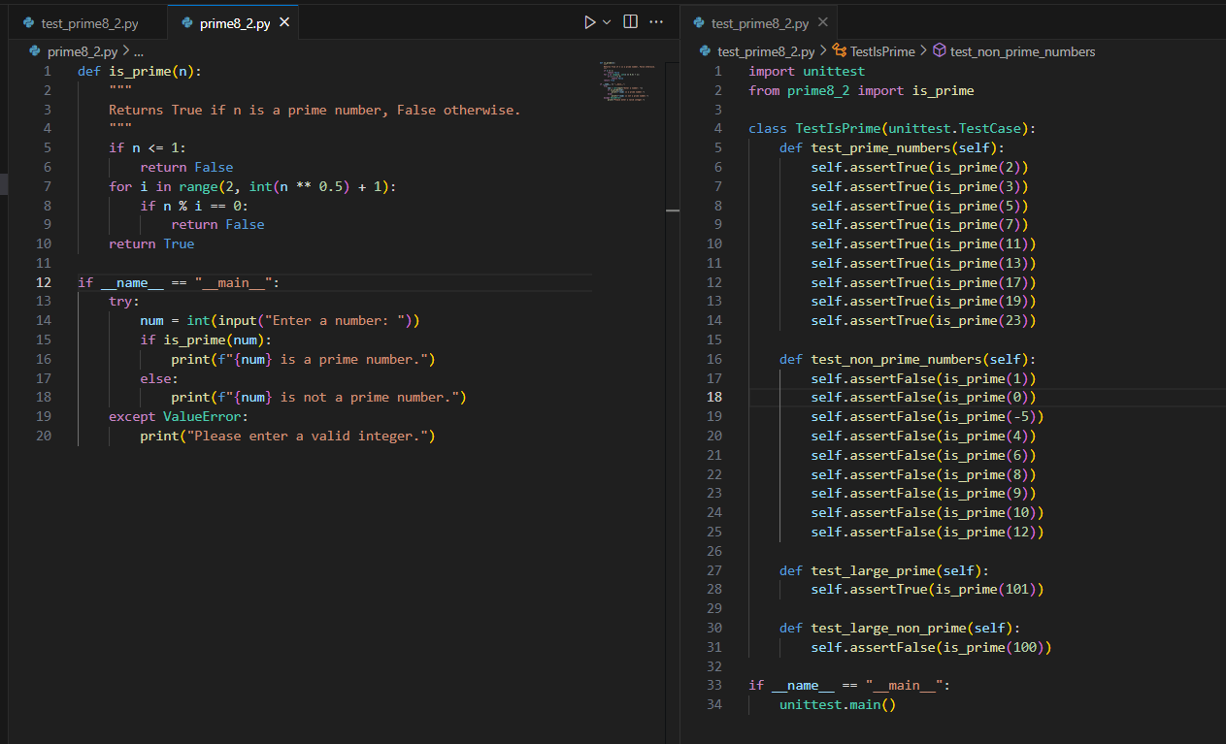
Output:
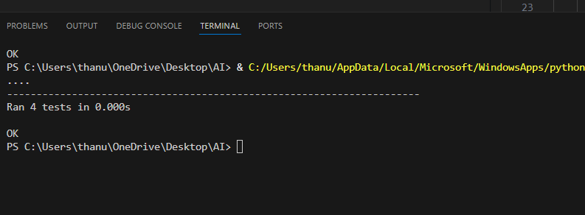
Explanation:
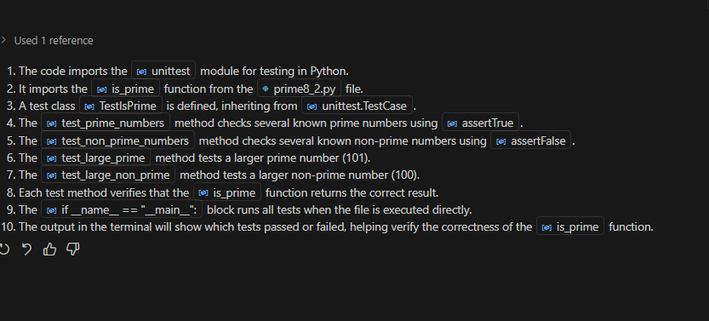

Task 2:
Generate python code for celsius_to_fahrenheit(c) and fahrenheit_to_celsius(f) that verify known conversions like 0°C = 32°F and 100°C = 212°F. Include decimal inputs such as 37.5°C and 98.6°F to test precision. Also cover invalid inputs like strings, None, or lists, and define expected error handling behavior.

Code:
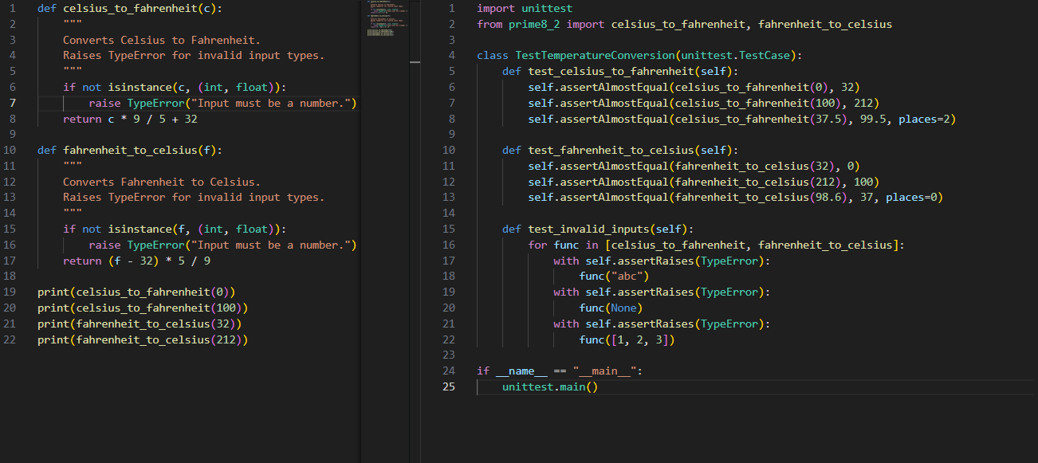

Output:
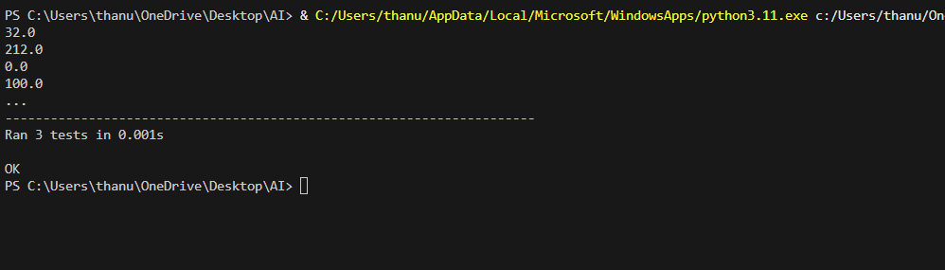
Explanation:
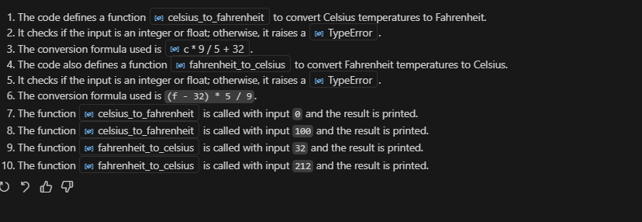

Task 3:
generate a python code using function count_words(text) that returns the number of
words in a sentenc Requirement are Handle normal text, multiple spaces, punctuation, and empty string
code:
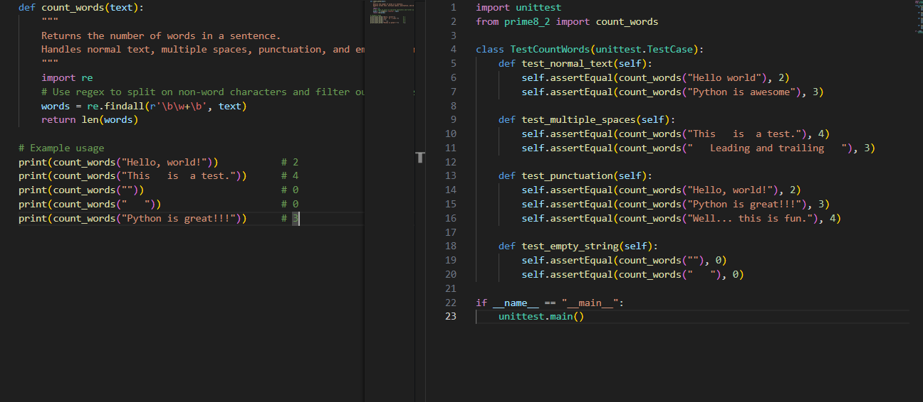
Output:
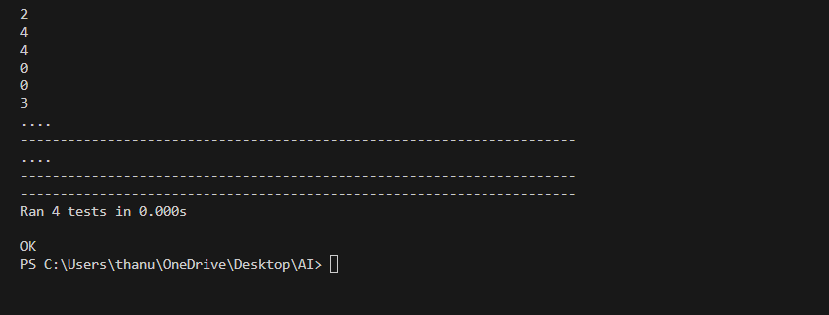
Explanation:
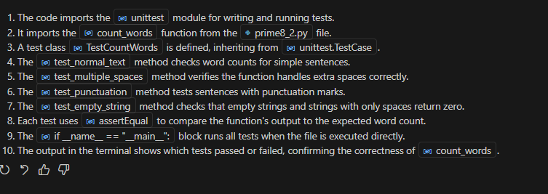

Task 4:
generate a python code for a BankAccount class with Methods: deposit(amount),withdraw(amount),check_balance(),Requirements are Negative deposits/withdrawals should raise an error, Cannot withdraw more than balance
Code: 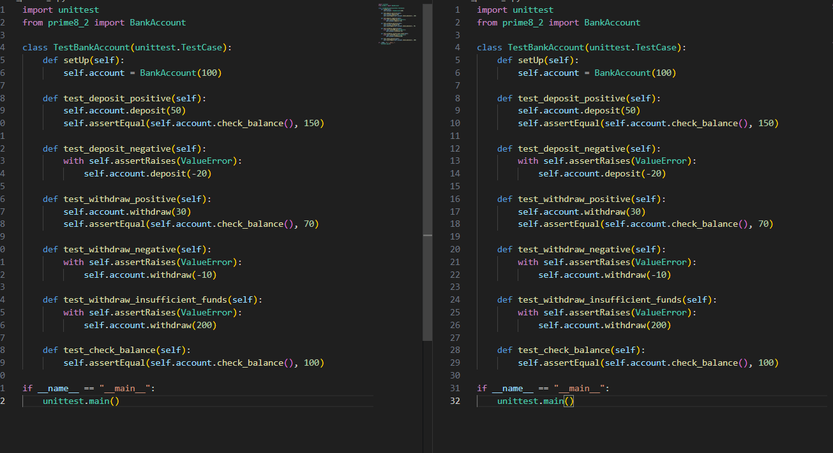
Output:
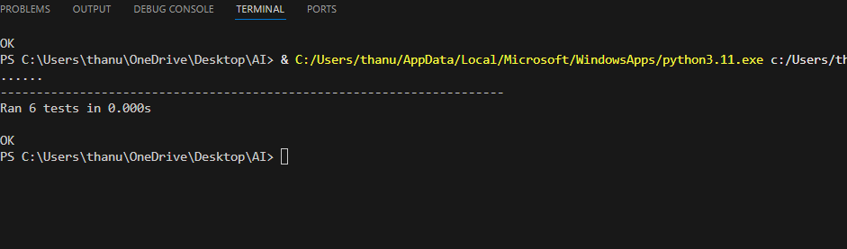
Explanation:
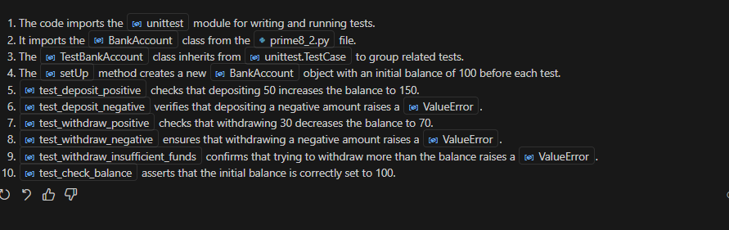

Task 5:
Generate a python code for is_number_palindrome(num), which checks if an integer reads the same backward. Examples: 121 → True,123 → False 0, negative numbers → handled gracefull

Code:
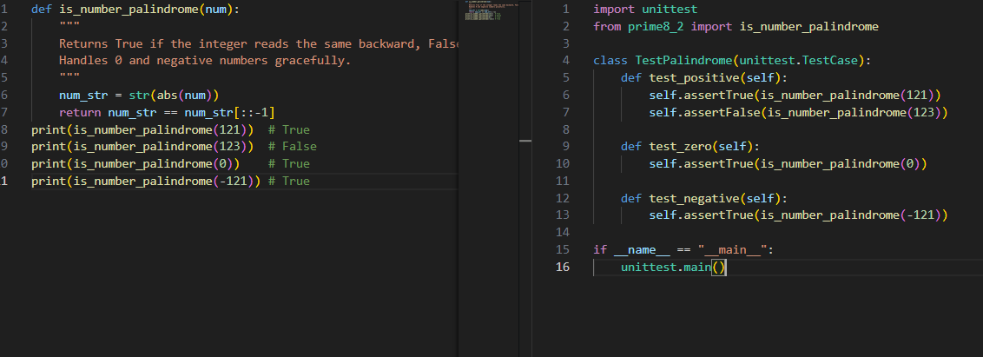

Output:
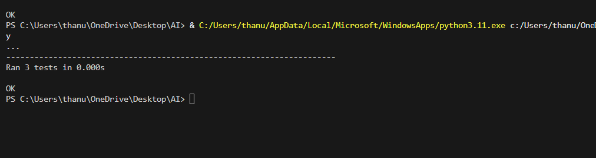
Explanation:
