SCHOOL OF COMPUTER SCIENCE AND ARTIFICIAL INTELLIGENCE |  |  |  |  | DEPARTMENT OF COMPUTER SCIENCE ENGINEERING
Program Name: B. Tech |  |  |  | Assignment Type: Lab |  |  | Academic Year:2025-2026
Course Coordinator Name |  |  |  | Venkataramana Veeramsetty
Instructor(s) Name |  |  |  | Dr. V. Venkataramana (Co-ordinator)  Dr. T. Sampath Kumar  Dr. Pramoda Patro  Dr. Brij Kishor Tiwari  Dr.J.Ravichander  Dr. Mohammand Ali Shaik  Dr. Anirodh Kumar  Mr. S.Naresh Kumar  Dr. RAJESH VELPULA  Mr. Kundhan Kumar  Ms. Ch.Rajitha  Mr. M Prakash  Mr. B.Raju  Intern 1 (Dharma teja)  Intern 2 (Sai Prasad)  Intern 3 (Sowmya)  NS_2 ( Mounika)
Course Code |  |  | 24CS002PC215 | Course Title |  | AI Assisted Coding
Year/Sem |  |  | II/I | Regulation |  | R24
Date and Day  of Assignment |  |  | Week7 - Thursday | Time(s)
Duration |  |  | 2 Hours | Applicable to  Batches
AssignmentNumber:13.1(Present assignment number)/24(Total number of assignments)
 | Q.No. | Question |  |  |  |  |  | Expected Time  to complete
 | 1 | Lab 13: Code Refactoring – Improving Legacy Code with AI Suggestions  Lab Objectives:  - Identify code smells and inefficiencies in legacy Python scripts.  - Use AI-assisted coding tools to refactor for readability, maintainability, and performance.  - Apply modern Python best practices while ensuring output correctness.  Task 1  - Task: Refactor repeated loops into a cleaner, more Pythonic approach.  Instructions:  - Analyze the legacy code.  - Identify the part that uses loops to compute values.  - Refactor using list comprehensions or helper functions while keeping the output the same.  Legacy Code:  numbers = [1, 2, 3, 4, 5]  squares = []  for n in numbers:  squares.append(n ** 2)  print(squares)  Code and Output:  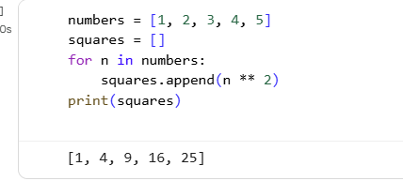  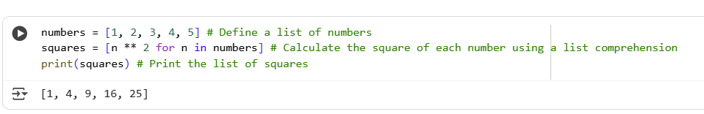  Explanation:  This code snippet in Python is designed to calculate the squares of numbers in a list. It starts by creating a list named numbers containing integers from 1 to 5. Then, it uses a list comprehension to efficiently create a new list called squares. A list comprehension is a concise way to create lists. In this comprehension, for each n (representing each number) in the numbers list, it calculates the square of n using n ** 2. The results of these calculations (the squares) are collected into the squares list. Finally, the code prints the squares list to the console. The output will be a list containing the squares of the numbers from 1 to 5. This approach is considered Pythonic because it's more compact and often more readable than a traditional for loop for simple list transformations. It effectively demonstrates how to perform an operation on each item in a list and collect the results into a new list.  Task 2  Task: Simplify string concatenation.  Instructions:  - Review the loop that builds a sentence using +=.  - Refactor using " ".join() to improve efficiency and readability.  Legacy Code:  words = ["AI", "helps", "in", "refactoring", "code"]  sentence = ""  for word in words:  sentence += word + " "  print(sentence.strip())  code and Output:  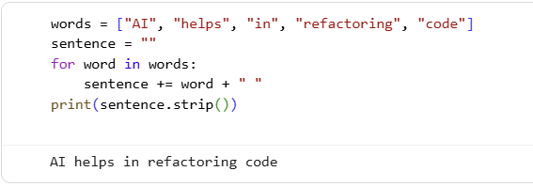  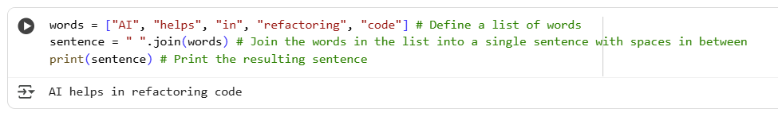  Explanation:  This code snippet joins a list of words into a single sentence. It initializes an empty string sentence. Then, it iterates through each word in the words list. In each iteration, it appends the word and a space to the sentence. Finally, it prints the sentence after removing any leading or trailing spaces using .strip().  Task 3  Task: Replace manual dictionary lookup with a safer method.  Instructions:  - Check how the code accesses dictionary keys.  - Use .get() or another Pythonic approach to handle missing keys gracefully.  Legacy Code:  student_scores = {"Alice": 85, "Bob": 90}  if "Charlie" in student_scores:  print(student_scores["Charlie"])  else:  print("Not Found")  Code and Output:  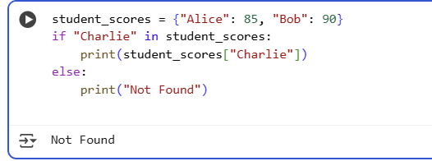  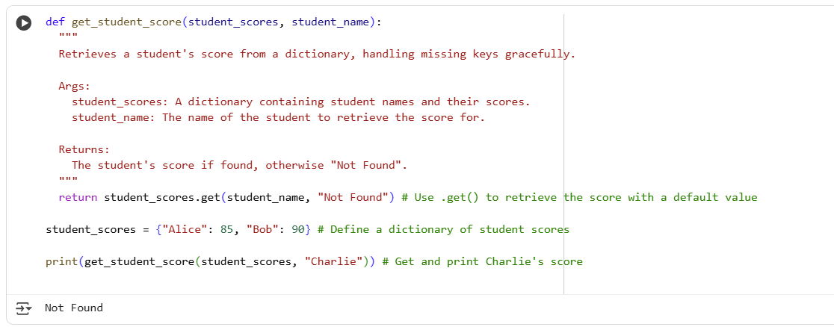  Explanation:  This code defines a function get_student_score that takes a dictionary of student scores and a student name as input. It uses the .get() method on the dictionary to retrieve the score for the given student name. If the student name is found in the dictionary, their score is returned. If the student name is not found, the .get() method returns the default value, which is "Not Found".  Task 4  Task: Refactor repetitive if-else blocks.  Instructions:  - Examine multiple if-elif statements for operations.  - Refactor using dictionary mapping to make the code scalable and clean.  Legacy Code:  operation = "multiply"  a, b = 5, 3  if operation == "add":  result = a + b  elif operation == "subtract":  result = a - b  elif operation == "multiply":  result = a * b  else:  result = None  print(result)  Code and Output:  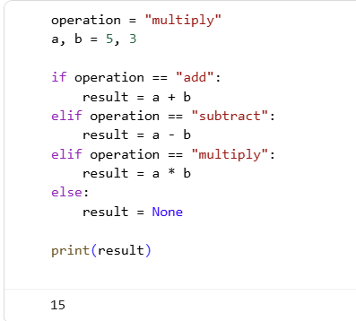  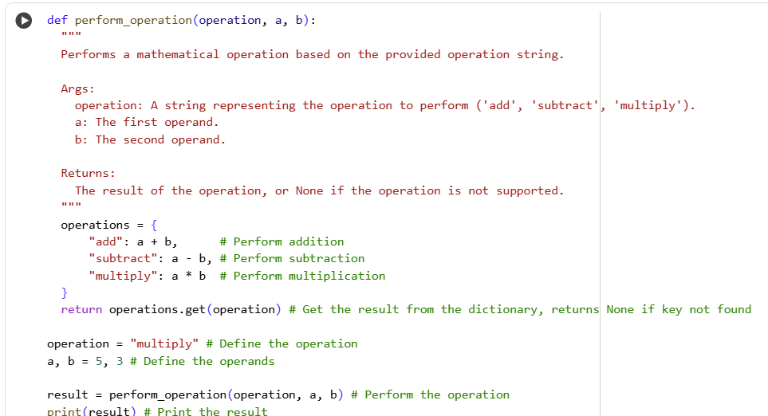  Explanation:  This code defines a function perform_operation that takes an operation string and two operands. It uses a dictionary operations to map operation names to the corresponding calculations. The .get() method is used to retrieve the result from the dictionary based on the operation string. If the operation is not found in the dictionary, .get() returns None. Finally, the code calls the function with "multiply" as the operation and prints the result.  Task 5  Task: Optimize nested loops for searching.  Instructions:  - Identify the nested loop used to find an element.  - Refactor using Python’s in keyword or other efficient search techniques.  Legacy Code:  items = [10, 20, 30, 40, 50]  found = False  for i in items:  if i == 30:  found = True  break  print("Found" if found else "Not Found")  Code and Output:  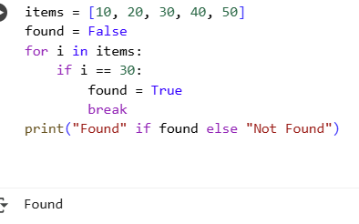  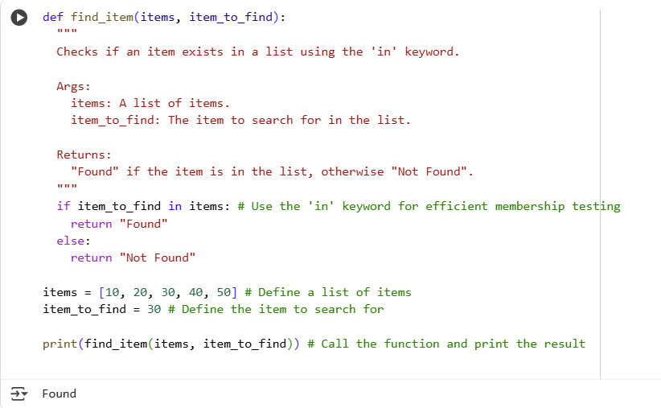  Explanation:  This code defines a function find_item to check if an item exists in a list. It uses the Python in keyword, which is an efficient way to test for membership in a list. If the item_to_find is found within the items list, the function returns "Found". Otherwise, if the item is not present, it returns "Not Found". The code then demonstrates using this function to search for both an existing item (30). |  |  |  |  |  | Week7 - Thursday

