TASK 2

Exploratory Data Analysis
Using Python, Pandas, Matplotlib and Seaborn
CodeOrbit Tech — Data Science Internship
Prepared by: [Enter your name]

Executive summary
This project explores the cleaned sales dataset prepared in Task 1. Pandas is used to summarize orders and group results by product, category, region, payment method and date. Charts are used to examine the distribution of sales, differences between groups, daily variation and possible outliers.
Measure | Result | Interpretation
Orders analysed | 30 | 30 cleaned practice records
Total sales | ₹15,538 | Combined sales amount across all records
Mean sales per order | ₹517.93 | Higher than the median due to larger orders
Median sales per order | ₹385.00 | Middle order value; less affected by high values
Most frequent product | Notebook (8 orders) | Highest order count, not highest sales value
Highest-sales product | Backpack (₹6,293) | Largest product total sales
Highest-sales day | 08 Jan 2026 (₹2,548) | Peak in this short sample

Method
- Loaded the Task 1 cleaned CSV and converted Order_Date to a datetime field.
- Reviewed data types, missing values and descriptive statistics before grouping records.
- Created histograms, bar charts, a daily-sales line chart and a scatter plot; investigated IQR-flagged values in context.

Main takeaway
Accessories generated the largest category sales, while Stationery had more orders and units but a lower total value. Chennai led both order count and regional sales in this sample. The results are illustrative only because the dataset is small and fictional.

1. Distribution and order volume

Sales amount per order
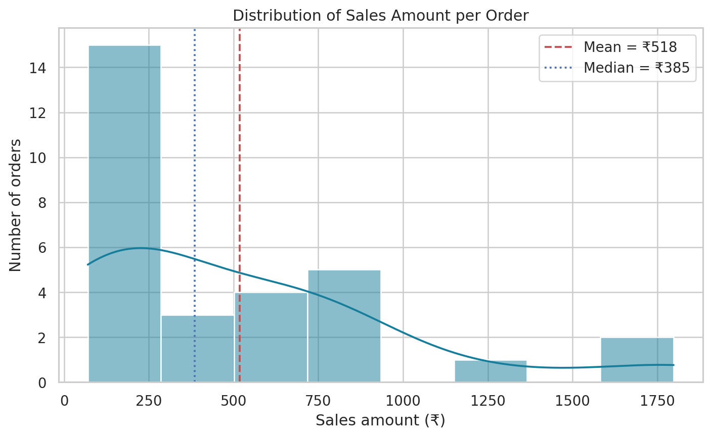
Figure 1. Most order values are below ₹1,000; mean ₹517.93 exceeds median ₹385.00, showing a right-skewed distribution.
The mean is pulled upward by a small number of large sales amounts. For this small dataset, the median is a useful additional summary of a typical order. A histogram helps show the concentration of order values and the less frequent high-value orders.

Orders by product
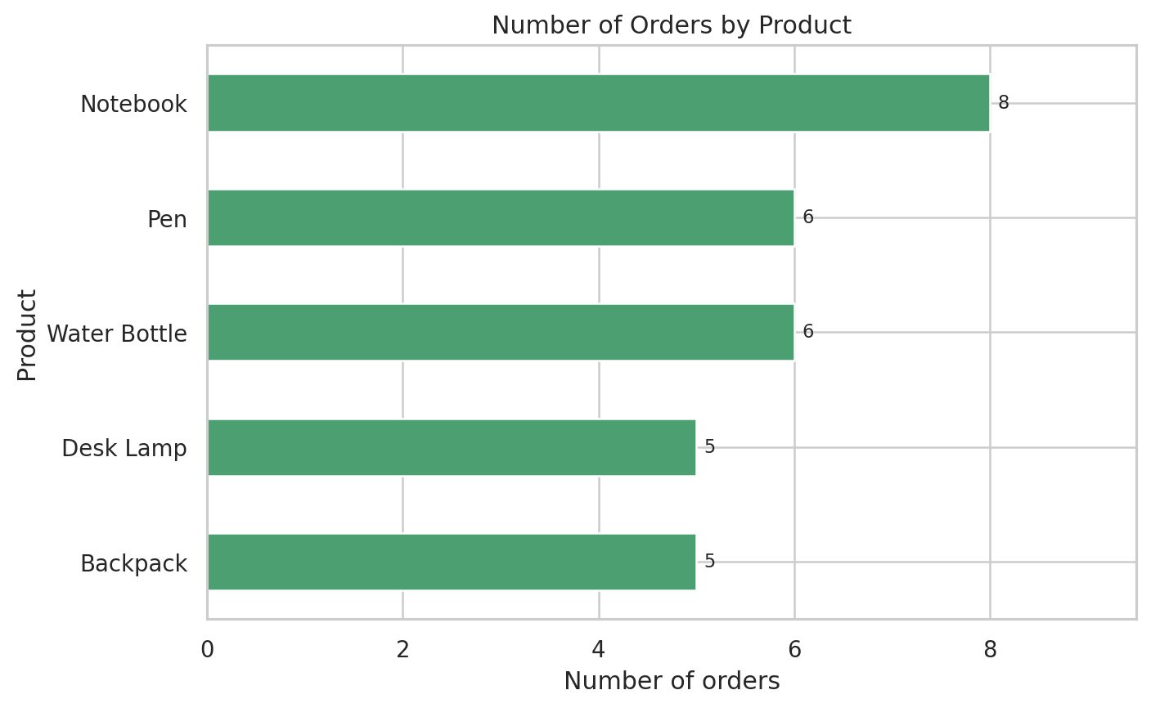
Figure 2. Notebook is the most frequently ordered product (8 orders); Pen and Water Bottle each have 6 orders.
Order count measures how often a product appears, not its sales contribution.

2. Sales contribution by product and category

Total sales by product
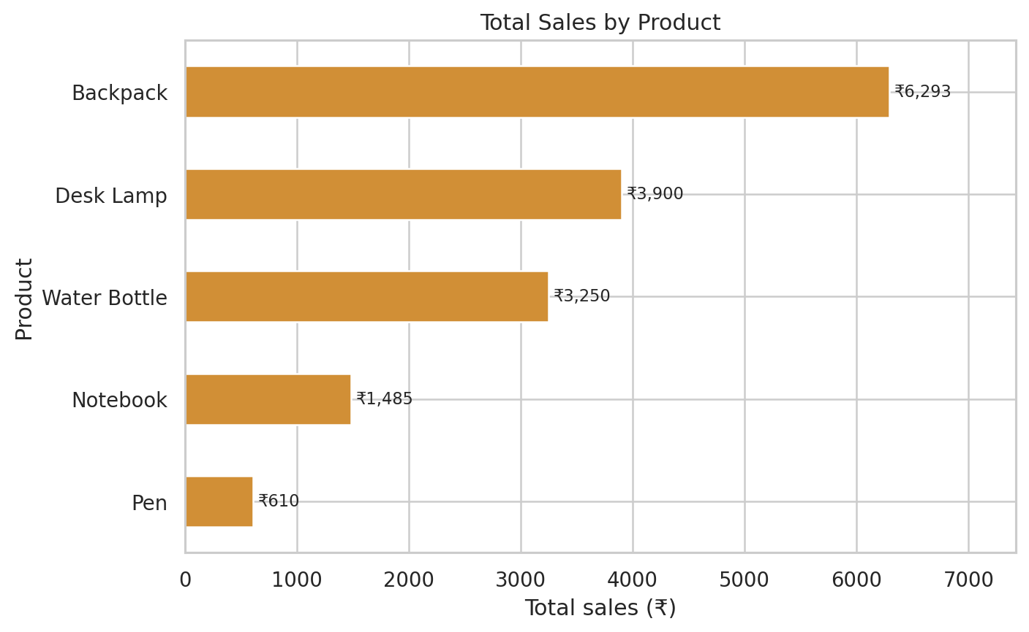
Figure 3. Backpack leads total sales at ₹6,293, followed by Desk Lamp at ₹3,900 and Water Bottle at ₹3,250.
Backpack has only five orders but the highest sales total, reflecting its higher unit price. Notebook leads order count but contributes ₹1,485, and Pen contributes ₹610.

Total sales by category
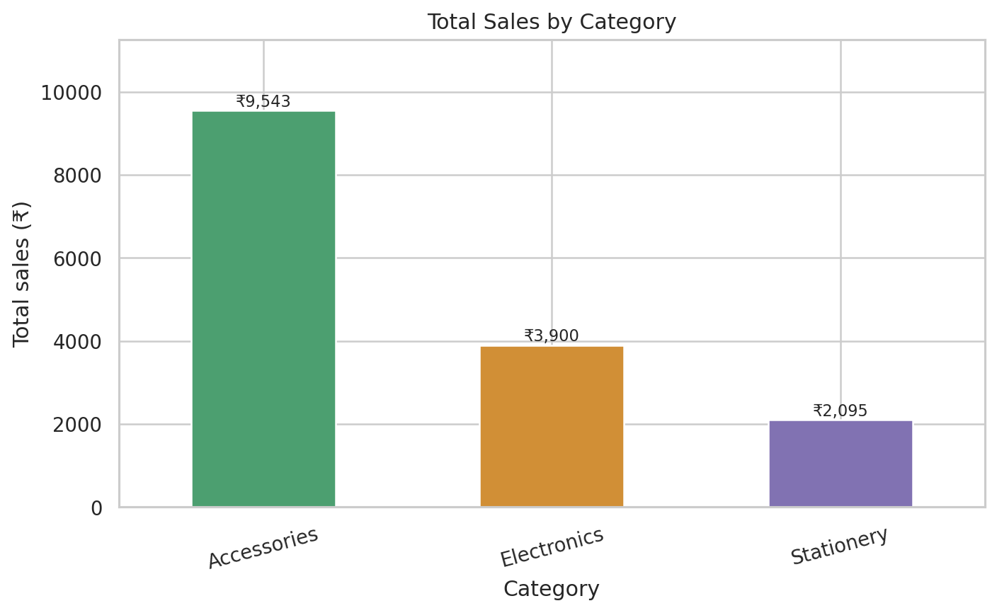
Figure 4. Accessories generated ₹9,543, Electronics ₹3,900 and Stationery ₹2,095.
Stationery supplied the most orders (14 of 30) and units, but lower prices kept its sales total at ₹2,095. Accessories contributed about 61% of sales.

3. Regional and time-based patterns

Total sales by region
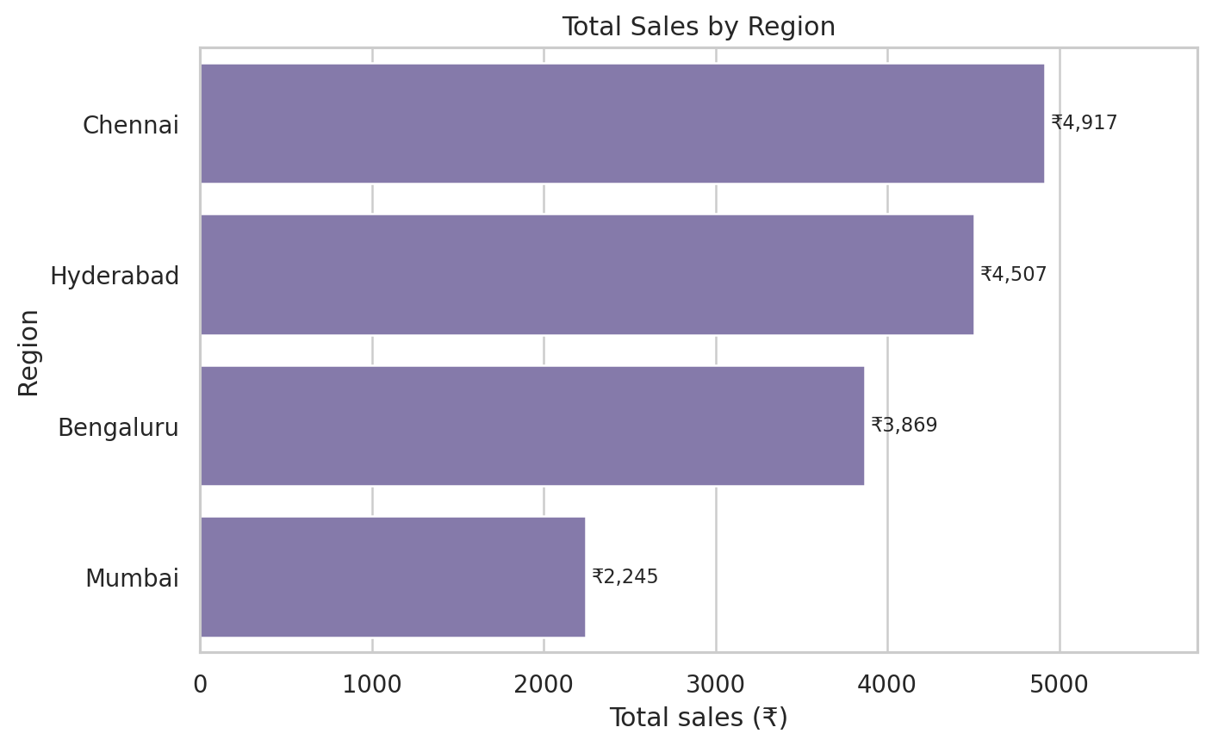
Figure 5. Chennai has the highest total sales at ₹4,917; Hyderabad is next at ₹4,507.
Chennai has 10 orders, the largest regional order count. Hyderabad has the highest average sales per order (about ₹643.86), so total sales and average order size provide different views of regional performance.

Daily sales trend
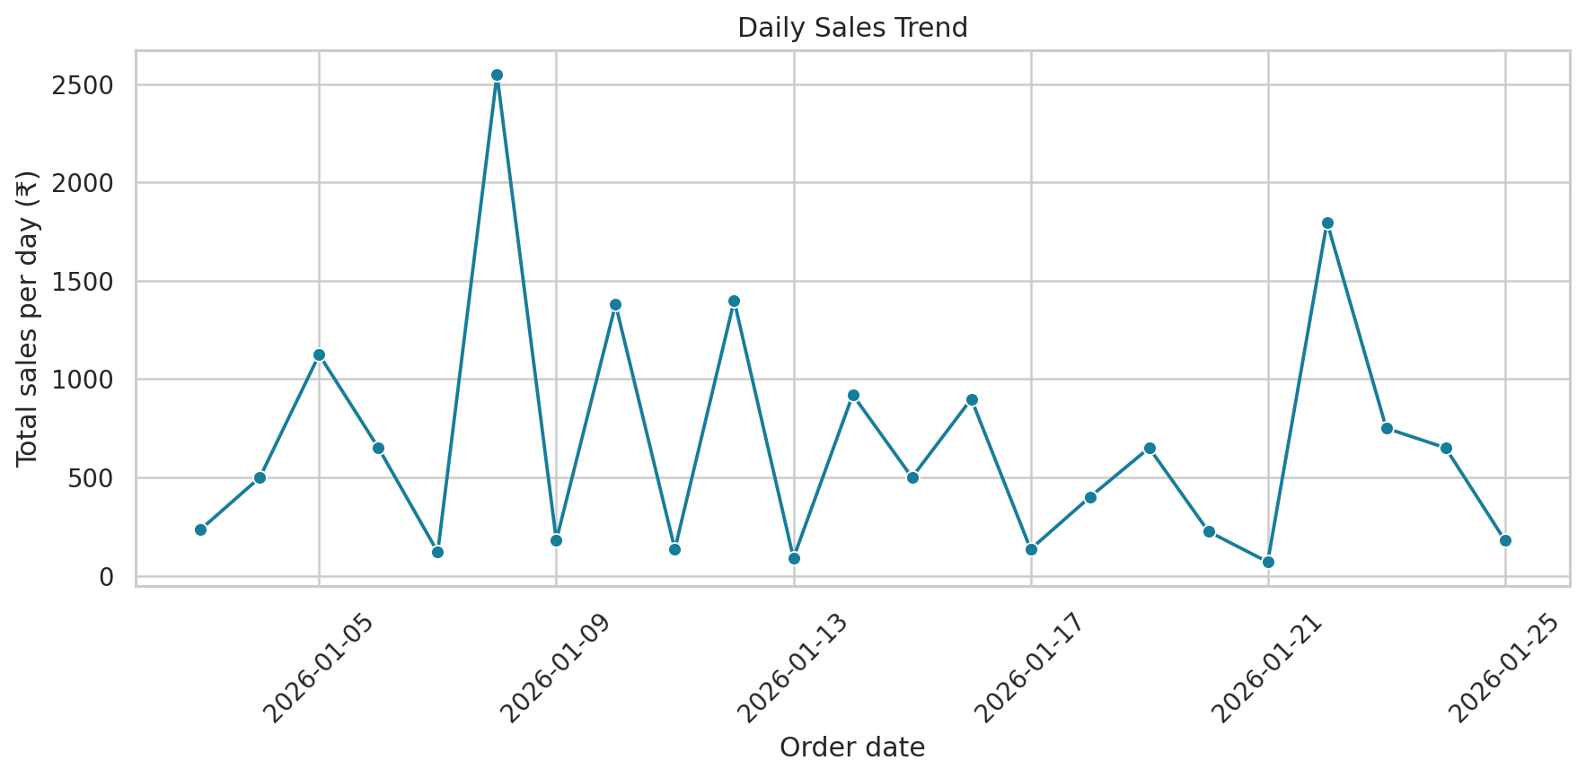
Figure 6. Sales fluctuate by day; the largest daily total is ₹2,548 on 08 January 2026.
The time series covers 3–25 January 2026. Some days have higher totals because of higher-value orders; the short date range is not enough to establish a reliable seasonal or long-term trend.

4. Relationships and outlier review

Unit price vs. sales amount
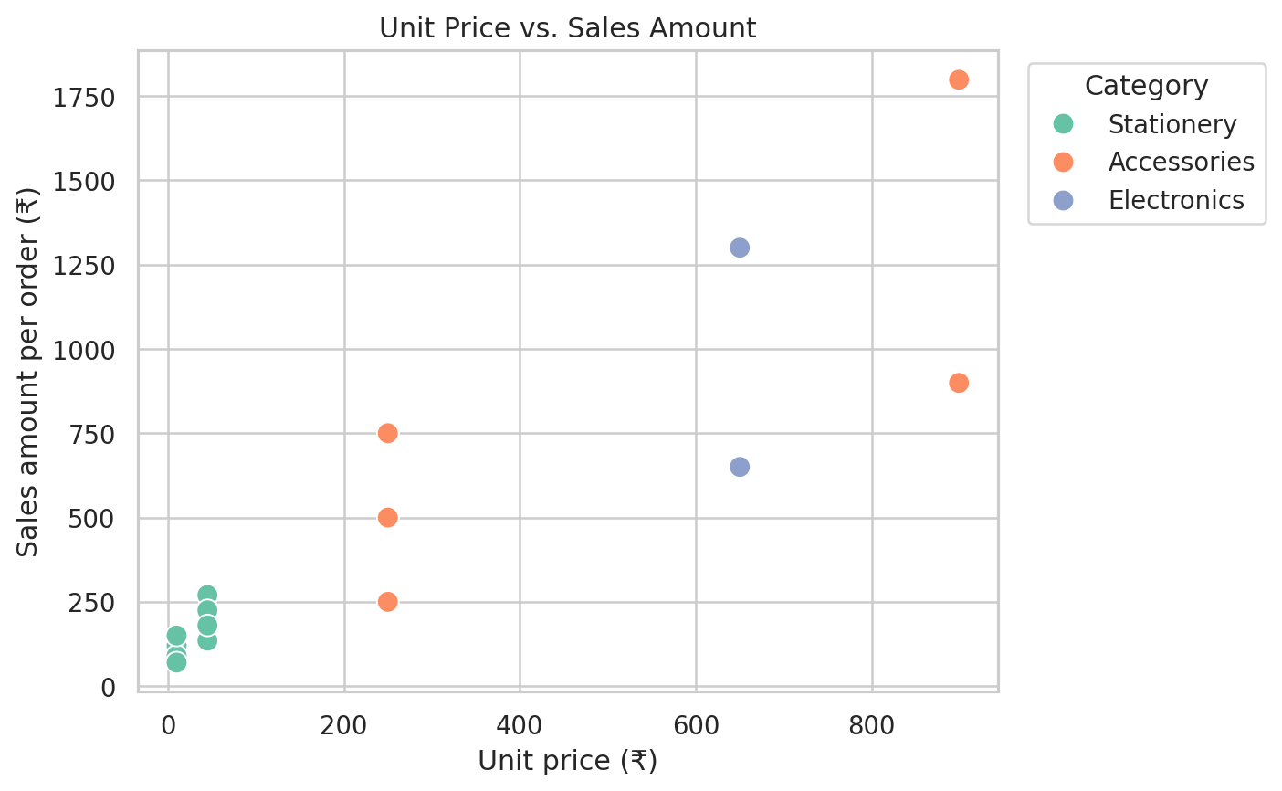
Figure 7. The correlation between Unit_Price and Sales_Amount is 0.861.
The strong positive relationship is expected because sales amount is quantity multiplied by unit price. Quantity and sales amount have a negative correlation in this sample (about -0.527), but this does not mean larger quantities cause lower sales; high-priced products tend to be purchased in smaller quantities.

Potential outliers
The IQR method gives an upper threshold of ₹1,604.38 for Sales_Amount and flags 2 orders above it. These are shown below for context:
Order ID | Product | Quantity | Unit price | Sales amount
1009 | Backpack | 2 | ₹899 | ₹1,798
1027 | Backpack | 2 | ₹899 | ₹1,798

Both flagged orders are Backpack orders: 2 units at ₹899 each, for ₹1,798. They appear mathematically plausible and should not be removed solely because an IQR rule flags them.

Conclusion and limitations
- Accessories led category sales; Backpack led product sales; Notebook led product order count.
- Chennai had the most orders and highest total regional sales; UPI was used in 15 of 30 orders.
- Daily sales varied, and two high-value orders were flagged for review but appear plausible.
Limitation: This is a small fictional practice dataset. Findings demonstrate EDA methods and should not be generalized to a real business or used as forecasts.

