Legionellosis: County and Population in Ohio

David Hibler

December 3, 2019

# Data

## Obtaining and Processing the Data

pop_2010 = Ohio county population from [2010 census](https://www.census.gov/quickfacts/OH).  
pop_2018 = [Estimated Ohio county population](http://worldpopulationreview.com/states/ohio/). Retrieved 2019-01-24, from <http://worldpopulationreview.com/states/ohio/>  
pop_dens = Population density calculated from 2018 population and county area in sq miles.  
ln_2018_pop = The calculated natural log of the 2018 population.  
ln_pop_density = The calculated natural log of the 2018 population density.  
pop_dif = The calculated change in population from 2010 to 2018.  
abs_pop_dif = The absolute value of change in population from 2010 to 2018.  
l_2017 = Reported Legionellosis infections in 2017 gathered from the [Ohio Department of Health Infections Diseases Report](https://odh.ohio.gov/wps/portal/gov/odh/know-our-programs/infectious-diseases/Reports/2017-annual-summary).  
l_2018 = Reported Legionellosis infections in 2018 that was specially disclosed by the Ohio Department of Health and is not yet available online, so was not used in this project.

Data set calculations (such as population densities and natural logs) were done in excell and then the data set was saved as a csv file to be analyzed in R.

## Analyzing the Data

Data sets were ploted for visual examination, and correlational tests (such as Pearson’s, Kendall’s, and Spearman’s) were run to check for signifigance.

set.seed(37)  
  
setwd("C:/Users/hible/Documents/School/Pubhealth/PUBHLTH 8802 - GISD sem")   
  
my_data <- read.csv("ohio_ld_2018.csv", header=TRUE)  
  
l_2017_v <- my_data$l_2017  
pop_2018_v <- my_data$pop_2018  
pop_density_v <- my_data$pop_density  
ln_2018_pop_v <- my_data$ln_2018_pop  
ln_pop_density_v <- my_data$ln_pop_density  
  
cor_p_values <- matrix(nrow=3, ncol=4)  
colnames(cor_p_values) <- c("Infections vs Population", "Infections vs Pop_density", "Infections vs Ln_Pop", "Infections vs Ln_Pop_density")  
rownames(cor_p_values) <- c("Pearson", "Kendall", "Spearman")  
  
i_p_p <- cor.test(l_2017_v,pop_2018_v, method = "pearson")  
cor_p_values[1,1] <- i_p_p$p.value  
i_p_k <- cor.test(l_2017_v,pop_2018_v, method = "kendall")  
cor_p_values[2,1] <- i_p_k$p.value  
i_p_s <- cor.test(l_2017_v,pop_2018_v, method = "spearman")

## Warning in cor.test.default(l_2017_v, pop_2018_v, method = "spearman"):  
## Cannot compute exact p-value with ties

cor_p_values[3,1] <- i_p_s$p.value  
  
i_p_p <- cor.test(l_2017_v,pop_density_v, method = "pearson")  
cor_p_values[1,2] <- i_p_p$p.value  
i_p_k <- cor.test(l_2017_v,pop_density_v, method = "kendall")  
cor_p_values[2,2] <- i_p_k$p.value  
i_p_s <- cor.test(l_2017_v,pop_density_v, method = "spearman")

## Warning in cor.test.default(l_2017_v, pop_density_v, method = "spearman"):  
## Cannot compute exact p-value with ties

cor_p_values[3,2] <- i_p_s$p.value  
  
i_p_p <- cor.test(l_2017_v,ln_2018_pop_v, method = "pearson")  
cor_p_values[1,3] <- i_p_p$p.value  
i_p_k <- cor.test(l_2017_v,ln_2018_pop_v, method = "kendall")  
cor_p_values[2,3] <- i_p_k$p.value  
i_p_s <- cor.test(l_2017_v,ln_2018_pop_v, method = "spearman")

## Warning in cor.test.default(l_2017_v, ln_2018_pop_v, method = "spearman"):  
## Cannot compute exact p-value with ties

cor_p_values[3,3] <- i_p_s$p.value  
  
cor.test(l_2017_v,ln_pop_density_v, method = "pearson")

##   
## Pearson's product-moment correlation  
##   
## data: l_2017_v and ln_pop_density_v  
## t = 7.8433, df = 86, p-value = 1.096e-11  
## alternative hypothesis: true correlation is not equal to 0  
## 95 percent confidence interval:  
## 0.5045721 0.7533242  
## sample estimates:  
## cor   
## 0.6457702

i_p_p <- cor.test(l_2017_v,ln_pop_density_v, method = "pearson")  
cor_p_values[1,4] <- i_p_p$p.value  
i_p_k <- cor.test(l_2017_v,ln_pop_density_v, method = "kendall")  
cor_p_values[2,4] <- i_p_k$p.value  
i_p_s <- cor.test(l_2017_v,ln_pop_density_v, method = "spearman")

## Warning in cor.test.default(l_2017_v, ln_pop_density_v, method =  
## "spearman"): Cannot compute exact p-value with ties

cor_p_values[3,4] <- i_p_s$p.value  
  
print(cor_p_values)

## Infections vs Population Infections vs Pop_density  
## Pearson 1.425785e-39 2.109105e-30  
## Kendall 4.891875e-14 1.331731e-13  
## Spearman 1.727944e-15 1.073629e-14  
## Infections vs Ln_Pop Infections vs Ln_Pop_density  
## Pearson 5.435431e-12 1.096061e-11  
## Kendall 4.891875e-14 1.331731e-13  
## Spearman 1.727944e-15 1.073629e-14

Infections were found to be highly significantly correlated with population size, population density,the natural log of the population size, and the natuarl log of the population density.

# Summary stats

# summarize the data  
summary(my_data)

## Ã¯..county area l_2018 pop_2010   
## Adams : 1 Min. :228.2 Min. : 0.00 Min. : 13319   
## Allen : 1 1st Qu.:409.5 1st Qu.: 1.00 1st Qu.: 37312   
## Ashland : 1 Median :439.1 Median : 3.00 Median : 57733   
## Ashtabula: 1 Mean :464.4 Mean : 10.57 Mean : 131368   
## Athens : 1 3rd Qu.:510.5 3rd Qu.: 8.00 3rd Qu.: 124145   
## Auglaize : 1 Max. :702.4 Max. :208.00 Max. :1267513   
## (Other) :82   
## pop_2018 pop_density ln_2018_pop ln_pop_density   
## Min. : 13142 Min. : 31.26 Min. : 9.484 Min. :3.442   
## 1st Qu.: 36946 1st Qu.: 83.94 1st Qu.:10.517 1st Qu.:4.429   
## Median : 57786 Median : 119.11 Median :10.964 Median :4.780   
## Mean : 131929 Mean : 292.84 Mean :11.169 Mean :5.047   
## 3rd Qu.: 123526 3rd Qu.: 256.16 3rd Qu.:11.724 3rd Qu.:5.546   
## Max. :1257401 Max. :2742.48 Max. :14.045 Max. :7.917   
##   
## pop_dif abs_pop_dif l_2017 inf_dif   
## Min. :-10112.0 Min. : 2 Min. : 0.000 Min. :-6.000   
## 1st Qu.: -633.5 1st Qu.: 244 1st Qu.: 1.000 1st Qu.: 0.000   
## Median : -256.5 Median : 583 Median : 2.000 Median : 1.000   
## Mean : 561.2 Mean : 1880 Mean : 6.602 Mean : 3.966   
## 3rd Qu.: 97.5 3rd Qu.: 1375 3rd Qu.: 5.000 3rd Qu.: 4.250   
## Max. : 55915.0 Max. :55915 Max. :123.000 Max. :85.000   
##

mean(my_data$l_2017)

## [1] 6.602273

mean(my_data$pop_2018)

## [1] 131929

mean(my_data$pop_density)

## [1] 292.8386

mean(my_data$ln_2018_pop)

## [1] 11.16865

mean(my_data$ln_pop_density)

## [1] 5.046705

# histograms  
hist(my_data$l_2017)

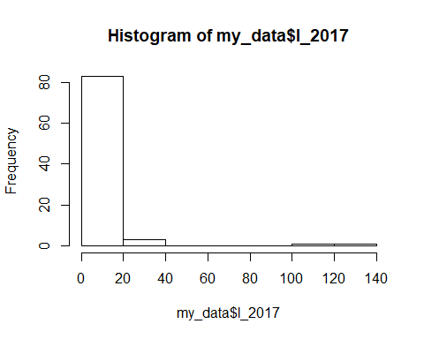

hist(my_data$pop_2018)

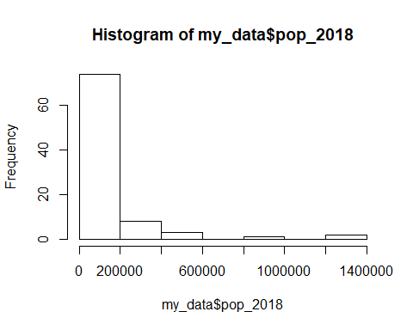

hist(my_data$pop_density)

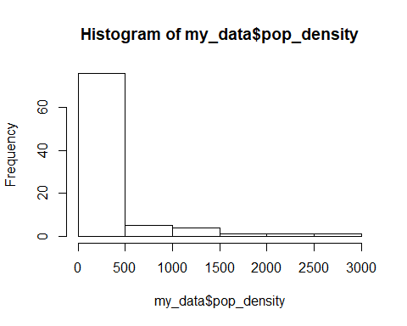

# variances, these should match what we supplied in the covariance matrix  
var(my_data$l_2017)

## [1] 317.7825

var(my_data$pop_2018)

## [1] 46858858822

var(my_data$pop_density)

## [1] 222635.3

# Plot

scatter.smooth(x=my_data$pop_2018, y=my_data$l_2017, main="l_2017 ~ pop_2018")

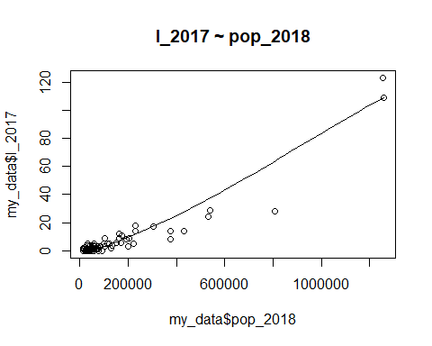

scatter.smooth(x=my_data$pop_density, y=my_data$l_2017, main="l_2017 ~ pop_density")

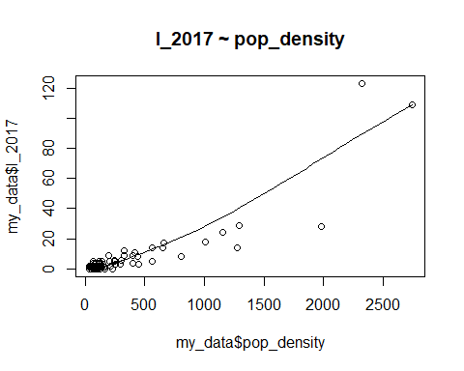

scatter.smooth(x=my_data$ln_2018_pop, y=my_data$l_2017, main="l_2017 ~ ln_2018_pop")

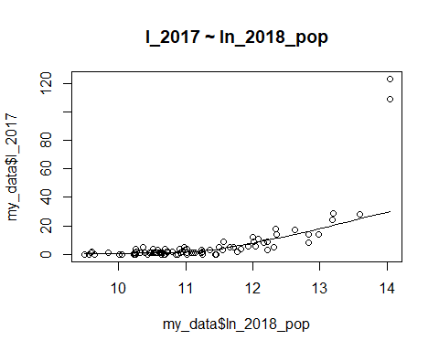

scatter.smooth(x=my_data$ln_pop_density, y=my_data$l_2017, main="l_2017 ~ ln_pop_density")

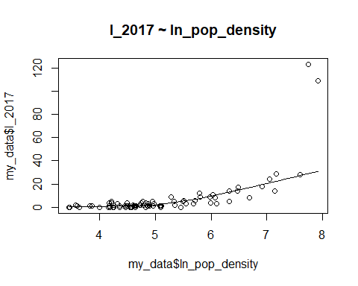 # Linear regression

linearMod_pop <- lm(l_2017 ~ pop_2018, data=my_data) # build linear regression model on full data  
print(linearMod_pop)

##   
## Call:  
## lm(formula = l_2017 ~ pop_2018, data = my_data)  
##   
## Coefficients:  
## (Intercept) pop_2018   
## -3.520e+00 7.672e-05

linearMod_popd <- lm(l_2017 ~ pop_density, data=my_data) # build linear regression model on full data  
print(linearMod_popd)

##   
## Call:  
## lm(formula = l_2017 ~ pop_density, data = my_data)  
##   
## Coefficients:  
## (Intercept) pop_density   
## -3.19690 0.03346

linearMod_lnpop <- lm(l_2017 ~ ln_2018_pop, data=my_data) # build linear regression model on full data  
print(linearMod_lnpop)

##   
## Call:  
## lm(formula = l_2017 ~ ln_2018_pop, data = my_data)  
##   
## Coefficients:  
## (Intercept) ln_2018_pop   
## -123.59 11.66

linearMod_lnpopd <- lm(l_2017 ~ ln_pop_density, data=my_data) # build linear regression model on full data  
print(linearMod_lnpopd)

##   
## Call:  
## lm(formula = l_2017 ~ ln_pop_density, data = my_data)  
##   
## Coefficients:  
## (Intercept) ln_pop_density   
## -51.54 11.52