# Accessing the Class Discussions on Zoom

1. Log in to CatCourses and go to our class site

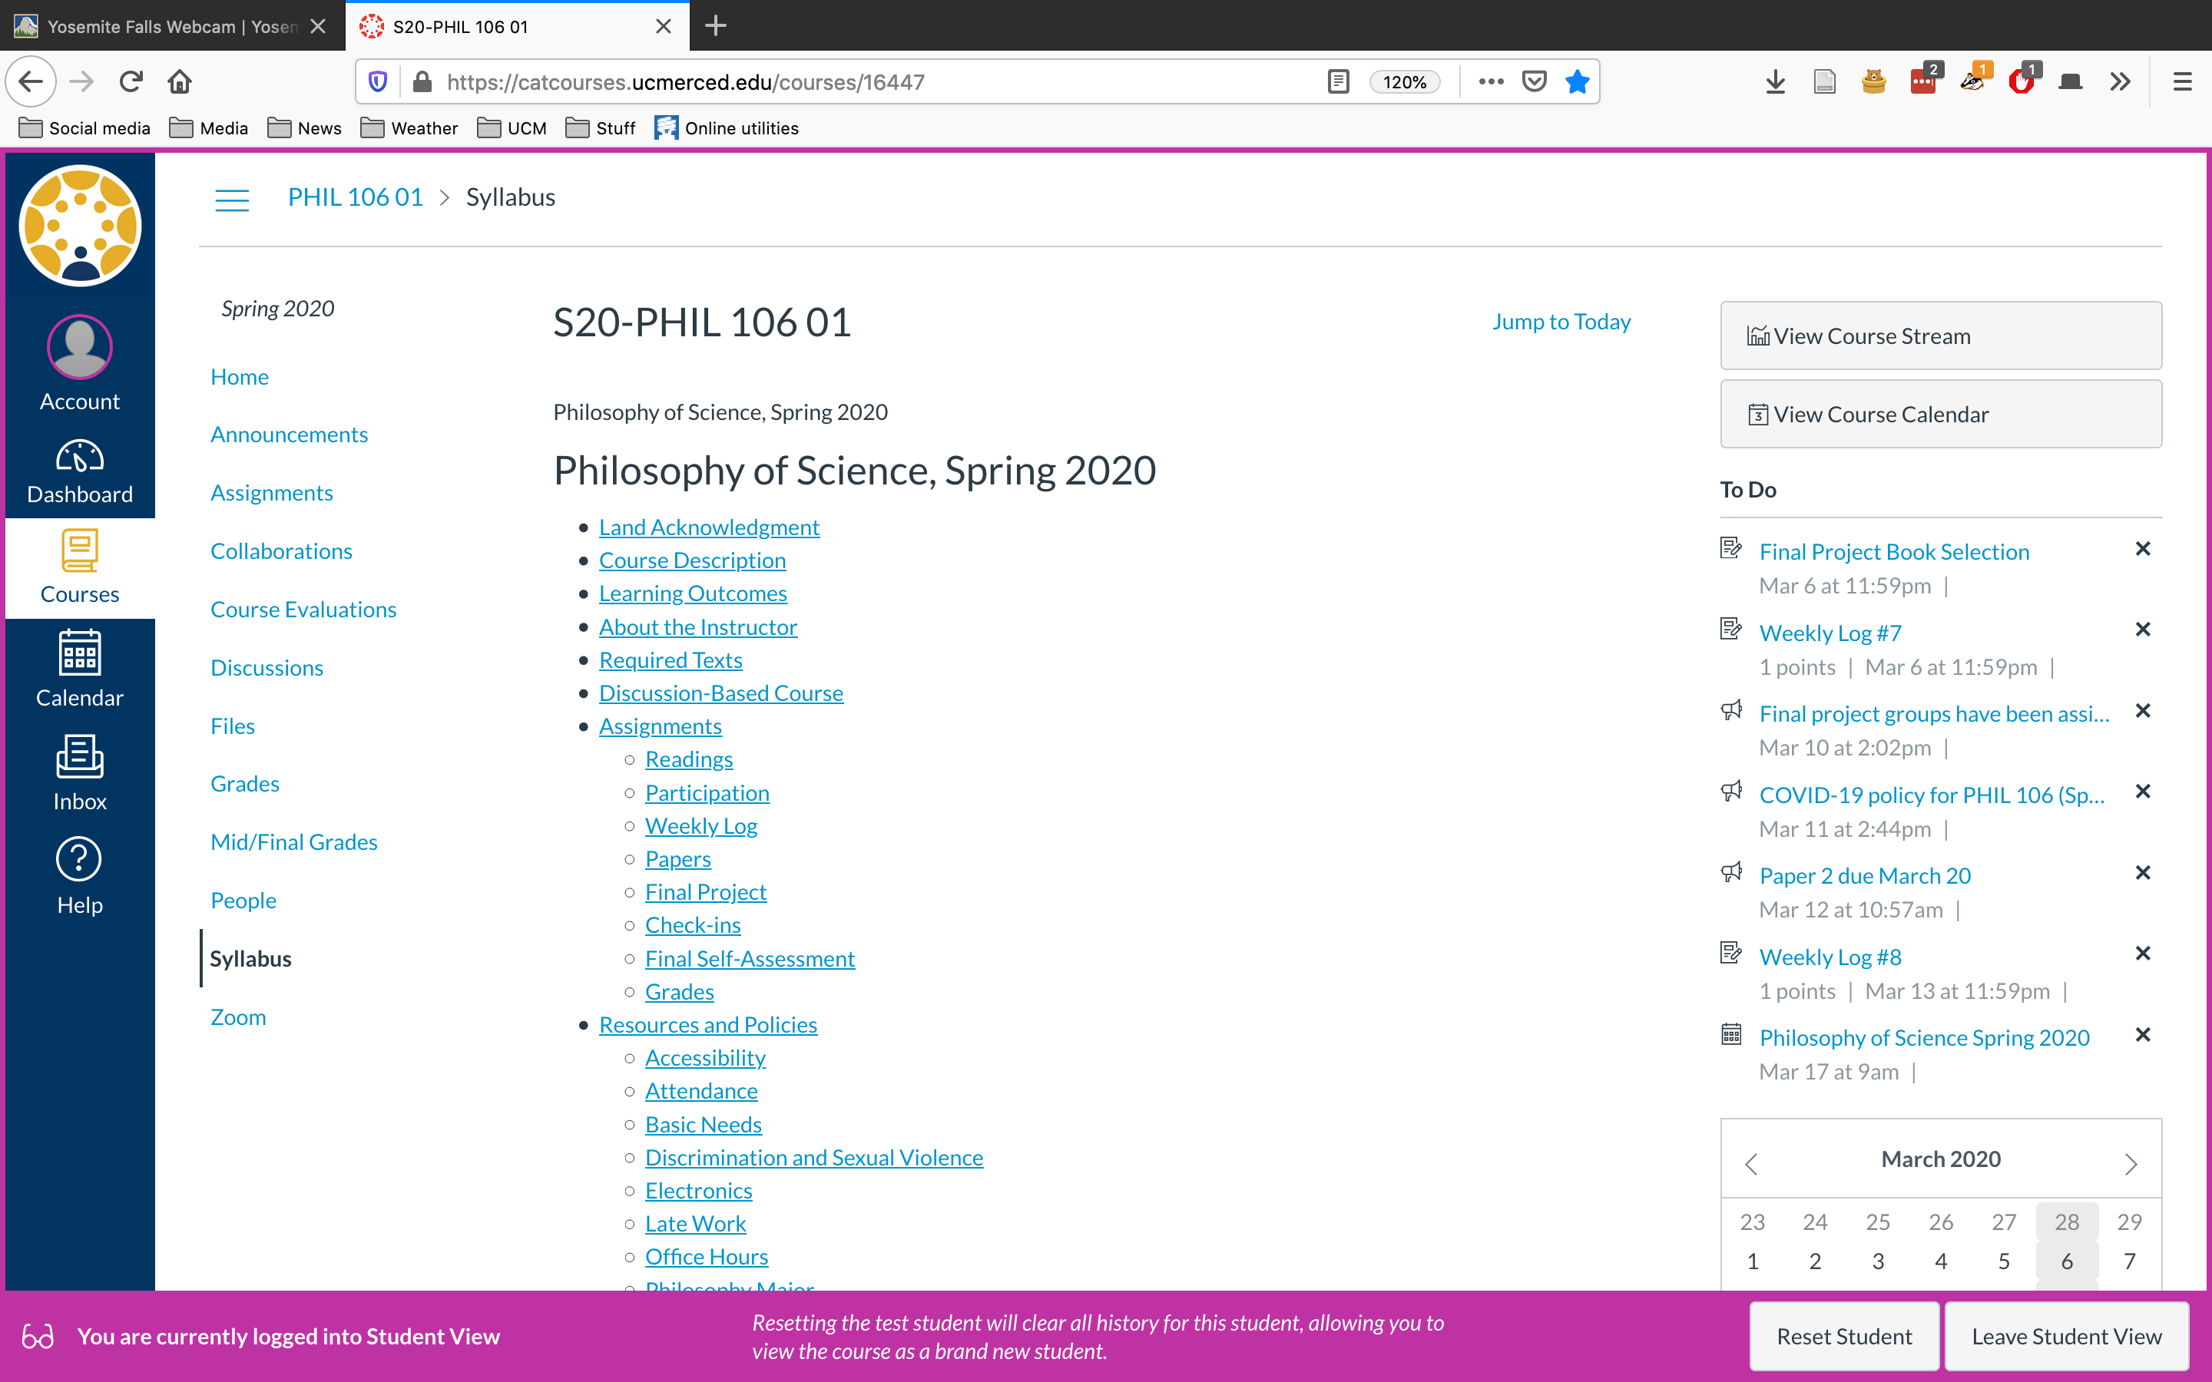

The landing page for our CatCourses site

1. Look for the Zoom section on the left-hand menu

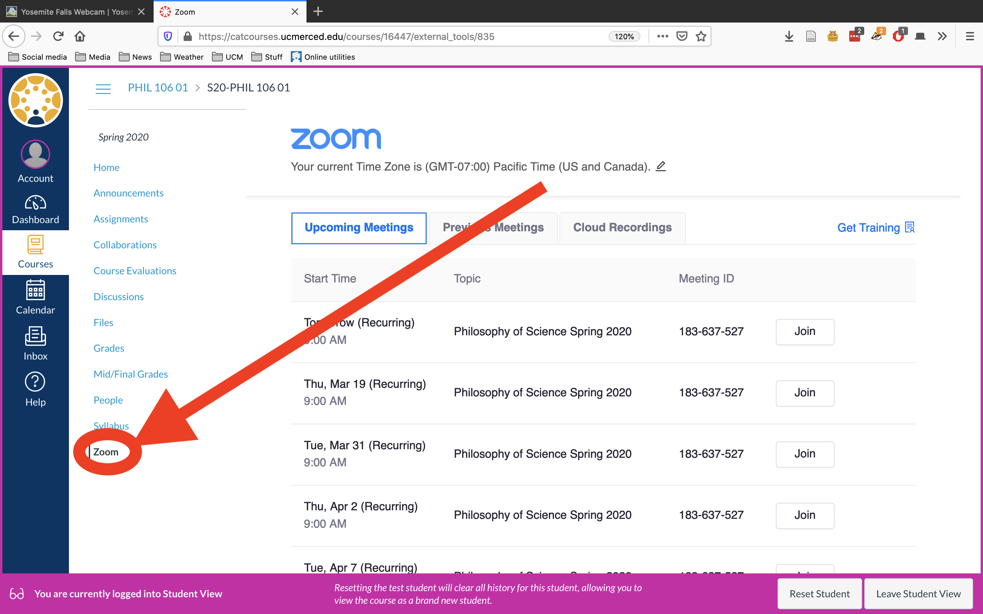

Zoom is on the left-hand side

1. The Zoom section shows a list of scheduled class Zoom sessions. Click Join.
2. Zoom will open a new launching page.
   * If you haven’t installed the Zoom client on your machine, you should get a prompt to approve a download and install.
   * After Zoom is installed, the launching page should automatically open the Zoom client.

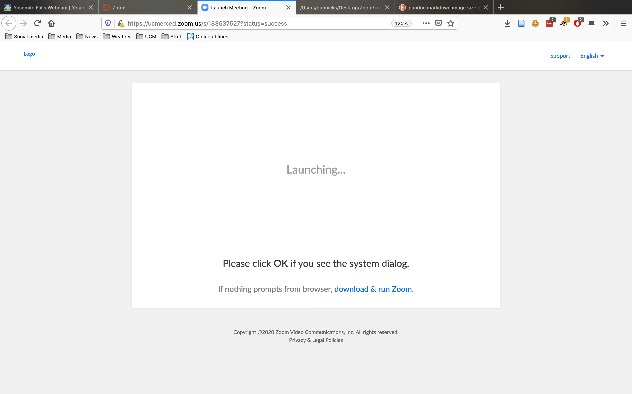

Zoom’s launching page in the web browser

1. **If Zoom doesn’t download**, go to this site and download and install manually: <https://support.zoom.us/hc/en-us/articles/201362233-Where-Do-I-Download-The-Latest-Version->
2. **If Zoom is installed but doesn’t open the meeting automatically**, check CatCourses for the Meeting ID for the meeting you’re trying to join. Open the Zoom client yourself. Look for a “Join” option, and enter the Meeting ID in the appropriate box.

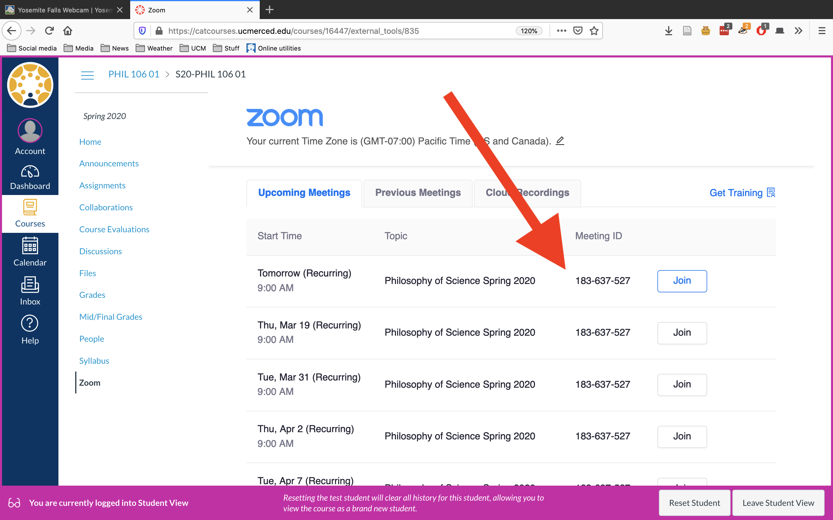

Check CatCourses for the Meeting ID

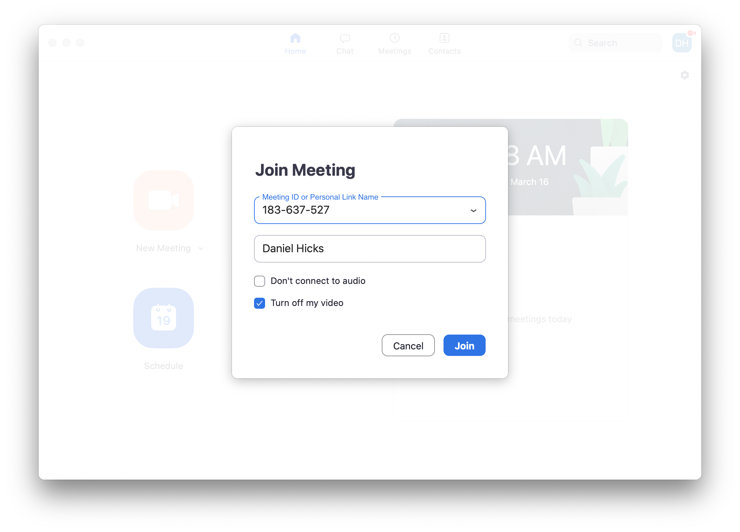

Enter the Meeting ID in Zoom