Underlying data
Simulation datasets for the study “Molecular Dynamics Study of Supramolecular Complexes in the Carbohydrate–Cation System.
This document lists the data files used in the study and provides a brief description of the contents of each file, including the figures and tables generated from these datasets.
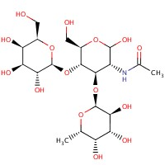

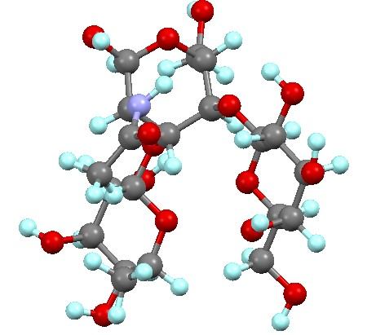

Figure 1. 2D and 3D structure of the sulfated disaccharide GlcpNAc3S(β1-3)Fucp.

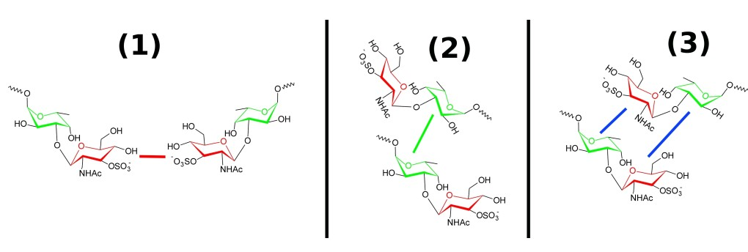

Figure. 2. Possible arrangements of disaccharides in the complex. one can still other similar conformations can be produced by rotation of a disaccharide molecule. The colored lines indicate contacts between the same (red or green) and different (blue) sugar rings

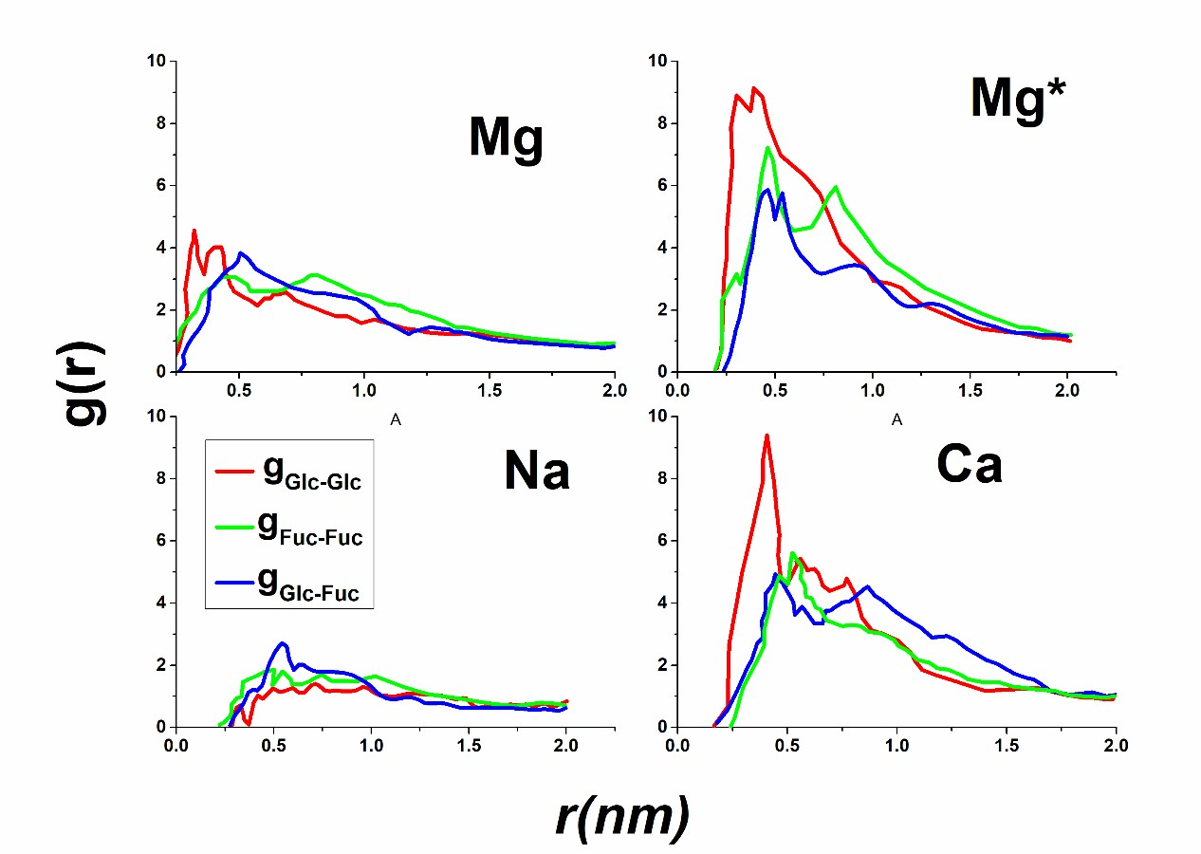
Figure. 3. Radial distribution function with respect to the centers of gravity of the sugar rings. The Color scheme is the same as in Figure 2. With the index 'Glc', the glucose rings and by 'Fuc' meant the fucose rings

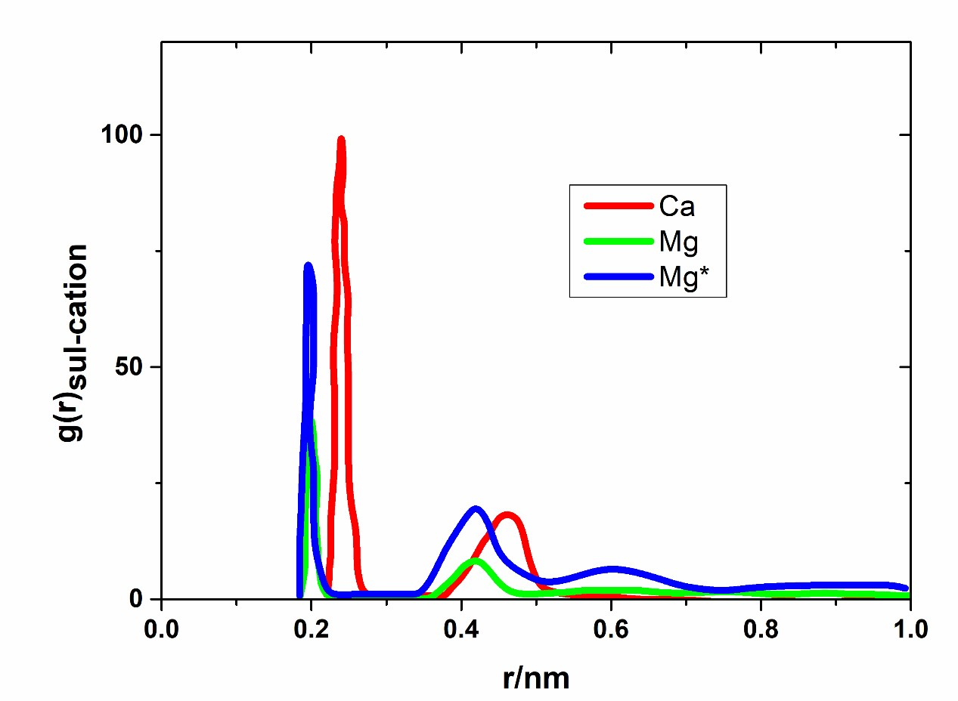
Figure 4, Radial distribution function with respect to the cations and the acidoatoms of the Sulfate groups.

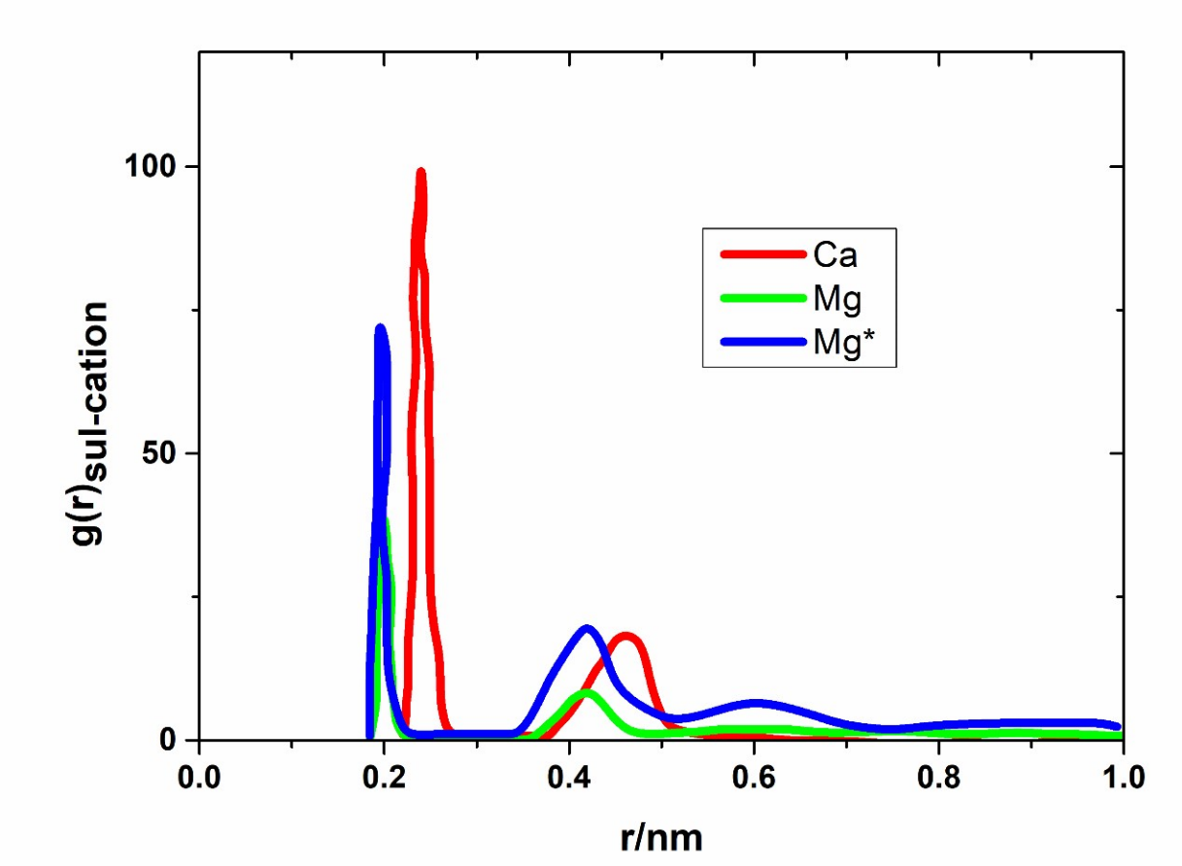
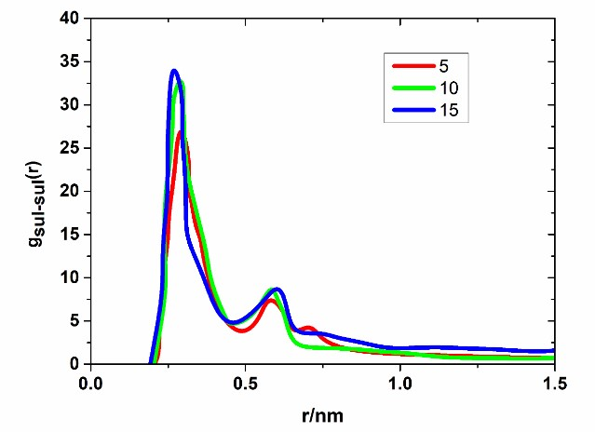
Figure 5. gSul-Sul for the calcium system. Left: gSul-Sul(Ca) at a given disaccharide concentration, where the four calcium concentrations were averaged out. right: Comparison of gSul-Sul(Ca) for two different simulation boxes, with the smaller box using to determine the radial distribution functions
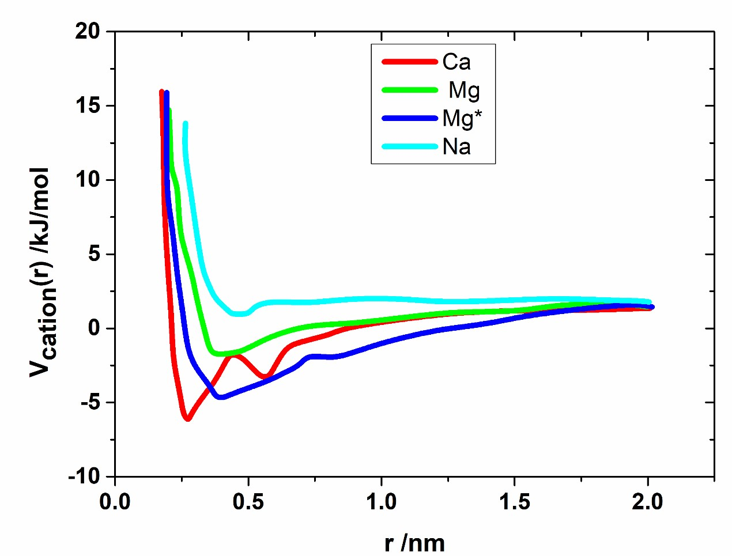
Figure 6. Potential of mean for the carbohydrate-cation-carbohydrate complex, where reaction coordinate, the distance between the sulfate groups is used.
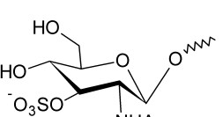

Figure 7. Monosaccharide that consists only of the glucose unit of the disaccharide

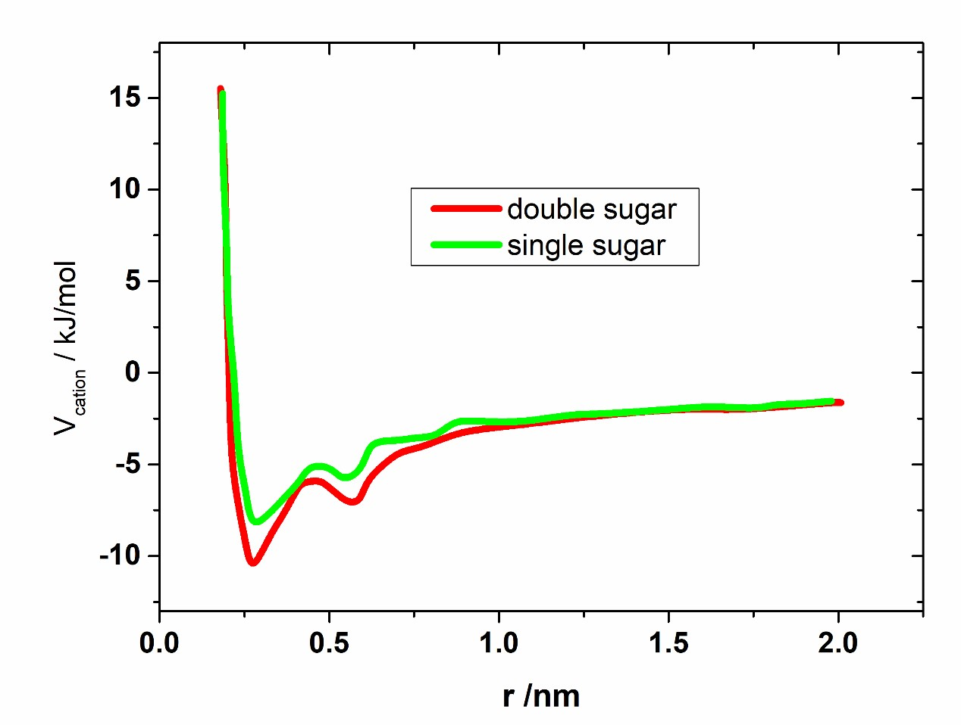
Figure 8. Potential of mean force for the carbohydrate-calcium-carbohydrate complex for the disaccharide and monosaccharide system.

Table 1. Number of saccharide molecules, cations (Ca2+ and Mg2+,) and counterions (Cl−) used in the simulations
saccharides | Cations / Counterions
5 | 15 / 25
5 | 20 / 35
5 | 25 / 45
5 | 40 / 75
10 | 20 / 30
10 | 40 / 70
10 | 60 / 110
10 | 80 / 150
15 | 20 / 25
15 | 40 / 65
15 | 60 / 105
15 | 80 / 145

Table 2: Number of disaccharide molecules, cations (Ca2+ or Mg2+) and counterions (Cl−), that were used in the simulations with the larger simulation box
saccharides | Cations / Counterions
30 | 120 / 210
30 | 150 / 270
30 | 180 / 330

Table 3: The experimentally determined values as well as the cation radius of both types of cations.
Cation type | Rcation / Å | ∆Hhydra / kJ/mol | kex / s−1
Mg2+ | 0.60 | -1922 | 5.3 · 105
Ca2+ | 0.95 | -1577 | (6 - 9) · 108

Table 4: The quantities of disaccharide molecules and cations employed in the simulations.
Disaccharides | cations (Ca, Na, Mg, Mg*)
5 | 15, 20, 25, 40
10 | 20, 40, 60, 80
15 | 20, 40, 60, 80

Table 5. Quantitative summary of binding energies and characteristic distances from RDF and PMF simulations
System | Binding Energy (kJ/mol) | g_Sul-Sul Peak Position (nm) | g_Sul-Cation 1st Peak (nm)
Ca²⁺ | -8.5 | ~0.6 | 0.24
Mg²⁺ | -3.9 | ~0.55 | 0.22
Mg* | -6.9 | ~0.54 | 0.21

