**EXPERIMENT 1:**

Create a topology and simulate sending a simple PDU from source to destination using hub and switch as connecting devices and demonstrate ping messages.

**OBSERVATION:**

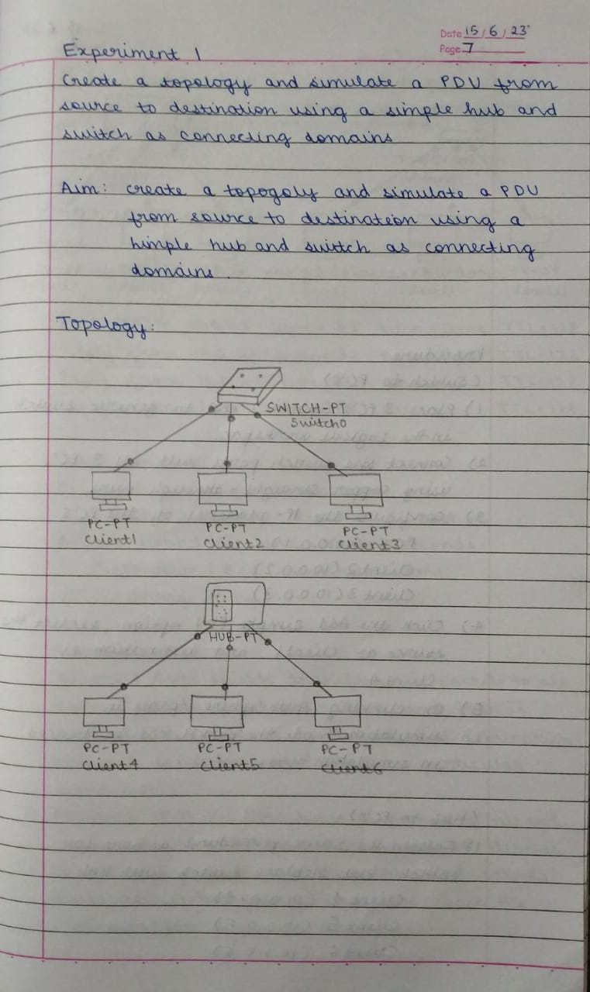

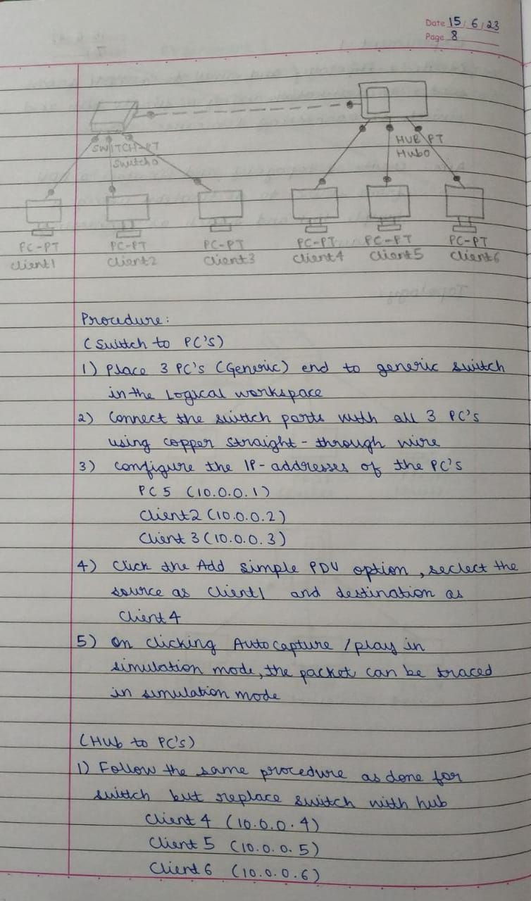

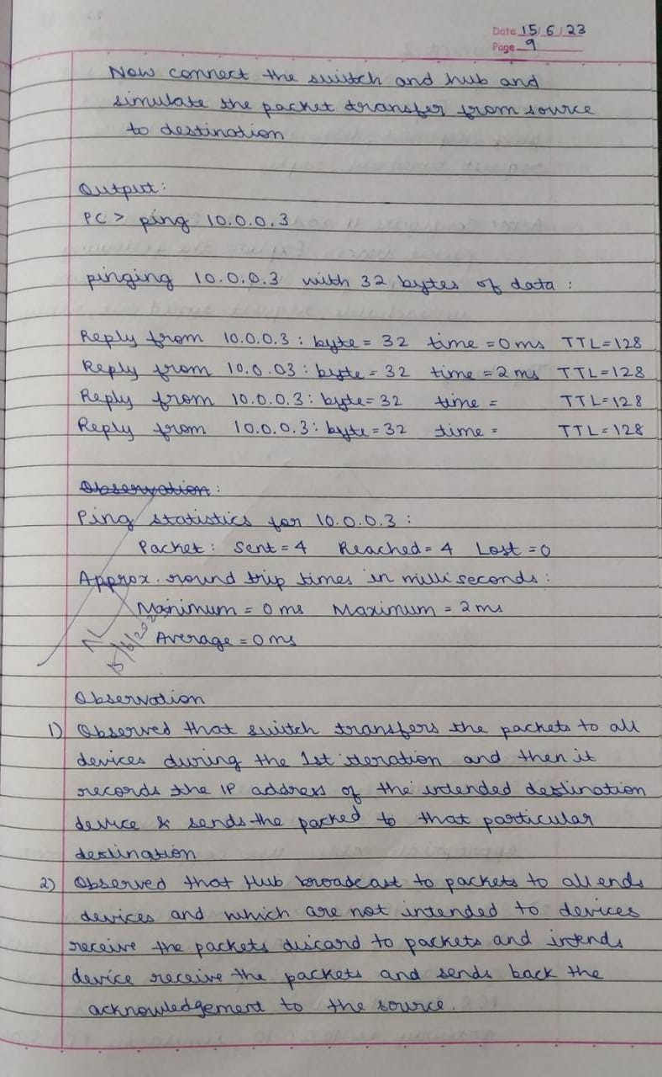

**Topology & Simulation Panel:**

Topology with Hub as connecting device:

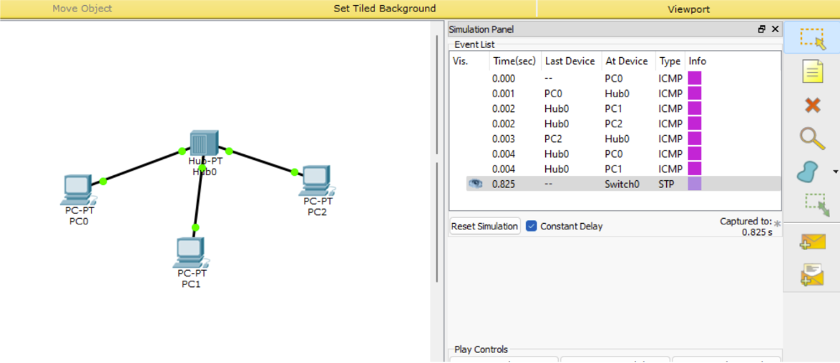

Topology with Switch as connecting device:

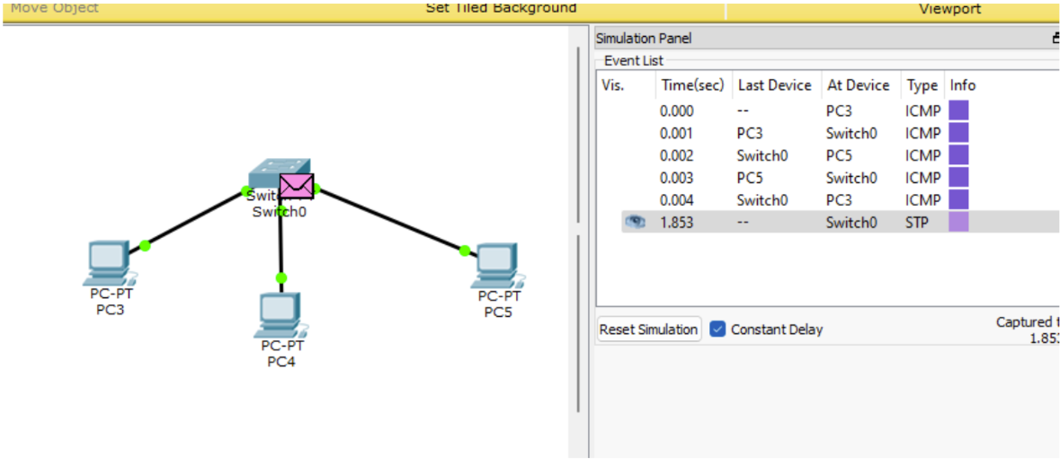

Topology with both Hub and Switch as connecting device:

