**Experiment 10:**

To understand the operation of TELNET by accessing the router in the server room from a PC in the IT office.

Aim: To understand the operation of TELNET by accessing the router in ……..server room from a PC in the IT office.

Topology:

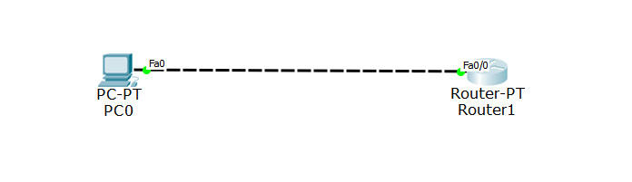

Output:

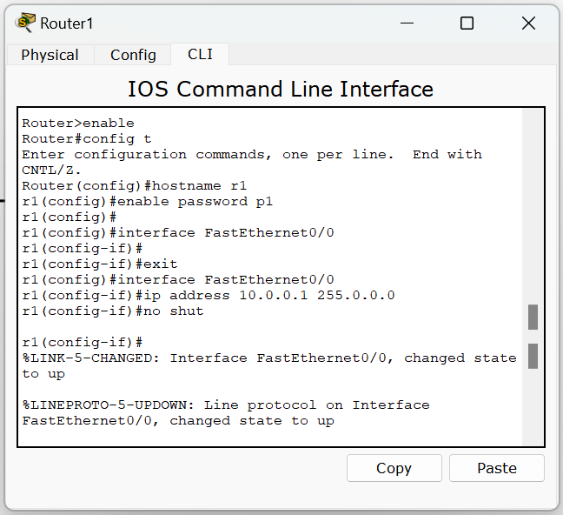

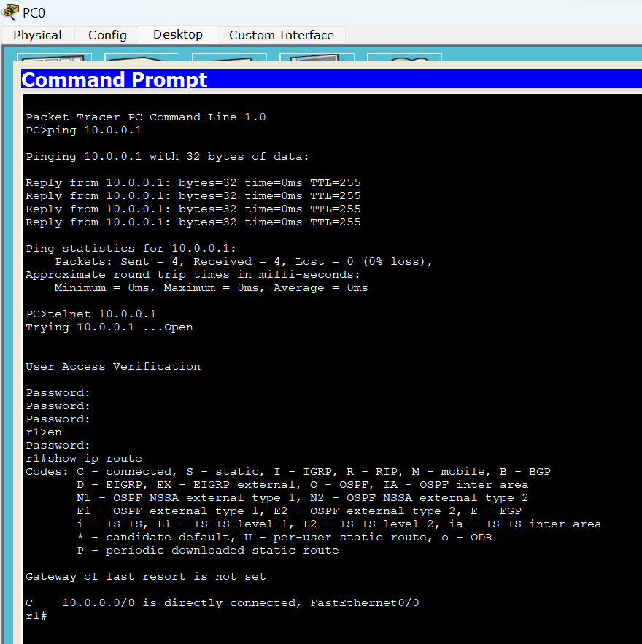

Observation:

