**Experiment 12:**

To construct a WLAN and make the nodes communicate wirelessly

Aim: To construct a WLAN and make the nodes communicate wirelessly.

Topology:

(Initial)

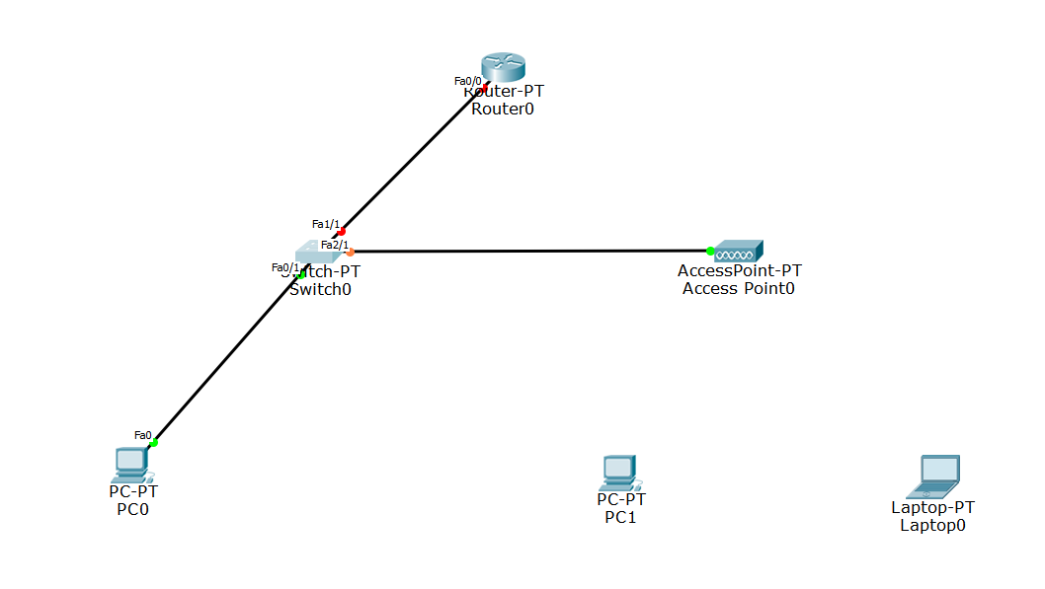

(Final)

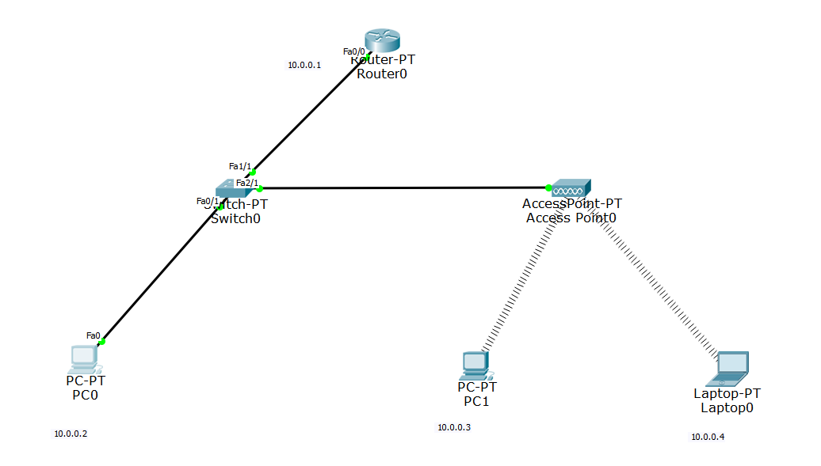

Output:

PC0 TO LAPTOP

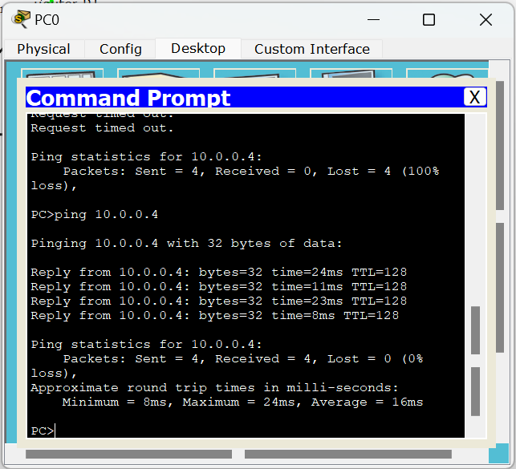

PC0 TO PC1

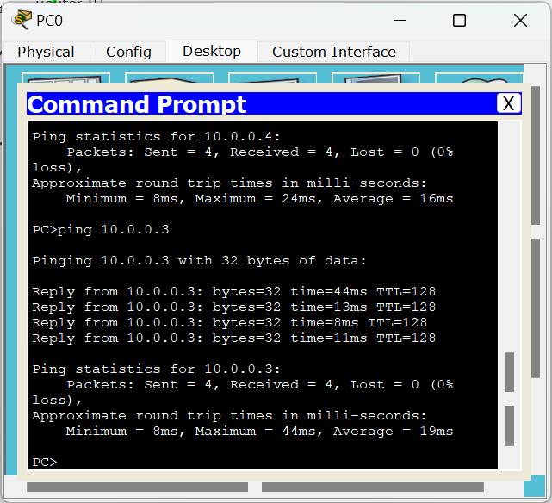

LAPTOP TO PC0

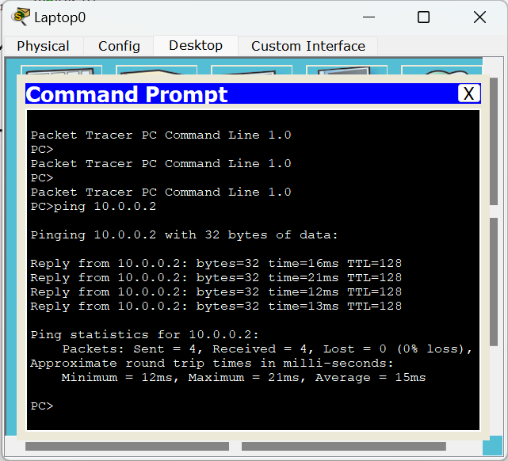

Observation:

