**Experiment 14:**

Write a program for congestion control using Leaky bucket algorithm

Aim: Write a program for congestion control using Leaky bucket algorithm

Code:

#include<stdio.h>

int main(){

int incoming, outgoing, buck_size, n, store = 0;

printf("Enter bucket size:");

scanf("%d", &buck_size);

printf("Enter outgoing rate:");

scanf("%d", &outgoing);

printf("Enter number of inputs:");

scanf("%d", &n);

while (n != 0) {

printf("Enter the incoming packet size: ");

scanf("%d", &incoming);

if (incoming <= (buck_size - store)){

store += incoming;

printf("Bucket buffer size %d out of %d\n", store, buck_size);

} else {

printf("Dropped %d no of packets\n", incoming - (buck_size - store));

printf("Bucket buffer size %d out of %d\n", store, buck_size);

store = buck_size;

}

store = store - outgoing;

printf("After outgoing %d packets left out of %d in buffer\n", store, buck_size);

n--;

}

}

Observation:

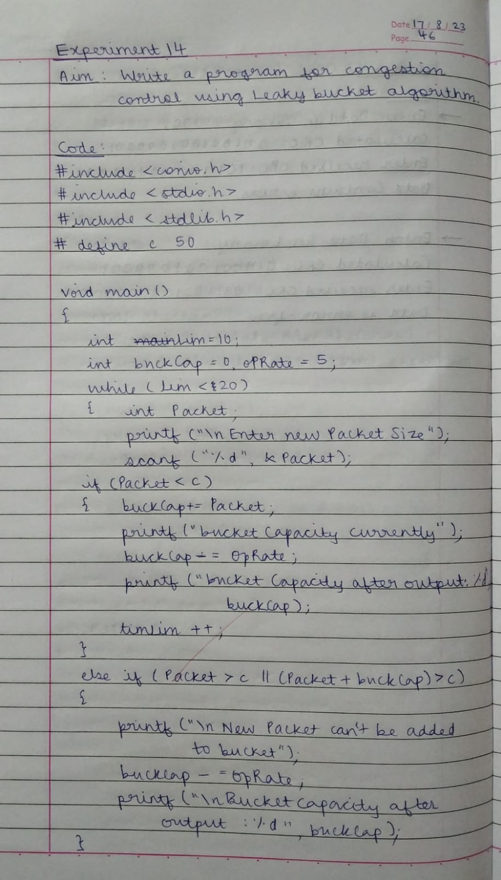

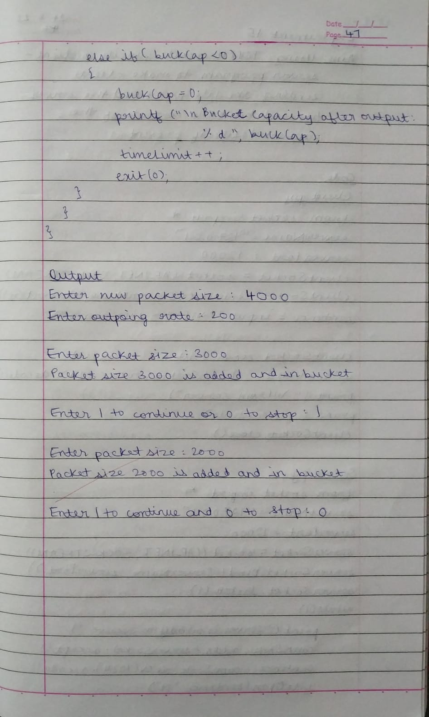

Output:

