**Experiment 15:**

Using TCP/IP sockets, write a client-server program to make the client send the file name and the server to send back the contents of the requested file if present.

Aim: Using TCP/IP sockets, write a client-server program to make the client ……..send the file name and the server to send back the contents of the ……..requested file if present.

Code:

**ClientTCP.py**

from socket import *

serverName = “127.0.0.1”

serverPort = 12000

clientSocket = socket(AF_INET, SOCK_STREAM)

clientSocket.connect((serverName,serverPort))

sentence = input(“\nEnter file name:”)

clientSocket.send(sentence.encode())

filecontents = clientSocket.recv(1024).decode()

print (“\nFrom Server:\n”)

print(filecontents)

clientSocket.close()

**ServerTCP.py**

from socket import *

serverName="127.0.0.1"

serverPort = 12000

serverSocket = socket(AF_INET,SOCK_STREAM)

serverSocket.bind((serverName,serverPort))

serverSocket.listen(1)

while 1:

print ("The server is ready to receive")

connectionSocket, addr = serverSocket.accept()

sentence = connectionSocket.recv(1024).decode()

file=open(sentence,"r")

l=file.read(1024)

connectionSocket.send(l.encode())

print ("\nSent contents of "+ sentence)

file.close()

connectionSocket.close()

Observation:

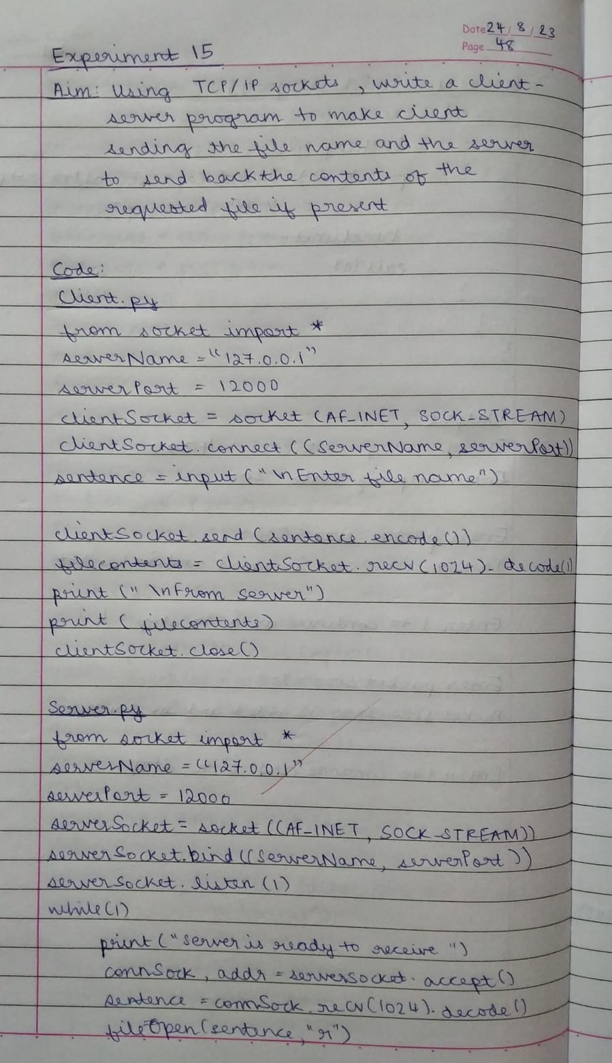

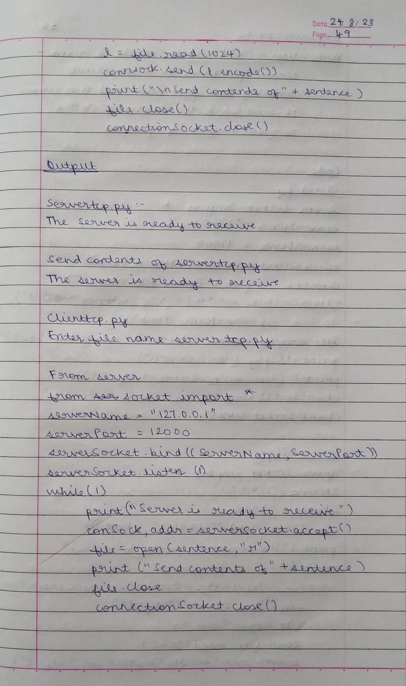

Output:

