**Experiment 16:**

Using UDP sockets, write a client-server program to make the client send the file name and the server to send back the contents of the requested file if present.

Aim: Using UDP sockets, write a client-server program to make the client ……..send the file name and the server to send back the contents of the ……..requested file if present.

Code:

**ClientUDP.py**

from socket import *

serverName = '127.0.0.1'

serverPort = 12000

clientSocket = socket(AF_INET, SOCK_DGRAM)

sentence = input('\nEnter file name')

clientSocket.sendto(bytes(sentence,'utf-8'),(serverName, serverPort))

filecontents,serverAddress = clientSocket.recvfrom(2048)

print ('\nReply from Server:\n')

print (filecontents.decode(&quot;utf-8&quot;))

clientSocket.close()

clientSocket.close()

**ServerUDP.py**

from socket import *

serverPort = 12000

serverSocket = socket(AF_INET, SOCK_DGRAM)

serverSocket.bind(('127.0.0.1', serverPort))

print ('The server is ready to receive')

while 1:

sentence, clientAddress = serverSocket.recvfrom(2048)

sentence = sentence.decode(‘utf-8’)

file=open(sentence,'r')

con=file.read(2048)

serverSocket.sendto(bytes(con,’utf=8’),clientAddress)

print ('\nSent contents of', end = ' ')

print (sentence)

file.close()

Observation:

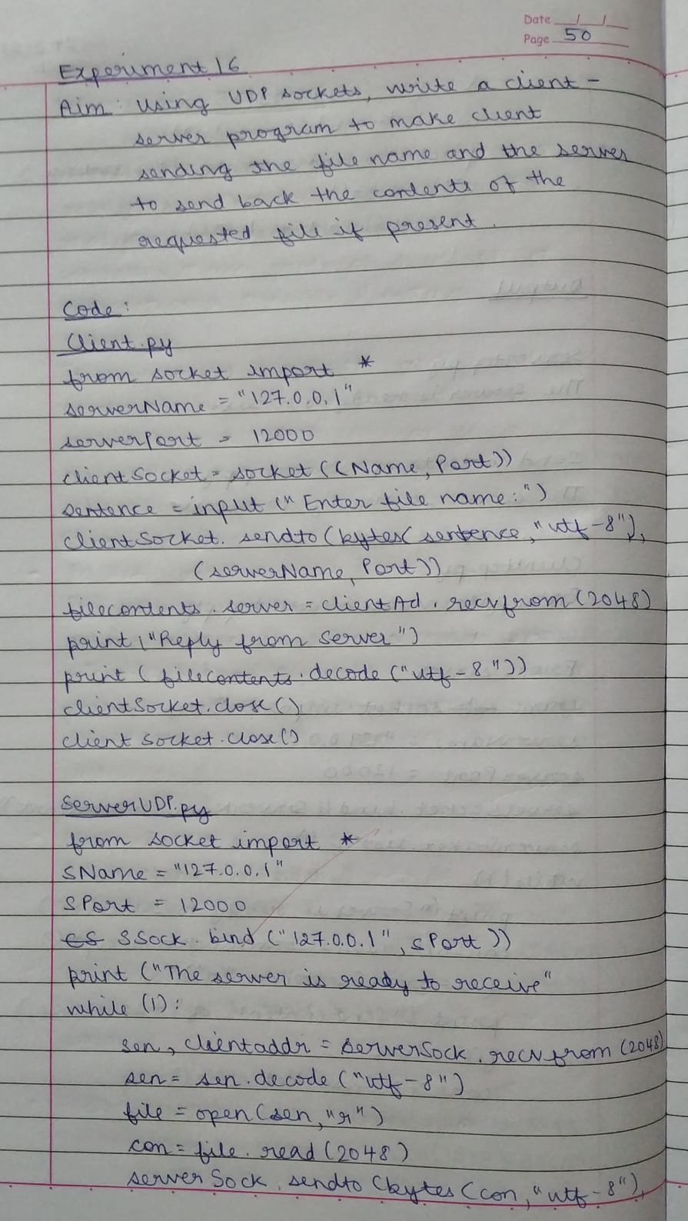

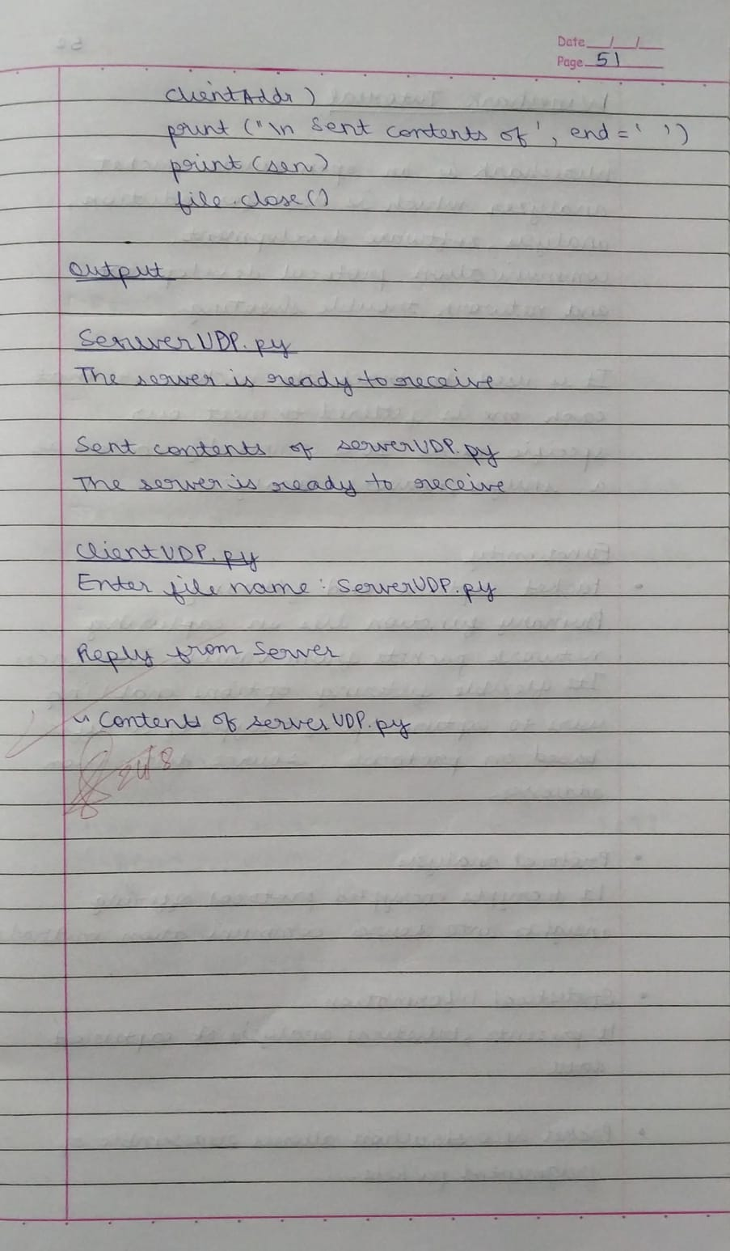

Output:

