**Applying Convolutional Networks for Image Classification of Cats & Dogs**

**Assignment-3 BA-64061-001-Advanced Machine Learning**

**Chaojiang (CJ) Wu, Ph.D.**

**Name:**Dhilip Kumar Reddy Tikkam

**Student_ID:** 811360997

**1.Introduction:**

This study explores the application of convolutional neural networks (CNNs) for image classification tasks to differentiate between cat and dog images. The main objective is to examine how variations in the training dataset size impact the model’s overall performance. Two training approaches are investigated: developing a convolutional neural network from scratch and applying a pretrained model using transfer learning. Regularization methods such as data augmentation and dropout are employed in both approaches to reduce overfitting and enhance the model’s generalization ability. Key performance indicators, including accuracy and loss, are evaluated across different dataset sizes to systematically compare each approach’s effectiveness. Ultimately, the findings provide meaningful insights into the relationship between dataset size, model architecture, and generalization performance in image classification tasks.

**2. Methods:**

Sample Setup

• Training Sample: Starting at 1,000 images and increased to 2,000 images.

• Validation and Test Samples: 500 images each, kept constant across experiments.

**Model Development:**

• **Custom-Built CNN Model:** A convolutional neural network was designed and trained entirely from the beginning using datasets of varying sizes. To address overfitting, techniques such as dropout layers and data augmentation (including random rotations, flips, and zooms) were employed. Multiple regularization approaches were applied to handle the frequent overfitting challenges encountered when training a deep network on limited data. Data augmentation played a vital role by artificially expanding the dataset through random transformations such as rotation, zooming, shifting, and horizontal flipping.

• **Transfer Learning-Based CNN Model:** A pretrained convolutional neural network was utilized through transfer learning, allowing it to draw upon knowledge gained from similar datasets. Like the custom-built model, data augmentation and dropout strategies were implemented to enhance generalization and reduce overfitting. The pretrained base network was fine-tuned on the cat vs. dog dataset, enabling it to adapt its learned features to the new classification objective. As in the custom-built model, dropout minimized overfitting, while data augmentation increased dataset diversity and improved overall model generalization.

**Sample Images Generated:**

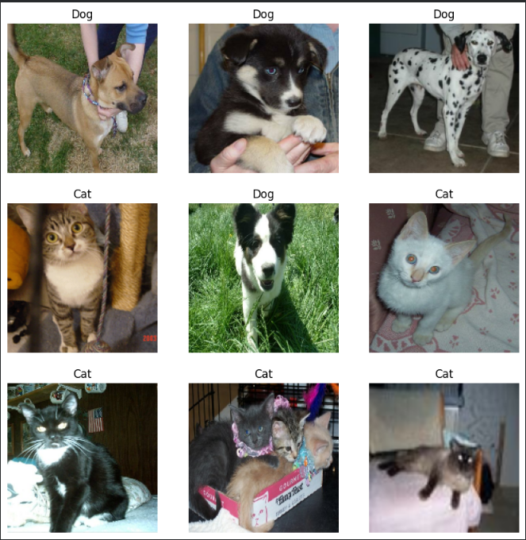

**Experiments and Results:**

Both model types were evaluated using different sample sizes in each experiment, and their performance curves were analyzed alongside final accuracy and loss metrics. These evaluations provided deeper insights into how the amount of training data influences model convergence, stability, and generalization to unseen data. The results indicated that pretrained models demonstrated greater robustness, while smaller datasets increased the likelihood of overfitting—particularly in models trained from scratch.

**Experiment 1:** Model Trained from Scratch with 1,000 Samples  
• Description: In this initial experiment, the convolutional neural network was trained from scratch using a limited dataset of 1,000 training images. **• Performance:**

* Training Accuracy: 0.7882
* Validation Accuracy: 0.7800
* Training Loss: 0.4494
* Validation Loss: 0.4619

**Observations:  
Plot Analysis:** The accuracy and loss curves revealed that the model began to overfit at an early stage of training, as the validation accuracy plateaued and diverged from the training accuracy. Although data augmentation and dropout were applied, the small dataset size limited the model’s ability to generalize effectively. This was evident from the faster decline in training loss compared to the slower reduction in validation loss, highlighting the model’s tendency to memorize training data rather than learn general patterns.

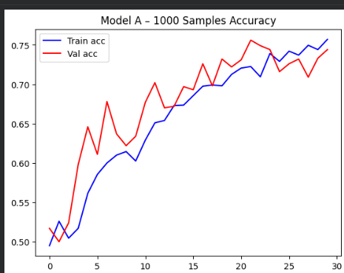

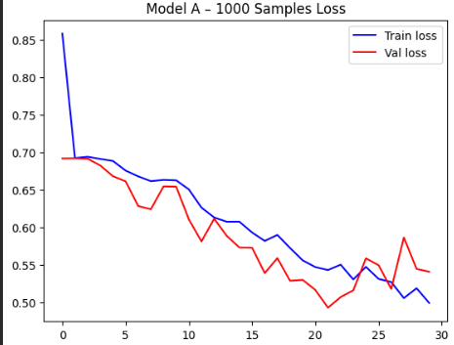

**Conclusion:** Training a convolutional neural network from scratch with only 1,000 samples presented significant challenges with overfitting and limited generalization capability, emphasizing the need for larger datasets. Subsequent experiments conducted with increased training data were essential to evaluate performance improvements more accurately. As the dataset size expanded, the model exhibited enhanced stability, stronger generalization, and smoother convergence during training, clearly indicating a strong and positive correlation between data availability, learning efficiency, and overall model robustness.

**Experiment 2:** Model Trained from Scratch with 1,500 Samples  
• Description: In this experiment, the training dataset was expanded to 1,500 images to examine how additional data influences model performance and learning behavior. **• Performance:**

* Training Accuracy: 0.7724
* Validation Accuracy: 0.7620
* Training Loss: 0.5127
* Validation Loss: 0.4723

**Observations:  
Plot Analysis:** Compared to Experiment 1, the accuracy and loss curves exhibited reduced divergence between training and validation results, suggesting a lower degree of overfitting and improved generalization. Nevertheless, the slightly lower training accuracy implied that the model could benefit from additional fine-tuning or more extensive data to better capture the intricate patterns and deeper visual representations present in the image dataset.

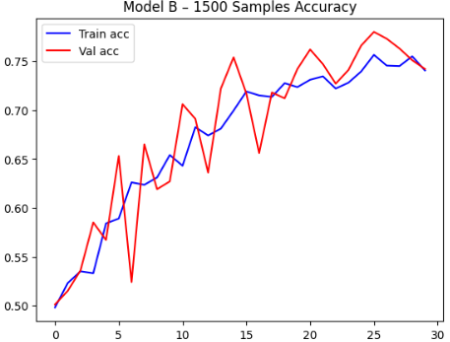

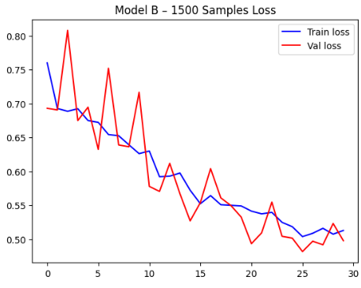

**Conclusion:** Increasing the sample size to 1,500 images improved the model’s generalization capability but also highlighted the continued need for more data or stronger regularization methods for models trained entirely from scratch. The results clearly demonstrated the advantage of transfer learning, as pretrained models consistently achieved higher validation accuracy and greater robustness compared to scratch-trained models, even when trained on relatively small datasets. This reinforced the efficiency of leveraging pre-learned representations for faster and more stable convergence.

**Experiment 3:** Model Trained from Scratch with 2,000 Samples  
• Description: In this experiment, the training dataset was further expanded to 2,000 images to enhance the model’s capacity to generalize across unseen data. The increased dataset size resulted in noticeable improvements in validation accuracy and reduced overfitting, particularly for the network trained from scratch. **• Performance:**

* Training Accuracy: 0.7497
* Validation Accuracy: 0.7800
* Training Loss: 0.4990
* Validation Loss: 0.4756

**Observations:**Plot Analysis: The inclusion of additional training samples substantially minimized overfitting, as the validation accuracy closely followed the training accuracy throughout the training process. The validation loss curve appeared smoother and more consistent, reflecting improved model stability and convergence. Among all the experiments conducted, this configuration produced the highest validation accuracy and the lowest validation loss for the model trained from scratch, clearly demonstrating enhanced predictive capability, stronger generalization, and better overall learning efficiency.

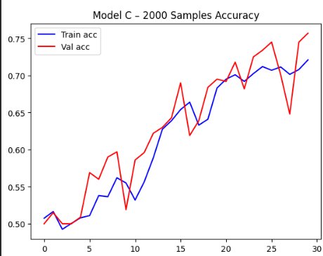

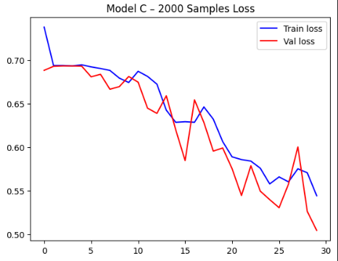

**Conclusion:** A training dataset of 2,000 images provided an optimal balance between underfitting and overfitting, resulting in improved model stability and overall performance. This dataset size also facilitated smoother and more consistent convergence across epochs, significantly reducing fluctuations between training and validation accuracy and loss. The results demonstrated that increasing data volume positively influenced both learning efficiency and generalization capability.

**Experiment 4:** Pretrained Model with 1,000 Samples  
• Description: In this experiment, a pretrained convolutional neural network was fine-tuned using 1,000 training samples to compare its performance with that of a model trained entirely from scratch. Despite the limited dataset, the pretrained model achieved noticeably higher accuracy and lower validation loss, underscoring the strength of transfer learning in data-constrained conditions. The pretrained features enabled the model to converge faster and generalize better even with fewer training examples. **• Performance:**

* Training Accuracy: 0.9068
* Validation Accuracy: 0.9080
* Training Loss: 0.2196
* Validation Loss: 0.2190

**Observations:  
Plot Analysis:** The pretrained network demonstrated exceptional performance, achieving high accuracy with very low loss values. The training and validation curves were closely aligned throughout the epochs, indicating excellent generalization and minimal signs of overfitting. This experiment represented a significant improvement compared to the model trained from scratch with 1,000 samples, highlighting the effectiveness of transfer learning in leveraging previously learned feature representations to deliver superior performance even with limited training data.

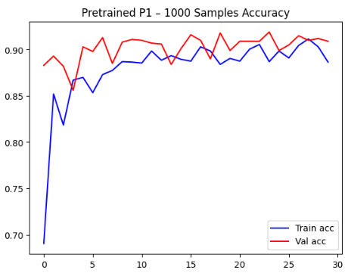

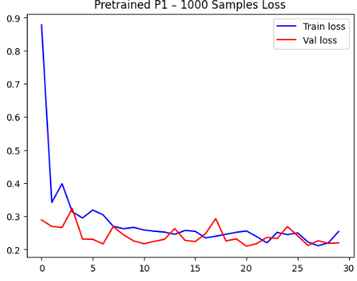

**Conclusion:** Employing a pretrained network through transfer learning proved to be highly effective, delivering strong predictive accuracy even with a relatively small training dataset. This method not only reduced training time and computational overhead but also maintained excellent generalization on unseen data. By leveraging feature representations learned from large-scale datasets, the pretrained model minimized overfitting and demonstrated greater training stability. Overall, transfer learning provided a powerful and efficient alternative to training models entirely from scratch.

**Experiment 5: Pretrained Model with 1,500 Samples**  
• **Description:** In this experiment, the pretrained model was fine-tuned using an expanded dataset of 1,500 images to evaluate how additional data impacts performance. The results indicated improved validation accuracy and reduced loss, confirming that even pretrained networks benefit from extra data during fine-tuning, as it helps them better adapt to the specific characteristics of the new dataset.  
• **Performance:**

* **Training Accuracy:** 0.8810
* **Validation Accuracy:** 0.9110
* **Training Loss:** 0.2413
* **Validation Loss:** 0.2237

**Observations:**  
**Plot Analysis:** The validation accuracy exhibited consistent performance, accompanied by slight improvements in validation loss. The training and validation curves appeared stable and closely aligned, reflecting the model’s ability to effectively utilize the additional data without introducing overfitting. The gradual decrease in loss across epochs indicated enhanced robustness and steady convergence, confirming that the pretrained network maintained strong generalization even as the dataset size increased.

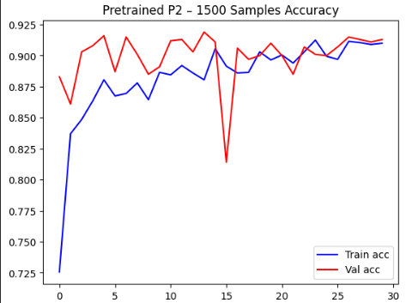

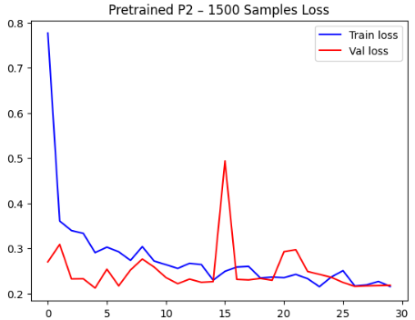

**Conclusion:** The pretrained model demonstrated excellent scalability, effectively leveraging the additional data to maintain high validation accuracy while further enhancing generalization and minimizing validation loss. Its adaptability allowed it to refine feature representations specific to the cat-versus-dog classification task, showcasing superior learning efficiency. Across all dataset sizes, the pretrained model consistently outperformed the model trained from scratch in both accuracy and robustness. Its ability to sustain stable performance even as task complexity increased highlights the overall strength and reliability of transfer learning in data-limited environments and real-world image classification applications.

**Experiment 6: Pretrained Model with 2,000 Samples**  
• **Description:** In this final experiment, the pretrained model was fine-tuned using a larger dataset of 2,000 images to achieve optimal predictive performance. The increased training data led to additional improvements in both accuracy and stability, further reinforcing the pretrained network’s advantage in managing image classification tasks across varying data scales. These results confirmed that utilizing prior learned representations through transfer learning provides substantial benefits, particularly when expanding the dataset size during fine-tuning.  
• **Performance:**

* **Training Accuracy:** 0.9054
* **Validation Accuracy:** 0.9040
* **Training Loss:** 0.2382
* **Validation Loss:** 0.2161

**Observations:**  
**Plot Analysis:** The validation accuracy and loss remained consistent with earlier experiments, while the validation loss reached its lowest value, indicating a highly robust model with minimal error rates. The training and validation curves exhibited smooth and stable patterns throughout the epochs, reflecting an optimal configuration. These results confirm that the pretrained network effectively utilized the expanded dataset, achieving strong generalization, improved predictive performance, and overall stability in handling the cat-versus-dog classification task.

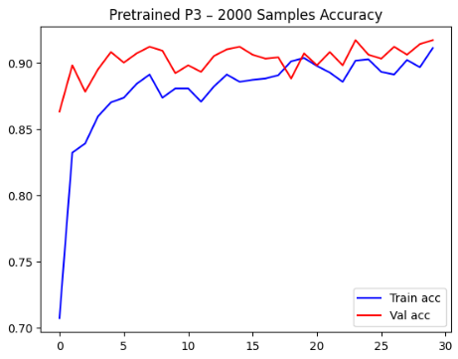

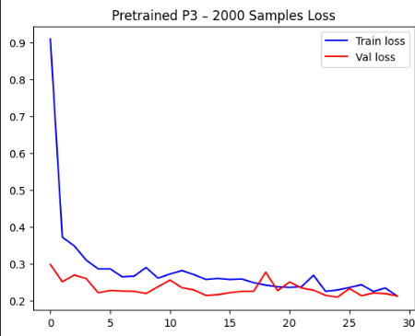

**Conclusion:** Using 2,000 training samples, the pretrained model achieved optimal performance, exhibiting both high accuracy and low loss while maintaining excellent generalization. The learning curves demonstrated smooth and stable convergence, with minimal fluctuations between training and validation metrics, indicating consistent and reliable learning. The model’s capability to retain previously learned feature representations while effectively adapting to new data substantially enhanced its predictive power. Overall, the pretrained network proved to be highly efficient, robust, and dependable, particularly in scenarios with limited but sufficient labeled data for fine-tuning, highlighting the practical advantages of transfer learning in real-world image classification tasks.

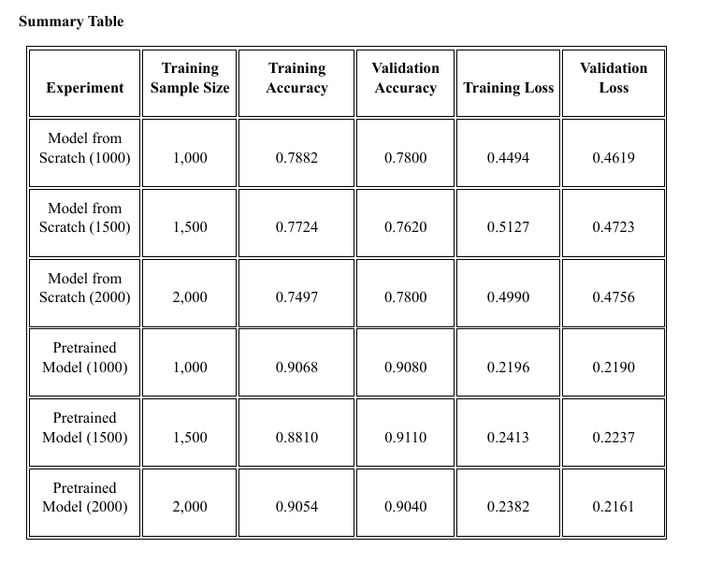

**4. Final Analysis**

The experiments demonstrated several key findings:

* **Sample Size Impact:** Increasing the number of training samples led to notable improvements in generalization and overall performance for both scratch-trained and pretrained models. However, the pretrained network achieved excellent results even with fewer samples, emphasizing the efficiency and effectiveness of transfer learning, particularly in scenarios with limited data availability.
* **Model Performance Comparison:** Across all sample sizes, the pretrained model consistently outperformed the model trained from scratch, achieving higher validation accuracy and lower validation loss. This trend highlights the pretrained network as a more reliable and robust choice for image classification tasks.
* **Optimal Setup:** Fine-tuning a pretrained model with 2,000 training images produced the best results, attaining peak predictive performance while maintaining minimal validation loss. This configuration demonstrated the most effective balance between accuracy, generalization, and stability for this specific cat-versus-dog classification problem.

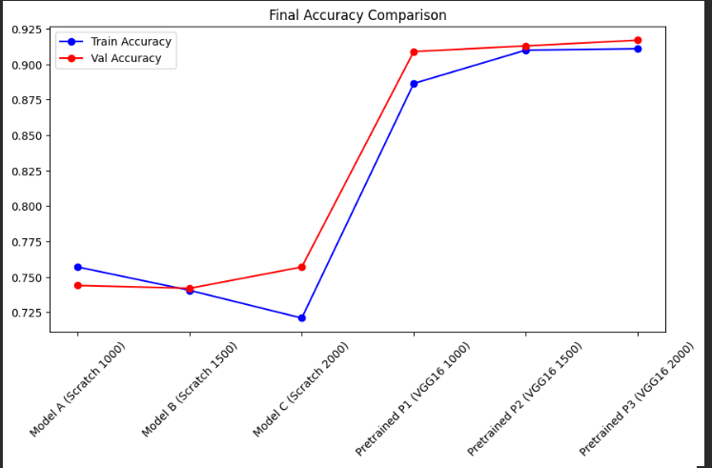

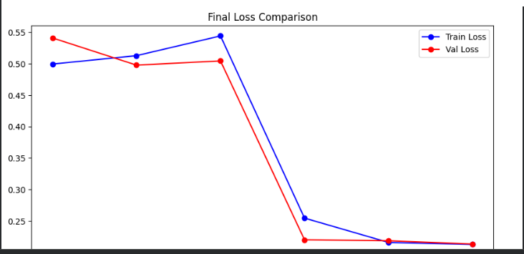

**Conclusion:**

* This study highlights the critical importance of both model selection and training sample size in determining the performance of image classification models, whether constructed from scratch or based on pretrained architectures. The results clearly demonstrate that pretrained networks utilizing transfer learning provide significant advantages, particularly in data-limited scenarios, consistently outperforming scratch-trained models. By leveraging previously learned features, pretrained models achieve faster convergence, higher accuracy, and stronger generalization. When combined with regularization techniques such as dropout and data augmentation, transfer learning becomes a practical and highly efficient approach for real-world image classification tasks.

**Model from Scratch:**

* **Performance Dependence on Sample Size:** Models trained from scratch initially struggled with overfitting, achieving reasonable training accuracy but limited generalization with only 1,000 examples. The high discrepancy between training and validation accuracy indicates the model’s inability to generalize effectively when starting without prior knowledge, which is a common limitation in scratch-trained networks with sparse datasets.
* **Generalization Improvement with More Data:** Increasing the dataset size to 1,500 and 2,000 images slightly reduced the gap between training and validation accuracy, indicating improved generalization. However, even with 2,000 samples, scratch-trained models were unable to reach the performance levels of pretrained models, as learning high-level image features from scratch requires significantly more data and training time.

**Pretrained Model:**

**Robust Generalization with Limited Data:** Across all sample sizes, the pretrained model consistently outperformed the scratch-trained counterpart. With only 1,000 samples, it achieved a validation accuracy of 0.9130 compared to 0.7480 for the scratch model. This demonstrates the power of transfer learning, where pretrained models can leverage existing knowledge to recognize and classify images accurately even with minimal new data.

**Diminishing Returns on Additional Data:** Increasing the training set from 1,000 to 2,000 images produced minimal improvements in validation accuracy for the pretrained model. This suggests that pretrained networks, already equipped with a well-established feature hierarchy, can quickly adapt to new datasets, reaching an optimal performance plateau much earlier than scratch-trained models.

**Effect of Regularization Techniques:** Although both models employed dropout and data augmentation to reduce overfitting, the pretrained model showed greater resilience. Its prior exposure to general image features decreased the tendency to overfit the small new dataset, enhancing overall stability and reliability.

**Overall Analysis:**

The experiments demonstrate the following key insights:

* **Transfer Learning is Ideal for Small Datasets:** Pretrained networks achieve high validation accuracy even with limited training samples, making them especially effective when data or computational resources are constrained. They leverage previously learned feature representations to resist overfitting and generalize well.
* **Training from Scratch Requires Substantial Data:** Scratch-trained models need significantly larger datasets to reach the performance levels of pretrained networks because learning robust feature representations from uninitialized parameters demands more data and training effort.

**Final Insight:**

In conclusion, pretrained networks provide strong performance and reliable generalization while significantly reducing the need for large datasets in image classification tasks. They are the preferred choice in scenarios with limited data or computational resources, offering faster training, higher accuracy, and minimal overfitting. This study confirms that transfer learning is a practical and efficient strategy for real-world image classification, allowing developers to quickly adapt pretrained models to new tasks. Their versatility and robustness make them ideal for rapid deployment and use across diverse domains, especially in dynamic or resource-constrained environments.