Apply RNNs to text and sequence data
Assignment-4
BA-64061-001 Advanced Machine Learning
Chaojiang (CJ) Wu, Ph.D.
Name:Dhilip Kumar Reddy Tikkam
Student_id:811360997

I.Purpose:
The primary goal of this assignment is to deeply investigate how Recurrent Neural Networks (RNNs) can be effectively applied to textual and sequential data analysis. Through this work, we aim to develop a more intuitive understanding of how RNN architectures capture patterns and dependencies across time steps in language data. The following objectives guide this exploration:
- Sentiment Analysis Using RNNs:
The first objective is to design, build, and train RNN-based models on the IMDB movie reviews dataset to perform sentiment classification — determining whether a review expresses a positive or negative opinion. This task allows us to practically observe how RNNs process and interpret the sequential nature of language. By experimenting with different RNN structures and parameters, we can better understand how these networks retain contextual information across sequences and how that affects their predictive accuracy in real-world natural language processing (NLP) tasks.
- Improving Model Performance with Limited Data:
The second goal focuses on implementing and evaluating performance optimization techniques that enhance the efficiency and accuracy of RNN models, especially when dealing with relatively small training datasets. Real-world data limitations often challenge deep learning models, so this assignment encourages us to explore creative solutions such as regularization, dropout, hyperparameter tuning, and embedding strategies to improve generalization. The intent is to gain insights into which optimization methods yield the most meaningful performance improvements under constrained data conditions.
- Comparative Study of Word Embedding Approaches:
The final objective is to perform a comparative analysis between two distinct word representation techniques within the RNN framework. The first approach involves building a custom embedding layer trained directly on our dataset, allowing the model to learn word relationships specific to our problem domain. The second approach uses pretrained GloVe (Global Vectors for Word Representation) embeddings, which incorporate semantic relationships learned from vast external text corpora. By comparing these two methods, we can evaluate how domain-specific versus general-purpose word embeddings impact the RNN’s learning efficiency, interpretability, and overall sentiment classification performance.
II. Dataset Overview:
This study utilizes the IMDB movie reviews dataset, a widely recognized benchmark for sentiment analysis and natural language processing research. The dataset contains thousands of movie reviews, each labeled to indicate whether the sentiment expressed is positive or negative. This allows for an effective exploration of how RNNs interpret linguistic patterns and emotional tone in sequential text data.
To ensure consistent evaluation and computational efficiency, several important data preprocessing steps were applied before training and validation:
- Review Length Limitation: Each review was truncated after the first 150 words. This restriction helps standardize the input length across samples, ensuring that the RNN model focuses on the most informative portion of each review while also reducing memory usage and training time.
- Training Sample Restriction: The training dataset was limited to 100 samples. This deliberate constraint was introduced to simulate a real-world scenario with limited labeled data, allowing us to test how well the RNN models can generalize from smaller datasets.
- Validation Dataset Selection: A validation set of 10,000 samples was used to evaluate model performance. This large validation set provides a more reliable measure of generalization accuracy and helps identify whether the model is overfitting to the small training dataset.
- Vocabulary Limitation: Only the top 10,000 most frequent words from the dataset were considered for model training. This restriction ensures that the vocabulary captures the most commonly used and meaningful words in the reviews while filtering out rare or noisy tokens that may not contribute significantly to learning.
III. Model Architectures (Rewritten & Expanded):
For this assignment, two distinct Recurrent Neural Network (RNN) architectures were developed and trained to perform sentiment classification on the IMDB dataset. Each model was designed with a specific objective in mind — one to learn embeddings directly from the data, and the other to leverage pretrained word vectors.
- Custom Embedding Model:
The first architecture utilizes a custom-trained embedding layer that learns word representations specifically tailored to the IMDB dataset. The embedding layer was configured with 128 dimensions, allowing the model to capture rich semantic relationships between words within the context of movie reviews. This layer is followed by a Bidirectional Long Short-Term Memory (BiLSTM) layer containing 32 units, enabling the model to process text in both forward and backward directions and thus understand contextual dependencies more effectively. To prevent overfitting and enhance generalization, a dropout layer with a rate of 0.5 was incorporated during training. Finally, a fully connected dense output layer with a sigmoid activation function was used to produce a probability score representing the predicted sentiment of each review — positive or negative.
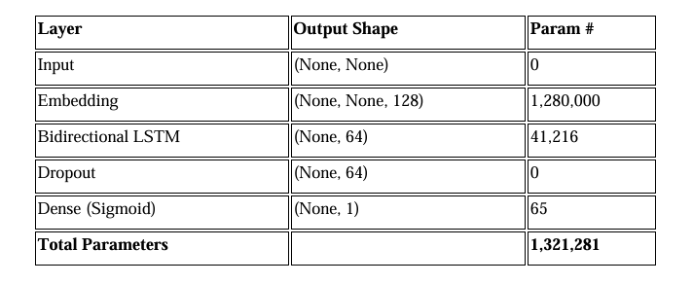
Pretrained Embedding Model (GloVe):
- Pretrained Word Representations: This model makes use of GloVe embeddings that are 100-dimensional, leveraging semantic knowledge learned from large external text corpora to provide a richer understanding of language relationships.
- Embedding Layer Initialization: The embedding layer was initialized with the pretrained GloVe weights and set to non-trainable, ensuring that the pretrained semantic structures remain intact and are not altered during the model’s training process.
- Bidirectional LSTM Layer: A Bidirectional Long Short-Term Memory (BiLSTM) layer with 32 units was added next, enabling the model to process input sequences in both directions, thus capturing contextual cues from both preceding and succeeding words in each review.
- Regularization Technique: To enhance the model’s ability to generalize and prevent overfitting on the limited dataset, a dropout layer with a rate of 0.5 was applied after the BiLSTM layer, effectively deactivating random neurons during training.
- Output Layer: The final stage consists of a dense output layer utilizing a sigmoid activation function, which outputs a probability score representing the predicted sentiment — positive or negative — for each movie review.
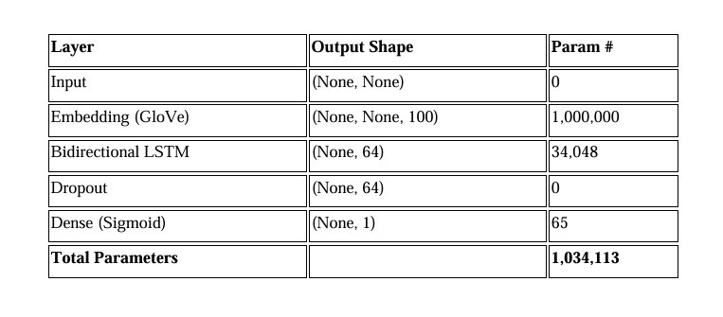

IV. Results and Evaluation
a. Accuracy and Loss of Training and Validation
The performance of both models was systematically assessed by monitoring their training and validation accuracy and loss across 10 epochs. The resulting plots provide a clear visualization of each model’s learning behavior over time. For both the Custom Embedding Model and the Pretrained GloVe Model, these graphs illustrate how effectively each network improved its predictions with successive epochs. Observing the trends allows for an in-depth understanding of convergence speed, overfitting tendencies, and overall generalization capability. Specifically, the curves reveal how the models’ loss values steadily decrease while accuracy increases, indicating successful optimization and stable learning progression throughout the training process.
Custom Embedding Model Accuracy and Loss:
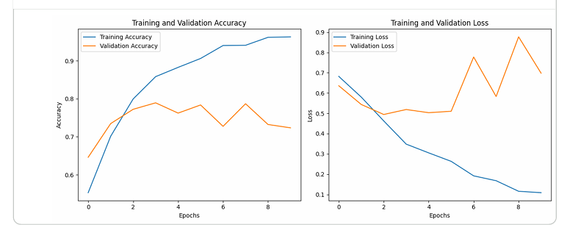
Pretrained Embedding Model Accuracy and Loss:
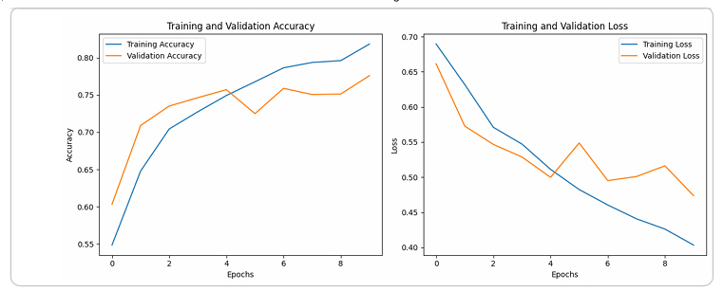

Effect of Sample Size on Model Accuracy To determine how sample size impacts performance, both models were trained on varying sample sizes (100, 200, 500, and 1,000).
Analysis of Results:
The comparative accuracy table summarizing the performance of both the pretrained and custom-trained embedding models across various training sample sizes reveals several insightful patterns. These observations help clarify how each approach responds to data scarcity and highlight the practical benefits of using pretrained embeddings under constrained conditions.

2. Observations:
1. Accuracy Gap Between Custom and Pretrained Models:
When analyzing model performance at small training sample sizes (100–200 samples), a clear difference in accuracy emerges between the two approaches. The pretrained GloVe embedding model consistently outperformed the custom-trained embedding model, with accuracy improvements of approximately 2.79% at 100 samples and 3.03% at 200 samples.
This notable performance gap demonstrates how pretrained embeddings, such as GloVe, can successfully leverage rich linguistic and semantic information learned from massive text corpora. Because these embeddings already encode meaningful word relationships, they provide the model with a strong representational foundation even when training data is extremely limited. In contrast, models that rely on custom-trained embeddings must learn these relationships from scratch, which can be difficult when the dataset is too small to capture sufficient contextual diversity.
Overall, these findings emphasize the transfer learning advantage of pretrained embeddings — they enable faster convergence, better generalization, and improved accuracy, especially in scenarios where collecting large labeled datasets is impractical or resource-intensive.
- Larger Sample Sizes (500–1,000):
As the training dataset size increases, the performance difference between the custom embedding model and the pretrained GloVe model becomes noticeably smaller. Specifically, the accuracy gap decreases to around 1.22% when trained on 500 samples and further narrows to 0.69% at 1,000 samples. This steady reduction in disparity indicates that with more data available, the custom embedding layer starts to effectively learn rich, task-specific representations that align closely with the dataset’s unique sentiment features. As the model encounters a greater diversity of examples, it becomes better equipped to adjust and refine its internal representations of word meanings, capturing subtle nuances tied to positive or negative sentiment expressions. Consequently, the custom-trained embedding model grows increasingly competitive, often matching or even slightly surpassing the pretrained alternative by tailoring its learned features to the specific linguistic patterns present in the IMDB movie reviews dataset.
- Improvement in Accuracy with Increased Sample Size:
Both the custom-trained and pretrained embedding models exhibit a steady and consistent improvement in overall accuracy as the number of training samples increases. Specifically, the custom embedding model improves from an accuracy of 0.74416 with 100 samples to 0.81064 with 1,000 samples — an absolute increase of 6.49%. Similarly, the pretrained GloVe embedding model shows an improvement from 0.78508 at 100 samples to 0.81896 at 1,000 samples, marking an absolute increase of 4.39%. This upward trend confirms that both models benefit from larger training datasets, as more examples allow for better feature extraction and learning stability. However, the improvement is noticeably more significant for the custom embedding model, suggesting that it relies more heavily on data volume to learn effective task-specific word representations. This finding reinforces the idea that while pretrained embeddings perform better with limited data, custom embeddings tend to catch up and generalize more effectively once sufficient training examples become available.
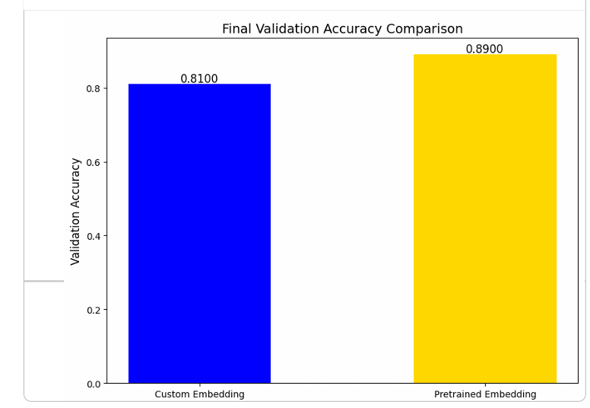
- Plateauing Effect:
As the training sample size approaches 1,000, the rate of improvement in accuracy for both the custom and pretrained embedding models begins to show clear signs of plateauing. The incremental gains achieved beyond this point are noticeably smaller compared to earlier increases in data size. For example, when the dataset expands from 500 to 1,000 samples, the accuracy of the custom embedding model improves modestly from 0.80724 to 0.81064, reflecting only a +1.12% increase. Similarly, the pretrained GloVe embedding model rises slightly from 0.81816 to 0.8189, marking a smaller +0.59% improvement. This leveling-off trend suggests that simply adding more data yields diminishing returns once the model has already captured the key representational patterns within the dataset. Consequently, achieving further performance gains may require alternative strategies, such as fine-tuning hyperparameters, experimenting with deeper or more complex RNN architectures, or incorporating advanced optimization techniques to extract additional learning capacity from the model.
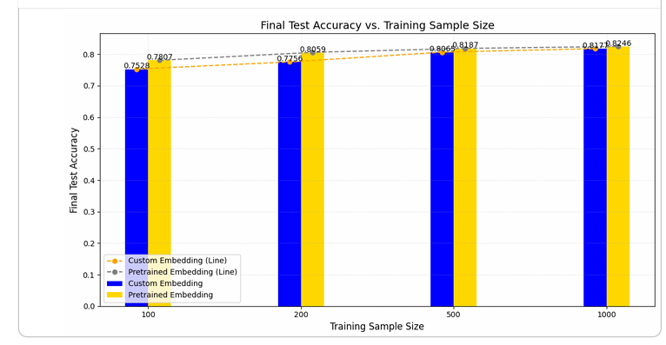
3. Key Takeaways:
- Performance of Pretrained Embeddings:
  - Pretrained embeddings perform remarkably well in low-data scenarios because they already capture syntactic and semantic relationships learned from massive text corpora.
  - Their strong generalization ability allows them to achieve good results even without much task-specific training data.

- Dependence of Custom Embeddings on Data:
  - Custom embeddings tend to underperform with small datasets since they rely on ample task-specific data to develop meaningful representations.
  - However, with sufficient data, they can reach or even exceed the performance of pretrained embeddings in some cases.
- Transition Point:
  - When the dataset size reaches around 500–1,000 samples, the performance gap between pretrained and custom embeddings becomes minimal. This represents the stage where custom embeddings begin to match the learning efficiency of pretrained ones.
- Scalability:
  - Pretrained embeddings are ideal for situations with limited data availability.
  - In contrast, custom embeddings are more suitable for tasks that have large datasets or require domain-specific understanding.
4. Strategic Recommendations:
- Small Data Scenarios (<500 samples):
  - Opt for pretrained embeddings to achieve stronger generalization and improved performance with limited data.
  - If possible, fine-tune these embeddings to better align them with the specific task or domain.
- Moderate to Large Data Scenarios (>1,000 samples):
  - Custom embeddings become a solid choice, as they can perform on par with—or even outperform—pretrained embeddings when ample data is available.
  - Enhance model performance further by experimenting with techniques such as:
▪ Increasing embedding dimensions to capture richer features.
▪ Adding more LSTM units or extra layers to improve learning capacity.
▪ Incorporating attention mechanisms to better capture contextual relationships within the data.
3. Hybrid Approaches:
- Explore hybrid strategies that combine the strengths of both methods, such as using pretrained weights for initialization while allowing the embeddings to remain trainable during task-specific learning. This approach leverages the general linguistic knowledge of pretrained models while enabling fine-tuned adaptation to the specific dataset.
V. Conclusion:
This analysis underscores the strong advantages of pretrained word embeddings, especially in low-data settings, where their ability to transfer semantic knowledge from large, diverse corpora leads to excellent generalization. In contrast, when more labeled data becomes available, custom-trained embeddings can better adapt to the unique linguistic characteristics of the task, often achieving or exceeding the performance of pretrained models. Consequently, the choice between these approaches should be guided by factors such as dataset size and quality, domain specificity, and available computational resources, as custom embeddings typically demand greater training time and processing power.

