Veeva Vault Automation Test Report

Test Date: 2025-10-29 17:31:28

Total Steps Captured: 7

Test Scenario: Login to Veeva Vault, Navigate to QMS Batches, and Logout

# Step 1: Navigate to Veeva Vault Login Page

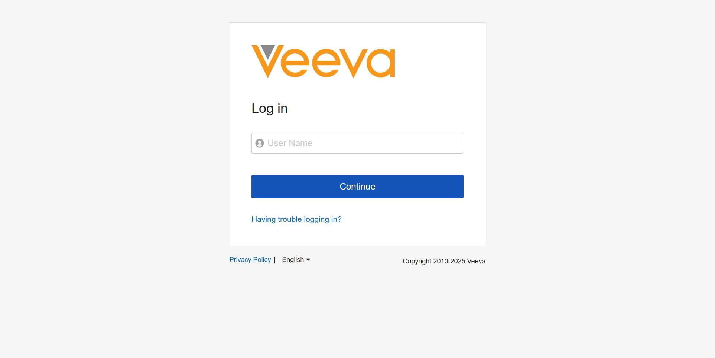

# Step 2: Successfully Logged into Veeva Vault

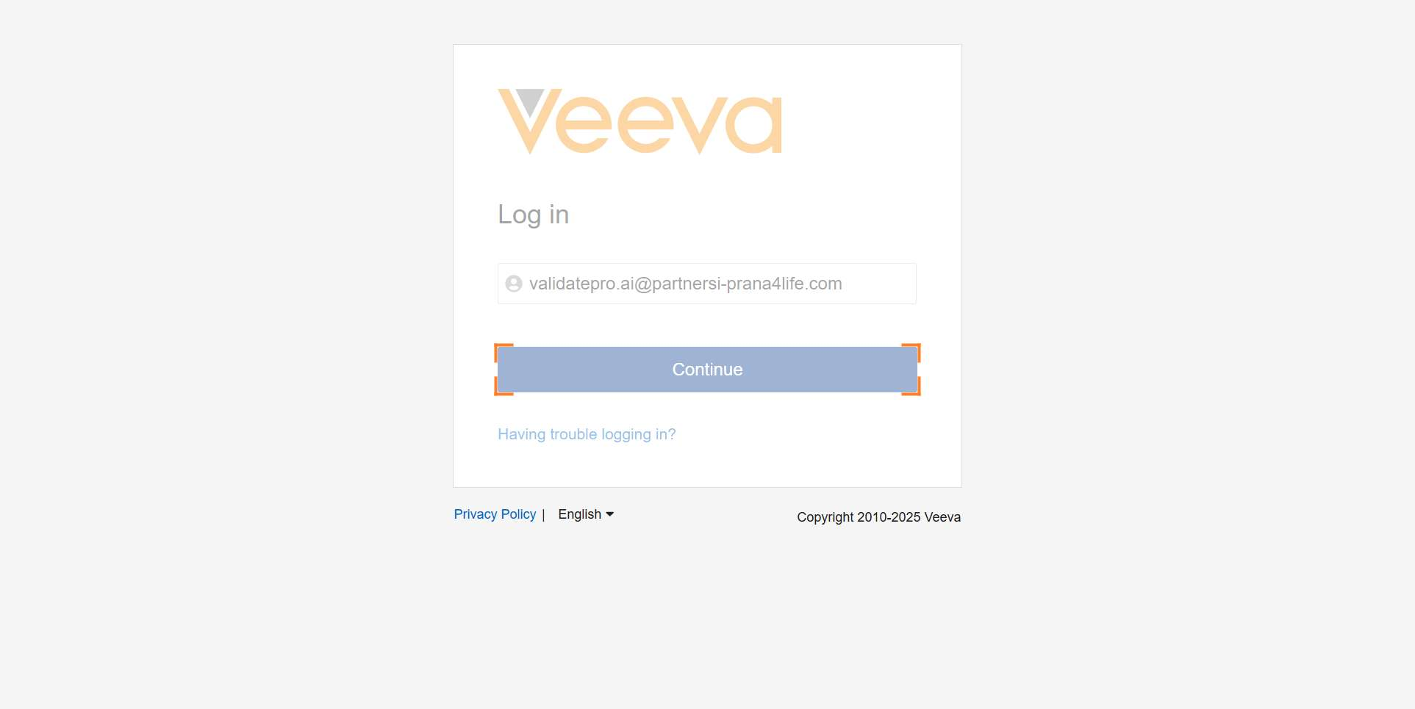

# Step 3: Click Tab Collection Menu

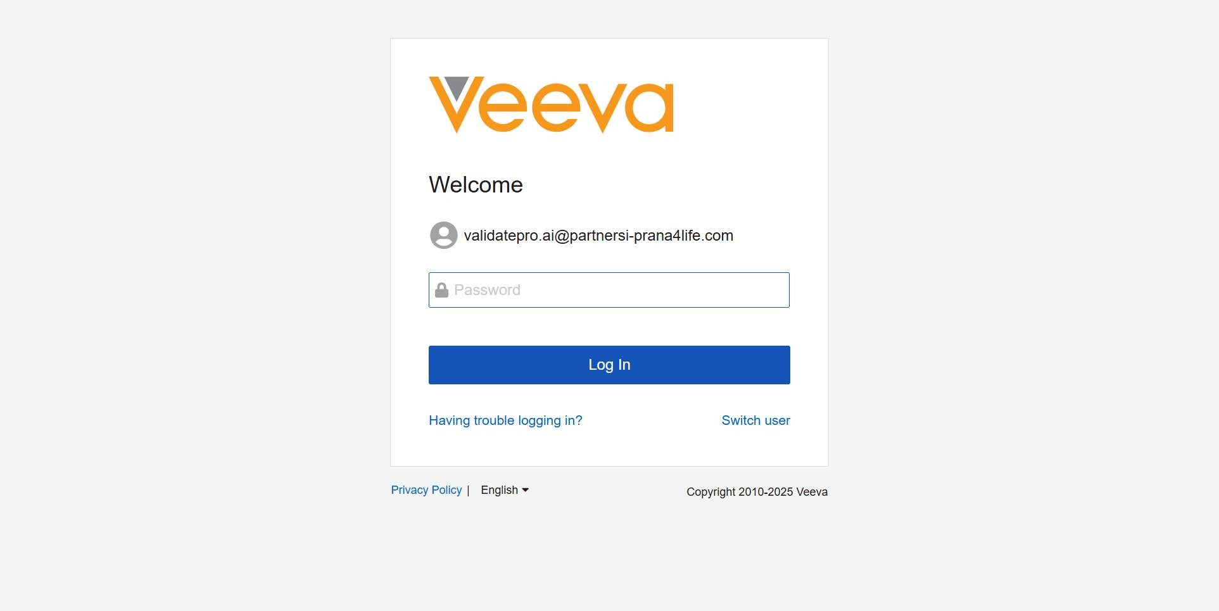

# Step 4: Select QMS from Tab Collection

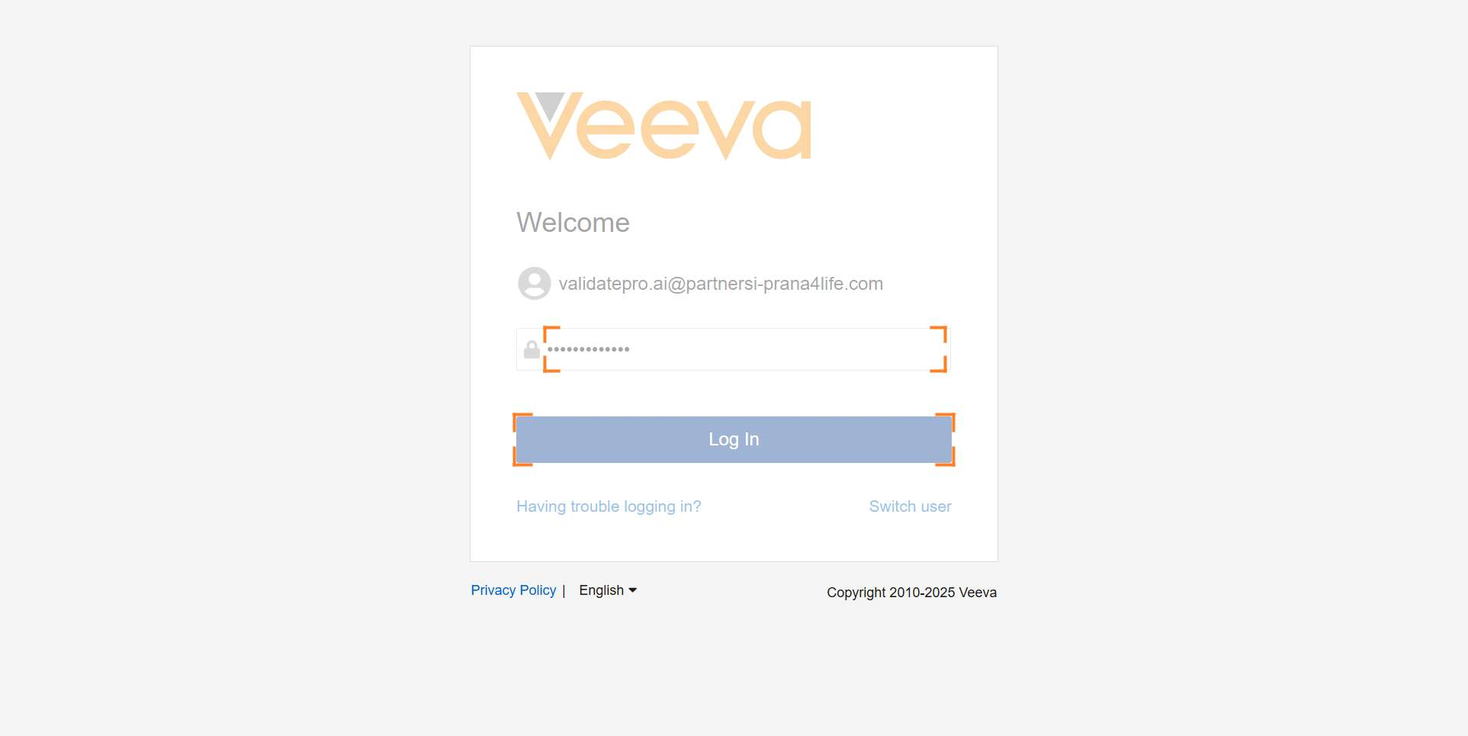

# Step 5: Navigate to Batches Tab

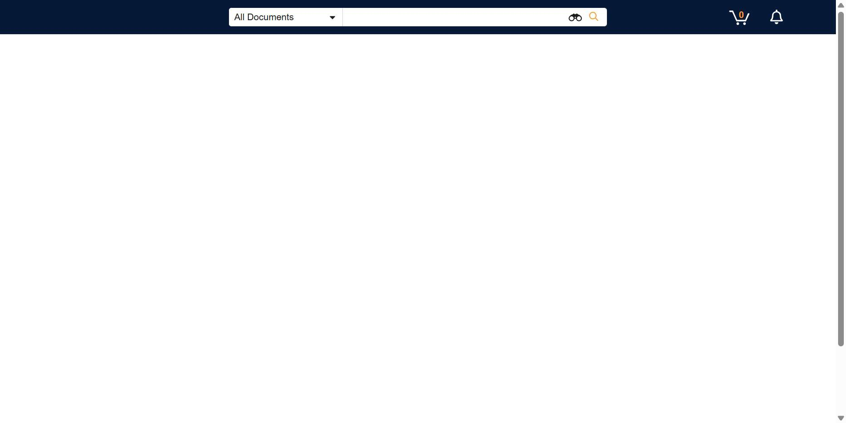

# Step 6: Click Profile Menu for Logout

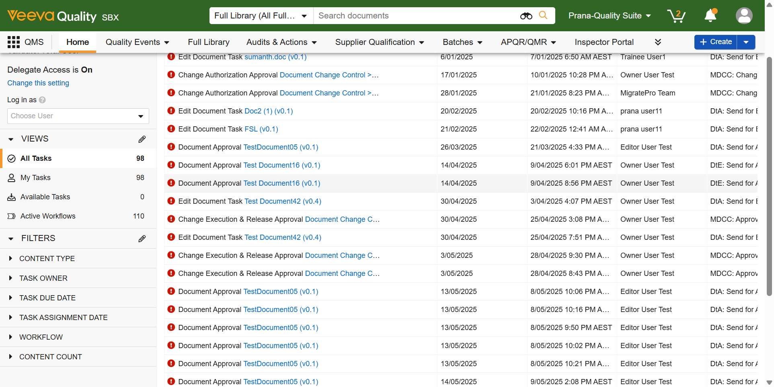

# Step 7: Successfully Logged Out

