Introduction to Programming in Python: An Interdisciplinary Approach

Chapter One. Elements of Programming
1.1 Your First Program
1.2 Built-in Types of Data
1.3 Conditionals and Loops
1.4 Arrays
1.5 Input and Output
1.6 Case Study: Random Web Surfer
Our goal in this chapter is to convince you that composing a program is easier than writing a piece of text, such as a paragraph or essay. Writing prose is difficult: you spend many years in school to learn how to do it. By contrast, just a few building blocks suffice to enable you to compose programs that can solve all sorts of fascinating, but otherwise unapproachable, problems. In this chapter, we take you through these building blocks, get you started on programming in Python, and study a variety of interesting programs. You will be able to express yourself (by composing programs) within just a few weeks. Like the ability to write prose, the ability to program is a lifetime skill that you can continually refine well into the future.
In this book, you will learn the Python programming language. This task will be much easier for you than, for example, learning a foreign language. Indeed, programming languages are characterized by only a few dozen vocabulary words and rules of grammar. Much of the material that we cover in this book could also be expressed in the Java or C++ languages, or any of several other modern programming languages. We describe everything specifically in Python so that you can get started creating and running programs right away. On the one hand, we will focus on learning to program, as opposed to learning details about Python. On the other hand, part of the challenge of programming is knowing which details are relevant in a given situation. Python is widely used, so learning Python will enable you to compose programs on many computers (your own, for example). Also, learning to program in Python will make it easy for you to learn other languages, including lower-level languages such as C and specialized languages such as Matlab.

1.1 Your First Program
In this section, our plan is to lead you into the world of Python programming by taking you through the basic steps required to get a simple program running. The Python system (hereafter abbreviated Python) is a collection of applications, not unlike many of the other applications that you are accustomed to using (such as your word processor, email program, and web browser). As with any application, you need to be sure that Python is properly installed on your computer. It comes preloaded on many computers, or you can download it easily. You also need a text editor and a terminal application. Your first task is to find the instructions for installing such a Python programming environment on your computer by visiting
Click here to view code image
http://introcs.cs.princeton.edu/python
1.1.1 Hello, World
1.1.2 Using a command-line argument
Programs in this section
We refer to this site as the booksite. It contains an extensive amount of supplementary information about the material in this book for your reference and use while programming.

Programming in Python
To introduce you to developing Python programs, we break the process down into two steps. To program in Python, you need to:
• Compose a program by typing it into a file named, say, myprogram.py.
• Run (or execute) it by typing python myprogram.py in the terminal window.
In the first step, you start with a blank screen and end with a sequence of typed characters on the screen, just as when you write an email message or an essay. Programmers use the term code to refer to program text and the term coding to refer to the act of creating and editing the code. In the second step, you transfer control of the computer from the system to your program (which returns control back to the system when finished). Many systems support several different ways to compose and execute programs. We choose the sequence given here because it is the simplest to describe and use for small programs.

Composing a program
A Python program is nothing more than a sequence of characters, like a paragraph or a poem, stored in a file whose name has a .py extension. To compose one, therefore, you need simply define that sequence of characters, in the same way as you do for email or any other computer application. You can use any text editor for this task, or you can use one of the more sophisticated program development environments described on the booksite. Such environments are overkill for the sorts of programs we consider in this book, but they are not difficult to use, have many useful features, and are widely used by professionals.

Executing a program
Once you compose the program, you can run (or execute) it. This is the exciting part, where your program takes control of your computer (within the constraints of what Python allows). It is perhaps more accurate to say that your computer follows your instructions. It is even more accurate to say that the Python compiler translates your Python program into a language that is more suitable for execution on a computer. Then, the Python interpreter directs your computer to follow these instructions. Throughout this book we use the term executing or running to refer to the combination of compiling and interpreting a program (as in “When Python executes this program...”). To use the Python compiler and interpreter to execute your program, type the python command followed by the name of the file containing the Python program in a terminal window.
PROGRAM 1.1.1 is an example of a complete Python program. Its code resides in a file named helloworld.py. The program’s sole action is to write a message back to the terminal window. A Python program consists of statements. Typically you place each statement on a distinct line.
• The first line of helloworld.py contains an import statement. That statement tells Python that you intend to use the features defined in the stdio module—that is, in a file named stdio.py. The stdio.py file is one that we designed specifically for this book. It defines functions related to reading input and writing output. Having imported the stdio module, you can later call a function that is defined in that module.
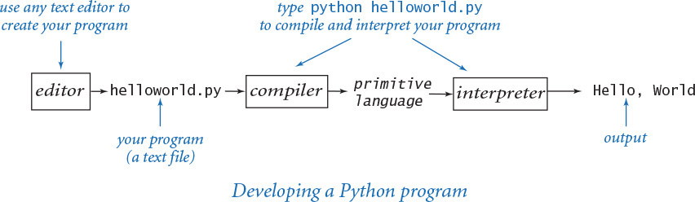
Program 1.1.1 Hello, World (helloworld.py)
Click here to view code image
import stdio
# Write 'Hello, World' to standard output.
stdio.writeln('Hello, World')
This code is a Python program that accomplishes a simple task. It is traditionally a beginner’s first program. The box below shows what happens when you execute the program. The terminal application gives a command prompt (% in this book) and executes the commands that you type (in boldface in this book). The result of executing python with this code is that the program writes Hello, World in the terminal window (the fourth line).
% python helloworld.py
Hello, World
• The second line is a blank line. Python ignores blank lines; programmers use them to separate logical blocks of code.
• The third line contains a comment, which serves to document the program. In Python a comment begins with the ‘#’ character and extends to the end of the line. In this book, we display comments in gray. Python ignores comments—they are present only for human readers of the program.
• The fourth line is the heart of the program. It is a statement that calls the stdio.writeln() function to write one line with the given text on it. Note that we call a function in another module by writing the module name, followed by a period, followed by the function name.
Python 2
The lingua france in this book is Python 3, because it is the future of Python programming. However, we have been very careful to ensure that the code in the book works with either Python 2 or Python 3. For example, in Python 2, PROGRAM 1.1.1 could be simply the single line print 'Hello, World', but this is not a valid program in Python 3. To develop code for writing output that works in either version of Python, we use our stdio module. Whenever there is a significant difference between the two languages, we call attention to Python 2 users in a callout box like this one.
Since the 1970s, it has been a tradition that a beginning programmer’s first program should write 'Hello, World'. So, you should go ahead and type the code in PROGRAM 1.1.1 into a file named helloworld.py and then execute it. By doing so, you will be following in the footsteps of countless others who have learned how to program. Also, you will be checking that you have a usable editor and terminal application. At first, accomplishing the task of writing something out in a terminal window might not seem very interesting; upon reflection, however, you will see that one of the most basic functions that we need from a program is its ability to tell us what it is doing.
For the time being, all our program code will be just like helloworld.py, except with a different file name, different comments, and a different sequence of statements following the comment. Thus, you do not need to start with a blank page to compose a program. Instead,
• Copy helloworld.py into a new file having a name of your choice, but make sure that the new file name ends with .py.
• Replace the comment and the stdio.writeln() statement with a different sequence of statements.
Your program is characterized by its sequence of statements and its name. By convention, each Python program resides in a file whose name has a .py extension.

Errors
It is easy to blur the distinction among editing, compiling, and interpreting programs. You should keep them separate in your mind when you are learning to program, to better understand the effects of the errors that inevitably arise. You can find several examples of errors in the Q&A at the end of this section.
You can fix or avoid most errors by carefully examining the program as you create it, the same way you fix spelling and grammatical errors when you compose an email message. Some errors, known as compile-time errors, are raised when Python compiles the program, because they prevent the compiler from doing the translation. Python reports a compile-time error as a SyntaxError. Other errors, known as run-time errors, are not raised until Python interprets the program. For example, if you forget the import stdio statement in helloworld.py, then Python will raise a NameError at run time.
In general, errors in programs, also commonly known as bugs, are the bane of a programmer’s existence: the error messages can be confusing or misleading, and the source of the error can be very hard to find. One of the first skills that you will learn is to identify errors; you will also learn to be sufficiently careful when coding, to avoid making many of them in the first place.

Input and output
Typically, we want to provide input to our programs—that is, data that they can process to produce a result. The simplest way to provide input data is illustrated in useargument.py (PROGRAM 1.1.2). Whenever you run the program useargument.py, it accepts the command-line argument that you type after the program name and writes it back out to the terminal as part of the message. The result of executing this program depends on what you type after the program name. You can run the program with different command-line arguments and get different written results.
In useargument.py, the statement import sys tells Python that you wish to use the features defined in the sys module. One of those features, named argv, is a list of command-line arguments (which appear after “python useargument.py” on the command line, delimited by spaces). Later in the book (SECTION 2.1) we will discuss this mechanism in more detail. For now it is sufficient to understand that sys.argv[1] is the first command-line argument that you type after the program name, sys.argv[2] is the second command-line argument that you type after the program name, and so forth. You can use sys.argv[1] within your program’s body to represent the string that you type on the command line when you execute it, just as in useargument.py.
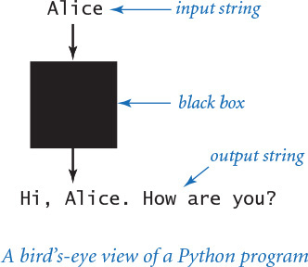
In addition to writeln(), PROGRAM 1.1.2 calls the write() function. This function is just like writeln(), but writes just the string (not a newline character).
Again, accomplishing the task of getting a program to write back out what we type in to it may not seem interesting at first, but upon reflection you will realize that another basic function of a program is its ability to respond to basic information from the user to control what the program does. The simple model that useargument.py represents will suffice to allow us to consider Python’s basic programming mechanism and to address all sorts of interesting computational problems.
Stepping back, we can see that useargument.py does neither more nor less than map a string of characters (the argument) into another string of characters (the message written back to the terminal). When using it, we might think of our Python program as a black box that converts our input string to some output string.
Program 1.1.2 Using a command-line argument (useargument.py)
Click here to view code image
import sys
import stdio
stdio.write('Hi, ')
stdio.write(sys.argv[1])
stdio.writeln('. How are you?')
This program shows how we can control the actions of our programs: by providing an argument on the command line. Doing so allows us to tailor the behavior of our programs. The program accepts a command-line argument, and writes a message that uses it.
% python useargument.py Alice
Hi, Alice. How are you?
% python useargument.py Bob
Hi, Bob. How are you?
% python useargument.py Carol
Hi, Carol. How are you?
This model is attractive because it is not only simple but also sufficiently general to allow completion, in principle, of any computational task. For example, the Python compiler itself is nothing more than a program that takes one string as input (a .py file) and produces another string as output (the corresponding program in a more primitive language). Later, you will be able to compose programs that accomplish a variety of interesting tasks (though we stop short of programs as complicated as a compiler). For the moment, we live with various limitations on the size and type of the input and output to our programs; in SECTION 1.5, you will see how to incorporate more sophisticated mechanisms for program input and output. In particular, you will see that we can work with arbitrarily long input and output strings and other types of data such as sound and pictures.

Q&A
Q. Why Python?
A. The programs that we are studying are very similar to their counterparts in several other languages, so our choice of language is not crucial. We use Python because it is widely available, embraces a full set of modern abstractions, and has a variety of automatic checks for mistakes in programs, so it is suitable for learning to program. Python is evolving and comes in many versions.
Q. Which version of Python should I use?
A. We recommend Python 3, but we have been very careful to ensure that the code in the book works with either Python 2 or Python 3. All of the code has been tested with Python versions 2.7 and 3.4 (the latest major releases of Python 2 and Python 3 at the time of publication). We use the generic term Python 2 to refer to Python 2.7 and Python 3 to refer to Python 3.4.
Q. How do I install a Python programming environment?
A. The booksite provides step-by-step instructions for installing a Python programming environment on your Mac OS X, Windows, or Linux system. This includes installation of our booksite modules, such as stdio.py.
Q. Do I really have to type in the programs in the book to try them out? I believe that you ran them and that they produce the indicated output.
A. You should type in and run helloworld.py. Your understanding will be greatly magnified if you also run useargument.py, try it on various inputs, and modify it to test different ideas of your own. To save some typing, you can find all of the code in this book (and much more) on the booksite. This site also has information about installing Python on your computer, answers to selected exercises, web links, and other extra information that you may find useful or interesting.
Q. When I run helloworld.py, Python generates the message
Click here to view code image
ImportError: No module named stdio.
What does that mean?
A. That means that the booksite module stdio is not available to Python.
Q. How can I make the booksite module stdio available to Python?
A. If you followed the step-by-step instructions on the booksite for installing a Python programming environment, the stdio module should already be available to Python. Alternatively, you can download the file stdio.py from the booksite and put it in the same directory as the program that uses it.
Q. What are Python’s rules regarding whitespace characters such as tabs, spaces, and newlines?
A. In general, Python considers most whitespace in program text to be equivalent, with two important exceptions: string literals and indentation. A string literal is a sequence of characters inside single quotes, such as 'Hello, World'. If you put any number of spaces within the quotes, you get precisely the same number of spaces in the string literal. Indentation is whitespace at a beginning of a line—the number of spaces at the beginning of a line plays an important role in structuring Python programs, as we will see in SECTION 1.3. For now you should not indent any code.
Q. Why should I use comments?
A. Comments are indispensable because they help other programmers to understand your code and even can help you to understand your own code in retrospect. The constraints of the book format demand that we use comments sparingly in the programs shown in this book (instead we describe each program thoroughly in the accompanying text and figures). The programs on the booksite are commented to a more realistic degree.
Q. Can I put more than one statement on a line?
A. Yes, by separating statements with semicolons. For example, this single line of code produces the same output as helloworld.py:
Click here to view code image
import stdio; stdio.writeln('Hello, World')
But many programmers advise against doing this, as a matter of style.
Q. What happens when you omit a parenthesis or misspell one of the words, like stdio or write or writeln?
A. It depends upon precisely what you do. These so-called syntax errors are usually caught by the compiler. For example, if you make a program bad.py that is exactly the same as helloworld.py except that you omit the first left parenthesis, you get the following reasonably helpful message:
Click here to view code image
% python bad.py
File "bad.py", line 4
stdio.write'Hello, World')
∧
SyntaxError: invalid syntax
From this message, you might correctly surmise that you need to insert a left parenthesis. But the compiler may not be able to tell you exactly which mistake you made, so the error message may be hard to understand. For example, if you omit the first right parenthesis instead of the first left parenthesis, you get the following less helpful message, which references the line following the erroneous one:
Click here to view code image
% python bad.py
File "bad.py", line 5
^
SyntaxError: unexpected EOF while parsing
One way to get used to such messages is to intentionally introduce mistakes into a simple program and then see what happens. Whatever the error message says, you should treat the compiler as a friend, because it is just trying to tell you that something is wrong with your program.
Q. When I run useargument.py, I get a strange error message. Please explain.
A. Most likely, you forgot to include a command-line argument:
Click here to view code image
% python useargument.py
Hi, Traceback (most recent call last):
File "useargument.py", line 5, in <module>
stdio.write(sys.argv[1])
IndexError: list index out of range
The Python interpreter is complaining that you ran the program but did not type a command-line argument as promised. You will learn more details about list indices in SECTION 1.4. Remember this error message: you are likely to see it again. Even experienced programmers forget to type command-line arguments on occasion.
Q. Which Python modules and functions are available for me to use?
A. Many standard modules are bundled with any Python installation. Many others are available as extension modules that you can download and install subsequently. We composed still others (such as the stdio module) specifically for this book and booksite; we’ll call them booksite modules. In short, hundreds of Python modules, each (typically) defining multiple functions, are available for you to use. This book introduces only the most fundamental modules and functions, and does so in a deliberately incremental fashion (starting in the next section) to avoid overwhelming you with information.

Exercises
1.1.1 Compose a program that writes the Hello, World message 10 times.
1.1.2 Describe what happens if you omit the following in helloworld.py:
a. import
b. stdio
c. import stdio
1.1.3 Describe what happens if you misspell (by, say, omitting the second letter) the following in helloworld.py:
a. import
b. stdio
c. write
d. writeln
1.1.4 Describe what happens if you omit the following in helloworld.py:
a. the first '
b. the second '
c. the stdio.writeln() statement
1.1.5 Describe what happens if you try to execute useargument.py with each of the following command lines:
a. python useargument.py python
b. python useargument.py @!&∧%
c. python useargument.py 1234
d. python useargument Bob
e. useargument.py Bob
f. python useargument.py Alice Bob
1.1.6 Modify useargument.py to compose a program usethree.py that takes three names and writes a proper sentence with the names in the reverse of the order they are given, so that, for example, python usethree.py Alice Bob Carol writes the string 'Hi Carol, Bob, and Alice'.

1.2 Built-in Types of Data
When programming in Python, you must always be aware of the type of data that your program is processing. The programs in SECTION 1.1 process strings, many of the programs in this section process numbers, and we consider numerous other types later in the book. Understanding the distinctions among them is so important that we formally define the idea: a data type is a set of values and a set of operations defined on those values.
1.2.1 String concatenation example
1.2.2 Integer operators
1.2.3 Float operators
1.2.4 Quadratic formula
1.2.5 Leap year
Programs in this section
Several data types are built into the Python language. In this section, we consider Python’s built-in data types int (for integers), float (for floating-point numbers), str (for sequences of characters) and bool (for true-false values), which are summarized in the table below.
For now, we concentrate on programs that are based on computing with these four basic built-in data types. Later, you will learn about additional data types that are available for your use, and you will learn how to compose your own data types. Indeed, programming in Python often is centered on composing data types, as you will see in CHAPTER 3.
After defining basic terms, we consider several sample programs and code fragments that illustrate the use of different types of data. These code fragments do not perform much real computing, but you will soon see similar code in longer programs. Understanding data types (values and operations on them) is an essential step in beginning to program. It sets the stage for you to begin working with more intricate programs in the next section. Every program that you compose will use code like the tiny fragments shown in this section.
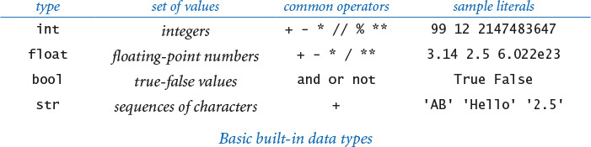

Definitions
To talk about data types, we need to introduce some terminology. To do so, we start with the following code fragment:
a = 1234
b = 99
c = a + b
This code creates three objects, each of type int, using the literals 1234 and 99 and the expression a + b, and binds (“bind” is a technical term indicating the creation of an association) variables a, b, and c to those objects using assignment statements. The end result is that variable c is bound to an object of type int whose value is 1333. Next, we define all of these italicized terms.

Literals
A literal is a Python-code representation of a data-type value. We use sequences of digits such as 1234 or 99 to represent values of data type int; we add a decimal point, as in 3.14159 or 2.71828, to represent values of type float, we use True or False to represent the two values of type bool; and we use a sequence of characters enclosed in matching quotes, such as 'Hello, World', to represent values of type str.

Operators
An operator is a Python-code representation of a data-type operation. Python uses + and * to represent addition and multiplication for integers and floating-point numbers; Python uses and, or, and not to represent boolean operations; and so forth. We will describe in detail the most commonly used operations for each of the four basic built-in types later in this section.

Identifiers
An identifier is a Python-code representation of a name. Each identifier is a sequence of letters, digits, and underscores, the first of which is not a digit. The sequences of characters abc, Ab_, abc123, and a_b are all legal Python identifiers, but Ab*, 1abc, and a+b are not. Identifiers are case-sensitive, so Ab, ab, and AB are all different names. Certain keywords—such as and, import, in, def, while, from, and lambda—are reserved, and you cannot use them as identifiers. Other names—such as int, sum, min, max, len, id, file, and input—have special meaning in Python, so it is best not to use them, either.

Variables
A variable is a name associated with a data-type value. We use variables to keep track of changing values as a computation unfolds. For example, we use a variable total in several programs in this book to keep the running total of a sum of a sequence of numbers. Programmers typically follow stylistic conventions when naming things. In this book our convention is to give each variable a name that consists of a lowercase letter followed by lowercase letters, uppercase letters, and digits. We use uppercase letters to mark the words of a multi-word variable name. So, for example, we use the variable names i, x, y, total, isLeapYear, and outDegrees, among many others.

Constant variables
We use the oxymoronic term constant variable to describe a variable whose associated a data-type value does not change during the execution of a program (or from one execution of the program to the next). In this book, our convention is to give each constant variable a name that consists of an uppercase letter followed by uppercase letters, digits, and underscores. For example, we might use the constant variable names SPEED_OF_LIGHT and DARK_RED.

Expressions
An expression is a combination of literals, variables, and operators that Python evaluates to produce a value. Many expressions look just like mathematical formulas, using operators to specify data-type operations to be performed on one or more operands. Most of the operators that we use are binary operators that take exactly two operands, such as x - 3 or 5 * x. Each operand can be any expression, perhaps within parentheses. For example, we can compose expressions like 4 * (x - 3) or 5 * x - 6 and Python will understand what we mean. An expression is a directive to perform a sequence of operations; the expression is a representation of the resulting value.
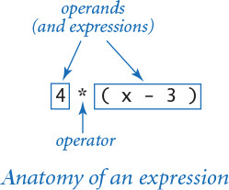

Operator precedence
An expression is shorthand for a sequence of operations: in which order should the operators be applied? Python has natural and well-defined precedence rules that fully specify this order. For arithmetic operations, multiplication and division are performed before addition and subtraction, so that a - b * c and a - (b * c) represent the same sequence of operations. When arithmetic operators have the same precedence, they are left associative, which means that a - b - c and (a - b) - c represent the same sequence of operations. The exponentiation operator ** is the exception: it is right associative, which means that a ** b ** c and a ** (b ** c) represent the same sequence of operations. You can use parentheses to override the rules, so you can write a - (b - c) if that is what you want. You might encounter in the future some Python code that depends subtly on precedence rules, but we use parentheses to avoid such code in this book. If you are interested, you can find full details on the rules on the booksite.

Assignment statements
How do we define an identifier to be a variable in Python code? How do we associate a variable with a data-type value? In Python, we use an assignment statement for both purposes. When we write a = 1234 in Python, we are not expressing mathematical equality, but are instead expressing an action, directing Python to
• define the identifier a to be a new variable (if no variable a already exists).
• associate the variable a with the integer data-type value 1234.
The right side of an assignment statement can be any expression. In such cases, Python evaluates the expression and associates the variable on the left side with the value produced by the expression. For example, when we write c = a + b, we are expressing this action: “associate the variable c with the sum of the values associated with the variables a and b.” The left side of an assignment statement must be a single variable. So, for example, both 1234 = a and a + b = b + a are invalid statements in Python. In short, the meaning of = in a program is decidedly not the same as in a mathematical equation.

Informal trace
An effective way to keep track of the values associated with variables is to use a table like the one at right, with one line giving the values after each statement has been executed. Such a table is called a trace, and is a time-honored technique for understanding the behavior of a program. We use traces like this throughout this book.
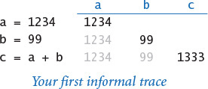
While descriptions of this sort are a valid way to understand the Python code in this section, it is worthwhile at the outset to consider in more detail how Python represents data-type values using objects and to revisit the definitions in that context. While these definitions are more complicated than the ones just considered, it is important for you to understand the underlying mechanism, as it is used consistently throughout Python and prepares you for object-oriented programming in CHAPTER 3.

Objects
All data values in a Python program are represented by objects and relationships among objects. An object is an in-computer-memory representation of a value from a particular data type. Each object is characterized by its identity, type, and value.
• The identity uniquely identifies an object. You should think of it as the location in the computer’s memory (or memory address) where the object is stored.
• The type of an object completely specifies its behavior—the set of values it might represent and the set of operations that can be performed on it.
• The value of an object is the data-type value that it represents.
Each object stores one value; for example, an object of type int can store the value 1234 or the value 99 or the value 1333. Different objects may store the same value. For example, one object of type str might store the value 'hello', and another object of type str also might store the same value 'hello'. We can apply to an object any of the operations defined by its type (and only those operations). For example, we can multiply two int objects but not two str objects.

Object references
An object reference is nothing more than a concrete representation of the object’s identity (the memory address where the object is stored). Python programs use object references either to access the object’s value or to manipulate the object references themselves, as you will see.

Formal object-based definitions
Now, we consider more formal definitions for the terminology we have been using.
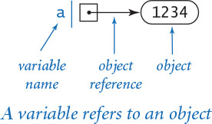
• A literal is a directive to Python to create an object having the specified value.
• A variable is a name for an object reference. We use diagrams like the one at right to show the binding of a variable to an object.
• An expression is a directive to Python to perform the indicated operations, producing an object having the value defined by the expression.
• An assignment statement is a directive to Python to bind the variable on the left side of the = operator to the object produced by evaluating the expression on the right side (regardless of the object, if any, to which the variable was previously bound).

Object-level trace
For a more complete understanding, we sometimes keep track of objects and references in traces, as in the object-level trace in the figure at right. For our example, the object-level trace illustrates the full effect of the three assignment statements:
• The statement a = 1234 creates an int object whose value is 1234; it then binds the variable a to this new int object.
• The statement b = 99 creates an int object whose value is 99; it then binds the variable b to this new int object.
• The statement c = a + b creates the int object whose value is 1333 as the sum of the value of the int object bound to a and the value of the int object bound to b; it then binds the variable c to the new int object.
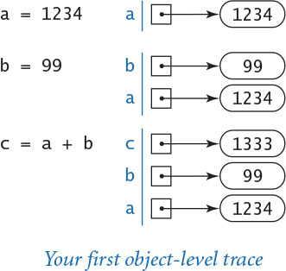
Throughout this book, we generally use the more succinct and intuitive informal traces just discussed, reserving object-level traces for situations when they provide a more insightful view of the underlying computation.

Example: incrementing a variable
As a first check on these concepts, consider the following code, which binds the variable i to an int object whose value is 17, and then increments it:
i = 17
i = i + 1
As we have noted, this second statement is nonsensical as a mathematical equality, but it is a very common operation in Python programming. Specifically, these two statements are a directive to Python to take the following actions:
• Create an int object whose value is 17 and bind the variable i to that object.
• Evaluate the expression i + 1 and create a new int object whose value is 18.
• Bind the variable i to this new object.
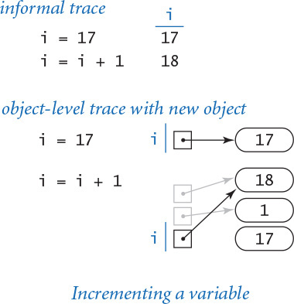
You can consult the traces at right to see the results after Python executes each statement.
This simple code fragment leads us to consider two aspects of the process of creating an object in a bit more detail. First, the assignment statement i = i + 1 does not change the value of any object. Instead, it creates a new object (with the desired value) and binds the variable i to this new object. Second, after Python executes the assignment statement i = i + 1, there is no variable bound to the object whose value is 17 (or to the object whose value is 1). Python takes responsibility for managing memory resources. When it identifies that a program can no longer access an object, it automatically reclaims the memory used to store the object.

Example: exchanging two variables
As a second check on these concepts, convince yourself that this code exchanges a and b (more precisely, the objects bound to a and b):
t = a
a = b
b = t
To do so, assume that a and b are bound to objects having two different values—1234 and 99, respectively—and consult the traces at right to convince yourself, step by step, that:
• t = a assigns a to t. That is, it assigns a (an object reference) to t, and thus a and t are bound to the same object—the int object whose value is 1234.
• a = b assigns b to a. That is, it assigns b (an object reference) to a, and thus a and b are bound to the same object—the int object whose value is 99.
• b = t assigns t to b. That is, it assigns t (an object reference) to b, and thus t and b are bound to the same object—the int object whose value is 1234.
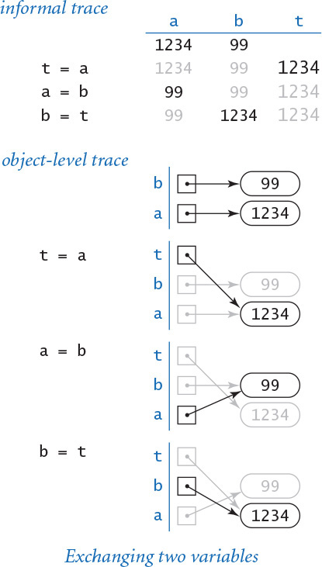
Thus, the references are exchanged: the variable a now is bound to the object whose value is 99 and the variable b now is bound to the object whose value is 1234.
Abbreviation alert
From this point forward we often abbreviate our descriptions of Python statements involving variables, objects, and object references. For example, we often omit some or all of the bracketed phrases in sentences like the examples here. When describing the statement a = 1234, we might say:
• “Bind/set a to [an int object whose value is] 1234.”
• “Assign to a [a reference to] [an int object whose value is] 1234.”
Similarly, after Python executes the statement a = 1234, we might say:
• “a is [bound/set to] [an int object whose value is] 1234.”
• “a is [a reference to] [an int object whose value is] 1234.”
• “[The value of] [the int object referenced by] a is 1234.”
So, when describing the statement c = a + b, we might say “c is the sum of a and b” instead of the more precise but untenably verbose “c is bound to an object whose value is the sum of the value of the object bound to a and the value of the object bound to b.” We use language that is as succinct as possible, but no more precise than necessary to make the point at hand.
We refer to binding a variable to an object for the first time in a program as defining and initializing the variable. So, when describing the statement a = 1234 in our first trace, we might say that it “defines the variable a and initializes it to 1234.” In Python, you cannot define a variable without simultaneously initializing it.
You might wonder whether the distinction between an object and a reference to an object is purely pedantic. In fact, understanding the difference between objects and references is the key to mastering many important features of Python programming, including functions (in CHAPTER 2), object-oriented programming (in CHAPTER 3), and data structures (in CHAPTER 4).
Next, we consider the details for the data types that you will use most often (strings, integers, floating-point numbers, and boolean values), along with sample code illustrating their use. To use a data type, you need to know not just its set of values, but also which operations you can perform, the language mechanism for invoking the operations, and the conventions for specifying literals.

Strings
The str data type represents strings, for use in text processing. The value of a str object is a sequence of characters. You can specify a str literal by enclosing a sequence of characters in matching single quotes; for example 'ab', represents a str object that stores two characters, the letter 'a' followed by the letter 'b'. There are many possible characters, but we usually restrict attention to the ones that represent letters, digits, symbols, and whitespace characters such as tab and newline. You can use a backslash to specify characters that otherwise would have special meaning. For example, you can specify the tab, newline, backslash, and single quote characters using the escape sequences '\t', '\n', '\\', and '\'', respectively.
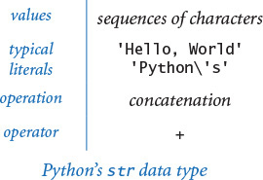
You can concatenate two strings using the operator +. That is, the + operator takes two str objects as operands and produces a new str object whose value is the sequence of characters in the first str object followed by the sequence of characters in the second str object. For example, the expression '123' + '456' evaluates to the str object whose value is '123456'. This example illustrates that applying the + operator to two str objects has quite different behavior (string concatenation) than applying the + operator to two int objects (addition).
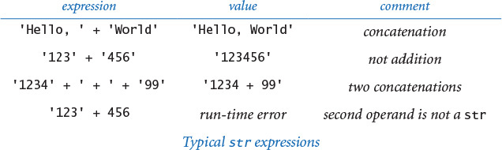
Abbreviation alert
From this point forward we use the term string to mean an object of type str whenever the rigor of the full phrase is unnecessary. We also use 'abc' instead of an object of type str whose value is 'abc'.
Program 1.2.1 String concatenation example (ruler.py)
Click here to view code image
import stdio
ruler1 = '1'
ruler2 = ruler1 + ' 2 ' + ruler1
ruler3 = ruler2 + ' 3 ' + ruler2
ruler4 = ruler3 + ' 4 ' + ruler3
stdio.writeln(ruler1)
stdio.writeln(ruler2)
stdio.writeln(ruler3)
stdio.writeln(ruler4)
% python ruler.py
1
1 2 1
1 2 1 3 1 2 1
1 2 1 3 1 2 1 4 1 2 1 3 1 2 1
This program writes the relative lengths of the subdivisions on a ruler. The nth line of output is the relative lengths of the marks on a ruler subdivided in intervals of 1/2n of an inch.
String concatenation is sufficiently powerful to allow us to attack some nontrivial computing tasks. As an example, ruler.py (PROGRAM 1.2.1) computes a table of values of the ruler function that describes the relative lengths of the marks on a ruler. One noteworthy feature of this computation is that it illustrates how easy it is to craft short programs that produce huge amounts of output. If you extend this program in the obvious way to write five lines, six lines, seven lines, and so forth, you will see that each time you add just two statements to this program, you increase the size of its output by precisely one more than a factor of 2. Specifically, if the program writes n lines, the nth line contains 2n – 1 numbers. For example, if you were to add statements in this way so that the program writes 30 lines, it would attempt to write more than 1 billion numbers.
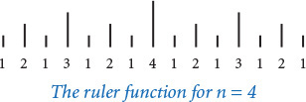
Next we consider two convenient mechanisms in Python for converting numbers to strings and strings to numbers.

Converting numbers to strings for output
Python provides the built-in function str() to convert numbers to strings. For example, str(123) evaluates to the str object '123', and str(123.45) evaluates to the str object '123.45'. If the argument to either stdio.write() or stdio.writeln() is not of type str, then these two functions automatically call the str() function on its argument to generate the string representation. For example, stdio.write(123), stdio.write(str(123)), and stdio.write('123') all write 123.
Our most frequent use of the string concatenation operator is to chain together the results of a computation for output with stdio.write() and stdio.writeln(), often in conjunction with the str() function, as in this example:
Click here to view code image
stdio.writeln(str(a) + ' + ' + str(b) + ' = ' + str(a+b))
If a and b are int objects whose values are 1234 and 99, respectively, then that statement writes the line of output 1234 + 99 = 1333. We consider the str data type first precisely because we need it to produce this sort of output in programs that process other types of data.

Converting strings to numbers for input
Python also provides built-in functions to convert strings (such as the ones we type as command-line arguments) to numeric objects. We use the Python built-in functions int() and float() for this purpose. For example, typing int('1234') in program text is equivalent to typing the int literal 1234. If the user types 1234 as the first command-line argument, then the code int(sys.argv[1]) also evaluates to the int object whose value is 1234. You will see several examples of this usage in this section.
With these features, our view of each Python program as a black box that takes string arguments and produces string results is still valid, but we can now interpret those strings as numbers and use them as the basis for meaningful computation.
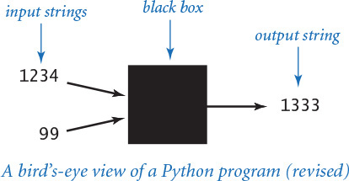

Integers
The int data type represents integers or natural numbers. We can specify an int literal with a sequence of the digits 0 through 9. When Python encounters an int literal, it creates an int object that stores the specified value. We use int objects frequently not just because they occur frequently in the real world, but also because they arise naturally when we are composing programs.
Python includes operators for common arithmetic operations on integers, including + for addition, - for subtraction, * for multiplication, // for floored division, % for remainder, and ** for exponentiation. These binary operators take two int objects as operands and typically produce an int object as a result. Python also includes the unary operators + and - to specify the sign of an integer. All of these operators are defined just as in grade school (keeping in mind that the floored division operator results in an integer): given two int objects a and b, the expression a // b evaluates to the number of times b goes into a with the fractional part discarded, and a % b evaluates to the remainder that you get when you divide a by b. For example, 17 // 3 evaluates to 5, and 17 % 3 evaluates to 2. Floored division or remainder with a zero divisor raises a ZeroDivisionError at run time.
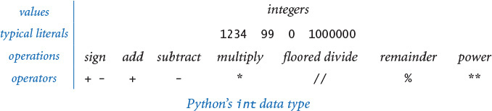
PROGRAM 1.2.2 (intops.py) illustrates basic operations for manipulating int objects, such as the use of expressions involving arithmetic operators. It also demonstrates the use of the built-in function int() to convert strings on the command line to int objects, as well as the use of the built-in function str() to convert int objects to strings for output.
Abbreviation alert
From this point forward we use the term integer to mean an object of type int whenever the rigor of the full phrase is unnecessary. We also use 123 instead of an object of type int whose value is 123.
Program 1.2.2 Integer operators (intops.py)
Click here to view code image
import sys
import stdio
a = int(sys.argv[1])
b = int(sys.argv[2])
total = a + b
diff = a - b
prod = a * b
quot = a // b
rem = a % b
exp = a ** b
stdio.writeln(str(a) + ' + ' + str(b) + ' = ' + str(total))
stdio.writeln(str(a) + ' - ' + str(b) + ' = ' + str(diff))
stdio.writeln(str(a) + ' * ' + str(b) + ' = ' + str(prod))
stdio.writeln(str(a) + ' // ' + str(b) + ' = ' + str(quot))
stdio.writeln(str(a) + ' % ' + str(b) + ' = ' + str(rem))
stdio.writeln(str(a) + ' ** ' + str(b) + ' = ' + str(exp))
This program accepts integer command-line arguments a and b, uses them to illustrate integer operators, and writes the results. Arithmetic for integers is built into Python. Most of this code is devoted to reading input and writing output; the actual arithmetic is in the simple statements in the middle of the program that assign values to total, diff, prod, quot, rem, and exp.
% python intops.py 1234 5
1234 + 5 = 1239
1234 - 5 = 1229
1234 * 5 = 6170
1234 // 5 = 246
1234 % 5 = 4
1234 ** 5 = 2861381721051424
In Python, the range of int values is arbitrarily large, constrained only by the amount of memory available on your computer system. Many other programming languages constrain the range of integers. For example, the Java programming language constrains integers to the range –231 (–2147483648) to 231 – 1 (2147483647). On the one hand, Python programmers do not have to worry about integers becoming too large to fit in the allowed range; on the other hand, Python programmers do have to worry about a faulty program filling the memory of their computer with one or more extremely huge integers.
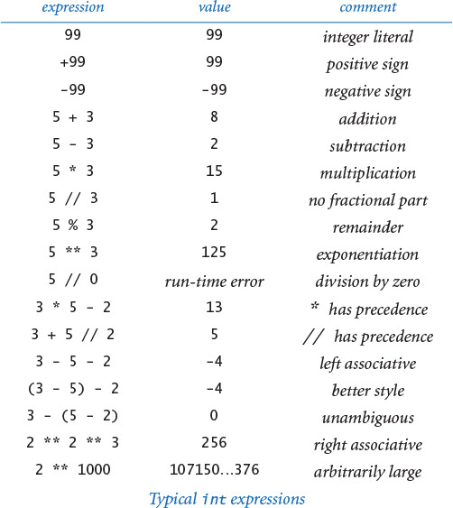
Python 2 alert
In Python 3, the / operator has the same behavior as the floating-point division operator when both its operands are integers. In Python 2, the / operator has the same behavior as the floored division operator // when both its operands are integers. For example, 17 / 2 evaluates to 8.5 in Python 3 and to 8 in Python 2. For compatibility among Python versions, we do not use the / operator with two int operands in this book.

Floating-point numbers
The float data type is for representing floating-point numbers, for use in scientific and commercial applications. We use floating-point numbers to represent real numbers, but they are decidedly not the same as real numbers! There are infinitely many real numbers, but we can represent only a finite number of floating-point numbers in any digital computer. Floating-point numbers do approximate real numbers sufficiently well that we can use them in applications, but we often need to cope with the fact that we cannot always do exact computations.
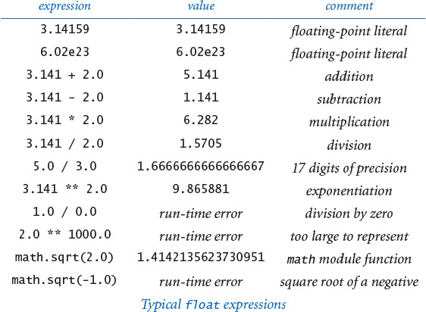
We can specify a floating-point literal using a sequence of digits with a decimal point. For example, 3.14159 represents an approximation to π. Alternatively, we can use a notation like scientific notation: the literal 6.022e23 represents the number 6.022 × 1023. As with integers, you can use these conventions to express floating-point literals in your programs or to provide floating-point numbers as string arguments on the command line.
PROGRAM 1.2.3 (floatops.py) illustrates the basic operations for manipulating float objects. Python includes the operators you expect for floating-point numbers, including + for addition, - for subtraction, * for multiplication, / for division, and ** for exponentiation. These operators take two float objects as operands and typically produce a float object as a result. PROGRAM 1.2.3 also illustrates the use of the float() function to convert a str object to a float object, and the use of the str() function to convert a float object to a str object.
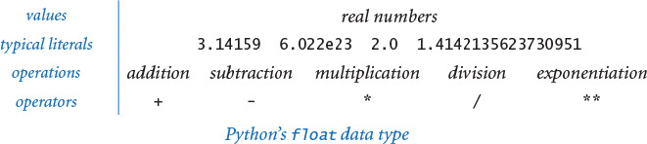
Program 1.2.3 Float operators (floatops.py)
Click here to view code image
import sys
import stdio
a = float(sys.argv[1])
b = float(sys.argv[2])
total = a + b
diff = a - b
prod = a * b
quot = a / b
exp = a ** b
stdio.writeln(str(a) + ' + ' + str(b) + ' = ' + str(total))
stdio.writeln(str(a) + ' - ' + str(b) + ' = ' + str(diff))
stdio.writeln(str(a) + ' * ' + str(b) + ' = ' + str(prod))
stdio.writeln(str(a) + ' / ' + str(b) + ' = ' + str(quot))
stdio.writeln(str(a) + ' ** ' + str(b) + ' = ' + str(exp))
This program takes floating-point numbers a and b as command-line arguments, uses them to illustrate floating-point operations, and writes the results. Arithmetic for floating-point numbers is built into Python. As with PROGRAM 1.2.2, most of this code is devoted to reading input and writing output; the actual arithmetic is in the simple statements in the middle of the program that assign values to total, diff, prod, quot, and exp.
Click here to view code image
% python floatops.py 123.456 78.9
123.456 + 78.9 = 202.356
123.456 - 78.9 = 44.556
123.456 * 78.9 = 9740.6784
123.456 / 78.9 = 1.5647148288973383
123.456 ** 78.9 = 1.0478827916671325e+165
When working with floating-point numbers, one of the first things that you will encounter is the issue of precision: 5.0/2.0 evaluates to 2.5 but 5.0/3.0 evaluates to 1.6666666666666667. Typically, floating-point numbers have 15-17 decimal digits of precision. In SECTION 1.5, you will learn Python’s mechanism for controlling the number of digits that you see in output. Until then, we will work with Python’s default output format. Though there are myriad details to consider when calculations involve float objects, you can use them in a natural way and compose Python programs instead of using a calculator for all kinds of calculations. For example, quadratic.py (PROGRAM 1.2.4) shows the use of float objects in computing the two roots of a quadratic equation using the quadratic formula.
Note the use of the math.sqrt() function in this program. The standard math module defines trigonometric functions, logarithm/exponential functions, and other common mathematical functions. When Python calls the function, it produces a value—the value computed by the function. You can use the math module in the same way that we have been using stdio in every program since helloworld.py: place the statement import math near the beginning of the program and then call functions using syntax such as math.sqrt(x). We discuss in more detail the mechanism behind this arrangement in SECTION 2.1 and provide more details about the math module at the end of this section.
As illustrated in the sample execution accompanying PROGRAM 1.2.4, quadratic.py does not check for error conditions. In particular, it assumes that the roots are real numbers. If not, it calls math.sqrt() with a negative number as its argument, which raises a ValueError at run time. Generally, it is good programming practice to check for such errors and inform the user about them. We will discuss how to do so after you learn a few more Python language mechanisms.
Abbreviation alert
From this point forward we use the term float to mean an object of type float whenever the rigor of the full phrase is unnecessary. We also use 123.456 instead of an object of type float whose value is 123.456.
Program 1.2.4 Quadratic formula (quadratic.py)
import math
import sys
import stdio
b = float(sys.argv[1])
c = float(sys.argv[2])
discriminant = b*b - 4.0*c
d = math.sqrt(discriminant)
stdio.writeln((-b + d) / 2.0)
stdio.writeln((-b - d) / 2.0)
This program writes the roots of the polynomial x2 + bx + c, using the quadratic formula. For example, the roots of x2 – 3x + 2 are 1 and 2 since we can factor the equation as (x – 1)(x – 2); the roots of x2 – x – 1 are ϕ and 1 – ϕ, where ϕ is the golden ratio, and the roots of x2 + x + 1 are not real numbers.
Click here to view code image
% python quadratic.py -3.0 2.0
2.0
1.0
% python quadratic.py -1.0 -1.0
1.618033988749895
-0.6180339887498949
% python quadratic.py 1.0 1.0
Traceback (most recent call last):
File "quadratic.py", line 9, in <module>
d = math.sqrt(discriminant)
ValueError: math domain error

Booleans
The bool data type represents truth values (either true or false) from logic. The data type has two possible values and two corresponding literals: True and False. The bool operations that we use have operands that are either True or False and evaluate to a result that is also either True or False. This simplicity is deceiving—the bool data type lies at the foundation of computer science. The operators defined for bool objects (and, or, and not) are known as logical operators and have familiar definitions:
• a and b is True if both operands are True, and False if either is False.
• a or b is False if both operands are False, and True if either is True.
• not a is True if a is False, and False if a is True.
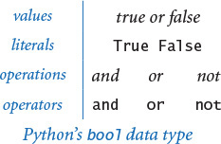
Despite the intuitive nature of these definitions, it is worthwhile to fully specify each possibility for each operation in truth tables, as shown at the bottom of this page. The not operator has only one operand: its result for each of the two possible values of the operand is specified in the second column. The and and or operators each have two operands: the results for each of the four possible values of these operands are specified in the right two columns.
We can use these operators with parentheses (and precedence rules) to develop arbitrarily complex expressions, each of which specifies a boolean function. The not operator has higher precedence than the and operator, which in turn has higher precedence than the or operator.
Often the same function appears in different guises. For example, the expressions (a and b) and not (not a or not b) are equivalent. One way to establish that this is the case is to use a truth-table proof like the one at the top of the next page, which checks all possibilities.
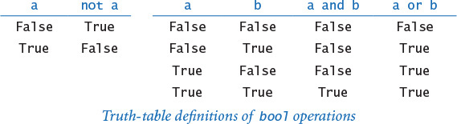
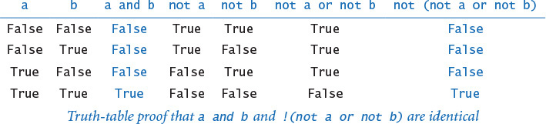
The study of manipulating expressions of this kind is known as Boolean logic. This field of mathematics is fundamental to computing: it plays an essential role in the design and operation of computer hardware itself, and it is also a starting point for the theoretical foundations of computation. In the present context, we are interested in bool expressions because we use them to control the behavior of our programs. Typically, a particular condition of interest is specified as a boolean expression and a piece of program code is written to execute one set of statements if the expression evaluates to True and a different set of statements if the expression evaluates to False. The mechanics of doing so are the topic of SECTION 1.3.
Abbreviation alert
From this point forward we use the term boolean to mean an object of type bool whenever the rigor of the full phrase is unnecessary. We also use True instead of the object of type bool whose value is True and False instead of the object of type bool whose value is False.

Comparisons
Some mixed-type operators take operands of one type and produce a result of another type. The most important operators of this kind are the comparison operators ==, !=, <, <=, >, and >=, which all are defined for both integers and floats and evaluate to a boolean result. Since operations are defined only with respect to data types, each of these operators stands for many operations, one for each data type. Both operands must be of compatible type. The result is always a boolean.
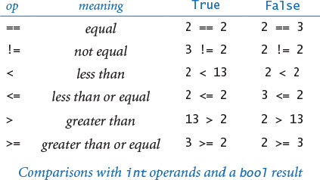
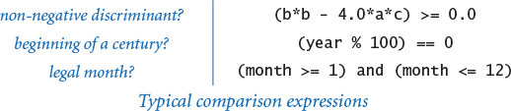
Even without going into the details of number representation, it is clear that the operations for the various types are really quite different. For example, it is one thing to compare two integers to check that (2 <= 2) is True, but quite another to compare two floats to check whether (2.0 <= 0.002e3) is True. Still, these operations are well defined and useful to compose code that tests for conditions such as (b*b - 4.0*a*c) >= 0.0, which is frequently needed, as you will see.
Comparison operators have lower precedence than arithmetic operators and higher precedence than boolean operators, so you do not need the parentheses in an expression like (b*b - 4.0*a*c) >= 0.0, and you could write an expression like month >= 1 and month <= 12 without parentheses to test whether month is between 1 and 12. (It is better style to use the parentheses, however.)
Comparison operations, together with boolean logic, provide the basis for decision making in Python programs. PROGRAM 1.2.5 (leapyear.py) shows the use of boolean expressions and comparison operations to compute whether a given year is a leap year. You can find other examples in the exercises at the end of this section. More importantly, in SECTION 1.3 we will see the role that boolean expressions play in more sophisticated programs.
PROGRAM 1.2.5 also illustrates a special and useful property of the logical operators known as short-circuiting: the and operator evaluates the second operand only if the first operand is True; the or operator evaluates the second operand only if the first operand is False. For example, in leapyear.py, Python evaluates the comparison expression (year % 100) != 0 only if the year is divisible by 4 and the comparison expression (year % 400) != 0 only if the year is divisible by 100.

Functions and APIs
As we have seen, many programming tasks involve using not only built-in operators, but also functions that perform useful operations. We distinguish three kinds of functions: built-in functions (such as int(), float(), and str()) that you can use directly in any Python program, standard functions (such as math.sqrt()) that are defined in a Python standard module and are available in any program that imports the module, and booksite functions (such as stdio.write() and stdio.writeln()) that are defined in our booksite modules and available for you to use after you have made them available to Python and imported them. The number of built-in functions, standard functions, and booksite functions available to you is very large. As you learn to program, you will learn to use more and more of those functions, but it is best at the beginning to restrict your attention to a relatively small set. In this chapter, you have already used some functions for writing, for converting data from one type to another, and for computing mathematical functions. We will describe some more useful functions in this section. In later chapters, you will learn not just how to use other functions, but how to define and use your own functions.
Program 1.2.5 Leap year (leapyear.py)
Click here to view code image
import sys
import stdio
year = int(sys.argv[1])
isLeapYear = (year % 4 == 0)
isLeapYear = isLeapYear and ((year % 100) != 0)
isLeapYear = isLeapYear or ((year % 400) == 0)
stdio.writeln(isLeapYear)
This program tests whether an integer corresponds to a leap year in the Gregorian calendar. A year is a leap year if it is divisible by 4 (2004), unless it is divisible by 100 in which case it is not (1900), unless it is divisible by 400 in which case it is (2000).
% python leapyear.py 2016
True
% python leapyear.py 1900
False
% python leapyear.py 2000
True
For convenience, we summarize the functions that you need to know how to use in tables like the one shown on the facing page. It includes examples of built-in functions, booksite functions from our stdio module, and standard functions from Python’s math and random modules. Such a table is known as an application programming interface (API). The first column specifies the information you need to use the function, including its name and its number of arguments; the second column describes its purpose.
In your code, you can call a function by typing its name followed by arguments, enclosed in parentheses and separated by commas. When Python executes your program, we say that it calls (or evaluates) the function with the given arguments and that the function returns a value. More precisely, the function returns a reference to an object, which has a value. A function call is an expression, so you can use a function call in the same way that you use variables and literals to build up more complicated expressions. For example, you can compose expressions like math.sin(x) * math.cos(y) and so on. You can also represent an argument using an expression—Python evaluates the expression and passes the result as an argument to the function. So, you can compose code like math.sqrt(b*b - 4.0*a*c) and Python knows what you mean.
In some cases, a function can have default values for optional arguments. The function math.log() is an example—it takes the base of the logarithm as an optional second argument, defaulting to the natural logarithm (base e) if you do not specify a second argument.
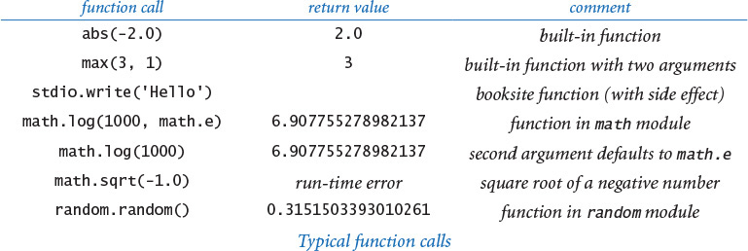
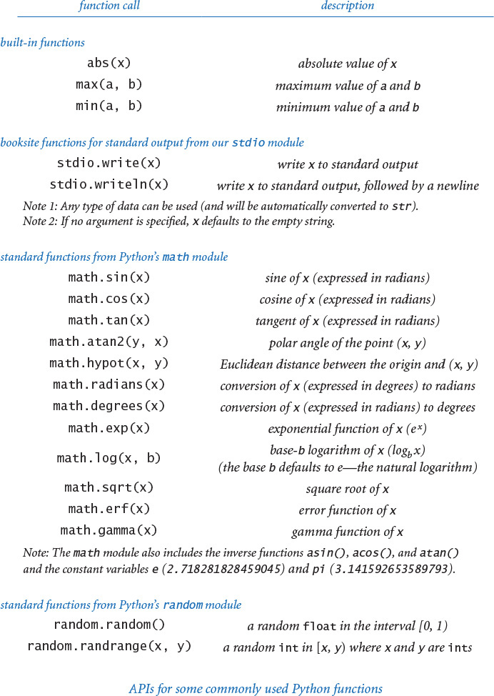
With three exceptions, the functions on the previous page are pure functions—given the same arguments, they always return the same value, without producing any observable side effect. The function random.random() is impure because it returns potentially a different value each time it is called; the functions stdio.write() and stdio.writeln() are impure because they produce side effects—writing strings to standard output. In APIs, we use a verb phrase to describe the behavior of a function that produces side effects; otherwise, we use a noun phrase to describe the return value.
The math module also defines the constant variables math.pi (for π) and math.e (for e), so that you can use those names to refer to those constants in your programs. For example, the function call math.sin(math.pi/2) returns 1.0 (because math.sin() takes its argument in radians) and the function call math.log(math.e) returns 1.0 (because the default base for math.log() is e).
These APIs are typical of the online documentation that is the standard in modern programming. There is extensive online documentation of the Python APIs that is used by professional programmers, and it is available to you (if you are interested) through our booksite. You do not need to consult the online documentation to understand the code in this book or to compose similar code, because we present and explain in the text all of the functions that we use in APIs like these and summarize them in the endpapers.
More important, in CHAPTERS 2 and 3 you will learn how to develop your own APIs and to implement functions for your own use.
Abbreviation alert
From this point forward we often abbreviate our descriptions of Python statements involving functions and function calls. For example, we often omit the bracketed phrases in sentences such as the following description of the function call math.sqrt(4.0): “The function call math.sqrt(4.0) returns [a reference to] [a float object whose value is] 2.0.” So we might say, “The function call sqrt(16.0) returns 4.0” instead of the more accurate but more verbose “When we pass to math.sqrt() a reference to an object of type float whose value is 16.0, it returns a reference to an object of type float whose value is 4.0.” We also use the term return value to describe the object whose reference is returned by a function.

Type conversion
Typical programming tasks involve processing multiple types of data. You should always be aware of the type of data that your program is processing, because only by knowing the type can you know precisely which set of values each object can have and which operations you can perform. In particular, we often need to convert data from one type to another. For example, suppose that we wish to compute the average of the four integers 1, 2, 3, and 4. Naturally, the expression (1 + 2 + 3 + 4) / 4 comes to mind, but it does not produce the desired result in many programming languages, because of type conversion conventions. Indeed, as we have already noted, Python 3 and Python 2 produce different results for this expression, so it is a worthy example for introducing this topic.
The problem stems from the fact that the operands are integers, but it is natural to expect a float for the result, so conversion from integer to float is necessary at some point. There are two ways to do so in Python.

Explicit type conversion
One approach is to use a function that takes an argument of one type (the object to be converted) and returns an object of another type. We have already used the built-in functions int(), float(), and str() to convert from strings to integers or floats, and vice versa. This is by far their most common usage, but you can also use them (and the additional function round()) to convert between integers and floats, as shown in the API at the top of the next page. For example, you can use either int(x) or int(round(x)) to convert from a float to an integer and float(x) to convert from an integer to a float. So, the expression float(1 + 2 + 3 + 4) / float(4) evaluates to 2.5 in both Python 3 and Python 2, as you would expect.
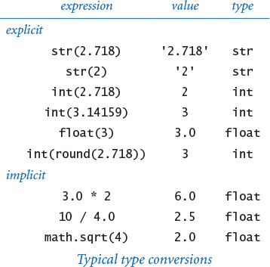
Python 2 alert
In Python 3, round(x) returns an integer; in Python 2, round(x) returns a float. In this book, we always use the expression int(round(x)) to round a float x to the nearest integer, so that the code works in both Python 3 and Python 2.
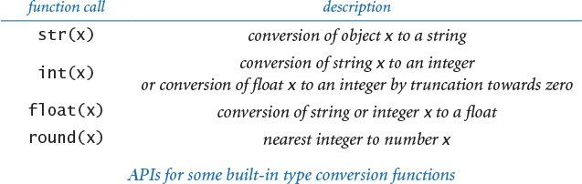

Implicit type conversion (from integer to float)
You can use an integer where a float is expected, because Python automatically converts integers to floats when appropriate. For example, 10/4.0 evaluates to 2.5 because 4.0 is a float and both operands need to be of the same type; thus, 10 is converted to a float and then the result of dividing two floats is a float. For another example, math.sqrt(4) evaluates to 2.0 because the 4 is converted to a float, as expected by math.sqrt(), which then returns a float. This kind of conversion is called automatic promotion or coercion. It is appropriate that Python implements automatic promotion because it can be done with no loss of information. But, as we have noted, there are pitfalls. For example, as we have seen, Python 3 automatically promotes each integer operand of the / operator to a float but Python 2 does not do so. So, (1 + 2 + 3 + 4) / 4 evaluates to the float 2.5 in Python 3 but to the integer 2 in Python 2.
The concept of automatic promotion is irrelevant if you always use the int() and float() functions to indicate your type-conversion wishes explicitly; in turn, some programmers avoid automatic promotion whenever possible. In this book we generally do rely upon automatic promotion because it leads to compact and easy-to-read code. However, whenever we want to divide two numbers with the / operator, we always arrange for (at least) one of the two operands to be a float. For our examples, when Python evaluates the expression (1 + 2 + 3 + 4) / 4.0, it triggers automatic promotion to a float for the first operand and produces the float 2.5, as expected. This practice ensures that our code works properly in both Python 3 and Python 2 (and many other languages). Again, in this book, we do not use the / operator when both operands are integers.
Beginning programmers tend to find type conversion to be an annoyance, but experienced programmers know that paying careful attention to data types is a key to success in programming. It may also be a key to avoiding failure: In a famous incident in 1985, a French rocket exploded in midair because of a type-conversion problem. While a bug in your program may not cause an explosion, it is well worth your while to take the time to understand what type conversion is all about. After you have written just a few programs, you will see that an understanding of data types will help you not only compose compact code but also make your intentions explicit and avoid subtle bugs in your programs.
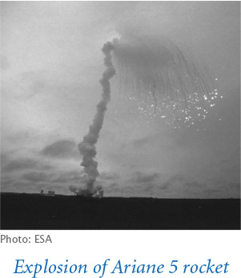

Summary
A data type is a set of values and a set of operations defined on those values. Python has built-in data types bool, str, int, and float; you will encounter others later in this book. In Python code, we use operators and expressions like those in familiar mathematical expressions to invoke the operations associated with each type. The bool type is for computing with true-false values; the str type is for sequences of characters; the int and float data types are numeric types, for computing with numbers.
The bool type (which includes the logical operators and, or, and not) is the basis for logical decision making in Python programs, when used in conjunction with the comparison operators ==, !=, <, <=, >, and >=. Specifically, we use bool expressions to control Python’s conditional (if) and loop (while) statements, which we will study in detail in the next section.
The numeric types, built-in functions, and functions defined in Python’s standard and extension modules and in our booksite modules give us the ability to use Python as an extensive mathematical calculator. We compose arithmetic expressions using the built-in operators +, -, *, /, //, %, and ** along with Python function calls.
Although the programs in this section are rudimentary by the standards of what we will be able to do after the next section, this class of programs is quite useful in its own right. You will use data types and basic mathematical functions extensively in Python programming, so the effort that you spend now in understanding them certainly will be worthwhile.

Interactive Python
Indeed, we can use Python as a calculator, directly. To do that, issue the command python (that is, the word python stand-alone, with no following file name) in your terminal window. Python identifies itself, and writes a >>> prompt. At that point you can type a Python statement and Python will execute it. Or, you can type a Python expression and Python will evaluate it and write the resulting value. Or, you can type help() to get access to Python’s extensive interactive documentation. Some examples are shown below (boldface indicates what you type). This is a convenient way to test new constructs and access documentation, thereby learning about modules and functions that are of interest to you. You are encouraged to do so in several of the Q&A sections that follow.
% python
...
>>> 1 + 2
3
>>> a = 1
>>> b = 2
>>> a + b
3
>>> import math
>>> math.sqrt(2.0)
1.4142135623730951
>>> math.e
2.718281828459045
>>>
Click here to view code image
% python
...
>>> import math
>>> help(math)
Help on module math:
NAME
math
DESCRIPTION
This module is always available. It provides
access to the mathematical functions defined
by the C standard.
FUNCTIONS
acos(...)
acos(x)
Return the arc cosine (in radians) of x.
...
sqrt(...)
sqrt(x)
Return the square root of x
...
DATA
e = 2.718281828459045
pi = 3.141592653589793

Q&A (strings)
Q. How does Python store strings internally?
Strings in Python 2
Python 2 uses ASCII instead of Unicode to encode characters. ASCII is a legacy standard that supports 128 characters, including the English alphabet, numbers, and punctuation. Python 2 offers a separate data type unicode for strings composed of Unicode characters, but many Python 2 libraries do not support it.
A. Strings are sequences of characters that are encoded with Unicode, a modern standard for encoding text. Unicode supports over 100,000 different characters, including more than 100 different languages plus mathematical and musical symbols.
Q. Which data type does Python provide for characters?
A. Python has no special data type for characters. A character is simply a string consisting of one element, such as 'A'.
Q. Can I compare strings using comparison operators such as == and < or built-in functions such as max() and min()?
A. Yes. Informally, Python uses lexicographic order to compare two strings, like words in a book index or dictionary. For example, 'hello' and 'hello' are equal, 'hello' and 'goodbye' are unequal, and 'goodbye' is less than 'hello'. See the Q&A at the end of SECTION 4.2 for full details.
Q. Can I use matching double quotes for string literals instead of single quotes?
A. Yes. For example, 'hello’ and "hello" are identical literals. Double quotes are useful to specify a string that contains single quotes, so that you don’t need to escape them. For example, 'Python\'s’ and "Python's" are identical string literals. You can also use matching triple quotes for multiline strings. For example, the following creates a two-line string and assigns it to the variable s:
Click here to view code image
s = """Python's "triple" quotes are useful to
specify string literals that span multiple lines
"""
In this book, we do not use double or triple quotes to delimit string literals.

Q&A (integers)
Q. How does Python store integers internally?
A. The simplest representation is for small positive integers, where the binary number system is used to represent each integer with a fixed amount of computer memory.
Q. What’s the binary number system?
A. You probably learned it in grade school. In the binary number system, we represent an integer as a sequence of bits. A bit is a single binary (base 2) digit—either 0 or 1—and is the basis for representing information in computers. In this case the bits are coefficients of powers of 2. Specifically, the sequence of bits bnbn–1...b2b1b0 represents the integer
bn2n +bn–12n–1 +...b222 +b121 +b020
For example, 1100011 represents the integer
99 = 1· 64 + 1· 32 + 0· 16 + 0· 8 + 0· 4 + 1· 2 +1· 1.
The more familiar decimal number system is the same except that the digits are between zero and 9 and we use powers of 10. Converting a number to binary is an interesting computational problem that we will consider in the next section. For small integers, Python uses a fixed number of bits, typically dictated by a basic design parameter of your computer—usually 32 or 64. For example, the integer 99 might be represented with the 32 bits 00000000000000000000000001100011.
Q. How about negative numbers?
A. Small negative numbers are handled with a convention known as two’s complement, which we need not consider in detail. The definition of “small” depends on the underlying computer system. On older 32-bit machines, “small” typically covers the range –2147483648 (–231) to 2147483647 (231 – 1). On newer 64-bit machines, “small” typically covers the range –263 to 263 – 1, in which case “small” is not so small! If an integer is not “small,” then Python automatically uses a more elaborate representation whose range is limited only by the amount of memory available on your computer system. Note that details of these internal representations are hidden from your programs, so you can use them systems with different representations without having to change them.
Q. What does the expression 1/0 evaluate to in Python?
A. It raises a ZeroDivisionError at run time. Note: The easiest way to answer such questions is to use Python’s interactive mode. Try it!
Q. How do the floored division operator // and remainder operator % work on negative operands?
A. Try them and see! -47 // 5 evaluates to -10 and -47 % 5 evaluates to 3. Generalizing, the floored division operator // yields the floored quotient; that is, the quotient is rounded toward minus infinity. The behavior of the remainder operator % is more complicated. In Python, if a and b are integers, then the expression a % b evaluates to an integer that has the same sign as b. This implies that b * (a // b) + a % b == a for any integers a and b. In some other languages (such as Java), the expression a % b evaluates to an integer that has the same sign as a.
Q. How does the exponentiation operator ** work with negative operands?
A. Try it out and see for yourself. Note that the ** operator has higher precedence than a unary plus/minus operator on its left but lower precedence than a unary plus/minus operator on its right. For example, -3**4 evaluates to -81 (and not 81). Also, it can result in an object of a different type. For example, 10**-2 evaluates to the float 0.01 and (-10)**(10**-2) evaluates to a complex number in Python 3 (but raises a run-time error in Python 2).
Q. Why does 10∧6 evaluate to 12 instead of 1000000?
A. The ∧ operator is not an exponentiation operator, which you must have been thinking. Instead, it is an operator that we do not use in this book. You want the literal 1000000. You could use the expression 10**6, but it is wasteful to use an expression (which requires evaluation at run time) when a literal would suffice.
Integers in Python 2
Python 2 supports two separate types for integers—int (for small integers) and long (for larger integers). Python 2 automatically promotes from type int to long whenever necessary.

Q&A (floating-point numbers)
Q. Why is the type for real numbers named float?
A. The decimal point can “float” across the digits that make up the real number. In contrast, with integers the (implicit) decimal point is fixed after the least significant digit.
Q. How does Python store floating-point numbers internally?
A. Generally, Python uses the representation that is natural for the underlying computer system. Most modern computer systems store floating-point numbers as defined by the IEEE 754 standard. That standard specifies that a floating-point number is stored using three fields: sign, mantissa, and exponent. If you are interested, see the booksite for more details. The IEEE 754 standard also specifies how special floating-point values—positive zero, negative zero, positive infinity, negative infinity, and NaN (not a number)—should be handled. For example, it specifies that -0.0/3.0 should evaluate to -0.0, 1.0/0.0 should evaluate to positive infinity, and 0.0/0.0 should evaluate to NaN. You can use the (rather unusual) expressions float('inf') and float('-inf') for positive and negative infinity in some simple calculations, but Python does not conform to this part of the IEEE 754 standard. For example, in Python, -0.0/3.0 correctly evaluates to -0.0, but both 1.0/0.0 and 0.0/0.0 raise a ZeroDivisionError at run time.
Q. Fifteen digits for floating-point numbers certainly seems enough to me. Do I really need to worry much about precision?
A. Yes, because you are used to mathematics based on real numbers with infinite precision, whereas the computer always deals with approximations. For example, in IEEE 754 floating point, the expression (0.1 + 0.1 == 0.2) evaluates to True but (0.1 + 0.1 + 0.1 == 0.3) evaluates to False! Pitfalls like this are not at all unusual in scientific computing. Novice programmers should avoid comparing two floating-point numbers for equality.
Q. It is annoying to see all those digits when writing a float. Is it possible to get stdio.write() and stdio.writeln() to write just two or three digits after the decimal point?
A. The booksite function stdio.writef() is one way to do the job—it is similar to the basic formatted writing function in the C programming language and many other modern languages, as discussed in SECTION 1.5. Until then, we will live with the extra digits (which is not all bad, since doing so helps us to get used to the different types of numbers).
Q. Can I apply the floored division operator // to two float operands?
A. Yes, it produces the floored division of its operands. That is, the result is the quotient in which digits after the decimal place are removed. We do not use the floored division operator on floats in this book.
Q. What does round() return if the fractional part of its argument is 0.5?
A. In Python 3, it returns the nearest even integer, so round(2.5) is 2, round(3.5) is 4, and round(-2.5) is -2. But in Python 2, the round() function rounds away from zero (and returns a float), so round(2.5) is 3.0, round(3.5) is 4.0, and round(-2.5) is -3.0.
Q. Can I compare a float to an int?
A. Not without doing a type conversion, but remember that Python does the requisite type conversion automatically. For example, if x is the integer 3, then the expression (x < 3.1) evaluates to True because Python promotes the integer 3 to generate the float 3.0 and then compares 3.0 with 3.1.
Q. Are there functions in Python’s math module for other trigonometric functions, such as arc sine, hyperbolic sine, and secant?
A. Yes, Python’s math module includes inverse trigonometric functions and hyperbolic functions. However, there are no functions for secant, cosecant, and cotangent because you could use math.sin(), math.cos(), and math.tan() to compute them easily. Choosing which functions to include in an API is a tradeoff between the convenience of having every function that you need and the annoyance of having to find one of the few that you need in a long list. No choice will satisfy all users, and the Python designers have many users to satisfy. Note that there are plenty of redundancies even in the APIs that we have listed. For example, you could use math.sin(x) / math.cos(x) instead of math.tan(x).

Q&A
Q. What happens if I access a variable that I haven’t bound to an object?
A. Python will raise a NameError at run time.
Q. How can I determine the type of a variable?
A. That’s a trick question. Unlike variables in many programming languages (such as Java), a Python variable does not have a type. Instead, it is the object to which a variable is bound that has a type. You can bind the same variable to objects of different types, as in this code fragment:
x = 'Hello, World'
x = 17
x = True
However, for clarity, it’s usually a bad idea to do so.
Q. How can I determine the type, identity, and value of an object?
A. Python provides built-in functions for this purpose. The function type() returns the type of an object; the function id() returns the identity of an object; the function repr() returns an unambiguous string representation of an object.
>>> import math
>>> a = math.pi
>>> id(a)
140424102622928
>>> type(a)
<class 'float'>
>>> repr(a)
'3.141592653589793'
You will rarely use these functions in ordinary programming, but you may find them useful when debugging.
Q. Is there a difference between = and == ?
A. Yes, they are quite different! The first specifies an assignment to a variable, and the second is a comparison operator that produces a boolean result. Your ability to understand this answer is a sure test of whether you understood the material in this section. Think about how you might explain the difference to a friend.
Q. Will a < b < c test whether the three numbers a, b, and c are in order?
A. Yes, Python supports arbitrary chaining of comparisons such as a < b < c that behave according to standard mathematical conventions. However, in many programming languages (such as Java) the expression a < b < c is illegal because the subexpression a < b evaluates to a boolean and that boolean is then compared with a number, which is meaningless. We do not use chained comparisons in this book; instead we prefer expressions such as (a < b) and (b < c).
Q. Will a = b = c = 17 set the three variables to 17?
A. Yes, even though Python assignment statements are not expressions, Python supports arbitrary chaining of assignment statements. We do not use chained assignments in the book because many Python programmers consider it poor style.
Q. Can I use the logical operators and, or, and not with operands that are not booleans?
A. Yes, but for clarity it’s usually a bad idea to do so. In this context, Python considers 0, 0.0, and the empty string '' to mean False, and any other integer, float, or string to mean True.
Q. Can I use arithmetic operators with boolean operands?
A. Yes, but again it’s bad form to do so. When you use boolean operands with arithmetic operators, they are promoted to integers: 0 for False and 1 for True. For example, (False - True - True) * True evaluates to the int value -2.
Q. Can I name a variable max?
A. Yes, but if you do, then you won’t be able to use the built-in function max(). The same holds for min(), sum(), float(), eval(), open(), id(), type(), file(), and other built-in functions.

Exercises
1.2.1 Suppose that a and b are integers. What does the following sequence of statements do? Draw an object-level trace of this computation.
t = a
b = t
a = b
1.2.2 Compose a program that uses math.sin() and math.cos() to check that the value of cos2 θ + sin2 θ is approximately 1.0 for any θ entered as a command-line argument. Just write the value. Why are the values not always exactly 1.0?
1.2.3 Suppose that a and b are booleans. Show that the expression
Click here to view code image
(not (a and b) and (a or b)) or ((a and b) or not (a or b))
evaluates to True.
1.2.4 Suppose that a and b are integers. Simplify the following expression:
(not (a < b) and not (a > b))
1.2.5 What does each of these statements write?
a. stdio.writeln(2 + 3)
b. stdio.writeln(2.2 + 3.3)
c. stdio.writeln('2' + '3')
d. stdio.writeln('2.2' + '3.3')
e. stdio.writeln(str(2) + str(3))
f. stdio.writeln(str(2.2) + str(3.3))
g. stdio.writeln(int('2') + int('3'))
h. stdio.writeln(int('2' + '3'))
i. stdio.writeln(float('2') + float('3'))
j. stdio.writeln(float('2' + '3'))
k. stdio.writeln(int(2.6 + 2.6))
l. stdio.writeln(int(2.6) + int(2.6))
Explain each outcome.
1.2.6 Explain how to use quadratic.py (PROGRAM 1.2.4) to find the square root of a number.
1.2.7 What does stdio.writeln((1.0 + 2 + 3 + 4) / 4) write?
1.2.8 Suppose that a is 3.14159. What do each of these statements write?
a. stdio.writeln(a)
b. stdio.writeln(a + 1.0)
c. stdio.writeln(8 // int(a))
d. stdio.writeln(8.0 / a)
e. stdio.writeln(int(8.0 / a))
Explain each outcome.
1.2.9 Describe the effect of writing sqrt instead of math.sqrt in PROGRAM 1.2.4.
1.2.10 Does (math.sqrt(2) * math.sqrt(2) == 2) evaluate to True or False?
1.2.11 Compose a program that takes two positive integers as command-line arguments and writes True if either evenly divides the other.
1.2.12 Compose a program that takes three positive integers as command-line arguments and writes False if any one of them is greater than or equal to the sum of the other two and True otherwise. (Note: This computation tests whether the three numbers could be the lengths of the sides of some triangle.)
1.2.13 Give the value of a after the execution of each of the following sequences:
Click here to view code image
a = 1 a = True a = 2
a = a + a a = not a a = a * a
a = a + a a = not a a = a * a
a = a + a a = not a a = a * a
1.2.14 A physics student gets unexpected results when using the code
Click here to view code image
force = G * mass1 * mass2 / radius * radius
to compute values according to the formula F = Gm1m2 / r2. Explain the problem and correct the code.
1.2.15 Suppose that x and y are two floats that represent the Cartesian coordinates of a point (x, y) in the plane. Give an expression that evaluates to the distance of the point from the origin.
1.2.16 Compose a program that takes two integers a and b from the command line and writes a random integer between a and b.
1.2.17 Compose a program that writes the sum of two random integers between 1 and 6 (such as you might get when rolling dice).
1.2.18 Compose a program that takes a float t from the command line and writes the value of sin(2t) + sin(3t).
1.2.19 Compose a program that takes three floats x0, v0, and t from the command line, evaluates x0 + v0t − G t2/ 2, and writes the result. (Note: G is the constant 9.80665. This value is the displacement in meters after t seconds when an object is thrown straight up from initial position x0 at velocity v0 meters per second.)
1.2.20 Compose a program that takes two integers m and d from the command line and writes True if day d of month m is between March 20 and June 20, and False otherwise. (Interpret m with 1 for January, 2 for February, and so forth.)

Creative Exercises
1.2.21 Continuously compounded interest. Compose a program that calculates and writes the amount of money you would have if you invested it at a given interest rate compounded continuously, taking the number of years t, the principal P, and the annual interest rate r as command-line arguments. The desired value is given by the formula Pert.
1.2.22 Wind chill. Given the temperature T (in degrees Fahrenheit) and the wind speed v (in miles per hour), the National Weather Service defines the effective temperature (the wind chill) to be:
w = 35.74 + 0.6215 T + (0.4275 T – 35.75) v0.16
Compose a program that takes two floats t and v from the command line and writes out the wind chill. Note: This formula is not valid if t is larger than 50 in absolute value or if v is larger than 120 or less than 3 (you may assume that the values you get are in that range).
1.2.23 Polar coordinates. Compose a program that converts from Cartesian to polar coordinates. Your program should accept two floats x and y from the command line and write the polar coordinates r and θ. Use the Python function math.atan2(y, x), which computes the arctangent value of y/x that is in the range from –π to π.
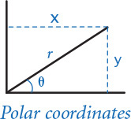
1.2.24 Gaussian random numbers. One way to generate a random number taken from the Gaussian distribution is to use the Box-Muller formula
w = sin(2 π v) (–2 ln u)1/2
where u and v are real numbers between 0 and 1 generated by the Math.random() method. Compose a program that writes a standard Gaussian random variable.
1.2.25 Order check. Compose a program that accepts three floats x, y, and z as command-line arguments and writes True if the values are strictly ascending or descending (x < y < z or x > y > z), and False otherwise.
1.2.26 Day of the week. Compose a program that accepts a date as input and writes the day of the week that date falls on. Your program should accept three command-line arguments: m (month), d (day), and y (year). For m, use 1 for January, 2 for February, and so forth. For output, write 0 for Sunday, 1 for Monday, 2 for Tuesday, and so forth. Use the following formulas for the Gregorian calendar:
y0 = y – (14 – m) / 12
x = y0 + y0 /4 – y0 /100 + y0 /400
m0 = m + 12 × ((14 – m) / 12) – 2
d0 = (d + x + (31×m0)/12) % 7
Example: On what day of the week was February 14, 2000?
y0 = 2000 – 1 = 1999
x = 1999 + 1999/4 – 1999/100 + 1999/400 = 2483
m0 = 2 + 12×1 – 2 = 12
d0 = (14 + 2483 + (31×12) / 12) % 7 = 2500 % 7 = 1 (Monday)
1.2.27 Uniform random numbers. Compose a program that writes five uniform random floats between 0.0 and 1.0, their average value, and their minimum and maximum values. Use the built-in min() and max() functions.
1.2.28 Mercator projection. The Mercator projection is a conformal (angle preserving) projection that maps latitude φ and longitude λ to rectangular coordinates (x, y). It is widely used—for example, in nautical charts and in the maps that you print from the web. The projection is defined by the equations x = λ – λ0 and y = 1/2 ln ((1 + sin φ) / (1 – sin φ)), where λ0 is the longitude of the point in the center of the map. Compose a program that accepts λ0 and the latitude and longitude of a point from the command line and writes its projection.
1.2.29 Color conversion. Several different formats are used to represent color. For example, the primary format for LCD displays, digital cameras, and web pages, known as the RGB format, specifies the level of red (R), green (G), and blue (B) on an integer scale from 0 to 255. The primary format for publishing books and magazines, known as the CMYK format, specifies the level of cyan (C), magenta (M), yellow (Y), and black (K) on a real scale from 0.0 to 1.0. Compose a program that converts RGB to CMYK. Accept three integers—r, g, and b—from the command line and write the equivalent CMYK values. If the RGB values are all 0, then the CMY values are all 0 and the K value is 1; otherwise, use these formulas:
w = max (r / 255, g / 255, b / 255)
c = (w – (r / 255)) / w
m = (w – (g / 255)) / w
y = (w – (b / 255)) / w
k = 1 – w
1.2.30 Great circle. Compose a program that accepts four floats as command-line arguments—x1, y1, x2, and y2—(the latitude and longitude, in degrees, of two points on the earth) and writes the great-circle distance between them. The great-circle distance d (in nautical miles) is given by the following equation:
d = 60 arccos(sin(x1) sin(x2) + cos(x1) cos(x2) cos(y1 – y2))
Note that this equation uses degrees, whereas Python’s trigonometric functions use radians. Use math.radians() and math.degrees() to convert between the two. Use your program to compute the great-circle distance between Paris (48.87° N and –2.33° W) and San Francisco (37.8° N and 122.4° W).
1.2.31 Three-sort. Compose a program that takes three integers from the command line and writes them in ascending order. Use the built-in min() and max() functions.
1.2.32 Dragon curves. Compose a program to write the instructions for drawing the dragon curves of order 0 through 5. The instructions are strings of F, L, and R characters, where F means “draw line while moving 1 unit forward,” L means “turn left,” and R means “turn right.” A dragon curve of order n is formed when you fold a strip of paper in half n times, then unfold it to right angles. The key to solving this problem is to note that a curve of order n is a curve of order n–1 followed by an L followed by a curve of order n–1 traversed in reverse order, and then to figure out a similar description for the reverse curve.
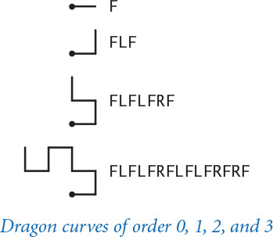

1.3 Conditionals and Loops
In the programs that we have examined to this point, each of the statements in the program is executed once, in the order given. Most programs are more complicated because the sequence of statements and the number of times each is executed can vary. We use the term control flow to refer to statement sequencing in a program. In this section, we introduce statements that allow us to change the control flow, using logic about the values of program variables. This feature is an essential component of programming.
1.3.1 Flipping a fair coin
1.3.2 Your first loop
1.3.3 Computing powers of 2
1.3.4 Your first nested loops
1.3.5 Harmonic numbers
1.3.6 Newton’s method
1.3.7 Converting to binary
1.3.8 Gambler’s ruin simulation
1.3.9 Factoring integers
Programs in this section
Specifically, we consider Python statements that implement conditionals, where some other statements may or may not be executed depending on certain conditions, and loops, where some other statements may be executed multiple times, again depending on certain conditions. As you will see in numerous examples in this section, conditionals and loops truly harness the power of the computer and will equip you to compose programs to accomplish a broad variety of tasks that you could not contemplate attempting without a computer.

If statements
Most computations require different actions for different inputs. One way to express these differences in Python is the if statement:
if <boolean expression>:
<statement>
<statement>
...
This description introduces a formal notation known as a template that we will use to specify the format of Python constructs. We put within angle brackets (< >) a construct that we have already defined, to indicate that we can use any instance of that construct where specified. In this case, <boolean expression> represents an expression that evaluates to a boolean, such as one involving a comparison operation, and <statement> represents a statement (each occurrence may represent a different statement). It is possible to make formal definitions of <boolean expression> and <statement>, but we refrain from going into that level of detail. The meaning of an if statement is self-explanatory: Python executes the indented statement(s) if and only if the boolean expression evaluates to True. We refer to the indented lines as a block. The first unindented line marks the end of the block. Most Python programmers indent by four spaces.
As a simple example, suppose that you want to compute the absolute value of an integer x. This code does the job:
if x < 0:
x = -x
(Precisely, if the value of the object referenced by x is negative, it changes x to refer to a new object whose value is the absolute value of that value.)
As a second simple example, consider the following code:
if x > y:
temp = x
x = y
y = temp
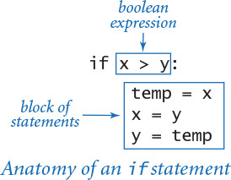
This code puts x and y in ascending order, by exchanging references if necessary.
Most other modern programming languages use some different mechanism to denote statement blocks (such as enclosing statements in matching curly braces). In Python the amount of indentation on each line is consequential, so you need to pay attention to it. For example, contrast these two code fragments, which have slightly different indentation.
Click here to view code image
if x >= 0: if x >= 0:
stdout.write('not ') stdout.write('not ')
stdout.writeln('negative') stdout.writeln('negative')
The code on the left is an if statement with a one-statement block followed by another statement; the code on the right is an if statement with a two-statement block. If x is greater than or equal to 0, then both fragments write not negative. In contrast, if x is less than 0, then the code on the left writes negative but the code on the right writes nothing at all.

Else clauses
You can add an else clause to an if statement, to express the concept of executing either one statement (or block of statements) or another, depending on whether the boolean expression is True or False, as in this template:
if <boolean expression>:
<block of statements>
else:
<block of statements>
As a simple example of the need for an else clause, the following code assigns the maximum of two int values to the variable maximum. (Alternatively, you can achieve the same result by calling the built-in function max().)
if x > y:
maximum = x
else:
maximum = y
When an if or else block contains only a single statement, for brevity, you can put that statement on the same line as the keyword if or else, as in the third and fourth rows in the table below.
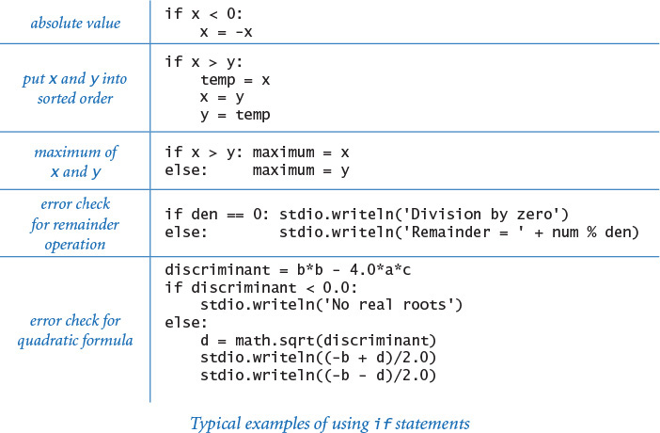
Program 1.3.1 Flipping a fair coin (flip.py)
Click here to view code image
import random
import stdio
if random.randrange(0, 2) == 0:
stdio.writeln('Heads')
else:
stdio.writeln('Tails')
This program simulates a fair coin flip by writing Heads or Tails, depending on the outcome of random.randrange(). A sequence of flips will have many of the same properties as a sequence that you would get by flipping a fair coin, but it is not a truly random sequence.
% python flip.py
Heads
% python flip.py
Tails
% python flip.py
Tails
The table on the facing page summarizes these and gives two other examples of the use of if and if-else statements. These examples are typical of simple calculations you might need in programs that you compose. Conditional statements are an essential part of programming. As the semantics (meaning) of statements like these is similar to their meanings as natural-language phrases, you will quickly grow used to them.
PROGRAM 1.3.1 (flip.py) is another example of the use of the if-else statement, in this case for the task of simulating a fair coin flip. The body of the program is a single statement, like the other considered so far, but it is worthy of special attention because it introduces an interesting philosophical issue that is valuable to contemplate: can a computer program produce random values? Certainly not, but a program can produce values that have many of the properties of random values.
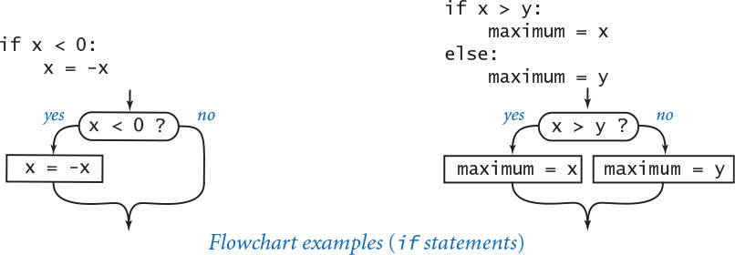
One way to understand control flow is to visualize it with a diagram called a flowchart. Paths through the flowchart correspond to flow-of-control paths in the program. In the early days of computing, when programmers used low-level languages and difficult-to-understand flows of control, flowcharts were an essential part of programming. With modern languages, we use flowcharts just to understand basic building blocks like the if statement.

While statements
Many computations are inherently repetitive. The basic Python construct for handling such computations has the following format:
while <boolean expression>:
<statement 1>
<statement 2>
...
The while statement has the same form as the if statement (the only difference being the use of the keyword while instead of if), but the meaning is quite different. It is an instruction to the computer to behave as follows: if the boolean expression evaluates to False, do nothing; if the expression evaluates to True, execute the block of statements in sequence (just as with if) but then check the expression again, execute the sequence of statements again if the expression evaluates to True, and continue as long as the expression evaluates to True. Thus the flow of control “loops back” to the boolean expression repeatedly. This loop back is evident at the left of the flowchart. (The while statement in this diagram is taken from PROGRAM 1.3.2, which we will examine shortly.) We say that the while statement implements a loop. We refer to the indented statement block within a while statement as the body of the loop and to the boolean expression as the loop-continuation condition. The loop-continuation condition is typically a test about the value of some variable(s), so each while loop is typically preceded by initialization code that sets initial value(s).
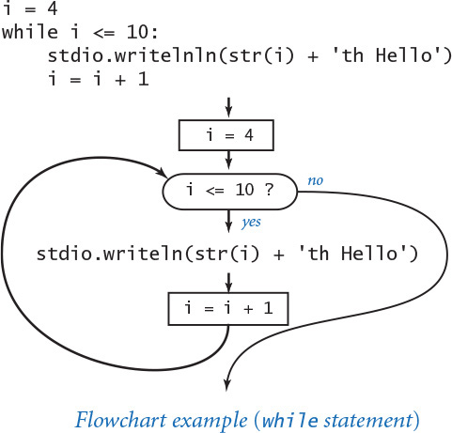
The while statement is equivalent to a sequence of identical if statements:
if <boolean expression>:
<statement 1>
<statement 2>
...
if <boolean expression>:
<statement 1>
<statement 2>
...
if <boolean expression>:
<statement 1>
<statement 2>
...
...
The body of the loop should change one or more variables to make the loop-continuation condition eventually evaluate to False, so that the sequence is broken and the loop terminates.
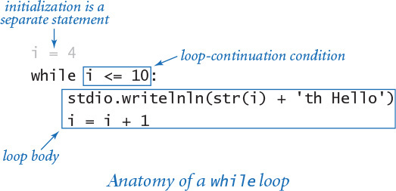
A common programming paradigm involves maintaining an integer value that keeps track of the number of times a loop iterates. We start at some initial value, and then increment the value by 1 each time through the loop, testing whether it exceeds a predetermined maximum before deciding to continue. PROGRAM 1.3.2 (tenhellos.py) is a simple example of this paradigm that uses a while statement. The key to the computation is the statement
i = i + 1
Program 1.3.2 Your first loop (tenhellos.py)
Click here to view code image
import stdio
stdio.writeln('1st Hello')
stdio.writeln('2nd Hello')
stdio.writeln('3rd Hello')
i = 4
while i <= 10:
stdio.writeln(str(i) + 'th Hello')
i = i + 1
i | loop control counter
This program writes 10 “hellos.” It accomplishes that by using a while loop. After the third line to be written, the lines differ only in the index counting the line written, so we define a variable i to contain that index. After initializing i to 4, we enter into a while loop where we use the i in the stdio.writeln() function call and increment it each time through the loop. After the program writes 10th Hello, i becomes 11 and the loop terminates.
% python tenhellos.py
1st Hello
2nd Hello
3rd Hello
4th Hello
5th Hello
6th Hello
7th Hello
8th Hello
9th Hello
10th Hello
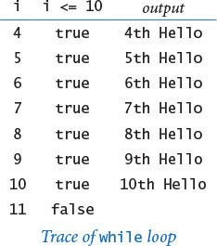
As a mathematical equation, this statement is nonsense, but as a Python assignment statement it makes perfect sense: it says to compute the value i + 1 and then assign the result to the variable i. If i is 4 before the statement executed, then it is 5 afterward; if i is 5 before the statement executes, then it is 6 afterward; and so forth. With the initial condition in tenhellos.py that i starts at 4, the statement block is executed seven times until the sequence is broken, when i finally is greater than 10.
Using the while statement is barely worthwhile for this simple task, but you will soon be addressing tasks where you will need to specify that statements be repeated far too many times to contemplate doing it without loops. There is a profound difference between programs with while statements and programs without them, because while statements allow us to specify a potentially unlimited number of statements to be executed in a program. In particular, the while statement allows us to specify lengthy computations in short programs. This ability opens the door to composing programs for tasks that we could not contemplate addressing without a computer. But there is also a price to pay: as your programs become more sophisticated, they become more difficult to understand.
PROGRAM 1.3.3 (powersoftwo.py) uses a while statement to write a table of the powers of 2. Beyond the loop control counter i, it maintains a variable power that holds the powers of 2 as it computes them. The loop body contains three statements: one to write the current power of 2, one to compute the next power of 2 (multiply the current one by 2), and one to increment the loop control counter.
Incidentally, there are many situations in computer science where it is useful to be familiar with powers of 2. You should know at least the first 10 values in this table and you should note that 210 is about 1,000, 220 is about 1 million, and 230 is about 1 billion.
PROGRAM 1.3.3 is a prototype for many useful computations. By varying the computations that change the accumulated value and the way that the loop control variable is incremented, we can write tables of a variety of functions (see EXERCISE 1.3.10).
It is worthwhile to carefully examine the behavior of programs that use loops by studying a trace of the program. For example, a trace of the operation of powersoftwo.py should show the value of each variable before each iteration of the loop and the value of the conditional expression that controls the loop. Tracing the operation of a loop can be very tedious, but it is nearly always worthwhile to run a trace because it clearly exposes what a program is doing.
Program 1.3.3 Computing powers of 2 (powersoftwo.py)
Click here to view code image
import sys
import stdio
n = int(sys.argv[1])
power = 1
i = 0
while i <= n:
# Write the ith power of 2.
stdio.writeln(str(i) + ' ' + str(power))
power = 2 * power
i = i + 1
n | loop termination value
i | loop control counter
power | current power of 2
This program accepts an integer n as command-line argument and writes a table containing the first n powers of 2. Each time through the loop, we increment i and double power. We show only the first three and the last three lines of the table; the program write n + 1 lines.
% python powersoftwo.py 5
0 1
1 2
2 4
3 8
4 16
5 32
% python powersoftwo.py 29
0 1
1 2
2 4
...
27 134217728
28 268435456
29 536870912
PROGRAM 1.3.3 is nearly a self-tracing program, because it writes the values of its variables each time through the loop. You can make any program produce a trace of itself by adding appropriate stdio.writeln() statements. Modern programming environments provide sophisticated tools for tracing, but this tried-and-true method is simple and effective. You certainly should add stdio.writeln() statements to the first few loops that you compose, to be sure that they are doing precisely what you expect.
As a more complicated example, suppose that we want to compute the largest power of 2 that is less than or equal to a given positive integer n. If n is 13 we want the result 8; if n is 1000, we want the result 512; if n is 64, we want the result 64; and so forth. This computation is simple to perform with a while loop:
power = 1
while 2*power <= n:
power = 2*power
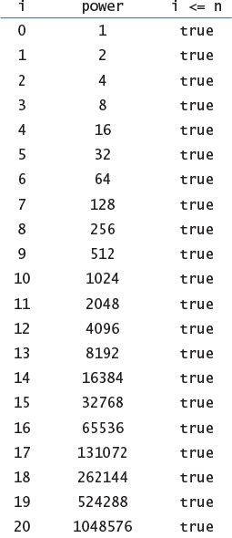
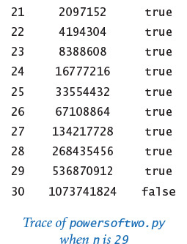
It takes some thought to convince yourself that this simple piece of code produces the desired result. You can do so by making these observations:
• power is always a power of 2.
• power is never greater than n.
• power increases each time through the loop, so the loop must terminate.
• After the loop terminates, 2*power is greater than n.
Reasoning of this sort is often important in understanding how while loops work. Even though many of the loops you will compose are much simpler than this one, you should verify for yourself that each loop you compose will behave as you expect.
The logic behind such arguments is the same whether the loop iterates just a few times, as in tenhellos.py; dozens of times, as in powersoftwo.py; or millions of times, as in several examples that we will soon consider. That leap from a few tiny cases to a huge computation is profound. When composing loops, understanding how the values of the variables change each time through the loop (and checking that understanding by adding statements to trace their values and running the program for a small number of iterations) is essential. Having done so, you can confidently remove those training wheels and truly unleash the power of the computer.

Shorthand assignment notation
Modifying a variable is something that we do so often in programming that modern programming languages like Python provide shorthand notations for the purpose. The most common practice is to abbreviate an assignment statement of the form i = i + 1 with the shorthand notation i += 1. The same notation works for other binary operators, including -, *, and /. For example, most programmers would use power *= 2 instead of power = 2 * power in PROGRAM 1.3.3. Such shortcuts came into widespread use with the C programming language in the 1970s and have become standard. They have survived the test of time because they lead to compact, elegant, and easy-to-understand programs. From this point forward, we will use such augmented assignment statements in our programs whenever possible.

For statements
As you will see, the while statement allows us to compose programs for all manner of applications. Before considering more examples, we will look at an alternative Python construct—the for statement—that allows us even more flexibility when composing programs with loops. This alternative notation is not fundamentally different from the basic while statement, but it often allows us to compose more compact and more readable programs than if we used only while statements.
As noted previously, we often need to design a loop that uses an integer to keep track of the number of times the loop iterates. We initially assign some integer to the variable, and then each time through the loop assign to the variable the integer that is one larger than the previous integer, testing whether the integer exceeds a predetermined maximum before deciding to continue. We call such a loop a counting loop.
In Python, we might implement a counting loop with a while statement using this code pattern:
<variable> = <start>
while <variable> < <stop>:
<block of statements>
<variable> += 1
The for statement is a more succinct way to implement a counting loop. In Python, the for statement has several formats. For now, we consider the following template:
Click here to view code image
for <variable> in range(<start>, <stop>):
<block of statements>
The <start> and <stop> arguments to the built-in range() function must be integers. When given a statement of this form, Python executes the indented block of statements repeatedly. The first time through the loop <variable> is <start>, the second time <variable> is <start> + 1, and so forth. The final time <variable> is <stop> - 1. In short, a for statement executes its indented statement repeatedly, with <variable> ranging from the integer <start> to the integer <stop> - 1, inclusive. For example, these lines of tenhellos.py (PROGRAM 1.3.2):
Click here to view code image
i = 4
while i <= 10:
stdio.writeln(str(i) + 'th Hello')
i = i + 1
can be expressed more succinctly using this for statement:
Click here to view code image
for i in range(4, 11):
stdio.writeln(str(i) + 'th Hello')
If range() has only one argument—that is, the <stop> value—then the <start> value defaults to 0. For example, the following for loop
Click here to view code image
power = 1
for i in range(n+1):
stdio.writeln(str(i) + ' ' + str(power))
power *= 2
is an improvement over the while loop in powersoftwo.py (PROGRAM 1.3.3).
Choosing among different formulations of the same computation is a matter of each programmer’s taste, as when a writer picks from among synonyms or chooses between using active and passive voice when composing a sentence. You will not find good hard-and-fast rules on how to compose a program any more than you will find such rules on how to compose a paragraph. Your goal should be to find a style that suits you, gets the computation done, and can be appreciated by others. Generally, in this book we use for statements for counting loops, and while statements for other kinds of loops.
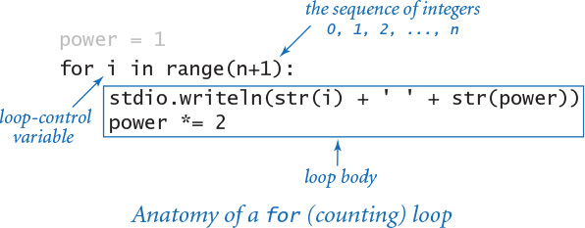
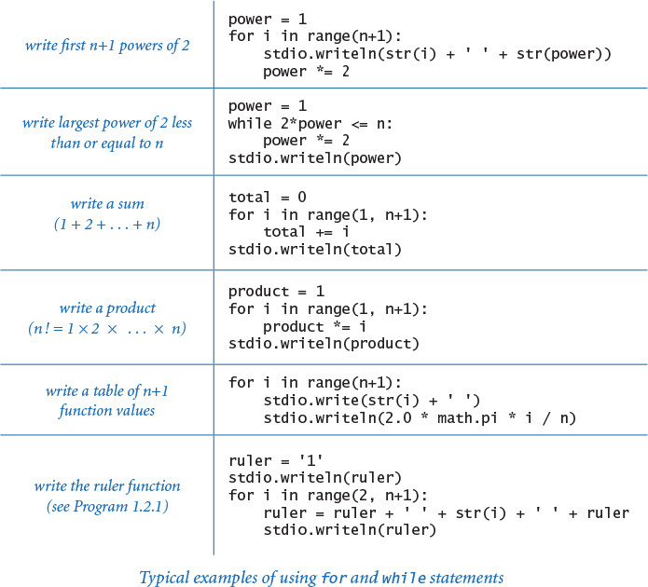
The preceding table includes several code fragments with typical examples of loops used in Python code. Some of these relate to code that you have already seen; others are new code for straightforward computations. To cement your understanding of loops in Python, put each of these code snippets into a program that takes an integer n from the command line (like powersoftwo.py) and run it. Then, compose some loops of your own to perform for similar computations of your own invention, or do some of the early exercises at the end of this section. There is no substitute for the experience gained by running code that you compose yourself, and it is imperative that you develop an understanding of how to compose code that uses loops.

Nesting
The if, while, and for statements have the same status as assignment statements or any other statements in Python. That is, we can use them whenever a statement is called for. In particular, we can nest one or more of them in the body of another. As a first example, divisorpattern.py (PROGRAM 1.3.4) has a for loop whose statements are a for loop (whose statement is an if statement) and a stdio.writeln() statement. It writes a pattern of asterisks where the ith row has an asterisk in each position corresponding to divisors of i (the same holds true for the columns).
PROGRAM 1.3.4 has a complicated control flow, as you can see from its flowchart (shown below). To derive a flowchart like this, it is best to work with a statement-by-statement version of the computation that uses while loops (see EXERCISE 1.3.15), because the for loop version masks the details. This diagram illustrates the importance of using a limited number of simple control structures in programming. With nesting, you can compose loops and conditionals to build programs that are easy to understand even though they may have a complicated control flow. A great many useful computations can be accomplished with just one or two levels of nesting. For example, many programs in this book have the same general structure as divisorpattern.py.
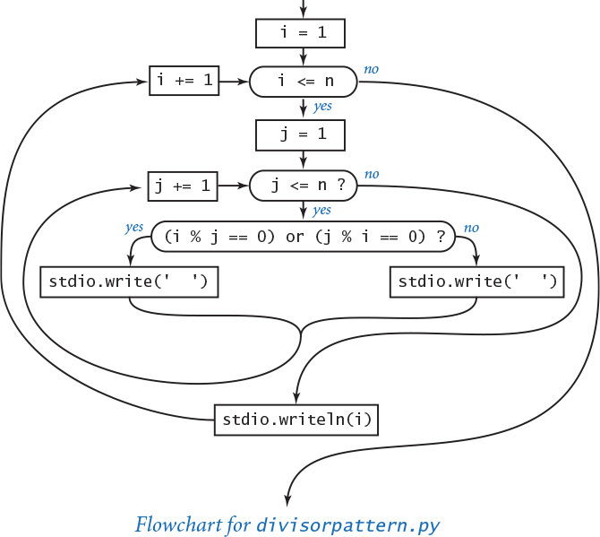
Program 1.3.4 Your first nested loops (divisorpattern.py)
Click here to view code image
import sys
import stdio
n = int(sys.argv[1])
for i in range(1, n+1):
# Write the ith line.
for j in range(1, n+1):
# Write the jth entry in the ith line.
if (i % j == 0) or (j % i == 0):
stdio.write('* ')
else:
stdio.write(' ')
stdio.writeln(i)
n | number of rows and columns
i | row index
j | column index
This program accepts an integer command-line argument n and writes an n-by-n table with an asterisk in row i and column j if either i divides j or j divides i. The program uses nested for loops. The loop control variables i and j control the computation.
Click here to view code image
% python divisorpattern.py 3
* * * 1
* * 2
* * 3
% python divisorpattern.py 16
* * * * * * * * * * * * * * * * 1
* * * * * * * * * 2
* * * * * * 3
* * * * * * 4
* * * * 5
* * * * * 6
* * * 7
* * * * * 8
* * * 9
* * * * 10
* * 11
* * * * * * 12
* * 13
* * * * 14
* * * * 15
* * * * * 16
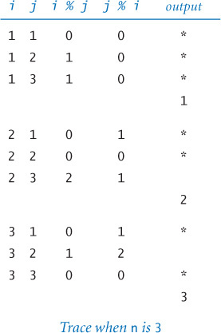
To indicate the nesting, we use indentation in the program code. Again, the indentation is significant in Python (many other programming languages require curly braces or some other notation to indicate nesting). In PROGRAM 1.3.4, we refer to the i loop as the outer loop and the j loop as the inner loop. The inner loop iterates all the way through for each iteration of the outer loop. As usual, the best way to understand a new programming construct like this is to study a trace.
As a second example of nesting, consider a tax preparation program that computes income tax rates. People with no income (or less) pay no income tax; people with income of $0 or more but less than $8,925 pay 10 percent; people with income of $8,925 or more but less than $36,250 pay 15 percent; and so forth. We might accomplish this by using if statements with else clauses, one nested within another:
Click here to view code image
if income < 0.0:
rate = 0.00
else:
if income < 8925:
rate = 0.10
else:
if income < 36250:
rate = 0.15
else:
if income < 87850:
rate = 0.25
...
In this application, the level of nesting becomes so deep that it makes the code hard to understand. Choosing among several mutually exclusive alternatives in this way is such a common task that an alternative that avoids this deep nesting is appropriate. The Python construct for this purpose is a generalized if statement that allows any number of “else if” clauses of the form
elif <boolean expression>:
<block of statements>
before the “else” clause. When an elif block contains only a single statement, you can put the statement on the same line as the elif keyword for brevity and clarity. With this construct, the code to compute a marginal tax rate is straightforward:
Click here to view code image
if income < 0: rate = 0.00
elif income < 8925: rate = 0.10
elif income < 36250: rate = 0.15
elif income < 87850: rate = 0.23
elif income < 183250: rate = 0.28
elif income < 398350: rate = 0.33
elif income < 400000: rate = 0.35
else: rate = 0.396
Python evaluates the boolean expressions sequence until reaching one that is True, when its corresponding block of statements is executed. Note that the final else is for the case where none of the conditions is satisfied (the tax rate for the rich, in this case). This construct is a special one that we use often.

Applications
The ability to program with conditionals and loops immediately opens up the full world of computation. To emphasize this fact, we next consider a variety of examples. These examples all involve working with the types of data that we considered in SECTION 1.2, but rest assured that the same mechanisms serve us well for any computational application. The programs are carefully crafted, and by studying and appreciating them, you will be prepared to compose your own programs containing loops.
The examples that we consider here involve computing with numbers. Several of our examples are tied to problems pondered by mathematicians and scientists over the past several centuries. While computers have existed for only 50 years or so, many of the computational methods that we use are based on a rich mathematical tradition tracing back to antiquity.

Finite sum
The computational paradigm used by powersoftwo.py is one that you will use frequently. It uses two variables—one as an index that controls a loop and the other to accumulate a computational result. PROGRAM 1.3.5 (harmonic.py) uses the same paradigm to evaluate the finite sum Hn = 1 + 1/2 + 1/3 + ... + 1/n. These numbers, which are known as the harmonic numbers, arise frequently in discrete mathematics. Harmonic numbers are the discrete analog of the logarithm. They also approximate the area under the curve y = 1/x. You can use PROGRAM 1.3.5 as a model for computing the values of other sums (see EXERCISE 1.3.16).
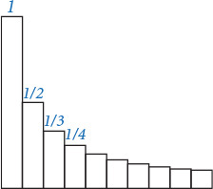
Program 1.3.5 Harmonic numbers (harmonic.py)
Click here to view code image
import sys
import stdio
n = int(sys.argv[1])
total = 0.0
for i in range(1, n+1):
# Add the ith term to the sum.
total += 1.0 / i
stdio.writeln(total)
n | number of terms in sum
i | loop control variable
total | cumulated sum
This program accepts integer n as a command-line argument and writes the nth harmonic number. The value is known from mathematical analysis to be about ln(n) + 0.57721 for large n. Note that ln(10,000) ≈ 9.21034.
% python harmonic.py 2
1.5
% python harmonic.py 10
2.9289682539682538
% python harmonic.py 10000
9.787606036044348

Computing the square root
How are functions in Python’s math module, such as math.sqrt(), implemented? PROGRAM 1.3.6 (sqrt.py) illustrates one technique. To compute the square root function, it uses an iterative computation that was known to the Babylonians over 4,000 years ago. It is also a special case of a general computational technique that was developed in the 17th century by Isaac Newton and Joseph Raphson and is widely known as Newton’s method. Under generous conditions on a given function f (x), Newton’s method is an effective way to find roots (values of x for which the function is 0). Start with an initial estimate, t0. Given the estimate ti, compute a new estimate by drawing a line tangent to the curve y = f (x) at the point (ti, f (ti)) and set ti+1 to the x-coordinate of the point where that line hits the x-axis. Iterating this process, we get closer to the root.
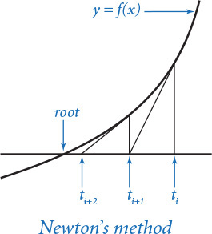
Computing the square root of a positive number c is equivalent to finding the positive root of the function f(x) = x2 – c. For this special case, Newton’s method amounts to the process implemented in sqrt.py (see PROGRAM 1.3.6 and EXERCISE 1.3.17). Start with the estimate t = c. If t is equal to c / t, then t is equal to the square root of c, so the computation is complete. If not, refine the estimate by replacing t with the average of t and c / t. With Newton’s method, we get the value of the square root of 2 accurate to 15 places in just 5 iterations of the loop.
Newton’s method is important in scientific computing because the same iterative approach is effective for finding the roots of a broad class of functions, including many for which analytic solutions are not known (so the Python math module would be no help). Nowadays, we take for granted that we can find whatever values we need of mathematical functions; before computers, scientists and engineers had to use tables or compute values by hand. Computational techniques that were developed to enable calculations by hand needed to be very efficient, so it is not surprising that many of those same techniques are effective when we use computers. Newton’s method is a classic example of this phenomenon.
Another useful approach for evaluating mathematical functions is to use Taylor series expansions (see EXERCISES 1.3.37 and 1.3.38). Evaluating trigonometric functions is a typical application.
Program 1.3.6 Newton’s method (sqrt.py)
Click here to view code image
import sys
import stdio
EPSILON = 1e-15
c = float(sys.argv[1])
t = c
while abs(t - c/t) > (EPSILON * t):
# Replace t by the average of t and c/t.
t = (c/t + t) / 2.0
stdio.writeln(t)
c | argument
EPSILON | error tolerance
t | estimate of c
This program accepts a positive float c as a command-line argument, and writes the square root of c to 15 decimal places of accuracy. It uses Newton’s method (see text) to compute the square root.
% python sqrt.py 2.0
1.414213562373095
% python sqrt.py 2544545
1595.1630010754388
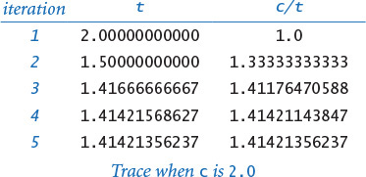
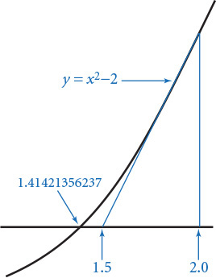

Number conversion
PROGRAM 1.3.7 (binary.py) writes the binary (base 2) representation of the decimal number typed as the command-line argument. It is based on decomposing a number into a sum of powers of 2. For example, the binary representation of 19 is 10011, which is the same as saying that 19 = 16 + 2 + 1. To compute the binary representation of n, we consider the powers of 2 less than or equal to n in decreasing order to determine which belong in the binary decomposition (and therefore correspond to a 1 bit in the binary representation). This process corresponds precisely to using a balance scale to weigh an object, using weights whose values are powers of 2. First, we find the largest weight not heavier than the object. Then, considering the weights in decreasing order, we add each weight to test whether the object is lighter. If so, we remove the weight; if not, we leave the weight and try the next one. Each weight corresponds to a bit in the binary representation of the weight of the object: leaving a weight corresponds to a 1 bit in the binary representation of the object’s weight, and removing a weight corresponds to a 0 bit in the binary representation of the object’s weight.
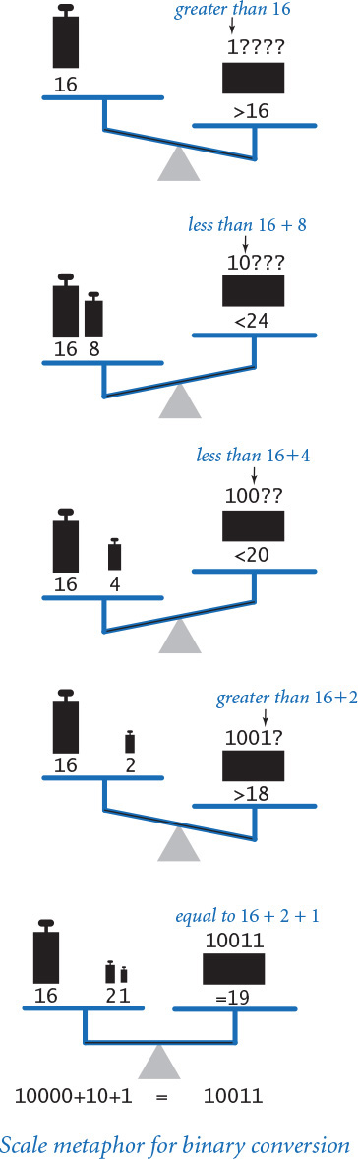
In binary.py, the variable v corresponds to the current weight being tested, and the variable n accounts for the excess (unknown) part of the object’s weight (to simulate leaving a weight on the balance, we just subtract that weight from n). The value of v decreases through the powers of 2. When v is larger than n, binary.py writes 0; otherwise, it writes 1 and subtracts v from n. As usual, a trace (of the values of n, v, n < v, and the output bit for each loop iteration) can be very useful in helping you to understand the program. Read from top to bottom in the rightmost column of the trace, the output is 10011—the binary representation of 19.
Program 1.3.7 Converting to binary (binary.py)
Click here to view code image
import sys
import stdio
n = int(sys.argv[1])
# Compute v as the largest power of 2 <= n.
v = 1
while v <= n // 2:
v *= 2
# Cast out powers of 2 in decreasing order.
while v > 0:
if n < v:
stdio.write(0)
else:
stdio.write(1)
n -= v
v //= 2
stdio.writeln()
v | current power of 2
n | current excess
This program writes the binary representation of a positive integer given as the command-line argument, by casting out powers of 2 in decreasing order (see text).
% python binary.py 19
10011
% python binary.py 255
11111111
% python binary.py 512
100000000
% python binary.py 100000000
101111101011110000100000000
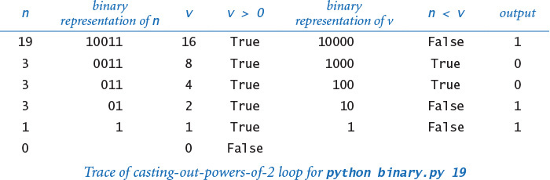
Converting data from one representation to another is a frequent theme in composing computer programs. Thinking about conversion emphasizes the distinction between an abstraction (an integer like the number of hours in a day) and a representation of that abstraction (24 or 11000). The irony here is that the computer’s representation of an integer is actually based on its binary representation.

Monte Carlo simulation
Our next example is different in character from the ones we have been considering, but it is representative of a common situation where we use computers to simulate what might happen in the real world so that we can make informed decisions. The specific example that we consider now is from a thoroughly studied class of problems known as gambler’s ruin. Suppose that a gambler makes a series of fair $1 bets, starting with some given initial stake. The gambler always goes broke eventually, but when we set other limits on the game, various questions arise. For example, suppose that the gambler decides ahead of time to walk away after reaching a certain goal. What are the chances that the gambler will win? How many bets might be needed to win or lose the game? What is the maximum amount of money that the gambler will have during the course of the game?
PROGRAM 1.3.8 (gambler.py) is a simulation that can help answer these questions. It performs a sequence of trials, using random.randrange() to simulate the sequence of bets, continuing until the gambler is broke or the goal is reached, and keeping track of the number of wins and the number of bets. After running the experiment for the specified number of trials, the program averages and writes the results. You might wish to run this program for various command-line arguments—not necessarily just to plan your next trip to the casino, but to help you think about the following questions: Is the simulation an accurate reflection of what would happen in real life? How many trials are needed to get an accurate answer? What are the computational limits on performing such a simulation? Simulations are widely used in applications in economics, science, and engineering, and questions of this sort are important in any simulation.
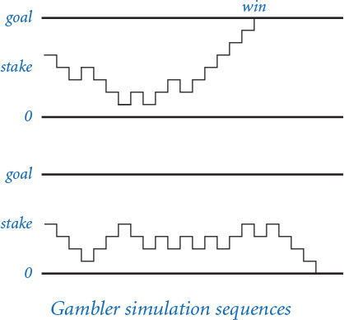
Program 1.3.8 Gambler’s ruin simulation (gambler.py)
Click here to view code image
import random
import sys
import stdio
stake = int(sys.argv[1])
goal = int(sys.argv[2])
trials = int(sys.argv[3])
bets = 0
wins = 0
for t in range(trials):
# Run one experiment.
cash = stake
while (cash > 0) and (cash < goal):
# Simulate one bet.
bets += 1
if random.randrange(0, 2) == 0:
cash += 1
else:
cash -= 1
if cash == goal:
wins += 1
stdio.writeln(str(100 * wins // trials) + '% wins')
stdio.writeln('Avg # bets: ' + str(bets // trials))
stake | initial stake
goal | walkaway goal
trials | number of trials
bets | bet count
wins | win count
cash | cash on hand
Click here to view code image
% python gambler.py 10 20 1000
50% wins
Avg # bets: 100
% python gambler.py 50 250 100
19% wins
Avg # bets: 11050
% python gambler.py 500 2500 100
21% wins
Avg # bets: 998071
This program accepts integer command-line arguments stake, goal, and trials. It performs trials experiments, each of which starts with stake dollars and terminates on 0 dollars or goal. Then it writes the percentage of wins and the average number of bets per experiment. The inner while loop simulates a gambler with stake dollars who makes a series of $1 bets, continuing until going broke or reaching goal. The running time of this program is proportional to the total number of bets (trials times the average number of bets). For example, the last experiment shown causes nearly 100 million random numbers to be generated.
In the case of gambler.py, we are verifying classical results from probability theory, which say the probability of success is the ratio of the stake to the goal and that the expected number of bets is the product of the stake and the desired gain (the difference between the goal and the stake). For example, if you want to go to Monte Carlo and try to turn $500 into $2,500, you have a reasonable (20 percent) chance of success, but you should expect to make a million $1 bets! If you try to turn $1 into $1,000, you have a 0.1 percent chance and can expect to be done (ruined, most likely) in about 999 bets (on average).
Simulation and analysis go hand-in-hand, each validating the other. In practice, the value of simulation is that it can suggest answers to questions that might be too difficult to resolve with analysis. For example, suppose that our gambler, recognizing that there will never be enough time to make a million bets, decides ahead of time to set an upper limit on the number of bets. How much money can the gambler expect to take home in that case? You can address this question with an easy change to PROGRAM 1.3.8 (see EXERCISE 1.3.24), but addressing it with mathematical analysis is not so easy.

Factoring
A prime is an integer greater than 1 whose only positive divisors are 1 and itself. The prime factorization of an integer is the multiset of primes whose product is the integer. For example, 3757208 = 2*2*2*7*13*13*397. PROGRAM 1.3.9 (factors.py) computes the prime factorization of any given positive integer. In contrast to many of the other programs that we have seen (which we could do in a few minutes with a calculator or even a pencil and paper), this computation would not be feasible without a computer. How would you go about trying to find the factors of a number like 287994837222311? You might find the factor 17 quickly, but even with a calculator it would take you quite a while to find 1739347.
Although factors.py is compact and straightforward, it certainly will take some thought to convince yourself that it produces the desired result for any given integer. As usual, following a trace that shows the values of the variables at the beginning of each iteration of the outer for loop is a good way to understand the computation. For the case where n is initially 3757208, the inner while loop iterates three times when factor is 2, to remove the three factors of 2; then zero times when factor is 3, 4, 5, and 6, since none of those numbers divides 469651; and so forth.
Program 1.3.9 Factoring integers (factors.py)
Click here to view code image
import sys
import stdio
n = int(sys.argv[1])
factor = 2
while factor*factor <= n:
while (n % factor) == 0:
# Cast out and write factor.
n //= factor
stdio.write(str(factor) + ' ')
factor += 1
# Any factors of n are greater than or equal to factor.
if n > 1:
stdio.write(n)
stdio.writeln()
n | unfactored part
factor | potential factor
This program writes the prime factorization of any positive integer. The code is simple, but it takes some thought to convince oneself that it is correct (see text).
Click here to view code image
% python factors.py 3757208
2 2 2 7 13 13 397
% python factors.py 287994837222311
17 1739347 9739789
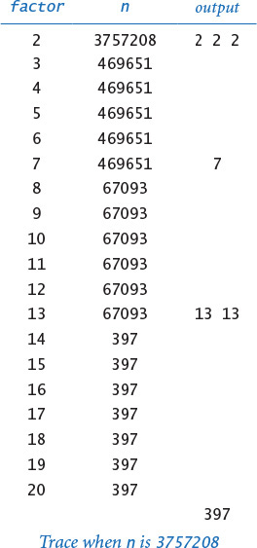
Tracing the program for a few example inputs clearly reveals its basic operation. To convince ourselves that the program will behave as expected for all inputs, we reason about what we expect each of the loops to do. The inner while loop clearly writes and removes from n all factors of factor. The key to understanding the program is to see that the following invariant holds at the beginning of each iteration of the outer while loop: n has no factors between 2 and factor-1. Thus, if factor is not prime, it will not divide n; if factor is prime, the while loop will do its job and the invariant will continue to hold. We can stop looking for factors when factor*factor is greater than n because if an integer n has a factor, it has one less than or equal to the square root of n.
In a more naïve implementation, we might simply have used the condition (factor < n) to terminate the outer loop. Even given the blinding speed of modern computers, such a decision would have a dramatic effect on the size of the numbers that we could factor. EXERCISE 1.3.26 encourages you to experiment with the program to explore the effectiveness of this simple change. On a computer that can do billions of operations per second, we could factor numbers on the order of 109 in a few seconds; with the (factor*factor <= n) test, we can factor numbers on the order of 1018 in a comparable amount of time. Loops give us the ability to solve difficult problems, but they also give us the ability to construct simple programs that run slowly, so we must always be cognizant of performance issues.
In modern applications such as cryptography, there are important situations where we wish to factor truly huge numbers (with, say, hundreds or thousands of digits). Even for experts, such a computation has so far turned out to be prohibitively difficult even with the use of a computer.

Loop and a half
Sometimes the loop we need does not fit neatly into the flow-control structure of either a for or while loop. For example, suppose we want a loop that repeatedly does the following: execute some sequence of statements, exit the loop if some loop-termination condition is satisfied, and execute some other sequence of statements. That is, we want to position the loop-control condition in the middle of the loop, not at the beginning. This is known as a loop and a half because you must go partway through the loop before reaching the loop-termination test. Python provides the break statement for this purpose. When Python executes a break statement, it immediately exits the (innermost) loop.
For example, consider the problem of generating points that are randomly distributed in the unit disk. We can call random.random() to generate x- and y-coordinates to get points that are randomly distributed in the 2-by-2 square centered at the origin. Most of these points fall within the unit disk, so we just reject those that do not. Since we always want to generate at least one point, we compose a while loop whose loop-continuation condition is always satisfied, generate the random point (x, y) in the 2-by-2 square, and use a break statement to terminate the loop if (x, y) is in the unit disk.
Click here to view code image
while True:
x = 1.0 + 2.0*random.random()
y = 1.0 + 2.0*random.random()
if x*x + y*y <= 1.0:
break
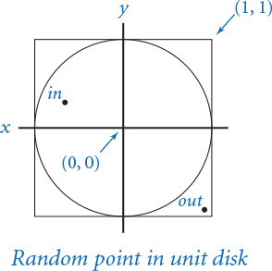
Since the area of the unit disk is π and the area of the square is 4, the expected number of times the loop is iterated is 4/π (about 1.27).
Experts debate the merits of such internal exits from a loop. When misused, break statements can complicate the flow of control for a loop. However, in situations like this one, alternatives can be complicated (see EXERCISE 1.3.30). Some languages provide a “do–while” statement specifically to handle such cases. In Python, we recommend judicious use of a break statement, when necessary.

Infinite loops
Before you compose programs that use loops, you need to think about the following issue: what if the loop-continuation condition in a while loop is always satisfied? With the statements that you have learned so far, one of two bad things could happen, both of which you need to learn to cope with.
First, suppose that such a loop calls stdout.writeln(). For example, if the loop-continuation condition in tenhellos.py were i > 3 instead of i <= 10, it would always be True. What happens? Nowadays, we use write as an abstraction to mean display in a terminal window, and the result of attempting to display an unlimited number of lines in a terminal window depends on the operating system’s conventions. If your system is set up to have write mean print characters on a piece of paper, you might run out of paper or have to unplug the printer. In a terminal window, you need a “stop writing” operation. Before running programs with loops on your own, you should make sure that you know how to “pull the plug” on an infinite loop of stdout.writeln() calls and then test out that strategy by making the change to tenhellos.py indicated previously and trying to stop it. On most systems, <Ctrl-c> means stop the current program and should do the job.
An infinite loop (with output)
import stdio
i = 4
while i > 3:
stdio.write(i)
stdio.writeln('th Hello')
i += 1
% python infiniteloop1.py
1st Hello
2nd Hello
3rd Hello
5th Hello
6th Hello
7th Hello
8th Hello
9th Hello
10th Hello
11th Hello
12th Hello
13th Hello
14th Hello
...
An infinite loop (with no output)
while True:
x = random.random()
y = random.random()
if x*x + y*y >= 2.0:
break
% python infiniteloop2.py
...
Second, nothing might happen. At least, nothing visible might happen. If your program has an infinite loop that does not produce any output, it will spin through the loop and you will see no results at all. The program will appear to stall. When you find yourself in such a situation, you can inspect the loops to make sure that the loop-termination condition always happens, but the problem may not be easy to identify. One way to locate such a bug is to insert calls to stdout.writeln() to produce a trace. If these calls fall within an infinite loop, this strategy reduces the problem to the case discussed in the previous paragraph, but the output might give you a clue about what to do.
You might not know (or it might not matter) whether a loop is infinite or just very long. If you run gambler.py with arguments such as python gambler.py 100000 200000 100, you may not want to wait for the answer. Later, you will learn to be aware of and to estimate the running time of your programs. SECTION 4.1 introduces this topic.
Why not have Python detect infinite loops and warn us about them? You might be surprised to know that it is not possible to do so, in general. This counterintuitive fact is one of the fundamental results of theoretical computer science.

Summary
For reference, the accompanying table lists the programs that we have considered in this section. They are representative of the kinds of tasks we can address with short programs consisting of if, while, and for statements that process built-in types of data. These types of computations are an appropriate way to become familiar with the basic Python flow-of-control constructs. The time that you spend now working with as many such programs as you can will certainly pay off in the future.
To learn how to use conditionals and loops, you must practice composing and debugging programs with if, while, and for statements. The exercises at the end of this section provide many opportunities for you to begin this process. For each exercise, you will compose a Python program, then run and test it. All programmers know that it is unusual to have a program work as planned the first time it is run, so you will want to have an understanding of your program and an expectation of what it should do, step by step. At first, use explicit traces to check your understanding and expectation. As you gain experience, you will find yourself thinking in terms of what a trace might produce as you compose your loops. Ask yourself the following kinds of questions: What will be the values of the variables after the loop iterates the first time? The second time? The final time? Is there any way this program could get stuck in an infinite loop?
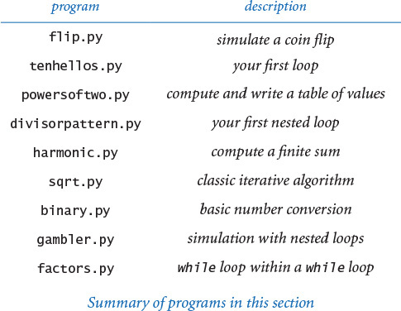
Loops and conditionals are a giant step in our ability to compute: if, while, and for statements take us from simple straight-line programs to an arbitrarily complicated flow of control. In the next several chapters, we will take more giant steps that will allow us to process large amounts of input data and to define and process types of data other than simple numeric types. The if, while, and for statements of this section will play an essential role in the programs that we consider as we take these steps.

Q&A
Q. What is the difference between = and ==?
A. We repeat this question here to remind you that you should not use = when you really mean == in a conditional expression. The statement x = y assigns y to x, whereas the expression x == y tests whether the two variables currently are equal. In some programming languages, this difference can wreak havoc in a program and be difficult to detect. In Python, assignment statements are not expressions. For example, if we were to make the mistake of typing cash = goal instead of cash == goal in PROGRAM 1.3.8, the compiler would find the bug for us:
Click here to view code image
% python gambler.py 10 20 1000
File "gambler.py", line 21
if cash = goal:
∧
SyntaxError: invalid syntax
Q. What happens if I leave out the colon in an if, while, or for statement?
A. Python raises a SyntaxError at compile time.
Q. What are the rules for indenting statement blocks?
A. Each statement in a block must have the same indentation; if it does not, Python will raise an IndentationError at compile time. Python programmers commonly use a four-space indentation scheme, which we follow throughout this book.
Q. Should I use tab characters to indent my code?
A. No, you should avoid placing tab characters in your .py files. Many editors, however, offer the option of automatically placing a sequence of spaces into your program when you type the <Tab> key; it’s appropriate to use that option when composing Python programs.
Q. Can I spread a long statement over multiple lines?
A. Yes, but some care is needed because of the way Python treats indentation. If the expression that spans multiple lines is enclosed inside parentheses (or square brackets or curly braces), then there is no need to do anything special. For example, this is a single statement that is spread over three lines:
Click here to view code image
stdio.write(a0 + a1 + a2 + a3 +
a4 + a5 + a6 + a7 +
a8 + a9)
However, if there is no implied line continuation, you must use the backslash character at the end of each line to be continued.
total = a0 + a1 + a2 + a3 + \
a4 + a5 + a6 + a7 + \
a8 + a9
Q. Suppose I want to skip over some of code in a loop in some cases, or suppose that I want the body of a conditional statement to be empty, so that no statement is executed. Does Python have language support for such things?
A. Yes, Python provides the continue and pass statements, respectively, for these conditions. However, situations in which they are really necessary are rare, and we do not use them in this book. Also, there is no switch statement in Python (for mutually exclusive alternatives), though one is commonly found in other languages, and no goto statement (for unstructured control flow).
Q. Can I use a non-boolean expression in an if or while statement?
A. Yes, but this is probably not a good idea. Expressions that evaluate to zero or the empty string are considered False; all other numeric and string expressions are considered True.
Q. Are there cases where I must use a for statement but not a while statement, or vice versa?
A. You can use a while statement to implement any kind of loop, but, as defined here, you can use a for statement only for the kind of loop that iterates over a finite sequence of integers. Later (SECTIONS 1.4, 3.3, and 4.4), we will consider other ways to use the for statement.
Q. Can I use the built-in range() function to create a sequence of integers with a step size of some value other than 1?
A. Yes, range() supports an optional third argument step, which defaults to 1. That is, range(start, stop, step) produces the sequence of integers start, start + step, start + 2 * step, and so forth. If step is a positive integer, the sequence continues as long as start + i * step is less than stop; if step is a negative integer, the sequence continues as long as start + i * step is greater than stop. For example, range(0, -100, -1) returns the integer sequence 0, -1, -2, ..., -99.
Q. Can I use floats as arguments to range()?
A. No, all arguments must be integers.
Q. Can I change the loop-index variable within a for loop?
A. Yes, but it will not affect the sequence of integers produced by range(). For example, the following loop writes the 100 integers from 0 to 99:
for i in range(100):
stdio.writeln(i)
i += 10
Q. In a for loop, what is the value of the loop-control variable after the loop terminates?
A. It is the last value of the loop-control variable during the loop. Upon termination of the for loop above, i refers to the integer 109. Using the loop-control variable after the termination of a for loop is generally considered poor style, so we do not do so in any of our programs.

Exercises
1.3.1 Compose a program that takes three integer command-line arguments and writes ‘equal' if all three are equal, and ‘not equal' otherwise.
1.3.2 Compose a more general and more robust version of quadratic.py (PROGRAM 1.2.4) that writes the roots of the polynomial ax2 + bx + c, writes an appropriate message if the discriminant is negative, and behaves appropriately (avoiding division by zero) if a is zero.
1.3.3 Compose a code fragment that takes two float command-line arguments and writes True if both are strictly between 0.0 and 1.0, and False otherwise.
1.3.4 Improve your solution to EXERCISE 1.2.22 by adding code to check that the values of the command-line arguments fall within the ranges of validity of the wind chill formula, as well as code to write an error message if that is not the case.
1.3.5 What is j after each of the following code fragments is executed?
a. j = 0
for i in range(j, 10):
j += i
b. j = 0
for i in range(10):
j += j
c. for j in range(10):
j += j
1.3.6 Redesign tenhellos.py to compose a program hellos.py that takes the number of lines to write as a command-line argument. You may assume that the argument is less than 1000. Hint: Use i % 10 and i % 100 to determine when to use st, nd, rd, or th for writing the ith Hello.
1.3.7 Compose a program fiveperline.py that, using one for loop and one if statement, writes the integers from 1,000 (inclusive) to 2,000 (exclusive) with five integers per line. Hint: Use the % operator.
1.3.8 Generalizing the “uniform random numbers” exercise from SECTION 1.2 (EXERCISE 1.2.27), compose a program stats.py that accepts an integer n as a command-line argument, uses random.random() to write n uniform random numbers between 0 and 1, and then writes their average value, their minimum value, and their maximum value.
1.3.9 In this section, we presented this code to implement the ruler function:
Click here to view code image
ruler = '1'
stdio.writeln(ruler)
for i in range(2, n+1):
ruler = ruler + ' ' + str(i) + ' ' + ruler
stdio.writeln(ruler)
Describe what happens when you run this code when n is too large—for example, when n is 100.
1.3.10 Compose a program functiongrowth.py that writes a table of the values log2 n, n, n loge n, n2, n3, and 2n for n = 2, 4, 8,16, 32, 64, ..., 2048. To line up columns, use tabs (\t characters).
1.3.11 What are m and n after the following code is executed?
n = 123456789
m = 0
while n != 0:
m = (10 * m) + (n % 10)
n /= 10
1.3.12 What does this code write?
f = 0
g = 1
for i in range(16):
stdio.writeln(f)
f = f + g
g = f - g
Solution: Even an expert programmer will tell you that the only way to understand a program like this is to trace it. When you do, you will find that it writes the values 0, 1, 1, 2, 3, 5, 8, 13, 21, 34, 55, 89, 134, 233, 377, and 610. These numbers are the first 16 of the famous Fibonacci sequence, which are defined by the following formulas: F0 = 0, F1 = 1, and Fn = Fn-1 + Fn-2 for n > 1. The Fibonacci sequence arises in a surprising variety of contexts; it has been studied for centuries, and many of its properties are well known. For example, the ratio of successive numbers approaches the golden ratio φ (about 1.618) as n approaches infinity.
1.3.13 Compose a program that takes a command-line argument n and writes all the positive powers of 2 less than or equal to n. Make sure that your program works properly for all values of n. (Your program should write nothing if n is negative.)
1.3.14 Expand your solution to the “Continuously compounded interest” exercise from SECTION 1.2 (EXERCISE 1.2.21) to write a table giving the total amount paid and the remaining principal after each monthly payment.
1.3.15 Compose a version of divisorpattern.py (PROGRAM 1.3.4) that uses while loops instead of for loops.
1.3.16 Unlike the harmonic numbers, the sum 1/12 + 1/22 + ... + 1/n2 does converge to a constant as n grows to infinity. (Indeed, the constant is π2/6, so this formula can be used to estimate the value of π.) Which of the following for loops computes this sum? Assume that n is the integer 1000000 and total is a float initialized to 0.0.
a. for i in range(1, n+1):
total += 1 / (i*i)
b. for i in range(1, n+1):
total += 1.0 / i*i
c. for i in range(1, n+1):
total += 1.0 / (i*i)
d. for i in range(1, n+1):
total += 1.0 / (1.0*i*i)
1.3.17 Show that sqrt.py (PROGRAM 1.3.6) implements Newton’s method for finding the square root of c. Hint: Use the fact that the slope of the tangent to a (differentiable) function f(x) at x = t is f’(t) to find the equation of the tangent line and then use that equation to find the point where the tangent line intersects the x-axis to show that you can use Newton’s method to find a root of any function as follows: at each iteration, replace the estimate t by t – f(t) / f’(t).
1.3.18 Using Newton’s method, develop a program that takes integers n and k as command-line arguments and writes the kth root of n (Hint: See EXERCISE 1.3.17.)
1.3.19 Modify binary.py to create a program kary.py that takes i and k as command-line arguments and converts i to base k. Assume that k is an integer between 2 and 16. For bases greater than 10, use the letters A through F to represent the 11th through 16th digits, respectively.
1.3.20 Compose a code fragment that puts the binary representation of a positive integer n into a String s.
Solution: Working from PROGRAM 1.3.7, we get the solution
s = ''
v = 1
while v <= n//2:
v *= 2
while v > 0:
if n < v:
s += '0'
else:
s += '1'
n -= v
v //= 2
A simpler option is to work from right to left:
s = ''
while n > 0:
s = str(n % 2) + s
n /= 2
Both of these methods are worthy of careful study.
1.3.21 Compose a version of gambler.py that uses two nested while loops or two nested for loops instead of a while loop inside a for loop.
1.3.22 Compose a program gamblerplot.py that traces a gambler’s ruin simulation by writing a line after each bet in which one asterisk corresponds to each dollar held by the gambler.
1.3.23 Modify gambler.py to take an extra command-line argument that specifies the (fixed) probability that the gambler wins each bet. Use your program to try to learn how this probability affects the chance of winning and the expected number of bets. Try a value of p close to 0.5 (say, 0.48).
1.3.24 Modify gambler.py to take an extra command-line argument that specifies the number of bets the gambler is willing to make, so that there are three possible ways for the game to end: the gambler wins, loses, or runs out of time. Add to the output to give the expected amount of money the gambler will have when the game ends. Extra credit: Use your program to plan your next trip to Monte Carlo.
1.3.25 Modify factors.py to write just one copy each of the prime divisors.
1.3.26 Run quick experiments to determine the impact of using the termination condition (i < n) instead of (i *i <= n) in factors.py (PROGRAM 1.3.9). For each method, find the largest n such that when you type in an n-digit number, the program is sure to finish within 10 seconds.
1.3.27 Compose a program checkerboard.py that takes one command-line argument n and uses a loop within a loop to write a two-dimensional n-by-n checkerboard pattern with alternating spaces and asterisks, like the following 5-by-5 pattern:
* * * * *
* * * *
* * * * *
* * * *
* * * * *
1.3.28 Compose a program gcd.py that finds the greatest common divisor (gcd) of two integers using Euclid’s algorithm, which is an iterative computation based on the following observation: if x is greater than y, then if y divides x, the gcd of x and y is y; otherwise, the gcd of x and y is the same as the gcd of x % y and y.
1.3.29 Compose a program relativelyprime.py that takes one command-line argument n and writes an n-by-n table such that there is an * in row i and column j if the gcd of i and j is 1 (i and j are relatively prime), and a space in that position otherwise.
1.3.30 Compose a program that generates a point that is randomly distributed in the unit disk, but without using a break statement. Compare your solution to the one given at the end of this section.
1.3.31 Compose a program that writes the coordinates of a random point (a, b, c) on the surface of a sphere. To generate such a point, use Marsaglia’s method: Start by picking a random point (x, y) in the unit disk using the method described at the end of this section. Then, set a to , b to , and c to 1– 2 (x2 + y2).

Creative Exercises
1.3.32 Ramanujan’s taxi. S. Ramanujan was an Indian mathematician who became famous for his intuition about numbers. When the English mathematician G. H. Hardy came to visit him in the hospital one day, Hardy remarked that the number of his taxi was 1729, a rather dull number. To which Ramanujan replied, “No, Hardy! No, Hardy! It is a very interesting number. It is the smallest number expressible as the sum of two cubes in two different ways.” Verify this claim by composing a program that takes a command-line argument n and writes all integers less than or equal to n that can be expressed as the sum of two cubes in two different ways. In other words, find distinct positive integers a, b, c, and d such that a3 + b3 = c3 + d3. Use four nested for loops.
1.3.33 Checksums. The International Standard Book Number (ISBN) is a 10-digit code that uniquely specifies a book. The rightmost digit is a checksum digit that can be uniquely determined from the other 9 digits, from the condition that d1 + 2d2 +3d3 + ... + 10d10 must be a multiple of 11 (here di denotes the ith digit from the right). The checksum digit di can be any value from 0 to 10: the ISBN convention is to use the character 'X' to denote 10. Example: The checksum digit corresponding to 020131452 is 5, because 5 is the only value of x between 0 and 10 for which
10·0 + 9·2 + 8·0 + 7·1 + 6·3 + 5·1 +4·4 +3·5 + 2·2 + 1·x
is a multiple of 11. Compose a program that takes a 9-digit integer as a command-line argument, computes the checksum, and writes the ISBN number.
1.3.34 Counting primes. Compose a program primecounter.py that takes a command-line argument n and writes the number of primes less than or equal to n. Use it to write the number of primes less than or equal to 10 million. Note: If you are not careful to make your program efficient, it may not finish in a reasonable amount of time. Later (in SECTION 1.4), you will learn about a more efficient way to perform this computation called the Sieve of Eratosthenes (see PROGRAM 1.4.3).
1.3.35 2D random walk. A two-dimensional random walk simulates the behavior of a particle moving in a grid of points. At each step, the random walker moves north, south, east, or west with probability equal to 1/4, independent of previous moves. Compose a program randomwalker.py that takes a command-line argument n and estimates how long it will take a random walker to hit the boundary of a 2n-by-2n square centered at the starting point.
1.3.36 Median-of-5. Compose a program that takes five distinct integers from the command line and writes the median value (the value such that two of the other integers are smaller and two are larger). Extra credit: Solve the problem with a program that compares values fewer than seven times for any given input.
1.3.37 Exponential function. Assume that x is a float. Compose a code fragment that uses the Taylor series expansion to assign ex = 1 + x + x2/2! + x3/3! + . . . to total.
Solution: The purpose of this exercise is to get you to think about how a library function like math.exp() might be implemented in terms of elementary operators. Try solving it, then compare your solution with the one developed here.
We start by considering the problem of computing one term. Suppose that x is a float and n is an integer. The following code assigns xn / n ! to term using the direct method of having one loop for the numerator and another loop for the denominator, then dividing the results:
num = 1.0
den = 1.0
for i in range(1, n+1):
num *= x
for i in range(1, n+1):
den *= i
term = num / den
A better approach is to use just a single for loop:
term = 1.0
for i in range(1, n+1):
term *= x / i
Besides being more compact and elegant, the latter solution is preferable because it avoids inaccuracies caused by computing with huge numbers. For example, the two-loop approach breaks down for values like x = 10 and n = 100 because 100! is too large to represent accurately as a float.
To compute ex, we nest this for loop within another for loop:
term = 1.0
total = 0.0
n = 1
while total != total + term:
total += term
term = 1.0
for i in range(1, n+1):
term *= x / i
n += 1
The number of times the while loop iterates depends on the relative values of the next term and the accumulated sum. Once total stops changing, we leave the loop. (This strategy is more efficient than using the termination condition (term > 0) because it avoids a significant number of iterations that do not change the value of the total.) This code is effective, but it is inefficient because the inner for loop recomputes all the values it computed on the previous iteration of the outer for loop. Instead, we can make use of the term that was added in on the previous loop iteration and solve the problem with a single while loop:
term = 1.0
total = 0.0
n = 1
while total != total + term:
total += term
term *= x/n
n += 1
1.3.38 Trigonometric functions. Compose programs sine.py and cosine.py that compute the sine and cosine functions using their Taylor series expansions sin x = x – x3/3! + x5/5! – ... and cos x = 1 – x2/2! + x4/4! – . . .
1.3.39 Experimental analysis. Run experiments to determine the relative costs of math.exp() and the three approaches from EXERCISE 1.3.37 for computing ex: the direct method with nested for loops, the improvement with a single while loop, and the latter with the termination condition (term > 0). Use trial-and-error with a command-line argument to determine how many times your computer can perform each computation in 10 seconds.
1.3.40 Pepys’s problem. In 1693 Samuel Pepys asked Isaac Newton which is more likely: getting 1 at least once when rolling a fair die six times or getting 1 at least twice when rolling it 12 times. Compose a program that could have provided Newton with a quick answer.
1.3.41 Game simulation. In the 1970s game show Let’s Make a Deal, a contestant is presented with three doors. Behind one of them is a valuable prize. After the contestant chooses a door, the host opens one of the other two doors (never revealing the prize, of course). The contestant is then given the opportunity to switch to the other unopened door. Should the contestant do so? Intuitively, it might seem that the contestant’s initial choice door and the other unopened door are equally likely to contain the prize, so there would be no incentive to switch. Compose a program montehall.py to test this intuition by simulation. Your program should take a command-line argument n, play the game n times using each of the two strategies (switch or do not switch), and write the chance of success for each of the two strategies.
1.3.42 Chaos. Compose a program to study the following simple model for population growth, which might be applied to study fish in a pond, bacteria in a test tube, or any of a host of similar situations. We suppose that the population ranges from 0 (extinct) to 1 (maximum population that can be sustained). If the population at time t is x, then we suppose the population at time t + 1 to be rx(1–x), where the parameter r, known as the fecundity parameter, controls the rate of growth. Start with a small population—say, x = 0.01—and study the result of iterating the model, for various values of r. For which values of r does the population stabilize at x = 1 – 1/r ? Can you say anything about the population when r is 3.5? 3.8? 5?
1.3.43 Euler’s sum-of-powers conjecture. In 1769 Leonhard Euler formulated a generalized version of Fermat’s Last Theorem, conjecturing that at least n nth powers are needed to obtain a sum that is itself an nth power, for n > 2. Compose a program to disprove Euler’s conjecture (which stood until 1967), using a quintuply nested loop to find four positive integers whose 5th power sums to the 5th power of another positive integer. That is, find five integers a, b, c, d, and e such that a5 + b5 + c5 + d5 = e5.

1.4 Arrays
In this section, we introduce you to the idea of a data structure and to your first data structure, the array. The primary purpose of an array is to facilitate storing and manipulating large quantities of data. Arrays play an essential role in many data processing tasks. They also correspond to vectors and matrices, which are widely used in science and in scientific programming. We will consider basic properties of array processing in Python, with many examples illustrating why arrays are useful.
1.4.1 Sampling without replacement
1.4.2 Coupon collector simulation
1.4.3 Sieve of Eratosthenes
1.4.4 Self-avoiding random walks
Programs in this section
A data structure is a way to organize data that we wish to process with a computer program. Data structures play an essential role in computer programming—indeed, CHAPTER 4 of this book is devoted to the study of classic data structures of all sorts.
A one-dimensional array (or array) is a data structure that stores a sequence of (references to) objects. We refer to the objects within an array as its elements. The method that we use to refer to elements in an array is numbering and then indexing them. If we have n elements in the sequence, we think of them as being numbered from 0 to n – 1. Then, we can unambiguously specify one of them by referring to the i th element for any integer i in this range.
A two-dimensional array is an array of (references to) one-dimensional arrays. Whereas the elements of a one-dimensional array are indexed by a single integer, the elements of a two-dimensional array are indexed by a pair of integers: the first specifying a row, and the second specifying a column.
Often, when we have a large amount of data to process, we first put all of the data into one or more arrays. Then we use indexing to refer to individual elements and to process the data. We might have exam scores, stock prices, nucleotides in a DNA strand, or characters in a book. Each of these examples involves a large number of objects that are all of the same type. We consider such applications when we discuss data input in SECTION 1.5 and in the case study that is the subject of SECTION 1.6. In this section, we expose the basic properties of arrays by considering examples where our programs first populate arrays with objects having computed values from experimental studies and then process them.

Arrays in Python
The simplest way to create an array in Python is to place comma-separated literals between matching square brackets. For example, the code
Click here to view code image
suits = ['Clubs', 'Diamonds', 'Hearts', 'Spades']
creates an array suits[] with four strings, and the code
x = [0.30, 0.60, 0.10]
y = [0.40, 0.10, 0.50]
creates two arrays x[] and y[], each with three floats. Each array is an object that contains data (references to objects) structured for efficient access. While the truth is a bit complicated (and explained in detail in SECTION 4.1), it is useful to think of references to the elements in an array as stored contiguously, one after the other, in your computer’s memory, as shown in the diagram at right for the suits[] array defined above.
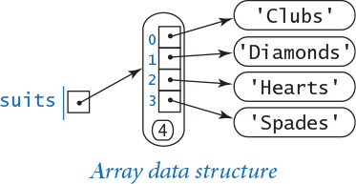
After creating an array, you can refer to any individual object anywhere you would use a variable name in a program by specifying the array name followed by an integer index within square brackets. In the preceding examples, suits[1] refers to 'Diamonds', x[0] refers to .30, y[2] refers to .50, and so forth. Note that x is a reference to the whole array, as opposed to x[i], which is a reference to the ith element. In the text, we use the notation x[] to indicate that variable x is an array (but we do not use x[] in Python code).
The obvious advantage of using an array is to avoid explicitly naming each variable individually. Using an array index is virtually the same as appending the index to the array name. For example, if we wanted to process eight floats, we could refer to them each individually with variable names like a0, a1, a2, a3, a4, a5, a6, and a7. Naming dozens of individual variables in this way would be cumbersome, however, and naming millions is untenable.
As an example of code that uses arrays, consider using arrays to represent vectors. We consider vectors in detail in SECTION 3.3; for the moment, think of a vector as a sequence of real numbers. The dot product of two vectors (of the same length) is the sum of the products of their corresponding components. For example, if our two example arrays x[] and y[] represent vectors, their dot product is the expression x[0]*y[0] + x[1]*y[1] + x[2]*y[2]. More generally, if we have two one-dimensional arrays of floats x[] and y[] whose length is given by a variable n, we can use a for loop to computer their dot product:
total = 0.0
for i in range(n)
total += x[i]*y[i]
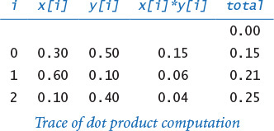
The simplicity of coding such computations makes the use of arrays the natural choice for all kinds of applications. Before considering more examples, we describe a number of important characteristics of programming with arrays.

Zero-based indexing
We always refer to the first element of an array a[] as a[0], the second as a[1], and so forth. It might seem more natural to refer to the first element as a[1], the second element as a[2], and so forth, but starting the indexing with 0 has some advantages and has emerged as the convention used in most modern programming languages. Misunderstanding this convention often leads to off-by one errors that are notoriously difficult to avoid and debug, so be careful!

Array length
You can access the length of an array using Python’s built-in len() function: len(a) is the number of elements in a[]. Note that the last element of an array a[] is always a[len(a)-1].

Increasing the length of an array at run time
In Python, we can use the += operator to append elements to an array. For example, if a[] is the array [1, 2, 3], then the statement a += [4] extends it to [1, 2, 3, 4]. More generally, we can make an array of n floats, with each element initialized to 0.0, with the code
a = []
for i in range(n)
a += [0.0]
The statement a = [] creates an empty array (of length 0, with no elements) and the statement a += [0.0] appends one extra element to the end. We note that, in Python, the time required to create an array in this manner is proportional to its length (for details, see SECTION 4.1).

Memory representation
Arrays are fundamental data structures in that they have a direct correspondence with memory systems on virtually all computers. References to the elements of an array are stored contiguously in memory, so that accessing any array element is easy and efficient. Indeed, we can view memory itself as a giant array. On modern computers, memory is implemented in hardware as a sequence of indexed memory locations, each of which can be quickly accessed with an appropriate index. When referring to computer memory, we normally refer to a location’s index as its address. It is convenient to think of the name of the array—say, x—as storing the memory address of a contiguous block of memory containing the length of the array and references to its elements. For the purposes of illustration, suppose that the computer’s memory is organized as 1,000 values, with addresses from 000 to 999. Now, suppose that an array x[] of three elements is stored in memory locations 523 through 526, with the length stored in 523 and references to the array elements stored in 524 through 526. When we specify x[i], Python generates code that adds the index i to the memory address of the first element of the array. In the example pictured here, the Python code x[2] would generate machine code that finds the reference at memory location 524 + 2 = 526. The same simple method is effective even when the memory and the array (and i) are huge. Accessing a reference to element i of an array is an efficient operation because it simply requires adding two integers and then referencing memory—just two elementary operations.
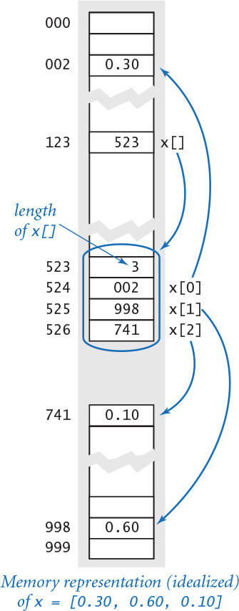

Bounds checking
As already indicated, you must be careful when programming with arrays. It is your responsibility to use legal indices when accessing an array element. If you have created an array of size n and use an index whose value is greater than n-1, your program will raise an IndexError at run time. (In many programming languages, such buffer overflow conditions are not checked by the system. These kinds of unchecked errors can and do lead to debugging nightmares, but it is also not uncommon for such an error to go unnoticed and remain in a finished program. You might be surprised to know that such a mistake can be exploited by a hacker to take control of a system—even your personal computer—to spread viruses, steal personal information, or wreak other malicious havoc.) The error messages provided by Python may seem annoying to you at first, but they are small price to pay to have a more secure program.

Mutability
An object is mutable if its value can change. Arrays are mutable objects because we can change their elements. For example, if we create an array with the code x = [.30, .60, .10], then the assignment statement x[1] = .99 changes it to the array [.30, .99, .10]. An object-level trace of this operation is shown at right.
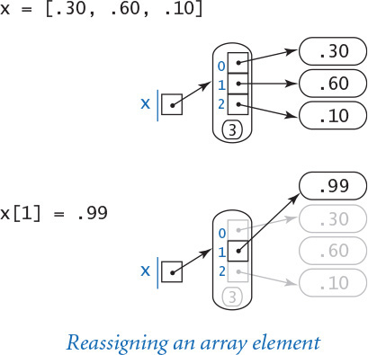
Often the point of a piece of code is to rearrange the elements in an array. For example, the following code reverses the order of the elements in an array a[]:
n = len(a)
for i in range(n // 2):
temp = a[i]
a[i] = a[n-1-i]
a[n-1-i] = temp
The three statements in the for loop implement the exchange operation that we studied when first learning about assignment statements in SECTION 1.2. You might wish to check your understanding of arrays by studying the informal trace of this code for a seven-element array [3, 1, 4, 1, 5, 9, 2], shown at the right. This table keeps track of i and all seven array elements at the end of each iteration of the for loop.
It is natural to expect mutability in arrays, but, as you will see, mutability is a key issue in data type design and has a number of interesting implications. We will discuss some of these implications later in this section, but defer most of the discussion to SECTION 3.3.
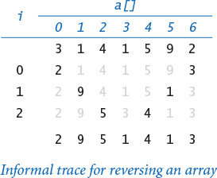

Iteration
One of the most basic operations on an array is to iterate over all its elements. For example, the following code computes the average of an array of floats:
total = 0.0
for i in range(len(a))
total += a[i]
average = total / len(a)
Python also supports iterating over the elements in an array in a[] without referring to the indices explicitly. To do so, put the array name after the in keyword in a for statement, as follows:
total = 0.0
for v in a:
total += v
average = total / len(a)
Python successively assigns each element in the array to the loop-control variable v, so this code is essentially equivalent to the code given earlier. In this book, we iterate over the indices when we need to refer to the array elements by their indices (as in the dot-product and array-reversal examples just considered). We iterate over the elements when only the sequence of elements matters, and not the indices (as in this compute-the-average example).

Built-in functions
Python has several built-in functions that can take arrays as arguments. We have already discussed the len() function. As another example, if the elements of a[] are numeric, then sum(a) computes their sum, so that we can compute their average with float(sum(a)) / len(a) instead of using either of the loops just described. Other useful built-in functions that can take arrays as arguments are min() for computing the minimum and max() for computing the maximum.

Writing an array
You can write an array by passing it as an argument to stdio.write() or stdio.writeln(). The array is written with a leading open square bracket, followed by the array’s objects separated with commas and spaces, followed by a trailing close square bracket, all on a single line. Each object in the array is converted to a string. If this format is not suited to your needs, you can use a for statement to write each array element individually.

Array aliases and copies
Before looking at programs that use arrays, it is worthwhile to examine two fundamental array-processing operations in more detail. The points that we discuss are subtle, but they are more important than they might seem at first glance. If you find yourself becoming a bit overwhelmed by technical details, you might prefer to return to these two pages after studying the applications programs that use arrays later in this section. Rereading this material to cement your understanding of these concepts is certain to pay dividends.

Aliasing
We can use variables that reference arrays in much the same way in our code that we can use variables that reference other types of objects, but it is very important to take the time to understand the effects of such usage. If you reflect on the situation, perhaps the first question that arises is this: What happens when you use an array variable name on the left side of an assignment statement? In other words, if x[] and y[] are arrays, what is the effect of the statement x = y? The answer is simple and consistent with Python usage for other data types: x and y reference the same array. But this result has an effect that is perhaps unexpected, at first, because it is natural to think of x and y as references to two independent arrays, which is not the case. For example, after the assignment statements
x = [.30, .60, .10]
y = x
x[1] = .99
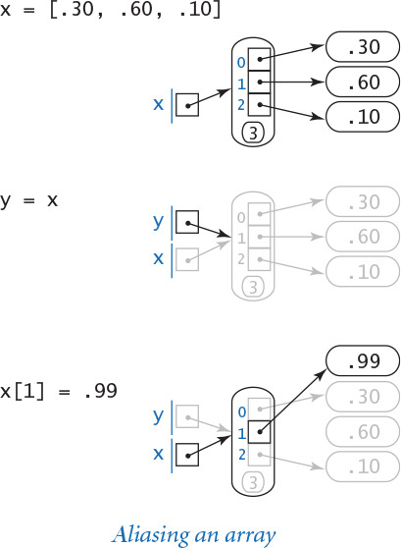
y[1] is also .99, even though the code does not refer directly to y[1]. This situation—whenever two variables refer to the same object—is known as aliasing, and is illustrated in the object-level trace at right. We avoid aliasing arrays (and other mutable objects) because it makes it more difficult to find errors in our programs. Still, as you will see in CHAPTER 2, there are natural situations where aliasing two arrays is helpful, so it is worthwhile for you to be aware of this concept at the outset.

Copying and slicing
The next natural question you might ask is the following: How do we arrange to make a copy y[] of a given array x[]? One answer to this question is to iterate through x[] to build y[], as in the following code:
y = []
for v in x:
y += [v]
After the copy operation, x and y refer to two different arrays. If we change the object that x[1] references, that change has no effect on y[1]. This situation is illustrated in the object-level trace at right.
Actually, copying an array is such a useful operation that Python provides language support for a more general operation known as slicing, where we can copy any contiguous sequence of elements within an array to another array. The expression a[i:j] evaluates to a new array whose elements are a[i], ..., a[j-1]. Moreover, the default value for i is 0 and the default value for j is len(a), so
y = x[:]
is equivalent to the code given earlier. This compact notation is convenient, but it is important for you to remember that it masks a potentially expensive operation—it takes time proportional to the length of x[].

System support for arrays
Python code for processing arrays can take many forms. We describe each briefly for context, but our emphasis for most of this book is on the few operations that you need to know to write meaningful and effective code. After you have some experience reading and composing code using these basic operations, you will better be able to understand the differences among the various approaches that are available for processing arrays in Python, so we revisit this topic in CHAPTER 4.
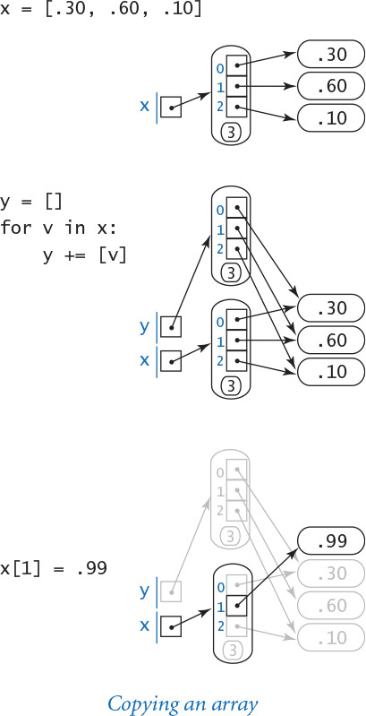

Python’s built-in list data type
In its most basic form, an array supports four core operations: creation, indexed access, indexed assignment, and iteration. In this book, we use Python’s built-in list data type for arrays because it supports these basic operations. We consider more elaborate operations supported by Python’s list data type in CHAPTER 4, including array-resizing operations that change the length of the array. Arrays, as defined here, are sufficiently powerful that you will be able to learn a great deal about programming and approach a number of interesting applications in the meantime. Python programmers typically do not make a distinction between arrays and Python lists. We make this distinction here because many other programming languages (such as Java and C) provide built-in support for fixed-length arrays and the four core operations (but not for the more elaborate array-resizing operations).

Python’s numpy module
The essence of programming language design is a tradeoff between simplicity and efficiency. Even though computers might seem to have the capability to perform huge numbers of elementary operations per second, you know that they can seem slow sometimes. In the case of Python, its built-in list data type can have severe performance problems, even for simple programs that use arrays to solve real-world problems. For that reason, scientists and engineers often use a Python extension module called numpy for processing huge arrays of numbers, because that module uses a lower-level representation that avoids many of the inefficiencies in the standard Python representation. Again we will delve deeply into understanding performance in CHAPTER 4, so that you may have a better understanding of how to approach such situations. In that context, we describe the use of numpy on the booksite.

Our stdarray module
Earlier in this chapter, we introduced our stdio module, which defines functions related to writing and reading integers, floats, strings, and booleans, and you have used the stdio.write() and stdio.writeln() functions extensively. The stdio module is a booksite module; that is, it is a nonstandard module that we composed specifically to support this book and its booksite. Now, we introduce another booksite module: the stdarray module. Its primary purpose is to define functions for processing arrays that we use throughout the book.
A fundamental operation that is found in nearly every array-processing program is to create an array of n elements, each initialized to a given value. As we have seen, you can do this in Python with code like the following:
a = []
for i in range(n):
a += [0.0]
Creating an array of a given length and initializing all of its elements to a given value is so common that Python even has a special shorthand notation for it: the code a = [0.0]*n is equivalent to the code just given. Rather than repeat such code throughout the book, we will use code like this:
a = stdarray.create1D(n, 0.0)
For consistency, stdarray also includes a create2D() function, which we will examine later in this section. We use these functions because they make our code “self-documenting” in the sense that the code itself precisely indicates our intent and does not depend on idioms specific to Python. We will delve deeply into issues surrounding library design in SECTION 2.2 (and show you how to create modules like stdarray yourself), again so that you may have a better understanding of how to approach such situations.
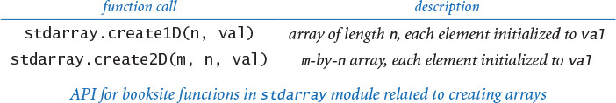
You now know how to create arrays in Python and access individual elements, and you have a basic understanding of Python’s built-in list data type. The table at the top of the next page describes the array operations that we have discussed. With this conceptual foundation complete, we can now move to applications. As you will see, this foundation leads to applications code that is not only easy to compose and understand, but also makes efficient use of computational resources.
Abbreviation alert
Throughout this book, we refer to Python lists as arrays because Python lists support the fundamental operations that characterize arrays—creation, indexed access, indexed assignment, and iteration.
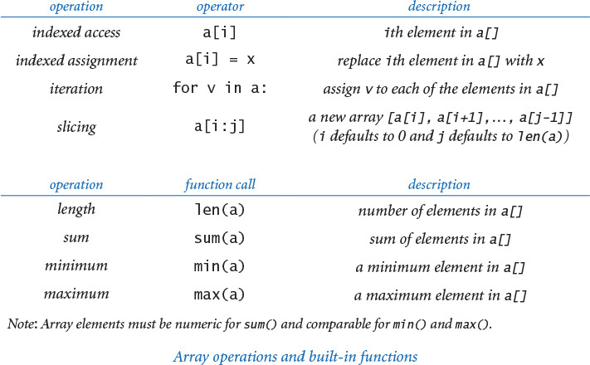

Sample applications of arrays
Next, we consider a number of applications that illustrate the utility of arrays and also are interesting in their own right.

Representing playing cards
Suppose that we want to compose programs that process playing cards. We might start with the following code:
Click here to view code image
SUITS = ['Clubs', 'Diamonds', 'Hearts', 'Spades']
RANKS = ['2', '3', '4', '5', '6', '7', '8', '9', '10',
'Jack', 'Queen', 'King', 'Ace']
For example, we might use these two arrays to write a random card name, such as Queen of Clubs, as follows:
Click here to view code image
rank = random.randrange(0, len(RANKS))
suit = random.randrange(0, len(SUITS))
stdio.writeln(RANKS[rank] + ' of ' + SUITS[suit])
A more typical situation is when we compute the values to be stored in an array. For example, we might use the following code to initialize an array of length 52 that represents a deck of playing cards, using the two arrays just defined:
Click here to view code image
deck = []
for rank in RANKS:
for suit in SUITS:
card = rank + ' of ' + suit
deck += [card]
After this code has been executed, writing the elements of deck[] in order from deck[0] through deck[51] with one element per line gives the sequence
2 of Clubs
2 of Diamonds
2 of Hearts
2 of Spades
3 of Clubs
3 of Diamonds
...
Ace of Hearts
Ace of Spades

Exchange
Frequently, we wish to exchange two elements in an array. Continuing our example with playing cards, the following code exchanges the cards at indices i and j using the same idiom that we used previously in this section to reverse an array:
temp = deck[i]
deck[i] = deck[j]
deck[j] = temp
When we use this code, we are assured that we are perhaps changing the order of the elements in the array but not the set of elements in the array. When i and j are equal, the array is unchanged. When i and j are not equal, the values a[i] and a[j] are found in different places in the array. For example, if we were to use this code with i equal to 1 and j equal to 4 in the deck[] of the previous example, it would leave the string '3 of Clubs' in deck[1] and the string '2 of Diamonds' in deck[4].

Shuffle
The following code shuffles our deck of cards:
Click here to view code image
n = len(deck)
for i in range(n):
r = random.randrange(i, n)
temp = deck[r]
deck[r] = deck[i]
deck[i] = temp
Proceeding from left to right, we pick a random card from deck[i] through deck[n-1] (each card equally likely) and exchange it with deck[i]. This code is more sophisticated than it might seem. First, we ensure that the cards in the deck after the shuffle are the same as the cards in the deck before the shuffle by using the exchange idiom. Second, we ensure that the shuffle is random by choosing uniformly from the cards not yet chosen. Incidentally, Python includes a standard function named shuffle() in the random module that uniformly shuffles a given array, so the function call random.shuffle(deck) does the same job as this code.

Sampling without replacement
In many situations, we want to draw a random sample from a set such that each element in set appears at most once in the sample. Drawing numbered ping-pong balls from a basket for a lottery is an example of this kind of sample, as is dealing a hand from a deck of cards. PROGRAM 1.4.1 (sample.py) illustrates how to sample, using the basic operation underlying shuffling. It takes command-line arguments m and n and creates a permutation of size n (a rearrangement of the integers from 0 to n-1) whose first m elements constitute a random sample.
The accompanying trace of the contents of the perm[] array at the end of each iteration of the main loop (for a run where the values of m and n are 6 and 16, respectively) illustrates the process. If the values of r are chosen such that each value in the given range is equally likely, then perm[0] through perm[m-1] are a random sample at the end of the process (even though some elements might move multiple times) because each element in the sample is chosen by taking each item not yet sampled, with each choice having equal probability of being selected.
One important reason to explicitly compute the permutation is that we can use it to write a random sample of any array by using the elements of the permutation as indices into the array. Doing so is often an attractive alternative to actually rearranging the array, because it may need to be in order for some other reason (for instance, a company might wish to draw a random sample from a list of customers that is kept in alphabetical order). To see how this trick works, suppose that we wish to draw a random poker hand from our deck[] array, constructed as just described. We use the code in sample.py with m = 5 and n = 52 and replace perm[i] with deck[perm[i]] in the stdio.write() statement (and change it to writeln()), resulting in output such as the following:
3 of Clubs
Jack of Hearts
6 of Spades
Ace of Clubs
10 of Diamonds
Program 1.4.1 Sampling without replacement (sample.py)
Click here to view code image
import random
import sys
import stdarray
import stdio
m = int(sys.argv[1]) # Choose this many elements
n = int(sys.argv[2]) # from 0, 1, ..., n-1.
# Initialize array perm = [0, 1, ..., n-1].
perm = stdarray.create1D(n, 0)
for i in range(n):
perm[i] = i
# Create a random sample of size m in perm[0..m).
for i in range(m):
r = random.randrange(i, n)
# Exchange perm[i] and perm[r].
temp = perm[r]
perm[r] = perm[i]
perm[i] = temp
# Write the results.
for i in range(m):
stdio.write(str(perm[i]) + ' ')
stdio.writeln()
m | sample size
n | range
perm[] | permutation of 0 to n-1
This program accepts integers m and n as command-line arguments, and writes a random sample of m integers in the range 0 to n-1 (no duplicates). This process is useful not just in state and local lotteries, but in scientific applications of all sorts. If the first argument is less than or equal to the second, the result is a random permutation of the integers from 0 to n-1. If the first argument is greater than the second, the program raises a ValueError at run time.
Click here to view code image
% python sample.py 6 16
9 5 13 1 11 8
% python sample.py 10 1000
656 488 298 534 811 97 813 156 424 109
% python sample.py 20 20
6 12 9 8 13 19 0 2 4 5 18 1 14 16 17 3 7 11 10 15
Sampling like this is widely used as the basis for statistical studies in polling, scientific research, and many other applications, whenever we want to draw conclusions about a large population by analyzing a small random sample. Python includes a standard function in the random module for sampling: given an array a[] and an integer k, the function call random.sample(a, k) returns a new array containing a sample of size k, chosen uniformly at random among the elements in a[].
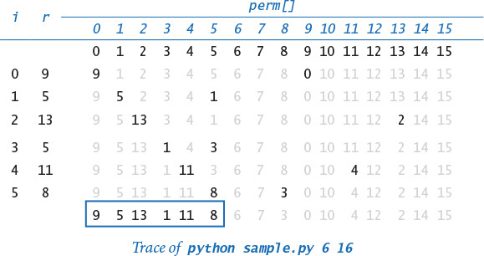

Precomputed values
Another application of arrays is to save values that you have computed for later use. As an example, suppose that you are composing a program that performs calculations using small values of the harmonic numbers (see PROGRAM 1.3.5). An efficient approach is to save the values in an array, as follows:
Click here to view code image
harmonic = stdarray.create1D(n+1, 0.0)
for i in range(1, n+1):
harmonic[i] = harmonic[i-1] + 1.0/i
Note that we waste one slot in the array (element 0) to make harmonic[1] correspond to the first harmonic number 1.0 and harmonic[i] correspond to the ith harmonic number. Precomputing values in this way is an example of a space–time tradeoff: by investing in space (to save the values), we save time (since we do not need to recompute them). This method is not effective if we need values for huge n, but it is very effective if we need values for small n many different times.

Simplifying repetitive code
As an example of another simple application of arrays, consider the following code fragment, which writes the name of a month given its number (1 for January, 2 for February, and so forth):
Click here to view code image
if m == 1: stdio.writeln('Jan')
elif m == 2: stdio.writeln('Feb')
elif m == 3: stdio.writeln('Mar')
elif m == 4: stdio.writeln('Apr')
...
elif m == 11: stdio.writeln('Nov')
elif m == 12: stdio.writeln('Dec')
A more compact alternative is to use an array of strings holding the month names:
Click here to view code image
MONTHS = ['', 'Jan', 'Feb', 'Mar', 'Apr', 'May', 'Jun',
'Jul', 'Aug', 'Sep', 'Oct', 'Nov', 'Dec']
...
stdio.writeln(MONTHS[m])
This technique would be especially useful if you needed to access the name of a month by its number in several different places in your program. Note that, again, we intentionally waste one slot in the array (element 0) to make MONTHS[1] correspond to January, as required.
With these basic definitions and examples out of the way, we can now consider two applications that both address interesting classical problems and illustrate the fundamental importance of arrays in efficient computation. In both cases, the idea of using data to efficiently index into an array plays a central role and enables a computation that would not otherwise be feasible.

Coupon collector
Suppose that you have a deck of cards and you pick cards at random (with replacement) one by one. How many cards do you need to turn up before you have seen one of each suit? How many cards do you need to turn up before seeing one of each rank? These are examples of the famous coupon collector problem. In general, suppose that a trading card company issues trading cards with n different possible cards: how many do you have to collect before you have all n possibilities, assuming that each possibility is equally likely for each card that you collect?
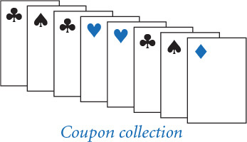
PROGRAM 1.4.2 (couponcollector.py) is an example program that simulates this process and illustrates the utility of arrays. It takes the integer n from the command line and generates a sequence of random integer values between 0 and n-1 using the function call random.randrange(0, n) (see PROGRAM 1.3.8). Each value represents a card; for each card, we want to know if we have seen that value before. To maintain that knowledge, we use an array isCollected[], which uses the card value as an index: isCollected[i] is True if we have seen a card with value i and False if we have not. When we get a new card that is represented by the integer value, we check whether we have seen its value before simply by accessing isCollected[value]. The computation consists of keeping count of the number of distinct values seen and the number of cards generated and writing the latter when the former reaches n.
As usual, the best way to understand a program is to consider a trace of the values of its variables for a typical run. It is easy to add code to couponcollector.py that produces a trace that gives the values of the variables at the end of the while loop. In the table at right, we use F for False and T for True to make the trace easier to follow. Tracing programs that use large arrays can be a challenge: when you have an array of length n in your program, it represents n variables, so you have to list them all. Tracing programs that use random.randrange() also can be a challenge because you get a different trace every time you run the program. Accordingly, we check relationships among variables carefully. Here, note that collectedCount always is equal to the number of True values in isCollected[].
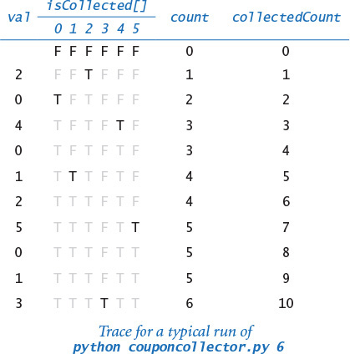
Program 1.4.2 Coupon collector simulation (couponcollector.py)
Click here to view code image
import random
import sys
import stdarray
import stdio
n = int(sys.argv[1])
count = 0
collectedCount = 0
isCollected = stdarray.create1D(n, False)
while collectedCount < n:
# Generate another coupon.
value = random.randrange(0, n)
count += 1
if not isCollected[value]:
collectedCount += 1
isCollected[value] = True
stdio.writeln(count)
n | # of coupon values (0 to n-1)
count | # of coupons collected
collectedCount | # of distinct coupons collected
isCollected[i] | has coupon i been collected?
value | value of current coupon
This program accepts an integer n as a command-line argument, and writes the number of coupons collected before obtaining one of each of n types. Thus it simulates a coupon collector.
Click here to view code image
% python couponcollector.py 1000
6583
% python couponcollector.py 1000
6477
% python couponcollector.py 1000000
12782673
Coupon collecting is no trivial problem. For example, it is very often the case that scientists want to know whether a sequence that arises in nature has the same characteristics as a random sequence. If so, that fact might be of interest; if not, further investigation may be warranted to look for patterns that might be of importance. For example, such tests are used by scientists to decide which parts of a genome are worth studying. One effective test of whether a sequence is truly random is the coupon collector test: compare the number of elements that need to be examined before all values are found against the corresponding number for a uniformly random sequence.
Without arrays, we could not contemplate simulating the coupon collector process for huge n; with arrays, it is easy to do so. We will see many examples of such processes throughout the book.

Sieve of Eratosthenes
Prime numbers play an important role in mathematics and computation, including cryptography. A prime number is an integer greater than 1 whose only positive divisors are 1 and itself. The prime counting function π(n) is the number of primes less than or equal to n. For example, π(25) = 9 because the first nine primes are 2, 3, 5, 7, 11, 13, 17, 19, and 23. This function plays a central role in number theory.
We might use a program like factors.py (PROGRAM 1.3.9) to count primes. Specifically, we could modify the code in factors.py to set a boolean variable to True if a given number is prime and False otherwise (instead of writing out factors), then enclose that code in a loop that increments a counter for each prime number. This approach is effective for small n, but becomes too slow as n grows.
PROGRAM 1.4.3 (primesieve.py) is an alternative that computes π(n) using a technique known as the sieve of Eratosthenes. The program uses an array isPrime[] of n booleans to record which of the integers less than or equal to n are prime. The goal is to set isPrime[i] to True if i is prime, and to False otherwise. The sieve works as follows: Initially, the program assigns True to all elements of the array, indicating that no factors of any integer have yet been found. Then, it repeats the following steps as long as i < n:
• Find the next smallest i for which no factors have been found.
• Leave isPrime[i] as True since i has no smaller factors.
• Assign False to all isPrime[] elements whose indices are multiples of i.
Program 1.4.3 Sieve of Eratosthenes (primesieve.py)
Click here to view code image
import sys
import stdarray
import stdio
n = int(sys.argv[1])
isPrime = stdarray.create1D(n+1, True)
for i in range(2, n):
if (isPrime[i]):
# Mark multiples of i as nonprime.
for j in range(2, n//i + 1):
isPrime[i*j] = False
# Count the primes.
count = 0
for i in range(2, n+1):
if (isPrime[i]):
count += 1
stdio.writeln(count)
n | argument
isPrime[i] | is i prime?
count | prime counter
This program takes a command-line argument n and computes the number of primes less than or equal to n. To do so, it computes an array of booleans with isPrime[i] set to True if i is prime, and to False otherwise.
Click here to view code image
% python primesieve.py 25
9
% python primesieve.py 100
25
% python primesieve.py 10000
1229
% python primesieve.py 1000000
78498
% python primesieve.py 100000000
5761455
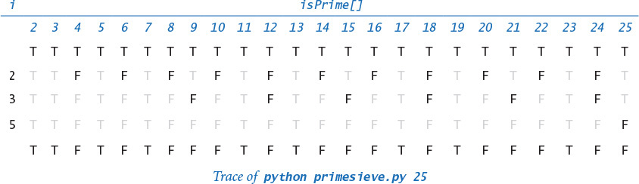
When the nested for loop ends, we have set the isPrime[] elements for all nonprimes to be False and have left the isPrime[] elements for all primes as True. Note that we might stop when i*i >= n, just as we did for factors.py, but the savings in this case would be marginal at best, since the inner for loop does not iterate at all for large i. With one more pass through the array, we can count the number of primes less than or equal to n.
As usual, it is easy to add code to write a trace. For programs such as primesieve.py, you have to be a bit careful—it contains a nested for-if-for, so you have to pay attention to the indentation to put the tracing code in the correct place.
With primesieve.py, we can compute π(n) for large n, limited primarily by the maximum array size allowed by Python. This is another example of a space–time tradeoff. Programs like primesieve.py play an important role in helping mathematicians to develop the theory of numbers, which has many important applications.

Two-dimensional arrays
In many applications, a convenient way to store information is to use a table of numbers organized in a rectangular table and refer to rows and columns in the table. For example, a teacher might need to maintain a table with a row corresponding to each student and a column corresponding to each assignment, a scientist might need to maintain a table of experimental data with rows corresponding to experiments and columns corresponding to various outcomes, or a programmer might want to prepare an image for display by setting a table of pixels to various grayscale values or colors.
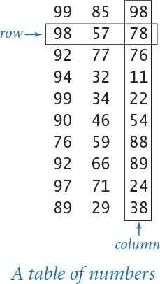
The mathematical abstraction corresponding to such tables is a matrix; the corresponding data structure is a two-dimensional array. You are likely to have already encountered many applications of matrices and two-dimensional arrays, and you will certainly encounter many others in science, in engineering, and in commercial applications, as we will demonstrate with examples throughout this book. As with vectors and one-dimensional arrays, many of the most important applications involve processing large amounts of data, and we defer considering those applications until we consider input and output, in SECTION 1.5.
Extending the one-dimensional array data structure that we have discussed to two-dimensional arrays is straightforward, once you realize that since an array can contain any type of data, its elements can also be arrays! That is, a two-dimensional array is implemented as an array of one-dimensional arrays, as detailed next.

Initialization
The simplest way to create a two-dimensional array in Python is to place comma-separated one-dimensional arrays between matching square brackets. For example, this matrix of integers having two rows and three columns
18 19 20
21 22 23
could be represented in Python using this array of arrays:
Click here to view code image
a = [[18, 19, 20], [21, 22, 23]]
We call such an array a 2-by-3 array. By convention, the first dimension is the number of rows and the second dimension is the number of columns. Python represents a 2-by-3 array as an array that contains two objects, each of which is an array that contains three objects.
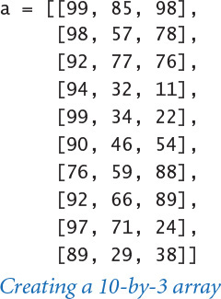
More generally, Python represents an m-by-n array as an array that contains m objects, each of which is an array that contains n objects. For example, this Python code creates an m-by-n array a[][] of floats, with all elements initialized to 0.0:
a = []
for i in range(m):
row = [0.0] * n
a += [row]
As for one-dimensional arrays, we use the self-descriptive alternative
stdarray.create2D(m, n, 0.0)
from our booksite module stdarray throughout this book.

Indexing
When a[][] is a two-dimensional array, the syntax a[i] denotes a reference to its ith row. For example, if a[][] is the array [[18, 19, 20], [21 22, 23]], then a[1] is the array [21, 22, 23]. It is more common to refer to a particular element in a two-dimensional array. The syntax a[i][j] refers to the object at row i and column j of the two-dimensional array a[][]. In our example, a[1][0] is 21. To access each of the elements in a two-dimensional array, we use two nested for loops. For example, this code writes each object of the m-by-n array a[][], one row per line.
for i in range(m):
for j in range(n):
stdio.write(a[i][j])
stdio.write(' ')
stdio.writeln()
This code achieves the same effect without using indices:
for row in a:
for v in row:
stdio.write(v)
stdio.write(' ')
stdio.writeln()

Spreadsheets
One familiar use of arrays is a spreadsheet for maintaining a table of numbers. For example, a teacher with m students and n test grades for each student might maintain an (m +1)-by-(n +1) array, reserving the last column for each student’s average grade and the last row for the average test grades. Even though we typically do such computations within specialized applications, it is worthwhile to study the underlying code as an introduction to array processing. To compute the average grade for each student (average values for each row), sum the elements for each row and divide by n. The row-by-row order in which this code processes the matrix elements is known as row-major order. Similarly, to compute the average test grade (average values for each column), sum the elements for each column and divide by n. The column-by-column order in which this code processes the matrix elements is known as column-major order. These operations are all illustrated in the figure at the top of the this page. To allow for half points, our teacher records all grades as floats.
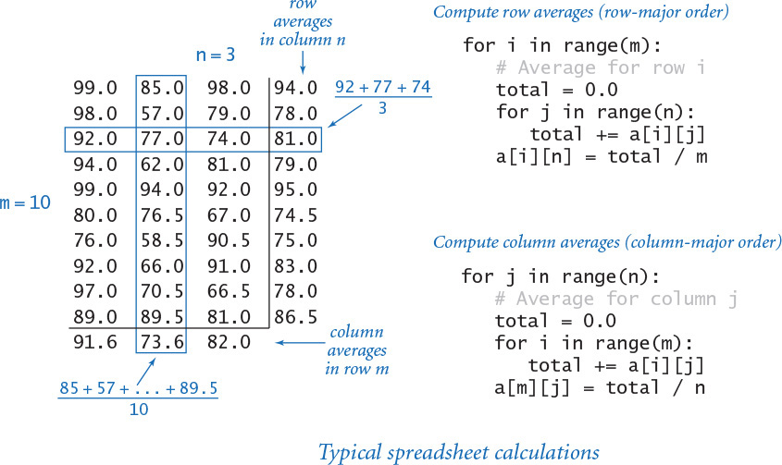

Matrix operations
Typical applications in science and engineering involve representing matrices as two-dimensional arrays and then implementing various mathematical operations with matrix operands. Again, even though such processing is often done within specialized applications and libraries, it is worthwhile for you to understand the underlying computation.
For example, we can add two n-by-n matrices a[][] and b[][] as follows:
Click here to view code image
c = stdarray.create2D(n, n, 0.0)
for i in range(n):
for j in range(n):
c[i][j] = a[i][j] + b[i][j]
Similarly, we can multiply two matrices. You may have learned matrix multiplication, but if you do not recall or are not familiar with it, the following Python code for square matrices is essentially the same as the mathematical definition. Each element c[i][j] in the product of a[][] and b[][] is computed by taking the dot product of row i of a[][] with column j of b[][].
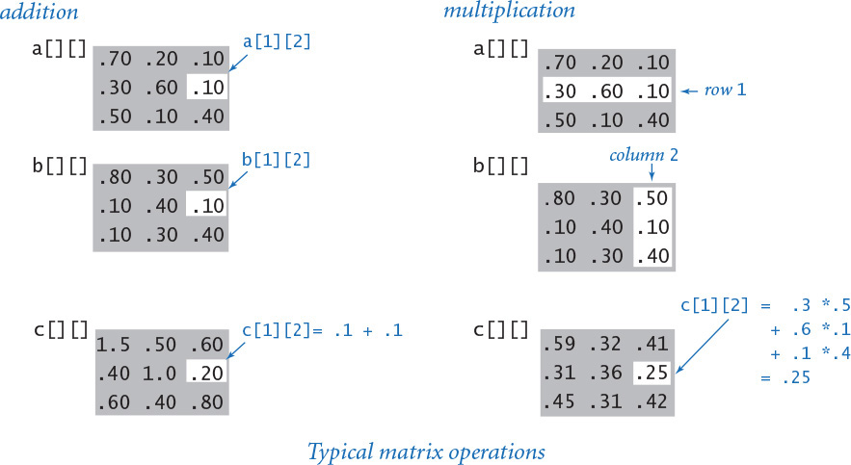
Click here to view code image
c = stdarray.create2D(n, n, 0.0)
for i in range(n):
for j in range(n):
# Compute the dot product of row i and column j
for k in range(n):
c[i][j] += a[i][k] * b[k][j]
The definition extends to matrices that may not be square (see EXERCISE 1.4.17).

Special cases of matrix multiplication
Two special cases of matrix multiplication are important. These special cases occur when one of the dimensions of one of the matrices is 1, so we can view it as a vector. In matrix–vector multiplication, we multiply an m-by-n matrix by a column vector (an n-by-1 matrix) to get an m-by-1 column vector result (each element in the result is the dot product of the corresponding row in the matrix with the operand vector). In vector–matrix multiplication, we multiply a row vector (a 1-by-m matrix) by an m-by-n matrix to get a 1-by-n row vector result (each element in the result is the dot product of the operand vector with the corresponding column in the matrix).
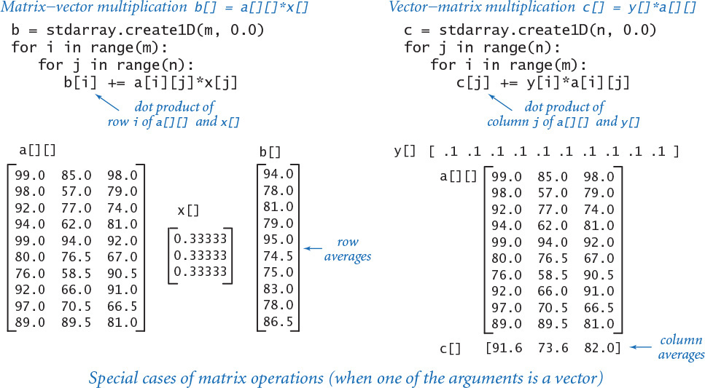
These operations provide a succinct way to express numerous matrix calculations. For example, the row-average computation for such a spreadsheet with m rows and n columns is equivalent to a matrix–vector multiplication where the row vector has n elements all equal to 1.0 / n. Similarly, the column-average computation in such a spreadsheet is equivalent to a vector-matrix multiplication where the column vector has m elements all equal to 1.0 / m. We return to vector–matrix multiplication in the context of an important application at the end of this chapter.

Ragged arrays
There is actually no requirement that all rows in a two-dimensional array have the same length. An array with rows of nonuniform length is known as a ragged array (see EXERCISE 1.4.32 for an example application). The possibility of ragged arrays creates the need for taking more care in crafting array-processing code. For example, this code writes the contents of a ragged array:
Click here to view code image
for i in range(len(a)):
for j in range(len(a[i])):
stdio.write(a[i][j])
stdio.write(' ')
stdio.writeln()
This code tests your understanding of Python arrays, so you should take the time to study it. In this book, we normally use square or rectangular arrays, whose dimensions are given by the variable m and n. Code that uses len(a[i]) in this way is a clear signal to you that an array is ragged.
Note that the equivalent code that does not use indices works equally well with both rectangular and ragged arrays:
for row in a:
for v in row:
stdio.write(v)
stdio.write(' ')
stdio.writeln()

Multidimensional arrays
The same notation extends to allow us to compose code using arrays that have any number of dimensions. Using arrays of arrays of arrays..., we can create three-dimensional arrays, four-dimensional arrays, and so forth, and then refer to an individual element with code like a[i][j][k].
Two-dimensional arrays provide a natural representation for matrices, which are omnipresent in science, mathematics, and engineering. They also provide a natural way to organize large amounts of data—a key factor in spreadsheets and many other computing applications. Through Cartesian coordinates, two- and three-dimensional arrays provide the basis for a models of the physical world. With all of these natural applications, arrays will provide fertile ground for interesting examples throughout this book as you learn to program.

Example: self-avoiding random walks
Suppose that you leave your dog in the middle of a large city whose streets form a familiar grid pattern. We assume that there are n north–south streets and n east–west streets, all regularly spaced and fully intersecting in a pattern known as a lattice. Trying to escape the city, the dog makes a random choice of which way to go at each intersection, but knows by scent to avoid visiting any place previously visited. But it is possible for the dog to get stuck in a dead end where there is no choice but to revisit some intersection. What is the chance that this will happen? This amusing problem is a simple example of a famous model known as the self-avoiding random walk, which has important scientific applications in the study of polymers and in statistical mechanics, among many others. For example, you can see that this process models a chain of material growing a bit at a time, until no growth is possible. To better understand such processes, scientists seek to understand the properties of self-avoiding walks.
The dog’s escape probability is certainly dependent on the size of the city. In a tiny 5-by-5 city, it is easy to convince yourself that the dog is certain to escape. But what are the chances of escape when the city is large? We are also interested in other parameters. For example, how long is the dog’s path, on average? How often does the dog come within one block of a previous position other than the one just left, on average? How often does the dog come within one block of escaping? These sorts of properties are important in the various applications just mentioned.
PROGRAM 1.4.4 (selfavoid.py) is a simulation of this situation that uses a two-dimensional boolean array, where each element represents an intersection. True indicates that the dog has visited the intersection; False indicates that the dog has not visited the intersection. The path starts in the center and takes random steps to places not yet visited until the dog gets stuck or escapes at a boundary. For simplicity, the code is written so that if a random choice is made to go to a spot that has already been visited, it takes no action, trusting that some subsequent random choice will find a new place (which is assured because the code explicitly tests for a dead end and exits the loop in that case).

Note that the code exhibits an important programming technique in which we code the loop-continuation test in the while statement as a guard against an illegal statement in the body of the loop. In this case, the loop-continuation test serves as a guard against an out-of-bounds array access within the loop. This corresponds to checking whether the dog has escaped. Within the loop, a successful dead-end test results in a break out of the loop.
As you can see from the sample runs, the unfortunate truth is that your dog is nearly certain to get trapped in a dead end in a large city. If you are interested in learning more about self-avoiding walks, you can find several suggestions in the exercises. For example, the dog is almost certain to escape in the three-dimensional version of the problem. While this is an intuitive result that is confirmed by our simulations, the development of a mathematical model that explains the behavior of self-avoiding walks is a famous open problem: despite extensive research, no one knows a succinct mathematical expression for the escape probability, the average length of the path, or any other important parameter.
Program 1.4.4 Self-avoiding random walks (selfavoid.py)
Click here to view code image
import random
import sys
import stdarray
import stdio
n = int(sys.argv[1])
trials = int(sys.argv[2])
deadEnds = 0
for t in range(trials):
a = stdarray.create2D(n, n, False)
x = n // 2
y = n // 2
while (x > 0) and (x < n-1) and (y > 0) and (y < n-1):
# Check for dead end and make a random move.
a[x][y] = True
if a[x-1][y] and a[x+1][y] and a[x][y-1] and a[x][y+1]:
deadEnds += 1
break
r = random.randrange(1, 5)
if (r == 1) and (not a[x+1][y]): x += 1
elif (r == 2) and (not a[x-1][y]): x -= 1
elif (r == 3) and (not a[x][y+1]): y += 1
elif (r == 4) and (not a[x][y-1]): y -= 1
stdio.writeln(str(100*deadEnds//trials) + '% dead ends')
n | lattice size
trials | # of trials
deadEnds | # of trials with a dead end
a[][] | intersections
x, y | current position
r | random number in [1, 5)
This program accepts integers n and trials as command-line arguments. It performs trials experiments, each a random self-avoiding walk in an n-by-n lattice, and then writes the percentage of dead ends encountered. For each walk, it creates an array of booleans, starts the walk in the center, and continues until reaching either a dead end or a boundary.
% python selfavoid.py 5 100
0% dead ends
% python selfavoid.py 20 100
35% dead ends
% python selfavoid.py 40 100
80% dead ends
% python selfavoid.py 80 100
98% dead ends
% python selfavoid.py 5 1000
0% dead ends
% python selfavoid.py 20 1000
32% dead ends
% python selfavoid.py 40 1000
76% dead ends
% python selfavoid.py 80 1000
98% dead ends
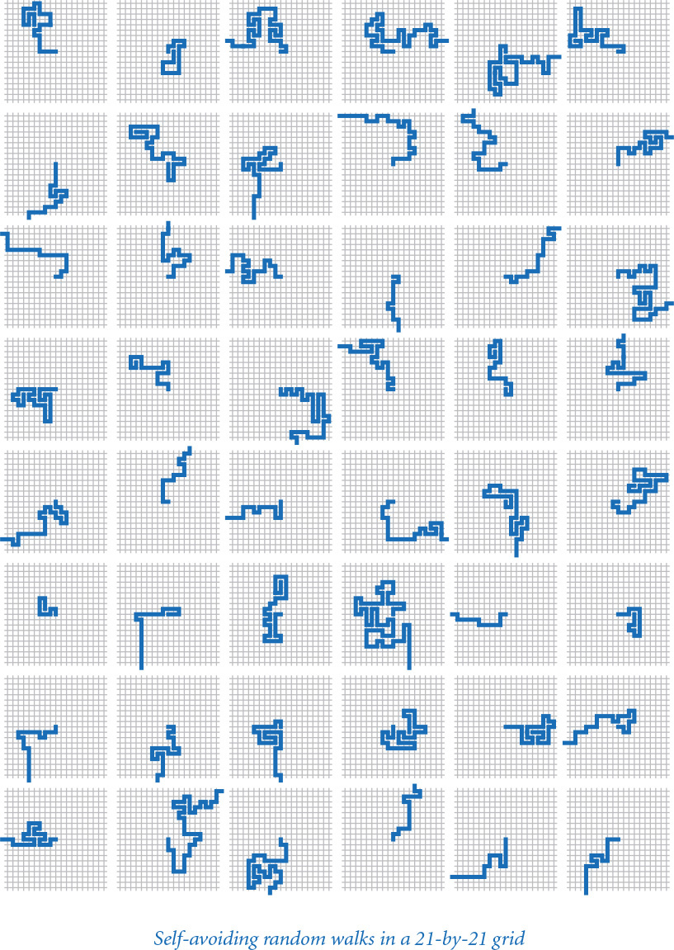

Summary
Arrays are the fourth basic construct (the first three are assignments, conditionals, and loops) found in almost every programming language. As you have seen with the sample programs presented in this section, you can compose programs that can solve all sorts of problems using just these constructs. In the next section, we consider mechanisms for communicating with our programs, which will complete our coverage of elementary programming mechanisms.
Arrays are prominent in many of the programs that we consider, and the basic operations that we have discussed here will serve you well in addressing many programming tasks. When you are not using arrays explicitly (and you are sure to be doing so frequently), you will be using them implicitly, because all computers have a memory that is conceptually equivalent to an array.
The fundamental ingredient that arrays add to our programs is a potentially huge increase in the size of a program’s state. The state of a program can be defined as the information you need to know to understand what a program is doing. In a program without arrays, if you know the values of the variables and which statement is the next to be executed, you can normally determine what the program will do next. When we trace a program, we are essentially tracking its state. When a program uses arrays, however, there can be too huge a number of values (each of which might be changed in each statement) for us to effectively track them all. This difference makes composing programs with arrays more of a challenge than composing programs without them.
Arrays directly represent vectors and matrices, so they are of direct use in computations associated with many basic problems in science and engineering. Arrays also provide a succinct notation for manipulating a potentially huge amount of data in a uniform way, so they play a critical role in any application that involves processing large amounts of data, as you will see throughout this book.
More importantly, arrays represent the tip of an iceberg. They are your first example of a data structure, where we organize data to enable us to conveniently and efficiently process it. We will consider more examples of data structures in CHAPTER 4, including resizing arrays, linked lists, and binary search trees, and hash tables. Arrays are also your first example of a collection, which groups many elements into a single unit. We will consider many more example of collections in CHAPTER 4, including Python lists, tuples, dictionaries, and sets, along with two classic examples, stacks and queues.

Q&A
Q. Why do Python array indices start at 0 instead of 1?
A. That convention originated with machine-language programming, where the address of an array element would be computed by adding the index to the address of the beginning of an array. Starting indices at 1 would entail either a waste of space at the beginning of the array or string, or a waste of time to subtract the 1.
Q. What happens if I use a negative integer to index an array?
A. The answer may surprise you. Given an array a[], you can use the index -i as shorthand for len(a) - i. For example, you can refer to the last element in the array with a[-1] or a[len(a) - 1] and the first element with a[-len(a)] or a[0]. Python raises an IndexError at run time if you use an index outside of the range -len(a) through len(a) - 1.
Q. Why does the slice a[i:j] include a[i] but exclude a[j]?
A. The notation is consistent with ranges defined with range(), which includes the left endpoint but excludes the right endpoint. It leads to some appealing properties: j - i is the length of the subarray (assuming no truncation); a[0:len(a)] is the entire array; a[i:i] is the empty array; and a[i:j] + a[j:k] is the subarray a[i:k].
Q. What happens when I compare two arrays a[] and b[] with (a == b)?
A. It depends. For arrays (or multidimensional arrays) of numbers, it works as you might expect: the arrays are equal if each has the same length and the corresponding elements are equal.
Q. What happens when a random walk does not avoid itself?
A. This case is well understood. It is a two-dimensional version of the gambler’s ruin problem, as described in SECTION 1.3.
Q. Which pitfalls should I watch out for when using arrays?
A. Remember that creating an array takes time proportional to the length of the array. You need to be particularly careful about creating arrays within loops.

Exercises
1.4.1 Compose a program that creates a one-dimensional array a containing exactly 1,000 integers and then attempts to access a[1000]. What happens when you run the program?
1.4.2 Given two vectors of length n that are represented with one-dimensional arrays, compose a code fragment that computes the Euclidean distance between them (the square root of the sums of the squares of the differences between corresponding elements).
1.4.3 Compose a code fragment that reverses the order of the elements in a one-dimensional array of floats. Do not create another array to hold the result. Hint: Use the code in the text for exchanging two elements.
1.4.4 What is wrong with the following code fragment?
a = []
for i in range(10):
a[i] = i * i
Solution: Initially a is the empty array. Subsequently no elements are appended to the array. Thus a[0], a[1], and so forth do not exist. The attempts to use them in an assignment statement will raise an IndexError at run time.
1.4.5 Compose a code fragment that writes the contents of a two-dimensional array of booleans, using * to represent True and a space to represent False. Include row and column numbers.
1.4.6 What does the following code fragment write?
a = stdarray.create1D(10, 0)
for i in range(10):
a[i] = 9 - i
for i in range(10):
a[i] = a[a[i]]
for v in a:
stdio.writeln(v)
1.4.7 What is a[] after executing the following code fragment?
n = 10
a = [0, 1]
for i in range(2, n):
a += [a[i-1] + a[i-2]]
1.4.8 Compose a program deal.py that takes a command-line argument n and writes n poker hands (five cards each) from a shuffled deck, separated by blank lines.
1.4.9 Compose code fragments to create a two-dimensional array b[][] that is a copy of an existing two-dimensional array a[][], under each of the following assumptions:
a. a is square
b. a is rectangular
c. a may be ragged
Your solution to b should work for a, and your solution to c should work for both b and a.
1.4.10 Compose a code fragment to write the transposition (rows and columns changed) of a two-dimensional array. For the example spreadsheet array in the text, your code would write the following:
Click here to view code image
99 98 92 94 99 90 76 92 97 89
85 57 77 32 34 46 59 66 71 29
98 78 76 11 22 54 88 89 24 38
1.4.11 Compose a code fragment to transpose a square two-dimensional array in place without creating a second array.
1.4.12 Compose a code fragment to create a two-dimensional array b[][] that is the transpose of an existing m-by-n array a[][].
1.4.13 Compose a program that computes the product of two square matrices of booleans, using the or operator instead of + and the and operator instead of *.
1.4.14 Compose a program that accepts an integer n from the command line and creates an n-by-n boolean array a such that a[i][j] is True if i and j are relatively prime (have no common factors), and False otherwise. Then write the array (see EXERCISE 1.4.5) using * to represent True and a space to represent False. Include row and column numbers. Hint: Use sieving.
1.4.15 Modify the spreadsheet code fragment in the text to compute a weighted average of the rows, where the weights of each test score are in a one-dimensional array weights[]. For example, to assign the last of the three tests in our example to be twice the weight of the others, you would use
weights = [.25, .25, .50]
Note that the weights should sum to 1.0.
1.4.16 Compose a code fragment to multiply two rectangular matrices that are not necessarily square. Note: For the dot product to be well defined, the number of columns in the first matrix must be equal to the number of rows in the second matrix. Write an error message if the dimensions do not satisfy this condition.
1.4.17 Modify selfavoid.py (PROGRAM 1.4.4) to calculate and write the average length of the paths as well as the dead-end probability. Keep separate the average lengths of escape paths and dead-end paths.
1.4.18 Modify selfavoid.py to calculate and write the average area of the smallest axis-oriented rectangle that encloses the path. Keep separate statistics for escape paths and dead-end paths.
1.4.19 Compose a code fragment that creates a three-dimensional n-by-n-by-n array of booleans, with each element initialized to False.

Creative Exercises
1.4.20 Dice simulation. The following code computes the exact probability distribution for the sum of two dice:
Click here to view code image
probabilities = stdarray.create1D(13, 0.0)
for i in range(1, 7):
for j in range(1, 7):
probabilities[i+j] += 1.0
for k in range(2, 13):
probabilities[k] /= 36.0
After this code completes, probabilities[k] is the probability that the dice sum to k. Run experiments to validate this calculation simulating n dice throws, keeping track of the frequencies of occurrence of each value when you compute the sum of two random integers between 1 and 6. How large does n have to be before your empirical results match the exact results to three decimal places?
1.4.21 Longest plateau. Given an array of integers, compose a program that finds the length and location of the longest contiguous sequence of equal values where the values of the elements just before and just after this sequence are smaller.
1.4.22 Empirical shuffle check. Run computational experiments to check that our shuffling code works as advertised. Compose a program shuffletest.py that takes command-line arguments m and n, does n shuffles of an array of size m that is initialized with a[i] = i before each shuffle, and writes an m-by-m table such that row i gives the number of times i wound up in position j for all j. All elements in the array should be close to n/m.
1.4.23 Bad shuffling. Suppose that you choose a random integer between 0 and n-1 in our shuffling code instead of one between i and n-1. Show that the resulting order is not equally likely to be one of the n! possibilities. Run the test of the previous exercise for this version.
1.4.24 Music shuffling. You set your music player to shuffle mode. It plays each of the m songs before repeating any. Compose a program to estimate the likelihood that you will not hear any sequential pair of songs (that is, song 3 does not follow song 2, song 10 does not follow song 9, and so on).
1.4.25 Minima in permutations. Compose a program that takes an integer n from the command line, generates a random permutation, writes the permutation, and writes the number of left-to-right minima in the permutation (the number of times an element is the smallest seen so far). Then compose a program that takes integers m and n from the command line, generates m random permutations of size n, and writes the average number of left-to-right minima in the permutations generated. Extra credit: Formulate a hypothesis about the number of left-to-right minima in a permutation of size n, as a function of n.
1.4.26 Inverse permutation. Compose a program that reads in a permutation of the integers 0 to n-1 from n command-line arguments and writes its inverse. (If the permutation is an array a[], its inverse is the array b[] such that a[b[i]] = b[a[i]] = i.) Be sure to check that the input is a valid permutation.
1.4.27 Hadamard matrix. The n-by-n Hadamard matrix Hn is a boolean matrix with the remarkable property that any two rows differ in exactly n/2 elements. (This property makes it useful for designing error-correcting codes.) H1 is a 1-by-1 matrix with the single element True, and for n > 1, H2n is obtained by aligning four copies of Hn in a large square, and then inverting all of the elements in the lower right n-by-n copy, as shown in the following examples (with T representing True and F representing False, as usual).
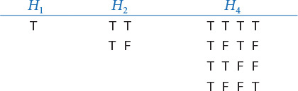
Compose a program that takes one command-line argument n and writes Hn. Assume that n is a power of 2.
1.4.28 Rumors. Alice is throwing a party with n other guests, including Bob. Bob starts a rumor about Alice by telling it to one of the other guests. A person hearing this rumor for the first time will immediately tell it to one other guest, chosen at random from all the people at the party except Alice and the person from whom they heard it. If a person (including Bob) hears the rumor for a second time, he or she will not propagate it further. Compose a program to estimate the probability that everyone at the party (except Alice) will hear the rumor before it stops propagating. Also calculate an estimate of the expected number of people to hear the rumor.
1.4.29 Find a duplicate. Given an array of n elements with each element between 1 and n, compose a code fragment to determine whether there are any duplicates. You do not need to preserve the contents of the given array, but do not use an extra array.
1.4.30 Counting primes. Compare primesieve.py with the alternative approach described in the text. This is an example of a space–time tradeoff: primesieve.py is fast, but requires a boolean array of length n; the alternative approach uses only two integer variables, but is substantially slower. Estimate the magnitude of this difference by finding the value of n for which this second approach can complete the computation in about the same time as python primesieve.py 1000000.
1.4.31 Minesweeper. Compose a program that takes three command-line arguments m, n, and p and produces an m-by-n boolean array where each element is occupied with probability p. In the minesweeper game, occupied cells represent bombs and empty cells represent safe cells. Write the array using an asterisk for bombs and a period for safe cells. Then, replace each safe square with the number of neighboring bombs (above, below, left, right, or diagonal) and write the result, as in this example.
* * . . . * * 1 0 0
. . . . . 3 3 2 0 0
. * . . . 1 * 1 0 0
Try to express your code so that you have as few special cases as possible to deal with, by using an (m+2)-by-(n+2) boolean array.
1.4.32 Self-avoiding walk length. Suppose that there is no limit on the size of the grid. Run experiments to estimate the average walk length.
1.4.33 Three-dimensional self-avoiding walks. Run experiments to verify that the dead-end probability is 0 for a three-dimensional self-avoiding walk and to compute the average walk length for various values of n.
1.4.34 Random walkers. Suppose that n random walkers, starting in the center of an n-by-n grid, move one step at a time, choosing to go left, right, up, or down with equal probability at each step. Compose a program to help formulate and test a hypothesis about the number of steps taken before all cells are touched.
1.4.35 Bridge hands. In the game of bridge, four players are dealt hands of 13 cards each. An important statistic is the distribution of the number of cards in each suit in a hand. Which is the most likely, 5-3-3-2, 4-4-3-2, or 4-3-3-3? Compose a program to help you answer this question.
1.4.36 Birthday problem. Suppose that people continue to enter an empty room until a pair of people share a birthday. On average, how many people will have to enter before there is a match? Run experiments to estimate the value of this quantity. Assume birthdays to be uniform random integers between 0 and 364.
1.4.37 Coupon collector. Run experiments to validate the classical mathematical result that the expected number of coupons needed to collect n values is about nHn. For example, if you are observing the cards carefully at the blackjack table (and the dealer has enough decks randomly shuffled together), you will wait until about 235 cards are dealt, on average, before seeing every card value.
1.4.38 Riffle shuffle. Compose a program to rearrange a deck of n cards using the Gilbert–Shannon–Reeds model of a riffle shuffle. First, generate a random integer r according to a binomial distribution: flip a fair coin n times and let r be the number of heads. Now, divide the deck into two piles: the first r cards and the remaining n – r cards. To complete the shuffle, repeatedly take the top card from one of the two piles and put it on the bottom of a new pile. If there are n1 cards remaining in the first pile and n2 cards remaining in the second pile, choose the next card from the first pile with probability n1 / (n1 + n2) and from the second pile with probability n2 / (n1 + n2). Investigate how many riffle shuffles you need to apply to a deck of 52 cards to produce a (nearly) uniformly shuffled deck.
1.4.39 Binomial coefficients. Compose a program that builds and writes a two-dimensional ragged array a such that a[n][k] contains the probability that you get exactly k heads when you toss a fair coin n times. Take a command-line argument to specify the maximum value of n. These numbers are known as the binomial distribution: if you multiply each element in row k by 2n, you get the binomial coefficients (the coefficients of xk in (x+1)n) arranged in Pascal’s triangle. To compute them, start with a[n][0] = 0.0 for all n and a[1][1] = 1.0, then compute values in successive rows, left to right, with a[n][k] = (a[n-1][k] + a[n-1][k-1])/2.0.
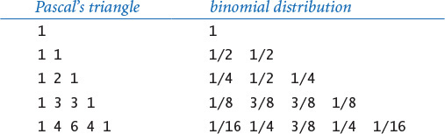

1.5 Input and Output
In this section we extend the set of simple abstractions (command-line arguments and standard output) that we have been using as the interface between our Python programs and the outside world to include standard input, standard drawing, and standard audio. Standard input makes it convenient for us to compose programs that process arbitrary amounts of input and to interact with our programs; standard drawing makes it possible for us to work with graphical representations of images, freeing us from having to encode everything as text; and standard audio adds sound. These extensions are easy to use, and will bring you to yet another new world of programming.
1.5.1 Generating a random sequence
1.5.2 Interactive user input
1.5.3 Averaging a stream of numbers
1.5.4 A simple filter
1.5.5 Standard input to draw filter
1.5.6 Function graph
1.5.7 Bouncing ball
1.5.8 Digital signal processing
Programs in this section
The abbreviation I/O is universally understood to mean input/output, a collective term that refers to the mechanisms by which programs communicate with the outside world. Your computer’s operating system controls the physical devices that are connected to your computer. To implement our “standard I/O” abstractions, we use modules containing functions that interface to the operating system.
You have already been accepting arguments from the command line and writing strings in a terminal window; the purpose of this section is to provide you with a much richer set of tools for processing and presenting data. Like the stdio.write() and stdio.writeln() functions that you have been using, these functions do not implement pure mathematical functions—their purpose is to produce some side effect, either on an input device or on an output device. Our prime concern is using such devices to get information into and out of our programs.
An essential feature of standard I/O mechanisms is that there is no limit on the amount of input or output data, from the point of view of the program. Your programs can consume input or produce output indefinitely.
One use of standard I/O mechanisms is to connect your programs to files on your computer’s external storage. It is easy to connect standard input, standard output, standard drawing, and standard audio to files. Such connections make it easy to have your Python programs save or load results to files for archival purposes or for later reference by other programs or other applications.

Bird’s-eye view
The conventional model that we have been using for Python programming has served us since SECTION 1.1. To build context, we begin by briefly reviewing the model.
A Python program takes input values from the command line and writes a string of characters as output. By default, both command-line arguments and standard output are associated with the application that takes commands (the one in which you have been typing the python command). We use the generic term terminal window to refer to this application. This model has proved to be a convenient and direct way for us to interact with our programs and data.

Command-line arguments
This mechanism, which we have been using to provide input to our programs, is a standard part of Python programming. The operating system presents the command-line arguments that we type to Python programs in an array named sys.argv[]. By convention, both Python and the operating system process the arguments as strings, so if we intend for an argument to be a number, we use a conversion function such as int() or float() to convert it from a string to the appropriate type.

Standard output
To write output values in our programs, we have been using the booksite functions stdio.write() and stdio.writeln(). Python puts the results of a program’s sequence of calls on these functions into the form of an abstract stream of characters known as standard output. By default, the operating system connects standard output to the terminal window. All of the output in our programs so far has been appearing in the terminal window.
For reference, and as a starting point, randomseq.py (PROGRAM 1.5.1) is a program that uses this model. It takes a command-line argument n and produces an output sequence of n random numbers between 0 and 1.
Now we will complement command-line arguments and standard output with three additional mechanisms that address their limitations and provide us with a far more useful programming model. These mechanisms give us a new bird’s-eye view of a Python program in which the program converts a standard input stream and a sequence of command-line arguments into a standard output stream, a standard drawing, and a standard audio stream.
Program 1.5.1 Generating a random sequence (randomseq.py)
Click here to view code image
import random
import sys
import stdio
n = int(sys.argv[1])
for i in range(n):
stdio.writeln(random.random())
This program accepts an integer command-line argument n, and writes to standard output a random sequence of n floats in the range [0, 1). The program illustrates the conventional model that we have been using so far for Python programming. From the program’s point of view, there is no limit on the length of the output sequence.
% python randomseq.py 1000000
0.879948024484513
0.8698170909139995
0.6358055797752076
0.9546013485661425
...

Standard input
The booksite stdio module defines several functions in addition to stdio.write() and stdio.writeln(). These additional functions implement a standard input abstraction to complement the standard output abstraction. That is, the stdio module contains functions that allow your programs to read from standard input. Just as you can write to standard output at any time during the execution of your program, so you can read from a standard input stream at any time.

Standard drawing
The booksite stddraw module allows you to create drawings with your programs. It uses a simple graphics model that allows you to create drawings consisting of points, lines, and geometric figures in a window on your computer. The stddraw module also includes facilities for text, color, and animation.

Standard audio
The booksite stdaudio module allows you to create and manipulate sound with your programs. It uses a standard format to convert arrays of floats into sound.
To use these modules, you must make the files stdio.py, stddraw.py, and stdaudio.py available to Python (see the Q&A at the end of this section).
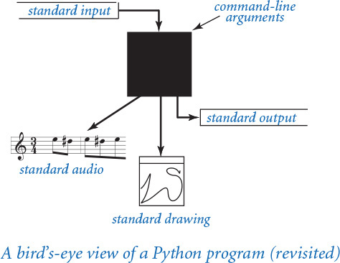
The standard input and standard output abstractions date back to the development of the Unix operating system in the 1970s and are found in some form on all modern systems. Although they are primitive by comparison to various mechanisms developed since, modern programmers still depend on them as a reliable way to connect data to programs. We have developed for this book stddraw and stdaudio in the same spirit as these earlier abstractions to provide you with an easy way to produce visual and aural output.

Standard output
As noted in SECTION 1.2, an application programming interface (API) is a description of the features that a module offers to its clients. At the bottom of this page is the API of the part of the stdio module that is relevant to standard output. The stdio.write() and stdio.writeln() functions are the ones that you have been using. The stdio.writef() function is a main topic of this section and will be of interest to you now because it gives you more control over the appearance of the output. It was a feature of the C language of the early 1970s and continues to survive in modern languages because it is so useful.
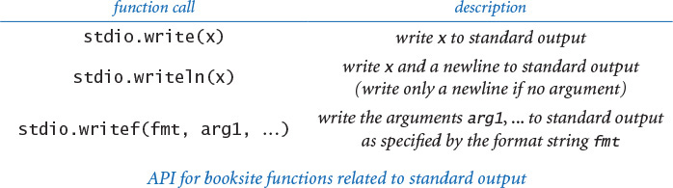
Since the first time that we wrote float objects, we have been distracted by excessive precision in the output. For example, when we call stdio.write(math.pi), we get the output 3.141592653589793, even though we might prefer to see 3.14 or 3.14159. The stdio.write() and stdio.writeln() functions present each number to up to 16 decimal digits of precision even when we would be happy with just a few digits of precision. The stdio.writef() function is more flexible: it allows us to specify the number of digits and the precision when converting numeric objects to strings for output. With stdio.writef(), we can write stdio.writef('%7.5f', math.pi) to get 3.14159.
Next, we describe the meaning and operation of these statements, along with extensions to handle the other built-in types of data.

Formatted writing basics
The simplest kind of call of stdio.writef() passes only one argument, a string. In that case, stdio.writef() simply writes the string to standard output, so it is equivalent to stdio.write(). A more commonly used call of stdio.writef() passes two arguments. In that context the first argument is called the format string. It contains a conversion specification that describes how the second argument is to be converted to a string for output. A conversion specification has the form %w.pc, where w and p are small integers and c is a character, to be interpreted as follows:
• w is the field width, the number of characters that should be written. If the number of characters to be written exceeds (or equals) the field width, then the field width is ignored; otherwise, the output is padded with spaces on the left. A negative field width indicates that the output instead should be padded with spaces on the right.
• p is the precision. For floats, the precision is the number of digits that should be written after the decimal point; for strings, it is the number of characters of the string that should be written. The precision is not used with integers.
• c is the conversion code. It should be d when writing an integer, f when writing a float, e when writing a float using scientific notation, and s when writing a string.
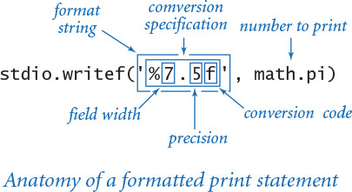
The field width and precision can be omitted, but every specification must have a conversion code.
Python must be able to convert the second argument to the type required by the specification. For s, there is no restriction, because every type of data can be converted to a string (via a call to the str() function). In contrast, a statement such as stdio.writef('%12d', 'Hello')—which asks Python to convert a string to an integer—causes Python to raise a TypeError at run time. The table at the bottom of this page shows format strings containing some common conversion specifications.
Any part of the format string that is not a conversion specification is simply passed through to standard output. For example, the statement
Click here to view code image
stdio.writef('pi is approximately %.2f\n', math.pi)
writes the line
pi is approximately 3.14
Note that we need to explicitly include the newline character \n in the argument to write a new line with stdio.writef().

Multiple arguments
The stdio.writef() function can take more than two arguments. In this case, the format string must have a format specifier for each additional argument, perhaps separated by other characters to pass through to the output. For example, we could replace stdio.write(t) in sqrt.py (PROGRAM 1.3.6) with
Click here to view code image
stdio.writef('The square root of %.1f is %.6f', c, t)
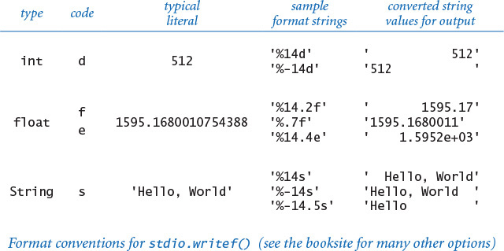
to get output like
Click here to view code image
The square root of 2.0 is 1.414214
As a more detailed example, if you were making payments on a loan, you might use code whose inner loop contains the statements
Click here to view code image
format = '%3s $%6.2f $%7.2f $%5.2f\n'
stdio.writef(format, month[i], pay, balance, interest)
to write the second and subsequent lines in a table like this (see EXERCISE 1.5.14):
Click here to view code image
payment balance interest
Jan $299.00 $9742.67 $41.67
Feb $299.00 $9484.26 $40.59
Mar $299.00 $9224.78 $39.52
...
Formatted writing is convenient because this sort of code is much more compact than the string-concatenation approach that we have been using to create output strings. We have described only the basic options; see the booksite for many details.

Standard input
Several functions in the booksite stdio module take data from a standard input stream that may be empty or may contain a sequence of values separated by whitespace (spaces, tabs, newline characters, and the like). Each value represents an integer, a float, a boolean, or a string. One of the key features of the standard input stream is that your program consumes values when it reads them. Once your program has read a value, it cannot back up and read it again. This assumption is restrictive, but it reflects physical characteristics of some input devices and simplifies implementing the abstraction. The stdio module offers 13 functions that are related to reading from standard input, as shown in the API on the next page. These functions fall into one of three categories: those for reading individual tokens, one at a time, and converting each to an integer, float, boolean or string; those for reading lines from standard input, one at a time; and those for reading a sequence of values of the same type (returning the values in an array). Generally, it is best not to mix functions from the different categories in the same program. Within the input stream model, those functions are largely self-documenting (the names describe their effect), but their precise operation is worthy of careful consideration, so we will consider several examples in detail.
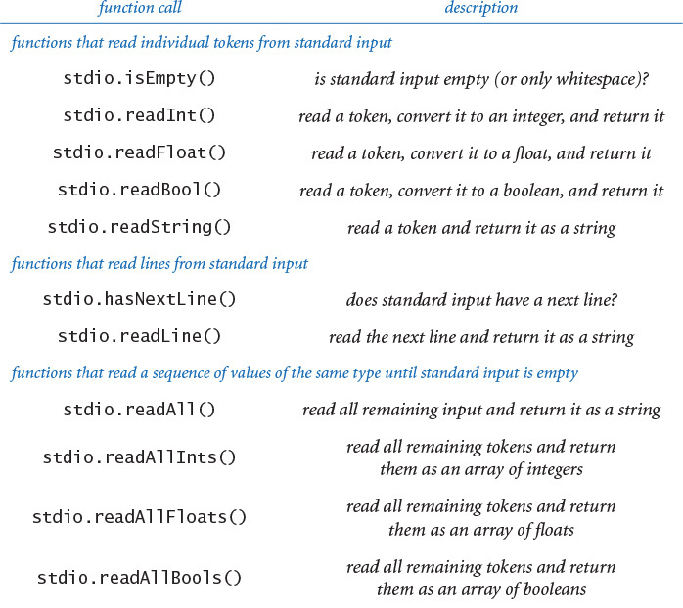
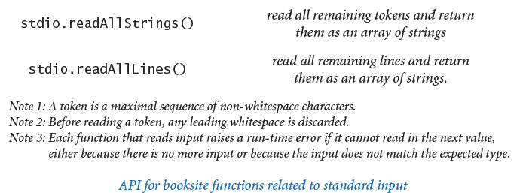

Typing input
When you use the python command to invoke a Python program from the command line, you actually are doing three things: (1) issuing a command to start executing your program, (2) specifying the values of the command line arguments, and (3) beginning to define the standard input stream. The string of characters that you type in the terminal window after the command line is the standard input stream. When you type characters, you are interacting with your program. The program waits for you to create the standard input stream. For example, consider the following program addints.py, which takes a integer n from the command line and then reads n integers from standard input, adds them, and writes the sum to standard output:
Click here to view code image
import sys
import stdio
n = int(sys.argv[1])
total = 0
for i in range(n):
total += stdio.readInt()
stdio.writeln('Sum is ' + str(total))
When you type python addints.py 4, the program starts execution. It takes the command-line argument, initializes total to 0, enters the for loop, eventually calls stdio.readInt(), and waits for you to type an integer. Suppose that you want 144 to be the first value. As you type 1, then 4, and then 4, nothing happens, because stdio does not know that you are done typing the integer. But when you finally type <return> to signify the end of your integer, stdio.readInt() immediately returns the value 144, which your program adds to total and then calls stdio.readInt() again. Again, nothing happens until you type the second value: if you type 2, then 3, then 3, and then <return> to end the number, stdio.readInt() returns the value 233, which your program again adds to total. After you have typed four numbers in this way, the program expects no more input and writes the sum, as desired. In the command-line traces, we use boldface to highlight the text that you type and differentiate it from the output of the program.
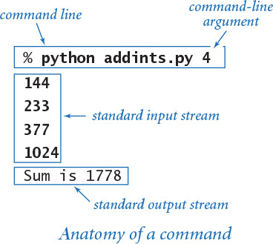

Input format
The stdio.readInt() function expects an integer. If you type abc or 12.2 or True, Python raises a ValueError at run time. The format for each type is the same as you have been using to specify literals within Python programs. For convenience, stdio treats strings of consecutive whitespace characters as identical to one space and allows you to delimit your numbers with such strings. It does not matter how many spaces you put between numbers, or whether you enter numbers on one line or separate them with tab characters or spread them out over several lines (except that your terminal application processes standard input one line at a time, so it will wait until you type <return> before sending all of the numbers on that line to standard input). You can mix values of different types in an input stream, but whenever the program expects a value of a particular type, the input stream must have a value of that type.

Interactive user input
PROGRAM 1.5.2 (twentyquestions.py) is a simple example of a program that interacts with its user. The program generates a random integer and then gives clues to a user trying to guess the number. (Note: By using binary search, you can always get to the answer in at most 20 questions. See SECTION 4.2.) The fundamental difference between this program and others that we have composed is that the user has the ability to change the control flow while the program is executing. This capability was very important in early applications of computing, but we rarely compose such programs nowadays because modern applications typically take such input through a graphical user interface, as discussed in CHAPTER 3. Even a simple program like twentyquestions.py illustrates that composing programs that support user interaction is potentially very difficult because you have to plan for all possible user inputs.

Processing an arbitrary-size input stream
Typically, input streams are finite: your program marches through the input stream, consuming values until the stream is empty. But there is no restriction on the size of the input stream, and some programs simply process all the input presented to them. Our next example, average.py (PROGRAM 1.5.3), reads in a sequence of real numbers from standard input and writes their average. It illustrates a key property of using an input stream: the length of the stream is not known to the program. We type all the numbers that we have, and then the program averages them. Before reading each number, the program calls the function stdio.isEmpty() to check whether there are any more numbers in the input stream.
Program 1.5.2 Interactive user input (twentyquestions.py)
Click here to view code image
import random
import stdio
RANGE = 1000000
secret = random.randrange(1, RANGE+1)
stdio.write('I am thinking of a secret number between 1 and ')
stdio.writeln(RANGE)
guess = 0
while guess != secret:
# Solicit one guess and provide one answer.
stdio.write('What is your guess? ')
guess = stdio.readInt()
if (guess < secret): stdio.writeln('Too low')
elif (guess > secret): stdio.writeln('Too high')
else: stdio.writeln('You win!')
secret | secret value
guess | user's guess
This program generates a random integer between 1 and 1 million. Then it repeatedly reads user guesses from standard input. It writes Too low or Too high to standard output, as appropriate, in response to each guess. It writes You win! to standard output and exits when the user’s guess is correct. You always can get the program to write You win! with fewer than 20 questions.
Click here to view code image
% python twentyquestions.py
I am thinking of a secret number between 1 and 1000000
What is your guess? 500000
Too high
What is your guess? 250000
Too low
What is your guess? 375000
Too high
What is your guess? 312500
Too high
What is your guess? 300500
Too low
...
How do we signal that we have no more data to type? By convention, we type a special sequence of characters known as the end-of-file sequence. Sadly, the terminal applications that we typically encounter on modern operating systems use different conventions for this critically important sequence. In this book, we use <Ctrl-d> (many systems require <Ctrl-d> to appear on a line by itself); the other widely used convention is <Ctrl-z> on a line by itself.
Actually, we rarely type numbers one by one on standard input. Instead, we keep our input data in files, as illustrated in the example accompanying PROGRAM 1.5.3 and explained in detail in the text.
Certainly average.py is a simple program, but it represents a profound new capability in programming: with standard input, we can compose programs that process an unlimited amount of data. As you will see, composing such programs is an effective approach for numerous data-processing applications.
Standard input is a substantial step up from the command-line argument model that we have been using, for two reasons, as illustrated by twentyquestions.py and average.py. First, we can interact with our program—with command-line arguments, we can provide data to the program only before it begins execution. Second, we can read in large amounts of data—with command-line arguments, we can enter only values that fit on the command line. Indeed, as illustrated by average.py, the amount of data processed by a program can be potentially unlimited, and many programs are made simpler by that assumption. A third reason for standard input is that your operating system makes it possible to change the source of standard input, so that you do not have to type all the input. Next, we consider the mechanisms that enable this possibility.

Redirection and piping
For many applications, typing input data as a standard input stream from the terminal window is untenable because our program’s processing power is then limited by the amount of data that we can type (and our typing speed). Similarly, we often want to save the information written on the standard output stream for later use. To address such limitations, we next focus on the idea that standard input is an abstraction—the program just expects its input and has no dependence on the source of the input stream. Standard output is a similar abstraction. The power of these abstractions derives from our ability (through the operating system) to specify various other sources for standard input and standard output, such as a file, the network, or another program. All modern operating systems implement these mechanisms.
Program 1.5.3 Averaging a stream of numbers (average.py)
Click here to view code image
import stdio
total = 0.0
count = 0
while not stdio.isEmpty():
value = stdio.readFloat()
total += value
count += 1
avg = total / count
stdio.writeln('Average is ' + str(avg))
count | count of numbers read
total | cumulated sum
This program reads floats from the standard input stream until it reaches the end-of-file. Then it writes to standard output the average of those floats. From its point of view, there is no limit on the size of the input stream. The commands shown below after the first one use redirection and piping (discussed in the next subsection) to provide 100,000 numbers to average.py.
% python average.py
10.0 5.0 6.0
3.0
7.0 32.0
<Ctrl-d>
Average is 10.5
Click here to view code image
% python ramdomseq.py 1000 > data.txt
% python average.py < data.txt
Average is 0.510473676174824
% python randomseq.py 1000 | python average.py
Average is 0.50499417963857

Redirecting standard output to a file
By adding a simple directive to the command that executes a program, we can redirect its standard output to a file, either for permanent storage or for input to another program at a later time. For example,
Click here to view code image
% python randomseq.py 1000 > data.txt
specifies that the standard output stream is not to be written in the terminal window, but instead is to be written to a text file named data.txt. Each call to stdio.write(), stdio.writeln(), or stdio.writef() appends text at the end of that file. In this example, the end result is a file that contains 1,000 random values. No output appears in the terminal window: it goes directly into the file named after the > symbol. Thus, we can save information for later retrieval. Note that we do not have to change randomseq.py (PROGRAM 1.5.1) in any way for this mechanism to work—it relies on using the standard output abstraction and is unaffected by our use of a different implementation of that abstraction. You can use this mechanism to save output from any program that you compose. Once we have expended a significant amount of effort to obtain a result, we often want to save the result for later reference. In a modern system, you can save some information by using cut-and-paste or some similar mechanism that is provided by the operating system, but cut-and-paste is inconvenient for large amounts of data. By contrast, redirection is specifically designed to make it easy to handle large amounts of data.
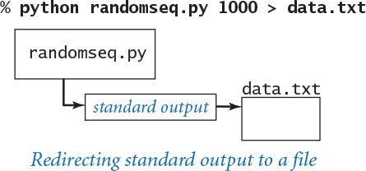

Redirecting from a file to standard input
We can redirect standard input so that our program reads data from a file instead of the terminal application:
Click here to view code image
% python average.py < data.txt
This command reads a sequence of numbers from the file data.txt and computes their average value. Specifically, the < symbol is a directive that tells the operating system to implement the standard input stream by reading from the text file data.txt instead of waiting for the user to type something into the terminal window. When the program calls stdio.readFloat(), the operating system reads the value from the file. The file data.txt could have been created by any application, not just a Python program—almost every application on your computer can create text files. This facility to redirect from a file to standard input enables us to create data-driven code, in which we can change the data processed by a program without having to change the program at all. Instead, we keep data in files and compose programs that read from standard input.
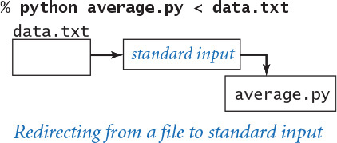

Connecting two programs
The most flexible way to implement the standard input and standard output abstractions is to specify that they are implemented by our own programs! This mechanism is called piping. For example, the command
Click here to view code image
% python randomseq.py 1000 | python average.py
specifies that the standard output for randomseq.py and the standard input stream for average.py are the same stream. The effect is as if randomseq.py were typing the numbers it generates into the terminal window while average.py is running. This example also has the same effect as the following sequence of commands:
Click here to view code image
% python randomseq.py 1000 > data.txt
% python average.py < data.txt
With piping, however, the file data.txt is not created. This difference is profound, because it removes another limitation on the size of the input and output streams that we can process. For example, we could replace 1000 in our example with 1000000000, even though we might not have the space to save a billion numbers on our computer (we do need the time to process them, however). When randomseq.py calls stdio.writeln(), a string is added to the end of the stream; when average.py calls stdio.readFloat(), a string is removed from the beginning of the stream. The timing of precisely what happens is up to the operating system: it might run randomseq.py until it produces some output, and then run average.py to consume that output, or it might run average.py until it needs some output, and then run randomseq.py until it produces the needed output. The end result is the same, but our programs are freed from worrying about such details because they work solely with the standard input and standard output abstractions.
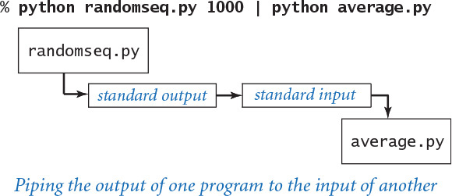

Filters
Piping, a core feature of the original Unix system of the early 1970s, still survives in modern systems because it is a simple abstraction for communicating among disparate programs. Testimony to the power of this abstraction is the fact that many Unix programs are still being used today to process files that are thousands or millions of times larger than imagined by the programs’ authors. We can communicate with other Python programs via calls on functions, but standard input and standard output allow us to communicate with programs that were written at another time and, perhaps, in another language. When we use standard input and standard output, we are agreeing on a simple interface to the outside world.
For many common tasks, it is convenient to think of each program as a filter that converts a standard input stream to a standard output stream in some way, with piping as the command mechanism to connect programs together. For example, rangefilter.py (PROGRAM 1.5.4) takes two command-line arguments and writes to standard output those numbers from standard input that fall within the specified range. You might imagine standard input to be measurement data from some instrument, with the filter being used to throw away data outside the range of interest for the experiment at hand.
Several standard filters that were designed for Unix still survive (sometimes with different names) as commands in modern operating systems. For example, the sort filter reads the lines from standard input and writes them to standard output in sorted order:
Click here to view code image
% python randomseq.py 9 | sort
0.0472650078535
0.0681950168757
0.0967410236589
0.0974385525393
0.118855769243
0.46604926859
0.522853708616
0.599692836211
0.685576779833
We discuss sorting in SECTION 4.2. A second useful filter is grep, which writes the lines from standard input that match a given pattern. For example, if you type
% grep lo < rangefilter.py
Program 1.5.4 A simple filter (rangefilter.py)
Click here to view code image
import sys
import stdio
lo = int(sys.argv[1])
hi = int(sys.argv[2])
while not stdio.isEmpty():
# Process one integer.
value = stdio.readInt()
if (value >= lo) and (value <= hi):
stdio.write(str(value) + ' ')
stdio.writeln()
lo | lower bound of range
hi | upper bound of range
value | current number
This program accepts integer command-line arguments lo and hi and then reads integers from standard input until it reaches end-of-file, writing to standard output each of those integers that is in the range lo to hi, inclusive. Thus the program is a filter (see text). There is no limit on the length of the streams.
Click here to view code image
% more rangedata.txt
3 1 4 1 5 9 2 6 5 3 5 8 9 7 9 3 2 3 8 4 6 2 6 4 3 3 8 3 2 7 9
% python rangefilter.py 5 9 < rangedata.txt
5 9 6 5 5 8 9 7 9 8 6 6 8 7 9
% python rangefilter.py 100 400
358 1330 55 165 689 1014 3066 387 575 843 203 48 292 877 65 998
358 165 387 203 292
<Ctrl-d>
you get all the lines in rangefilter.py that contain 'lo':
Click here to view code image
lo = int(sys.argv[1])
if (value >= lo) and (value <= hi):
Programmers often use tools such as grep to get a quick reminder of variable names or language usage details. A third useful filter is more, which reads data from standard input (or from a file specified as a command-line argument) and displays it in your terminal window one screenful at a time. For example, if you type
Click here to view code image
% python randomseq.py 1000 | more
you will see as many numbers as fit in your terminal window, but more will wait for you to hit the space bar before displaying each succeeding screenful. The term filter is perhaps misleading: it was meant to describe programs like rangefilter.py that write some subsequence of standard input to standard output, but it is now often used to describe any program that reads from standard input and writes to standard output.

Multiple streams
For many common tasks, we want to compose programs that take input from multiple sources and/or produce output intended for multiple destinations. In SECTION 3.1 we discuss our instream.py and outstream.py modules, which generalize stdio.py to allow for multiple input and output streams. These modules include provisions for redirecting these streams, not just to and from files, but also from arbitrary web pages.
Processing large amounts of information plays an essential role in many applications of computing. A scientist may need to analyze data collected from a series of experiments, a stock trader may wish to analyze information about recent financial transactions, or a student may wish to maintain collections of music and movies. In these and countless other applications, data-driven programs are the norm. Standard output, standard input, redirection, and piping provide us with the capability to address such applications with our Python programs. We can collect data into files on our computer through the web or any of the standard devices and use redirection and piping to connect data to our programs.

Standard drawing
Up to this point, our input/output abstractions have focused exclusively on text input and output. Now we introduce an abstraction for producing drawings as output. This module is easy to use and allows us to take advantage of a visual medium to cope with far more information than is possible with just text.
Standard drawing is very simple: we imagine an abstract drawing device capable of drawing lines and points on a two-dimensional canvas and then displaying that “canvas” on your screen in the standard drawing window. The device is capable of responding to the commands that our programs issue in the form of calls to functions in the stddraw module.
The module’s API consists of two kinds of functions: drawing functions that cause the device to take an action (such as drawing a line or drawing a point) and control functions that control how the drawing is shown and set parameters such as the pen size or the coordinate scales.

Creating drawings
The basic functions for drawing are described in the API at the bottom of this page. Like the functions for standard input and standard output, the drawing functions are nearly self-documenting: stddraw.line() draws a straight line segment connecting two points whose coordinates are given as arguments and stddraw.point() draws a dot centered at the given coordinates. The default coordinate scale is the unit square (all coordinates between 0 and 1). The point (0.0, 0.0) is at the lower left, and the point (1.0, 1.0) is at the upper right—thus corresponding to the first quadrant of the familiar Cartesian coordinate system. The default settings draw black lines and black points on a white background.
The control function stddraw.show() needs a bit more explanation. When your program calls any drawing function such as stddraw.line() or stddraw.point(), stddraw uses an abstraction known as the background canvas. The background canvas is not displayed; it exists only in computer memory. All points, lines, and so forth are drawn on the background canvas, not directly in the standard drawing window. Only when you call stddraw.show() does your drawing get copied from the background canvas to the standard drawing window, where it is displayed until the user closes the standard drawing window—typically by clicking on the Close button in the window’s title bar.
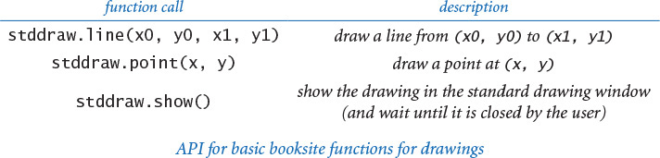
Why does stddraw need to use a background canvas? The main reason is that use of two canvases instead of one makes the stddraw module more efficient. Incrementally displaying a complex drawing as it is being created can be intolerably inefficient on many computer systems. In computer graphics, this technique is known as double buffering.
To summarize the information that you need to know, a typical program using the stddraw module has this structure:
• Import the stddraw module.
• Call drawing functions such as stddraw.line() and stddraw.point() to create a drawing on the background canvas.
• Call stddraw.show() to show the background canvas in the standard drawing window and wait until the window is closed.
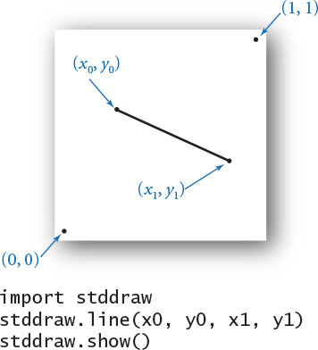
It is important to remember that all drawing goes to the background canvas. Typically, a program that creates a drawing finishes with a call to stddraw.show(), because only when stddraw.show() is called will you see your picture.
Next, we will consider several examples that will open up a whole new world of programming by freeing you from the restriction of communicating with your program just through text.

Your first drawing
The “Hello, World” equivalent for graphics programming with stddraw is to draw a triangle with a point inside. To form the triangle, we draw three lines: one from the point (0, 0) at the lower-left corner to the point (1, 0), one from that point to the third point at (1/2, ), and one from that point back to (0, 0). As a final flourish, we draw a spot in the middle of the triangle. Once you have successfully downloaded and run triangle.py, you are ready to compose your own programs that draw figures consisting of lines and points. This ability literally adds a new dimension to the output that you can produce.
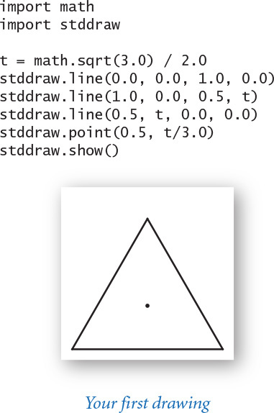
When you use a computer to create drawings, you get immediate feedback (the drawing) so that you can refine and improve your program quickly. With a computer program, you can create drawings that you could not contemplate making by hand. In particular, instead of viewing our data as just numbers, we can use pictures, which are far more expressive. We will consider other graphics examples after we discuss a few other drawing commands.

Saving a drawing
You can save the standard drawing window canvas to a file, thus giving you the ability to print a drawing or to share a drawing with other people. To do so, right-click anywhere on the window canvas (usually while stddraw is waiting forever because your program called its stddraw.show() function). After you do that, stddraw displays a file dialog box which allows you to specify a file name. Then, after you type a file name into the dialog box and click the Save button, stddraw saves the window canvas to a file with the specified name. The file name must end with either .jpg (to save the window canvas in JPEG format) or .png (to save the window canvas in “Portable Network Graphics” format). The drawings generated by the graphics programs shown in this chapter were saved to files using this mechanism.

Control commands
The default coordinate system for standard drawing is the unit square, but we often want to draw plots at different scales. For example, a typical situation is to use coordinates in some range for the x-coordinate, or the y-coordinate, or both. Also, we often want to draw lines of different thickness and points of different size from the standard. To accommodate these needs, stddraw has the functions shown at the top of the next page.
For example, when you call the function stddraw.setXscale(0, n), you are telling the drawing device that you will be using x-coordinates between 0 and n. Note that the two-call sequence
stddraw.setXscale(x0, x1)
stddraw.setYscale(y0, y1)
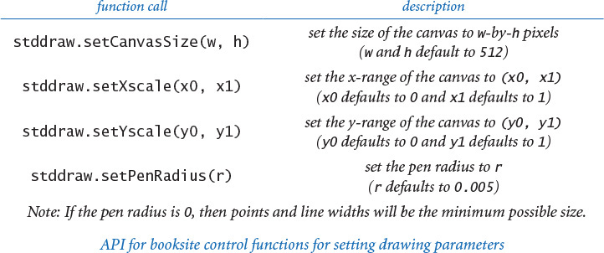
sets the drawing coordinates to be within a bounding box whose lower-left corner is at (x0, y0) and whose upper-right corner is at (x1, y1). If you use integer coordinates, Python promotes them to floats, as expected. The figure at right is a simple example that demonstrates the utility of scaling. Scaling is the simplest of the transformations commonly used in graphics. Several of the applications that we consider in this chapter are typical—we use scaling in a straightforward way to match our drawings to our data.
The pen is circular, so that when you set the pen radius to r and draw a point, you get a circle of radius r. Also, lines are of thickness 2r and have rounded ends. The default pen radius is 0.005 and is not affected by coordinate scaling. This default pen radius is about 1/200 the width of the default window, so that if you draw 100 points equally spaced along a horizontal or vertical line, you will be able to see individual circles, but if you draw 200 such points, the result will look like a line. When you make the function call stddraw.setPenRadius(.025), you are saying that you want the thickness of the lines and the size of the points to be five times the 0.005 standard. To draw points with the minimum possible radius (one pixel on typical displays), set the pen radius to 0.0.
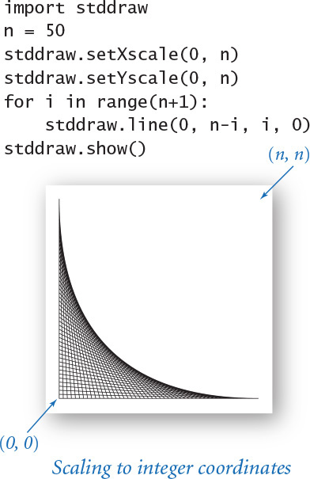
Program 1.5.5 Standard input to drawing filter (plotfilter.py)
Click here to view code image
import stddraw
import stdio
# Read and set the x- and y-scales.
x0 = stdio.readFloat()
y0 = stdio.readFloat()
x1 = stdio.readFloat()
y1 = stdio.readFloat()
stddraw.setXscale(x0, x1)
stddraw.setYscale(y0, y1)
# Read and plot the points.
stddraw.setPenRadius(0.0)
while not stdio.isEmpty():
x = stdio.readFloat()
y = stdio.readFloat()
stddraw.point(x, y)
stddraw.show()
x0 | left bound
y0 | bottom bound
x1 | right bound
y1 | top bound
x, y | current point
This program reads x- and y-scales from standard input, and configures the stddraw canvas accordingly. Then it reads points from standard input until it reaches end-of-file, and plots them to standard drawing. The file usa.txt on the booksite has the coordinates of the U.S. cities with populations over 500. Some data, such as the data in usa.txt, is inherently visual.
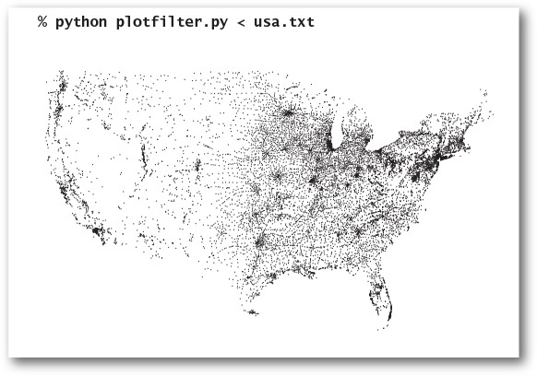

Filtering data to a standard drawing
One of the simplest applications of standard drawing is to plot data, by filtering it from standard input to the drawing. PROGRAM 1.5.5 (plotfilter.py) is such a filter: it reads a sequence of points defined by (x, y) coordinates and draws a spot at each point. It adopts the convention that the first four numbers read from standard input specify the bounding box, so that it can scale the plot without having to make an extra pass through all the points to determine the scale (this kind of convention is typical with such data files).
The graphical representation of points plotted in this way is far more expressive (and far more compact) than the numbers themselves or anything that we could create with the standard output representation that our programs have been limited to until now. The plotted image that is produced by plotfilter.py makes it far easier for us to infer properties of the cities (such as, for example, clustering of population centers) than does a list of the coordinates. Whenever we are processing data that represents the physical world, a visual image is likely to be one of the most meaningful ways in which we can use to display output. PROGRAM 1.5.5 illustrates just how easily you can create such an image.

Plotting a function graph
Another important use of stddraw is to plot experimental data or the values of a mathematical function. For example, suppose that we want to plot values of the function y = sin(4x) + sin(20x) in the interval [0, π]. Accomplishing this task is a prototypical example of sampling: there are an infinite number of points in the interval, so we have to make do with evaluating the function at a finite number of points within the interval. We sample the function by choosing a set of x-values, then computing y-values by evaluating the function at each x-value. Plotting the function by connecting successive points with lines produces a piecewise linear approximation. The simplest way to proceed is to regularly space the x values: we decide ahead of time on a sample size, then space the x-coordinates by the interval size divided by the sample size. To make sure that the values we plot fall in the visible canvas, we scale the x-axis corresponding to the interval and the y-axis corresponding to the maximum and minimum values of the function within the interval. PROGRAM 1.5.6 (functiongraph.py) gives the Python code for this process.
The smoothness of the curve depends on properties of the function and the size of the sample. If the sample size is too small, the rendition of the function may not be at all accurate (it might not be very smooth, and it might miss major fluctuations, as shown in the example on the next page); if the sample is too large, producing the plot may be time-consuming, since some functions are time-consuming to compute. (In SECTION 2.4, we will look at an efficient method for accurately plotting a smooth curve.) You can use this same technique to plot the function graph of any function you choose: identify an x-interval where you want to plot the function, compute function values evenly spaced in that interval and store them in an array, determine and set the y-scale, and draw the line segments.
Program 1.5.6 Function graph (functiongraph.py)
Click here to view code image
import math
import sys
import stdarray
import stddraw
n = int(sys.argv[1])
x = stdarray.create1D(n+1, 0.0)
y = stdarray.create1D(n+1, 0.0)
for i in range(n+1):
x[i] = math.pi * i / n
y[i] = math.sin(4.0*x[i]) + math.sin(20.0*x[i])
stddraw.setXscale(0, math.pi)
stddraw.setYscale(-2.0, +2.0)
for i in range(n):
stddraw.line(x[i], y[i], x[i+1], y[i+1])
stddraw.show()
n | # of samples
x[] | x-coordinates
y[] | y-coordinates
This program accepts integer command-line argument n and then plots a piecewise linear approximation to the function y = sin(4x) + sin(20x) by sampling the function at n+1 points between x = 0 and x = π and drawing n line segments. This example illustrates the need for choosing the number of samples carefully—on the left, with only 20 samples, we miss most of the fluctuations in the curve.
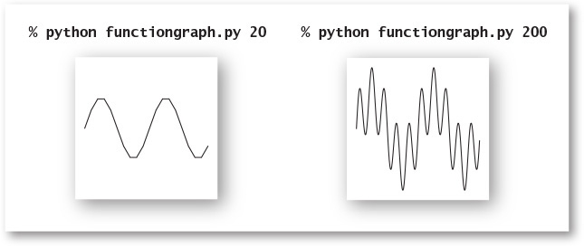

Outline and filled shapes
The booskite’s stddraw module also includes functions to draw circles, rectangles, and arbitrary polygons. Each shape defines an outline. When the function name is just the shape name, that outline is traced by the drawing pen. When the name begins with filled, the named shape is instead filled solid, not traced. As usual, we summarize the available functions in an API, shown at the bottom of this page.
The arguments for stddraw.circle() and stddraw.filledCircle() define a circle of radius r centered at (x, y); the arguments for stddraw.square() and stddraw.filledSquare() define a square of side length 2r centered at (x, y); and the arguments for stddraw.polygon() and stddraw.filledPolygon() define a sequence of points that we connect by lines, including one from the last point to the first point. If you want to define shapes other than squares or circles, use one of these functions. To check your understanding, try to figure out what this code draws, before reading the answer:
xd = [x-r, x, x+r, x]
yd = [y, y+r, y, y-r]
stddraw.polygon(xd, yd)
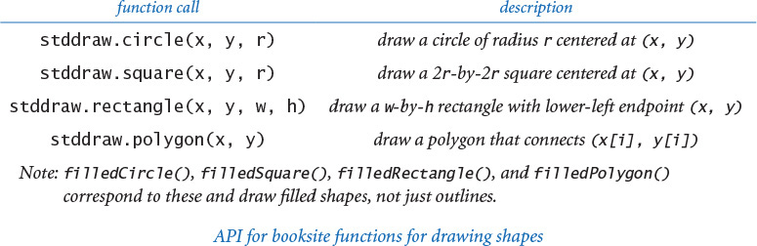
The answer is that you would never know, because it draws on the background canvas and there is no call to stddraw.show(). If there were such a call, it would draw a diamond (a rotated square) centered at the point (x, y). Several other examples of code that draws shapes and filled shapes are shown on the facing page.

Text and color
Occasionally, you may wish to annotate or highlight various elements in your drawings. The stddraw module has a function for drawing text, two other functions for setting parameters associated with text, and another for changing the color of the ink in the pen. We make scant use of these features in this book, but they can be very useful, particularly for drawings on your computer screen. You will find many examples of their use on the booksite.
In this code, color and fonts use types that you will learn about in SECTION 3.1. Until then, we leave the details to stddraw. The available pen colors are BLACK, BLUE, CYAN, DARK_GRAY, GRAY, GREEN, LIGHT_GRAY, MAGENTA, ORANGE, PINK, RED, WHITE, and YELLOW, defined as constants within stddraw. For example, the call stddraw.setPenColor(stddraw.GRAY) changes to gray ink. The default ink color is stddraw.BLACK. The default font in stddraw suffices for most of the drawings that you need (and you can find information on using other fonts on the booksite). For example, you might wish to call these functions to annotate function plots to highlight relevant values, and you might find it useful to compose similar functions to annotate other parts of your drawings.
Shapes, color, and text are basic tools that you can use to produce a dizzying variety of images, but you should use them judiciously. Use of such artifacts usually presents a design challenge, and our stddraw commands are crude by the standards of modern graphics libraries, so that you are likely to need more code than you might expect to produce the beautiful images that you may imagine.
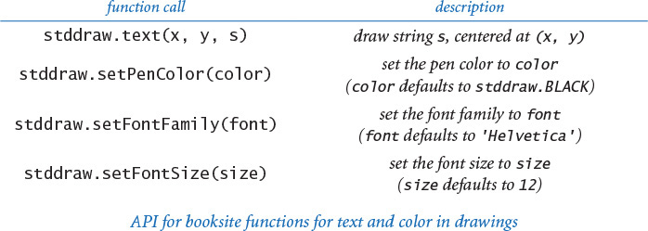
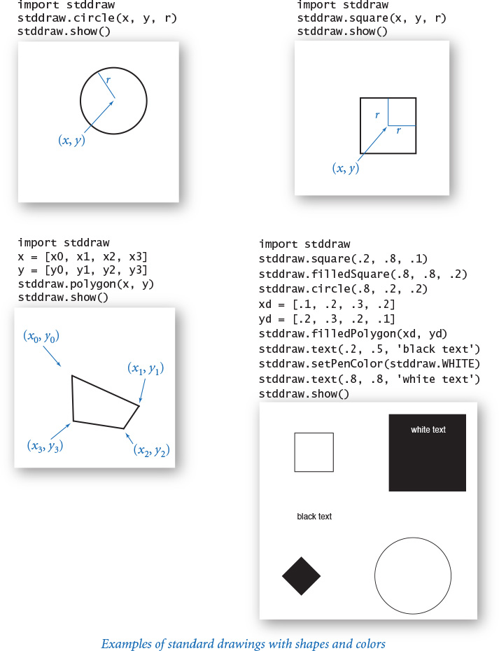

Animation
If we provide an argument to stddraw.show(), then that call need not be the last action of a program: it will copy the background canvas to the standard drawing window and then wait for the specified number of milliseconds. As you will soon see, this capability (coupled with the ability to erase, or clear the background canvas) provides limitless opportunities for creating interesting effects involving dynamic changes in the images in the standard drawing window. Such effects can provide compelling visualizations. We give an example next that also works for the printed page. The booksite offers even more examples that are likely to capture your imagination.
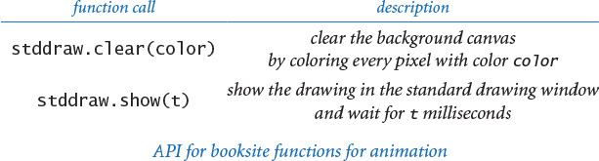

Bouncing ball
The “Hello, World” program for animation is to produce a black ball that appears to move around on the canvas. Suppose that the ball is at position (rx, ry) and we want to create the impression of moving it to a new position nearby, such as, for example, (rx + 0.01, ry + 0.02). We do so in three steps:
• Clear the background canvas.
• Draw a black ball at the new position.
• Show the drawing and wait for a short while.
To create the illusion of movement, we iterate these steps for a whole sequence of positions (one that will form a straight line, in this case). The argument to stddraw.show() quantifies “a short while” and controls the apparent speed.
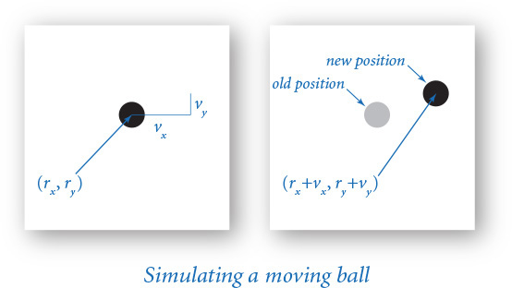
Program 1.5.7 Bouncing ball (bouncingball.py)
Click here to view code image
import stddraw
stddraw.setXscale(-1.0, 1.0)
stddraw.setYscale(-1.0, 1.0)
DT = 20.0
RADIUS = 0.05
rx = 0.480
ry = 0.860
vx = 0.015
vy = 0.023
while True:
# Update ball position and draw it there.
if abs(rx + vx) + RADIUS > 1.0: vx = -vx
if abs(ry + vy) + RADIUS > 1.0: vy = -vy
rx = rx + vx
ry = ry + vy
stddraw.clear(stddraw.GRAY)
stddraw.filledCircle(rx, ry, RADIUS)
stddraw.show(DT)
DT | wait time
RADIUS | ball radius
rx, ry | position
vx, vy | velocity
This program draws a bouncing ball to standard drawing. That is, it simulates the movement of a bouncing ball in the unit box. The ball bounces off the boundary according to the laws of elastic collision. The 20-millisecond wait period keeps the black image of the ball persistent on the screen, even though most of the ball’s pixels alternate between black and white. If you modify this code to take the wait time dt as a command-line argument, you can control the speed of the ball. The images below, which show the track of the ball, are produced by a modified version of this code where the call to stddraw.clear() is outside the loop (see Exercise 1.5.34).

PROGRAM 1.5.7 (bouncingball.py) implements these steps to create the illusion of a ball moving in the 2-by-2 box centered at the origin. The current position of the ball is (rx, ry), and we compute the new position at each step by adding vx to rx and vy to ry. Since (vx, vy) is the fixed distance that the ball moves in each time unit, it represents the velocity. To keep the ball in the drawing, we simulate the effect of the ball bouncing off the walls according to the laws of elastic collision. This effect is easy to implement: when the ball hits a vertical wall, we just change the velocity in the x-direction from vx to –vx, and when the ball hits a horizontal wall, we change the velocity in the y-direction from vy to –vy. Of course, you have to download the code from the booksite and run it on your computer to see motion.
Since we cannot show a moving image on the printed page, we slightly modified bouncingball.py to show the track of the ball as it moves (see EXERCISE 1.5.34) in the examples shown below the code.
To familiarize yourself with animation on your computer, you are encouraged to modify the various parameters in bouncingball.py to draw a bigger ball, make it move faster or slower, and experiment with the distinction between the velocity in the simulation and the apparent speed on your display. For maximum flexibility, you might wish to modify bouncingball.py to take all these parameters as command-line arguments.
Standard drawing substantially improves our programming model by adding a “picture is worth a thousand words” component. It is a natural abstraction that you can use to better open up your programs to the outside world. With it, you can easily produce the function plots and visual representations of data that are commonly used in science and engineering. We will put it to such uses frequently throughout this book. Any time that you spend now working with the sample programs on the last few pages will be well worth the investment. You can find many useful examples on the booksite and in the exercises, and you are certain to find some outlet for your creativity by using stddraw to meet various challenges. Can you draw an n-pointed star? Can you make our bouncing ball actually bounce (add gravity)? You may be surprised at how easily you can accomplish these and other tasks.

Standard audio
As a final example of a basic abstraction for output, we consider stdaudio, a module that you can use to play, manipulate, and synthesize sound. You probably have used your computer to process music; now you can compose programs to do so. At the same time, you will learn some concepts behind a venerable and important area of computer science and scientific computing: digital signal processing. We will merely scratch the surface of this fascinating subject, but you may be surprised at the simplicity of the underlying concepts.

Concert A
Sound is the perception of the vibration of molecules—in particular, the vibration of our eardrums. Therefore, oscillation is the key to understanding sound. Perhaps the simplest place to start is to consider the musical note A above middle C, which is known as concert A. This note is nothing more than a sine wave, scaled to oscillate at a frequency of 440 times per second. The function sin(t) repeats itself once every 2π units, so if we measure t in seconds and plot the function sin(2πt ×440), we get a curve that oscillates 440 times per second. When you play an A by plucking a guitar string, pushing air through a trumpet, or causing a small cone to vibrate in a speaker, this sine wave is the prominent part of the sound that you hear and recognize as concert A. We measure frequency in hertz (cycles per second). When you double or halve the frequency, you move up or down one octave on the scale. For example, 880 hertz is one octave above concert A and 110 hertz is two octaves below concert A. For reference, the frequency range of human hearing is about 20 to 20,000 hertz. The amplitude (y-value) of a sound corresponds to the volume. We plot our curves between –1 and +1 and assume that any devices that record and play sound will scale as appropriate, with further scaling controlled by you when you turn the volume knob.
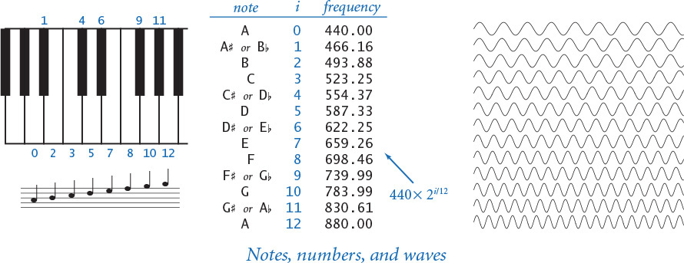

Other notes
A simple mathematical formula characterizes the other notes on the chromatic scale. There are 12 notes on the chromatic scale, divided equally on a logarithmic (base 2) scale. We get the i th note above a given note by multiplying its frequency by the (i /12)th power of 2. In other words, the frequency of each note in the chromatic scale is precisely the frequency of the previous note in the scale multiplied by the twelfth root of 2 (about 1.06). This information suffices to create music! For example, to play the tune Frère Jacques, we just need to play each of the notes A B C# A by producing sine waves of the appropriate frequency for about half a second and then repeat the pattern.

Sampling
For digital sound, we represent a curve by sampling it at regular intervals, in precisely the same manner as when we plot function graphs. We sample sufficiently often that we have an accurate representation of the curve—a widely used sampling rate for digital sound is 44,100 samples per second. For concert A, that rate corresponds to plotting each cycle of the sine wave by sampling it at about 100 points. Since we sample at regular intervals, we need to compute only the y-coordinates of the sample points. It is that simple: we represent sound as an array of numbers (float values that are between –1 and +1). Our booksite sound module function stdaudio.playSamples() takes an array of floats as its argument and plays the sound represented by that array on your computer.
For example, suppose that you want to play concert A for 10 seconds. At 44,100 samples per second, you need an array of 441,001 float values. To fill in the array, use a for loop that samples the function sin(2πt × 440) at t = 0 / 44100, 1 / 44100, 2 / 44100, 3 / 44100, ..., 441000 / 44100. Once we fill the array with these values, we are ready for stdaudio.playSamples(), as in the following code:
Click here to view code image
SPS = 44100 # samples per second
hz = 440.0 # concert A
duration = 10.0 # ten seconds
n = int(SPS * duration)
a = stdarray.create1D(n+1)
for i in range(n+1):
a[i] = math.sin(2.0 * math.pi * i * hz / SPS)
stdaudio.playSamples(a)
stdaudio.wait()
This code is the “Hello, World” of digital audio. Once you use it to get your computer to play this note, you can compose code to play other notes and make music! The difference between creating sound and plotting an oscillating curve is nothing more than the output device. Indeed, it is instructive and entertaining to send the same numbers to both standard drawing and standard audio (see EXERCISE 1.5.27).

Saving to a file
Music can take up a lot of space on your computer. At 44,100 samples per second, a four-minute song corresponds to 4 × 60 × 44100=10,584,000 numbers. Therefore, it is common to represent the numbers corresponding to a song in a binary format that uses less space than the string-of-digits representation that we use for standard input and output. Many such formats have been developed in recent years—stdaudio uses the .wav format. You can find some information about the .wav format on the booksite, but you do not need to know the details, because stdaudio takes care of the conversions for you. The stdaudio module allows you to play .wav files, to compose programs to create and manipulate arrays of floats, and to read and write them as .wav files.
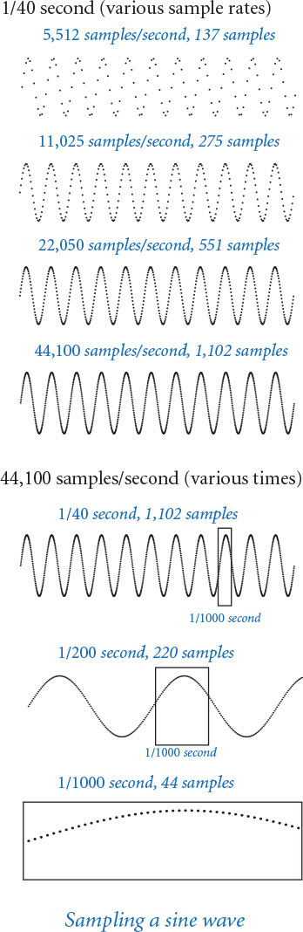
To see how easily we can create music with the functions in the stdaudio module (detailed at the top of page 175), consider PROGRAM 1.5.8 (playthattune.py). It takes notes from standard input, indexed on the chromatic scale from concert A, and plays them to standard audio. You can imagine all sorts of extensions on this basic scheme, some of which are addressed in the exercises.
Program 1.5.8 Digital signal processing (playthattune.py)
Click here to view code image
import math
import stdarray
import stdaudio
import stdio
SPS = 44100
CONCERT_A = 440.0
while not stdio.isEmpty():
pitch = stdio.readInt()
duration = stdio.readFloat()
hz = CONCERT_A * (2 ** (pitch / 12.0))
n = int(SPS * duration)
samples = stdarray.create1D(n+1, 0.0)
for i in range(n+1):
samples[i] = math.sin(2.0 * math.pi * i * hz / SPS)
stdaudio.playSamples(samples)
stdaudio.wait()
pitch | distance from A
duration | note play time
hz | frequency
n | number of samples
samples[] | sampled sine wave
This program reads sound samples from standard input, and plays the sound to standard audio. This data-driven program plays pure tones from the notes on the chromatic scale, specified on standard input as a pitch (distance from concert A) and a duration (in seconds). The test client reads the notes from standard input, creates an array by sampling a sine wave of the specified frequency and duration at 44,100 samples per second, and then plays each note by calling stdaudio.playSamples().
% more elise.txt
7 .25
6 .25
7 .25
6 .25
7 .25
2 .25
5 .25
3 .25
0 .50
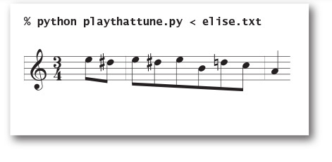
We include stdaudio in our basic arsenal of programming tools because sound processing is one important application of scientific computing that is certainly familiar to you. Not only has the commercial application of digital signal processing had a phenomenal impact on modern society, but the science and engineering behind it combine physics and computer science in interesting ways. We will study more components of digital signal processing in some detail later in the book. (For example, you will learn in SECTION 2.1 how to create sounds that are more musical than the pure sounds produced by playthattune.py.)
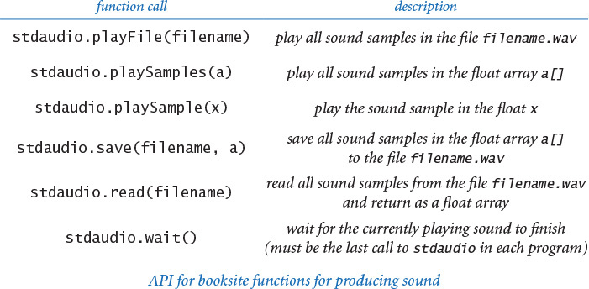

Summary
I/O is a particularly convincing example of the power of abstraction because standard input, standard output, standard drawing, and standard audio can be tied to different physical devices at different times without making any changes to programs. Although devices may differ dramatically, we can compose programs that can do I/O without depending on the properties of specific devices. From this point forward, we will call functions from stdio, stddraw, and/or stdaudio in nearly every program in this book, and you will use them in nearly all of your programs. One important advantage of using such modules is that you can switch to new devices that are faster or cheaper, or hold more data, without changing your program at all. In such a situation, the details of the connection are a matter to be resolved between your operating system and the booksite module implementations. On modern systems, new devices are typically supplied with software that resolves such details automatically for both the operating system and for Python.
Conceptually, one of the most significant features of the standard input, standard output, standard drawing, and standard audio data streams is that they are infinite: from the point of view of your program, there is no limit on their length. This point of view leads to more than just programs that have a long useful life (because they are less sensitive to changes in technology than programs with built-in limits). It also is related to the Turing machine, an abstract device used by theoretical computer scientists to help us understand fundamental limitations on the capabilities of real computers. One of the essential properties of the model is the idea of a finite discrete device that works with an unlimited amount of input and output.

Q&A
Q. How can I make the booksite modules stdio, stddraw, and stdaudio available to Python?
A. If you followed the step-by-step instructions on the booksite for installing Python, these module should already be available to Python. Note that copying the files stddraw.py and stdaudio.py from the booksite and putting them in the same directory as the programs that use them is insufficient because they rely upon a library (set of modules) named Pygame for graphics and audio.
Q. Are there standard Python modules for handling standard output?
A. Actually, such features are built into Python. In Python 2, you can use the print statement to write data to stdout. In Python 3, there is no print statement; instead, there is a print() function, which is similar.
Q. Why, then, are we using the booksite stdio module for writing to standard output instead of using the features already provided by Python?
A. Our intention is to compose code that works (as much as possible) with all versions of Python. For example, using the print statement in all our programs would mean they would work with Python 2, but not with Python 3. Since we use stdio functions, we just need to make sure that we have the proper library.
Q. How about standard input?
A. There are (different) capabilities in Python 2 and Python 3 that correspond to stdio.readLine(), but nothing corresponding to stdio.readInt() and similar functions. Again, by using stdio, we can compose programs that not just take advantage of these additional capabilities, but also work in both versions of Python.
Q. How about drawing and sound?
A. Python does not come with an audio library. Python comes with a graphics library named Tkinter for producing drawings, but it is too slow for some of the graphics applications in the book. Our stddraw and stdaudio modules provide easy-to-use APIs, based on the Pygame library.
Q. So, let me get this straight; if I use the format %2.4f with stdio.writef() to write a float, I get two digits before the decimal point and four digits after the decimal point, right?
A. No, that specifies just four digits after the decimal point. The number preceding the decimal point is the width of the whole field. You want to use the format %7.2f to specify seven characters in total—four before the decimal point, the decimal point itself, and two digits after the decimal point.
Q. Which other conversion codes are there for stdio.writef()?
A. For integers, there is o for octal and x for hexadecimal. There are also numerous formats for dates and times. See the booksite for more information.
Q. Can my program reread data from standard input?
A. No. You get only one shot at it, in the same way that you cannot undo a call of stdio.writeln().
Q. What happens if my program attempts to read data from standard input after it is exhausted?
A. Python will raise an EOFError at run time. The functions stdio.isEmpty() and stdio.hasNextLine() allow you to avoid such an error by checking whether more input is available.
Q. Why does stddraw.square(x, y, r) draw a square of width 2r instead of r?
A. This makes it consistent with the function stddraw.circle(x, y, r), where the third argument is the radius of the circle, not the diameter. In this context, r is the radius of the biggest circle that can fit inside the square.
Q. What happens if my program calls stddraw.show(0)?
A. That function call tells stddraw to copy the background canvas to the standard drawing window, and then wait 0 milliseconds (that is, do not wait at all) before proceeding. That function call is appropriate if, for example, you want to run an animation at the fastest rate supported by your computer.
Q. Can I draw curves other than circles with stddraw?
A. We had to draw the line somewhere (pun intended), so we support only the basic shapes discussed in the text. You can draw other shapes one point at a time, as explored in several exercises in the text, but filling them is not directly supported.
Q. So I use negative integers to go below concert A when making input files for playthattune.py?
A. Right. Actually, our choice to put concert A at 0 is arbitrary. A popular standard, known as the MIDI Tuning Standard, starts numbering at the C five octaves below concert A. By that convention, concert A is 69 and you do not need to use negative numbers.
Q. Why do I hear weird results from standard audio when I try to sonify a sine wave with a frequency of 30,000 hertz (or more)?
A. The Nyquist frequency, defined as one-half the sampling frequency, represents the highest frequency that can be reproduced. For standard audio, the sampling frequency is 44,100, so the Nyquist frequency is 22,050.

Exercises
1.5.1 Compose a program that reads in integers (as many as the user enters) from standard input and writes the maximum and minimum values to standard output.
1.5.2 Modify your program from the previous exercise to insist that the integers must be positive (by prompting the user to enter positive integers whenever the value entered is not positive).
1.5.3 Compose a program that accepts an integer n from the command line, reads n floats from standard input, and writes their mean (average value) and standard deviation (square root of the sum of the squares of their differences from the average, divided by n) to standard output.
1.5.4 Extend your program from the previous exercise to create a filter that writes all the floats in standard input that are more than 1.5 standard deviations from the mean.
1.5.5 Compose a program that reads in a sequence of integers and writes both the integer that appears in a longest consecutive run and the length of the run. For example, if the input is 1 2 2 1 5 1 1 7 7 7 7 1 1, then your program should write Longest run: 4 consecutive 7s.
1.5.6 Compose a filter that reads in a sequence of integers and writes the integers, removing repeated values that appear consecutively. For example, if the input is 1 2 2 1 5 1 1 7 7 7 7 1 1 1 1 1 1 1 1 1, your program should write 1 2 1 5 1 7 1.
1.5.7 Compose a program that takes a command-line argument n, reads from standard input N-1 distinct integers between 1 and n, and determines the missing integer.
1.5.8 Compose a program that reads in positive real numbers from standard input and writes their geometric and harmonic means. The geometric mean of n positive numbers x1, x2, ..., xn is (x1 × x2 × ... × xn)1/n. The harmonic mean is (1/x1 + 1/x2 + ... + 1/xn) / (1/n). Hint: For the geometric mean, consider taking logarithms to avoid overflow.
1.5.9 Suppose that the file in.txt contains the two strings F and F, and consider the following program (dragon.py):
Click here to view code image
import stdio
dragon = stdio.readString()
nogard = stdio.readString()
stdio.write(dragon + 'L' + nogard)
stdio.write(' ')
stdio.write(dragon + 'R' + nogard)
stdio.writeln()
What does the following command do (see EXERCISE 1.2.35)?
Click here to view code image
python dragon.py < in.txt | python dragon.py | python dragon.py
1.5.10 Compose a filter tenperline.py that reads a sequence of integers between 0 and 99 and writes 10 integers per line, with columns aligned. Then compose a program randomintseq.py that takes two command-line arguments m and n and outputs n random integers between 0 and m-1. Test your programs with the command python randomintseq.py 200 100 | python tenperline.py.
1.5.11 Compose a program that reads in text from standard input and writes the number of words in the text. For the purpose of this exercise, a word is a sequence of non-whitespace characters that is surrounded by whitespace.
1.5.12 Compose a program that reads in lines from standard input with each line containing a name and two integers and then uses writef() to write a table with a column of the names, the integers, and the result of dividing the first by the second, accurate to three decimal places. You could use a program like this to tabulate batting averages for baseball players or grades for students.
1.5.13 Which of the following require saving all the values from standard input (in an array, say), and which could be implemented as a filter using only a fixed number of variables? For each, the input comes from standard input and consists of n floats between 0 and 1.
• Write the maximum and minimum float.
• Write the k th smallest float.
• Write the sum of the squares of the floats.
• Write the average of the n floats.
• Write the percentage of floats greater than the average.
• Write the n floats in increasing order.
• Write the n floats in random order.
1.5.14 Compose a program that writes a table of the monthly payments, remaining principal, and interest paid for a loan, taking three numbers as command-line arguments: the number of years, the principal, and the interest rate (see EXERCISE 1.2.24).
1.5.15 Compose a program that takes three command-line arguments x, y, and z, reads from standard input a sequence of point coordinates (xi, yi, zi), and writes the coordinates of the point closest to (x, y, z). Recall that the square of the distance between (x, y, z) and (xi, yi, zi) is (x – xi)2 + (y – yi)2 + (z – zi)2. For efficiency, do not use either math.sqrt() or the ** operator.
1.5.16 Compose a program that, given the positions and masses of a sequence of objects, computes their center-of-mass, or centroid. The centroid is the average position of the n objects, weighted by mass. If the positions and masses are given by (xi, yi, mi), then the centroid (x, y, m) is given by
m = m1 + m2 + ... + mn
x = (m1 x1 + ... + mn xn) / m
y = (m1 y1 + ... + mn yn) / m
1.5.17 Compose a program that reads in a sequence of real numbers between –1 and +1 and writes their average magnitude, average power, and the number of zero crossings. The average magnitude is the average of the absolute values of the data values. The average power is the average of the squares of the data values. The number of zero crossings is the number of times a data value transitions from a strictly negative number to a strictly positive number, or vice versa. These three statistics are widely used to analyze digital signals.
1.5.18 Compose a program that takes a command-line argument n and plots an n-by-n checkerboard with red and black squares. Color the lower-left square red.
1.5.19 Compose a program that takes as command-line arguments an integer n and a float p (between 0 and 1), plots n equally spaced points of size on the circumference of a circle, and then, with probability p for each pair of points, draws a gray line connecting them.
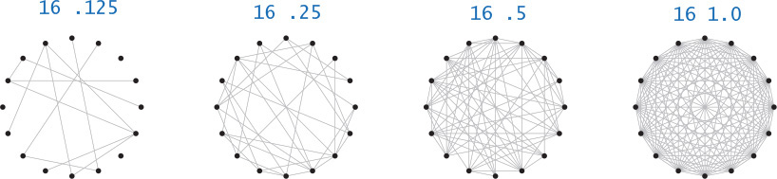
1.5.20 Compose code to draw hearts, spades, clubs, and diamonds. To draw a heart, draw a diamond, then attach two semicircles to the upper-left and upper-right sides.
1.5.21 Compose a program that takes a command-line argument n and plots a “flower” with n petals (if n is odd) or 2n petals (if n is even), by plotting the polar coordinates (r, θ) of the function r = sin(n θ) for θ ranging from 0 to 2π radians.
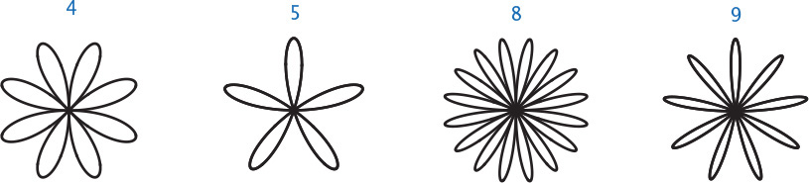
1.5.22 Compose a program that takes a string s from the command line and displays it in banner style on the screen, moving from left to right and wrapping back to the beginning of the string as the end is reached. Add a second command-line argument to control the speed.
1.5.23 Modify playthattune.py to take additional command-line arguments that control the volume (multiply each sample value by the volume) and the tempo (multiply each note’s duration by the tempo).
1.5.24 Compose a program that takes the name of a .wav file and a playback rate r as command-line arguments and plays the file at the given rate. First, use stdaudio.read() to read the file into an array a[]. If r = 1, just play a[]; otherwise, create a new array b[] of approximate size r times a.length. If r < 1, populate b[] by sampling from the original; if r > 1, populate b[] by interpolating from the original. Then play b[].
1.5.25 Compose programs that use stddraw to create each of these designs.

1.5.26 Compose a program circles.py that draws filled circles of random size at random positions in the unit square, producing images like those below. Your program should take four command-line arguments: the number of circles, the probability that each circle is black, the minimum radius, and the maximum radius.
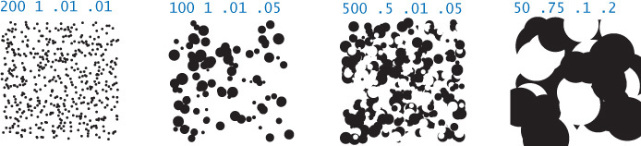

Creative Exercises
1.5.27 Visualizing audio. Modify playthattune.py (PROGRAM 1.5.8) to send the values played to standard drawing, so that you can watch the sound waves as they are played. You will have to experiment with plotting multiple curves in the drawing canvas to synchronize the sound and the picture.
1.5.28 Statistical polling. When collecting statistical data for certain political polls, it is very important to obtain an unbiased sample of registered voters. Assume that you have a file with n registered voters, one per line. Compose a filter that writes a random sample of size m (see sample.py, PROGRAM 1.4.1).
1.5.29 Terrain analysis. Suppose that a terrain is represented by a two-dimensional grid of elevation values (in meters). A peak is a grid point whose four neighboring cells (left, right, up, and down) have strictly lower elevation values. Compose a program peaks.py that reads a terrain from standard input and then computes and writes the number of peaks in the terrain.
1.5.30 Histogram. Suppose that the standard input stream is a sequence of floats. Compose a program that takes an integer n and two floats lo and hi from the command line and uses stddraw to plot a histogram of the count of the numbers in the standard input stream that fall into each of the n intervals defined by dividing the interval (lo, hi) into n equal-sized intervals.
1.5.31 Spirographs. Compose a program that takes three parameters R, r, and a from the command line and draws the resulting spirograph. A spirograph (technically, an epicycloid) is a curve formed by rolling a circle of radius r around a larger fixed circle of radius R. If the pen offset from the center of the rolling circle is (r+a), then the equation of the resulting curve at time t is given by
x(t) = (R + r) cos (t) – (r + a) cos ((R + r)t /r)
y(t) = (R + r) sin (t) – (r + a) sin ((R + r)t /r)
Such curves were popularized by a best-selling toy that contains discs with gear teeth on the edges and small holes that you could put a pen in to trace spirographs.
1.5.32 Clock. Compose a program that displays an animation of the second, minute, and hour hands of an analog clock. Use the call stddraw.show(1000) to update the display roughly once per second.
1.5.33 Oscilloscope. Compose a program to simulate the output of an oscilloscope and produce Lissajous patterns. These patterns are named after the French physicist, Jules A. Lissajous, who studied the patterns that arise when two mutually perpendicular periodic disturbances occur simultaneously. Assume that the inputs are sinusoidal, so that the following parametric equations describe the curve:
x(t) = Ax sin (wx t + θx)
y(t) = A y sin (wy t + θy)
Take the six parameters Ax and Ay (amplitudes); wx and wy (angular velocity); and θx and θy (phase factors) from the command line.
1.5.34 Bouncing ball with tracks. Modify bouncingball.py to produce images like the ones shown in the text, which show the track of the ball on a gray background.
1.5.35 Bouncing ball with gravity. Modify bouncingball.py to incorporate gravity in the vertical direction. Add calls to stdaudio.playFile() to add one sound effect when the ball hits a wall and a different one when it hits the floor.
1.5.36 Random tunes. Compose a program that uses stdaudio to play random tunes. Experiment with keeping in key, assigning high probabilities to whole steps, repetition, and other rules to produce reasonable melodies.
1.5.37 Tile patterns. Using your solution to EXERCISE 1.5.25, compose a program tilepattern.py that takes a command-line argument n and draws an n-by-n pattern, using the tile of your choice. Add a second command-line argument that adds a checkerboard option. Add a third command-line argument for color selection. Using the patterns on the facing page as a starting point, design a tile floor. Be creative! Note: These are all designs from antiquity that you can find in many ancient (and modern) buildings.
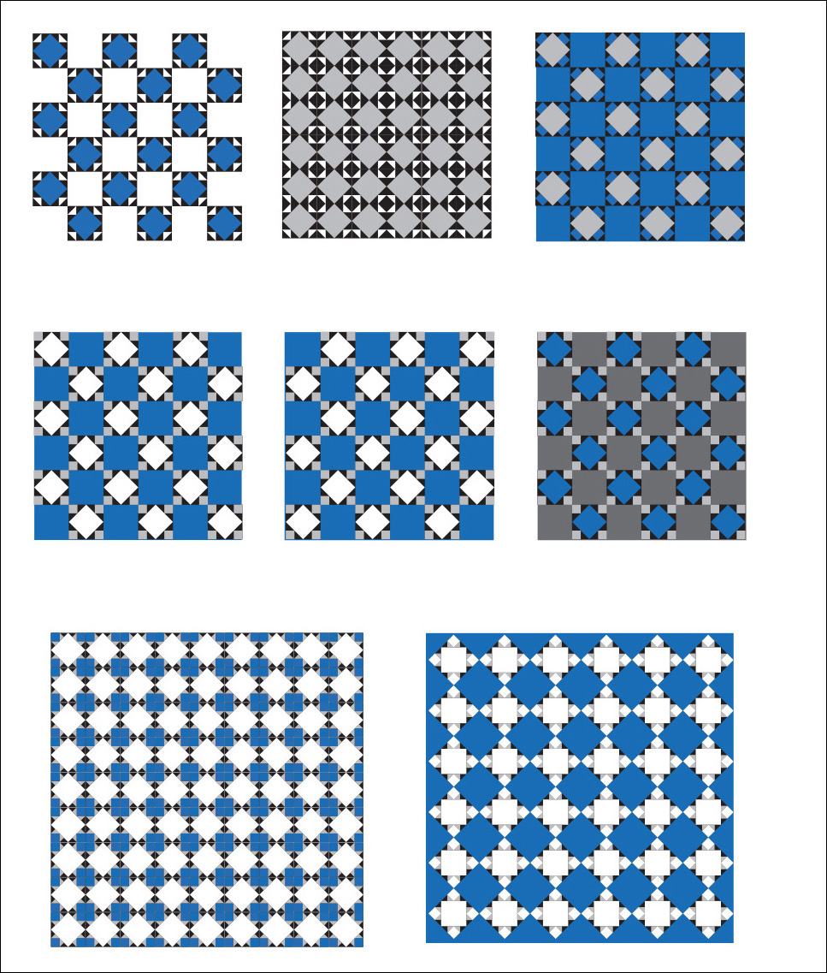

1.6 Case Study: Random Web Surfer
Communicating across the web has become an integral part of everyday life. This communication is enabled in part by scientific studies of the structure of the web, a subject of active research since its inception. We next consider a simple model of the web that has proved to be a particularly successful approach to understanding some of its properties. Variants of this model are widely used and have been a key factor in the explosive growth of search applications on the web.
1.6.1 Computing the transition matrix
1.6.2 Simulating a random surfer
1.6.3 Mixing a Markov chain
Programs in this section
The model, which is known as the random surfer model, is simple to describe. We consider the web to be a fixed set of pages, with each page containing a fixed set of links, and each link a reference to some other page. We study what happens to a person (the random surfer) who randomly moves from page to page, either by typing a page name into the address bar or by clicking a link on the current page.
The underlying mathematical model behind the web model is known as the graph, which we will consider in detail at the end of the book (in SECTION 4.5). We defer discussion of the details of processing graphs until then. Instead, we concentrate on calculations associated with a natural and well-studied probabilistic model that accurately describes the behavior of the random surfer.
The first step in studying the random surfer model is to formulate it more precisely. The crux of the matter is to specify what it means to randomly move from page to page. The following intuitive 90-10 rule captures both methods of moving to a new page: Assume that 90 percent of the time the random surfer clicks a random link on the current page (each link chosen with equal probability) and that 10 percent of the time the random surfer goes directly to a random page (all pages on the web chosen with equal probability).
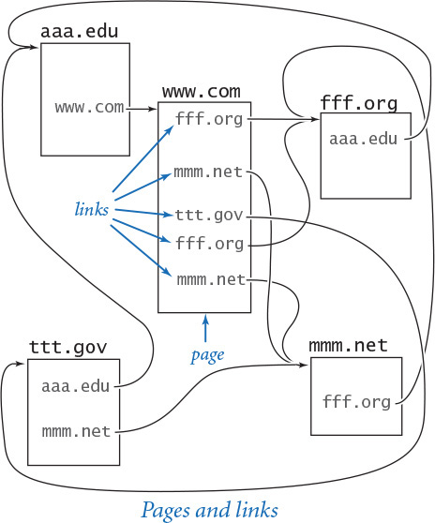
You can immediately see that this model has flaws, because you know from your own experience that the behavior of a real web surfer is not quite so simple:
• No one chooses links or pages with equal probability.
• There is no real potential to surf directly to each page on the web.
• The 90-10 (or any fixed) breakdown is just a guess.
• It does not take the “back” button or bookmarks into account.
• We can afford to work with only a small sample of the web.
Despite these flaws, the model is sufficiently rich that computer scientists have learned a great deal about properties of the web by studying it. To appreciate the model, consider the small example on the previous page. Which page do you think the random surfer is most likely to visit?
Each person using the web behaves a bit like the random surfer, so understanding the fate of the random surfer is of intense interest to people building web infrastructure and web applications. The model is a tool for understanding the experience of each of the billions of web users. In this section, you will use the basic programming tools from this chapter to study the model and its implications.

Input format
We want to be able to study the behavior of the random surfer on various web models, not just one example. Consequently, we want to compose data-driven code, where we keep data in files and compose programs that read the data from standard input. The first step in this approach is to define an input format that we can use to structure the information in the input files. We are free to define any convenient input format.
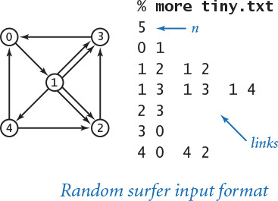
Later in the book, you will learn how to read web pages in Python programs (SECTION 3.1) and to convert from names to numbers (SECTION 4.4) as well as other techniques for efficient graph processing. For now, we assume that there are n web pages, numbered from 0 to n – 1, and we represent links with ordered pairs of such numbers, the first specifying the page containing the link and the second specifying the page to which it refers. Given these conventions, a straightforward input format for the random surfer problem is an input stream consisting of an integer (the value of n) followed by a sequence of pairs of integers (the representations of all the links). Because of the way stdio reading functions treat whitespace characters, we are free to either put one link per line or arrange them several to a line.

Transition matrix
We use a two-dimensional matrix, which we refer to as the transition matrix, to completely specify the behavior of the random surfer. With n web pages, we define an n-by-n matrix such that the element in row i and column j is the probability that the random surfer moves to page j when on page i. Our first task is to compose code that can create such a matrix for any given input. When we apply the 90-10 rule, this computation is not difficult. We do so in three steps:
• Read n, and then create arrays linkCounts[][] and outDegrees[].
• Read the links and accumulate counts so that linkCounts[i][j] counts links from i to j and outDegrees[i] counts links from i to anywhere.
• Use the 90-10 rule to compute the probabilities.
The first two steps are elementary, and the third is not much more difficult: multiply linkCounts[i][j] by 0.90/outDegrees[i] if there is a link from i to j (take a random link with probability 0.9), and then add 0.10/n to each element (go to a random page with probability 0.1). PROGRAM 1.6.1 (transition.py) performs this calculation: it is a filter that converts the list-of-links representation of a web model into a transition-matrix representation.
The transition matrix is significant because each row represents a discrete probability distribution—the elements fully specify the behavior of the random surfer’s next move, giving the probability of surfing to each page. Note in particular that the elements sum to 1 (the surfer always goes somewhere).
The output of transition.py defines another file format, one for matrices of float values: the numbers of rows and columns followed by the values for matrix elements. Now, we can compose code that reads and processes transition matrices.
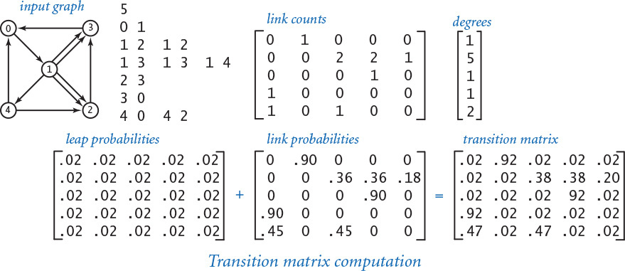
Program 1.6.1 Computing the transition matrix (transition.py)
Click here to view code image
import stdarray
import stdio
n = stdio.readInt()
linkCounts = stdarray.create2D(n, n, 0)
outDegrees = stdarray.create1D(n, 0)
while not stdio.isEmpty():
# Accumulate link counts.
i = stdio.readInt()
j = stdio.readInt()
outDegrees[i] += 1
linkCounts[i][j] += 1
stdio.writeln(str(n) + ' ' + str(n))
for i in range(n):
# Write probability distribution for row i.
for j in range(n):
# Write probability for column j.
p = (0.90 * linkCounts[i][j] / outDegrees[i]) + (0.10 / n)
stdio.writef('%8.5f', p)
stdio.writeln()
n | # pages
linkCounts[i][j] | # links from page i to page j
outDegrees[i] | # links out of page i
p | transition probability
This program is a filter that reads links from standard input and writes the corresponding transition matrix to standard output. First, it processes the input to count the links from each page. Then it applies the 90-10 rule to compute the transition matrix (see text). It assumes that there are no pages in the input that have zero outdegrees (see EXERCISE 1.6.3).
% more tiny.txt
5
0 1
1 2 1 2
1 3 1 3 1 4
2 3
3 0
4 0 4 2
Click here to view code image
% python transition.py < tiny.txt
5 5
0.02000 0.92000 0.02000 0.02000 0.02000
0.02000 0.02000 0.38000 0.38000 0.20000
0.02000 0.02000 0.02000 0.92000 0.02000
0.92000 0.02000 0.02000 0.02000 0.02000
0.47000 0.02000 0.47000 0.02000 0.02000

Simulation
Given the transition matrix, simulating the behavior of the random surfer involves surprisingly little code, as you can see in randomsurfer.py (PROGRAM 1.6.2). This program reads a transition matrix and surfs according to the rules, starting at page 0 and taking the number of moves as a command-line argument. It counts the number of times that the surfer visits each page. Dividing that count by the number of moves yields an estimate of the probability that a random surfer winds up on the page. This probability is known as the page’s rank. In other words, randomsurfer.py computes an estimate of all page ranks.

One random move
The key to the computation is the random move, which is specified by the transition matrix. We maintain a variable page whose value is the current location of the surfer. Row page of the matrix p[][] gives, for each j, the probability that the surfer next goes to j. In other words, when the surfer is at page, our task is to generate a random integer between 0 and n-1 according to the distribution given by row page in the transition matrix (the one-dimensional array p[page]). How can we accomplish this task? We can use random.random() to generate a random float r between 0 and 1, but how does that help us get to a random page? One way to answer this question is to think of the probabilities in row page as defining a set of n intervals in (0, 1), with each probability corresponding to an interval length. Then our random variable r falls into one of the intervals, with probability precisely specified by the interval length. This reasoning leads to the following code:
total = 0.0
for j in range(0, n)
total += p[page][j]
if r < total:
page = j
break
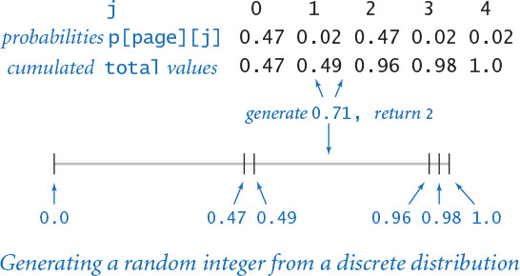
The variable total tracks the endpoints of the intervals defined in row p[page], and the for loop finds the interval containing the random value r. For example, suppose that the surfer is at page 4 in our example. The transition probabilities are 0.47, 0.02, 0.47, 0.02, and 0.02, and total takes on the values 0.0, 0.47, 0.49, 0.96, 0.98, and 1.0. These values indicate that the probabilities define the five intervals (0, 0.47), (0.47, 0.49), (0.49, 0.96), (0.96, 0.98), and (0.98, 1), one for each page. Now, suppose that random.random() returns the value 0.71. We increment j from 0 to 1 to 2 and stop there, which indicates that 0.71 is in the interval (0.49, 0.96), so we send the surfer to the third page (page 2). Then, we perform the same computation for p[2], and the random surfer is off and surfing. For large n, we can use binary search to substantially speed up this computation (see EXERCISE 4.2.35). Typically, we are interested in speeding up the search in this situation because we are likely to need a huge number of random moves, as you will see.
Program 1.6.2 Simulating a random surfer (randomsurfer.py)
Click here to view code image
import random
import sys
import stdarray
import stdio
moves = int(sys.argv[1])
n = stdio.readInt()
stdio.readInt() # Not needed (another n).
p = stdarray.create2D(n, n, 0.0)
for i in range(n):
for j in range(n):
p[i][j] = stdio.readFloat()
hits = stdarray.create1D(n, 0)
page = 0 # Start at page 0.
for i in range(moves):
r = random.random() # Compute a random page
total = 0.0 # according to distribution
for j in range(0, n): # in row p[page] (see text).
total += p[page][j] #
if r < total: #
page = j #
break #
hits[page] += 1
for v in hits:
stdio.writef('%8.5f', 1.0 * v / moves)
stdio.writeln()
moves | # moves
n | # pages
page | current page
p[i][j] | probability that the surfer moves from page i to page j
hits[i] | # times the surfer hits page i
This program uses a transition matrix to simulate the behavior of a random surfer. It accepts the number of moves as a command-line argument, reads the transition matrix, performs the indicated number of moves as prescribed by the matrix, and writes the relative frequency of hitting each page. The key to the computation is the random move to the next page (see text).
Click here to view code image
% python transition.py < tiny.txt | python randomsurfer.py 100
0.24000 0.23000 0.16000 0.25000 0.12000
% python transition.py < tiny.txt | python randomsurfer.py 10000
0.27280 0.26530 0.14820 0.24830 0.06540
% python transition.py < tiny.txt | python randomsurfer.py 1000000
0.27324 0.26568 0.14581 0.24737 0.06790

Markov chains
The random process that describes the surfer’s behavior is known as a Markov chain, named after the Russian mathematician Andrey Markov, who developed the concept in the early 20th century. Markov chains are widely applicable, are well studied, and have many remarkable and useful properties. For example, you might have wondered why randomsurfer.py starts the random surfer at page 0, whereas you might have expected a random choice. A basic limit theorem for Markov chains says that the surfer could start anywhere, because the probability that a random surfer eventually winds up on any particular page is the same for all starting pages! No matter where the surfer starts, the process eventually stabilizes to a point where further surfing provides no further information. This phenomenon is known as mixing. Although this phenomenon might seem counterintuitive at first, it explains coherent behavior in a situation that might seem chaotic. In the present context, it captures the idea that the web looks pretty much the same to everyone after surfing for a sufficiently long time.
Not all Markov chains have this mixing property. For example, if we eliminate the random leap from our model, certain configurations of web pages can present problems for the surfer. Indeed, there exist on the web sets of pages known as spider traps, which are designed to attract incoming links but have no outgoing links. Without the random leap, the surfer could get stuck in a spider trap. The primary purpose of the 90-10 rule is to guarantee mixing and eliminate such anomalies.

Page ranks
The randomsurfer.py simulation is straightforward: it loops for the indicated number of moves, randomly surfing through the graph. Because of the mixing phenomenon, increasing the number of iterations gives increasingly accurate estimates of the probability that the surfer lands on each page (the page ranks). How do the results compare with your intuition when you first thought about the question? You might have guessed that page 4 was the lowest-ranked page, but did you think that pages 0 and 1 would rank higher than page 3? If we want to know which page is the highest rank, we need more precision and more accuracy. The randomsurfer.py program needs 10d moves to get answers precise to d decimal places and many more moves for those answers to stabilize to an accurate value. For our example, it takes tens of thousands of iterations to get answers accurate to two decimal places and millions of iterations to get answers accurate to three places (see EXERCISE 1.6.5). The end result is that page 0 beats page 1 by 27.3 percent to 26.6 percent. That such a tiny difference would appear in such a small problem is quite surprising: if you guessed that page 0 is the most likely spot for the surfer to end up, you were lucky!
Accurate page rank estimates for the web are valuable in practice for many reasons. First, using them to put in order the pages that match the search criteria for web searches proved to be vastly more in line with people’s expectations than previous methods. Next, this measure of confidence and reliability led to the investment of huge amounts of money in web advertising based on page ranks. Even in our tiny example, page ranks might be used to convince advertisers to pay up to four times as much to place an ad on page 0 as on page 4. Computing page ranks is mathematically sound, an interesting computer science problem, and big business, all rolled into one.
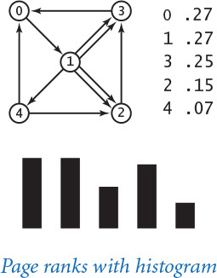

Visualizing the histogram
With stddraw, it is easy to create a visual representation that can give you a feeling for how the random surfer visit frequencies converge to the page ranks. If you scale the x- and y-coordinates in the standard drawing window appropriately and add this code
Click here to view code image
if i % 1000 == 0:
stddraw.clear()
for k in range(n):
stddraw.filledRectangle(k - 0.25, 0.0, 0.5, hits[k])
stddraw.show(10)
to the random move loop in randomsurfer.py and run the code for, say, millions of moves, you will see a drawing of the frequency histogram that eventually stabilizes to the page ranks. (The constants 1000 and 10 in this code are a bit arbitrary; you might wish to change them when you run the code.) After you have used this tool once, you are likely to find yourself using it every time you want to study a new model (perhaps with some minor adjustments to handle larger models).

Studying other models
Our programs randomsurfer.py and transition.py are excellent examples of data-driven programs. You can easily create a data model just by creating a file like tiny.txt that starts with an integer n and then specifies pairs of integers between 0 and n-1 that represent links connecting pages. You are encouraged to run it for various data models as suggested in the exercises, or make up some models of your own to study. If you have ever wondered how web page ranking works, this calculation is your chance to develop better intuition about what causes one page to be ranked more highly than another. Which kind of page is likely to be rated highly? One that has many links to other pages, or one that has just a few links to other pages? The exercises in this section present many opportunities to study the behavior of the random surfer. Since randomsurfer.py uses standard input, you can compose simple programs that generate large input models, pipe their output to randomsurfer.py, and thereby study the random surfer on large models. Such flexibility is an important reason to use standard input and standard output.
Directly simulating the behavior of a random surfer to understand the structure of the web is appealing, but it has limitations. Think about the following question: Could you use it to compute page ranks for a web model with millions (or billions!) of web pages and links? The quick answer to this question is no, because you cannot even afford to store the transition matrix for such a large number of pages. A matrix for millions of pages would have trillions of elements. Do you have that much space on your computer? Could you use randomsurfer.py to find page ranks for a smaller model with, say, thousands of pages? To answer this question, you might run multiple simulations, record the results for a large number of trials, and then interpret those experimental results. We do use this approach for many scientific problems (the gambler’s ruin problem is one example; SECTION 2.4 is devoted to another), but it can be very time-consuming, as a huge number of trials may be necessary to get the desired accuracy. Even for our tiny example, we saw that it takes millions of iterations to get the page ranks accurate to three or four decimal places. For larger models, the required number of iterations to obtain accurate estimates becomes truly huge.

Mixing a Markov chain
It is important to remember that the page ranks are a property of the web model, not any particular approach for computing it. That is, randomsurfer.py is just one way to compute page ranks. Fortunately, a simple computational model based on a well-studied area of mathematics provides a far more efficient approach than simulation to the problem of computing page ranks. That model makes use of the basic arithmetic operations on two-dimensional matrices that we considered in SECTION 1.4.

Squaring a Markov chain
What is the probability that the random surfer will move from page i to page j in two moves? The first move goes to an intermediate page k, so we calculate the probability of moving from i to k and then from k to j for all possible k and add up the results. For our example, the probability of moving from 1 to 2 in two moves is the probability of moving from 1 to 0 to 2 (0.02 × 0.02), plus the probability of moving from 1 to 1 to 2 (0.02 × 0.38), plus the probability of moving from 1 to 2 to 2 (0.38 × 0.02), plus the probability of moving from 1 to 3 to 2 (0.38 × 0.02), plus the probability of moving from 1 to 4 to 2 (0.20 × 0.47), which adds up to a grand total of 0.1172. The same process works for each pair of pages. This calculation is one that we have seen before, in the definition of matrix multiplication: the element in row i and column j in the result is the dot product of row i and column j in the original. In other words, the result of multiplying p[][] by itself is a matrix where the element in row i and column j is the probability that the random surfer moves from page i to page j in two moves. Studying the elements of the two-move transition matrix for our example is well worth your time and will help you better understand the movement of the random surfer. For instance, the largest element in the square is the one in row 2 and column 0, reflecting the fact that a surfer starting on page 2 has only one link out, to page 3, where there is also only one link out, to page 0. Therefore, by far the most likely outcome for a surfer starting on page 2 is to end up in page 0 after two moves. All of the other two-move routes involve more choices and are less probable. It is important to note that this is an exact computation (up to the limitations of Python’s floating-point precision), in contrast to randomsurfer.py, which produces an estimate and needs more iterations to get a more accurate estimate.
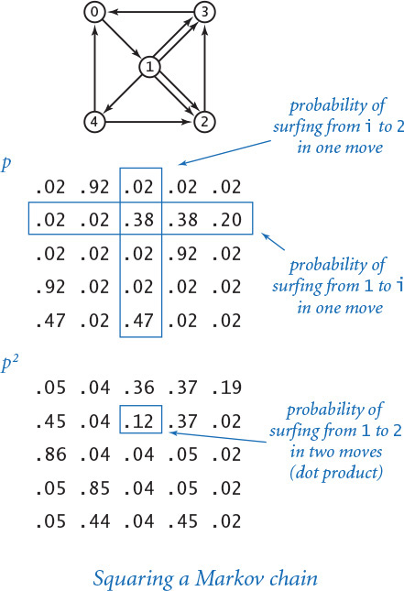

The power method
We might then calculate the probabilities for three moves by multiplying by p[][] again, and for four moves by multiplying by p[][] yet again, and so forth. However, matrix–matrix multiplication is expensive, and we are actually interested in a vector–matrix calculation. For our example, we start with the vector
[1.0 0.0 0.0 0.0 0.0]
which specifies that the random surfer starts on page 0. Multiplying this vector by the transition matrix gives the vector
[.02 .92 .02 .02 .02]
which is the probabilities that the surfer winds up on each of the pages after one step. Now, multiplying this vector by the transition matrix gives the vector
[.05 .04 .36 .37 .19]
which contains the probabilities that the surfer winds up on each of the pages after two steps. For example, the probability of moving from 0 to 2 in two moves is the probability of moving from 0 to 0 to 2 (0.02 × 0.02), plus the probability of moving from 0 to 1 to 2 (0.92 × 0.38), plus the probability of moving from 0 to 2 to 2 (0.02 × 0.02), plus the probability of moving from 0 to 3 to 2 (0.02 × 0.02), plus the probability of moving from 0 to 4 to 2 (0.02 × 0.47), which adds up to a grand total of 0.36. From these initial calculations, the pattern is clear: the vector giving the probabilities that the random surfer is at each page after t steps is precisely the product of the corresponding vector for t – 1 steps and the transition matrix. By the basic limit theorem for Markov chains, this process converges to the same vector no matter where we start; in other words, after a sufficient number of moves, the probability that the surfer ends up on any given page is independent of the starting point.
PROGRAM 1.6.3 (markov.py) is an implementation that you can use to check convergence for our example. For instance, it gets the same results (the page ranks accurate to two decimal places) as randomsurfer.py, but with just 20 matrix–vector multiplications instead of the tens of thousands of iterations needed by randomsurfer.py. Another 20 multiplications gives the results accurate to three decimal places, as compared with millions of iterations for randomsurfer.py, and just a few more multiplications give the results to full precision (see EXERCISE 1.6.6).
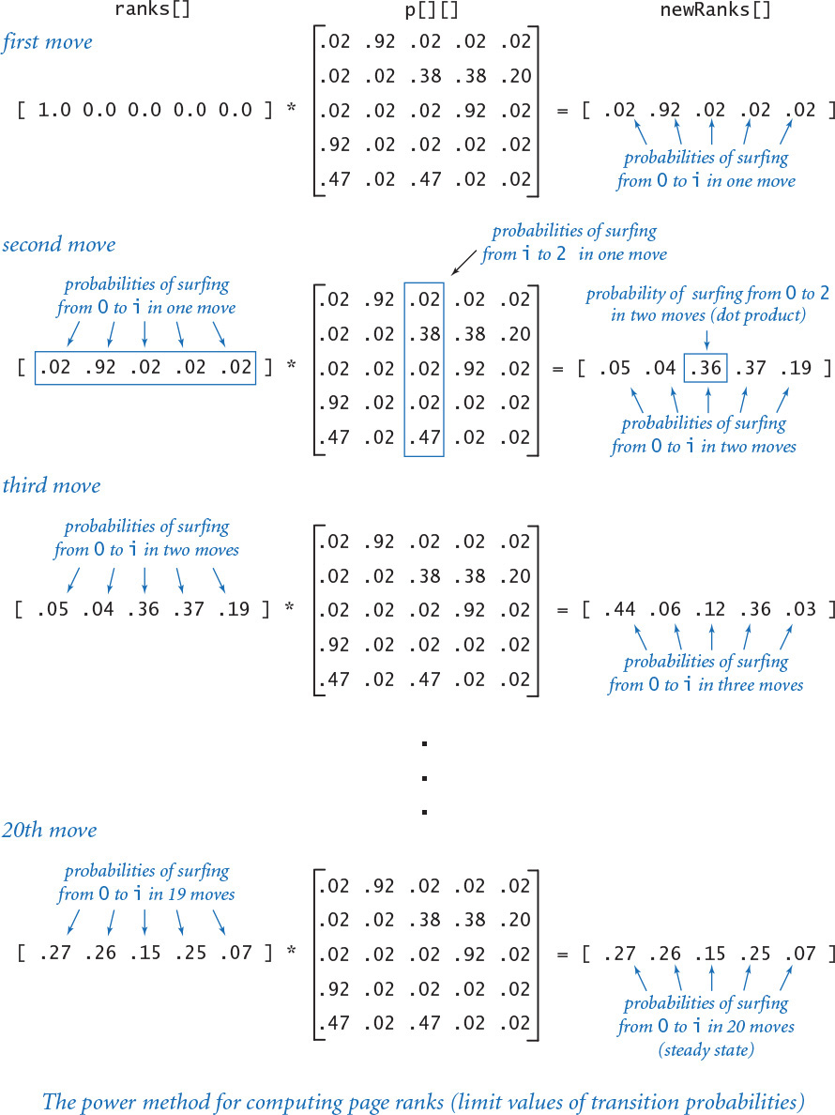
Program 1.6.3 Mixing a Markov chain (markov.py)
Click here to view code image
import sys
import stdarray
import stdio
moves = int(sys.argv[1])
n = stdio.readInt()
stdio.readInt()
p = stdarray.create2D(n, n, 0.0)
for i in range(n):
for j in range(n):
p[i][j] = stdio.readFloat()
ranks = stdarray.create1D(n, 0.0)
ranks[0] = 1.0
for i in range(moves):
newRanks = stdarray.create1D(n, 0.0)
for j in range(n):
for k in range(n):
newRanks[j] += ranks[k] * p[k][j]
ranks = newRanks
for i in range(n):
stdio.writef('%8.5f', ranks[i])
stdio.writeln()
moves | number of iterations
n | number of pages
p[][] | transition matrix
ranks[] | page ranks
newRanks[] | new page ranks
This program takes a command-line integer moves, reads a transition matrix from standard input, computes the probabilities that a random surfer lands on each page (page ranks) after moves matrix–vector multiplications, and writes the page ranks to standard output.
Click here to view code image
% python transition.py < tiny.txt | python markov.py 20
0.27245 0.26515 0.14669 0.24764 0.06806
% python transition.py < tiny.txt | python markov.py 40
0.27303 0.26573 0.14618 0.24723 0.06783
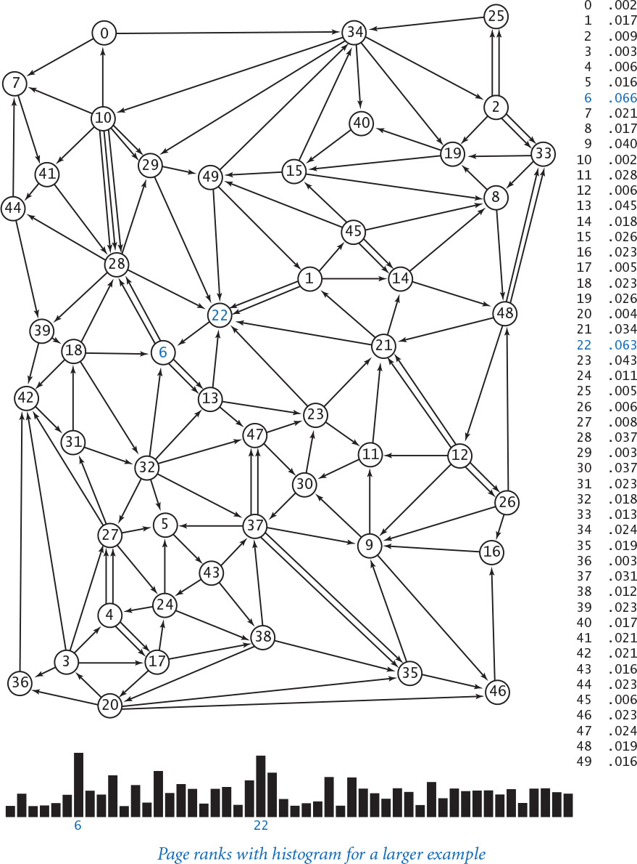
Markov chains are well studied, but their impact on the web was not truly felt until 1998, when two graduate students, Sergey Brin and Lawrence Page, had the audacity to build a Markov chain and compute the probabilities that a random surfer hits each page for the whole web. Their work revolutionized web search and is the basis for the page ranking method used by Google, the highly successful web search company that they founded. Specifically, the company periodically recomputes the random surfer’s probability for each page. Then, when you do a search, it lists the pages related to your search keywords in order of these ranks. Such page ranks now predominate because they somehow correspond to the expectations of typical web users, reliably providing them with relevant web pages for typical searches. The computation that is involved is enormously time-consuming, due to the huge number of pages on the web, but the result has turned out to be enormously profitable and well worth the expense. The method used in markov.py is far more efficient than simulating the behavior of a random surfer, but it is still too slow to actually compute the probabilities for a huge matrix corresponding to all the pages on the web. That computation is enabled by better data structures for graphs (see CHAPTER 4).

Lessons
Developing a full understanding of the random surfer model is beyond the scope of this book. Instead, our purpose is to show you an application that involves composing a bit more code than the short programs that we have been using to teach specific concepts. Which specific lessons can we learn from this case study?

We already have a full computational model
Built-in data types, combined with conditionals and loops, arrays, and standard input/output, enable you to address interesting problems of all sorts. Indeed, it is a basic precept of theoretical computer science that this model suffices to specify any computation that can be performed on any reasonable computing device. In the next two chapters, we discuss two critical ways in which the model has been extended to drastically reduce the amount of time and effort required to develop large and complex programs.

Data-driven code is prevalent
The concept of using standard input and output streams and saving data in files is a powerful one. We compose filters to convert from one kind of input to another, generators that can produce huge input files for study, and programs that can handle a wide variety of models. We can save data for archiving or later use. We can also process data derived from some other source and then save it in a file, whether it is from a scientific instrument or a distant website. The concept of data-driven code is an easy and flexible way to support this suite of activities.

Accuracy can be elusive
It is a mistake to assume that a program produces accurate answers simply because it can write numbers to many decimal places of precision. Often, the most difficult challenge that we face is ensuring that we have accurate answers.

Uniform random numbers are just a start
When we speak informally about random behavior, we often are thinking of something more complicated than the “every value equally likely” model that random.random() gives us. Many of the problems that we consider involve working with random numbers from other distributions, such as randomsurfer.py.

Efficiency matters
It is also a mistake to assume that your computer is so fast that it can do any computation. Some problems require much more computational effort than others. CHAPTER 4 is devoted to a thorough discussion of evaluating the performance of the programs that you compose. We defer detailed consideration of such issues until then, but remember that you always need to have some general idea of the performance requirements of your programs.
Perhaps the most important lesson to learn from composing programs for complicated problems like the example in this section is that debugging is difficult. The polished programs in the book mask that lesson, but you can rest assured that each one is the product of a long bout of testing, fixing bugs, and running the program on numerous inputs. Generally we avoid describing bugs and the process of fixing them in the text because that makes for a boring account and overly focuses attention on bad code, but you can find some examples and descriptions in the exercises and on the booksite.

Exercises
1.6.1 Modify transition.py to take the leap probability from the command line and use your modified version to examine the effect on page ranks of switching to an 80-20 rule or a 95-5 rule.
1.6.2 Modify transition.py to ignore the effect of multiple links. That is, if there are multiple links from one page to another, count them as one link. Create an example that shows how this modification can change the order of page ranks.
1.6.3 Modify transition.py to handle pages with no outgoing links, by filling rows corresponding to such pages with the value 1/n.
1.6.4 The code fragment in randomsurfer.py that generates the random move fails if the probabilities in the row p[page] do not add up to 1. Explain what happens in that case, and suggest a way to fix the problem.
1.6.5 Determine, to within a factor of 10, the number of iterations required by randomsurfer.py to compute page ranks to four decimal places and to five decimal places for tiny.txt.
1.6.6 Determine the number of iterations required by markov.py to compute page ranks to three decimal places, to four decimal places, and to ten decimal places for tiny.txt.
1.6.7 Download the file medium.txt from the booksite (which reflects the 50-page example depicted in this section) and add to it links from page 23 to every other page. Observe the effect on the page ranks, and discuss the result.
1.6.8 Add to medium.txt (see the previous exercise) links to page 23 from every other page, observe the effect on the page ranks, and discuss the result.
1.6.9 Suppose that your page is page 23 in medium.txt. Is there a link that you could add from your page to some other page that would raise the rank of your page?
1.6.10 Suppose that your page is page 23 in medium.txt. Is there a link that you could add from your page to some other page that would lower the rank of that page?
1.6.11 Use transition.py and randomsurfer.py to determine the transition probabilities for the eight-page example shown below.
1.6.12 Use transition.py and markov.py to determine the transition probabilities for the eight-page example shown below.
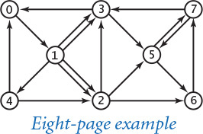

Creative Exercises
1.6.13 Matrix squaring. Compose a program like markov.py that computes page ranks by repeatedly squaring the matrix, thus computing the sequence p, p2, p4, p8, p16, and so forth. Verify that all of the rows in the matrix converge to the same values.
1.6.14 Random web. Compose a generator for transition.py that takes as input a page count n and a link count m and writes to standard output n followed by m random pairs of integers between 0 and n-1. (See SECTION 4.5 for a discussion of more realistic web models.)
1.6.15 Hubs and authorities. Add to your generator from the previous exercise a fixed number of hubs, which have links pointing to them from 10 percent of the pages, chosen at random, and authorities, which have links pointing from them to 10 percent of the pages. Compute page ranks. Which rank higher, hubs or authorities?
1.6.16 Page ranks. Design an array of pages and links where the highest-ranking page has fewer links pointing to it than some other page.
1.6.17 Hitting time. The hitting time for a page is the expected number of moves between times the random surfer visits the page. Run experiments to estimate page hitting times for tiny.txt, compare the results with page ranks, formulate a hypothesis about the relationship, and test your hypothesis on medium.txt.
1.6.18 Cover time. Compose a program that estimates the time required for the random surfer to visit every page at least once, starting from a random page.
1.6.19 Graphical simulation. Create a graphical simulation where the size of the dot representing each page is proportional to its rank. To make your program data-driven, design a file format that includes coordinates specifying where each page should be drawn. Test your program on medium.txt.

Chapter Two. Functions and Modules
2.1 Defining Functions
2.2 Modules and Clients
2.3 Recursion
2.4 Case Study: Percolation
This chapter is centered on a construct that has as profound an impact on control flow as do conditionals and loops: the function, which allows us to transfer control back and forth between different pieces of code. Functions are important because they allow us to clearly separate tasks within a program and because they provide a general mechanism that enables us to reuse code. Using and defining functions is a central component of Python programming.
When we have a number of functions to work with, we group them together in modules. With the use of modules, we can break a computational task into subtasks of a reasonable size. You will learn in this chapter how to build modules of your own and how to use them in a style of programming known as modular programming. In particular, we consider in this chapter modules for generating random numbers, analyzing data, and input/output for arrays. Modules vastly extend the set of operations that we can use in our programs.
We pay special attention to functions that transfer control to themselves. This process is known as recursion. At first, recursion may seem counterintuitive, but it allows us to develop simple programs that can address complex tasks that would otherwise be much more difficult to carry out.
Whenever you can clearly separate tasks within a computation, you should do so. We repeat this mantra throughout this chapter, and end the chapter with an example showing how a complex programming task can be handled by breaking it into smaller subtasks, then independently developing modules that interact with one another to address the subtasks. Throughout the chapter, we make use of functions and modules developed earlier in the chapter, to emphasize the utility of modular programming.

2.1 Defining Functions
You have been composing code that calls Python functions since the beginning of this book, from writing strings with stdio.writeln() to using type conversion functions such as str() and int() to computing mathematical functions such as math.sqrt() to using all of the functions in stdio, stddraw, and stdaudio. In this section, you will learn how to define and call your own functions.
2.1.1 Harmonic numbers (revisited)
2.1.2 Gaussian functions
2.1.3 Coupon collector (revisited)
2.1.4 Play that tune (revisited)
Programs in this section
In mathematics, a function maps an input value of one type (the domain) to an output value of another type (the range). For example, the square function f(x) = x2 maps 2 to 4, 3 to 9, 4 to 16, and so forth. At first, we work with Python functions that implement mathematical functions, because they are so familiar. Many standard mathematical functions are implemented in Python’s math module, but scientists and engineers work with a broad variety of mathematical functions, which cannot all be included in the module. At the beginning of this section, you will learn how to implement and use such functions on your own.
Later, you will learn that we can do more with Python functions than implement mathematical functions: Python functions can have strings and other types as their domain or range, and they can have side effects such as writing output. We also consider in this section how to use Python functions to organize programs and thereby simplify complicated programming tasks.
From this point forward, we use the generic term function to mean either Python function or mathematical function depending on the context. We use the more specific terminology only when the context requires that we do so.
Functions support a key concept that will pervade your approach to programming from this point forward: Whenever you can clearly separate tasks within a computation, you should do so. We will be overemphasizing this point throughout this section and reinforcing it throughout the rest of the chapter (and the rest of the book). When you write an essay, you break it up into paragraphs; when you compose a program, you break it up into functions. Separating a larger task into smaller ones is much more important when programming than when writing an essay, because it greatly facilitates debugging, maintenance, and reuse, which are all critical in developing good software.

Using and defining functions
As you know from the functions you have been using, the effect of calling a Python function is easy to understand. For example, when you place math.sqrt(a-b) in a program, the effect is as if you had replaced that code with the return value that is produced by Python’s math.sqrt() function when passed the expression a-b as an argument. This usage is so intuitive that we have hardly needed to comment on it. If you think about what the system has to do to create this effect, however, you will see that it involves changing a program’s control flow. The implications of being able to change the control flow in this way are as profound as doing so for conditionals and loops.
You can define functions in any Python program, using the def statement that specifies the function signature, followed by a sequence of statements that constitute the function. We will consider the details shortly, but begin with a simple example that illustrates how functions affect control flow. Our first example, PROGRAM 2.1.1 (harmonicf.py), includes a function named harmonic() that takes an argument n and computes the nth harmonic number (see PROGRAM 1.3.5). It also illustrates the typical structure of a Python program, having three components:
• A sequence of import statements
• A sequence of function definitions
• Arbitrary global code, or the body of the program
PROGRAM 2.1.1 has two import statements, one function definition, and four lines of arbitrary global code. Python executes the global code when we invoke the program by typing python harmonicf.py on the command line; that global code calls the harmonic() function defined earlier.
The implementation in harmonicf.py is preferable to our original implementation for computing harmonic numbers (PROGRAM 1.3.5) because it clearly separates the two primary tasks performed by the program: calculating harmonic numbers and interacting with the user. (For purposes of illustration, we have made the user-interaction part of the program a bit more complicated than in PROGRAM 1.3.5.) Whenever you can clearly separate tasks within a computation, you should do so. Next, we carefully examine precisely how harmonicf.py achieves this goal.

Control flow
The diagram on the next page illustrates the flow of control for the command python harmonicf.py 1 2 3. First, Python processes the import statements, thus making all of the features defined in the sys and stdio modules available to the program. Next, Python processes the definition of the harmonic() function at lines 4 through 8, but does not execute the function—Python executes a function only when it is called. Then, Python executes the first statement in the global code after the function definition, the for statement, which proceeds normally until Python begins to execute the statement value = harmonic(arg), starting by evaluating the expression harmonic(arg) when arg is 1. To do so it transfers control to the harmonic() function—the flow of control passes to the code in the function definition. Python initializes the “parameter” variable n to 1 and the “local” variable total to 0.0 and then executes the for loop within harmonic(), which terminates after one iteration with total equal to 1.0. Then, Python executes the return statement at the end of the definition of harmonic(), causing the flow of control to jump back to the calling statement value = harmonic(arg), continuing from where it left off, but now with the expression harmonic(arg) replaced by 1.0. Thus, Python assigns 1.0 to value and writes it to standard output. Then, Python iterates the loop once more, and calls the harmonic() function a second time with n initialized to 2, which results in 1.5 being written. The process is then repeated a third time with arg (and then n) equal to 4, which results in 2.083333333333333 being written. Finally, the for loop terminates and the whole process is complete. As the diagram indicates, the simple code masks a rather intricate flow of control.
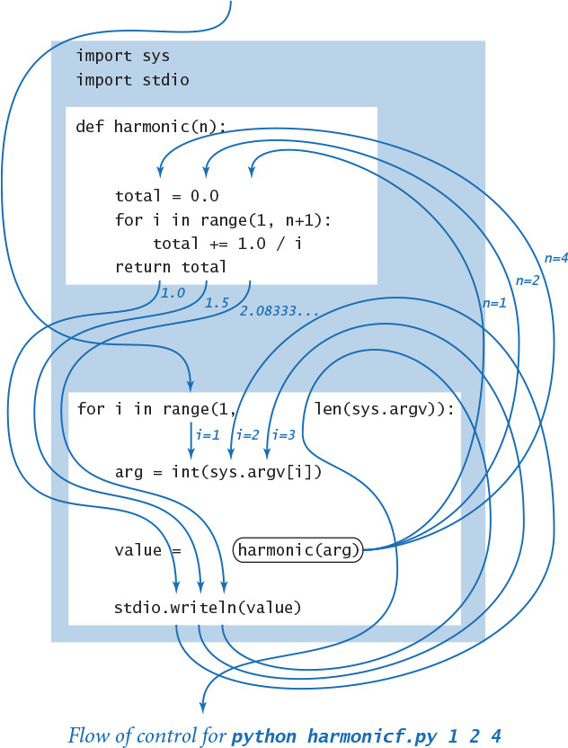
Program 2.1.1 Harmonic numbers (revisited) (harmonicf.py)
Click here to view code image
import sys
import stdio
def harmonic(n):
total = 0.0
for i in range(1, n+1):
total += 1.0 / i
return total
for i in range(1, len(sys.argv)):
arg = int(sys.argv[i])
value = harmonic(arg)
stdio.writeln(value)
n | parameter variable
i | loop index
total | return value
i | argument index
arg | argument
value | Harmonic number
This program writes to standard output the harmonic numbers specified as command-line arguments. The program defines a function harmonic() that, given an int argument n, computes the nth harmonic number 1 + 1/2 + 1/3 + ... + 1/n.
% python harmonicf.py 1 2 4
1.0
1.5
2.083333333333333
Click here to view code image
% python harmonicf.py 10 100 1000 10000
2.9289682539682538
5.187377517639621
7.485470860550343
9.787606036044348
Abbreviation alert
We continue to use the abbreviations that we introduced in SECTION 1.2 for functions and function calls. For example, we might say, “The function call harmonic(2) returns the value 1.5,” instead of the more accurate but verbose “When we pass to harmonic() a reference to an object of type int whose value is 2, it returns a reference to an object of type float whose value is 1.5.” We strive to use language that is succinct and only as precise as necessary in a given context.

Informal function call/return trace
One simple approach to following the control flow through function calls is to imagine that each function writes its name and argument(s) when it is called and its return value just before returning, with indentation added on calls and subtracted on returns. The result enhances the process of tracing a program by writing the values of its variables, which we have been using since SECTION 1.2. An informal trace for our example is shown at right. The added indentation exposes the flow of the control, and helps us check that each function has the effect that we expect. Generally, adding calls on stdio.writef() to trace any program’s control flow in this way is a fine approach to begin to understand what it is doing. If the return values match our expectations, we need not trace the function code in detail, saving us a substantial amount of work.
Click here to view code image
i = 1
arg = 1
harmonic(1)
total = 0.0
total = 1.0
return 1.0
value = 1.0
i = 2
arg = 2
harmonic(2)
total = 0.0
total = 1.0
total = 1.5
return 1.5
value = 1.5
i = 3
arg = 4
harmonic(4)
total = 0.0
total = 1.0
total = 1.5
total = 1.8333333333333333
total = 2.083333333333333
return 2.083333333333333
value = 2.083333333333333
Informal trace with function call/return for python harmonicf.py 1 2 4
For the rest of this chapter, your programming will be centered on creating and using functions, so it is worthwhile to consider in more detail their basic properties and, in particular, the terminology surrounding functions. Following that, we will study several examples of function implementations and applications.

Basic terminology
As we have been doing throughout, it is useful to draw a distinction between abstract concepts and Python mechanisms to implement them (the Python if statement implements the conditional, the while statement implements the loop, and so forth). There are several concepts rolled up in the idea of a mathematical function and there are Python constructs corresponding to each, as summarized in the table at the top of the following page. While you can rest assured that these formalisms have served mathematicians well for centuries (and have served programmers well for decades), we will refrain from considering in detail all of the implications of this correspondence and focus on those that will help you learn to program.
When we use a symbolic name in a formula that defines a mathematical function (such as f(x) = 1 + x + x2), the symbol x is a placeholder for some input value that will be substituted into the formula to determine the output value. In Python, we use a parameter variable as a symbolic placeholder and we refer to a particular input value where the function is to be evaluated as an argument.
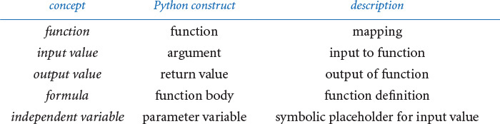

Function definition
The first line of a function definition, known as its signature, gives a name to the function and to each parameter variable. The signature consists of the keyword def; the function name; a sequence of zero or more parameter variable names separated by commas and enclosed in parentheses; and a colon. The indented statements following the signature define the function body. The function body can consist of the kinds of statements that we discussed in CHAPTER 1. It also can contain a return statement, which transfers control back to the point where the function was called and returns the result of the computation or return value. The body may also define local variables, which are variables that are available only inside the function in which they are defined.
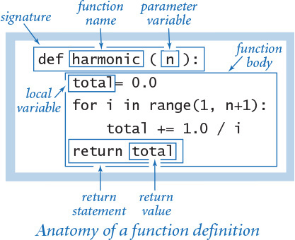

Function calls
As we have seen throughout, a Python function call is nothing more than the function name followed by its arguments, separated by commas and enclosed in parentheses, in precisely the same form as is customary for mathematical functions. As noted in SECTION 1.2, each argument can be an expression, which is evaluated and the resulting value passed as input to the function. When the function finishes, the return value takes the place of the function call as if it were the value of a variable (perhaps within an expression).
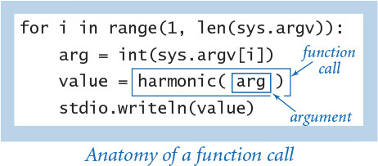

Multiple arguments
Like a mathematical function, a Python function can have more than one parameter variable, so it can be called with more than one argument. The function signature lists the name of each parameter variable, separated by commas. For example, the following function computes the length of the hypotenuse of a right triangle with sides of length a and b:
Click here to view code image
def hypot(a, b)
return math.sqrt(a*a + b*b)

Multiple functions
You can define as many functions as you want in a .py file. The functions are independent, except that they may refer to each other through calls. They can appear in any order in the file:
Click here to view code image
def square(x):
return x*x
def hypot(a, b):
return math.sqrt(square(a) + square(b))
However, the definition of a function must appear before any global code that calls it. That is the reason that a typical Python program contains (1) import statements, (2) function definitions, and (3) arbitrary global code, in that order.

Multiple return statements
You can put return statements in a function wherever you need them: control goes back to the calling program as soon as the first return statement is reached. This primality-testing function is an example of a function that is natural to define using multiple return statements:
Click here to view code image
def isPrime(n):
if n < 2: return False
i = 2
while i*i <= n:
if n % i == 0: return False
i += 1
return True

Single return value
A Python function provides only one return value to the caller (or, more precisely, it returns a reference to one object). This policy is not as restrictive as it might seem, because Python data types can contain more information than a single number, boolean, or string. For example, you will see later in this section that you can use arrays as return values.

Scope
The scope of a variable is the set of statements that can refer to that variable directly. The scope of a function’s local and parameter variables is limited to that function; the scope of a variable defined in global code—known as a global variable—is limited to the .py file containing that variable. Therefore, global code cannot refer to either a function’s local or parameter variables. Nor can one function refer to either the local or parameter variables that are defined in another function. When a function defines a local (or parameter) variable with the same name as a global variable (such as i in PROGRAM 2.1.1), the variable name in the function refers to the local (or parameter) variable, not the global variable.
A guiding principle when designing software is to define each variable so that its scope is as small as possible. One of the important reasons that we use functions is so that changes made to one part of a program will not affect an unrelated part of the program. So, while code in a function can refer to global variables, it should not do so: all communication from a caller to a function should take place via the function’s parameter variables, and all communication from a function to its caller should take place via the function’s return value. In SECTION 2.2, we consider a technique for removing most global code, thereby limiting scope and the potential for unexpected interactions.
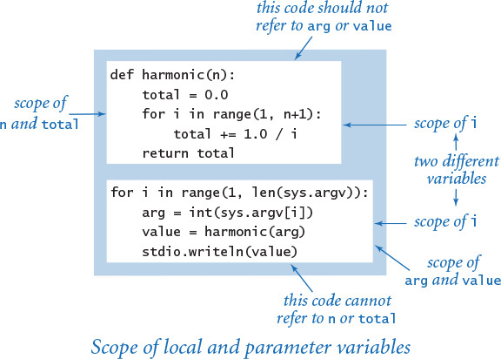

Default arguments
A Python function may designate an argument to be optional by specifying a default value for that argument. If you omit an optional argument in a function call, then Python substitutes the default value for that argument. We have already encountered a few examples of this feature. For example, math.log(x, b) returns the base-b logarithm of x. If you omit the second argument, then b defaults to math.e—that is, math.log(x) returns the natural logarithm of x. It might appear that the math module has two different logarithm functions, but it actually has just one, with an optional argument and a default value.
You can specify an optional argument with a default value in a user-defined function by putting an equals sign followed by the default value after the parameter variable in the function signature. You can specify more than one optional argument in a function signature, but all of the optional arguments must follow all of the mandatory arguments.
For example, consider the problem of computing the nth generalized harmonic number of order r: Hn, r = 1 + 1/2r + 1/3r + ... + 1/nr. For example, H1, 2 = 1, H2, 2 = 5/4, and H2, 2 = 49/36. The generalized harmonic numbers are closely related to the Riemann zeta function from number theory. Note that the nth generalized harmonic number of order r = 1 is equal to the nth harmonic number. Therefore it is appropriate to use 1 as the default value for r if the caller omits the second argument. We specify by writing r=1 in the signature:
Click here to view code image
def harmonic(n, r=1):
total = 0.0
for i in range(1, n+1):
total += 1.0 / (i ** r)
return total
With this definition, harmonic(2, 2) returns 1.25, while both harmonic(2, 1) and harmonic(2) return 1.5. To the client, it appears that we have two different functions, one with a single argument and one with two arguments, but we achieve this effect with a single implementation.

Side effects
In mathematics, a function maps one or more input values to some output value. In computer programming, many functions fit that same model: they accept one or more arguments, and their only purpose is to return a value. A pure function is a function that, given the same arguments, always return the same value, without producing any observable side effects, such as consuming input, producing output, or otherwise changing the state of the system. So far, in this section we have considered only pure functions.
However, in computer programming it is also useful to define functions that do produce side effects. In fact, we often define functions whose only purpose is to produce side effects. An explicit return statement is optional in such a function: control returns to the caller after Python executes the function’s last statement. Functions with no specified return value actually return the special value None, which is usually ignored.
For example, the stdio.write() function has the side effect of writing the given argument to standard output (and has no specified return value). Similarly, the following function has the side effect of drawing a triangle to standard drawing (and has no specified return value):
Click here to view code image
def drawTriangle(x0, y0, x1, y1, x2, y2):
stddraw.line(x0, y0, x1, y1)
stddraw.line(x1, y1, x2, y2)
stddraw.line(x2, y2, x0, y0)
It is generally poor style to compose a function that both produces side effects and returns a value. One notable exception arises in functions that read input. For example, the stdio.readInt() function both returns a value (an integer) and produces a side effect (consuming one integer from standard input).

Type checking
In mathematics, the definition of a function specifies both the domain and the range. For example, for the harmonic numbers, the domain is the positive integers and the range is the positive real numbers. In Python, we do not specify the types of the parameter variables or the type of the return value. As long as Python can apply all of the operations within a function, Python executes the function and returns a value.
If Python cannot apply an operation to a given object because it is of the wrong type, it raises a run-time error to indicate the invalid type. For example, if you call the square() function defined earlier with an int argument, the result is an int; if you call it with a float argument, the result is a float. However, if you call it with a string argument, then Python raises a TypeError at run time.
This flexibility is a popular feature of Python (known as polymorphism) because it allows us to define a single function for use with objects of different types. It can also lead to unexpected errors when we call a function with arguments of unanticipated types. In principle, we could include code to check for such errors, and we could carefully specify which types of data each function is supposed to work with. Like most Python programmers, we refrain from doing so. However, in this book, our message is that you should always be aware of the type of your data, and the functions that we consider in this book are built in line with this philosophy, which admittedly clashes with Python’s tendency toward polymorphism. We will discuss this issue in some detail in SECTION 3.3.
The table below summarizes our discussion by collecting together the function definitions that we have examined so far. To check your understanding, take the time to reread these examples carefully.
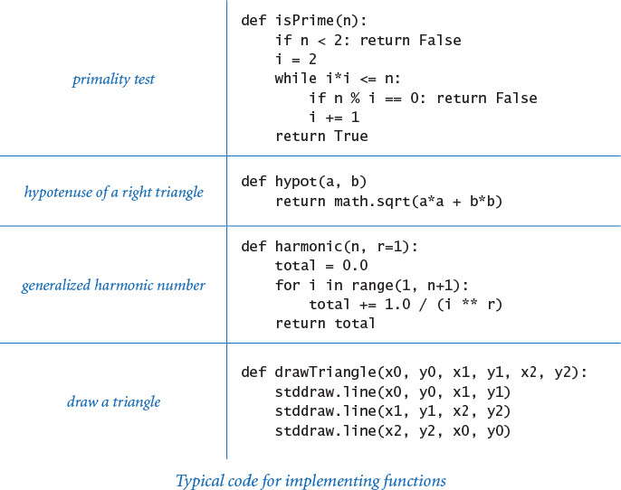

Implementing mathematical functions
Why not just use the Python built-in functions and those that are defined in the standard or extension Python modules? For example, why not use the math.hypot() function instead of defining our own hypot() function? The answer to this question is that we do use such functions when they are present (because they are likely to be faster and more accurate). However, there is an unlimited number of functions that we may wish to use and only a finite number of functions is defined in the Python standard and extension modules. When you need a function that is not defined in the Python standard or extension modules, you need to define the function yourself.
As an example, we consider the kind of code required for a familiar and important application that is of interest to many potential college students in the United States. In a recent year, over 1 million students took the Scholastic Aptitude Test (SAT). The test consists of two major sections: critical reading and mathematics. Scores range from 200 (lowest) to 800 (highest) on each section, so overall test scores range from 400 to 1600. Many universities consider these scores when making important decisions. For example, student athletes are required by the National Collegiate Athletic Association (NCAA), and thus by many universities, to have a combined score of at least 820 (out of 1600), and the minimum eligibility requirement for certain academic scholarships is 1500 (out of 1600). What percentage of test takers is ineligible for athletics? What percentage is eligible for the scholarships?
Two functions from statistics enable us to compute accurate answers to these questions. The standard normal (Gaussian) probability density function is characterized by the familiar bell-shaped curve and defined by the formula The standard normal (Gaussian) cumulative distribution function Φ(z) is defined to be the area under the curve defined by φ(x) above the x-axis and to the left of the vertical line x = z. These functions play an important role in science, engineering, and finance because they arise as accurate models throughout the natural world and because they are essential in understanding experimental error. In particular, these functions are known to accurately describe the distribution of test scores in our example, as a function of the mean (average value of the scores) and the standard deviation (square root of the average of the squares of the differences between each score and the mean), which are published each year. Given the mean μ and the standard deviation σ of the test scores, the percentage of students with scores less than a given value z is closely approximated by the function Φ(z, μ, σ) = Φ((z – μ)/σ). Functions to calculate φ and Φ are not available in Python’s math module, so we develop our own implementations.
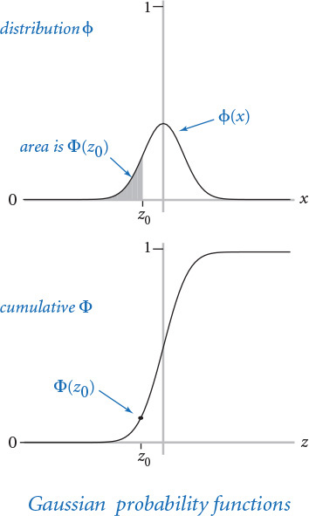

Closed form
In the simplest situation, we have a closed-form mathematical formula defining our function in terms of functions that are implemented in Python’s math module. This situation is the case for φ—the math module includes functions to compute the exponential and the square root functions (and a constant value for π), so a function pdf() corresponding to the mathematical definition is easy to implement. For convenience, gauss.py (PROGRAM 2.1.2) uses the default arguments μ = 0 and σ = 1 and actually computes φ(x, μ, σ) = φ((x – μ) / σ) / σ.

No closed form
If no formula is known, we may need a more complicated algorithm to compute function values. This situation is the case for Φ—no closed-form expression exists for this function. Algorithms to compute function values sometimes follow immediately from Taylor series approximations, but developing reliably accurate implementations of mathematical functions is an art and a science that needs to be addressed carefully, taking advantage of the knowledge built up in mathematics over the past several centuries. Many different approaches have been studied for evaluating Φ. For example, a Taylor series approximation to the ratio of Φ and φ turns out to be an effective basis for evaluating the function:
Φ(z) = 1/2 + φ(z) (z + z3 / 3 + z5/ (3·5) + z7 / (3·5·7) +...).
This formula readily translates to the Python code for the function cdf() in PROGRAM 2.1.2. For small (respectively large) z, the value is extremely close to 0 (respectively 1), so the code directly returns 0 (respectively 1); otherwise, it uses the Taylor series to add terms until the sum converges. Again, for convenience, PROGRAM 2.1.2 actually computes Φ(z, μ, σ) = Φ((z – μ) / σ), using the defaults μ = 0 and σ = 1.
Running gauss.py with the appropriate arguments on the command line tells us that about 17% of the test takers were ineligible for athletics in a year when the mean was 1019 and the standard deviation was 209. In the same year, about 1% percent qualified for academic scholarships.
Computing with mathematical functions of all sorts plays a central role in science and engineering. In a great many applications, the functions that you need are expressed in terms of the functions in Python’s math module, as we have just seen with pdf(), or in terms of a Taylor series approximation or some other formulation that is easy to compute, as we have just seen with cdf(). Indeed, support for such computations has played a central role throughout the evolution of computing systems and programming languages.
Program 2.1.2 Gaussian functions (gauss.py)
Click here to view code image
import math
import sys
import stdio
def pdf(x, mu=0.0, sigma=1.0):
x = float(x - mu) / sigma
return math.exp(-x*x/2.0) / math.sqrt(2.0*math.pi) / sigma
def cdf(z, mu=0.0, sigma=1.0):
z = float(z - mu) / sigma
if z < -8.0: return 0.0
if z > +8.0: return 1.0
total = 0.0
term = z
i = 3
while total != total + term:
total += term
term *= z * z / i
i += 2
return 0.5 + total * pdf(z)
z = float(sys.argv[1])
mu = float(sys.argv[2])
sigma = float(sys.argv[3])
stdio.writeln(cdf(z, mu, sigma))
total | cumulated sum
term | current term
This code implements the Gaussian (normal) probability density (pdf) and cumulative distribution (cdf) functions, which are not implemented in Python’s math library. The pdf() implementation follows directly from its definition, and the cdf() implementation uses a Taylor series and also calls pdf() (see accompanying text at left and EXERCISE 1.3.36). Note: If you are referring to this code for use in another program, please see gaussian.py (PROGRAM 2.2.1), which is designed for reuse.
Click here to view code image
% python gauss.py 820 1019 209
0.17050966869132106
% python gauss.py 1500 1019 209
0.9893164837383885

Using functions to organize code
Beyond evaluating mathematical functions, the process of calculating an output value as a function of input values is important as a general technique for organizing control flow in any computation. Doing so is a simple example of an extremely important principle that is a prime guiding force for any good programmer: Whenever you can clearly separate tasks within a computation, you should do so.
Functions are natural and universal mechanism for expressing computational tasks. Indeed, the “bird’s-eye view” of a Python program that we began with in SECTION 1.1 was equivalent to a function: we began by thinking of a Python program as a function that transforms command-line arguments into an output string. This view expresses itself at many different levels of computation. In particular, it is generally the case that you can express a long program more naturally in terms of functions instead of as a sequence of Python assignment, conditional, and loop statements. With the ability to define functions, you can better organize your programs by defining functions within them when appropriate.
For example, coupon.py (PROGRAM 2.1.3) on the facing page is an improved version of couponcollector.py (PROGRAM 1.4.2) that better separates the individual components of the computation. If you study PROGRAM 1.4.2, you will identify three separate tasks:
• Given the number of coupon values n, compute a random coupon value.
• Given n, do the coupon collection experiment.
• Get n from the command line, then compute and write the result.
PROGRAM 2.1.3 rearranges the code to reflect the reality that these three activities underlie the computation. The first two are implemented as functions, the third as global code.
With this organization, we could change getCoupon() (for example, we might want to draw the random numbers from a different distribution) or the global code (for example, we might want to take multiple inputs or run multiple experiments) without worrying about the effect of any of these changes on collect().
Using functions isolates the implementation of each component of the collection experiment from others, or encapsulates them. Typically, programs have many independent components, which magnifies the benefits of separating them into different functions. We will discuss these benefits in further detail after we have seen several other examples, but you certainly can appreciate that it is better to express a computation in a program by breaking it up into functions, just as it is better to express an idea in an essay by breaking it up into paragraphs. Whenever you can clearly separate tasks within a computation, you should do so.
Program 2.1.3 Coupon collector (revisited) (coupon.py)
Click here to view code image
import random
import sys
import stdarray
import stdio
def getCoupon(n):
return random.randrange(0, n)
def collect(n):
isCollected = stdarray.create1D(n, False)
count = 0
collectedCount = 0
while collectedCount < n:
value = getCoupon(n)
count += 1
if not isCollected[value]:
collectedCount += 1
isCollected[value] = True
return count
n = int(sys.argv[1])
result = collect(n)
stdio.writeln(result)
n | # of coupon values (0 to n-1)
isCollected[i] | has coupon i been collected?
count | # of coupons collected
collectedCount | # of distinct coupons collected
value | value of current coupon
This version of PROGRAM 1.4.2 illustrates the style of encapsulating computations in functions. This code has the same effect as couponcollector.py, but better separates the code into its three constituent pieces: generating a random integer between 0 and n-1, running a collection experiment, and managing the I/O.
% python coupon.py 1000
6522
% python coupon.py 1000
6481
% python coupon.py 1000000
12783771

Passing arguments and returning values
Next, we examine the specifics of Python’s mechanisms for passing arguments to and returning values from functions. These mechanisms are conceptually very simple, but it is worthwhile to take the time to understand them fully, as the effects are actually profound. Understanding argument-passing and return-value mechanisms is key to learning any new programming language. In the case of Python, the concepts of immutability and aliasing play a central role.

Call by object reference
You can use parameter variables anywhere in the body of the function in the same way as you use local variables. The only difference between a parameter variable and a local variable is that Python initializes the parameter variable with the corresponding argument provided by the calling code. We refer to this approach as call by object reference. (It is more commonly known as call by value, where the value is always an object reference—not the object’s value.) One consequence of this approach is that if a parameter variable refers to a mutable object and you change that object’s value within a function, then this also changes the object’s value in the calling code (because it is the same object). Next, we explore the ramifications of this approach.

Immutability and aliasing
As discussed in SECTION 1.4, arrays are mutable data types, because we can change array elements. By contrast, a data type is immutable if it is not possible to change the value of an object of that type. The other data types that we have been using (int, float, str, and bool) are all immutable. In an immutable data type, operations that might seem to change a value actually result in the creation of a new object, as illustrated in the simple example at right. First, the statement i = 99 creates an integer 99, and assigns to i a reference to that integer. Then j = i assigns i (an object reference) to j, so both i and j reference the same object—the integer 99. Two variables that reference the same objects are said to be aliases. Next, j += 1 results in j referencing an object with value 100, but it does not do so by changing the value of the existing integer from 99 to 100! Indeed, since int objects are immutable, no statement can change the value of that existing integer. Instead, that statement creates a new integer 1, adds it to the integer 99 to create another new integer 100, and assigns to j a reference to that integer. But i still references the original 99. Note that the new integer 1 has no reference to it in the end—that is the system’s concern, not ours. The immutability of integers, floats, strings, and booleans is a fundamental aspect of Python. We will consider the advantages and disadvantages of this approach in more detail in SECTION 3.3.
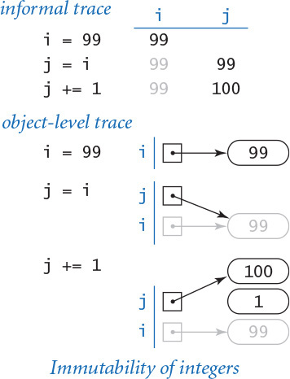

Integers, floats, booleans, and strings as arguments
The key point to remember about passing arguments to functions in Python is that whenever you pass arguments to a function, the arguments and the function’s parameter variables become aliases. In practice, this is the predominant use of aliasing in Python, and it is important to understand its effects. For purposes of illustration, suppose that we need a function that increments an integer (our discussion applies to any more complicated function as well). A programmer new to Python might try this definition:
def inc(j):
j += 1
and then expect to increment an integer i with the call inc(i). Code like this would work in some programming languages, but it has no effect in Python, as shown in the figure at right. First, the statement i = 99 assigns to global variable i a reference to the integer 99. Then, the statement inc(i) passes i, an object reference, to the inc() function. That object reference is assigned to the parameter variable j. At this point i and j are aliases. As before, the inc() function’s j += 1 statement does not change the integer 99, but rather creates a new integer 100 and assigns a reference to that integer to j. But when the inc() function returns to its caller, its parameter variable j goes out of scope, and the variable i still references the integer 99.
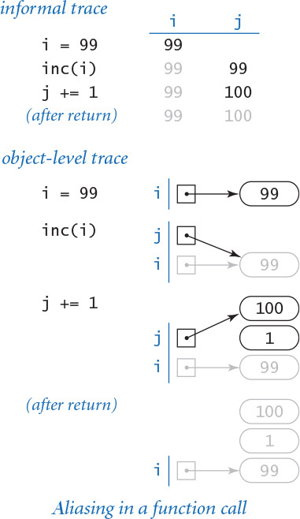
This example illustrates that, in Python, a function cannot produce the side effect of changing the value of an integer object (nothing can do so). To increment variable i, we could use the definition
def inc(j):
j += 1
return j
and call the function with the assignment statement i = inc(i).
The same holds true for any immutable type. A function cannot change the value of an integer, a float, a boolean, or a string.

Arrays as arguments
When a function takes an array as an argument, it implements a function that operates on an arbitrary number of objects. For example, the following function computes the mean (average) of an array of floats or integers:
def mean(a):
total = 0.0
for v in a:
total += v
return total / len(a)
We have been using arrays as arguments from the beginning of the book. For example, by convention, Python collects the strings that you type after the program name in the python command into an array sys.argv[] and implicitly calls your global code with that array of strings as the argument.

Side effects with arrays
Since arrays are mutable, it is often the case that the purpose of a function that takes an array as argument is to produce a side effect (such as changing the order of array elements). A prototypical example of such a function is one that exchanges the elements at two given indices in a given array. We can adapt the code that we examined at the beginning of SECTION 1.4:
def exchange(a, i, j):
temp = a[i]
a[i] = a[j]
a[j] = temp
This implementation stems naturally from the Python array representation. The first parameter variable in exchange() is a reference to the array, not to all of the array’s elements: when you pass an array as an argument to a function, you are giving it the opportunity to operate on that array (not a copy of it). A formal trace of a call on this function is shown on the facing page. This diagram is worthy of careful study to check your understanding of Python’s function-call mechanism.
A second prototypical example of a function that takes an array argument and produces side effects is one that randomly shuffles the elements in the array, using this version of the algorithm that we examined in SECTION 1.4 (and the exchange() function just defined):
Click here to view code image
def shuffle(a):
n = len(a)
for i in range(n):
r = random.randrange(i, n)
exchange(a, i, r)
Incidentally, Python’s standard function random.shuffle() does the same task. As another example, we will consider in SECTION 4.2 functions that sort an array (rearrange its elements so that they are in order).

Arrays as return values
A function that sorts, shuffles, or otherwise modifies an array taken as argument does not have to return a reference to that array, because it is changing the contents of a client array, not a copy. But there are many situations where it is useful for a function to provide an array as a return value. Chief among these are functions that create arrays for the purpose of returning multiple objects of the same type to a client.
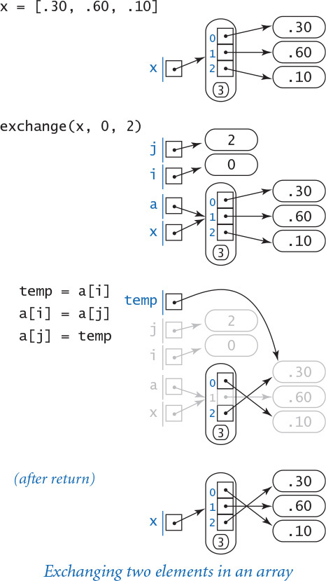
As an example, consider the following function, which returns an array of random floats:
Click here to view code image
def randomarray(n):
a = stdarray.create1D(n)
for i in range(n):
a[i] = random.random()
return a
Later in this chapter, we will be developing numerous functions that return huge amounts of data in this way.
The table below concludes our discussion of arrays as function arguments by highlighting some typical array-procession functions.
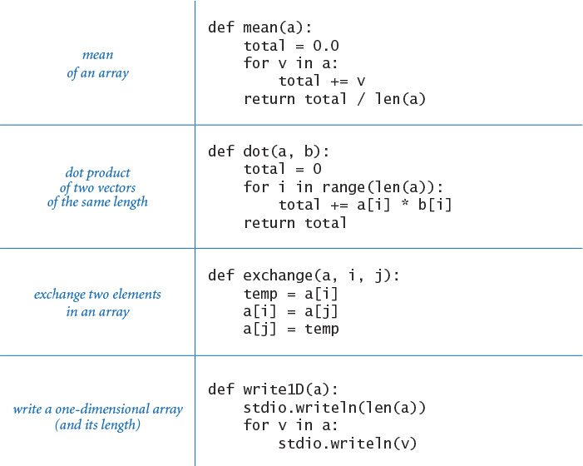
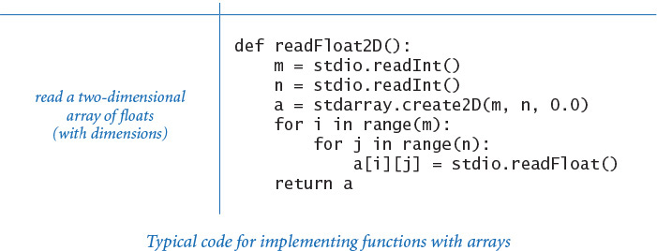

Example: superposition of sound waves
As discussed in SECTION 1.5, the simple audio model that we studied there needs to be embellished to create sound that resembles the sound produced by a musical instrument. Many different embellishments are possible; with functions, we can systematically apply them to produce sound waves that are far more complicated than the simple sine waves that we produced in SECTION 1.5. As an illustration of the effective use of functions to solve an interesting computational problem, we consider a program that has essentially the same functionality as playthattune.py (PROGRAM 1.5.8), but adds harmonic tones one octave above and one octave below each note to produce a more realistic sound.

Chords and harmonics
Notes like concert A have a pure sound that is not very musical, because the sounds that you are accustomed to hearing have many other components. The sound from a guitar string echoes off the wooden part of the instrument, the walls of the room that you are in, and so forth. You may think of such effects as modifying the basic sine wave. For example, most musical instruments produce harmonics (the same note in different octaves and not as loud), or you might play chords (multiple notes at the same time). To combine multiple sounds, we use superposition: simply add their waves together and rescale to make sure that all values stay between –1 and +1. As it turns out, when we superpose sine waves of different frequencies in this way, we can get arbitrarily complicated waves. Indeed, one of the triumphs of 19th-century mathematics was the development of the idea that any smooth periodic function can be expressed as a sum of sine and cosine waves, known as a Fourier series. This mathematical idea corresponds to the notion that we can create a large range of sounds with musical instruments or our vocal cords and that all sound consists of a composition of various oscillating curves. Any sound corresponds to a curve and any curve corresponds to a sound, so we can create arbitrarily complex curves with superposition.
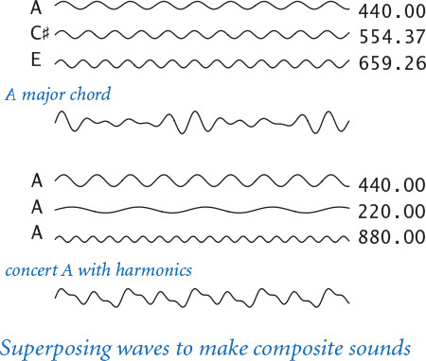

Computing with sound waves
In SECTION 1.5, we saw how to represent sound waves by arrays of numbers that represent their values at the same sample points. Now, we will use such arrays as return values and arguments to functions to process such data. For example, the following function takes a frequency (in hertz) and a duration (in seconds) as arguments and returns a representation of a sound wave (more precisely, an array that contains values sampled from the specified wave at the standard 44,100 samples per second).
Click here to view code image
def tone(hz, duration, sps=44100):
n = int(sps * duration)
a = stdarray.create1D(n+1, 0.0)
for i in range(n+1):
a[i] = math.sin(2.0 * math.pi * i * hz / sps)
return a
The size of the array returned depends on the duration: it contains about sps*duration floats (nearly half a million floats for 10 seconds). But we can now treat that array (the value returned from tone) as a single entity and compose code that processes sound waves, as we will soon see in PROGRAM 2.1.4.

Weighted superposition
Since we represent sound waves by arrays of numbers that represent their values at the same sample points, superposition is simple to implement: we add together their sample values at each sample point to produce the combined result. For greater control, we also specify a relative weight for each of the two waves to be superposed, with the following function:
Click here to view code image
def superpose(a, b, aWeight, bWeight):
c = stdarray.create1D(len(a), 0.0)
for i in range(len(a)):
c[i] = aWeight*a[i] + bWeight*b[i]
return c
(This code assumes that a[] and b[] are of the same length.) For example, if we have a sound represented by an array a[] that we want to have three times the effect of the sound represented by an array b[], we would call superpose(a, b, 0.75, 0.25). The figure at the top of the next page shows the use of two calls on this function to add harmonics to a tone (we superpose the harmonics, then superpose the result with the original tone, which has the effect of giving the original tone twice the weight of each harmonic). As long as the weights are positive and sum to 1, superpose() preserves our convention of keeping the values of all waves between –1 and +1.
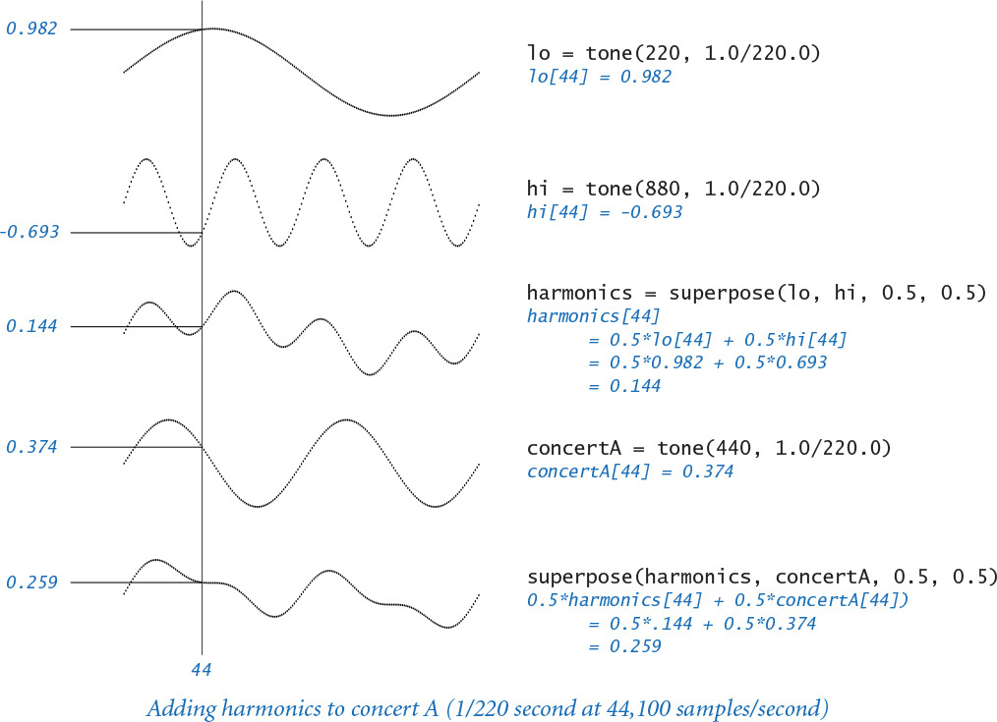
PROGRAM 2.1.4 (playthattunedeluxe.py) is an implementation that applies these concepts to produce a more realistic sound than that produced by PROGRAM 1.5.8. To do so, it makes use of functions to divide the computation into four parts:
• Given a frequency and duration, create a pure tone.
• Given two sound waves and relative weights, superpose them.
• Given a pitch and duration, create a note with harmonics.
• Read and play a sequence of pitch/duration pairs from standard input.
Program 2.1.4 Play that tune (revisited) (playthattunedeluxe.py)
Click here to view code image
import math
import stdarray
import stdaudio
import stdio
def superpose(a, b, aWeight, bWeight):
c = stdarray.create1D(len(a), 0.0)
for i in range(len(a)):
c[i] = aWeight*a[i] + bWeight*b[i]
return c
def tone(hz, duration, sps=44100):
n = int(sps * duration)
a = stdarray.create1D(n+1, 0.0)
for i in range(n+1):
a[i] = math.sin(2.0 * math.pi * i * hz / sps)
return a
def note(pitch, duration):
hz = 440.0 * (2.0 ** (pitch / 12.0))
lo = tone(hz/2, duration)
hi = tone(2*hz, duration)
harmonics = superpose(lo, hi, 0.5, 0.5)
a = tone(hz, duration)
return superpose(harmonics, a, 0.5, 0.5)
while not stdio.isEmpty():
pitch = stdio.readInt()
duration = stdio.readFloat()
a = note(pitch, duration)
stdaudio.playSamples(a)
stdaudio.wait()
hz | frequency
lo[] | lower harmonic
hi[] | upper harmonic
h[] | combined harmonics
a[] | pure tone
This program reads sound samples, embellishes the sounds by adding harmonics to create a more realistic tone than PROGRAM 1.5.8, and plays the resulting sound to standard audio.
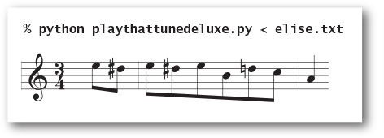
% more elise.txt
7 .125 6 .125
7 .125 6 .125 7 .125
2 .125 5 .125 3 .125
0 .25
These tasks are all amenable to implementation as functions, which depend on one another. Each function is well defined and straightforward to implement. All of them (and stdaudio) represent sound as a series of discrete values kept in an array, corresponding to sampling a sound wave at 44,100 samples per second.
Up to this point, our use of functions has been somewhat of a notational convenience. For example, the control flow in PROGRAM 2.1.1, PROGRAM 2.1.2, and PROGRAM 2.1.3 is simple—each function is called in just one place in the code. By contrast, PROGRAM 2.1.4 is a convincing example of the effectiveness of defining functions to organize a computation because each function is called multiple times. For example, as illustrated in the figure below, the function note() calls the function tone() three times and the function superpose() twice. Without functions, we would need multiple copies of the code in tone() and superpose(); with functions, we can deal directly with concepts close to the application. Like loops, functions have a simple but profound effect: one sequence of statements (those in the function definition) is executed multiple times during the execution of our program—once for each time the function is called in the control flow in the global code.
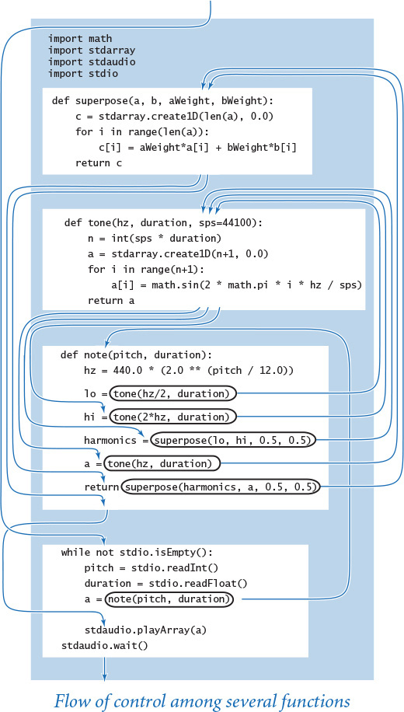
Functions are important because they give us the ability to extend the Python language within a program. Having implemented and debugged functions such as harmonic(), pdf(), cdf(), mean(), exchange(), shuffle(), isPrime(), superpose(), tone(), and note(), we can use them almost as if they were built into Python. The flexibility to do so opens up a whole new world of programming. Before, you were safe in thinking about a Python program as a sequence of statements. Now you need to think of a Python program as a set of functions that can call one another. The statement-to-statement control flow to which you have been accustomed is still present within functions, but programs have a higher-level control flow defined by function calls and returns. This ability enables you to think in terms of operations called for by the application, not just the operations that are built into Python.
Whenever you can clearly separate tasks within a computation, you should do so. The examples in this section (and the programs throughout the rest of the book) clearly illustrate the benefits of adhering to this maxim. With functions, we can
• Divide a long sequence of statements into independent parts.
• Reuse code without having to copy it.
• Work with higher-level concepts (such as sound waves).
This point of view leads to code that is easier to understand, maintain, and debug compared to a long program composed solely of Python assignment, conditional, and loop statements. In the next section, we discuss the idea of using functions defined in other files, which again takes us to another level of programming.

Q&A
Q. Can I use the statement return in a function without specifying a value?
A. Yes. Technically, it returns the None object, which is the sole value of the type NoneType.
Q. What happens if a function has one control flow that leads to a return statement that returns a value but another control flow that reaches the end of the function body?
A. It would be poor style to define such a function, because doing so would place a severe burden on the function’s callers: the callers would need to know under which circumstances the function returns a value, and under which circumstances it returns None.
Q. What happens if I compose code in the body of a function that appears after the return statement?
A. Once a return statement is reached, control returns to the caller. So any code in the body of a function that appears after a return statement is useless; it is never executed. In Python, it is poor style, but not illegal to define such a function.
Q. What happens if I define two functions with the same name (but possibly a different number of arguments) in the same .py file?
A. This is known as function overloading, which is embraced by many programming languages. Python, however, is not one of those languages: the second function definition will overwrite the first one. You can often achieve the same effect by using default arguments.
Q. What happens if I define two functions with the same name in different files?
A. That is fine. For example, it would be good design to have a function named pdf() in gauss.py that computes the Gaussian probability density function and another function named pdf() in cauchy.py that computes the Cauchy probability density function. In SECTION 2.2 you will learn how to call functions defined in different .py files.
Q. Can a function change the object to which a parameter variable is bound?
A. Yes, you can use a parameter variable on the left side of an assignment statement. However, many Python programmers consider it poor style to do so. Note that such an assignment statement has no effect in the client.
Q. The issue with side effects and mutable objects is complicated. Is it really all that important?
A. Yes. Properly controlling side effects is one of a programmer’s most important tasks in large systems. Taking the time to be sure that you understand the difference between passing arrays (which are mutable) and passing integers, floats, booleans, and strings (which are immutable) will certainly be worthwhile. The very same mechanisms are used for all other types of data, as you will learn in CHAPTER 3.
Q. How can I arrange to pass an array to a function in such a way that the function cannot change the elements in the array?
A. There is no direct way to do so. In SECTION 3.3 you will see how to achieve the same effect by building a wrapper data type and passing an object of that type instead. You will also see how to use Python’s built-in tuple data type, which represents an immutable sequence of objects.
Q. Can I use a mutable object as a default value for an optional argument?
A. Yes, but it may lead to unexpected behavior. Python evaluates a default value only once, when the function is defined (not each time the function is called). So, if the body of a function modifies a default value, subsequent function calls will use the modified value. Similar difficulties arise if you initialize the default value by calling an impure function. For example, after Python executes the code fragment
Click here to view code image
def append(a=[], x=random.random()):
a += [x]
return a
b = append()
c = append()
b[] and c[] are aliases for the same array of length 2 (not 1), which contains one float repeated twice (instead of two different floats).

Exercises
2.1.1 Compose a function max3() that takes three int or float arguments and returns the largest one.
2.1.2 Compose a function odd() that takes three bool arguments and returns True if an odd number of arguments are True, and False otherwise.
2.1.3 Compose a function majority() that takes three bool arguments and returns True if at least two of the arguments are True, and False otherwise. Do not use an if statement.
2.1.4 Compose a function areTriangular() that takes three numbers as arguments and returns True if they could be lengths of the sides of a triangle (none of them is greater than or equal to the sum of the other two), and False otherwise.
2.1.5 Compose a function sigmoid() that takes a float argument x and returns the float obtained from the formula 1 / (1+e–x).
2.1.6 Compose a function lg() that takes an integer n as an argument and returns the base-2 logarithm of n. You may use Python’s math module.
2.1.7 Compose a function lg() that takes an integer n as an argument and returns the largest integer not larger than the base-2 logarithm of n. Do not use the math module.
2.1.8 Compose a function signum() that takes a float argument n and returns -1 if n is less than 0, 0 if n is equal to 0, and +1 if n is greater than 0.
2.1.9 Consider this function duplicate():
def duplicate(s):
t = s + s
What does the following code fragment write?
Click here to view code image
s = 'Hello'
s = duplicate(s)
t = 'Bye'
t = duplicate(duplicate(duplicate(t)))
stdio.writeln(s + t)
2.1.10 Consider this function cube():
def cube(i):
i = i * i * i
How many times is the following while loop iterated?
i = 0
while i < 1000:
cube(i)
i += 1
Solution: Just 1,000 times. A call to cube() has no effect on the client code. It changes the parameter variable i, but that change has no effect on the variable i in the while loop, which is a different variable. If you replace the call to cube(i) with the statement i = i * i * i (maybe that was what you were thinking), then the loop is iterated five times, with i taking on the values 0, 1, 2, 9, and 730 at the beginning of the five iterations.
2.1.11 What does the following code fragment write?
for i in range(5):
stdio.write(i)
for j in range(5):
stdio.write(i)
Solution: 0123444444. Note that the second call to stdio.write() uses i, not j. Unlike analogous loops in many other programming languages, when the first for loop terminates, the variable i is 4 and it remains in scope.
2.1.12 The following checksum formula is widely used by banks and credit card companies to validate legal account numbers:
d0 + f (d1) + d2 + f (d3) + d4 + f (d5) + ... = 0 (mod 10)
The di are the decimal digits of the account number and f (d) is the sum of the decimal digits of 2d (for example, f (7) = 5 because 2 × 7 = 14 and 1 + 4 = 5). For example 17327 is valid because 1 + 5 + 3 + 4 + 7 = 20, which is a multiple of 10. Implement the function f and compose a program to take a 10-digit integer as a command-line argument and write a valid 11-digit number with the given integer as its first 10 digits and the checksum as the last digit.
2.1.13 Given two stars with angles of declination and right ascension (d1, a1) and (d2, a2), respectively, the angle they subtend is given by the formula
2 arcsin((sin2(d/2) + cos (d1)cos(d2)sin2(a/2))1/2),
where a1 and a2 are angles between –180 and 180 degrees, d1 and d2 are angles between –90 and 90 degrees, a = a2 – a1, and d = d2 – d1. Compose a program to take the declination and right ascension of two stars as command-line arguments and write the angle they subtend. Hint: Be careful about converting from degrees to radians.
2.1.14 Compose a readBool2D() function that reads a two-dimensional matrix of 0 and 1 values (with dimensions) into an array of booleans.
Solution: The body of the function is virtually the same as for the corresponding function given in the table in the text for two-dimensional arrays of floats:
Click here to view code image
def readBool2D():
m = stdio.readInt()
n = stdio.readInt()
a = stdarray.create2D(m, n, False)
for i in range(m):
for j in range(n):
a[i][j] = stdio.readBool()
return a
2.1.15 Compose a function that takes an array a[] of strictly positive floats as its argument and rescales the array so that each element is between 0 and 1 (by subtracting the minimum value from each element and then dividing each element by the difference between the minimum and maximum values). Use the built-in max() and min() functions.
2.1.16 Compose a function histogram() that takes an array a[] of integers and an integer m as arguments and returns an array of length m whose ith element is the number of times the integer i appears in the argument array. Assume that the values in a[] are all between 0 and m-1, so that the sum of the values in the returned array should be equal to len(a).
2.1.17 Assemble code fragments in this section and in SECTION 1.4 to develop a program that takes an integer n from the command line and writes n five-card hands, separated by blank lines, drawn from a randomly shuffled card deck, one card per line using card names like Ace of Clubs.
2.1.18 Compose a function multiply() that takes two square matrices of the same dimension as arguments and returns their product (another square matrix of that same dimension). Extra credit: Make your program work whenever the number of columns in the first matrix is equal to the number of rows in the second matrix.
2.1.19 Compose a function any() that takes an array of booleans as an argument and returns True if any of the elements in the array is True, and False otherwise. Compose a function all() that takes an array of booleans as an argument and returns True if all of the elements in the array are True, and False otherwise. Note that all() and any() are built-in Python functions; the goal of this exercise is to understand them better by creating your own versions.
2.1.20 Develop a version of getCoupon() that better models the situation when one of the n coupons is rare: choose one value at random, return that value with probability 1/(1000n), and return all other values with equal probability. Extra credit: How does this change affect the average value of the coupon collector function?
2.1.21 Modify playthattune.py to add harmonics two octaves away from each note, with half the weight of the one-octave harmonics.

Creative Exercises
2.1.22 Birthday problem. Compose a program with appropriate functions for studying the birthday problem (see EXERCISE 1.4.35).
2.1.23 Euler’s totient function. Euler’s totient function is an important function in number theory: φ(n) is defined as the number of positive integers less than or equal to n that are relatively prime with n (no factors in common with n other than 1). Compose a function that takes an integer argument n and returns φ(n). Include global code that takes an integer from the command line, calls the function, and writes the result.
2.1.24 Harmonic numbers. Create a program harmonic.py that defines three functions harmonic(), harmonicSmall(), and harmonicLarge() for computing the harmonic numbers. The harmonicSmall() function should just compute the sum (as in PROGRAM 2.1.1), the harmonicLarge() function should use the approximation Hn = loge(n) + γ + 1/(2n) – 1/(12n2) + 1/(120n4) (the number γ = 0.577215664901532... is known as Euler’s constant), and the harmonic() function should call harmonicSmall() for n < 100 and harmonicLarge() otherwise.
2.1.25 Gaussian random values. Experiment with the following function for generating random variables from the Gaussian distribution, which is based on generating a random point in the unit circle and using a form of the Box-Muller formula (see EXERCISE 1.2.24).
Click here to view code image
def gaussian():
r = 0.0
while (r >= 1.0) or (r == 0.0):
x = -1.0 + 2.0 * random.random()
y = -1.0 + 2.0 * random.random()
r = x*x + y*y
return x * math.sqrt(-2.0 * math.log(r) / r)
Take a command-line argument n and generate n random numbers, using an array a[] of 20 integers to count the numbers generated that fall between i*.05 and (i+1)*.05 for i from 0 to 19. Then use stddraw to plot the values and to compare your result with the normal bell curve. Remark: This approach is faster and more accurate than the one described in EXERCISE 1.2.24. Although it involves a loop, the loop is executed only 4 / π (about 1.273) times on average. This reduces the overall expected number of calls to transcendental functions.
2.1.26 Binary search. A general function that we study in detail in SECTION 4.2 is effective for computing the inverse of a cumulative distribution function like cdf(). Such functions are continuous and nondecreasing from (0, 0) to (1, 1). To find the value x0 for which f (x0) = y0, check the value of f (0.5). If it is greater than y0, then x0 must be between 0 and 0.5; otherwise, it must be between 0.5 and 1. Either way, we halve the length of the interval known to contain x0. Iterating, we can compute x0 to within a given tolerance. Add a function cdfInverse() to gauss.py that uses binary search to compute the inverse. Change the global code to take a number p between 0 and 100 as a third command-line argument and write the minimum score that a student would need to be in the top p percent of students taking the SAT in a year when the mean and standard deviation were the first two command-line arguments.
2.1.27 Black-Scholes option valuation. The Black-Scholes formula supplies the theoretical value of a European call option on a stock that pays no dividends, given the current stock price s, the exercise price x, the continuously compounded risk-free interest rate r, the standard deviation σ of the stock’s return (volatility), and the time (in years) to maturity t. The value is given by the formula s Φ(a) – x e–rt Φ(b), where Φ(z) is the Gaussian cumulative distribution function, a = (ln(s /x) + (r + σ2/2) t) / (σ), and b = a – σ . Compose a program that takes s, x, r, sigma, and t from the command line and writes the Black-Scholes value.
2.1.28 Implied volatility. Typically the volatility is the unknown value in the Black-Scholes formula. Compose a program that reads s, x, r, t, and the current price of the European call option from the command line and uses binary search (see EXERCISE 2.1.26) to compute σ.
2.1.29 Horner’s method. Compose a program horner.py with a function evaluate(x, a) that evaluates the polynomial a(x) whose coefficients are the elements in the array a[]:
a0 +a1x1 + a2 x2 + ... + an–2 xn–2 +an–1 xn–1
Use Horner’s method, an efficient way to perform the computations that is suggested by the following parenthesization:
a0 + x (a1 + x (a2 + ... + x (an–2 + x an–1)...))
Then compose a function exp() that calls evaluate() to compute an approximation to ex, using the first n terms of the Taylor series expansion ex = 1 + x + x2/2! + x3/3! + .... Take an argument x from the command line, and compare your result against that computed by math.exp(x).
2.1.30 Benford’s law. The American astronomer Simon Newcomb observed a quirk in a book that compiled logarithm tables: the beginning pages were much grubbier than the ending pages. He suspected that scientists performed more computations with numbers starting with 1 than with 8 or 9, and postulated the first digit law, which says that under general circumstances, the leading digit is much more likely to be 1 (roughly 30%) than 9 (less than 4%). This phenomenon is known as Benford’s law and is now often used as a statistical test. For example, IRS forensic accountants rely on it to discover tax fraud. Compose a program that reads in a sequence of integers from standard input and tabulates the number of times each of the digits 1–9 is the leading digit, breaking the computation into a set of appropriate functions. Use your program to test the law on some tables of information from your computer or from the web. Then, compose a program to foil the IRS by generating random amounts from $1.00 to $1,000.00 with the same distribution that you observed.
2.1.31 Binomial distribution. Compose a function binomial() that accepts an integer n, an integer k, and a float p, and computes the probability of obtaining exactly k heads in n biased coin flips (heads with probability p) using the formula
f (k, n, p) = pk(1–p)n–k n! / (k!(n–k)!).
Hint: To avoid computing with huge integers, compute x = ln f (k, n, p) and then return ex. In the global code, take n and p from the command line and check that the sum over all values of k between 0 and n is (approximately) 1. Also, compare every value computed with the normal approximation
2.1.32 Coupon collecting from a binomial distribution. Compose a version of getCoupon() that uses binomial() from the previous exercise to return coupon values according to the binomial distribution with p = 1/2. Hint: Generate a uniformly distributed random number x between 0 and 1, then return the smallest value of k for which the sum of f (j, n, p) for all j < k exceeds x. Extra credit: Develop a hypothesis for describing the behavior of the coupon collector function under this assumption.
2.1.33 Chords. Compose a version of playthattunedeluxe.py that can handle songs with chords (three or more different notes, including harmonics). Develop an input format that allows you to specify different durations for each chord and different amplitude weights for each note within a chord. Create test files that exercise your program with various chords and harmonics, and create a version of Für Elise that uses them.
2.1.34 Postal barcodes. The barcode used by the U.S. Postal System to route mail is defined as follows: Each decimal digit in the ZIP code is encoded using a sequence of three half-height and two full-height bars. The barcode starts and ends with a full-height bar (the guard rail) and includes a checksum digit (after the five-digit ZIP code or ZIP+4), computed by summing up the original digits modulo 10. Define the following functions:
• Draw a half-height or full-height bar on stddraw.
• Given a digit, draw its sequence of bars.
• Compute the checksum digit.
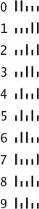
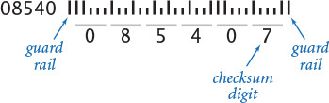
Also define global code that reads in a five- (or nine-) digit ZIP code as the command-line argument and draws the corresponding postal barcode.
2.1.35 Calendar. Compose a program cal.py that takes two command-line arguments m and y and writes the monthly calendar for the mth month of year y, as in this example:
% python cal.py 2 2015
February 2015
S M Tu W Th F S
1 2 3 4 5 6 7
8 9 10 11 12 13 14
15 16 17 18 19 20 21
22 23 24 25 26 27 28
Hint: See leapyear.py (PROGRAM 1.2.5) and EXERCISE 1.2.26.
2.1.36 Fourier spikes. Compose a program that takes a command-line argument n and plots the function
(cos(t) + cos(2 t) + cos(3 t) +... + cos(N t)) / N
for 500 equally spaced samples of t from –10 to 10 (in radians). Run your program for n = 5 and n = 500. Note: You will observe that the sum converges to a spike (0 everywhere except a single value). This property is the basis for a proof that any smooth function can be expressed as a sum of sinusoids.

2.2 Modules and Clients
Each program that you have written so far consists of Python code that resides in a single .py file. For large programs, keeping all the code in a single file is restrictive and unnecessary. Fortunately, it is easy in Python to call a function that is defined in another file. This ability has two important consequences.
2.2.1 Gaussian functions module
2.2.2 Sample Gaussian client
2.2.3 Random number module
2.2.4 Iterated function systems
2.2.5 Data analysis module
2.2.6 Plotting data values
2.2.7 Bernoulli trials
Programs in this section
First, it enables code reuse. One program can use code that is already written and debugged, not by copying the code, but just by calling it. This ability to define code that can be reused is an essential part of modern programming. It amounts to extending Python—you can define and use your own set of operations on data.
Second, it enables modular programming. You can not only divide a program into functions, as just described in SECTION 2.1, but also keep them in different files, grouped together according to the needs of the application. Modular programming is important because it allows us to independently compose and debug parts of big programs one piece at a time, leaving each finished piece in its own file for later use without having to worry about its details again. We compose modules of functions for use by any other program, keeping each module in its own file and using its functions in any other program. Python’s math module and the booksite std* modules for input/output are examples that you have already used. More important, you will soon see that it is very easy to define modules of your own. The ability to define modules and then use them in multiple programs is a critical ingredient in our ability to build programs to address complex tasks.
Having just moved in SECTION 2.1 from thinking of a Python program as a sequence of statements to thinking of a Python program as a set of functions (and global code), you will be ready after this section to think of a Python program as a set of files, each of which is an independent module consisting of a set of functions. Since each function can call a function in another module, all of your code can interact as a network of functions that call one another, grouped together in modules. With this capability, you can start to think about managing complexity when programming by breaking up programming tasks into modules that can be implemented and tested independently.

Using functions in other programs
To refer to a function in one Python program that is defined in another, we use the same mechanism that we have been using to call functions in our std* modules and Python’s math and random modules. In this section, we describe this basic Python language mechanism. To do so, we distinguish two types of Python programs:
• A module contains functions that are available for use by other programs.
• A client is a program that makes use of a function in a module.
A program can be both a module and a client: the terminology is just with respect to any particular function.
There are five (simple) steps that you need to take to create and use a module: import the module in the client, qualify function calls in the client, compose a test client for the module, eliminate global code in the module, and make the module accessible to the client. Next, we discuss each of these steps in turn. In this discussion, we use the notation module.py to refer to the name of the module and client.py to refer to the name of the client. In the following discussion, we illustrate the complete process with the module gaussian.py (PROGRAM 2.2.1), which is a modularized version of gauss.py (PROGRAM 2.1.2) for computing the Gaussian distribution functions, and the client gaussiantable.py (PROGRAM 2.2.2), which uses the module to compute and write a table of values.

In the client: import the module
To use a module, place the statement import module (note the absence of the .py extension) in client.py. The purpose of the import statement is to inform Python that the code in the client might call one or more of the functions defined in module.py. In our example, the client gaussiantable.py contains the statement import gaussian; now it can call any function defined in the module gaussian.py. In most Python code (including all the programs in the book), import statements appear at the beginning of a program, with all standard Python modules appearing before all user-defined modules.

In the client: qualify function calls to the module
To call a function that is defined in a module module.py in any other Python (client) program, type the module name module followed by the dot operator (.) and the function name. You are already accustomed to doing this with function calls such as stdio.writeln() and math.sqrt(). In our example, the client gaussiantable.py uses the function call gaussian.cdf(score, mu, sigma) to call the cdf() function that is defined in the module gaussian.py.
Program 2.2.1 Gaussian functions module (gaussian.py)
Click here to view code image
import math
import sys
import stdio
def pdf(x, mu=0.0, sigma=1.0):
x = float(x - mu) / sigma
return math.exp(-x*x/2.0) / math.sqrt(2.0*math.pi) / sigma
def cdf(z, mu=0.0, sigma=1.0):
z = float(z - mu) / sigma
if z < -8.0: return 0.0
if z > +8.0: return 1.0
total = 0.0
term = z
i = 3
while total != total + term:
total += term
term *= z * z / i
i += 2
return 0.5 + total * pdf(z)
def main():
z = float(sys.argv[1])
mu = float(sys.argv[2])
sigma = float(sys.argv[3])
stdio.writeln(cdf(z, mu, sigma))
if __name__ == '__main__': main()
Click here to view code image
% python gaussian.py 820 1019 209
0.17050966869132106
% python gaussian.py 1500 1019 209
0.9893164837383885
% python gaussian.py 1500 1025 231
0.9801220907365491
This program repackages the pdf() and cdf() functions from gauss.py (PROGRAM 2.1.2) into a module that is usable by client code that resides in another file, such as gaussiantable.py (PROGRAM 2.2.2). It also defines a main() test client that accepts floats z, mu, and sigma as command-line arguments and uses them to test the pdf() and cdf() functions.
Program 2.2.2 Sample Gaussian client (gaussiantable.py)
Click here to view code image
import sys
import stdio
import gaussian
mu = float(sys.argv[1])
sigma = float(sys.argv[2])
for score in range(400, 1600+1, 100):
percent = gaussian.cdf(score, mu, sigma)
stdio.writef('%4d %.4f\n', score, percent)
This client of gaussian (and sys and stdio) writes a table of the percentage of students scoring below certain scores on the SAT, assuming the test scores obey a Gaussian distribution with a given mean and standard deviation. It illustrates how to call functions in other modules: import the module and then call any functions within the module by prepending the module name and a period before the function name. In particular, this code calls the cdf() function in gaussian.py (PROGRAM 2.2.1).
Click here to view code image
% python gaussiantable.py 1019 209
400 0.0015
500 0.0065
600 0.0225
700 0.0635
800 0.1474
900 0.2845
1000 0.4638
1100 0.6508
1200 0.8068
1300 0.9106
1400 0.9658
1500 0.9893
1600 0.9973

In the module: compose a test client
An excellent programming practice that good programmers have adhered to for decades is to compose code to test the functions in a module and to include that code within that module. A long-standing tradition is to put this code in a function named main(). In our example, the module gaussian.py contains a main() function that takes three command-line arguments, calls the functions in the module, and writes the results to standard output.

In the module: eliminate arbitrary global code
Python’s import statement executes all global code that appears in the imported module (including function definitions and arbitrary global code). So, we cannot leave arbitrary global code in a module (such as test code that writes output) because Python will execute it every time the module is imported. Instead, we put our test code in a main() function, as just described. Now, we can arrange for Python to call main() when we execute the program from the command line (and only then), using the following incantation:
Click here to view code image
if __name__ == '__main__': main()
Informally, this code tells Python that if this .py file is being executed directly by the python command (and not via an import statement), then call main(). The effect is that the main() function defined in module.py is executed when you are debugging the module by issuing the command python module.py, but it is not executed during the import process when you are using the module in a client.

Make the module accessible to the client
Python needs to be able to find the file module.py when it processes the import module statement in client.py. When a module is not a built-in or a standard Python module, the first place it looks is in the same directory as client.py. So, the simplest way for you to proceed is to place the client and the module in the same directory. The Q&A at the end of this section describes an alternative approach.
In summary, the functions in the module gaussian.py are available for use by any other program via an import gaussian statement. In contrast, the client gaussiantable.py contains arbitrary global code and is not intended for use by other programs—it is code that might be typed in interactive mode. We use the term script to refer to such code. There is not much difference between a module and a script: Python programmers often begin by composing a script and ultimately modularize it by removing arbitrary global code.
Abbreviation alert
From this point forward we reserve the term module to refer to a .py file structured so that its features can be reused in other Python programs (so it does not contain any arbitrary global code) and the term script to refer to a .py file not intended for reuse (because it contains arbitrary global code), although we most often refer to either as a program.

Modular programming
The potential effect of programming by defining multiple files, each an independent module with multiple functions, is another profound change in our programming style. Generally, we refer to this approach as modular programming. We independently develop and debug functions for an application and then utilize them at any later time. In this section, we will consider numerous illustrative examples to help you get used to the idea.
If you think of each program that you compose as something that you might want to make use of later, you will soon find yourself with all sorts of useful tools. Modular programming allows us to view every solution to a computational problem that we may develop as adding value to our computational environment.
For example, suppose that you need to evaluate the Gaussian cumulative distribution function for some future application. Why not just cut and paste the code that implements cdf() from our original gauss.py? That would work, but would leave you with two copies of the code, making it more difficult to maintain. If you later want to fix or improve the code, you would need to do so in both copies. Instead, you can modularize your code, as we just did to turn gauss.py (PROGRAM 2.1.2) into gaussian.py (PROGRAM 2.2.1). Then you can use any function in your module by adding an import module statement at the beginning and prepending “module.” to any function call.
The impact of modular programming on the flow of control of Python program is profound, and worth reflecting upon. Even for our simple example (illustrated on the next page), the flow of control moves from our gaussiantable.py script to cdf() and then pdf() in gaussian.py to exp() and then to sqrt() in Python’s math module and then back to pdf() and then to cdf() in gaussian.py and finally back to gaussiantable.py again. In a typical modular programming application, the flow of control meanders among several modules, as you will see in examples later in this section. Each module is useful for and is used by many other modules and scripts.
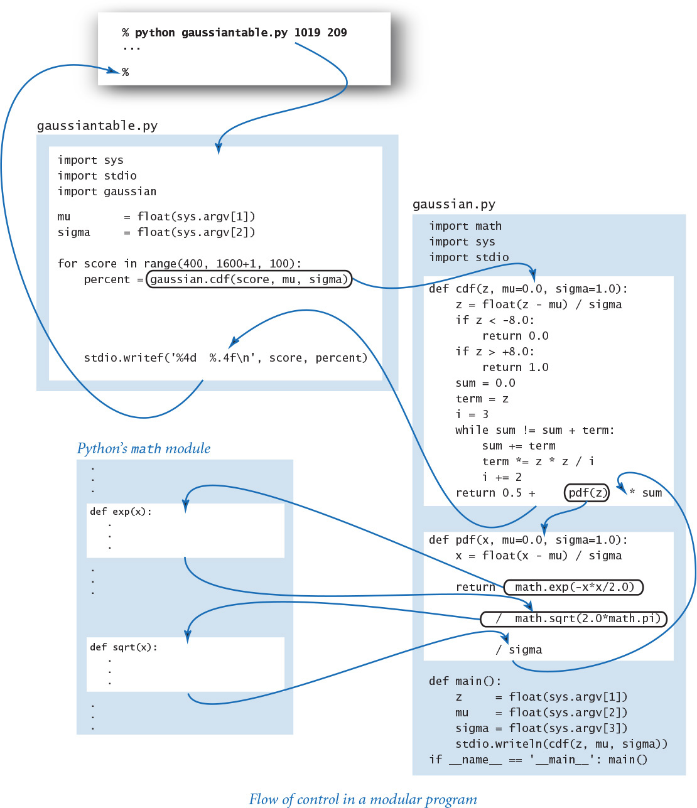
The key benefit of modular programming, and the reason that every programmer should practice it, is that encourages us to break a computation up into smaller parts that can be individually debugged and tested. Generally, you should compose every program by identifying a reasonable way to divide the computation into separate parts of a manageable size and implement each part as if someone will want to use it later. This mindset yields important and fruitful benefits, even for small programs. Most frequently, that someone will be you, and you will have yourself to thank for saving the effort of re-composing and re-debugging code.
In this book, we modularize any program containing a function that we want to reuse. Our implementations and uses of them will soon proliferate, so having them properly packaged for later use is a worthy goal.

Modular programming abstractions
One of the most important characteristics of programming in Python is that many, many functions have been predefined for you, in literally thousands of Python modules that are available for your use. In this section, however, we focus on the even more important idea that we can build user-defined modules, which are nothing more than files that each contain a set of related functions for use by other programs. No Python module (or library of modules) can contain all the functions that we might need for a given computation, so this ability is a crucial step in addressing complex programming applications. To manage the process, we work with a time-honored approach that gives us some flexibility during development. Next, we describe three abstractions that serve as the basis of that approach.

Implementations
We use the generic term implementation to describe code that implements a set of functions that are intended for reuse. A Python module is an implementation: we refer to the set of functions collectively with a name module and keep them in a file module.py. For example, as you have seen, gaussian.py is an implementation. Choosing an appropriate set of functions to group together and implement is a design art and one of the key challenges in developing a large program. The guiding principle in module design is to provide to clients the functions that they need and no others. A module with a huge number of functions may be a burden to implement; a module that is lacking important functions may be unnecessarily inconvenient for clients. We have already seen examples of this principle. For example, Python’s math module does not contain functions for secant, cosecant, and cotangent because it is so easy to use math.sin(), math.cos(), and math.tan() to compute them.

Clients
We use the generic term client to refer to a program that makes use of an implementation. We say that a Python program (a script or a module) that calls a function that is defined in a file named module.py is a client of module. For example, as you have seen, gaussiantable.py is a client of gaussian.py. Typically, a module will have multiple clients—the programs that you have composed that call math.sqrt() all are clients of Python’s math module. When you implement a new module, you need to have a very clear of idea of what it is going to do for its clients.

Application programming interfaces (APIs)
Programmers normally think in terms of a contract between the client and the implementation that is a clear specification of what the implementation is to do. This approach enables code reuse. You have been able to compose programs that are clients of math and random and other standard Python modules because of an informal contract (an English-language description of what they are supposed to do) along with a precise specification of the signatures of the functions that are available for use. Collectively, this information is known as an application programming interface (API). The same mechanism is effective for user-defined modules. The API allows any client to use the module without having to examine the code that defines the module, just as you have been doing with math and random. When we compose a new module, we always provide an API. For example, the API for our gaussian.py module is shown at the top of the next page.
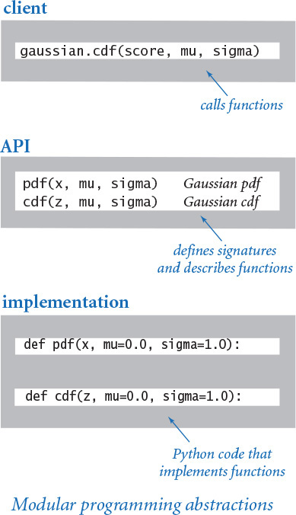
How much information should an API contain? This is a gray area and a hotly debated issue among programmers and computer-science educators. We might try to put as much information as possible in the API, but (as with any contract!) there are limits to the amount of information that we can productively include. In this book, we stick to a principle that parallels our guiding design principle: provide to client programmers the information they need and no more. Doing so gives us vastly more flexibility than the alternative of providing detailed information about implementations. Indeed, any extra information amounts to implicitly extending the contract, which is undesirable.
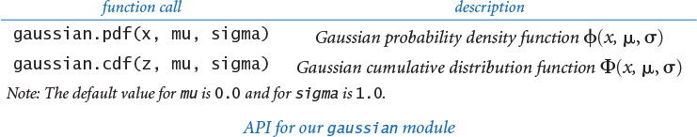

Private functions
Sometimes we wish to define in a module a helper function that is not intended to be called directly by clients. We refer to such a function as a private function. By convention, Python programmers use an underscore as the first character in the name of a private function. For example, the following is an alternative implementation of the pdf() function from gaussian.py that calls the private function _phi():
Click here to view code image
def _phi(x):
return math.exp(-x*x/2.0) / math.sqrt(2*math.pi)
def pdf(x, mu=0.0, sigma=1.0):
return _phi(float((x - mu) / sigma)) / sigma
We do not include private functions in APIs because they are not part of the contract between clients and implementations. Indeed, a leading underscore in the name of a function signals clients not to call the function explicitly. (Regrettably, Python has no mechanism for enforcing this convention.)

Libraries
A library is a collection of related modules. For example, Python has a standard library (which includes the modules random and math) and many extension libraries (such as NumPy for scientific computing and Pygame for graphics and sound). Also, for this book, we provide a booksite library (which includes the modules stdio and stddraw). We reveal information about modules and libraries that might be of interest to you throughout the book. After you gain more experience with Python programming, you will be better prepared to cope with the range and scope of libraries available to you.

Documentation
The APIs of all standard, extension, and booksite modules are available through the built-in help() function in interactive Python. As illustrated below, all you need to do is type python (to enter interactive Python), then enter the statement import module (to load the module), then type help(module) to see the API for module. The APIs of the standard and extension Python modules also are available in another form through the online Python documentation; see the booksite for details. The APIs of some standard Python modules and some of our booksite modules were discussed in previous sections of this book. Specifically, SECTION 1.5 provides the APIs of the stdio, stddraw, and stdaudio modules, and SECTION 1.4 provides part of the API of the stdarray module.
Click here to view code image
% python
...
>>> import stddraw
>>> help(stddraw)
Help on module stddraw:
NAME
stddraw - stddraw.py
FILE
.../stddraw.py
DESCRIPTION
The stddraw module defines functions that allow the user
to create a drawing. A drawing appears on the canvas.
The canvas appears in the window.
FUNCTIONS
circle(x, y, r)
Draw a circle of radius r centered at (x, y).
filledCircle(x, y, r)
Draw a filled circle of radius r centered at (x, y).
filledPolygon(x, y)
Draw a filled polygon with coordinates (x[i], y[i]).
...
Accessing an API in interactive Python
Every Python module and every module that we compose is an implementation of some API, but no API is of any use without some implementation, and no implementation is of any use without a client. Our goal when developing an implementation is to honor the terms of the contract. Often, there are many ways to do so. The idea of separating client code from implementation code through the API gives us the freedom to substitute new and improved implementations. This is a powerful idea that has served programmers well for decades.
Next, we present the APIs for our stdrandom module (for generating random numbers), our stdarray module (for one- and two-dimensional arrays), and our stdstats module (for statistical calculations). We discuss implementations of some of the functions in the modules to illustrate how you might implement your own module. However, we stop short of exhibiting all of the implementations because there is no reason to do so, just as there is no reason to show you the implementations of all the functions in Python’s math module. We also describe some interesting clients of these modules. Our purpose in considering all of these modules is twofold. First, they provide an enriched programming environment for your use as you develop increasingly sophisticated client programs of your own. Second, they serve as examples for you to study as you begin to develop modules for your own use and build your own modular programs.

Random numbers
We have composed several programs that use Python’s random module, but our code often uses particular idioms to provide the type of randomness that we need for particular applications. For example, we studied code to randomly shuffle an array in SECTION 1.4 and code to draw randomly from a discrete distribution in SECTION 1.6.
To effectively reuse our code that implements these idioms, we will, from now on, use the stdrandom module (PROGRAM 2.2.3), which includes functions that generate random numbers from various distributions and an array-shuffling function. We summarize these functions in the API at the top of the next page. These functions are familiar, so the short descriptions in the API suffice to specify what they do. As usual, to use these functions, the client must include an import statement and you must make stdrandom.py available to Python, either by putting it in the same directory as your client code or by using your operating system’s path mechanism (see the Q&A at the end of this section).
By collecting all of these functions that use random to generate random numbers of various types in one file (stdrandom.py), we concentrate our attention on generating random numbers on this one file (and reuse the code in that file) instead of spreading it through every program that uses these functions. Each program that uses one of these functions is clearer than code that calls random.random() directly, because its purpose is clearly articulated by the choice of function from stdrandom. In some cases, implementations are available or might become available in other Python libraries. In practice, we might make use of these implementations (indeed, our booksite code might differ from PROGRAM 2.2.3). Articulating our own API gives us the freedom to do so without having to change any client code.
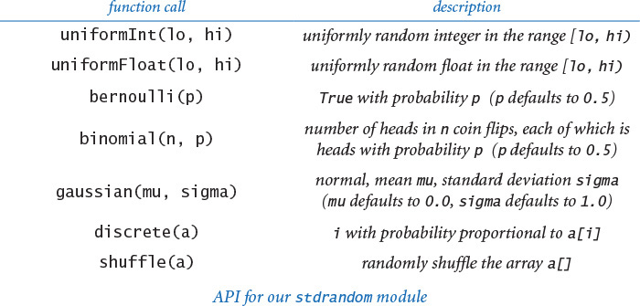

API design
We make certain assumptions about the objects passed to each function in stdrandom. For example, we assume that clients will pass to stdrandom.bernoulli() a float between 0.0 and 1.0, and to stdrandom.discrete() an array of nonnegative numbers (not all of which are zero). Such assumptions are part of the contract between the client and the implementation. We strive to design modules such that the contract is clear and unambiguous and to avoid getting bogged down with details. As with many tasks in programming, a good API design is often the result of several iterations of trying out and living with various possibilities. We always take special care in designing APIs, because when we change an API we might have to change all clients and all implementations. Our goal is to articulate what clients are to expect in the API, separate from the code. This practice frees us to change the code, and perhaps to change to an implementation that achieves the desired effect more efficiently or with more accuracy.
Program 2.2.3 Random number module (stdrandom.py)
Click here to view code image
import math
import random
def uniformInt(lo, hi):
return random.randrange(lo, hi)
def uniformFloat(lo, hi):
return random.uniform(lo, hi)
def bernoulli(p=0.5):
return random.random() < p
def binomial(n, p=0.5):
heads = 0
for i in range(n):
if bernoulli(p): heads += 1
return heads
def gaussian(mu=0.0, sigma=1.0):
# See Exercise 2.1.25.
def discrete(a):
r = uniformFloat(0.0, sum(a))
subtotal = 0.0
for i in range(len(a)):
subtotal += a[i]
if subtotal > r: return i
def shuffle(a):
# See Exercise 2.2.13.
Click here to view code image
% python stdrandom.py 5
90 26.36076 False 47 8.79269 0
13 18.02210 False 55 9.03992 1
58 56.41176 True 51 8.80501 0
29 16.68454 False 58 8.90827 0
85 86.24712 True 47 8.95228 0
This module defines functions that implement various types of randomness: random integers or floats uniformly distributed in a given range, a random boolean (Bernoulli), random integers drawn from a binomial distribution, random floats drawn from a Gaussian distribution, random integers drawn from a given discrete distribution, and randomly shuffling an array. The test client appears on the next page.

Unit testing
We implement stdrandom without reference to any particular client, but it is good programming practice to include a basic test client main() that, at a minimum,
• Exercises all the code.
• Provides some assurance that the code is working.
• Takes an argument from the command line to allow flexibility in testing.
Although it is not intended for clients, we use main() when debugging, testing, and improving the functions in a module. This practice is call unit testing. For example, a test client for stdrandom is shown below (we omit testing of the shuffle() function—see EXERCISE 1.4.22). As shown with PROGRAM 2.2.1, when we invoke this function by typing python stdrandom.py 10, the output brings no surprises: the numbers in the first column might be equally likely to be any integer from 0 to 99; the numbers in the second column might be uniformly spread between 10.0 and 99.0; about half of the values in the third column are True; the numbers in the fourth column are close to 50; the numbers in the fifth column seem to average about 9.0, and seem unlikely to be too far from 9.0; and the last column seems to be not far from 50% 0s, 30% 1s, 10% 2s, and 10% 3s. If something seems amiss, we can see many more results by typing python stdrandom.py 100. Typically, it is good practice to refine the main() function to do more exhaustive testing as you use the library more extensively.
Proper unit testing can be a significant programming challenge in itself. In this particular case, it is appropriate to do more extensive testing in a separate client to check that the numbers have many of the same properties as truly random numbers drawn from the cited distributions (see EXERCISE 2.2.2). Note: Experts still debate the best way of testing whether the functions in stdrandom produce numbers that have the same characteristics as truly random numbers.
Click here to view code image
def main():
trials = int(sys.argv[1])
for i in range(trials):
stdio.writef('%2d ' , uniformInt(10, 100))
stdio.writef('%8.5f ', uniformFloat(10.0, 99.0))
stdio.writef('%5s ' , bernoulli(0.5))
stdio.writef('%2d ' , binomial(100, 0.5))
stdio.writef('%7.5f ', gaussian(9.0, 0.2))
stdio.writef('%1d ' , discrete([5, 3, 1, 1]))
stdio.writeln()
if __name__ == '__main__': main()
Basic test client for stdrandom
One effective approach is to compose test clients that use stddraw, as data visualization can be a quick indication that a program is behaving as intended. In the present context, a plot of a large number of points whose x- and y-coordinates are both drawn from various distributions often produces a pattern that gives direct insight into the important properties of the distribution. More important, a bug in the random number generation code is likely to show up immediately in such a plot. An example script that tests stdrandom.gaussian() is shown at right.

Stress testing
An extensively used module such as stdrandom should also be subject to stress testing, where we make sure that it does not fail unexpectedly, even when the client does not follow the contract or makes some assumption that is not explicitly covered. Python’s standard modules have all been subject to such testing, which requires carefully examining each line of code and questioning whether some condition might cause a problem. What should stdrandom.discrete() do if some array elements are negative? What if the argument is an array of length 0? What should stdrandom.uniform() do if the second argument is less than (or equal to) the first argument? Any question that you can think of is fair game. Such cases are sometimes referred to as corner cases. You are certain to encounter a teacher or a supervisor who is a stickler about corner cases. With experience, most programmers learn to address them early, to avoid an unpleasant bout of debugging later. Again, a reasonable approach is to implement a stress test as a separate client.
Click here to view code image
import sys
import stddraw
import stdrandom
trials = int(sys.argv[1])
stddraw.setPenRadius(0.0)
for i in range(trials):
x = stdrandom.gaussian(0.5, 0.2)
y = stdrandom.gaussian(0.5, 0.2)
stddraw.point(x, y)
stddraw.show()
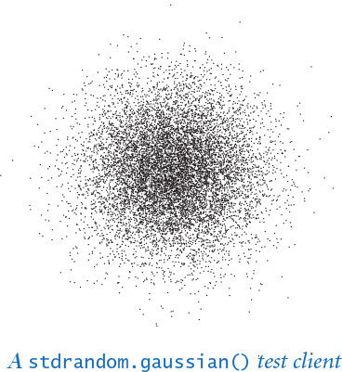

Array-processing API
In SECTION 1.4 we saw the utility of functions that create one-dimensional arrays of a specified length and two-dimensional arrays with a specified number of rows and columns. Thus, we introduced the stdarray module from the booksite library, and specifically its functions for creating and initializing arrays stdarray.create1D() and stdarray.create2D().
Moreover, we have seen and will continue to see many examples where we wish to read values from standard input into an array and write values from an array to standard output. Accordingly, we have included in the stdarray module functions for reading arrays of integers, floats, and booleans from standard input and for writing them to standard output—thus complementing the stdio module. Here is the full API for stdarray:
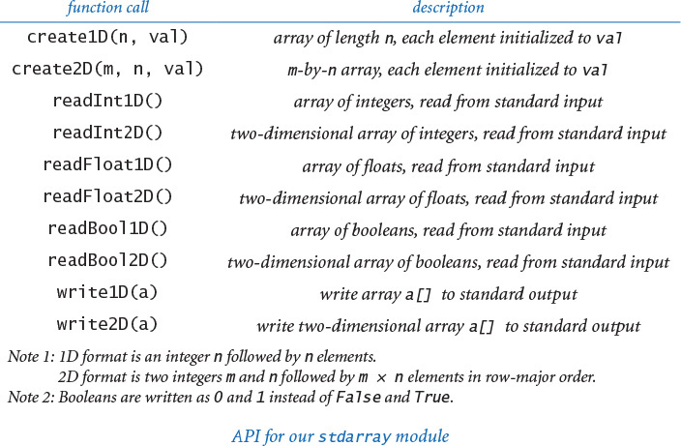
As usual, you can also find this information when working online, with interactive Python: first type import stdarray, then type help(stdarray) to see the API.
The array writing and reading functions must agree on a file format. For simplicity and harmony, we have adopted the convention that arrays appearing on standard input include the dimension(s) and appear in the order indicated, as illustrated in the diagram at the bottom of this page. The read*() functions expect this format, the write*() functions produce output in this format, and we can easily create files in this format for data from some other source.
For arrays of booleans, our file format uses 0 and 1 values instead of False and True. This convention is much more economical for large arrays. More important, patterns in the data are much easier to spot with this file format, as you will see in SECTION 2.4.
Implementing these functions is straightforward with the array-processing code that we have considered in SECTION 1.4 and in SECTION 2.1. We omit the module implementation because we have already studied the basic code. If you are interested, you can find the full implementation in the stdarray.py file on the booksite.
Packaging up all of these functions into one file—stdarray.py—allows us to easily reuse the code and saves us from having to worry about the details of creating, writing, and reading arrays when composing client programs later on. Moreover, these client programs, having calls to these functions instead of code that implements them, are more compact and easier to understand.
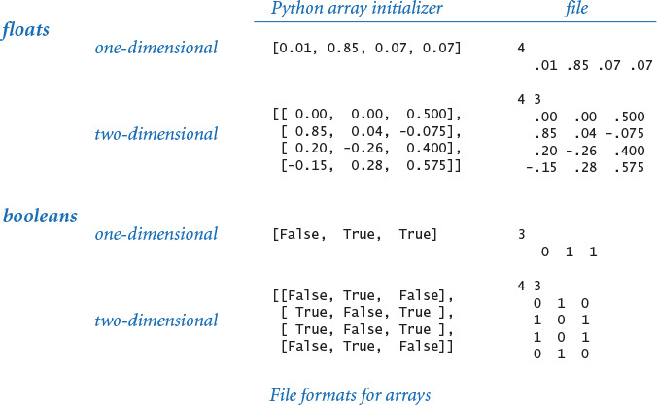

Iterated function systems
Scientists have discovered that complex visual images can arise unexpectedly from simple computational processes. With stdrandom, stddraw, and stdarray, we can easily study the behavior of such systems.

Sierpinski triangle
As a first example, consider the following simple process: Start by plotting a point at one of the vertices of a given equilateral triangle. Then pick one of the three vertices at random and plot a new point halfway between the point just plotted and that vertex. Continue performing this same operation. Each time, we are picking a random vertex from the triangle to establish the line whose midpoint will be the next point plotted. Since we are making a random choice, the set of points should have some of the characteristics of random points, and that does seem to be the case after the first few iterations:
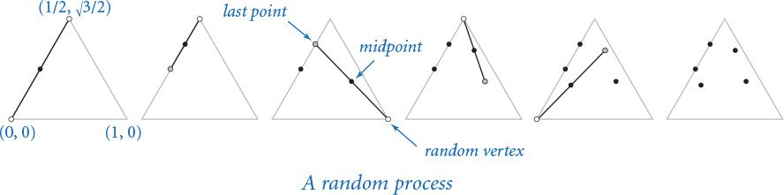
But we can study the process for a large number of iterations by composing a script to plot n points according to the rules:
Click here to view code image
cx = [0.000, 1.000, 0.500]
cy = [0.000, 0.000, 0.866]
x = 0.0
y = 0.0
for i in range(n):
r = stdrandom.uniformInt(0, 3)
x = (x + cx[r]) / 2.0
y = (y + cy[r]) / 2.0
stddraw.point(x, y)
stddraw.show()
We keep the x- and y-coordinates of the triangle vertices in the arrays cx[] and cy[], respectively. We use stdrandom.uniformInt() to choose a random index r into these arrays—the coordinates of the chosen vertex are (cx[r], cy[r]). The x-coordinate of the midpoint of the line from (x, y) to that vertex is given by the expression (x + cx[r]) / 2.0, and a similar calculation gives the y-coordinate. Adding a call to stddraw.point() and putting this code in a loop completes the implementation. Remarkably, despite the randomness, the same figure always emerges after a large number of iterations! This figure is known as the Sierpinski triangle (see EXERCISE 2.3.27). Understanding why such a regular figure should arise from such a random process is a fascinating question.
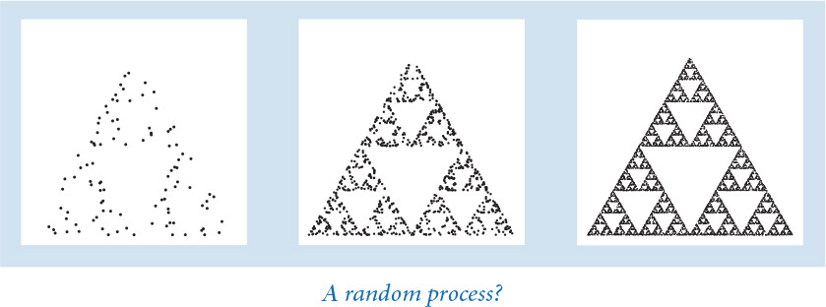

Barnsley fern
To add to the mystery, we can produce pictures of remarkable diversity by playing the same game with different rules. One striking example is known as the Barnsley fern. To generate it, we use the same process, but this time driven by the following table of formulas. At each step, we choose the formulas to use to update x and y with the indicated probability (1% of the time we use the first pair of formulas, 85% of the time we use the second pair of formulas, and so forth).
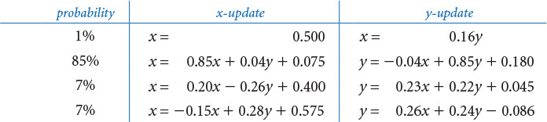
We could compose code just like the code we just wrote for the Sierpinski triangle to iterate these rules, but matrix processing provides a uniform way to generalize that code to handle any set of rules. We have m different transformations, chosen from a 1-by-m vector with stdrandom.discrete(). For each transformation, we have an equation for updating x and an equation for updating y, so we use two m-by-3 matrices for the equation coefficients—one for x and one for y. PROGRAM 2.2.4 (ifs.py) implements this data-driven version of the computation. This program enables limitless exploration: it performs the iteration for any input containing a vector that defines the probability distribution and the two matrices that define the coefficients, one for updating x and the other for updating y. For the coefficients just given, even though we choose a random equation at each step, the same figure emerges every time that we do this computation: an image that looks remarkably similar to a fern that you might see in the woods, not something generated by a random process on a computer.
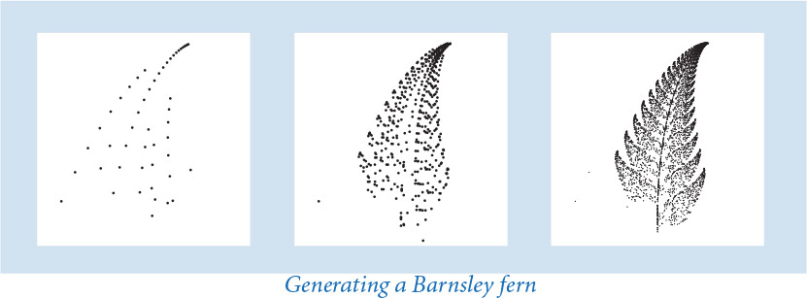
That the same short program that takes a few numbers from standard input and plots points to standard drawing can (given different data) produce both the Sierpinski triangle and the Barnsley fern (and many, many other images) is truly remarkable. Because of its simplicity and the appeal of the results, this sort of calculation is useful in making synthetic images that have a realistic appearance in computer-generated movies and games.
Perhaps more significantly, the ability to produce such realistic diagrams so easily suggests intriguing scientific questions: What does computation tell us about nature? What does nature tell us about computation?
Program 2.2.4 Iterated function systems (ifs.py)
Click here to view code image
import sys
import stdarray
import stddraw
import stdrandom
n = int(sys.argv[1])
probabilities = stdarray.readFloat1D()
cx = stdarray.readFloat2D()
cy = stdarray.readFloat2D()
x = 0.0
y = 0.0
stddraw.setPenRadius(0.0)
for i in range(n):
r = stdrandom.discrete(probabilities)
x0 = cx[r][0]*x + cx[r][1]*y + cx[r][2]
y0 = cy[r][0]*x + cy[r][1]*y + cy[r][2]
x = x0
y = y0
stddraw.point(x, y)
stddraw.show()
n | iterations
probabilities[] | probabilities
cx[][] | x coefficients
cy[][] | y coefficients
x, y | current point
This data-driven script is a client of stdarray, stdrandom, and stddraw. It iterates the function system defined by a 1-by-m vector (probabilities) and two m-by-3 matrices (coefficients for updating x and y, respectively) on standard input, plotting the result as a set of points on standard drawing. Curiously, this code does not need to refer to m.
% more sierpinski.txt
3
.33 .33 .34
3 3
.50 .00 .00
.50 .00 .50
.50 .00 .25
3 3
.00 .50 .00
.00 .50 .00
.00 .50 .433
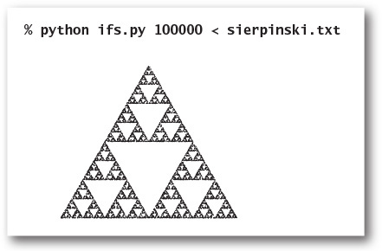
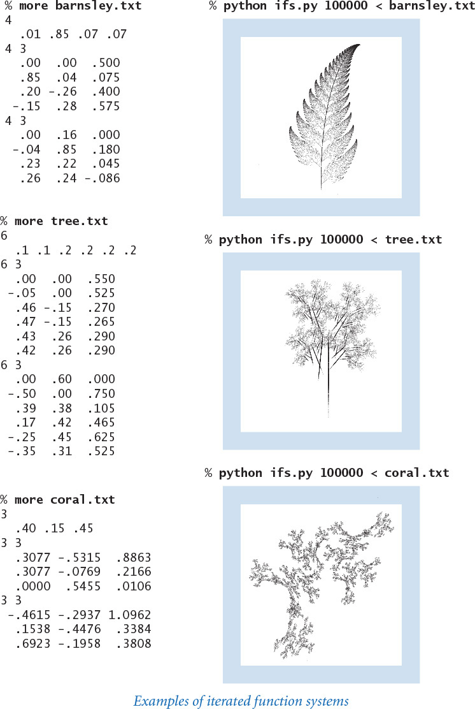

Standard statistics
Next, we consider a module for a set of mathematical calculations and basic visualization tools that arise in all sorts of applications in science and engineering (and are not all implemented in standard Python modules). These calculations relate to the task of understanding the statistical properties of a sequence of numbers. Such a module is useful, for example, when we perform a series of scientific experiments that yield measurements of a quantity. One of the most important challenges facing modern scientists is proper analysis of such data, and computation is playing an increasingly important role in such analysis. These basic data analysis functions are not difficult to implement and are summarized in the API shown at the bottom of this page.

Basic statistics
Suppose that we have n measurements x0, x1, ..., xn–1. The average value of these measurements, otherwise known as the mean, is given by the formula μ = (x0 + x1 + . . . + xn–1) / n and is an estimate of the value of the quantity. The minimum and maximum values are also of interest, as is the median (the middle value if the measurements are sorted and n is odd, or the average of the two middle values if n is even). Also of interest is the sample variance, which is given by the formula
σ2 = ((x0 – μ)2 + (x1 – μ)2 + ... + (xn–1 – μ)2) / (n–1)
and the sample standard deviation, the square root of the sample variance. PROGRAM 2.2.5 (stdstats.py) is a module for computing these basic statistics (the median is more difficult to compute efficiently than the others—we will consider the implementation of median() in SECTION 4.2). The main() test client for stdstats reads numbers from standard input into an array and calls each of the functions. As with stdrandom, a more extensive test of the calculations is called for. Typically, as we debug or test new functions in the module, we adjust the unit testing code accordingly, testing the functions one at a time. A mature and widely used module like stdstats also deserves a stress-testing client for extensively testing everything after any change. If you are interested in seeing what such a client might look like, you can find one for stdstats on the booksite (also see EXERCISE 2.2.2). Most experienced programmers will advise you that any time spent doing unit testing and stress testing will more than pay for itself later.
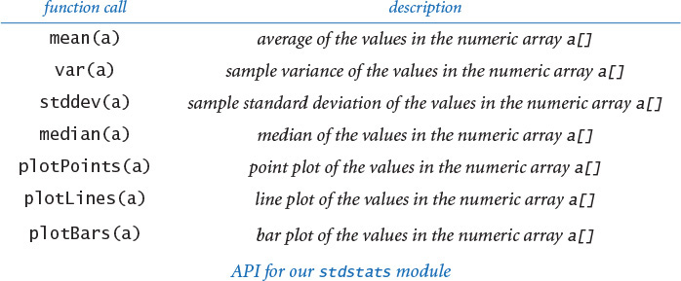
Program 2.2.5 Data analysis module (stdstats.py)
Click here to view code image
import math
import stdarray
import stddraw
import stdio
def mean(a):
return sum(a) / float(len(a))
def var(a):
mu = mean(a)
total = 0.0
for x in a:
total += (x - mu) * (x - mu)
return total / (len(a) - 1)
def stddev(a):
return math.sqrt(var(a))
def median(a):
# See Exercise 4.2.16.
# See Program 2.2.6 for plotting functions.
def main():
a = stdarray.readFloat1D()
stdio.writef(' mean %7.3f\n', mean(a))
stdio.writef('std dev %7.3f\n', stddev(a))
stdio.writef(' median %7.3f\n', median(a))
if __name__ == '__main__': main()
This module implements functions to compute the minimum, maximum, mean, variance, and standard deviation of numbers in a client array. Plotting functions are in PROGRAM 2.2.6.
% more tiny1D.txt
7
3.0 1.0 4.0 7.0 8.0 9.0 6.0
Click here to view code image
% python stdstats.py < tiny1D.txt
mean 5.429
std dev 2.878
median 6.000

Plotting
One important use of stddraw is to help us visualize data rather than relying on tables of numbers. In a typical situation, we perform experiments, save the experimental data in an array, and then compare the results against a model, perhaps a mathematical function that describes the data. To expedite this process for the typical case where values of one variable are equally spaced, our stdstats module defines functions that you can use for plotting data in an array. PROGRAM 2.2.6 is an implementation of the plotPoints(), plotLines(), and plotBars() functions for stdstats. These functions display the values in the argument array at regularly spaced intervals in the drawing window, either connected together by line segments (lines), filled circles at each value (points), or bars from the x-axis to the value (bars). They all plot the points with x-coordinate i and y-coordinate a[i] using filled circles, lines through the points, and bars, respectively. They all rescale x to fill the drawing window (so that the points are evenly spaced along the x-coordinate) and leave to the client scaling the y-coordinates.
These functions are not intended to form a general-purpose plotting module. Indeed, you can certainly think of all sorts of things that you might want to add: different types of spots, labeled axes, color, and many other artifacts are commonly found in modern systems that can plot data. Some situations might call for more complicated functions than these. Our intent with stdstats is to introduce you to data analysis while showing you how easy it is to define a module to take care of useful tasks. In fact, this module has already proved useful—we used these plotting functions to produce the figures in this book that depict function graphs, sound waves, and experimental results. Next, we consider several examples of their use.

Plotting function graphs
You can use the stdstats.plot*() functions to draw a plot of the function graph for any function at all: choose an x-interval where you want to plot the function, compute function values evenly spaced through that interval and store them in an array, determine and set the y-scale, and then call stdstats.plotLines() or another plot*() function, as shown in the example plot at right. The smoothness of the curve is determined by properties of the function and by the number of points plotted. As we discussed when first considering stddraw, you have to be careful to sample enough points to catch fluctuations in the function. We will consider another approach to plotting functions based on sampling values that are not equally spaced in SECTION 2.4. Often, rescaling the y-axis is necessary (scaling the x-axis is automatically handled by the stdstats functions). For example, to plot a sine function, rescale the y-axis to cover values between –1 and +1. Generally, to rescale the y-axis, you can call stddraw.setYscale(min(a), max(a)).
Click here to view code image
n = int(sys.argv[1])
a = stdarray.create1D(n+1, 0.0)
for i in range(n+1):
a[i] = gaussian.pdf(-4.0 + 8.0 * i / n)
stdstats.plotPoints(a)
stdstats.plotLines(a)
stddraw.show()
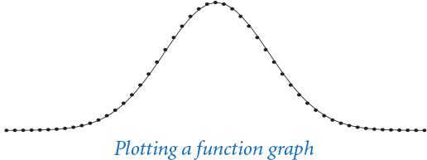

Plotting sound waves
Both the stdaudio module and the stdstats plot functions work with arrays that contain sampled values at regular intervals, so it is easy to plot sound waves. The diagrams of sound waves in SECTION 1.5 and at the beginning of this section were each produced by first scaling the y-axis so as to give the curve a reasonable appearance, then plotting the points with stdstats.plotPoints(). As you have seen, such plots give direct insight into processing audio. You can also produce interesting effects by plotting sound waves as you play them with stdaudio, although this task is a bit challenging because of the huge amount of data involved (see EXERCISE 1.5.27).
def tone(hz, t):
# See Program 2.4.7
stddraw.setYscale(-6.0, 6.0)
hi = tone(440, 0.01)
stdstats.plotPoints(hi)
stddraw.show()
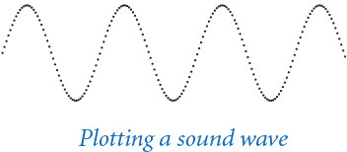
Program 2.2.6 Plotting data values (stdstats.py,)
Click here to view code image
def plotPoints(a):
n = len(a)
stddraw.setXscale(0, n-1)
stddraw.setPenRadius(1.0 / (3.0 * n))
for i in range(n):
stddraw.point(i, a[i])
def plotLines(a):
n = len(a)
stddraw.setXscale(0, n-1)
stddraw.setPenRadius(0.0)
for i in range(1, n):
stddraw.line(i-1, a[i-1], i, a[i])
def plotBars(a):
n = len(a)
stddraw.setXscale(0, n-1)
for i in range(n):
stddraw.filledRectangle(i-0.25, 0.0, 0.5, a[i])
This code implements the three functions in stdstats.py (PROGRAM 2.2.5) for plotting data. Given an array a[], they plot the points (i, a[i]) with filled circles, connecting line segments, and bars, respectively. Clients are responsible for calling stddraw.show().
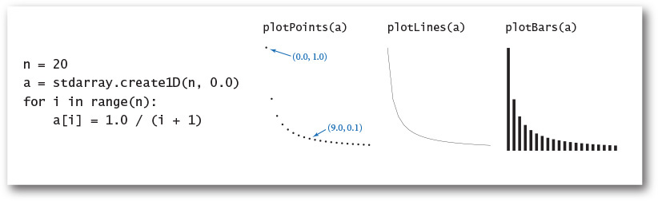

Plotting experimental results
You can put multiple plots on the same drawing. One typical reason to do so is to compare experimental results with a theoretical model. For example, bernoulli.py (PROGRAM 2.2.7) counts the number of heads found when a fair coin is flipped n times and compares the result with the predicted Gaussian (normal) distribution function. A famous result from probability theory is that the distribution of this quantity is the binomial distribution, which is extremely well approximated by the Gaussian probability density function φ with mean n / 2 and standard deviation . The more trials we perform, the more accurate the approximation. The drawing produced by bernoulli.py, shown at the bottom of this page, is a succinct summary of the results of the experiment and a convincing validation of the theory. This example is prototypical of a scientific approach to applications programming that we use often throughout this book and that you should use whenever you run an experiment. If a theoretical model that can explain your results is available, a visual plot comparing the experiment to the theory can validate both.
These few examples are intended to indicate to you what is possible with a well-designed module of functions for data analysis. Several extensions and other ideas are explored in the exercises. You may find stdstats to be useful for basic plots, and you are encouraged to experiment with these implementations and modify them or to add functions to make your own module that can draw plots of your own design. As you continue to address an ever-widening circle of programming tasks, you will naturally be drawn to the idea of developing tools like these for your own use.
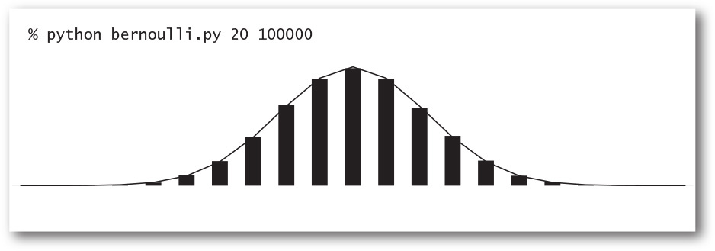
Program 2.2.7 Bernoulli trials (bernoulli.py)
Click here to view code image
import sys
import math
import stdarray
import stddraw
import stdrandom
import stdstats
import gaussian
n = int(sys.argv[1])
trials = int(sys.argv[2])
freq = stdarray.create1D(n+1, 0)
for t in range(trials):
heads = stdrandom.binomial(n, 0.5)
freq[heads] += 1
norm = stdarray.create1D(n+1, 0.0)
for i in range(n+1):
norm[i] = 1.0 * freq[i] / trials
phi = stdarray.create1D(n+1, 0.0)
stddev = math.sqrt(n)/2.0
for i in range(n+1):
phi[i] = gaussian.pdf(i, n/2.0, stddev)
stddraw.setCanvasSize(1000, 400)
stddraw.setYscale(0, 1.1 * max(max(norm), max(phi)))
stdstats.plotBars(norm)
stdstats.plotLines(phi)
stddraw.show()
n | number of flips per trial
trials | number of trials
freq[] | experimental results
norm[] | normalized results
phi[] | Gaussian model
This script provides convincing visual evidence that the number of heads observed when a fair coin is flipped n times obeys a Gaussian distribution (see output on facing page).

Modular programming
The modules that we have developed illustrate a programming style known as modular programming. Instead of composing a new program that is self-contained in its own file to address a new problem, we break up each large task into smaller, more manageable subtasks, then implement and independently debug code that addresses each subtask. Whenever you can clearly separate tasks within a computation, you should do so. Python supports such separation by allowing us to independently develop functions in modules, which can then be used by clients. Thus, Python facilitates modular programming by allowing us to define modules of important subtasks for use by clients.
Our iterated function system script ifs.py (PROGRAM 2.2.4) exemplifies modular programming because it is a relatively sophisticated computation that is implemented with several relatively small interacting modules, each developed independently. It makes use of stdrandom and stdarray, as well as the functions from sys and stddraw that we are accustomed to using. If we were to put all of the code required for ifs.py in a single file, we would have a large amount of code to maintain and debug; with modular programming, we can study iterated function systems with some confidence that the arrays are read properly and that the random number generator will produce properly distributed values, because we have already implemented and tested the code for these tasks in separate modules.
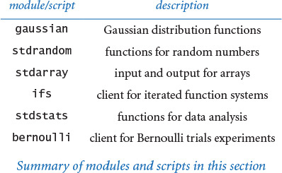
Similarly, bernoulli.py (PROGRAM 2.2.7) exemplifies modular programming. It is a client of gaussian, sys, math, stdrandom, stdarray, stddraw, and stdstats. Again, we can have some confidence that the functions in these modules produce the expected results because they are system modules or modules that we have tested, debugged, and used before.
To describe the relationships among modules in a modular program, we can draw a dependency graph, where we connect two module names with an arrow if the first module uses features defined in the second module. Such diagrams play an important role because understanding the relationships among modules is necessary for proper development and maintenance. A dependency graph for ifs.py and bernoulli.py and the modules they use appears at the top of the next page.
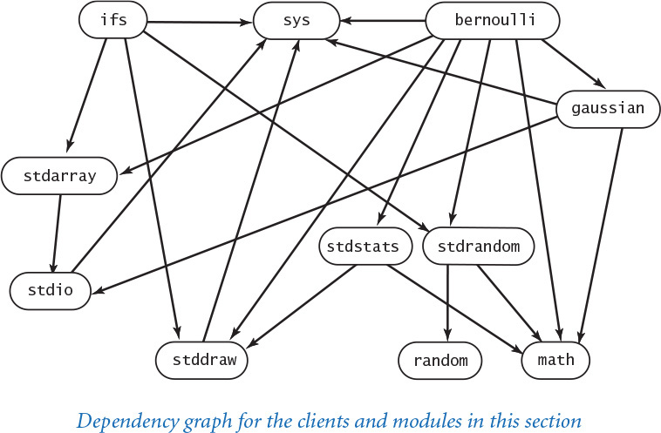
We emphasize modular programming throughout this book because it has many important advantages that have come to be accepted as essential in modern programming, including the following:
• We can compose programs of a reasonable size, even in large systems.
• Debugging is restricted to small pieces of code.
• We can reuse code without having to reimplement it.
• Maintaining (and improving) code is much simpler.
The importance of these advantages is difficult to overstate, so we will expand upon each of them.

Programs of a reasonable size
No large task is so complex that it cannot be divided into smaller subtasks. If you find yourself with a program that stretches to more than a few pages of code, you must ask yourself the following questions: Are there subtasks that could be implemented separately? Can some of these subtasks logically be grouped together in a separate module? Could other clients use this code in the future? At the other end of the range, if you find yourself with a huge number of tiny modules, you must ask yourself questions such as these: Is there some group of subtasks that logically belong in the same module? Is each module likely to be used by multiple clients? There is no hard-and-fast rule on module size: one implementation of a critically important abstraction might properly be a few lines of code, whereas another module with a large number of functions might properly extend to hundreds of lines of code.

Debugging
Tracing a program rapidly becomes more difficult as the number of statements and interacting variables increases. Tracing a program with hundreds of variables requires keeping track of hundreds of objects, as any statement might affect or be affected by any variable. To do so for hundreds or thousands of statements or more is untenable. With modular programming and our guiding principle of keeping the scope of variables local to the extent possible, we severely restrict the number of possibilities that we have to consider when debugging. Equally important is the idea of a contract between the client and the implementation. Once we are satisfied that an implementation is meeting its end of the bargain, we can debug all its clients under that assumption.

Code reuse
Once we have implemented modules such as stdrandom and stdstats, we do not have to worry about composing code to compute means or standard deviations or to generate random numbers again—we can simply reuse the code that we have composed. Moreover, we do not need to make copies of the code—any module can refer to any function in any other module.

Maintenance
Like a good essay, a good program can always be improved, and modular programming facilitates the process of continually improving your Python programs because improving a module improves all of its clients. Normally there are several different approaches to solving a particular problem. With modular programming, you can implement more than one and try them independently. As long as client code relies only on behavior documented in the APIs, it should continue to work without modification with new implementations. More important, suppose that while developing a new client, you find a bug in some module. With modular programming, fixing that bug essentially fixes the same bugs in all of the module’s clients.
If you encounter an old program (or a new program composed by an old programmer!), you are likely to find one huge module—a long sequence of statements, stretching to several pages or more, where any statement can refer to any variable in the program. Huge modules of this sort are extremely difficult to understand, maintain, and debug. Old programs of this kind are found in critical parts of our computational infrastructure (for example, some nuclear power plants and some banks) precisely because the programmers charged with maintaining them cannot even understand them well enough to reimplement them in a modern language! With support for modular programming, modern languages like Python help us avoid such situations by separately developing sets of functions in independent files.
The ability to share functions among different files fundamentally extends our programming model in two different ways. First, it allows us to reuse code without having to maintain multiple copies of it. Second, by allowing us to organize a program into files of manageable size that can be independently tested and debugged, it strongly supports our basic message: whenever you can clearly separate tasks within a computation, you should do so.
In this section, we have supplemented the std* libraries of SECTION 1.5 with several other libraries that you can use: gaussian, stdarray, stdrandom, and stdstats. Furthermore, we have illustrated their use with several client programs. These tools are centered on basic mathematical concepts that may arise in any scientific project or engineering task. Our intent is not just to provide tools, but also to illustrate that it is easy for you to create your own tools. The first question that most modern programmers ask when addressing a complex task is “Which tools do I need?” When the needed tools are not conveniently available, the second question is “How difficult would it be to implement them?” To be a good programmer, you must have the confidence to build a software tool when you need it and the wisdom to know when it might be better to seek a solution in an existing module.
After modules and modular programming, you have one more step to learn to have a complete modern programming model: object-oriented programming, the topic of CHAPTER 3. With object-oriented programming, you can build modules of functions that use side effects (in a tightly controlled manner) to vastly extend the Python programming model. Before moving to object-oriented programming, we consider in this chapter the profound ramifications of the idea that any function can call itself (in SECTION 2.3) and a more extensive case study (in SECTION 2.4) of modular programming than the small clients in this section.

Q&A
Q. How can I make a module such as gaussian or stdrandom available to my Python programs?
A. The easiest way is to download gaussian.py from the booksite and put it in the same directory as the client. However, if you do this, you might end up with several copies of gaussian.py in different directories, which makes the code harder to maintain. Instead, you can put gaussian.py in a single directory and configure the PYTHONPATH environment variable to include this directory. The booksite contains instructions for setting the PYTHONPATH variable on your operating system. If you followed the step-by-step instructions on the booksite for installing Python, all of our standard modules (including stdio, stddraw, stdarray, stdrandom, and stdstats) should already be available for use in your Python programs.
Q. I tried to import the gaussian module, but got the following error message. What’s wrong?
Click here to view code image
ImportError: No module named gaussian
A. You did not make gaussian available to Python, as described above.
Q. I tried to call gaussian.pdf() but I got the following error. What’s wrong?
Click here to view code image
NameError: name 'gaussian' is not defined
A. You left out the import gaussian statement.
Q. Is there a keyword that identifies a .py file as a module (and not a script)?
A. No. Technically, the key point is to avoid arbitrary global code using the patterns described earlier in this section. If you avoid arbitrary global code in a .py file, so that the .py file can be imported into some other .py file, then we call it a module. Pragmatically, however, there is a bit of a conceptual leap in this viewpoint, because it is one thing to sit down to create a .py file that you will run (and perhaps run again sometime later with different data), but quite another thing to create a .py file that you will rely on much later in the future, and still another thing to create a .py file for someone else to use in the future.
Q. How do I develop a new version of a module that I have been using for a while?
A. With care. Any change to the API might break any client program, so it is best to work in a separate directory. Of course, with this approach you are working with a copy of the code. If you are changing a module that has a lot of clients, you can appreciate the problems faced by companies putting out new versions of their software. If you just want to add a few functions to a module, go ahead: that is usually not too dangerous.
Q. How do I know that an implementation behaves properly? Why not automatically check that it satisfies the API?
A. We use informal specifications because composing a detailed specification is not much different from composing a program. Moreover, a fundamental tenet of theoretical computer science says that doing so does not even solve the basic problem because there is no way in general to check that two different programs perform the same computation.
Q. I notice that files whose names are suffixed with .pyc are appearing when I run the programs from this section. For example, when I issue the command python gaussiantable.py, I notice that Python automatically creates a file named gaussian.pyc. What are these .pyc files?
A. As noted in SECTION 1.1, whenever Python executes a program, it compiles the program into an internal (not human-readable) form that is more amenable to execution, known as bytecode. When you import a module for the first time, Python compiles the code and stores the resulting bytecode in a .pyc file. This makes the module load faster because Python does not need to recompile it each time (but it does not make running the program any faster). It’s fine to delete .pyc files at any time; Python will regenerate them when appropriate. It’s also fine not to delete .pyc files because if you edit a .py file after Python has generated the corresponding .pyc file, Python will regenerate the .pyc file automatically.

Exercises
2.2.1 Compose a module that implements the hyperbolic trigonometric functions based on the definitions sinh(x) = (ex – e–x) / 2 and cosh(x) = (ex + e–x) / 2, with tanh(x), coth(x), sech(x), and csch(x) defined in a manner analogous to the standard trigonometric functions.
2.2.2 Compose a test client for both stdstats and stdrandom that checks that all of the functions in both modules (with the exception of shuffle()—see EXERCISE 1.4.22) operate as expected. Take a command-line argument n, generate n random numbers using each of the functions in stdrandom, and write their statistics. Extra credit: Defend the results that you get by comparing them to the results expected from mathematical analysis.
2.2.3 Develop a client that does stress testing for stdrandom. Pay particular attention to discrete(). For example, are the probabilities nonnegative? Are they all zero?
2.2.4 Compose a function that takes floats ymin and ymax (with ymin strictly less than ymax) and a float array a[] as arguments and linearly scales the elements in a[] so that they are all between ymin and ymax.
2.2.5 Compose a gaussian and stdstats client that explores the effects of changing the mean and standard deviation of the Gaussian distribution curve. Create one plot with curves having a fixed mean and various standard deviations and another with curves having a fixed standard deviation and various means.
2.2.6 Add to stdrandom a function maxwellBoltzmann() that returns a random value drawn from a Maxwell-Boltzmann distribution with parameter σ. To produce such a value, return the square root of the sum of the squares of three Gaussian random variables with mean 0 and standard deviation σ. (The speeds of molecules in an ideal gas have a Maxwell-Boltzmann distribution.)
2.2.7 Modify bernoulli.py to animate the bar graph, replotting it after each experiment, so that you can watch it converge to the normal distribution.
2.2.8 Modify bernoulli.py to take an extra command-line argument p that specifies the probability p that a biased coin comes up heads. Run experiments to get a feeling for the distribution corresponding to a biased coin. Be sure to try values of p that are close to 0 and close to 1.
2.2.9 Compose a module matrix.py that implements the following API for vectors and matrices (see SECTION 1.4):
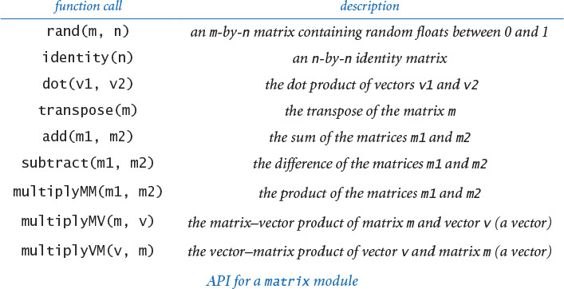
As a test client, use the following code, which performs the same calculation as markov.py (PROGRAM 1.6.3):
Click here to view code image
moves = int(sys.argv[1])
p = stdarray.readFloat2D()
ranks = stdarray.create1D(len(p), 0.0)
ranks[0] = 1.0
for i in range(moves):
ranks = matrix.multiplyVM(ranks, p)
stdarray.write1D(ranks)
In practice, mathematicians and scientists use mature libraries such as NumPy (or special-purpose matrix-processing languages such as Matlab) for such tasks because they are likely to be more efficient, accurate, and robust than anything you could compose yourself. See the booksite for information on using NumPy.
2.2.10 Compose a matrix.py client that implements the version of markov.py described in SECTION 1.6 but is based on squaring the matrix, instead of iterating the vector-matrix multiplication.
2.2.11 Redesign randomsurfer.py (PROGRAM 1.6.2) using the stdarray and stdrandom modules.
Partial solution:
Click here to view code image
...
p = stdarray.readFloat2D()
page = 0 # Start at page 0.
hits = stdarray.create1D(n, 0)
for i in range(moves):
page = stdrandom.discrete(p[page])
hits[page] += 1
...
2.2.12 Add a function exp() to stdrandom.py that takes an argument λ and returns a random number from the exponential distribution with rate λ: if x is a random number uniformly distributed between 0 and 1, then –ln x / λ is a random number from the exponential distribution with rate λ.
2.2.13 Implement the function shuffle() in stdrandom.py that takes an array as an argument and shuffles the elements in the array. Use the shuffling algorithm described in SECTION 1.4.

Creative Exercises
2.2.14 Sicherman dice. Suppose that you have two six-sided dice, one with faces labeled 1, 3, 4, 5, 6, and 8 and the other with faces labeled 1, 2, 2, 3, 3, and 4. Compare the probabilities of occurrence of each of the values of the sum of the dice with those for a standard pair of dice. Use stdrandom and stdstats.
2.2.15 Craps. The following are the rules for a pass bet in the game of craps. Roll two six-sided dice, and let x be their sum.
• If x is 7 or 11, you win.
• If x is 2, 3, or 12, you lose.
Otherwise, repeatedly roll the two dice until their sum is either x or 7.
• If their sum is x, you win.
• If their sum is 7, you lose.
Compose a modular program to estimate the probability of winning a pass bet. Modify your program to handle loaded dice, where the probability of a die landing on 1 is taken from the command line, the probability of landing on 6 is 1/6 minus that probability, and 2–5 are assumed equally likely. Hint: Use stdrandom.discrete().
2.2.16 Dynamic histogram. Suppose that the standard input stream is a sequence of floats. Compose a program that takes an integer n and two floats l and r from the command line and uses stdstats to plot a histogram of the count of the numbers in the standard input stream that fall in each of the n intervals defined by dividing (l, r) into n equal-sized intervals. Use your program to add code to your solution to EXERCISE 2.2.2 to plot a histogram of the distribution of the numbers produced by each function, taking n from the command line.
2.2.17 Tukey plot. A Tukey plot is a data visualization that generalizes a histogram; it is appropriate for use when each integer in a given range is associated with a set of y-values. For each integer i in the range, we compute the mean, standard deviation, 10th percentile, and 90th percentile of all the associated y-values; draw a vertical line with x-coordinate i running from the 10th percentile y-value to the 90th percentile y-value; and then draw a thin rectangle centered on the line that runs from one standard deviation below the mean to one standard deviation above the mean. Suppose that the standard input stream is a sequence of pairs of numbers where the first number in each pair is an integer and the second a float. Compose a stdstats and stddraw client that takes an integer n from the command line and, assuming that all the integers on the input stream are between 0 and n-1, uses standard drawing to make a Tukey plot of the data.
2.2.18 IFS. Experiment with various inputs to ifs.py to create patterns of your own design like the Sierpinski triangle, the Barnsley fern, or the other examples in the text. You might begin by experimenting with minor modifications to the given inputs.
2.2.19 IFS matrix implementation. Compose a version of ifs.py that uses matrix.multiplyMV() (see EXERCISE 2.2.9) instead of the equations that compute the new values of x and y.
2.2.20 Stress test. Compose a client that does stress testing for stdstats. Work with a classmate, with one person composing code and the other testing it.
2.2.21 Gambler’s ruin. Compose a stdrandom client to study the gambler’s ruin problem (see PROGRAM 1.3.8 and EXERCISE 1.3.23).
2.2.22 Module for properties of integers. Compose a module based on the functions that we have considered in this book for computing properties of integers. Include functions for determining whether a given integer is prime; whether two integers are relatively prime; all the factors of a given integer; the greatest common divisor and least common multiple of two integers; Euler’s totient function (see EXERCISE 2.1.23); and any other functions that you think might be useful. Create an API, a client that performs stress testing, and clients that solve several of the exercises earlier in this book.
2.2.23 Voting machines. Compose a stdrandom client (with appropriate functions of its own) to study the following problem: Suppose that in a population of 100 million voters, 51% vote for candidate A and 49% vote for candidate B. However, the voting machines are prone to make mistakes, and 5% of the time they produce the wrong answer. Assuming the errors are made independently and at random, is a 5% error rate enough to invalidate the results of a close election? Which error rate can be tolerated?
2.2.24 Poker analysis. Compose a stdrandom and stdstats client (with appropriate functions of its own) to estimate the probabilities of getting one pair, two pair, three of a kind, a full house, and a flush in a five-card poker hand via simulation. Divide your program into appropriate functions and defend your design decisions. Extra credit: Add straight and straight flush to the list of possibilities.
2.2.25 Music module. Develop a module based on the functions in playthattunedeluxe.py (PROGRAM 2.1.4) that you can use to compose client programs to create and manipulate songs.
2.2.26 Animated plots. Compose a program that takes a command-line argument m and produces a bar graph of the m most recent floats on standard input. Use the same animation technique that we used for bouncingball.py (PROGRAM 1.5.7): repeatedly call clear(), draw the graph, and call show(). Each time your program reads a new number, it should redraw the whole graph. Since most of the picture does not change as it is redrawn slightly to the left, your program will produce the effect of a fixed-size window dynamically sliding over the input values. Use your program to plot a huge time-variant data file, such as stock prices.
2.2.27 Array plot module. Develop your own plot functions that improve upon those in stdstats. Be creative! Try to make a plotting module that you think will be useful for some application in the future.

2.3 Recursion
The idea of calling one function from another immediately suggests the possibility of a function calling itself. The function-call mechanism in Python and in most modern programming languages supports this possibility, which is known as recursion. In this section, we will study examples of elegant and efficient recursive solutions to a variety of problems. Once you get used to the idea, you will see that recursion is a powerful general-purpose programming technique with many attractive properties. It is a fundamental tool that we use often in this book. Recursive programs are often more compact and easier to understand than their nonrecursive counterparts. Few programmers become sufficiently comfortable with recursion to use it in everyday code, but solving a problem with an elegantly crafted recursive program is a satisfying experience that is certainly accessible to every programmer (even you!).
2.3.1 Euclid’s algorithm
2.3.2 Towers of Hanoi
2.3.3 Gray code
2.3.4 Recursive graphics
2.3.5 Brownian bridge
Programs in this section
Recursion is much more than a programming technique. In many settings, it is a useful way to describe the natural world. For example, the recursive tree (to the left) resembles a real tree, and has a natural recursive description. Many, many phenomena are well explained by recursive models. In particular, recursion plays a central role in computer science. It provides a simple computational model that embraces everything that can be computed with any computer; it helps us to organize and to analyze programs; and it is the key to numerous critically important computational applications, ranging from combinatorial search to tree data structures that support information processing to the fast Fourier transform for signal processing.
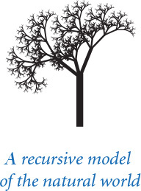
One important reason to embrace recursion is that it provides a straightforward way to build simple mathematical models that we can use to prove important facts about our programs. The proof technique that we use to do so is known as mathematical induction. Generally, we avoid going into the details of mathematical proofs in this book, but you will see in this section that it is worthwhile to understand that point of view and to make the effort to convince yourself that recursive programs have the intended effect.
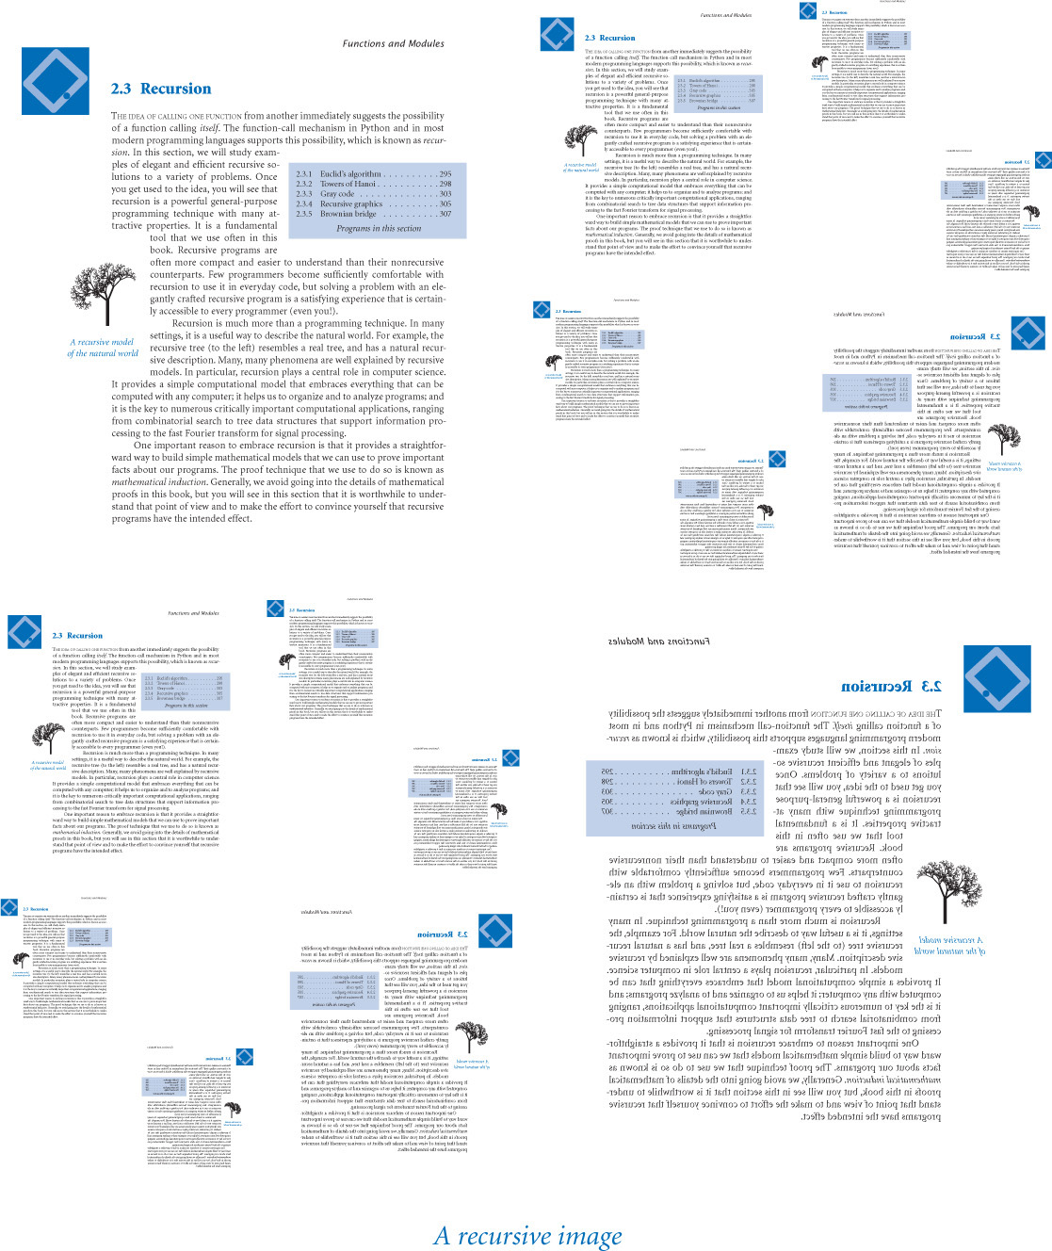

Your first recursive program
The “Hello, World” for recursion (the first recursive program that most programmers implement) is the factorial function, defined for positive integers n by the equation
n ! = n × (n–1) × (n–2) × ... × 2 × 1
In other words, n! is the product of the positive integers less than or equal to n. Now, n! is easy to compute with a for loop, but an even easier approach is to use the following recursive function:
def factorial(n)
if n == 1: return 1
return n * factorial(n-1)
This function calls itself to produce the desired effect. You can persuade yourself that it does so by noting that factorial() returns 1 = 1! when n is 1 and that if it properly computes the value
(n–1) ! = (n–1) × (n–2) × ... × 2 × 1
then it properly computes the value
n ! = n × (n–1)!
= n × (n–1) × (n–2) × ... × 2 × 1
Click here to view code image
1 1
2 2
3 6
4 24
5 120
6 720
7 5040
8 40320
9 362880
10 3628800
11 39916800
12 479001600
13 6227020800
14 87178291200
15 1307674368000
16 20922789888000
17 355687428096000
18 6402373705728000
19 121645100408832000
20 2432902008176640000
Values of n!
To compute factorial(5), the recursive function needs to compute factorial(4); to compute factorial(4), it needs to compute factorial(3); and so forth. This process is repeated until factorial(1), which directly returns the value 1. Then factorial(2) multiplies that return value by 2 and returns 2; factorial(3) multiplies that return value by 3 and returns 6, and so forth. We can trace this computation in precisely the same way that we trace any sequence of function calls. Since we view all of the calls as invoking independent copies of the code, the fact that they are recursive is immaterial.
factorial(5)
factorial(4)
factorial(3)
factorial(2)
factorial(1)
return 1
return 2*1 = 2
return 3*2 = 6
return 4*6 = 24
return 5*24 = 120
Function call trace for factorial()
Our factorial() implementation exhibits the two main components that are required for every recursive function. The base case returns a value without making any subsequent recursive calls. It does this for one or more special arguments for which the function can be evaluated without recursion. For factorial(), the base case is when n is 1. The reduction step is the central part of a recursive function. It relates the function at one (or more) arguments to the function evaluated at one (or more) other arguments. For factorial(), the reduction step is n * factorial(n-1). All recursive functions must have these two components. Furthermore, the sequence of argument values must converge to the base case. For factorial(), the value of n decreases by 1 for each call, so the sequence of argument values converges to the base case.
Tiny functions such as factorial() are slightly clearer if we put the reduction step in an else clause. However, adopting this convention for every recursive function would unnecessarily complicate larger functions because it would involve putting most of the code (for the reduction step) in an indented block after the else. Instead, we adopt the convention of putting the base case as the first statement, ending with a return, and then devoting the rest of the code to the reduction step.
The same technique is effective for defining all sorts of functions. For example, the recursive function
Click here to view code image
def harmonic(n):
if n == 1: return 1.0
return harmonic(n-1) + 1.0/n
is an effective function for computing the harmonic numbers (see PROGRAM 1.3.5) when n is small, based on the following equations:
Hn = 1 + 1/2 + ... + 1/n
= (1 + 1/2 + ... + 1/(n–1)) + 1/n = Hn–1 + 1/n
Indeed, this same approach is effective for computing, with only a few lines of code, the value of any discrete sum for which you have a compact formula. Recursive programs like these are just loops in disguise, but recursion can help us better understand this sort of computation.

Mathematical induction
Recursive programming is directly related to mathematical induction, a technique for proving facts about discrete functions.
Proving that a statement involving an integer n is true for infinitely many values of n by mathematical induction involves the following two steps:
• The base case: prove the statement true for some specific value or values of n (usually 1).
• The induction step (the central part of the proof): assume the statement to be true for all positive integers less than n, then use that fact to prove it true for n.
Such a proof suffices to show that the statement is true for all positive integers n: we can start at the base case, and use our proof to establish that the statement is true for each larger value of n, one by one.
Everyone’s first induction proof is to demonstrate that the sum of the positive integers less than or equal to n is given by the formula n (n+1)/ 2. That is, we wish to prove that the following equation is valid for all n ≥ 1:
1 + 2 + 3 ... + (n–1) + n = n (n+1) /2
The equation is certainly true for n = 1 (base case) because 1 = 1. If we assume it to be true for all integers less than n, then, in particular, it is true for n–1, so
1 + 2 + 3 ... + (n–1) = (n–1) n/2
and we can add n to both sides of this equation and simplify to get the desired equation (induction step).
Every time we compose a recursive function, we need mathematical induction to be convinced that the function has the desired effect. The correspondence between induction and recursion is self-evident. The difference in nomenclature indicates a difference in outlook: in a recursive function, our outlook is to get a computation done by reducing to a smaller problem, so we use the term reduction step; in an induction proof, our outlook is to establish the truth of the statement for larger problems, so we use the term induction step.
When we compose recursive functions, we usually do not write down a full formal proof that they produce the desired result, but we always depend on the existence of such a proof. We do often appeal to an informal induction proof to convince ourselves that a recursive function operates as expected. For example, we just discussed an informal proof that factorial(n) computes the product of the positive integers less than or equal to n.
Program 2.3.1 Euclid’s algorithm (euclid.py)
Click here to view code image
import sys
import stdio
def gcd(p, q):
if q == 0: return p
return gcd(q, p % q)
def main():
p = int(sys.argv[1])
q = int(sys.argv[2])
stdio.writeln(gcd(p, q))
if __name__ == '__main__': main()
Click here to view code image
% python euclid.py 1440 408
24
% python euclid.py 314159 271828
1
This script takes two positive integers from the command line and computes their greatest common divisor, using a recursive implementation of Euclid’s algorithm.

Euclid’s algorithm
The greatest common divisor (gcd) of two positive integers is the largest integer that divides evenly into both of them. For example, the greatest common divisor of 102 and 68 is 34 since both 102 and 68 are multiples of 34, but no integer larger than 34 divides evenly into 102 and 68. You may recall learning about the greatest common divisor when you learned to reduce fractions. For example, we can simplify 68/102 to 2/3 by dividing both numerator and denominator by 34, their gcd. Finding the gcd of huge integers is an important problem that arises in many commercial applications, including the famous RSA cryptosystem.
We can efficiently compute the gcd using the following property, which holds for positive integers p and q:
If p > q, the gcd of p and q is the same as the gcd of q and p % q.
To convince yourself of this fact, first note that the gcd of p and q is the same as the gcd of q and p–q, because a number divides both p and q if and only if it divides both q and p–q. By the same argument, q and p–2q, q and p–3q, and so forth have the same gcd, and one way to compute p % q is to subtract q from p until we get a number less than q.
The function gcd() in euclid.py (PROGRAM 2.3.1) is a compact recursive function whose reduction step is based on this property. The base case is when q is 0, with gcd(p, 0) = p. To see that the reduction step converges to the base case, observe that the value of the second argument strictly decreases in each recursive call since p % q < q. If p < q, then the first recursive call switches the two arguments. In fact, the value of the second argument decreases by at least a factor of 2 for every second recursive call, so the sequence of argument values quickly converges to the base case (see EXERCISE 2.3.13). This recursive solution to the problem of computing the greatest common divisor is known as Euclid’s algorithm and is one of the oldest known algorithms—it is over 2,000 years old.
gcd(1440, 408)
gcd(408, 216)
gcd(216, 24)
gcd(192, 24)
gcd(24, 0)
return 24
return 24
return 24
return 24
return 24
Function call trace for gcd()

Towers of Hanoi
No discussion of recursion would be complete without the famous towers of Hanoi problem. In this problem, we have three poles and n discs that fit onto the poles. The discs differ in size and are initially stacked on one of the poles, in order from largest (disc n) at the bottom to smallest (disc 1) at the top. The task is to move all n discs to another pole, while obeying the following rules:
• Move only one disc at a time.
• Never place a larger disc on a smaller one.
One legend says that the world will end when a certain group of monks accomplishes this task in a temple with 64 golden discs on three diamond needles. But how can the monks accomplish the task at all, playing by the rules?
To solve the problem, our goal is to issue a sequence of instructions for moving the discs. We assume that the poles are arranged in a row, and that each instruction to move a disc specifies its number and whether to move it left or right. If a disc is on the left pole, an instruction to move left means to wrap to the right pole; if a disc is on the right pole, an instruction to move right means to wrap to the left pole. When the discs are all on one pole, there are two possible moves (move the smallest disc left or right); otherwise, there are three possible moves (move the smallest disc left or right, or make the one legal move involving the other two poles). Choosing among these possibilities on each move to achieve the goal is a challenge that requires a plan. Recursion provides just the plan that we need, based on the following idea: first we move the top n–1 discs to an empty pole, then we move the largest disc to the other empty pole (where it does not interfere with the smaller ones), and then we complete the job by moving the n–1 discs onto the largest disc. To simplify the instructions, we move discs either left or right, with wraparound: moving left from the leftmost pole means to move to the rightmost pole and moving right from the rightmost pole means move to the leftmost pole.
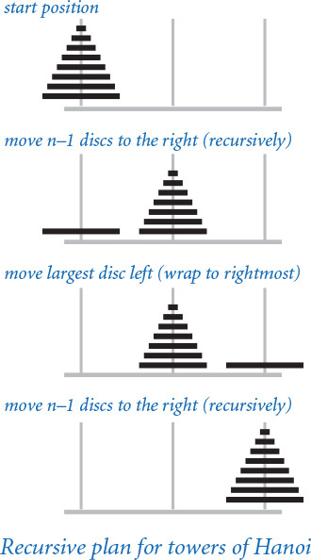
PROGRAM 2.3.2 (towersofhanoi.py) is a direct implementation of this strategy. It reads in a command-line argument n and writes the solution to the towers of Hanoi problem on n discs. The recursive function moves() writes the sequence of moves to move the stack of discs to the left (if the argument left is True) or to the right (if left is False), with wraparound. It does so exactly according to the plan just described.

Function-call trees
To better understand the behavior of modular programs that have multiple recursive calls (such as towersofhanoi.py), we use a visual representation known as a function-call tree. Specifically, we represent each function call as a tree node, depicted as a circle labeled with the values of the arguments for that call. Below each tree node, we draw the tree nodes corresponding to each call in that use of the function (in order from left to right) and lines connecting to them. This diagram contains all the information we need to understand the behavior of the program. It contains a tree node for each function call.
We can use function-call trees to understand the behavior of any modular program, but they are particularly useful in exposing the behavior of recursive programs. For example, the tree corresponding to a call to move() in towersofhanoi.py is easy to construct. Start by drawing a tree node labeled with the values of the command-line arguments. The first argument is the number of discs in the pile to be moved (and the label of the disc to actually be moved); the second is the direction to move the pile. For clarity, we depict the direction (a boolean value) as an arrow that points left or right, since that is our interpretation of the value—the direction to move the disc. Then draw two tree nodes below with the number of discs decremented by 1 and the direction switched, and continue doing so until only nodes with labels corresponding to a first argument value 1 have no nodes below them. These nodes correspond to calls on moves() that do not lead to further recursive calls.
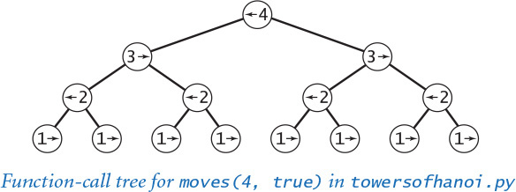
Program 2.3.2 Towers of Hanoi (towersofhanoi.py)
Click here to view code image
import sys
import stdio
def moves(n, left):
if n == 0: return
moves(n-1, not left)
if left:
stdio.writeln(str(n) + ' left')
else:
stdio.writeln(str(n) + ' right')
moves(n-1, not left)
n = int(sys.argv[1])
moves(n, True)
n | number of discs
left | direction to move pile
This script writes the instructions for the towers of Hanoi problem. The recursive function moves() writes the moves needed to move n discs to the left (if left is True) or to the right (if left is False).
% python towersofhanoi.py 1
1 left
% python towersofhanoi.py 2
1 right
2 left
1 right
% python towersofhanoi.py 3
1 left
2 right
1 left
3 left
1 left
2 right
1 left
% python towersofhanoi.py 4
1 right
2 left
1 right
3 right
1 right
2 left
1 right
4 left
1 right
2 left
1 right
3 right
1 right
2 left
1 right
Take a moment to study the function-call tree depicted earlier in this section and to compare it with the corresponding function-call trace depicted at right. When you do so, you will see that the function-call tree is just a compact representation of the trace. In particular, reading the node labels from left to right gives the moves needed to solve the problem.
Moreover, when you study the tree, you may notice several patterns, including the following two:
• Alternate moves involve the smallest disc.
• That disc always moves in the same direction.
These observations are relevant because they give a solution to the problem that does not require recursion (or even a computer): every other move involves the smallest disc (including the first and last), and each intervening move is the only legal move at the time not involving the smallest disc. We can prove that this strategy produces the same outcome as the recursive program, using induction. Having started centuries ago without the benefit of a computer, perhaps our monks are using this strategy.
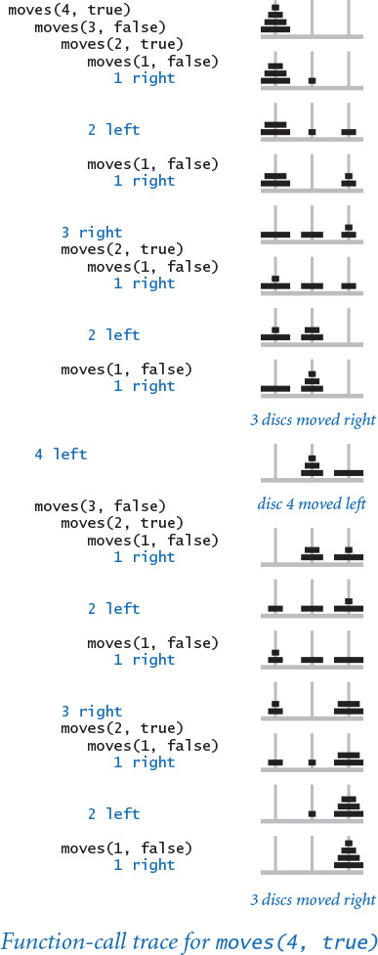
Trees are relevant and important in understanding recursion because the tree is the quintessential recursive object. As an abstract mathematical model, trees play an essential role in many applications, and in CHAPTER 4, we will consider the use of trees as a computational model to structure data for efficient processing.

Exponential time
One advantage of using recursion is that often we can develop mathematical models that allow us to prove important facts about the behavior of recursive programs. For the towers of Hanoi, we can estimate the amount of time until the end of the world (assuming that the legend is true). This exercise is important not just because it tells us that the end of the world is quite far off (even if the legend is true), but also because it provides insight that can help us avoid composing programs that will not finish until then.
For the towers of Hanoi problem, the mathematical model is simple: if we define the function T(n) to be the number of move directives issued by towersofhanoi.py to move n discs from one pole to another, then the recursive code immediately implies that T(n) must satisfy the following equation:
T(n) = 2 T(n–1) + 1 for n > 1, with T(1) = 1
Such an equation is known in discrete mathematics as a recurrence relation. Recurrence relations naturally arise in the study of recursive programs. We can often use them to derive a closed-form expression for the quantity of interest. For T(n), you may have already guessed from the initial values T(1) = 1, T(2) = 3, T(3) = 7, and T(4) = 15 that T(n) = 2n – 1. The recurrence relation provides a way to prove this to be true, by mathematical induction:
• Base case: T(1) = 2n – 1 = 1
• Induction step: if T(n–1)= 2n–1 – 1, T(n) = 2 (2n–1 – 1) + 1 = 2n – 1
Therefore, by induction, T(n) = 2n – 1 for all n > 0. The minimum possible number of moves also satisfies the same recurrence (see EXERCISE 2.3.11).
Knowing the value of T(n), we can estimate the amount of time required to perform all the moves. If the monks move discs at the rate of one per second, it would take more than one week for them to finish a 20-disc problem, more than 34 years to finish a 30-disc problem, and more than 348 centuries for them to finish a 40-disc problem (assuming that they do not make a mistake). The 64-disc problem would take more than 5.8 billion centuries. The end of the world is likely to be even further off than that because those monks presumably never have had the benefit of using PROGRAM 2.3.2, and might not be able to move the discs so rapidly or to figure out so quickly which disc to move next.
Even computers are no match for exponential growth. A computer that can do a billion operations per second will still take centuries to do 264 operations, and no computer will ever do 21,000 operations, say. The lesson is profound: with recursion, you can easily compose simple short programs that take exponential time, but they simply will not run to completion when you try to run them for large n. Novices are often skeptical of this basic fact, so it is worth your while to pause now to think about it. To convince yourself that it is true, take calls on stdio.writeln() out of towersofhanoi.py and run it for increasing values of n starting at 20. You can easily verify that each time you increase the value of n by 1, the running time doubles, and you will quickly lose patience waiting for it to finish. If you wait for an hour for some value of n, you will wait more than a day for n+5, more than a month for n+10, and more than a century for n+20 (no one has that much patience). Your computer is just not fast enough to run every short Python program that you compose, no matter how simple the program might seem! Beware of programs that might require exponential time.
We are often interested in predicting the running time of our programs. In SECTION 4.1, we will discuss the use of the same process that we just used to help estimate the running time of other programs.
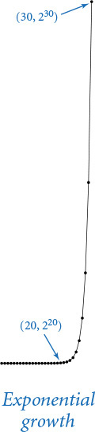

Gray codes
The towers of Hanoi problem is no toy. It is intimately related to basic algorithms for manipulating numbers and discrete objects. As an example, we consider Gray codes, a mathematical abstraction with numerous applications.
The playwright Samuel Beckett, perhaps best known for Waiting for Godot, wrote a play called Quad that had the following property: starting with an empty stage, characters enter and exit one at a time so that each subset of characters on the stage appears exactly once. How did Beckett generate the stage directions for this play?
One way to represent a subset of n discrete objects is to use a string of n bits. For Beckett’s problem, we use a 4-bit string, with bits numbered 1 to n from right to left and a bit value of 1 indicating the character onstage. For example, the string 0 1 0 1 corresponds to the scene with characters 3 and 1 onstage. This representation gives a quick proof of a basic fact: the number of different subsets of n objects is exactly 2n. Quad has four characters, so there are 24 = 16 different scenes. Our task is to generate the stage directions.
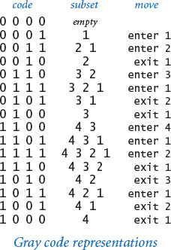
An n-bit Gray code is a list of the 2n different n-bit binary numbers such that each entry in the list differs in precisely one bit from its predecessor. Gray codes directly apply to Beckett’s problem because changing the value of a bit from 0 to 1 corresponds to a character entering the subset onstage; changing a bit from 1 to 0 corresponds to a character exiting the subset.
How do we generate a Gray code? A recursive plan that is very similar to the one that we used for the towers of Hanoi problem is effective. The n-bit binary-reflected Gray code is defined recursively as follows:
• The (n–1) bit code, with 0 prepended to each codeword, followed by
• The (n–1) bit code in reverse order, with 1 prepended to each codeword
The 0-bit code is defined to be null, so the 1-bit code is 0 followed by 1. From this recursive definition, we can verify by induction that the n-bit binary reflected Gray code has the required property: adjacent codewords differ in one bit position. It is true by the inductive hypothesis, except possibly for the last codeword in the first half and the first codeword in the second half: this pair differs only in their first bit.
The recursive definition leads, after some careful thought, to the implementation in beckett.py (PROGRAM 2.3.3) for writing Beckett’s stage directions. This program is remarkably similar to towersofhanoi.py. Indeed, except for nomenclature, the only difference is in the values of the second arguments in the recursive calls!
As with the directions of the disc moves in towersofhanoi.py, the enter and exit directions are redundant in beckett.py, since exit is issued only when an actor is onstage, and enter is issued only when an actor is not onstage. Indeed, both beckett.py and towersofhanoi.py directly involve the ruler function that we considered in one of our first programs, ruler.py (PROGRAM 1.2.1). Without the redundant instructions, they both implement a simple recursive function that could be used to write the values of the ruler function for any value given as a command-line argument.
Gray codes have many applications, ranging from analog-to-digital converters to experimental design. They have been used in pulse code communication, the minimization of logic circuits, and hypercube architectures, and were even proposed to organize books on library shelves.
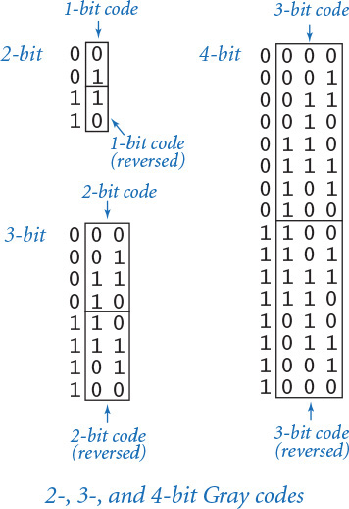
Program 2.3.3 Gray code (beckett.py)
Click here to view code image
import sys
import stdio
def moves(n, enter):
if n == 0: return
moves(n-1, True)
if enter:
stdio.writeln('enter ' + str(n))
else:
stdio.writeln('exit ' + str(n))
moves(n-1, False)
n = int(sys.argv[1])
moves(n, True)
n | number of characters
enter | stage direction
This script reads an integer n from the command line and uses a recursive function to write Beckett’s stage instructions (the bit positions that change in a binary-reflected Gray code) for an n-character play. The bit position that changes is precisely described by the ruler function, and (of course) each character alternately enters and exits.
% python beckett.py 1
enter 1
% python beckett.py 2
enter 1
enter 2
exit 1
% python beckett.py 3
enter 1
enter 2
exit 1
enter 3
enter 1
exit 2
exit 1
% python beckett.py 4
enter 1
enter 2
exit 1
enter 3
enter 1
exit 2
exit 1
enter 4
enter 1
enter 2
exit 1
enter 3
enter 1
exit 2
exit 1

Recursive graphics
Simple recursive drawing schemes can lead to pictures that are remarkably intricate. Recursive drawings not only relate to numerous applications, but also provide an appealing platform for developing a better understanding of properties of recursive programs, because we can watch the process of a recursive figure taking shape.
As a first simple example, we define an H-tree of order n, as follows: The base case is to draw nothing for n = 0. The reduction step is to draw, within the unit square
• Three lines in the shape of the letter H
• Four H-trees of order n–1, one connected to each tip of the H
with the additional provisos that the H-trees of order n–1 are halved in size and centered on the four tips of the square. PROGRAM 2.3.4 (htree.py) takes a command-line argument n, and draws an H-tree of order n.
Drawings like these have many practical applications. For example, consider a cable company that needs to run cable to all of the homes distributed throughout its region. A reasonable strategy is to use an H-tree to get the signal to a suitable number of centers distributed throughout the region, then run cables connecting each home to the nearest center. The same problem is faced by computer designers who want to distribute power or signal throughout an integrated circuit chip.
H-trees exhibit exponential growth. An H-tree of order n connects 4n centers, so you would be trying to plot more than 1 million lines with n = 10 and more than 1 billion with n = 15. The program will certainly not finish the drawing with n = 30.
EXERCISE 2.3.14 asks you to modify htree.py to animate the drawing of the H-tree. If you run the resulting program on your computer for a drawing that takes a minute or so to complete, you will, just by watching the drawing progress, have the opportunity to gain substantial insight into the nature of recursive functions, because you can see the order in which the H figures appear and how they form into H-trees. An even more instructive exercise, which derives from the fact that the same drawing results no matter in which order the recursive draw() calls and the stddraw.line() calls appear, is to observe the effect of rearranging the order of these calls on the order in which the lines appear in the emerging drawing (see EXERCISE 2.3.14).
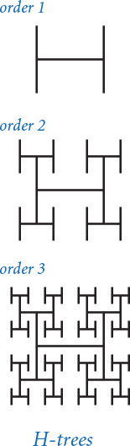
Program 2.3.4 Recursive graphics (htree.py)
Click here to view code image
import sys
import stddraw
def draw(n, size, x, y):
if n == 0: return
x0 = x - size/2.0
x1 = x + size/2.0
y0 = y - size/2.0
y1 = y + size/2.0
stddraw.line(x0, y, x1, y)
stddraw.line(x0, y0, x0, y1)
stddraw.line(x1, y0, x1, y1)
draw(n-1, size/2.0, x0, y0)
draw(n-1, size/2.0, x0, y1)
draw(n-1, size/2.0, x1, y0)
draw(n-1, size/2.0, x1, y1)
n = int(sys.argv[1])
stddraw.setPenRadius(0.0)
draw(n, 0.5, 0.5, 0.5)
stddraw.show()
n | depth
size | line length
x, y | center
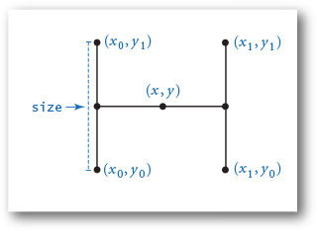
This script accepts a command-line argument n and uses a recursive function to draw an H-tree of order n: it draws three lines in the shape of the letter H that connect the center (x, y) of the square with the centers of the four tips, then calls itself for each of the tips. The integer argument controls the depth of the recursion and the float argument is the size of the initial H.
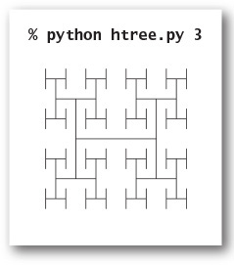
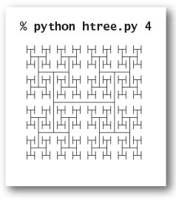
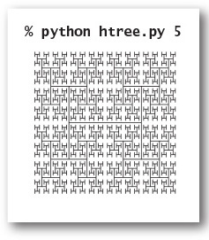

Brownian bridge
An H-tree is a simple example of a fractal: a geometric shape that can be divided into parts, each of which is (approximately) a reduced-size copy of the original. Fractals are easy to produce with recursive functions, although scientists, mathematicians, and programmers study them from many different points of view. We have already encountered fractals several times in this book—for example, ifs.py (PROGRAM 2.2.4).
The study of fractals plays an important and lasting role in artistic expression, economic analysis, and scientific discovery. Artists and scientists use them to build compact models of complex shapes that arise in nature and resist description using conventional geometry, such as clouds, plants, mountains, riverbeds, human skin, and many others. Economists also use fractals to model function graphs of economic indicators.
Fractional Brownian motion is a mathematical model for creating realistic fractal models for many naturally rugged shapes. It is used in computational finance and in the study of many natural phenomena, including ocean flows and nerve membranes. Computing the exact fractals specified by the model can be a difficult challenge, but it is not difficult to compute approximations with recursive functions. We consider one simple example here; you can find much more information about the model on the booksite.
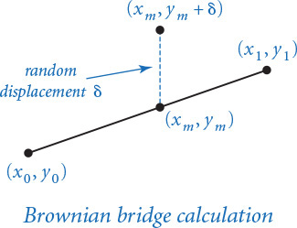
PROGRAM 2.3.5 (brownian.py) plots a function graph that approximates a simple example of fractional Brownian motion known as a Brownian bridge and closely related functions. You can think of this graph as a random walk that connects two points, from (x0, y0) to (x1, y1), controlled by a few parameters. The implementation is based on the midpoint displacement method, which is a recursive plan for drawing the plot within the interval [x0, x1]. The base case is to draw a straight line connecting the two endpoints. The reduction case is to divide the interval into two halves, proceeding as follows:
• Compute the midpoint (xm, ym) of the interval.
• Add to the y-coordinate ym of the midpoint a random value δ, drawn from the Gaussian distribution with mean 0 and a given variance.
• Recur on the subintervals, dividing the variance by a given scaling factor β.
The shape of the curve is controlled by two parameters: the volatility (the initial value of the variance) controls the distance the graph strays from the straight line connecting the points, and the Hurst exponent controls the smoothness of the curve. We denote the Hurst exponent by H and divide the variance by β = 22H at each recursive level. When H is 1/2 (divide by 2 at each level), the curve is a Brownian bridge: a continuous version of the gambler’s ruin problem (see PROGRAM 1.3.8). When 0 < H < 1/2, the displacements tend to increase, resulting in a rougher curve; and when 1/2 < H < 2, the displacements tend to decrease, resulting in a smoother curve. The value 2 –H is known as the fractal dimension of the curve.
Program 2.3.5 Brownian bridge (brownian.py)
Click here to view code image
import math
import sys
import stddraw
import stdrandom
def curve(x0, y0, x1, y1, var, beta, n=7):
if n == 0:
stddraw.line(x0, y0, x1, y1)
return
xm = (x0 + x1) / 2.0
ym = (y0 + y1) / 2.0
delta = stdrandom.gaussian(0.0, math.sqrt(var))
curve(x0, y0, xm, ym+delta, var/beta, beta, n-1)
curve(xm, ym+delta, x1, y1, var/beta, beta, n-1)
hurstExponent = float(sys.argv[1])
stddraw.setPenRadius(0.0)
beta = 2.0 ** (2.0 * hurstExponent)
curve(0.0, 0.5, 1.0, 0.5, 0.01, beta)
stddraw.show()
n | recursion depth
x0, y0 | left endpoint
x1, y1 | right endpoint
xm, ym | middle
delta | displacement
var | variance
beta | smoothness
This script draws a Brownian bridge across the middle of the window, by adding a small random number (drawn from the Gaussian distribution) to a recursive function that would otherwise plot a straight line. The command-line argument, known as the Hurst exponent, controls the smoothness of the curves—the recursive function uses it to compute a factor beta that adjusts the variance of the Gaussian distribution.
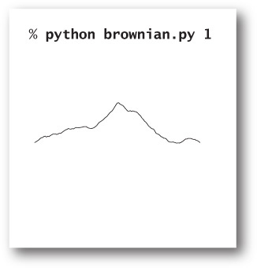
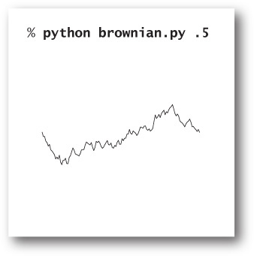
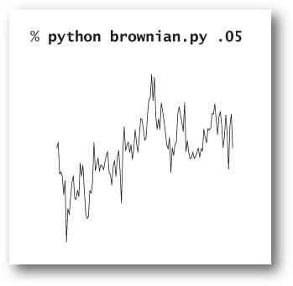
The volatility and initial endpoints of the interval have to do with scale and positioning. The global code in brownian.py allows you to experiment with the smoothness parameter H. With values larger than 1/2, you get plots that look something like the horizon in a mountainous landscape; with values smaller than 1/2, you get plots similar to those you might see for the value of a stock index.
Extending the midpoint displacement method to two dimensions produces fractals known as plasma clouds. To draw a rectangular plasma cloud, we use a recursive plan where the base case is to draw a rectangle of a given color and the reduction step is to draw a plasma cloud in each quadrant with colors that are perturbed from the average with a random number drawn from the Gaussian distribution. Using the same volatility and smoothness controls as in brownian.py, we can produce synthetic clouds that are remarkably realistic. We can use the same code to produce synthetic terrain, by interpreting the color value as the altitude. Variants of this scheme are widely used in the entertainment industry to generate background scenery for movies and computer games.
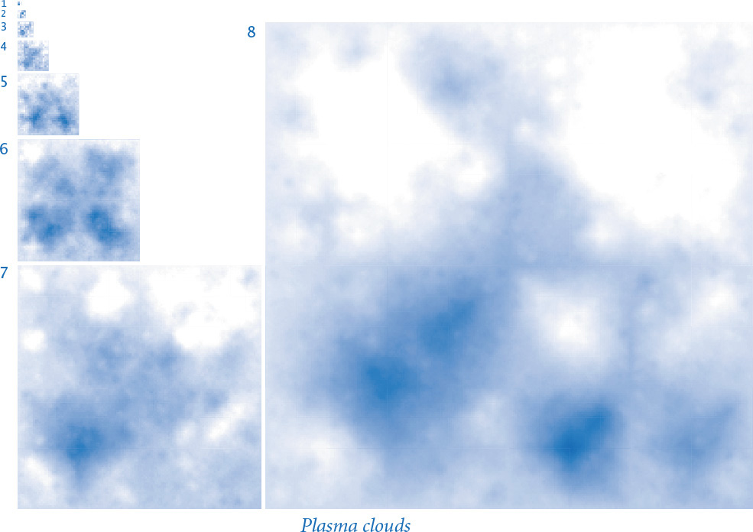

Pitfalls of recursion
By now, you are perhaps persuaded that recursion can help you compose compact and elegant programs. As you begin to craft your own recursive programs, you need to be aware of several common pitfalls that can arise. We have already discussed one of them in some detail (the running time of your program might grow exponentially). Once identified, these problems are generally not difficult to overcome, but you must be very careful to avoid them when composing recursive functions.

Missing base case
Consider the following recursive function, which is supposed to compute harmonic numbers, but is missing a base case:
Click here to view code image
def harmonic(n):
return harmonic(n-1) + 1.0/n
If you run a client that calls this function, it will repeatedly call itself and never return, so your program will never terminate. You probably already have encountered infinite loops, where you run your program and nothing happens (or perhaps you get an unending sequence of lines of output). With infinite recursion, however, the result is different because the system keeps track of each recursive call (using a mechanism that we will discuss in SECTION 4.3, based on a data structure known as a stack) and eventually runs out of memory trying to do so. Eventually, Python raises a RuntimeError and reports maximum recursion depth exceeded. When you run a recursive program, you should always try to convince yourself that it has the desired effect by making an informal argument based on mathematical induction. Doing so might uncover a missing base case.

No guarantee of convergence
Another common problem is to include within a recursive function a recursive call to solve a subproblem that is not smaller than the original problem. For example, the following function goes into an infinite recursive loop for any value of its argument n except 1:
Click here to view code image
def harmonic(n):
if n = 1: return 1.0
return harmonic(n) + 1.0/n
Bugs like this one are easy to spot, but subtle versions of the same problem can be harder to identify.

Excessive memory requirements
If a function calls itself recursively an excessive number of times before returning, the memory required by Python to keep track of the recursive calls may be prohibitive, resulting in a “maximum depth exceeded” run-time error. To get an idea of how much memory is involved, run a small set of experiments using this recursive function for computing the harmonic numbers for increasing values of n (say, by starting at 1,000 and increasing by factors of 10):
Click here to view code image
def harmonic(n):
if n == 1: return 1.0
return harmonic(n-1) + 1.0/n
The point at which you get the “maximum recursion depth exceeded” run-time error will give you some idea of how much memory Python uses to implement recursion. By contrast, you can run PROGRAM 1.3.5 to compute Hn for huge n using only a tiny bit of space.

Excessive recomputation
The temptation to compose a simple recursive function to solve a problem must always be tempered by the understanding that a simple function might take exponential time (unnecessarily) due to excessive recomputation. This effect is possible even in the simplest recursive functions, and you certainly need to learn to avoid it. For example, the Fibonacci sequence
0, 1, 1, 2, 3, 5, 8, 13, 21, 34, 55, 89, 144, 233, 377, ...
is defined by the recurrence Fn = Fn–1 + Fn–2 for n ≥ 2 with F0 = 0 and F1 = 1. The Fibonacci sequence has many interesting properties and arises in numerous applications. A novice programmer might implement this recursive function to compute numbers in the Fibonacci sequence:
Click here to view code image
def fib(n):
if n == 0: return 0
if n == 1: return 1
return fib(n-1) + fib(n-2)
This function is spectacularly inefficient—do not use it! Novice programmers often refuse to believe this fact, and run code like this expecting that the computer is certainly fast enough to crank out an answer. Go ahead; see if your computer is fast enough to compute fib(50). To see why it is futile to do so, consider what the function does to compute fib(7) = 13. It first computes fib(6) = 8 and fib(5) = 5. To compute fib(6), it recursively computes fib(5) = 5 again and fib(4) = 3. Things rapidly get worse because both times it computes fib(5), it ignores the fact that it already computed fib(4), and so forth. In fact, you can prove by induction that the number of times this program computes fib(1) when computing fib(n) is precisely Fn (see EXERCISE 2.3.12). The mistake of recomputation is compounded exponentially. As an example, to compute fib(200), the number of times the naive recursive function needs to compute fib(1) is F200 > 1043! No imaginable computer will ever be able to do this many calculations. Beware of programs that might require exponential time. Many calculations that arise and find natural expression as recursive functions fall into this category. Do not fall into the trap of implementing and trying to run them.
The following is one caveat: a systematic technique known as memoization allows us to avoid this pitfall while still taking advantage of the compact recursive description of a computation. In memoization, we maintain an array that keeps track of the values we have computed so that we can return those values and make recursive calls only for new values. This technique is a form of dynamic programming, a well-studied technique for organizing computations that you will learn if you take courses in algorithms or in operations research.
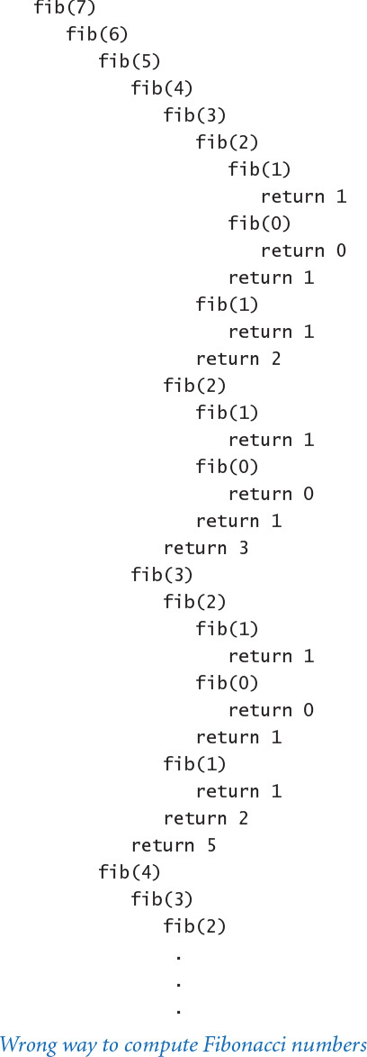

Perspective
Programmers who do not use recursion are missing two opportunities. First, recursion leads to compact solutions to complex problems. Second, recursive solutions embody an argument that the program operates as anticipated. In the early days of computing, the overhead associated with recursive functions was prohibitive in some systems, and many people avoided recursion. In modern systems like Python, recursion is often the method of choice.
If you are intrigued by the mystery of how Python manages to implement the illusion of independently operating copies of the same piece of code, be assured that we will consider this issue in CHAPTER 4. You may be surprised at the simplicity of the solution. It is so easy to implement that programmers were using recursion well before the advent of high-level programming languages like Python. Indeed, you might be surprised to learn that you could compose programs equivalent to the ones considered in this chapter with just the basic loops, conditionals, and arrays programming model discussed in CHAPTER 1.
Recursion has reinforced for us the idea of proving that a program operates as intended. The natural connection between recursion and mathematical induction is essential. For everyday programming, our interest in correctness is to save time and energy tracking down bugs. In modern applications, security and privacy concerns make correctness an essential part of programming. If the programmer cannot be convinced that an application works as intended, how can a user who wants to keep personal data private and secure be so convinced?
Recursive functions truly illustrate the power of a carefully articulated abstraction. While the concept of a function having the ability to call itself seems absurd to many people at first, the many examples that we have considered are certainly evidence that mastering recursion is essential to understanding and exploiting computation and in understanding the role of computational models in studying natural phenomena.
Recursion is the last piece in a programming model that served to build much of the computational infrastructure that was developed as computers emerged to take a central role in daily life in the latter part of the 20th century. Programs built from modules of functions consisting of statements that operate on built-in types of data, conditionals, loops, and function calls (including recursive ones) can solve important applications of all sorts. In the next section, we emphasize this point and review these concepts in the context of a large application. In CHAPTER 3 and CHAPTER 4, we will examine extensions to these basic ideas that embrace the more expansive style of programming that now dominates the computing landscape.

Q&A
Q. Are there situations when iteration is the only option available to address a problem?
A. No, any loop can be replaced by a recursive function, though the recursive version might require excessive memory.
Q. Are there situations when recursion is the only option available to address a problem?
A. No, any recursive function can be replaced by an iterative counterpart. In SECTION 4.3, we will see how compilers produce code for function calls by using a data structure called a stack.
Q. Which should I prefer, recursion or iteration?
A. Whichever leads to the simpler, more easily understood, or more efficient code.
Q. I get the concern about excessive space and excessive recomputation in recursive code. Anything else to be concerned about?
A. Be extremely wary of creating arrays in recursive code. The amount of space used can pile up very quickly, as can the amount of time required for memory management.

Exercises
2.3.1 What happens if you call factorial() with a negative value of n? With a large value, say, 35?
2.3.2 Write a recursive function that computes the value of ln(n !)
2.3.3 Give the sequence of integers written by a call to ex233(6):
def ex233(n):
if n <= 0: return
stdio.writeln(n)
ex233(n-2)
ex233(n-3)
stdio.writeln(n)
2.3.4 Give the value of ex234(6):
Click here to view code image
def ex234(n):
if n <= 0: return ''
return ex234(n-3) + str(n) + ex234(n-2) + str(n)
2.3.5 Criticize the following recursive function:
Click here to view code image
def ex235(n):
s = ex233(n-3) + str(n) + ex235(n-2) + str(n)
if n <= 0: return ''
return s
Solution: The base case will never be reached. A call to ex235(3) will result in calls to ex235(0), ex235(-3), ex235(-6), and so forth until the “maximum depth exceeded” run-time error occurs.
2.3.6 Given four positive integers a, b, c, and d, explain the value computed by gcd(gcd(a, b), gcd(c, d)).
2.3.7 Explain in terms of integers and divisors the effect of the following Euclid-like function:
def gcdlike(p, q):
if q == 0: return p == 1
return gcdlike(q, p % q)
2.3.8 Consider the following recursive function:
Click here to view code image
def mystery(a, b):
if b == 0:
return 0
if b % 2 == 0:
return mystery(a+a, b/2)
return mystery(a+a, b/2) + a
What are the values of mystery(2, 25) and mystery(3, 11)? Given positive integers a and b, describe the value that mystery(a, b) computes. Answer the same question, but replace + with * and return 0 with return 1.
2.3.9 Write a recursive program rules.py to plot the subdivisions of a ruler using stddraw (see PROGRAM 1.2.1).
2.3.10 Solve the following recurrence relations, all with T(1) = 1. Assume n is a power of 2.
• T(n) = T(n/2) + 1
• T(n) = 2T(n/2) + 1
• T(n) = 2T(n/2) + n
• T(n) = 4T(n/2) + 3
2.3.11 Prove by induction that the minimum possible number of moves needed to solve the towers of Hanoi problem satisfies the same recurrence as the number of moves used by our recursive solution.
2.3.12 Prove by induction that the recursive program given in the text makes exactly Fn recursive calls to fib(1) when computing fib(n).
2.3.13 Prove that the second argument to gcd() decreases by at least a factor of 2 for every second recursive call, and then prove that gcd(p, q) uses at most 2 log2 n + 1 recursive calls where n is the larger of p and q.
2.3.14 Modify htree.py (PROGRAM 2.3.4) to animate the drawing of the H-tree:
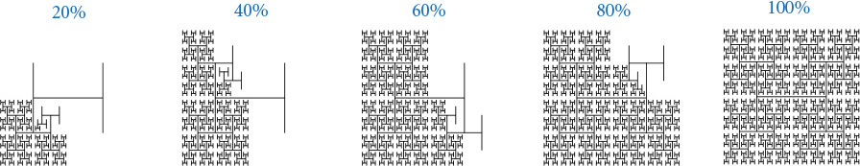
Next, rearrange the order of the recursive calls (and the base case), view the resulting animation, and explain each outcome.

Creative Exercises
2.3.15 Binary representation. Compose a program that takes a positive integer n (in decimal) from the command line and writes its binary representation. Recall that in binary.py (PROGRAM 1.3.7, we used the method of subtracting out powers of 2. Instead, use the following simpler method: repeatedly divide 2 into n and read the remainders backward. First, compose a while loop to carry out this computation and write the bits in the wrong order. Then, use recursion to write the bits in the correct order.
2.3.16 A4 paper. The width-to-height ratio of paper in the ISO format is the square root of 2 to 1. Format A0 has an area of 1 square meter. Format A1 is A0 cut with a vertical line into two equal halves, A2 is A1 cut with a horizontal line into in two halves, and so on. Compose a program that takes a command-line integer n and uses stddraw to show how to cut a sheet of A0 paper into 2n pieces.
2.3.17 Permutations. Compose a program permutations.py that takes a command-line argument n and writes all n ! permutations of the n letters starting at a (assuming that n is no greater than 26). A permutation of n elements is one of the n ! possible orderings of the elements. As an example, when n = 3 you should get the following output. Do not worry about in which order you write the permutations.
bca cba cab acb bac abc
2.3.18 Permutations of size k. Modify your solution to the previous exercise so that it takes two command-line arguments n and k, and writes all of the permutations that contain exactly k of the n elements. The number of such permutations is P(n, k) = n ! / (n–k)!. Below is the desired output when k = 2 and n = 4. Do not worry about in which order you enumerate the permutations.
Click here to view code image
ab ac ad ba bc bd ca cb cd da db dc
2.3.19 Combinations. Compose a program combinations.py that takes one command-line argument n and writes all 2n combinations of any size. A combination is a subset of the n elements, independent of order. As an example, when n = 3 you should get the following output:
a ab abc ac b bc c
Note that your program needs to write the empty string (subset of size 0).
2.3.20 Combinations of size k. Modify your solution to the previous exercise so that it takes two command-line arguments n and k and writes all of the combinations of size k. The number of such combinations is C(n, k) = n ! / (k !(n–k)!). For example, when n = 5 and k = 3, you should get the following output:
Click here to view code image
abc abd abe acd ace ade bcd bce bde cde
2.3.21 Hamming distance. The Hamming distance between two bit strings of length n is equal to the number of bits in which the two strings differ. Compose a program that takes an integer k and a bitstring s from the command line and writes all bitstrings that have Hamming distance at most k from s. For example, if k is 2 and s is 0000, then your program should write
0011 0101 0110 1001 1010 1100
Hint: Choose k of the n bits in s to flip.
2.3.22 Recursive squares. Compose programs to produce each of the following recursive patterns. The ratio of the sizes of the squares is 2.2:1. To draw a shaded square, draw a filled gray square, then an unfilled black square.
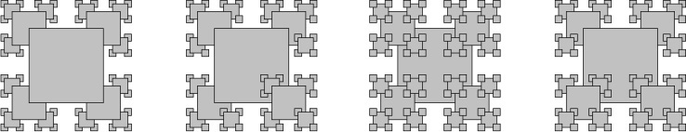
2.3.23 Pancake flipping. You have a stack of n pancakes of varying sizes on a griddle. Your goal is to rearrange the stack in descending order so that the largest pancake is on the bottom and the smallest one is on top. You are only permitted to flip the top k pancakes, thereby reversing their order. Devise a recursive scheme to arrange the pancakes in the proper order that uses at most 2n – 3 flips.
2.3.24 Gray code. Modify beckett.py (PROGRAM 2.3.3) to write the Gray code (not just the sequence of bit positions that change).
2.3.25 Towers of Hanoi variant. Consider the following variant of the towers of Hanoi problem. There are 2n discs of increasing size stored on three poles. Initially all of the discs with odd size (1, 3, ..., 2n-1) are piled on the left pole from top to bottom in increasing order of size; all of the discs with even size (2, 4, ..., 2n) are piled on the right pole. Compose a program to provide instructions for moving the odd discs to the right pole and the even discs to the left pole, obeying the same rules as for towers of Hanoi.
2.3.26 Animated towers of Hanoi. Use stddraw to animate a solution to the towers of Hanoi problem, moving the discs at a rate of approximately 1 per second.
2.3.27 Sierpinski triangles. Compose a recursive program to draw Sierpinski triangles (see PROGRAM 2.2.4). As with htree.py, use a command-line argument to control the depth of the recursion.
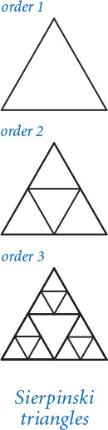
2.3.28 Binomial distribution. Estimate the number of recursive calls that would be used by the code
Click here to view code image
def binomial(n, k):
if (n == 0) or (k == 0): return 1.0
if (n < 0) or (k < 0): return 0.0
return (binomial(n-1, k) + binomial(n-1, k-1)) / 2.0
to compute binomial(100, 50). Develop a better implementation that is based on memoization. Hint: See EXERCISE 1.4.39.
2.3.29 A strange function. Consider McCarthy’s 91 function:
Click here to view code image
def mcCarthy(n):
if n > 100: return n - 10
return mcCarthy(mcCarthy(n+11))
Determine the value of mcCarthy(50) without using a computer. Give the number of recursive calls used by mcCarthy() to compute this result. Either prove that the base case is reached for all positive integers n or give a value of n for which this function goes into an infinite recursive loop.
2.3.30 Collatz function. Consider the following recursive function, which is related to a famous unsolved problem in number theory, known as the Collatz problem, or the 3n+1 problem:
def collatz(n):
stdio.write(str(n) + ' ')
if n == 1: return
if n % 2 == 0:
collatz(n // 2)
else:
collatz(3*n + 1)
For example, a call to collatz(7) writes this sequence of 17 integers
Click here to view code image
7 22 11 34 17 52 26 13 40 20 10 5 16 8 4 2 1
after 17 function calls. Compose a program that takes a command-line argument m and returns the value of n < m for which the number of recursive calls for collatz(n) is maximized. The unsolved problem is that no one knows whether the function terminates for all positive values of n (mathematical induction is no help, because one of the recursive calls is for a larger value of the argument). Develop a better implementation that is based on memoization.
2.3.31 Plasma clouds. Compose a program that uses recursion to draw plasma clouds, using the approach suggested in the text.
2.3.32 Recursive tree. Compose a program tree.py that takes a command-line argument n and produces tree-like recursive patterns like these for n equal to 1, 2, 3, 4, and 8:
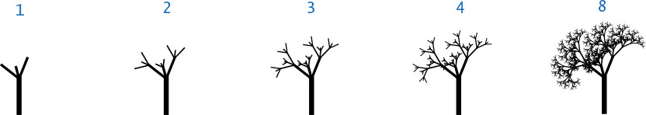
2.3.33 Brownian island. B. Mandelbrot asked the famous question How long is the coast of Britain? Modify brownian.py (PROGRAM 2.3.5) to get a program brownianisland.py that plots Brownian islands, whose coastlines resemble that of Great Britain. The modifications are simple: first, change curve() to add a Gaussian random variable to the x-coordinate as well as to the y-coordinate; second, change the global code to draw a curve from the point at the center of the canvas back to itself. Experiment with various values of the parameters to get your program to produce islands with a realistic look.
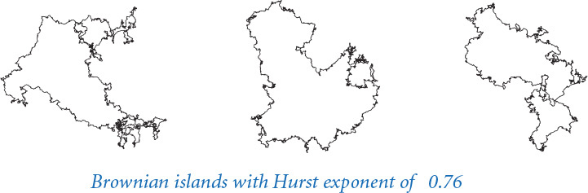

2.4 Case Study: Percolation
The programming tools that we have considered to this point allow us to attack all manner of important problems. We conclude our study of functions and modules by considering a case study of developing a program to solve an interesting scientific problem. Our purpose in doing so is to review the basic elements that we have covered, in the context of the various challenges that you might face in solving a specific problem, and to illustrate a programming style that you can apply broadly.
2.4.1 Percolation scaffolding
2.4.2 Vertical percolation detection
2.4.3 Percolation input/output
2.4.4 Visualization client
2.4.5 Percolation probability estimate
2.4.6 Percolation detection
2.4.7 Adaptive plot client
Programs in this section
Our example applies a computing technique to a simple model that has been extremely useful in helping scientists and engineers in numerous contexts. We consider a widely applicable technique known as Monte Carlo simulation to study a natural model known as percolation. This is not just of direct importance in materials science and geology, but also explains many other natural phenomena.
The term Monte Carlo simulation is broadly used to encompass any computational technique that employs randomness to estimate an unknown quantity by performing multiple trials (known as simulations). We have used Monte Carlo simulation in several other contexts already—for example, in the gambler’s ruin and coupon collector problems. Rather than develop a complete mathematical model or measure all possible outcomes of an experiment, we rely on the laws of probability and statistics.
You will learn quite a bit about percolation in this case study, but our focus is on the process of developing modular programs to address computational tasks. We identify subtasks that can be addressed independently, striving to identify the key underlying abstractions and asking ourselves questions such as the following: Is there some specific subtask that would help solve this problem? What are the essential characteristics of this specific subtask? Might a solution that addresses these essential characteristics be useful in solving other problems? Asking such questions pays significant dividends, because they lead us to develop software that is easier to create, debug, and reuse, so that we can more quickly address the main problem of interest.

Percolation
It is not unusual for local interactions in a system to imply global properties. For example, an electrical engineer might be interested in composite systems consisting of randomly distributed insulating and metallic materials: which fraction of the materials needs to be metallic so that the composite system is an electrical conductor? As another example, a geologist might be interested in a porous landscape with water on the surface (or oil below); under which conditions will the water be able to drain through to the bottom (or the oil to gush through to the surface)? Scientists have defined an abstract process known as percolation to model such situations. It has been studied widely and shown to be an accurate model in a dizzying variety of applications, beyond insulating materials and porous substances to the spread of forest fires and disease epidemics to evolution to the study of the Internet.
For simplicity, we begin by working in two dimensions and model the system as an n-by-n grid of sites. Each site is either blocked or open; open sites are initially empty. A full site is an open site that can be connected to an open site in the top row via a chain of neighboring (left, right, up, down) open sites. If there is a full site in the bottom row, then we say that the system percolates. In other words, a system percolates if we fill all open sites connected to the top row and that process fills some open site on the bottom row. For the insulating/metallic materials example, the open sites correspond to metallic materials, so that a system that percolates has a metallic path from top to bottom, with full sites conducting. For the porous substance example, the open sites correspond to empty space through which water might flow, so that a system that percolates lets water fill open sites, flowing from top to bottom.
In a famous scientific problem, researchers are interested in the following question: if sites are independently set to be open with vacancy probability p (and therefore blocked with probability 1–p), what is the probability that the system percolates? Despite decades of scientific research, no mathematical solution to this problem has yet been derived. Our task is to compose computer programs to help study the problem.
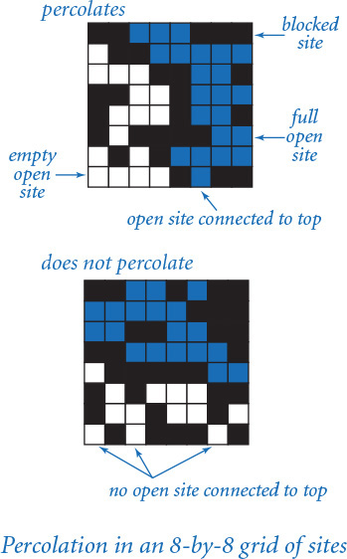

Basic scaffolding
To address percolation with a Python program, we face numerous decisions and challenges, and we certainly will end up with much more code than in the short programs that we have considered so far in this book. Our goal is to illustrate an incremental style of programming where we independently develop modules that address parts of the problem, building confidence with a small computational infrastructure of our own design and construction as we proceed.
The first step is to pick a representation of the data. This decision will have substantial impact on the kind of code that we compose later, so it is not to be taken lightly. Indeed, it is often the case that we learn something while working with a chosen representation that causes us to scrap it and start all over using a new one.
For percolation, the path to an effective representation is clear: use an n-by-n array. One possibility is to use a code such as 0 to indicate an empty site, 1 to indicate a blocked site, and 2 to indicate a full site. Alternatively, note that we typically describe sites in terms of questions: Is the site open or blocked? Is the site full or empty? This characteristic of the elements suggests that we might use an n-by-n array in which each element is either True or False. In computer science, we refer to such two-dimensional arrays as boolean matrices.
Boolean matrices are fundamental mathematical objects with many applications. Python does not provide direct support for operations on boolean matrices, but we can use the functions in stdarray to read and write boolean matrices. This choice illustrates a basic principle that often comes up in programming: the effort required to build a more general tool usually pays dividends. Using a natural abstraction such as boolean matrices is preferable to using a specialized representation. In the present context, it turns out that using boolean matrices instead of integer matrices leads to code that is easier to understand.
Eventually, we will want to work with random data, but we also want to be able to read and write files because debugging programs with random inputs can be counterproductive. With random data, you get a different input each time that you run the program; after fixing a bug, what you want to see is the same input that you just used, to check that the fix was effective. Accordingly, it is best to start with some specific cases that we understand, kept in files formatted to be read by stdarray.readBool2D() (dimensions followed by 0 and 1 values in row-major order).
When you start working on a new problem that involves several files, it is usually worthwhile to create a new folder (directory) to isolate those files from others that you may be working on. For example, we might create a folder named percolation to store the code we compose in this section. We can then implement and debug the basic code for reading and writing percolation systems, create test files, check that the files are compatible with the code, and so forth, before really worrying about percolation at all. This type of code, sometimes called scaffolding, is straightforward to implement, but making sure that it is solid at the outset will save us from distraction when approaching the main problem.
Now we can turn to the code for testing whether a boolean matrix represents a system that percolates. Referring to the helpful interpretation in which we can think of the task as simulating what would happen if the top were flooded with water (does it flow to the bottom or not?), our first design decision is that we will want to have a flow() function that takes as an argument a boolean matrix isOpen[][] that specifies which sites are open and returns another boolean matrix isFull[][] that specifies which sites are full. For the moment, we will not worry at all about how to implement this function; we are just deciding how to organize the computation. It is also clear that we will want client code to be able to use a percolates() function that checks whether the boolean matrix returned by flow() has any full sites on the bottom.
PROGRAM 2.4.1 (percolation0.py) summarizes these decisions. It does not perform any interesting computation, but, after running and debugging this code we can start thinking about actually solving the problem. A function that performs no computation, such as flow(), is sometimes called a stub. Having this stub allows us to test and debug percolates() and main() in the context in which we will need them. We refer to code like PROGRAM 2.4.1 as scaffolding. As with the scaffolding that construction workers use when erecting a building, this kind of code provides the support that we need to develop a program. By fully implementing and debugging this code (much, if not all, of which we need, anyway) at the outset, we provide a sound basis for building code to solve the problem at hand. Often, we carry the analogy one step further and remove the scaffolding (or replace it with something better) after the implementation is complete.

Vertical percolation
Given a boolean matrix that represents the open sites, how do we figure out whether it represents a system that percolates? As we will see at the end of this section, this computation turns out to be directly related to a fundamental question in computer science. For the moment, we will consider a much simpler version of the problem that we call vertical percolation.
Program 2.4.1 Percolation scaffolding (percolation0.py)
Click here to view code image
import stdarray
import stdio
def flow(isOpen):
n = len(isOpen)
isFull = stdarray.create2D(n, n, False)
# Percolation flow computation goes here.
# See Program 2.4.2 and Program 2.4.6.
return isFull
def percolates(isOpen):
isFull = flow(isOpen)
n = len(isFull)
for j in range(n):
if isFull[n-1][j]: return True
return False
def main():
isOpen = stdarray.readBool2D()
stdarray.write2D(flow(isOpen))
stdio.writeln(percolates(isOpen))
if __name__ == '__main__': main()
n | system size (n-by-n)
isFull[][] | full sites
isOpen[][] | open sites
To get started with percolation, we compose this code, which handles all the straightforward tasks surrounding the computation. The primary function flow() returns a two-dimensional array giving the full sites (none, in the placeholder code here). The helper function percolates() checks the bottom row of the returned array to decide whether the system percolates. The test client reads a boolean two-dimensional array from standard input and then writes the result of calling flow() and percolates() for that array.
% more test5.txt
5 5
0 1 1 0 1
0 0 1 1 1
1 1 0 1 1
1 0 0 0 1
0 1 1 1 1
Click here to view code image
% python percolation0.py < test5.txt
5 5
0 0 0 0 0
0 0 0 0 0
0 0 0 0 0
0 0 0 0 0
0 0 0 0 0
False
The simplification is to restrict attention to vertical connection paths. If such a path connects top to bottom in a system, we say that the system vertically percolates along the path (and that the system itself vertically percolates). This restriction is perhaps intuitive if we are talking about sand traveling through cement, but not if we are talking about water traveling through cement or about electrical conductivity. Simple as it is, vertical percolation is a problem that is interesting in its own right because it suggests various mathematical questions. Does the restriction make a significant difference? How many vertical percolation paths do we expect?
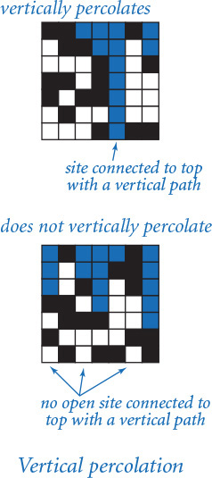
Determining the sites that are filled by some path that is connected vertically to the top is a simple calculation. We initialize the top row of our result array from the top row of the percolation system, with full sites corresponding to open ones. Then, moving from top to bottom, we fill in each row of the array by checking the corresponding row of the percolation system. Proceeding from top to bottom, we fill in the rows of isFull[][] to mark as True all elements that correspond to sites in isOpen[][] that are vertically connected to a full site on the previous row. PROGRAM 2.4.2 (percolationv.py) is the same as percolation0.py except for an implementation of flow() that returns a boolean matrix of full sites (True if connected to the top via a vertical path, False otherwise).
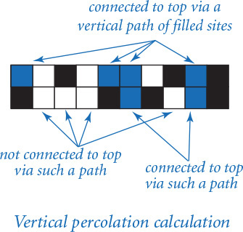

Testing
After we become convinced that our code is behaving as planned, we want to run it on a broader variety of test cases and address some of our scientific questions. At this point, our initial scaffolding becomes less useful, as representing large boolean matrices with 0s and 1s on standard input and standard output and maintaining large numbers of test cases quickly becomes uninformative and unwieldy. Instead, we want to automatically generate test cases and observe the operation of our code on them, to be sure that it is operating as expected. Specifically, to gain confidence in our code and to develop a better understanding of percolation, our next goals are to:
• Test our code for large random boolean matrices.
• Given a vacancy probability p, estimate the system percolation probability.
Program 2.4.2 Vertical percolation detection (percolationv.py)
Click here to view code image
# Same as percolation0.py except replace flow() with this:
def flow(isOpen):
n = len(isOpen)
isFull = stdarray.create2D(n, n, False)
for j in range(n):
isFull[0][j] = isOpen[0][j]
for i in range(1, n):
for j in range(n):
if isOpen[i][j] and isFull[i-1][j]:
isFull[i][j] = True
return isFull
n | system size (n-by-n)
isFull[][] | full sites
isOpen[][] | open sites
Substituting this function for the stub in PROGRAM 2.4.2 gives a solution to the vertical-only percolation problem that solves our test case as expected (see text).
% more test5.txt
5 5
0 1 1 0 1
0 0 1 1 1
1 1 0 1 1
1 0 0 0 1
0 1 1 1 1
Click here to view code image
% python percolationv.py < test5.txt
5 5
0 1 1 0 1
0 0 1 0 1
0 0 0 0 1
0 0 0 0 1
0 0 0 0 1
True
To accomplish these goals, we need new clients that are slightly more sophisticated than the scaffolding we used to get the program up and running. Our modular programming style is to develop such clients in independent modules without modifying our percolation code at all.

Monte Carlo simulation
We want our code to work properly for any boolean matrix. Moreover, the scientific question of interest involves random boolean matrices. To this end, we compose a function random() that takes two arguments n and p and generates a random n-by-n boolean array in which the probability that each element is True is p. Having debugged our code on a few specific test cases, we can use this function to test it on larger random systems. It is possible that such cases may uncover a few more bugs, so some care is in order to check results. However, having debugged our code for a small system, we can proceed with some confidence. It is easier to focus on new bugs after eliminating the obvious bugs.

Data visualization
We can work more easily with bigger problem instances if we use stddraw for output. Accordingly, we develop a function draw() to visualize the contents of a boolean matrix as a subdivision of the standard drawing window into squares, one for each site. For flexibility, we include a second argument that specifies which squares we want to fill—those corresponding to True elements or those corresponding to False elements. As you will see, this function pays dividends in its ability to help us visualize large problem instances. Using draw() to draw our arrays representing blocked and full sites in different colors gives a compelling visual representation of percolation.
With these tools, testing our percolation code for larger boolean matrices on a larger set of trials is straightforward. PROGRAM 2.4.3 (percolationio.py) is a small module that contains the two functions just described, for use as input and output for testing our percolation code; PROGRAM 2.4.4 (visualizev.py) is a client script that takes a percolation system size, a probability, and a number of trials from the command line and then runs the specified number of trials, creating a new random boolean matrix, and displaying the result of the percolation flow calculation for each, pausing for a brief time between trials.
Our eventual goal is to compute an accurate estimate of percolation probabilities, perhaps by running a large number of trials. Nevertheless, these tools helps us gain more familiarity with the problem by studying some large cases (while at the same time gaining confidence that our code is working properly). When you run visualizev.py for moderate-size n (50 to 100, say) and various values of p, you will immediately be drawn into using this program to try to answer some questions about percolation. Clearly, the system never percolates when p is low and always percolates when p is very high. How does it behave for intermediate values of p? How does the behavior change as n increases?
Program 2.4.3 Percolation input/output (percolationio.py)
Click here to view code image
import sys
import stdarray
import stddraw
import stdio
import stdrandom
def random(n, p):
a = stdarray.create2D(n, n, False)
for i in range(n):
for j in range(n):
a[i][j] = stdrandom.bernoulli(p)
return a
def draw(a, which):
n = len(a)
stddraw.setXscale(-1, n)
stddraw.setYscale(-1, n)
for i in range(n):
for j in range(n):
if a[i][j] == which:
stddraw.filledSquare(j, n-i-1, 0.5)
def main():
n = int(sys.argv[1])
p = float(sys.argv[2])
test = random(n, p)
draw(test, False)
stddraw.show()
if __name__ == '__main__': main()
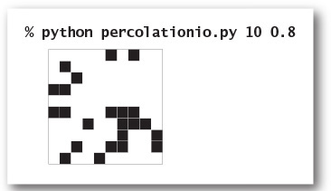
These helper functions are useful for testing when we are studying percolation. The call random(n, p) creates a random n-by-n boolean array, where the probability that each element is True is p, and the call draw(test, False) produces a visualization of the given two-dimensional array in the standard drawing window, with filled squares corresponding to False elements.
Program 2.4.4 Visualization client (visualizev.py)
Click here to view code image
import sys
import stddraw
import percolationv
import percolationio
n = int(sys.argv[1])
p = float(sys.argv[2])
trials = int(sys.argv[3])
for i in range(trials):
isOpen = percolationio.random(n, p)
stddraw.clear()
stddraw.setPenColor(stddraw.BLACK)
percolationio.draw(isOpen, False)
stddraw.setPenColor(stddraw.BLUE)
isFull = percolationv.flow(isOpen)
percolationio.draw(isFull, True)
stddraw.show(1000.0)
stddraw.show()
n | system size (n-by-n)
p | site vacancy probability
trials | number of trials
isOpen[][] | open sites
isFull[][] | full sites
This client takes command-line arguments n, p, and trials, then generates random n-by-n boolean arrays with site vacancy probability p, computes the directed percolation flow, and draws the result in the stanard drawing window. Such drawings increase confidence that our code is operating properly and help develop an intuitive understanding of percolation.
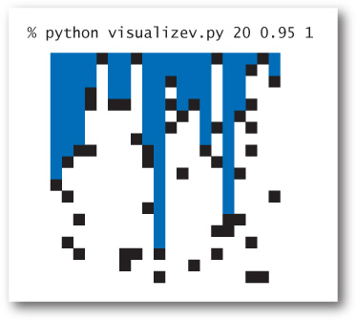
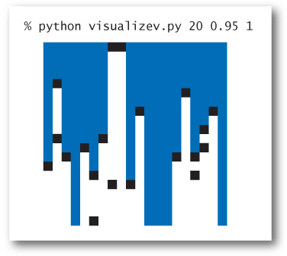

Estimating probabilities
The next step in our program development process is to compose code to estimate the probability that a random system percolates. We refer to this quantity as the percolation probability. To estimate its value, we simply run a number of experiments. The situation is no different from our study of coin flipping (see PROGRAM 2.2.7), but instead of flipping a coin, we generate a random system and check whether it percolates.
PROGRAM 2.4.5 (estimatev.py) encapsulates this computation in a function evaluate() that returns an estimate of the probability that an n-by-n system with site vacancy probability p percolates, obtained by generating a given number of random systems and calculating the fraction of them that percolate. The function takes three arguments: n, p, and trials.
How many trials do we need to obtain an accurate estimate of the percolation probability? This question is addressed by basic methods in probability and statistics, which are beyond the scope of this book, but we can get a feeling for the problem with computational experience. With just a few runs of estimatev.py, you can learn that if the site vacancy probability is close to 0 or very close to 1, then we do not need many trials, but that there are values for which we need as many as 10,000 trials to be able to estimate the percolation probability within two decimal places. To study the situation in more detail, we might modify estimatev.py to produce output like bernoulli.py (PROGRAM 2.2.7), plotting a histogram of the data points so that we can see the distribution of values (see EXERCISE 2.4.11).
Using estimatev.evaluate() represents a giant leap in the amount of computation that we are doing. All of a sudden, it makes sense to run thousands of trials. It would be unwise to try to do so without first having thoroughly debugged our percolation functions. Also, we need to begin to take the time required to complete the computation into account. The basic methodology for doing so is the topic of SECTION 4.1, but the structure of these programs is sufficiently simple that we can do a quick calculation, which we can verify by running the program. Each trial involves n2 sites, so the total running time of estimatev.evaluate() is proportional to n2 times the number of trials. If we increase the number of trials by a factor of 10 (to gain more precision), the running time increases by about a factor of 10. If we increase n by a factor of 10 (to study percolation for larger systems), the running time increases by about a factor of 100.
Can we run this program to determine percolation probabilities for a system with billions of sites with several digits of precision? No. No computer is fast enough to use estimatev.evaluate() for this purpose. Moreover, in a scientific experiment on percolation, the value of n is likely to be much higher. We can hope to formulate a hypothesis from our simulation that can be tested experimentally on a much larger system, but not to precisely simulate a system that corresponds atom-for-atom with the real world. Simplification of this sort is essential in science.
Program 2.4.5 Percolation probability estimate (estimatev.py)
Click here to view code image
import sys
import stdio
import percolationv
import percolationio
def evaluate(n, p, trials):
count = 0
for i in range(trials):
isOpen = percolationio.random(n, p)
if (percolationv.percolates(isOpen)):
count += 1
return 1.0 * count / trials
def main():
n = int(sys.argv[1])
p = float(sys.argv[2])
trials = int(sys.argv[3])
q = evaluate(n, p, trials)
stdio.writeln(q)
if __name__ == '__main__': main()
n | system size (n-by-n)
p | site vacancy probability
trials | number of trials
isOpen[][] | open sites
q | percolation probability
To estimate the probability that a system percolates, we generate random n-by-n systems with site vacancy probability p and compute the fraction of them that percolate. This is a Bernoulli process, no different from coin flipping (see PROGRAM 2.2.6). Increasing the number of trials increases the accuracy of the estimate. If the site vacancy probability is close to 0 or to 1, not many trials are needed.
Click here to view code image
% python estimatev.py 20 .75 10
0.0
% python estimatev.py 20 .95 10
1.0
% python estimatev.py 20 .85 10
0.7
Click here to view code image
% python estimatev.py 20 .85 1000
0.564
% python estimatev.py 20 .85 1000
0.561
% python estimatev.py 40 .85 100
0.11
You are encouraged to download estimatev.py from the booksite to get a feel for both the percolation probabilities and the amount of time required to compute them. When you do so, you are not just learning more about percolation, but also testing the hypothesis that the models we have described apply to the running times of our simulations of the percolation process.
What is the probability that a system with site vacancy probability p vertically percolates? Vertical percolation is sufficiently simple that elementary probabilistic models can yield an exact formula for this quantity, which we can validate experimentally with estimatev.py. Since our only reason for studying vertical percolation was that it represented an easy starting point around which we could develop supporting software for studying percolation methods, we leave further study of vertical percolation for an exercise (see EXERCISE 2.4.13) and turn to the main problem.

Recursive solution for percolation
How do we test whether a system percolates in the general case when any path starting at the top and ending at the bottom (not just a vertical one) will do the job?
Remarkably, we can solve this problem with a compact program, based on a classic recursive scheme known as depth-first search. PROGRAM 2.4.6 (percolation.py) is an implementation of flow() that computes the flow matrix isFull[][], based on a recursive four-argument function _flow(). The recursive function takes as arguments the site vacancy matrix isOpen[][], the flow matrix isFull[][], and a site position specified by a row index i and a column index j. The base case is a recursive call that just returns (we refer to such a call as a null call), for one of the following reasons:
• Either i or j is outside the two-dimensional array bounds.
• The site is blocked (isOpen[i][j] is False).
• We have already marked the site as full (isFull[i][j] is True).
The reduction case is to mark the site as filled and issue recursive calls for the site’s four neighbors: isOpen[i+1][j], isOpen[i][j+1], isOpen[i][j-1], and isOpen[i-1][j]. To implement flow(), we call the recursive _flow() function for every site on the top row. The recursion always terminates because each recursive call either is null or marks a new site as full. We can show by an induction-based argument (as usual for recursive programs) that a site is marked as full if and only if it is open and connected to one of the sites on the top row via a chain of neighboring open sites.
Program 2.4.6 Percolation detection (percolation.py)
Click here to view code image
# Same as percolation0.py except replace flow() with this code:
def _flow(isOpen, isFull, i, j):
n = len(isFull)
if (i < 0) or (i >= n): return
if (j < 0) or (j >= n): return
if not isOpen[i][j]: return
if isFull[i][j]: return
isFull[i][j] = True
_flow(isOpen, isFull, i+1, j ) # Down.
_flow(isOpen, isFull, i , j+1) # Right.
_flow(isOpen, isFull, i , j-1) # Left.
_flow(isOpen, isFull, i-1, j ) # Up.
def flow(isOpen):
n = len(isOpen)
isFull = stdarray.create2D(n, n, False)
for j in range(n):
_flow(isOpen, isFull, 0, j)
return isFull
n | system size (n-by-n)
isOpen[][] | open sites
isFull[][] | full sites
i, j | current site row, column
Substituting these functions for the flow() stub in PROGRAM 2.4.1 gives a depth-first-search-based solution to the percolation problem. The call _flow(isOpen, isFull, i, j) fills sites by setting to True the element in isFull[][] corresponding to any site that can be reached from isOpen[i][j] via a path of open sites. The one-argument flow() calls the recursive function for every site on the top row.
% more test8.txt
8 8
0 0 1 1 1 0 0 0
1 0 0 1 1 1 1 1
1 1 1 0 0 1 1 0
0 0 1 1 0 1 1 1
0 1 1 1 0 1 1 0
0 1 0 0 0 0 1 1
1 0 1 0 1 1 1 1
1 1 1 1 0 1 0 0
Click here to view code image
% python percolation.py < test8.txt
8 8
0 0 1 1 1 0 0 0
0 0 0 1 1 1 1 1
0 0 0 0 0 1 1 0
0 0 0 0 0 1 1 1
0 0 0 0 0 1 1 0
0 0 0 0 0 0 1 1
0 0 0 0 1 1 1 1
0 0 0 0 0 1 0 0
True
Tracing the operation of _flow() on a tiny test case is an instructive exercise in examining the dynamics of the process, as shown in the diagram at left. The function calls itself for every site that can be reached via a path of open sites from the top. This example illustrates that simple recursive programs can mask computations that otherwise are quite sophisticated. This function is a special case of the classic depth-first search algorithm, which has many important applications.
We can visualize and perform experiments with this algorithm using scripts like the visualizev.py and estimatev.py tools that we have developed. To do so, we can create the file visualize.py as a copy of visualizev.py, and then edit visualize.py by replacing the two instances of percolationv with percolation. Similarly, we can create the file estimate.py as an edited copy of estimatev.py. (To save space, we do not show visualize.py and estimate.py in the book; they are available through the booksite.) If you do so, and try various values for n and p, you will quickly get a feeling for the situation: the systems always percolate when p is high and never percolate when p is low, and (particularly as n increases) there is a value of p above which the systems (almost) always percolate and below which they (almost) never percolate (see examples at the top of the next page).
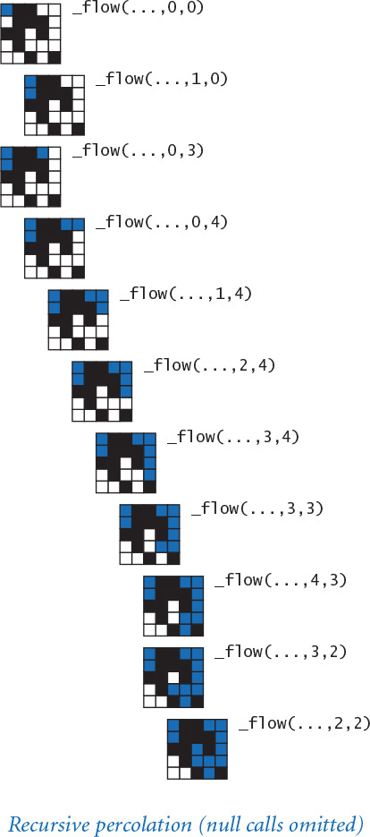
Having debugged visualizev.py and estimatev.py on the simple vertical percolation process, we can use them with more confidence to study percolation, and turn quickly to study the real scientific problem of interest. Note that if we want to study both versions of percolation, we could compose clients of both percolationv and percolation that call both flow() functions to compare them.
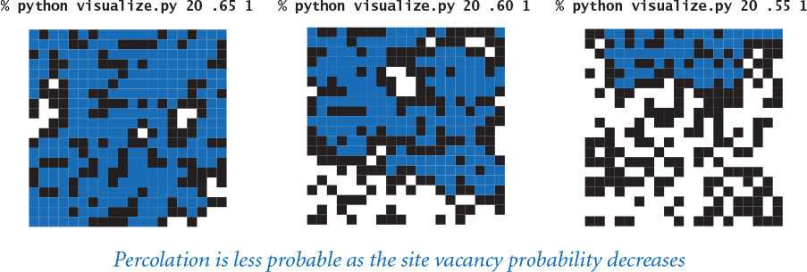

Adaptive plot
To gain more insight into percolation, our next step in program development might be to compose a program that plots the percolation probability q as a function of the site vacancy probability p for a given value of n. Perhaps the best way to produce such a plot is to first derive a mathematical equation for the function, and then use that equation to make the plot. For percolation, however, no one has been able to derive such an equation, so the next option is to use the Monte Carlo method: run simulations and plot the results.
Immediately, we are faced with numerous decisions. For how many values of p should we compute an estimate of the percolation probability? Which values of p should we choose? How much precision should we aim for in these calculations? These decisions constitute an experimental design problem. Much as we might like to instantly produce an accurate rendition of the curve for any given n, the computation cost can be prohibitive. For example, the first thing that comes to mind is to plot, say, 100 to 1,000 equally spaced points, using stdstats.py (PROGRAM 2.2.5). But, as you learned from using estimate.py, computing a sufficiently precise value of the percolation probability for each point might take several seconds or longer, so the whole plot might take minutes or hours or even longer. Moreover, it is clear that a lot of this computation time is completely wasted, because we know that values for small p are 0 and values for large p are 1. We might prefer to spend that time on more precise computations for intermediate p. How should we proceed?
PROGRAM 2.4.7 (percplot.py) implements a recursive approach that is widely applicable to similar problems. The basic idea is simple: we choose the minimum distance that we want between values of the x-coordinate (which we refer to as the gap tolerance), the minimum known error that we wish to tolerate in the y-coordinate (which we refer to as the error tolerance), and the number of trials per point that we wish to perform. The recursive function draws the plot within a given x-interval [x0, x1], from (x0, y0) to (x1, y1). For our problem, the plot is from (0, 0) to (1, 1). The base case (if the distance between x0 and x1 is less than the gap tolerance, or the distance between the line connecting the two endpoints and the value of the function at the midpoint is less than the error tolerance) is to simply draw a line from (x0, y0) to (x1, y1). The reduction step is to (recursively) plot the two halves of the curve, from (x0, y0) to (xm, ym) and from (xm, ym) to (x1, y1).
Program 2.4.7 Adaptive plot client (percplot.py)
Click here to view code image
import sys
import stddraw
import estimate
def curve(n, x0, y0, x1, y1, trials=10000, gap=0.01, err=0.0025):
xm = (x0 + x1) / 2.0
ym = (y0 + y1) / 2.0
fxm = estimate.evaluate(n, xm, trials)
if (x1 - x0 < gap) or (abs(ym - fxm) < err):
stddraw.line(x0, y0, x1, y1)
stddraw.show(0.0)
return
curve(n, x0, y0, xm, fxm)
stddraw.filledCircle(xm, fxm, 0.005)
stddraw.show(0.0)
curve(n, xm, fxm, x1, y1)
n = int(sys.argv[1])
stddraw.setPenRadius(0.0)
curve(n, 0.0, 0.0, 1.0, 1.0)
stddraw.show()
n | system size (n-by-n)
x0, y0 | left endpoint
x1, y1 | right endpoint
xm, ym | midpoint
fxm | value at midpoint
trials | number of trials
gap | gap tolerance
err | error tolerance
This program accepts an integer n as a command-line argument and then runs experiments to build an adaptive plot that relates site vacancy probability (the control variable) to percolation probability (the experimental observations) for n-by-n systems.
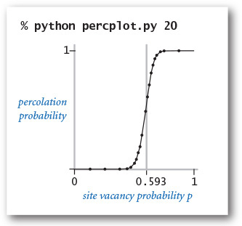
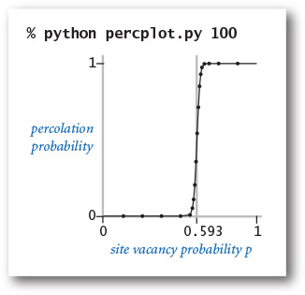
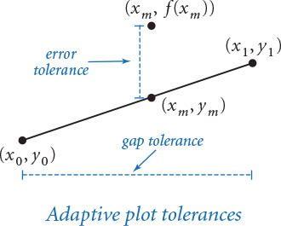
The code in percplot.py is relatively simple and produces a good-looking curve at relatively low cost. We can use it to study the shape of the curve for various values of n, or we can choose smaller tolerances to be more confident that the curve is close to the actual values. Precise mathematical statements about quality of approximation can, in principle, be derived, but it is perhaps not appropriate to go into too much detail while exploring and experimenting, since our goal is simply to develop a hypothesis about percolation that can be tested by scientific experimentation.
Indeed, the curves produced by percplot.py immediately confirm the hypothesis that there is a threshold value (about 0.593): if p is greater than the threshold, then the system almost certainly percolates; if p is less than the threshold, then the system almost certainly does not percolate. As n increases, the curve approaches a step function that changes value from 0 to 1 at the threshold. This phenomenon, known as a phase transition, is found in many physical systems.
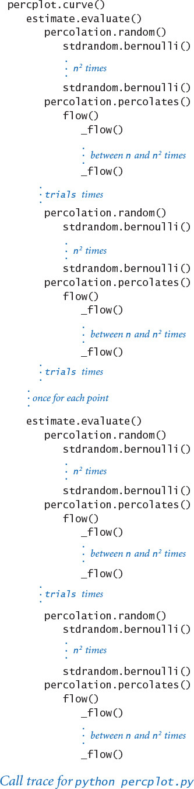
The simple form of the output of percplot.py masks the huge amount of computation behind it. For example, the curve drawn for n = 100 has 18 points, each the result of 10,000 trials, each trial involving n2 sites. Generating and testing each site involves a few lines of code, so this plot comes at the cost of executing billions of statements. There are two lessons to be learned from this observation. First, we need to have confidence in any line of code that might be executed billions of times, so our care in developing and debugging code incrementally is justified. Second, although we might be interested in systems that are much larger, we need further study in computer science to be able to handle larger cases—that is, to develop faster algorithms and a framework for knowing their performance characteristics.
With this reuse of all of our software, we can study all sorts of variants on the percolation problem, just by implementing different flow() functions. For example, if you leave out the last recursive call in the recursive _flow() function in PROGRAM 2.4.6, it tests for a type of percolation known as directed percolation, where paths that go up are not considered. This model might be important for a situation like a liquid percolating through porous rock, where gravity might play a role, but not for a situation like electrical connectivity. If you run percplot.py for both functions, will you be able to discern the difference (see EXERCISE 2.4.5)?
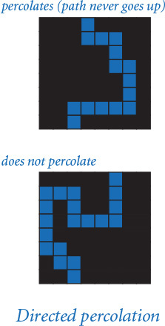
To model physical situations such as water flowing through porous substances, we need to use three-dimensional arrays. Is there a similar threshold in the three-dimensional problem? If so, what is its value? Depth-first search is effective for studying this question, though the addition of another dimension requires that we pay even more attention to the computational cost of determining whether a system percolates (see EXERCISE 2.4.21). Scientists also study more complex lattice structures that are not well modeled by multidimensional arrays—we will see how to model such structures in SECTION 4.5.
Percolation is interesting to study via in silico experimentation because no one has been able to derive the threshold value mathematically for several natural models. The only way that scientists know the value is by using Monte Carlo simulations like those we have studied in this section. A scientist needs to do experiments to see whether the percolation model reflects what is observed in nature, perhaps through refining the model (for example, using a different lattice structure). Percolation is an example of an increasing number of problems where computer science of the kind described here is an essential part of the scientific process.

Lessons
We might have approached the problem of studying percolation by sitting down to design and implement a single program, which probably would run to hundreds of lines, to produce the kind of plots that are drawn by PROGRAM 2.4.7. In the early days of computing, programmers had little choice but to work with such programs, and would spend enormous amounts of time isolating bugs and correcting design decisions. With modern programming tools like Python, we can do better, using the incremental modular style of programming presented in this chapter and keeping in mind some of the lessons that we have learned.

Expect bugs
Every interesting piece of code that you compose will have at least one or two bugs, if not many more. By running small pieces of code on small test cases that you understand, you can more easily isolate any bugs and then more easily fix them when you find them. Once the code is debugged, you can depend on using a module as a building block for any client.

Keep modules small
You can focus attention on at most a few dozen lines of code at a time, so you may as well break your code into small modules as you compose it. Some modules that contain collections of related functions may eventually grow to contain hundreds of lines of code; otherwise, we should work with small files.
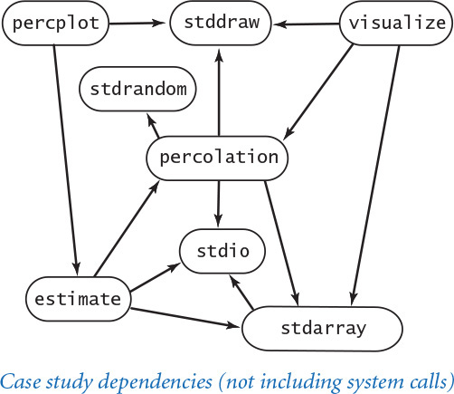

Limit interactions
In a well-designed modular program, most modules should depend on just a few others. In particular, a module that calls a large number of other modules needs to be divided into smaller pieces. Modules that are called by a large number of other modules (you should have only a few) need special attention, because if you do need to make changes in a module’s API, you have to reflect those changes in all its clients.

Develop code incrementally
You should run and debug each small module as you implement it. That way, you are never working with more than a few dozen lines of unreliable code at any given time. If you put all your code in one big module, it is difficult to be confident that any of it is safe from bugs. Running code early also forces you to think sooner rather than later about I/O formats, the nature of problem instances, and other issues. Experience gained when thinking about such issues and debugging related code makes the code that you develop later in the process more effective.

Solve an easier problem
Some working solution is better than no solution, so it is typical to begin by putting together the simplest code that you can craft that solves a given problem, as we did with vertical-only percolation. This implementation is the first step in a process of continual refinements and improvements as we develop a more complete understanding of the problem by examining a broader variety of test cases and developing support software such as our visualize.py and estimate.py programs.

Consider a recursive solution
Recursion is an indispensable tool in modern programming that you should learn to trust. If you are not already convinced of this fact by the simplicity and elegance of percplot.py and percolation.py, you might wish to try to develop a nonrecursive program for testing whether a system percolates and then reconsider the issue.

Build tools when appropriate
Our visualization function draw() and random boolean matrix generation function random() of percolationio.py are certainly useful for many other applications, as is the adaptive plotting function curve() of percplot.py. Incorporating these functions into appropriate modules would be simple. It is no more difficult (indeed, perhaps easier) to implement general-purpose functions like these than it would be to implement special-purpose functions for percolation.

Reuse software when possible
Our stdio, stdrandom, and stddraw modules all simplified the process of developing the code in this section, and we were also immediately able to reuse programs such as estimate.py, and visualize.py for percolation after developing them for vertical percolation. After you have composed a few programs of this kind, you might find yourself developing versions of these programs that you can reuse for other Monte Carlo simulations or other experimental data analysis problems.
The primary purpose of this case study is to convince you that modular programming will take you much further than you could get without it. Although no approach to programming is a panacea for all problems, the tools and approach that we have discussed in this section will allow you to attack complex programming tasks that might otherwise be far beyond your reach.
The success of modular programming is only a start. Modern programming systems rely on a vastly more flexible programming model than the module-as-a-collection-of-functions model that we have been considering. In the next two chapters, we develop this model, along with many examples that illustrate its utility.

Q&A
Q. Editing visualize.py and estimate.py to rename every occurrence of percolation to percolationv (or whatever module we want to study) seems to be a bother. Is there a way to avoid doing so?
A. Yes. The most straightforward approach is to keep multiple files named percolation.py in separate subdirectories. Then copy the desired percolation.py file from one of the subdirectories to your working directory, thereby selecting one particular implementation. An alternative approach is to use Python’s import as statement to define an identifier to refer to the module:
Click here to view code image
import percolationv as percolation
Now, any call to percolation.percolates() uses the function defined in percolationv.py instead of the one defined in percolation.py. In this situation, changing implementations involves editing only one line of source code.
Q. That recursive flow() function makes me nervous. How can I better understand what it’s doing?
A. Run it for small examples of your own making, instrumented with instructions to write a function-call trace. After a few runs, you will gain confidence that it always fills the sites connected to the start point.
Q. Is there a simple nonrecursive approach?
A. There are several known approaches that perform the same basic computation. We will revisit the problem at the end of the book, in SECTION 4.5. In the meantime, working on developing a nonrecursive implementation of flow() is certain to be an instructive exercise, if you are interested.
Q. PROGRAM 2.4.7 (percplot.py) seems to involve a huge amount of calculation to get a simple function graph. Is there some better way?
A. The best strategy would be a mathematical proof of the threshold value, but that derivation has eluded scientists.

Exercises
2.4.1 Compose a program that takes a command-line argument n and creates an n-by-n boolean array with the element in row i and column j set to True if i and j are relatively prime, then shows the n-by-n boolean array on standard drawing (see EXERCISE 1.4.14). Then, compose a similar program to draw the Hadamard matrix of order n (see EXERCISE 1.4.27) and another program to draw the matrix with the element in row n and column j set to True if the coefficient of xj in (1+x)i (binomial coefficient) is odd (see EXERCISE 1.4.39). You may be surprised at the pattern formed by the latter.
2.4.2 Compose a write() function for percolationIO.py that writes 1 for blocked sites, 0 for open sites, and * for full sites.
2.4.3 Give the recursive calls for percolation.py given the following input:
3 3
1 0 1
0 0 0
1 1 0
2.4.4 Compose a client of percolation.py like visualize.py that does a series of experiments for a command-line argument n where the site vacancy probability p increases from 0 to 1 by a given increment (also taken from the command line).
2.4.5 Compose a program percolationd.py that tests for directed percolation (by leaving off the last recursive call in the recursive _flow() function in PROGRAM 2.4.6, as described in the text), then use percplot.py (suitably modified) to draw a plot of the directed percolation probability as a function of the site vacancy probability.
2.4.6 Compose a client of percolation.py and percolationd.py that takes a site vacancy probability p from the command line and writes an estimate of the probability that a system percolates but does not percolate down. Perform enough experiments to get an estimate that is accurate to three decimal places.
2.4.7 Describe the order in which the sites are marked when percolation.py is used on a system with no blocked sites. Which is the last site marked? What is the depth of the recursion?
2.4.8 Modify percolation.py to animate the flow computation, showing the sites filling one by one. Check your answer to the previous exercise.
2.4.9 Experiment with using percplot.py to plot various mathematical functions (just by replacing the call on estimate.evaluate() with an expression that evaluates the function). Try the function sin(x) + cos(10*x) to see how the plot adapts to an oscillating curve, and come up with interesting plots for three or four functions of your own choosing.
2.4.10 Modify percolation.py to compute the maximum depth of the recursion used in the flow calculation. Plot the expected value of that quantity as a function of the site vacancy probability p. How does your answer change if the order of the recursive calls is reversed?
2.4.11 Modify estimate.py to produce output like that produced by bernoulli.py (PROGRAM 2.2.7). Extra credit: Use your program to validate the hypothesis that the data obeys the Gaussian (normal) distribution.
2.4.12 Modify percolationio.py, estimate.py, percolation.py, and visualize.py to handle m-by-n grids and m-by-n boolean matrices. Use an optional argument so that m defaults to n if only one of the two dimensions is specified.

Creative Exercises
2.4.13 Vertical percolation. Show that an n-by-n percolation system with site vacancy probability p vertically percolates with probability 1 – (1 – pn)n, and use estimate.py to validate your analysis for various values of n.
2.4.14 Rectangular percolation systems. Modify the code in this section to allow you to study percolation in rectangular systems. Compare the percolation probability plots of systems whose ratio of width to height is 2:1 with those whose ratio is 1:2.
2.4.15 Adaptive plotting. Modify percplot.py to take its control parameters (gap tolerance, error tolerance, and number of trials) from the command line. Experiment with various values of the parameters to learn their effect on the quality of the curve and the cost of computing it. Briefly describe your findings.
2.4.16 Percolation threshold. Compose a percolation.py client that uses binary search to estimate the threshold value (see EXERCISE 2.1.26).
2.4.17 Nonrecursive directed percolation. Compose a nonrecursive program that tests for directed percolation by moving from top to bottom as in our vertical percolation code. Base your solution on the following computation: if any site in a contiguous subrow of open sites in the current row is connected to some full site on the previous row, then all of the sites in the subrow become full.
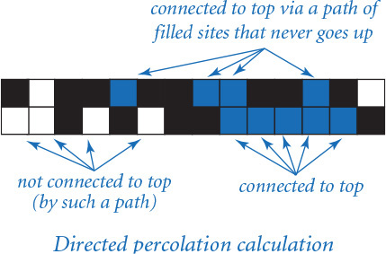
2.4.18 Fast percolation test. Modify the recursive _flow() function in PROGRAM 2.4.6 so that it returns as soon as it finds a site on the bottom row (and fills no more sites). Hint: Use an argument done that is True if the bottom has been hit, False otherwise. Give a rough estimate of the performance improvement factor for this change when running percplot.py. Use values of n for which the programs run at least a few seconds but not more than a few minutes. Note that the improvement is ineffective unless the first recursive call in _flow() is for the site below the current site.
2.4.19 Bond percolation. Compose a modular program for studying percolation under the assumption that the edges of the grid provide the connectivity. That is, an edge can be either empty or full, and a system percolates if there is a path consisting of full edges that goes from top to bottom. Note : This problem has been solved analytically, so your simulations should validate the hypothesis that the percolation threshold approaches 1/2 as n gets large.
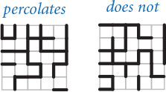
2.4.20 Bond percolation on a triangular grid. Compose a modular program for studying bond percolation on a triangular grid, where the system is composed of 2n2 equilateral triangles packed together in an n-by-n grid of rhombus shapes and, as in the previous exercise, the edges of the grid provide the connectivity. Each interior point has six bonds; each point on the edge has four; and each corner point has two.
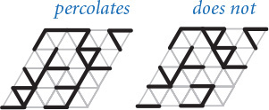
2.4.21 Percolation in three dimensions. Implement modules percolation3d.py and percolation3dio.py (for I/O and random generation) to study percolation in three-dimensional cubes, generalizing the two-dimensional case studied in this chapter. A percolation system is an n-by-n-by-n cube of sites that are unit cubes, with probability of being open p and probability of being blocked 1–p. Paths can connect an open cube with any open cube that shares a common face (one of six neighbors, except on the boundary). The system percolates if there exists a path connecting any open site on the bottom plane to any open site on the top plane. Use a recursive version of _flow() like the one in PROGRAM 2.4.6, but with eight recursive calls instead of four. Plot percolation probability versus site vacancy probability for as large a value of n as you can. Be sure to develop your solution incrementally, as emphasized throughout this section.
2.4.22 Game of life. Implement a module life.py that simulates Conway’s game of life. Consider a boolean matrix corresponding to a system of cells that we refer to as being either live or dead. The game consists of checking and perhaps updating the value of each cell, depending on the values of its neighbors (the adjacent cells in every direction, including diagonals). Live cells remain live and dead cells remain dead, with the following exceptions:
• A dead cell with exactly three live neighbors becomes live.
• A live cell with exactly one live neighbor becomes dead.
• A live cell with more than three live neighbors becomes dead.
Test your program with a glider, a famous pattern that moves down and to the right every four generations, as shown in the diagram below. Then try two gliders that collide. Then try a random boolean matrix, or use one of the starting patterns on the booksite. This game has been heavily studied, and relates to foundations of computer science (see the booksite for more information)
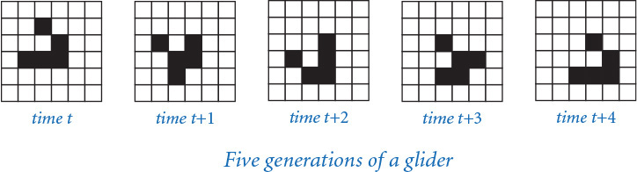

Chapter Three. Object-Oriented Programming
3.1 Using Data Types
3.2 Creating Data Types
3.3 Designing Data Types
3.4 Case Study: N-Body Simulation
Your next step to programming effectively is conceptually simple. Now that you know how to use built-in data types, you will learn in this chapter how to use, create, and design higher-level data types.
An abstraction is a simplified description of something that captures its essential elements while suppressing all other details. In science, engineering, and programming, we are always striving to understand complex systems through abstraction. In Python programming, we do so with object-oriented programming, where we break a large and potentially complex program into a set of interacting elements, or objects. The idea originates from modeling (in software) real-world entities such as electrons, people, buildings, or solar systems and readily extends to modeling abstract entities such as bits, numbers, colors, images, or programs.
As discussed in SECTION 1.2, a data type is a set of values and a set of operations defined on those values. In Python, the values and operations for many data types such as int and float are predefined. In object-oriented programming, we compose code to create new data types.
This ability to define new data types and to manipulate objects holding data-type values is also known as data abstraction, and leads us to a style of modular programming that naturally extends the function abstraction style that was the basis for CHAPTER 2. A data type allows us to isolate data as well as functions. Our mantra for this chapter is this: Whenever you can clearly separate data and associated tasks within a computation, you should do so.

3.1 Using Data Types
Organizing data for processing is an essential step in the development of a computer program. Programming in Python is largely based on doing so with data types that are designed to support object-oriented programming, a style of programming that integrates code and data.
3.1.1 Identifying a potential gene
3.1.2 Charged-particle client
3.1.3 Albers squares
3.1.4 Luminance module
3.1.5 Converting color to grayscale
3.1.6 Image scaling
3.1.7 Fade effect
3.1.8 Visualizing electric potential
3.1.9 Concatenating files
3.1.10 Screen scraping for stock quotes
3.1.11 Splitting a file
Programs in this section
You certainly noticed in the first two chapters of this book that our programs were confined to operations on numbers, booleans, and strings. Of course, the reason is that the Python data types that we’ve encountered so far—int, float, bool, and str—manipulate numbers, booleans, and strings, using familiar operations. In this chapter, we begin to consider other data types.
We first examine a host of new operations on objects of type str, which will introduce you to object-oriented programming because most of these operations are implemented as methods that manipulate objects. Methods are very similar to functions, except that each method call is explicitly associated with a specified object. To illustrate the natural style of programming induced by the use of methods, we consider a string-processing application from genomics.
Even more significantly, you will learn in SECTION 3.2 to define your own data types to implement any abstraction whatsoever. This ability is crucial in modern programming. No library of modules can meet the needs of all possible applications, so programmers routinely create data types to meet their own needs.
In this section, we focus on client programs that use existing data types, to give you some concrete reference points for understanding these new concepts and to illustrate their broad reach. We introduce constructors to create objects from a data type and methods to operate on their values. We consider programs that manipulate electrical charges, colors, images, files, and web pages—quite a leap from the built-in data types that we used in previous chapters.

Methods
In SECTION 1.2, you learned that a data type is a set of values and a set of operations defined on those values, and you learned details of Python’s built-in data types int, bool, float, and str. You also learned that all data in a Python program are represented by objects and relationships among objects. Since then, we have focused on composing programs that use the operations associated with the built-in types to manipulate objects of those types. To do so, we have used conditionals, loops, and functions, which enable us to build large programs where the flow of control from operation to operation is well understood. In this section, we put these concepts together.
In the programs that we have encountered so far, we apply data-type operations using built-in operators such as +, -, *, /, and []. Now, we are going to introduce a new way to apply data-type operations that is more general. A method is a function associated with a specified object (and, by extension, with the type of that object). That is, a method corresponds to a data-type operation.
We can call (or invoke) a method by using a variable name, followed by the dot operator (.), followed by the method name, followed by a list of arguments delimited by commas and enclosed in parentheses. As a simple example, Python’s built-in int type has a method named bit_length(), so you can determine the number of bits in the binary representation of an int value as follows:
x = 3 ** 100
bits = x.bit_length()
stdio.writeln(bits)
This code writes 159 to standard output, telling you that 3100 (a huge integer) has 159 bits when expressed in binary.
The syntax and behavior of method calls is nearly the same as the syntax and behavior of function calls. For example, a method can take any number of arguments, those arguments are passed by object reference, and the method returns a value to its caller. Similarly, like a function call, a method call is an expression, so you can use it anywhere in your program where you would use an expression. The main difference in syntactic: you invoke a method using a specified object and the dot operator.
In “object-oriented programming,” we usually prefer method-call syntax to function-call syntax because it emphasizes the role of the object. This approach has proved for decades to be a fruitful way to develop programs, particularly those that are developed to build and understand models of the real world.

Distinction between methods and functions
The key difference between a function and a method is that a method is associated with a specified object. You can think of this specified object as an extra argument that gets passed to a function, in addition to the ordinary methods argument. You can distinguish between method calls and function calls in client code by looking to the left of the dot operator: a function call typically uses a module name and a method call typically uses a variable name. These differences are illustrated at left and summarized in the table at the bottom of this page.
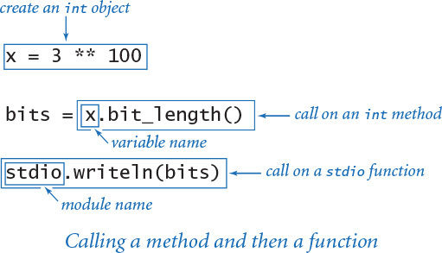

String processing
Out of necessity, we have been using the str data type from the beginning of this book, to create human-readable output for our programs. Your experience with using str demonstrates that you do not need to know how a data type is implemented to be able to use it (one of several mantras we repeat in this book because of its importance). You know that str values are sequences of characters and that you can perform the operation of concatenating two str values to produce a str result.
Python’s str data type includes many other operations, as documented in the API on the facing page. It is one of Python’s most important data types because string processing is critical to many computational applications. Strings lie at the heart of our ability to compile and execute Python programs and to perform many other core computations; they are the basis of the information-processing systems that are critical to most business systems; people use them every day when typing into email, blog, or chat applications or preparing documents for publication; and they are critical ingredients in scientific progress in several fields, particularly molecular biology.
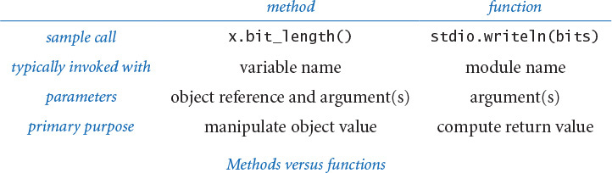
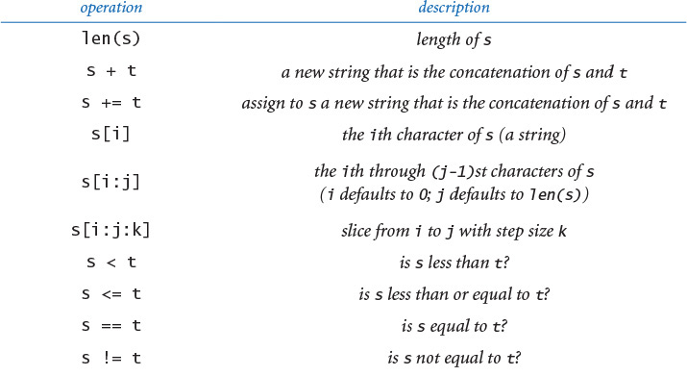
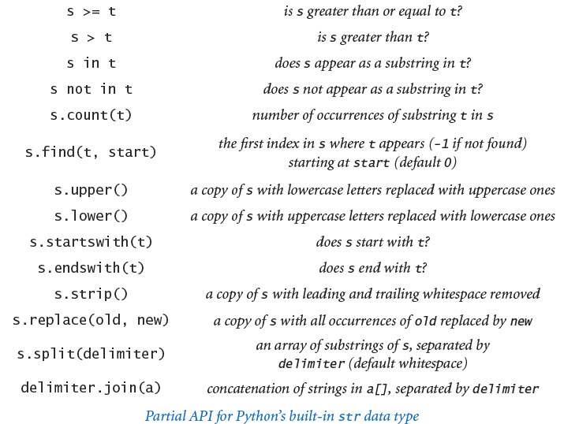
On closer examination, you will see that the operations in the str API can be divided into three categories:
• Built-in operators +, +=, [], [:], in, not in, and the comparison operators, which are characterized by special symbols and syntax
• A built-in function len() with standard function-call syntax
• Methods upper(), startswith(), find(), and so forth, which are distinguished in the API with a variable name followed by the dot operator
From this point forward, any API that we might consider will have these kinds of operations. Next, we consider each of them in turn.
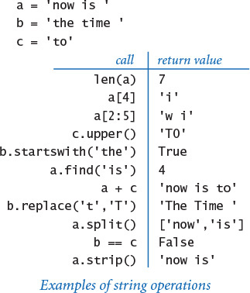

Built-in operators
An operator (or function) that you can apply to more than one type of data is said to be polymorphic. Polymorphism is an important feature of Python programming, and several built-in operators allow you to compose compact code using familiar operators for processing any type of data. You have already been using the + operator, familiar for numbers, for string concatenation. The API tells you that you can use the [] operator, familiar for arrays, to extract a single character from a string and the [:] operator to extract a substring from a string. Not all data types provide implementations for all operators—for example, the operator / is not defined for strings because it makes no sense to divide two strings.

Built-in functions
Python also builds in a number of polymorphic functions, such as the len() function, that are likely to make sense for numerous data types. When a data type implements such a function, Python automatically calls that implementation, based on the type of the argument. Polymorphic functions are like polymorphic operators, but without the special syntax.

Methods
We include built-in operators and built-in functions for convenience (and to conform to Python norms), but most of our effort in creating data types goes into developing methods that operate on object values, such as upper(), startswith(), find(), and the other methods in the str API.
In point of fact, these three kinds of operations end up being the same in implementations, as you will see in SECTION 3.2. Python automatically maps built-in operators and functions to special methods, using the convention that such special methods have double underscores before and after their names. For example, s + t is equivalent to the method call s.__add__(t) and len(s) is equivalent to the method call s.__len__(). We never use the double underscore form in client code, but we do use it to implement special methods, as you will see in SECTION 3.2.
The table below gives several examples of simple string-processing applications that illustrate the utility of the various operations in Python’s str data type. The examples are just an introduction; we examine a more sophisticated client next.
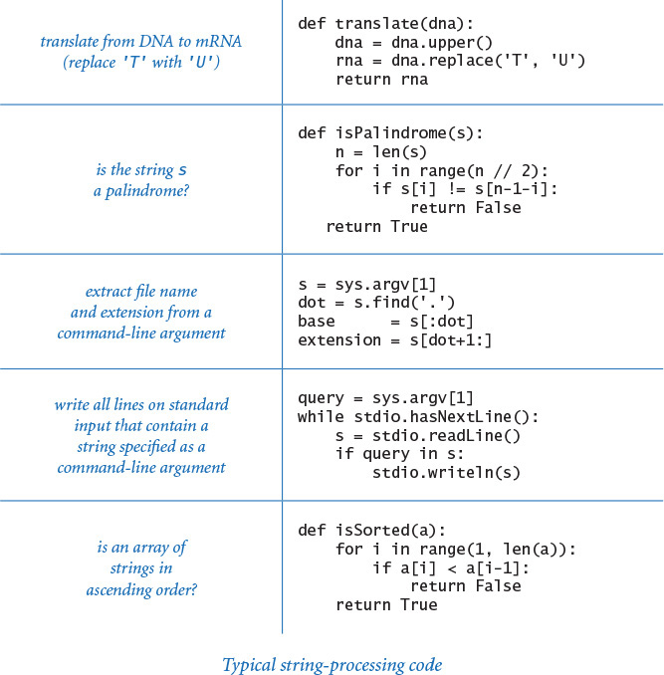

String-processing application: genomics
To give you more experience with string processing, we will give a very brief overview of the field of genomics and consider a program that a bioinformatician might use to identify potential genes. Biologists use a simple model to represent the building blocks of life, in which the letters A, C, T, and G represent the four bases in the DNA of living organisms. In each living organism, these basic building blocks appear in a set of long sequences (one for each chromosome) known as a genome. Understanding properties of the genome is a key to understanding the processes that manifest themselves in living organisms. The genomic sequences for many living things are known, including the human genome, which is a sequence of about 3 billion bases. Since the sequences have been identified, scientists have begun composing computer programs to study their structure. String processing is now one of the most important methodologies—experimental or computational—in molecular biology.

Gene prediction
A gene is a substring of a genome that represents a functional unit of critical importance in understanding life processes. A gene consists of a sequence of codons, each of which is a sequence of three bases that represents one amino acid. The start codon ATG marks the beginning of a gene, and any of the stop codons TAG, TAA, or TGA marks the end of a gene (and no other occurrences of any of these stop codons can appear within the gene). One of the first steps in analyzing a genome is to identify its potential genes, which is a string-processing problem that Python’s str data type equips us to solve.
PROGRAM 3.1.1 (potentialgene.py) is a program that serves as a first step. It takes a DNA sequence as a command-line argument and determines whether it corresponds to a potential gene based on the following criteria: length is a multiple of 3, starts with the start codon, ends with the stop codon, and has no intervening stop codons. To make the determination, the program uses a mixture of string methods, built-in operators, and built-in functions.
Although the rules that define genes are a bit more complicated than those we have sketched here, potentialgene.py exemplifies how a basic knowledge of programming can enable a scientist to study genomic sequences more effectively.
In the present context, our interest in str is that it illustrates what a data type can be—a well-developed encapsulation of an important abstraction that is useful to clients. Python’s language mechanisms, from polymorphic functions and operators to methods that operate on object values, help us achieve that goal. Next, we proceed to numerous other examples.
Program 3.1.1 Identifying a potential gene (potentialgene.py)
Click here to view code image
import sys
import stdio
def isPotentialGene(dna):
# number of bases is a multiple of 3
if (len(dna) % 3) != 0: return False
# starts with start codon
if not dna.startswith('ATG'): return False
# no intervening stop codons
for i in range(len(dna) - 3):
if i % 3 == 0:
if dna[i:i+3] == 'TAA': return False
if dna[i:i+3] == 'TAG': return False
if dna[i:i+3] == 'TGA': return False
# ends with a stop codon
if dna.endswith('TAA'): return True
if dna.endswith('TAG'): return True
if dna.endswith('TGA'): return True
return False
dna = sys.argv[1]
stdio.writeln(isPotentialGene(dna))
This program takes a DNA sequence as a command-line argument and determines whether it corresponds to a potential gene: length is a multiple of 3, starts with the start codon (ATG), ends with a stop codon (TAA or TAG or TGA), and has no intervening stop codons.
Click here to view code image
% python potentialgene.py ATGCGCCTGCGTCTGTACTAG
True
% python potentialgene.py ATGCGCTGCGTCTGTACTAG
False

A user-defined data type
As a running example of a user-defined data type, we will consider a data type Charge for charged particles. In particular, we are interested in a two-dimensional model that uses Coulomb’s law, which tells us that the electric potential at a point due to a given charged particle is represented by V = kq/r, where q is the charge value, r is the distance from the point to the charge, and k =8.99×109 N m2/C2 is a constant known as the electrostatic constant, or Coulomb’s constant. For consistency, we use SI (Système International d’Unités): in this formula, N designates newtons (force), m designates meters (distance), and C represent coulombs (electric charge). When there are multiple charged particles, the electric potential at any point is the sum of the potentials due to each charge. Our interest is computing the potential at various points in the plane due to a given set of charged particles. To do so, we will compose programs that create and manipulate Charge objects.
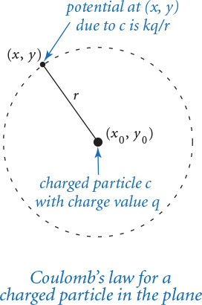

Application programming interface
To fulfill our mantra promise that you do not need to know how a data type is implemented to use it, we specify the behavior of the Charge data type by listing its operations in an API, deferring the discussion of the implementation until SECTION 3.2.
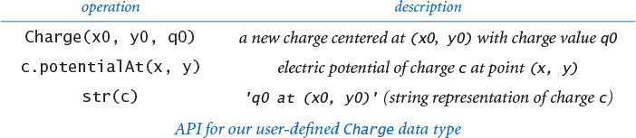
The first entry in the API, which has the same name as the data type, is known as a constructor. Clients call the constructor to create new objects; each call to the Charge constructor creates exactly one new Charge object. The other two entries define the data-type operations. The first is a method potentialAt(), which computes and returns the potential due to the charge at the given point (x, y). The second is the built-in function str(), which returns a string representation of the charged particle. Next, we discuss how to make use of this data type in client code.

File conventions
The code that defines a user-defined data type resides in a .py file. By convention, we define each data type in a distinct .py file, with the same name as the data type (but not capitalized). Thus, the Charge data type is found in a file named charge.py. To compose a client program that uses the Charge data type, we put the following import statement at the top of the client .py file:
from charge import Charge
Note that the format of the import statement that we use with user-defined data types differs from the format we use with functions. As usual, you must make charge.py available to Python, either by putting it in the same directory as your client code or by using your operating system’s path mechanism (see the Q&A at the end of SECTION 2.2).

Creating objects
To create an object from a user-defined data type, you call its constructor, which directs Python to create a new individual object. You call a constructor just as if it were a function, using the name of the data type, followed by the constructor’s arguments enclosed in parentheses and separated by commas. For example, Charge(x0, y0, q0) creates a new Charge object with position (x0, y0) and charge value q0 and returns a reference to the new object. Typically, you call a constructor to create a new object and set a variable to reference that object in the same line of code, as in the example shown in the diagram at right. Once you have created the object, the values x0, y0, and q0 belong to the object. As usual, it is helpful to picture the newly created variable and object as in the memory diagram at right.
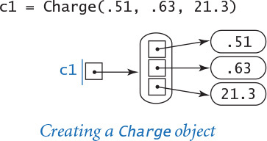
You can create any number of objects of the same data type. Recall from SECTION 1.2 that each object has its own identity, type, and value. So, while any two objects reside at distinct places in computer memory, they may be of the same type and store the same value. For example, the code in the diagram at the top of the next page creates three distinct Charge objects. The variables c1 and c3 reference distinct objects, even though the two objects store the same value. In other words, the objects referenced by c1 and c3 are equal (that is, they are objects of the same data type and they happen to store the same value), but they are not identical (that is, they have distinct identities because they reside in different places in computer memory). In contrast, c2 and c4 refer to the same object—they are aliases.

Calling a method
As discussed at the beginning of this section, we typically use a variable name to identify the object to be associated with the method we intend to call. For our example, the method call c1.potentialAt(.20, .50) returns a float that represents the potential at the query point (0.20, 0.50) due to the Charge object referenced by c1. The distance between the query point and the charge location is 0.34, so this potential is 8.99 × 109 × 0.51 / 0.34 = 1.35 × 1010.
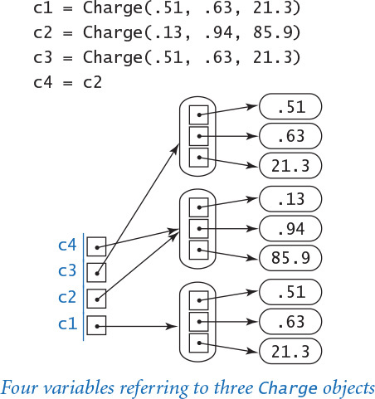

String representation
In any data-type implementation, it is typically worthwhile to include an operation that converts an object’s value to a string. Python has a built-in function str() for this purpose, which you been using from the beginning to convert integers and floats to strings for output. Since our Charge API has a str() implementation, any client can call str() to get a string representation of a Charge object. For our example, the call str(c1) returns the string '21.3 at (0.51, 0.63)'. The nature of the conversion is completely up to the implementation, but usually the string encodes the object’s value in a human-readable format. We will examine the exact mechanism behind this convention when we discuss the implementation, in SECTION 3.2.
These mechanisms are summarized in the client chargeclient.py (PROGRAM 3.1.2), which creates two Charge objects and computes the total potential due to the two charges at a query point taken from the command line. This code illustrates the idea of developing an abstract model (for a charged particle) and separating the code that implements the abstraction (which you haven’t even seen yet) from the code that uses it. This is a turning point in this book: we have not yet seen any code of this nature, but virtually all of the code that we compose from this point forward will be based on defining and invoking methods that implement data-type operations.
Program 3.1.2 Charged-particle client (chargeclient.py)
Click here to view code image
import sys
import stdio
from charge import Charge
x = float(sys.argv[1])
y = float(sys.argv[2])
c1 = Charge(.51, .63, 21.3)
c2 = Charge(.13, .94, 81.9)
v1 = c1.potentialAt(x, y)
v2 = c2.potentialAt(x, y)
stdio.writef('potential at (%.2f, %.2f) due to\n', x, y)
stdio.writeln(' ' + str(c1) + ' and')
stdio.writeln(' ' + str(c2))
stdio.writef('is %.2e\n', v1+v2)
x, y | query point
c1 | first charge
c2 | second charge
v1 | potential due to c1
v2 | potential due to c2
This object-oriented client takes a query point (x, y) as command-line argument, creates two charges c1 and c2 with fixed position and charge values, and writes to standard output the two charges and the potential at (x, y) due to the two charges. The potential at (x, y) is the sum of the potential at (x, y) due to charges c1 and c2.
Click here to view code image
% python chargeclient.py .2 .5
potential at (0.20, 0.50) due to
21.3 at (0.51, 0.63) and
81.9 at (0.13, 0.94)
is 2.22e+12
% python chargeclient.py .51 .94
potential at (0.51, 0.94) due to
21.3 at (0.51, 0.63) and
81.9 at (0.13, 0.94)
is 2.56+12
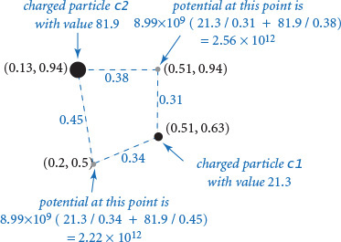
The basic concepts that we have just covered are the starting point for object-oriented programming, so it is worthwhile to review them here. At the conceptual level, a data type is a set of values and a set of operations defined on those values. At the concrete level, we use a data type to create objects. An object is characterized by three essential properties: identity, type, and value.
• The identity of an object is the location in the computer’s memory where the object is stored. It uniquely identifies the object.
• The type of an object completely specifies the behavior of the object—the set of operations that the object supports.
• The value (or state) of an object is the data-type value that it currently represents.
In object-oriented programming, we call constructors to create objects and then manipulate their values by calling their methods. In Python, we access objects through references. A reference is a name that refers to the location in memory (identity) of an object.
The famous Belgian artist René Magritte captured the concept of a reference in the painting The Treachery of Images, where he created an image of a pipe along with the caption ceci n’est pas une pipe (this is not a pipe) below it. We might interpret the caption as saying that the image is not actually a pipe, just an image of a pipe. Or perhaps Magritte meant that the caption is neither a pipe nor an image of a pipe, just a caption! In the present context, this image reinforces the idea that a reference to an object is nothing more than a reference; it is not the object itself.


Similarities between user-defined and built-in data types
In most ways, user-defined data types (that is, the standard, extension, and booksite data types, as well as data types that you might define) are no different from built-in data types such as int, float, bool, and str. You can use objects of any type
• In assignment statements
• As elements in arrays
• As arguments or return values in methods or functions
• As operands with built-in operators such as +, -, *, /,+=, <,<=,>, >=, ==, !=, [], and [:]
• As arguments to built-in functions such as str() and len()
These capabilities enable us to create elegant and understandable client code that directly manipulates our data in a natural manner, as you saw in our str client potentialgene.py and will see in many other examples later in this section.

Differences between user-defined and built-in data types
The built-in types do have special status in Python, notably evidenced by the following considerations:
• You do not need an import statement to use the built-in data types.
• Python provides special syntax for creating objects of built-in data types. For example, the literal 123 creates an int object and the expression ['Hello', 'World'] creates an array whose elements are str objects. In contrast, to create an object of a user-defined data type, we must call a constructor.
• By convention, built-in types begin with lowercase letters while user-defined types begin with uppercase letters.
• Python provides automatic type promotion for built-in arithmetic types, such as from int to float.
• Python provides built-in functions for type conversion to built-in types, including int(), float(), bool(), and str().
To demonstrate the power of object orientation, we next consider several more examples. Our primary purpose in presenting these examples is to get you used to the idea of defining and computing with abstractions, but we also will develop data types that are generally useful and that we use throughout the rest of the book. First, we consider the familiar world of image processing, where we process Color and Picture objects. These are both quintessential abstractions, and we can reduce them to simple data types that allow us to compose programs that process images like the ones that you capture with a camera and view on a display. They are also very useful for scientific visualization, as you will see. Then, we revisit the subject of input/output, moving substantially beyond the features offered by the booksite stdio module. Specifically, we consider abstractions that will allow you to compose Python programs that directly process web pages and files on your computer.

Color
Color is a sensation in the eye attributable to electromagnetic radiation. Since we often want to view and manipulate color images on our computers, color is a widely used abstraction in computer graphics. In professional publishing, in print, and on the web, working with color is a complex task. For example, the appearance of a color image depends in a significant way on the medium used to present it. Our Color data type, defined in the module color.py, separates the creative designer’s problem of specifying a desired color from the system’s problem of faithfully reproducing it. Its API is shown at the bottom of this page.
To represent color values, Color uses the RGB color model, in which a color is defined by three integers, each between 0 and 255, that represent the intensity of the red, green, and blue (respectively) components of the color. Other color values are obtained by mixing the red, green, and blue components. Using this model, we can represent 2563 (that is, approximately 16.7 million) distinct colors. Scientists estimate that the human eye can distinguish only about 10 million distinct colors.
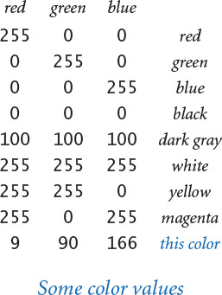
Color has a constructor that takes three integer arguments, so that you can compose the code
Click here to view code image
red = color.Color(255, 0, 0)
blue = color.Color( 0, 0, 255)
to create objects whose values represent pure red and pure blue, respectively. We have been using colors in stddraw since SECTION 1.5, but have been limited to a set of predefined colors, such as stddraw.BLACK, stddraw.RED, and stddraw.PINK. Now you have millions of colors available for your use.
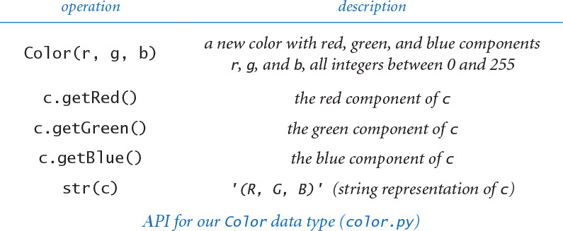
PROGRAM 3.1.3 (alberssquares.py) is a Color and stddraw client that allows you to experiment with colors. The program accepts two colors from the command line, and displays the colors in the format developed in the 1960s by the color theorist Josef Albers, who revolutionized the way that people think about color.
Our primary purpose is to use Color as an example to illustrate object-oriented programming. If you try it for a variety of arguments, you will see that even a simple program like alberssquares.py is a useful and interesting way to study interactions among colors. At the same time, we may as well develop a few useful tools that we can use to compose programs that process colors. Next, we choose one color property as an example to help convince you that composing object-oriented code to process abstract concepts like color is a convenient and useful approach.

Luminance
The quality of the images on modern displays such as LCD monitors, LED TVs, and cellphone screens depends on an understanding of a color property known as monochrome luminance, or effective brightness. A standard formula for luminance is derived from the eye’s sensitivity to red, green, and blue. It is a linear combination of the three intensities: if a color’s red, green, and blue values are r, g, and b, respectively, then its luminance is defined by this formula:
Y = 0.299 r + 0.587g + 0.114b
Since the coefficients are positive and sum to 1 and the intensities are all integers between 0 and 255, the luminance is a real number between 0 and 255.

Grayscale
The RGB color model has the property that when all three color intensities are the same, the resulting color is on a grayscale that ranges from black (all 0s) to white (all 255s). To print a color photograph in a black-and-white newspaper (or a book), we need a function to convert from color to grayscale. A simple way to convert a color to grayscale is to replace the color with a new one whose red, green, and blue values equal its monochrome luminance.
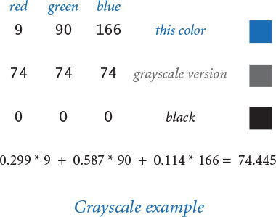
Program 3.1.3 Albers squares (alberssquares.py)
Click here to view code image
import sys
import stddraw
from color import Color
r1 = int(sys.argv[1])
g1 = int(sys.argv[2])
b1 = int(sys.argv[3])
c1 = Color(r1, g1, b1)
r2 = int(sys.argv[4])
g2 = int(sys.argv[5])
b2 = int(sys.argv[6])
c2 = Color(r2, g2, b2)
stddraw.setPenColor(c1)
stddraw.filledSquare(.25, .5, .2)
stddraw.setPenColor(c2)
stddraw.filledSquare(.25, .5, .1)
stddraw.setPenColor(c2)
stddraw.filledSquare(.75, .5, .2)
stddraw.setPenColor(c1)
stddraw.filledSquare(.75, .5, .1)
stddraw.show()
r1, g1, b1 | RGB values
c1 | first color
r2, g2, b2 | RGB values
c2 | second color
This program displays the two colors entered in RGB representation on the command line in the familiar format developed in the 1960s by the color theorist Josef Albers.
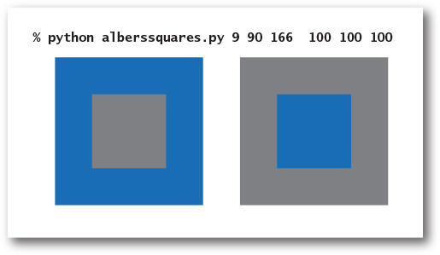

Color compatibility
The luminance value is also crucial in determining whether two colors are compatible, in the sense that printing text in one of the colors on a background in the other color will be readable. A widely used rule of thumb is that the difference between the luminance of the foreground and background colors should be at least 128. For example, black text on a white background has a luminance difference of 255, but black text on a (book) blue background has a luminance difference of only 74. This rule is important in the design of advertising, road signs, websites, and many other applications. PROGRAM 3.1.4 (luminance.py) is a module that we can use to convert a color to grayscale and to test whether two colors are compatible, for example, when we use colors in stddraw applications. The luminance(), toGray(), and areCompatible() functions in luminance.py illustrate the utility of using data types to organize information. Using the Color data type and passing objects as arguments makes these implementations substantially simpler than the alternative of having to pass around the three intensity values. Returning multiple values from a function also would be awkward and more error prone without the Color data type.
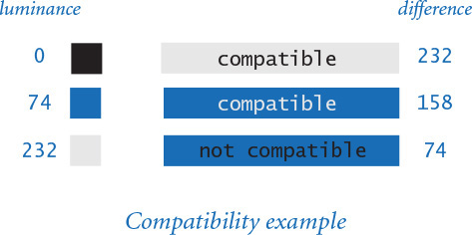
Having an abstraction for color is important not just for direct use, but also in building higher-level data types that have Color values. Next, we illustrate this point by building on the color abstraction to develop a data type that allows us to compose programs to process digital images.
Program 3.1.4 Luminance module (luminance.py)
Click here to view code image
import sys
import stdio
from color import Color
def luminance(c):
red = c.getRed()
green = c.getGreen()
blue = c.getBlue()
return .299*red + .587*green + .114*blue
def toGray(c):
y = int(round(luminance(c)))
return Color(y, y, y)
def areCompatible(c1, c2):
return abs(luminance(c1) - luminance(c2)) >= 128.0
def main():
r1 = int(sys.argv[1])
g1 = int(sys.argv[2])
b1 = int(sys.argv[3])
r2 = int(sys.argv[4])
g2 = int(sys.argv[5])
b2 = int(sys.argv[6])
c1 = Color(r1, g1, b1)
c2 = Color(r2, g2, b2)
stdio.writeln(areCompatible(c1, c2))
if __name__ == '__main__': main()
y | luminance of c
c1 | first color
c2 | second color
This module comprises three important functions for manipulating color: luminance, conversion to gray, and background/foreground compatibility.
Click here to view code image
% python luminance.py 232 232 232 0 0 0
True
% python luminance.py 9 90 166 232 232 232
True
% python luminance.py 9 90 166 0 0 0
False

Digital image processing
You are, of course, familiar with the concept of a photograph. Technically, we might define a photograph as a two-dimensional image created by collecting and focusing visible wavelengths of electromagnetic radiation that constitutes a representation of a scene at a point in time. That technical definition is beyond our scope, except to note that the history of photography is a history of technological development. During the last century, photography was based on chemical processes, but its future is now based in computation. Your mobile device is a computer with lenses and light-sensitive devices capable of capturing images in digital form, and your computer has photo-editing software that allows you to process those images. You can crop them, enlarge and reduce them, adjust the contrast, brighten or darken the images, remove red eye, and perform scores of other operations. Many such operations are remarkably easy to implement, given a simple basic data type that captures the idea of a digital image.

Digital images
We have been using stddraw to plot geometric objects (points, lines, circles, squares) in a window on the computer screen. Which set of values do we need to process digital images, and which operations do we need to perform on those values? The basic abstraction for computer displays is the same one that is used for digital photographs and is very simple: A digital image is a rectangular grid of pixels (picture elements), where the color of each pixel is individually defined. Digital images are sometimes referred to as raster or bitmapped images, in contrast to the types of images we produce with stddraw, which are referred to as vector graphics.
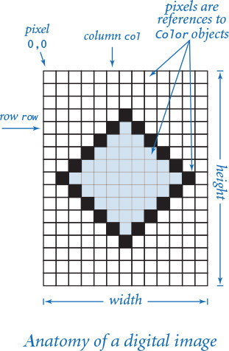
Our Picture data type, defined in the module picture.py, implements the digital image abstraction. The set of values is nothing more than a two-dimensional array of Color values, and the operations are what you might expect: create an image (either a blank one with a given width and height or one initialized from a picture file), set a pixel to a given color, return the color of a given pixel, return the width or the height of the image, show the image in a window on your computer screen, and save the image to a file, as detailed in the API at the top of the next page.
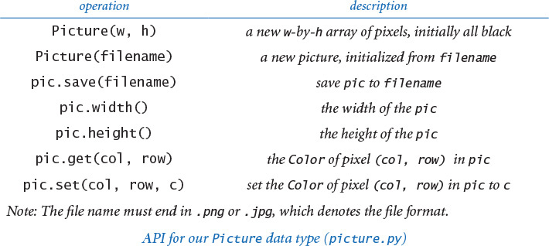
By convention, (0, 0) is the upper leftmost pixel, so the image is laid out as in the customary order for arrays (by contrast, the convention for stddraw is to have the point (0,0) at the lower-left corner, so that drawings are oriented as in the customary manner for Cartesian coordinates). Most image-processing programs are filters that scan through the pixels in a source image as they would a two-dimensional array and then perform some computation to determine the color of each pixel in a target image. The supported file formats are the widely used .png and .jpg formats, so that you can compose programs to process your own photographs and add the results to an album or a website. The Picture data type, together with Color, opens the door to image processing.
Because of the save() method, you can view the images that you create in the same way that you view photographs or other images. In addition, the stddraw module supports a picture() function that allows you to draw a given Picture object in the standard drawing window along with lines, rectangles, circles, and so forth (details in the API below).
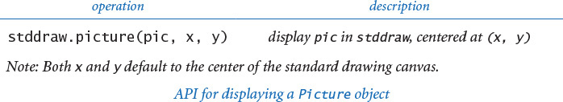

Grayscale
You will find many examples of color images on the booksite, and all of the methods that we describe are effective for full-color images, but all our example images in the text will be grayscale. Accordingly, our first task is to compose a program that can convert images from color to grayscale. This task is a prototypical image-processing task. For each pixel in the source, we have a pixel in the target with a different color. PROGRAM 3.1.5 (grayscale.py) is a filter that takes a file name from the command line and produces a grayscale version of that image. It creates a new Picture object initialized with the color image, then sets the color of each pixel to a new Color having a grayscale value computed by applying the toGray() function in luminance.py (PROGRAM 3.1.4) to the color of the corresponding pixel in the source.

Scaling
One of the most common image-processing tasks is to make an image smaller or larger. Examples of this basic operation, known as scaling, include making small thumbnail photos for use in a chat room or a cellphone, changing the size of a high-resolution photo to make it fit into a specific space in a printed publication or on a web page, or zooming in on a satellite photograph or an image produced by a microscope. In optical systems, we can just move a lens to achieve a desired scale, but in digital imagery, we have to do more work.
In some cases, the strategy is clear. For example, if the target image is to be half the size (in each dimension) of the source image, we simply choose half the pixels—say, by deleting half the rows and half the columns. This technique is known as sampling. If the target image is to be double the size (in each dimension) of the source image, we can replace each source pixel by four target pixels of the same color. Note that we can lose information when we downscale, so halving an image and then doubling it generally does not give back the same image.
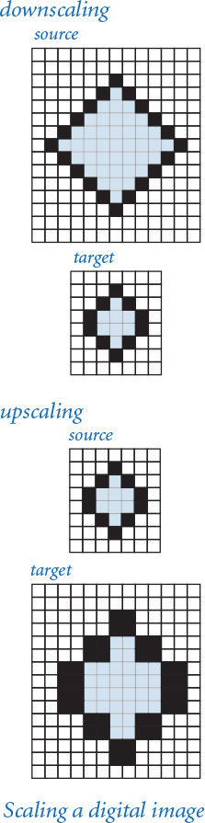
A single strategy is effective for both downscaling and upscaling. Our goal is to produce the target image, so we proceed through the pixels in the target, one by one, scaling each pixel’s coordinates to identify a pixel in the source whose color can be assigned to the target. If the width and height of the source are ws and hs, respectively, and the width and height of the target are wt and ht, respectively, then we scale the column index by ws /wt and the row index by hs /ht. That is, we get the color of the pixel in column c and row r of the target from column c×ws/wt and row r×hs/ht in the source. For example, if we are halving the size of a picture, the scale factors are 2, so the pixel in column 4 and row 6 of the target gets the color of the pixel in column 8 and row 12 of the source; if we are doubling the size of the picture, the scale factors are 1/2, so the pixel in column 4 and column 6 of the target gets the color of the pixel in column 2 and row 3 of the source. PROGRAM 3.1.6 (scale.py) is an implementation of this strategy. More sophisticated strategies can be effective for low-resolution images of the sort that you might find on old web pages or from old cameras. For example, we might downscale to half size by averaging the values of four pixels in the source to make one pixel in the target. For the high-resolution images that are common in most applications today, the simple approach used in scale.py is effective.
Program 3.1.5 Converting color to grayscale (grayscale.py)
Click here to view code image
import sys
import stddraw
import luminance
from picture import Picture
pic = Picture(sys.argv[1])
for col in range(pic.width()):
for row in range(pic.height()):
pixel = pic.get(col, row)
gray = luminance.toGray(pixel)
pic.set(col, row, gray)
stddraw.setCanvasSize(pic.width(), pic.height())
stddraw.picture(pic)
stddraw.show()
pic | image from file
col, row | pixel coordinates
pixel | pixel color
gray | pixel grayscale
This program illustrates a simple image-processing client. First, it creates a Picture object initialized with an image file named by the command-line argument. Then it converts each pixel in the image to grayscale by creating a grayscale version of each pixel’s color and resetting the pixel to that color. Finally, it shows the image. You can perceive individual pixels in the image on the right, which was upscaled from a low-resolution image (see the discussion of scaling starting on the previous page).
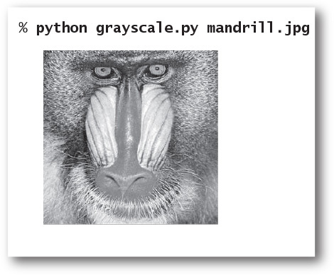
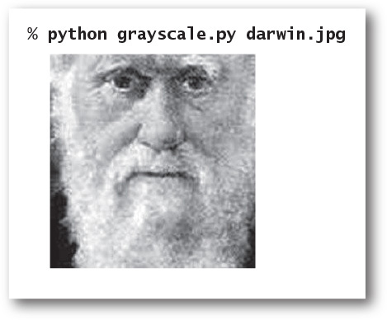
The same basic idea of computing the color value of each target pixel as a function of the color values of specific source pixels is effective for all sorts of image-processing tasks. Next, we consider two more examples, and you will find numerous other examples in the exercises and on the booksite.

Fade effect
Our next image-processing example is an entertaining computation where we transform one image to another in a series of discrete steps. Such a transformation is sometimes known as a fade effect. PROGRAM 3.1.7 (fade.py) is a Picture, Color, and stddraw client that uses a linear interpolation strategy to implement this effect. It computes n–1 intermediate images, with each pixel in the tth image being a weighted average of the corresponding pixels in the source and target. The function blend() implements the interpolation: the source color is weighted by a factor of 1 – t / n and the target color by a factor of t / n (when t is 0, we have the source color; when t is n, we have the target color). This simple computation can produce striking results. When you run fade.py on your computer, the change appears to happen dynamically. Try running it on some images from your photo library. Note that fade.py assumes that the images have the same width and height; if you have images for which this is not the case, you can use scale.py to create a scaled version of one or both of them for fade.py.
Program 3.1.6 Image scaling (scale.py)
Click here to view code image
import sys
import stddraw
from picture import Picture
file = sys.argv[1]
wT = int(sys.argv[2])
hT = int(sys.argv[3])
source = Picture(file)
target = Picture(wT, hT)
for colT in range(wT):
for rowT in range(hT):
colS = colT * source.width() // wT
rowS = rowT * source.height() // hT
target.set(colT, rowT, source.get(colS, rowS))
stddraw.setCanvasSize(wT, hT)
stddraw.picture(target)
stddraw.show()
wT, hT | target dimensions
source | source image
target | target image
colT, rowT | target pixel coords
colS, rowS | source pixel coords
This program accepts the name of either a .jpg or .png image file and two integers wT and hT as command-line arguments and displays the image, scaled to width wT and height hT.
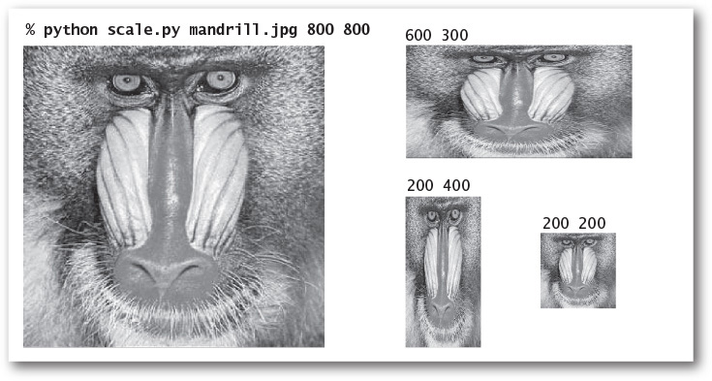
Program 3.1.7 Fade effect (fade.py)
Click here to view code image
import sys
import stddraw
from color import Color
from picture import Picture
def blend(c1, c2, alpha):
r = (1-alpha)*c1.getRed() + alpha*c2.getRed()
g = (1-alpha)*c1.getGreen() + alpha*c2.getGreen()
b = (1-alpha)*c1.getBlue() + alpha*c2.getBlue()
return Color(int(r), int(g), int(b))
sourceFile = sys.argv[1]
targetFile = sys.argv[2]
n = int(sys.argv[3])
source = Picture(sourceFile)
target = Picture(targetFile)
width = source.width()
height = source.height()
stddraw.setCanvasSize(width, height)
pic = Picture(width, height)
for t in range(n+1):
for col in range(width):
for row in range(height):
c0 = source.get(col, row)
cn = target.get(col, row)
alpha = 1.0 * t / n
pic.set(col, row, blend(c0, cn, alpha))
stddraw.picture(pic)
stddraw.show(1000.0)
stddraw.show()
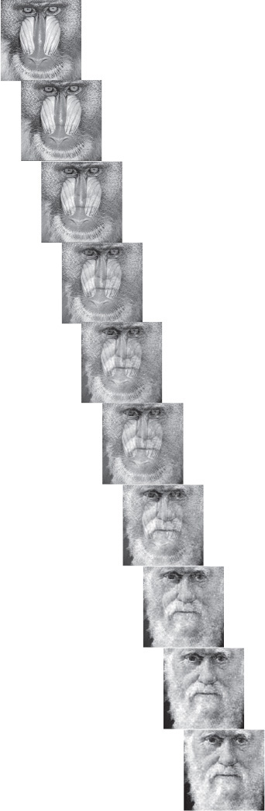
To fade from one image into another in n-1 intermediate steps, we set each pixel in the tth image to a weighted average of the corresponding pixel in the source and the destination, with the source getting weight 1-t/n and the destination getting weight t/n. The example transformation shown at right is produced by python fade.py mandrill.jpg darwin.jpg 9.

Potential value visualization
Image processing is also helpful in scientific visualization. As an example, we consider a Picture client for visualizing properties of a Charge object—that is, an object of data type Charge as defined at the beginning of this section. PROGRAM 3.1.8 (potential.py) visualizes the potential values created by a set of charged particles. First, potential.py creates an array of particles, with values taken from standard input. Next, it creates a Picture object and sets each pixel in the picture to a shade of gray that is proportional to the potential value at the corresponding point. The calculation at the heart of the approach is very simple: for each pixel, we compute corresponding (x, y) values in the unit square, then call potentialAt() for each charge to find the potential at that point due to all of the charges, summing the values returned. With appropriate assignment of potential values to grayscale values (scaling them to fall between 0 and 255), we get a striking visual representation of the electric potential that is an excellent aid to understanding interactions among such particles. We could produce a similar image using filledSquare() in the stddraw module, but the Picture data type provides us with more accurate control over the color of each pixel on the screen. The same basic approach is useful in many other settings—you can find several examples on the booksite.
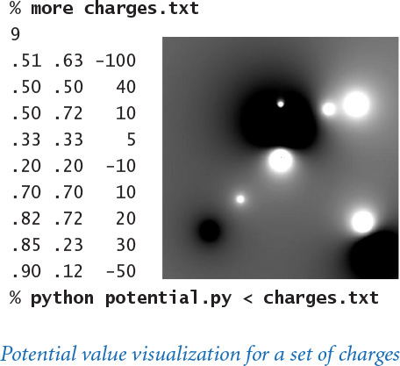
It is worthwhile to reflect briefly on the code in potential.py, because it exemplifies data abstraction and object-oriented programming. We want to produce an image that shows interactions among charged particles, and our code reflects precisely the process of creating that image, using a Picture object for the image (which is manipulated via Color objects) and Charge objects for the particles. When we want information about a Charge, we invoke the appropriate method directly for that Charge; when we want to create a Color, we use a Color constructor; when we want to set a pixel, we directly involve the appropriate method for the Picture. These data types are independently developed, but their use together in a single client is easy and natural. We next consider several more examples, to illustrate the broad reach of data abstraction while at the same time adding a number of useful data types to our basic programming model.
Program 3.1.8 Visualizing electric potential (potential.py)
Click here to view code image
import stddraw
import stdio
import stdarray
from charge import Charge
from color import Color
from picture import Picture
n = stdio.readInt()
charges = stdarray.create1D(n)
for i in range(n):
x0 = stdio.readFloat()
y0 = stdio.readFloat()
q0 = stdio.readFloat()
charges[i] = Charge(x0, y0, q0)
pic = Picture()
for col in range(pic.width()):
for row in range(pic.height()):
x = 1.0 * col / pic.width()
y = 1.0 * row / pic.height()
v = 0.0
for i in range(n):
v += charges[i].potentialAt(x, y)
v = (255 / 2.0) + (v / 2.0e10)
if v < 0: gray = 0
elif v > 255: gray = 255
else: gray = int(v)
color = Color(gray, gray, gray)
pic.set(col, pic.height()-1-row, color)
stddraw.setCanvasSize(pic.width(), pic.height())
stddraw.picture(pic)
stddraw.show()
n | number of charges
charges[] | array of charges
x0, y0 | charge position
q0 | charge value
col, row | pixel position
x, y | point in unit square
gray | scaled potential value
color | pixel color
This program reads values from standard input to create an array of charged particles, sets each pixel color in an image to a grayscale value proportional to the total of the potentials due to the particles at corresponding points, and shows the resulting image.

Input and output revisited
In SECTION 1.5, you learned how to read and write numbers and text using our stdio module. You have certainly come to appreciate the utility of these mechanisms in getting information into and out of your programs. One reason that they are convenient is that the “standard” conventions make them accessible from anywhere within a program. One disadvantage of these conventions is that they leave us dependent upon the operating system’s piping and redirection mechanism for access to files, and they restrict us to working with just one input file and one output file for any given program. With object-oriented programming, we can define mechanisms that are similar to stdio but allow us to work with multiple input streams and output streams within one program.
Specifically, we define in this section the data types InStream and OutStream for input streams and output streams, respectively. As usual, you must make instream.py and outstream.py available to Python, either by putting them in the same directory as your client code or by using your operating system’s path mechanism (see the Q&A at the end of SECTION 2.2).
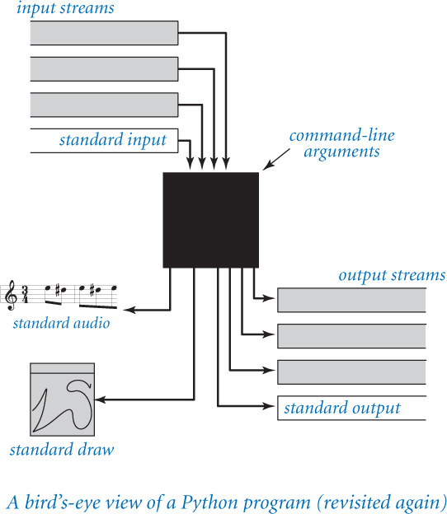
The purpose of InStream and OutStream is to provide the flexibility that we need to address many common data-processing tasks within our Python programs. Rather than being restricted to just one input stream and one output stream, we can readily create multiple objects of each data type, connecting the streams to various sources and destinations. We also get the flexibility to set variables to reference such objects, pass them as arguments to or return values from functions or methods, and create arrays of them, manipulating them just as we manipulate objects of any data type. We will consider several examples of their use after we have presented the APIs.

Input stream data type
Our data type InStream, defined in the module instream.py, is a more general version of the reading aspects of stdio that supports reading numbers and text from files and websites as well as the standard input stream. The API is shown at the bottom of this page.
Instead of being restricted to one abstract input stream (standard input), this data type gives you the ability to specify directly the source of an input stream. Moreover, that source can be either a file or a website. When you call the InStream constructor with a string argument, the constructor first tries to find a file on your local computer with that name. If it cannot do so, it assumes the argument is a website name and tries to connect to that website. (If no such website exists, it raises an IOError at run time.) In either case, the specified file or website becomes the source of the input for the InStream object thus created, and the read*() methods will read input from that stream.
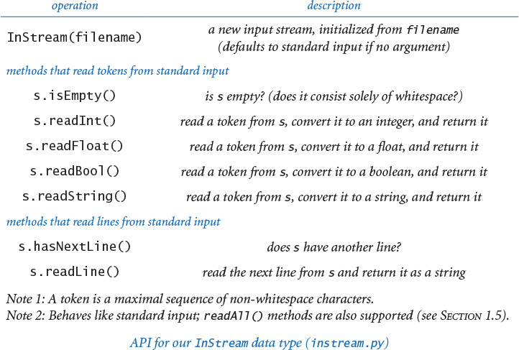
This arrangement makes it possible to process multiple files within the same program. Moreover, the ability to directly access the web opens up the whole web as potential input for your programs. For example, it allows you to process data that is provided and maintained by someone else. You can find such files all over the web. Scientists now regularly post data files with measurements or results of experiments, ranging from genome and protein sequences to satellite photographs to astronomical observations; financial services companies, such as stock exchanges, regularly publish on the web detailed information about the performance of stock and other financial instruments; governments publish election results; and so forth. Now you can compose Python programs that read these kinds of files directly. The InStream data type gives you a great deal of flexibility to take advantage of the multitude of data sources that are now available.

Output stream data type
Similarly, our data type OutStream, defined in the module outstream.py, is a more general version of the writing aspect of stdio that supports writing strings to a variety of output streams, including standard output and files. Again, the API specifies the same methods as its stdio counterpart. You specify the file that you want to use for output by using the one-argument constructor with the file’s name as argument. OutStream interprets this string as the name of a new file on your local computer, and sends its output there. If you provide no argument to the constructor, then you obtain standard output.
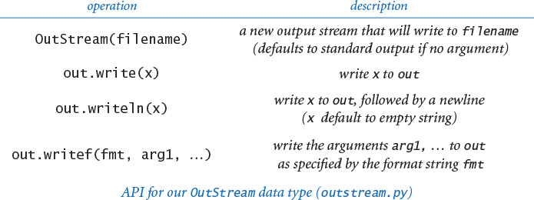
Program 3.1.9 Concatenating files (cat.py)
Click here to view code image
import sys
from instream import InStream
from outstream import OutStream
inFilenames = sys.argv[1:len(sys.argv)-1]
outFilename = sys.argv[len(sys.argv)-1]
outstream = OutStream(outFilename)
for filename in inFilenames:
instream = InStream(filename)
s = instream.readAll()
outstream.write(s)
outstream | output stream
filename | current file name
instream | current input stream
s | contents of filename
This program creates an output file whose name is given by the last command-line argument and whose contents are copies of the input files whose names are given as the other arguments.
% more in1.txt
This is
% more in2.txt
a tiny
test.
Click here to view code image
% python cat.py in1.txt in2.txt out.txt
% more out.txt
This is
a tiny
test.

File concatenation and filtering
PROGRAM 3.1.9 (cat.py) is a sample client of InStream and OutStream that uses multiple input streams to concatenate several input files into a single output file. Some operating systems have a command known as cat that implements this function. However, a Python program that does the same thing is perhaps more useful, because we can tailor it to filter the input files in various ways: we might wish to ignore irrelevant information, change the format, or select only some of the data, to name just a few examples. We now consider one example of such processing, and you can find several others in the exercises.

Screen scraping
The combination of InStream (which allows us to create an input stream from any page on the web) and str (which provides powerful tools for processing text strings) opens up the entire web to direct access by our Python programs, without any direct dependence on the operating system or the browser. One paradigm is known as screen scraping: the goal is to extract some information from a web page with a program rather than having to browse to find it. To do so, we take advantage of the fact that many web pages are defined with text files in a highly structured format (because they are created by computer programs!). Your browser has a mechanism that allows you to examine the source code that produces the web page that you are viewing, and by examining that source you can often figure out what to do.
Click here to view code image
...
(GOOG)</h2> <span class="rtq_
exch"><span class="rtq_dash">-</span>
NMS </span><span class="wl_sign">
</span></div></div>
<div class="yfi_rt_quote_summary_rt_top
sigfig_promo_1"><div>
<span class="time_rtq_ticker">
<span id="yfs_l84goog">1,100.62</span>
</span> <span class="down_r time_rtq_
content"><span id="yfs_c63_goog">
...
HTML code from the web
Suppose that we want to take a stock trading symbol as a command-line argument and write out its current trading price. Such information is published on the web by financial service companies and internet service providers. For example, you can find the stock price of a company whose symbol is goog by browsing to http://finance.yahoo.com/q?s=goog. Like many web pages, the name encodes an argument (goog), and we could substitute any other ticker symbol to get a web page with financial information for any other company. Also, like many other files on the web, the referenced file is a text file, written in a formatting language known as HTML. From the point of view of a Python program, it is just a str value accessible through an InStream object. You can use your browser to download the source of that file, or you could use
Click here to view code image
python cat.py "http://finance.yahoo.com/q?s=goog" mycopy.txt
to put the source into a local file mycopy.txt on your computer (though there is no real need to do so). Now, suppose that goog is trading at $1,100.62 at the moment. If you search for the string '1,100.62' in the source of that page, you will find the stock price buried within some HTML code. Without having to know details of HTML, you can figure out something about the context in which the price appears. In this case, you can see that the stock price is enclosed between the substrings <span id="yfs_l84goog"> and </span>.
Program 3.1.10 Screen scraping for stock quotes (stockquote.py)
Click here to view code image
import sys
import stdio
from instream import InStream
def _readHTML(stockSymbol):
WEBSITE = 'http://finance.yahoo.com/q?s='
page = InStream(WEBSITE + stockSymbol)
html = page.readAll()
return html
def priceOf(stockSymbol):
html = _readHTML(stockSymbol)
trade = html.find('yfs_l84', 0)
beg = html.find('>', trade)
end = html.find('</span>', beg)
price = html[beg+1:end]
price = price.replace(',', '')
return float(price)
def main():
stockSymbol = sys.argv[1]
price = priceOf(stockSymbol)
stdio.writef('%.2f\n', price)
if __name__ == '__main__': main()
page | input stream
html | contents of page
trade | yfs_l84 index
beg | > after trade index
end | </span> after to index
price | current price
This program accepts a stock ticker symbol as a command-line argument and writes to standard output the current stock price for that stock, as reported by the website http://finance.yahoo.com. It uses string slicing and the find() and replace() methods from str.
% python stockquote.py goog
1100.62
% python stockquote.py adbe
70.51
With the str data type’s find() method and string slicing, you easily can grab this information, as illustrated in stockquote.py (PROGRAM 3.1.10). This program depends on the web page format used by http://finance.yahoo.com; if this format changes, stockquote.py will not work. Indeed, by the time you read this page, the format may have changed. Still, making appropriate changes is not likely to be difficult. You can entertain yourself by embellishing stockquote.py in all kinds of interesting ways. For example, you could grab the stock price on a periodic basis and plot it, compute a moving average, or save the results to a file for later analysis. Of course, the same technique works for sources of data found all over the web, as you can see in examples in the exercises at the end of this section and on the booksite.

Extracting data
The ability to maintain multiple input and output streams gives us a great deal of flexibility in meeting the challenges of processing large amounts of data coming from a variety of sources. We now consider one more example. Suppose that a scientist or a financial analyst has a large amount of data within a spreadsheet program. Typically such spreadsheets are tables with a relatively large number of rows and a relatively small number of columns. You are not likely to be interested in all the data in the spreadsheet, but you may be interested in a few of the columns. You can do some calculations within the spreadsheet program (this is its purpose, after all), but you certainly do not have the flexibility that you can realize with Python programming. One way to address this situation is to have the spreadsheet export the data to a text file, using some special character to delimit the columns, and then compose a Python program that reads the file from an input stream. One standard practice is to use commas as delimiters: write one line per row, with commas separating column entries. Such files are known as comma-separated-value or .csv files. With the split() method in Python’s str data type, we can read the file line-by-line and isolate the data that we want. We will see several examples of this approach later in the book. PROGRAM 3.1.11 (split.py) is an InStream and OutStream client that goes one step further: it creates multiple output streams and makes one file for each column.
These examples are convincing illustrations of the utility of working with text files, with multiple input and output streams, and with direct access to web pages. Web pages are written in HTML precisely so that they will be accessible to any program that can read strings. People use text formats such as .csv files rather than data formats that are beholden to particular applications precisely to allow as many people as possible to access the data with simple programs like split.py.
Program 3.1.11 Splitting a file (split.py)
Click here to view code image
import sys
import stdarray
from instream import InStream
from outstream import OutStream
basename = sys.argv[1]
n = int(sys.argv[2])
instream = InStream(basename + '.csv')
out = stdarray.create1D(n)
for i in range(n):
out[i] = OutStream(basename + str(i) + '.txt')
while instream.hasNextLine():
line = instream.readLine()
fields = line.split(',')
for i in range(n):
out[i].writeln(fields[i])
basename | base file name
n | number of fields
instream | input stream
out[] | output streams
line | current line
fields[] | values in current line
This program uses multiple output streams to split a .csv file into separate files, one for each comma-delimited field. It accepts a string basename and an integer n as command-line arguments and splits the file whose name is basename.csv, by field (comma-separated), into n files named basename0.txt, basename1.txt, and so forth.
Click here to view code image
% more djia.csv
...
31-Oct-29,264.97,7150000,273.51
30-Oct-29,230.98,10730000,258.47
29-Oct-29,252.38,16410000,230.07
28-Oct-29,295.18,9210000,260.64
25-Oct-29,299.47,5920000,301.22
24-Oct-29,305.85,12900000,299.47
23-Oct-29,326.51,6370000,305.85
22-Oct-29,322.03,4130000,326.51
21-Oct-29,323.87,6090000,320.91
...
% python split.py djia 4
% more djia2.txt
...
7150000
10730000
16410000
9210000
5920000
12900000
6370000
4130000
6090000
...

Memory management
Now that you have seen several examples of object-oriented data types (str, Charge, Color, Picture, InStream, and Outstream) and client programs that use them, we can discuss in more detail the challenges Python faces in providing support for such programs. To a large extent, Python protects novice programmers from having to know these details, but having some idea of what is going on inside the system is sometimes helpful in writing correct, effective, and efficient object-oriented programs.
In Python, we create objects by calling a constructor. Each time we create an object, Python reserves computer memory for that object. But when and how do we destroy objects so that the memory in which they reside can be freed for reuse? We will briefly address this question.

Orphaned objects
The ability to bind a variable to a different object creates the possibility that a program may have created an object that it can no longer reference. For example, consider the three assignment statements in the figure at right. After the third assignment statement, not only do c1 and c2 refer to the same Charge object (the one at (.51, .63) with potential 21.3), but there is also no longer a reference to the Charge object that was created and used to initialize c2. The only reference to that object was in the variable c2, and this reference was overwritten by the assignment, so there is no way to refer to the object again. Such an object is said to be an orphan. Objects can also become orphans when variables go out of scope. Python programmers pay little attention to orphaned objects because the system automatically reuses the memory that they occupy, as we discuss next.
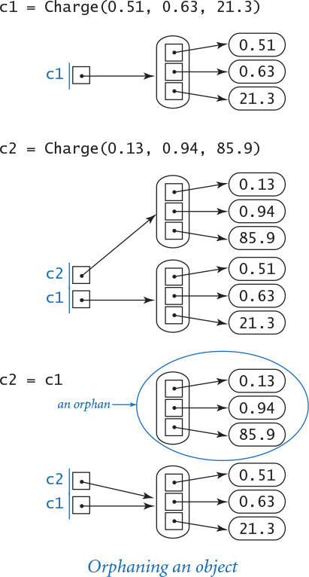

Memory management
Programs tend to create huge numbers of objects but have a need for only a small number of them at any given time. Accordingly, programming languages and systems need mechanisms to create objects (and allocate memory), and mechanisms to destroy objects (and free memory) when the objects become orphans. Most programming systems take care of allocating memory for variables when they come into existence and freeing that memory when they go out of scope. Memory management for objects is more complicated: Python knows to allocate memory for an object when it is created, but cannot know precisely when to free the memory associated with an object, because the dynamics of a program in execution determine when an object becomes an orphan and so should be destroyed. There is no way for the system to predict what a program will do, so it has to monitor what a program is doing and take action accordingly.

Memory leaks
In many languages (such as C and C++), the programmer is responsible for both allocating and deallocating memory. Doing so is tedious and notoriously error-prone. For example, suppose that a program deallocates the memory for an object, but then continues to refer to it (perhaps much later in the program). In the meantime, the system may have reallocated the same memory for another use, so all kinds of havoc can result. Another insidious problem occurs when a programmer neglects to ensure that the memory for an orphaned object is deallocated. This bug is known as a memory leak because it can result in a steadily increasing amount of memory devoted to orphaned objects (and therefore not available for use). The effect is that performance degrades, just as if memory were leaking out of your computer. Have you ever had to reboot your computer because it was gradually getting less and less responsive? A common cause of such behavior is a memory leak in one of your applications.

Garbage collection
One of Python’s most significant features is its ability to automatically manage memory. The idea is to free the programmers from the responsibility of managing memory by keeping track of orphaned objects and returning the memory they use to a pool of free memory. Reclaiming memory in this way is known as garbage collection, and Python’s type system enables it to perform this operation this efficiently and automatically. Garbage collection is an old idea, and some people still debate whether the overhead of automatic garbage collection justifies the convenience of not having to worry about memory management. But many other people (including Python and Java programmers, for example) very much enjoy the benefits of not having to worry about memory management and memory leaks.
For reference, we summarize the data types that we have considered in this section in the table at right. We chose these examples to help you understand the essential properties of data types and object-oriented programming.
A data type is a set of values and a set of operations defined on those values. With built-in numeric types, we worked with a small and simple set of values. Colors, pictures, strings, and input/output streams are high-level data types that indicate the breadth of applicability of data abstraction. You do not need to know how a data type is implemented to be able to use it. Each data type (there are hundreds in Python’s standard and extension modules, and you will soon learn to create your own) is characterized by an API (application programming interface) that provides the information that you need to use it. A client program creates objects that hold data-type values and calls methods to manipulate those values. We compose client programs with the basic statements and control structures that you learned in CHAPTERS 1 and 2, but now have the capability to work with a vast variety of data types, not just the built-in ones to which you have grown accustomed. With experience, you will find that this ability opens up new horizons in programming.
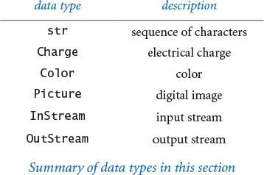
Our Charge example demonstrated that you can tailor one or more data types to the needs of your application. The ability to do so is a profound benefit, and also is the subject of the next section. When properly designed and implemented, data types lead to client programs that are clearer, easier to develop, and easier to maintain than equivalent programs that do not take advantage of data abstraction. The client programs in this section are testimony to this claim. Moreover, as you will see in the next section, implementing a data type is a straightforward application of the basic programming skills that you have already learned. In particular, addressing a large and complex application becomes a process of understanding its data and the operations to be performed on it, then composing programs that directly reflect this understanding. Once you have learned to do so, you might wonder how programmers ever developed large programs without using data abstraction.

Q&A
Q. What happens if I call a method that is not defined for a given object?
A. Python raises an AttributeError at run time.
Q. Why can we use stdio.writeln(x) instead of stdio.writeln(str(x)) to write an object x that is not a string?
A. For convenience, the stdio.writeln() function calls the built-in str() function automatically whenever a string object is needed.
Q. I noticed that potential.py (PROGRAM 3.1.8) calls stdarray.create1D() to create an array of Charge objects, but provides only one argument (the desired number of elements). Doesn’t stdarray.create1D() require that I provide two arguments: the desired number of elements and the initial value of the elements?
A. If no initial value is specified, both stddarray.create1D() and stdarray.create2D() use the special value None, which refers to no object. Immediately after calling stdarray.create1D(), potential.py changes each array element so it refers to a new Charge object.
Q. Can I call a method with a literal or other expression?
A. Yes, from the client’s point of view, you can use any expression to invoke a method. When Python executes the method call, it evaluates the expression and calls the method on the resulting object. For example, 'python'.upper() returns ‘Python' and (3 ** 100).bit_length() returns 159. However, you need to be careful with integer literals—for example, 1023.bit_length() raises a SyntaxError because Python interprets 1023. as a floating-point literal; instead, you can use (1023).bit_length().
Q. Can I chain together several string method calls in one expression?
A. Yes. For example, the expression s.strip().lower() works as expected. That is, it evaluates to a new string that is a copy of s with leading and trailing whitespace removed, and with all remaining characters converted to lowercase. It works because (1) each of the methods returns its result as a string and (2) the dot operator is left associative, so Python calls the methods from left to right.
Q. Why red, green, and blue instead of red, yellow, and blue?
A. In theory, any three colors that contain some amount of each primary color would work, but two different color models have evolved: RGB produces good colors on television screens, computer monitors, and digital cameras, and CMYK is typically used for the printed page (see EXERCISE 1.2.28). CMYK does include yellow (cyan, magenta, yellow, and black). Two different schemes are appropriate because printed inks absorb color; thus, where there are two different inks, there are more colors absorbed and fewer reflected. In contrast, video displays emit color; thus, where there are two different colored pixels, there are more colors emitted.
Q. Is there any problem with creating thousands of Color objects, as in grayscale.py (PROGRAM 3.1.5)? It seems wasteful.
A. All programming-language constructs come at some cost. In this case the cost is reasonable, since the time required to create the Color objects is tiny compared to the time required to actually draw the picture.
Q. Can a data type have two methods (or constructors) with the same name but with a different number of arguments?
A. No, just as with functions, you cannot have two methods (or constructors) with the same name. As with functions, methods (and constructors) can use optional arguments with default values. This is how the Picture data type creates the illusion of having two constructors.

Exercises
3.1.1 Compose a program that takes a float command-line argument w, creates four Charge objects that are each distance w in each of the four cardinal directions from (0.5, 0.5), and writes the potential at (0.25, 0.5).
3.1.2 Compose a program that takes from the command line three integers between 0 and 255 that represent red, green, and blue values of a color and then creates and shows a 256-by-256 Picture of that color.
3.1.3 Modify alberssquares.py (PROGRAM 3.1.3) to take nine command-line arguments that specify three colors and then draw the six squares showing all the Albers squares with the large square in each color and the small square in each different color.
3.1.4 Compose a program that takes the name of a grayscale picture file as a command-line argument and uses stddraw to plot a histogram of the frequency of occurrence of each of the 256 grayscale intensities.
3.1.5 Compose a program that takes the name of a picture file as a command-line argument and flips the image horizontally.
3.1.6 Compose a program that takes the name of a picture file as a command-line input, and creates three images—one with only the red components, one with only the green components, and one with only the blue components.
3.1.7 Compose a program that takes the name of a picture file as a command-line argument and writes the pixel coordinates of the lower-left corner and the upper-right corner of the smallest bounding box (rectangle parallel to the x- and y-axes) that contains all of the non-white pixels.
3.1.8 Compose a program that takes as command-line arguments the name of a picture file and the pixel coordinates of a rectangle within the image; reads from standard input a list of Color values (represented as triples of integers); and serves as a filter, writing those Color values for which all pixels in the rectangle are background/foreground compatible. (Such a filter can be used to pick a color for text to label an image.)
3.1.9 Compose a function isValidDNA() that takes a string as its argument and returns True if and only if it consists entirely of the characters A, C, T, and G.
3.1.10 Compose a function complementWC() that takes a DNA string as its argument and returns its Watson–Crick complement: replace A with T, and C with G, and vice versa.
3.1.11 Compose a function palindromeWC() that takes a DNA string as its argument and returns True if the string is a Watson–Crick complemented palindrome, and False otherwise. A Watson–Crick complemented palindrome is a DNA string that is equal to the reverse of its Watson–Crick complement.
3.1.12 Compose a program to check whether an ISBN number is valid (see EXERCISE 1.3.33), taking into account that an ISBN number can have hyphens inserted at arbitrary places.
3.1.13 What does the following code fragment write?
s = 'Hello World'
s.upper()
s[6:11]
stdio.writeln(s)
Solution: 'Hello World'. String objects are immutable—a string method returns a new str object with the appropriate value, but does not change the value of the string that was used to invoke it. Therefore, this code ignores the objects returned and just writes the original string. To update s, write s = s.upper() and s = s[6:11].
3.1.14 A string s is a circular shift of a string t if it matches when the characters are circularly shifted by any number of positions. For example, ACTGACG is a circular shift of TGACGAC, and vice versa. Detecting this condition is important in the study of genomic sequences. Compose a function that checks whether two given strings s and t are circular shifts of one another. Hint: The solution is a one-liner with the in operator and string concatenation.
3.1.15 Given a string that represents a website URL, compose a code fragment that determines its domain type. For example, the domain type for our booksite URL http://introcs.cs.princeton.edu/python is edu.
3.1.16 Compose a function that takes a domain name as an argument and returns the reverse domain (reverse the order of the strings between periods). For example, the reverse domain of introcs.cs.princeton.edu is edu.princeton.cs.introcs. This computation is useful for web log analysis. (See EXERCISE 4.2.33.)
3.1.17 What does the following recursive function return?
Click here to view code image
def mystery(s):
n = len(s)
if (n <= 1): return s
a = s[0 : n//2]
b = s[n//2 : n]
return mystery(b) + mystery(a)
3.1.18 Compose a version of potentialgene.py (PROGRAM 3.1.1) that finds all potential genes contained in a long DNA string. Add a command-line argument to allow the user to specify a minimum length of a potential gene.
3.1.19 Compose a program that takes a start string and a stop string as command-line arguments and writes all substrings of a given string that start with the first, end with the second, and otherwise contain neither. Note: Be especially careful of overlaps!
3.1.20 Compose a filter that reads text from an input stream and writes it to an output stream, removing any lines that consist only of whitespace.
3.1.21 Modify potential.py (PROGRAM 3.1.8) to take an integer n from the command line and generate n random Charge objects in the unit square, with potential values drawn randomly from a Gaussian distribution with mean 50 and standard deviation 10.
3.1.22 Modify stockquote.py (PROGRAM 3.1.10) to take multiple symbols on the command line.
3.1.23 The example file djia.csv used for split.py (PROGRAM 3.1.11) lists the date, high price, volume, and low price of the Dow Jones stock market average for every day since records have been kept. Download this file from the booksite and compose a program that plots the prices and volumes, at a rate taken from the command line.
3.1.24 Compose a program merge.py that takes a delimiter string followed by an arbitrary number of file names as command-line arguments; concatenates the corresponding lines of each file, separated by the delimiter; and then writes the result to standard output, thus performing the opposite operation from split.py (PROGRAM 3.1.11).
3.1.25 Find a website that publishes the current temperature in your area, and write a screen-scraper program weather.py so that typing python weather.py followed by your ZIP code will give you a weather forecast.

Creative Exercises
3.1.26 Picture filtering. Compose a module rawpicture.py with read() and write() functions for use with standard input and standard output. The write() function takes a Picture as argument and writes the picture to standard output, using the following format: if the picture is w-by-h, write w, then h, then w*h triples of integers representing the pixel color values, in row-major order. The read() function takes no arguments and returns a Picture, which it creates by reading a picture from standard input, in the format just described. Note: The picture filtering will use up much more disk space than the picture—the standard formats compress this information so that it will not take up so much space.
3.1.27 Kama Sutra cipher. Compose a filter KamaSutra that takes two strings as command-line argument (the key strings), then reads standard input, substitutes for each letter as specified by the key strings, and writes the result to standard output. This operation is the basis for one of the earliest known cryptographic systems. The condition on the key strings is that they must be of equal length and that any letter in standard input must be in one of them. For example, if input is all capitals and the keys are THEQUICKBROWN and FXJMPSVRLZYDG, then we make this table:
T H E Q U I C K B R O W N
F X J M P S V L A Z Y D G
That is, we should substitute F for T, T for F, H for X, X for H, and so forth when copying the input to the output. The message is encoded by replacing each letter with its pair. For example, the message MEET AT ELEVEN is encoded as QJJF BF JKJCJG. Someone receiving the message can use the same keys to get the message back.
3.1.28 Safe password verification. Compose a function that takes a string as an argument and returns True if it meets the following conditions, False otherwise:
• At least eight characters long
• Contains at least one digit (0–9)
• Contains at least one uppercase letter
• Contains at least one lowercase letter
• Contains at least one character that is neither a letter nor a number
Such checks are commonly used for passwords on the web.
3.1.29 Sound visualization. Compose a program that uses stdaudio and Picture to create an interesting two-dimensional color visualization of a sound file while it is playing. Be creative!
3.1.30 Color study. Compose a program that displays the color study shown at right, which gives Albers squares corresponding to each of the 256 levels of blue (blue-to-white in row-major order) and gray (black-to-white in column-major order) that were used to print this book.
3.1.31 Entropy. The Shannon entropy measures the information content of an input string and plays a cornerstone role in information theory and data compression. Given a string of n characters, let fc be the frequency of occurrence of character c. The quantity pc = fc / n is an estimate of the probability that c would be in the string if it were a random string, and the entropy is defined to be the sum of the quantity –pc log2 pc, over all characters that appear in the string. The entropy is said to measure the information content of a string: if each character appears the same number of times, the entropy is at its minimum value. Compose a program that computes and writes to standard output the entropy of the string read from standard input. Run your program on a web page that you read regularly, on a recent paper that you wrote, and on the fruit fly genome found on the website.
3.1.32 Minimize potential. Compose a function that takes an array of Charge objects with positive potential as its argument and finds a point such that the potential at that point is within 1% of the minimum potential anywhere in the unit square. Compose a test client that calls your function to write the point coordinates and charge value for the data given in the text and for the random charges described in EXERCISE 3.1.21.

3.1.33 Slide show. Compose a program that takes the names of several image files as command-line arguments and displays them in a slide show (one every two seconds), using a fade effect to black and a fade from black between pictures.
3.1.34 Tile. Compose a program that takes the name of an image file and two integers m and n as command-line arguments and creates an m-by-n tiling of the picture.
3.1.35 Rotation filter. Compose a program that takes two command-line arguments (the name of an image file and a real number theta) and rotates the image θ degrees counterclockwise. To rotate, copy the color of each pixel (si, s j) in the source image to a target pixel (ti, t j) whose coordinates are given by the following formulas:
ti = (si – ci)cos θ – (sj – cj)sin θ + ci
tj = (si – ci)sin θ + (sj – cj)cos θ + cj
where (c i, c j) is the center of the image.
3.1.36 Swirl filter. Creating a swirl effect is similar to rotation, except that the angle changes as a function of distance to the center. Use the same formulas as in the previous exercise, but compute θ as a function of (si, s j)—specifically, π / 256 times the distance to the center.
3.1.37 Wave filter. Compose a filter like those in the previous two exercises that creates a wave effect, by copying the color of each pixel (si, s j) in the source image to a target pixel (ti, t j), where ti = si and tj = sj +20 sin(2 π si /64). Add code to take the amplitude (20 in the accompanying figure) and the frequency (64 in the accompanying figure) as command-line arguments. Experiment with various values of these parameters.
3.1.38 Glass filter. Compose a program that takes the name of an image file as a command-line argument and applies a glass filter: set each pixel p to the color of a random neighboring pixel (whose pixel coordinates are each within 5 pixels of p’s coordinates).
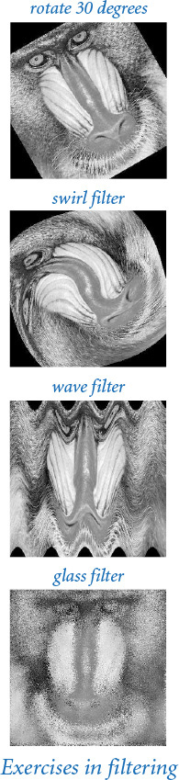
3.1.39 Morph. The example images in the text for fade.py do not quite line up in the vertical direction (the mandrill’s mouth is much lower than Darwin’s mouth). Modify fade.py to add a transformation in the vertical dimension that makes a smoother transition.
3.1.40 Clusters. Compose a program that takes the name of a picture file from the command line and produces and displays to stddraw a picture with filled circles that cover compatible areas. First, scan the image to determine the background color (a dominant color that is found in more than half the pixels). Use a depth-first search (see PROGRAM 2.4.6) to find contiguous sets of pixels that are foreground-compatible with the background. A scientist might use a program to study natural scenarios such as birds in flight or particles in motion. Take a photo of balls on a billiards table and try to get your program to identify the balls and positions.
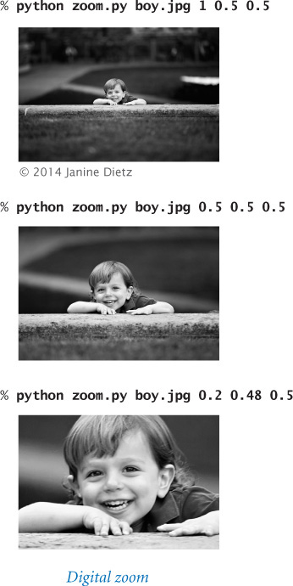
3.1.41 Digital zoom. Compose a program zoom.py that takes the name of a picture file and three floats s, x, and y as command-line arguments and displays a picture that zooms in on a portion of the input picture. The numbers should all be between 0 and 1, with s to be interpreted as a scale factor and (x, y) as the relative coordinates of the point that is to be at the center of the output image. Use this program to zoom in on your pet, friend, or relative in some digital image on your computer.

3.2 Creating Data Types
In principle, we could compose all of our programs using only built-in data types. However, as we saw in the last section, it is much more convenient to compose programs at a higher level of abstraction. Thus, many other data types are defined in Python’s standard and extension modules. Still, we certainly cannot expect those modules to define every conceivable data type that we might ever wish to use, so we need to be able to define our own. The purpose of this section is to explain how to build our own data types in Python.
3.2.1 Charged particle
3.2.2 Stopwatch
3.2.3 Histogram
3.2.4 Turtle graphics
3.2.5 Spira mirabilis
3.2.6 Complex numbers
3.2.7 Mandelbrot set
3.2.8 Stock account
Programs in this section
A data type is a set of values and a set of operations defined on those values. In Python, we implement a data type using a class. The API specifies the operations that we need to implement, but we are free to choose any convenient representation for the values. Implementing a data type as a Python class is not very different from implementing a function module as a set of functions. The primary differences are that we associate values (in the form of instance variables) with methods and that each method call is associated with the object used to invoke it.
To cement the basic concepts, we begin by defining a class that implements the data type for charged particles that we introduced in SECTION 3.1. Then, we illustrate the process of defining classes by considering a range of examples, from complex numbers to stock accounts, including a number of software tools that we will use later in the book. Useful client code is testimony to the value of any data type, so we also consider a number of clients, including one that depicts the famous and fascinating Mandelbrot set.
The process of defining a data type is known as data abstraction (as opposed to the function abstraction style that is the basis of CHAPTER 2). We focus on the data and implement operations on that data. Whenever you can clearly separate data and associated operations within a computation, you should do so. Modeling physical objects or mathematical abstractions is straightforward and useful, but the true power of data abstraction is that it allows us to model anything that we can precisely specify. Once you gain experience with this style of programming, you will see that it naturally helps address programming challenges of arbitrary complexity.

Basic elements of a data type
To illustrate the process of implementing a data type as a Python class, we now consider an implementation of the Charge data type of SECTION 3.1 in full detail. We have already considered client programs that demonstrate the utility of having such a data type (in PROGRAM 3.1.2 and PROGRAM 3.1.8); now we focus on the implementation details. Every data-type implementation that you will develop has the same basic ingredients as this example.

API
The application programming interface is the contract with all clients and, therefore, the starting point for any implementation. To emphasize that APIs are critical for implementations, we repeat below the Charge API. To implement the Charge data type as a Python class, we need to define the data-type values, compose code to initialize new Charge objects with specified data-type values, and implement two methods that manipulate those values. When faced with the problem of creating a completely new data type for some application, the first step is to develop an API. This step is a design activity that we will address in SECTION 3.3. We have already looked at APIs as specifications of how to use data types in client code; now look at them as specifications of how to implement data types.

Class
In Python, we implement a data type as a class. As we have seen, Python’s convention is to put the code for a data type in a file with the same name as the class, but in lowercase and followed by the .py extension. Thus, we keep the code for Charge in a file named charge.py. To define a class, you use the keyword class, followed by the class name, followed by a colon, and then a list of method definitions. Our class adheres to conventions that define three key features of a data type: a constructor, instance variables, and methods, which we will address in detail next. Since these features are intertwined, the discussion is a bit circular at points, so a good strategy is to read all three descriptions, then reread them.
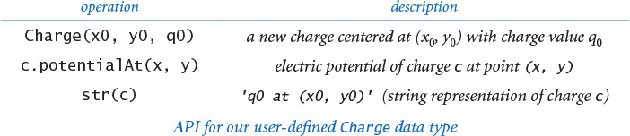

Constructor
A constructor creates an object of the specified type and returns a reference to that object. For our example, the client code
c = Charge(x0, y0, q0)
returns a new Charge object, suitably initialized. Python provides a flexible and general mechanism for object creation, but we adopt a simple subset that well serves our style of programming. Specifically, in this book, each data type defines a special method __init__() whose purpose is to define and initialize the instance variables, as described below. The double underscores before and after the name are your clue that it is “special”—we will be encountering other special methods soon.
When a client calls a constructor, Python’s default construction process creates a new object of the specified type, calls the __init__() method to define and initialize the instance variables, and returns a reference to the new object. In this book, we refer to __init__() as the constructor for the data type, even though it is technically only the pertinent part of the object-creation process.
The code at right is the __init__() implementation for Charge. It is a method, so its first line is a signature consisting of the keyword def, its name (__init__), a list of parameter variables, and a colon. By convention, the first parameter variable is named self. As part of Python’s default object creation process, the value of the self parameter variable when __init()__ is invoked is a reference to the newly created object. The ordinary parameter variables from the client follow the special parameter variable self. The remaining lines make up the body of the constructor. Our convention throughout this book is for __init()__ to consist of code that initializes the newly created object by defining and initializing the instance variables.
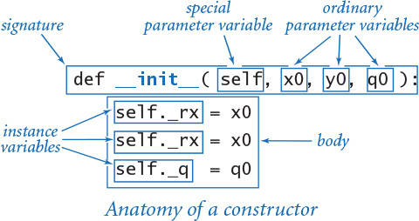

Instance variables
A data type is a set of values and a set of operations defined on those values. In Python, instance variables implement the values. An instance variable belongs to a particular instance of a class—that is, to a particular object. In this book, our convention is to define and initialize each instance variable of the newly created object in the constructor and only in the constructor. The standard convention in Python programs is that instance variable names begin with an underscore. In our implementations, you can inspect the constructor to see the entire set of instance variables. For example, the __init__() implementation on the previous page tells us that Charge has three instance variables _rx, _ry, and _q. When an object is created, the value of the self parameter variable of the __init__() method is a reference to that object. Just as we can call a method for a charge c with the syntax c.potentialAt(), so we can refer to an instance variable for a charge self with the syntax self._rx. Therefore the three lines within the __init__() constructor for Charge define and initialize _rx, _ry, and _q for the new object.

Details of object creation
The memory diagrams at right detail the precise sequence of events when a client creates a new Charge object with the code
c1 = Charge(0.51, 0.63, 21.3)
• Python creates the object and calls the __init__() constructor, initializing the constructor’s self parameter variable to reference the newly created object, its x0 parameter variable to reference 0.51, its y0 parameter variable to reference 0.63, and its q0 parameter variable to reference 21.3.
• The constructor defines and initializes the _rx, _ry, and _q instance variables within the newly created object referenced by self.
• After the constructor finishes, Python automatically returns to the client the self reference to the newly created object.
• The client assigns that reference to c1.
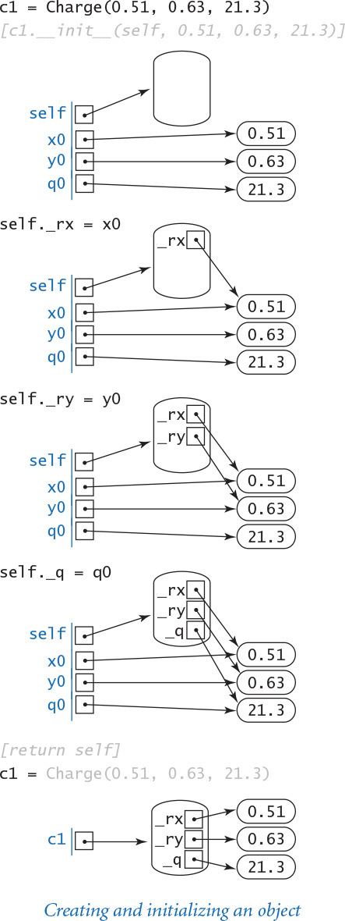
The parameter variables x0, y0, and q0 go out of scope when __init__() is finished, but the objects they reference are still accessible via the new object’s instance variables.

Methods
A data type is a set of values and a set of operations defined on those values. In Python, methods (or instance methods) implement data-type operations, which are associated with a specified object. To define methods, we compose code that is precisely like the code that we learned in CHAPTER 2 to define functions, with the (significant) exception that methods can also access instance variables. For example, the code of the potentialAt() method for our Charge data type is shown below. The first line is the method’s signature: the keyword def, the name of the method, parameter variables names in parentheses, and a colon. The first parameter variable of every method is named self. When a client calls a method, Python automatically sets that self parameter variable to reference the object to be manipulated—the object that was used to invoke the method. For example, when a client calls our method with c.potentialAt(x, y), the value of the self parameter variable of the __potentialAt__() method is set to c. The ordinary parameter variables from the client (x and y, in this case) follow the special parameter variable self. The remaining lines make up the body of the potentialAt() method.
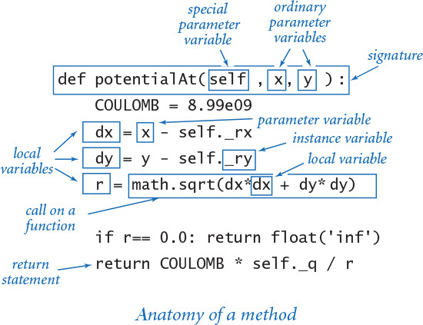

Variables within methods
To understand method implementations, it is very important to know that a method typically uses three kinds of variables:
• The self object’s instance variables
• The method’s parameter variables
• Local variables
There is a critical distinction between instance variables and the parameter and local variables that you are accustomed to: there is just one value corresponding to each local or parameter variable at a given time, but there can be many values corresponding to each instance variable—one for each object that is an instance of the data type. There is no ambiguity with this arrangement, because each time that you call a method, you use an object to do so, and the implementation code
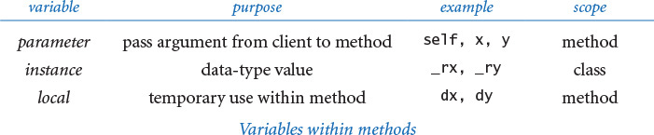
can directly refer to that object’s instance variables using the self parameter variable. Be sure that you understand the distinctions among these three kinds of variables. The differences are summarized in table above, and are a key to object-oriented programming. In our example, potentialAt() uses the _rx, _ry, and _q instance variables of the object referenced by self, the parameter variables x and y, and the local variables COULOMB, dx, dy, and r to compute and return a value. As an example, note that the statement
dx = x - self._rx
uses all three kinds of variables. With these distinctions in mind, check that you understand how potentialAt() gets its job done.

Methods are functions
A method is a special kind of function that is defined in a class and associated with an object. Since methods are functions, a method can take any number of arguments, specify optional arguments with default values, and return a value to its caller. In our example, potentialAt() takes two ordinary arguments and returns a float to the client. The key difference between functions and methods is that a method is associated with a specified object, with direct access to its instance variables. Indeed, we will see examples later in this section where the purpose of a method is to have the side effect of changing an instance variable, rather than returning a value to the client.

Built-in functions
The third operation in the Charge API is a built-in function str(c). Python’s convention is to automatically translate this function call to a standard method call c.__str()__. Thus, to support this operation, we implement the special method __str__(), which uses the instance variables associated with the invoking object to string together the desired result. Recall that Python knows the type of each object at run time, so Python can infer which __str__() method to call—the one defined in the class corresponding to the invoking object.

Privacy
A client should access a data type only through the methods in its API. Sometimes it is convenient to define helper methods in the implementation that are not intended to be called directly by the client. The special method __str__() is a prototypical example. As we saw in SECTION 2.2 with private functions, the standard Python convention is to name such methods with a leading underscore. The leading underscore is a strong signal to the client not to call that private method directly. Similarly, naming instance variables with a leading underscore signals to the client not to access such private instance variables directly. Even though Python has no language support for enforcing these conventions, most Python programmers treat them as sacrosanct.
These are the basic components that you must understand to implement data types as classes in Python. Every data-type implementation (Python class) that we will consider has instance variables, constructors, and methods. In each data type that we develop, we go through the same steps. Rather than thinking about which action we need to take next to accomplish a computational goal (as we did when first learning to program), we think about the needs of a client, then accommodate them in a data type. PROGRAM 3.2.1 is a full implementation of our Charge data type; it illustrates all of the features we have just discussed. Note that charge.py also has a test client. As with modules, it is good style to include a test client with every data-type implementation.

Summary
At the risk of being repetitive, we summarize the basic steps that we have described in the process of creating a new data type.
The first step in creating a data type is to specify an API. The purpose of the API is to separate clients from implementations, thereby facilitating modular programming. We have two goals when specifying an API. First, we want to enable clear and correct client code. Indeed, it is a good idea to compose some client code before finalizing the API to gain confidence that the specified data-type operations are the ones that clients need. Second, we need to be able to implement the operations. There is no point in specifying operations that we have no idea how to implement.
The second step in creating a data type is to implement a Python class that meets the API specifications. First, we compose the constructor to define and initialize the instance variables; then, we compose the methods that manipulate the instance variables to implement the desired functionality. In Python, we normally need to implement three kinds of methods:
Program 3.2.1 Charged particle (charge.py)
Click here to view code image
import math
import sys
import stdio
class Charge:
def __init__(self, x0, y0, q0):
self._rx = x0
self._ry = y0
self._q = q0
def potentialAt(self, x, y):
COULOMB = 8.99e09
dx = x - self._rx
dy = y - self._ry
r = math.sqrt(dx*dx + dy*dy)
if r == 0.0: return float('inf')
return COULOMB * self._q / r
def __str__(self):
result = str(self._q) + ' at ('
result += str(self._rx) + ', ' + str(self._ry) + ')'
return result
def main():
x = float(sys.argv[1])
y = float(sys.argv[2])
c = Charge(.51, .63, 21.3)
stdio.writeln(c)
stdio.writeln(c.potentialAt(x, y))
if __name__ == '__main__': main()
instance variables
_rx | x-coordinate
_ry | y-coordinate
_q | charge value
COULOMB | Coulomb's constant
dx, dy | delta distances to query point
r | distance to query point
x, y | query point
c | charge
This implementation of our data type for charged particles contains the basic ingredients found in every data type: instance variables _rx, _ry, and _q; a constructor __init__(); the methods potentialAt() and __str__(); and a test client main() (see also PROGRAM 3.1.1).
% python charge.py .5 .5
21.3 at (0.51, 0.63)
1468638248194.164
• To implement a constructor, we implement a special method __init__() with self as its first parameter variable, followed by the constructor’s ordinary parameter variables.
• To implement a method, we implement a function of the desired name, with self as its first parameter variable, followed by the method’s ordinary parameter variables.
• To implement a built-in function, we implement a special method with the same name enclosed in double underscores and with self as its first parameter variable.
Examples from Charge are shown in the table at the bottom of this page. In all three cases, we use self to access the instance variables of the invoking object and otherwise use parameter and local variables to compute a result and return a value to the caller.
The third step in creating a data type is to compose a test client, to validate and test the design decisions made in the first two steps.
The diagram on the facing page summarizes the terminology that we have discussed. It is well worth careful study, as we will be using this terminology extensively for the rest of the book.
For the rest of this section, we apply these basic steps to create a number of interesting data types and clients. We start each example with an API, and then consider implementations, followed by clients. You will find many exercises at the end of this section intended to give you experience with data-type creation. SECTION 3.3 provides an overview of the design process and related language mechanisms.
What are the values that define the data type, and which operations do clients need to perform on those values? With these basic decisions made, you can create new data types and compose clients that use them in the same way as you have been using built-in data types.
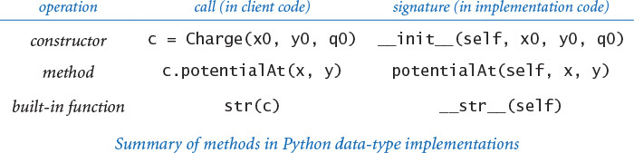
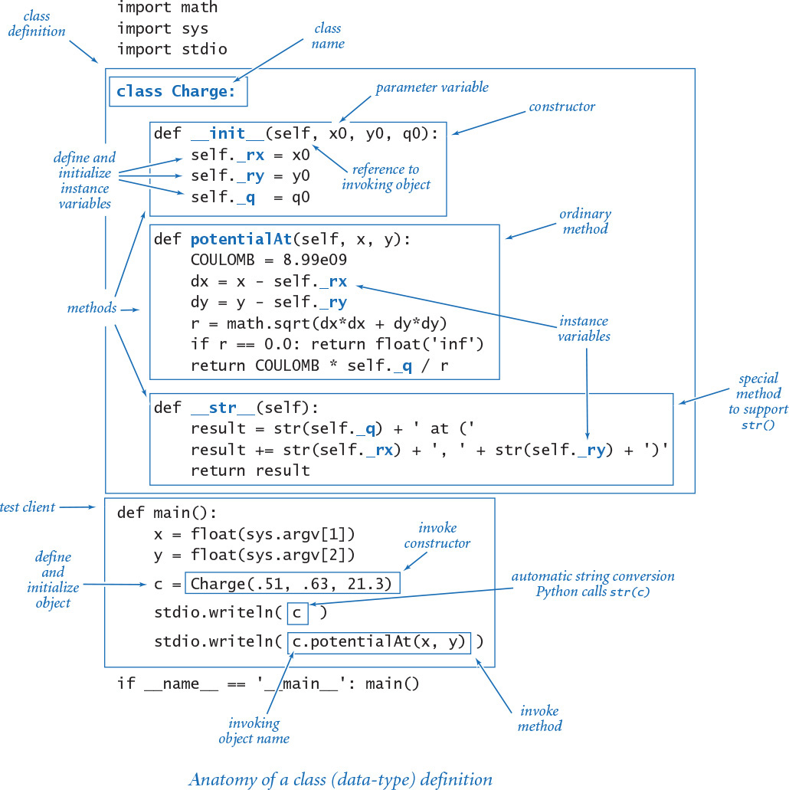

Stopwatch
One of the hallmarks of object-oriented programming is the idea of easily modeling real-world objects by creating abstract programming objects. As a simple example, consider stopwatch.py (PROGRAM 3.2.2), which implements our Stopwatch data type, defined by the following API:
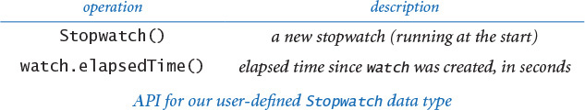
In other words, a Stopwatch object is a stripped-down version of an old-fashioned stopwatch. When you create one, it starts running, and you can ask it how long it has been running by invoking the method elapsedTime(). You might imagine adding all sorts of bells and whistles to Stopwatch, limited only by your imagination. Do you want to be able to reset the stopwatch? Start and stop it? Include a lap timer? These sorts of things are easy to add (see EXERCISE 3.2.11).
The implementation in stopwatch.py takes advantage of the Python function time() in the time module, which returns a float giving the current time in seconds (typically, the number of seconds since midnight on January 1, 1970 UTC). The data-type implementation could hardly be simpler. A Stopwatch object saves its creation time in an instance variable, then returns the difference between that time and the current time whenever a client calls its elapsedTime() method. A Stopwatch object itself does not actually tick (an internal system clock on your computer does all the ticking for all Stopwatch objects); it just creates the illusion that it does for clients. Why not just use time.time() in clients? We could do so, but using the higher-level Stopwatch abstraction leads to client code that is easier to understand and maintain.
The test client is typical. It creates two Stopwatch objects, uses them to measure the running time of two different computations and then writes the ratio of the running times.
The question of whether one approach to solving a problem is better than another has been lurking since the first few programs that you have run, and plays an essential role in program development. In SECTION 4.1, we will develop a scientific approach to understanding the cost of computation. Stopwatch is a useful tool in that approach.
Program 3.2.2 Stopwatch (stopwatch.py)
Click here to view code image
import math
import sys
import time
import stdio
class Stopwatch:
def __init__(self):
self._start = time.time()
def elapsedTime(self):
return time.time() - self._start
def main():
n = int(sys.argv[1])
total1 = 0.0
watch1 = Stopwatch()
for i in range(1, n+1):
total1 += i**2
time1 = watch1.elapsedTime()
total2 = 0.0
watch2 = Stopwatch()
for i in range(1, n+1):
total2 += i*i
time2 = watch2.elapsedTime()
stdio.writeln(total1/total2)
stdio.writeln(time1/time2)
if __name__ == '__main__': main()
instance variable
_start | creation time
This module defines a class Stopwatch that implements a data type that we can use to compare running times of performance-critical methods (see SECTION 4.1). The test client accepts an integer n from the command line and compares the cost for squaring a number using either i**2 or i*i for the task of computing the sum of the squares of the numbers from 1 to n. This quick test indicates that i*i is about three times faster than i**2.
% python stopwatch.py 1000000
1.0
3.179422835633626

Histogram
PROGRAM 3.2.3 (histogram.py) defines a data type Histogram for graphically representing the distribution of data using bars of different heights in a chart known as a histogram. A Histogram object maintains an array of the frequency of occurrence of integer values in a given interval. It uses stdstats.plotBars() to display a histogram of the values, controlled by this API:
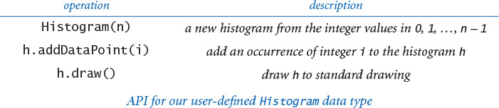
With this simple data type, we reap the benefits of modular programming (reusable code, independent development of small programs, and so forth) that we discussed in CHAPTER 2, with the additional benefit that we also separate the data. A histogram client need not maintain the data (or know anything about its representation); it just creates a histogram and calls addDataPoint().
When studying this code and the next several examples, it is best to carefully consider the client code. Each class that we implement essentially extends the Python language, allowing us to create objects of the new data type and perform operations on them. All client programs are conceptually the same as the first programs that you learned that use built-in data types. Now you have the ability to define whatever types and operations you need in your client code!
In this case, using Histogram actually enhances the readability of the client code, as the addDataPoint() call focuses attention on the data being studied. Without Histogram, we would have to mix the code for creating the histogram with the code for the computation of interest, resulting in a program that is much more difficult to understand and maintain than the two separate programs. Whenever you can clearly separate data and associated operations within a computation, you should do so.
Once you understand how a data type will be used in client code, you can consider the implementation. An implementation is characterized by its instance variables (data-type values). Histogram maintains an array with the frequency of each point. Its draw() method scales the drawing (so that the tallest bar fits snugly in the canvas) and then plots the frequencies.
Program 3.2.3 Histogram (histogram.py)
Click here to view code image
import sys
import stdarray
import stddraw
import stdrandom
import stdstats
class Histogram:
def __init__(self, n):
self._freq = stdarray.create1D(n, 0)
def addDataPoint(self, i):
self._freq[i] += 1
def draw(self):
stddraw.setYscale(0, max(self._freq))
stdstats.plotBars(self._freq)
def main():
n = int(sys.argv[1])
p = float(sys.argv[2])
trials = int(sys.argv[3])
histogram = Histogram(n+1)
for t in range(trials):
heads = bernoulli.binomial(n, p)
histogram.addDataPoint(heads)
stddraw.setCanvasSize(500, 200)
histogram.draw()
stddraw.show()
if __name__ == '__main__': main()
instance variables
_freq[] | frequency counts
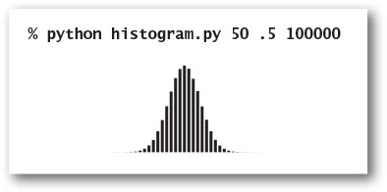
This module defines a Histogram class that implements a data type for creating dynamic histograms. The frequency counts are kept in an instance-variable array _freq. The test client accepts integer n, float p, and integer trials as command-line arguments. It performs trials experiments, each of which counts the number of heads found when a biased coin (heads with probability p and tails with probability 1 - p) is flipped n times. Then, it draws the results to standard drawing.

Turtle graphics
Whenever you can clearly separate tasks within a computation, you should do so. In object-oriented programming, we extend that mantra to include state with the tasks. A small amount of state can be immensely valuable in simplifying a computation. Next, we consider turtle graphics, which is based on the data type defined by this API:
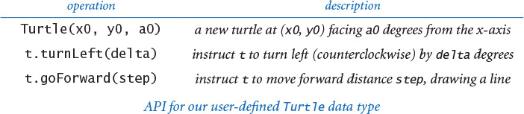
Imagine a turtle that lives in the unit square and draws lines as it moves. It can move a specified distance in a straight line, or it can rotate left (counterclockwise) a specified number of degrees. According to the API, when we create a turtle, we place it at a specified point, facing a specified direction. Then, we create drawings by giving the turtle a sequence of goForward() and turnLeft() commands.
For example, to draw a triangle we create a turtle at (0, 0.5) facing at an angle of 60 degrees counterclockwise from the x-axis, then direct it to take a step forward, then rotate 120 degrees counterclockwise, then take another step forward, then rotate another 120 degrees counterclockwise, and then take a third step forward to complete the triangle. Indeed, all of the turtle clients that we will examine simply create a turtle, then give it an alternating series of step and rotate commands, varying the step size and the amount of rotation. As you will see in the next several pages, this simple model allows us to create arbitrarily complex drawings, with many important applications.
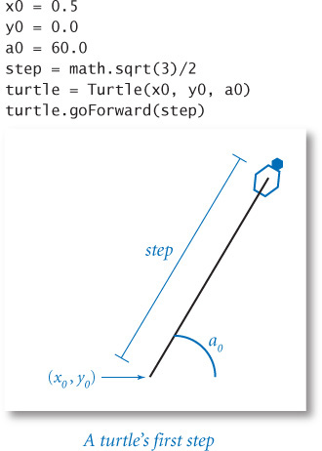
The Turtle class defined in PROGRAM 3.2.4 (turtle.py) is an implementation of this API that uses stddraw. It maintains three instance variables: the coordinates of the turtle’s position and the current direction it is facing, measured in degrees counterclockwise from the x-axis (polar angle). Implementing the two methods requires updating the values of these variables, so Turtle objects are mutable. The necessary updates are straightforward: turnLeft(delta) adds delta to the current angle, and goForward(step) adds the step size times the cosine of its argument to the current x-coordinate and the step size times the sine of its argument to the current y-coordinate.
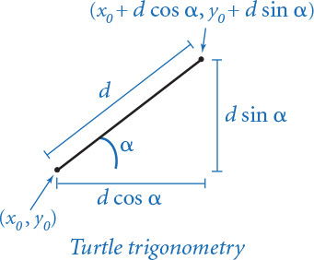
The test client in Turtle takes an integer n as a command-line argument and draws a regular polygon with n sides. If you are interested in elementary analytic geometry, you might enjoy verifying that fact. Whether or not you choose to do so, think about what you would need to do to compute the coordinates of all the points in the polygon. The simplicity of the turtle’s approach is very appealing. In short, turtle graphics serves as a useful abstraction for describing geometric shapes of all sorts. For example, we obtain a good approximation to a circle by taking n to a sufficiently large value.
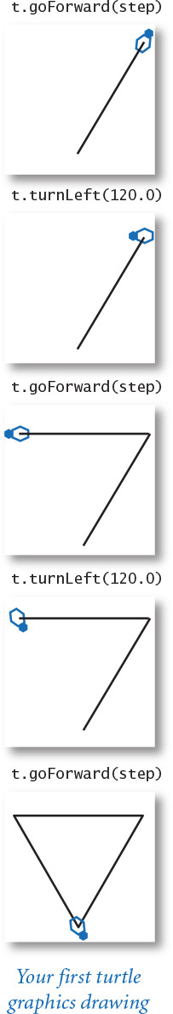
You can use a Turtle as you use any other object. Programs can create arrays of Turtle objects, pass them as arguments to functions, and so forth. Our examples will illustrate these capabilities and convince you that creating a data type like Turtle is both very easy and very useful. For each of them, as with regular polygons, it is possible to compute the coordinates of all the points and draw straight lines to get the drawings, but it is easier to do so with a Turtle. Turtle graphics exemplifies the value of data abstraction.
Program 3.2.4 Turtle graphics (turtle.py)
Click here to view code image
import math
import sys
import stddraw
class Turtle:
def __init__(self, x0, y0, a0):
self._x = x0
self._y = y0
self._angle = a0
def turnLeft(self, delta):
self._angle += delta
def goForward(self, step):
oldx = self._x
oldy = self._y
self._x += step * math.cos(math.radians(self._angle))
self._y += step * math.sin(math.radians(self._angle))
stddraw.line(oldx, oldy, self._x, self._y)
def main():
n = int(sys.argv[1])
step = math.sin(math.radians(180.0/n))
turtle = Turtle(.5, .0, 180.0/n)
for i in range(n):
turtle.goForward(step)
turtle.turnLeft(360.0/n)
stddraw.show()
if __name__ == '__main__': main()
instance variables
_x, _y | position (in unit square)
_angle | polar angle (in degrees)
This data type supports turtle graphics, which often simplifies the creation of drawings.
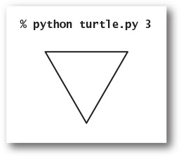
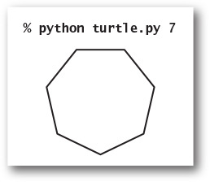
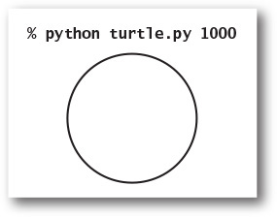

Recursive graphics
A Koch curve of order 0 is a straight line. To form a Koch curve of order n, draw a Koch curve of order n − 1, turn left 60 degrees, draw a second Koch curve of order n − 1, turn right 120 degrees (left −120 degrees), draw a third Koch curve of order n − 1, turn left 60 degrees, and draw a fourth Koch curve of order n − 1. These recursive instructions lead immediately to turtle client code. With appropriate modifications, recursive schemes like this have proved useful in modeling self-similar patterns found in nature, such as snowflakes.
The client code below is straightforward, except for the value of the step size. If you carefully examine the first few examples, you will see (and be able to prove by induction) that the width of the curve of order n is 3n times the step size, so setting the step size to 1/3n produces a curve of width 1. Similarly, the number of steps in a curve of order n is 4n, so koch.py will not finish if you invoke it for large n.
You can find many examples of recursive patterns of this sort that have been studied and developed by mathematicians, scientists, and artists from many cultures in many contexts. Here, our interest in them is that the turtle graphics abstraction greatly simplifies the client code that draws them.
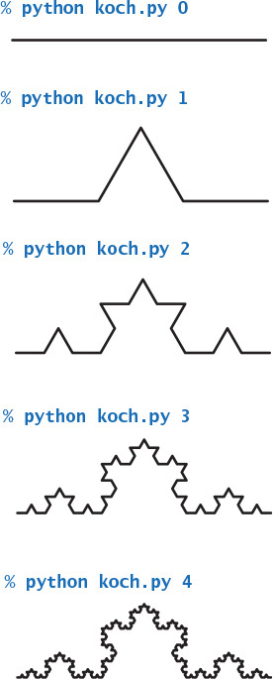
Click here to view code image
import sys
import stddraw
from turtle import Turtle
def koch(n, step, turtle):
if n == 0:
turtle.goForward(step)
return
koch(n-1, step, turtle)
turtle.turnLeft(60.0)
koch(n-1, step, turtle)
turtle.turnLeft(-120.0)
koch(n-1, step, turtle)
turtle.turnLeft(60.0)
koch(n-1, step, turtle)
n = int(sys.argv[1])
stddraw.setPenRadius(0.0)
step = 3.0 ** -n
turtle = Turtle(0.0, 0.0, 0.0)
koch(n, step, turtle)
stddraw.show()
Drawing Koch curves with turtle graphics

Spira mirabilis
Perhaps the turtle is a bit tired after taking 4n steps to draw a Koch curve (or just lazy). Accordingly, imagine that the turtle’s step size decays by a tiny constant factor (close to 1) each time it takes a step. What happens to our drawings? Remarkably, modifying the polygon-drawing test client in PROGRAM 3.2.4 to answer this question leads to an image known as a logarithmic spiral, a curve that is found in many contexts in nature.
PROGRAM 3.2.5 (spiral.py) is an implementation of this curve. It instructs the turtle to alternately step and turn until it has wound around itself a given number of times, with the step size decaying by a constant factor after each step. The script takes three command-line arguments, which control the shape and nature of the spiral. As you can see from the four examples given with the program, the path spirals into the center of the drawing. You are encouraged to experiment with spiral.py yourself to develop an understanding of the way in which the parameters control the behavior of the spiral.
The logarithmic spiral was first described by René Descartes in 1638. Jacob Bernoulli was so amazed by its mathematical properties that he named it the spira mirabilis (miraculous spiral) and even asked to have it engraved on his tombstone. Many people also consider it to be “miraculous” that this precise curve is clearly present in a broad variety of natural phenomena. Three examples are depicted below: the chambers of a nautilus shell, the arms of a spiral galaxy, and the cloud formation in a tropical storm. Scientists have also observed it as the path followed by a hawk approaching its prey and the path followed by a charged particle moving perpendicular to a uniform magnetic field.
One of the goals of scientific enquiry is to provide simple but accurate models of complex natural phenomena. Our tired turtle certainly passes that test!
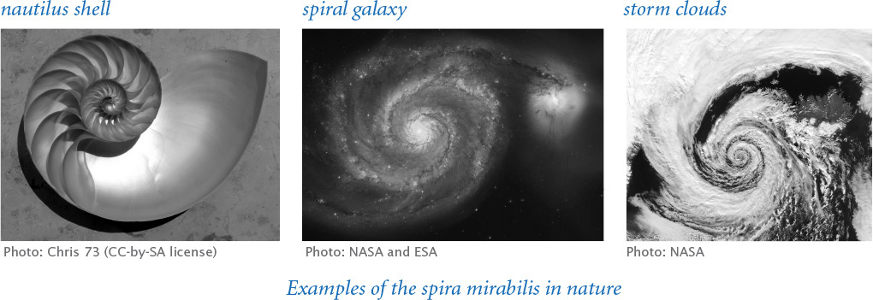
Program 3.2.5 Spira mirabilis (spiral.py)
Click here to view code image
import math
import sys
import stddraw
from turtle import Turtle
n = int(sys.argv[1])
wraps = int(sys.argv[2])
decay = float(sys.argv[3])
angle = 360.0 / n
step = math.sin(math.radians(angle/2.0))
turtle = Turtle(0.5, 0, angle/2.0)
stddraw.setPenRadius(0)
for i in range(wraps * n):
step /= decay
turtle.goForward(step)
turtle.turnLeft(angle)
stddraw.show()
n | number of sides
wraps | wrap count
step | step size
decay | decay factor
angle | rotation amount
step | step size
turtle | lazy turtle
This code is a modification of the test client in PROGRAM 3.2.4 that decreases the step size at each step and cycles around a given number of times. The value of n controls the shape; wraps controls its extent; and decay controls the nature of the spiral.
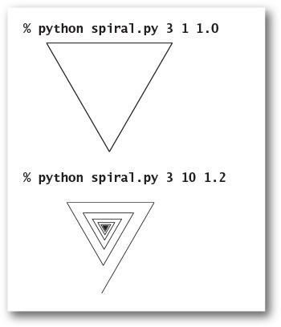
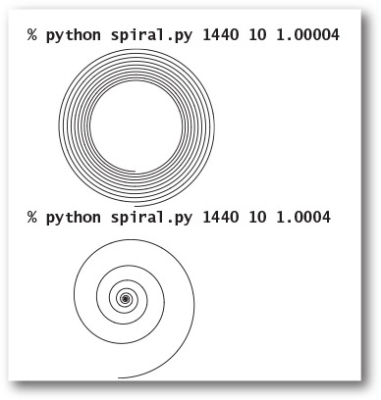

Brownian motion
Or perhaps the turtle has had one too many. Accordingly, imagine that the disoriented turtle (again following its standard alternating turn-and-step regimen) turns in a random direction before each step. Again, it is easy to plot the path followed by such a turtle for millions of steps, and again, such paths are found in nature in many contexts. In 1827, the botanist Robert Brown observed through a microscope that tiny particles ejected from pollen grains seemed to move about in just such a random fashion when immersed in water. This process later became known as Brownian motion and led to Albert Einstein’s insights into the atomic nature of matter.
Or perhaps our turtle has friends, all of whom have had one too many. After they have wandered around for a sufficiently long time, their paths merge together and become indistinguishable from a single path. Astrophysicists today are using this model to understand observed properties of distant galaxies.
Turtle graphics was originally developed by Seymour Papert at MIT in the 1960s as part of an educational programming language, Logo, that is still used today in toys. But turtle graphics is no toy, as we have just seen in numerous scientific examples. Turtle graphics also has numerous commercial applications. For example, it is the basis for PostScript, a programming language for creating printed pages that is used for most newspapers, magazines, and books. In the present context, Turtle is a quintessential object-oriented programming example, showing that a small amount of saved state (data abstraction using objects, not just functions) can vastly simplify a computation.
Click here to view code image
import sys
import stddraw
import stdrandom
from turtle import Turtle
trials = int(sys.argv[1])
step = float(sys.argv[2])
stddraw.setPenRadius(0.0)
turtle = Turtle(0.5, 0.5, 0.0)
for t in range(trials):
angle = stdrandom.uniformFloat(0.0, 360.0)
turtle.turnLeft(angle)
turtle.goForward(step)
stddraw.show(0)
stddraw.show()
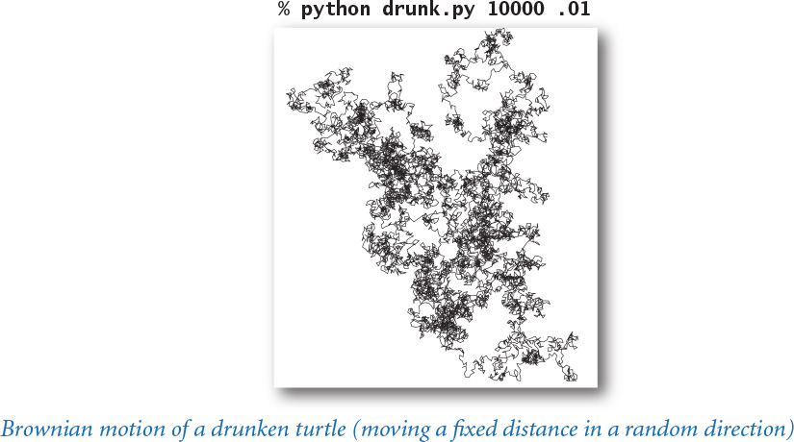
Click here to view code image
import sys
import stdarray
import stddraw
import stdrandom
from turtle import Turtle
n = int(sys.argv[1])
trials = int(sys.argv[2])
step = float(sys.argv[3])
stddraw.setPenRadius(0.0)
turtles = stdarray.create1D(n)
for i in range(n):
x = stdrandom.uniformFloat(0.0, 1.0)
y = stdrandom.uniformFloat(0.0, 1.0)
turtles[i] = Turtle(x, y, 0.0)
for t in range(trials):
for i in range(n):
angle = stdrandom.uniformFloat(0.0, 360.0)
turtles[i].turnLeft(angle)
turtles[i].goForward(step)
stddraw.show(0)
stddraw.show()
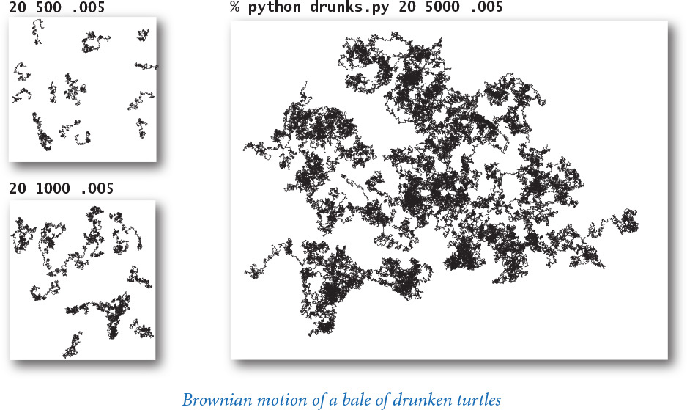

Complex numbers
A complex number is a number of the form x + yi, where x and y are real numbers and i is the square root of –1. The number x is known as the real part of the complex number, and the number y is known as the imaginary part. This terminology stems from the idea that the square root of –1 has to be an imaginary number, because no real number can have this value. Complex numbers are a quintessential mathematical abstraction: whether or not one believes that it makes sense physically to take the square root of –1, complex numbers help us understand the natural world. They are used extensively in applied mathematics and play an essential role in many branches of science and engineering. They are used to model physical systems of all sorts, from circuits to sound waves to electromagnetic fields. These models typically require extensive computations involving manipulating complex numbers according to well-defined arithmetic operations, so we want to compose computer programs to do the computations. In short, we need a new data type.
No programming language can provide implementations of every mathematical abstraction that we might possibly need, but the ability to implement data types give us not just the ability to compose programs to easily manipulate abstractions such as complex numbers, polynomials, vectors, and matrices, but also the freedom to think in terms of new abstractions.
The Python language provides a complex (with a lowercase c) data type. However, since developing a data type for complex numbers is a prototypical exercise in object-oriented programming, we now consider our own Complex (with an uppercase C) data type. Doing so will allow us to consider a number of interesting issues surrounding data types for mathematical abstractions, in a nontrivial setting.
The operations on complex numbers that are needed for basic computations are to add and multiply them by applying the commutative, associative, and distributive laws of algebra (along with the identity i2 = –1); to compute the magnitude; and to extract the real and imaginary parts, according to the following equations:
• Addition: (x+yi) + (v+wi) = (x+v) + (y+w)i
• Multiplication: (x + yi) * (v + wi) = (xv – yw) + (yv + xw) i
• Magnitude: 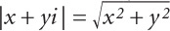
• Real part: Re(x + yi) = x
• Imaginary part: Im(x + yi) = y
For example, if a = 3 + 4i and b = –2 + 3i, then a +b = 1 + 7i, a *b = –18 + i, Re(a) = 3, Im(a) = 4, and |a| = 5.
With these basic definitions, the path to implementing a data type for complex numbers is clear. As usual, we start with an API that specifies the data-type operations. For simplicity, we concentrate in the text on just the basic operations in this API, but EXERCISE 3.2.18 asks you to consider several other useful operations that might be supported. Except for the uppercase C, this API is also implemented by Python’s built-in data type complex.
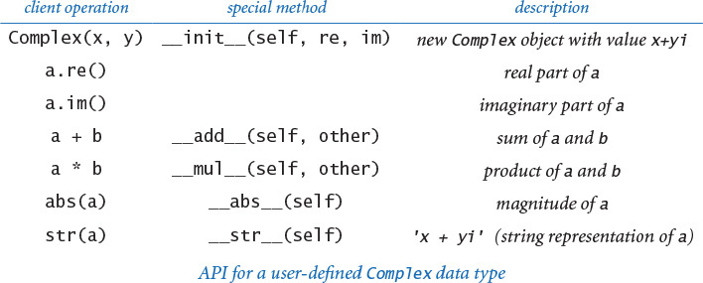

Special methods
How can we implement data-type operations so that clients can invoke them using arithmetic operators, such as + and *? The answer is found in another set of Python special methods that are specifically designed for this purpose. For example, when Python sees the expression a + b in client code, it replaces it with the method call a.__add__(b). Similarly, Python replaces a * b with the method call a.__mul__(b). Therefore, we need only to implement the special methods __add__() and __mul__() for addition and multiplication to operate as expected. The mechanism is the same one that we used to support Python’s built-in str() function for Charge, by implementing the __str__() special method, except that the special methods for arithmetic operators take two arguments. The above API includes an extra column that maps the client operations to the special methods. We generally omit this column in our APIs because these names are standard, and irrelevant to clients. The list of Python special methods is extensive—we will discuss them further in SECTION 3.3.
Complex (PROGRAM 3.2.6) is a class that implements this API. It has all of the same components as did Charge (and every Python data-type implementation): instance variables (_re and _im), a constructor, methods, and a test client. The test client first sets z0 to 1 + i, then sets z to z0, and then evaluates the expressions:
z = z2 + z0 = (1 + i)2 + (1 + i) = (1 + 2i –1) + (1 + i) = 1 + 3i
z = z2 + z0 = (1 + 3i)2 + (1 + i) = (1 + 6i – 9) + (1 + i) = –7 + 7i
This code is straightforward and similar to code that you have seen earlier in this chapter.

Accessing instance variables in objects of this type
The implementations of both __add__() and __mul__() need to access values in two objects: the object passed as an argument and the object used to call the method (that is, the object referenced by self). When the client calls a.__add__(b), the parameter variable self is set to reference the same object as argument a does, and the parameter variable other is set to reference the same object as argument b does. We can access the instance variables of a using self._re and self._im, as usual. To access the instance variables of b, we use the code other._re and other._im. Since our convention is to keep the instance variables private, we do not access directly instance variables in another class. Accessing instance variables within another object in the same class does not violate this privacy policy.

Immutability
The two instance variables in Complex are set for each Complex object when it is created and do not change during the lifetime of an object. That is, Complex objects are immutable. We discuss the benefits of this design decision in SECTION 3.3.
Complex numbers are the basis for sophisticated calculations from applied mathematics that have many applications. Our main reason for developing Complex—even though complex is built-in to Python—is to demonstrate the use of Python’s special functions in a simple but authentic setting. In real applications, you certainly should take advantage of complex unless you find yourself wanting more operations than Python provides.
To give you a feeling for the nature of calculations involving complex numbers and the utility of the complex number abstraction, we next consider a famous example of a complex (or Complex) client.
Program 3.2.6 Complex numbers (complex.py)
Click here to view code image
import math
import stdio
class Complex:
def __init__(self, re=0, im=0):
self._re = re
self._im = im
def re(self): return self._re
def im(self): return self._im
def __add__(self, other):
re = self._re + other._re
im = self._im + other._im
return Complex(re, im)
def __mul__(self, other):
re = self._re * other._re - self._im * other._im
im = self._re * other._im + self._im * other._re
return Complex(re, im)
def __abs__(self):
return math.sqrt(self._re*self._re + self._im*self._im)
def __str__(self):
return str(self._re) + ' + ' + str(self._im) + 'i'
def main():
z0 = Complex(1.0, 1.0)
z = z0
z = z*z + z0
z = z*z + z0
stdio.writeln(z)
if __name__ == '__main__': main()
instance variables
_re | real part
_im | imaginary part
This data type enables us to compose Python programs that manipulate complex numbers.
% python complex.py
-7.0 + 7.0i

Mandelbrot set
The Mandelbrot set is a specific set of complex numbers discovered by Benoît Mandelbrot that has many fascinating properties. It is a fractal pattern that is related to the Barnsley fern, the Sierpinski triangle, the Brownian bridge, the Koch curve, the drunken turtle, and other recursive (self-similar) patterns and programs that we have seen in this book. Patterns of this kind are found in natural phenomena of all sorts, and these models and programs are very important in modern science.
The set of points in the Mandelbrot set cannot be described by a single mathematical equation. Instead, it is defined by an algorithm and, therefore, a perfect candidate for a complex client: we study the set by composing a program to plot it.
The rule for determining whether a complex number z0 is in the Mandelbrot set is deceptively simple. Consider the sequence of complex numbers z0, z1, z2, . . ., zt, . . ., where zt+1 = (zt)2 + z0. For example, this table shows the first few entries in the sequence corresponding to z0 =1 + i:
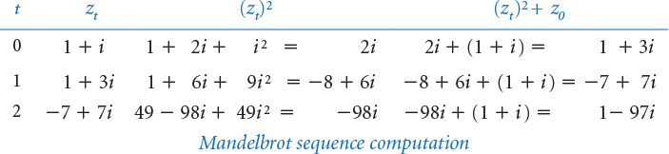
Now, if the sequence |zt| diverges to infinity, then z0 is not in the Mandelbrot set; if the sequence is bounded, then z0 is in the Mandelbrot set. For many points, the test is simple. For many other points, the test requires more computation, as indicated by the examples in this table:
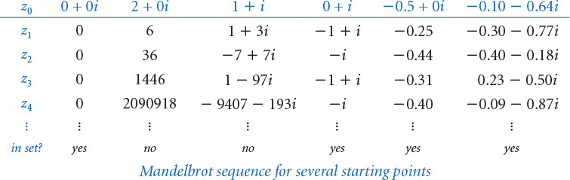
For brevity, the numbers in the rightmost two columns of this table are given to just two decimal places. In some cases, we can prove whether numbers are in the set; for example, 0 + 0i is certainly in the set (since the magnitude of all the numbers in its sequence is 0), and 2 + 0i is certainly not in the set (since its sequence dominates the powers of 2, which diverge). In other cases, the growth is readily apparent; for example, 1 + i does not seem to be in the set. Other sequences exhibit a periodic behavior; for example, the sequence for 0 + i alternates between –1 + i and –i. And some sequences go on for a very long time before the magnitude of the numbers begins to get large.
To visualize the Mandelbrot set, we sample complex points, just as we sample real-valued points to plot a real-valued function. Each complex number x + yi corresponds to a point (x, y) in the plane, so we can plot the results as follows: for a specified resolution n, we define a regularly spaced n-by-n pixel grid within a specified square and draw a black pixel if the corresponding point is in the Mandelbrot set and a white pixel if it is not. This plot is a strange and wondrous pattern, with all the black dots connected and falling roughly within the 2-by-2 square centered at the point –1/2 + 0i. Large values of n produce higher-resolution images, albeit at the cost of more computation. Looking closer reveals self-similarities throughout the plot, as shown in the example at right. For example, the same bulbous pattern with self-similar appendages appears all around the contour of the main black cardioid region, of sizes that resemble the simple ruler function of PROGRAM 1.2.1. When we zoom in near the edge of the cardioid, tiny self-similar cardioids appear!
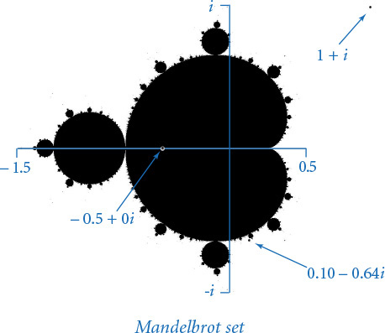
But how, precisely, do we produce such plots? Actually, no one knows for sure, because there is no simple test that enables us to conclude that a point is surely in the set. Given a complex point, we can compute the terms at the beginning of its sequence, but may not be able to know for sure that the sequence remains bounded. There is a simple mathematical test that tells us for sure that a point is not in the set: if the magnitude of any number in the sequence ever exceeds 2 (such as 1 + 3i), then the sequence surely will diverge.
PROGRAM 3.2.7 (mandelbrot.py) uses this test to plot a visual representation of the Mandelbrot set. Since our knowledge of the set is not quite black-and-white, we use grayscale in our visual representation. The basis of the computation is the function mandel(), which takes a complex argument z0 and an integer argument limit and computes the Mandelbrot iteration sequence starting at z0, returning the number of iterations for which the magnitude stays less than (or equal to) 2, up to the given limit.
For each pixel, the main script in mandelbrot.py computes the point z0 corresponding to the pixel and then computes 255 - mandel(z0, 255) to create a grayscale color for the pixel. Any pixel that is not black corresponds to a point that we know to be not in the Mandelbrot set because the magnitude of the numbers in its sequence exceeds 2 (and therefore will go to infinity). The black pixels (grayscale value 0) correspond to points that we assume to be in the set because the magnitude stayed less than (or equal to) 2 for 255 iterations, but we do not necessarily know for sure.
The complexity of the images that this simple program produces is remarkable, even when we zoom in on a tiny portion of the plane. For even more dramatic pictures, we can use color (see EXERCISE 3.2.32). Moreover, the Mandelbrot set is derived from iterating just one function (z2 + z0); we have a great deal to learn from studying the properties of other functions as well.
The simplicity of the code masks a substantial amount of computation. There are about 250,000 pixels in a 512-by-512 image, and all of the black ones require 255 iterations, so producing an image with mandelbrot.py requires hundreds of millions of operations on complex values. Accordingly, we use Python’s complex data type, which is certain to be more efficient than the Complex data type that we just considered (see EXERCISE 3.2.14).
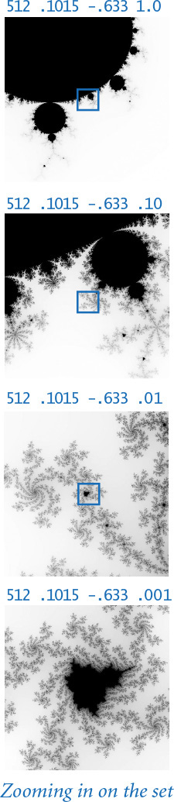
Fascinating as it is to study, our primary interest in the Mandelbrot set is to illustrate that computing with a type of data that is a pure abstraction is a natural and useful programming activity. The client code in mandelbrot.py is a simple and natural expression of the computation, made so by the ease of designing, implementing, and using data types in Python.
Program 3.2.7 Mandelbrot set (mandelbrot.py)
Click here to view code image
import sys
import stddraw
from color import Color
from picture import Picture
def mandel(z0, limit):
z = z0
for i in range(limit):
if abs(z) > 2.0: return i
z = z*z + z0
return limit
n = int(sys.argv[1])
xc = float(sys.argv[2])
yc = float(sys.argv[3])
size = float(sys.argv[4])
pic = Picture(n, n)
for col in range(n):
for row in range(n):
x0 = xc - size/2 + size*col/n
y0 = yc - size/2 + size*row/n
z0 = complex(x0, y0)
gray = 255 - mandel(z0, 255)
color = Color(gray, gray, gray)
pic.set(col, n-1-row, color)
stddraw.setCanvasSize(n, n)
stddraw.picture(pic)
stddraw.show()
x0, y0 | point in square
z0 | x0 + y0 i
limit | iteration limit
xc, yc | center of square
size | square is size-by-size
n | grid is n-by-n pixels
pic | image for output
color | pixel color for output
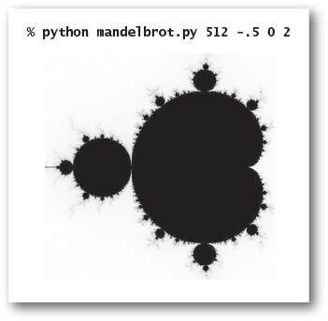
This program takes three command-line arguments that specify the n-by-n grid and the center (xc, yc) and size of a square region of interest, and makes a digital image showing the result of sampling the Mandelbrot set in that region at a n-by-n grid of equally spaced pixels. It colors each pixel with a grayscale value that is determined by counting the number of iterations before the Mandelbrot sequence for the corresponding complex number exceeds 2.0, up to 255.

Commercial data processing
One of the driving forces behind the development of object-oriented programming has been the need for an extensive amount of reliable software for commercial data processing. As an illustration, we consider next an example of a data type that might be used by a financial institution to keep track of customer information.
Suppose that a stock broker needs to maintain customer accounts containing shares of various stocks. That is, the set of values the broker needs to process includes the customer’s name, number of different stocks held, number of shares and ticker symbol for each stock, and cash on hand. To process an account, the broker needs at least the operations defined in this API:
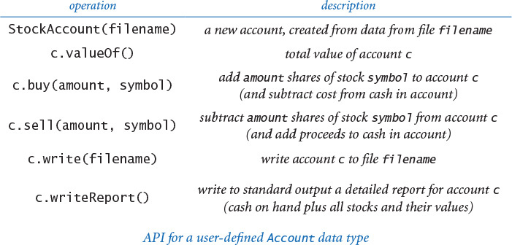
The broker certainly needs to buy, sell, and provide reports to the customer, but the first key to understanding this kind of data processing is to consider the StockAccount() constructor and the write() method in this API. The customer information has a long lifetime and needs to be saved in a file or database. To process an account, a client program needs to read information from the corresponding file; process the information as appropriate; and, if the information changes, write it back to the file, saving it for later. To enable this kind of processing, we need a file format and an internal representation, or a data structure, for the account information. The situation is analogous to what we saw for matrix processing in CHAPTER 1, where we defined a file format (numbers of rows and columns followed by the elements in row-major order) and an internal representation (Python two-dimensional arrays) to enable us to compose programs for the random surfer and other applications.
As a (whimsical) running example, we imagine that a broker is maintaining a small portfolio of stocks in leading software companies for Alan Turing, the father of computing. As an aside: Turing’s life story is a fascinating one that is worth investigating further. Among many other things, he worked on computational cryptography that helped to bring about the end of World War II, he developed the basis for modern theoretical computer science, he designed and built one of the first computers, and he was a pioneer in artificial intelligence research. It is perhaps safe to assume that Turing, whatever his financial situation as an academic researcher in the middle of the last century, would be sufficiently optimistic about the potential impact of computing software in today’s world that he would make some small investments.

File format
Modern systems often use text files, even for data, to minimize dependence on formats defined by any one program. For simplicity, we use a direct representation where we list the account holder’s name (a string), cash balance (a float), and number of stocks held (an integer), followed by a line for each stock giving the number of shares and the ticker symbol, as shown in the example at right. It is also wise to use tags such as <Name> and <Number of shares> and so forth to label all the information, to further minimize dependencies on any one program, but we omit such tags here for brevity.
% more turing.txt
Turing, Alan
10.24
4
100 ADBE
25 GOOG
97 IBM
250 MSFT

Data structure
To represent information for processing by Python programs, we define a data type and use instance variables to organize the information. The instance variables specify the type of information and provide the structure that we need to refer to it in code. For example, to implement a StockAccount, we use the following instance variables:
• A string for the account name
• A float for the cash on hand
• An integer for the number of stocks
• An array of strings for stock symbols
• An array of integers for numbers of shares
We directly reflect these choices in the instance variable declarations in StockAccount, defined in PROGRAM 3.2.8. The arrays _stocks[] and _shares[] are known as parallel arrays. Given an index i, _stocks[i] gives a stock symbol and _shares[i] gives the number of shares of that stock in the account. An alternative design would be to define a separate data type for stocks to manipulate this information for each stock and maintain an array of objects of that type in StockAccount.
StockAccount includes a constructor, which reads a file and builds an account with this internal representation. It also includes a method valueOf(), which uses stockquote.py (PROGRAM 3.1.10) to get each stock’s price from the web. To provide a periodic detailed report to customers, our broker might use the following code for writeReport() in StockAccount:
Click here to view code image
def writeReport(self):
stdio.writeln(self._name)
total = self._cash
for i in range(self._n):
amount = self._shares[i]
price = stockquote.priceOf(self._stocks[i])
total += amount * price
stdio.writef('%4d %4s ', amount, self._stocks[i])
stdio.writef(' %7.2f %9.2f\n', price, amount*price)
stdio.writef('%21s %10.2f\n', 'Cash:', self._cash)
stdio.writef('%21s %10.2f\n', 'Total:', total)
On the one hand, this client illustrates the kind of computing that was one of the primary drivers in the evolution of computing in the 1950s. Banks and other companies bought early computers precisely because of the need to do such financial reporting. For example, formatted writing was developed precisely for such applications. On the other hand, this client exemplifies modern web-centric computing, as it gets information directly from the web, without using a browser.
The implementations of buy() and sell() require the use of basic mechanisms introduced in SECTION 4.4, so we defer them to EXERCISE 4.4.39. Beyond these basic methods, an actual application of these ideas would likely use a number of other clients. For example, a broker might want to create an array of all accounts, then process a list of transactions that both modify the information in those accounts and actually carry out the transactions through the web. Of course, such code needs to be developed with great care!
Program 3.2.8 Stock account (stockaccount.py)
Click here to view code image
import sys
import stdarray
import stdio
import stockquote
from instream import InStream
class StockAccount:
def __init__(self, filename):
instream = InStream(filename)
self._name = instream.readLine()
self._cash = instream.readFloat()
self._n = instream.readInt()
self._shares = stdarray.create1D(self._n, 0)
self._stocks = stdarray.create1D(self._n, 0)
for i in range(self._n):
self._shares[i] = instream.readInt()
self._stocks[i] = instream.readString()
def valueOf(self):
total = self._cash
for i in range(self._n):
price = stockquote.priceOf(self._stocks[i])
amount = self._shares[i]
total += amount * price
return total
def main():
acct = StockAccount(sys.argv[1])
acct.writeReport()
if __name__ == '__main__': main()
instance variables
_name | customer name
_cash | cash balance
_n | number of stocks
_shares[] | numbers of shares
_stocks[] | stock symbols
instream | input stream
Click here to view code image
% python stockaccount.py turing.txt
Turing, Alan
100 ADBE 70.56 7056.00
25 GOOG 502.30 12557.50
97 IBM 156.54 15184.38
250 MSFT 45.68 11420.00
Cash: 10.24
Total: 46228.12
This class for processing accounts illustrates typical usage of object-oriented programming for commercial data processing. See the text for the writeReport() method; see EXERCISE 3.2.20 for the write() method and EXERCISE 4.4.39 for the buy() and sell() methods.
When you learned how to define functions that can be used in multiple places in a program (or in other programs) in CHAPTER 2, you moved from a world where programs are simply sequences of statements in a single file to the world of modular programming, summarized in our mantra: whenever you can clearly separate tasks within a computation, you should do so. The analogous capability for data, introduced in this chapter, moves you from a world where data has to be one of a few elementary types of data to a world where you can define your own types of data. This profound new capability vastly extends the scope of your programming. As with the concept of a function, once you have learned to implement and use data types, you will marvel at the primitive nature of programs that do not use them.
But object-oriented programming is much more than structuring data. It enables us to associate the data relevant to a subtask with the operations that manipulate this data and to keep both separate in an independent module. With object-oriented programming, our mantra is this: whenever you can clearly separate data and associated operations within a computation, you should do so.
The examples that we have considered are persuasive evidence that object-oriented programming can play a useful role in a broad range of programming activities. Whether we are trying to design and build a physical artifact, develop a software system, understand the natural world, or process information, a key first step is to define an appropriate abstraction, such as a geometric description of the physical artifact, a modular design of the software system, a mathematical model of the natural world, or a data structure for the information. When we want to compose programs to manipulate instances of a well-defined abstraction, we implement the abstraction as a data type in a Python class and compose Python programs to create and manipulate objects of that type.
Each time that we develop a class that makes use of other classes by creating and manipulating objects of the type defined by the class, we are programming at a higher layer of abstraction. In the next section, we discuss some of the design challenges inherent in this kind of programming.

Q&A
Q. Can I define a class in a file whose name is unrelated to the class name? Can I define more than one class in a single .py file?
A. Yes and yes, but we do not do so in this chapter as a matter of style. In CHAPTER 4, we will encounter a few situations where these features are appropriate.
Q. If __init__() is technically not a constructor, what is?
A. Another special function, __new__(). To create a object, Python first calls __new__() and then __init__(). For the programs in this book, the default implementation of __new__() serves our purposes, so we do not discuss it.
Q. Must every class have a constructor?
A. Yes, but if you do not define a constructor, Python provides a default (no-argument) constructor automatically. With our conventions, such a data type would be useless, as it would have no instance variables.
Q. Why do I need to use self explicitly when referring to instance variables?
A. Syntactically, Python needs some way to know whether you are assigning to a local variable or to an instance variable. In many other programming languages (such as C++ and Java), you declare explicitly the data type’s instance variables, so there is no ambiguity. The self variable also makes it easy for programmers to know whether code is referring to a local variable or an instance variable.
Q. Suppose I do not include a __str__() method in my data type. What happens if I call str() or stdio.writeln() with an object of that type?
A. Python provides a default implementation that returns a string containing the object’s type and its identity (memory address). This is unlikely to be of much use, so you usually want to define your own.
Q. Are there other kinds of variables besides parameter, local, and instance variables in a class?
A. Yes. Recall from CHAPTER 1 that you can define global variables in global code, outside of the definition of any function, class, or method. The scope of global variables is the entire .py file. In modern programming, we focus on limiting scope and therefore rarely use global variables (except in tiny scripts not intended for reuse). Python also supports class variables, which are defined inside a class but outside any method. Each class variable is shared among all of the objects in a class; this contrasts with instance variables, where there is one per object. Class variables have some specialized uses, but we do not use them in this book.
Q. Is it just me, or are Python’s conventions for naming things complicated?
A. Yes, but this is also true of many other programming languages. Here is a quick summary of the naming conventions we have encountered in the book:
• A variable name starts with lowercase letter.
• A constant variable name starts with an uppercase letter.
• An instance variable name starts with an underscore and a lowercase letter.
• A method name starts with a lowercase letter.
• A special method name starts with a double underscore and a lowercase letter and ends with a double underscore.
• A user-defined class name starts with an uppercase letter.
• A built-in class name starts with a lowercase letter.
• A script or module is stored in a file whose name consists of lowercase letters and ends with .py.
Most of those conventions are not part of the language, though many Python programmers treat them as if they are. You might wonder: If they are so important, why not make them part of the language? Good question. Still, some programmers are passionate about such conventions, and you are likely to someday encounter a teacher, supervisor, or colleague who insists that you follow a certain style, so you may as well go with the flow. Indeed, many Python programmers separate multi-word variable names with underscores instead of capital letters, preferring is_prime and hurst_exponent to isPrime and hurstExponent.
Q. How can I specify a literal for the complex data type?
A. Appending the character j to a numeric literal produces an imaginary number (whose real part is zero). You can add this character to a numeric literal to produce a complex number, as in 3 + 7j. The choice of j instead of i is common in some engineering disciplines. Note that j is not a complex literal—instead, you must use 1j.
Q. You said that mandelbrot.py creates hundreds of millions of complex objects. Doesn’t all that object-creation overhead slow things down?
A. Yes, but not so much that we cannot generate our plots. Our goal is to make our programs readable and easy to compose and maintain. Limiting scope via the complex number abstraction helps us achieve that goal. If you need to speed up mandelbrot.py significantly for some reason, you might consider bypassing the complex number abstraction and using a lower-level language where numbers are not objects. Generally, Python is not optimized for performance. We will revisit this issue in CHAPTER 4.
Q. Why is it okay for the __add__(self, other) method in complex.py (PROGRAM 3.2.6) to refer to the instance variables of the parameter variable other? Aren’t these instance variables supposed to be private?
A. Python programmers view privacy as relative to a particular class, not to a particular object. So, a method can refer to the instance variables of any object in the same class. Python has no “superprivate” naming conventions in which you can refer only to the instance variables of the invoking object. Accessing the instance variables of other can be a bit risky, however, because a careless client might pass an argument that is not of type Complex, in which case we would be (unknowingly) accessing an instance variable in another class! With a mutable type, we might even (unknowingly) modify or create instance variables in another class!
Q. If methods are really functions, can I call a method using function-call syntax?
A. Yes, you can call a function defined in a class as either a method or an ordinary function. For example, if c is an object of type Charge, then the function call Charge.potentialAt(c, x, y) is equivalent to the method call c.potentialAt(x, y). In object-oriented programming, we prefer the method-call syntax to highlight the role of the featured object and to avoid hardwiring the name of the class into the function call.

Exercises
3.2.1 Consider the following data-type implementation for (axis-aligned) rectangles, which represents each rectangle with the coordinates of its center point and its width and height:
Click here to view code image
class Rectangle:
# Create rectangle with center (x, y),
# width w, and height h.
def __init__(self, x, y, w, h):
self._x = x
self._y = y
self._width = w
self._height = h
# The area of self.
def area(self):
return self._width * self._height
# The perimeter of self.
def perimeter(self):
...
# True if self intersects other; False otherwise.
def intersects(self, other):
...
# True if self contains other; False otherwise.
def contains(self, other):
...
# Draw self on stddraw.
def draw(self):
...
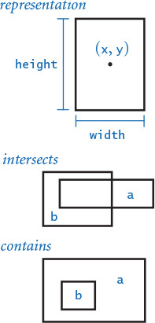
Compose an API for this data type, and complete its implementation as a class by filling in the code for perimeter(), intersects(), contains(), and draw(). Note: Treat coincident lines as intersecting, so that, for example, a.intersects(a) is True and a.contains(a) is True.
3.2.2 Compose a test client for Rectangle that takes three command-line arguments n, lo, and hi; generates n random rectangles whose width and height are uniformly distributed between lo and hi in the unit square; draws those rectangles to standard drawing; and writes their average area and average perimeter to standard output.
3.2.3 Add to your test client from the previous exercise code to compute the average number of pairs of rectangles that intersect and are contained in one another.
3.2.4 Develop an implementation of your Rectangle API from the previous exercises that represents rectangles with the coordinates of their lower-left and upper-right corners. Do not change the API.
3.2.5 What is wrong with the following code?
Click here to view code image
class Charge:
def __init__(self, x0, y0, q0):
_rx = x0
_ry = y0
_q = q0
...
Solution: The assignment statements in the constructor create local variables _rx, _ry, and _q, which are assigned values from the parameter variables but are never used. They disappear when the constructor is finished executing. Instead, the constructor should create instance variables by prefixing each variable with self followed by the dot operator and an underscore, like this:
Click here to view code image
class Charge:
def __init__(self, x0, y0, q0):
self._rx = x0
self._ry = y0
self._q = q0
...
The underscore is not strictly required in Python, but we follow this standard Python convention throughout this book to indicate that our intent is for instance variables to be private.
3.2.6 Create a data type Location that represents a location on Earth using latitudes and longitudes. Include a method distanceTo() that computes distances using the great-circle distance (see 1.2.30).
3.2.7 Python provides a data type Fraction, defined in the standard module fraction.py, that implements rational numbers. Implement your own version of that data type. Specifically, develop an implementation of the following API for a data type for rational numbers:
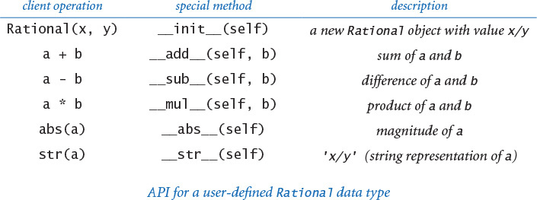
Use euclid.gcd() (PROGRAM 2.3.1) to ensure that the numerator and the denominator never have any common factors. Include a test client that exercises all of your methods.
3.2.8 An interval is defined to be the set of all points on a line greater than or equal to left and less than or equal to right. In particular, an interval with right less than left is empty. Compose a data type Interval that implements the API at the top of the next page. Include a test client that is a filter and takes a float x from the command line and writes to standard output (1) all of the intervals from standard input (each defined by a pair of floats) that contain x and (2) all pairs of intervals from standard input that intersect one another.
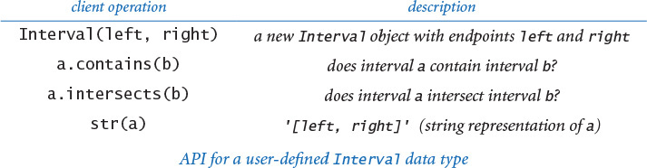
3.2.9 Develop an implementation of your Rectangle API from EXERCISE 3.2.1 that takes advantage of Interval to simplify and clarify the code.
3.2.10 Compose a data type Point that implements the following API. Include a test client of your own design.
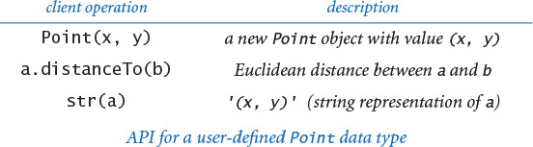
3.2.11 Add methods to Stopwatch that allow clients to stop and restart the stopwatch.
3.2.12 Use a Stopwatch to compare the cost of computing harmonic numbers with a for loop (see PROGRAM 1.3.5) as opposed to using the recursive method given in SECTION 2.3.
3.2.13 Modify the test client in turtle.py to produce stars with n points for odd n.
3.2.14 Compose a version of mandelbrot.py that uses Complex instead of Python’s complex, as described in the text. Then use Stopwatch compute the ratio of the running times of the two programs.
3.2.15 Modify the __str__() method in complex.py so that it writes complex numbers in the traditional format. For example, it should write the value 3 – i as 3 - i instead of 3.0 + -1.0i, the value 3 as 3 instead of 3.0 + 0.0i, and the value 3i as 3i instead of 0.0 + 3.0i.
3.2.16 Compose a complex client that takes three floats a, b, and c as command-line arguments and writes the complex roots of a x2 + b x + c.
3.2.17 Compose a complex client Roots that takes two floats a and b and an integer n from the command line and writes the nth roots of a + b i. Note: Skip this exercise if you are not familiar with the operation of taking roots of complex numbers.
3.2.18 Implement the following additions to the Complex API:
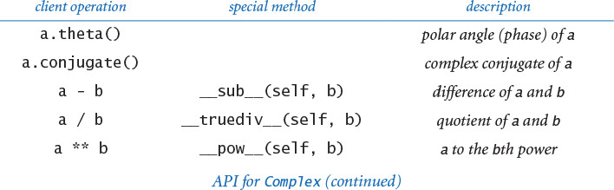
Include a test client that exercises all of your methods.
3.2.19 Find a complex number for which mandel() returns an iteration count greater than 100, and then zoom in on that number, as in the examples in the text.
3.2.20 Implement the method write() in stockaccount.py, which takes a file name as an argument and writes the contents of the account to the file, using the file format specified in the text.

Creative Exercises
3.2.21 Mutable charges. Modify Charge so that the charge value q0 can change, by adding a method increaseCharge() that takes a float argument and adds the given value to q0. Then, compose a client that initializes an array with
Click here to view code image
a = stdarray.create1D(3)
a[0] = charge.Charge(.4, .6, 50)
a[1] = charge.Charge(.5, .5, -5)
a[2] = charge.Charge(.6, .6, 50)
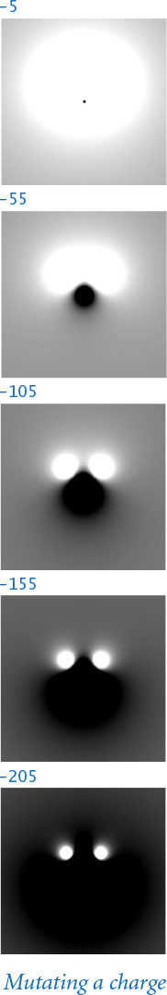
and then displays the result of slowly decreasing the charge value of a[1] by wrapping the code that computes the picture in a loop like the following:
for t in range(100):
# Compute the picture p.
stddraw.clear()
stddraw.picture(p)
stddraw.show(0)
a[1].increaseCharge(-2.0)
3.2.22 Complex timing. Write a Stopwatch client that compares the cost of using complex to the cost of composing code that directly manipulates two floats, for the task of doing the calculations in mandelbrot.py. Specifically, create a version of mandelbrot.py that just does the calculations (remove the code that refers to Picture), then create a version of that program that does not use complex, and then compute the ratio of the running times.
3.2.23 Quaternions. In 1843, Sir William Hamilton discovered an extension to complex numbers called quaternions. A quaternion is a vector a = (a0, a1, a2, a3) with the following operations:
• Magnitude:
• Conjugate: the conjugate of a is (a0, –a1, –a2, –a3)
• Inverse:
• Sum: a + b = (a0 + b0, a1 + b1, a2 + b2, a3 + b3)
• Product: a * b = (a0 b0 – a1 b1 – a2 b2 – a3 b3, a0 b1 – a1 b0 + a2 b3 – a3 b2, a0 b2 – a1 b3 + a2 b0 + a3 b1, a0 b3 + a1 b2 – a2 b1 + a3 b0)
• Quotient: a / b = ab-1
Create a data type for quaternions and a test client that exercises all of your code. Quaternions extend the concept of rotation in three dimensions to four dimensions. They are used in computer graphics, control theory, signal processing, and orbital mechanics.
3.2.24 Dragon curves. Write a recursive Turtle client Dragon that draws dragon curves (see EXERCISES 1.2.32 and 1.5.9).
Solution: These curves, which were originally discovered by three NASA physicists, were popularized in the 1960s by Martin Gardner and later used by Michael Crichton in the book and movie Jurassic Park. This exercise can be solved with remarkably compact code, based on a pair of mutually interacting recursive functions derived directly from the definition in EXERCISE 1.2.32. One of them, dragon(), should draw the curve as you expect; the other, nogard(), should draw the curve in reverse order. See the booksite for details.
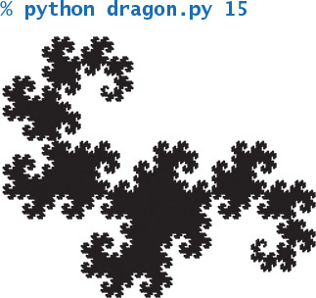
3.2.25 Hilbert curves. A space-filling curve is a continuous curve in the unit square that passes through every point. Write a recursive Turtle client that produces these recursive patterns, which approach a space-filling curve that was defined by the mathematician David Hilbert at the end of the 19th century.
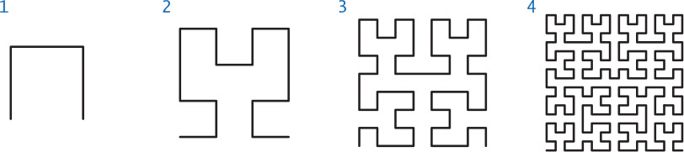
Partial solution: See the previous exercise. You need a pair of methods: hilbert(), which traverses a Hilbert curve, and treblih(), which traverses a Hilbert curve in reverse order. See the booksite for details.
3.2.26 Gosper island. Compose a recursive Turtle client that produces these recursive patterns.
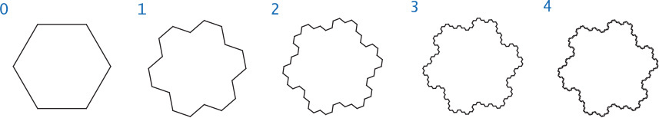
3.2.27 Data analysis. Compose a data type for use in running experiments where the control variable is an integer in the range [0, n) and the dependent variable is a float. For example, studying the running time of a program that takes an integer argument would involve such experiments. A Tukey plot is a way to visualize the statistics of such data (see EXERCISE 2.2.17). Implement the API shown below.
You can use the functions in stdstats to do the statistical calculations and draw the plots. Use stddraw so clients can use different colors for plot() and plotTukey() (for example, light gray for all the points and black for the Tukey plot). Compose a test client that plots the results (percolation probability) of running experiments with percolation (see SECTION 2.4) as the grid size increases.
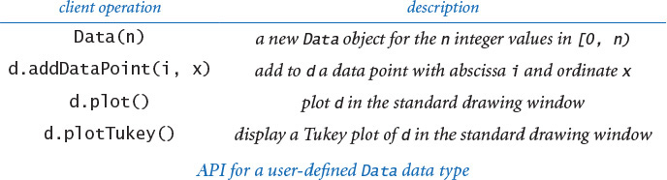
3.2.28 Elements. Compose a data type Element for entries in the periodic table of elements. Include data-type values for the element, atomic number, symbol, and atomic weight and accessor methods for each of these values. Then, compose a data type PeriodicTable that reads values from a file to create an array of Element objects (you can find the file and a description of its format on the booksite) and responds to queries from standard input so that a user can type a molecular formula like H2O and have the program respond by writing the molecular weight. Develop APIs and implementations for each data type.
3.2.29 Stock prices. The file DJIA.csv on the booksite contains all closing stock prices in the history of the Dow Jones Industrial Average, using the comma-separated-value format. Compose a data type Entry that can hold one entry in the table, with values for the date, opening price, daily high, daily low, closing price, and so forth. Then, compose a data type Table that reads the file to build an array of Entry objects and supports methods for computing averages over various periods of time. Finally, create interesting Table clients to produce plots of the data. Be creative: this path is well trodden.
3.2.30 Chaos with Newton’s method. The polynomial f (z) = z4 – 1 has four roots: at 1, –1, i, and –i. We can find the roots using Newton’s method in the complex plane: zk+1 = zk – f (zk) / f′ (zk). Here, f (z) = z4 – 1 and f′ (z) = 4z3. The method converges to one of the four roots, depending on the starting point z0. Compose a Complex client Newton that takes a command-line argument n and colors pixels in an n-by-n Picture white, red, green, or blue by mapping the pixel’s complex points in a regularly spaced grid in the square of size 2 centered at the origin and by coloring each pixel according to which of the four roots the corresponding point converges on (black if no convergence occurs after 100 iterations).
3.2.31 Equipotential surfaces. An equipotential surface is the set of all points that have the same electric potential V. Given a group of point charges, it is useful to visualize the electric potential by plotting equipotential surfaces (also known as a contour plot). Compose a program equipotential.py that draws a line every 5V by computing the potential at each pixel and checking whether the potential at the corresponding point is within 1 pixel of a multiple of 5V. Note: A very easy approximate solution to this exercise is obtained from PROGRAM 3.1.8 by scrambling the color values assigned to each pixel, rather than having them be proportional to the grayscale value. For example, the figure at left is created by inserting the code above it before creating the Color. Explain why it works, and experiment with your own version.
3.2.32 Color Mandelbrot plot. Create a file of 256 integer triples that represent interesting Color values, and then use those colors instead of grayscale values to plot each pixel in mandelbrot.py. Read the values to create an array of 256 Color values, then index into that array with the return value of mandel(). By experimenting with various color choices at various places in the set, you can produce astonishing images. See mandel.txt on the booksite for an example.
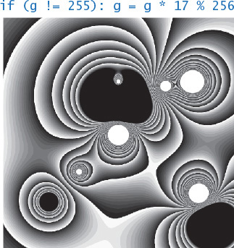
3.2.33 Julia sets. The Julia set for a given complex number c is a set of points related to the Mandelbrot function. Instead of fixing z and varying c, we fix c and vary z. Those points z for which the modified Mandelbrot function stays bounded are in the Julia set; those for which the sequence diverges to infinity are not in the set. All points z of interest lie in the 4-by-4 box centered at the origin. The Julia set for c is connected if and only if c is in the Mandelbrot set! Compose a program colorjulia.py that takes two command-line arguments a and b, and plots a color version of the Julia set for c = a + bi, using the color-table method described in the previous exercise.
3.2.34 Biggest winner and biggest loser. Compose a StockAccount client that builds an array of StockAccount objects, computes the total value of each account, and writes a report for the account with the largest value and the account with the smallest value. Assume that the data in the accounts are kept in a single file that contains the information for each of the accounts, one after the other, in the format given in the text.

3.3 Designing Data Types
The ability to create data types turns every programmer into a language designer. We do not have to settle for the data types and associated operations that are built into the language, because we can easily create our own data types data and then compose client programs that use them. For example, Python does not have a built-in facility for charged particles, but we can define a Charge data type and compose client programs that take immediate advantage of this abstraction. Even when Python does have a particular facility, we can use a data type to tailor it to our needs, as we do when we use our booksite modules instead of the more extensive ones provided by Python for software developers.
3.3.1 Complex numbers (polar)
3.3.2 Counter
3.3.3 Spatial vectors
3.3.4 Document sketch
3.3.5 Similarity detection
Programs in this section
At this point, the first thing that we strive for when composing a program is an understanding of the data types that we will need. Developing this understanding is a design activity. In this section, we focus on developing APIs as a critical step in the development of any program. We need to consider various alternatives, understand their impact on both client programs and implementations, and refine the design to strike an appropriate balance between the needs of clients and the possible implementation strategies.
If you take a course in systems programming, you will learn that this design activity is critical when building large systems, and that Python and similar languages have powerful high-level mechanisms that support code reuse when composing large programs. Many of these mechanisms are intended for use by experts building large systems, but the general approach is worthwhile for every programmer, and some of these mechanisms are useful when composing small programs.
In this section we discuss encapsulation, immutability, and inheritance, with particular attention to the use of these ideas in data-type design to enable modular programming, facilitate debugging, and compose clear and correct code.
At the end of the section, we discuss Python’s mechanisms for use in checking design assumptions against actual conditions at run time. Such tools are invaluable aids in developing reliable software.

Designing APIs
In SECTION 3.1, we composed client programs that use APIs; in SECTION 3.2, we implemented APIs. Now we consider the challenge of designing APIs. Treating these topics in this order and with this focus is appropriate because most of the time that you spend programming will be composing client programs. The main purpose of designing a good API is to streamline and simplify client code.
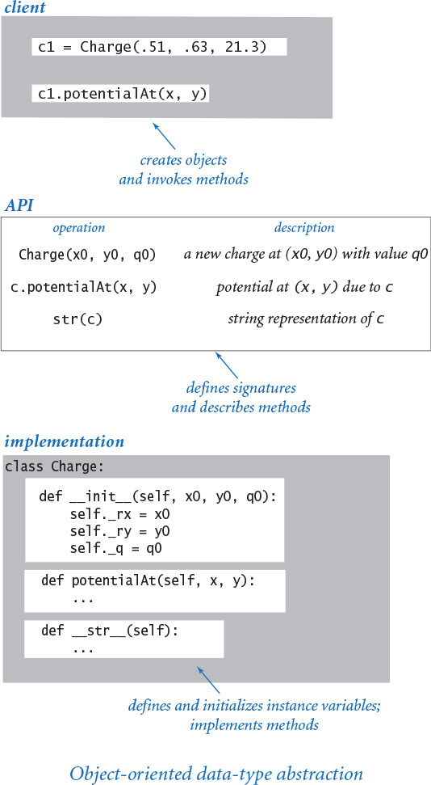
Often the most important and most challenging step in building software is designing the APIs. This task takes practice, careful deliberation, and many iterations. However, any time spent designing a good API is certain to be repaid in time saved during debugging or with code reuse.
Articulating an API might seem to be overkill when composing a small program, but you should consider composing every program as though you will need to reuse the code someday—not because you know that you will reuse that code, but because you are quite likely to want to reuse some of your code and you cannot know which code you will need.

Standards
It is easy to understand why conforming to an API is so important by considering other domains. From railroad tracks, to threaded nuts and bolts, to MP3s and DVDs, to radio frequencies, to Internet standards, we know that using a common standard interface enables the broadest usage of a technology. Python itself is another example: your Python programs are clients of the Python virtual machine, which is a standard interface that is implemented on a wide variety of hardware and software platforms. By using APIs to separate clients from implementations, we reap the benefits of standard interfaces for every program that we compose.

Specification problem
Our APIs for data types are sets of methods, along with brief English-language descriptions of what the methods are supposed to do. Ideally, an API would clearly articulate behavior for all possible arguments, including side effects, and then we would have software to check that implementations meet the specification. Unfortunately, a fundamental result from theoretical computer science, known as the specification problem, says that this goal is actually impossible to achieve. Briefly, such a specification would have to be written in a formal language like a programming language, and the problem of determining whether two programs perform the same computation is known, mathematically, to be unsolvable. (If you are interested in this idea, you can learn much more about the nature of unsolvable problems and their role in our understanding of the nature of computation in a course in theoretical computer science.) Therefore, we resort to informal descriptions with examples, such as those in the text surrounding our APIs.

Wide interfaces
A wide interface is one that has an excessive number of methods. An important principle to follow in designing an API is to avoid wide interfaces. The size of an API naturally tends to grow over time because it is easy to add methods to an existing API, whereas it is difficult to remove methods without breaking existing clients. In certain situations, wide interfaces are justified—for example, in widely used built-in types such as str. Various techniques are helpful in reducing the effective width of an interface. For example, one approach is to include only methods that are orthogonal in functionality—Python’s math module includes methods for sin(), cos(), and tan(), but not sec().

Start with client code
One of the primary purposes of developing a data type is to simplify client code. Therefore, it makes sense to pay attention to client code from the start when designing an API. Very often, doing so is no problem at all, because a typical reason to develop a data type in the first place is to simplify client code that is becoming cumbersome. When you find yourself with some client code that you are not proud of, one way to proceed is to compose a fanciful simplified version of the code that expresses the computation in the way that you are thinking about it, at some higher level that does not involve the details of the code. Or, if you have done a good job of composing succinct comments to describe your computation, one possible starting point is to think about opportunities to convert the comments into code.
Remember the basic mantra for data types: whenever you can clearly separate data and associated operations within a computation, you should do so. Whatever the source, it is normally wise to compose client code (and develop the API) before working on an implementation. Composing two clients is even better. Starting with client code is one way of ensuring that developing an implementation will be worth the effort.

Avoid dependence on representation
Usually when developing an API, we have a representation in mind. After all, a data type is a set of values and a set of operations defined on those values, and it does not make much sense to talk about the operations without knowing the values. But that is different from knowing the representation of the values. One purpose of the data type is to simplify client code by allowing it to avoid details of and dependence on a particular representation. For example, our client programs for Picture and stdaudio work with simple abstract representations of pictures and sound, respectively. The primary value of the APIs for these abstraction is that they allow client code to ignore a substantial amount of detail that is found in the standard representations of those abstractions.

Pitfalls in API design
An API may be too hard to implement, implying implementations that are difficult or impossible to develop, or too hard to use, creating client code that is more complicated than without the API. An API might be too narrow, omitting methods that clients need, or too wide, including a large number of methods not needed by any client. An API may be too general, providing no useful abstractions, or too specific, providing abstractions so detailed or so diffuse as to be useless. These considerations are sometimes summarized in yet another motto: provide to clients the methods they need and no others.
When you first started programming, you typed in helloworld.py without understanding much about it except the effect that it produced. From that starting point, you learned to program by mimicking the code in the book and eventually developing your own code to solve various problems. You are at a similar point with API design. There are many APIs available in the book, on the booksite, and in online Python documentation that you can study and use, to gain confidence in designing and developing APIs of your own.

Encapsulation
The process of separating clients from implementations by hiding information is known as encapsulation. Details of the implementation are kept hidden from clients, and implementations have no way of knowing details of client code, which may even be created in the future.
As you may have surmised, we have been practicing encapsulation in our data-type implementations. In SECTION 3.1, we started with the mantra you do not need to know how a data type is implemented to use it. This statement describes one of the prime benefits of encapsulation. We consider it to be so important that we have not described to you any other way of designing a data type. Now, we discuss in more detail our three primary reasons for doing so. We use encapsulation:
• To enable modular programming
• To facilitate debugging
• To clarify program code
These reasons are tied together (well-designed modular code is easier to debug and understand than code based entirely on built-in types).

Modular programming
The modular programming style that we have been developing since learning functions in CHAPTER 2 has been predicated on the idea of breaking large programs into small modules that can be developed and debugged independently. This approach improves the resiliency of our software by limiting and localizing the effects of making changes, and it promotes code reuse by making it possible to substitute new implementations of a data type to improve performance, accuracy, or memory footprint. The key to success in modular programming is to maintain independence among modules. We do so by insisting on the API being the only point of dependence between client and implementation—data-type implementation code can assume that the client knows nothing but the API.

Changing an API
We often reap the benefits of encapsulation when we use standard modules. New versions of Python often, for example, may include new implementations of various data types or modules that define functions. There is a strong and constant motivation to improve data-type implementations because all clients can potentially benefit from an improved implementation. However, Python APIs rarely change. When changes do occur, they are costly throughout the Python community—everyone has to update their clients. As an extreme example, consider the change in the meaning of the / operator for integer operands from Python 2 to Python 3 (see page 27). Whatever the benefits of this change, it amounts to a change in the API for the int data type (changing the behavior of the / operator), requiring all programs that use the / operator with integers to be checked and debugged! Some people have estimated that this change might delay the widespread adoption of Python 3 for up to a decade. This situation calls for another mantra: once a significant number of clients are using a module, do not change the API.

Changing an implementation
Consider the class Complex, defined in PROGRAM 3.3.1 (complexpolar.py). It has the same name and API as the class Complex from PROGRAM 3.2.6, but uses a different representation for the complex numbers. The Complex class defined in complex.py uses the Cartesian representation, where instance variables _re and _im represent a complex number as x + yi. The Complex class defined in complexpolar.py uses the polar representation, where instance variables _r and _theta represent complex numbers as r (cos θ + i sin θ). In this representation, we refer to r as the magnitude and θ as the polar angle. The polar representation is of interest because certain operations on complex numbers are easier to perform in the polar representation. Addition and subtraction are easier in the Cartesian representation; multiplication and division are easier in the polar representation. As you will learn in SECTION 4.1, it is often the case that performance differences for different approaches are dramatic. The idea of encapsulation is that we can substitute one of these programs for the other (for whatever reason) without changing client code, except to change the import statement to use complexpolar instead of complex. The choice between the two implementations depends on the client. Indeed, in principle, the only difference to the client should be in different performance properties. This capability is of critical importance for many reasons. One of the most important is that it allows us to improve software constantly: when we develop a better way to implement a data type, all of its clients can benefit. You take advantage of this property every time you install a new version of a software system, including Python itself.
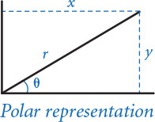

Private
Many programming languages provide support for enforcing encapsulation. For example, Java provides the private visibility modifier. When you declare an instance variable (or method) to be private, you are making it impossible for any client (code in another module) to directly access the instance variable (or method) that is the subject of the modifier. As a result, clients can use the class only through its public methods and constructors—that is, through its API.
Program 3.3.1 Complex numbers (complexpolar.py)
Click here to view code image
import math
import stdio
class Complex:
def __init__(self, re=0, im=0):
self._r = math.hypot(im, re)
self._theta = math.atan2(im, re)
def re(self): return self._r * math.cos(self._theta)
def im(self): return self._r * math.sin(self._theta)
def __add__(self, other):
re = self.re() + other.re()
im = self.im() + other.im()
return Complex(re, im)
def __mul__(self, other):
c = Complex()
c._r = self._r * other._r
c._theta = self._theta + other._theta
return c
def __abs__(self): return self.r
def __str__(self):
return str(self.re()) + ' + ' + str(self.im()) + 'i'
def main():
z0 = Complex(1.0, 1.0)
z = z0
z = z*z + z0
z = z*z + z0
stdio.writeln(z)
if __name__ == '__main__': main()
instance variables
_r | magnitude
_theta | polar angle
This data type implements the same API as PROGRAM 3.2.6. It uses the same methods but different instance variables. Since the instance variables are private, this program might be used in place of PROGRAM 3.2.6 without changing any client code (except for the import statement).
Click here to view code image
% python complexpolar.py
-7.000000000000002 + 7.000000000000003i
Python does not offer a private visibility modifier, which means that clients can directly access all instance variables, methods, and functions. However the Python programming community espouses a pertinent convention: if an instance variable, method, or function has a name that begins with an underscore, then clients should consider that instance variable, method, or function to be private. Through this naming convention, clients are informed that they should not directly access the instance variable, method, or function thus named.
Programmers who conform to the underscore convention can modify the implementation of private functions or methods (or use different private instance variables) and know that no client that also conforms to the convention will be directly affected. For example, in the Complex class defined in complex.py (PROGRAM 3.2.6), if the instance variables _re and _im (note the leading underscores indicating that the variables are private) were instead named re and im (note the absence of leading underscores indicating that the variables are public), then a client might compose code that directly accesses them. If z is a variable that refers to a Complex object, then the client can use z.re and z.im to refer to its instance variables. But any client code that does so becomes dependent on that particular implementation of the API, violating a basic precept of encapsulation. A switch to a different implementation, such as the one in PROGRAM 3.3.1, could render that client useless.
To protect ourselves against such situations, in this book, we go one step further and always make all instance variables private in our classes. We strongly recommend that you do the same—there is no good reason to access an instance variable directly from a client. Next, we examine some ramifications of this convention.

Planning for the future
There are numerous examples where significant expense can be traced directly to programmers not encapsulating their data types.
• Y2K problem. In the last millennium, many programs represented the year using only two decimal digits to save storage. Such programs could not distinguish between the year 1900 and the year 2000. As January 1, 2000, approached, programmers raced to fix such rollover errors and avert the catastrophic failures that were predicted by many technologists.
• ZIP codes. In 1963, The United States Postal Service (USPS) began using a five-digit ZIP code to improve the sorting and delivery of mail. Programmers wrote software assuming that these codes would remain at five digits forever. In 1983, the USPS introduced an expanded ZIP code called ZIP+4, which consists of the original five-digit ZIP code plus four extra digits.
• IPv4 versus IPv6. The Internet Protocol (IP) is a standard used by electronic devices to exchange data over the Internet. Each device is assigned a unique integer or address. IPv4 uses 32-bit addresses and supports about 4.3 billion addresses. Due to explosive growth of the Internet, a new version, IPv6, uses 128-bit addresses and supports 2128 addresses.
In each of these cases, if the programmer did not properly encapsulate the data, then a change to the internal representation (to accommodate the new standard) would break a large amount of client code (that depended on the old standard). The estimated costs for the changes in each of these cases runs to hundreds of millions of dollars! That is a huge cost for failing to encapsulate a single number. These predicaments might seem distant to you, but you can be sure that every individual programmer (that’s you) who does not take advantage of the protection available through encapsulation risks losing significant amounts of time and effort fixing broken code when standards change.
Our convention of always considering all of our instance variables to be private provides some protection against such problems. If you adopt this convention when implementing a data type for a year, ZIP code, IP address, or whatever, you can change the internal representation without affecting clients. The data-type implementation knows the data representation, and the object holds the data; the client holds only a reference to the object and does not know the details.

Limiting the potential for error
Encapsulation also helps programmers ensure that their code operates as intended. As an example, we consider yet another horror story: in the 2000 presidential election, Al Gore received negative 16,022 votes on an electronic voting machine in Volusia County, Florida. The counter variable was not properly encapsulated in the voting machine software! To understand the problem, consider Counter (PROGRAM 3.3.2), which implements a simple counter according to the API at the bottom of this page. This abstraction is useful in many
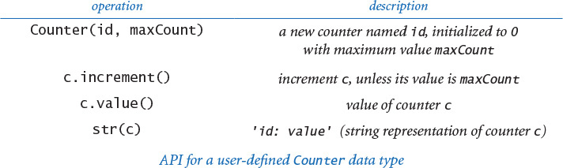
Program 3.3.2 Counter (counter.py)
Click here to view code image
import sys
import stdarray
import stdio
import stdrandom
class Counter:
def __init__(self, id, maxCount):
self._name = id
self._maxCount = maxCount
self._count = 0
def increment(self):
if self._count < self._maxCount:
self._count += 1
def value(self):
return self._count
def __str__(self):
return self._name + ': ' + str(self._count)
def main():
n = int(sys.argv[1])
p = float(sys.argv[2])
heads = Counter('Heads', n)
tails = Counter('Tails', n)
for i in range(n):
if stdrandom.bernoulli(p): heads.increment()
else: tails.increment()
stdio.writeln(heads)
stdio.writeln(tails)
if __name__ == '__main__': main()
instance variables
_name | counter name
_maxCount | maximum value
_count | value
This class encapsulates a simple integer counter, assigning it a string name and initializing it to 0, incrementing it each time the client calls increment(), reporting the value when the client calls value(), and creating a string with its name and value when the client calls str().
Click here to view code image
% python counter.py 1000000 .75
Heads: 750056
Tails: 249944
contexts, including, for example, an electronic voting machine. It encapsulates a single integer and ensures that the only operation that can be performed on the integer is increment by one. Therefore, it can never go negative. The goal of data abstraction is to restrict the operations on the data. It also isolates operations on the data. For example, we could add a new implementation with a logging capability so that counter.increment() records a timestamp for each vote or some other information that can be used for consistency checks. But the most important problem is that Python’s convention is no protection against malicious client code. For example, there could be client code like the following somewhere in the voting machine:
Click here to view code image
counter = Counter('Volusia', VOTERS_IN_VOLUSIA_COUNTY)
counter._count = -16022;
In a programming language that enforces encapsulation, code like this will not even compile; without such protection, Gore’s vote count was negative. Proper encapsulation is far from a complete solution to the voting security problem, but it is a good start. For this reason, security experts generally view Python as being unsafe for such applications.

Code clarity
Precisely specifying a data type improves design because it leads to client code that can more clearly express its computation. You have seen many examples of such client code in SECTIONS 3.1 and 3.2, from charged particles to pictures to complex numbers. One key to good design is to observe that code composed with the proper abstractions can be nearly self-documenting.
We have stressed the benefits of encapsulation throughout this book. We summarize them again here, in the context of designing data types. Encapsulation enables modular programming, allowing us to
• Independently develop client and implementation code
• Substitute improved implementations without affecting clients
• Support clients not yet composed (any client can compose code to the API)
Encapsulation also isolates data-type operations, which leads to the possibility of
• Adding consistency checks and other debugging tools in implementations
• Clarifying client code
A properly implemented data type (encapsulated) extends the Python language, allowing any client program to make use of it.

Immutability
An object from a data type is immutable if its data-type value cannot change once created. An immutable data type, such as a Python string, is one in which all objects of that type are immutable. By contrast, a mutable data type, such as a Python list/array, is one in which objects of that type have values that are designed to change. Of the data types considered in this chapter, Charge, Color, and Complex are all immutable, and Picture, Histogram, Turtle, StockAccount, and Counter are all mutable. Whether to make a data type immutable is a fundamental design decision and depends on the application at hand.

Immutable data types
The purpose of many data types is to encapsulate values that do not change. For example, a programmer implementing a Complex client might reasonably expect to compose the code z = z0, thus setting two variables to reference the same Complex object, in the same way as for floats or integers. But if Complex were mutable and the object referenced by z were to change after the assignment z = z0, then the object referenced by z0 would also change (they are aliases, or both references to the same object). Conceptually, changing the value of z would change the value of z0! This unexpected result, known as an aliasing bug, comes as a surprise to many newcomers to object-oriented programming. One very important reason to implement immutable types is that we can use immutable objects in assignment statements and as arguments and return values from functions without having to worry about their values changing.
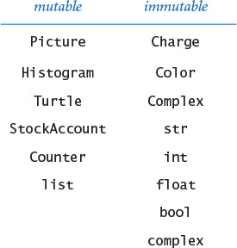

Mutable data types
For many other data types, the very purpose of the abstraction is to encapsulate values as they change. The Turtle class defined in PROGRAM 3.2.4 (turtle.py) is a prime example. Our reason for using Turtle is to relieve client programs of the responsibility of tracking the changing values. Similarly, Picture, Histogram, StockAccount, Counter, and Python lists/arrays are all types where we expect values to change. In a client where we pass a Turtle as an argument to a function or method, as in koch.py, we expect the turtle’s position and orientation to change.

Arrays and strings
You have already encountered this distinction as a client programmer, when using Python lists/arrays (mutable) and Python strings (immutable). When you pass a string to a method/function, you do not need to worry about that method/function changing the sequence of characters in the string. In contrast, when you pass an array to a method/function, the method/function is free to change the elements of the array. Python strings are immutable because we generally do not want str values to change; Python arrays are mutable because we often do want array elements to change. There are also situations where we want to have mutable strings and where we want to have immutable arrays, which we consider later in this section.

Advantages of immutability
Generally, immutable data types are easier to use and harder to misuse because the scope of code that can change object values is far smaller than for mutable types. It is easier to debug code that uses immutable data types because it is easier to guarantee that objects remain in a consistent state. When using mutable data types, you must always be concerned about where and when object values might change.

Cost of immutability
The downside of immutability is that you must create a new object for every value. For example, when you are using the Complex data type, the expression z = z*z + z0 involves creating a third object (to hold the value z*z), then using that object with the + operator (without saving an explicit reference to it) and creating a fourth object to hold the value z*z + z0, and assigning that object to z (thereby orphaning the original reference to z). A program such as mandelbrot.py (PROGRAM 3.2.7) creates a huge number of such intermediate objects. However, this expense is normally manageable because Python’s memory management is typically optimized for such situations.

Enforcing immutability
Some languages include direct support to help enforce immutability. For example, Java supports the final modifier for instance variables whose values never change, which serves as documentation that the value does not change, prevents accidental changes, and makes programs easier to debug. It is possible to simulate this behavior in Python, but such code is best left for experts. In this book, the best that we can do is to state our intent to make a data type immutable and make sure not to change any object’s value in our implementation code (which is not always as easy as you might think).

Defensive copies
Suppose that we wish to develop an immutable data type named Vector, whose constructor takes an array of floats as an argument to initialize an instance variable. Consider this attempt:
Click here to view code image
class Vector:
def __init__(self, a):
self._coords = a # array of coordinates
...
This code makes Vector a mutable data type. A client program could create a Vector object by specifying the elements in an array, and then (bypassing the API) change the elements of the Vector after creation:
Click here to view code image
a = [3.0, 4.0]
v = new Vector(a)
a[0] = 17.0 # bypasses the public API
The instance variable _coords is marked as private (via its leading underscore), but Vector is mutable because the implementation holds a reference to the same array as does the client; if the client changes an element in that array, then the client also changes the Vector object.
To ensure immutability of a data type that includes an instance variable of a mutable type, the implementation needs to make a local copy, known as a defensive copy. Recall from SECTION 1.4 that the expression a[:] creates a copy of array a[]. As a consequence, this code creates a defensive copy:
Click here to view code image
class Vector:
def __init__(self, a):
self._coords = a[:] # array of coordinates
...
Next, we consider a full implementation of such a data type.
Immutability needs to be taken into account in any data-type design. Ideally, whether a data type is immutable should be specified in the API, so that clients know that object values will not change. Implementing an immutable type can be a burden. For complicated types, making the defensive copy is one challenge; ensuring that none of the methods change object values is another.

Example: spatial vectors
To illustrate these ideas in the context of a useful mathematical abstraction, we now consider a vector data type. Like complex numbers, the basic definition of the vector abstraction is familiar because it has played a central role in applied mathematics for over 100 years. The field of mathematics known as linear algebra is concerned with properties of vectors. Linear algebra is a rich and successful theory with numerous applications, and it plays an important role in all fields of social and natural science. Full treatment of linear algebra is certainly beyond the scope of this book, but several important applications are based upon elementary and familiar calculations, so we touch upon vectors and linear algebra throughout the book (for example, the random surfer example in SECTION 1.6 is based on linear algebra). Accordingly, it is worthwhile to encapsulate such an abstraction in a data type.
A spatial vector is an abstract entity that has a magnitude and a direction. Spatial vectors provide a natural way to describe properties of the physical world, such as force, velocity, momentum, or acceleration. One standard way to specify a vector is as an arrow from the origin to a point in a Cartesian coordinate system: the direction is the ray from the origin to the point and the magnitude is the length of the arrow (distance from the origin to the point). To specify the vector, it suffices to specify the point.
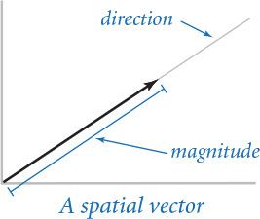
This concept extends to any number of dimensions: an ordered list of n real numbers (the coordinates of an n-dimensional point) suffices to specify a vector in n-dimensional space. By convention, we use a boldface letter to refer to a vector and numbers or indexed variable names (the same letter in italics) separated by commas within parentheses to denote its value. For example, we might use x to denote the vector (x0, x1, . . ., xn–1) and y to denote the vector (y0, y1, . . ., yn–1).

API
The basic operations on vectors are to add two vectors, multiply a vector by a scalar (a real number), compute the dot product of two vectors, and compute the magnitude and direction, as follows:
• Addition: x + y = (x0 + y0, x1 + y1, . . ., xn–1 + yn–1)
• Scalar product: αx = (αx0, αx1, . . ., αxn–1)
• Dot product: x · y = x0y0 + x1y1 + . . . + xn–1yn–1
• Magnitude: |x| = (x02 + x12 + . . . + xn–1 2)1/2
• Direction: x / |x| = (x0 / |x|, x1 / |x|, . . ., xn–1 / |x|)
The results of addition, scalar product, and direction are vectors, but the magnitude and the dot product are scalar quantities (floats). For example, if x = (0, 3, 4, 0), and y = (0, –3, 1, –4), then x + y = (0, 0, 5, –4), 3x = (0, 9, 12, 0), x · y = –5, |x| = 5, and x / |x| = (0, 0.6, 0.8, 0). The direction vector is a unit vector: its magnitude is 1. These definitions lead to the API shown at the bottom of this page. As with Complex, this API does not explicitly specify that the data type is immutable, but we know that client programmers (who are likely to be thinking in terms of the mathematical abstraction) will certainly expect that convention, and perhaps we would rather not explain to them that we are trying to protect them from aliasing bugs!

Representation
As usual, our first choice in developing an implementation is to choose a representation for the data. Using an array to hold the Cartesian coordinates provided in the constructor is a clear choice, but not the only reasonable choice. Indeed, one of the basic tenets of linear algebra is that other sets of n vectors can be used as the basis for a coordinate system: any vector can be expressed as a linear combination of a set of n vectors, satisfying a certain condition known as linear independence. This ability to change coordinate systems aligns nicely with encapsulation. Most clients do not need to know about the representation at all and can work with Vector objects and operations. If warranted, the implementation can change the coordinate system without affecting client code.
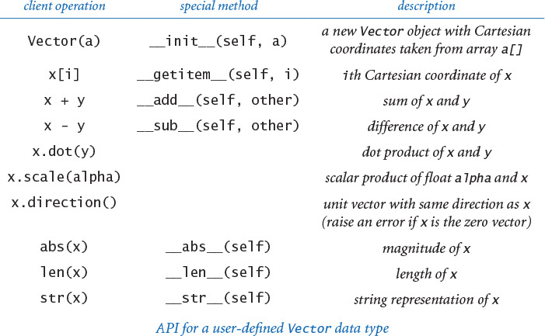
Program 3.3.3 Spatial vectors (vector.py)
Click here to view code image
import math
import stdarray
import stdio
class Vector:
def __init__(self, a):
self._coords = a[:]
self._n = len(a)
def __add__(self, other):
result = stdarray.create1D(self._n, 0)
for i in range(self._n):
result[i] = self._coords[i] + other._coords[i]
return Vector(result)
def dot(self, other):
result = 0
for i in range(self._n):
result += self._coords[i] * other._coords[i]
return result
def scale(self, alpha):
result = stdarray.create1D(self._n, 0)
for i in range(self._n):
result[i] = alpha * self._coords[i]
return Vector(result)
def direction(self): return self.scale(1.0 / abs(self))
def __getitem__(self, i): return self._coords[i]
def __abs__(self): return math.sqrt(self.dot(self))
def __len__(self): return self._n
def __str__(self): return str(self._coords)
instance variables
_coords[] | Cartesian coordinates
_n | dimension
This implementation encapsulates the mathematical spatial-vector abstraction in an immutable Python data type. PROGRAM 3.3.4 (sketch.py) and PROGRAM 3.4.1 (body.py) are typical clients. The test client and __sub__() implementations are left for EXERCISES 3.3.5 and 3.3.6.

Implementation
Given the representation, the code that implements all of these operations is straightforward, as you can see in the Vector class defined in vector.py (PROGRAM 3.3.3). The constructor makes a defensive copy of the client array and none of the methods assigns a value to the copy, so that Vector objects are immutable. Note in particular that the implementation of x[i] (__getitem__(self, i)) is easy in our Cartesian coordinate representation: return the appropriate coordinate in the array. It actually implements a mathematical function that is defined for any Vector representation—the geometric projection onto the ith Cartesian axis.
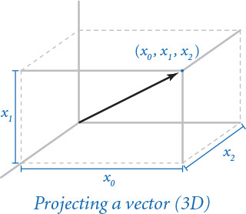
How can we ensure immutability when it seems that the client is free to compose code like x[i] = 2.0? The answer to this question lies in a special method that we do not implement in an immutable data type: in such a case, Python calls the special method __setitem__() instead of __getitem__(). Since Vector does not implement that method, such client code would raise an AttributeError at run time. Later in this section, we will survey Python’s special methods so that you will have some context when faced with such issues.
Why go to the trouble of using a Vector data type when all of the operations are so easily implemented with arrays? By now the answer to this question should be obvious to you: to enable modular programming, facilitate debugging, and clarify code. The array is a low-level Python mechanism that admits all kinds of operations. By restricting ourselves to just the operations in the Vector API (which are the only ones that we need, for many clients), we simplify the process of designing, implementing, and maintaining our programs. Because the type is immutable, we can use it as we use built-in types (int, float, bool, and str). For example, when we pass a Vector to a function, we are assured its value will not change, but we do not have that assurance with an array. Composing programs that use Vector objects and operations is an easy and natural way to take advantage of the extensive amount of mathematical knowledge that has been developed around this abstract concept.

Tuples
Python’s built-in tuple data type represents an immutable sequence of objects. It is similar to the built-in list data type (which we use for arrays), except that once you create a tuple, you cannot change its items. In situations where you need to change the items in the sequence (such as reversing or shuffling an array) you must use arrays; in situations where the items do not change (such as the coordinates in our Vector data type), you should use tuples.
You can manipulate tuples using familiar array notation, as documented in the API at the bottom of the page. You can create tuples either using the built-in function tuple() or by listing a sequence of expressions, separated by commas, and (optionally) enclosed in matching parentheses.
Using tuples can improve the design of a program. For example, if we replace the first statement in the constructor of vector.py with
self._coords = tuple(a)
then any attempt to change a vector coordinate within the Vector class raises a TypeError at run time, helping to enforce immutability of Vector objects.
Python also provides a powerful tuple assignment feature known as tuple packing and tuple unpacking that lets you assign a tuple of expressions on the right-hand side of an assignment operator to a tuple of variables on the left-hand side (provided the number of variables on the left matches the number of expressions on the right). You can use this feature to assign multiple variables simultaneously. For example, the following statement exchanges the object references in variable x and y:
x, y = y, x
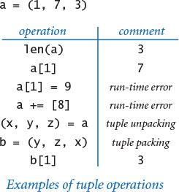
You can also use tuple packing and unpacking to return multiple values from a function (see EXERCISE 3.3.14).
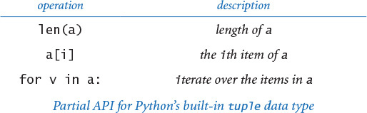

Polymorphism
Often, when we compose methods (or functions), we intend for them to work only with objects of specific types. Sometimes, we want them to work with objects of different types. A method (or function) that can take arguments with different types is said to be polymorphic.
The best kind of polymorphism is the unexpected kind: when you apply an existing method/function to a new data type (for which you never planned) and discover that the method/function has exactly the behavior that you wanted. The worst kind of polymorphism is also the unexpected kind: when you apply an existing method/function to a new data type and it returns the wrong answer! Finding a bug of this sort can be an extraordinary challenge.

Duck typing
Duck typing is a programming style in which the language does not formally specify the requirements for a function’s arguments; instead, it just tries to call the function if a compatible one is defined (and raises a run-time error otherwise). The name comes from an old quote attributed to the poet J. W. Riley:
When I see a bird that
walks like a duck and swims like a duck and quacks like a duck
I call that bird a duck
In Python, if an object walks like a duck, swims like a duck, and quacks like a duck, you can treat that object as a duck; you don’t need to explicitly declare it to be a duck. In many languages (such as Java or C++), you do need to explicitly declare the types of variables, but not in Python—Python uses duck typing for all operations (function calls, method calls, and operators). It raises a TypeError at run time if an operation cannot be applied to an object because it is of an inappropriate type. One principle of duck typing is that a method/function should not care about the type of an object, just whether a client can perform the desired operations on that object. That is, if all of the operations within a method/function can be applied to a type, then the method/function can be applied to that type. This approach leads to simpler and more flexible client code and puts the focus on operations that are actually used rather than the type.

Disadvantages of duck typing
The primary disadvantage of duck typing is that it is difficult to know precisely what the contract is between the client and the implementation, especially when a required method is needed only indirectly. The API simply does not carry this kind of information. This lack of information can lead to run-time errors. Worse, the end result can be semantically incorrect, with no error raised at all. Next, we consider a simple example of this situation.

A case in point
We designed our Vector data type under the implicit assumption that the vector components would be floats and that the client would create a new vector by passing an array of float objects to the constructor. If the client creates two vectors x and y in this way, then both x[i] and x.dot(y) return floats and both x + y and x - y return vectors with float components, as expected.
Suppose, instead, that a client creates a Vector with integer components by passing an array of int objects to the constructor. If the client creates two vectors x and y in this manner, then both x[i] and x.dot(y) return integers and both x + y and x - y return vectors with integer components, as desired. Of course, abs(x) returns a float and x.direction() returns a vector with float components. This is the best kind of polymorphism, where duck typing works serendipitously.
Now, suppose that a client creates a Vector with complex components by passing an array of complex objects to the constructor. There is no problem with vector addition or scalar multiplication, but the implementation of the dot product operation (along with the implementations of magnitude and direction, which depend on the dot product) fails spectacularly. Here is an example:
a = [1 + 2j, 2 + 0j, 4 + 0j]
x = Vector(a)
b = abs(x)
This code results in a TypeError at run time, with math.sqrt() trying to take the square root of a complex number. The problem is that the dot product of two complex-valued vectors x and y requires taking the complex conjugate of the elements in the second vector:
In our example, the __abs__() special method in Vector calls x.dot(x), which is supposed to compute the result
(1 + 2i)(1–2i) + 2·2 + 4·4 = 25
but actually computes the result
(1 + 2i)(1 + 2i) + 2·2 + 4·4 = 17+ 4i
which is the complex number that raises the TypeError for math.sqrt(). An unexpected run-time error is bad enough, but suppose that the last line of the code were b = abs(x.dot(x)). In that case, b would get assigned the integer 33 (it is supposed to be 25) with no indication whatsoever of any problem. Let’s hope that such code is not being used to control a nuclear power plant or a surface-to-air missile somewhere. Computing with a wrong result is certain to wreak havoc.
Once we are aware of the problem, we can fix Vector to be compatible with complex numbers by making two changes, one to dot() and one to __abs__():
Click here to view code image
def dot(self, other):
result = 0
for i in range(self._length):
result += self._coords[i] * other._coords[i].conjugate()
return result
def __abs__(self):
return math.sqrt(abs(self.dot(self)))
The modification to dot() works because Python’s numeric types all include a conjugate() method that returns the complex conjugate of a number (which is the number itself if it is an integer or float). The modification to __abs__() is needed because math.sqrt() raises a TypeError if its argument is complex (even if its imaginary part is zero). The dot product of a complex number with itself is guaranteed to be a nonnegative real number, but it is a complex, so we take its magnitude (a float) using abs() before taking the square root.
In this case, duck typing is the worst kind of polymorphism. It is certainly reasonable for a client to expect the implementation of Vector to work properly when vector components are complex numbers. How can an implementation anticipate and prepare for all potential uses of a data type? This situation presents a design challenge that is impossible to meet. All we can do is caution you to check, if possible, that any data type that you use can handle the types of data that you intend to use with it.

Overloading
The ability to define a data type that provides its own definitions of operators is a form of polymorphism known as operator overloading. In Python, you can overload almost every operator, including operators for arithmetic, comparisons, indexing, and slicing. You can also overload built-in functions, including absolute value, length, hashing, and type conversion. Overloading operators and built-in functions makes user-defined types behave more like built-in types.

Special methods
The Python mechanism for supporting overloading is to associate a special method with each operator and each built-in function. Though you have already seen the use of special methods in several data-type implementations (notably Complex and Vector), we briefly summarize the concept here.
To perform an operation, Python internally converts the expression into a call on the corresponding special method; to call a built-in function, Python internally calls the corresponding special method instead. To overload an operator or built-in function, you include an implementation of the corresponding special method with your own code. For example, whenever Python sees x + y in client code, it converts that expression into the special method call x.__add__(y). Thus, to overload the + operator in your data type, just include an implementation of the special method __add__(). Similarly, whenever Python sees str(x) in client code, it converts that expression into the special method call x.__str__(). Thus, to overload the str() built-in function, just include an implementation of the special method __str__().

Arithmetic operators
In Python, arithmetic operations like x + y and x * y are not just for integers and floats. Python associates a special method with each of its arithmetic operators, so you can overload any arithmetic operation by implementing the corresponding special method, as detailed in the table below.
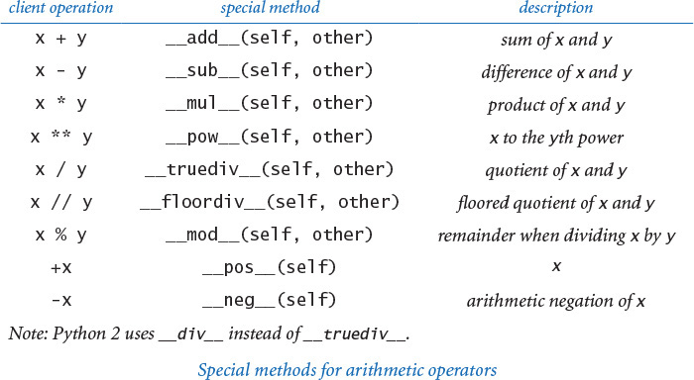

Equality
The == and != operators for testing equality require special attention. For example, consider the code in the diagram at right, which creates two Charge objects, referenced by three variables c1, c2, and c3. As illustrated in the diagram, c1 and c3 both reference the same object, which is different from the one referenced by c2. Clearly, c1 == c3 is True, but what about c1 == c2? The answer to this question is unclear because there are two ways to think about equality in Python:
• Reference equality (identity equality). Reference equality holds when two references are equal—they refer to the same object. The built in function id() gives the identity of an object (its memory address); the is and is not operators test whether two variables refer to the same object. That is, the implementation of c1 is c2 tests whether id(c1) and id(c2) are the same. In our example, c1 is c3 is True as expected, but c1 is c2 is False because c1 and c2 reside at different memory addresses.
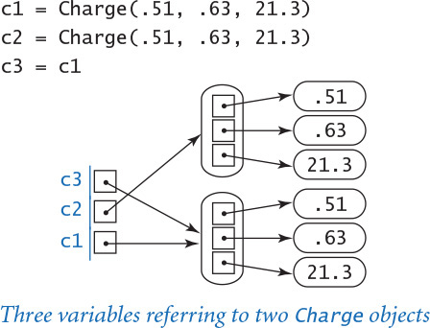
• Object equality (value equality). Object equality holds when two objects are equal—they have the same data-type value. You should use the == and != operators, defined using the special methods __eq__() and __ne__(), to test for object equality. If you do not define an __eq__() method, then Python substitutes the is operator. That is, by default == implements reference equality. So, in our earlier example, c1 == c2 is False even though c1 and c2 have the same position and charge value. If we want two charges with identical position and charge value to be considered equal, we can ensure this outcome by including the following code in charge.py (PROGRAM 3.2.1):
Click here to view code image
def __eq__(self, other):
if self._rx != other._rx: return False
if self._ry != other._ry: return False
if self._q != other._q: return False
return True
def __ne__(self, other):
return not __eq__(self, other)
With this code in place, c1 == c2 is now True in our example. In this case, which is typical, it is not so clear whether clients would expect this behavior (that is why we did not include these methods in our implementation). Deciding about object equality is an important (and challenging) design decision for any data type.
>>> a = 123456789
>>> b = 123456789
>>> c = a
>>> a == b
True
>>> a == c
True
>>> id(a)
140461201279248
>>> id(b)
140461201280816
>>> id(c)
140461201279248
>>> a is b
False
>>> a is c
True
To test your understanding of these ideas, study the interactive Python session diagrammed at right. In the example, a and b refer to different int objects with the same value, whereas a and c refer to the same int object.

Hashing
We now consider a fundamental operation related to equality testing, known as hashing, that maps an object to an integer, known as a hash code. This operation is so important that it is handled by Python’s special method __hash__() in support of the built-in hash() function. We refer to an object as hashable if it satisfies the following three properties:
• The object can be compared for equality with other objects via the == operator.
• Whenever two objects compare as equal, they have the same hash code.
• The object’s hash code does not change during its lifetime.
For example, in the interactive Python session at right, a and b refer to equal str objects, so they must have the same hash code; a and c refer to different str objects, so we expect their hash codes to be different.
In typical applications, we use the hash code to map an object x to an integer in a small range, say between 0 and m-1, using the hash function
hash(x) % m
Then, we can use the hash function value as an integer index into an array of length m (see PROGRAM 3.3.4 and PROGRAM 4.4.3). By definition, hashable objects that are equal have the same hash code, so they also have the same hash function value. Objects that are not equal can have the same hash function value but we expect the hash function to divide the objects into m groups of roughly equal length. All of Python’s immutable data types (including int, float, str, and tuple) are hashable and engineered to distribute the objects in a reasonable manner.
>>> a = 'Python'
>>> b = 'Python'
>>> c = 'programmer'
>>> hash(a)
-2359742753373747800
>>> hash(b)
-2359742753373747800
>>> hash(c)
7354308922443094682
String hash example
You can make a user-defined data types hashable by implementing the two special methods __hash__() and __eq__(). Crafting a good hash function requires a deft combination of science and engineering, and is beyond the scope of this book. Instead, we describe a simple recipe for doing so in Python that is effective in a wide variety of situations:
• Ensure that the data type is immutable.
• Implement __eq__() by comparing all significant instance variables.
• Implement __hash__() by putting the same instance variables into a tuple and calling the built-in hash() function on the tuple.
For example, following is a __hash__() implementation for the Charge data type (PROGRAM 3.2.1) to accompany the __eq__() implementation that we just considered:
Click here to view code image
def __hash__(self):
a = (self._rx, self._ry, self._q)
return hash(a)
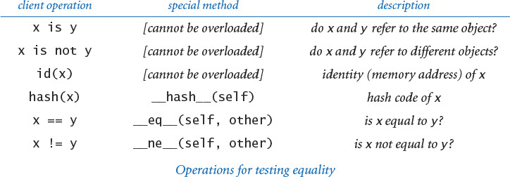

Comparison operators
Similarly, comparisons like x < y and x >= y are not just for integers, floats, and strings in Python. Again, Python associates a special method with each of its comparison operators, so you can overload any comparison operator by implementing the corresponding special method, as detailed in the table on the next page. As a matter of style, if you define any one of the comparison methods, then you should define all of them, and in a consistent manner. For example, if x < y, then you should ensure that both y > x and x <= y. Moreover, in any data type where the client might expect to sort objects, the comparison methods must define a total order. Specifically, the following three properties must hold:
• Antisymmetry: if both x <= y and y <= x, then x == y.
• Transitivity: if both x <= y and y <= z, then x <= z.
• Totality: either x <= y or y <= x or both.
We refer to a data type as comparable if implements the six comparison methods and they define a total order. Python’s built-in int, float, and str types are all comparable. You can make a user-defined type comparable by implementing the six special methods, as we do here for Counter (PROGRAM 3.3.2):
Click here to view code image
def __lt__(self, other): return self._count < other._count
def __le__(self, other): return self._count <= other._count
def __eq__(self, other): return self._count == other._count
def __ne__(self, other): return self._count != other._count
def __gt__(self, other): return self._count > other._count
def __ge__(self, other): return self._count >= other._count
We will consider several applications of comparable objects in SECTION 4.1 (sorting) and SECTION 4.3 (symbol tables).
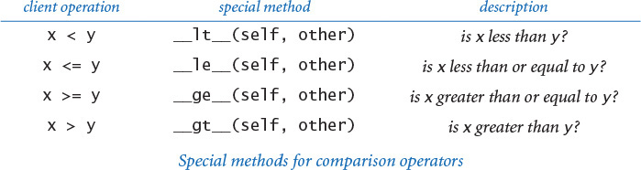

Other operators
Almost every operator in Python can be overloaded. For example, you can overload augmented assignment operators such as += and *=, and bitwise logical operators such as &, |, and ^. If you want to overload such an operator, you can track down the corresponding special method on our booksite or in Python’s online documentation. There are a number of operations relating to processing strings, arrays, and similar data types (like the [] operator and corresponding __getitem__() special method that we used in Vector) that we will consider in more detail in SECTION 4.4.

Built-in functions
We have been overloading the built-in function str() in every class we develop, and there are several other built-in functions that we can overload in the same way. The ones that we use in this book are summarized in the table below. We have already used all of these functions, except for iter(), which we defer until SECTION 4.4.
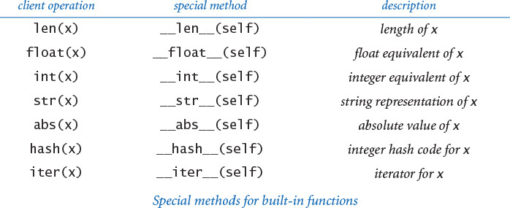
The ability to overload operators and built-in functions is a powerful feature of the Python language. It enables a programmer to create user-defined types that have similar behavior to built-in types. However, with great power comes great responsibility. While it is natural to overload arithmetic operators with familiar mathematical entities (such as complex number or spatial vectors, as we have seen), sometimes it is inappropriate to overload arithmetic operators for non-mathematical data types, as doing so can lead to unclear code.
For example, a digital artist might be tempted to develop a way to compute with colors by defining a + b or a * b in insightful ways when a and b are Color objects, or a musician might be tempted to do something similar for tones or chords. Far be it from us to discourage such creativity, but do you really want to be adding, subtracting, and multiplying Turtle objects (or whatever type of object you are considering)? Using ordinary methods (with descriptive names) might be a better approach. In fact, many programming languages (such as Java) do not support operator overloading because programmers often abuse this power. Overloading operators properly can entail a significant amount of work, and is worthwhile only when it leads to natural and expected behavior.

Functions are objects
In Python, “everything” is an object, including functions. This means that you can use functions as arguments to functions and return them as results. Defining so-called higher-order functions that manipulate other functions is common both in mathematics and in scientific computing. For example, in calculus, the derivative is a function that takes a function as an argument and produces another function as a result. In scientific computing, we often want to differentiate functions, integrate functions, find roots of functions, and so forth.
As an example, consider the problem of estimating the Riemann integral of a positive real-valued function f (the area under the curve) in an interval (a, b). This computation is known as quadrature or numerical integration. A number of methods have been developed for quadrature. Perhaps the simplest is known as the rectangle rule, where we approximate the value of the integral by computing the total area of n equal-width rectangles under the curve. The integrate() function defined below evaluates the integral of a real-valued function f () in the interval (a, b), using the rectangle rule with n rectangles:
Click here to view code image
def square(x):
return x*x
def integrate(f, a, b, n=1000):
total = 0.0
dt = 1.0 * (b - a) / n
for i in range(n):
total += dt * f(a + (i + 0.5) * dt)
return total
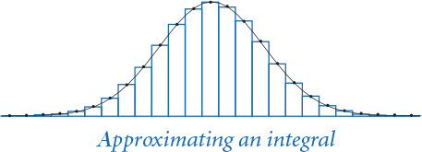
The indefinite integral of x2 is x3/3, so the definite integral between 0 and 10 is 1000/3. The call to integrate(square, 0, 10) returns 333.33324999999996, which is the correct answer to six significant digits of accuracy. Similarly, the call to integrate(gaussian.pdf, -1, 1) returns 0.6826895727940137, which is the correct answer to seven significant digits of accuracy (recall the Gaussian probability density function and PROGRAM 2.2.1).
Quadrature is not always the most efficient or accurate way to evaluate a function. For example, the gaussian.cdf() function in PROGRAM 2.2.1 is a faster and more accurate way to integrate the Gaussian probability density function. However, quadrature has the advantage of being useful for any function whatsoever, subject only to certain technical conditions on smoothness.

Inheritance
Python provides language support for defining relationships among classes, known as inheritance. Software developers use inheritance widely, so you will study it in detail if you take a course in software engineering. Effective use of inheritance is beyond the scope of this book, but we briefly describe it here because there are a few situations where you may encounter it.
When used properly, inheritance enables a form of code reuse known as subclassing. Subclassing is a powerful technique that enables a programmer to change the behavior of a class and add functionality without recomposing the entire class from scratch. The idea is to define a new class (subclass, or derived class) that inherits instance variables and methods from another class (superclass, or base class). The subclass contains more methods than the superclass. Systems programmers use subclassing to build so-called extensible modules. The idea is that one programmer (even you) can add methods to a class built by another programmer (or, perhaps, a team of systems programmers), effectively reusing the code in a potentially huge module. This approach is widely used, particularly in the development of user interfaces, so that the large amount of code required to provide all the facilities that users expect (drop-down menus, cut-and-paste, access to files, and so forth) can be reused.
An important use of subclassing in Python is the so-called numeric tower that implements Python’s numeric types, in the numbers.py module. This module includes the classes Integral, Rational, Real, and Complex, structured with subclassing relationships. For example, Real includes all of the methods in Complex plus those that work on real numbers, such as the comparison operators <, <=, >, and >=. The built-in numeric types are subclasses of these—for example, int is a subclass of Integral and float is a subclass of Real.
Despite its advantages, the use of subclassing is controversial, even among systems programmers. We do not use it in this book because it generally works against encapsulation. Subclassing makes modular programming more difficult for two reasons. First, any change in the superclass affects all subclasses. The subclass cannot be developed independently of the superclass; indeed, it is completely dependent on the superclass. This problem is known as the fragile base class problem. Second, the subclass code, having access to instance variables, can subvert the intention of the superclass code. For example, the designer of a class such as Vector may have taken great care to make the Vector immutable, but a subclass, with full access to the instance variables, can just change them, wreaking havoc for any client assuming the class to be immutable.

Application: data mining
To illustrate some of the concepts discussed in this section in the context of an application, we next consider a software technology that is proving important in addressing the daunting challenges of data mining—that is, the process of searching through massive amounts of information. This technology can serve as the basis for dramatic improvements in the quality of web search results, for multimedia information retrieval, for biomedical databases, for plagiarism detection, for research in genomics, for improved scholarship in many fields, for innovation in commercial applications, for learning the plans of evildoers, and for many other purposes. Accordingly, there is intense interest and extensive ongoing research on data mining.
You have direct access to thousands of files on your computer and indirect access to billions of files on the web. As you know, these files are remarkably diverse: there are commercial web pages, music and video, email, program code, and all sorts of other information. For simplicity, we will restrict our attention to text documents (though the approach we will consider applies to pictures, music, and all sorts of other files as well). Even with this restriction, there is remarkable diversity in the types of documents. For reference, you can find the documents listed at the bottom of this page on the booksite.
Our interest is in finding efficient ways to search through the files using their content to characterize documents. One fruitful approach to this problem is to associate with each document a vector known as a sketch, which is an ultra-compact representation of its content. The basic idea is that the sketch should capture salient statistical features of the document, so that documents that are different have sketches that are “different” and documents that are similar have sketches that are “similar.” You probably are not surprised to learn that this approach can enable us to distinguish among a novel, a Python program, and a genome, but you might be surprised to learn that it can tell the difference between novels written by different authors and can be effective as the basis for many other subtle search criteria.
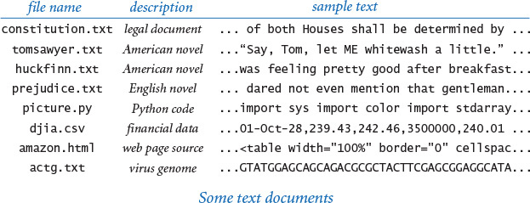
To start, we need an abstraction for documents. What is a document? Which operations do we want to perform on documents? The answers to these questions inform our design and therefore, ultimately, the code that we compose. For our purposes, a document is the contents of any text file. As indicated, we store only a document’s sketch (and not the whole document), and we use the sketches to measure the similarity between associated documents. These considerations lead to the API at the bottom of this page. The arguments of the constructor are a string and two integers that control the quality of the sketch. Clients can use similarTo() to determine the extent of similarity between two sketches on a scale of 0 (not similar) to 1 (similar). This simple data type provides a good separation between implementing a similarity measure and implementing clients that use the measure to search among documents.

Computing sketches
Computing a sketch of a document is the first challenge. Our first choice is to use a Vector to represent a document’s sketch. But which information should go into the sketch and how do we compute it? Many different approaches have been studied, and researchers are still actively seeking efficient and effective algorithms for this task. Our implementation sketch.py (PROGRAM 3.3.4) uses a simple frequency count approach. In addition to the string, the constructor has two arguments, an integer k and a vector dimension d. It scans the document and examines all of the k-grams in the document—that is, the substrings of length k starting at each position. In its simplest form, the sketch is a vector that gives the relative frequency of occurrence of the k-grams in the string: an element for each possible k-gram giving the number of k-grams in the document that have that value. For example, suppose that we use k = 2 in genomic data, with d = 16 (there are 4 possible character values and therefore 16 possible 2-grams). The 2-gram AT occurs 4 times in the string ATAGATGCATAGCGCATAGC, so, for example, the element in the vector corresponding to AT would be 4. To build the frequency vector, we need to convert each of the k-grams into an integer between 0 and 15 (the function that maps strings to integers is known as a hash function). For genomic data, this is an easy exercise (see EXERCISE 3.3.27). Then, we can compute an array to build the frequency vector in one scan through the text, incrementing the array element corresponding to each k-gram encountered. While we lose information by disregarding the order of the k-grams, remarkably, the information content of that order is lower than that of k-grams’ frequency. (A Markov model paradigm not dissimilar from the one that we studied for the random surfer in SECTION 1.6 can be used to take order into account—such models are effective, but more work to implement.) We encapsulate the computation into the Sketch class, defined in sketch.py (PROGRAM 3.3.4). This gives us the flexibility to experiment with various designs without needing to rewrite Sketch clients.
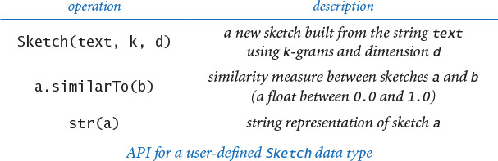
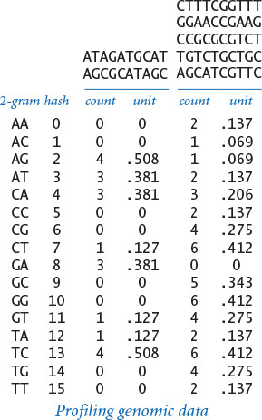

Hashing
On many systems there are 128 different possible values for each character, so there are 128k possible k-grams, and the dimension d would have to be 128k for the simple scheme just described. This number is prohibitively large even for moderately large k. For Unicode, with more than 65,536 characters, even 2-grams lead to huge vector sketches. To ameliorate this problem, we use hashing, a fundamental operation that we considered earlier in this section to map an object to an integer. For any string s, hash(s) % d is an integer between 0 and d - 1 that we can use as an index into an array to compute frequencies. The sketch that we use is the direction of the vector defined by frequencies of these values for all k-grams in the document (the unit vector with the same direction).
Python 2 alert
All hash functions start their computation with a numeric “seed.” In Python 2, the hash seed is constant, so the hash value of any given object is the same each time you run the program. In contrast, the hash seed in Python 3 varies (by default). In Python 3, then, the hash value of any given object, although the same within any given run of the program, is very likely to differ across runs of the program. Thus, sketch.py will produce different output each time you run it using Python 3.
Program 3.3.4 Document sketch (sketch.py)
Click here to view code image
import sys
import stdarray
import stdio
from vector import Vector
class Sketch:
def __init__(self, text, k, d):
freq = stdarray.create1D(d, 0)
for i in range(len(text) - k):
kgram = text[i:i+k]
freq[hash(kgram) % d] += 1
vector = Vector(freq)
self._sketch = vector.direction()
def similarTo(self, other):
return self._sketch.dot(other._sketch)
def __str__(self):
return str(self._sketch)
def main():
text = stdio.readAll()
k = int(sys.argv[1])
d = int(sys.argv[2])
sketch = Sketch(text, k, d)
stdio.writeln(sketch)
if __name__ == '__main__': main()
instance variable
_sketch | unit vector
text | document string
k | length of gram
d | dimension
| k consecutive
kgram | characters
| in document
freq[] | hash frequencies
vector | frequencies vector
This Vector client creates a unit vector from a document’s k-grams that clients can use to measure its similarity with other documents (see text).
Click here to view code image
% more genome20.txt
ATAGATGCATAGCGCATAGC
% python sketch.py 2 16 < genome20.txt
[ 0.0, 0.0, 0.0, 0.0, 0.504, 0.504, ..., 0.126, 0.0, 0.0, 0.378 ]

Comparing sketches
The second challenge is to compute a similarity measure between two sketches. Again, there are many different ways to compare two vectors. Perhaps the simplest is to compute the Euclidean distance between them. Given vectors x and y, this distance is defined as follows:
|x – y| = ((x0 – y0)2 + (x1 – y1)2 + ... + (xd–1 – yd–1)2)1/2
You are familiar with this formula for d = 2 or d = 3. With Vector, the distance is easy to compute. If x and y are two Vectors, then abs(x - y) is the Euclidean distance between them. If documents are similar, we expect their sketches to be similar and the distance between them to be low. Another widely used similarity measure, known as the cosine similarity measure, is even simpler: since our sketches are unit vectors with nonnegative coordinates, their dot product
x · y = x0y0 + x1y1 + ... + xd–1yd–1
is a number between 0 and 1. Geometrically, this quantity is the cosine of the angle formed by the two vectors (see EXERCISE 3.3.9). The more similar the documents, the closer we expect this measure to be to 1. If x and y are two Vectors, then x.dot(y) is their dot product.

Comparing all pairs
PROGRAM 3.3.5 (comparedocuments.py) is a simple and useful Sketch client that provides the information needed to solve the following problem: given a set of documents, find the two that are most similar. Since this specification is a bit subjective, comparedocuments.py writes the cosine similarity measure for all pairs of documents. For moderate-size k and d, the sketches do a remarkably good job of characterizing our sample set of documents. The results show not only that genomic data, financial data, Python code, and web source code are quite different from legal documents and novels, but also that Tom Sawyer and Huckleberry Finn are much more similar to each other than to Pride and Prejudice. A researcher in comparative literature could use this program to discover relationships between texts; a teacher could use this program to detect plagiarism in a set of student submissions; and a biologist could use this program to discover relationships among genomes.
Program 3.3.5 Similarity detection (comparedocuments.py)
Click here to view code image
import sys
import stdarray
import stdio
from instream import InStream
from sketch import Sketch
k = int(sys.argv[1])
d = int(sys.argv[2])
filenames = stdio.readAllStrings()
sketches = stdarray.create1D(len(filenames))
for i in range(len(filenames)):
text = InStream(filenames[i]).readAll()
sketches[i] = Sketch(text, k, d)
stdio.write(' ')
for i in range(len(filenames)):
stdio.writef('%8.4s', filenames[i])
stdio.writeln()
for i in range(len(filenames)):
stdio.writef('%.4s', filenames[i])
for j in range(len(filenames)):
stdio.writef('%8.2f', sketches[i].similarTo(sketches[j]))
stdio.writeln()
k | length of gram
d | dimension
filenames[] | document names
sketches[] | all sketches
% more documents.txt
constitution.txt
tomsawyer.txt
huckfinn.txt
prejudice.txt
picture.py
djia.csv
amazon.html
actg.txt
This Sketch client reads a list of documents from standard input, computes sketches based on k-gram frequencies for all the documents, and writes a table of similarity measures between all pairs of documents. It takes the value k and the dimension d as command-line arguments.
Click here to view code image
% python comparedocuments.py 5 10000 < documents.txt
cons toms huck prej pict djia amaz actg
cons 1.00 0.69 0.63 0.67 0.06 0.15 0.19 0.12
toms 0.69 1.00 0.93 0.89 0.05 0.18 0.19 0.14
huck 0.63 0.93 1.00 0.83 0.03 0.16 0.16 0.13
prej 0.67 0.89 0.83 1.00 0.04 0.20 0.20 0.14
pict 0.06 0.05 0.03 0.04 1.00 0.01 0.13 0.01
djia 0.15 0.18 0.16 0.20 0.01 1.00 0.11 0.07
amaz 0.19 0.19 0.16 0.20 0.13 0.11 1.00 0.06
actg 0.12 0.14 0.13 0.14 0.01 0.07 0.06 1.00

Searching for similar documents
Another natural Sketch client is one that uses sketches to search among a large number of documents to identify those that are similar to a given document. For example, web search engines uses clients of this type to present you with pages that are similar to those you have previously visited, online book merchants use clients of this type to recommend books that are similar to ones you have purchased, and social networking websites use clients of this type to identify people whose personal interests are similar to yours. Since the Instream constructor can take a web address as an argument instead of a file name, it is feasible to compose a program that surfs the web, computes sketches, and returns links to pages with sketches that are similar to the ones sought. We leave this client for a challenging exercise.
This solution is just an overview. Many sophisticated algorithms for efficiently computing sketches and comparing them are still being invented and studied by computer scientists. Our purpose here is to introduce you to this fundamental problem domain while at the same time illustrating the power of abstraction in addressing a computational challenge. Vectors are an essential mathematical abstraction, and we can build search solutions by developing layers of abstraction: Vector is built with an array, Sketch is built with Vector, and client code uses Sketch. As usual, we have spared you from a lengthy account of our many attempts to develop these APIs, but you can see that the data types are designed in response to the needs of the problem, with an eye toward the requirements of implementations. Identifying and implementing appropriate abstractions is the key to effective object-oriented programming. The power of abstraction—in mathematics, physical models, and computer programs—pervades these examples. As you become fluent in developing data types to address your own computational challenges, your appreciation for this power will surely grow.
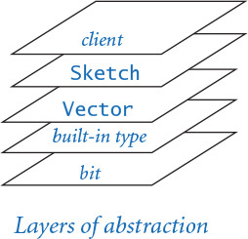

Design-by-contract
To conclude, we briefly discuss Python language mechanisms that enable you to verify assumptions about your program while it is running. For example, if you have a data type that represents a particle, you might assert that its mass is positive and its speed is less than the speed of light. Or if you have a method to add two vectors of the same dimension, you might assert that the dimension of the resulting vector also has the same dimension.

Exceptions
An exception is a disruptive event that occurs while a program is running, often to signal an error. The action taken is known as raising an exception (or error). We have already encountered exceptions raised by Python’s standard modules in the course of learning to program: IndexError and ZeroDivisionError are typical examples. You can also raise your own exceptions. The simplest kind is an Exception that disrupts execution of the program and writes an error message:
Click here to view code image
raise Exception('Error message here.')
It is good practice to use exceptions when they can be helpful to the client. For example, in Vector (PROGRAM 3.3.3), we should raise an exception in __add__() if the two Vectors to be added have different dimensions. To do so, we insert the following statement at the beginning of __add__():
Click here to view code image
if len(self) != len(other):
raise Exception('vectors have different dimensions')
This leads to a more informative error message than the IndexError that the client otherwise would receive if the dimensions of self and other do not agree.

Assertions
An assertion is a boolean expression that you are affirming is True at that point in the program. If the expression is False, the program will raise an AssertionError at run time. Programmers uses assertions to detect bugs and gain confidence in the correctness of their programs. Assertions also serve to document the programmer’s intent. For example, in Counter (PROGRAM 3.3.2), we might check that the counter is never negative by adding the following assertion as the last statement in increment():
assert self._count >= 0
This statement would call attention to a negative count. You can also add an optional detail message, such as
Click here to view code image
assert self._count >= 0, 'Negative count detected!'
to help identify the bug.
By default, assertions are enabled, but you can disable them from the command line by using the -O (that’s a minus sign followed by an uppercase “oh”) flag with the python command. (The O stands for “optimize.”) Assertions are for debugging only; your program should not rely on assertions for normal operation since they may be disabled.
When you take a course in systems programming, you will learn to use assertions to ensure that your code never terminates in a system error or goes into an infinite loop. One model, known as the design-by-contract model of programming, expresses this idea. The designer of a data type expresses a precondition (the condition that the client promises to satisfy when calling a method), a postcondition (the condition that the implementation promises to achieve when returning from a method), invariants (any condition that the implementation promises to satisfy while the method is executing), and side effects (any other change in state that the method could cause). During development, these conditions can be tested with assertions. Many programmers use assertions liberally to aid in debugging.
The language mechanisms discussed throughout this section illustrate that effective data-type design takes us into deep water in programming-language design. Experts are still debating the best ways to support some of the design ideas that we are discussing. Why does Python not enforce access control of “private” instance variables? Why are functions not first-class objects in Java? Why does Matlab pass copies of arrays and matrices to functions instead of references? As mentioned early in CHAPTER 1, it is a slippery slope from complaining about features in a programming language to becoming a programming-language designer. If you do not plan to do so, your best strategy is to use widely available languages. Most systems have extensive libraries that you certainly should use when appropriate, but you often can simplify your client code and protect yourself by building abstractions that can be easily translated to other languages. Your main goal is to develop data types so that most of your work is done at a level of abstraction that is appropriate to the problem at hand.

Q&A
Q. Why is the underscore convention not part of (and enforced by) Python?
A. Good question.
Q. Why all the leading underscores?
A. This is just one of many examples where a programming-language designer goes with a personal preference and we live with the result. Fortunately, most Python programs that you compose will be client programs, which do not directly call special methods or refer to private instance variables, so they will not need many leading underscores. The relatively few Python programmers who implement their own data types (that’s you, now) need to follow the underscore conventions, but even those programmers are likely to be composing more client code than class implementations, so the underscores may not be so onerous in the long run.
Q. The __mul__() method in complexpolar.py (PROGRAM 3.3.1) is awkward because it create a Complex object (representing 0 + 0i) and then immediately changes its instance variables to the desired polar coordinates. Wouldn’t the design be better if I could add a second constructor that takes the polar coordinates as arguments?
A. Yes, but we already have a constructor that takes the rectangular coordinates as arguments. A better design might be to have two ordinary functions (not methods) createRect(x, y) and createPolar(r, theta) in the API that create and return new objects. This design is perhaps better because it would provide the client with the capability to switch to polar coordinates. This example demonstrates that it is a good idea to think about more than one implementation when developing a data type. Of course, making such a change necessitates enhancing all existing implementations and clients of the API, so this thinking should happen as early in the design process as possible.
Q. How do I specify a tuple consisting of zero items or one item?
A. You can use () and (1,), respectively. Without the comma in the second expression, Python would treat it as an arithmetic expression enclosed in parentheses.
Q. Do I really need to overload all six comparison methods if I want to make my data type comparable?
A. Yes. This is an example where the convention is to provide maximum flexibility to clients at the expense of extra code in implementations. Often, you can use symmetries to cut down on the actual amount of implementation code. Also, Python 3 supplies a few shortcuts. For example, if you define an __eq__() method for a data type but do not define an __ne__() method, then Python automatically provides an implementation that calls __eq__() and negates the result. However, Python 2 does not provide these shortcuts, so it is best not to rely upon them in your code.
Q. Is there is any situation where I would not want the six comparison methods to implement a total order?
A. Yes, you might want to implement a partial order, where not every pair of objects can be compared. For example, you might compare people according to genealogical order, where one person is considered less than another if he or she is a descendant (child, grandchild, great-grandchild, and so forth) of the other. Not all people are related in this manner. Also, you might want to be able to compare Counter objects by their counts (when sorting) but you might want to consider two Counter objects to be equal only if they have both the same count and name.
Q. What is the range of integer values returned by the built-in hash() function?
A. Typically, Python uses a 64-bit integer, so the range is between −263 and 263 − 1. For cryptographic applications, you should use Python’s hashlib module, which supports “secure” hash functions that support much larger ranges.
Q. Which Python operators cannot be overloaded?
A. In Python, you cannot overload
• The boolean operators and, or, and not.
• The is and is not operators, which test for object identity.
• The string format operator %, which can be applied only to strings.
• The assignment operator =.

Exercises
3.3.1 Create a data type Location for dealing with locations on Earth using spherical coordinates (latitude/longitude). Include methods to generate a random location on the surface of the Earth, parse a location “25.344 N, 63.5532 W,” and compute the great-circle distance between two locations.
3.3.2 Create a data type for a three-dimensional particle with position (rx, ry, rz), mass (m), and velocity (vx, vy, vz). Include a method to return its kinetic energy, which equals 1/2 m (vx2 + vy2 + vz2). Use the Vector data type.
3.3.3 If you know your physics, develop an alternative implementation of the data type from the previous exercise based on using the momentum (px, py, pz) as an instance variable.
3.3.4 Develop an implementation of Histogram (PROGRAM 3.2.3) that uses the Counter (PROGRAM 3.3.2) data type.
3.3.5 Design a test client for Vector.
3.3.6 Compose an implementation of __sub__() for Vector that subtracts two vectors.
3.3.7 Implement a data type Vector2D for two-dimensional vectors that has the same API as Vector, except that the constructor takes two floats as arguments. Use two floats (instead of an array) for instance variables.
3.3.8 Implement the Vector2D data type of the previous exercise using one Complex object as the only instance variable.
3.3.9 Prove that the dot product of two two-dimensional unit-vectors is the cosine of the angle between them.
3.3.10 Implement a data type Vector3D for three-dimensional vectors that has the same API as Vector, except that the constructor takes three floats as arguments. Also, add a cross-product method; the cross-product of two vectors is another vector, defined by the equation
a × b = c |a| |b| sin θ
where c is the unit normal vector perpendicular to both a and b, and θ is the angle between a and b. In Cartesian coordinates, the following equation defines the cross-product:
(a0, a1, a2) × (b0, b1, b2) = (a1 b2 –a2 b1, a2 b0 –a0 b2, a0 b1 –a1 b0)
The cross-product arises in the definition of torque, angular momentum, and vector operator curl. Also, |a × b| is the area of the parallelogram with sides a and b.
3.3.11 Which modifications (if any) would you need to make Vector work with Complex components (see PROGRAM 3.2.6) or Rational components (see EXERCISE 3.2.7)?
3.3.12 Add code to charge.py to make Charge objects comparable using the value of the charge to determine the total order.
3.3.13 Compose a function fibonacci() that takes an integer argument n and computes the nth Fibonacci number. Use tuple packing and unpacking.
3.3.14 Revise the gcd() function in PROGRAM 2.3.1 so that it takes two nonnegative integer arguments p and q and returns a tuple of integers (d, a, b) such that d is the greatest common divisor of p and q, and the coefficients a and b satisfy Bézout’s identity: d = a*p + b*q. Use tuple packing and unpacking.
Solution: This algorithm is known as extended Euclid’s algorithm:
Click here to view code image
def gcd(p, q):
if q == 0: return (p, 1, 0)
(d, a, b) = gcd(q, p % q)
return (d, b, a - (p // q) * b)
3.3.15 Discuss the advantages and disadvantages of Python’s design in making the built-in type bool be a subclass of the built-in type int.
3.3.16 Add code to Counter to raise a ValueError at run time if the client tries to create a Counter object using a negative value for maxCount.
3.3.17 Use exceptions to develop an implementation of Rational (see EXERCISE 3.2.7) that raises a ValueException at run time if the denominator is zero.

Data-Type Design Exercises
This group of exercises is intended to give you experience in developing data types. For each problem, design one or more APIs with API implementations, testing your design decisions by implementing typical client code. Some of the exercises require either knowledge of a particular domain or a search for information about it on the web.
3.3.18 Statistics. Develop a data type for maintaining statistics in a set of floats. Provide a method to add data points and methods that return the number of points, the mean, the standard deviation, and the variance. Develop two implementations: one whose instance values are the number of points, the sum of the values, and the sum of the squares of the values, and another that keeps an array containing all the points. For simplicity, you may take the maximum number of points in the constructor. Your first implementation is likely to be faster and use substantially less space, but is also likely to be susceptible to round-off error. See the booksite for a well-engineered alternative.
3.3.19 Genome. Develop a data type to store the genome of an organism. Biologists often abstract the genome to a sequence of bases (A, C, G, or T). The data type should support the methods addCodon(c) and baseAt(i), as well as isPotentialGene() (see PROGRAM 3.1.1). Develop three implementations.
• Use a string as the only instance variable; implement addCodon() with string concatenation.
• Use an array of single-character strings as the only instance variable; implement addCodon() with the += operator.
• Use a boolean array, encoding each base with two bits.
3.3.20 Time. Develop a data type for the time of day. Provide client methods that return the current hour, minute, and second, as well as a __str__() method. Develop two implementations: one that keeps the time as a single int value (number of seconds since midnight) and another that keeps three int values, one each for seconds, minutes, and hours.
3.3.21 Vector fields. Develop a data type for force vectors in two dimensions. Provide a constructor, a method to add two vectors, and an interesting test client.
3.3.22 Dates. Develop an API for dates (year, month, day). Include methods for comparing two dates chronologically, computing the number of days between two dates, determining the day of the week of a given date, and any other operations that you think a client might want. After you have designed your API, look at the Python’s datetime.date data type.
3.3.23 Polynomials. Develop a data type for univariate polynomials with integer coefficients, such as x3 + 5x2 + 3x + 7. Include methods for standard operations on polynomials such as addition, subtraction, multiplication, degree, evaluation, composition, differentiation, definite integration, and testing equality.
3.3.24 Rational polynomials. Repeat the previous exercise, ensuring that the polynomial data type behaves correctly when provided coefficients of type int, float, complex, and Fraction (see EXERCISE 3.2.7).

Creative Exercises
3.3.25 Calendar. Develop Appointment and Calendar APIs that can be used to keep track of appointments (by day) in a calendar year. Your goal is to enable clients to schedule appointments that do not conflict and to report current appointments to clients. Use Python’s datetime module.
3.3.26 Vector field. A vector field associates a vector with every point in a Euclidean space. Compose a version of potential.py (PROGRAM 3.1.8) that takes as input a grid size n, computes the Vector value of the potential due to the point charges at each point in an n-by-n grid of equally spaced points, and draws the unit vector in the direction of the accumulated field at each point.
3.3.27 Genome sketching. Compose a function hash() that takes as an argument a k-gram (string of length k) whose characters are all A, C, G, or T and returns an int between 0 and 4k that corresponds to treating the string as base-4 numbers with {A, C, G, T} replaced by {0, 1, 2, 3}, respectively, as suggested by the table in the text. Next, compose a function unhash() that reverses the transformation. Use your methods to create a class Genome that is like Sketch, but is based on exact counting of k-grams in genomes. Finally, compose a version of comparealldocuments.py for Genome objects and use it to look for similarities among a set of genome files.
3.3.28 Sketching. Pick an interesting set of documents from the booksite (or use a collection of your own) and run comparealldocuments.py with various command-line arguments, to learn about their effect on the computation.
3.3.29 Multimedia search. Develop sketching strategies for sound and pictures, and use them to discover interesting similarities among songs in the music library and photos in the photo album on your computer.
3.3.30 Data mining. Compose a recursive program that surfs the web, starting at a page given as the first command-line argument, and looks for pages that are similar to the page given as the second command-line argument, as follows. To process a name, open an input stream, do a readAll(), sketch it, and write the name if its distance to the target page is greater than the threshold value given as the third command-line argument. Then scan the page for all strings that contain the substring http:// and (recursively) process pages with those names. Note: This program might read a very large number of pages!

3.4 Case Study: N-Body Simulation
We can express several of the examples that we considered in CHAPTERS 1 and 2 more clearly as object-oriented programs. For example, we can implement bouncingball.py (PROGRAM 1.5.7) as a data type whose values are the position and the velocity of the ball and a client that calls methods to move and draw the ball. Such a data type enables, for example, clients that can simulate the motion of several balls at once (see EXERCISE 3.4.1). Similarly, our case study for percolation in SECTION 2.4 certainly makes an interesting exercise in object-oriented programming, as does our random-surfer case study in SECTION 1.6. We leave the former for an exercise (see EXERCISE 3.4.11) and will revisit the latter in SECTION 4.5. In this section, we consider a new program that exemplifies object-oriented programming.
3.4.1 Gravitational body
3.4.2 N-body simulation
Programs in this section
Our task is to compose a program that dynamically simulates the motion of n bodies under the influence of mutual gravitational attraction. This n-body simulation problem was first formulated by Isaac Newton over 350 years ago, and scientists still study it intensely today.
What is the set of values, and what are the operations on those values? One reason that this problem is a compelling example of object-oriented programming is that it presents a direct and natural correspondence between physical objects in the real world and the abstract objects that we use in programming. The shift from solving problems by putting together sequences of statements to be executed to beginning with data-type design is a difficult one for many novices. As you gain more experience, you will benefit from applying this approach to computational problem solving.
First, we revisit a few basic concepts and equations that you learned in high-school physics. Understanding these equations fully is not required to appreciate the code—because of encapsulation, these equations are restricted to a few methods, and because of data abstraction, most of the code is intuitive and will make sense to you. In a sense, this is the ultimate object-oriented program.

N-body simulation
The bouncing-ball simulation of SECTION 1.5 is based on Newton’s first law of motion: a body in motion remains in motion at the same velocity unless acted on by an outside force. Embellishing that example to include Newton’s second law of motion (which explains how outside forces affect velocity) leads us to a basic problem that has fascinated scientists for ages. Given a system of n bodies, mutually affected by gravitational forces, the problem is to describe their motion. The same basic model applies to problems ranging in scale from astrophysics to molecular dynamics.
In 1687, Newton formulated the principles governing the motion of two bodies under the influence of their mutual gravitational attraction, in his famous Principia. However, Newton was unable to develop a mathematical description of the motion of three bodies. It has since been shown that not only that no such description exists in terms of elementary functions, but also that chaotic behavior is possible, depending on initial values. To study such problems, scientists have no recourse except to develop accurate simulations. In this section, we develop an object-oriented program that implements such a simulation. Scientists are interested in studying such problems for huge numbers of bodies, so our solution is only an introduction to the subject, but you are likely to be surprised at the ease with which we can develop realistic images depicting the complexity of the motion.

Body data type
In bouncingball.py (PROGRAM 1.5.7), we keep the displacement from the origin in the floats rx and ry and the velocity in the floats vx and vy, and displace the ball the amount it moves in one time unit with the statements:
rx = rx + vx
ry = ry + vy
With Vector (PROGRAM 3.3.3), we can keep the position in the Vector r and the velocity in the Vector v, and then displace the body the amount it moves in dt time units with a single statement:
r = r + v.scale(dt)
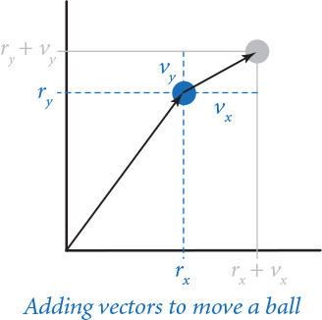
In n-body simulation, we have several operations of this kind, so our first design decision is to work with Vector objects instead of individual components. This decision leads to code that is clearer, more compact, and more flexible than the alternative of working with individual components. PROGRAM 3.4.1 (body.py) implements Body, a Python class for a data type for moving bodies. Body is a Vector client—the values of the data type are Vector objects that carry the body’s position and velocity, as well as a float that carries the mass. The data-type operations allow clients to move and to draw the body (and to compute the force vector due to gravitational attraction from another body), as defined by the API at the top of this page. Technically, the body’s position (displacement from the origin) is not a vector (it is a point in space, not a direction and a magnitude), but it is convenient to represent it as a Vector because Vector operations lead to compact code for the transformation that we need to move the body, as just discussed. When we move a Body, we need to change not just its position, but also its velocity.
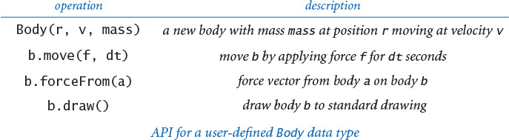

Force and motion
Newton’s second law of motion says that the force on a body (a vector) is equal to the scalar product of its mass and its acceleration (also a vector): F = m a. In other words, to compute the acceleration of a body, we compute the force, then divide by its mass. In Body, the force is a Vector argument f to move(), so that we can first compute the acceleration vector just by dividing by the mass (a scalar value that is kept as a float in an instance variable) and then compute the change in velocity by adding to it the amount this vector changes over the time interval (in the same way that we used the velocity to change the position). This law immediately translates to the following code for updating the position and velocity of a body due to a given force vector f and amount of time dt:
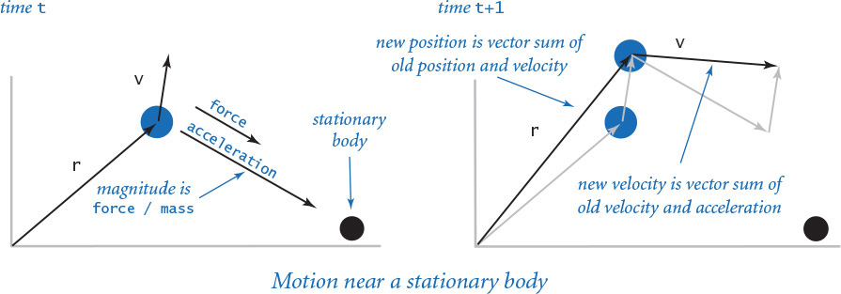
a = f.scale(1.0 / mass)
v = v + a.scale(dt)
r = r + v.scale(dt)
This code appears in the move() method in Body, to adjust its values to reflect the consequences of that force being applied for that amount of time: the body moves and its velocity changes. This calculation assumes that the acceleration is constant during the time interval.

Forces among bodies
The computation of the force imposed by one body on another is encapsulated in the method forceFrom() in Body, which takes a Body object as argument and returns a Vector. Newton’s law of universal gravitation is the basis for the calculation: the magnitude of the gravitational force between two bodies is given by the product of their masses divided by the square of the distance between them (scaled by the gravitational constant G, which is 6.67 × 10-11 N m2 / kg2) and the direction of the force is the line between the two particles. This law translates to the following code for computing a.forceFrom(b):
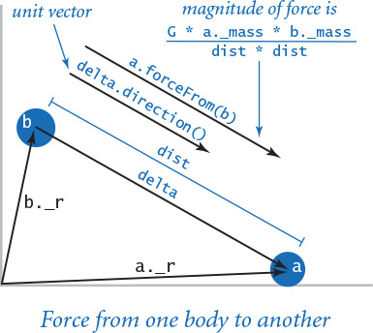
Click here to view code image
G = 6.67e-11
delta = b._r - a._r
dist = abs(delta)
magnitude = G * a.mass * b.mass / (dist * dist)
f = delta.direction().scale(magnitude)
The magnitude of the force vector is the float magnitude, and the direction of the force vector is the same as the direction of the difference vector between the two body’s positions. The force vector f is the product of magnitude and direction.
Program 3.4.1 Gravitational body (body.py)
Click here to view code image
import stddraw
from vector import Vector
class Body:
def __init__(self, r, v, mass):
self._r = r
self._v = v
self._mass = mass
def move(self, f, dt):
a = f.scale(1.0 / self._mass)
self._v = self._v + a.scale(dt)
self._r = self._r + self._v.scale(dt)
def forceFrom(self, other):
G = 6.67e-11
delta = other._r - self._r
dist = abs(delta)
m1 = self._mass
m2 = other._mass
magnitude = G * m1 * m2 / (dist * dist)
return delta.direction().scale(magnitude)
def draw(self):
stddraw.setPenRadius(0.0125)
stddraw.point(self._r[0], self._r[1])
instance variables
_r | position
_v | velocity
_mass | mass
f | force on this body
dt | time increment
a | acceleration
self | invoking body
other | another body
G | gravitational constant
delta | vector between bodies
dist | distance between bodies
magnitude | magnitude of force
This data type provides the operations that we need to simulate the motion of physical bodies such as planets or atomic particles. It is a mutable type whose instance variables are the position and velocity of the body, which change in the move() method in response to external forces (the body’s mass is not mutable). The forceFrom() method returns a force vector. The unit test is deferred to EXERCISE 3.4.2.

Universe data type
Universe (PROGRAM 3.4.2) is a data type that implements the following API:
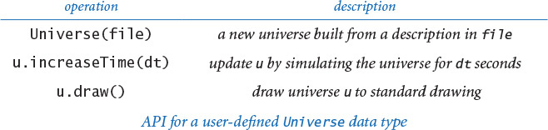
Its data-type values define a universe (its size, the number of bodies, and an array of bodies) and two data-type operations: increaseTime(), which adjusts the positions (and velocities) of all of the bodies, and draw(), which draws all of the bodies. The key to the n-body simulation is the implementation of increaseTime() in Universe. The first part of the computation is a doubly nested loop that computes the force vector describing the gravitational force of each body on each other body. It applies the principle of superposition, which says that we can add together the force vectors affecting a body to get a single vector representing the aggregate force. After it has computed all of the forces, it calls the move() method for each body to apply the computed force for a fixed time quantum.
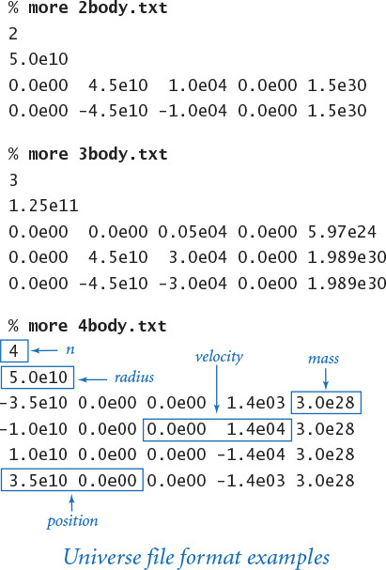

File format
We use a data-driven design with input taken from a file. The constructor reads the universe parameters and body descriptions from a file that contains the following information:
• The number of bodies
• The radius of the universe
• The position, velocity, and mass of each body
As usual, for consistency, all measurements are in standard SI units (recall that the gravitational constant G also appears in our code). With this defined file format, the code for our Universe constructor is straightforward.
Click here to view code image
def __init__(self, filename):
instream = InStream(filename)
n = instream.readInt()
radius = instream.readFloat()
stddraw.setXscale(-radius, +radius)
stddraw.setYscale(-radius, +radius)
self._bodies = stdarray.create1D(n)
for i in range(n):
rx = instream.readFloat()
ry = instream.readFloat()
vx = instream.readFloat()
vy = instream.readFloat()
mass = instream.readFloat()
r = Vector([rx, ry])
v = Vector([vx, vy])
self._bodies[i] = Body(r, v, mass)
Each Body is characterized by five floats: the x- and y-coordinates of its position, the x- and y-components of its initial velocity, and its mass.
To summarize, we have in the test client main() in Universe a data-driven program that simulates the motion of n bodies mutually attracted by gravity. The constructor creates an array of n Body objects, reading each body’s initial position, initial velocity, and mass from the file name specified as the command-line argument. The increaseTime() method calculates the mutual force on the bodies and uses that information to update the acceleration, velocity, and position of each body after a time quantum dt. The main() test client invokes the constructor, then stays in a loop calling increaseTime() and draw() to simulate motion.
Program 3.4.2 N-body simulation (universe.py)
Click here to view code image
import sys
import stdarray
import stddraw
from body import Body
from instream import InStream
from vector import Vector
class Universe:
def __init__(self, filename):
// See text.
def increaseTime(self, dt):
n = len(self._bodies)
f = stdarray.create1D(n, Vector([0, 0]))
for i in range(n):
for j in range(n):
if i != j:
bodyi = self._bodies[i]
bodyj = self._bodies[j]
f[i] = f[i] + bodyi.forceFrom(bodyj)
for i in range(n):
self._bodies[i].move(f[i], dt)
def draw(self):
for body in self._bodies:
body.draw()
def main():
universe = Universe(sys.argv[1])
dt = float(sys.argv[2])
while True:
universe.increaseTime(dt)
stddraw.clear()
universe.draw()
stddraw.show(10)
if __name__ == '__main__': main()
instance variables
_bodies | array of bodies
n | number of bodies
f[] | force on each body
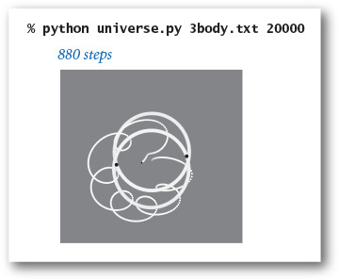
This data-driven program simulates motion in the universe defined by the data in the file specified on the command line, increasing time at the rate dt specified on the command line. The constructor is given in the text.
You will find on the booksite a variety of files that define “universes” of all sorts, and you are encouraged to run universe.py and observe their motion. When you view the motion for even a small number of bodies, you will understand why Newton had trouble deriving the equations that define their trajectories. The figures on the facing page illustrate the result of running universe.py for the 2-body, 3-body, and 4-body examples in the data files given earlier. The 2-body example is a mutually orbiting pair, the 3-body example is a chaotic situation with a moon jumping between two orbiting planets, and the 4-body example has two pairs of mutually orbiting bodies that are slowly rotating. (The 3-body example uses a slightly modified version of Body where the radius of the body drawn is proportional to its mass.) The static images on these pages were made by modifying Universe and Body to draw the bodies in white, and then black on a gray background, as in bouncingball.py (PROGRAM 1.5.7). By comparison, the dynamic images that you get when you run universe.py as it stands give a realistic feeling of the bodies orbiting one another, which is difficult to discern in the fixed pictures. When you run universe.py on an example with a large number of bodies, you can appreciate why simulation is such an important tool for scientists trying to understand a complex problem. The n-body simulation model is remarkably versatile, as you will see if you experiment with some of these input files.
You will certainly be tempted to design your own universe (see EXERCISE 3.4.10). The biggest challenge in creating a data file is appropriately scaling the numbers so that the radius of the universe, time scale, and the mass and velocity of the bodies lead to interesting behavior. You can study the motion of planets rotating around a sun or subatomic particles interacting with one another, but you will have no luck studying the interaction of a planet with a subatomic particle. When you work with your own data, you are likely to have some bodies that will fly off to infinity and some others that are sucked into others, but enjoy!
planetary scale
Click here to view code image
% more 2body.txt
2
5.0e10
0.0e00 4.5e10 1.0e04 0.0e00 1.5e30
0.0e00 -4.5e10 -1.0e04 0.0e00 1.5e30
subatomic scale
Click here to view code image
% more 2bodyTiny.txt
2
5.0e-10
0.0e00 4.5e-10 1.0e-16 0.0e00 1.5e-30
0.0e00 -4.5e-10 -1.0e-16 0.0e00 1.5e-30
Two input files of varying scale
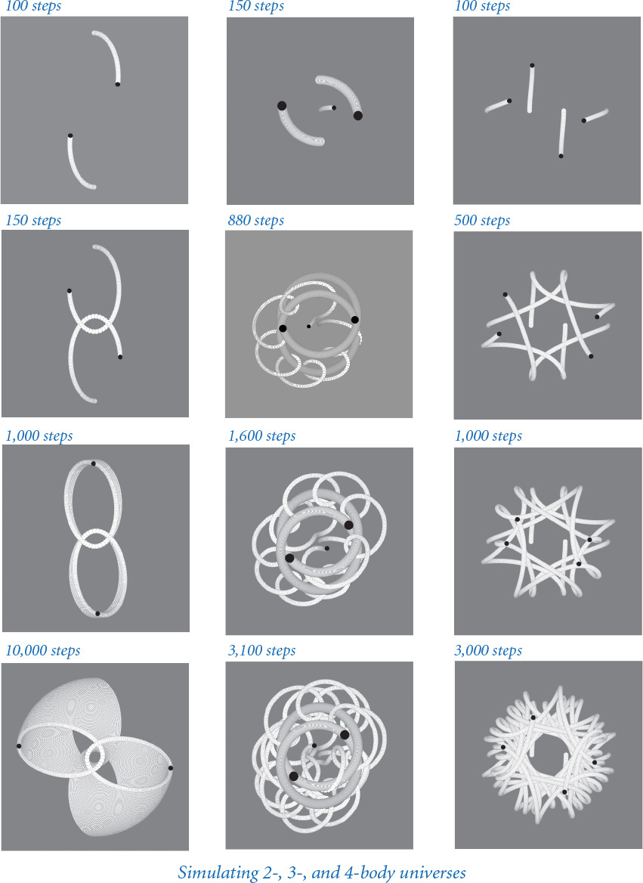
Our purpose in presenting this example is to illustrate the utility of data types, not to present simulation code for production use. There are many issues that scientists have to deal with when using this approach to study natural phenomena. One such issue is numerical accuracy: it is common for inaccuracies in the calculations to accumulate and yield dramatic effects in the simulation that would not be observed in nature. The technique that we use to update the positions and velocities is known as the leapfrog method; it produces more accurate results than many competing approaches. A second issue is efficiency: the move() method in Universe takes time proportional to n2 and, therefore, is not usable for huge numbers of bodies. Our simulation also ignores other forces. For example, our code takes no special action when two (or more) bodies collide. Addressing scientific problems related to the n-body problem involves not just knowledge of the original problem domain, but also the core issues that computer scientists have been studying since the early days of computation.
For simplicity, we are working with a two-dimensional universe, which is realistic only when we are considering bodies in motion on a plane. But an important implication of basing the implementation of Body on Vector is that a client could use three-dimensional vectors to simulate the motion of moving balls in three dimensions (actually, any number of dimensions) without changing much code (see EXERCISE 3.4.9).
The test client in Universe is just one possibility; we can use the same basic model in all sorts of other situations (for example, involving different kinds of interactions among the bodies). One such possibility is to observe and measure the current motion of some existing bodies and then run the simulation backward! Astrophysicists use just such a method to try to understand the origins of the universe. In science, we try to understand the past and to predict the future; with a good simulation, we can do both.

Q&A
Q. The Universe API is certainly small. Why not just implement that code in a main() test client for Body?
A. Our design is an expression of what many people believe about the universe: it was created, and then time moves on. It clarifies the code and allows for maximum flexibility in simulating what goes on in the universe.
Q. Why is forceFrom() a method? Wouldn’t it be better for it to be a function that takes two Body objects as arguments?
A. Implementing forceFrom() as a method is one of several possible alternatives, and having a function that takes two Body objects as arguments is certainly a reasonable choice. Some programmers prefer to completely avoid functions in data-type implementations; another option is to maintain the force acting on each Body as an instance variable. Our choice is a compromise between these two options.
Q. Shouldn’t the move() method in body.py update the position using the old velocity instead of the updated velocity?
A. It turns out that using the updated velocity (known as the leapfrog method) produces more accurate results than using the old velocity (known as the Euler method). If you take a course in numerical analysis, you will learn why.

Exercises
3.4.1 Develop an object-oriented version of bouncingball.py (PROGRAM 1.5.7). Include a constructor that starts each ball moving in a random direction at a random velocity (within reasonable limits) and a test client that takes an integer n from the command line and simulates the motion of n bouncing balls.
3.4.2 Add to body.py (PROGRAM 3.4.1) a main() method that unit tests the Body data type.
3.4.3 Modify body.py so that the radius of the circle it draws for a body is proportional to its mass.
3.4.4 What happens in a universe with no gravitational force? This situation would correspond to forceFrom() in Body always returning the zero vector.
3.4.5 Create a data type Universe3D to model three-dimensional universes. Develop a data file to simulate the motion of the planets in our solar system around the sun.
3.4.6 Compose a test client that simulates the motion of two different universes (defined by two different files and appearing in two distinct parts of the standard drawing window). You also need to modify the draw() method in Body.
3.4.7 Compose a class RandomBody that initializes its instance variables with (carefully chosen) random values instead of taking them as arguments. Then compose a client that takes a single argument n from the command line and simulates motion in a random universe with n bodies.
3.4.8 Modify Vector to include a method __iadd__(self, other) to support the in-place addition operator +=, which enables the client to compose code like r += v.scale(dt). Using this method, revise body.py and universe.py.
3.4.9 Modify the Vector constructor so that if passed a positive integer d as argument, it creates and returns the all-zero vector of dimension d. Using this modified constructor, revise universe.py so that it works with three- (or higher-) dimensional universes. For simplicity, don’t worry about changing the draw() method in body.py—it projects the position onto the plane defined by the first x- and y-coordinates.

Creative Exercises
3.4.10 New universe. Design a new universe with interesting properties and simulate its motion with Universe. This exercise is truly an opportunity to be creative!
3.4.11 Percolation. Compose an object-oriented version of percolation.py (PROGRAM 2.4.6). Think carefully about the design before you begin, and be prepared to defend your design decisions.

Chapter Four. Algorithms and Data Structures
4.1 Performance
4.2 Sorting and Searching
4.3 Stacks and Queues
4.4 Symbol Tables
4.5 Case Study: Small-World
This chapter presents fundamental data types that are essential building blocks for a broad variety of applications. We present full implementations, even though some of them are built into Python, so that you can have a clear idea of how they work and why they are important.
Objects can contain references to other objects, so we can build structures known as linked structures, which can be arbitrarily complex. With linked structures and arrays, we can build data structures to organize information in such a way that we can efficiently process it with associated algorithms. In a data type, we use the set of values to build data structures and the methods that operate on those values to implement algorithms.
The algorithms and data structures that we consider in this chapter introduce a body of knowledge developed over the past several decades that constitutes the basis for the efficient use of computers for a broad variety of applications. From n-body simulation problems in physics to genetic sequencing problems in bioinformatics, the basic approaches we describe have become essential in scientific research; from database systems to search engines, these methods are the foundation of commercial computing. As the scope of computing applications continues to expand, so grows the impact of these basic approaches.
Algorithms and data structures themselves are valid subjects of scientific inquiry. Accordingly, we begin by describing a scientific approach for analyzing the performance of algorithms, which we use throughout the chapter to study the performance characteristics of our implementations.

4.1 Performance
In this section, you will learn to respect a principle that is succinctly expressed in yet another mantra that should live with you whenever you program: Pay attention to the cost. If you become an engineer, that will be your job; if you become a biologist or a physicist, the cost will dictate which scientific problems you can address; if you are in business or become an economist, this principle needs no defense; and if you become a software developer, the cost will dictate whether the software that you build will be useful to your clients.
4.1.1 3-sum problem
4.1.2 Validating a doubling hypothesis
Programs in this section
To study the cost of running them, we study our programs themselves via the scientific method, the commonly accepted body of techniques universally used by scientists to develop knowledge about the natural world. We also apply mathematical analysis to derive concise models of the cost.
Which features of the natural world are we studying? In most situations, we are interested in one fundamental characteristic: time. Whenever we run a program, we are performing an experiment involving the natural world, putting a complex system of electronic circuitry through series of state changes involving a huge number of discrete events that we are confident will eventually stabilize to a state with results that we want to interpret. Although developed in the abstract world of Python programming, these events most definitely are happening in the natural world. What will be the elapsed time until we see the result? It makes a great deal of difference to us whether that time is a millisecond, a second, a day, or a week. Therefore, we want to learn, through the scientific method, how to properly control the situation, just as when we launch a rocket, build a bridge, or smash an atom.
On the one hand, modern programs and programming environments are complex; on the other hand, they are developed from a simple (but powerful) set of abstractions. It is a small miracle that a program produces the same result each time we run it. To predict the time required, we take advantage of the relative simplicity of the supporting infrastructure that we use to build programs. You may be surprised at the ease with which you can develop cost estimates and predict the performance characteristics of many of the programs that you compose.

Scientific method.
The following five-step approach briefly summarizes the scientific method:
• Observe some feature of the natural world.
• Hypothesize a model that is consistent with the observations.
• Predict events using the hypothesis.
• Verify the predictions by making further observations.
• Validate by repeating until the hypothesis and observations agree.
One of the key tenets of the scientific method is that the experiments we design must be reproducible, so that others can convince themselves of the validity of the hypothesis. In addition, the hypotheses we formulate must be falsifiable—we have the possibility of knowing for sure when a hypothesis is wrong (and thus needs revision).

Observations
Our first challenge is to make quantitative measurements of the running time of our programs. Although measuring the exact running time of our program is difficult, usually we are happy with estimates. There are a number of tools available to help us obtain such approximations. Perhaps the simplest is a physical stopwatch or the Stopwatch data type (see PROGRAM 3.2.2). We can simply run a program on various inputs, measuring the amount of time to process each input.
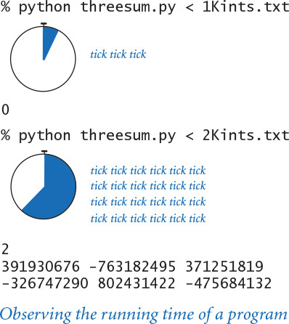
Our first qualitative observation about most programs is that there is a problem size that characterizes the difficulty of the computational task. Normally, the problem size is either the size of the input or the value of a command-line argument. Intuitively, the running time should increase with the problem size, but the question of how much it increases naturally arises every time we develop and run a program.
Another qualitative observation for many programs is that the running time is relatively insensitive to the input itself; it depends primarily on the problem size. If this relationship does not hold, we need to run more experiments to better understand, and perhaps better control, the running time’s sensitivity to the input. Since this relationship does often hold, we focus now on the goal of better quantifying the correspondence between problem size and running time.
As a concrete example, we start with threesum.py (PROGRAM 4.1.1), which counts the number of triples in an array of n numbers that sum to 0. This computation may seem contrived to you, but it is deeply related to numerous fundamental computational tasks, particularly those found in computational geometry, so it is a problem worthy of careful study. What is the relationship between the problem size n and the running time for threesum.py?

Hypotheses
In the early days of computer science, Donald Knuth showed that, despite all of the complicating factors in understanding the running times of our programs, it is possible in principle to create accurate models that can help us predict precisely how long a particular program will take. Proper analysis of this sort involves:
• Detailed understanding of the program
• Detailed understanding of the system and the computer
• Advanced tools of mathematical analysis
Thus it is best left for experts. Every programmer, however, needs to know how to make back-of-the-envelope performance estimates. Fortunately, we can often acquire such knowledge by using a combination of empirical observations and a small set of mathematical tools.

Doubling hypotheses
For a great many programs, we can quickly formulate a hypothesis for the following question: What is the effect on the running time of doubling the size of the input? For clarity, we refer to this hypothesis as a doubling hypothesis. Perhaps the easiest way to pay attention to the cost is to ask yourself this question about your programs during development and also as you use them in practical applications. Next, we describe how to develop answers via the scientific method.

Empirical analysis
Clearly, we can get a headstart on developing a doubling hypothesis by doubling the size of the input and observing the effect on the running time. For example, doublingtest.py (PROGRAM 4.1.2) generates a sequence of random input arrays for threesum.py, doubling the array length at each step, and writes the ratio of running times of threesum.countTriples() for each input over the previous (which was one-half the size). If you run this program, you will find yourself caught in a prediction–verification cycle: It writes several lines very quickly, but then begins to slow down. Each time it writes a line, you find yourself wondering how long it will be until it writes the next line. Checking the stopwatch as the program runs, it is easy to predict that the elapsed time increases by about a factor of 8 to write each line. This prediction is verified by the Stopwatch measurements that the program writes, and leads immediately to the hypothesis that the running time increases by a factor of 8 when the input size doubles. We might also plot the running times, either on a standard plot (left), which shows that the rate of increase of the running time increases with input size, or on a log-log plot. In the case of threesum.py, the log-log plot (below) is a straight line with slope 3, which clearly suggests the hypothesis that the running time satisfies a power law of the form cn3 (see EXERCISE 4.1.29).
Program 4.1.1 3-sum problem (threesum.py)
Click here to view code image
import stdarray
import stdio
def writeTriples(a):
# See Exercise 4.1.1.
def countTriples(a):
n = len(a)
count = 0
for i in range(n):
for j in range(i+1, n):
for k in range(j+1, n):
if (a[i] + a[j] + a[k]) == 0:
count += 1
return count
def main():
a = stdarray.readInt1D()
count = countTriples(a)
stdio.writeln(count)
if count < 10:
writeTriples(a)
if __name__ == '__main__': main()
a[] | array of integers
n | length of a[]
count | number of triples that sum to 0
This program reads an array of integers from standard input, and writes to standard output the number of triples in the array that sum to 0. If the number is low, then it also writes the triples. The file 1000ints.txt contains 1,000 random 32-bit integers (between –231 and 231 – 1). Such a file is not likely to have such a triple (see EXERCISE 4.1.27).
% more 8ints.txt
8
30
-30
-20
-10
40
0
10
5
Click here to view code image
% python threesum.py < 8ints.txt
4
30 -30 0
30 -20 -10
-30 -10 40
-10 0 10
% python threesum.py < 1000ints.txt
0
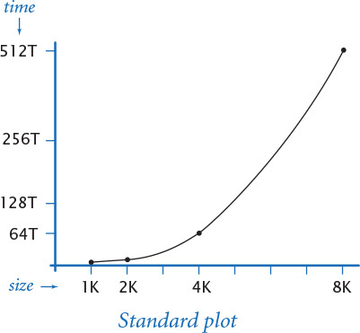

Mathematical analysis
Knuth’s basic insight on building a mathematical model to describe the running time of a program is simple: the total running time is determined by two primary factors:
• The cost of executing each statement
• The frequency of execution of each statement
The former is a property of the system, and the latter is a property of the algorithm. If we know both for all instructions in the program, we can multiply them together and sum for all instructions in the program to get the running time.
The primary challenge is to determine the frequency of execution of the statements. Some statements are easy to analyze; for example, the statement that initializes count to 0 in threesum.countTriples() is executed only once. Others require higher-level reasoning; for example, the if statement in threesum.countTriples() is executed precisely n (n–1)(n–2)/6 times (that is precisely the number of ways to pick three different numbers from the input array—see EXERCISE 4.1.5).
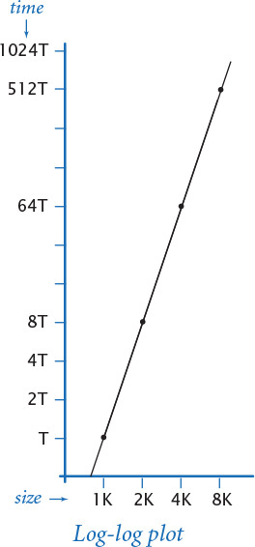
Frequency analyses of this sort can lead to complicated and lengthy mathematical expressions. To substantially simplify matters in the mathematical analysis, we develop simpler approximate expressions in two ways. First, we work with the leading term of mathematical expressions by using a mathematical device known as the tilde notation. We write ~ f(n) to represent any quantity that, when divided by f(n), approaches 1 as n grows. We also write g(n) ~ f(n) to indicate that g(n) / f(n) approaches 1 as n grows. With this notation, we can ignore complicated parts of an expression that represent small values. For example, the if statement in threesum.py is executed ~n3/6 times because n (n–1) (n–2) / 6 = n3/6 – n2/2 + n/3, which, when divided by n3/6, approaches 1 as n grows. This notation is useful when the terms after the leading term are relatively insignificant (for example, when n = 1,000, this assumption amounts to saying that –n2/2 + n/3 ≈ – 499,667 is relatively insignificant by comparison with n3/6 ≈ 166,666,667, which it is). Second, we focus on the instructions that are executed most frequently, sometimes referred to as the inner loop of the program. In this program it is reasonable to assume that the time devoted to the instructions outside the inner loop is relatively insignificant.
Program 4.1.2 Validating a doubling hypothesis (doublingtest.py)
Click here to view code image
import sys
import stdarray
import stdio
import stdrandom
import threesum
from stopwatch import Stopwatch
# Time to solve a random three-sum instance of size n.
def timeTrial(n):
a = stdarray.create1D(n, 0)
for i in range(n):
a[i] = stdrandom.uniformInt(-1000000, 1000000)
watch = Stopwatch()
count = threesum.countTriples(a)
return watch.elapsedTime()
n = int(sys.argv[1])
while True:
previous = timeTrial(n // 2)
current = timeTrial(n)
ratio = current / previous
stdio.writef('%7d %4.2f\n', n, ratio)
n *= 2
n | problem size
a[] | random integers
watch | stopwatch
n | problem size
previous | running time for n // 2
current | running time for n
ratio | ratio of running times
This program writes to standard output a table of doubling ratios for the three-sum problem. The table shows how doubling the problem size affects the running time of the function call threesum.countTriples() for problem sizes that double for each row of the table. These experiments lead to the hypothesis that the running time increases by a factor of 8 when the input size doubles. When you run the program, note carefully that the elapsed time increases by a factor of 8 for each line written, validating the hypothesis.
% python doublingtest.py 256
256 7.52
512 8.09
1024 8.07
2048 7.97
...
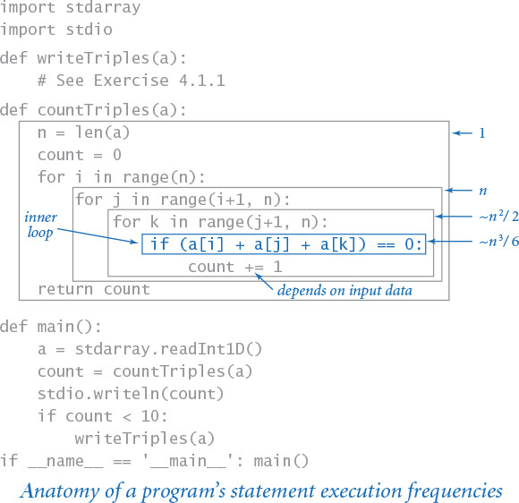
The key point in analyzing the running time of a program is this: for a great many programs, the running time satisfies the relationship
T(n) ∼ c f(n)
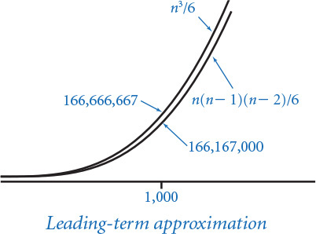
where c is a constant and f(n) is a function known as the order of growth of the running time. For typical programs, f(n) is a function such as log n, n, n log n, n2, or n3, as you will soon see (customarily, we express order-of-growth functions without any constant coefficient). When f(n) is a power of n, as is often the case, this assumption is equivalent to saying that the running time satisfies a power law. In the case of threesum.py, it is a hypothesis already verified by our empirical observations: the order of growth of the running time of threesum.py is n3. The value of the constant c depends both on the cost of executing instructions and on details of the frequency analysis, but we normally do not need to work out the value, as you will now see.
The order of growth is a simple but powerful model of running time. For example, knowing the order of growth typically leads immediately to a doubling hypothesis. In the case of threesum.py, knowing that the order of growth is n3 tells us to expect the running time to increase by a factor of 8 when we double the size of the problem because
T(2n)/T(n) → c (2n)3/(cn3) = 8
This matches the value resulting from the empirical analysis, thus validating both the model and the experiments. Study this example carefully, because you can use the same method to better understand the performance of any program that you compose.
Knuth showed that it is possible to develop an accurate mathematical model of the running time of any program, and many experts have devoted much effort to developing such models. But you do not need such a detailed model to understand the performance of your programs: it is typically safe to ignore the cost of the instructions outside the inner loop (because that cost is negligible by comparison to the cost of the instruction in the inner loop) and not necessary to know the value of the constant in the running-time approximation (because it cancels out when you use a doubling hypothesis to make predictions).
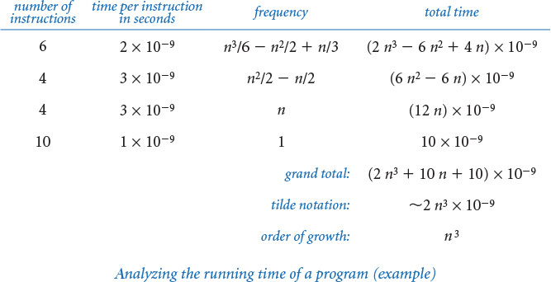
These approximations are significant because they relate the abstract world of a Python program to the real world of a computer running it. The approximations are such that characteristics of the particular machine that you are using do not play a significant role in the models—the analysis separates the algorithm from the system. The order of growth of the running time of threesum.py is n3 does not depend on whether it is implemented in Python or whether it is running on your laptop, someone else’s mobile phone, or a supercomputer; rather, it depends primarily on the fact that it examines all the triples. The properties of the computer and the system are all summarized in various assumptions about the relationship between program statements and machine instructions, and in the actual running times that we observe as the basis for the doubling hypothesis. The algorithm that you are using determines the order of growth. This separation is a powerful concept because it allows us to develop knowledge about the performance of algorithms and then apply that knowledge to any computer. In fact, much of the knowledge about the performance of classic algorithms was developed decades ago, but that knowledge is still relevant to today’s computers.
Empirical and mathematical analyses like those we have described constitute a model (an explanation of what is going on) that might be formalized by listing all of the assumptions mentioned (each instruction takes the same amount of time each time it is executed, running time has the given form, and so forth). Not many programs are worthy of a detailed model, but you need to have an idea of the running time that you might expect for every program that you compose. Pay attention to the cost. Formulating a doubling hypothesis—through empirical studies, mathematical analysis, or (preferably) both—is a good way to start. This information about performance is extremely useful, and you will soon find yourself formulating and validating hypotheses every time you run a program. Indeed, doing so is a good use of your time while you wait for your program to finish!

Order of growth classifications
We use just a few structural primitives (statements, conditionals, loops, and function calls) to build Python programs, so very often the order of growth of our programs is one of just a few functions of the problem size, summarized in the table on the next page. These functions immediately lead to a doubling hypothesis, which we can verify by running the programs. Indeed, you have been running programs that exhibit these orders of growth, as you can see in the following brief discussions.

Constant
A program whose running time’s order of growth is constant executes a fixed number of statements to finish its job; consequently, its running time does not depend on the problem size. Our first several programs in CHAPTER 1—such as helloworld.py (PROGRAM 1.1.1) and leapyear.py (PROGRAM 1.2.5)—fall into this category: they each execute several statements just once.
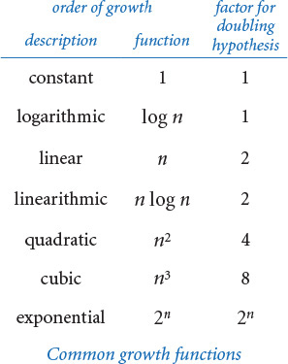
All of Python’s operations on standard numeric types take constant time. That is, applying an operation to a large number consumes no more time than does applying it to a small number. (One exception is that operations involving integers with a huge number of digits can consume more than constant time; see the Q&A at the end of this section for details.) The functions in Python’s math module also take constant time. Note that we do not specify the size of the constant. For example, the constant for math.atan2() is somewhat larger than the constant for math.hypot().

Logarithmic
A program whose running time’s order of growth is logarithmic is barely slower than a constant-time program. The classic example of a program whose running time is logarithmic in the problem size is looking for an element in a sorted array, which we consider in the next section (see PROGRAM 4.2.3, binarysearch.py). The base of the logarithm is not relevant with respect to the order of growth (since all logarithms with a constant base are related by a constant factor), so we use log n when referring to the order of growth. Occasionally, we write more precise formulas using lg n (base 2, or binary log) or ln n (base e, or natural logarithm) because both arise naturally when studying computer programs. For example, lg n, rounded up, is the number of bits in the binary representation of n, and ln n arises in the analysis of binary search trees (see SECTION 4.4).

Linear
Programs that spend a constant amount of time processing each piece of input data, or that are based on a single for loop, are quite common. The order of growth of such a program is said to be linear—its running time is directly proportional to the problem size. PROGRAM 1.5.3 (average.py), which computes the average of the numbers on standard input, is prototypical, as is our code to shuffle the elements in an array in SECTION 1.4. Filters such as plotfilter.py (PROGRAM 1.5.5) also fall into this category, as do the various image-processing filters that we considered in SECTION 3.2, which perform a constant number of arithmetic operations per input pixel.

Linearithmic
We use the term linearithmic to describe programs whose running time for a problem of size n has order of growth n log n. Again, the base of the logarithm is not relevant. For example, couponcollector.py (PROGRAM 1.4.2) is linearithmic. The prototypical example is mergesort (see PROGRAM 4.2.6). Several important problems have natural solutions that are quadratic but clever algorithms that are linearithmic. Such algorithms (including mergesort) are critically important in practice because they enable us to address problem sizes far larger than could be addressed with quadratic solutions. In the next section, we consider a general design technique for developing linearithmic algorithms.
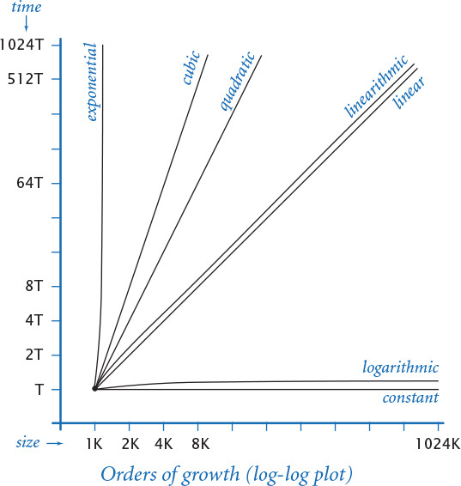

Quadratic
A typical program whose running time has order of growth n2 has two nested for loops, used for some calculation involving all pairs of n elements. The force update double loop in universe.py (PROGRAM 3.4.2) is a prototype of the programs in this classification, as is the elementary sorting algorithm insertion sort (see PROGRAM 4.2.4).

Cubic
Our example for this section, threesum.py, is cubic (its running time has order of growth n3) because it has three nested for loops, to process all triples of n elements. The running time of matrix multiplication, as implemented in SECTION 1.4 has order of growth m3 to multiply two m-by-m matrices, so the basic matrix multiplication algorithm is often considered to be cubic. However, the size of the input (the number of elements in the matrices) is proportional to n = m2, so the algorithm is best classified as n3/2, not cubic.
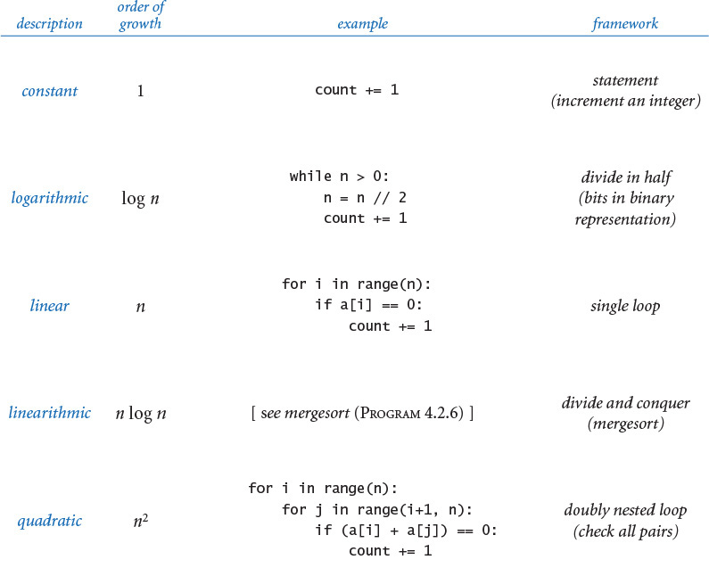
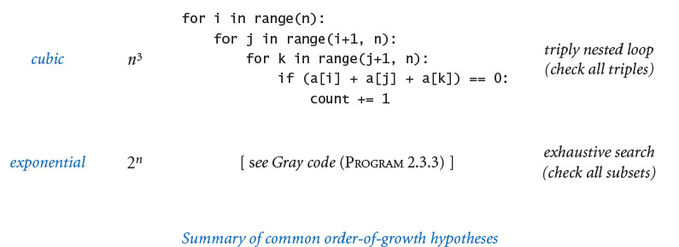

Exponential
As discussed in SECTION 2.3, both towersofhanoi.py (PROGRAM 2.3.2) and beckett.py (PROGRAM 2.3.3) have running times proportional to 2n because they process all subsets of n elements. Generally, we use the term “exponential” to refer to algorithms whose order of growth is bn for any constant b > 1, even though different values of b lead to vastly different running times. Exponential algorithms are extremely slow—you should never run one of them for a large problem. They play a critical role in the theory of algorithms because there exists a large class of problems for which it seems that an exponential algorithm is the best possible choice.
These classifications are the most common, but certainly not a complete set. Indeed, the detailed analysis of algorithms can require the full gamut of mathematical tools that have been developed over the centuries. Understanding the running time of programs such as factors.py (PROGRAM 1.3.9), primesieve.py (PROGRAM 1.4.3), and euclid.py (PROGRAM 2.3.1) requires fundamental results from number theory. Classic algorithms like hashst.py (PROGRAM 4.4.3) and bst.py (PROGRAM 4.4.4) require careful mathematical analysis. The programs sqrt.py (PROGRAM 1.3.6) and markov.py (PROGRAM 1.6.3) are prototypes for numerical computation: their running time depends on the rate of convergence of a computation to a desired numerical result. Monte Carlo simulations such as gambler.py (PROGRAM 1.3.8) and percolation.py (PROGRAM 2.4.6) and variants are of interest precisely because detailed mathematical models for them are not available.
Nevertheless, a great many of the programs that you will compose have straightforward performance characteristics that can be described accurately by one of the orders of growth that we have considered, as documented in the table on the preceding page. Accordingly, we can usually work with simple higher-level hypotheses, such as the order of growth of the running time of mergesort is linearithmic. For economy, we abbreviate such a statement to just say mergesort is linearithmic. Most of our hypotheses about cost are of this form, or of the form mergesort is faster than insertion sort. Again, a notable feature of such hypotheses is that they are statements about algorithms, not just about programs.

Predictions
You can always try to estimate the running time of a program by simply running it, but that might be a poor way to proceed when the problem size is large. In that case, it is analogous to trying to estimate where a rocket will land by launching it, how destructive a bomb will be by igniting it, or whether a bridge will stand by building it.
Knowing the order of growth of the running time allows us to make decisions about addressing large problems so that we can invest whatever resources we have to deal with the specific problems that we actually need to solve. We typically use the results of verified hypotheses about the order of growth of the running time of programs in one of the following ways.

Estimating the feasibility of solving large problems
To pay attention to the cost, you need to answer this basic question for every program that you compose: Will this program be able to process this input data in a reasonable amount of time? For example, a cubic algorithm that runs in a couple of seconds for a problem of size n will require a few weeks for a problem of size 100n because it will be a million (1003) times slower, and a couple of million seconds is a few weeks. If that is the size of the problem that you need to solve, you have to find a better method. Knowing the order of growth of the running time of an algorithm provides precisely the information that you need to understand limitations on the size of the problems that you can solve. Developing such understanding is the most important reason to study performance. Without it, you are likely have no idea how much time a program will consume; with it, you can perform a back-of-the-envelope calculation to estimate costs and proceed accordingly.
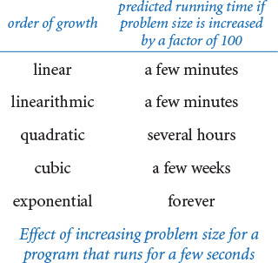

Estimating the value of using a faster computer
To pay attention to the cost, you also may be faced with this basic question: How much faster can I solve a problem if I run it on a faster computer? Again, knowing the order of growth of the running time provides precisely the information that you need. A famous rule of thumb known as Moore’s law implies that you can expect to have a computer with about double the speed and double the memory 18 months from now, or a computer with about 10 times the speed and 10 times the memory in about 5 years. It is natural to think that if you buy a new computer that is 10 times faster and has 10 times more memory than your old one, you can solve a problem 10 times the size, but that is unmistakably not the case for quadratic or cubic algorithms. Whether it is an investment banker running daily financial models or a scientist running a program to analyze experimental data or an engineer running simulations to test a design, it is not unusual for people to regularly run programs that take several hours to complete. Suppose that you are using a program whose running time is cubic, and then buy a new computer that is 10 times faster with 10 times more memory, not just because you need a new computer, but because you face problem sizes that are 10 times larger. The rude awakening is that your program will take 100 times longer than before! This kind of situation is the primary reason that linear and linearithmic algorithms are so valuable: with such an algorithm and a new computer that is 10 times faster with 10 times more memory than the old computer, you can solve a problem that is 10 times larger than could be solved by the old computer in the same amount of time. In other words, you cannot keep pace with Moore’s law if you are using a quadratic or a cubic algorithm.
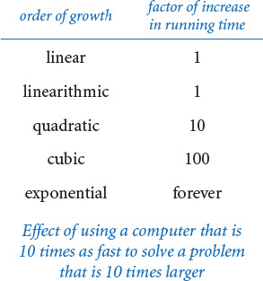

Comparing programs
We always seek ways to improve our programs, and we can often extend or modify our hypotheses to evaluate the effectiveness of various improvements. With the ability to predict performance, we can make design decisions during development that can guide us toward better, more efficient implementations. In many cases, we can determine the order of growth of the running times and develop accurate hypotheses about comparative performance. The order of growth is extremely useful in this process because it allows us to compare one particular algorithm with whole classes of algorithms. For example, once we have a linearithmic algorithm to solve a problem, we become less interested in quadratic or cubic algorithms to solve the same problem.

Caveats
There are many reasons that you might get inconsistent or misleading results when trying to analyze program performance in detail. All of them have to do with the idea that one or more of the basic assumptions underlying our hypotheses might not be quite correct. We can develop new hypotheses based on new assumptions, but the more details that we take into account, the more care we need in the analysis.

Instruction time
The assumption that each instruction always takes the same amount of time is not always correct. For example, most modern computer systems use a technique known as caching to organize memory, in which case accessing elements in huge arrays can take much longer if they are not close together in the array. You may be able to observe the effect of caching for threesum.py by letting doublingtest.py run for a while. After seeming to converge to 8, the ratio of running times may jump to a larger value for large arrays because of caching.

Nondominant inner loop
The assumption that the inner loop dominates may not always be correct. The problem size n might not be sufficiently large to make the leading term in the mathematical description of the frequency of execution of instructions in the inner loop so much larger than lower-order terms that we can ignore them. Some programs have a significant amount of code outside the inner loop that needs to be taken into consideration.

System considerations
Typically, there are many, many things going on in your computer. Python is just one application of many competing for resources, and Python itself has many options and controls that significantly affect performance. Such considerations can interfere with the bedrock principle of the scientific method that experiments should be reproducible, since what is happening at this moment in your computer will never be reproduced again. Whatever else is going on in your system (that is beyond your control) should in principle be negligible.

Too close to call
Often, when we compare two different programs for the same task, one might be faster in some situations, and slower in others. One or more of the considerations just mentioned could make the difference. Again, there is a natural tendency among some programmers (and some students) to devote an extreme amount of energy running such horseraces to find the “best” implementation, but such work is best left for experts.

Strong dependence on input values
One of the first assumptions that we made to determine the order of growth of the program’s running time of a program was that the running time should be relatively insensitive to the input values. When that is not the case, we may get inconsistent results or be unable to validate our hypotheses. Our running example threesum.py does not have this problem, but we will see several examples in this chapter of programs whose running time does depends on the input values. Often, a prime design goal is to eliminate such dependence on the input values. If we cannot do so, we need to more carefully model the kind of input to be processed in the problems that we need to solve, which may be a significant challenge. For example, if we are composing a program to process a genome, how do we know how it will perform on a different genome? But a good model describing the genomes found in nature is precisely what scientists seek, so estimating the running time of our programs on data found in nature actually makes a valuable contribution to that model!

Multiple problem parameters
We have been focusing on measuring performance as a function of a single parameter n, generally the value of a command-line argument or the size of the input. However, it is not unusual to measure performance using two (or more) parameters. For example, suppose that a[] is an array of length m and b[] is an array of length n. Consider the following code fragment that counts the number of pairs i and j for which a[i] + b[j] equals 0:
for i in range(m):
for j in range(n):
if a[i] + b[j] == 0:
count += 1
In such cases, we treat the parameters m and n separately, holding one fixed while analyzing the other. For example, the order of growth of the running time of this code fragment is mn.
Despite all these caveats, understanding the order of growth of the running time of each program is valuable knowledge for any programmer, and the methods that we have described are powerful and broadly applicable. Knuth’s insight was that we can carry these methods through to the last detail in principle to make detailed, accurate predictions. Typical computer systems are extremely complex and close analysis is best left for experts, but the same methods are effective for developing approximate estimates of the running time of any program. A rocket scientist needs to have some idea of whether a test flight will land in the ocean or in a city; a medical researcher needs to know whether a drug trial will kill or cure all the subjects; and any scientist or engineer using a computer program needs to have some idea of whether it will run for a second or for a year.

Performance guarantees
For some programs, we demand that the running time of a program is less than a certain bound for any input of a given size. To provide such performance guarantees, theoreticians take an extremely pessimistic view: what would the running time be in the worst case?
For example, such a conservative approach might be appropriate for the software that runs a nuclear reactor or an air traffic control system or the brakes in your car. We must guarantee that such software completes its job within the bounds that we set because the result could be catastrophic if it does not. Scientists normally do not contemplate the worst case when studying the natural world: in biology, the worst case might the extinction of the human race; in physics, the worst case might be the end of the universe. But the worst case can be a very real concern in computer systems, where the input is generated by another (potentially malicious) user, rather than by nature. For example, websites that do not use algorithms with performance guarantees are subject to denial-of-service attacks, where hackers flood them with pathological requests that make them run harmfully slower than planned.
Performance guarantees are difficult to verify with the scientific method, because we cannot test a hypothesis such as mergesort is guaranteed to be linearithmic without trying all possible inputs, which we cannot do because there are far too many of them. We might falsify such a hypothesis by providing inputs for which mergesort is slow, but how can we prove it to be true? We must do so not with experimentation, but rather with mathematical models.
It is the task of the algorithm analyst to discover as much relevant information about an algorithm as possible, and it is the task of the applications programmer to apply that knowledge to develop programs that effectively solve the problems at hand. For example, if you are using a quadratic algorithm to solve a problem but can find an algorithm that is guaranteed to be linearithmic, you will usually prefer the linearithmic one. On rare occasions, you might still prefer the quadratic algorithm because it is faster on the kinds of inputs that you need to solve or because the linearithmic algorithm is too complex to implement.
Ideally, we want algorithms that lead to clear and compact code that provides both a good worst-case guarantee and good performance on inputs of interest. Many of the classic algorithms that we consider in this chapter are of importance for a broad variety of applications precisely because they have all of these properties. Using these algorithms as models, you can develop good solutions yourself for typical problems that you face while programming.

Python lists and arrays
Python’s built-in list data type represents a mutable sequence of objects. We have been using Python lists throughout the book—recall that we use Python lists as arrays because they support the four core array operations: creation, indexed access, indexed assignment, and iteration. However, Python lists are more general than arrays because you can also insert items into and delete items from Python lists. Even though Python programmers typically do not distinguish between lists and arrays, many other programmers do make such a distinction. For example, in many programming languages, arrays are of fixed length and do not support insertions or deletions. Indeed, all of the array-processing code that we have considered in this book so far could have been done using fixed-length arrays.
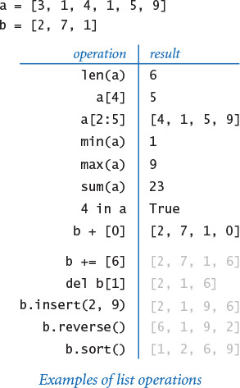
The table on the facing page gives the most commonly used operations for Python lists. Note that several of these operations—indexing, slicing, concatenation, deletion, containment, and iteration—enjoy direct language support in the form of special syntax. As illustrated in the table at right, some of these operations return values while others mutate the invoking list.
We have deferred this API to this section because programmers who use Python lists without following our mantra pay attention to the cost are in for trouble. For example, consider these two code snippets:
Click here to view code image
# quadratic time # linear time
a = [] a = []
for i in range(n): for i in range(n):
a .insert(0, 'slow') a.insert(i, 'fast')
The one on the left takes quadratic time; the one on the right takes linear time. To understand why Python list operations have the performance characteristics that they do, you need to learn more about Python’s resizing array representation of lists, which we discuss next.
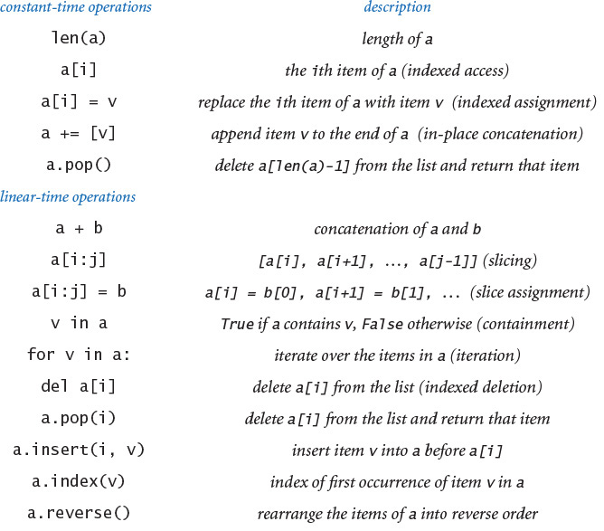
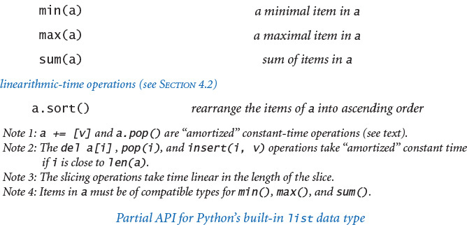

Resizing arrays
A resizing array is a data structure that stores a sequence of items (not necessarily fixed in length), which can be accessed by indexing. To implement a resizing array (at the machine level), Python uses a fixed-length array (allocated as one contiguous block of memory) to store the item references. The array is divided into two logical parts: the first part of the array contains the items in the sequence; the second part of the array is unused and reserved for subsequent insertions. Thus, we can append or remove items from the end in constant time, using the reserved space. We use the term size to refer to the number of items in the data structure and the term capacity to refer to the length of the underlying array.
The main challenge is ensuring that the data structure has sufficient capacity to hold all of the items, but is not so large as to waste an excessive amount of memory. Achieving these two goals turns out to be remarkably easy.
First, if we want to append an item to the end of a resizing array, we check its capacity. If there is room, we simply insert the new item at the end. If not, we double its capacity by creating a new array of twice the length and copying the items from the old array into the new array.
Similarly, if we want to remove an item from the end of the resizing array, we check its capacity. If it is excessively large, we halve its capacity by creating a new array of half the length and copying the items from the old array into the new array. An appropriate test is to check whether the size of the resizing array is less than one-fourth of its capacity. That way, after the capacity is halved, the resizing array is about half full and can accommodate a substantial number of insertions before we have to change its capacity again.
The doubling-and-halving strategy guarantees that the resizing array remains between 25% and 100% full, so that space is linear in the number of items. The specific strategy is not sacrosanct. For example, typical Python implementations expand the capacity by a factor of 9/8 (instead of 2) when the resizing array is full. This wastes less space (but triggers more expansion and shrinking operations).
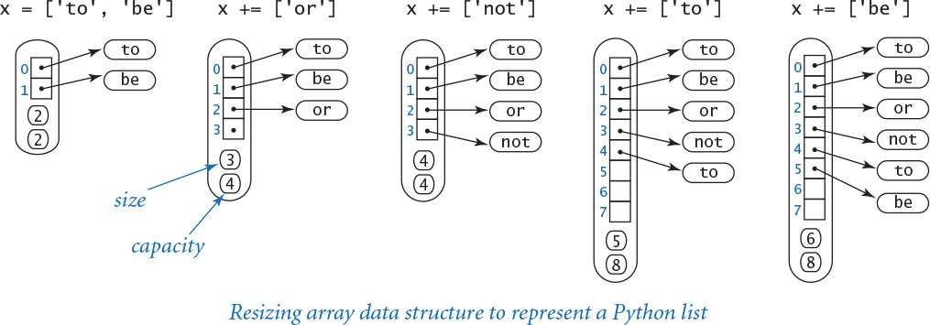

Amortized analysis
The doubling-and-halving strategy is a judicious tradeoff between wasting space (by setting the capacity to be too large and leaving much of the array unused) and wasting time (either by creating a new array or by reorganizing the existing array). More important, we can prove that the cost of doubling and halving is always absorbed (to within a constant factor) in the cost of other Python list operations.
More precisely, starting from an empty Python list, any sequence of n operations labeled as “constant time” in the API table on page 531 takes time linear in n. In other words, the total cost of any such sequence of Python list operations divided by the number of operations is bounded by a constant. This kind of analysis is known as amortized analysis. This guarantee is not as strong as saying that each operation is constant-time, but it has the same implications in many applications (for example, when our primary interest is in total running time). We leave the full details as an exercise for the mathematically inclined.
For the special case where we perform a sequence of n insertions into an empty resizing array, the idea is simple: each insertion takes constant time to add the item; each insertion that triggers a resizing (when the current size is a power of 2) takes additional time proportional to n to copy the elements from the old array of length n to a new array of length 2n. Thus, assuming n is a power of 2 for simplicity, the total cost is proportional to
(1 + 1 + 1 + ... + 1) + (1 + 2 + 4 + 8 + ... + n) ~ 3n
The first term (which sums to n) accounts for the n insertion operations; the second term (which sums to 2n − 1) accounts for the lg n resizing operations.
Understanding resizing arrays is important in Python programming. For example, it explains why creating a Python list of n items by repeatedly appending items to the end takes time proportional to n (and why creating a list of n items by repeatedly prepending items to the front takes time proportional to n2). Such performance pitfalls are precisely the reason that we recommend using narrower interfaces that address performance.

Strings
Python’s string data type has some similarity to Python lists, with one very important exception: strings are immutable. When we introduced strings, we did not emphasize this fact, but it makes lists and strings quite different. For example, you may not have noticed at the time, but you cannot change a character in a string. For example, you might think that you could capitalize a string s having the value 'hello' with s[0] = 'H', but that will result in this run-time error:
Click here to view code image
TypeError: 'str' object does not support item assignment
If you want 'Hello', you need to create a completely new string. This difference reinforces the idea of immutability and has significant implications with regard to performance, which we now examine.

Internal representation
First, Python uses a much simpler internal representation for strings than for lists/arrays, as detailed in the diagram at left. Specifically, a string object contains two pieces of information:
• A reference to a place in memory where the characters in the string are stored contiguously
• The length of the string
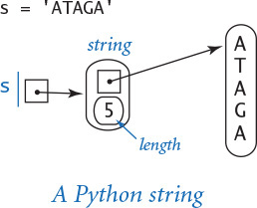
By contrast, consider the diagram at right, which is an array of one-character strings. We will consider a more detailed analysis later in this section, but you can see that the string representation is certainly significantly simpler. It uses much less space per character and provides faster access to each character. In many applications, these characteristics are very important because strings can be very long. So, it is important both that the memory usage be not much more than is required for the characters themselves and that characters can be quickly accessed by their index, as in an array.
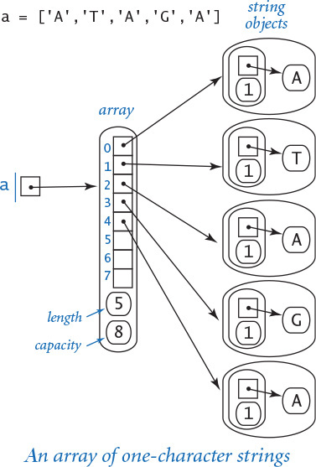

Performance
As for arrays, indexed access and computing the length of strings are constant-time operations. It is clear from the API at the beginning of SECTION 3.1 that most other operations take linear time as a function of the length of the input string or strings, because they refer to a copy of the string. In particular, concatenating a character to a string takes linear time and concatenating two strings takes time proportional to the length of the result. An example is shown at right. With respect to performance, this is the most significant difference between strings and lists/arrays: Python does not have resizable strings, because strings are immutable.

Example
Not understanding the performance of string concatenation often leads to performance bugs. The most common performance bug is building up a long string one character at a time. For example, consider the following code fragment to create a new string whose characters are in reverse order of the characters in a string s:
n = len(s)
reverse = ''
for i in range(n):
reverse = s[i] + reverse
During iteration i of the for loop, the string concatenation operator produces a string of length i+1. Thus, the overall running time is proportional to 1 + 2 + ... + n ~ n2 / 2 (see EXERCISE 4.1.4). That is, the code fragment takes quadratic time as a function of the string length n (see EXERCISE 4.1.13 for a linear-time solution).
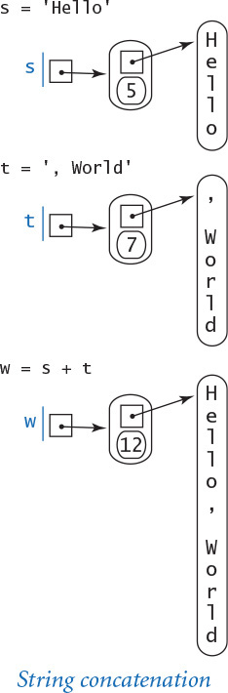
Understanding differences between data types like strings and Python lists is critical in learning any programming language, and programmers must be vigilant to ensure they avoid performance bugs like the one just described. This has been the case since the early days of data abstraction. For example, the string data type in the C language that was developed in the 1970s has a linear-time length function, and countless programmers using the length in a for loop that iterates through the string have found themselves with a quadratic-time performance bug for a simple linear-time job.

Memory
As with running time, a program’s memory usage connects directly to the physical world: a substantial amount of your computer’s circuitry enables your program to store values and later retrieve them. The more values you need to store at any given instant, the more circuitry you need. To pay attention to the cost, you need to be aware of memory usage. You probably are aware of limits on memory usage on your computer (even more so than for time) because you probably have paid extra money to get more memory.
At the outset, you should be aware that the flexibility that we get from Python’s pure approach to object-oriented programming (everything is an object, even boolean values) comes with costs, and one of the most significant costs is the amount of memory consumed. This will become more clear as we examine some specific examples.
Memory usage is well defined for Python on your computer (every value will require precisely the same amount of memory each time that you run your program), but Python is implemented on a very wide range of computational devices, and memory consumption is implementation-dependent. Different versions of Python might implement the same data type in different ways. For economy, we use the word typical to signal values that are particularly subject to machine dependencies. Analyzing memory usage is somewhat different from analyzing time usage, primarily because one of Python’s most significant features is its memory allocation system, which is supposed to relieve you of having to worry about memory. Certainly, you are well advised to take advantage of this feature when appropriate. Still, it is your responsibility to know, at least approximately, when a program’s memory requirements might prevent you from solving a given problem.
Computer memory is divided into bytes, where each byte consists of 8 bits, and where each bit is a single binary digit. To determine the memory usage of a Python program, we count up the number of objects used by the program and weight them by the number of bytes that they require, according to their type. To use that approach, we must know the number of bytes consumed by an object of any given type. To determine the memory consumption of an object, we add the amount of memory used by each of its instance variables to the overhead associated with each object.
Python does not define the sizes of the built-in data types that we have been using (int, float, bool, str, and list); the sizes of objects of those types differ from system to system. Accordingly, the sizes of data types that you create also will differ from system to system because they are based on these built-in data types. The function call sys.getsizeof(x) returns the number of bytes that a built-in object x consumes on your system. The numbers that we give in this section are observations gathered by using this function in interactive Python on one typical system. We encourage you to do the same on your computer!
Python 3 alert
The numbers we give in this section are for a typical Python 2 system. Python 3 uses a more complicated memory model. For example, the memory used by the int object 0 is not the same as the memory used by the int object 1.

Integers
To represent an int object whose value is in the range (–263 to 263 – 1), Python uses 16 bytes for overhead and 8 bytes (that is, 64 bits) for the numeric value. So, for example, Python uses 24 bytes to represent the int object whose value is 0, 24 bytes to represent the int object whose value is 1234, and so forth. In most applications, we are not dealing with huge integers outside this range, so the memory consumption for each integer is 24 bytes. Python switches to a different internal representation for integers outside this range, which consumes memory proportional to the number of digits in the integer, as in the case with strings (see below).

Floats
To represent a float object, Python uses 16 bytes for overhead and 8 bytes for the numeric value (that is, the mantissa, exponent, and sign), no matter what value the object has. So a float object always consumes 24 bytes.
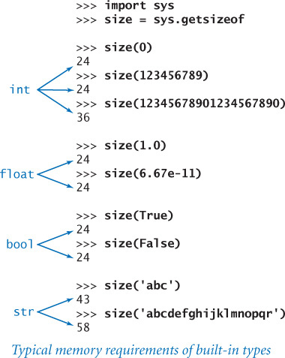

Booleans
In principle, Python could represent a boolean value using a single bit of computer memory. In practice, Python represents boolean values as integers. Specifically, Python uses 24 bytes to represent the bool object True and 24 bytes to represent the bool object False. That is a factor of 192 higher than the minimum amount needed! However, this wastefulness is partially mitigated because Python “caches” the two boolean objects, as we discuss next.

Caching
To save memory, Python creates only one copy of objects with certain values. For example, Python creates only one bool object with value true and only one with value false. That is, every boolean variables holds a reference to one of these two objects. This caching technique is possible because the bool data type is immutable. On typical systems, Python also caches small int values (between –5 and 256), as they are the ones that programmers use most often. Python does not typically cache float objects.
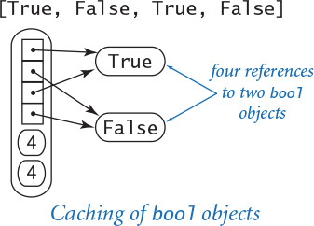

Strings
To represent a str object, Python uses 40 bytes for overhead (including the string length), plus one byte for each character of the string. So, for example, Python represents the string 'abc' using 40 + 3 = 43 bytes and represents the string 'abcdefghijklmnopqr' using 40 + 18 = 58 bytes. Python typically caches only string literals and one-character strings.

Arrays (Python lists)
To represent an array, Python uses 72 bytes for overhead (including the array length) plus 8 bytes for each object reference (one for each element in the array). So, for example, the Python representation of the array [0.3, 0.6, 0.1] uses 72 + 8*3 = 96 bytes. This does not include the memory for the objects that the array references, so the total memory consumption for the array [0.3, 0.6, 0.1] is 96 + 3*24 = 168 bytes. In general, the memory consumption for an array of n integers or floats is 72 + 32n bytes. This total is likely to be an underestimate, because the resizing array data structure that Python uses to implement arrays may consume an additional n bytes in reserved space.
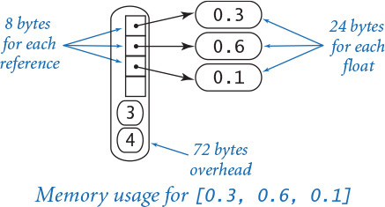

Two-dimensional arrays and arrays of objects
A two-dimensional array is an array of arrays, so we can calculate the memory consumption of a two-dimensional array with m rows and n columns from the information in the previous paragraph. Each row is an array that consumes 72 + 32n bytes, so the total is 72 (overhead) plus 8m (references to the rows) plus m(72 + 32n) (memory for the m rows) bytes, for a grand total of 72 + 80m + 32mn bytes. The same logic works for an array of any type of object: if an object uses x bytes, an array of m such objects consumes a total of 72 + m(x+8) bytes. Again, this is likely to be a slight underestimate because of the resizing array data structure Python uses to represent arrays. Note: Python’s sys.getsizeof(x) is not much help in these calculations because it does not calculate the memory for the objects themselves—it returns 72 + 8m for any array of length m (or any two-dimensional array with m rows).
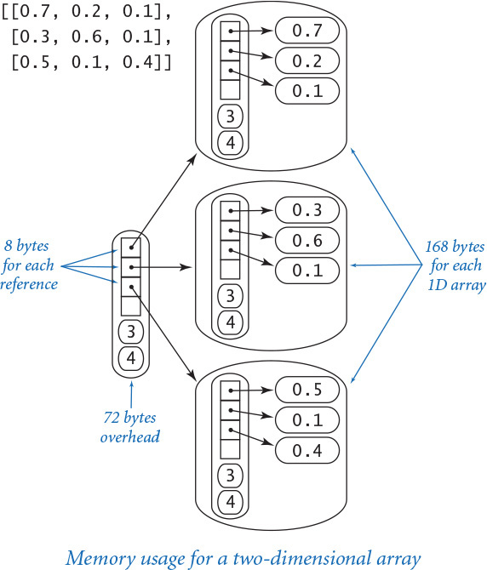

Objects
A key question for Python programming is the following: How much memory is required to represent a user-defined object? The answer to this question may surprise you, but is important to know: hundreds of bytes, at least. Specifically, Python uses 72 bytes of overhead plus 280 bytes for a dictionary that binds instance variables to objects (we will discuss dictionaries in SECTION 4.4) plus 24 bytes for a reference to each instance variable plus memory for the instance variables themselves. For example, to represent a Charge object, Python uses at least 72 + 280 = 352 bytes for overhead, 8 * 3 = 24 bytes to store the object references for the three instance variables, 24 bytes to store the float object referenced by the _rx instance variable, 24 bytes to store the float object referenced by the _ry instance variable, and 24 bytes to store the float object referenced by the _q instance variable, for a grand total of (at least) 448 bytes. The total might be even higher on your system, because some implementations consume even more overhead.
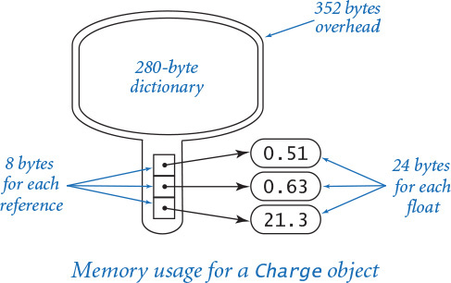
These basic mechanisms are effective for estimating the memory usage of a great many programs, but there are numerous complicating factors that can make the task significantly more difficult. For example, we have already noted the potential effect of caching. Moreover, memory consumption is a complicated dynamic process when function calls are involved because the system memory allocation mechanism plays a more important role. For example, when your program calls a function, the system allocates the memory needed for the function (for its local variables) from a special area of memory called the stack, and when the method returns to the caller, this memory is returned to the stack. For this reason, creating arrays or other large objects in recursive functions is dangerous, since each recursive call implies significant memory usage. When you create an object, the system allocates the memory needed for the object from another special area of memory known as the heap. Every object lives until no references to it remain, at which point a system process known as garbage collection reclaims its memory for the heap. Such dynamics can make the task of precisely estimating memory usage of a program challenging.
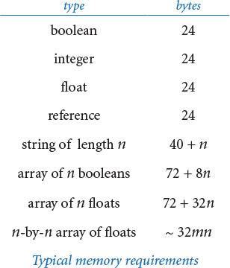
Despite all these caveats, it is important for every Python programmer to understand that each object of a user-defined type is likely to consume a large amount of memory. So, a Python program that defines a large number of objects of a user-defined type can use much more space (and time) than you might expect. That is especially true if each object contains only a few instance variables—in that case, the ratio of memory devoted to overhead versus memory devoted to instance variables is very high. For example, if you compare the performance of our Complex type with Python’s built-in complex type for mandelbrot.py, you will certainly notice this effect. Numerous object-oriented languages have come and gone since the concept was introduced decades ago, and many of them eventually embraced lightweight objects for user-defined types. Python offers two advanced features for this purpose—named tuples and slots—but we will not take advantage of such memory optimizations in this book.

Perspective
Good performance is important. An impossibly slow program is almost as useless as an incorrect one, so it is certainly worthwhile to pay attention to the cost at the outset, so as to have some idea of what sorts of problems you might feasibly address. In particular, it is always wise to have some idea of which code constitutes the inner loop of your programs.
Perhaps the most common mistake made in programming is to pay too much attention to performance characteristics. Your first priority is to make your code clear and correct. Modifying a program for the sole purpose of speeding it up is best left for experts. Indeed, doing so is often counterproductive, as it tends to create code that is complicated and difficult to understand. C. A. R. Hoare (the inventor of quicksort and a leading proponent of composing clear and correct code) once summarized this idea by saying that “premature optimization is the root of all evil,” to which Knuth added the qualifier “(or at least most of it) in programming.” Beyond that, improving the running time is not worthwhile if the available cost benefits are insignificant. For example, improving the running time of a program by a factor of 10 is inconsequential if the running time is only an instant. Even when a program takes a few minutes to run, the total time required to implement and debug an improved algorithm might be substantially longer than the time required simply to run a slightly slower one—you may as well let the computer do the work. Worse, you might spend a considerable amount of time and effort implementing ideas that do not actually make a program any faster.
Perhaps the second most common mistake made in developing an algorithm is to ignore performance characteristics. Faster algorithms are often more complicated than brute-force solutions, so you might be tempted to accept a slower algorithm to avoid having to deal with more complicated code. However, you can sometimes reap huge savings with just a few lines of good code. Users of a surprising number of computer systems lose substantial time waiting for simple quadratic algorithms to finish solving a problem, even though linear or linearithmic algorithms are available that are only slightly more complicated and could therefore solve the problem in a fraction of the time. When we are dealing with huge problem sizes, we often have no choice but to seek better algorithms.
Improving a program to make it clearer, more efficient, and elegant should be your goal every time that you work on it. If you pay attention to the cost all the way through the development of a program, you will reap the benefits every time you use it.

Q&A
Q. The text notes that operations on very large integers can consume more than constant time. Can you be more precise?
A. Not really. The definition of “very large” is system dependent. For most practical purposes, you can consider operations applied to 32- or 64-bit integers to work in constant time. Modern applications in cryptography involve huge numbers with hundreds or thousands of digits.
Q. How do I find out how long it takes to add or multiply two floats on my computer?
A. Run some experiments! The program timeops.py on the booksite uses Stopwatch to test the execution time of various arithmetic operations on integers and floats. This technique measures the actual elapsed time as would be observed on a wall clock. If your system is not running many other applications, it can produce accurate results. Python also includes the timeit module for measuring the running time of small code fragments.
Q. Is there any way to measure processor time instead of wall clock time?
A. On some systems, the function call time.clock() returns the current processor time as a float, expressed in seconds. When available, you should substitute time.time() with time.clock() for benchmarking Python programs.
Q. How much time do functions such as math.sqrt(), math.log(), and math.sin() take?
A. Run some experiments! Stopwatch makes it easy to compose programs such as timeops.py to answer questions of this sort for yourself. You will be able to use your computer much more effectively if you get in the habit of doing so.
Q. Why does allocating an array (Python list) of size n take time proportional to n?
A. Python initializes all array elements to whatever values the programmer specifies. That is, in Python there is no way to allocate memory for an array without also assigning an object reference to each element of the array. Assigning object references to each element of an array of size n takes time proportional to n.
Q. How do I find out how much memory is available for my Python programs?
A. Since Python will raise a MemoryError when it runs out of memory, it is not difficult to run some experiments. For example, use this program (bigarray.py):
import sys
import stdarray
import stdio
n = int(sys.argv[1])
a = stdarray.create1D(n, 0)
stdio.writeln('finished')
and run it like this:
Click here to view code image
% python bigarray.py 100000000
finished
to show that you have room for 100 million integers. But if you type
Click here to view code image
% python bigarray.py 1000000000
Python will hang, crash, or raise a run-time error; you can conclude that you do not have room for an array of 1 billion integers.
Q. What does it mean when someone says that the worst-case running time of an algorithm is O(n2)?
A. That is an example of a notation known as big-O notation. We write f(n) is O(g(n)) if there exist constants c and n0 such that f(n) ≤ c g(n) for all n > n0. In other words, the function f(n) is bounded above by g(n), up to constant factors and for sufficiently large values of n. For example, the function 30n2 + 10n+ 7 is O(n2). We say that the worst-case running time of an algorithm is O(g(n)) if the running time as a function of the input size n is O(g(n)) for all possible inputs. This notation is widely used by theoretical computer scientists to prove theorems about algorithms, so you are sure to see it if you take a course in algorithms and data structures. It provides a worst-case performance guarantee.
Q. So can I use the fact that the worst-case running time of an algorithm is O(n3) or O(n2) to predict performance?
A. No, because the actual running time might be much less. For example, the function 30n2 + 10n+ 7 is O(n2), but it is also O(n3) and O(n10) because big-O notation provides only an upper bound on the worst-case running time. Moreover, even if there is some family of inputs for which the running time is proportional to the given function, perhaps these inputs are not encountered in practice. Consequently, you cannot use big-O notation to predict performance. The tilde notation and order-of-growth classifications that we use are more precise than big-O notation because they provide matching upper and lower bounds on the growth of the function. Many programmers incorrectly use big-O notation to indicate matching upper and lower bounds.
Q. How much memory does Python typically use to store a tuple of n items?
A. 56 + 8n bytes, plus whatever memory is needed for the objects themselves. This is a bit less than for arrays because Python can implement a tuple (at the machine level) using an array instead of a resizing array.
Q. Why does Python use so much memory (280 bytes) to store a dictionary that maps an object’s instance variables to its values?
A. In principle, different objects from the same data type can have different instance variables. In this case, Python would need some way to manage an arbitrary number of possible instance variables for each object. But most Python code does not call for this (and, as a matter of style, we never need it in this book).

Exercises
4.1.1 Implement the function writeAllTriples() for threesum.py, which writes all of the triples that sum to zero.
4.1.2 Modify threesum.py to take a command-line argument x and find a triple of numbers on standard input whose sum is closest to x.
4.1.3 Compose a program foursum.py that reads an integer n from standard input, then reads n integers from standard input, and counts the number of distinct 4-tuples that sum to zero. Use a quadruply nested loop. What is the order of growth of the running time of your program? Estimate the largest n that your program can handle in an hour. Then, run your program to validate your hypothesis.
4.1.4 Prove that 1 + 2 + ... + n = n(n+1)/2.
Solution: We proved this by induction at the beginning of SECTION 2.3. Here is the basis for another proof:
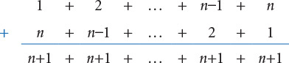
4.1.5 Prove by induction that the number of distinct triples of integers between 0 and n–1 is n(n–1)(n–2)/6.
Solution: The formula is correct for n = 2. For n > 2, count all the triples that do not include n, which is (n–1)(n–2)(n–3)/6 by the inductive hypothesis, and all the triples that do include n–1, which is (n–1)(n–2)/2, to get the total
(n–1)(n–2)(n–3)/6 + (n–1)(n–2)/2 = n(n–1)(n–2)/6.
4.1.6 Show by approximating with integrals that the number of distinct triples of integers between 0 and n–1 is about n3/6.
Solution:
4.1.7 What is the value of x (as a function of n) after running the following code fragment?
Click here to view code image
x = 0
for i in range(n):
for j in range(i+1, n):
for k in range(j+1, n):
x += 1
Solution: n (n–1) (n–2) / 6.
4.1.8 Use tilde notation to simplify each of the following formulas, and give the order of growth of each:
a. n(n – 1)(n – 2) (n – 3)/24
b. (n – 2) (lg n – 2) (lg n +2)
c. n(n +1) – n2
d. n(n +1)/2 +n lg n
e. ln((n – 1)(n – 2) (n – 3))2
4.1.9 Is the following code fragment linear, quadratic, or cubic (as a function of n)?
Click here to view code image
for i in range(n):
for j in range(n):
if i == j: c[i][j] = 1.0
else: c[i][j] = 0.0
4.1.10 Suppose the running time of an algorithm on inputs of size 1,000, 2,000, 3,000, and 4,000 is 5 seconds, 20 seconds, 45 seconds, and 80 seconds, respectively. Estimate how long it will take to solve a problem of size 5,000. Is the algorithm linear, linearithmic, quadratic, cubic, or exponential?
4.1.11 Which would you prefer: a quadratic, linearithmic, or linear algorithm?
Solution: While it is tempting to make a quick decision based on the order of growth, it is very easy to be misled by doing so. You need to have some idea of the problem size and of the relative value of the leading coefficients of the running time. For example, suppose that the running times are n2 seconds, 100 n log2 n seconds, and 10,000n seconds. The quadratic algorithm will be fastest for n up to about 1,000, and the linear algorithm will never be faster than the linearithmic one (n would have to be greater than 2100—far too large to bother considering).
4.1.12 Apply the scientific method to develop and validate a hypothesis about order of growth of the running time of the following code fragment, as a function of the argument n:
def f(n):
if (n == 0): return 1
return f(n-1) + f(n-1)
4.1.13 Apply the scientific method to develop and validate a hypothesis about order of growth of the running time of each of the following code fragments as a function of n:
Click here to view code image
s = ''
for i in range(n):
if stdrandom.bernoulli(0.5): s += '0'
else: s += '1'
s = ''
for i in range(n):
oldS = s
if stdrandom.bernoulli(0.5): s += '0'
else: s += '1'
Solution: On many systems, the first is linear; the second is quadratic. You have no way of knowing why: In the first case, Python detects that s is the only variable that refers to the string, so it appends each character to the string as it would with a list (in amortized constant time) even though the string is immutable! A safer alternative is to create a list containing the characters and concatenate them together with by calling the join() method.
Click here to view code image
a = []
for i in range(n):
if stdrandom.bernoulli(0.5): a += ['0']
else: a += ['1']
s = ''.join(a)
4.1.14 Each of the four Python functions below returns a string of length n whose characters are all x. Determine the order of growth of the running time of each function. Recall that concatenating two strings in Python takes time proportional to the sum of their lengths.
Click here to view code image
def f1(n):
if (n == 0):
return ''
temp = f1(n // 2)
if (n % 2 == 0): return temp + temp
else: return temp + temp + 'x'
def f2(n):
s = ''
for i in range(n):
s += 'x'
return s
def f3(n):
if (n == 0): return ''
if (n == 1): return 'x'
return f3(n//2) + f3(n - n//2)
def f4(n):
temp = stdarray.create1D(n, 'x')
return ''.join(temp)
def f5(n):
return 'x' * n
4.1.15 Each of the three Python functions below returns the reverse of a string of length n. What is the order of growth of the running time of each function?
Click here to view code image
def reverse1(s):
n = len(s)
reverse = ''
for i in range(n):
reverse = s[i] + reverse
return reverse
def reverse2(s):
n = len(s)
if (n <= 1):
return s
left = s[0 : n//2]
right = s[n//2 : n]
return reverse2(right) + reverse2(left)
def reverse3(s):
return s[::-1]
The slice expression s[::-1] uses an optional third argument to specify the step size.
4.1.16 The following code fragment (adapted from a Java programming book) creates a random permutation of the integers from 0 to n–1. Determine the order of growth of its running time as a function of n. Compare its order of growth with the shuffling code in SECTION 1.4.
Click here to view code image
a = stdarray.create1D(n, 0)
taken = stdarray.create1D(n, False)
count = 0
while (count < n):
r = stdrandom.uniform(0, n)
if not taken[r]:
a[r] = count
taken[r] = True
count += 1
4.1.17 How many times does the following code fragment execute the first if statement in the triply nested loop?
Click here to view code image
for i in range(n):
for j in range(n):
for k in range(n):
if (i < j) and (j < k):
if a[i] + a[j] + a[k] == 0:
count += 1
Use tilde notation to simply your answer.
4.1.18 Apply the scientific method to develop and validate a hypothesis about order of growth of the running time of the collect() method in coupon.py (PROGRAM 2.1.3), as a function of the argument n. Note: Doubling is not effective for distinguishing between the linear and linearithmic hypotheses—you might try squaring the size of the input.
4.1.19 Apply the scientific method to develop and validate a hypothesis about order of growth of the running time of markov.py (PROGRAM 1.6.3), as a function of the arguments moves and n.
4.1.20 Compose a program mooreslaw.py that takes a command-line argument n and writes the increase in processor speed over a decade if processor speed doubles every n months. How much will processor speed increase over the next decade if speeds double every n = 15 months? 24 months?
4.1.21 Using the memory model from the text, give the memory requirements for each object of the following data types from CHAPTER 3:
a. Stopwatch
b. Turtle
c. Vector
d. Body
e. Universe
4.1.22 Estimate, as a function of the grid size n, the amount of memory used by visualizev.py (PROGRAM 2.4.4) with vertical percolation detection (PROGRAM 2.4.2). Extra credit: Answer the same question for the case where the recursive percolation detection method percolation.py (PROGRAM 2.4.6) is used.
4.1.23 Estimate the size of the largest n-by-n array of integers that your computer can hold, and then try to allocate such an array.
4.1.24 Estimate, as a function of the number of documents n and the dimension d, the amount of space used by comparedocuments.py (PROGRAM 3.3.5).
4.1.25 Compose a version of primesieve.py (PROGRAM 1.4.3) that uses an array of integers instead of an array of booleans and uses 32 bits in each integer, to raise the largest value of n that it can handle by a factor of 32.
4.1.26 The following table gives running times for various programs for various values of n. Fill in the blanks with estimates that you think are reasonable on the basis of the information given.
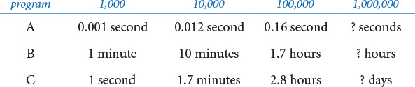
Give hypotheses for the order of growth of the running time of each program.

Creative Exercises
4.1.27 Three-sum analysis. Calculate the probability that no triple among n random 32-bit integers sums to 0, and give an approximate estimate for n equal to 1,000, 2,000, and 4,000. Extra credit: Give an approximate formula for the expected number of such triples (as a function of n), and run experiments to validate your hypothesis.
4.1.28 Closest pair. Design a quadratic algorithm that finds the pair of integers that are closest to each other. (In the next section you will be asked to find a linearithmic algorithm.)
4.1.29 Power law. Show that a log-log plot of the function cnb has slope b and x-intercept log c. What are the slope and x-intercept for 4 n3 (log n)2 ?
4.1.30 Sum furthest from zero. Design an algorithm that finds the pair of integers whose sum is furthest from zero. Can you discover a linear-time algorithm?
4.1.31 The “beck” exploit. A popular web server supports a function no2slash() whose purpose is to collapse multiple / characters. For example, the string /d1///d2////d3/test.html becomes /d1/d2/d3/test.html. The original algorithm was to repeatedly search for a / and copy the remainder of the string:
Click here to view code image
def no2slash(name):
for x in range(1, len(name)):
if x > 0:
if (name[x-1] == '/') and (name[x] == '/'):
for y in range(x+1, len(name)):
name[y-1] = name[y]
else:
x += 1
Unfortunately, the running time of this code is quadratic in the number of / characters in the input. By sending multiple simultaneous requests with large numbers of / characters, a hacker can deluge a server and starve other processes for CPU time, thereby creating a denial-of-service attack. Develop a version of no2slash() that runs in linear time and does not allow for this type of attack.
4.1.32 Young tableaux. Suppose you have in memory an n-by-n array of integers a[][] such that a[i][j] < a[i+1][j] and a[i][j] < a[i][j+1] for all i and j, like the table below:
5 23 54 67 89
6 69 73 74 90
10 71 83 84 91
60 73 84 86 92
99 91 92 93 94
Devise an algorithm whose order of growth is linear in n to determine whether a given integer x is in a given Young tableaux.
4.1.33 Subset sum. Compose a program anysum.py that takes an integer n from standard input, then reads n integers from standard input, and counts the number of subsets that sum to 0. Give the order of growth of the running time of your program.
4.1.34 Array rotation. Given an array of n elements, give a linear-time algorithm to rotate the array by k positions. That is, if the array contains a0, a1, ..., an-1, the rotated array is ak, ak+1, ..., an-1, a0, ..., ak-1. Use at most a constant amount of extra space (array indices and array values). Hint: Reverse three subarrays.
4.1.35 Finding a duplicated integer. (a) Given an array of n integers from 1 to n with one value repeated twice and one missing, give an algorithm that finds the missing integer, in linear time and constant extra space. (b) Given a read-only array of n integers, where each value from 1 to n–1 occurs once and one occurs twice, give an algorithm that finds the duplicated value, in linear time and constant extra space. (c) Given a read-only array of n integers with values between 1 and n–1, give an algorithm that finds a duplicated value, in linear time and constant extra space.
4.1.36 Factorial. Design a fast algorithm to compute n! for large values of n. Use your program to compute the longest run of consecutive 9s in 1000000!. Develop and validate a hypothesis for the order of growth of the running time of your algorithm.
4.1.37 Maximum sum. Design a linear-time algorithm that finds a contiguous subsequence of at most m in a sequence of n integers that has the highest sum among all such subsequences. Implement your algorithm, and confirm that the order of growth of its running time is linear.
4.1.38 Pattern matching. Given an n-by-n array of black (1) and white (0) pixels, design a linear algorithm that finds the largest square subarray that consists of entirely black pixels. As an example, the following 8-by-8 array contains a 3-by-3 subarray entirely of black pixels:
1 0 1 1 1 0 0 0
0 0 0 1 0 1 0 0
0 0 1 1 1 0 0 0
0 0 1 1 1 0 1 0
0 0 1 1 1 1 1 1
0 1 0 1 1 1 1 0
0 1 0 1 1 0 1 0
0 0 0 1 1 1 1 0
Implement your algorithm and confirm that the order of growth of its running time is linear in the number of pixels. Extra credit: Design an algorithm to find the largest rectangular black subarray.
4.1.39 Maximum average. Compose a program that finds a contiguous subarray of at most m elements in an array of n integers that has the highest average value among all such subarrays, by trying all subarrays. Use the scientific method to confirm that the order of growth of the running time of your program is mn2. Next, compose a program that solves the problem by first computing prefix[i] = a[0] + ... + a[i] for each i, then computing the average in the interval from a[i] to a[j] with the expression (prefix[j] - prefix[i]) / (j - i + 1). Use the scientific method to confirm that this method reduces the order of growth by a factor of n.
4.1.40 Sub-exponential function. Find a function whose order of growth is larger than any polynomial function, but smaller than any exponential function. Extra credit: Compose a program whose running time has that order of growth.
4.1.41 Resizing arrays. For each of the following strategies, either show that each resizing array operation takes constant amortized time or find a sequence of n operations (starting from an empty data structure) that takes quadratic time.
a. Double the capacity of the resizing array when it is full and halve the capacity when it is half full.
b. Double the capacity of the resizing array when it is full and halve the capacity when it is one-third full.
c. Increase the capacity of the resizing array by a factor of 9/8 when it is full and decrease it by a factor of 9/8 when it is 80% full.

4.2 Sorting and Searching
The sorting problem seeks to rearrange an array of elements in ascending order. It is a familiar and critical task in many computational applications: the songs in your music library are in alphabetical order, your email messages are in reverse order of the time received, and so forth. Keeping things in some kind of order is a natural desire. One reason that it is so useful is that it is much easier to search for something in a sorted list than an unsorted one. This need is particularly acute in computing, where the list of things to search can be huge and an efficient search can be an important factor in a problem’s solution.
4.2.1 Binary search (20 questions)
4.2.2 Bisection search
4.2.3 Binary search (in a sorted array)
4.2.4 Insertion sort
4.2.5 Doubling test sorts
4.2.6 Mergesort
4.2.7 Frequency counts
Programs in this section
Sorting and searching are important for commercial applications (businesses keep customer files in order) and scientific applications (to organize data and computation), and have all manner of applications in fields that may appear to have little to do with keeping things in order, including data compression, computer graphics, computational biology, numerical computing, combinatorial optimization, cryptography, and many others.
We use these fundamental problems to illustrate the idea that efficient algorithms are one key to effective solutions for computational problems. Indeed, many different sorting and searching algorithms have been proposed. Which should we use to address a given task? This question is important because different algorithms can have vastly differing performance characteristics, enough to make the difference between success in a practical situation and not coming close to doing so, even on the fastest available computer.
In this section, we will consider in detail two classical algorithms for sorting and searching, along with several applications in which their efficiency plays a critical role. With these examples, you will be convinced not just of the utility of these algorithms, but also of the need to pay attention to the cost whenever you address a problem that requires a significant amount of computation.

Binary search
The game of “twenty questions” (see PROGRAM 1.5.2, twentyquestions.py) provides an important and useful lesson in the idea of designing and using efficient algorithms for computational problems. The setup is simple: your task is to guess the value of a secret number that is one of the n integers between 0 and n – 1. Each time that you make a guess, you are told whether your guess is equal to the secret number, too high, or too low. As we discussed in SECTION 1.5, an effective strategy is to guess the number in the middle of the interval, then use the answer to halve the length of the interval that can contain the secret number. For reasons that will become clear later, we begin by slightly modifying the game to make the questions of the form “Is the number greater than or equal to m?” with only true or false answers, and assume for the moment that n is a power of 2. Now, the basis of an effective algorithm that always gets to the secret number in a minimal number of questions (in the worst case) is to maintain an interval that contains the secret number and shrink it by half at each step. More precisely, we use a half-open interval, which contains the left endpoint but not the right one. We use the notation [l o, hi) to denote all of the integers greater than or equal to lo and less than (but not equal to) hi. We start with lo = 0 and hi = n and use the following recursive strategy:
• Base case: If hi –lo equals 1, then the secret number is lo.
• Recursive step: Otherwise, ask whether the secret number is greater than or equal to the number mid = (hi + lo) / 2. If so, look for the number in [mid, hi); if not, look for the number in [lo, mid).
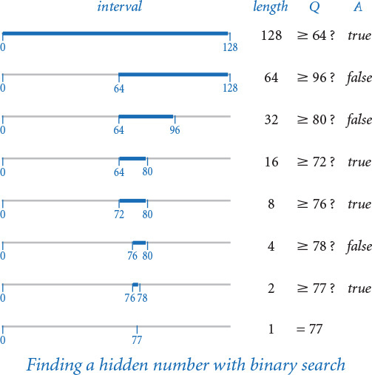
This strategy is an example of the general problem-solving algorithm known as binary search, which has many applications. PROGRAM 4.2.1 (questions.py) is an implementation.
Program 4.2.1 Binary search (20 questions) (questions.py)
Click here to view code image
import sys
import stdio
def search(lo, hi):
if (hi - lo) == 1:
return lo
mid = (hi + lo) // 2
stdio.write('Greater than or equal to ' + str(mid) + '? ')
if stdio.readBool():
return search(mid, hi)
else:
return search(lo, mid)
k = int(sys.argv[1])
n = 2 ** k
stdio.write('Think of a number ')
stdio.writeln('between 0 and ' + str(n - 1))
guess = search(0, n)
stdio.writeln('Your number is ' + str(guess))
lo | smallest possible integer
hi - 1 | largest possible integer
mid | midpoint
n | number of possible integers
k | number of questions
This script uses binary search to play the same game as PROGRAM 1.5.2, but with the roles reversed: you choose the secret number and the program guesses its value. It takes a command-line argument k, asks you to think of a number between 0 and 2k–1, and always guesses the answer with k questions.
Click here to view code image
% python questions.py 7
Think of a number between 0 and 127
Greater than or equal to 64? True
Greater than or equal to 96? False
Greater than or equal to 80? False
Greater than or equal to 72? True
Greater than or equal to 76? True
Greater than or equal to 78? False
Greater than or equal to 77? True
Your number is 77

Correctness proof
First, we have to convince ourselves that the strategy is correct—in other words, that it always leads us to the secret number. We do so by establishing the following facts:
• The interval always contains the secret number.
• The interval lengths are the powers of 2, decreasing from 2k.
The first of these facts is enforced by the code; the second follows by noting that if (hi–lo) is a power of 2, then (hi – lo) / 2 is the next smaller power of 2 and also the length of both halved intervals. These facts are the basis of an induction proof that the algorithm operates as intended. Eventually, the interval length becomes 1, so we are guaranteed to find the number.

Analysis of running time
Let n be the number of possible values. In questions.py, we have n = 2k, where k = lg n. Now, let T(n) be the number of questions. The recursive strategy immediately implies that T(n) must satisfy the following recurrence relation:
T(n) = T(n/2) + 1
with T(1) = 0. Substituting 2k for n, we can telescope the recurrence (apply it to itself) to immediately get a closed-form expression:
T(2k) = T(2k–1) + 1 = T(2k–2) + 2 = ... = T(1) + k = k.
Substituting back n for 2k (and lg n for k) gives the result
T(n) = lg n
We normally use this equation to justify a hypothesis that the running time of a program that uses binary search is logarithmic. Note: Binary search and questions.search() work even when n is not a power of 2 (see EXERCISE 4.2.1).

Linear–logarithmic chasm
The alternative to using binary search is to guess 0, then 1, then 2, then 3, and so forth, until we hit the secret number. We refer to such an algorithm as a brute-force algorithm: it seems to get the job done, but without much regard to the cost (which might prevent it from actually getting the job done for large problems). In this case, the running time of the brute-force algorithm is sensitive to the secret number, but could take as many as n questions in the worst case. Meanwhile, binary search guarantees to take no more than lg n questions (or, more precisely, ⌈lg n⌉ if n is not a power of 2). As you will learn to appreciate, the difference between n and lg n makes a huge difference in practical applications. Understanding the enormity of this difference is a critical step to understanding the importance of algorithm design and analysis. In the present context, suppose that it takes 1 second to process a question. With binary search, you can guess the value of any number less than 1 million in 20 seconds; with the brute-force algorithm, it might take 1 million seconds, which is more than 1 week. We will see many examples where such a cost difference is the determining factor in whether a practical problem can be feasibly solved.

Binary representation
If you look back to PROGRAM 1.3.7 (binary.py), you will immediately recognize that binary search is nearly the same computation as converting a number to binary! Each question determines one bit of the answer. In our example, the information that the number is between 0 and 127 says that the number of bits in its binary representation is 7, the answer to the first question (Is the number greater than or equal to than 64?) tells us the value of the leading bit, the answer to the second question tells us the value of the next bit, and so forth. For example, if the number is 77, the sequence of answers True False False True True False True immediately yields 1001101, the binary representation of 77.
Thinking in terms of the binary representation is another way to understand the linear–logarithmic chasm: when we have a program whose running time is linear in a parameter n, its running time is proportional to the value of n, whereas a logarithmic running time is just proportional to the number of digits in n. In a context that is perhaps slightly more familiar to you, think about the following question, which illustrates the same point: would you rather earn $6 or a six-figure salary?

Inverting a function
As an example of the utility of binary search in scientific computing, we revisit a problem that we first encountered in SECTION 2.1: inverting an increasing function (see EXERCISE 2.1.26). Given an increasing function f and a value y, and an open interval (lo, hi), our task is to find a value x within the interval such that f(x) = y. In this situation, we use real numbers as the endpoints of our interval, not integers, but we use the same essential approach that we used for guessing a hidden integer with the “twenty questions” problem: we halve the length of the interval at each step, keeping x in the interval, until the interval is sufficiently small that we know the value of x to within a desired precision δ, which we take as an argument to the function. The figure at the top of the next page illustrates the first step.
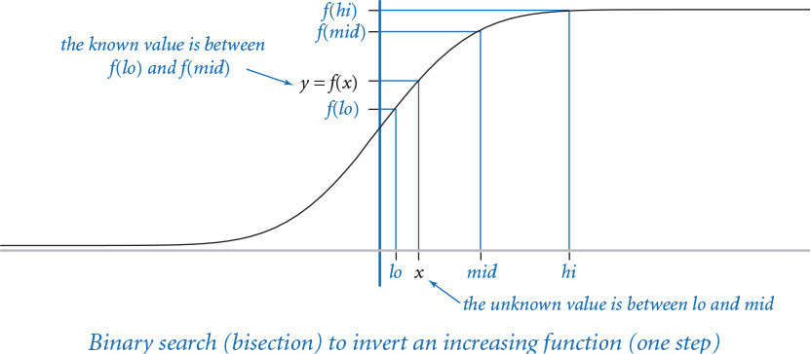
PROGRAM 4.2.2 (bisection.py) implements this strategy. We start with an interval (lo, hi) known to contain x and use the following recursive procedure:
• Compute mid = (hi + lo) / 2.
• Base case: If hi – lo is less than δ, then return mid as an estimate of x.
• Recursive step: Otherwise, test whether f(mid) > y. If so, look for x in (lo, mid); if not, look for x in (mid, hi).
The key to this approach is the idea that the function is increasing—for any values a and b, knowing that f(a) < f(b) tells us that a < b, and vice versa. The recursive step just applies this knowledge: knowing that y = f(x) < f(mid) tells us that x < mid, so that x must be in the interval (lo, mid), and knowing that y = f(x) > f(mid) tells us that x > mid, so that x must be in the interval (mid, hi). You can think of the problem as determining which of the n = (hi–l o) / δ tiny intervals of length δ within (lo, hi) contains x, with running time logarithmic in n. As with converting an integer to binary, we determine one bit of x in each iteration. In this context, binary search is often called bisection search because we bisect the interval at each stage.

Weighing an object
Binary search has been known since antiquity, perhaps partly because of the following application. Suppose that you need to determine the weight of a given object using only a balancing scale. With binary search, you can do so with weights that are powers of 2 (and just one weight of each type). Put the object on the right side of the balance and try the weights in decreasing order on the left side. If a weight causes the balance to tilt to the left, remove it; otherwise, leave it. This process is precisely analogous to determining the binary representation of a number by subtracting decreasing powers of 2, as in PROGRAM 1.3.7.
Program 4.2.2 Bisection search (bisection.py)
Click here to view code image
import sys
import stdio
import gaussian
def invert(f, y, lo, hi, delta=0.00000001):
mid = (lo + hi) / 2.0
if (hi - lo) < delta:
return mid
if f(mid) > y:
return invert(f, y, lo, mid, delta)
else:
return invert(f, y, mid, hi, delta)
def main():
y = float(sys.argv[1])
x = invert(gaussian.cdf, y, -8.0, 8.0)
stdio.writef('%.3f\n', x)
if __name__ == '__main__': main()
f | function
y | given value
delta | precision
lo | left endpoint
mid | midpoint
hi | right endpoint
The function invert() in this program uses binary search to compute a float x within the interval (lo, hi) for which f(x) is equal to a given value y, within a given precision delta, for any function f that is increasing in the interval. It is a recursive function that halves the interval containing the given value, evaluates the function at the midpoint of the interval, and decides whether the desired float x is in the left half or the right half, continuing until the interval length is less than the given precision.
% python bisection.py .5
0.000
% python bisection.py .95
1.645
% python bisection.py .975
1.960
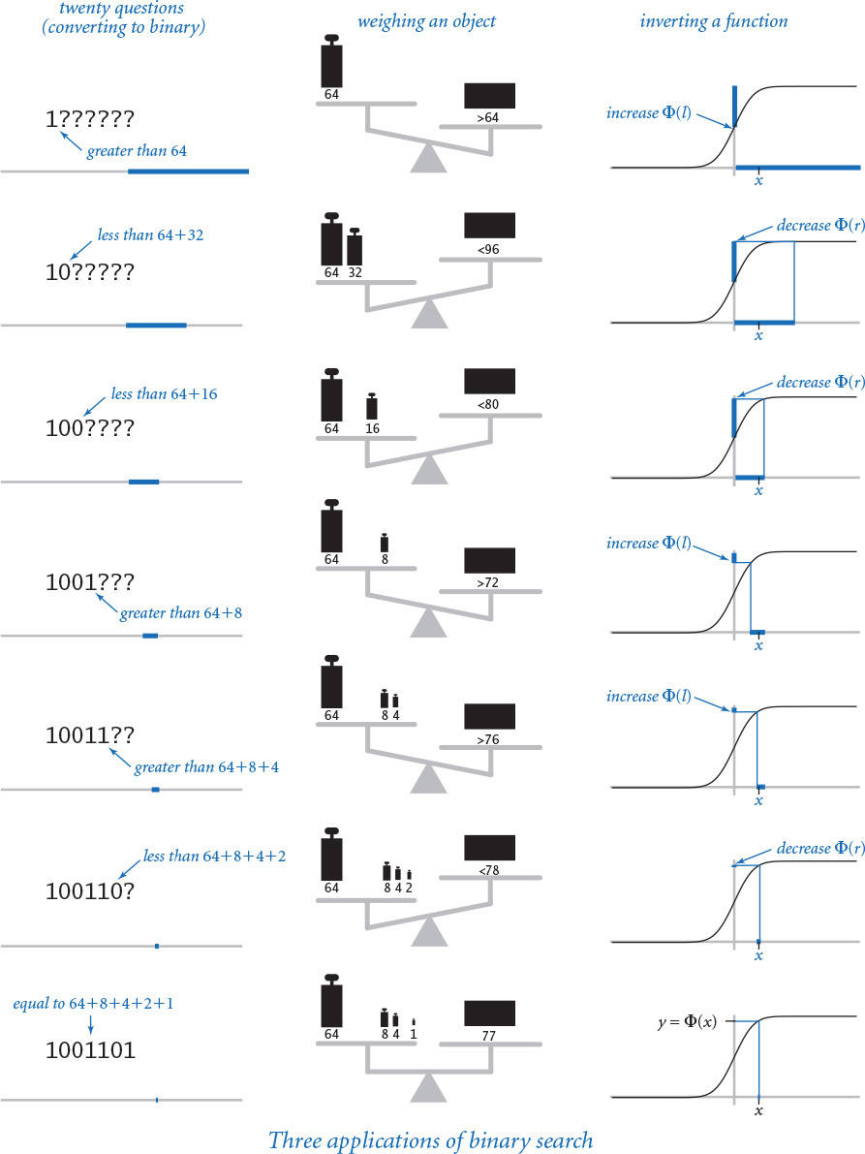

Binary search in a sorted array
One of the most important uses of binary search is to find a piece of information using a key to guide the search. This usage is ubiquitous in modern computing, to the extent that printed artifacts that depend on the same concepts are well on their way to becoming obsolete. For example, during the last few centuries, people would use a publication known as a dictionary to look up the definition of a word, and during much of the last century people would use a publication known as a phone book to look up a person’s phone number. In both cases, the basic mechanism is the same: entries appear in order, sorted by a key that identifies it (the word in the case of the dictionary, and the person’s name in the case of the phone book, sorted in alphabetical order in both cases). You probably use your computer to reference such information, but think about how you would look up a word in a dictionary. A brute-force solution known as sequential search is to start at the beginning, examine each key one at a time, and continue until you find the word. No one uses that approach: instead, you open the book to some interior page and look for the word on that page. If it is there, you are done; otherwise, you eliminate either the part of the book before the current page or the part of the book after the current page from consideration, and then repeat. We now recognize this approach as binary search. Whether you look exactly in the middle is immaterial; as long as you eliminate at least a constant fraction of the keys each time that you look, your search will be logarithmic.
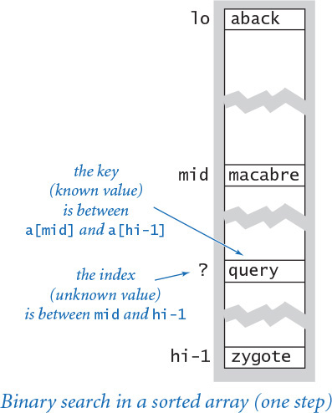

Exception filter
We will consider in SECTION 4.3 the details of implementing the kind of computer program that you use in place of a dictionary or a phone book. PROGRAM 4.2.3 (binarysearch.py) uses binary search to solve the simpler existence problem: is a given key in a sorted array of keys, in any location? For example, when checking the spelling of a word, you need to know only whether your word is in the dictionary and are not interested in the definition. In a computer search, we keep the information in an array, sorted in order of the key (for some applications, the information comes in sorted order; for others, we have to sort it first, using one of the algorithms discussed later in this section). The binary search in binarysearch.py differs from our other applications in two details. First, the array length n need not be a power of 2. Second, it has to allow for the possibility that the key sought is not in the array. Coding binary search to account for these details requires some care, as discussed in this section’s Q&A and exercises.
Program 4.2.3 Binary search (in a sorted array) (binarysearch.py)
Click here to view code image
import sys
import stdio
from instream import InStream
def _search(key, a, lo, hi):
if hi <= lo: return -1 # Not found.
mid = (lo + hi) // 2
if a[mid] > key:
return _search(key, a, lo, mid)
elif a[mid] < key:
return _search(key, a, mid+1, hi)
else:
return mid
def search(key, a):
return _search(key, a, 0, len(a))
def main():
instream = InStream(sys.argv[1])
a = instream.readAllStrings()
while not stdio.isEmpty():
key = stdio.readString()
if search(key, a) < 0: stdio.writeln(key)
if __name__ == '__main__': main()
key | key sought
a[] | sorted array
lo | smallest possible index
mid | midpoint
hi | largest possible index
The search() method uses binary search to find the index of a key in a sorted array (or returns -1 if the key is not in the array). The test client is an exception filter that reads a sorted array of strings from the whitelist file given on the command line and writes the words from standard input that are not in the whitelist.
% more emails.txt
bob@office
carl@beach
marvin@spam
bob@office
bob@office
mallory@spam
dave@boat
eve@airport
alice@home
Click here to view code image
% more white.txt
alice@home
bob@office
carl@beach
dave@boat
% python binarysearch.py white.txt < emails.txt
marvin@spam
mallory@spam
eve@airport
The test client in binarysearch.py is known as an exception filter: it reads in a sorted array of strings from a file (which we refer to as the whitelist) and an arbitrary sequence of strings from standard input, and writes those in the sequence that are not in the whitelist. Exception filters have many direct applications. For example, if the whitelist is the words from a dictionary and standard input is a text document, the exception filter will write the misspelled words. Another example arises in web applications: your email application might use an exception filter to reject any messages that are not on a whitelist that contains the email addresses of your friends, or your operating system might have an exception filter that disallows network connections to your computer from any device having an IP address that is not on a preapproved whitelist.
Fast algorithms are an essential element of the modern world, and binary search is a prototypical example that illustrates the impact of fast algorithms. Whether it be extensive experimental data or detailed representations of some aspect of the physical world, modern scientists are awash in vast amounts of data. With a few quick calculations, you can convince yourself that problems like finding all the misspelled words in a document or protecting your computer from intruders using an exception filter require a fast algorithm like binary search. Take the time to do so—a fast algorithm can certainly make the difference between being able to solve a problem easily and spending substantial resources trying to do so (and failing). You can find the exceptions in a million-word document to a million-entry whitelist in an instant, whereas that task might take days or weeks using the brute-force algorithm. Nowadays, web companies routinely provide services that are based on using binary search billions of times in arrays with billions of elements—without a fast algorithm like binary search, we could not contemplate such services.

Insertion sort
Binary search requires that the array be sorted, and sorting has many other direct applications, so we now turn to sorting algorithms. We consider first a brute-force algorithm, then a sophisticated algorithm that we can use for huge arrays.
The brute-force algorithm we consider is known as insertion sort. It is based on a simple approach that people often use to arrange hands of playing cards—that is, consider the cards one at a time and insert each into its proper place among those already considered (keeping them sorted).
PROGRAM 4.2.4 (insertion.py) contains an implementation of a sort() function that mimics this process to sort elements in an array a[] of length n. The test client reads all the strings from standard input, puts them into the array, calls the sort() function to sort them, and then writes the sorted result to standard output.
In insertion.sort(), the outer for loop sorts the first i elements in the array. The inner while loop completes the sort by putting a[i] into its proper position in the array, as in the following example when i is 6:
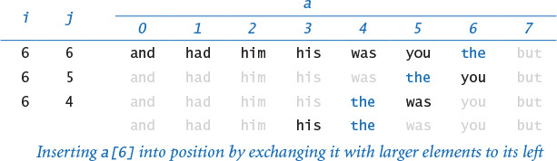
Element a[i] is put in its place among the sorted elements to its left by exchanging it (using a tuple-packing variant of the exchange() function that we first encountered in SECTION 2.1) with each larger element to its left, moving from right to left, until it reaches its proper position. The black elements in the three bottom rows in this trace are the ones that are compared (and exchanged, on all but the final iteration).
The insertion process just described is executed first with i equal to 1, then 2, then 3, and so forth, as illustrated in the trace at the top of the next page. When i reaches the end of the array, the whole array is sorted.
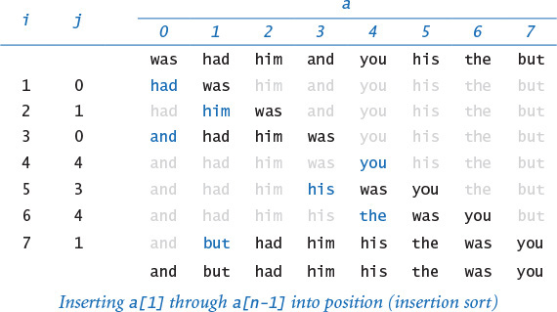
This trace displays the contents of the array each time the outer for loop completes, along with the value of j at that time. The highlighted element is the one that was in a[i] at the beginning of the loop, and the other elements printed in black are the other ones that were involved in exchanges and moved to the right one position within the loop. Since the elements a[0] through a[i-1] are in sorted order when the loop completes for each value of i, they are, in particular, in sorted order the final time the loop completes, when the value of i is len(a). This discussion again illustrates the first thing that you need to do when studying or developing a new algorithm: convince yourself that it is correct. Doing so provides the basic understanding that you need to study its performance and use it effectively.

Analysis of running time
The sort() function contains a while loop nested inside a for loop, which suggests that the running time is quadratic. However, we cannot immediately draw this conclusion because the while loop terminates as soon as a[j] is greater than or equal to a[j-1]. For example, in the best case, when the argument array is already in sorted order, the while loop amounts to nothing more than a comparison (to learn that a[j] is greater than or equal to a[j-1] for each j from 1 to n-1), so the total running time is linear. On the other hand, if the argument array is in reverse-sorted order, the while loop does not terminate until j equals 0. So, the frequency of execution of the instructions in the inner loop is
1 + 2 + ... + n–1 ~ n2 /2
Program 4.2.4 Insertion sort (insertion.py)
Click here to view code image
import sys
import stdio
def exchange(a, i, j):
a[i], a[j] = a[j], a[i]
def sort(a):
n = len(a)
for i in range(1, n):
j = i
while (j > 0) and (a[j] < a[j-1]):
exchange(a, j, j-1)
j -= 1
def main():
a = stdio.readAllStrings()
sort(a)
for s in a:
stdio.write(s + ' ')
stdio.writeln()
if __name__ == '__main__': main()
a[] | array to sort
n | number of elements
This program reads strings from standard input, sorts them into increasing order, and writes them to standard output. The sort() function is an implementation of insertion sort. It sorts arrays of any type of data that supports < (implements a __lt__() method). Insertion sort is appropriate for small arrays or for large arrays that are nearly in order, but is too slow to use for large arrays that are out of order.
Click here to view code image
% more tiny.txt
was had him and you his the but
% python insertion.py < tiny.txt
and but had him his the was you
% python insertion.py < TomSawyer.txt
tick tick tick tick tick tick tick tick tick tick tick tick tick tick tick tick tick tick tick tick tick tick tick tick
tick tick tick tick tick tick tick tick tick tick tick tick tick tick tick tick tick tick tick tick tick tick tick tick
and the running time is quadratic (see EXERCISE 4.1.4). To understand the performance of insertion sort for randomly ordered arrays, take a careful look at the trace: it is an n-by-n array with one black element corresponding to each exchange. That is, the number of black elements is the frequency of execution of instructions in the inner loop. We expect that each new element to be inserted is equally likely to fall into any position, so that element will move halfway to the left on average. Thus, on the average, we expect only about one-half the elements below the diagonal (about n2/4 in total) to be black. This observation leads immediately to the hypothesis that the expected running time of insertion sort for a randomly ordered array is quadratic.
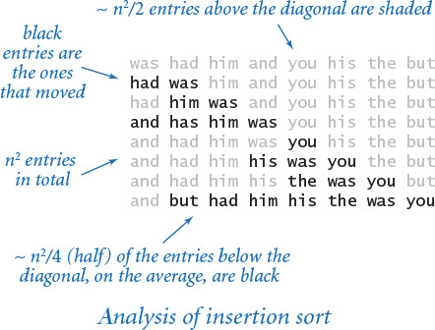

Empirical analysis
PROGRAM 4.2.5 (timesort.py) provides the functions that we need to test our hypothesis that insertion sort is quadratic for randomly ordered arrays by running a doubling test (see SECTION 4.1). The module includes two function: timeTrials(), which runs experiments for a given problem size n, and doublingTest(), which computes the ratios of running times between problems of size n/2 and n. We can also use these functions for other sorting algorithms. For insertion sort, the interactive Python session ratio converges to 4, which validates the hypothesis that the running time is quadratic, as discussed in the last section. You are encouraged to run timesort.py on your own computer. As usual, you might notice the effect of caching or some other system characteristic for some values of n, but the quadratic running time should be quite evident, and you will be quickly convinced that insertion sort is too slow to be useful for large inputs.

Sensitivity to input
Note that each function in timesort.py takes an argument trials and runs trials experiments for each problem size, not just one. As we have just observed, one reason for doing so is that the running time of insertion sort is sensitive to its input values. This behavior is quite different from (for example) threesum.py, and it means that we have to carefully interpret the results of our analysis. It is not correct to flatly predict that the running time of insertion sort will be quadratic, because your application might involve input for which the running time is linear. When an algorithm’s performance is sensitive to input values, you might not be able to make accurate predictions without taking the input values into account. We will return to this issue often as we face real applications. Are the strings that we need to sort in random order? Indeed, that is often not the case. In particular, if only a few elements in a large array are out of position, then insertion sort is the method of choice.
Program 4.2.5 Doubling test for sorts (timesort.py)
Click here to view code image
import stdio
import stdrandom
import stdarray
from stopwatch import Stopwatch
def timeTrials(f, n, trials):
total = 0.0
a = stdarray.create1D(n, 0.0)
for t in range(trials):
for i in range(n):
a[i] = stdrandom.uniformFloat(0.0, 1.0)
watch = Stopwatch()
f(a)
total += watch.elapsedTime()
return total
def doublingTest(f, n, trials):
while True:
prev = timeTrials(f, n // 2, trials)
curr = timeTrials(f, n, trials)
ratio = curr / prev
stdio.writef('%7d %4.2f\n', n, ratio)
n *= 2
f() | function to test
n | problem size
trials | number of trials
total | total elapsed time
a[] | array to sort
watch | stopwatch
n | problem size
prev | running time for n // 2
curr | running time for n
ratio | ratio of running times
The function timeTrials() runs the function f() for arrays of n random floats, performing this experiment trials times. Multiple trials produce more accurate results because they dampen system effects and dependence on the input. The function doublingTest() performs a doubling test starting at n, doubling n, and writing the ratio of the time for the current n and the time for the previous n each time through the loop.
Click here to view code image
% python
>>> import insertion
>>> import timesort
>>> timesort.doublingTest(insertion.sort, 128, 100)
128 3.90
256 3.93
512 3.98
1024 4.12
2048 4.13

Comparable keys
We want to be able to sort any type of data that has a natural order. In a scientific application, we may wish to sort experimental results by numeric values; in a commercial application, we may wish to use monetary amounts, times, or dates; in systems software, we might wish to use IP addresses or account numbers.
Happily, our insertion sort and binary search functions work not only with strings but also with any data type that is comparable. Recall from SECTION 3.3 that a data type is comparable if it implements the six comparison methods and they define a total order. Python’s built-in int, float, and str types are all comparable.
You can make a user-defined type comparable by implementing the six special methods corresponding to the <, <=, ==, !=, >=, and > operators. In fact, our insertion sort and binary search functions rely on only the < operator, but it is better style to implement all six special methods.
A more general design is sometimes appropriate for user-defined types. For example, a teacher might wish to sort a file of student grade records by name on some occasions and by grade on some other occasions. One solution that is often used to handle such situations is to pass the function that is to be used to compare keys as an argument to the sort function.
It is more likely than not in natural applications that the running time of insertion sort is quadratic, so we need to consider faster sorting algorithms. As we know from SECTION 4.1, a back-of-the-envelope calculation can tell us that having a faster computer is not much help. A dictionary, a scientific database, or a commercial database can contain billions of elements; how can we sort such a large array? Next, we turn to a classic algorithm for addressing this question.

Mergesort
To develop a faster sorting method, we use recursion (as we did for binary search) and a divide-and-conquer approach to algorithm design that every programmer needs to understand. This nomenclature refers to the idea that one way to solve a problem is to divide it into independent parts, conquer them independently, and then use the solutions for the parts to develop a solution for the full problem. To sort an array of comparable keys with this strategy, we divide it into two halves, sort the two halves independently, and then merge the results to sort the full array. This method is known as mergesort.
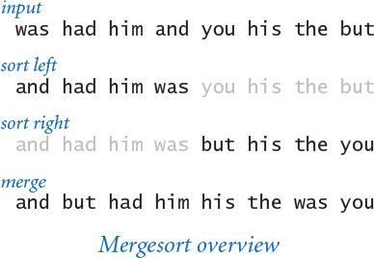
We process contiguous subarrays of a given array, using the notation a [lo, hi) to refer to a[lo], a[lo+1], ..., a[hi–1], (adopting the same convention as we used for binary search to denote a half-open interval that excludes a[hi]). To sort a[lo, hi), we use the following recursive strategy:
• Base case: If the length of the subarray is 0 or 1, it is already sorted.
• Recursive step: Otherwise, compute mid = (hi + lo) / 2, sort (recursively) the two subarrays a [lo, mid) and a [mid, hi), and merge them.
PROGRAM 4.2.6 (merge.py) is an implementation of this algorithm. The array elements are rearranged by the code that follows the recursive calls, which merges the two halves of the array that were sorted by the recursive calls. As usual, the easiest way to understand the merge process is to study a trace of the contents of the array during the merge. The code maintains one index i into the first half, another index j into the second half, and a third index k into an auxiliary array aux[] that holds the result. The merge implementation is a single loop that sets aux[k] to either a[i] or a[j] (and then increments k and the index for the value that is used). If either i or j has reached the end of its subarray, aux[k] is set from the other; otherwise, it is set to the smaller of a[i] or a[j]. After all of the elements from the two halves have been copied to aux[], the sorted result is copied back to the original array. Take a moment to study the trace just given to convince yourself that this code always properly combines the two sorted subarrays to sort the full array.
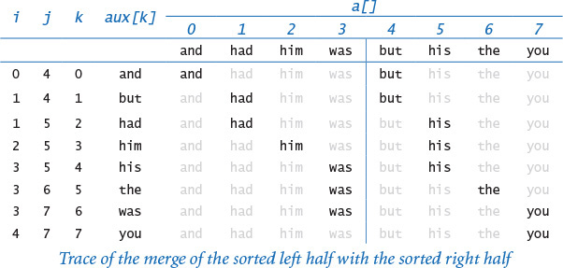
Program 4.2.6 Mergesort (merge.py)
Click here to view code image
import sys
import stdio
import stdarray
def _merge(a, lo, mid, hi, aux):
n = hi - lo
i = lo
j = mid
for k in range(n):
if i == mid: aux[k] = a[j]; j += 1
elif j == hi: aux[k] = a[i]; i += 1
elif a[j] < a[i]: aux[k] = a[j]; j += 1
else: aux[k] = a[i]; i += 1
a[lo:hi] = aux[0:n]
def _sort(a, lo, hi, aux):
n = hi - lo
if n <= 1: return
mid = (lo + hi) // 2
_sort(a, lo, mid, aux)
_sort(a, mid, hi, aux)
_merge(a, lo, mid, hi, aux)
def sort(a):
n = len(a)
aux = stdarray.create1D(n)
_sort(a, 0, n, aux)
a[lo, hi) | subarray to sort
n | length of subarray
mid | midpoint
aux[] | extra array for merge
Click here to view code image
% python merge.py < tiny.txt
was had him and you his the but
had was
and him
and had him was
his you
but the
but his the you
and but had him his the was you
The sort() function in this module is a fast function that you can use to sort arrays of any comparable data type. It is based on a recursive sort() that sorts a[lo, hi) by sorting its two halves recursively, then merging together the two halves to create the sorted result. The output at right is a trace of the sorted subarray for each call to sort() (see EXERCISE 4.2.8). In contrast to insertion.sort(), merge.sort() is suitable for sorting huge arrays.
The recursive method ensures that the two halves of the array are put into sorted order before the merge. Again, the best way to gain an understanding of this process is to study a trace of the contents of the array each time the recursive sort() method returns. Such a trace for our example is shown next. First a[0] and a[1] are merged to make a sorted subarray in a[0, 2), then a[2] and a[3] are merged to make a sorted subarray in a[2, 4), then these two subarrays of size 2 are merged to make a sorted subarray in a[0, 4), and so forth. If you are convinced that the merge works properly, you need only convince yourself that the code properly divides the array to be convinced that the sort works correctly. Note that when the number of elements is not even, the left half will have one fewer element than the right half.
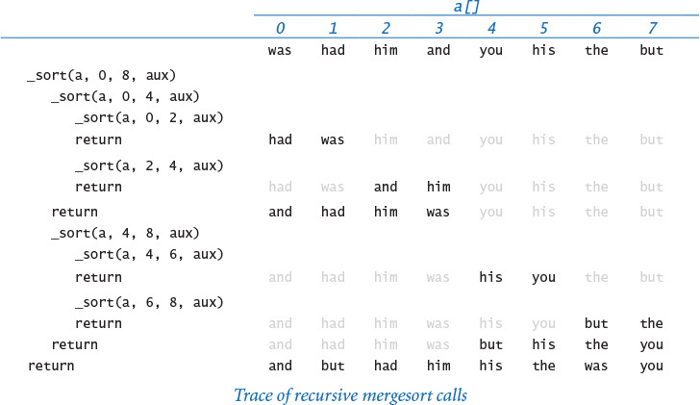

Analysis of running time
The inner loop of mergesort is centered on the auxiliary array. The for loop involves n iterations, so the frequency of execution of the instructions in the inner loop is proportional to the sum of the subarray lengths over all calls to the recursive function. The value of this quantity emerges when we arrange the calls on levels according to their size. For simplicity, suppose that n is a power of 2, with n = 2k. On the first level, we have one call for size n; on the second level, we have two calls for size n/2; on the third level, we have four calls for size n/4; and so forth, down to the last level with n/2 calls of size 2. There are precisely k = lg n levels, giving the grand total n lg n for the frequency of execution of the instructions in the inner loop of mergesort. This equation justifies a hypothesis that the running time of mergesort is linearithmic. Note: When n is not a power of 2, the subarrays on each level are not necessarily all the same size, but the number of levels is still logarithmic, so the linearithmic hypothesis is justified for all n (see EXERCISES 4.2.14 and 4.2.15). The interactive Python script at left uses timesort.doublingTest() (see PROGRAM 4.2.5) to validate this hypotheses.
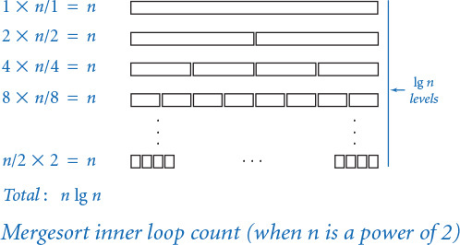
% python
...
>>> import merge
>>> import timesort
>>> timesort.doublingTest(
... merge.sort, 1024, 100)
1024 1.92
2048 2.19
4096 2.07
8192 2.13
16384 2.13
32768 2.11
65536 2.31
131072 2.14
262144 2.29
524288 2.13
1048576 2.17
You are encouraged to run these tests on your computer. If you do so, you certainly will appreciate that merge.sort() is much faster for large arrays than is insertion.sort() and that you can sort huge arrays with relative ease. Validating the hypothesis that the running time is linearithmic (and not linear) is a bit more work, but you certainly can see that mergesort scales, making it possible for us to address sorting problems that we could not contemplate solving with a brute-force algorithm such as insertion sort.

Quadratic–linearithmic chasm
The difference between n2 and n log n makes a huge difference in practical applications, just as with the linear–logarithmic chasm that is overcome by binary search. Understanding the enormity of this difference is another critical step to understanding the importance of the design and analysis of algorithms. For a great many important computational problems, a speedup from quadratic to linearithmic—such as we achieve with mergesort over insertion sort—makes the difference between the ability to solve a problem involving a huge amount of data and not being able to effectively address it at all.

Python system sort
Python includes two operations for sorting. The method sort() in the built-in list data type rearranges the items in the underlying list into ascending order, much like merge.sort(). In contrast, the built-in function sorted() leaves the underlying list alone; instead, it returns a new list containing the items in ascending order. The interactive Python script at right illustrates both techniques. The Python system sort uses a version of mergesort:. It is likely to be substantially faster (10–20×) than merge.py because it uses a low-level implementation that is not composed in Python, thereby avoiding the substantial overhead that Python imposes on itself. As with our sorting implementations, you can use the system sort with any comparable data type, such as Python’s built-in str, int, and float data types.
% python
...
>>> a = [3, 1, 4, 1, 5]
>>> b = sorted(a)
>>> a
[3, 1, 4, 1, 5]
>>> b
[1, 1, 3, 4, 5]
>>> a.sort()
>>> a
[1, 1, 3, 4, 5]
Mergesort traces back to john von Neumann, an accomplished physicist, who was among the first to recognize the importance of computation in scientific research. Von Neumann made many contributions to computer science, including a basic conception of the computer architecture that has been used since the 1950s. When it came to applications programming, von Neumann recognized that:
• Sorting is an essential ingredient in many applications.
• Quadratic algorithms are too slow for practical purposes.
• A divide-and-conquer approach is effective.
• Proving programs correct and knowing their cost is important.
Computers are many orders of magnitude faster and have many orders of magnitude more memory, but these basic concepts remain important today. People who use computers effectively and successfully know, as did von Neumann, that brute-force algorithms are often only a start. That Python and other modern systems still use von Neumann’s method is testimony to the power of these ideas.

Application: frequency counts
PROGRAM 4.2.7 (frequencycount.py) reads a sequence of strings from standard input and writes to standard output a table of the distinct strings found and the number of times each was found, in decreasing order of frequency. This computation is useful in numerous applications: a linguist might be studying patterns of word usage in long texts, a scientist might be looking for frequently occurring events in experimental data, a merchant might be looking for the customers who appear most frequently in a long list of transactions, or a network analyst might be looking for the heaviest users. Each of these applications might involve millions of strings or more, so we need a linearithmic algorithm (or better). PROGRAM 4.2.7 accomplishes this by performing two sorts.

Computing the frequencies
Our first step is to read the strings from standard input and sort them. In this case, we are not so much interested in the fact that the strings are put into sorted order, but in the fact that sorting brings equal strings together. If the input is
to be or not to be to
then the result of the sort is
be be not or to to to
with equal strings, such as the two occurrences of be and the three occurrences of to, brought together in the array. Now, with equal strings all together in the array, we can make a single pass through the array to compute all of the frequencies. The Counter data type (PROGRAM 3.3.2) is the perfect tool for the job. Recall that a Counter has a string instance variable (initialized to the constructor argument), a count instance variable (initialized to 0), and an increment() method, which increments the counter by 1. We maintain a Python list zipf[] of Counter objects and do the following for each string:
• If the string is not equal to the previous one, create a new Counter and append it to the end of zipf[].
• Increment the most recently created Counter.
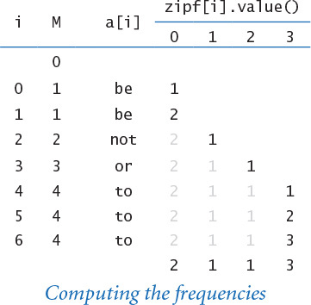
At the end of this process, zipf[i] contains the ith string and its frequency.
Program 4.2.7 Frequency counts (frequencycount.py)
Click here to view code image
import sys
import stdio
from counter import Counter
words = stdio.readAllStrings()
words.sort() # or merge.sort(words)
zipf = []
for i in range(len(words)):
if (i == 0) or (words[i] != words[i-1]):
entry = Counter(words[i], len(words))
zipf += [entry]
zipf[len(zipf) - 1].increment()
zipf.sort() # or merge.sort(zipf)
zipf.reverse()
for entry in zipf:
stdio.writeln(entry)
words | strings in input
zipf[] | counter array
This program sorts the words on standard input, uses the sorted array to count the frequency of occurrence of each, and then sorts the frequencies. The test file used below has over 20 million words. The plot compares the ith frequency relative to the first (bars) with 1/i (blue). This program assumes that the Counter data type is comparable (see PROGRAM 3.3.2 and page 476).
Click here to view code image
% python frequencycount.py < leipzig.txt
1160105 the
593492 of
560945 to
472819 a
435866 and
430484 in
205531 for
192296 The
188971 that
172225 is
148915 said
147024 on
...
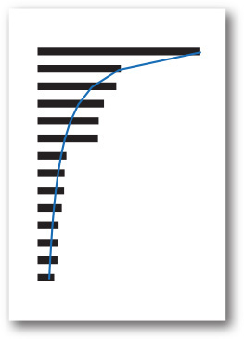

Sorting the frequencies
Next, we sort the Counter objects by frequency. We can do so in client code by augmenting the Counter data type to include the six comparison methods for comparing Counter objects by their counts, as on page 476. Thus, we simply sort the array of Counter objects to rearrange them in ascending order of frequency! Next, we reverse the array so that the elements are in descending order of frequency. Finally, we write each Counter object to standard output. As usual, Python automatically calls the built-in str() function to do so, which, for Counter objects, writes the count followed by the string.
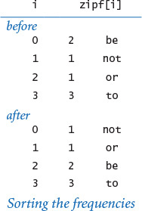

Zipf’s law
The application highlighted in frequencycount.py is elementary linguistic analysis: which words appear most frequently in a text? A phenomenon known as Zipf’s law says that the frequency of the i th most frequent word in a text of m distinct words is proportional to 1/i (with its constant of proportionality being the mth harmonic number). For example, the second most common word should appear about half as often as the first. This is an empirical hypothesis that holds in a surprising variety of situations, ranging from financial data to web usage statistics. The test client run in PROGRAM 4.2.7 validates Zipf’s law for a database containing 1 million sentences drawn from the web (see the booksite).
You are likely to find yourself composing a program sometime in the future for a simple task that could easily be solved by first using a sort. With a linearithmic sorting algorithm such as mergesort, you can address such problems even for huge data sets. PROGRAM 4.2.7 (frequencycount.py), which uses two different sorts, is a prime example. Without a good algorithm (and an understanding of its performance characteristics), you might find yourself frustrated by the idea that your fast and expensive computer cannot solve a problem that seems to be a simple one. With an ever-increasing set of problems that you know how to solve efficiently, you will find that your computer can be a much more effective tool than you now imagine.

Lessons
The vast majority of programs that we compose involve managing the complexity of addressing a new practical problem by developing a clear and correct solution, breaking the program into modules of manageable size, and making use of the basic available resources. From the very start, our approach in this book has been to develop programs along these lines. But as you become involved in ever more complex applications, you will find that a clear and correct solution is not always sufficient, because the cost of computation can be a limiting factor. The examples in this section are a basic illustration of this fact.

Respect the cost of computation
If you can quickly solve a small problem with a simple algorithm, fine. But if you need to address a problem that involves a large amount of data or a substantial amount of computation, you need to take into account the cost. For insertion sort, we did a quick analysis to determine that the brute-force method is infeasible for large arrays.

Divide-and-conquer algorithms
It is worthwhile for you to reflect a bit on the power of the divide-and-conquer paradigm, as illustrated by developing a logarithmic search algorithm (binary search) and a linearithmic sorting algorithm (mergesort). The same basic approach is effective for many important problems, as you will learn if you take a course on algorithm design. For the moment, you are particularly encouraged to study the exercises at the end of this section, which describe problems for which divide-and-conquer algorithms provide feasible solutions and which could not be addressed without such algorithms.

Reduction to sorting
We say that problem A reduces to problem B if we can use a solution to B to solve A. Designing a new divide-and-conquer algorithm from scratch is sometimes akin to solving a puzzle that requires some experience and ingenuity, so you may not feel confident that you can do so at first. But it is often the case that a simpler approach is effective: given a new problem that lends itself to a quadratic brute-force solution, ask yourself how you would solve it if the data were sorted. Often, a relatively simple linear pass through the sorted data will do the job. Thus, we get a linearithmic algorithm, with the ingenuity hidden in the mergesort implementation. For example, consider the problem of determining whether every element in an array has a distinct value. This problem reduces to sorting because we can sort the array, and then pass through the sorted array to check whether the value of any element is equal to the next—if not, they are all distinct.

Know your underlying tools
Our ability to count word frequencies for huge texts using frequencycount.py (PROGRAM 4.2.7) depends on the performance characteristics of the particular operations that we use on arrays and lists. First, its efficiency depends on the fact that mergesort can sort an array in linearithmic time. Second, the efficiency of creating zipf[] depends on the fact that building a list in Python by repeatedly appending items one at time takes time and space linear in the length of the resulting list. This is made possible by the resizing array data structure that Python uses (which we examined in SECTION 4.1). As an applications programmer you must be vigilant, because not all programming languages support such an efficient implementation of appending an item to a list (and performance characteristics are rarely stated in APIs).
Since the advent of computing, people have been developing algorithms such as binary search and mergesort that can efficiently solve practical problems. The field of study known as design and analysis of algorithms encompasses the study of design paradigms like divide-and-conquer, techniques to develop hypotheses about algorithms’ performance, and algorithms for solving fundamental problems like sorting and searching that can be put to use for practical applications of all kinds. Implementations of many of these algorithms are found in Python libraries or other specialized libraries, but understanding these basic tools of computation is like understanding the basic tools of mathematics or science. You can use a matrix-processing package to find the eigenvalues of a matrix, but you still need a course in linear algebra to apply the concepts and interpret the results. Now that you know that a fast algorithm can make the difference between spinning your wheels and properly addressing a practical problem, you can be on the lookout for situations where efficient algorithms like binary search and mergesort can do the job or opportunities where algorithm design and analysis can make the difference.

Q&A
Q. Why do we need to go to such lengths to prove a program correct?
A. To spare ourselves considerable pain. Binary search is a notable example. For example, you now understand binary search; a classic programming exercise is to compose a version that uses a while loop instead of recursion. Try solving EXERCISES 4.2.1–3 without looking back at the code in the book. In a famous experiment, Jon Bentley once asked several professional programmers to do so, and most of their solutions were not correct.
Q. Why introduce the mergesort algorithm when Python provides an efficient sort() method defined in the list data type?
A. As with many topics we have studied, you will be able to use such tools more effectively if you understand the background behind them.
Q. What is the running time of the following version of insertion sort on an array that is already sorted?
Click here to view code image
def sort(a):
n = len(a)
for i in range(1, n):
for j in range(i, 0, -1):
if a[j] < a[j-1]: exchange(a, j, j-1)
else: break
A. Quadratic time in Python 2; linear time in Python 3. The reason is that, in Python 2, range() is a function that returns an array of integers of length equal to the length of the range (which can be wasteful if the loop terminates early because of a break or return statement). In Python 3, range() returns an iterator, which generates only as many integers as needed.
Q. What happens if I try to sort an array of elements that are not all of the same type?
A. If the elements are of compatible types (such as int and float), everything works fine. For example, mixed numeric types are compared according to their numeric value, so 0 and 0.0 are treated as equal. If the elements are of incompatible types (such as str and int), then Python 3 raises a TypeError at run time. Python 2 supports some mixed-type comparisons, using the name of the class to determine which object is smaller. For example, Python 2 treats all integers as less than all strings because 'int' is lexicographically less than 'str'.
Q. Which order is used when comparing strings with operators such as == and < ?
A. Informally, Python uses lexicographic order to compare two strings, as words in a book index or dictionary. For example 'hello' and 'hello' are equal, 'hello' and 'goodbye' are unequal, and 'goodbye' is less than 'hello'. More formally, Python first compares the first character of each string. If those characters differ, then the strings as a whole compare as those two characters compare. Otherwise, Python compares the second character of each string. If those characters differ, then the strings as a whole compare as those two characters compare. Continuing in this manner, if Python reaches the ends of the two strings simultaneously, then it considers them to be equal. Otherwise, it considers the shorter string to be the smaller one. Python uses Unicode for character-by-character comparisons. We list a few of the most important properties:
• '0' is less than '1', and so forth.
• 'A' is less than 'B', and so forth.
• 'a' is less than 'b', and so forth.
• Decimal digits ('0' to '9') are less than the uppercase letters ('A' to 'Z').
• Uppercase letters ('A' to 'Z') are less than lowercase letters ('a' to 'z').

Exercises
4.2.1 Develop an implementation of questions.py (PROGRAM 4.2.1) that takes the maximum number n as a command-line argument (it need not be a power of 2). Prove that your implementation is correct.
4.2.2 Compose a nonrecursive version of binary search (PROGRAM 4.2.3).
4.2.3 Modify binarysearch.py so that if the search key is in the array, it returns the smallest index i for which a[i] is equal to key, and otherwise it returns the largest index i for which a[i] is smaller than key (or –1 if no such index exists).
4.2.4 Describe what happens if you apply binary search to an unordered array. Why shouldn’t you check whether the array is sorted before each call to binary search? Could you check that the elements binary search examines are in ascending order?
4.2.5 Describe why it is desirable to use immutable keys with binary search.
4.2.6 Let f() be a monotonically increasing function with f(a) < 0 and f(b) > 0. Compose a program that computes a value x such that f(x) = 0 (up to a given error tolerance).
4.2.7 Add code to insertion.py to produce the trace given in the text.
4.2.8 Add code to merge.py to produce the trace given in the text.
4.2.9 Give traces of insertion sort and mergesort in the style of the traces in the text, for the input it was the best of times it was.
4.2.10 Compose a program dedup.py that reads strings from standard input and writes them to standard output with all duplicates removed (and in sorted order).
4.2.11 Compose a version of mergesort (PROGRAM 4.2.6) that creates an auxiliary array in each recursive call to _merge() instead of creating only one auxiliary array in sort() and passing it as an argument. What impact does this change have on performance?
4.2.12 Compose a nonrecursive version of mergesort (PROGRAM 4.2.6).
4.2.13 Find the frequency distribution of words in your favorite book. Does it obey Zipf’s law?
4.2.14 Analyze mergesort mathematically when n is a power of 2, as we did for binary search.
Solution: Let M(n) be the frequency of execution of the instructions in the inner loop. Then M(n) must satisfy the following recurrence relation:
M(n) = 2M(n/2) + n
with M(1) = 0. Substituting 2k for n gives
M(2k) = 2 M(2k–1) + 2k
which is similar to but more complicated than the recurrence that we considered for binary search. But if we divide both sides by 2k, we get
M(2k)/2k = M(2k–1)/2k–1 + 1
which is precisely the recurrence that we had for binary search. That, is M(2k)/ 2k = T(2k) = k. Substituting back n for 2k (and lg n for k) gives the result M(n) = n lg n.
4.2.15 Analyze mergesort for the case when n is not a power of 2.
Partial solution: When n is an odd number, one subarray has to have one more element than the other, so when n is not a power of 2, the subarrays on each level are not necessarily all the same size. Still, every element appears in some subarray, and the number of levels is still logarithmic, so the linearithmic hypothesis is justified for all n.

Creative Exercises
The following exercises are intended to give you experience in developing fast solutions to typical problems. Think about using binary search or mergesort, or devising your own divide-and-conquer algorithm. Implement and test your algorithm.
4.2.16 Median. Implement the function median() in stdstats.py so that it computes the median in linearithmic time. Hint: Reduce to sorting.
4.2.17 Mode. Add to stdstats.py a function mode() that computes in linearithmic time the mode (the value that occurs most frequently) of a sequence of n integers. Hint: Reduce to sorting.
4.2.18 Integer sort. Compose a linear-time filter that reads from standard input a sequence of integers that are between 0 and 99 and writes the integers in sorted order to standard output. For example, presented with the input sequence
Click here to view code image
98 2 3 1 0 0 0 3 98 98 2 2 2 0 0 0 2
your program should write the output sequence
Click here to view code image
0 0 0 0 0 0 1 2 2 2 2 2 3 3 98 98 98
4.2.19 Floor and ceiling. Given a sorted array of n comparable keys, compose functions floor() and ceiling() that return the index of the largest (or smallest) key not larger (or smaller) than an argument key in logarithmic time.
4.2.20 Bitonic maximum. An array is bitonic if it consists of an increasing sequence of keys followed immediately by a decreasing sequence of keys. Given a bitonic array, design a logarithmic algorithm to find the index of a maximum key.
4.2.21 Search in a bitonic array. Given a bitonic array of n distinct integers, design a logarithmic-time algorithm to determine whether a given integer is in the array.
4.2.22 Closest pair. Given an array of n floats, compose a function to find in linearithmic time the pair of integers that are closest in value.
4.2.23 Furthest pair. Given an array of n floats, compose a function to find in linear time the pair of integers that are furthest apart in value.
4.2.24 Two sum. Compose a function that takes as an argument an array of n integers and determines in linearithmic time whether any two of them sum to 0.
4.2.25 Three sum. Compose a function that takes as an argument an array of n integers and determines whether any three of them sum to 0. Your program should run in time proportional to n2 log n. Extra credit: Develop a program that solves the problem in quadratic time.
4.2.26 Majority. Given an array of n elements, an element is a majority if it appears more than n/2 times. Compose a function that takes an array of n strings as an argument and identifies a majority (if it exists) in linear time.
4.2.27 Common element. Compose a function that takes as an argument three arrays of strings, determines whether there is any string common to all three arrays, and if so, returns one such string. The running time of your method should be linearithmic in the total number of strings.
4.2.28 Largest empty interval. Given n timestamps for when a file is requested from web server, find the largest interval of time in which no file is requested. Compose a program to solve this problem in linearithmic time.
4.2.29 Prefix-free codes. In data compression, a set of strings is prefix-free if no string is a prefix of another. For example, the set of strings 01, 10, 0010, and 1111 is prefix-free, but the set of strings 01, 10, 0010, 1010 is not prefix-free because 10 is a prefix of 1010. Compose a program that reads in a set of strings from standard input and determines whether the set is prefix-free.
4.2.30 Partitioning. Compose a function that sorts an array that is known to have at most two different values. Hint: Maintain two pointers, one starting at the left end and moving right, and the other starting at the right end and moving left. Maintain the invariant that all elements to the left of the left pointer are equal to the smaller of the two values and all elements to the right of the right pointer are equal to the larger of the two values.
4.2.31 Dutch national flag. Compose a function that sorts an array that is known to have at most three different values. (Edsgar Dijkstra named this the Dutch-national-flag problem because the result is three “stripes” of values like the three stripes in the flag.)
4.2.32 Quicksort. Compose a recursive program that sorts an array of randomly ordered distinct values. Hint: Use a method like the one described in EXERCISE 4.2.31. First, partition the array into a left part with all elements less than v, followed by v, followed by a right part with all elements greater than v. Then, recursively sort the two parts. Extra credit: Modify your method (if necessary) to work properly when the values are not necessarily distinct.
4.2.33 Reverse domain. Compose a program to read in a list of domain names from standard input and write the reverse domain names in sorted order. For example, the reverse domain of cs.princeton.edu is edu.princeton.cs. This computation is useful for web log analysis. To do so, create a data type Domain that implements the special comparison methods, using reverse domain name order.
4.2.34 Local minimum in an array. Given an array of n floats, compose a function to find in logarithmic time a local minimum (an index i such that a[i] < a[i–1] and a[i] < a[i+1]).
4.2.35 Discrete distribution. Design a fast algorithm to repeatedly generate numbers from the discrete distribution. Given an array p[] of nonnegative floats that sum to 1, the goal is to return index i with probability p[i]. Form an array s[] of cumulated sums such that s[i] is the sum of the first i elements of p[]. Now, generate a random float s between 0 and 1, and use binary search to return the index i for which s[i] <= r < s[i+1].
4.2.36 Rhyming words. Tabulate a list that you can use to find words that rhyme. Use the following approach:
• Read in a dictionary of words into an array of strings.
• Reverse the letters in each word (confound becomes dnuofnoc, for example).
• Sort the resulting array.
• Reverse the letters in each word back to their original order.
For example, confound is adjacent to words such as astound and surround in the resulting list.

4.3 Stacks and Queues
In this section, we introduce two closely related data types for manipulating arbitrarily large collections of items: the stack and the queue. Stacks and queues are special cases of the idea of a collection. A collection of items is characterized by five operations: create the collection, insert an item, remove an item, and test whether the collection is empty, and determine its size or number of items.
4.3.1 Stack (resizing array)
4.3.2 Stack (linked list)
4.3.3 Expression evaluation
4.3.4 FIFO queue (linked list)
4.3.5 M/M/1 queue simulation
4.3.6 Load-balancing simulation
Programs in this section
When we insert an item, our intent is clear. But when we remove an item, which one do we choose? You have encountered different ways to answer this question in various real-world situations, perhaps without thinking about it.
Each kind of collection is characterized by the rule used for remove. Moreover, depending on the removal rule each kind of collection is amenable to various implementations with differing performance characteristics. For example, the rule used for a queue is to always remove the item that has been in the collection the most amount of time. This policy is known as first-in first-out, or FIFO. People waiting in line to buy a ticket follow this discipline: the line is arranged in the order of arrival, so the person who leaves the line is the one who has been there longer than any other person in the line.
A policy with quite different behavior is the rule used for a stack: always remove the item that has been in the collection the least amount of time. This policy is known as last-in first-out, or LIFO. For example, you follow a policy closer to LIFO when you enter and leave the coach cabin in an airplane: people near the front of the cabin board last and exit before those who boarded earlier.
Stacks and queues are broadly useful, so it is important for you to be familiar with their basic properties and the kind of situation where each might be appropriate. They are excellent examples of fundamental data types that we can use to address higher-level programming tasks. They are widely used in systems and applications programming, as we will see in several examples in this section. The implementations and data structures that we consider also serve as models for other removal rules, some of which we examine in the exercises at the end of this section.

Pushdown stacks
A pushdown stack (or just a stack) is a collection that is based on the last-in-first-out (LIFO) policy.
When you keep your mail in a pile on your desk, you are using a stack. You pile pieces of new mail on the top when they arrive and take each piece of mail from the top when you are ready to read it. People do not process as much paper mail as they did in the past, but the same organizing principle underlies several of the applications that you use regularly on your computer. For example, many people organize their email as a stack, where messages go on the top when they are received and are taken from the top, with most recently received first (last in, first out). The advantage of this strategy is that we see interesting email as soon as possible; the disadvantage is that some old email might never get read if we never empty the stack.
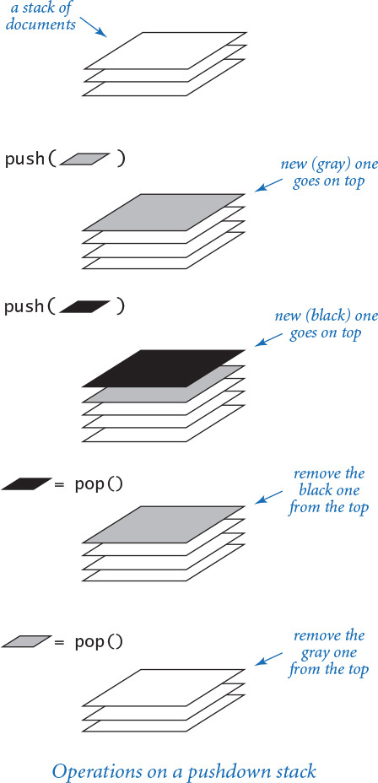
You have likely encountered another common example of a stack when surfing the web. When you click a link, your browser displays the new page (and inserts it onto a stack). You can keep clicking on links to visit new pages, but you can always revisit the previous page by clicking the back button (remove it from a stack). The last-in-first-out policy offered by a stack provides just the behavior that you expect.
Such uses of stacks are intuitive, but perhaps not persuasive. In fact, the importance of stacks in computing is fundamental and profound, but we defer further discussions of applications to later in this section. For the moment, our goal is to make sure that you understand how stacks work and how to implement them.
Programmers have been using stacks since the earliest days of computing. By tradition, we name the stack insert operation push and the stack remove operation pop, as indicated in the API at the top of the next page:
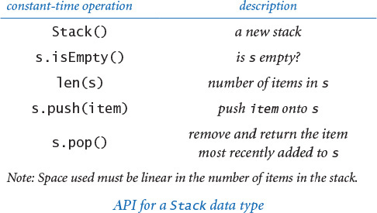
The API includes the core push() and pop() methods, along with a method isEmpty() to test whether the stack is empty and the built-in function len() to get the number of items on the stack. The pop() method raises a run-time error if it is called when the stack is empty. It is the client’s responsibility to call isEmpty() to avoid doing so. Next we consider two implementations of this API: arraystack.py and linkedstack.py.
Important note: When we include performance specifications in an API, as we have in Stack, we consider them to be requirements. An implementation that does not meet them might implement a SlowStack or a SpaceWastingStack, but not a Stack. We want clients to be able to depend on the performance guarantees.

Python list (resizing array) implementation of a stack
Representing a stack with a Python list is a natural idea, but before reading further, it is worthwhile for you to think for a moment about how you would do so.
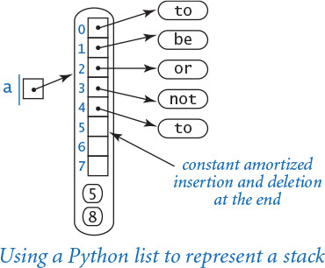
Naturally, you need an instance variable a[] to hold the stack items in a Python list. Should you maintain the items in order of their insertion, with the least recently inserted item in a[0], the second in a[1], and so forth? Or should you maintain the items in reverse order of their insertion? For efficiency, we store the items in order of their insertion because inserting and deleting from the end of a Python list takes constant amortized time per operation (whereas inserting and deleting from the front takes linear time per operation).
We could hardly hope for a simpler implementation of the stack API than stack.py (PROGRAM 4.3.1)—all of the methods are one-liners! The instance variable is a Python list _a[] that holds the items in the stack in order of their insertion. To push an item, we append it to the end of the list using the += operator; to pop an item, we call the pop() method, which removes and returns the item from the end of the list; to determine the size of the stack, we call the built-in len() function. These operations preserve the following properties:
• That stack contains len(_a) items.
• The stack is empty when len(_a) is 0.
• The list _a[] contains the stack items, in order of their insertion.
• The item most recently inserted onto the stack (if nonempty) is _a[len(_a) - 1].
As usual, thinking in terms of invariants of this sort is the easiest way to verify that an implementation operates as intended.
Be sure that you fully understand this implementation. Perhaps the best way to do so is to carefully examine a trace of the list contents for a sequence of push() and pop() operations. The test client in stack.py allows for testing with an arbitrary sequence of operations: it does a push() for each string on standard input except the string consisting of a minus sign, for which it does a pop(). The diagram at right is a trace for the test input shown.
The primary characteristics of this implementation are that it uses space linear in the number of items in the stack and that the push and pop operations take constant amortized time. These properties follow immediately from the corresponding properties for Python lists that we discussed at the end of SECTION 3.1, which, in turn, depend on Python’s resizing array implementation of Python lists. If your programming language provides fixed-size arrays as a built-in data type (but not resizing arrays), you can implement a stack by implementing your own resizing array (see EXERCISE 4.3.45).
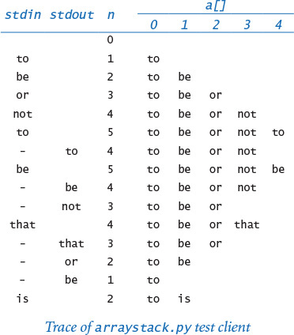
Program 4.3.1 Stack (resizing array) (arraystack.py)
Click here to view code image
import sys
import stdio
class Stack:
def __init__(self):
self._a = []
def isEmpty(self):
return len(self._a) == 0
def __len__(self):
return len(self._a)
def push(self, item):
self._a += [item]
def pop(self):
return self._a.pop()
def main():
stack = Stack()
while not stdio.isEmpty():
item = stdio.readString()
if item != '-': stack.push(item)
else: stdio.write(stack.pop() + ' ')
stdio.writeln()
if __name__ == '__main__': main()
instance variables
_a[] | stack items
This program defines a Stack class implemented as a Python list (which, in turn, is implemented using a resizing array). The test client reads strings from standard input, popping and writing to standard output when an input string is a minus sign and pushing otherwise.
Click here to view code image
% more tobe.txt
to be or not to - be - - that - - - is
% python arraystack.py < tobe.txt
to be not that or be

Linked-list implementation of a stack
Next, we consider a completely different way to implement a stack, using a fundamental data structure known as a linked list. Reuse of the word “list” here is a bit confusing, but we have no choice—linked lists have been around much longer than Python.
A linked list is a recursive data structure defined as follows: it is either empty (null) or a reference to a node having a reference to a linked list. The node in this definition is an abstract entity that might hold any kind of data, in addition to the node reference that characterizes its role in building linked lists. As with a recursive program, the concept of a recursive data structure can be a bit mind bending at first, but is of great value because of its simplicity.
With object-oriented programming, implementing linked lists is not difficult. We start with a class for the node abstraction:
Click here to view code image
class Node:
def __init__(self, item, next):
self.item = item
self.next = next
An object of type Node has two instance variables: item (a reference to an item) and next (a reference to another Node object). The next instance variable characterizes the linked nature of the data structure. To emphasize that we are just using the Node class to structure the data, we define no methods other than the constructor. We also omit leading underscores from the names of the instance variables, thus indicating that it is permissible for code external to the data type (but still within our Stack implementation) to access those instance variables.
Now, from the recursive definition, we can represent a linked list with a reference to a Node object, which contains a reference to an item and a reference to another Node object, which contains a reference to an item and a reference to another Node object, and so forth. The final Node object in the linked list must indicate that it is, indeed, the final Node object. In Python, we accomplish that by assigning None to the next instance variable of the final Node object. Recall that None is a Python keyword—a variable assigned the value None references no object.
Note that our definition of the Node class conforms to our recursive definition of a linked list. With our Node class we can represent a linked list as a variable whose value is either (1) None or (2) a reference to a Node object whose next field is a reference to a linked list. We create an object of type Node by calling the constructor with two arguments: a reference to an item and a reference to the next Node object in the linked list.
For example, to build a linked list that contains the items 'to', 'be', and 'or', we execute this code:
third = Node('or', None)
second = Node('be', third)
first = Node('to', second)
The end result of these operations is actually to create three linked lists:
• third is a linked list—it is a reference to a Node object that contains 'or' and None, which is the reference to an empty linked list.
• second is a linked list—it is a reference to a Node object that contains 'be' and a reference to third, which is a linked list.
• first is a linked list—it is a reference to a Node object that contains 'to' and a reference to second, which is a linked list.
A linked list represents a sequence of items. In this example, first represents the sequence 'to', 'be', 'or'.
We might also use an ordinary array (or Python list) to represent a sequence. For example, we could use the array ['to', 'be', 'or'] to represent the same sequence of strings. One key difference is that linked lists enable efficient insertion of items into (or deletion of items from) either the front or back of the sequence. Next, we consider code to accomplish these tasks.
When tracing code that uses linked lists and other linked structures, we use a visual representation where:
• We draw a rectangle to represent each object.
• We put the values of instance variables within the rectangle.
• We use arrows that point to the referenced objects to depict references.
This visual representation captures the essential characteristic of linked lists. For economy, we use the term link to refer to a Node reference. For simplicity, when the item is a string (as in our examples), we put it within the node rectangle (rather than using the more accurate rendition in which the node holds a reference to a string object, which is external to the node). This visual representation allows us to focus on the links.
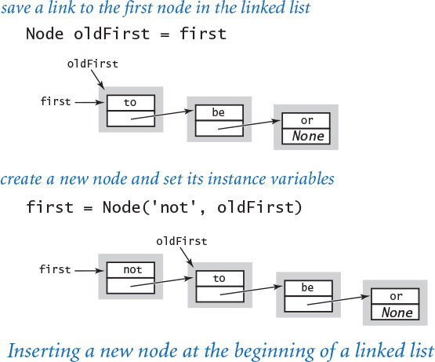
Suppose that you want to remove the first node from a linked list. This operation is easy: simply assign to first the value first.next. Normally, you would retrieve the item (by assigning it to some variable) before doing this assignment, because once you change the variable first, you may lose any access to the node to which it was referring previously. Typically, the Node object becomes an orphan, and Python’s memory management system eventually reclaims it.
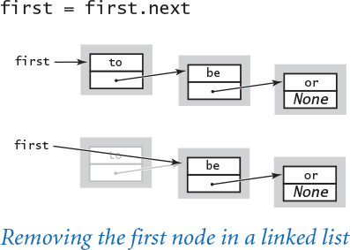
Now, suppose that you want to insert a new node into a linked list. The easiest place to do so is at the beginning of the linked list. For example, to insert the string 'not' at the beginning of a given linked list whose first node is first, we save first in a variable oldFirst; create a new Node whose item instance variable is 'not' and whose next instance variable is oldFirst; and assign first to refer to that new Node.
This code for inserting and removing a node from the beginning of a linked list involves just a few assignment statements and thus takes constant time (independent of the length of the list). If you hold a reference to a node at an arbitrary position in a list, you can use similar (but more complicated) code to remove the node after it or to insert a node after it, also in constant time, no matter how long the list. We leave those implementations as exercises (see EXERCISES 4.3.22 and 4.3.24) because inserting and removing at the beginning are the only linked-list operations that we need to implement stacks.
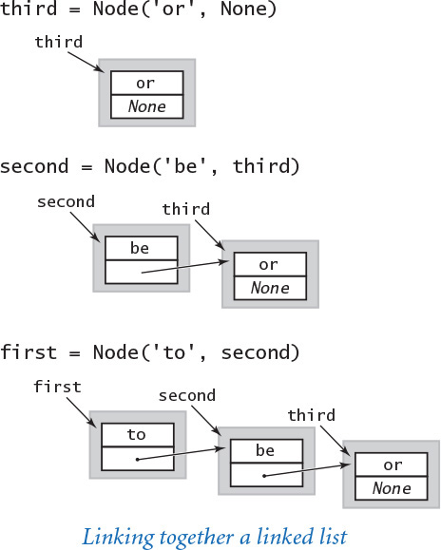
Program 4.3.2 Stack (linked list) (linkedstack.py)
Click here to view code image
import stdio
class Stack:
def __init__(self):
self._first = None
def isEmpty(self):
return self._first is None
def push(self, item):
self._first = _Node(item, self._first)
def pop(self):
item = self._first.item
self._first = self._first.next
return item
class _Node:
def __init__(self, item, next):
self.item = item
self.next = next
def main():
stack = Stack()
while not stdio.isEmpty():
item = stdio.readString()
if item != '-': stack.push(item)
else: stdio.write(stack.pop() + ' ')
stdio.writeln()
if __name__ == '__main__': main()
instance variable for Stack
_first | first node on list
instance variables for Node
item | list item
next | next node on list
This program defines a Stack class implemented as a linked list, using a private class _Node as the basis for representing the stack as a linked list of _Node objects. The instance variable first refers to the most recently inserted _Node in the linked list. The instance variable next in each _Node refers to the next _Node (the value of next in the final node is None). The test client is the same as in arraystack.py. We defer the __len__() method to EXERCISE 4.3.4.
Click here to view code image
% python linkedstack.py < tobe.txt
to be not that or be
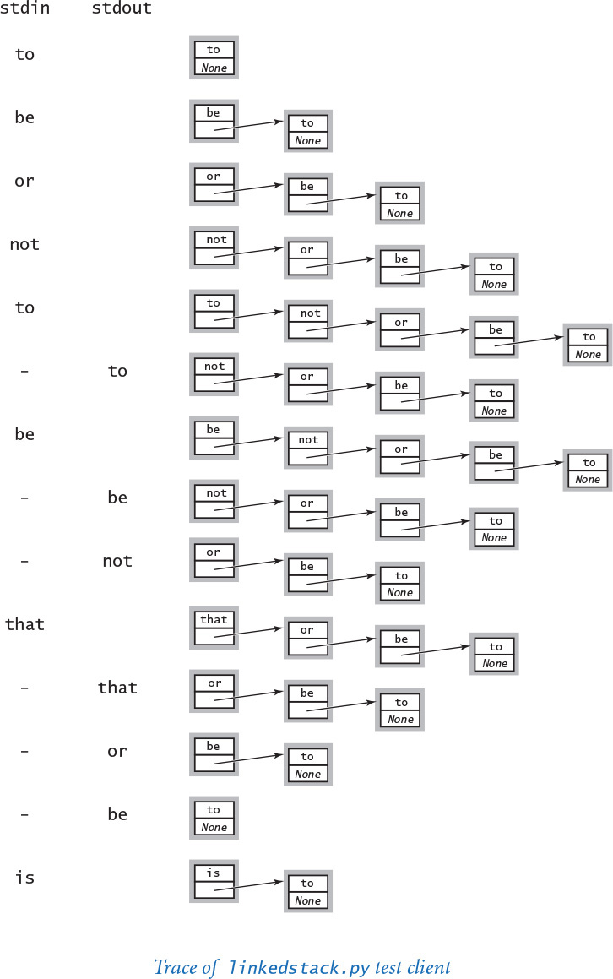

Implementing stacks with linked lists
PROGRAM 4.3.2 (linkedstack.py) uses a linked list to implement a stack, using little more code than the elementary solution that uses a Python list. The implementation is based on a private _Node class that is identical to the Node class that we have been using. Python allows us to define more than one class in a module and use it in this natural way. We make the class private because clients of the Stack data type do not need to know any of the details of the linked lists. As usual, we give the class a name that begins with a leading underscore (that is, we name it _Node instead of Node) to emphasize to Stack clients that they should not access the _Node class directly.
The Stack class defined in linkedstack.py itself has just one instance variable: a reference to the linked list that represents the stack, with the item most recently inserted in the first node. That single link suffices to directly access the item at the top of the stack and also provides access to the rest of the items in the stack for push() and pop().
Again, be sure that you understand this implementation—it is the prototype for several implementations using linked structures that we will examine later in this chapter.

Linked list traversal
While we do not do so in linkedstack.py, many linked-list applications need to iterate over the items in a linked list. To do so, we first initialize a loop index variable x that references the first Node of the linked list. Next, we get the item associated with x by accessing x.item, and then update x to refer to the next Node in the linked list, assigning to it the value of x.next and repeating this process until x is None (which indicates that we have reached the end of the linked list). This process is known as traversing the list.
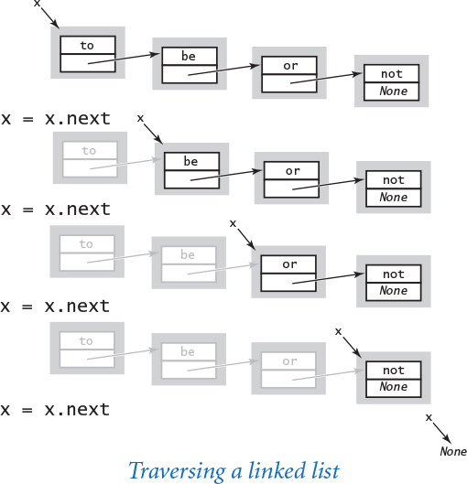
With a linked-list implementation we can implement collections of all sorts without having to worry much about space usage, so linked lists are widely used in programming. Indeed, typical implementations of the Python memory management system are based on maintaining linked lists corresponding to blocks of memory of various sizes. Before the widespread use of high-level languages like Python, the details of memory management and programming with linked lists were critical parts of any programmer’s arsenal. In modern systems, most of these details are encapsulated in the implementations of a few data types like the pushdown stack, including the queue, the symbol table, and the set, which we will consider later in this chapter. If you take a course in algorithms and data structures, you will learn several others and gain expertise in creating and debugging programs that manipulate linked lists. Otherwise, you can focus your attention on understanding the role played by linked lists in implementing these fundamental data types.
For stacks, linked lists are significant because they allow us to implement the push() and pop() methods in constant time in the worst case, while using only a small constant factor of extra space (for the links). If you are uncertain about the value of linked structures, you might think about how you might achieve the same performance specifications for our stack API without using them.
Specifically, arraystack.py does not implement performance specifications in the API, because resizing arrays do not provide a constant-time guarantee for every operation. In many practical situations, the distinction between amortized and guaranteed worst-case performance is a minor one, but you might want to think about whether there might be some huge Python list being resized the next time your phone does not respond to a swipe, the next time your plane is readying for takeoff, or the next time you step on the brakes in your car.
Still, Python programmers usually prefer Python lists (resizing arrays), primarily because of the substantial Python overhead for user-defined types like our linked-list Node. The same principles apply to collections of any sort. For some data types that are more complicated than stacks, resizing arrays are also preferred over linked lists because the ability to access any item in the array in constant time (through indexing) is critical for implementing certain operations (see, for example, RandomQueue in EXERCISE 4.3.40). For some other data types, linked structures are easier to manipulate, as we will see in SECTION 4.4.

Stack applications
Pushdown stacks play an essential role in computation. If you study operating systems, programming languages, and other advanced topics in computer science, you will learn that not only are stacks used explicitly in many applications, but they also serve as the basis for executing programs composed in high-level languages such as Python.
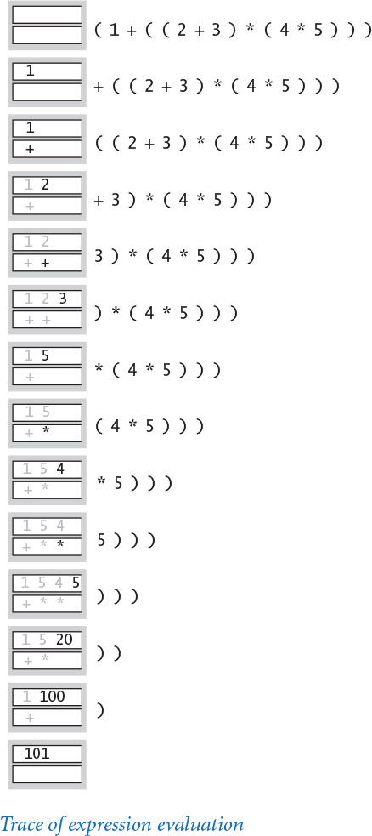

Arithmetic expressions
Some of the first programs that we considered in CHAPTER 1 involved computing the value of arithmetic expressions like this one:
Click here to view code image
( 1 + ( ( 2 + 3 ) * ( 4 * 5 ) ) )
If you multiply 4 by 5, add 3 to 2, multiply the result, and then add 1, you get the value 101. But how does Python do this calculation? Without going into the details of how Python is built, we can address the essential ideas just by composing a Python program that can take a string as input (the expression) and produce the number represented by the expression as output. For simplicity, we begin with the following explicit recursive definition: an arithmetic expression is either a number or a left parenthesis followed by an arithmetic expression followed by an operator followed by another arithmetic expression followed by a right parenthesis. For simplicity, this definition applies to fully parenthesized arithmetic expressions, which specifies precisely which operators apply to which operands. With a bit more work, we could also handle expressions like 1 + 2 * 3, which use precedence rules instead of parentheses, but we avoid that complication here. For specificity, we support the familiar binary operators *, +, and -, as well as a square-root operator sqrt that takes only one argument. We could easily allow more operators and more kinds of operators to embrace a large class of familiar mathematical expressions, involving trigonometric, exponential, and logarithmic functions and whatever other operators we might wish to include. Our focus here, however, is on understanding how to interpret the string of parentheses, operators, and numbers to enable performing in the proper order the low-level arithmetic operations that are available on any computer.

Arithmetic expression evaluation
Precisely how can we convert an arithmetic expression—a string of characters—to the value that it represents? A remarkably simple algorithm that was developed by Edsgar Dijkstra in the 1960s uses two pushdown stacks (one for operands and one for operators) to do this job. An expression consists of parentheses, operators, and operands (numbers). Proceeding from left to right and taking these entities one at a time, we manipulate the stacks according to four possible cases, as follows:
• Push operands onto the operand stack.
• Push operators onto the operator stack.
• Ignore left parentheses.
• On encountering a right parenthesis, pop an operator, pop the requisite number of operands, and push onto the operand stack the result of applying that operator to those operands.
After the final right parenthesis has been processed, there is one value on the stack, which is the value of the expression. This method may seem mysterious at first, but it is easy to convince yourself that it computes the proper value: anytime the algorithm encounters a subexpression consisting of two operands separated by an operator, all surrounded by parentheses, it leaves the result of performing that operation on those operands on the operand stack. The result is the same as if that value had appeared in the input instead of the subexpression, so we can think of replacing the subexpression by the value to get an expression that would yield the same result. We can apply this argument again and again until we get a single value. For example, the algorithm computes the same value of all of these expressions:
Click here to view code image
( 1 + ( ( 2 + 3 ) * ( 4 * 5 ) ) )
( 1 + ( 5 * ( 4 * 5 ) ) )
( 1 + ( 5 * 20 ) )
( 1 + 100 )
101
PROGRAM 4.3.3 (evaluate.py) is an implementation of this algorithm. This code is a simple example of an interpreter: a program that interprets the computation specified by a given string and performs the computation to arrive at the result. A compiler is a program that converts the string into code on a lower-level machine that can do the job. This conversion is a more complicated process than the step-by-step conversion used by an interpreter, but it is based on the same underlying mechanism. Initially, Python was based on using an interpreter. Now, however, it includes a compiler that converts arithmetic expressions (and, more generally, Python programs) into code for the Python virtual machine, an imaginary machine that is easy to simulate on an actual computer.

Stack-based programming languages
Remarkably, Dijkstra’s two-stack algorithm also computes the same value as in our example for this expression:
Click here to view code image
( 1 ( ( 2 3 + ) ( 4 5 * ) * ) + )
In other words, we can put each operator after its two operands instead of between them. In such an expression, each right parenthesis immediately follows an operator so we can ignore both kinds of parentheses, writing the expressions as follows:
1 2 3 + 4 5 * * +
This notation is known as reverse Polish notation, or postfix. To evaluate a postfix expression, we use one stack (see EXERCISE 4.3.13). Proceeding from left to right, taking these entities one at a time, we manipulate the stacks according to just two possible cases:
• Push operands onto the operand stack.
• On encountering an operator, pop the requisite number of operands and push onto the operand stack the result of applying the operator to those operands.
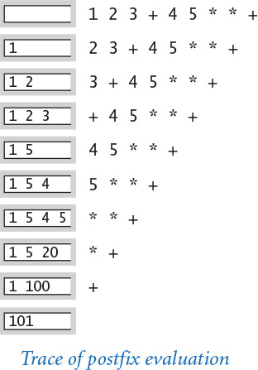
Again, this process leaves one value on the stack, which is the value of the expression. This representation is so simple that some programming languages, such as Forth (a scientific programming language) and PostScript (a page description language that is used on most printers) use explicit stacks. For example, the string 1 2 3 + 4 5 * * + is a legal program in both Forth and PostScript that leaves the value 101 on the execution stack. Aficionados of these and similar stack-based programming languages prefer them because they are simpler for many types of computation. Indeed, the Python virtual machine itself is stack-based.
Program 4.3.3 Expression evaluation (evaluate.py)
Click here to view code image
import stdio
import math
from arraystack import Stack
ops = Stack()
values = Stack()
while not stdio.isEmpty():
token = stdio.readString()
if token == '+': ops.push(token)
elif token == '-': ops.push(token)
elif token == '*': ops.push(token)
elif token == 'sqrt': ops.push(token)
elif token == ')':
op = ops.pop()
value = values.pop()
if op == '+': value = values.pop() + value
elif op == '-': value = values.pop() - value
elif op == '*': value = values.pop() * value
elif op == 'sqrt': value = math.sqrt(value)
values.push(value)
elif token != '(':
values.push(float(token))
stdio.writeln(values.pop())
ops | operator stack
values | operand stack
token | current token
value | current value
This Stack client reads a fully parenthesized numeric expression from standard input, uses Dijkstra’s two-stack algorithm to evaluate it, and writes the resulting number to standard output. It illustrates an essential computational process: interpreting a string as a program and executing that program to compute the desired result. Executing a Python program is nothing other than a more complicated version of this same process.
Click here to view code image
% python evaluate.py
( 1 + ( ( 2 + 3 ) * ( 4 * 5 ) ) )
101.0
Click here to view code image
% python evaluate.py
( ( 1 + sqrt ( 5.0 ) ) * 0.5 )
1.618033988749895
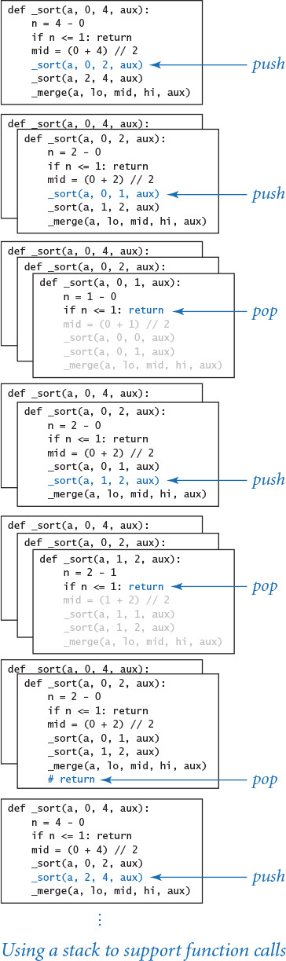

Function-call abstraction
You may have noticed a pattern in the formal traces that we have shown throughout this book. When the flow of control enters a function, Python creates the function’s parameter variables on top of the other variables that might already exist. As the function executes, Python creates the function’s local variables—again on top of the other variables that might already exist. When flow of control returns from a function, Python destroys that function’s local and parameter variables. In that sense Python creates and destroys parameter and local variables in stack-like fashion: the variables that were created most recently are the first to be destroyed.
Indeed, most programs use stacks implicitly because they support a natural way to implement function calls, as follows: at any point during the execution of a function, define its state to be the values of all of its variables and a pointer to the next instruction to be executed. One of the fundamental characteristics of computing environments is that every computation is fully determined by its state (and the value of its inputs). In particular, the system can suspend a computation by saving away its state, then restart it by restoring the state. If you take a course about operating systems, you will learn the details of this process, because it is critical to much of the behavior of computers that we take for granted (for example, switching from one application to another is simply a matter of saving and restoring state). Now, the natural way to implement the function-call abstraction, which is used by almost all modern programming environments, is to use a stack. To call a function, push the state on a stack. To return from a function call, pop the state from the stack to restore all variables to their values before the function call, substitute the function return value (if there is one) in the expression containing the function call (if there is one), and resume execution at the next instruction to be executed (whose location was saved as part of the state of the computation). This mechanism works whenever functions call one another, even recursively. Indeed, if you think about the process carefully, you will see that it is essentially the same process that we just examined in detail for expression evaluation. A program is a sophisticated expression.
The pushdown stack is a fundamental computational abstraction. Stacks have been used for expression evaluation, implementing the function-call abstraction, and other basic tasks since the earliest days of computing. We will examine another (tree traversal) in SECTION 4.4. Stacks are used explicitly and extensively in many areas of computer science, including algorithm design, operating systems, compilers, and numerous other computational applications.

FIFO queues
A FIFO queue (or just a queue) is a collection that is based on the first-in first-out (FIFO) policy.
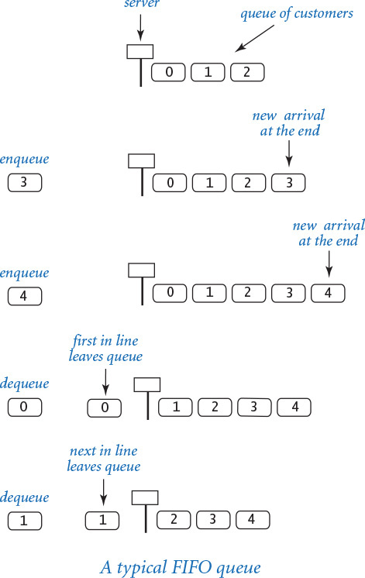
The policy of doing tasks in the same order that they arrive is one that we encounter frequently in everyday life, from people waiting in line at a theater, to cars waiting in line at a toll booth, to tasks waiting to be serviced by an application on your computer.
One bedrock principle of any service policy is the perception of fairness. The first idea that comes to mind when most people think about fairness is that whoever has been waiting the longest should be served first. That is precisely the FIFO discipline, so queues play a central role in numerous applications. Queues are a natural model for so many everyday phenomena—their properties were studied in detail even before the advent of computers.
As usual, we begin by articulating an API. Again by tradition, we name the queue insert operation enqueue and the remove operation dequeue, as indicated in the API below.
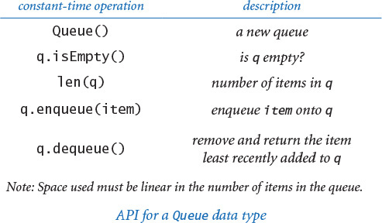
Applying our knowledge from stacks, we can use either Python lists (resizing arrays) or linked lists to develop implementations where the operations take constant time and the memory associated with the queue grows and shrinks with the number of elements in the queue. As with stacks, each of these implementations represents a classic programming exercise. You may wish to think about how you might achieve these goals in an implementation before reading further.

Linked-list implementation
To implement a queue with a linked list, we keep the items in order of their arrival (the reverse of the order that we used in linkedstack.py). The implementation of dequeue() is the same as the pop() implementation in linkedstack.py (save the item in the first node, remove the first node from the queue, and return the saved item). Implementing enqueue(), however, is a bit more challenging: how do we add a node to the end of a linked list? To do so, we need a link to the last node in the list, because that node’s link has to be changed to reference a new node containing the item to be inserted. In Stack, the only instance variable is a reference to the first node in the linked list; with just that information available, our only recourse is to traverse all the nodes in the linked list to get to the end. That solution is unattractive when lists might be lengthy. A reasonable alternative is to maintain a second instance variable that always references the last node in the linked list. Adding an extra instance variable that needs to be maintained is not something that should be taken lightly, particularly in linked-list code, because every method that modifies the linked list needs code to check whether that variable needs to be modified (and to make the necessary modifications). For example, removing the first node in the linked list might involve changing the reference to the last node in the linked list, since when there is only one node in the linked list, it is both the first one and the last one! Similarly, we need an extra check when adding a new node to an empty linked list. Details like these make linked-list code notoriously difficult to debug.
Program 4.3.4 FIFO queue (linked list) (linkedqueue.py)
Click here to view code image
class Queue:
def __init__(self):
self._first = None
self._last = None
self._n = 0
def isEmpty(self):
return self._first is None
def enqueue(self, item):
oldLast = self._last
self._last = _Node(item, None)
if self.isEmpty(): self._first = self._last
else: oldLast.next = self._last
self._n += 1
def dequeue(self):
item = self._first.item
self._first = self._first.next
if self.isEmpty(): self._last = None
self._n -= 1
return item
def __len__(self):
return self._n
class _Node:
def __init__(self, item, next):
self.item = item
self.next = next
instance variables for Queue
_first | first node on list
_last | last node on list
_n | number of items
instance variables for Node
item | list item
next | next node on list
This program defines a Queue class implemented as a linked list. The implementation is very similar to our linked-list stack implementation (PROGRAM 4.3.2): dequeue() is almost the same as pop(), but enqueue() links the new item onto the end of the list, not the beginning as in push(). To do so, it maintains an instance variable that references the last node on the list. The test client is similar to the ones we have been using (it reads strings from standard input, dequeuing and writing to standard output when an input string is a minus sign, enqueuing the string otherwise) and is omitted.
Click here to view code image
% python linkedqueue.py < tobe.txt
to be or not to be
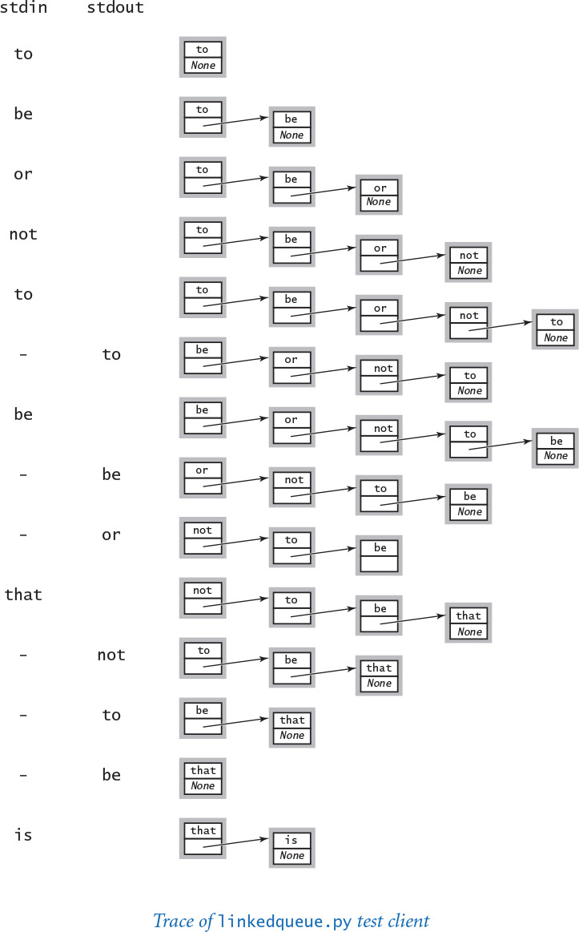
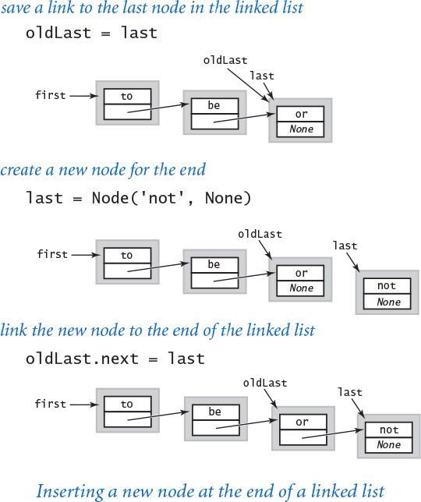
PROGRAM 4.3.4 (linkedqueue.py) is a linked-list implementation of Queue that has the same performance properties as Stack: all of the methods are constant-time operations, and space usage is linear in the number of items on the queue.

Resizing array implementation
It is also possible to develop a FIFO queue implementation that is based on an explicit resizing array representation that has the same performance characteristics as those that we developed for a stack in arraystack.py (PROGRAM 4.3.1). This implementation is a worthy and classic programming exercise that you are encouraged to pursue further (see EXERCISE 4.3.46). It might be tempting to use one-line calls on Python list methods, as in PROGRAM 4.3.1. However, the methods for inserting or deleting items at the front of a Python list will not fill the bill, as they take linear time (see EXERCISES 4.3.16 and 4.3.17). For example, if a is a list with n items, then operations such as a.pop(0) and a.insert(0, item) take time proportional to n (and not constant amortized time). Again, an implementation that does not provide the specified performance guarantees might implement a SlowQueue, but not a Queue.

Random queues
Even though they are widely applicable, there is nothing sacred about the FIFO and LIFO disciplines. It makes perfect sense to consider other rules for removing items. One of the most important to consider is a data type for which dequeue() removes a random item (sampling without replacement) and sample() returns a random item without removing it from the queue (sampling with replacement). Such actions are precisely called for in numerous applications, some of which we have already considered, starting with sample.py (PROGRAM 1.4.1). With a Python list (resizing array) representation, implementing sample() is straightforward, and we can use the same idea as in PROGRAM 1.4.1 to implement dequeue() (exchange a random item with the last item before removing it). We use the name RandomQueue to refer to this data type (see EXERCISE 4.3.40). Note that this solution depends on using a resizing-array representation (Python list): it is not possible to access a random item in a linked list in constant time because we have to start from the beginning of the list and traverse links one at a time to access it. With a Python list (resizing array), all of the operations take constant amortized time.
The stack, queue, and random queue APIs are essentially identical—they differ only in the choice of class and method names (which are chosen arbitrarily). Thinking about this situation is a good way to cement your understanding of the basic issues surrounding data types that we introduced in SECTION 3.3. The true differences among these data types are in the semantics of the remove operation—which item is to be removed? The differences between stacks and queues are embodied in the English-language descriptions of what they do. These differences are akin to the differences between math.sin(x) and math.log(x), but we might want to articulate them with a formal description of stacks and queues (in the same way as we have mathematical descriptions of the sine and logarithm functions). But precisely describing what we mean by first-in-first-out or last-in-first-out or random-out is not so simple. For starters, which language would you use for such a description? English? Python? Mathematical logic? The problem of describing how a program behaves is known as the specification problem, and it leads immediately to deep issues in computer science. One reason for our emphasis on clear and concise code is that the code itself can serve as the specification for simple data types such as stacks and queues.

Queue applications
In the past century, FIFO queues proved to be accurate and useful models in a broad variety of applications, ranging from manufacturing processes to telephone networks to traffic simulations. A field of mathematics known as queuing theory has been used with great success to help understand and control complex systems of all kinds. FIFO queues also play an important role in computing. You often encounter queues when you use your computer: a queue might hold songs on a playlist, documents to be printed, or events in a game.
Perhaps the ultimate queue application is the Internet itself, which is based on huge numbers of messages moving through huge numbers of queues that have all sorts of different properties and are interconnected in all sorts of complicated ways. Understanding and controlling such a complex system involves solid implementations of the queue abstraction, application of mathematical results of queueing theory, and simulation studies involving both. We consider next a classic example to give a flavor of this process.

M/M/1 queue
One of the most important queueing models is known as an M/M/1 queue, which has been shown to accurately model many real-world situations, such as a single line of cars entering a toll booth or patients entering an emergency room. The M stands for Markovian or memoryless and indicates that both arrivals and services are Poisson processes: both the interarrival times and service times obey an exponential distribution (see EXERCISE 2.2.12) and the 1 indicates that there is one server. An M/M/1 queue is parameterized by its arrival rate λ (for example, the number of cars per minute arriving at the toll booth) and its service rate μ (for example, the number of cars per minute that can pass through the toll booth) and is characterized by three properties:
• There is one server—a FIFO queue.
• Interarrival times to a queue obey an exponential distribution with rate λ per minute.
• Service times from a nonempty queue obey an exponential distribution with rate μ per minute.
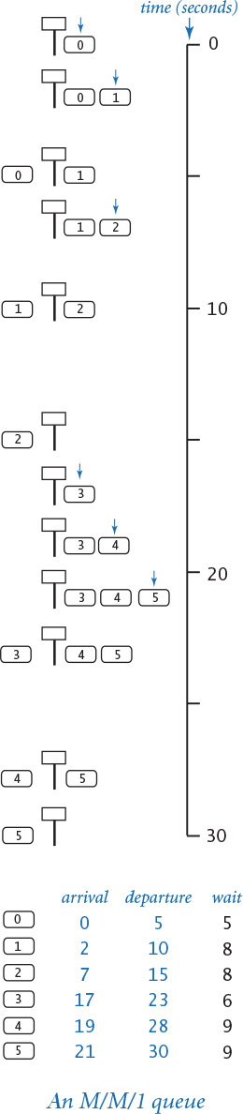
The average time between arrivals is 1/λ minutes and the average time between services (when the queue is nonempty) is 1/μ minutes. So, the queue will grow without bound unless μ > λ; otherwise, customers enter and leave the queue in an interesting dynamic process.

Analysis
In practical applications, people are interested in the effect of the parameters λ and μ on various properties of the queue. If you are a customer, you may want to know the expected amount of time you will spend in the system; if you are designing the system, you might want to know how many customers are likely to be in the system, or something more complicated, such as the likelihood that the queue size will exceed a given maximum size. For simple models, probability theory yields formulas expressing these quantities as functions of λ and μ. For M/M/1 queues, it is known that:
• The average number of customers in the system L is λ / (μ – λ).
• The average time a customer spends in the system W is 1 / (μ – λ).
For example, if the cars arrive at a rate of λ = 10 per minute and the service rate is μ = 15 per minute, then the average number of cars in the system will be 2 and the average time that a customer spends in the system will be 1/5 minutes or 12 seconds. These formulas confirm that the wait time (and queue length) grows without bound as λ approaches μ. They also obey a general rule known as Little’s law: the average number of customers in the system is λ times the average time a customer spends in the system (L = λW) for many types of queues.

Simulation
PROGRAM 4.3.5 (mm1queue.py) is a Queue client that you can use to validate these sorts of mathematical results. It is a simple example of an event-based simulation: we generate events that take place at particular times and adjust our data structures accordingly for the events, simulating what happens at the time they occur. In an M/M/1 queue, there are two kinds of events: we either have a customer arrival or a customer service. In turn, we maintain two variables:
• nextService is the time of the next service.
• nextArrival is the time of the next arrival.
To simulate an arrival event, we enqueue a float nextArrival (the time of arrival); to simulate a service, we dequeue a float, compute the wait time wait (which is the time that the service is completed minus the time that the customer arrived and entered the queue), and add the wait time to a histogram (see PROGRAM 3.2.3). The shape that results after a large number of trials is characteristic of the M/M/1 queueing system. From a practical point of view, one of the most important characteristics of the process, which you can discover for yourself by running mm1queue.py for various values of the parameters λ and μ, is that the average time a customer spends in the system (and the average number of customers in the system) can increase dramatically when the service rate approaches the arrival rate. When the service rate is high, the histogram has a visible tail where the frequency of customers having a given wait time decreases to a negligible duration as the wait time increases. But when the service rate is close to the arrival rate, the tail of the histogram stretches to the point that most values are in the tail, so the frequency of customers having at least the highest wait time displayed dominates.
Program 4.3.5 M/M/1 queue simulation (mm1queue.py)
Click here to view code image
import sys
import stddraw
import stdrandom
from linkedqueue import Queue
from histogram import Histogram
lambd = float(sys.argv[1])
mu = float(sys.argv[2])
histogram = Histogram(60 + 1)
queue = Queue()
stddraw.setCanvasSize(700, 500)
nextArrival = stdrandom.exp(lambd)
nextService = nextArrival + stdrandom.exp(mu)
while True:
while nextArrival < nextService:
queue.enqueue(nextArrival)
nextArrival += stdrandom.exp(lambd)
arrival = queue.dequeue()
wait = nextService - arrival
stddraw.clear()
histogram.addDataPoint(min(60, int(round(wait))))
histogram.draw()
stddraw.show(20.0)
if queue.isEmpty():
nextService = nextArrival + stdrandom.exp(mu)
else:
nextService = nextService + stdrandom.exp(mu)
lambd | arrival rate λ
mu | service rate μ
histogram | histogram
queue | M/M/1 queue
nextArrival | time of next arrival
nextService | time of next service completion
arrival | arrival time of next customer to be serviced
wait | time on queue
This program accepts float command-line arguments lambd and mu and simulates an M/M/1 queue with arrival rate lambd and service rate mu, producing a dynamic Histogram of the wait times. Time is tracked with two variables nextArrival and nextService and a single Queue of floats. The value of each item on the queue is the (simulated) time it entered the queue. Example plots produced by the program are shown and discussed on the next page.
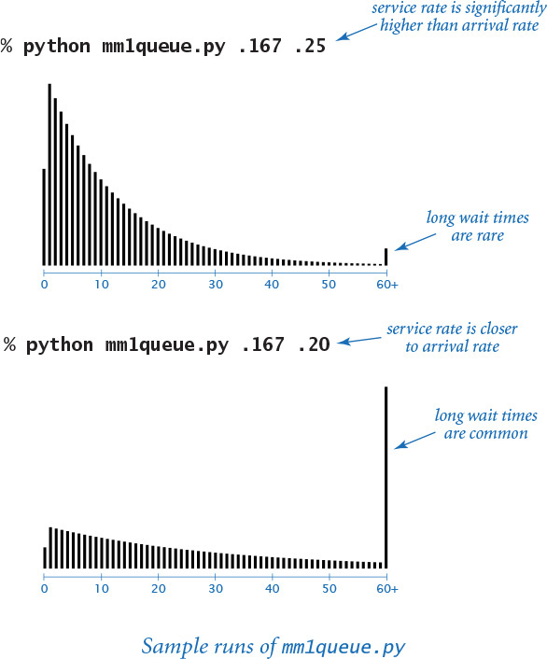
As in many other applications that we have studied, the use of simulation to validate a well-understood mathematical model is a starting point for studying more complex situations. In practical applications of queues, we may have multiple queues, multiple servers, multistage servers, limits on queue length, and many other restrictions. Moreover, the distributions of interarrival and service times may not be possible to characterize mathematically. In such situations, we may have no recourse but to use simulations. It is quite common for a system designer to build a computational model of a queuing system (such as mm1queue.py) and to use it to adjust design parameters (such as the service rate) to properly respond to the outside environment (such as the arrival rate).

Resource allocation
Next, we examine another application that illustrates the data structures that we have been considering. A resource-sharing system involves a large number of loosely cooperating servers that want to share resources. Each server agrees to maintain a queue of items for sharing, and a central authority distributes the items to the servers (and informs users where they may be found). For example, the items might be songs, photos, or videos to be shared by a large number of users. To fix ideas, we will think in terms of millions of items and thousands of servers.
We will consider the kind of program that the central authority might use to distribute the items, ignoring the dynamics of deleting items from the systems, adding and deleting servers, and so forth.
If we use a round-robin policy, cycling through the servers to make the assignments, we get a balanced allocation, but it is rarely possible for a distributor to have such complete control over the situation. For example, there might be a large number of independent distributors, so none of them could have up-to-date information about the servers. Accordingly, such systems often use a random policy, where the assignments are based on random choice. An even better policy is to choose a random sample of servers and assign a new item to the one that has smallest number of items. For small queues, differences among these policies is immaterial, but in a system with millions of items on thousands of servers, the differences can be quite significant, since each server has a fixed amount of resources to devote to this process. Indeed, similar systems are used in Internet hardware, where some queues might be implemented in special-purpose hardware, so queue length translates directly to extra equipment cost. But how big a sample should we take?
PROGRAM 4.3.6 (loadbalance.py) is a simulation of the sampling policy, which we can use to study this question. This program makes good use of the RandomQueue data type that we have been considering to provide an easily understood program that we can use for experimentation. The simulation maintains a random queue of queues and builds the computation around an inner loop where each new request for service goes on the smallest of a sample of queues, using the sample() method from RandomQueue to randomly sample queues. The surprising end result is that samples of size 2 lead to near-perfect balancing, so there is no point in taking larger samples.
Program 4.3.6 Load-balancing simulation (loadbalance.py)
Click here to view code image
import sys
import stddraw
import stdstats
from linkedqueue import Queue
from randomqueue import RandomQueue
m = int(sys.argv[1])
n = int(sys.argv[2])
t = int(sys.argv[3])
servers = RandomQueue()
for i in range(m):
servers.enqueue(Queue())
for j in range(n):
best = servers.sample()
for k in range(1, t):
queue = servers.sample()
if len(queue) < len(best):
best = queue
best.enqueue(j)
lengths = []
while not servers.isEmpty():
lengths += [len(servers.dequeue())]
stddraw.setYscale(0, 2.0*n/m)
stdstats.plotBars(lengths)
stddraw.show()
m | number of servers
n | number of items
t | sample size
servers | queues
best | shortest in sample
lengths | queue lengths
This Queue and RandomQueue client simulates the process of assigning n items to a set of m servers. Requests are put on the shortest of a sample of t queues chosen at random.
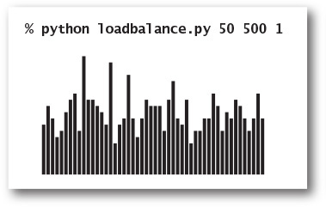
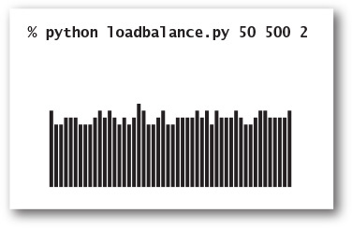
We have considered in detail the issues surrounding the time and memory usage of basic implementations of the stack and queue APIs not just because these data types are important and useful, but also because you are likely to encounter the very same issues in the context of your own data-type implementations.
Should you use a pushdown stack, a FIFO queue, or a random queue when developing a client that maintains collections of data? The answer to this question depends on a high-level analysis of the client to determine which of the LIFO, FIFO, or random disciplines is appropriate.
Should you use a linked list or a resizing array to structure your data? The answer to this question depends on low-level analysis of performance characteristics. A linked list has the advantage that you can add items at either end but the disadvantage that you cannot access an arbitrary item in constant time. A resizing array has the advantage that you can access any item in constant time but the disadvantage that the constant running time is only for insertions and deletions at one end (and it is constant time only in the amortized sense). Each data structure is appropriate in various different situations; you are likely to encounter both in most programming environments.
The careful attention to performance guarantees that we have emphasized in our Stack and Queue APIs are not to be taken for granted. They are just the first in a progression of data types that provide the underpinnings of our computational infrastructure. The next section is devoted to an even more important one, the symbol table, and you will learn about others when you take a course on data structures and algorithms. By now, you know that learning to use a new data type is not so different from learning to ride a bicycle or implement helloworld.py: it seems completely mysterious until you have done it for the first time, but quickly becomes second nature. And learning to design and implement a new data type by developing a new data structure is a challenging, fruitful, and satisfying activity. As you will see in the exercises that follow, stacks, queues, linked lists, and resizing arrays raise a host of fascinating questions, but they are also just the beginning.

Q&A
Q. When should I call the _Node constructor?
A. Just as with any other class, you should call the _Node constructor when you want to create a new _Node object (a new node in the linked list). You should not use it to create a new reference to an existing _Node object. For example, the code
oldfirst = _Node(item, next)
oldfirst = first
creates a new _Node object, then immediately loses track of the only reference to it. This code does not result in an error, but it is a bit untidy to create orphans for no reason.
Q. Why not define Node as a stand-alone class in a separate file named node.py?
A. By defining _Node in the same file as linkedstack.py or linkedqueue.py and giving it a name that begins with an underscore, we encourage clients of the Stack or Queue classes not to use the _Node class directly. Our intention is that the _Node objects be used only in the linkedstack.py or linkedqueue.py implementations, not in other clients.
Q. Should a client be allowed to insert the item None onto a stack or queue?
A. This question arises frequently when implementing collections in Python. Our implementations do permit the insertion of any object, including None.
Q. Are there standard Python modules for stacks and queues?
A. Not really. As noted earlier in this section, Python’s built-in list data type has operations that make it is easy to efficiently implement a stack using a list. But the list data type also needs many additional methods that are not normally associated with a stack, such as indexed access and deleting an arbitrary item. The prime advantage of restricting ourselves to the set of operations that we need (and only those operations) is that it makes it easier to develop an implementation that can provide the best possible performance guarantees for those operations. Python also includes a data type collections.deque that implements a mutable sequence of items with efficient insertion and deletion to either the front or the back.
Q. Why not have a single data type that implements methods to insert an item, remove the most recently inserted item, remove the least recently inserted item, remove a random item, iterate over the items, return the number of items in the collection, and whatever other operations we might desire? Then we could get them all implemented in a single class that could be used by many clients.
A. This is an example of a wide interface, which, as we pointed out in SECTION 3.3, should be avoided. As just mentioned, one reason to avoid wide interfaces is that it is difficult to construct implementations that are efficient for all operations. A more important reason is that narrow interfaces enforce a certain discipline on your programs, which makes client code much easier to understand. If one client uses Stack and another uses Queue, we have a good idea that the LIFO discipline is important to the first and the FIFO discipline is important to the second. Another approach is to use inheritance to try to encapsulate operations that are common to all collections. However, such implementations are best left for experts, whereas any programmer can learn to build implementations such as Stack and Queue.
Q. Is there any way that I can compose a client that uses both arraystack.py and linkedstack.py in the same program?
A. Yes, the easiest way is to add an as clause to the import statement, as below. In effect, this kind of import statement creates an alias for the name of the class and your code can then use that alias instead of the name of the class.
Click here to view code image
from arraystack import Stack as ArrayStack
from linkedstack import Stack as LinkedStack
...
stack1 = ArrayStack()
stack2 = LinkedStack()

Exercises
4.3.1 Give the output written by python arraystack.py for the following input:
Click here to view code image
it was - the best - of times - - - it was - the - -
4.3.2 Give the contents and length of the array for arraystack.py after each operation for the following input:
Click here to view code image
it was - the best - of times - - - it was - the - -
4.3.3 Suppose that a client performs an intermixed sequence of push and pop operations on a Stack. The push operations put the integers 0 through 9 in order onto the stack; the pop operations write the return value. Which of the following sequence(s) could not occur?
a. 4 3 2 1 0 9 8 7 6 5
b. 4 6 8 7 5 3 2 9 0 1
c. 2 5 6 7 4 8 9 3 1 0
d. 4 3 2 1 0 5 6 7 8 9
e. 1 2 3 4 5 6 9 8 7 0
f. 0 4 6 5 3 8 1 7 2 9
g. 1 4 7 9 8 6 5 3 0 2
h. 2 1 4 3 6 5 8 7 9 0
4.3.4 Compose a stack client reverse.py that reads in strings from standard input and writes them in reverse order to standard output.
4.3.5 Compose a stack client parentheses.py that reads in a text stream from standard input and uses a stack to determine whether its parentheses are properly balanced. For example, your program should write True for [()]{}{[()()]()} and False for [(]).
4.3.6 Add the method __len__() to the Stack class in linkedstack.py (PROGRAM 4.3.2).
4.3.7 Add a method peek() to the Stack class in arraystack.py that returns the most recently inserted item on the stack (without popping it).
4.3.8 What does the following code fragment write when n is 50? Give a high-level description of what the code fragment does for a given positive integer n.
stack = Stack()
while n > 0:
stack.push(n % 2)
n /= 2
while not stack.isEmpty():
stdio.write(stack.pop())
stdio.writeln()
Solution: It writes the binary representation of n (110010 when n is 50).
4.3.9 What does the following code fragment do to the queue queue?
Click here to view code image
stack = Stack()
while not queue.isEmpty(): stack.push(queue.dequeue())
while not stack.isEmpty(): queue.enqueue(stack.pop())
4.3.10 Draw an object-level trace diagram for the three-node example used to introduce linked lists in this section.
4.3.11 Compose a program that takes from standard input an expression without left parentheses and writes the equivalent infix expression with the parentheses inserted. For example, given the input
Click here to view code image
1 + 2 ) * 3 - 4 ) * 5 - 6 ) ) )
your program should write
Click here to view code image
( ( 1 + 2 ) * ( ( 3 - 4 ) * ( 5 - 6 ) )
4.3.12 Compose a filter infixtopostfix.py that converts a fully parenthesized arithmetic expression from infix to postfix.
4.3.13 Compose a program evaluatepostfix.py that reads a postfix expression from standard input, evaluates it, and writes the value to standard output. (Piping the output of your program from the previous exercise to this program gives equivalent behavior to evaluate.py.)
4.3.14 Suppose that a client performs an intermixed sequence of enqueue and dequeue operations on a Queue. The enqueue operations put the integers 0 through 9 in order onto the queue; the dequeue operations write the return value. Which of the following sequence(s) could not occur?
a. 0 1 2 3 4 5 6 7 8 9
b. 4 6 8 7 5 3 2 9 0 1
c. 2 5 6 7 4 8 9 3 1 0
d. 4 3 2 1 0 5 6 7 8 9
4.3.15 Compose a Queue client that takes a command-line argument k writes the kth from the last string found on standard input.
4.3.16 Give the running time of each operation in the following Queue class, where the item least recently inserted is at _a[0].
Click here to view code image
class Queue:
def __init__(self): self._a = []
def isEmpty(self): return len(self._a) == 0
def __len__(self): return len(self._a)
def enqueue(self, item): self._a += [item]
def dequeue(self): return self._a.pop(0)
4.3.17 Give the running time of each operation in the following Queue class, where the item most recently inserted is at _a[0].
Click here to view code image
class Queue:
def __init__(self): self._a = []
def isEmpty(self): return len(self._a) == 0
def __len__(self): return len(self._a)
def enqueue(self, item): self._a.insert(0, item)
def dequeue(self): return self._a.pop()
4.3.18 Modify mm1queue.py to make a program md1queue.py that simulates a queue for which the service times are fixed (deterministic) at rate of μ. Verify Little’s law empirically for this model.

Linked-List Exercises
The following exercises are intended to give you experience in working with linked lists. The easiest way to work them is to make drawings using the visual representation described in the text.
4.3.19 Suppose x is a linked-list node. What is the effect of the following code fragment?
x.next = x.next.next
Solution: Deletes from the list the node immediately following x.
4.3.20 Compose a function find() that takes the first node in a linked list and an object key as arguments and returns True if some node in the list has key as its item field, and False otherwise.
4.3.21 Compose a function delete() that takes the first node in a linked list and an integer k as arguments and deletes the kth element in a linked list, if it exists.
4.3.22 Suppose that x is a linked-list node. What is the effect of the following code fragment?
t.next = x.next
x.next = t
Solution: Inserts node t immediately after node x.
4.3.23 Why does the following code fragment not have the same effect as the code fragment in the previous question?
x.next = t
t.next = x.next
Solution: When it comes time to update t.next, x.next is no longer the original node following x, but is instead t itself!
4.3.24 Compose a function removeAfter() that takes a linked-list node as an argument and removes the node following the given one (and does nothing if the argument or the next field in the argument node is None).
4.3.25 Compose a function copy() that takes a linked-list node as an argument and creates a new linked list with the same sequence of items, without destroying the original linked list.
4.3.26 Compose a function remove() that takes a linked-list node and an object item as arguments and removes every node in the list whose item is item.
4.3.27 Compose a function listmax() that takes the first node in a linked list as an argument and returns the value of the maximum item in the list. Assume that the items are comparable, and return None if the list is empty.
4.3.28 Develop a recursive solution to the previous question.
4.3.29 Compose a function that takes the first node in a linked list as an argument and reverses the list, returning the first node in the result.
Iterative solution: To accomplish this task, we maintain references to three consecutive nodes in the linked list: reverse, first, and second. At each iteration, we extract the node first from the original linked list and insert it at the beginning of the reversed list. We maintain the invariant that first is the first node of what’s left of the original list, second is the second node of what’s left of the original list, and reverse is the first node of the resulting reversed list.
def reverse(first):
reverse = None
while first is not None:
second = first.next
first.next = reverse
reverse = first
first = second
return reverse
When composing code involving linked lists, we must always be careful to properly handle the exceptional cases (when the linked list is empty, when the list has only one or two nodes) and the boundary cases (dealing with the first or last items). This is usually much trickier than handling the normal cases.
4.3.30 Compose a recursive function to write the elements of a linked list in reverse order. Do not modify any of the links. Easy: Use quadratic time, constant extra space. Also easy: Use linear time, linear extra space. Not so easy: Develop a divide-and-conquer algorithm that uses linearithmic time and logarithmic extra space.
Quadratic time, constant space solution: We recursively reverse the part of the list starting at the second node, and then carefully append the first element to the end.
def reverse(first):
if first is None:
return None
if first.next is None:
return first
second = first.next
rest = reverse(second)
second.next = first
first.next = None
return rest
4.3.31 Compose a recursive function to randomly shuffle the elements of a linked list by modifying the links. Easy: Use quadratic time, constant extra space. Not so easy: Develop a divide-and-conquer algorithm that takes linearithmic time and uses logarithmic extra memory. For the “merging” step, see EXERCISE 1.4.38.

Creative Exercises
4.3.32 Deque. A double-ended queue or deque (pronounced “deck”) is a combination of a stack and a queue. Compose a class Deque that uses a linked list to implement this API:
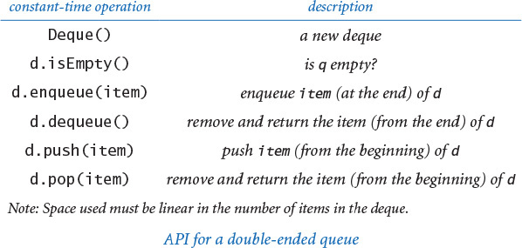
4.3.33 Josephus problem. In the Josephus problem from antiquity, n people are in dire straits and agree to the following strategy to reduce the population. They arrange themselves in a circle (at positions numbered from 0 to n) and proceed around the circle, eliminating every m person until only one person is left. Legend has it that Josephus figured out where to sit to avoid being eliminated. Compose a Queue client josephus.py that takes n and m from the command line and writes the order in which people are eliminated (and thus would show Josephus where to sit in the circle).
% python josephus.py 7 2
1 3 5 0 4 2 6
4.3.34 Merging two sorted queues. Given two queues with strings in ascending order, move all of the strings to a third queue so that the third queue ends up with the strings in ascending order.
4.3.35 Nonrecursive mergesort. Given n strings, create n queues, each containing one of the strings. Create a queue of the n queues. Then, repeatedly apply the sorted merging operation to the first two queues and reinsert the merged queue at the end. Repeat until the queue of queues contains only one queue.
4.3.36 Delete ith element. Implement a class that supports the following API:
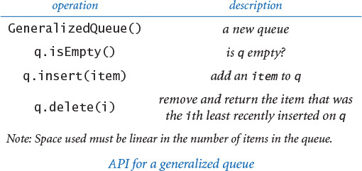
First, develop an implementation that uses a Python list (resizing array) implementation, and then develop one that uses a linked-list implementation. (See EXERCISE 4.4.69 for a more efficient implementation that uses a binary search tree.)
4.3.37 Queue with two stacks. Show how to implement a queue using two stacks (and only a constant amount of extra memory) so that each queue operations uses a constant amortized number of stack operations.
4.3.38 Ring buffer. A ring buffer, or circular queue, is a FIFO data structure of a fixed capacity n. It is useful for transferring data between asynchronous processes or for storing log files. When the buffer is empty, the consumer waits until data is deposited; when the buffer is full, the producer waits to deposit data. Develop an API for a ring buffer and an implementation that uses an array representation (with circular wrap-around).
4.3.39 Move-to-front. Read in a sequence of characters from standard input and maintain the characters in a linked list with no duplicates. When you read in a previously unseen character, insert it at the front of the list. When you read in a duplicate character, delete it from the list and reinsert it at the beginning. Name your program MoveToFront: it implements the well known move-to-front strategy, which is useful for caching, data compression, and many other applications where items that have been recently accessed are more likely to be reaccessed.
4.3.40 Random queue. A random queue stores a collection of items as per this API:
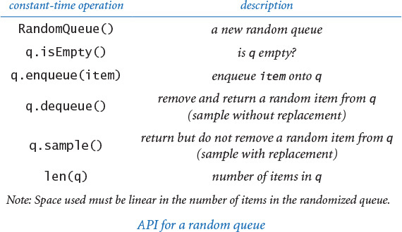
Compose a class RandomQueue that implements this API. Hint: Use a Python list (resizing array) representation, as in PROGRAM 4.3.1. To remove an item, swap one at a random position (indexed 0 through n-1) with the one at the last position (index n-1). Then delete and return the last object. Compose a client that writes a deck of cards in random order using RandomQueue.
4.3.41 Topological sort. You have to sequence the order of n jobs that are numbered from 0 to n-1 on a server. Some of the jobs must complete before others can begin. Compose a program topologicalsorter.py that takes n as a command-line argument and a sequence on standard input of ordered pairs of jobs i j, and then writes a sequence of integers such that for each pair i j in the input, job i appears before job j. Use the following algorithm: First, from the input, build, for each job, (1) a queue of the jobs that must follow it and (2) its indegree (the number of jobs that must come before it). Then, build a queue of all nodes whose indegree is 0 and repeatedly delete some job with zero indegree, maintaining all the data structures. This process has many applications; for example, you can use it to model course prerequisites for your major so that you can find a sequence of courses to take so that you can graduate.
4.3.42 Text editor buffer. Develop a data type for a buffer in a text editor that implements the following API:
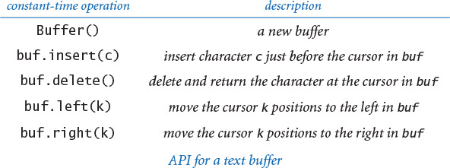
Hint: Use two stacks.
4.3.43 Copy a stack. Create a copy() method for the linked-list implementation of Stack so that
stack2 = stack1.copy()
makes stack2 a reference to a new and independent copy of the stack stack1. You should be able to push and pop from either stack1 or stack2 without influencing the other.
4.3.44 Copy a queue. Create a copy() method for the linked-list implementation of Queue so that
queue2 = queue1.copy()
makes queue2 a reference to a new and independent copy of the queue queue1. Hint: Delete all of the items from queue1 and add these items to both queue1 and queue2.
4.3.45 Stack with explicit resizing array. Implement a stack using an explicit resizing array: initialize an empty stack by using an array of length 1 as an instance variable; double the length of the array when it becomes full and halve the length of the array when it becomes one-fourth full.
Solution:
Click here to view code image
class Stack:
def __init__(self):
self._a = [None]
self._n = 0
def isEmpty(self):
return self._n == 0
def __len__(self):
return self._n
def _resize(self, capacity):
temp = stdarray.create1D(capacity)
for i in range(self._n):
temp[i] = self._a[i]
self._a = temp
def push(self, item):
if self._n == len(self._a):
self._resize(2 * self._n)
self._a[self._n] = item
self._n += 1
def pop(self):
self._n -= 1
item = self._a[self._n]
self._a[self._n] = None
if (self._n > 0) and (self._n == len(self._a) // 4):
self._resize(self._n // 2)
return item
4.3.46 Queue with explicit resizing array. Implement a queue using an explicit resizing array so that all operations take constant amortized time. Hint: The challenge is that the items will “crawl across” the array as items are added to and removed from the queue. Use modular arithmetic to maintain the array indices of the items at the front and back of the queue.
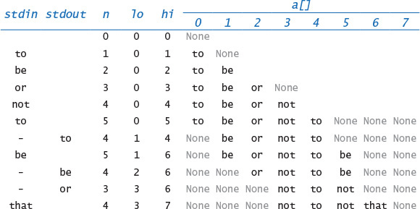
4.3.47 Queue simulations. Study what happens when you modify mm1queue.py to use a stack instead of a queue. Does Little’s law hold? Answer the same question for a random queue. Plot histograms and compare the standard deviations of the waiting times.
4.3.48 Load-balancing simulations. Revise loadbalance.py to write the average queue length and the maximum queue length instead of plotting the histogram, and use it to run simulations for 1 million items on 100,000 queues. Write the average value of the maximum queue length for 100 trials each with sample sizes 1, 2, 3, and 4. Do your experiments validate the conclusion drawn in the text about using a sample of size 2?
4.3.49 Listing files. A folder is a list of files and subfolders. Compose a program that takes the name of a folder as a command-line argument and writes all of the file names contained in that folder, with the contents of each folder recursively listed (indented) under that folder’s name. Hint: Use a queue, and see the listdir() function defined in Python’s os module.

4.4 Symbol Tables
A symbol table is a data type that we use to associate values with keys. Clients can store (put) an entry into the symbol table by specifying a key–value pair and then can retrieve (get) the value corresponding to a particular key from the symbol table. For example, a university might associate information such as a student’s name, home address, and grades (the value) with that student’s Social Security number (the key), so that each student’s record can be accessed by specifying a Social Security number. The same approach might be appropriate for a scientist who needs to organize data, a business that needs to keep track of customer transactions, an Internet search engine that has to associate keywords with web pages, or in countless other ways.
4.4.1 Dictionary lookup
4.4.2 Indexing
4.4.3 Hash table
4.4.4 Binary search tree
Programs in this section
Because of their fundamental importance, symbol tables have been heavily used and studied since the early days of computing. The development of implementations that guarantee good performance continues to be an active area of research. Several other operations on symbol tables beyond the characteristic put and get operations naturally arise, and guaranteeing good performance for richer sets of operations can be quite challenging.
In this chapter we consider a basic API for the symbol-table data type. Our API adds to the put and get operations the abilities to test whether any value has been associated with a given key (contains) and to iterate over the keys. We also consider an extension to the API for the case where keys are comparable, which admits a number of useful operations.
We also consider two classic implementations. The first uses an operation known as hashing, which transforms keys into array indices that we can use to access values. The second is based on a data structure known as the binary search tree (BST). Both are remarkably simple solutions that perform well in many practical situations and also serve as the basis for the industrial-strength symbol-table implementations that are found in modern programming environments. The code that we consider for symbol tables is only slightly more complicated than the resizing array and linked-list code that we considered for stacks and queues, but it will introduce you to new dimensions in structuring data that have far-reaching impact.

API
A symbol table is a collection of key–value pairs—every symbol-table entry associates a value with a key, as follows:
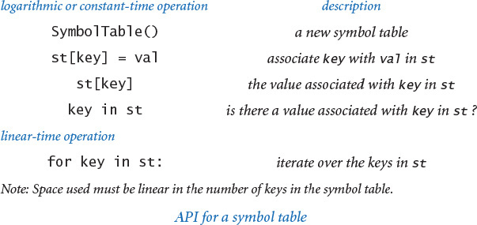
In this section, we discuss this API, clients, implementations, and extensions. The API is consistent with the API for Python’s built-in dict data type, which we consider later in this section. The API already reflects several design decisions, which we now enumerate.

Associative arrays
We overload the [] operator for the two basic operations put and get. In client code this means that we can think of a symbol table as an associative array, where we can use standard array syntax with any type of data inside the square brackets instead of an integer between 0 and the length, as for an array. Thus, we can associate a codon with an amino acid name with client code like
amino['TTA'] = 'Leucine'
and we can later access the name associated with a given codon with client code like
stdio.writeln(amino['TTA'])
That is, an associative array reference is a get operation, unless it is on the left side of an assignment statement, when it is a put operation. We can support these operations by implementing the special methods __getitem__() and __setitem__(). Thinking in terms of associative arrays is a good way to understand the basic purpose of symbol tables.

Replace-the-old-value policy
If a value is to be associated with a key that already has an associated value, we adopt the convention that the new value replaces the old one (just as with an array assignment statement). Again, this is what one would expect from the associative-array abstraction. The key in st operation, supported by the special method __contains__(), gives the client the flexibility to avoid doing so, if desired.

Not found
The call st[key] raises a KeyError if no value has been associated with key in the table. An alternative design would be to return None in such cases.

None keys and values
Clients may use None as a key or value, though they typically do not do so. An alternative design would be to disallow either None keys and/or values.

Iterable
To support the for key in st: construct, Python’s convention is that we need to implement a special method __iter__() that returns an iterator, a special data type that includes methods that are called at the beginning and for each iteration of the for loop. We consider Python’s mechanism for iteration at the end of this section.

Remove
Our basic API does not include a method for removing keys from the symbol table. Some applications do require such a method, and Python provides the special syntax del st[key] that can be supported by implementing the special method __delitem__(). We leave implementations as exercises or for a more advanced course in algorithms.

Immutable keys
We assume the keys do not change their value while in the symbol table. The simplest and most commonly used types of keys (integers, floats, and strings) are immutable. If you think about it, you will see that is a very reasonable assumption! If a client changes a key, how could the symbol table implementation keep track of that fact?

Variations
Computer scientists have identified numerous other useful operations on symbol tables, and APIs based on various subsets of them have been widely studied. We consider several of these operations throughout this section, and particularly in the exercises at the end.

Comparable keys
In many applications, the keys may be integers, floats, strings, or other data types of data that have a natural order. In Python, as discussed in SECTION 3.3, we expect such keys to be comparable. Symbol tables with comparable keys are important for two reasons. First, we can take advantage of key ordering to develop implementations of put and get that can guarantee the performance specifications in the API. Second, a whole host of new operations come to mind (and can be supported) with comparable keys. A client might want the smallest key, or the largest, or the median, or to iterate over the keys in sorted order. Full coverage of this topic is more appropriate for a book on algorithms and data structures, but we examine a typical client and an implementation of such a data type later in this section. A partial API is shown at the bottom of this page.
Symbol tables are among the most widely studied data structures in computer science, so the impact of these and many alternative design decisions has been carefully studied, as you will learn if you take later courses in computer science. In this section, our approach is to introduce you to the most important properties of symbol tables by considering two prototypical client programs, developing two classic and efficient implementations, and studying the performance characteristics of those implementations, to show you that they can meet the needs of typical clients, even when the symbol tables are huge.
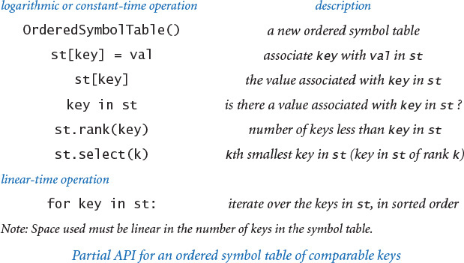

Symbol table clients
Once you gain some experience with the idea, you will realize that symbol tables are broadly useful. To convince you of this fact, we start with two prototypical examples, each of which arises in a large number of important and familiar practical applications.

Dictionary lookup
The most basic kind of symbol-table client builds a symbol table with successive put operations to support get requests. We maintain a collection of data so that we can quickly access the data we need. Most applications also take advantage of the idea that a symbol table is a dynamic dictionary, where it is easy both to look up information and to update the information in the table. The following list of familiar examples illustrates the utility of this approach.
• Phone book. When keys are people’s names and values are their phone numbers, a symbol table models a phone book. A very significant difference from a printed phone book is that we can add new names or change existing phone numbers. We could also use the phone number as the key and the name as the value. If you have never done so, try typing your phone number (with area code) into the search field in your browser.
• Dictionary. Associating a word with its definition is a familiar concept that gives us the name “dictionary.” For centuries people kept printed dictionaries in their homes and offices so that they could check the definitions and spellings (values) of words (keys). Now, because of good symbol-table implementations, people expect built-in spell checkers and immediate access to word definitions on their computers.
• Account information. People who own stock now regularly check the current price on the web. Several services on the web associate a ticker symbol (key) with the current price (value), usually along with a great deal of other information. Commercial applications of this sort abound, including financial institutions associating account information with a name or account number or educational institutions associating grades with a student name or identification number.
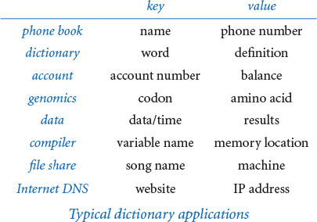
• Genomics. Symbols play a central role in modern genomics, as we have already seen (see PROGRAM 3.1.1). The simplest example is the use of the letters A, C, T, and G to represent the nucleotides found in the DNA of living organisms. The next simplest is the correspondence between codons (nucleotide triplets) and amino acids (TTA corresponds to leucine, TCT to cycstine, and so forth), then the correspondence between sequences of amino acids and proteins, and so forth. Researchers in genomics routinely use various types of symbol tables to organize this knowledge.
• Experimental data. From astrophysics to zoology, modern scientists are awash in experimental data, and organizing and efficiently accessing this data is vital to understanding what it means. Symbol tables are a critical starting point, and advanced data structures and algorithms that are based on symbol tables are now an important part of scientific research.
• Programming languages. One of the earliest uses of symbol tables was to organize information for programming. At first, programs were simply sequences of numbers, but programmers very quickly found that using symbolic names for operations and memory locations (variable names) was far more convenient. Associating the names with the numbers requires a symbol table. As the size of programs grew, the cost of the symbol-table operations became a bottleneck in program development time, which led to the development of data structures and algorithms like the ones we consider in this section.
• Files. We use symbol tables regularly to organize data on computer systems. Perhaps the most prominent example is the file system, where we associate a file name (key) with the location of its contents (value). Your music player uses the same system to associate song titles (keys) with the location of the music itself (value).
• Internet DNS. The domain name system (DNS) that is the basis for organizing information on the Internet associates URLs (keys) that humans understand (such as www.princeton.edu or www.wikipedia.org) with IP addresses (values) that computer network routers understand (such as 208.216.181.15 or 207.142.131.206). This system is the next-generation “phone book.” Thus, humans can use names that are easy to remember and machines can efficiently process the numbers. The number of symbol-table lookups done each second for this purpose on Internet routers around the world is huge, so performance is of obvious importance. Millions of new computers and other devices are put onto the Internet each year, so these symbol tables on Internet routers need to be dynamic.
Click here to view code image
% more amino.csv
TTT,Phe,F,Phenylalanine
TTC,Phe,F,Phenylalanine
TTA,Leu,L,Leucine
TTG,Leu,L,Leucine
TCT,Ser,S,Serine
TCC,Ser,S,Serine
TCA,Ser,S,Serine
TCG,Ser,S,Serine
TAT,Tyr,Y,Tyrosine
TAC,Tyr,Y,Tyrosine
TAA,Stop,Stop,Stop
...
GCA,Ala,A,Alanine
GCG,Ala,A,Alanine
GAT,Asp,D,Aspartic Acid
GAC,Asp,D,Aspartic Acid
GAA,Gly,G,Glutamic Acid
GAG,Gly,G,Glutamic Acid
GGT,Gly,G,Glycine
GGC,Gly,G,Glycine
GGA,Gly,G,Glycine
GGG,Gly,G,Glycine
% more djia.csv
...
20-Oct-87,1738.74,608099968,1841.01
19-Oct-87,2164.16,604300032,1738.74
16-Oct-87,2355.09,338500000,2246.73
15-Oct-87,2412.70,263200000,2355.09
...
30-Oct-29,230.98,10730000,258.47
29-Oct-29,252.38,16410000,230.07
28-Oct-29,295.18,9210000,260.64
25-Oct-29,299.47,5920000,301.22
...
% more ip.csv
...
www.ebay.com,66.135.192.87
www.princeton.edu,128.112.128.15
www.cs.princeton.edu,128.112.136.35
www.harvard.edu,128.103.60.24
www.yale.edu,130.132.51.8
www.cnn.com,64.236.16.20
www.google.com,216.239.41.99
www.nytimes.com,199.239.136.200
www.apple.com,17.112.152.32
www.slashdot.org,66.35.250.151
www.espn.com,199.181.135.201
www.weather.com,63.111.66.11
www.yahoo.com,216.109.118.65
...
Typical comma-separated-value (CSV) files
Despite its scope, this list is still just a representative sample, intended to give you a flavor of the scope of applicability of the symbol-table abstraction. Whenever you specify something by name, there is a symbol table at work. Your computer’s file system or the web might do the work for you, but there is still a symbol table there somewhere.
PROGRAM 4.4.1 (lookup.py) builds a set of key–value pairs from a file of comma-separated values (see SECTION 3.1) as specified on the command line and then writes values corresponding to the keys read from standard input. The command-line arguments are the file name and two integers, one specifying the field to serve as the key and the other specifying the field to serve as the value. Examples of similar but slightly more sophisticated test clients are described in the exercises. For instance, we could make the dictionary dynamic by also allowing standard-input commands to change the value associated with a key (see EXERCISE 4.4.1).
Your first step in understanding symbol tables is to download lookup.py and hashst.py (the symbol-table implementation that we consider next) from the booksite to do some symbol-table searches. You can find numerous comma-separated-value (.csv) files that are related to various applications that we have described, including amino.csv (codon-to-amino-acid encodings), djia.csv (opening price, volume, and closing price of the stock market average, for every day in its history), and ip.csv (a selection of entries from the DNS database). When choosing which field to use as the key, remember that each key must uniquely determine a value. If there are multiple put operations to associate values with a key, the table will remember only the most recent one (think about associative arrays). We will consider next the case where we want to associate multiple values with a key.
Program 4.4.1 Dictionary lookup (lookup.py)
Click here to view code image
import sys
import stdio
from instream import InStream
from hashst import SymbolTable
instream = InStream(sys.argv[1])
keyField = int(sys.argv[2])
valField = int(sys.argv[3])
database = instream.readAllLines()
st = SymbolTable()
for line in database:
tokens = line.split(',')
key = tokens[keyField]
val = tokens[valField]
st[key] = val
while not stdio.isEmpty():
query = stdio.readString()
if query in st: stdio.writeln(st[query])
else: stdio.writeln('Not found')
instream | input stream (.csv)
keyField | key position
valField | value position
database[] | lines in input
st | symbol table
tokens | values on a line
key | key
val | value
query | query string
This data-driven symbol table client reads key–value pairs from a comma-separated file, then writes values corresponding to keys on standard input. Both keys and values are strings.
Click here to view code image
% python lookup.py amino.csv 0 3
TTA
Leucine
ABC
Not found
TCT
Serine
% python lookup.py amino.csv 3 0
Glycine
GGG
Click here to view code image
% python lookup.py ip.csv 0 1
www.google.com
216.239.41.99
% python lookup.py ip.csv 1 0
216.239.41.99
www.google.com
% python lookup.py djia.csv 0 1
29-Oct-29
252.38
Later in this chapter, we will see that the cost of associative array references in lookup.py can be linear or logarithmic. This fact implies that you may experience a small delay getting the answer to your first request (for all the put operations to build the table), but you get immediate response for all the others.

Indexing
PROGRAM 4.4.2 (index.py) is a prototypical example of a symbol-table client for comparable keys. It reads in a list of strings from standard input and writes a sorted table of all the different strings along with a list of integers for each string specifying the positions where it appears in the input. In this case, we seem to be associating multiple values with each key, but we actually associating just one: a Python list. Again, this problem has familiar applications:
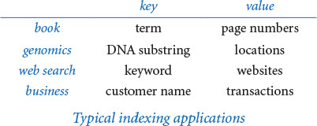
• Book index. Every textbook has an index where you look up a word and get the page numbers containing that word. While no reader wants to see every word in the book in an index, a program like index.py can provide a starting point for creating a good index.
• Programming languages. In a large program that uses a large number of symbols, it is useful to know where each name is used. A program like index.py can be a valuable tool to help programmers keep track of where symbols are used in their programs. Historically, an explicit printed symbol table was one of the most important tools used by programmers to manage large programs. In modern systems, symbol tables are the basis of software tools that programmers use to manage names of modules in systems.
• Genomics. In a typical (if oversimplified) scenario in genomics research, a scientist wants to know the positions of a given genetic sequence in an existing genome or set of genomes. Existence or proximity of certain sequences may be of scientific significance. The starting point for such research is an index like the one produced by index.py, modified to take into account the fact that genomes are not separated into words.
Program 4.4.2 Indexing (index.py)
Click here to view code image
import sys
import stdio
from bst import OrderedSymbolTable
minLength = int(sys.argv[1])
minCount = int(sys.argv[2])
words = stdio.readAllStrings()
bst = OrderedSymbolTable()
for i in range(len(words)):
word = words[i]
if len(word) >= minLength:
if word not in bst: bst[word] = []
bst[word] += [i]
for word in bst:
if len(bst[word]) >= minCount:
stdio.write(word + ': ')
for i in bst[word]:
stdio.write(str(i) + ' ')
stdio.writeln()
minLength | minimum length
minCount | count threshold
bst | ordered symbol table
word | current word
bst[word] | array of positions for current word
This program accepts integers minLength and minCount as command-line arguments, reads all of the words from standard input and creates a sorted index indicating where each word appears within standard input. It considers only words that have at least minLength characters and it writes only words that occur at least minCount times. The computation is based on a symbol table of comparables, where each key is a word and each corresponding value is an array of positions where the word occurs in standard input.
Click here to view code image
% python index.py 9 30 < tale.txt
confidence: 2794 23064 25031 34249 47907 48268 48577 ...
courtyard: 11885 12062 17303 17451 32404 32522 38663 ...
evremonde: 86211 90791 90798 90802 90814 90822 90856 ...
expression: 3777 5575 6574 7116 7195 8509 8928 15015 ...
gentleman: 2521 5290 5337 5698 6235 6301 6326 6338 ...
influence: 27809 36881 43141 43150 48308 54049 54067 ...
monseigneur: 85 90 36587 36590 36611 36636 36643 ...
...
• Web search. When you type a keyword and get a list of websites containing that keyword, you are using an index created by your web search engine. There is one value (the list of pages) associated with each key (the query), although the reality is a bit more dynamic and complicated because we often specify multiple keys and the pages are spread through the web, not kept in a table on a single computer.
• Account information. One way for a company that maintains customer accounts to keep track of a day’s transactions is to keep an index of the list of the transactions. The key is the account number; the value is the list of occurrences of that account number in the transaction list.
To cut down on the amount of output, index.py takes three command-line arguments: a file name and two integers. The first integer is the minimum string length to include in the symbol table, and the second is the minimum number of occurrences (among the words that appear in the text) to include in the printed index. Again, several similar clients for various useful tasks are discussed in the exercises. For example, one common scenario is to build multiple indices on the same data, using different keys. In our account example, one index might use customer account numbers for keys and another might use vendor account numbers.
As with lookup.py, you are certainly encouraged to download index.py and bst.py (the symbol-table implementation for comparable keys that we consider later) from the booksite and run them on various input files to gain further appreciation for the utility of symbol tables for comparable keys. If you do so, you will find that the programs can build large indices for huge files with little delay, because each symbol-table operation is taken care of immediately.
One reason for the proliferation of algorithms and implementations is that the needs of symbol-table clients can vary widely. On the one hand, when the symbol table or the number of operations to be performed is small, any implementation will do. On the other hand, symbol tables for some applications are so huge that they are organized as databases that reside on external storage or the web. In this section, we focus on the huge class of clients like index.py and lookup.py whose needs fall between these extremes, where we need to be able to use associative assignments to build and maintain large tables dynamically while also responding immediately to a large number of associative lookups. Providing this immediate response for huge dynamic tables is one of the classic contributions of algorithmic technology.

Elementary symbol-table implementations
All of these examples are persuasive evidence of the importance of symbol tables. Symbol-table implementations have been heavily studied, many different algorithms and data structures have been invented for this purpose, and modern programming environments (including Python) provide direct support. As usual, knowing how a basic implementation works will help you appreciate, choose among, and more effectively use the advanced ones, or help implement your own version for some specialized situation that you might encounter.
To begin, we briefly consider four different elementary implementations, based on the two basic data structures that we have encountered: resizing arrays and linked lists. Our purpose in doing so is to establish that we need a more sophisticated data structure, as none of these achieve the performance requirements in our API. Each implementation uses linear time for one of the operations, which makes each of them unsuitable for large practical applications.
Perhaps the simplest implementation is to use sequential search with two parallel (resizing) arrays, one for keys and one for values, as follows (see EXERCISE 4.4.10 and EXERCISE 4.4.33 for implementations of __contains__() and __iter__(), respectively):
Click here to view code image
# sequential search implementation of a symbol table
class SymbolTable:
def __init__(self):
self._keys = []
self._vals = []
def __getitem__(self, key):
for i in range(len(self._keys)):
if self._keys[i] == key:
return self._vals[i]
raise KeyError
def __setitem__(self, key, val):
for i in range(len(self._keys)):
if self._keys[i] == key:
self._vals[i] = val
return
self._keys += [key]
self._vals += [val]
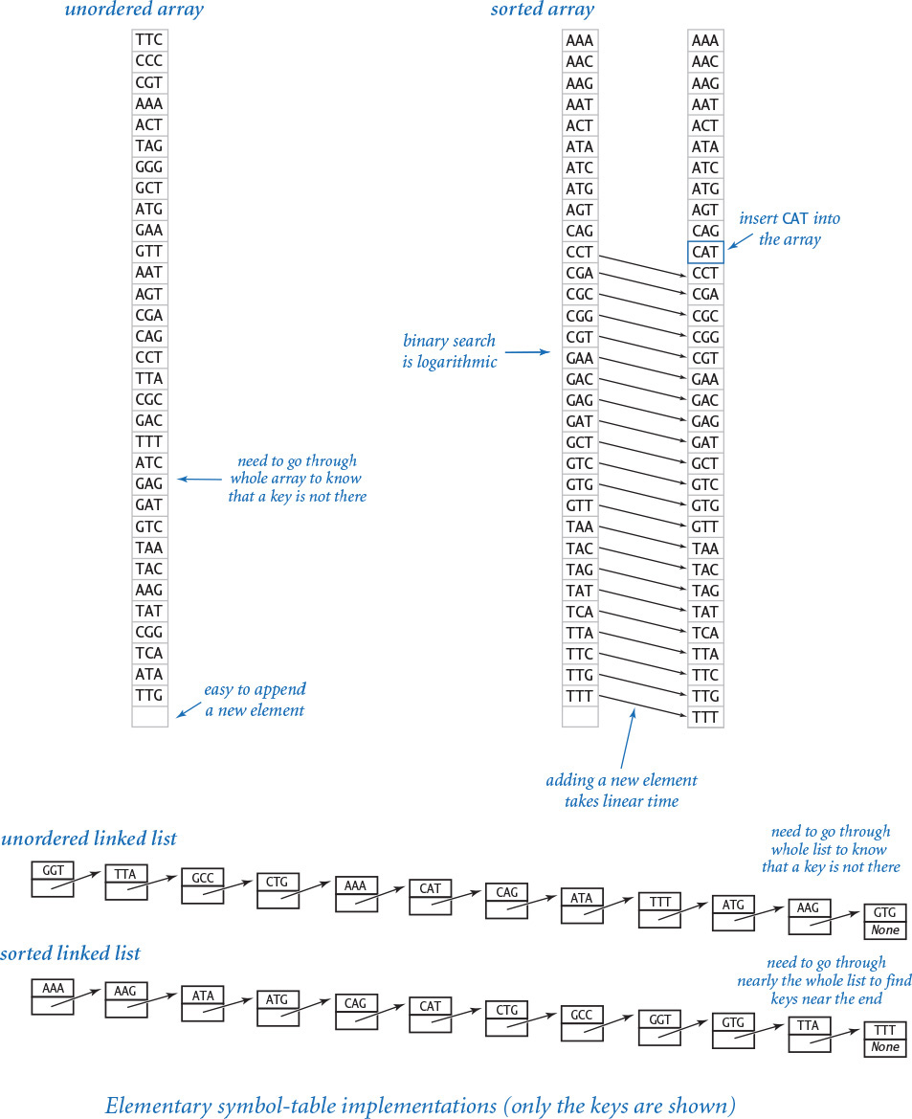
The key array is unordered—we just append new keys at the end. As usual, this is an (amortized) constant-time operation for Python lists. But a search for a key in the symbol table is typically a linear-time operation: For example, if we are looking for a key that is not in the table, we have to examine all of the keys.
To respond to the linear-time search cost, we might use a sorted (resizing) array for the keys. Actually, we already considered the idea of a dictionary when we considered binary search in SECTION 4.2. It is not difficult to build a symbol-table implementation that is based on binary search (see EXERCISE 4.4.5) but such an implementation is not feasible for use with a client like index.py, because it depends on maintaining a resizing array sorted in order of the keys. Each time a new key is added, larger keys have to be shifted one position higher in the array, which implies that the total time required to build the table is quadratic in the size of the table.
Alternatively, we might consider basing an implementation on an unordered linked list, because we can quickly add new key–value pairs at the beginning. But such an implementation is also not feasible for use by typical clients, because the only way to search for a key in a linked list is to traverse its links, so the total time required for searches is the product of the number of searches and the size of the table, which again is prohibitive. Associating a key with a value is also slow because we have to search first to avoid putting duplicate keys in the symbol table. Even keeping the linked list in sorted order does not help much—for example, traversing all the links is still required to add a new node to the end of the linked list.
To implement a symbol table that is feasible for use with clients such as lookup.py and index.py, we need data structures that are more flexible and efficient than these elementary examples. Next, we consider two examples of such data structures: the hash table and the binary search tree.

Hash tables
A hash table is a data structure in which we divide the keys into small groups that can be quickly searched. The basic idea is simple. We choose a parameter m and divide the keys into m groups, which we expect to be about equal in size. For each group, we keep the keys in a list and use sequential search, as in the elementary implementation we just considered.
To divide the keys into small groups, we use a function called a hash function that maps every possible key into a hash value—an integer between 0 and m – 1. This enables us to model the symbol table as a fixed-length array of lists and use the hash value as an array index to access the desired list. In Python, we can implement both the fixed-length array and the lists using the built-in list data type.
Hashing is widely useful, so many programming languages include direct support for it. As we saw in SECTION 3.3, Python provides the built-in hash() function for this purpose, which takes a hashable object as an argument returns an integer hash code. To convert that to a hash value between 0 and m – 1, we use the expression
hash(x) % m
Recall that an object is hashable if it satisfies the following three properties:
• The object can be compared for equality with other objects.
• Whenever two objects compare as equal, they have the same hash code.
• The object’s hash code does not change during its lifetime.
Objects that are not equal may have the same hash code. However, for good performance, we expect the hash function to divide our keys into m groups of roughly equal length.
At right are hash codes and hash values for 12 representative string keys, with m = 5. The hash codes and hash values on your system may differ, due to a different or randomized hash() implementation.
With this preparation, implementing an efficient symbol table with hashing is a straightforward extension of the sequential search code that we have already considered. For the keys, we maintain an array of m lists, with element i containing a Python list of keys whose hash value is i. For the values, we maintain a parallel array of m lists, so that when we have located a key, we can access the corresponding value using the same indices. PROGRAM 4.4.3 (hashst.py) is a full implementation, using a fixed number of m lists (1,024 by default).
The efficiency of hashst.py depends on the value of m and the quality of the hash function. Assuming the hash function reasonably distributes the keys, performance is about m times faster than that for sequential search, at the cost of m extra references and lists. This is a classic space–time tradeoff: the higher the value of m, the more space we use, but the less time we spend.
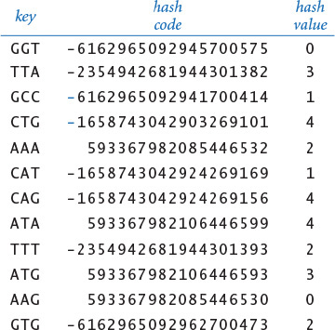
Program 4.4.3 Hash table (hashst.py)
Click here to view code image
import stdio
import stdarray
class SymbolTable:
def __init__(self, m=1024):
self._m = m
self._keys = stdarray.create2D(m, 0)
self._vals = stdarray.create2D(m, 0)
def __getitem__(self, key):
i = hash(key) % self._m
for j in range(len(self._keys[i])):
if self._keys[i][j] == key:
return self._vals[i][j]
raise KeyError
def __setitem__(self, key, val):
i = hash(key) % self._m
for j in range(len(self._keys[i])):
if self._keys[i][j] == key:
self._vals[i][j] = val
return
self._keys[i] += [key]
self._vals[i] += [val]
instance variables
_m | number of lists
_keys | array of lists (keys)
_vals | array of lists (values)
This program uses two parallel arrays of lists to implement a hash table. Each list is represented as a Python list of varying length. The hash function selects one of the m lists. When there are n keys in the table, the average cost of a put or get operation is n/m, for suitable hash() functions. This cost per operation is constant if we use a resizing array to ensure that the average number of keys per list is between 1 and 8 (see EXERCISE 4.4.12). We defer implementations of __contains__() to EXERCISE 4.4.11 and __iter__() to EXERCISE 4.4.34.
The figure at left shows the symbol table built for our sample keys, inserted in the order given on page 648. (To save space, we omit the resizing array capacities in the Python lists in this diagram.) First, GGT is inserted in list 0, then TTA is inserted in list 3, then GCC is inserted in list 1, and so forth. After the table is built, a search for TTT starts by computing its hash value and then searching through _keys[2]. After finding the key TTT at _keys[2][1], __getitem__() returns the entry _vals[2][1], or Phenylalnine.
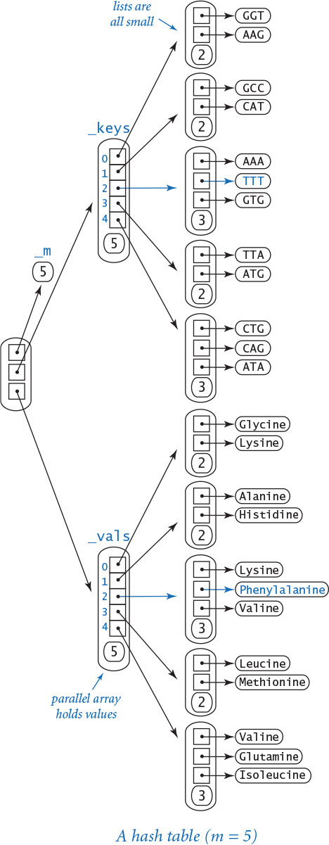
Typically, programmers choose a large fixed value of m (like the 1,024 default we have chosen) based on a rough estimate of the number of keys to be handled. With more care, we can arrange things so that the average number of keys per list is a constant, using resizing arrays for _keys[] and _vals[]. For example, EXERCISE 4.4.12 shows how to ensure that the average number of keys per list is always between 1 and 8, which leads to constant (amortized) time performance for both put and get. There is certainly opportunity to adjust these parameters to best fit a given practical situation.
The primary disadvantage of hash tables is that they do not take advantage of order in the keys and therefore cannot provide the keys in sorted order or support efficient implementations of operations like finding the minimum or maximum. For example, the keys will come out in arbitrary order in index.py, not the sorted order that is called for. Next, we consider a symbol table implementation that can support such operations when keys are comparable, without sacrificing much performance.

Binary search trees
The binary tree is a mathematical abstraction that plays a central role in the efficient organization of information. As with arrays, linked lists, and hash tables, we use binary trees to store collections of data. Binary trees play an important role in computer programming because they strike an efficient balance between flexibility and ease of implementation.
For symbol-table implementations, we use a special type of binary tree to organize the data and to provide a basis for efficient implementations of the symbol-table put operations and get requests. A binary search tree (BST) associates comparable keys with values, in a structure defined recursively. A BST is one of the following:
• Empty (None)
• A node having a key–value pair and two references to BSTs, a left BST with smaller keys and a right BST with larger keys
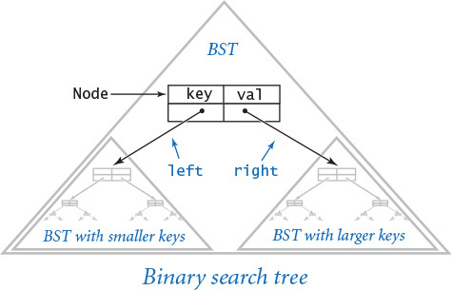
The keys must be comparable via the < operator. The type of the value is not specified, so a BST node can hold any kind of data in addition to the key and the (characteristic) references to BSTs. As with our linked-list definition in SECTION 4.3, the idea of a recursive data structure can be a bit mind bending, but all we are doing is adding a second link to our linked-list definition (and imposing an ordering restriction).
To implement BSTs, we start with a class for the node abstraction, which has references to a key, a value, and left and right BSTs:
Click here to view code image
class Node:
def __init__(self, key, val):
self.key = key
self.val = val
self.left = None
self.right = None
This definition is like our definition of nodes for linked lists, except that it has two links, not just one. From the recursive definition of BSTs, we can represent a BST with a variable of type Node by ensuring that its value is either None or a reference to a Node whose left and right instance variables are references to BSTs, and by ensuring that the ordering condition is satisfied (keys in the left BST are smaller than key and keys in the right BST are larger than key).
The result of Node(key, val) is a reference to a Node object whose key and val instance variables are set to the given values and whose left and right instance variables are both initialized to None.
As with linked lists, when tracing code that uses BSTs, we can use a visual representation of the changes:
• We draw a rectangle to represent each object.
• We put the values of instance variables within the rectangle.
• We depict references as arrows that point to the referenced object.
Most often, we use an even simpler abstract representation where we draw rectangles containing keys to represent nodes (suppressing the values) and connect the nodes with arrows that represent links. This abstract representation allows us to focus on the structure.
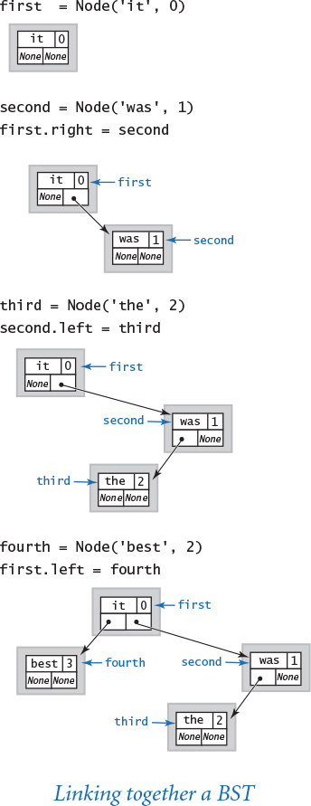
For example, to build a one-node BST that associates the string key 'it' with the integer value 0, we just create a Node:
first = Node('it', 0)
Since the left and right links are both None, both refer to BSTs, so this node is a BST. To add a node that associates the key 'was' with the value 1, we create another Node:
second = Node('was', 1)
(which itself is a BST) and link to it from the right field of the first Node
first.right = second
The second node has to go to the right of the first because 'it' compares as less than 'was' (or we could have chosen to set second.left to first). Now we can add a third node that associates the key 'the' with the value 2 with the code:
third = Node('the', 2)
second.left = third
and a fourth node that associates the key 'best' with the value 3 with the code
fourth = new Node('best', 3)
first.left = fourth
Note that each of our links—first, second, third, and fourth—are, by definition, BSTs (each is either None or refers to BSTs, and the ordering condition is satisfied at each node).
We often use tree-based terminology when discussing BSTs. We refer to the node at the top as the root of the tree, the BST referenced by its left link as the left subtree, and the BST referenced by its right link as the right subtree. Traditionally, computer scientists draw trees upside down, with the root at the top. Nodes whose links are both null are called leaf nodes. The height of a tree is the maximum number of links on any path from the root node to a leaf node. Trees have many applications in science, mathematics, and computational applications, so you are certain to encounter this model on many occasions.
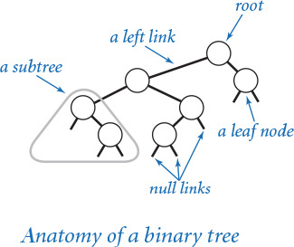
In the present context, we take care to ensure that we always link together nodes such that every Node that we create is the root of a BST (has a key, a value, a link to a left BST with smaller values, and a link to a right BST with a larger value). From the standpoint of the BST data structure, the value is immaterial, so we often ignore it in our diagrams. We also intentionally confuse our nomenclature, using st to signify both “symbol table” and “search tree” because search trees play such a central role in symbol-table implementations.
A BST represents an ordered sequence of items. In the example considered on the previous page, first represents the sequence best it the was. As we have seen, we might also use an array to represent an ordered sequence. For example, we could use
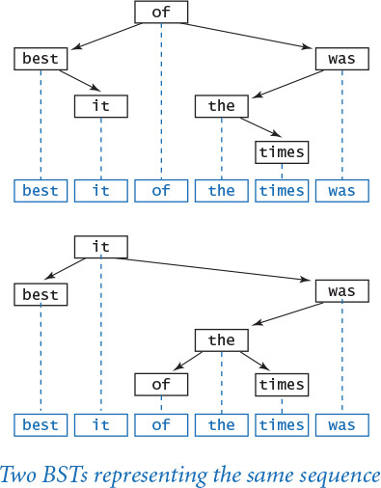
Click here to view code image
a = ['best', 'it', 'the', 'was']
to represent the same ordered sequence of strings. Given a set of distinct keys, there is only one way to represent the set as an ordered array, but there are many ways to represent the set as a BST (see EXERCISE 4.4.14). This flexibility allows us to develop efficient symbol-table implementations. For instance, in our example we were able to insert each new item by creating a new node and changing just one link. As it turns out, it is always possible to do so. Equally important, we can easily find a given key in the tree and find the place where we need to add a link to a new node with a given key. Next, we consider symbol-table code that accomplishes these tasks.
Suppose that you want to search for a node with a given key in a BST (or to get a value with a given key in a symbol table). There are two possible outcomes: the search might be successful (we find the key in the BST; in a symbol-table implementation, we return the associated value) or it might be unsuccessful (there is no key in the BST with the given key; in a symbol-table implementation, we raise a run-time error).
A recursive searching algorithm is immediate: Given a BST (a reference to a Node), first check whether the tree is empty (the reference is None). If so, then terminate the search as unsuccessful (in a symbol-table implementation, raise a run-time error). If the tree is nonempty, check whether the key in the node is equal to the search key. If so, then terminate the search as successful (in a symbol-table implementation, return the value associated with the key). If not, compare the search key with the key in the node. If it is smaller, search (recursively) in the left subtree; if it is greater, search (recursively) in the right subtree.
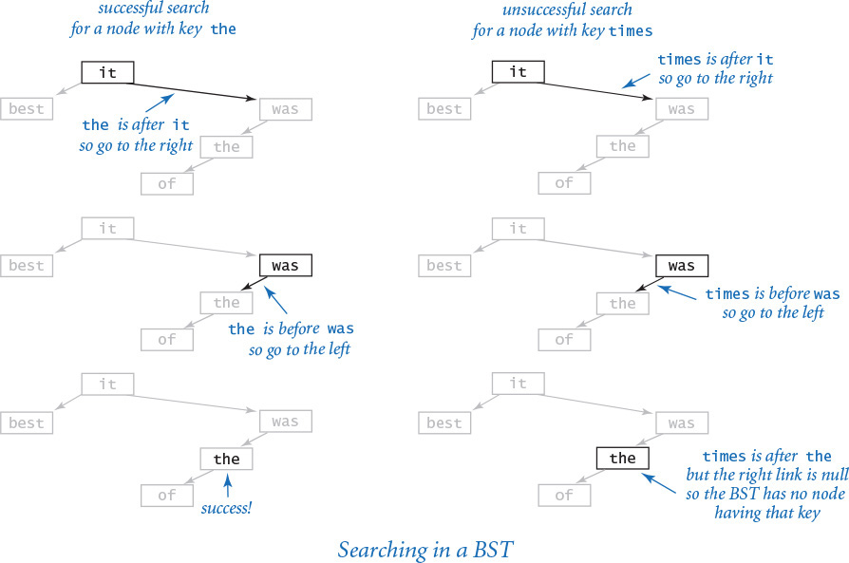
Thinking recursively, it is not difficult to become convinced that this method behaves as intended, based on the invariant that the key is in the BST if and only if it is in the current subtree. The key property of the recursive method is that we always have just one node to examine to decide what to do next. Moreover, we typically examine only a small number of the nodes in the tree: whenever we go to one of the subtrees at a node, we will never examine any of the nodes in the other subtree.
Suppose that you want to insert a new node into a BST (in a symbol-table implementation, put a new key–value pair into the data structure). The logic is similar to searching for a key, but the implementation is trickier. The key to understanding it is to realize that only one link must be changed to point to the new node, and that link is precisely the link that would be found to be None in an unsuccessful search for the key in that node.
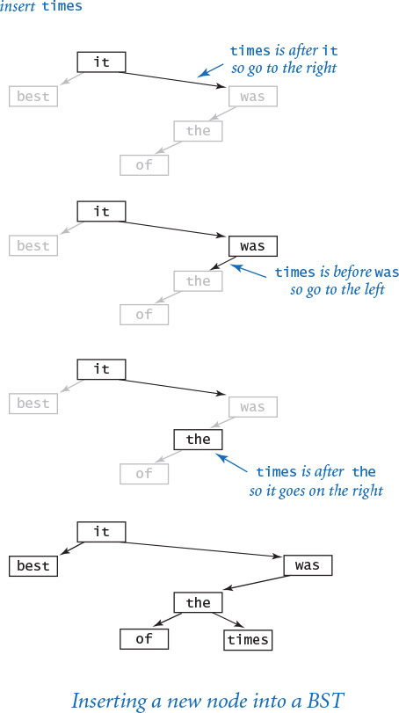
If the BST is empty, we create and return a new Node containing the key–value pair; if the search key is less than the key at the root, we set the left link to the result of inserting the key–value pair into the left subtree; if the search key is greater, we set the right link to the result of inserting the key–value pair into the right subtree; otherwise, if the search key is equal, we overwrite the existing value with the new value. Resetting the left or right link after the recursive call in this way is usually unnecessary, because the link changes only if the subtree is empty, but it is as easy to set the link as it is to test to avoid setting it.
Program 4.4.4 Binary search tree (bst.py)
Click here to view code image
class OrderedSymbolTable:
def __init__(self):
self._root = None
def _get(self, x, key):
if x is None: raise KeyError
if key < x.key: return self._get(x.left, key)
elif x.key < key: return self._get(x.right, key)
else: return x.val
def __getitem__(self, key):
return self._get(self._root, key)
def _set(self, x, key, val):
if x is None: return _Node(key, val)
if key < x.key: x.left = self._set(x.left, key, val)
elif x.key < key: x.right = self._set(x.right, key, val)
else: x.val = val
return x
def __setitem__(self, key, val):
self._root = self._set(self._root, key, val)
class _Node:
def __init__(self, key, val):
self.key = key
self.val = val
self.left = None
self.right = None
instance variable for BST
_root | BST root
instance variables for Node
key | key
val | value
left | left subtree
right | right subtree
This implementation of the symbol-table data type is centered on the recursive BST data structure and recursive methods for traversing it. We defer implementations of __contains__() to EXERCISE 4.4.13 and __iter__() to page 661.
PROGRAM 4.4.4 (bst.py) is a symbol-table implementation based on these two recursive algorithms. As with linkedstack.py and linkedqueue.py, we use a private _Node class to emphasize that clients of OrderedSymbolTable do not need to know any of the details of the binary search tree representation.
If you compare bst.py with our binary search implementation binarysearch.py (PROGRAM 4.2.3) and our stack and queue implementations linkedstack.py (PROGRAM 4.3.2) and linkedqueue.py (PROGRAM 4.3.4), you will appreciate the elegance and simplicity of this code. Take the time to think recursively and convince yourself that this code behaves as intended. Perhaps the simplest way to do so is to trace the construction of an initially empty BST from a sample sequence of keys (see the diagram at right). Your ability to do so is a sure test of your understanding of this fundamental data structure.
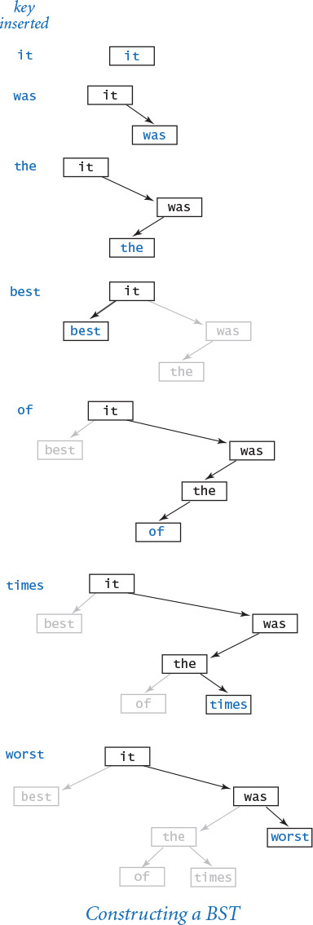
Moreover, the put and get implementations in BST are remarkably efficient; typically, each accesses a small number of the nodes in the BST (those on the path from the root to the node sought or to the null link that is replaced by a link to the new node). Next, we show that put operations and get requests take logarithmic time (under certain assumptions). Also, to add a new key–value pair to the symbol table, only one new node is created and linked onto the bottom of the tree. If you make a drawing of a BST built by inserting some keys into an initially empty tree, you certainly will be convinced of this fact—you can just draw each new node at its unique position at the bottom of the tree.

Performance characteristics of BSTs
The running times of BST algorithms are ultimately dependent on the shape of the trees, and the shape of the trees is dependent on the order in which the keys are inserted. Understanding this dependence is a critical factor in being able to use BSTs effectively in practical situations.

Best case
In the best case, the tree is perfectly balanced (each Node has exactly two children that are not None, except the nodes at the bottom, which have exactly two children that are None), with lg n nodes between the root node and each leaf node. In such a tree, it is easy to see that the cost of an unsuccessful search is logarithmic,
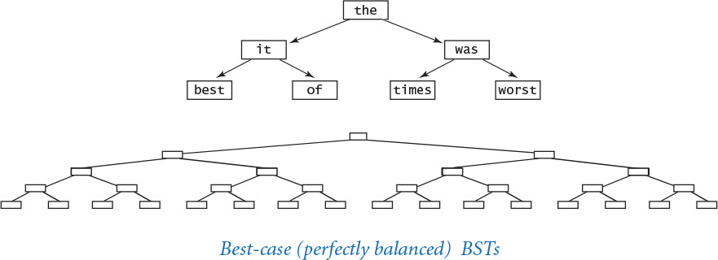
because that cost satisfies the same recurrence relation as the cost of binary search (see SECTION 4.2) so that the cost of every put operation and get request is proportional to lg n or less. You would have to be quite lucky to get a perfectly balanced tree like this by inserting keys one by one in practice, but it is worthwhile to know the best possible performance characteristics.
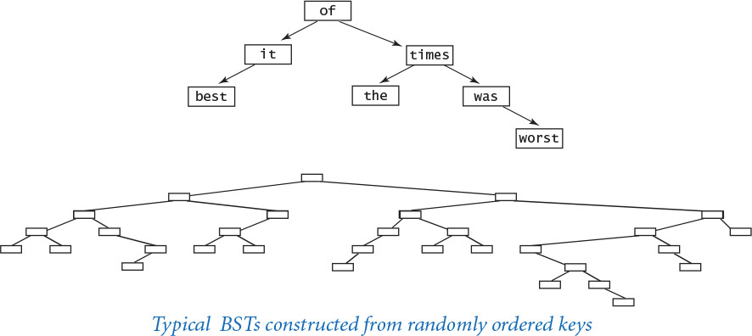

Average case
If we insert random keys, we might expect the search times to be logarithmic as well, because the first key becomes the root of the tree and should divide the keys roughly in half. Applying the same argument to the subtrees, we expect to get about the same result as for the best case. This intuition is, indeed, validated by careful analysis: a classic mathematical derivation shows that the time required for put and get in a tree constructed from randomly ordered keys is logarithmic (see the booksite for references). More precisely, the expected number of key comparisons is ~2 ln n for a random put or get in a tree built from n randomly ordered keys. In a practical application such as lookup.py, when we can explicitly randomize the order of the keys, this result suffices to (probabilistically) guarantee logarithmic performance. Indeed, since 2 ln n is about 1.39 lg n, the average case is only about 39% greater than the best case. In an application like index.py, where we have no control over the order of insertion, there is no guarantee, but typical data gives logarithmic performance (see EXERCISE 4.4.26). As with binary search, this fact is very significant because of the enormousness of the logarithmic–linear chasm: with a BST-based symbol table implementation, we can perform millions of operations per second (or more), even in a huge symbol table.

Worst case
In the worst case, each node has exactly one null link, so the BST is like a linked list with an extra wasted link, where put operations and get requests take linear time. Unfortunately, this worst case is not rare in practice—it arises, for example, when we insert the keys in order.
Thus, good performance of the basic BST implementation is dependent on the keys being sufficiently similar to random keys that the tree is not likely to contain many long paths. If you are not sure that assumption is justified, do not use a simple BST. Your only clue that something is amiss will be slow response time as the problem size increases. (Note: It is not unusual to encounter software of this sort!) Remarkably, there are BST variants that eliminate this worst case and guarantee logarithmic performance per operation, by making all trees nearly perfectly balanced. One popular variant is known as a red-black tree.
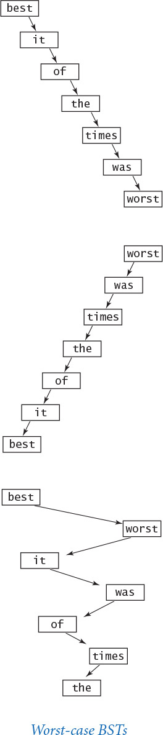

Traversing a BST
Perhaps the most basic tree-processing function is known as tree traversal: given a (reference to) a tree, we want to systematically process every key–value pair in the tree. For linked lists, we accomplish this task by following the single link to move from one node to the next. For binary trees, however, we have decisions to make, because there are generally two links to follow. Recursion comes immediately to the rescue. To process every key in a BST:
• Process every key in the left subtree.
• Process the key at the root.
• Process every key in the right subtree.
This approach is known as inorder tree traversal, to distinguish it from preorder (do the root first) and postorder (do the root last), which arise in other applications. Given a BST, it is easy to convince yourself with mathematical induction that not only does this approach process every key in the BST, but that it processes them in key-sorted order. For example, the following method writes the keys in the BST rooted at its argument in key-sorted order:
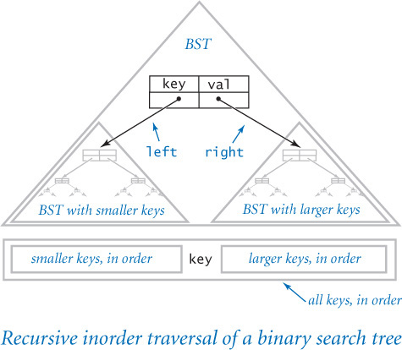
def inorder(x):
if x is None: return
inorder(x.left)
stdio.writeln(x.key)
inorder(x.right)
This remarkably simple method is worthy of careful study. It can be used as a basis for a str() implementation for BSTs (see EXERCISE 4.4.23) and as a starting point for developing the iterator that we need to provide clients with the ability to use a for loop to process the keys in key-sorted order. Indeed, one of the fundamental operations on a collection is to iterate over its items. The paradigm that we consider next leads to clear and compact code that is largely separate from the details of the collection’s implementation. In the case of BSTs, it takes advantage of this natural procedure for traversing a tree.

Iterables
As you learned in SECTION 1.3 and SECTION 1.4, you can use a for loop to iterate over either integers in a range or elements in an array a[].
Click here to view code image
for i in range(n): for v in a:
stdio.writeln(i) stdio.writeln(v)
The for loop is not just for integer ranges and arrays—you can use it with any iterable object. An iterable object is an object that is capable of returning its items one at a time. All of Python’s sequence types—including list, tuple, dict, set, and str—are iterable, as is the object returned by the built-in range() function.
Now, our goal is to make SymbolTable iterable, so that we can use a for loop to iterate over its keys (and use indexing to get the corresponding values):
Click here to view code image
st = SymbolTable()
...
for key in st:
stdio.writeln(str(key) + ' ' + str(st[key]))
To make a user-defined date type iterable, you must implement the special method __iter__(), in support of the built-in function iter(). The iter() function creates and returns an iterator, which is a data type that includes a special method __next__() that Python calls at the beginning of each iteration of a for loop.
While this appears complicated, we can use a shortcut based on the fact that Python lists are iterable: if a is a Python list, then iter(a) returns an iterator over its items. With this in mind, making our sequential-search symbol table (from page 645) iterable is a one-liner:
def __iter__():
return iter(_keys)
Similarly, we can make our hash table and binary search tree implementations iterable by collecting the keys in a Python list and returning an iterator for that list. For example, to make bst.py iterable, we modify the recursive inorder() method from the previous page to collect the keys in a Python list instead of writing them. Then we can return an iterator for that list, as follows:
Click here to view code image
def __iter__(self):
a = []
self._inorder(self._root, a)
return iter(a)
def _inorder(self, x, a):
if x is None: return
self._inorder(x.left, a)
a += [x.key]
self._inorder(x.right, a)
Python includes several built-in functions that either take iterables as arguments or return iterables, as documented in the API table below.
Python 2 alert
In Python 3, range() returns an iterable of integers; in Python 2, range() returns an array of integers.
Most of these built-in operations take linear time because the default implementation scans through all of the items in the iterable to compute the result. Of course, for performance-critical applications, we would use a symbol table instead of the built-in in construct to test whether an item is in a collection.
Next, we will see that it is also possible to develop implementations of minimum and maximum that are much more efficient than min() and max() when the underlying data structure is a BST, and we can support a broad range of other useful operations as well.
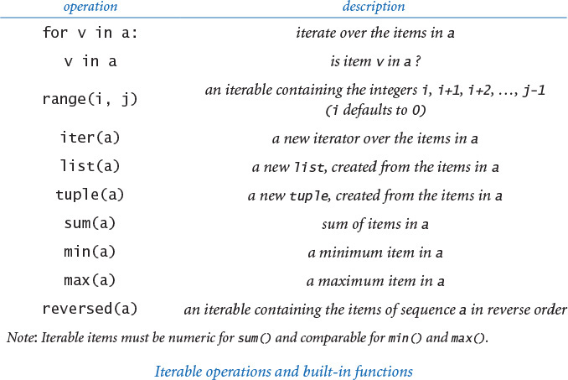

Ordered symbol table operations
The flexibility of BSTs and the ability to compare keys enables the implementation of many useful operations beyond those that can be supported efficiently in hash tables. We leave implementations of these operations for exercises and leave further study of their performance characteristics and applications for a course in algorithms and data structures.

Minimum and maximum
To find the smallest key in a BST, follow left links from the root until reaching None. The last key encountered is the smallest in the BST. The same procedure following right links leads to the largest key in the BST (see EXERCISE 4.4.27).

Size and subtree sizes
To keep track of the number of nodes in a BST, keep an extra instance variable n in OrderedSymbolTable that counts the number of nodes in the tree. Initialize it to 0 and increment it whenever creating a new _Node. Alternatively, keep an extra instance variable n in each _Node that counts the number of nodes in the subtree rooted at that node (see EXERCISE 4.4.29).

Range search and range count
With a recursive method like _inorder(), we can return an iterator for keys falling between two given values in time proportional to the height of the BST plus the number of keys in the range (see EXERCISE 4.4.30). If we maintain an instance variable in each node having the size of the subtree rooted at each node, we can count the number of keys falling between two given values in time proportional to the height of the BST (see EXERCISE 4.4.31).

Order statistics and ranks
If we maintain an instance variable in each node having the size of the subtree rooted at each node, we can implement a recursive method that returns the kth smallest key in time proportional to the height of the BST (see EXERCISE 4.4.64). Similarly, we can compute the rank of a key, which is the number of keys in the BST that are strictly smaller than the key (see EXERCISE 4.4.65).

Remove
Many applications demand the ability to remove a key–value pair with a given key. You can find code for removing a node from a BST on the booksite or in a book on algorithms and data structures (see EXERCISE 4.4.32).
This list is representative; numerous other important operations have been invented for BSTs that are broadly useful in applications.

Dictionary data type
Now that you understand how a symbol table works, you are ready to use Python’s industrial-strength version. The built-in dict data type follows the same basic API as SymbolTable, but with a richer set of operations, including deletion; a version of get that returns a default value if the key is not in the dictionary; and iteration over the key–value pairs. The underlying implementation is a hash table, so ordered operations are not supported. As usual, since Python uses a lower-level language and does not impose on itself the overhead it imposes on all its users, that implementation will be more efficient and is preferred if ordered operations are not important.
As a simple example, the following dict client reads a sequence of strings from standard input, counts the number of times each string appears, and writes the strings and their frequencies. The strings do not come out in sorted order.
Click here to view code image
import stdio
while not stdio.isEmpty():
word = stdio.readString()
st[word] = 1 + st.get(word, 0)
for word, frequency in st.iteritems():
stdio.writef('%4d %s\n', word, frequency)
Several examples of dict clients appear in the exercises at the end of this section.
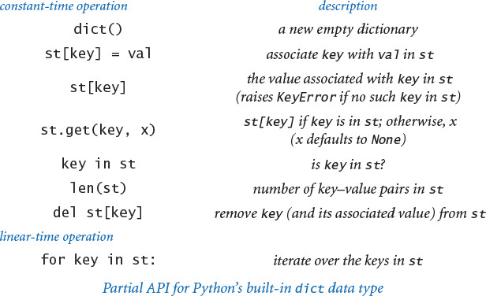

Set data type
As a final example, we consider a data type that is simpler than a symbol table, still broadly useful, and easy to implement with hashing or with BSTs. A set is a collection of distinct keys, like a symbol table with no values. For example, we could implement a set by deleting references to values in hashst.py or bst.py (see EXERCISES 4.4.20 and 4.4.21). Again, Python provides a set data type that is implemented in a lower-level language. A partial API is given at the bottom of this page.
For example, consider the task of reading a sequence of strings from standard input and writing the first occurrence of each string (thereby removing duplicates). We might use a set, as in the following client code:
import stdio
distinct = set()
while not stdio.isEmpty():
key = stdio.readString()
if key not in distinct:
distinct.add(key)
stdio.writeln(key)
You can find several other examples of set clients in the exercises at the end of this section.
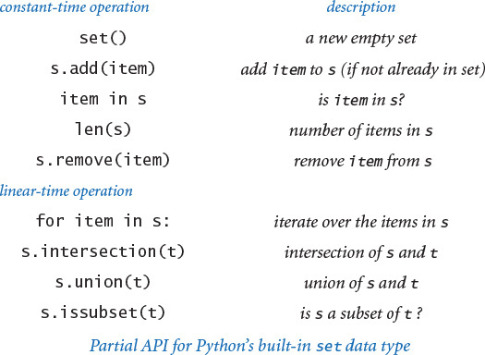

Perspective
Symbol-table implementations are a prime topic of further study in algorithms and data structures. Different APIs and different assumptions about keys call for different implementations. Methods are available that have even better performance than hashing and BSTs under various circumstances. Examples include balanced BSTs and tries. Implementations of many of these algorithms and data structures are found in Python and most other computational environments. Researchers in algorithms and data structures still study symbol-table implementations of all sorts.
Which symbol-table implementation is better, hashing or BSTs? The first point to consider is whether the client has comparable keys and needs symbol-table operations that involve ordered operations such as selection and rank. If so, then you need to use BSTs. If not, most programmers are likely to use hashing, though that choice requires caution in two respects: (1) you need check that you have a good hash function for the key data type, and (2) you need to make sure that the hash table is appropriately sized, either through resizing arrays or an appropriate application-dependent choice.
Should you use Python’s built-in dict and set data types? Of course, if they support the operations that you need, because they are written in a lower-level language, not subject to the overhead Python imposes on user code, and therefore are likely to be faster than anything that you could implement yourself. But if your application needs order-based operations like finding the minimum or maximum, you may wish to consider BSTs.
People use dictionaries, indexes, and other kinds of symbol tables every day. Applications based on symbol tables have completely replaced phone books, encyclopedias, and all sorts of physical artifacts that served us well in the last millennium. Without symbol-table implementations based on data structures such as hash tables and BSTs, such applications would not be feasible; with them, we have the feeling that anything that we need is instantly accessible online.

Q&A
Q. Can I use an array (or Python list) as a key in a dict or set?
A. No, the built-in list data type is mutable, so you should not use arrays as keys in a symbol table or set. In fact, Python lists are not hashable, so you cannot use them as keys in a dict or set. The built-in tuple data type is immutable (and hashable), so you can that instead.
Q. Why doesn’t my user-defined data type work with dict or set?
A. By default, user-defined types are hashable, with hash(x) returning id(x) and == testing reference equality. While these default implementations satisfy the hashable requirements, they rarely provide the behavior you want.
Q. Why can’t I return a Python list directly in the special method __iter__()? Why must I instead call the built-in iter() function with the Python list as an argument?
A. A Python list is an iterable object (because it has an __iter__() method that returns an iterator) but it is not an iterator.
Q. Which data structure does Python use to implement dict and set?
A. Python uses an open-addressing hash table, which is a cousin of the separate-chaining hash table we considered in this section. Python’s implementation is highly optimized and written in a low-level programming language.
Q. Does Python provide language support for specifying set and dict objects?
A. Yes, you can specify a set by enclosing in curly braces a comma-separated list of its items. You can specify a dict by enclosing in curly braces a comma-separated list of its key–value pairs, with a colon between each key and its associated value.
Click here to view code image
stopwords = {'and', 'at', 'of', 'or', on', 'the', 'to'}
grades = {'A+':4.33, 'A':4.0, 'A-':3.67, 'B+':3.33, 'B':3.0}
Q. Does Python provide a built-in data type for an ordered symbol table (or ordered set) that supports ordered iteration, order statistics, and range search?
A. No. If you need only ordered iteration (with comparable keys), you could use Python’s dict data type and sort the keys (and pay a performance hit for sorting). For example, if you use a dict instead of a binary search tree in index.py, you can arrange to write the keys in sorted order by using code like
for word in sorted(st):
If you need other ordered symbol table operations (such as range search or order statistics), you can use our binary search tree implementation (and pay a performance hit for using a data type that is implemented in Python).

Exercises
4.4.1 Modify lookup.py to make a program lookupandput.py that allows put operations to be specified on standard input. Use the convention that a plus sign indicates that the next two strings typed are the key–value pair to be inserted.
4.4.2 Modify lookup.py to make a program lookupmultiple.py that handles multiple values having the same key by collecting the values in an array, as in index.py, and then writing them all out on a get request, as follows:
Click here to view code image
% python lookupmultiple.py amino.csv 3 0
Leucine
TTA TTG CTT CTC CTA CTG
4.4.3 Modify index.py to make a program indexbykeyword.py that takes a file name from the command line and makes an index from standard input using only the keywords in that file. Note: Using the same file for indexing and keywords should give the same result as index.py.
4.4.4 Modify index.py to make a program indexlines.py that considers only consecutive sequences of letters as keys (no punctuation or numbers) and uses line numbers instead of word position as the value. This functionality is useful for programs: When given a Python program as input, indexlines.py should write an index showing each keyword or identifier in the program (in sorted order), along with the line numbers on which it occurs.
4.4.5 Develop an implementation OrderedSymbolTable of the symbol-table API that maintains parallel arrays of keys and values, keeping them in key-sorted order. Use binary search for get, and move larger elements to the right by one position for put (using resizing arrays to keep the array length linear in the number of key–value pairs in the table). Test your implementation with index.py, and validate the hypothesis that using such an implementation for index.py takes time proportional to the product of the number of strings and the number of distinct strings in the input.
4.4.6 Develop an implementation LinkedSymbolTable of the symbol-table API that maintains a linked list of nodes containing keys and values, keeping them in arbitrary order. Test your implementation with index.py, and validate the hypothesis that using such an implementation for index.py takes time proportional to the product of the number of strings and the number of distinct strings in the input.
4.4.7 Compute hash(x) % 5 for the single-character keys
E A S Y Q U E S T I O N
In the style of the drawing in the text, draw the hash table created when the ith key in this sequence is associated with the value i, for i from 0 to 11.
4.4.8 What is wrong with the following __hash__() implementation?
def __hash__(self):
return -17
Solution: While technically it satisfies the conditions needed for a data type to be hashable (if two objects are equal, they have the same hash value), it will lead to poor performance because we expect hash(x) % m to divide keys into m groups of roughly equal size.
4.4.9 Extend Complex (PROGRAM 3.2.6) and Vector (PROGRAM 3.3.3) to make them hashable by implementing the special methods __hash__() and __eq__().
4.4.10 Implement the special method __contains__() for the sequential-search symbol table on page 645.
4.4.11 Implement the special method __contains__() for hashst.py.
4.4.12 Modify hashst.py to use a resizing array so that the average length of the list associated with each hash value is between 1 and 8.
4.4.13 Implement the special method __contains__() for bst.py.
4.4.14 Draw all the different BSTs that can represent the key sequence
best of it the time was
4.4.15 Draw the BST that results when you insert items with keys
E A S Y Q U E S T I O N
in that order into an initially empty tree. What is the height of the resulting BST?
4.4.16 Suppose we have integer keys between 1 and 1000 in a BST and search for 363. Which of the following cannot be the sequence of keys examined?
a. 2 252 401 398 330 363
b. 399 387 219 266 382 381 278 363
c. 3 923 220 911 244 898 258 362 363
d. 4 924 278 347 621 299 392 358 363
e. 5 925 202 910 245 363
4.4.17 Suppose that the following 31 keys appear (in some order) in a BST of height 5:
Click here to view code image
10 15 18 21 23 24 30 30 38 41 42 45 50 55 59
60 61 63 71 77 78 83 84 85 86 88 91 92 93 94 98
Draw the top three nodes of the tree (the root and its two children).
4.4.18 Describe the effect on performance if you replaced hashst with bst in lookup.py. To protect against the worst case, call stdrandom.shuffle(database)before processing client queries.
4.4.19 True or false: Given a BST, let x be a leaf node, and let p be its parent. Then either (i) the key of p is the smallest key in the BST larger than the key of x or (ii) the key of p is the largest key in the BST smaller than the key of x.
4.4.20 Modify the class SymbolTable in hashst.py to make a class Set that implements the constant-time operations in the partial API given in the text for Python’s built-in set data type.
4.4.21 Modify the class OrderedSymbolTable in bst.py to make a class OrderedSet that implements the constant-time operations in the partial API given in the text for Python’s built-in set data type, assuming that the keys are comparable.
4.4.22 Modify hashst.py to support the client code del st[key] by adding a method __delitem__() that takes a key argument and removes that key (and the corresponding value) from the symbol table, if it exists. As in EXERCISE 4.4.12, use a resizing array to ensure that the average length of the list associated with each hash value is between 1 and 8.
4.4.23 Implement __str__() for bst.py, using a recursive helper method like traverse(). As usual, you can accept quadratic performance because of the cost of string concatenation. Extra credit: Compose a linear-time __str__() method for bst.py that uses an array and the join() method of Python’s built-in str data type.
4.4.24 A concordance is an alphabetical list of the words in a text that gives all word positions where each word appears. Thus, python index.py 0 0 produces a concordance. In a famous incident, one group of researchers tried to establish credibility while keeping details of the Dead Sea Scrolls secret from others by making public a concordance. Compose a program invertconcordance.py that takes a command-line argument n, reads a concordance from standard input, and writes the first n words of the corresponding text on standard output.
4.4.25 Run experiments to validate the claims in the text that the put operations and get requests for lookup.py are constant-time operations when using hashst.py with resizing arrays, as described in EXERCISE 4.4.12. Develop test clients that generate random keys and also run tests for various data sets, either from the booksite or of your own choosing.
4.4.26 Run experiments to validate the claims in the text that the put operations and get requests for index.py are logarithmic in the size of the symbol table when using bst.py. Develop test clients that generate random keys and also run tests for various data sets, either from the booksite or of your own choosing.
4.4.27 Modify bst.py to add methods min() and max() that return the smallest (or largest) key in the table (or None if the table is empty).
4.4.28 Modify bst.py to add methods floor() and ceiling() that take as an argument a key and return the largest (smallest) key in the set that is no larger (no smaller) than the given key.
4.4.29 Modify bst.py to support the special len() function by implementing a special method __len__() that returns the number of key–value pairs in the symbol table. Use the approach of storing within each _Node the number of nodes in the subtree rooted there.
4.4.30 Modify bst.py to add a method rangeSearch() that take two keys lo and hi as arguments and return an iterator over all keys that are between lo and hi. The running time should be proportional to the height plus the number of keys in the range.
4.4.31 Modify bst.py to add a method rangeCount() that takes keys as arguments and returns the number of keys in a BST between the two given keys. Your method should take time proportional to the height of the tree. Hint: First complete the previous exercise.
4.4.32 Modify bst.py to support the client code del st[key] by adding a method __delitem__() that takes a key argument and removes that key (and the corresponding value) from the symbol table, if it exists. Hint: This operation is more difficult than it might seem. Replace the key and its associated value with the next largest key in the BST and its associated value; then remove from the BST the node that contained the next largest key.
4.4.33 Implement the special method __iter__() for the sequential-search symbol table on page 645.
4.4.34 Implement the special method __iter__() for hashst.py to support iteration.
Solution: Collect all the keys in a list.
Click here to view code image
def __iter__(self):
a = []
for i in range(self._m):
a += self._keys[i]
return iter(a)
4.4.35 Modify the symbol-table API to handle values with duplicate keys by having get() return an iterator for the values having a given key. Reimplement hashst.py and bst.py as dictated by this API. Discuss the pros and cons of this approach versus the one given in the text.
4.4.36 Suppose that a[] is an array of hashable objects. What is the effect of the following statement?
a = list(set(a))
4.4.37 Recompose lookup.py and index.py using a dict instead of using hashst.py and bst.py, respectively. Compare performance.
4.4.38 Compose a dict client that creates a symbol table mapping letter grades to numerical scores, as in the table below, and then reads from standard input a list of letter grades and computes their average (GPA).
Click here to view code image
A+ A A- B+ B B- C+ C C- D F
4.33 4.00 3.67 3.33 3.00 2.67 2.33 2.00 1.67 1.00 0.00
4.4.39 Implement the methods buy() and sell() methods in stockaccount.py (PROGRAM 3.2.8). Use a dict to store the number of shares of each stock.

Binary Tree Exercises
The following exercises are intended to give you experience in working with binary trees that are not necessarily BSTs. They all assume a Node class with three instance variables: a positive double value and two Node references. As with linked lists, you will find it helpful to make drawings using the visual representation shown in the text.
4.4.40 Implement the following functions, each of which takes as an argument a Node that is the root of a binary tree.
size(node) number of nodes in the tree rooted at node
leaves(node) number of nodes in the tree rooted at node whose links are both None
total(node) sum of the key values in all nodes in the tree rooted at node
Your methods should all run in linear time.
4.4.41 Implement a linear-time function height() that returns the maximum number of nodes on any path from the root to a leaf node (the height of the empty tree is 0; the height of a one-node tree is 1).
4.4.42 A binary tree is heap-ordered if the key at the root is larger than the keys in all of its descendants. Implement a linear-time function heapOrdered() that returns True if the tree is heap-ordered, and False otherwise.
4.4.43 Given a binary tree, a single-value subtree is a maximal subtree that contains the same value. Design a linear-time algorithm that counts the number of single-value subtrees in a binary tree.
4.4.44 A binary tree is balanced if both its subtrees are balanced and the height of its two subtrees differ by at most 1. Implement a linear-time method balanced() that returns True if the tree is balanced, and False otherwise.
4.4.45 Two binary trees are isomorphic if only their key values differ (that is, they have the same shape). Implement a linear-time function isomorphic() that takes two tree references as arguments and returns True if they refer to isomorphic trees, and False otherwise. Then, implement a linear-time function eq() that takes two tree references as arguments and returns True if they refer to identical trees (isomorphic with the same key values), and False otherwise.
4.4.46 Compose a function levelOrder() that writes BST keys in level order: first write the root; then the nodes one level below the root, from left to right; then the nodes two levels below the root, from left to right; and so forth. Hint: Use a Queue.
4.4.47 Implement a linear-time function isBST() that returns True if the binary tree is a BST, and False otherwise.
Solution: This task is a bit more difficult than it might seem. Use a recursive helper function _inRange() that takes two additional arguments lo and hi and returns True if the binary tree is a BST and all its values are between lo and hi, and use None to represent both the smallest possible key and the largest possible key.
Click here to view code image
def _inRange(node, lo, hi):
if node is None: return True
if (lo is not None) and (node.item <= lo): return False
if (hi is not None) and (hi <= node.item): return False
if not _inRange(node.left, lo, node.item): return False
if not _inRange(node.right, node.item, hi): return False
return True
def _isBST(node):
return _inRange(node, None, None)
We note that this implementation uses both the < and <= operators, whereas our binary search tree code uses only the < operator.
4.4.48 Compute the value returned by mystery() on some sample binary trees, and then formulate a hypothesis about the value and prove it.
Click here to view code image
def mystery(node):
if node is None: return 1
return mystery(node.left) + mystery(node.right)

Creative Exercises
4.4.49 Spell checking. Compose a set client spellchecker.py that takes as a command-line argument the name of a file containing a dictionary of words, and then reads strings from standard input and writes any string that is not in the dictionary. You can find a dictionary file on the booksite. Extra credit: Augment your program to handle common suffixes such as -ing or -ed.
4.4.50 Spell correction. Compose a dict client spellcorrector.py that serves as a filter that replaces commonly misspelled words on standard input with a suggested replacement, writing the result to standard output. Take as a command-line argument a file that contains common misspellings and corrections. You can find an example on the booksite.
4.4.51 Web filter. Compose a set client webblocker.py that takes as a command-line argument the name of a file containing a list of objectionable websites, and then reads strings from standard input and writes only those websites not on the list.
4.4.52 Set operations. Add the methods union() and intersection() to OrderedSet (EXERCISE 4.4.21), each of which takes two sets as arguments and that return the union and intersection, respectively, of those two sets.
4.4.53 Frequency symbol table. Develop a data type FrequencyTable that supports the following operations: click() and count(), both of which take string arguments. The data-type value is an integer that keeps track of the number of times the click() operation has been called with the given string as an argument. The click() operation increments the count by 1, and the count() operation returns the value, possibly 0. Clients of this data type might include a web traffic analyzer, a music player that counts the number of times each song has been played, phone software for counting calls, and so forth.
4.4.54 1D range searching. Develop a data type that supports the following operations: insert a date, search for a date, and count the number of dates in the data structure that lie in a particular interval. Use Python’s datetime.Date data type.
4.4.55 Non-overlapping interval search. Given a list of non-overlapping intervals of integers, compose a function that takes an integer argument and determines in which, if any, interval that value lies. For example, if the intervals are 1643–2033, 5532–7643, 8999–10332, and 5666653–5669321, then the query point 9122 lies in the third interval and 8122 lies in no interval.
4.4.56 IP lookup by country. Compose a dict client that uses the data file ip-to-country.csv found on the booksite to determine from which country a given IP address is coming. The data file has five fields: beginning of IP address range, end of IP address range, two-character country code, three-character country code, and country name. The IP addresses are non-overlapping. Such a database tool can be used for credit card fraud detection, spam filtering, auto-selection of language on a website, and web server log analysis.
4.4.57 Inverted index of web pages with single-word queries. Given a list of web pages, create a symbol table of words contained in the web pages. Associate with each word a list of web pages in which that word appears. Compose a program that reads in a list of web pages, creates the symbol table, and supports single-word queries by returning the list of web pages in which that query word appears.
4.4.58 Inverted index of web pages with multi-word queries. Extend the previous exercise so that it supports multi-word queries. In this case, output the list of web pages that contain at least one occurrence of each of the query words.
4.4.59 Multiple-word search (unordered). Compose a program that takes k keywords from the command line, reads in a sequence of words from standard input, and identifies the smallest interval of text that contains all of the k keywords (not necessarily in the same order). You do not need to consider partial words.
4.4.60 Multiple-word search (ordered). Repeat the previous exercise, but now assume the keywords must appear in the same order as specified.
4.4.61 Repetition draw in chess. In the game of chess, if a board position is repeated three times with the same side to move, the side to move can declare a draw. Describe how you could test this condition using a computer program.
4.4.62 Registrar scheduling. The registrar at a prominent Northeastern university recently scheduled an instructor to teach two different classes at the same exact time. Help the registrar prevent future mistakes by describing a method to check for such conflicts. For simplicity, assume all classes run for 50 minutes and start at 9, 10, 11, 1, 2, or 3.
4.4.63 Entropy. We define the relative entropy of a text corpus with n words, k of which are distinct as
E = 1 / (n lg n) (p0 lg(k/p0) + p1 lg(k/p1) +... +pk–1 lg(k/pk–1))
where pi is the fraction of times that word i appears. Compose a program that reads in a text corpus and writes the relative entropy. Convert all letters to lowercase and treat punctuation marks as whitespace.
4.4.64 Order statistics. Add to bst.py a method select() that takes an integer argument k and returns the kth smallest key in the BST. Maintain subtree sizes in each node (see EXERCISE 4.4.29). The running time should be proportional to the height of the tree.
4.4.65 Rank query. Add to bst.py a method rank() that takes a key as an argument and returns the number of keys in the BST that are strictly smaller than key. Maintain subtree sizes in each node (see EXERCISE 4.4.29). The running time should be proportional to the height of the tree.
4.4.66 Random element. Add to bst.py a method random() that returns a random key. Maintain subtree sizes in each node (see EXERCISE 4.4.29). The running time should be proportional to the height of the tree.
4.4.67 Queue with no duplicates. Create a data type that is a queue, except that an element may appear on the queue at most once at any given time. Ignore requests to insert an item if it is already on the queue.
4.4.68 Unique substrings of a given length. Compose a program that reads in text from standard input and calculates the number of unique substrings of a given length k that it contains. For example, if the input is CGCGGGCGCG, then there are five unique substrings of length 3: CGC, CGG, GCG, GGC, and GGG. This calculation is useful in data compression. Hint: Use the string slice s[i:i+k] to extract the ith substring and insert into a symbol table. Test your program on a large genome from the booksite and on the first 10 million digits of π.
4.4.69 Generalized queue. Implement a class that supports the following API:
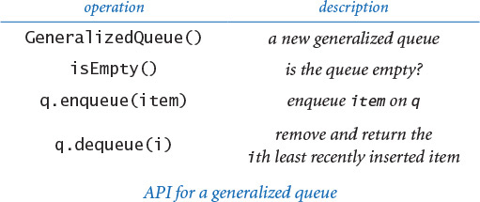
Use a BST that associates the kth element inserted with the key k and maintains in each node the total number of nodes in the subtree rooted at that node. To find the i th least recently added item, search for the ith smallest element in the BST.
4.4.70 Dynamic discrete distribution. Create a data type that supports the following two operations: add() and random(). The add() method should insert a new item into the data structure if it has not been seen before; otherwise, it should increase its frequency count by 1. The random() method should return an element at random, where the probabilities are weighted by the frequency of each element. Use space proportional to the number of items.
4.4.71 Password checker. Compose a program that takes a string as a command-line argument and a dictionary of words from standard input, and checks whether the string is a “good” password. Here, assume “good” means that it (1) is at least eight characters long, (2) is not a word in the dictionary, (3) is not a word in the dictionary followed by a digit 0-9 (e.g., hello5), (4) is not two words in the dictionary concatenated together (e.g., helloworld), and (5) none of (2) through (4) hold for reverses of words in the dictionary.
4.4.72 Random phone numbers. Compose a program that takes a command-line argument n and writes n random phone numbers of the form (xxx) xxx-xxxx. Use a set to avoid choosing the same number more than once. Use only legal area codes (you can find a file of such codes on the booksite).
4.4.73 Sparse vectors. An n-dimensional vector is sparse if its number of nonzero values is small. Your goal is to represent a vector with space proportional to its number of nonzeros, and to be able to add two sparse vectors in time proportional to the total number of nonzeros. Implement a class that supports the following API:
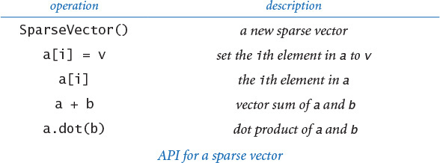
4.4.74 Sparse matrices. An n-by-n matrix is sparse if its number of nonzeros is proportional to n (or less). Your goal is to represent a matrix with space proportional to n, and to be able to add and multiply two sparse matrices in time proportional to the total number of nonzeros (perhaps with an extra log n factor). Implement a class that supports the following API:
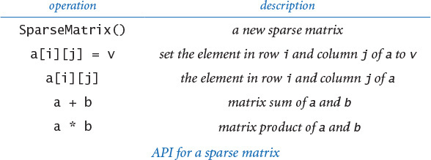
4.4.75 Mutable string. Create a data type that supports the following API on a string. Use a BST to implement all operations in logarithmic time.
4.4.76 Assignment statements. Compose a program to parse and evaluate programs consisting of assignment and write statements with fully parenthesized arithmetic expressions (see PROGRAM 4.3.3). For example, given the input
A = 5
B = 10
C = A + B
D = C * C
write(D)
your program should write the value 225. Assume that all variables and values are floats. Use a symbol table to keep track of variable names.
4.4.77 Codon usage table. Compose a program that uses a symbol table to write summary statistics for each codon in a genome taken from standard input (frequency per thousand), like the following:
Click here to view code image
UUU 13.2 UCU 19.6 UAU 16.5 UGU 12.4
UUC 23.5 UCC 10.6 UAC 14.7 UGC 8.0
UUA 5.8 UCA 16.1 UAA 0.7 UGA 0.3
UUG 17.6 UCG 11.8 UAG 0.2 UGG 9.5
CUU 21.2 CCU 10.4 CAU 13.3 CGU 10.5
CUC 13.5 CCC 4.9 CAC 8.2 CGC 4.2
CUA 6.5 CCA 41.0 CAA 24.9 CGA 10.7
CUG 10.7 CCG 10.1 CAG 11.4 CGG 3.7
AUU 27.1 ACU 25.6 AAU 27.2 AGU 11.9
AUC 23.3 ACC 13.3 AAC 21.0 AGC 6.8
AUA 5.9 ACA 17.1 AAA 32.7 AGA 14.2
AUG 22.3 ACG 9.2 AAG 23.9 AGG 2.8
GUU 25.7 GCU 24.2 GAU 49.4 GGU 11.8
GUC 15.3 GCC 12.6 GAC 22.1 GGC 7.0
GUA 8.7 GCA 16.8 GAA 39.8 GGA 47.2

4.5 Case Study: Small-World Phenomenon
The mathematical model that we use for studying the nature of pairwise connections among entities is known as the graph. Graphs are important for studying the natural world and for helping us to better understand and refine the networks that we create. From models of the nervous system in neurobiology, to the study of the spread of infectious diseases in medical science, to the development of the telephone system, graphs have played a critical role in science and engineering over the past century, including the development of the Internet itself.
4.5.1 Graph data type
4.5.2 Using a graph to invert an index
4.5.3 Shortest-paths client
4.5.4 Shortest-paths implementation
4.5.5 Small-world test
4.5.6 Performer–performer graph
Programs in this section
Some graphs exhibit a specific property known as the small-world phenomenon. You may be familiar with this property, which is sometimes known as six degrees of separation. It is the basic idea that, even though each of us has relatively few acquaintances, there is a relatively short chain of acquaintances (the six degrees of separation) separating us from one another. This hypothesis was validated experimentally by Stanley Milgram in the 1960s and modeled mathematically by Duncan Watts and Stephen Strogatz in the 1990s. In recent years, the principle has proved important in a remarkable variety of applications. Scientists are interested in small-world graphs because they model natural phenomena, and engineers are interested in building networks that take advantage of the natural properties of small-world graphs.
In this section, we address basic computational questions surrounding the study of small-world graphs. Indeed, the simple question
Does a given graph exhibit the small-world phenomenon?
can present a significant computational burden. To address this question, we will consider a graph-processing data type and several useful graph-processing clients. In particular, we will examine a client for computing shortest paths, a computation that has a vast number of important applications in its own right.
A persistent theme of this section is that the algorithms and data structures that we have been studying play a central role in graph processing. Indeed, you will see that several of the fundamental data types introduced earlier in this chapter help us to develop elegant and efficient code for studying the properties of graphs.

Graphs
We begin with some basic definitions. A graph is composed of a set of vertices and a set of edges. Each edge represents a connection between two vertices. Two vertices are neighbors if they are connected by an edge, and the degree of a vertex is its number of neighbors. Note that there is no relationship between a graph and the idea of a function graph (a plot of a function values) or the idea of graphics (drawings). We often visualize graphs by drawing labeled geometric shapes (vertices) connected by lines (edges), but it is always important to remember that it is the connections that are essential, not the way we depict them.
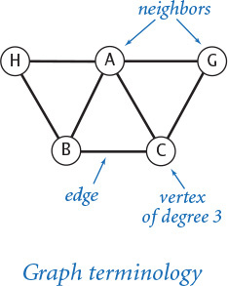
The following list suggests the diverse range of systems where graphs are appropriate starting points for understanding structure.

Transportation systems
Train tracks connect stations, roads connect intersections, and airline routes connect airports, so all of these systems naturally admit a simple graph model. No doubt you have used applications that are based on such models when getting directions from an interactive mapping program or a GPS device, or using an online service to make travel reservations. What is the best way to get from here to there?
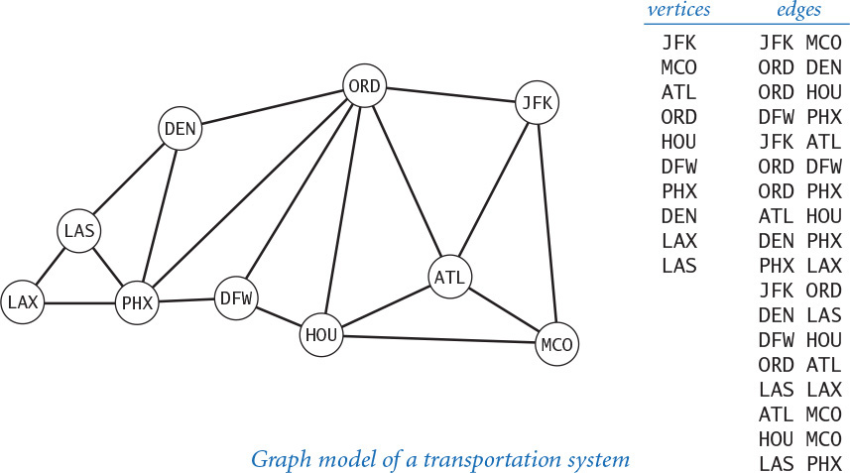

Human biology
Arteries and veins connect organs, synapses connect neurons, and joints connect bones, so an understanding of the human biology depends on understanding appropriate graph models. Perhaps the largest and most important such modeling challenge in this arena is the human brain. How do local connections among neurons translate to consciousness, memory, and intelligence?

Social networks
People have relationships with other people. From the study of infectious diseases to the study of political trends, graph models of these relationships are critical to our understanding of their implications. Hoes does information propagate in online networks?

Physical systems
Atoms connect to form molecules; molecules connect to form a material or a crystal; and particles are connected by mutual forces such as gravity or magnetism. Graph models are appropriate for studying the percolation problem that we considered in SECTION 2.4, the interacting charges that we considered in SECTION 3.1, and the n-body problem that we considered in SECTION 3.4. How do local interactions propagate through such systems as they evolve?
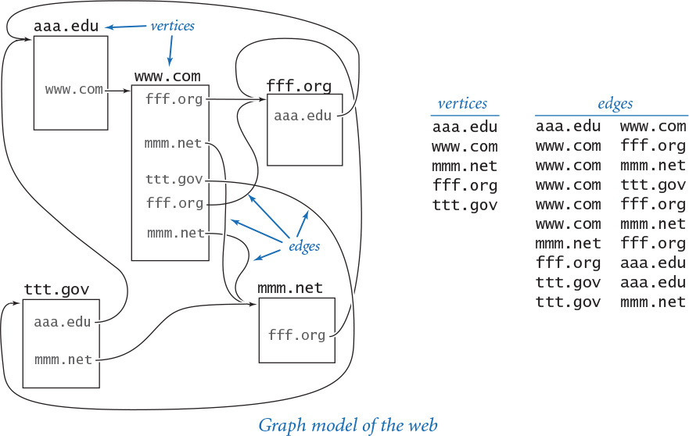

Communications systems
From electric circuits, to the telephone system, to the Internet, to wireless services, communications systems are all based on the idea of connecting devices. For at least the past century, graph models have played a critical role in the development of such systems. What is the best way to connect the devices?

Resource distribution
Power lines connect power stations and home electrical systems, pipes connect reservoirs and home plumbing, and truck routes connect warehouses and retail outlets. The study of effective and reliable means of distributing resources depends on accurate graph models. Where are the bottlenecks in a distribution system?

Mechanical systems
Trusses or steel beams connect joints in a bridge or a building. Graph models help us to design these systems and to understand their properties. Which forces must a joint or a beam withstand?

Software systems
Methods in one program module invoke methods in other modules. As we have seen throughout this book, understanding relationships of this sort is a key to success in software design. Which modules will be affected by a change in an API?

Financial systems
Transactions connect accounts, and accounts connect customers to financial institutions. These are but a few of the graph models that people use to study complex financial transactions, and to profit from better understanding them. Which transactions are routine and which are indicative of a significant event that might translate into profits?
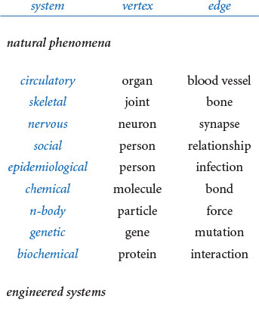
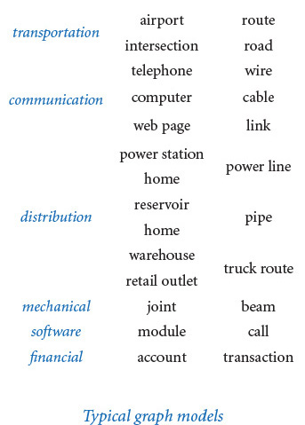
Some of these graphs are models of natural phenomena, where our goal is to gain a better understanding of the natural world by developing simple models and then using them to formulate hypotheses that we can test. Other graph models are of networks that we engineer, where our goal is to build a better network or to better maintain a network by understanding its basic characteristics.
Graphs are useful models whether they are small or massive. A graph having just dozens of vertices and edges (for example, one modeling a chemical compound, where vertices are molecules and edges are bonds) is already a complicated combinatorial object because there are a huge number of possible graphs, so understanding the structures of the particular ones at hand is important. A graph having billions or trillions of vertices and edges (for example, a government database containing all phone calls or a graph model of the human nervous system) is vastly more complex, and presents significant computational challenges.
Processing graphs typically involves building a graph from information in a database and then answering questions about the graph. Beyond the application-specific questions in the examples just cited, we often need to ask basic questions about graphs. How many vertices and edges does the graph have? What are the neighbors of a given vertex? Some questions depend on an understanding of the structure of a graph. For example, a path in a graph is a sequence of vertices connected by edges. Is there a path connecting two given vertices? What is the shortest such path? What is the maximum length of a shortest path in the graph (the graph’s diameter)? We have already seen in this book several examples of questions from scientific applications that are much more complicated than these. What is the probability that a random surfer will land on each vertex? What is the probability that a system represented by a certain graph percolates?
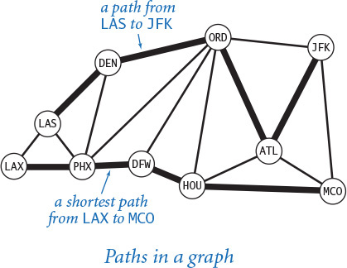
As you encounter complex systems in later courses, you are certain to encounter graphs in many different contexts. You may also study their properties in detail in later courses in mathematics, operations research, or computer science. Some graph-processing problems present insurmountable computational challenges; others can be solved with relative ease with data-type implementations of the sort we have been considering.

Graph data type
Graph-processing algorithms generally first build an internal representation of a graph by adding edges, then process it by iterating through the vertices and through the edges that are adjacent to a vertex. The API at the bottom of this page supports such processing. As usual, this API reflects several design choices, each made from among various alternatives, some of which we now briefly discuss.

Undirected graph
Edges are undirected: an edge that connects v to w is the same as one that connects w to v. Our interest is in the connection, not the direction. Directed edges (for example, one-way streets in road maps) require a slightly different data type (see EXERCISE 4.5.38).

String vertex type
We assume that vertices are strings. We might use a more general vertex type, to allow clients to build graphs with objects of any comparable or hashable type. We leave such implementations to EXERCISE 4.5.10 because string vertices suffice for the applications that we consider here.
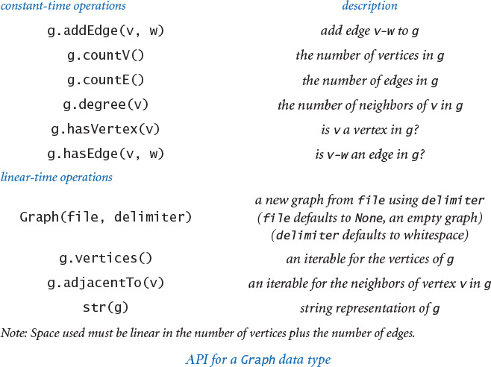

Implicit vertex creation
When an object is used as an argument to addEdge(), we assume that it is a (string) vertex name. If no edge using that name has yet been added, our implementation creates a vertex with that name. The alternative design of having an addVertex() method requires more client code (to create the vertices) and more cumbersome implementation code (to check that edges connect vertices that have previously been created).

Self-loops and parallel edges
Although the API does not explicitly address the issue, we assume that implementations do allow self-loops (edges connecting a vertex to itself) but do not allow parallel edges (two copies of the same edge). Checking for self-loops and parallel edges is easy; our choice is to omit both checks.

Client query methods
We also include the methods countV() and countE() in our API to provide to the client the number of vertices and edges in the graph. Similarly, the methods degree(), hasVertex(), and hasEdge() are useful in client code. All of these implementations are constant-time one-liners.
None of these design decisions is sacrosanct; they are simply the choices that we have made for the code in this book. Some other choices might be appropriate in various situations, and some decisions are still left to implementations. It is wise to carefully consider the choices that you make for design decisions like this and to be prepared to defend them.
PROGRAM 4.5.1 (graph.py) implements this API. Its internal representation is a symbol table of sets: the keys are vertices and the values are the sets of neighbors—the vertices adjacent to the key. A small example is illustrated at right. To implement this representation, we use the two built-in data types dict and set that we introduced in SECTION 4.4. This choice leads to three important properties:
• Clients can efficiently iterate over the graph vertices.
• Clients can efficiently iterate over a vertex’s neighbors.
• Space used is proportional to the number of vertices plus the number of edges.
These properties follow from basic properties of dict and set. As you will see, the two iterators are at the heart of graph processing.
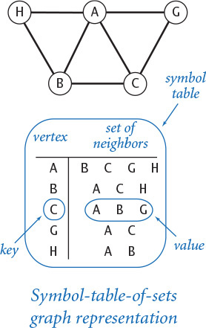
Program 4.5.1 Graph data type (graph.py)
Click here to view code image
import sys
import stdio
from instream import InStream
class Graph:
# See text for __str__() and __init__()
def addEdge(self, v, w):
if not self.hasVertex(v): self._adj[v] = set()
if not self.hasVertex(w): self._adj[w] = set()
if not self.hasEdge(v, w):
self._e += 1
self._adj[v].add(w)
self._adj[w].add(v)
def adjacentTo(self, v): return iter(self._adj[v])
def vertices(self): return iter(self._adj)
def hasVertex(self, v): return v in self._adj
def hasEdge(self, v, w): return w in self._adj[v]
def countV(self): return len(self._adj)
def countE(self): return self._e
def degree(self, v): return len(self._adj[v])
def main():
file = sys.argv[1]
graph = Graph(file)
stdio.writeln(graph)
if __name__ == '__main__': main()
instance variables
_e | # of edges
_adj | adjacency lists
This implementation uses the built-in types dict and set (see SECTION 4.4) to implement the graph data type. Clients can build graphs by adding edges one at a time or by reading from a file; they can process graphs by iterating over the set of all vertices or over the set of vertices adjacent to a given vertex. The test client builds a graph from the file specified on the command line.
% more tinygraph.txt
A B
A C
C G
A G
H A
B C
B H
Click here to view code image
% python graph.py tinygraph.txt
A B C G H
B A C H
C A B G
G A C
H A B
A natural way to write a Graph is to put the vertices one per line, each followed by a list of its immediate neighbors. Accordingly, we support the built-in function str() by implementing __str__() as follows:
Click here to view code image
def __str__(self):
s = ''
for v in self.vertices():
s += v + ' '
for w in self.adjacentTo(v):
s += w + ' '
s += '\n'
return s
The resulting string includes two representations of each edge, one for the case in which we discover that w is a neighbor of v and one for the case in which we discover that v is a neighbor of w. Many graph algorithms are based on this basic paradigm of processing each edge in the graph (twice). This implementation is intended for use only for small graphs, as the running time is quadratic in the string length on some systems (see EXERCISE 4.5.3).
The output format for str() also defines a reasonable input file format. The __init__() method supports creating a graph from a file in this format (each line is a vertex name followed by the names of neighbors of that vertex, separated by whitespace). For flexibility, we allow for the use of delimiters besides whitespace (so that, for example, vertex names may contain spaces), as follows:
Click here to view code image
def __init__(self, filename=None, delimiter=None):
self._e = 0
self._adj = dict()
if filename is not None:
instream = InStream(filename)
while instream.hasNextLine():
line = instream.readLine()
names = line.split(delimiter)
for i in range(1, len(names)):
self.addEdge(names[0], names[i])
Note that the constructor (with the default whitespace delimiter) works properly even when the input is a list of edges, one per line, as in the test client for PROGRAM 4.5.1. Also, the constructor, with the default file name and delimiter, creates an empty graph. Adding __init__() and __str__() to Graph provides a complete data type suitable for a broad variety of applications, as we will now see.

Graph client example
As a first graph-processing client, we consider an example of social relationships—one that is certainly familiar to you and for which extensive data is readily available.
On the booksite you can find the file movies.txt (and many similar movie-cast files), which contains a list of movies and the performers who appeared in them. Each line gives the name of a movie followed by the cast (a list of the names of the performers who appeared in that movie). Since names have spaces and commas in them, we use the '/' character as a delimiter. Now you can see why we provided graph clients with a way to specify the delimiter.
If you study movies.txt, you will notice a number of characteristics that, though minor, need attention when working with the database:
• Cast lists are not in alphabetical order.
• Movie titles and performer names are Unicode strings.
• Movies have the year in parentheses after the title.
• Multiple performers with the same name are differentiated by Roman numerals within parentheses.
Depending on your terminal and operating system settings, special characters may be replaced by blanks or question marks. These types of anomalies are common when working with large amounts of real-world data. If you experience problems, consult the booksite for details on how to configure your environment to work with Unicode characters properly.
Click here to view code image
% more movies.txt
...
Tin Men (1987)/DeBoy, David/Blumenfeld, Alan/... /Geppi, Cindy/Hershey, Barbara
Tirez sur le pianiste (1960)/Heymann, Claude/.../Berger, Nicole (I)
Titanic (1997)/Mazin, Stan/...DiCaprio, Leonardo/.../Winslet, Kate/...
Titus (1999)/Weisskopf, Hermann/Rhys, Matthew/.../McEwan, Geraldine
To Be or Not to Be (1942)/Verebes, Ernö (I)/.../Lombard, Carole (I)
To Be or Not to Be (1983)/.../Brooks, Mel (I)/.../Bancroft, Anne/...
To Catch a Thief (1955)/París, Manuel/.../Grant, Cary/.../Kelly, Grace/...
To Die For (1995)/Smith, Kurtwood/.../Kidman, Nicole/.../ Tucci, Maria
...
Movie database example
Using Graph, we can compose a simple and convenient client for extracting information from movies.txt. We begin by building a Graph to better structure the information. What should the vertices and edges model? Should the vertices be movies, with edges connecting two movies if a performer has appeared in both? Should the vertices be performers, with edges connecting two performers if both have appeared in the same movie? These choices are both plausible, but which should we use? This decision affects both the client and the implementation code. Another way to proceed (which we choose because it leads to simple implementation code) is to have vertices for both the movies and the performers, with an edge connecting each movie to each performer in that movie. As you will see, programs that process this graph can answer a great variety of interesting questions for us.
PROGRAM 4.5.2 (invert.py) is a first example. It is a Graph client that takes a query, such as the name of a movie, and writes the list of performers who appear in that movie.
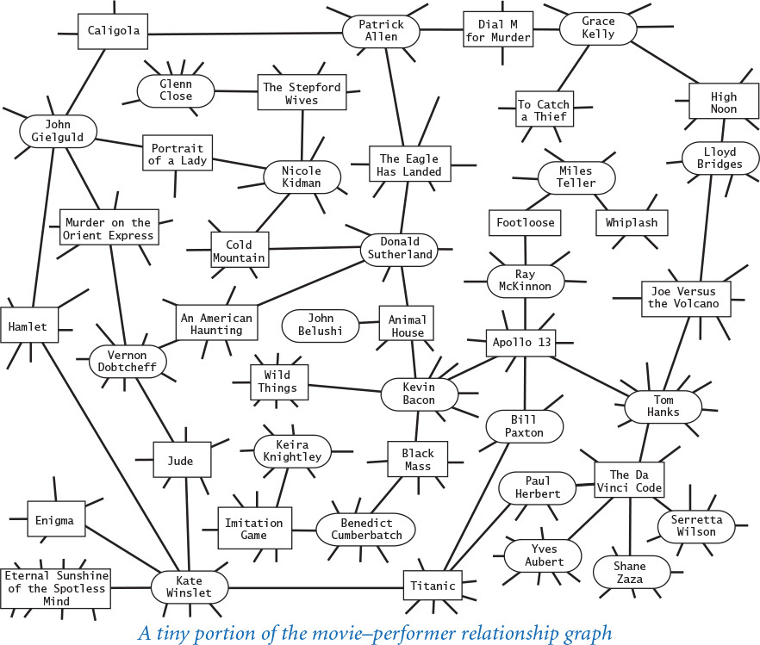
Program 4.5.2 Using a graph to invert an index (invert.py)
Click here to view code image
import sys
import stdio
from graph import Graph
file = sys.argv[1]
delimiter = sys.argv[2]
graph = Graph(file, delimiter)
while stdio.hasNextLine():
v = stdio.readLine()
if graph.hasVertex(v):
for w in graph.adjacentTo(v):
stdio.writeln(' ' + w)
file | input file
delimiter | vertex delimiter
graph | graph
v | query
w | neighbor of v
This Graph client takes the name of a graph file and a delimiter as command-line arguments, builds a graph from the file, and then repeatedly reads a vertex name from standard input and writes the neighbors of that vertex. When the file is a movie-cast file (such as movies.txt) index, it creates a bipartite graph and amounts to an interactive inverted index.
Click here to view code image
% python invert.py tinygraph.txt " "
C
A
B
G
A
B
C
G
H
Click here to view code image
% python invert.py movies.txt "/"
Da Vinci Code, The (2006)
Fosh, Christopher
Sciarappa, Fausto Maria
Zaza, Shane
L'Abidine, Dhaffer
Bettany, Paul
...
Bacon, Kevin
Murder in the First (1995)
JFK (1991)
Novocaine (2001)
In the Cut (2003)
Where the Truth Lies (2005)
...
Typing a movie name and getting its cast does not entail much more than regurgitating the corresponding line in movies.txt. (Note that the cast list appears in arbitrary order because we use a set to represent each adjacency list.) A more interesting feature of invert.py is that you can type the name of a performer and get the list of movies in which that performer has appeared. Why does this work? Even though the database seems to connect movies to performers and not the other way around, the edges in the graph are connections that also connect performers to movies.
A graph in which connections all connect one kind of vertex to another kind of vertex is known as a bipartite graph. As this example illustrates, bipartite graphs have many natural properties that we can often exploit in interesting ways.
As we saw at the beginning of SECTION 4.4, the indexing paradigm is general and very familiar. It is worth reflecting on the fact that building a bipartite graph provides a simple way to automatically invert any index! The movies.txt database is indexed by movie, but we can query it by performer. You could use invert.py in precisely the same way to write the index words appearing on a given page or the codons corresponding to a given amino acid (see the example shown at right), or to invert any of the other indices discussed at the beginning of SECTION 4.2. Since invert.py takes the delimiter as a command-line argument, you can use it to create an interactive inverted index for a .csv file or a test file with space delimiters.
Click here to view code image
% more amino.csv
TTT,Phe,F,Phenylalanine
TTC,Phe,F,Phenylalanine
TTA,Leu,L,Leucine
TTG,Leu,L,Leucine
TCT,Ser,S,Serine
TCC,Ser,S,Serine
TCA,Ser,S,Serine
TCG,Ser,S,Serine
TAT,Tyr,Y,Tyrosine
...
GGA,Gly,G,Glycine
GGG,Gly,G,Glycine
% python invert.py amino.csv ","
TTA
Lue
L
Leucine
Serine
TCT
TCC
TCA
TCG
Inverting an index
This inverted-index functionality is a direct benefit of the graph data structure. Next, we examine some of the added benefits to be derived from algorithms that process the data structure.

Shortest paths in graphs
Given two vertices in a graph, a path is a sequence of vertices connected by edges. A shortest path is one with the minimal number of edges over all such paths (there may be multiple shortest paths). Finding a shortest path connecting two vertices in a graph is a fundamental problem in computer science. Shortest paths have been famously and successfully applied to solve large-scale problems in a broad variety of applications, from routing the Internet to financial arbitrage transactions to studying the dynamics of neurons in the brain.
As an example, imagine that you are a customer of an imaginary no-frills airline that serves a limited number of cities with a limited number of routes. Assume that best way to get from one place to another is to minimize your number of flight segments, because delays in transferring from one flight to another are likely to be lengthy (or perhaps the best thing to do is to consider paying more for a direct flight on another airline!). A shortest-path algorithm is just what you need to plan a trip. Such an application appeals to intuition in understanding the basic problem and our approach to solving it. After covering these topics in the context of this example, we will consider an application where the graph model is more abstract.
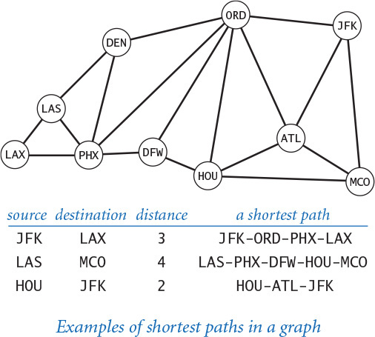
Depending on the application, clients have various needs with regard to shortest paths. Do we want the shortest path connecting two given vertices? Just the length of such a path? Will we have a large number of such queries? Is one particular vertex of interest? Our choice is to start with the following API:
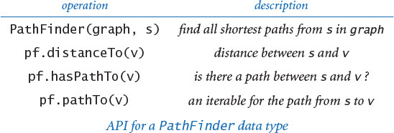
In huge graphs or for huge numbers of queries, we have to pay particular attention to API design because the cost of computing paths might prove to be prohibitive. With this design, clients can create a PathFinder object for a given graph and a given vertex, and then use that object either to find the length of the shortest path or to iterate over the vertices on a shortest path to any other vertex in the graph. An implementation of these methods is known as a single-source shortest-path algorithm. A classic algorithm known as breadth-first search provides a direct and elegant solution where the constructor takes linear time, distanceTo() takes constant time, and pathTo() takes time proportional to the length of the path. Before examining our implementation, we will consider some clients.

Single-source client
Suppose that you have available to you the graph of vertices and connections for your no-frills airline’s route map. Then, using your home city as a source, you can compose a client that writes your route anytime you want to go on a trip. PROGRAM 4.5.3 (separation.py) is a PathFinder client that provides this functionality for any graph. This sort of client is particularly useful in applications where we anticipate numerous queries from the same source. In this situation, the cost of building a PathFinder is amortized over the cost of all the queries. You are encouraged to explore the properties of shortest paths by running PathFinder on our sample input routes.txt or any input model that you choose. In fact, many people frequently use an algorithm like this, in the map application on their phone.

Degrees of separation
One of the classic applications of shortest-paths algorithms is to find the degrees of separation between individuals in a social network. To fix ideas, we discuss this application in terms of a recently popularized pastime known as the Kevin Bacon game, which uses the movie–performer graph that we just considered. Kevin Bacon is a prolific actor who has appeared in many movies. We assign every performer who has appeared in a movie a Kevin Bacon number: Bacon himself is 0, any performer who has been in the same cast as Bacon has a Kevin Bacon number of 1, any other performer (except Bacon) who has been in the same cast as a performer whose number is 1 has a Kevin Bacon number of 2, and so forth. For example, Meryl Streep has a Kevin Bacon number of 1 because she appeared in The River Wild with Kevin Bacon. Nicole Kidman’s number is 2: although she did not appear in any movie with Kevin Bacon, she was in Cold Mountain with Donald Sutherland, and Sutherland appeared in Animal House with Kevin Bacon. Given the name of a performer, the simplest version of the game is to find some alternating sequence of movies and performers that leads back to Kevin Bacon. For example, a movie buff might know that Tom Hanks was in Joe Versus the Volcano with Lloyd Bridges, who was in High Noon with Grace Kelly, who was in Dial M for Murder with Patrick Allen, who was in The Eagle Has Landed with Donald Sutherland, who we know was in Animal House with Kevin Bacon. But this knowledge does not suffice to establish Tom Hanks’s Bacon number (it is actually 1 because he was in Apollo 13 with Kevin Bacon). You can see that the Kevin Bacon number is defined by counting the movies in a shortest such sequence, so it is hard to be sure whether someone wins the game without using a computer. Remarkably, separation.py (PROGRAM 4.5.3 is just the program you need to find a shortest path that establishes the Kevin Bacon number of any performer in movies.txt—the number is precisely half the distance. You might enjoy using this program, or extending it to answer some entertaining questions about the movie business or in one of many other domains. For example, mathematicians play this same game with the graph defined by paper co-authorship and their connection to Paul Erdös, a prolific 20th-century mathematician. Similarly, everyone in New Jersey seems to have a Bruce Springsteen number of 2, because everyone in the state seems to know someone who claims to know Bruce.
Program 4.5.3 Shortest-paths client (separation.py)
Click here to view code image
import sys
import stdio
from graph import Graph
from pathfinder import PathFinder
file = sys.argv[1]
delimiter = sys.argv[2]
graph = Graph(file, delimiter)
s = sys.argv[3]
pf = PathFinder(graph, s)
while stdio.hasNextLine():
t = stdio.readLine()
if pf.hasPathTo(t):
distance = pf.distanceTo(t)
for v in pf.pathTo(t):
stdio.writeln(' ' + v)
stdio.writeln('distance: ' + str(distance))
file | name of graph file
delimiter | delimiter of vertex names
graph | graph
pf | PathFinder from s
s | source vertex
t | destination vertex
v | vertex on path from s to t
This PathFinder test client takes a file name, a delimiter, and a source vertex as command-line arguments. It builds a Graph from the file, assuming that each line of the file specifies a vertex and a list of vertices connected to that vertex, separated by the delimiter. When you type a destination vertex t on standard input, you get the shortest path from the source to that destination.
% more routes.txt
JFK MCO
ORD DEN
ORD HOU
DFW PHX
JFK ATL
ORD DFW
ORD PHX
ATL HOU
DEN PHX
...
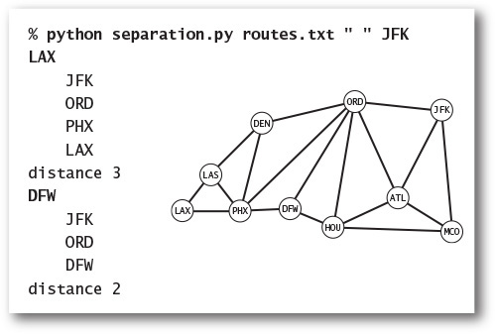
Click here to view code image
% python separation.py movies.txt "/" "Bacon, Kevin"
Kidman, Nicole
Bacon, Kevin
Animal House (1978)
Sutherland, Donald (I)
Cold Mountain (2003)
Kidman, Nicole
distance 4
Hanks, Tom
Bacon, Kevin
Apollo 13 (1995)
Hanks, Tom
distance 2
Degrees of separation from Kevin Bacon

Other clients
PathFinder is a versatile data type that can be put to many practical uses. For example, it is easy to develop a client that handles pairwise source–destination requests on standard input, by building a PathFinder for each vertex (see EXERCISE 4.5.11). Travel services use precisely this approach to handle requests at a very high service rate. Since this client builds a PathFinder for each vertex (each of which might consume space proportional to the number of vertices), space usage might be a limiting factor in using it for huge graphs. For an even more performance-critical application that is conceptually the same, consider an Internet router that has a graph of connections among machines available and must decide the best next stop for packets heading to a given destination. To do so, it can build a PathFinder with itself as the source, then send a packet heading to the first vertex in pf.pathTo(w)—that is, the next stop on the shortest path to w. Or a central authority might build a PathFinder for each of several dependent routers and use them to issue routing instructions. The ability to handle such requests at a high service rate is one of the prime responsibilities of Internet routers, and shortest-paths algorithms are a critical part of the process.

Shortest-path distances
We define the distance between two vertices to be the length of the shortest path between them. The first step in understanding breadth-first search is to consider the problem of computing distances between the source and each vertex (the implementation of distanceTo() in PathFinder). Our approach is to compute and store away all the distances in the constructor, and then just return the requested value when a client invokes distanceTo(). To associate an integer distance with each vertex name, we use a symbol table:
_distTo = dict()
The purpose of this symbol table is to associate with each vertex the length of the shortest path (the distance) between that vertex and s. We begin by giving s the distance 0 with _distTo[s] = 0, and we assign to s’s neighbors the distance 1 with the following code:
for v in g.adjacentTo(s)
self._distTo[v] = 1
But then what do we do? If we blindly set the distances to all the neighbors of each of those neighbors to 2, then not only would we face the prospect of unnecessarily setting many values twice (neighbors may have many common neighbors), but we would also set s’s distance to 2 (it is a neighbor of each of its neighbors)—and we clearly do not want that outcome. The solution to these difficulties is simple:
• Consider the vertices in order of their distance from s.
• Ignore vertices whose distance to s is already known.
To organize the computation, we use a FIFO queue. Starting with s on the queue, we perform the following operations until the queue is empty:
• Dequeue a vertex v.
• Assign all of v’s unknown neighbors a distance 1 greater than v’s distance.
• Enqueue all of the unknown neighbors.
This method dequeues the vertices in nondecreasing order of their distance from the source s. Following a trace of this method on a sample graph will help persuade you that it is correct. Showing that this method labels each vertex v with its distance to s is an exercise in mathematical induction (see EXERCISE 4.5.13).

Shortest-paths tree
We need not only distances from the source, but also paths. To implement pathTo(), we use a subgraph known as the shortest-paths tree, defined as follows:
• Put the source vertex s at the root of the tree.
• Put vertex v’s neighbors in the tree if they are added to the queue, with an edge connecting each to v.
Since we enqueue each vertex only once, this structure is a proper tree: it consists of a root (the source) connected to one subtree for each neighbor of the source. Studying such a tree, you can see immediately that the distance from each vertex to the root in the tree is the same as the shortest-path distance to the source in the graph. More importantly, each path in the tree is a shortest path in the graph. This observation is important because it gives us an easy way to provide clients with the shortest paths themselves (implement pathTo() in PathFinder).
First, we maintain a symbol table associating each vertex with the vertex one step nearer to the source on the shortest path:
_edgeTo = dict()
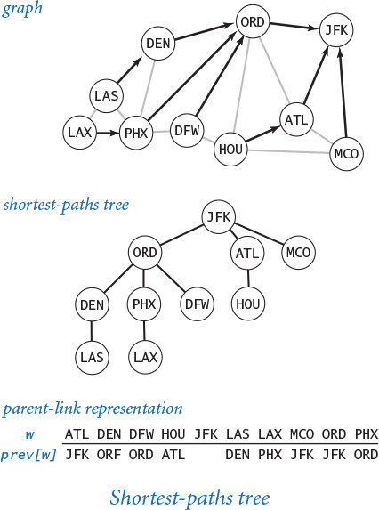
To each vertex w, we want to associate the previous stop on the shortest path from the source to w. Augmenting the shortest-distances method to also compute this information is easy: when we enqueue w because we first discover it as a neighbor of v, we do so precisely because v is the previous stop on the shortest path from the source to w, so we can assign _edgeTo[w] = v. The _prev data structure is nothing more than a representation of the shortest-paths tree: it provides a link from each node to its parent in the tree. Then, to respond to a client request for the path from the source to v (a call to pathTo(v) in PathFinder), we follow these links up the tree from v, which traverses the path in reverse order. We collect the vertices in an array as we encounter them, then reverse the array, so the client gets the path from s to v when using the iterator returned from pathTo().

Breadth-first search
PROGRAM 4.5.4 (pathfinder.py) is an implementation of the single-source shortest-paths API, based on the ideas just discussed. It maintains two symbol tables. One symbol table stores the distance between the source vertex and each vertex; the other symbol table stores the previous stop on a shortest path from the source vertex to each vertex. The constructor uses a queue to keep track of vertices that have been encountered (neighbors of vertices for which the shortest paths have been found but whose neighbors have not yet been examined). This process is known as breadth-first search (BFS) because it searches broadly in the graph.
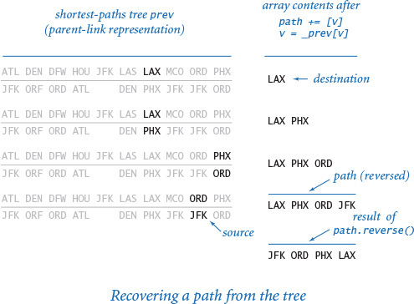
By contrast, another important graph-search method known as depth-first search is based on a recursive method like the one we used for percolation in PROGRAM 2.4.6 and searches deeply into the graph. Depth-first search tends to find long paths; breadth-first search is guaranteed to find shortest paths.

Performance
The cost of graph-processing algorithms typically depends on two graph parameters: the number of vertices V and the number of edges E. For simplicity, we assume that there is a path between the source vertex and each other vertex. Then, as implemented in PathFinder, the time required for breadth-first search is linear in the size of the input—proportional to E + V—under suitable technical assumptions about the hash function. To convince yourself of this fact, first observe that the outer (while) loop iterates exactly V times, once for each vertex, because we are careful to ensure that a vertex is not enqueued more than once. Next, observe that the inner (for) loop iterates 2E times over all iterations, because it examines each edge exactly twice—once for each of the two vertices it connects. The body of the inner (for) loop requires at least one search operation (to determine if the vertex has been previously encountered) and perhaps one get and two put operations (to update the distance and path information) on symbol tables of size at most V. Thus, the overall running time is proportional to E + V (under suitable technical assumptions about the hash function). If we were to use binary search trees instead of hash tables, then the overall running time would be linearithmic—proportional to E log V.
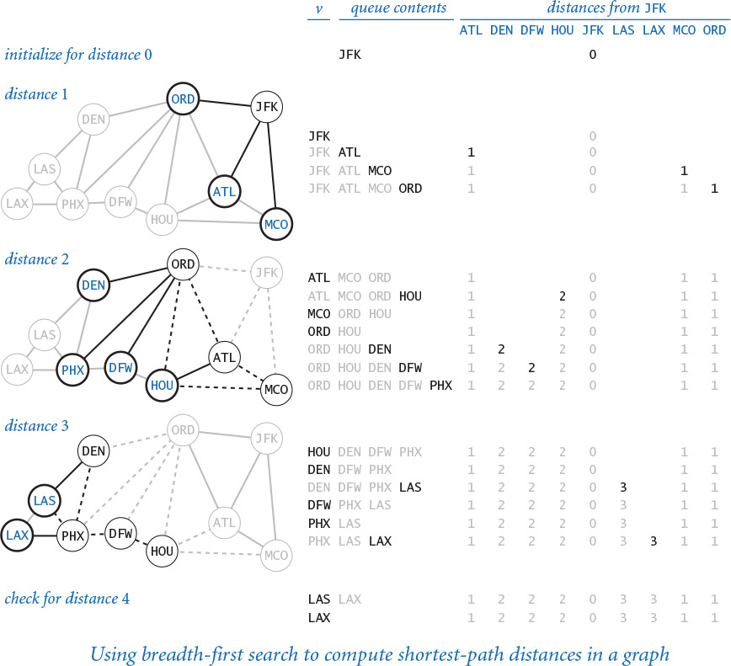
Program 4.5.4 Shortest-paths implementation (pathfinder.py)
Click here to view code image
import stdio
import graph
from linkedqueue import Queue
class PathFinder:
def __init__(self, graph, s):
self._distTo = dict()
self._edgeTo = dict()
queue = Queue()
queue.enqueue(s)
self._distTo[s] = 0
self._edgeTo[s] = None
while not queue.isEmpty():
v = queue.dequeue()
for w in graph.adjacentTo(v):
if w not in self._distTo:
queue.enqueue(w)
self._distTo[w] = 1 + self._distTo[v]
self._edgeTo[w] = v
def distanceTo(self, v):
return self._distTo[v]
def hasPathTo(self, v):
return v in self._distTo
def pathTo(self, v):
path = []
while v is not None:
path += [v]
v = self._edgeTo[v]
return reversed(path)
instance variables
_distTo | distance to s
_prevTo | previous vertex on shortest path from s
graph | graph
s | source
queue | queue of vertices to visit
v | current vertex
w | neighbors of v
This class allows clients to find (shortest) paths connecting a specified vertex to other vertices in a graph. See PROGRAM 4.5.3 and EXERCISE 4.5.17 for sample clients.

Adjacency-matrix representation
Without proper data structures, fast performance for graph-processing algorithms is sometimes not easy to achieve, and so should not be taken for granted. For example, another graph representation that programmers often implement, known as the adjacency-matrix representation, uses a symbol table to map vertex names to integers between 0 and V–1, then maintains a V-by-V array of booleans with True in the element in row i and column j (and, symmetrically, the element in row j and column i) if there is an edge connecting the vertex corresponding to i with the vertex corresponding to j, and False if there is no such edge. We have already used similar representations in this book, when studying the random-surfer model for ranking web pages in SECTION 1.6. The adjacency-matrix representation is simple, but infeasible for use with huge graphs—a graph with a million vertices would require an adjacency matrix with a trillion elements. Understanding this distinction for graph-processing problems makes the difference between solving a problem that arises in a practical situation and not being able to address it at all.
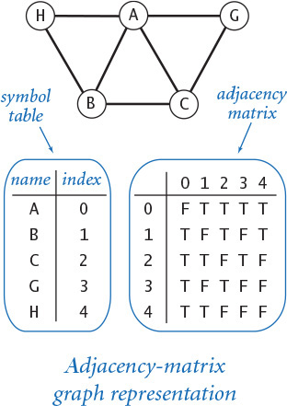
Breadth-first search is a fundamental algorithm that you use in applications on your mobile device to find your way around an airline route map or a city subway or in numerous similar situations. As indicated by our degrees-of-separation example, it is used for countless other applications as well, from crawling the web or routing packets on the Internet, to studying infectious disease, models of the brain, or relationships among genomic sequences. Many of these applications involve huge graphs, so an efficient algorithm is absolutely essential.
An important generalization of the shortest-paths model is to associate a positive weight (which may represent distance or time) with each edge and seek to find a path that minimizes the sum of the edge weights. If you take later courses in algorithms or in operations research, you will learn a generalization of breadth-first search known as Dijkstra’s algorithm that solves this problem in linearithmic time. When you get directions from a GPS device or a map application on your phone, Dijkstra’s algorithm is the basis for solving the associated shortest-path problems. These important and omnipresent applications are just the tip of an iceberg, because graph models are much more general than maps.

Small-world graphs
Scientists have identified a particularly interesting class of graphs that arise in numerous applications in the natural and social sciences. Small-world graphs are characterized by the following three properties:
• They are sparse: the number of vertices is much smaller than the number of edges.
• They have short average path lengths: if you pick two random vertices, the length of the shortest path between them is short.
• They exhibit local clustering: if two vertices are neighbors of a third vertex, then the two vertices are likely to be neighbors of each other.
We refer to graphs having these three properties collectively as exhibiting the small-world phenomenon. The term small world refers to the idea that the preponderance of vertices have both local clustering and short paths to other vertices. The modifier phenomenon refers to the unexpected fact that so many graphs that arise in practice are sparse, exhibit local clustering, and have short paths. Beyond the social-relationships applications just considered, small-world graphs have been used to study the marketing of products or ideas, the formation and spread of fame and fads, the analysis of the Internet, the construction of secure peer-to-peer networks, the development of routing algorithms and wireless networks, the design of electrical power grids, modeling information processing in the human brain, the study of phase transitions in oscillators, the spread of infectious viruses (in both living organisms and computers), and many other applications. Starting with the seminal work of Watts and Strogatz in the 1990s, an intensive amount of research has gone into quantifying the small-world phenomenon.
A key question in such research is the following: Given a graph, how can we tell whether it is a small-world graph? To answer this question, we begin by imposing the conditions that the graph is not small (say, 1,000 vertices or more) and that it is connected (there exists some path connecting each pair of vertices). Then, we need to settle on specific thresholds for each of the small-world properties:
• By sparse, we mean the average vertex degree is less than 20 lg V .
• By short average path length, we mean the average length of the shortest path between two vertices is less than 10 lg V.
• By locally clustered, we mean that a certain quantity known as the clustering coefficient should be greater than 10%.
The definition of locally clustered is a bit more complicated than the definitions of sparsity and average path length. Intuitively, the clustering coefficient of a vertex represents the probability that if you pick two of its neighbors at random, they will also be connected by an edge. More precisely, if a vertex has t neighbors, then there are t (t –1)/2 possible edges that connect those neighbors; its local clustering coefficient is the fraction of those edges that are in the graph (or 0 if the vertex has degree 0 or 1). The clustering coefficient of a graph is the average of the local clustering coefficients of its vertices. If that average is greater than 10%, we say that the graph is locally clustered. The diagram below calculates these three quantities for a tiny graph.
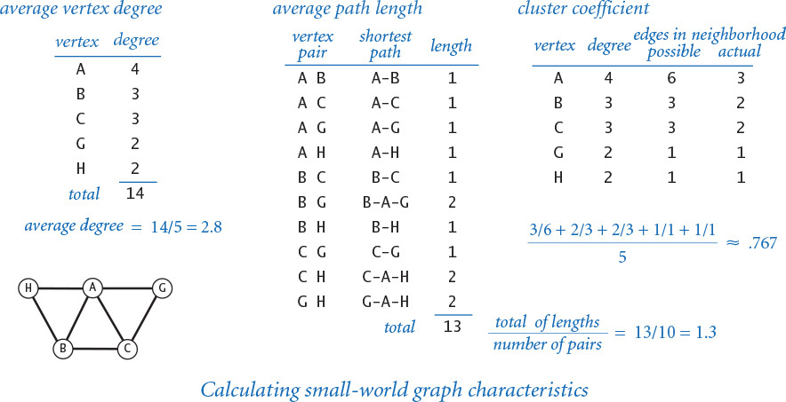
To better familiarize you with these definitions, we next define some simple graph models, and consider whether they describe small-world graphs by checking whether they exhibit the three requisite properties.

Complete graphs
A complete graph with V vertices has V (V–1) / 2 edges, one connecting each pair of vertices. Complete graphs are not small-world graphs. They have short average path length (every shortest path has length is 1) and they exhibit local clustering (the cluster coefficient is 1), but they are not sparse (the average vertex degree is V–1, which is much greater than 20 lg V for large V).

Ring graphs
A ring graph is a set of V vertices equally spaced on the circumference of a circle, with each vertex connected to its neighbor on either side. In a k-ring graph, each vertex is connected to its k nearest neighbors on either side. The diagram at right illustrates a 2-ring graph with 16 vertices. Ring graphs are also not small-world graphs. For example, 2-ring graphs are sparse (every vertex has degree 4) and exhibit local clustering (the cluster coefficient is 1/2), but their average path length is not short (see EXERCISE 4.5.17).

Random graphs
The Erdös-Renyi model is a well studied model for generating random graphs. In this model, we build a random graph on V vertices by including each possible edge with probability p. Random graphs with a sufficient number of edges are very likely to be connected and have short average path lengths but they are not small-world graphs, because they are not locally clustered (see EXERCISE 4.5.43).
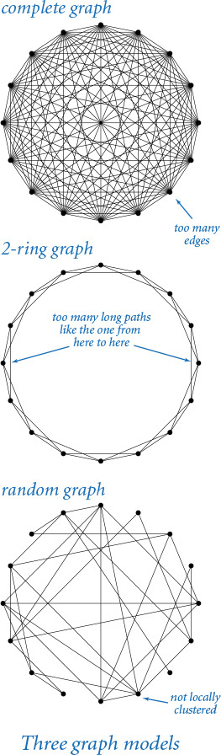
These examples illustrate that developing a graph model that satisfies all three properties simultaneously is a puzzling challenge. Take a moment to try to design a graph model that you think might do so. After you have thought about this problem, you will realize that you are likely to need a program to help with calculations. Also, you may agree that it is quite surprising that they are found so often in practice. Indeed, you might be wondering if any graph is a small-world graph!
Choosing 10% for the clustering threshold instead of some other fixed percentage is somewhat arbitrary, as is the choice of 20 lg V for the sparsity threshold and 10 lg V for the short paths threshold, but we often do not come close to these borderline values. For example, consider the web graph, which has a vertex for each web page and an edge connecting two web pages if they are connected by a link. Scientists estimate that the number of clicks to get from one web page to another is rarely more than about 30. Since there are billions of web pages, this estimate implies that the average length of a path between two vertices is very short, much lower than our 10 lg V threshold (which would be about 300 for 1 billion vertices).
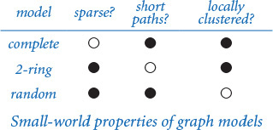
Having settled on the definitions, testing whether a graph is a small-world graph can still be a significant computational burden. As you probably have suspected, the graph-processing data types that we have been considering provide precisely the tools that we need. PROGRAM 4.5.5 (smallworld.py) is a Graph and PathFinder client that implements these tests. Without the efficient data structures and algorithms that we have been considering, the cost of this computation would be prohibitive. Even so, for large graphs (such as movies.txt), we must resort to statistical sampling to estimate the average path length and the cluster coefficient in a reasonable amount of time (see EXERCISE 4.5.41) because the functions averagePathLength() and clusteringCoefficient() take quadratic time.
Program 4.5.5 Small-world test (smallworld.py)
Click here to view code image
from pathfinder import PathFinder
def averageDegree(graph):
return 2.0 * graph.countE() / graph.countV()
def averagePathLength(graph):
total = 0
for v in graph.vertices():
pf = PathFinder(graph, v)
for w in graph.vertices():
total += pf.distanceTo(w)
return 1.0 * total / (graph.countV() * (graph.countV() - 1))
def clusteringCoefficient(graph):
total = 0
for v in graph.vertices():
possible = graph.degree(v) * (graph.degree(v) - 1)
actual = 0
for u in graph.adjacentTo(v):
for w in graph.adjacentTo(v):
if graph.hasEdge(u, w):
actual += 1
if possible > 0:
total += 1.0 * actual / possible
return total / graph.countV()
# See Exercise 4.5.21 for a test client.
This Graph and PathFinder client computes the values of various graph parameters to test whether the graph exhibits the small-world phenomenon.
Click here to view code image
% python smallworld.py tinygraph.txt " "
5 vertices, 7 edges
average degree = 2.800
average path length = 1.300
clustering coefficient = 0.767

A classic small-world graph
Our movie–performer graph is not a small-world graph, because it is bipartite and therefore has a clustering coefficient of 0. Also, some pairs of performers are not connected to each other by any paths. However, the simpler performer–performer graph defined by connecting two performers by an edge if they appeared in the same movie is a classic example of a small-world graph (after discarding performers not connected to Kevin Bacon). The diagram below illustrates the movie–performer and performer–performer graphs associated with a tiny movie-cast file.
PROGRAM 4.5.6 (performer.py) is a script that creates a performer–performer graph from a file in our movie-cast input format. Recall that each line in a movie-cast file consists of a movie followed by all of the performers who appeared in that movie, delimited by slashes. The script connects all pairs of performers in that movie by adding an edge connecting each pair. Doing so for each movie in the input produces a graph that connects the performers, as desired.
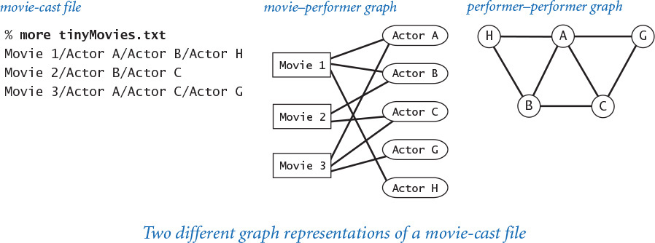
Program 4.5.6 Performer–performer graph (performer.py)
Click here to view code image
import sys
import stdio
import smallworld
from graph import Graph
from instream import InStream
file = sys.argv[1]
delimiter = sys.argv[2]
graph = Graph()
instream = InStream(file)
while instream.hasNextLine():
line = instream.readLine()
names = line.split(delimiter)
for i in range(1, len(names)):
for j in range(i+1, len(names)):
graph.addEdge(names[i], names[j])
degree = smallworld.averageDegree(graph)
length = smallworld.averagePathLength(graph)
cluster = smallworld.clusteringCoefficient(graph)
stdio.writef('number of vertices = %d\n', graph.countV())
stdio.writef('average degree = %7.3f\n', degree)
stdio.writef('average path length = %7.3f\n', length)
stdio.writef('clustering coefficient = %7.3f\n', cluster)
This script is a smallworld.py client takes the name of a movie-cast file and a delimiter as command-line arguments and creates the associated performer–performer graph. It writes to standard output the number of vertices, the average degree, the average path length, and the clustering coefficient of this graph. It assumes that the performer–performer graph is connected (see EXERCISE 4.5.22) so that the average page length is defined.
Click here to view code image
% python performer.py tinymovies.txt "/"
number of vertices = 5
average degree = 2.800
average path length = 1.300
clustering coefficient = 0.767
Click here to view code image
% python performer.py moviesg.txt "/"
number of vertices = 19044
average degree = 148.688
average path length = 3.494
clustering coefficient = 0.911
Since a performer–performer graph typically has many more edges than the corresponding movie–performer graph, we will work for the moment with the smaller performer–performer graph derived from the file moviesg.txt, which contains 1,261 G-rated movies and 19,044 performers (all of which are connected to Kevin Bacon). Now, performer.py tells us that the performer–performer graph associated with moviesg.txt has 19,044 vertices and 1,415,808 edges, so the average vertex degree is 148.7 (about half of 20 lg V = 284.3), which means it is sparse; its average path length is 3.494 (much less than 10 lg V = 142.2), so it has short paths; and its clustering coefficient is 0.911, so it has local clustering. We have found a small-world graph! These calculations validate the hypothesis that social relationship graphs of this sort exhibit the small-world phenomenon. You are encouraged to find other real-world graphs and to test them with smallworld.py. You will find many suggestions in the exercises at the end of this section.
One approach to understanding something like the small-world phenomenon is to develop a mathematical model that we can use to test hypotheses and to make predictions. We conclude by returning to the problem of developing a graph model that can help us to better understand the small-world phenomenon. The trick to developing such a model is to combine two sparse graphs: a 2-ring graph (which has a high cluster coefficient) and a random graph (which has small average path length).

Ring graphs with random shortcuts
One of the most surprising facts to emerge from the work of Watts and Strogatz is that adding a relatively small number of random edges to a sparse graph with local clustering produces a small-world graph. To gain some insight into why this is the case, consider a 2-ring graph, where the diameter (length of path between farthest pair of vertices) is ~ V/4 (see the figure at right). Adding a single edge connecting antipodal vertices decreases the diameter to ~ V/8 (see EXERCISE 4.5.18). Adding V/2 random “shortcut” edges to a 2-ring graph is extremely likely to significantly lower the average path length, making it logarithmic (see EXERCISE 4.5.25). Moreover, it does so while increasing the average degree by only 1 and without lowering the cluster coefficient much below 1/2. That is, a 2-ring graph with V/2 random shortcut edges is extremely likely to be a small-world graph!
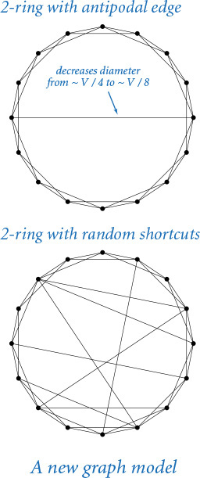
Generators that create graphs drawn from such models are simple to develop, and we can use smallworld.py to determine whether the graphs exhibit the small-world phenomenon (see EXERCISE 4.5.22). We also can verify the analytic results that we derived for simple graphs such as tinygraph.txt, complete graphs, and ring graphs. As with most scientific research, new questions arise as quickly as we answer old ones. How many random shortcuts do we need to add to get a short average path length? What is the average path length and the clustering coefficient in a random connected graph? Which other graph models might be appropriate for study? How many samples do we need to accurately estimate the clustering coefficient or the average path length in a huge graph? You can find in the exercises many suggestions for addressing such questions and for further investigations of the small-world phenomenon. With the basic tools and the approach to programming developed in this book, you are well equipped to address this and many other scientific questions.
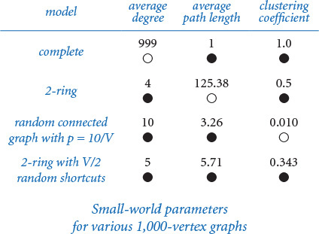

Lessons
This case study illustrates the importance of algorithms and data structures in scientific research. It also reinforces several of the lessons that we have learned throughout this book, which are worth repeating.

Carefully design your data type
One of our most persistent messages throughout this book is that effective programming is based on a precise understanding of the possible set of data-type values and the operations on them. Using a modern object-oriented programming language such as Python provides a path to this understanding because we design, build, and use our own data types. Our Graph data type is a fundamental one, the product of many iterations and experience with the design choices that we have discussed. The clarity and simplicity of our client code are testimony to the value of taking seriously the design and implementation of basic data types in any program.

Develop code incrementally
As with all of our other case studies, we build software one module at a time, testing and learning about each module before moving to the next.

Solve problems that you understand before addressing the unknown
Our shortest-paths example involving air routes between a few cities is a simple one that is easy to understand. It is just complicated enough to hold our interest while debugging and following through a trace, but not so complicated as to make these tasks unnecessarily laborious.

Keep testing and check results
When working with complex programs that process huge amounts of data, you cannot be too careful in checking your results. Use common sense to evaluate every bit of output that your program produces. Novice programmers have an optimistic mindset (“If the program produces an answer, it must be correct”); experienced programmers know that a pessimistic mindset (“There must be something wrong with this result”) is far better.

Use real-world data
The movies.txt file from the Internet Movie Database is just one example of the data files that are now omnipresent on the web. In past years, such data was often cloaked behind private or parochial formats, but most people are now realizing that simple text formats are much preferred. The various methods in Python’s str data type make it easy to work with real data, which is the best way to formulate hypotheses about real-world phenomena. Start working with small files in the real-world format, so that you can test and learn about performance before attacking huge files.

Reuse software
Another of our most persistent messages is that effective programming is based on an understanding of the fundamental data types available for our use, so that we do not have to rewrite code for basic functions. Our use of dict and set in Graph is a prime example—most programmers still use lower-level representations and implementations that use linked lists or arrays for graphs, which means, inevitably, that they are recomposing code for simple operations such as maintaining and traversing linked lists. Our shortest-paths class PathFinder uses dict, list, Graph, and Queue—an all-star lineup of fundamental data structures.

Performance matters
Without good algorithms and data structures, many of the problems that we have addressed in this chapter would go unsolved, because naïve methods require an impossible amount of time or space. Maintaining an awareness of the approximate resource needs of our programs is essential.
This case study is an appropriate place to end the book because the programs that we have considered are a starting point, not a complete study. This book is a starting point, too, for your further study in science, mathematics, or engineering. The approach to programming and the tools that you have learned here should prepare you well for addressing any computational problem whatsoever.

Q&A
Q. How many different graphs are there with V given vertices?
A. With no self-loops or parallel edges, there are V(V–1)/2 possible edges, each of which can be present or not present, so the grand total is 2V(V–1)/2. The number grows to be huge quite quickly, as shown in the following table:
These huge numbers provide some insight into the complexities of social relationships. For example, if you just consider the next nine people that you see on the street, there are over 68 trillion mutual-acquaintance possibilities!
Q. Can a graph have a vertex that is not connected to any other vertex by an edge?
A. Good question. Such vertices are known as isolated vertices. Our implementation disallows them. Another implementation might choose to allow isolated vertices by including an explicit addVertex() method for the add a vertex operation.
Q. Why do the countV() and countE() query methods need to have constant-time implementations. Won’t most clients would call such methods only once?
A. It might seem so, but code like this
while i < g.countE():
...
i += 1
would take quadratic time if you were to use a lazy implementation that counts the edges instead of maintaining an instance variable with the number of edges.
Q. Why are Graph and PathFinder in separate classes? Wouldn’t it make more sense to include the PathFinder methods in the Graph API?
A. Finding shortest paths is just one of many graph-processing algorithms. It would be poor software design to include all of them in a single interface. Please reread the discussion of wide interfaces in SECTION 3.3.

Exercises
4.5.1 Find the performer in movies.txt who has appeared in the most movies.
4.5.2 Modify the __str__() method in Graph so that it returns the vertices in sorted order (assuming the vertices are comparable). Hint: Use the built-in sorted() function.
4.5.3 Modify the __str__() method in Graph so that it runs in time linear in the number of vertices and the number of edges in the worst case. Hint: Use the join() method in the str data type. (See EXERCISE 4.1.13.)
4.5.4 Add to Graph a method copy() that creates and return a new, independent copy of the graph. Any future changes to the original graph should not affect the newly created graph (and vice versa!).
4.5.5 Compose a version of Graph that supports explicit vertex creation and allows self-loops, parallel edges, and isolated vertices (vertices of degree 0).
4.5.6 Add to Graph a method removeEdge() that takes two string arguments and deletes the specified edge from the graph, if present.
4.5.7 Add to Graph a method subgraph() that takes a set of strings as an argument and returns the induced subgraph (the graph consisting of only those vertices and only those edges from the original graph that connect any two of them).
4.5.8 Describe the advantages and disadvantages of using an array or a linked list to represent the neighbors of a vertex instead of using a set.
4.5.9 Compose a Graph client that reads a Graph from a file, then writes the edges in the graph, one per line.
4.5.10 Modify Graph so that it supports vertices of any hashable type.
4.5.11 Implement a PathFinder client allshortestpaths.py that takes the name of a graph file and a delimiter as command-line arguments, builds a PathFinder for each vertex, and then repeatedly takes from standard input the names of two vertices (on one line, separated by the delimiter) and writes the shortest path connecting them. Note: For movies.txt, the vertex names may both be performers, both be movies, or be a performer and a movie.
4.5.12 True or false: At some point during breadth-first search, the queue can contain two vertices, one whose distance from the source is 7 and one whose distance from the source is 9.
Solution: False. The queue can contain vertices of at most two distinct distances d and d+1. Breadth-first search examines the vertices in increasing order of distance from the source. When examining a vertex at distance d, only vertices of distance d+1 can be enqueued.
4.5.13 Prove by induction on the set of vertices visited that PathFinder finds the shortest-path distances from the source to each vertex.
4.5.14 Suppose you use a stack instead of a queue for breadth-first search in PathFinder. Does it still find a path? Does it still correctly compute shortest paths? In each case, prove that it does or give a counterexample.
4.5.15 Compose a program that plots average path length versus the number of random edges as random shortcuts are added to a 2-ring graph on 1,000 vertices.
4.5.16 Add an optional argument k to clusterCoefficient() in the module smallworld.py so that it computes a local cluster coefficient for the graph based on the total edges present and the total edges possible among the set of vertices within distance k of each vertex. Use the default value k=1 so that your function produces results identical to the function with the same name in smallworld.py.
4.5.17 Show that the cluster coefficient in a k-ring graph is (2k−2) / (2k−1). Derive a formula for the average path length in a k-ring graph on V vertices as a function of both V and k.
4.5.18 Show that the diameter in a 2-ring graph on V vertices is ~ V/4. Show that if you add one edge connecting two antipodal vertices, then the diameter decreases to ~V/8.
4.5.19 Perform computational experiments to verify that the average path length in a ring graph on V vertices is ~ 1/4 V. Repeat, but add one random edge to the ring graph and verify that the average path length decreases to ~3/16 V.
4.5.20 Add to smallworld.py a function isSmallWorld() that takes a graph as an argument and returns True if the graph exhibits the small-world phenomenon (as defined by the specific thresholds given in the text) and False otherwise.
4.5.21 Implement a test client main() for smallworld.py (PROGRAM 4.5.5) that produces the output given in the sample runs. Your program should take the name of a graph file and a delimiter as command-line arguments; write the number of vertices and edges, the average degree, the average path length, and the clustering coefficient for the graph; and indicate whether the values are too large or too small for the graph to exhibit the small-world phenomenon.
4.5.22 Compose a program to generate random connected graphs and 2-ring graphs with random shortcuts. Using smallworld.py, generate 500 random graphs from both models (with 1,000 vertices each) and compute their average degree, average path length, and clustering coefficient. Compare your results to the corresponding values in the table on page 714.
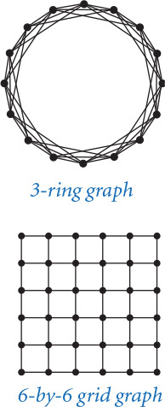
4.5.23 Compose a smallworld.py and Graph client that generates k-ring graphs and tests whether they exhibit the small-world phenomenon (first do EXERCISE 4.5.20).
4.5.24 In a grid graph, vertices are arranged in an n-by-n grid, with edges connecting each vertex to its neighbors above, below, to the left, and to the right in the grid. Compose a smallworld.py and Graph client that generates grid graphs and tests whether they exhibit the small-world phenomenon (first do EXERCISE 4.5.20).
4.5.25 Extend your solutions to the previous two exercises to also take a command-line argument m and to add m random edges to the graph. Experiment with your programs for graphs with approximately 1,000 vertices to find small-world graphs with relatively few edges.
4.5.26 Compose a Graph and PathFinder that takes the name of a movie-cast file and a delimiter as arguments and writes a new movie-cast file, but with all movies not connected to Kevin Bacon removed.

Creative Exercises
4.5.27 Large Bacon numbers. Find the performers in movies.txt with the largest, but finite, Kevin Bacon number.
4.5.28 Histogram. Compose a program baconhistorgram.py that writes a histogram of Kevin Bacon numbers, indicating how many performers from movies.txt have a Bacon number of 0, 1, 2, 3, .... Include a category for those who have an infinite number (not connected at all to Kevin Bacon).
4.5.29 Performer–performer graph. As mentioned in the text, an alternative way to compute Kevin Bacon numbers is to build a graph where there is a vertex for each performer (but not for each movie), and where two performers are connected by an edge if they appear in a movie together. Calculate Kevin Bacon numbers by running breadth-first search on the performer–performer graph. Compare the running time with the running time on movies.txt. Explain why this approach is so much slower. Also explain what you would need to do to include the movies along the path, as happens automatically with our implementation.
4.5.30 Connected components. A connected component in an undirected graph is a maximal set of vertices that are mutually reachable. Compose a data type ConnectedComponents that computes the connected components of a graph. Include a constructor that takes a Graph as an argument and computes all of the connected components using breadth-first search. Include a method areConnected(v, w) that returns True if v and w are in the same connected component and False otherwise. Also add a method components() that returns the number of connected components.
4.5.31 Flood fill. A Picture is a two-dimensional array of Color values (see SECTION 3.1) that represent pixels. A blob is a collection of neighboring pixels of the same color. Compose a Graph client whose constructor builds a grid graph (see EXERCISE 4.5.24) from a given image and supports the flood fill operation. Given pixel coordinates col and row and a color c, change the color of that pixel and all the pixels in the same blob to c.
4.5.32 Word ladders. Compose a program wordladder.py that takes two 5-letter strings from the command line, reads in a list of 5-letter words from standard input, and writes a shortest word ladder using the words on standard input connecting the two strings (if it exists). Two words can be connected in a word ladder chain if they differ in exactly one letter. As an example, the following word ladder connects green and brown:
Click here to view code image
green greet great groat groan grown brown
Compose a simple filter to get the 5-letter words from a system dictionary for standard input or download a list from the booksite. (This game, originally known as doublet, was invented by Lewis Carroll.)
4.5.33 All paths. Compose a Graph client class AllPaths whose constructor takes a Graph as an argument and supports operations to count or write all simple paths between two given vertices s and t in the graph. A simple path does not revisit any vertex more than once. In two-dimensional grids, such paths are referred to as self-avoiding walks (see SECTION 1.4). It is a fundamental problem in statistical physics and theoretical chemistry, for example, to model the spatial arrangement of linear polymer molecules in a solution. Warning: There might be exponentially many paths.
4.5.34 Percolation threshold. Develop a graph model for percolation, and compose a Graph client that performs the same computation as percolation.py (PROGRAM 2.4.6). Estimate the percolation threshold for triangular, square, and hexagonal grids.
4.5.35 Subway graphs. In the Tokyo subway system, routes are labeled by letters and stops by numbers, such as G-8 or A-3. Stations allowing transfers are sets of stops. Find a Tokyo subway map on the web, develop a simple database format, and compose a Graph client that reads a file and can answer shortest-path queries for the Tokyo subway system. If you prefer, do the Paris subway system, where routes are sequences of names and transfers are possible when two stations have the same name.
4.5.36 Center of the Hollywood universe. We can measure how good a center Kevin Bacon is by computing each performer’s Hollywood number or average path length. The Hollywood number of Kevin Bacon is the average Bacon number of all the performers (in its connected component). The Hollywood number of another performer is computed the same way, making that performer the source instead of Kevin Bacon. Compute Kevin Bacon’s Hollywood number and find a performer with a better Hollywood number than Kevin Bacon. Find the performers (in the same connected component as Kevin Bacon) with the best and worst Hollywood numbers.
4.5.37 Diameter. The eccentricity of a vertex is the greatest distance between it and any other vertex. The diameter of a graph is the greatest distance between any two vertices (the maximum eccentricity of any vertex). Compose a Graph client diameter.py that can compute the eccentricity of a vertex and the diameter of a graph. Use it to find the diameter of the graph represented by movies.txt.
4.5.38 Directed graphs. Implement a Digraph data type that represents directed graphs, where the direction of edges is significant: addEdge(v, w) means to add an edge from v to w but not from w to v. Replace adjacentTo() with two methods: adjacentFrom(), to give the set of vertices having edges directed to them from the argument vertex, and adjacentTo(), to give the set of vertices having edges directed from them to the argument vertex. Explain how to modify PathFinder to find shortest paths in directed graphs.
4.5.39 Random surfer. Modify your Digraph class of the previous exercise to make a MultiDigraph class that allows parallel edges. For a test client, run a random surfer simulation that matches randomsurfer.py (PROGRAM 1.6.2).
4.5.40 Transitive closure. Compose a Digraph client class TransitiveClosure whose constructor takes a Digraph as an argument and whose method isReachable(v, w) returns True if w is reachable from v along a directed path in the digraph and False otherwise. Hint: Run breadth-first search from each vertex, as in allshortestpaths.py (EXERCISE 4.5.11).
4.5.41 Statistical sampling. Use statistical sampling to estimate the average path length and clustering coefficient of a graph. For example, to estimate the clustering coefficient, pick t random vertices and compute the average of the clustering coefficients of those vertices. The running time of your functions should be orders of magnitude faster than the corresponding functions from smallworld.py.
4.5.42 Cover time. A random walk in a connected undirected graph moves from a vertex to one of its neighbors, each chosen with equal probability. (This process is the random surfer analog for undirected graphs.) Write programs to run experiments that support the development of hypotheses on the number of steps used to visit every vertex in the graph. What is the cover time for a complete graph with V vertices? A ring graph? A 2-ring graph? Can you find a family of graphs where the cover time grows proportionally to V3 or 2V?
4.5.43 Erdös-Renyi random graph model. In the classical random graph model, we build a random graph on V vertices by including each possible edge with probability p, independently of the other edges. Compose a Graph client to verify the following properties:
• Connectivity thresholds: If p < 1/V and V is large, then most of the connected components are small, with the largest being logarithmic in size. If p > 1/V, then there is almost surely a giant component containing almost all vertices. If p < ln V / V, the graph is disconnected with high probability; if p > ln V / V, the graph is connected with high probability.
• Distribution of degrees: The distribution of degrees follows a binomial distribution, centered on the average, so most vertices have similar degrees. The probability that a vertex is connected to k other vertices decreases exponentially in k.
• No hubs: The maximum vertex degree when p is a constant is at most logarithmic in V.
• No local clustering: The cluster coefficient is close to 0 if the graph is sparse and connected. Random graphs are not small-world graphs.
• Short path lengths: If p > ln V / V, then the diameter of the graph (see EXERCISE 4.5.37) is logarithmic.
4.5.44 Power law of web links. The indegrees and outdegrees of pages in the web obey a power law that can be modeled by a preferred attachment process. Suppose that each web page has exactly one outgoing link. Each page is created one at a time, starting with a single page that points to itself. With probability p < 1, it links to one of the existing pages, chosen uniformly at random. With probability 1–p, it links to an existing page with probability proportional to the number of incoming links of that page. This rule reflects the common tendency for new web pages to point to popular pages. Compose a program to simulate this process and plot a histogram of the number of incoming links.
Partial solution: The fraction of pages with indegree k is proportional to k−1 / (1−p).
4.5.45 Global clustering coefficient. Add a function to smallworld.py that computes the global clustering coefficient of a graph. The global clustering coefficient is the conditional probability that two random vertices that are neighbors of a common vertex are neighbors of each other. Find graphs for which the local and global clustering coefficients are different.
4.5.46 Watts–Strogatz graph model. (See EXERCISES 4.5.24 and 4.5.25.) Watts and Strogatz proposed a hybrid model that contains typical links of vertices near each other (people know their geographic neighbors), plus some random long-range connection links. Plot the effect of adding random edges to an n-by-n grid graph on the average path length and on the cluster coefficient, for n = 100. Do the same for k-ring graphs on V vertices, for V = 10,000 and various values of k up to 10 log V.
4.5.47 Bollobás–Chung graph model. Bollobás and Chung proposed a hybrid model that combines a 2-ring on V vertices (V is even), plus a random matching. A matching is a graph in which every vertex has degree 1. To generate a random matching, shuffle the V vertices and add an edge between vertex i and vertex i+1 in the shuffled order. Determine the degree of each vertex for graphs in this model. Using smallworld.py, estimate the average path length and cluster coefficient for random graphs generated according to this model for V = 1,000.
4.5.48 Kleinberg graph model. There is no way for participants in the Watts-Strogatz model to find short paths in a decentralized network. But Milgram’s experiment also had a striking algorithmic component—individuals can find short paths! Jon Kleinberg proposed making the distribution of shortcuts obey a power law, with probability proportional to the dth power of the distance (in d dimensions). Each vertex has one long-range neighbor. Compose a program to generate graphs according to this model, with a test client that uses smallworld.py to test whether they exhibit the small-world phenomenon. Plot histograms to show that the graphs are uniform over all distance scales (same number of links at distances 1–10 as at distances 10–100 or 100–1000). Compose a program to compute the average lengths of paths obtained by taking the edge that brings the path as close to the target as possible in terms of lattice distance, and test the hypothesis that this average is proportional to (log V)2.

Context
In this closing section, we place your newly acquired knowledge of programming in a broader context by briefly describing some of the basic elements of the world of computation that you are likely to encounter. It is our hope that this information will whet your appetite to use your knowledge of programming as a platform for learning more about the role of computation in the world around you.
You now know how to program. Just as learning to drive an SUV is not difficult when you know how to drive a car, so learning to program in a different language will not be difficult for you. Many scientists regularly use several different languages, for different purposes. The built-in data types, conditionals, loops, and functional abstraction of CHAPTERS 1 and 2 (which served programmers well for the first couple of decades of computing) and the object-oriented programming approach of CHAPTER 3 (which is used by modern programmers) are basic models found in many programming languages. Your skill in using them and the fundamental data types of CHAPTER 4 will prepare you to cope with libraries, program development environments, and specialized applications of all sorts. You are also well positioned to appreciate the power of abstraction in designing complex systems and understanding how they work.
The study of computer science is much more than learning to program. Now that you are familiar with programming and conversant with computing, you are well prepared to learn about some of the outstanding intellectual achievements of the past century, some of the most important unsolved problems of our time, and their role in the evolution of the computational infrastructure that surrounds us. Perhaps even more significant, as we have hinted throughout the book, is that computation is playing an ever-increasing role in our understanding of nature, from genomics to molecular dynamics to astrophysics. Further study of the basic precepts of computer science is certain to pay dividends for you.

Standard Python modules
The Python system provides a wide range of resources for your use. We have made extensive use of some Python standard modules, such as math, but have ignored most of them. A great deal of information about the standard modules is readily available online. If you have not yet browsed through the Python standard modules, now is the time to do so. You will find that much of this code is intended for use by professional developers, but there are a number of modules that you are likely to find interesting. Perhaps the most important thing to keep in mind when studying modules is that you may not need to use them, but you can use them. When you find an API that seems to meet your needs, take advantage of it, by all means.

Programming environments
You will certainly find yourself using other programming environments besides Python in the future. Many programmers, even experienced professionals, are caught between the past, because of huge amounts of legacy code in old languages such as C, C++, and Fortran, and the future, because of the availability of modern tools like JavaScript, Ruby, Java, Python, and Scala. Again, perhaps the most important thing to keep in mind when using a programming language is that you do not need to use it, but you can use it. If some other language might better meet your needs, take advantage of it, by all means. People who insist on staying within a single programming environment, for whatever reason, are missing opportunities.

Scientific computing
In particular, computing with numbers can be very tricky because of issues related to accuracy and precision, so the use of libraries of mathematical functions is certainly justified. Many scientists use Fortran, an old scientific language; many others use Matlab, a language that was developed specifically for computing with matrices. The combination of good libraries and built-in matrix operations makes Matlab an attractive choice for many problems. However, since Matlab lacks support for mutable types and other modern facilities, Python is a better choice for many other problems. You can use both! The same mathematical libraries used by Matlab and Fortran programmers are accessible from Python. Indeed, the Python community has extensive ties to this software in the NumPy (numerical Python) and SciPy (scientific Python) libraries. If you are engaged in scientific computing, you should make use of these libraries. You can find information on the booksite about how to do so.

Computer systems
Properties of specific computer systems once completely determined the nature and extent of problems that could be solved, but now they hardly intrude on these considerations. You can still count on having a faster machine with much more memory next year at this time. Strive to keep your code machine-independent, so that you can easily make the switch. More importantly, the web is playing an increasingly critical role in commercial and scientific computing, as you have seen in many examples in this book. You can compose programs that process data that is maintained elsewhere, compose programs that interact with programs executing elsewhere, and take advantage of many other properties of the extensive and evolving computational infrastructure. Do not hesitate to do so. People who invest significant effort in writing programs for specific machines, even high-powered supercomputers, are missing opportunities.

Theoretical computer science
By contrast, fundamental limits on computation have been apparent from the start and continue to play an important role in determining the kinds of problems that we can address. You might be surprised to learn that there are some problems that no computer program can solve and many other problems, which arise commonly in practice, that are thought to be too difficult to solve on any conceivable computer. Everyone who depends on computation for problem solving, creative work, or research needs to respect these facts.
You have certainly come a long way since you tentatively created, compiled, and ran helloworld.py, but you also still have a great deal to learn. Keep programming, and keep learning about programming environments, scientific computing, computer systems, and theoretical computer science, and you will open opportunities for yourself that people who do not program cannot even conceive.

