Express js Introduction

- What is express.js?
→ A popular framework of node.js. It is used to develop applications, enhances code readability, maintability etc. It is currently owned by IBM. Less number of code is required than node.js to perform similar operations.
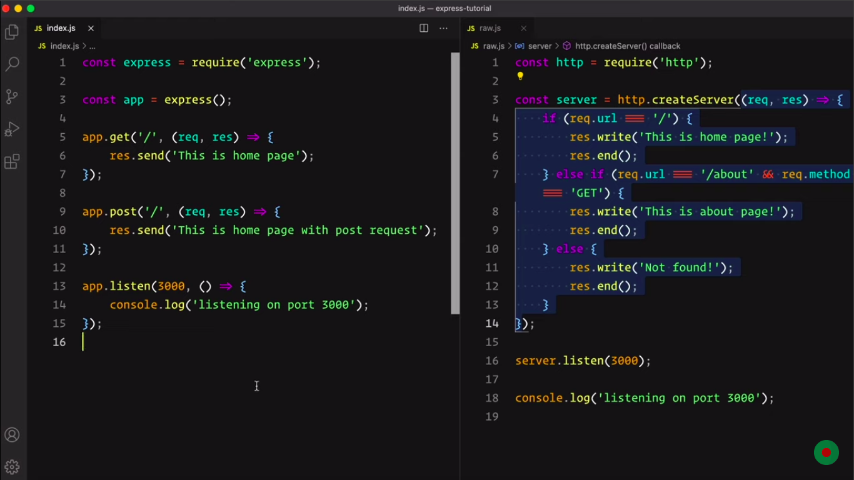
Above code shows Raw node.js code is on the right and same operations using express.js is on left.

It has got 5 pillar topics. They are express() function, application object, request object, response object and router concept.

- express() funtion
→ If we use the express.json() method, we can get the request parsed as a json and it returns an object.
→ If we use the express.raw() method, we can get the request body as a buffer. Content-Type is application/octet-stream.
→ If we use the express.text() method, we can get the request body as a plain text.
→ If we use the express.urlencoded() method, we can send the value like a html form.
→ If we use the express.static() method, we can access the static assests like image file or text file.
→ If we use the express.Router() method, it returns a router object. It is by default case insensitive but can be made case sensitive.

- application Object
→ apps.locals properties is used to create local variables throughout the application, a created one can be accessed from anywhere of the application.
→ apps.mountpath properties contain one or more path pattern where a subpath was mounted.
→ mount event is fired on a sub app, when it is mounted on a parent app.
→ app.all() method is used if a route is used for all of the http methods.
→ app.disable()/app.enable() method is used to disable/enable any settings of express.
e.g: ‘case sensitive routing’
→ app.disabled()/app.enabled() method ireturns true/false on the basis of a settings is disable/enabled.
→ app.get(name) method is used get any saved info., app.set(‘name’, property) is used to save that info. It’s quite similar like local variables.
→ app.get(path, callback) methods is used to get info. of a specified path.
→ app.listen() method is used to listen the server on any port.
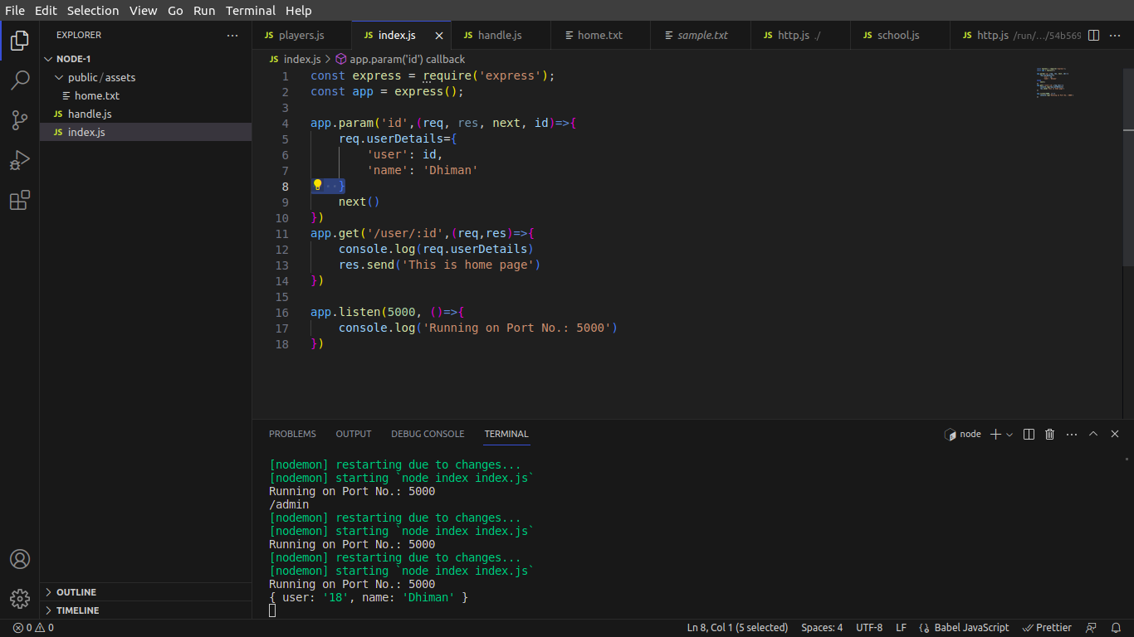
→ app.param([name], callback) method is used to match any parameter value and perform some operations if the param matches. Basically, it’s like an middleware before making the actual request.
→ app.path() method is used to get the canonical path.
→ app.route() method is used to perform different http methods on an identical path.
→ app.engine() is used for rendering html.

- Request Object
→ represents the HTTP request.
→ Known as req
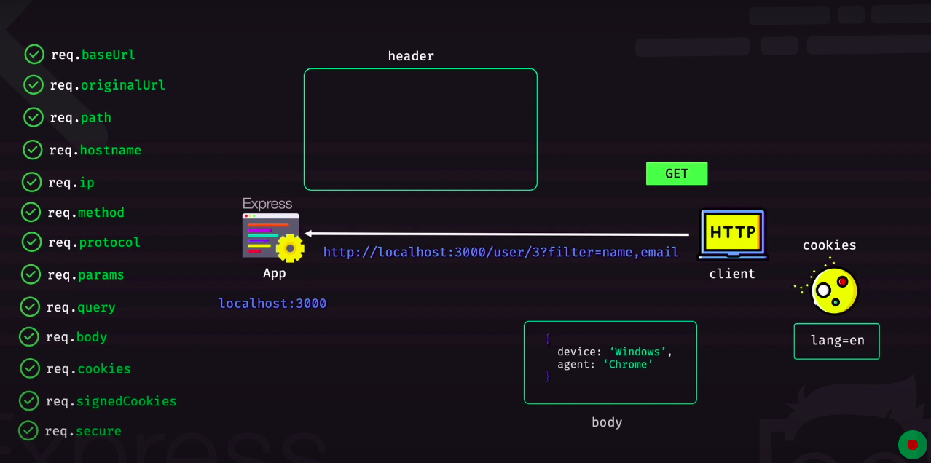
Properties:
→ req.baseUrl provides the route on which the sub app is mounted.
→ If req.url is used and if we go to any sub app the url’s last part is only displayed. So, req.originalUrl is used.
→ req.path returns the path, it returns the path only in the case of a sub app excluding the sub app url.
→ req.ip returns the IP adress.
→ req.hostname returns the name of the host.
→ req.method returns the HTTP method.
→ req.params returns the js object of params.
→ req.query returns the js object of query object.
→ req.body returns the request object.
→ req.body returns cookies. A cookie parser is needed to be installed.
→ req.secure returns true if the request is an https request, else returns false.
→ req.app allows to access the app object throughout the project.
→ req.route provides info. About a route.
Methods:
→ req.accepts() takes the value of the accepted request type and returns true if it matches with the one sent from client or else false.
→ req.get() returns the accepts, content-type or any specified http request header field.

- Request Object
→ represents the HTTP response.
→ Known as res.

Properties:
→ res.app references to the app instance.
→ res.locals represents local variables scoped to the response. It’s used in the case of view engine.
→ res.headerSent returns boolean if the app sent http header for the response.

