MongoDB

* MongoDB
* A NoSQL database.
* SQL vs NoSQL

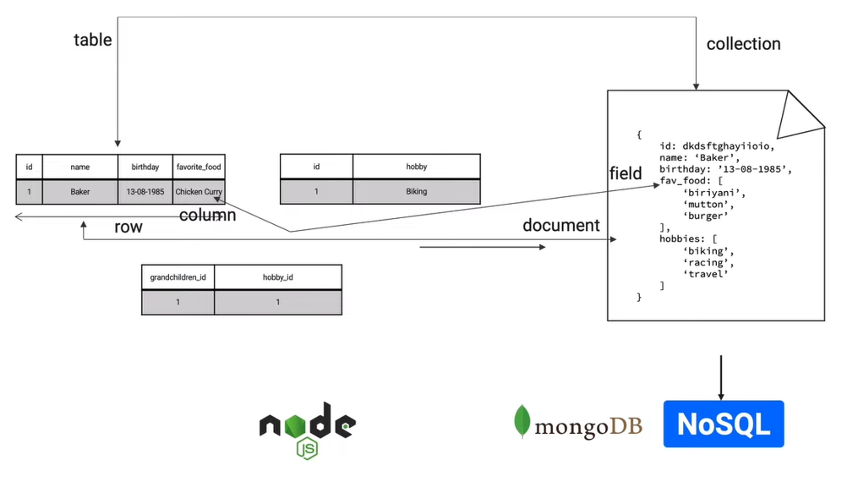

* Basic basic CRUD commands

1. Show dbs: Shows the databases containing data
2. Use [databaseName]: To create a new database.
3. db: returns the current database.
4. db.[collectionName].insertOne({key,value}): creates a collection with one record(document) & generates an id for that record automatically with key “_id”.
5. db.[collectonName].find(): returns the records in the collection.
6. db.[collectonName].find().pretty():returns the records in the collection in a decorated manner.
7. db.[collectionName].insertMany([Array of {key,value}]): creates a collection with multiple records.
8. db.[collectonName].find(QueryObject{key,value}): returns the record matching the query.
9. db.[collectonName].find(QueryObject{key,value},projection{field:0/1}): returns the record(s) with desired fields only. Value 0 for not desired ones, value 1 for the desired ones. If not provided, 1 by default.
10. db.[collectonName].find().pretty().limit(N): returns the top N records.
11. db.[collectonName].find().pretty().limit(N).skip(M): returns the N records skipping M records.
12. db.[collectonName].findOne(): returns the top 1 record, can’t be used with pretty().
13. db.[collectonName].updateOne(matching_condition{key,value},{$set {key,value}}): updates one record with the matched conditions. If no matching condition is provided, all the records will be matched.
14. db.[collectonName].updateMany(matching_condition{key,value},{$set {key,value}}): updates multiple records with the matched conditions. If no matching condition is provided, all the records will be matched.
15. db.[collectonName].deleteOne(matching_condition{key,value}:

deletes one record matching the condition.

1. db.[collectonName].deleteMany(matching_condition{key,value}: deletes multiple records matching the conditions. If no matching condition is provided, then all the records will be deleted.

Mongoose

* Elegant Object Data Modelling for node.js

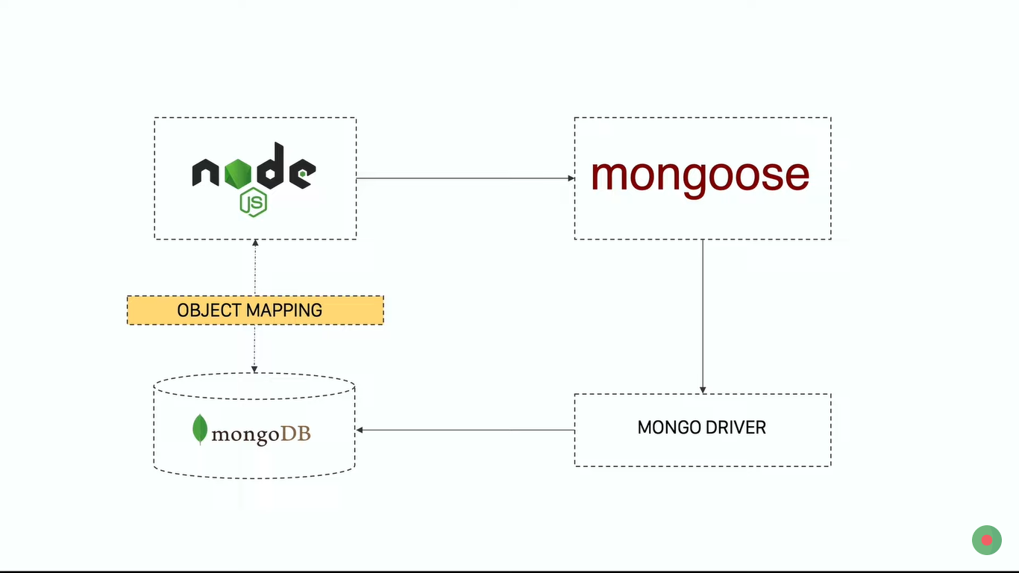

It connects to mongoDB with mongo driver.

