

Name: Sharik Dhiman
PRN: 25070122177
Division: B3
ASSIGNMENT NO: 5
TITLE: Develop a Java application demonstrating the use of ArrayList, Vector, and StringBuffer for dynamic data storage, management, and string manipulation.
Problem Statement: Develop a Java application demonstrating the use of ArrayList, Vector, and StringBuffer for dynamic data storage, management, and string manipulation.
Learning Objectives: To implement dynamic data storage and string manipulation using ArrayList, Vector, and StringBuffer.
Theory: ArrayList and Vector are dynamic array implementations provided by the Java Collections Framework. ArrayList offers faster performance in single-threaded applications, whereas Vector provides synchronized operations for thread safety. StringBuffer is a mutable sequence of characters that allows efficient string modification without creating new objects. These classes are commonly used in applications requiring dynamic memory allocation and efficient string processing.

Exercise:
- Create a To-Do List application using ArrayList to store tasks and StringBuffer to display tasks.
Program: 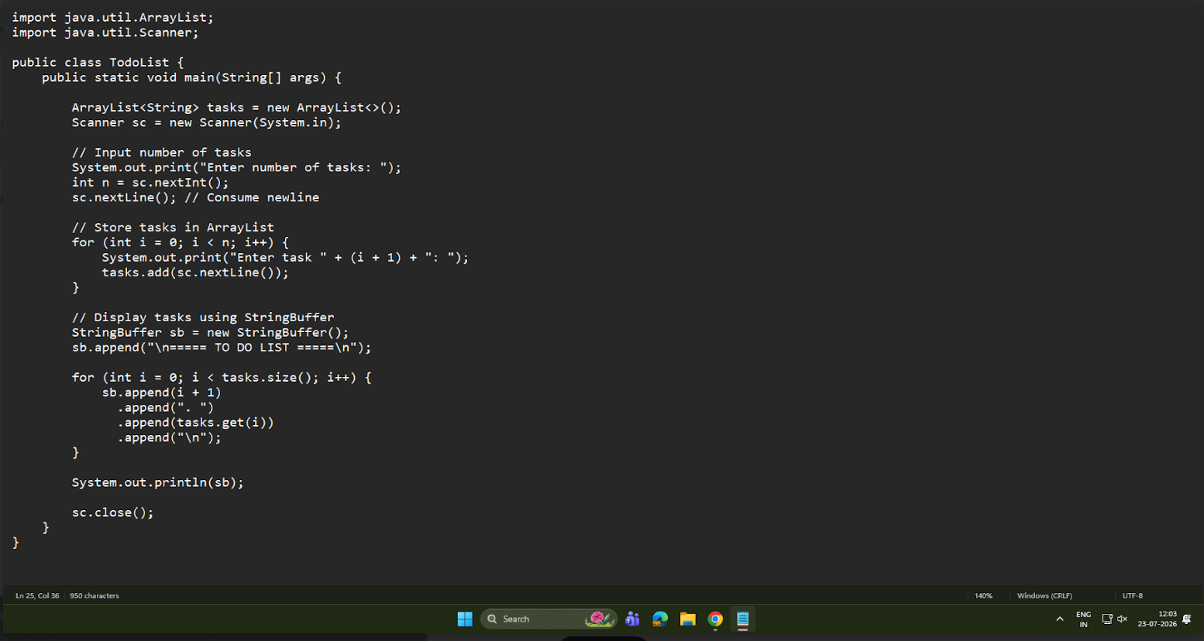

Output:
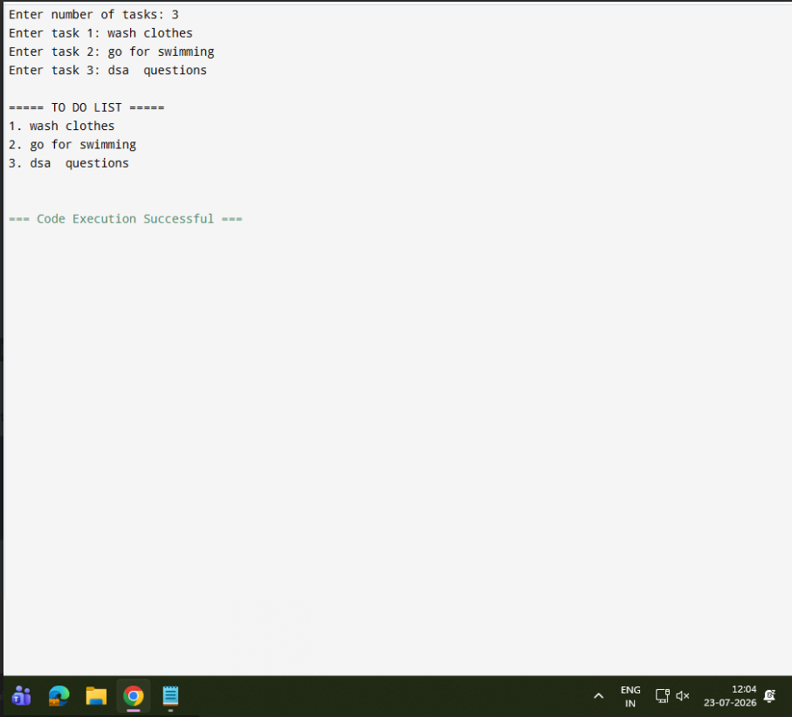

- Create a Student Course Registration System using ArrayList to store the list of courses registered by a student and StringBuffer to generate and display the registered course list. The application should allow users to add, remove, and view registered courses.
Program:

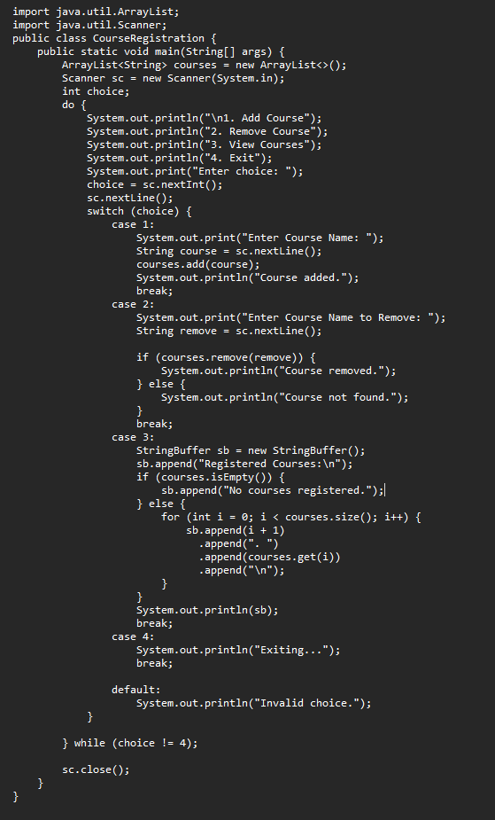
Output: 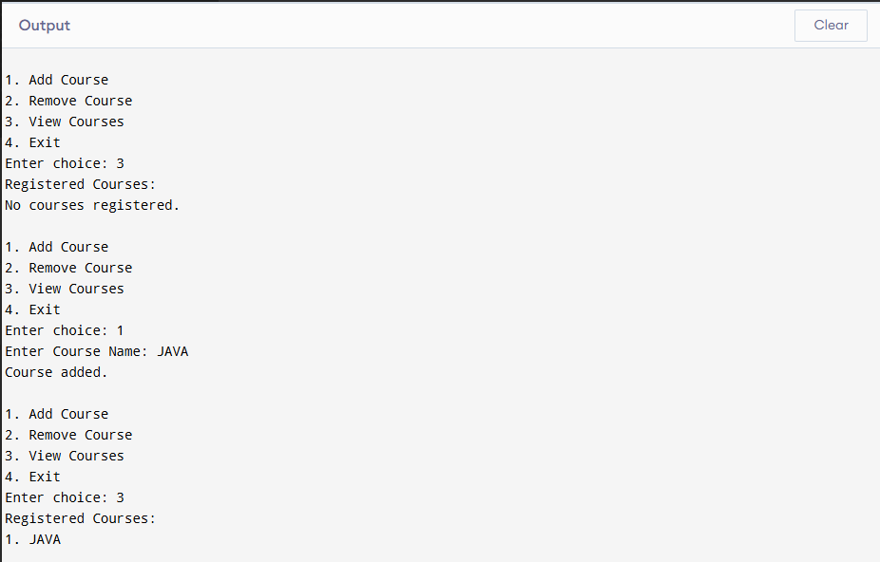

CONCLUSION:
Java application demonstrating the use of ArrayList, Vector, and StringBuffer for dynamic data storage, management, and string manipulation done successfully

