

Name: Sharik Dhiman
PRN: 25070122177
Division: B3
ASSIGNMENT No: 11
TITLE: Write a Java program to demonstrate the implementation of interfaces.
Problem Statement: Write a Java program to demonstrate the implementation of interfaces.
Learning Objectives: To implement interfaces for achieving abstraction and multiple inheritance of type.
Theory: An interface specifies a set of abstract methods that implementing classes must define. It provides complete abstraction and supports multiple inheritance of type. Interfaces improve modularity, loose coupling, and software flexibility. They allow different classes to implement common behavior while maintaining independent implementations. Interfaces are widely used in enterprise application development.

Exercise:
- Create an interface Printable and implement it in Student and Employee classes.
Program:
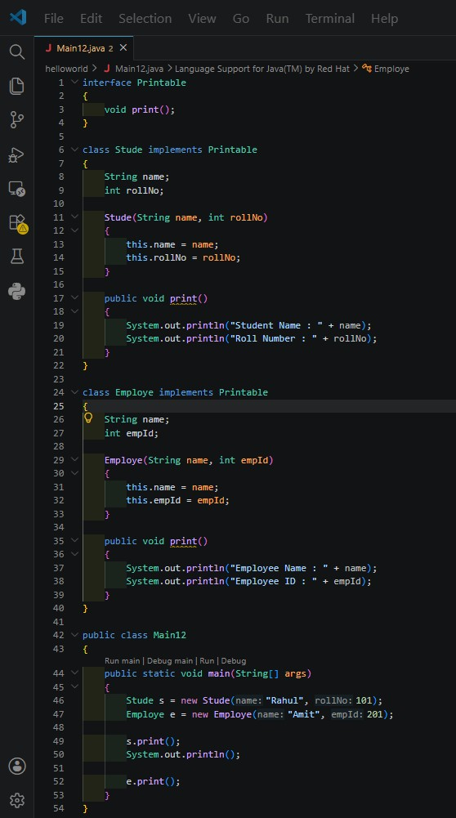
Output:
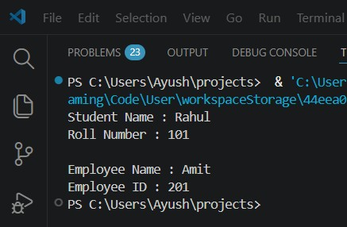

- Create an interface Switchable with a method turnOn(). Implement the interface in Light and Fan classes to display the device status.
Program:
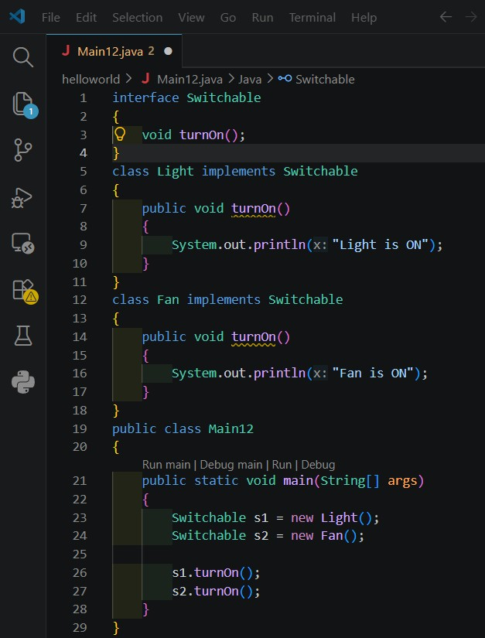
Output:
