

Name: Sharik Dhiman
PRN:25070122177
Division: B3
ASSIGNMENT No: 6
TITLE: Write a Java program to demonstrate the use of an inner class, an anonymous class.
Problem Statement: Write a Java program to demonstrate the use of an inner class, an anonymous class.
Learning Objectives: To implement inner classes and anonymous classes for improving encapsulation and event handling in Java.
Theory: An inner class is a class defined inside another class and has access to all members of the enclosing class, including private members. Inner classes help improve code organization and logical grouping of related classes. Anonymous classes are unnamed inner classes that are instantiated only once and are mainly used for implementing interfaces or abstract classes. They simplify code by eliminating the need for separate class definitions. These concepts are widely used in Java GUI programming and event handling outcome .

Exercise
1.Create a Vehicle program where an inner class displays vehicle details and anonymous class performs an action.
Program:
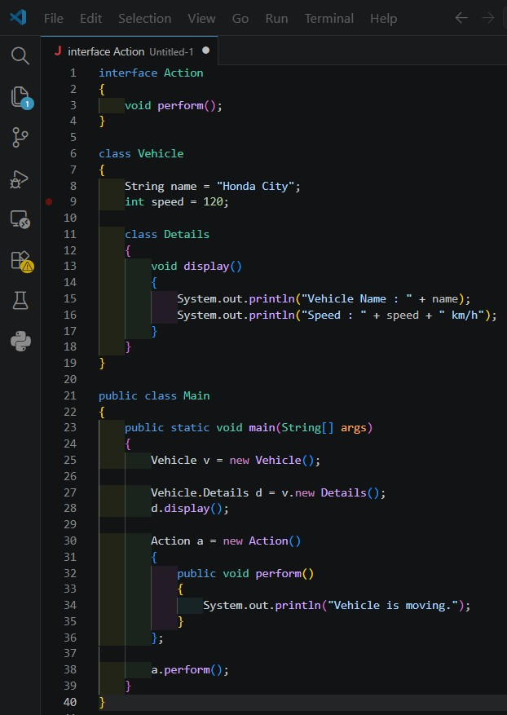

Output:
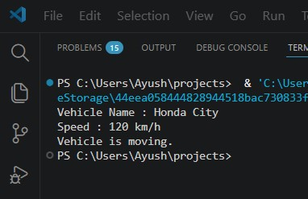
2. Develop a Food Delivery Application where an inner class handles order details and anony mous classes handle delivery status updates.
Program:
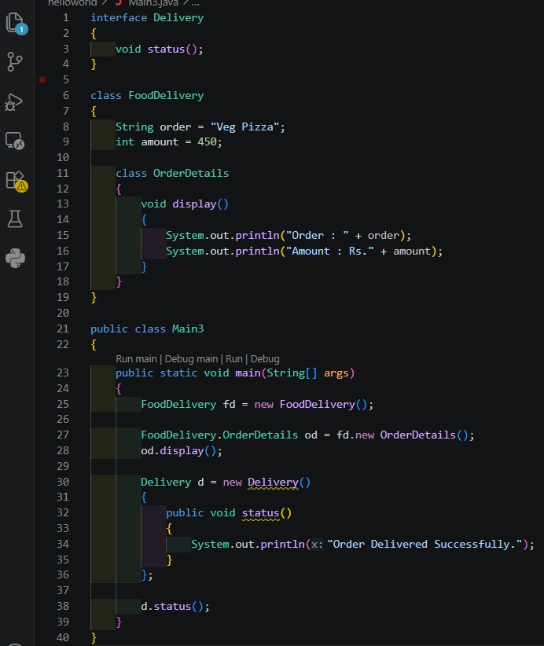
Output:
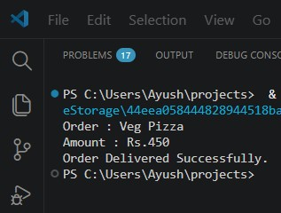

CONCLUSION:
Implementation of inner classes and anonymous classes for improving encapsulation and event handling in Java done successfully.

