

Name: Sharik Dhiman
PRN: 25070122177
Division: B3
ASSIGNMENT NO: 7
TITLE: Implement a Java program to demonstrate inheritance and interfaces using suitable real-world examples.
Problem Statement: Implement a Java program to demonstrate inheritance and interfaces using suitable realworld examples.
Learning Objectives: To implement inheritance and interfaces for achieving code reusability and abstraction.
Theory: Inheritance allows one class to acquire the properties and methods of another class, promoting code reuse and reducing redundancy. Java supports single inheritance through the extends keyword. Interfaces define a contract that implementing classes must follow, enabling abstraction and multiple inheritance of type. Together, inheritance and interfaces support polymorphism and modular software development. They are fundamental concepts of object-oriented programming.

Exercise:
1.Create a Shape application where Circle and Rectangle inherit from Shape and calculate area.
Program:
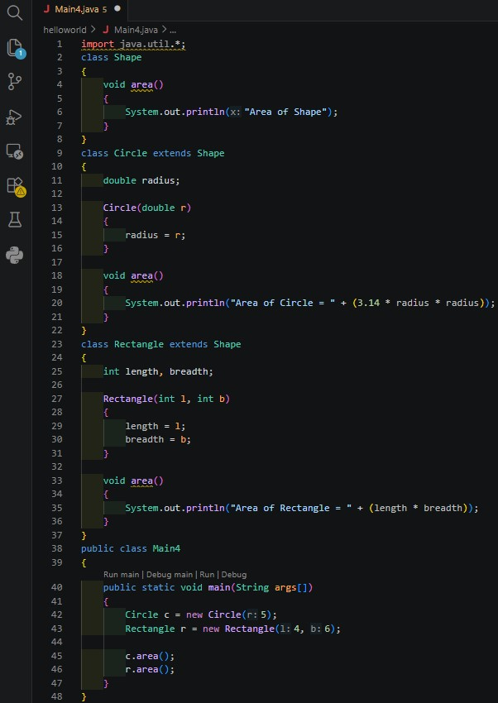
Output:
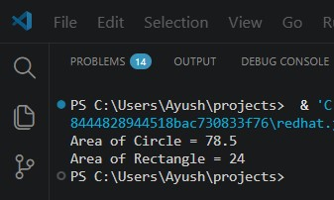

2. Develop an E-Commerce Product System where electronic, clothing, and grocery products inherit common properties and implement product interfaces. Program:
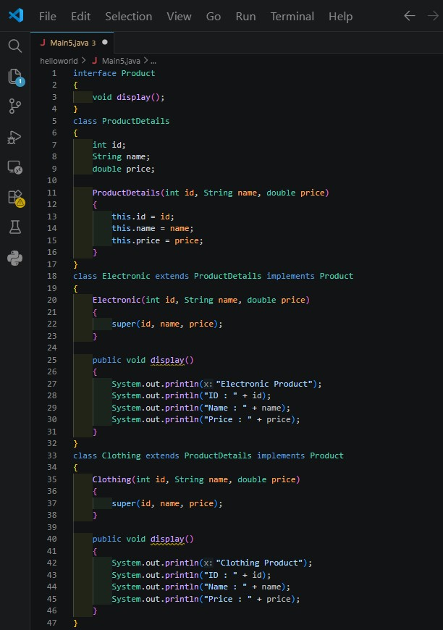
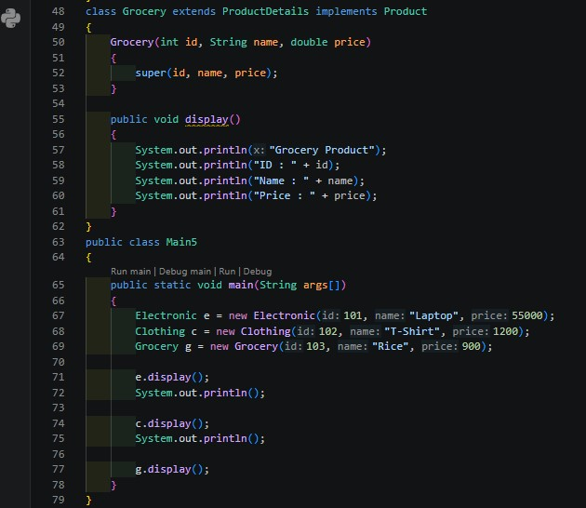
Output:
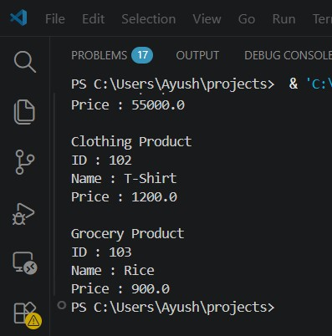

CONCLUSION:
Implementation of a Java program to demonstrate inheritance and interfaces using suitable realworld examples was done correctly.

