

Department of Computer Science & Engineering
Programming with Java
Assignment No. 1

Title: Develop an application based on Java environment setup, JDK/JRE/JVM, variables, methods and constructors.
Name: Sharik Dhiman
PRN: 25070122177
Batch: CSE B3

Problem Statement
Develop an application based on Java environment setup, JDK/JRE/JVM, variables, methods and constructors and demonstrate the implementation through suitable examples.

Learning Objectives
- Understand Java environment setup.
- Learn JDK, JRE and JVM.
- Understand variables, methods and constructors.
- Implement these concepts in Java.

Theory
JDK provides development tools, JRE provides the runtime environment, and JVM executes Java bytecode. Variables store data, methods define program behavior, and constructors initialize objects.

Sample Java Program
import java.util.*; class Student
{
// Instance variables String name; int age;
String course;
// Default Constructor Student() { name = "Unknown";
age = 0; course = "Not Assigned";
}
// Parameterized Constructor (without using 'this')
Student(String studentName, int studentAge, String studentCourse) {
name = studentName; age = studentAge; course = studentCourse;
}
// Method to display student details void displayDetails() {
System.out.println("Student Name : " + name);
System.out.println("Age : " + age);
System.out.println("Course : " + course);
}
// Method to check eligibility void checkEligibility() { if (age >= 18) {
System.out.println("Eligible for College Activities");
} else {
System.out.println("Not Eligible for College Activities");
}
}
public static void main()
{
// Object using Default Constructor
Student s1 = new Student(); System.out.println("----- Student 1 -----"); s1.displayDetails();

// Object using Parameterized Constructor
Student s2 = new Student("Sharik Dhiman", 20, "B.Tech CSE"); System.out.println("\n----- Student 2 -----"); s2.displayDetails(); s2.checkEligibility();
}

Output Screenshot
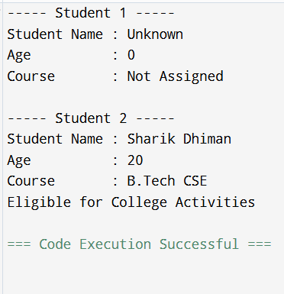

Conclusion
The assignment demonstrates Java environment setup and the use of JDK, JRE, JVM, variables, methods and constructors.

Questions & Answers
- 1. Explain the main concept used in Java environment setup, variables and methods.
ANS: JDK is used for development, JRE provides the runtime environment, JVM executes bytecode. Variables store data and methods perform tasks.
- 2. What are the advantages of using Java variables and methods?
ANS: They improve code reusability, readability, modularity and maintainability.
- 3. How can this implementation be improved?
ANS: By adding user input, exception handling, comments and advanced OOP concepts.
- 4. What are the real-world applications?
ANS: Enterprise software, Android apps, banking systems, web applications and cloud services.

