
Name: Sharik Dhiman
PRN: 25070122177
Division: B3
ASSIGNMENT No: 14
TITLE: Write a Java program to demonstrate exception handling using try and catch blocks, nested and multiple try-catch blocks.
Problem Statement: Write a Java program to demonstrate exception handling using try and catch blocks, nested and multiple try-catch blocks.
Learning Objectives: To handle runtime exceptions using try-catch, nested try, and multiple catch blocks.
Theory: Exception handling prevents abnormal termination of programs due to runtime errors. The try block contains code that may generate exceptions, while catch blocks handle specific exceptions. Nested and multiple try-catch structures allow complex error management. Exception handling improves software reliability and user experience by gracefully managing unexpected situations.

Exercise:
- Create an ATM program handling invalid withdrawal amount using try-catch Program:
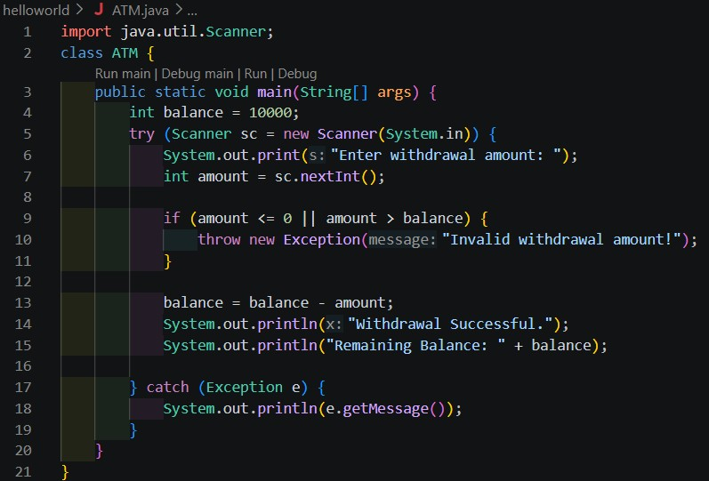
Output:
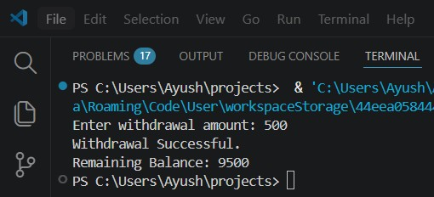

- Create an Online Shopping program that handles an invalid product quantity entered by the user using a try-catch block. Display an appropriate error message if the quantity is less than or equal to zero.
Program:

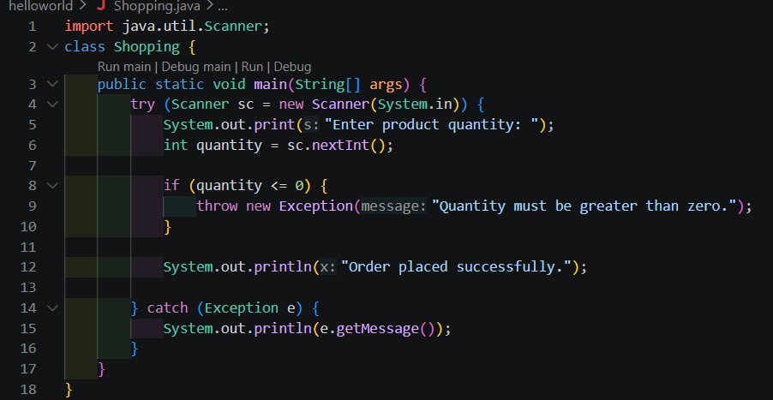
Output:
