ASSIGNMENT No: 16
NAME: Sharik Dhiman
PRN: 25070122177
BATCH: CSE B3
A.Y: 2025-29
TITLE:
Write a Java program to create and handle a user-defined exception.
Problem Statement

Write a Java program to create and handle a user-defined exception.
Learning Objectives
To create and implement custom exceptions for application-specific error handling.
Theory:
User-defined exceptions are created by extending the Exception class. They allow developers to define meaningful exceptions for specific business logic. Custom exceptions improve program readability and simplify debugging by providing descriptive error messages. They are widely used in enterprise software and validation systems.
SOURCE CODE:
(DONE IN CLASS)
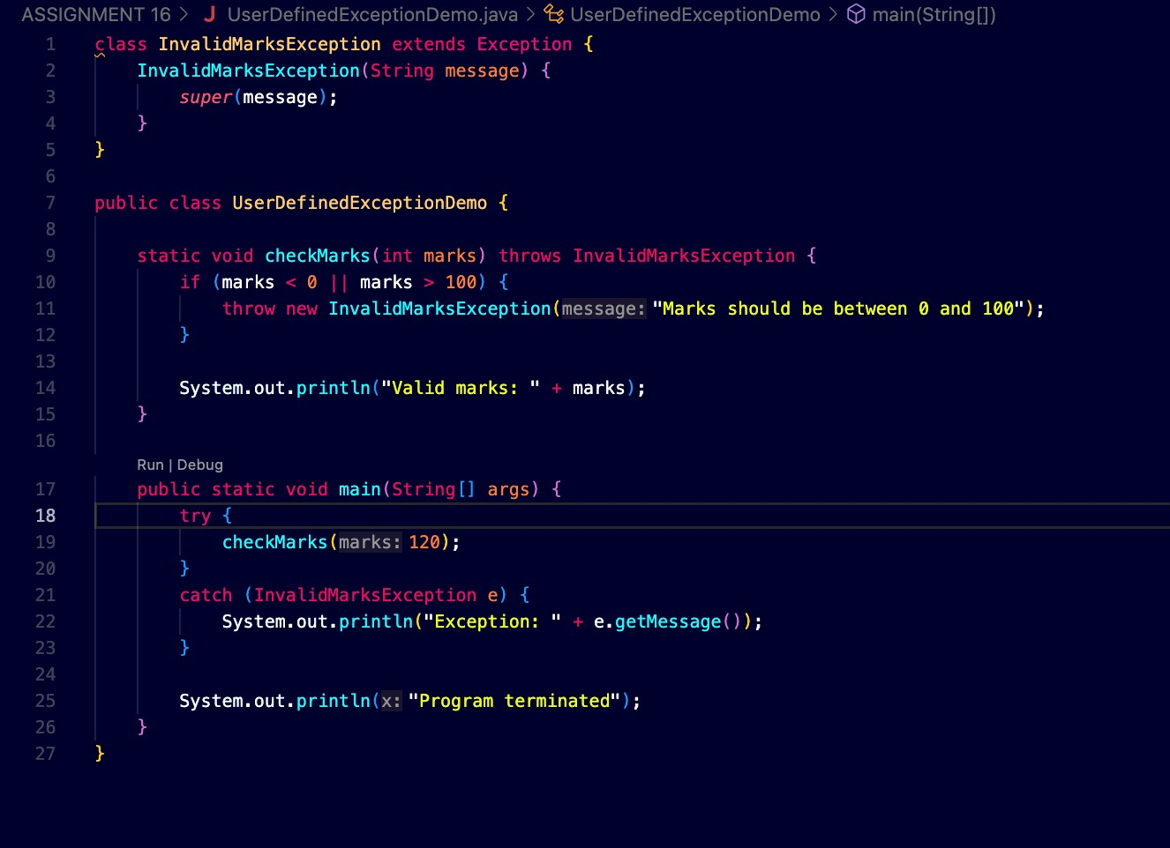

OUTPUT:

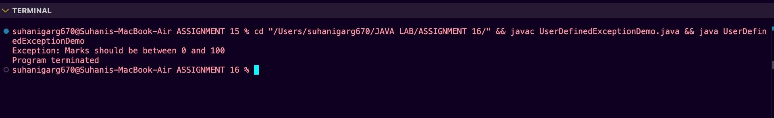
Exercise
- Create a Voting System that throws a custom exception if age is below 18
SOURCE CODE:
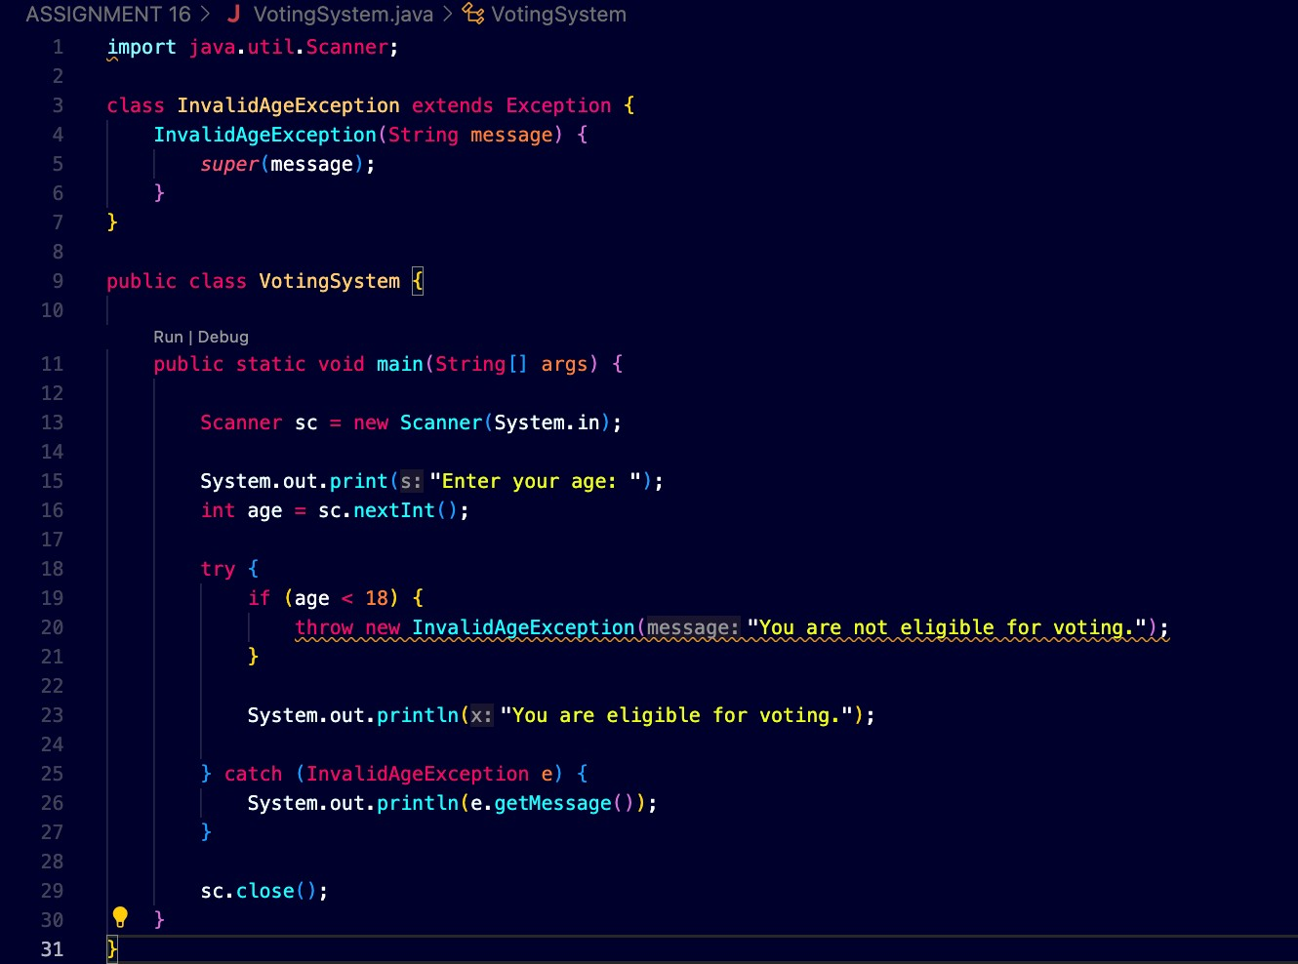

OUTPUT:

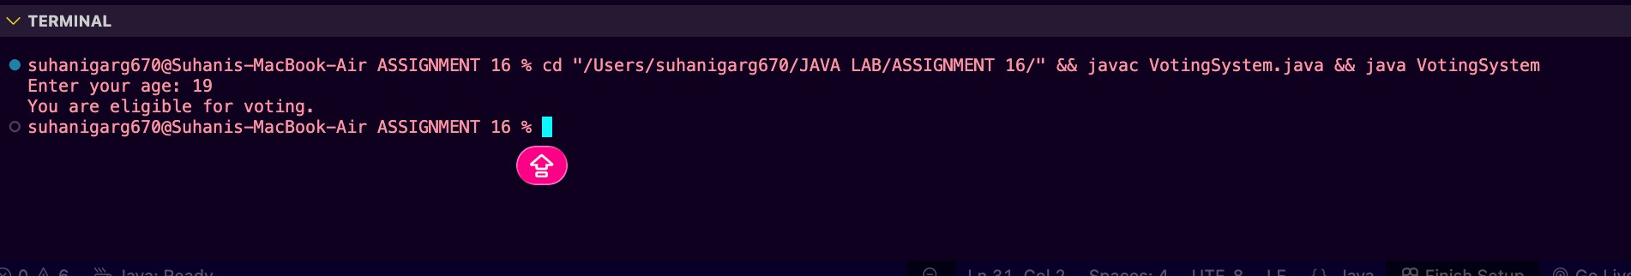
- Create a Driving License System that throws a custom exception if the user’s age is below 18. If the age is valid, display that the user is eligible for a driving license
SOURCE CODE:

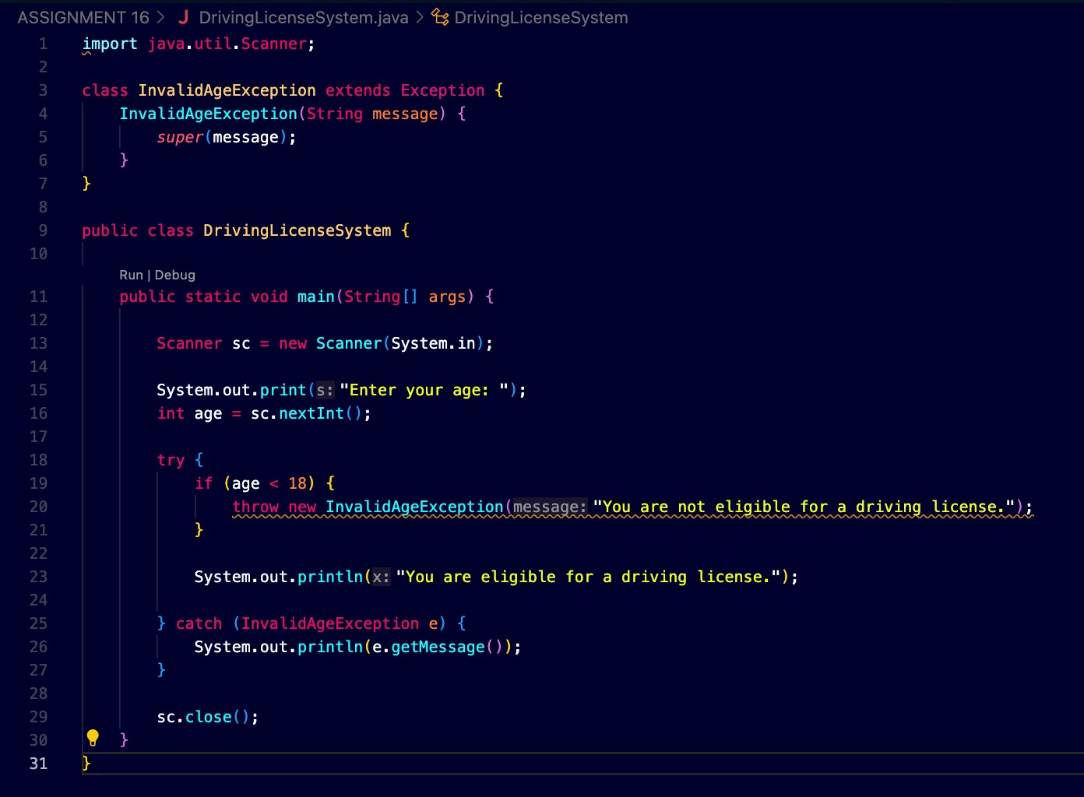
OUTPUT:

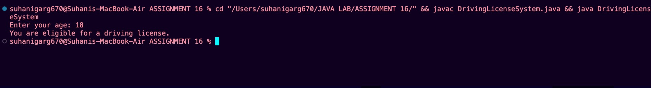

Conclusion
This assignment helped us understand how to create and handle user-defined exceptions in Java. We created custom exceptions by extending the Exception class and used them to handle invalid age conditions in the Voting System and Driving License System. The throw statement was used to generate the custom exception, while the try-catch block was used to handle it. Thus, user-defined exceptions make programs more clear, meaningful, and suitable for handling application-specific errors.

