
Name: Sharik Dhiman
PRN: 25070122177
Division: B3
ASSIGNMENT No: 9
TITLE: Write a Java program to demonstrate the use of the final keyword with variables, methods, and classes.
Problem Statement: Write a Java program to demonstrate the use of the final keyword with variables, methods, and classes.
Learning Objectives: To implement the final keyword with variables, methods, and classes.
Theory : The final keyword restricts modification in Java programs. A final variable cannot be reassigned after initialization. A final method cannot be overridden by subclasses, while a final class cannot be inherited. This improves security, prevents accidental modifications, and increases program reliability. Final is commonly used for constants and immutable classes.

Exercise
- Create a Bank Account program where account number is final and cannot be changed.
Program:
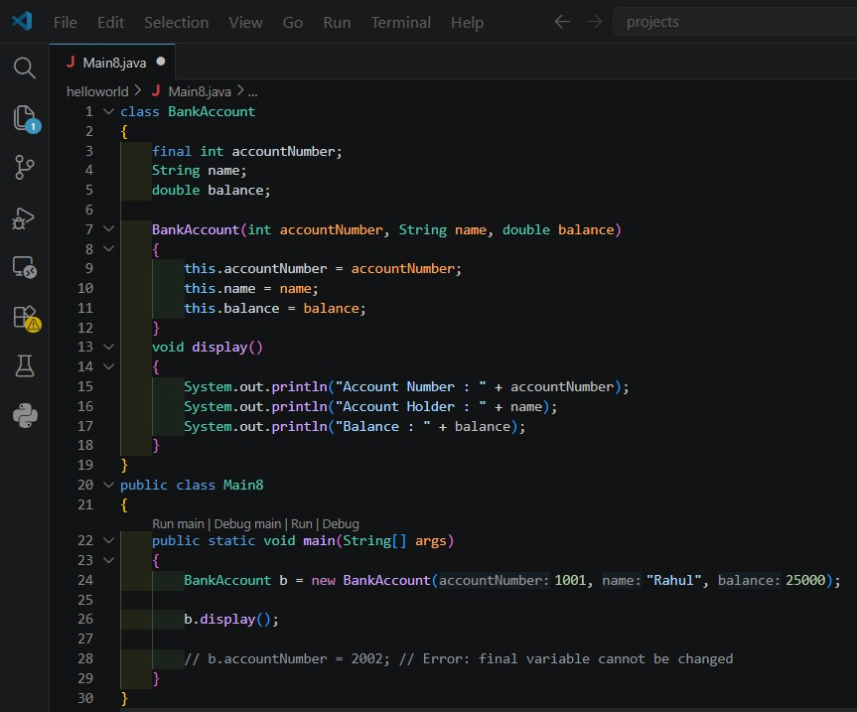
Output:
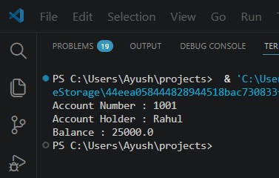

- Create a Library Book Management program where the book ISBN is declared as final and cannot be changed once assigned. Display the book's ISBN, title, author, and price. Program:
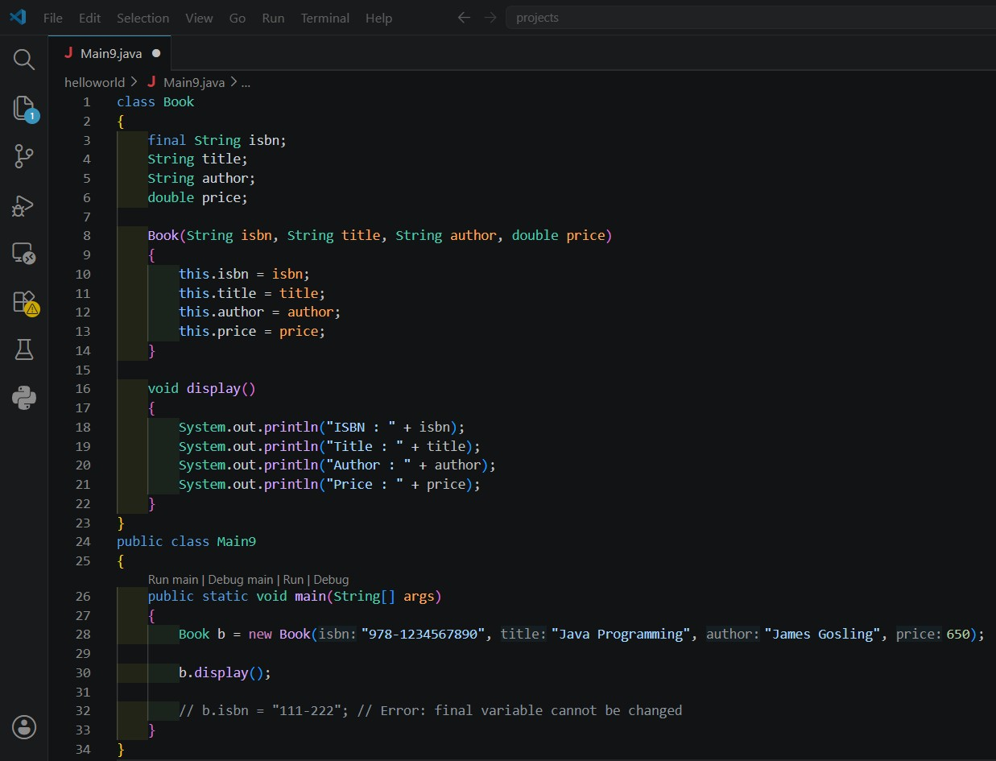
Output:
