ASSIGNMENT No: 15
NAME: Sharik Dhiman
PRN: 25070122177
BATCH: CSE B3
A.Y: 2025-29
TITLE:
Write a Java program to demonstrate exception handling using finally, throw, and throws.
Problem Statement
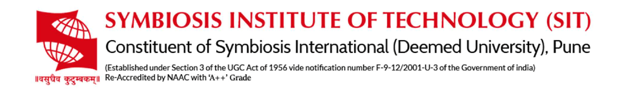
Write a Java program to demonstrate exception handling using finally, throw, and throws.
Learning Objectives
To implement finally, throw, and throws for effective exception management.
Theory
The finally block always executes regardless of whether an exception occurs, making it suitable for resource cleanup. The throw keyword explicitly generates an exception, while throws declares exceptions that a method may pass to its caller. These mechanisms improve structured error handling and application stability.
Exercise
1. Create a Login program that throws an exception for invalid password and uses finally block
SOURCE CODE:
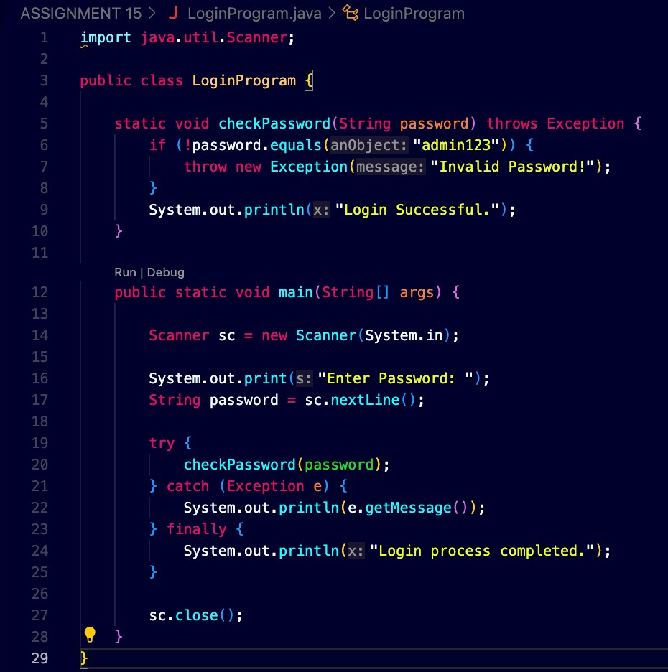
OUTPUT:
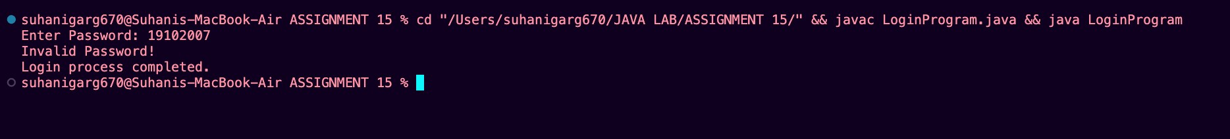

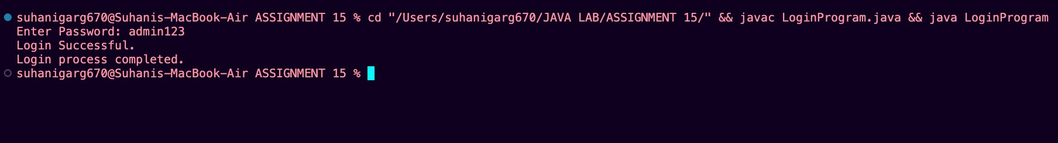

2.Create an ATM PIN Verification program that throws an exception for an invalid PIN entered by the user and uses a finally block to display a message indicating that the verification process has completed.
SOURCE CODE:

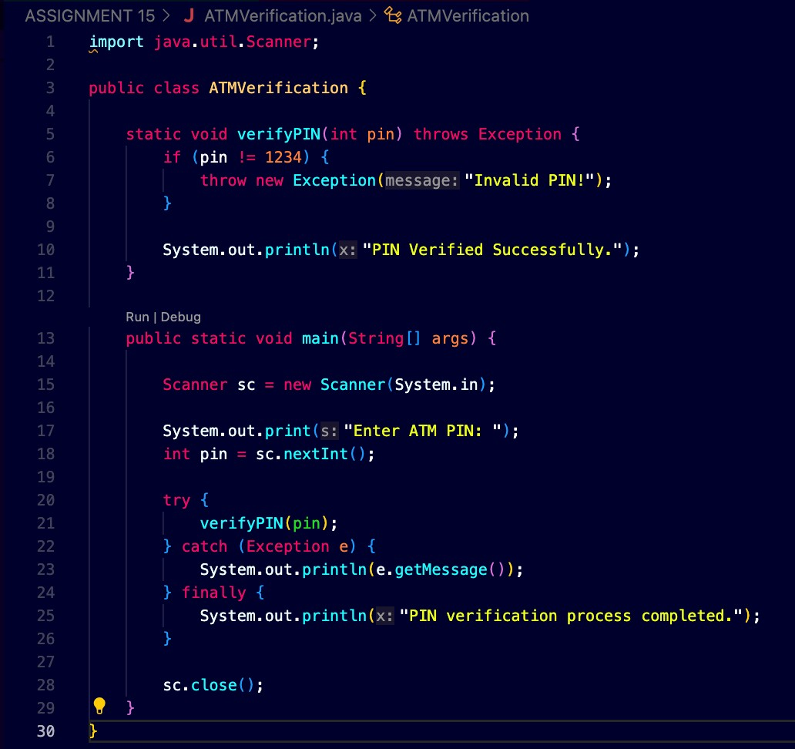
OUTPUT:
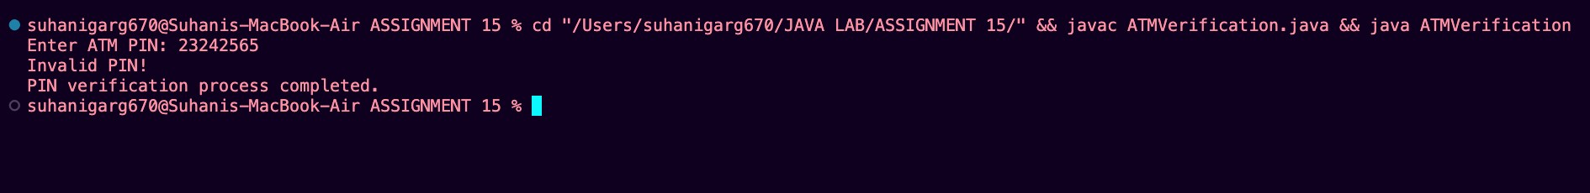
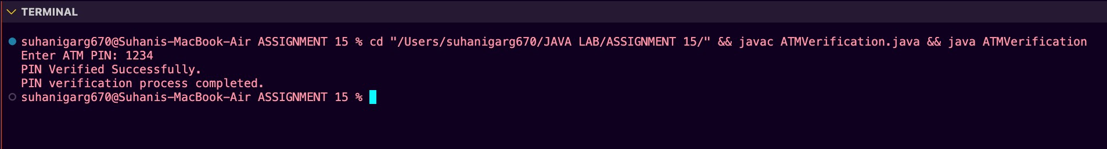

CONCLUSION:
This assignment helped us understand exception handling in Java using finally, throw, and throws. We learned how to handle invalid passwords and PINs using exceptions. The throw keyword was used to generate exceptions, throws was used to declare exceptions, and the finally block was used to execute a message after the process was completed. Thus, exception handling makes Java programs more reliable and prevents abnormal termination.

