

Name: Sharik Dhiman
PRN: 25070122177
Division : B3
ASSIGNMENT No: 4
TITLE: Develop a Java application demonstrating the use of wrapper classes for conversion between primitive data types and objects, and performing basic operations on wrapped values.
Problem Statement: Develop a Java application demonstrating the use of wrapper classes for conversion between primitive data types and objects, and performing basic operations on wrapped values.
Learning Objectives: To perform conversion between primitive data types and wrapper objects using Java wrapper classes.
Theory: Wrapper classes are predefined classes that encapsulate primitive data types into objects. Java provides wrapper classes such as Integer, Double, Character, and Boolean for every primitive type. They support autoboxing, unboxing, parsing, and conversion methods. Wrapper classes are widely used in Java Collections Framework and when object representation of primitive values is required.

Exercise:
1.Create a program to convert student marks from String format to Integer and calculate total marks.
Program:
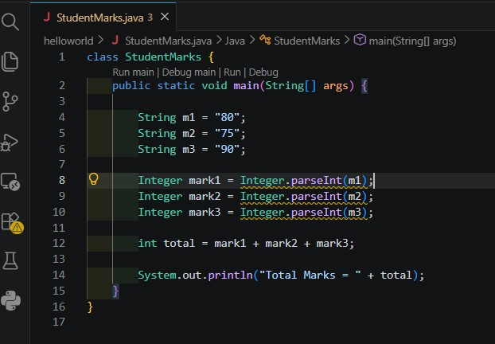
Output:
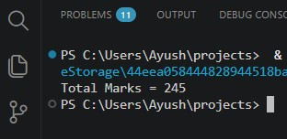

2. Develop an Employee Payroll System that accepts employee IDs, basic salary, and bonus amounts from the user. Convert the entered values into wrapper objects and perform validation operations to ensure valid salary values before calculating the net salary.
Program:
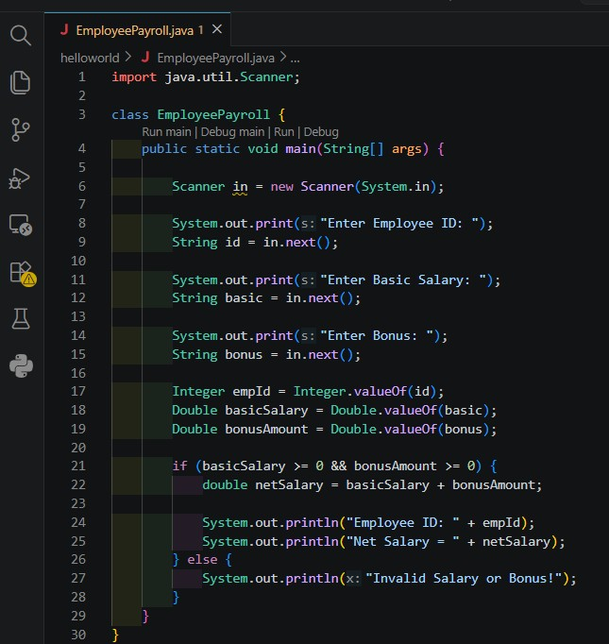
Output:

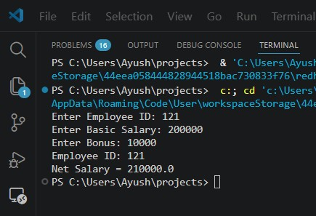
CONCLUSION:
We have successfully done the program and output is successfully displayed.

