

Name: Sharik Dhiman
PRN: 25070122177
Division: B3
ASSIGNMENT No: 13
TITLE: Write a Java program to perform reading from and writing to a file using file handling operations.
Problem Statement: Write a Java program to perform reading from and writing to a file using file handling operations.
Learning Objectives: To perform file reading and writing operations using Java file handling classes.
Theory: Java provides file handling through the java.io package. Classes such as File, FileReader, FileWriter, BufferedReader, and BufferedWriter are used to perform input and output operations. File handling enables permanent storage and retrieval of application data. Proper exception handling is necessary to manage file-related errors. These concepts are essential for data persistence.

Exercise:
- Create a program to write and read employee details from a file.

Program:
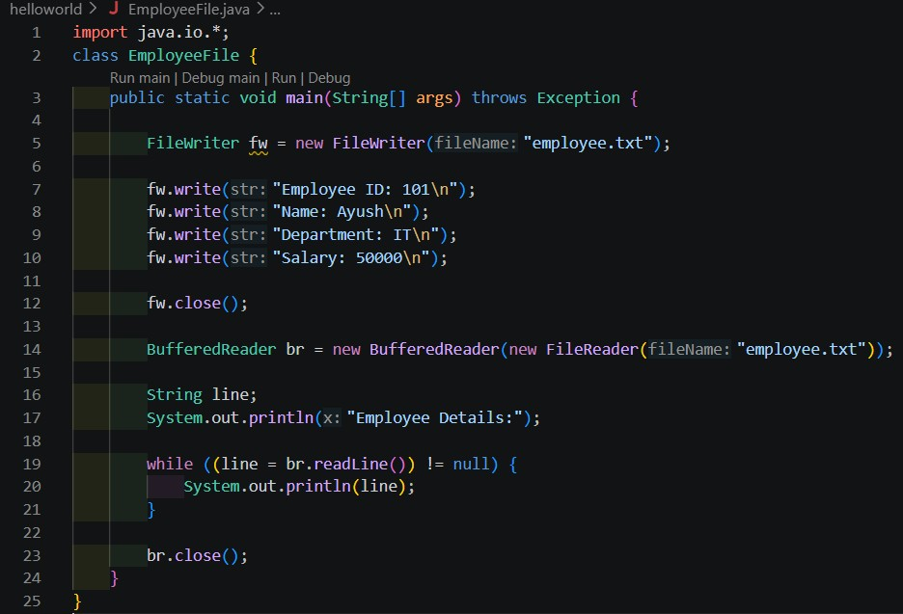

Output:
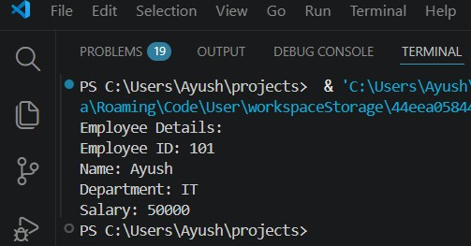

- a Java program to write patient details (patient ID, name, age, and diagnosis) to a file and read the details from the file for display.

Program:
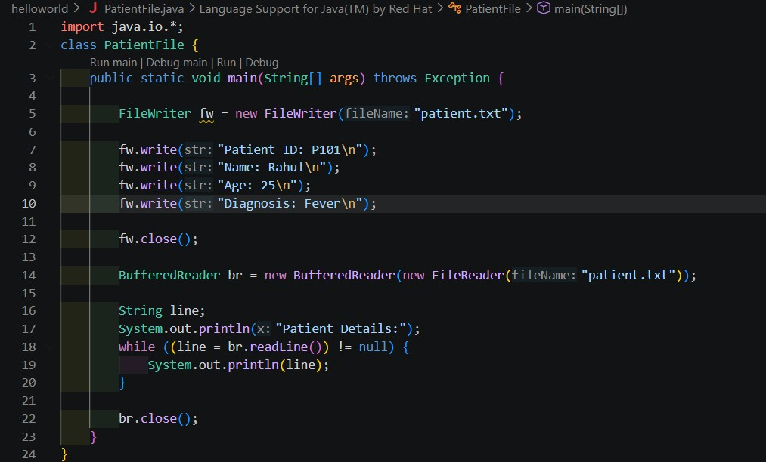

Output:
