Linix Custom command

1. I want a manual page of command so that I can see the full documentation of the command.

For example if you execute the command

man ls

Ans –

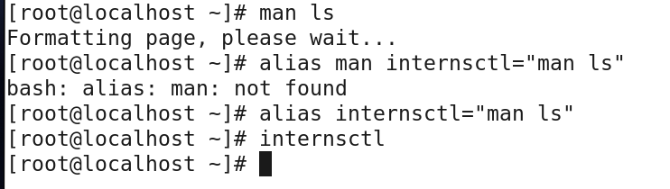

2. 2. Each linux command has an option --help which helps the end user to understand the use

cases via examples. Similarly if I execute internsctl --help it should provide me the

necessary help

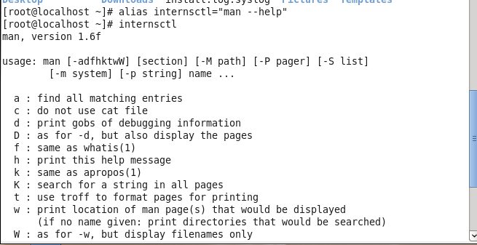

3. I want to see version of my command by executing

internsctl –version

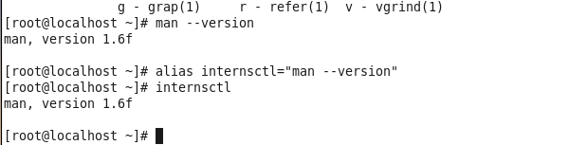

I want to list all the regular users present on my server through the following command:

$ internsctl user list

