**How to setup this project**

1. Download mysql and mysql workbench v8 and install.
2. Download anyone IDE like netbeans or eclipse.
3. Create database in mysql workbench v8

**Structure of library_management database**

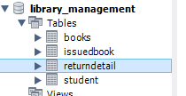

Create 4 tables inside library_management

**Student table**

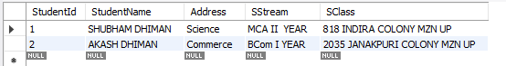

**Book table**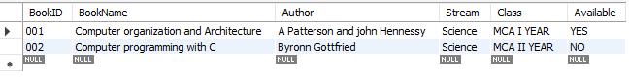

**Issuedbook table**



**Returndetails table**

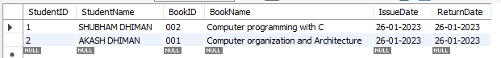

**NOTE:** After setup download source code zip file extract it and open inside any IDE and run the project