AS-IS State Document
Fan Data & Revenue Operations — Current State Assessment

Executive Summary
Fan data today lives in five disconnected systems with no shared fan identifier. Marketing, ticket sales, and gameday operations each make decisions on data that is, at best, seven days stale. Based on interviews with the VP of Marketing, Director of Ticket Sales, and Arena GM, we estimate the current process leaves approximately $2.4M in preventable season-ticket revenue unprotected each renewal cycle — not because the fans can't be saved, but because no one sees the warning signs in time.

Stakeholder Pain Log
Stakeholder | Pain Point | Current Workaround | Business Impact
VP of Marketing | No single view of a fan across ticketing, F&B, and email | Manual CSV joins in Excel every Monday | Campaigns target on 7+ day old data; wasted spend on already-churned fans
VP of Marketing | Can't tell which fans are disengaging until they don't renew | None — renewal non-response is the first signal | Reactive save offers instead of proactive retention
Director of Ticket Sales | No churn score for season ticket holders | Gut-feel calls based on tenure, not behavior | Est. 340 preventable non-renewals per cycle go uncontacted
Director of Ticket Sales | Renewal conversations happen without context | Rep looks up account manually across 3 systems before calling | Avg. 12 min prep per call; inconsistent talking points
Arena GM | Concession staffing is based on last year's attendance, not this game's forecast | Manager's own spreadsheet, updated by hand | Over/understaffing on 30%+ of gamedays; spoilage and long lines
Arena GM | Post-game NPS complaints (seats, wait times) surface days later, if at all | Google Sheet reviewed "when someone has time" | Guest complaints go unresolved same-night; no real-time escalation

Current-State Data Flow
Every fan touchpoint below writes to a different, disconnected system. There is no unified fan ID and no automated flow between them.
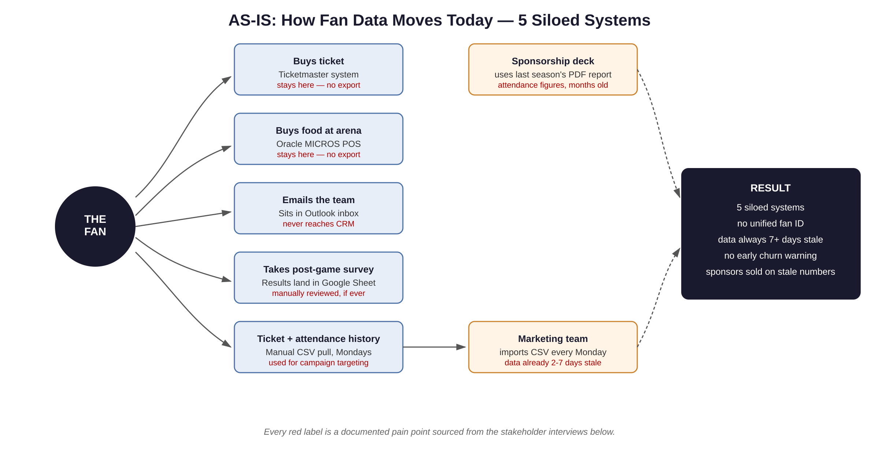

Cost of Doing Nothing
The calculation below is deliberately conservative — it counts only accounts with multiple concrete warning signs (declining attendance, lapsed app engagement, zero NPS response) at least 60 days before their renewal deadline, a population the current process cannot see because it spans three systems and one spreadsheet.
Input | Value
Active season ticket holder base | 8,500 accounts
Historical non-renewal rate showing detectable early warning signs (declining attendance, lapsed app engagement, zero NPS response) 60+ days before deadline — currently invisible across siloed systems | 4.0% of base = 340 accounts
Average annual account value (season ticket package + concessions + parking) | $7,058
Estimated at-risk revenue this renewal cycle, uncontacted under the current process | 340 × $7,058 ≈ $2.4M
This $2.4M figure is the baseline this project is built to recover. It becomes the headline number in the Phase 10 executive memo, backed by a churn model and a per-fan intervention list rather than a stakeholder estimate.

Appendix — Stakeholder Interview Transcripts
Simulated interviews conducted to establish the current-state pain log above. Each interview follows the same structure: current process, biggest pain point, and desired future state.
Sarah Coleman — VP of Marketing
Q: Walk me through how you decide who to target for a ticket renewal campaign.
A: Honestly? I pull a CSV export from Ticketmaster every Monday morning, and my analyst joins it against last week's email opens in Mailchimp by hand. By the time we send anything, the data's a week old. If a season ticket holder stopped opening emails two weeks ago, we don't find out until they don't renew.
Q: What keeps you up at night about the fan data situation?
A: That we're spending sponsor and marketing dollars targeting fans who've already checked out. I know it's happening — I just can't see it in time to do anything about it. We found out last spring that we sent a full-price upsell campaign to 200 accounts that had already requested refunds. That's embarrassing in front of a sponsor.
Q: If you could wave a magic wand, what would you want to see tomorrow morning?
A: One list. Every morning. Who's at risk, why, and what to do about it. Not five exports I have to reconcile myself.
Marcus Webb — Director of Ticket Sales
Q: How do you currently identify season ticket holders who might not renew?
A: We mostly go by tenure and gut feel. My reps have been doing this a long time, so they can sometimes tell from a phone call. But we have no scoring system — we find out for certain when the renewal deadline passes and the account just doesn't come back.
Q: What happens when a rep prepares to call an account?
A: They have to check Ticketmaster for purchase history, check our internal notes doc for past complaints, and sometimes call the box office for attendance. That's easily 10-15 minutes per account before they even dial. With 8,500 accounts, we simply can't do that depth of prep for everyone — so the reps that get proactive attention are the ones a rep happens to remember, not necessarily the ones actually at risk.
Q: Do you have a sense of how much revenue this is costing?
A: Not a hard number, no — that's part of why I'm glad this project is happening. But every year we lose accounts that, looking back, gave us every signal in the book: stopped showing up, stopped responding to surveys, let their parking pass lapse. We just never connected the dots in time.
Diane Ruiz — Arena General Manager
Q: How do you plan concession staffing for a given game?
A: Mostly off last year's attendance for the same opponent, adjusted for gut feel — day of week, whether it's a big rival. We don't have a real demand forecast. Some nights we're overstaffed and paying people to stand around; other nights, especially unexpected sellouts, the lines get so long we get complaints on social media before halftime.
Q: How do you find out about fan complaints during or after a game?
A: Post-game survey responses land in a Google Sheet. Someone on my team reviews it a couple of days later, if things are slow. By the time we know Section 112 had a wait-time problem, that game is long over and we've already lost those fans' goodwill — and sometimes the same section has the same problem again next game because nobody flagged it in time.
Q: What would change your ability to run gameday operations?
A: If I could see, in real time, what's selling and what the lines look like, I could move staff mid-game instead of finding out from a complaint.

