Upgrading JIRA

Following document will briefly describe the process of upgrading JIRA instance to a latest version.
Pre-requisites:
1. Admin Login credentials for the JIRA instance: This is required to create an XML backup of your existing JIRA installation.
2. Sudo User Login credentials to SSH the server on which the JIRA is hosted.
Make a note of the current JIRA version, and check for the latest JIRA version to which you wish to upgrade.
Procedure:
1. A JIRA installation can be done using two methods: Standalone and WAR file, for this document we take an example of upgrading JIRA instance from version 4.3.0 to 6.0.1, which is hosted on an Ubuntu 64bit Server. Please go though the link provided below to check for the most suitable method to upgrade your JIRA instance accordingly.
Link: https://confluence.atlassian.com/display/JIRA/Upgrading+JIRA
for this tutorial we will be following "Upgrading JIRA Using a Rapid Upgrade Method".
Before we start with the actual upgrade process lets go through the following steps:
i. Read about the new version.
ii. Check if your JIRA license is still valid.
iii. Check for known issues Link
iv. Check for compatibility issues.
Once all of the above points are taken into consideration, and you feel that you are confident enough to move forward with the up-gradation process, continue reading.
2. First and foremost thing to do before we start the up-gradation process are to take a backup for your External Database. Follow the steps given below to do this:
i. Login to JIRA as an Administrator.
ii. The Backup feature can be found under System -> Import and Export Tab.
iii. Here you enter a file name for the backup file that needs to be created. This backup process takes some time according to the size of the data on your JIRA instance. Once the backup is complete you will be displayed the path to your backup file. (*Please make a note of this, as this path is your <JIRA-HOME> directory, which will be required as we move forward).
iv. On the same screen, you will see a warning "Attachments will not be backed up..” This specifies that user uploaded attachments such as images, files and related external data linked to the JIRA tickets will not be backed up in the XML file and you will have to do this manually. For this please create a copy of the Attachments directory to a known place on the JIRA server. Path to attachments dir: <JIRA-HOME>/data/attachments/

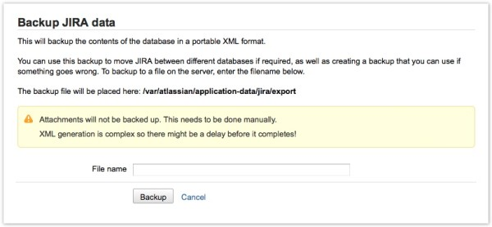
3. Once all the backups are done, we are not ready to start with the actual upgrade task. Follow this LINK according to your Operating System.
Step 1: SSH with the sudo user credentials to the server on which the JIRA instance is running.
Step 2: Locate and make note of the JIRA installation Directory <JIRA-INSTALL> and JIRA Home <JIRA-HOME> Directory.
Important: Before you move any further with the Upgrade, you first need to shutdown you current running JIRA. JIRA Startup and Shutdown scripts are present in <JIRA-HOME>/bin directory.
Start Script: start-jira.sh
Stop Script: stop-jira.sh
Run the following scripts accordingly.
Sample directory structure for the above following is given below
a. Home Image
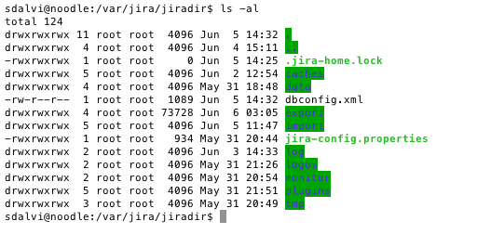
b. Install Image
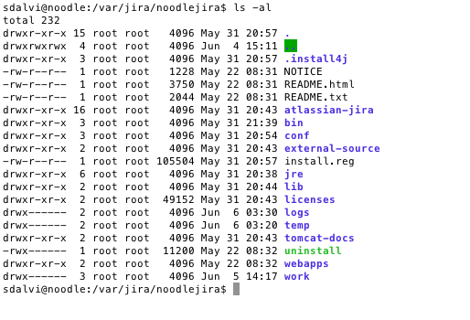
Step 3: Download the appropriate 'JIRA 'Linux 64-bit / 32-bit Installer' (.bin) file that suits your operating system (for the new version of JIRA) from the JIRA Download page.
Step 4: On your terminal, go to the directory where the JIRA installation (.bin) file is downloaded. Check if the bin file is executable, else run:
Command: chmod a+x atlassian-jira-X.Y.bin (where X.Y represents your version of JIRA)
Step 5: Execute the bin file to start the upgrade process.
Command: sudo ./atlassian-jira-X.Y.bin
Step 6: When prompted to choose between creating a new JIRA installation or upgrading an existing installation, choose the Upgrade an existing JIRA installation option.
Step 7: Specify the Jira Installation Directory <JIRA-INSTALL>, the upgrade process will attempt to find the existing installation directory and provide you with its path.
Step 8: During the further course of up gradation, you will be asked to backup JIRA directories. This creates 'zip' archive file backups of your existing JIRA Installation and JIRA Home Directories in their respective parent directory locations.
<Choosing this option is strongly recommended>
Step 9: At this point, the upgrade wizard notes any customizations in your existing JIRA Installation Directory which it cannot automatically migrate to your upgraded JIRA installation. If you are informed of any files containing such customizations, please make a note of these files as you will need to manually migrate their customizations (which are not mentioned in the overview above) to your upgraded JIRA installation. One relatively common customization that the upgrade wizard cannot automatically migrate is an SSL configuration defined in the conf/server.xml file of the JIRA Installation Directory.
Step 10: Next is the 'Upgrade Check List' step, which backups your external database. Note that we have already taken a backup during the start of this document. Still let the process continue its way.
Step 11: After the 'Upgrade Check List' step, the existing JIRA installation will be shut down if it is still running. The upgrade wizard will then:
1. Back up your existing JIRA installation.
2. Delete the contents of the existing JIRA installation directory.
3. Install the new version of JIRA to the existing JIRA installation directory.
4. Starts your new (upgraded) JIRA installation, if you noted any files that contain customizations which must be migrated manually to your upgraded JIRA installation (above), then:
1. Stop the upgraded JIRA installation.
2. Migrate the customizations from these files into the upgraded JIRA Installation Directory.
3. Restart the upgraded JIRA installation.
Step 12: The last step of the upgrade wizard provides you with a link to launch the upgraded JIRA installation in a browser, so you can check the upgrade.
Kudos!! With this you have successfully upgraded your JIRA if you have followed this tutorial from start step-by-step.
Post Up-gradation Checks:
1. Check if the database has been successfully linked to the updated JIRA, you will know this if all previous User data and Jira Tickets are intact and properly displayed.
2. You still need to copy the "attachments" directory back to its original place <JIRA-HOME>/data/attachments/ (We had earlier created a copy of the same.)
3. Upgrade your plugins after successfully upgrading JIRA. This can be done via the Plugin Repository in your Administration Console.
Congratulations! You have completed your JIRA upgrade.
Known Problems faced:
1. For an upgrade over JIRA version before v4.3.3 to v6, the port numbers differ in the conf/server.xml file. Please create a copy of your server.xml file when prompted in 'Step 9', check for the differences apart from the port numbers after the upgrade is complete and manually make those changes. (Note: Please do not make changes to the port numbers in the upgraded system.xml file unless you intentionally need to host JIRA or Tomcat over another specific port).
2. You may also face problems with some plugins, which are not compatible with the latest version, simplest thing to do here is to upgrade them or you can search the web to find different solution to overcome this problem.
References:
https://confluence.atlassian.com/display/JIRA/Upgrading+JIRA
https://confluence.atlassian.com/display/JIRA/Upgrading+JIRA+Using+a+Rapid+Upgrade+Method
http://www.atlassian.com/software/jira/download
https://confluence.atlassian.com/display/JIRAKB/Browse+JIRA+Articles+by+Version
http://blogs.atlassian.com/2013/04/6-steps-to-prepare-for-jira-6/
https://confluence.atlassian.com/display/JIRA/Upgrading+JIRA+Using+a+Rapid+Upgrade+Method#UpgradingJIRAUsingaRapidUpgradeMethod-upgradingonlinux
https://confluence.atlassian.com/display/JIRA/JIRA+6.0+Upgrade+Notes

