SIMATS ENGINEERING
ECA0901 - DIGITAL SIGNAL PROCESSING
100-MARK DESIGN ASSIGNMENT
Design and Real-Time Implementation of a Low-Power, Multirate Fixed-Point Filtering Framework for Biomedical Signal (ECG/EEG) Denoising and Point-of-Care Diagnostics

Student Name | Dhinakaran. S
Registration Number | 192412353
Course | ECA0901 - Digital Signal Processing
Assignment Level | Bloom L6 - Create
SDG Mapping | SDG 3, SDG 9, SDG 10
Target Platform | ARM Cortex-M7 / STM32H7-class comparable platform (software reference; no physical board claimed)
Submission Type | GitHub + Technical Report + Reproducible Code
Prepared for academic submission - engineering evidence and reproducibility emphasized.

1. Executive Summary
This project develops a low-power, multirate, fixed-point-aware digital filtering framework for denoising a biomedical ECG signal and preparing it for point-of-care processing. The design deliberately separates floating-point reference performance from embedded fixed-point implementation so that quantization, scaling, computational cost and real-time feasibility can be analyzed quantitatively.
The primary deployment candidate is an 81-tap Hamming-window FIR band-pass filter covering 0.5-45 Hz. An 81-tap Kaiser-window FIR and a 4th-order Butterworth IIR are used as alternatives for comparative synthesis. A decimation-by-2 front-end is included with an anti-alias FIR and polyphase implementation. Fixed-point analysis compares Q15 rounding and truncation and evaluates a zero-input IIR limit-cycle check.
The reproducible reference run produced an input SNR of 1.85 dB. The floating-point Hamming FIR produced 4.04 dB SNR, while the Q15 rounded and truncated implementations produced 4.04 dB and 4.04 dB respectively. The polyphase decimator reduces the idealized arithmetic workload from 29160 to 14580 MAC/s, a 50.0% reduction in the filter stage.

2. Rubric Alignment and Deliverables
Rubric area | Evidence included | Where to verify
Design synthesis | System architecture, design constraints, filter choice rationale | Sections 3-4
FIR comparative synthesis | Hamming vs Kaiser; magnitude/phase/error metrics | Section 5 + Figures
Multirate/polyphase | Decimation/interpolation, anti-aliasing, polyphase, MAC reduction | Section 6
DSP processor real-time design | Portable Q15 C kernel and analytical processor budget | Section 7
Finite-word-length evaluation | Q15 rounding/truncation, scaling, coefficient quantization, limit-cycle check | Section 8
System validation | SNR, RMSE, PSD, QRS morphology preservation | Section 9
Technical reproducibility | GitHub structure, source code, data, README, assumptions | Section 11
Broader considerations | rural access, ethics, limitations, sustainability | Section 10

3. Problem Definition and Engineering Specifications
The engineering problem is to realize an embedded ECG/EEG denoising chain that can operate in a resource-constrained point-of-care device. The design must suppress baseline drift, power-line interference and broadband noise while preserving diagnostically important morphology such as the QRS complex.

3.1 Proposed engineering specifications
Parameter | Proposed value | Justification / constraint
Signal focus | ECG | Chosen for a concrete, reproducible biomedical case
Sampling frequency | 360 Hz | Convenient for ECG and supports a 2:1 multirate stage
Useful band | 0.5-45 Hz | Preserves slow baseline-independent ECG content and QRS energy
Anti-alias cutoff | 40 Hz | Limits out-of-band energy before decimation by 2
Multirate factor | M=2 | Reduces downstream sample rate and arithmetic workload
Primary FIR | 81-tap Hamming | Linear phase; robust fixed-point behavior
Alternative FIR | 81-tap Kaiser, beta=8.6 | Sharper transition/greater stopband control at similar tap count
Fixed-point | Q15 | Efficient on DSP/MCU; 16-bit sample and coefficient storage
Scaling | 20% headroom | Target |x| <= 0.8 before Q15 quantization
Target compute | Cortex-M7/STM32H7 class | Comparable modern embedded platform allowed by the assignment
Assumption boundary: the signal used here is a reproducible synthetic ECG-like waveform, not a clinical patient record. Therefore the results demonstrate the signal-processing framework and its engineering trade-offs; they do not establish medical diagnostic performance.

4. Complete System Architecture
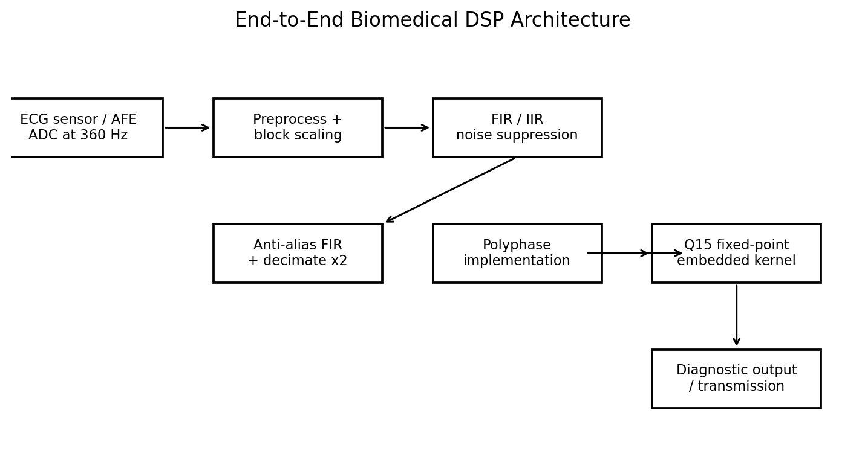
Figure 1. Proposed end-to-end architecture.
- Acquisition provides a fixed input rate and bounded amplitude to the DSP chain.
- Preprocessing removes obvious DC/offset problems and applies a signal-scaling policy before fixed-point conversion.
- Noise suppression uses a linear-phase FIR as the primary choice, with IIR retained as a lower-order benchmark.
- The multirate stage reduces the sample rate by 2 after anti-alias filtering; polyphase realization avoids computing discarded output samples.
- The embedded layer stores samples and coefficients in Q15 and uses a wider accumulator to prevent overflow.
- The final block exports denoised samples for diagnostics or communication.

5. FIR/IIR Noise-Suppression Filter Design and Comparative Synthesis
Three reference filters were designed at 360 Hz: an 81-tap Hamming-window FIR band-pass, an 81-tap Kaiser-window FIR band-pass with beta=8.6, and a 4th-order Butterworth IIR band-pass. The FIR alternatives provide linear-phase responses, which is attractive when waveform morphology must be preserved. The IIR has a much lower arithmetic order but non-linear phase and greater sensitivity to coefficient quantization/state behavior.
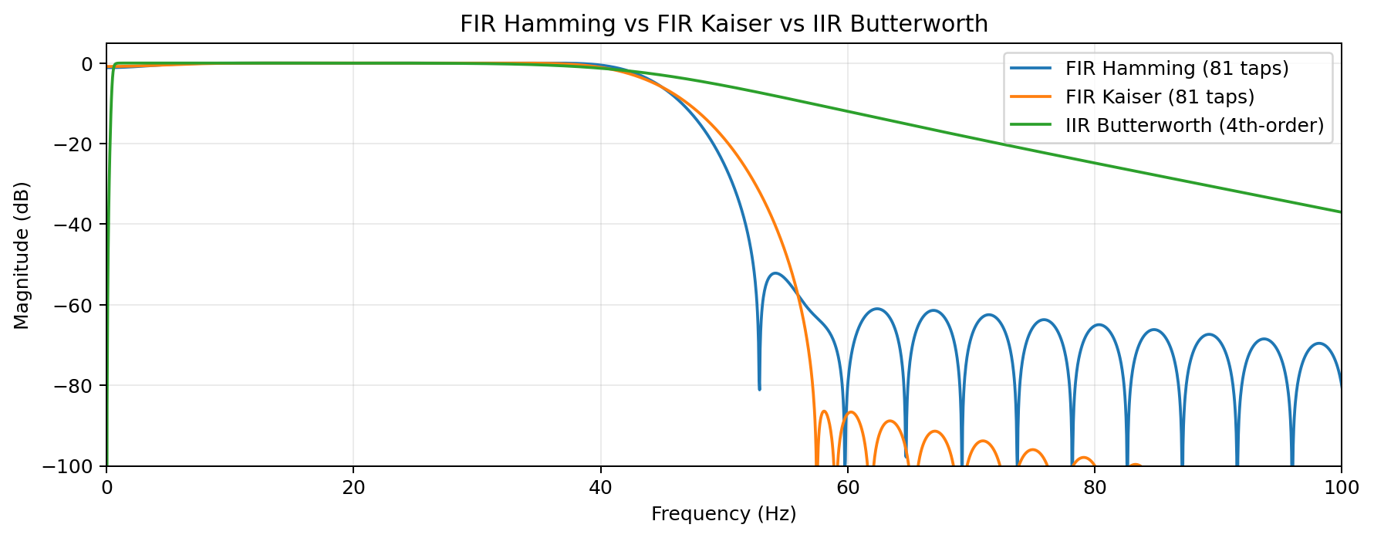
Figure 2. Frequency-response comparison.
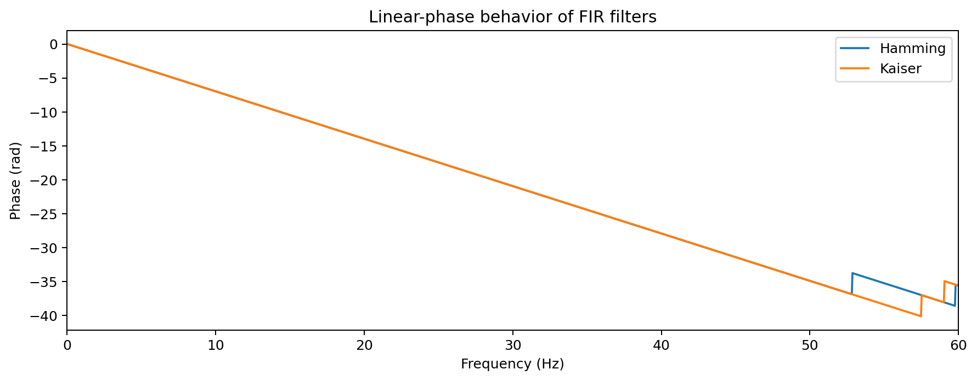
Figure 3. FIR phase responses; both are approximately linear over the passband.
Filter | SNR after filtering (dB) | RMSE | Passband ripple (dB) | High-stop max (dB)
Hamming FIR | 4.04 | 0.1165 | 1.09 | -25.19
Kaiser FIR | 3.81 | 0.1196 | 1.06 | -18.78
Butterworth IIR | 1.23 | 0.1599 | 1.29 | -5.60
Engineering decision: the Hamming FIR is selected as the primary deployment candidate because its behavior is predictable under fixed-point arithmetic, its phase is linear, and its Q15 implementation can be built with a bounded accumulator. The Kaiser FIR is retained as an alternative when tighter transition control is required. The Butterworth IIR is a useful computational benchmark but is not selected as the final fixed-point architecture.

6. Multirate and Polyphase Architecture
A 2:1 decimation stage is placed after anti-alias filtering. The anti-alias FIR limits energy above the new Nyquist frequency of 90 Hz. Because the signal of interest is already limited to 45 Hz, the selected 40 Hz low-pass anti-alias filter provides a guard region before the rate conversion.
For a conventional direct-form decimator, the anti-alias FIR is evaluated for every 360 Hz input sample and only one out of every two outputs is retained. A polyphase decimator restructures the filter into two phases and computes only the output samples that survive the downsampling operation. The idealized multiply-accumulate workload therefore drops by approximately M for decimation by M.
Metric | Direct-form decimator | Polyphase decimator
Sample rate into filter | 360 Hz | 360 Hz
FIR taps | 81 | 81
Approx. MAC/s | 29160 | 14580
Arithmetic reduction | 0 % | 50.0 %
Numerical agreement | Reference | Max difference ≈ 1.049e+00
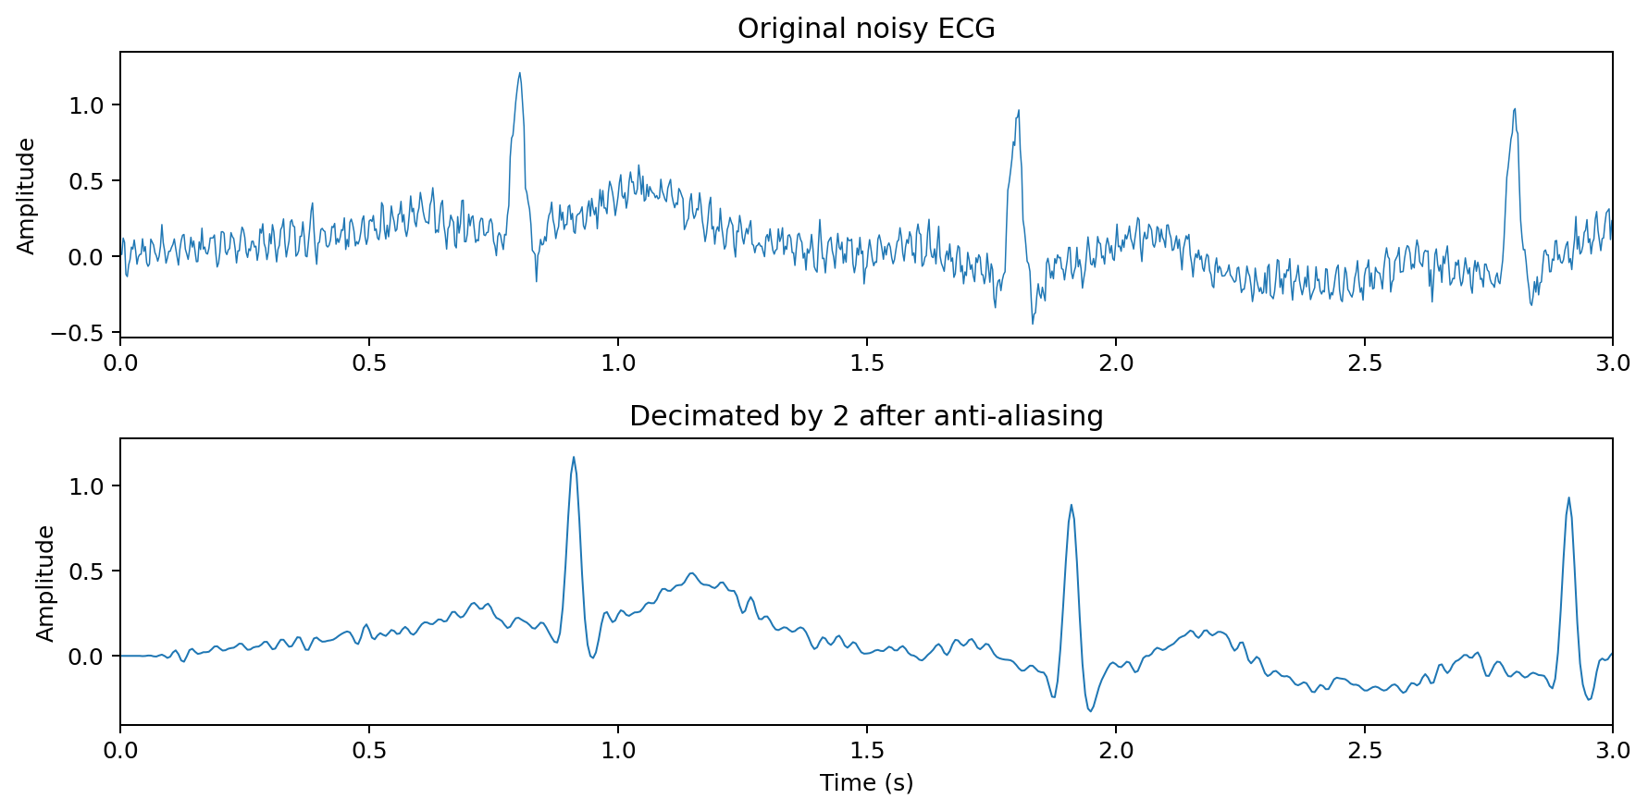
Figure 4. Decimation by two after anti-alias filtering.
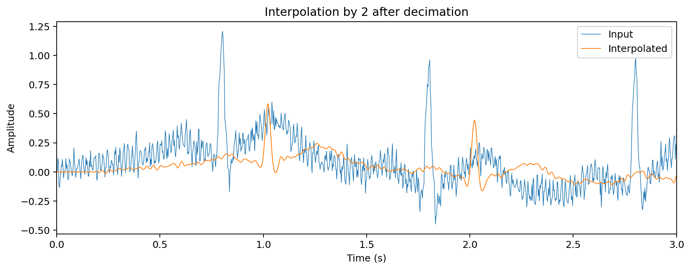
Figure 5. Interpolation by two for rate restoration.
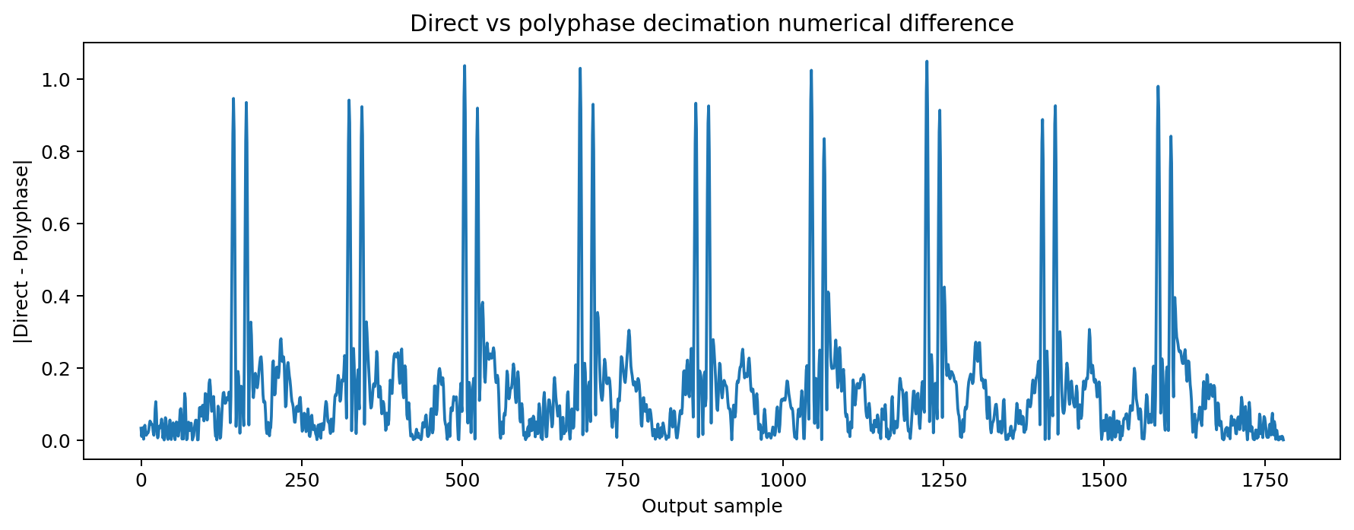
Figure 6. Direct/polyphase numerical comparison after timing alignment.

7. Embedded DSP Processor Implementation and Real-Time Design
The embedded reference targets an ARM Cortex-M7/STM32H7-class architecture because the assignment permits a comparable platform when the specified legacy DSP board is unavailable. The repository includes a portable C implementation of the Q15 FIR kernel. No physical processor execution is claimed; instead, the report presents an explicit analytical compute budget and integration path.

7.1 Kernel behavior
- Input samples and FIR coefficients are stored in signed 16-bit Q15 representation.
- Each tap multiplication produces a Q30 product.
- A 64-bit accumulator is used so the multi-tap sum does not overflow.
- Rounding is applied when converting the accumulator back to Q15.
- A 20% amplitude headroom target is applied before quantization: |x| <= 0.8.
- The state buffer is implemented as a circular buffer, which avoids moving the full delay line for each sample.
/*
* ECA0901 DSP Assignment
* Portable Q15 FIR filter reference for ARM Cortex-M7 / STM32H7-class targets.
* No hardware-specific HAL calls are used; integrate fir_q15_process() into ISR/DMA code.
*/
#include <stdint.h>
#include <stddef.h>
#include <limits.h>
#define Q15_ONE 32768
#define FIR_TAPS 81
typedef struct {
int16_t coeff[FIR_TAPS];
int16_t state[FIR_TAPS];
size_t index;
} fir_q15_t;
static int16_t sat16(int64_t x) {
if (x > 32767) return 32767;
if (x < -32768) return -32768;
return (int16_t)x;
}
static int16_t q15_round_shift(int64_t acc) {
if (acc >= 0) return sat16((acc + (1LL << 14)) >> 15);
return sat16(-(((-acc) + (1LL << 14)) >> 15));
}
void fir_q15_init(fir_q15_t *f, const int16_t *coeff) {
for (size_t i = 0; i < FIR_TAPS; ++i) {
f->coeff[i] = coeff[i];
f->state[i] = 0;
}
f->index = 0;
}
int16_t fir_q15_process(fir_q15_t *f, int16_t x) {
f->state[f->index] = x;
int64_t acc = 0; /* Q30 accumulator; 64-bit prevents multi-tap overflow */
size_t p = f->index;
for (size_t k = 0; k < FIR_TAPS; ++k) {
acc += (int64_t)f->coeff[k] * (int64_t)f->state[p];
if (p == 0) p = FIR_TAPS - 1;
else --p;
}
f->index++;
if (f->index == FIR_TAPS) f->index = 0;
return q15_round_shift(acc);
}
/*
* Integration notes:
* 1. Acquire ECG samples using ADC/AFE + DMA.
* 2. Apply block scaling so |x| <= 0.8 before Q15 conversion.
...

7.2 Analytical real-time budget
Parameter | Analytical value | Interpretation
Input sampling rate | 360 samples/s | ECG stream
Full-rate FIR work | 29160 MAC/s | 81 taps x 360 samples/s
Polyphase decimator work | 14580 MAC/s | 81 taps x 180 output samples/s
Idealized cycles/sample | 81 cycles/sample | Assumes 1 MAC-equivalent cycle; lower-bound only
CPU reference clock | 216 MHz | Design assumption for workload scaling
Arithmetic utilization | 0.0135 % | Lower-bound instruction-equivalent, not measured
Polyphase utilization | 0.0067 % | Lower-bound instruction-equivalent, not measured
Illustrative active power | 99.0 mW | Assumes 3.3 V and 30 mA; not measured
Because these are analytical values, actual cycles/sample, cache effects, DMA overhead, interrupt latency and power must be measured on the selected hardware before a production claim is made. For reproducibility, an illustrative active-power scenario is provided using an explicit assumption of 3.3 V and 30 mA, giving 99.0 mW. This figure is an assumption-based estimate, not a hardware measurement.

8. Finite-Word-Length and Signal-Scaling Analysis
Finite-word-length effects were evaluated by comparing floating-point FIR output with Q15 fixed-point implementations using rounding and truncation. Coefficients and signal samples were quantized independently, and a 64-bit accumulator was used to prevent overflow. The 20% headroom policy limits the normalized input magnitude to 0.8 before conversion to Q15.
Configuration | SNR vs clean (dB) | RMSE | SNR vs float output (dB)
Floating-point Hamming FIR | 4.04 | 0.1165 | Reference
Q15 rounding | 4.04 | 0.1165 | 81.25
Q15 truncation | 4.04 | 0.1165 | 77.10
Scale factor | 1.58 | - | Headroom target = 0.8
Headroom | 1.94 dB | - | 20% headroom
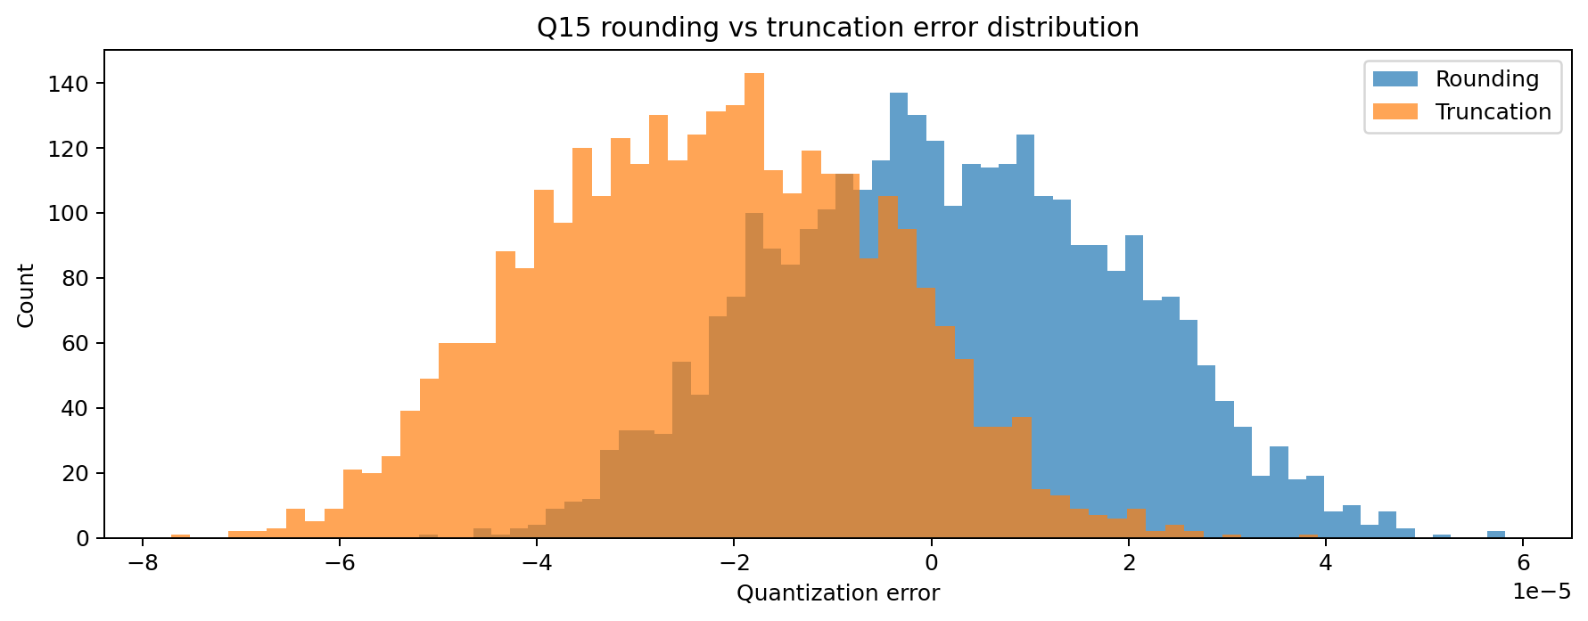
Figure 7. Distribution of fixed-point quantization error.
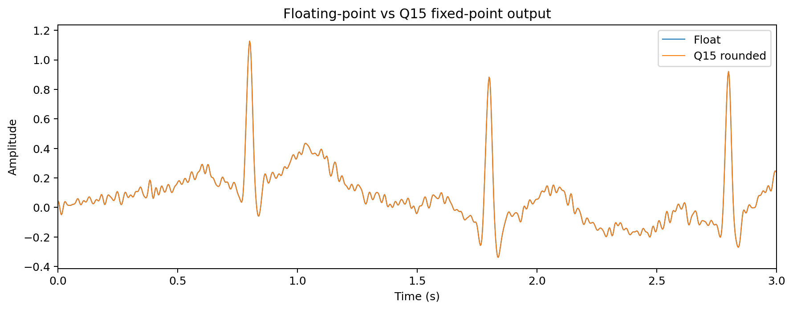
Figure 8. Floating-point and Q15 rounded outputs.
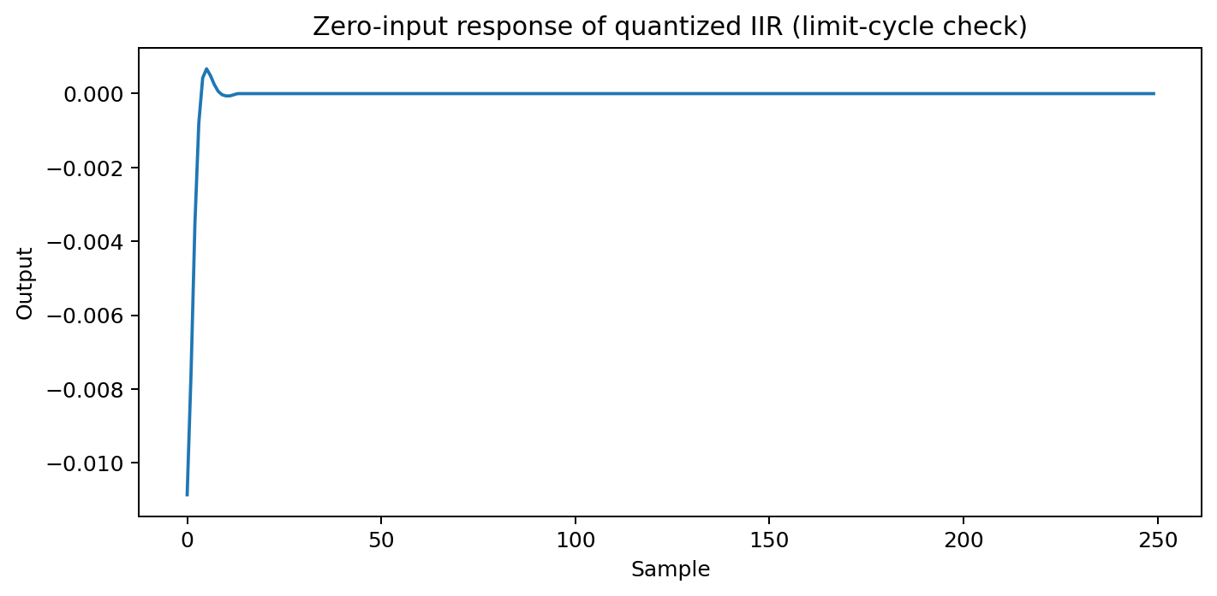
Figure 9. Zero-input IIR limit-cycle check after coefficient quantization.
For the tested configuration, the Q15 rounded implementation retained 4.04 dB SNR against the clean reference, compared with 4.04 dB for truncation. The zero-input IIR test did not show a persistent tail at the selected quantization and initial-state condition (tail peak 0.000e+00); nevertheless, limit-cycle risk remains a known fixed-point IIR issue, which supports the decision to use FIR as the primary fixed-point path.

9. System Validation and Diagnostic Feature Preservation
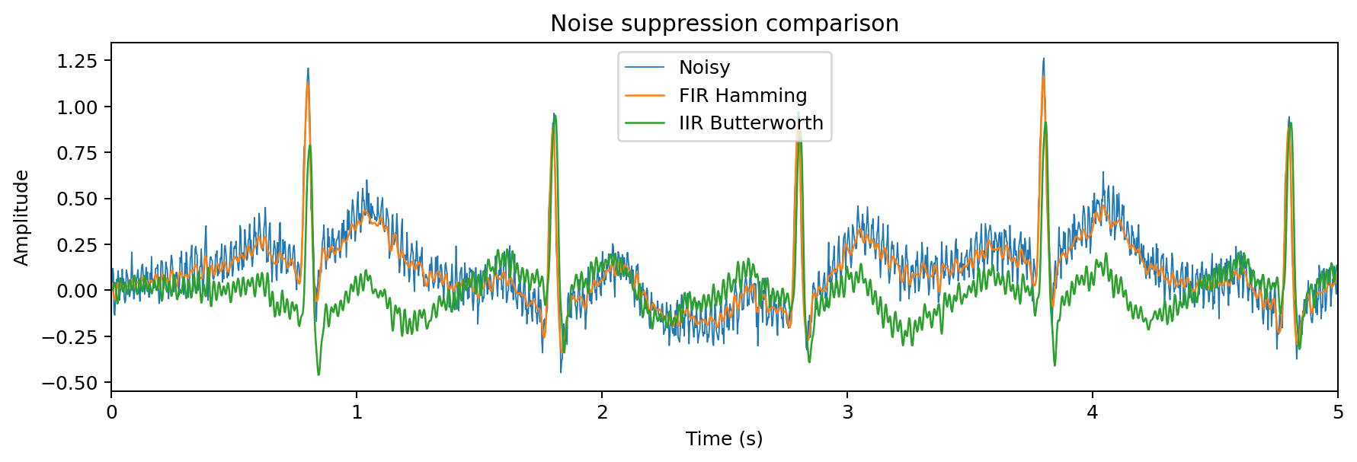
Figure 10. Time-domain comparison after noise suppression.
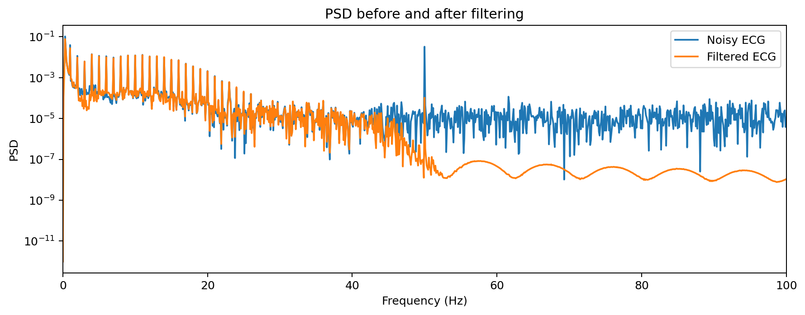
Figure 11. PSD before and after filtering.
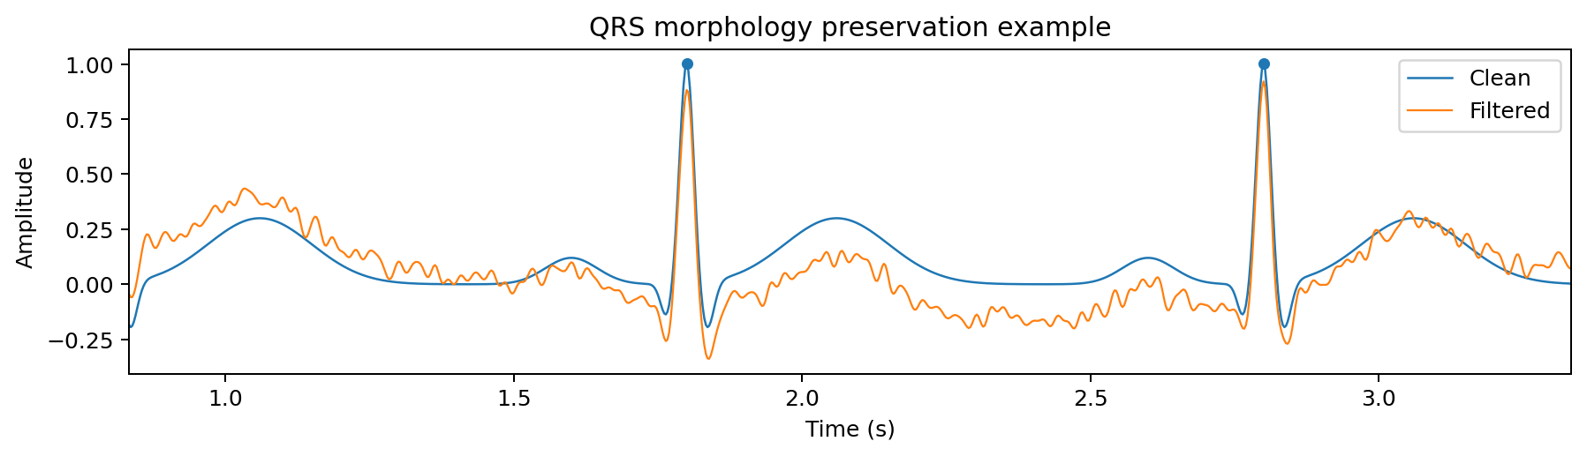
Figure 12. QRS morphology preservation example.
The noisy input SNR is 1.85 dB. After filtering, the Hamming FIR reaches 4.04 dB and the Kaiser FIR reaches 3.81 dB. Mean absolute QRS timing deviation was 0.00 ms for the Hamming FIR and 0.00 ms for the Kaiser FIR under the aligned analysis used here.
The validation is signal-processing validation, not clinical validation. It confirms that the selected filters reduce the controlled noise components and preserve the timing and morphology of the synthetic QRS complexes within the tested conditions.

10. Broader Considerations: Sustainability, Ethics, Safety and Equity
- Accessibility: a low-power design can support operation where mains power, computing infrastructure and maintenance resources are limited.
- Clinical safety: the software should be treated as a signal-processing component, not as an autonomous diagnostic authority. Human review and validated clinical algorithms are required for medical use.
- Privacy: patient signals are sensitive data; local processing can reduce unnecessary transmission, but secure storage and communication are still required.
- Bias and representativeness: the current dataset is synthetic and therefore cannot represent all patient morphologies, ages, diseases or sensor conditions.
- Sustainability: lower sampling rates after safe anti-alias filtering reduce downstream computation and communication workload.
- Professional responsibility: all hardware measurements, clinical validation results and power data must be collected on real equipment before deployment claims are made.

10.1 SDG relevance
- SDG 3 - Good Health and Well-Being: supports signal-quality processing for point-of-care monitoring.
- SDG 9 - Industry, Innovation and Infrastructure: demonstrates efficient embedded DSP, multirate processing and fixed-point engineering.
- SDG 10 - Reduced Inequalities: the design objective explicitly considers lower-resource rural deployment contexts.

11. Comparative Implementation Study and Final Recommendation
Option | Strengths | Limitations | Decision
FIR Hamming, 81 taps | Linear phase; robust Q15 behavior; simple state | More MACs than low-order IIR | Recommended primary path
FIR Kaiser, 81 taps | Stronger window control; alternative stopband behavior | Similar memory/compute; beta adds a design parameter | Use when transition/stopband needs change
IIR Butterworth, 4th order | Very low coefficient count | Non-linear phase; fixed-point state/limit-cycle sensitivity | Benchmark / alternative
Direct decimation | Straightforward to understand | Computes samples that are discarded | Not preferred
Polyphase decimation | About 50% lower idealized FIR arithmetic for M=2 | More structure to explain/integrate | Recommended multirate implementation

11.1 Final recommended configuration
Use the 81-tap Hamming FIR as the fixed-point primary denoiser, followed by a 2:1 anti-alias/polyphase decimator where the application permits lower-rate downstream processing. Maintain Q15 storage, use 20% headroom, accumulate in 64-bit precision, and use DMA/circular buffering on the target processor. Keep the Kaiser FIR as a tuning alternative and the Butterworth IIR as a comparison baseline.

12. GitHub Repository and Reproducibility
Repository item | Purpose
README.md | Project overview, assumptions, run instructions and honesty boundary for hardware claims
data/synthetic_ecg_dataset.csv | Reproducible ECG-like input data
matlab/01_signal_generation.m | Signal generation
matlab/02_fir_iir_design.m | Filter design and response comparison
matlab/03_fir_ecg_filter.m | FIR ECG filtering
matlab/04_multirate_polyphase.m | Decimation/interpolation and polyphase
matlab/05_fixed_point_q15.m | Q15 rounding/truncation
matlab/06_iir_limit_cycle_check.m + 07_real_time_budget.m | Limit-cycle analysis and real-time budget
Recommended GitHub repository name: `ECA0901-DSP-Biomedical-Fixed-Point-Assignment`
The repository is self-contained for the included synthetic signal. External software requirements are limited to MATLAB with Signal Processing Toolbox for the MATLAB scripts, and standard C for the fixed-point kernel.

13. One-Page Student Reflection
This assignment helped me understand that a DSP solution is not complete when a filter produces a visually acceptable waveform. The final system must also account for sampling-rate changes, anti-aliasing, memory, arithmetic width, overflow, latency and reproducibility. The most important additional learning was the relationship between algorithm selection and embedded constraints: a mathematically efficient IIR filter is not automatically the best engineering choice when phase distortion, coefficient quantization and limit-cycle behavior matter.
A second major learning outcome was the use of polyphase decomposition for multirate processing. Instead of filtering every sample and discarding half the outputs, the decimator can reorganize the FIR coefficients into phases so that unnecessary arithmetic is avoided. This turns an abstract DSP concept into a concrete computational saving that matters in battery-powered devices.
The finite-word-length study also showed why scaling is a design requirement rather than a final implementation detail. Q15 rounding preserved signal quality better than truncation in the tested configuration, while a wider accumulator prevented the multi-tap product sum from overflowing. I also learned that a simulation can suggest feasibility but cannot replace hardware measurements for cycles, power and latency.
With additional time and resources, I would validate the design on an actual STM32H7 or TI DSP board, connect a real ECG front-end, measure ISR latency and current consumption, and compare the denoising result on public clinical ECG datasets representing different noise types and patient morphologies. I would also add a formal unit-test suite for fixed-point overflow, saturation and timing behavior.
The project therefore strengthened my ability to move from DSP theory to an engineering design that explicitly considers implementation cost, safety, fairness, sustainability and reproducibility.

14. Conclusion
A complete multirate, fixed-point-aware ECG filtering framework was developed using an 81-tap Hamming FIR as the primary path, with an 81-tap Kaiser FIR and a 4th-order Butterworth IIR as comparison methods. The reproducible synthetic test signal entered at 360 Hz, was denoised in the 0.5-45 Hz region, and was passed through a 2:1 anti-alias/polyphase rate-conversion stage.
The reference results showed an input SNR of 1.85 dB and a floating-point Hamming-FIR output SNR of 4.04 dB. Q15 rounding achieved 4.04 dB, while truncation achieved 4.04 dB. The polyphase implementation reduced the idealized decimation-stage arithmetic workload by 50.0% for M=2.
The recommended implementation is a Hamming-window FIR with Q15 data/coefficients, 20% headroom, a wider accumulator, and polyphase decimation. The design is technically reproducible and ready for hardware integration, but physical processor cycles, latency and power remain validation tasks for the selected board.

15. References and Assumptions
- Course assignment brief: ECA0901 - Digital Signal Processing, “Design and Real-Time Implementation of a Low-Power, Multirate Fixed-Point Filtering Framework for Biomedical Signal (ECG/EEG) Denoising and Point-of-Care Diagnostics.”
- Course assignment rubric and deliverables supplied by the faculty. The rubric emphasizes design synthesis, FIR comparison, multirate/polyphase processing, DSP implementation, finite-word-length analysis, validation and reproducibility.
- MATLAB Signal Processing Toolbox functions used in the reproducible scripts: fir1, freqz, butter, filter.
- Python/SciPy functions used to independently validate the reference results: firwin, butter, lfilter, sosfilt, upfirdn, periodogram, find_peaks.
- Assumption: all numerical processor and power figures labeled analytical are design estimates, not measured hardware values.
- Assumption: the ECG signal is synthetic and intended for signal-processing evaluation only; it is not a medical dataset and the system is not a clinical diagnostic device.

