3.Read about the difference between window, screen and document in javascript

Window Vs Document
Window object : It is the top most object and outermost element of the object hierarchy as shown in Figure 1.
Document object : Each HTML document that gets loaded into a window becomes a document object. The document contains the contents of the page. Using document object, JavaScript can modify, add and delete the HTML elements, attributes CSS styles in the page
The window object represents a window/tab containing a DOM document where as document object is property of window object that points to the DOM document loaded in that window.
You can access a document object either using window.document property or using document object directly as window is global object. In the below example, title is the property of document object.
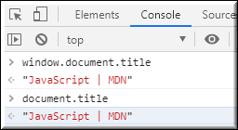
The other major difference is that both window object and document object have properties and methods. Few method names are same in both objects but with different behavior. In the below example window.open() opens a new tab or window and document.open() creates a blank document within the window.
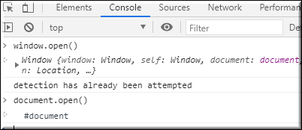

Screen
Screen is the window property that holds information of browser screen. It refers to screen object associated with that window object. Used to display screen width, height, colorDepth, pixelDepth etc
Similar to document screen can be accessed either by window.screen or screen object directly. Screen object doesn't have any methods as in window and document objects.
