

WarrantyGuard AI – Explainable Multimodal Warranty Claim Verification & Risk-Triage Platform
A project report
Submitted by

KARTHIK JAYAKRISHNA A (714024247051)

in partial fulfillment for the award of the degree
of
BACHELOR OF TECHNOLOGY
IN
ARTIFICIAL INTELLIGENCE AND MACHINE LEARNING
SRI SHAKTHI
INSTITUTE OF ENGINEERING AND TECHNOLOGY
ANNA UNIVERSITY: CHENNAI 600025
NOVEMBER 2026
BONAFIDE CERTIFICATE
This is to certify that the project report titled “WARRANTYGUARD AI –
Explainable Multimodal Warranty Claim Verification & Risk-Triage
Platform” is the Bonafide work of “KARTHIK JAYAKRISHNA A
(714024247051)”, who carried out the project work under my guidance and
supervision.

SIGNATURE | SIGNATURE
Mrs. S. Hemalatha | Ms. K.Priyanka
HEAD OF THE DEPARTMENT | SUPERVISOR
Artificial Intelligence and  Machine Learning. | Artificial Intelligence and Machine Learning.
Sri Shakthi Institute  of Engineering and Technology, Coimbatore – 641 062 | Sri Shakthi Institute  of Engineering and Technology, Coimbatore – 641 062
Submitted for the project work Viva Voice Examination held on …………………

INTERNAL EXAMINER EXTERNAL EXAMINER

ACKNOWLEDGEMENT

First and foremost, I would like to thank God Almighty for giving me the strength to complete this work. Without His blessings, this achievement would not have been possible.
I express my deepest gratitude to our Chairman Dr. S. Thangavelu for his continuous encouragement and support throughout my course of study.
I am thankful to our Secretary Dr. T. Dheepan for his unwavering support during the entire course of this project work.
I am also thankful to our Joint Secretary Mr. T. Sheelan for his support during the entire course of this project work.
I am highly indebted to our Principal Dr. R. Saravana Kumar for his support during the tenure of the project.
I sincerely thank Mrs. S. Hemalatha, Head of the Department of Artificial Intelligence and Machine Learning, and Mss. K. Priyanka, my Project Guide, for their invaluable guidance, technical support, and the facilities provided throughout this project. I also extend our gratitude to all the teachers and non-teaching staff of our department, as well as my family and friends, for their constant encouragement and support.
KARTHIK JAYAKRISHNA A (714024247051)

ABSTRACT
WarrantyGuard AI is an enterprise-grade, multi-tenant warranty claim processing and fraud prevention platform designed for hardware manufacturers and consumer-electronics retailers. In traditional warranty operations, support agents manually inspect proof-of-purchase invoices, match serial numbers against product labels, consult policy documents for exclusions such as accidental damage or liquid spills, and try to spot duplicate or forged submissions. This manual triage typically takes three to seven days, leads to customer dissatisfaction, and remains vulnerable to human error.
WarrantyGuard AI replaces this process with an automated eight-step AI triage pipeline. The system extracts the purchase date, price and model from invoices and the serial number from product labels using PaddleOCR (PP-OCRv4); analyses the complaint text for severity and intent using spaCy; validates warranty eligibility and model consistency through a rule engine backed by an organisation-specific product catalogue; detects recycled or forged photographs using 64-bit perceptual hashing; retrieves the relevant manufacturer policy clauses through a brand-partitioned Retrieval-Augmented Generation (RAG) module built on Sentence-Transformers and FAISS; and finally uses a Groq-hosted large language model to produce a structured decision (approved, rejected, needs manual review, or duplicate evidence) with reasoning and a recommended action, in under two seconds of decision latency.
The platform is delivered as a React 19 single-page application backed by a FastAPI service, a PostgreSQL database and S3-compatible object storage on Supabase. Customers submit claims and track progress in a self-service portal; agents review auto-triaged claims on a command-centre dashboard with filters, bulk actions and live pipeline progress via Server-Sent Events; administrators manage the product catalogue, team members, SLA targets and organisation settings. Security is enforced through organisation-level tenant isolation, role-based access control, bcrypt password hashing, JWT access and revocable refresh tokens, OWASP security headers, rate limiting, SHA-256 evidence checksums and an immutable audit trail. Docker-based packaging and a GitHub Actions CI/CD pipeline support reproducible deployment. WarrantyGuard AI thereby shortens resolution time, reduces fraud and gives support teams transparent, explainable decisions.

TABLE OF CONTENTS

CHAPTER NO TITLE PAGE NO

ACKNOWLEDGEMENT iii
ABSTRACT iv
LIST OF TABLES viii
LIST OF FIGURES ix

1 INTRODUCTION 1
1.1 General Overview 1
1.2 Problem Statement 1
1.3 Objectives of WarrantyGuard AI System 2
1.4 Scope of the Project 3

2 LITERATURE REVIEW 4
2.1 Overview of Warranty Claim Management 4
2.2 OCR and Document Intelligence 4
2.3 Fraud Detection And Image Forensics 5
2.4 Web Solutions 5
2.5 Research Gap 6

3 PROPOSED SYSTEM 7
3.1 System Overview 7
3.2 Module Description 7
3.2.1 User Authentication And Access Control 7
Module
3.2.2 Claim Ssubmission And Evidence 8
Module
3.2.3 AI Triage Pipeline Module 8

CHAPTER NO TITLE PAGE NO

3.2.4 Agent Dashboard And Analytics 8
Module
3.2.5 Administration And Multi-Tenant 8
Management Module
3.3 Advantages Of The Proposed WarrantyGuard 8
AI System
3.4 Addressing Limitations Of Existing 9
Systems
3.5 Process Flow 10
3.6 Use Case Diagram 12

4 SYSTEM DESIGN 13
4.1 System Architecture 13
4.2 Database Design 14
4.2.1 Entities and Relationships 14
4.2.2 Normalization 16
4.3 Sequence Diagrams 17
4.4 Functionalities 17
4.4.1 User Authentication and Access 18
Control Module
4.4.2 Claim Submission and Evidence 18
Management Module
4.4.3 AI Triage Module 19
4.4.4 Agent Dashboard and Search Module 19
4.4.5 Claim Detail, Comments and Audit 19
Module
4.4.6 Analytics, SLA and Notification 20
Module

CHAPTER NO TITLE PAGE NO

4.4.7 Administration and Multi-Tenant 20
Management Module

5 IMPLEMENTATION 21
5.1 Overview of Implementation 21
5.2 Technological Stack 21
5.2.1 Frontend 21
5.2.2 Backend 22
5.2.3 Database and Storage Layer 22
5.2.4 AI and Machine-Learning Engine 23
5.2.5 Deployment, Containerisation and 23
CI/CD
5.3 Implementation Process 25
5.4 Testing and Quality Assurance 25

6 RESULTS 27
6.1 Dashboard Output Screens 27
6.2 Claim Submission Results 28
6.3 AI Triage and Claim Detail Results 29
6.4 Administration Management Results 30
6.5 User Profile and Settings Results 30

7 CONCLUSION AND FUTURE ENHANCEMENT
7.1 Conclusion 32
7.2 Future Enhancements 32
APPENDIX 33
REFERENCES 40

LIST OF TABLES

TABLE NO DESCRIPTION PAGE NO
2.1 Summary of Existing Methods in Warranty and 6
Support Management
3.1 The Eight-Step AI Triage Pipeline 10
4.1 Role-Based Access Control Matrix 19
5.1 Summary of Technologies Used 24

LIST OF FIGURES

FIGURE NO | DESCRIPTION | PAGE NO
3.5 | Process Flow | 10
3.6 | Use Case Diagram | 12
4.1 | System Architecture | 14
4.2.1 | Schema Diagram | 16
4.3 | Sequence Diagram | 17
6.1.1 | Landing Page and Login Screen | 27
6.1.2 | Agent Dashboard | 28
6.2.1 | New Claim Submission Page | 28
6.3.1 | Claim Detail Page | 29
6.4.1 | Analytics Dashboard | 30
6.4.2 | Product Catalogue and User Management | 30
6.5.1 | Settings Page | 31

CHAPTER 1

INTRODUCTION

1.1 General Overview
Consumer-electronics manufacturers and retailers handle thousands of warranty claims every year. Each claim requires a support agent to verify that the product is genuine and within its warranty period, that the serial number and model on the device match the purchase invoice, that the complaint falls under the covered defects of the manufacturer’s policy, and that the submission is not a duplicate or a doctored resubmission. Because these checks involve reading scanned receipts, comparing photographs and interpreting long policy documents, they are performed manually and a single claim commonly takes three to seven days to triage.
Advances in optical character recognition (OCR), natural language processing (NLP), semantic vector search and large language models (LLMs) now make it possible to automate most of these checks while keeping a human agent in control of the final decision. WarrantyGuard AI applies these technologies to build an end-to-end triage copilot: it reads the evidence, validates it against business rules and manufacturer policy, flags suspected fraud and produces an explainable recommendation that the agent can accept or override with a single click. The platform is multi-tenant, so many manufacturers (for example HP, Dell, Lenovo, Apple, Asus, Acer and MSI) can use one deployment with complete data isolation.

1.2 Problem Statement
In most warranty-service operations, claim triage is a manual, repetitive and error-prone process. Agents must open each invoice image, read the purchase date and model, match the serial number on the chassis label, search through lengthy policy documents for exclusions such as accidental damage or liquid spills, and compare the submitted photographs with earlier cases to detect reused evidence. This leads to several problems:
- Slow turnaround: decisions take several business days, which frustrates genuine customers and increases the support backlog.
- High operational cost: skilled agents spend most of their time on low-value verification work instead of complex cases.
- Fraud exposure: altered invoices, recycled damage photographs and repeated claims for the same device are difficult to catch by eye.
- Inconsistent decisions: different agents interpret the same policy clauses differently, and the reasoning behind a decision is rarely recorded.
- Fragmented tooling: general-purpose ticketing systems store the claim but do not read the evidence, so verification remains outside the system.
- Weak multi-tenant controls: organisations that serve several brands need strict separation of customers, claims, catalogues and audit data.
Therefore, there is a strong need for a unified platform that automatically extracts and validates evidence, retrieves the relevant policy clause, detects duplicate or forged submissions and presents an explainable recommendation within seconds.
WarrantyGuard AI aims to address this need.

1.3 Objectives of WarrantyGuard AI System
The primary objective of WarrantyGuard AI is to automate warranty claim triage so that valid claims are resolved faster and fraudulent claims are blocked, while preserving transparency and human oversight. The specific objectives are:
- To provide a self-service portal in which customers can submit claims with invoice, label and product photographs and track progress in real time.
- To extract purchase date, price, model and serial number from evidence images using OCR.
- To analyse complaint text and determine its severity and customer intent (repair or replace).
- To validate warranty eligibility and model consistency against an organisation-specific product catalogue.
- To detect duplicate or recycled evidence using perceptual image hashing.
- To retrieve brand-specific warranty clauses using semantic search and to generate a structured, explainable decision using an LLM.
- To give agents a command-centre dashboard with search, filters, bulk actions, live pipeline progress and analytics.
- To enforce multi-tenant isolation, role-based access control, secure authentication and an immutable audit trail.
- To package the system with Docker and CI/CD so that it can be deployed reliably.

1.4 Scope of the Project
The scope of WarrantyGuard AI covers the complete warranty-claim lifecycle from submission to closure: submitted → processing → triaged → approved | rejected → closed. The system includes a customer-facing portal, an agent triage dashboard and an administrator console. The backend is built with FastAPI and exposes a versioned REST API (/api/v1) together with a Server-Sent Events (SSE) stream for live pipeline progress. Data is stored in PostgreSQL and evidence files in an S3-compatible Supabase storage bucket, with a local-storage fallback. The AI engine comprises PaddleOCR, spaCy, a rule engine, ImageHash, FAISS with Sentence-Transformers, and a Groq-hosted LLM. The platform supports four roles (customer, agent, admin and super admin), organisation-level tenant isolation, SLA tracking, bulk claim operations, analytics and e-mail notification preferences. The final claim decision remains with the human agent; the AI output is a recommendation. Payment processing, courier or repair-logistics integration and native mobile applications are outside the present scope.

CHAPTER 2

LITERATURE REVIEW
This chapter reviews the existing approaches and technologies related to warranty-claim management, document intelligence, fraud detection and web-based enterprise platforms. Each section discusses what has been achieved and where the limitations lie, and the chapter concludes with the research gap that motivates the proposed WarrantyGuard AI system.

2.1 OVERVIEW OF WARRANTY CLAIM MANAGEMENT
Warranty management is the set of processes through which a manufacturer or seller verifies, services and settles customer claims for defective products within the warranty period. Conventional systems are ticket-oriented: the customer fills a form, attaches documents and an agent reviews them. Enterprise customer-service suites and ERP warranty modules improve record keeping, routing and reporting, but the verification of the attached evidence is still largely performed by humans. Studies on service operations note that verification effort, rather than repair itself, is a major contributor to claim-handling delay and cost. Automating verification while keeping a transparent audit trail is therefore a central goal of modern warranty platforms.

2.2 OCR AND DOCUMENT INTELLIGENCE
Optical character recognition converts text in scanned images into machine-readable strings. Modern deep-learning OCR engines such as PaddleOCR (PP-OCR series) combine text detection, direction classification and recognition in lightweight models suitable for CPU deployment, and perform well on receipts, labels and mixed-layout documents. Combined with pattern extraction (regular expressions for dates, prices, model codes and serial numbers), OCR can turn unstructured invoices into structured fields. The main practical challenges are high-resolution phone photographs that slow inference, and noisy labels; these are addressed by image pre-scaling and result caching.

2.3 FRAUD DETECTION AND IMAGE FORENSICS
Warranty fraud includes reusing the same invoice for several claims, submitting the same damage photograph for different devices, and altering purchase dates. Cryptographic hashes such as SHA-256 prove that a file has not been modified but cannot recognise a re-saved or resized copy of the same picture. Perceptual hashing (pHash) instead maps the visual structure of an image to a compact 64-bit fingerprint, so that near-identical images have a small Hamming distance. Choosing the threshold is critical: a loose threshold produces false positives for similar products photographed against plain backgrounds, whereas a strict threshold reliably catches true reuse.

2.4 WEB SOLUTIONS
Modern enterprise platforms follow a decoupled architecture in which a single-page application communicates with an API service over HTTPS. Python frameworks such as FastAPI provide asynchronous request handling, automatic OpenAPI documentation and strong data validation through Pydantic, while SQLAlchemy and Alembic provide object-relational mapping and versioned schema migrations. Token-based authentication (JWT with revocable refresh tokens), role-based access control, rate limiting and security headers are standard safeguards. Containerisation with Docker and automation with CI/CD pipelines enable reproducible builds and deployments. Retrieval-Augmented Generation (RAG) combines semantic vector search with an LLM so that generated answers are grounded in retrieved documents, which is well suited to policy interpretation.

2.5 RESEARCH GAP
Although many tools handle a part of the problem, very few integrate the entire triage chain in a single, explainable, multi-tenant system. Ticketing suites store claims but do not read evidence; generic OCR services extract text but do not know warranty rules; fraud tools work on transactions rather than on evidence images; and standalone chatbots can summarise a policy but are not grounded in the specific brand’s clauses or connected to a case workflow. The research gap lies in building a unified platform that (a) extracts structured data from invoices and labels, (b) validates it against a product catalogue and warranty period, (c) detects duplicate evidence with perceptual hashing, (d) retrieves brand-specific policy clauses through RAG, (e) produces a reasoned recommendation through an LLM, and (f) preserves tenant isolation, human control and a complete audit trail.
WarrantyGuard AI is designed to fill this gap.

SUMMARY OF EXISTING METHODS IN WARRANTY AND SUPPORT
MANAGEMENT
System / Approach | Key Features | Limitations
Manual agent review | Human judgement on every claim | Slow (days), inconsistent, costly, weak fraud detection
General helpdesk / ticketing tools | Ticket tracking, routing, SLAs, reporting | Do not read invoices or labels; no duplicate-image detection; no policy reasoning
Enterprise CRM / ERP warranty modules | Entitlement tracking, workflow, integration with service operations | Heavy and costly to configure; evidence verification still manual
Manufacturer support portals | Warranty status lookup by serial number | Single-brand; no evidence analysis; no agent copilot
Generic OCR services | Text extraction from images | No warranty rules, catalogue validation or fraud checks
Standalone LLM chatbots | Natural-language policy answers | Not grounded in brand clauses; no case workflow, audit or tenant isolation
TABLE 2.1

CHAPTER 3

PROPOSED SYSTEM

3.1 SYSTEM OVERVIEW
WarrantyGuard AI is a multi-tenant web platform that automates the triage of hardware warranty claims. A customer submits a claim with the product model, serial number, a complaint description and photographs of the invoice, the product label and the damaged product. The backend stores the evidence securely, computes a SHA-256 checksum and a perceptual hash for each file, and starts an eight-step asynchronous AI pipeline. The pipeline reads the evidence, validates it, retrieves the relevant policy clauses and produces a categorised recommendation with reasoning. Agents review the recommendation, inspect the evidence side by side and approve or reject the claim. Every action is written to an immutable audit log. Unlike conventional ticketing systems that only store claims, WarrantyGuard AI actively verifies them.

3.2 MODULE DESCRIPTION
The system is organised into interconnected modules, each responsible for a key functional area.

3.2.1 USER AUTHENTICATION AND ACCESS CONTROL MODULE
This module provides registration, login, token refresh, logout, password change and role assignment. Passwords are hashed with bcrypt; sessions use a short-lived JWT access token (HS256, 24 hours) and a revocable 32-byte refresh token valid for seven days. Four roles — customer, agent, admin and super admin — determine which pages and endpoints a user can access. Login is rate limited to five requests per minute per IP address to prevent brute-force attacks.

3.2.2 CLAIM SUBMISSION AND EVIDENCE MODULE
This module lets customers create claims and attach evidence (invoice, label photo, product photo). The frontend validates file formats (JPG, PNG, PDF) before upload, and the backend enforces a 5 MB limit, computes SHA-256 and pHash values, stores the file in the Supabase evidence bucket and logs an audit event. If an upload fails midway, the frontend rolls back by deleting the partially created claim, which prevents “ghost” claims from triggering false duplicate alerts.

3.2.3 AI TRIAGE PIPELINE MODULE
This is the core of the system. It runs the eight-step pipeline (evidence fetching, invoice OCR, label OCR, complaint NLP, rule engine, duplicate detection, policy RAG and GenAI decision) as a background task, publishes live progress through polling and SSE endpoints, and saves a TriageResult with category, reasoning summary and recommended action.

3.2.4 AGENT DASHBOARD AND ANALYTICS MODULE
This module gives support agents a triage hub with five KPI cards, debounced search across customer name, model and serial number, status and date-range filters, sortable columns, server-side pagination and multi-select bulk approve/reject. The claim-detail view shows the AI Triage Intelligence card, evidence with checksums, an activity timeline and a Redo Triage button. The analytics page presents the distribution of AI triage categories and weekly claim volume, and an SLA query lists overdue claims.

3.2.5 ADMINISTRATION AND MULTI-TENANT MANAGEMENT

MODULE
Administrators manage the organisation profile, the product catalogue (model, brand, category and warranty months), team members and invitations, SLA targets and notification preferences. Every table carries an org_id, and all queries are automatically scoped to the caller’s organisation, so tenants can never see one another’s data. Super administrators have platform-wide visibility.

3.3 ADVANTAGES OF THE PROPOSED WARRANTYGUARD AI SYSTEM
WarrantyGuard AI provides the following benefits:
- Faster resolution: claim turnaround is reduced from several business days to near-instant decision recommendations (around 80% faster according to the project’s measurements).
- Fraud resistance: perceptual hashing with a strict 2-bit Hamming threshold blocks recycled receipts and duplicate photographs.
- Explainable decisions: each recommendation includes reasoning and a suggested action, and is stored with an audit trail.
- Brand-aware policy retrieval: vector indices are partitioned by brand so that, for example, an HP clause is never applied to a Lenovo claim.
- Zero cold-start lag: OCR and embedding models are pre-warmed in a background thread at server start-up.
- Enterprise readiness: multi-tenancy, RBAC, rate limiting, security headers, Docker packaging and CI/CD.
- Human in the loop: agents retain the final authority and can re-run the pipeline when new evidence arrives.

3.4 ADDRESSING LIMITATIONS OF EXISTING SYSTEMS
Traditional helpdesk and warranty tools store tickets but leave evidence verification to humans, whereas WarrantyGuard AI reads invoices and labels automatically and cross-checks the extracted model against both the claimed model and the product catalogue. Where manual reviewers cannot remember every earlier photograph, the platform compares perceptual hashes against all earlier valid claims in the same organisation. Where generic chatbots may hallucinate policy terms, the system grounds the LLM in the top semantic matches retrieved from the specific brand’s warranty document. Where single-tenant tools cannot serve several manufacturers, WarrantyGuard AI isolates each organisation by org_id and role. Finally, the immutable audit log and live progress tracking give supervisors the transparency that manual processes lack.

3.5 PROCESS FLOW
The workflow begins when a customer registers or logs in. The customer fills the claim form (model, serial number, complaint) and attaches the invoice, label photo and product photo. The frontend validates the files and creates the claim, uploads each file and then triggers the pipeline. The server responds immediately with 202 Accepted and the background worker executes the eight steps while the claim page shows live progress. When the pipeline completes, the claim status becomes triaged. The agent opens the claim, reviews the AI recommendation and evidence, and approves or rejects it; the claim may finally be closed. The claim lifecycle is:
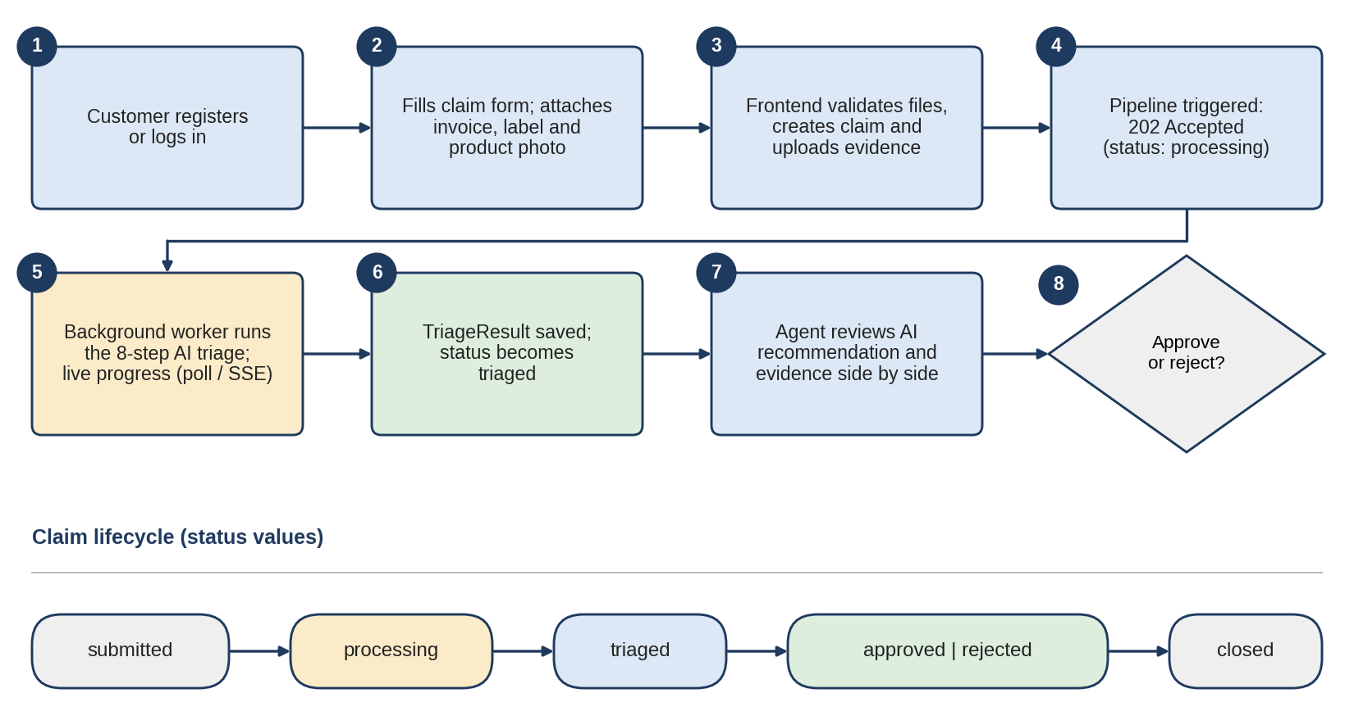
Figure 3.5 Process Flow

THE EIGHT-STEP AI TRIAGE PIPELINE
Step | Module | Technology | Function
1 | Evidence Fetching | Local storage / Supabase  Storage | Loads evidence files locally or downloads them from the  evidence bucket;  initialises safe fallbacks for omitted files
2 | Invoice OCR | PaddleOCR PP-OCRv4, Pillow | Extracts purchase date, price and product model using regular expressions; scales images above 1280 px; caches results
3 | Product Label OCR | PaddleOCR | Extracts the hardware serial number and model from the label photograph
4 | Complaint NLP | spaCy en_core_web_sm | Lemmatises the complaint; assigns severity (e.g. dead, crash, smoke, fire) and intent (repair or replace)
5 | Warranty Rule Engine | python-dateutil, product catalogue | Checks that purchase date + warranty months ≥ today; cross-compares claimed, invoice and label models
6 | Duplicate Detection | ImageHash (pHash) | Compares perceptual hashes with earlier valid claims in the organisation; Hamming distance ≤ 2 bits flags  duplicates
7 | Brand-Partitioned Policy  RAG | Sentence-Transformers all-MiniLM-L6-v2, FAISS  IndexFlatIP | Embeds brand policy clauses and retrieves the top-2 matches for the complaint
8 | GenAI Report and  Decision | Groq LLM  (openai/gpt-oss-120b) | Produces JSON with category, reasoning summary and recommended action; saves TriageResult; sets status to triaged; writes an audit event
TABLE 3.1

3.6 USE CASE DIAGRAM
The use case diagram illustrates the interactions between the actors and the
WarrantyGuard AI platform. The primary actors are the Customer, the Support Agent, the Organisation Administrator and the Super Administrator. The customer registers and logs in, submits claims, uploads evidence, tracks claim status and reads public comments. The agent views all organisational claims, inspects evidence and AI analysis, re-runs the pipeline, posts internal or public comments, approves or rejects claims, performs bulk updates and reviews audit logs and analytics. The administrator inherits all agent capabilities and additionally manages the product catalogue, users, invitations, SLA targets and organisation settings. The super administrator has platform-wide oversight across organisations. Inside the system boundary, the platform authenticates users, runs the triage pipeline, streams progress, enforces tenant isolation and records audit events.
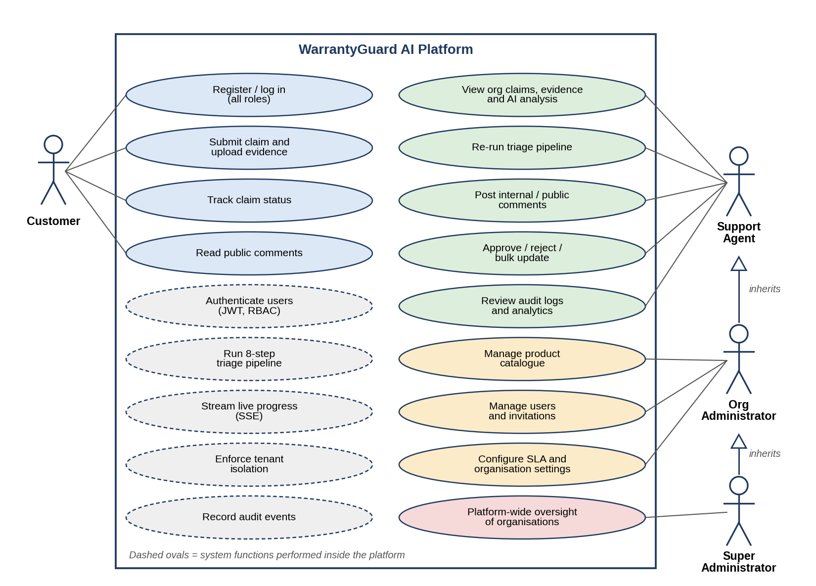
Figure 3.6 Use Case Diagram

CHAPTER 4

SYSTEM DESIGN
The system design of WarrantyGuard AI converts the functional requirements into a technical blueprint. It explains how the system is organised, how data flows between the components and how the architecture supports scalability, security, performance and maintainability. The platform follows a layered architecture that separates the presentation layer, the API and security gateway, the AI triage pipeline and the data and storage layer. This separation allows each layer to be changed or scaled independently and keeps the heavy machine-learning components isolated from the user interface.

4.1 System Architecture
The architecture has four cooperating layers.
Client layer. A React 19 single-page application built with Vite 8 provides the landing page, customer portal, new-claim wizard, claim-detail and triage inspector, agent dashboard, analytics, audit log viewer and the administration pages. Navigation is protected by role-aware routes.
API and security gateway. A FastAPI application exposes the versioned REST API under /api/v1. A middleware stack adds security headers and CORS rules, the SlowAPI rate limiter throttles abusive clients, the authentication layer validates JWT access tokens and enforces role-based access, and an SSE endpoint streams live pipeline progress to the browser.
AI triage pipeline. Claims are processed by the eight-step pipeline in a FastAPI background task, which updates a pipeline_statuses record after each step so that the client can display progress. At server start-up a daemon thread pre-loads the OCR and embedding models so that the first claim is not delayed.
Storage and database layer. PostgreSQL (Supabase) stores all relational data, the Supabase S3 bucket evidence stores invoices and photographs, and a local ./app/storage folder acts as a fallback and holds the brand policy corpora.
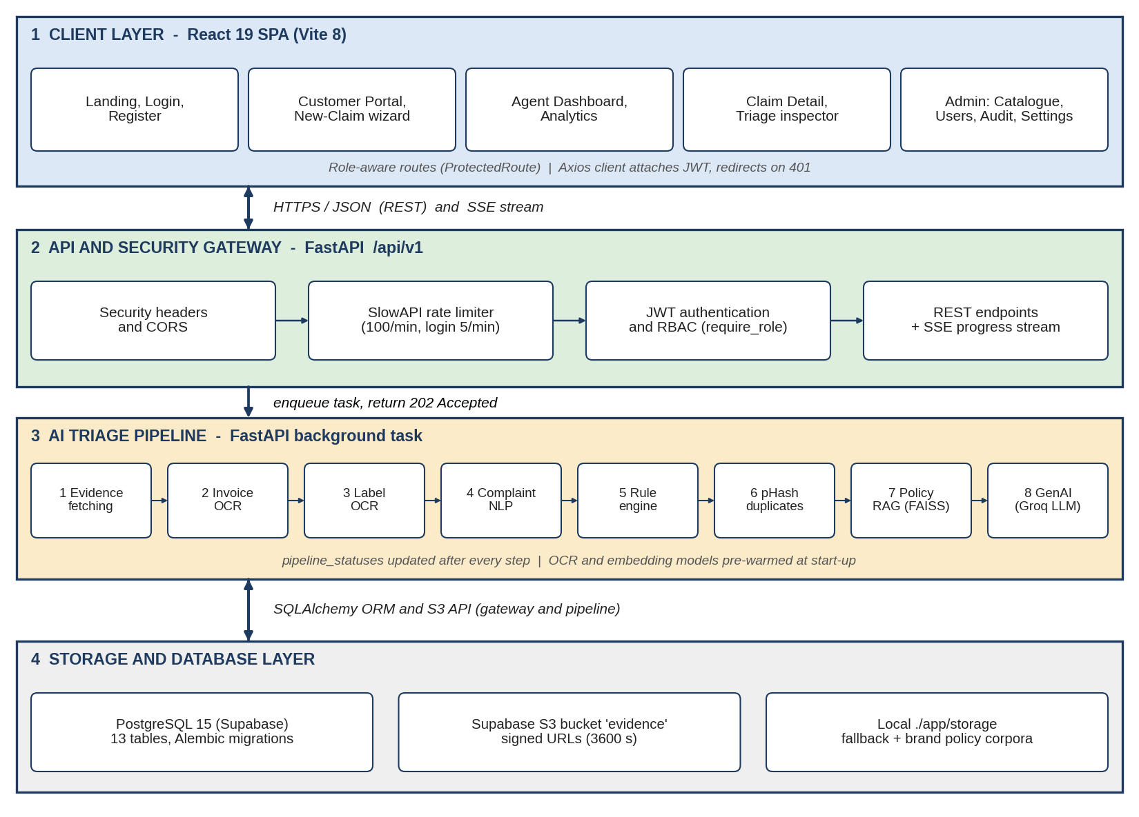
Figure 4.1 System Architecture

4.2 Database Design
The system uses a relational model in PostgreSQL, accessed through SQLAlchemy 2.0 and versioned with Alembic migrations (initial Supabase schema, multi-tenancy, refresh tokens, and asynchronous pipeline/SLA/notification preferences). Each entity is stored in its own table with a primary key, and relationships are expressed with foreign keys. Almost every table carries an org_id that links to the organizations table, which is the basis of tenant isolation.

4.2.1 Entities and Relationships
The Organization entity represents a tenant such as a manufacturer; it owns users, claims, products, warranty policies, invitations and one SLA record. A User belongs to an organisation (or to the platform if a super administrator), has a role and may submit claims, write comments, hold refresh tokens and configure notification preferences. A Claim is the central case filed by a customer and optionally assigned to an agent; it contains many Evidence records, has at most one TriageResult and one PipelineStatus, and records many AuditLog and Comment entries. A Product describes a supported model, its brand, category and warranty months, and is governed by WarrantyPolicy documents. The main tables are:

Table |  | Purpose | Key fields
organizations |  | Tenant workspace | id (UUID), name, slug, is_active
Table |  | Purpose | Key fields
users |  | Accounts and roles | id, org_id, email, hashed_password, full_name, role, is_active
claims |  | Warranty case | id, org_id, user_id, assigned_agent_id, customer_name, product_model, serial_number, complaint_text, status
evidence |  | Uploaded files | id, claim_id, type (invoice, product_photo, label_photo, policy_doc), file_path, file_hash (SHA-256), phash
triage_results |  | AI decision | claim_id (unique), category, reasoning_summary, recommended_action
pipeline_statuses |  | Live progress | claim_id (unique), current_step, total_steps (8), status, error_message
products |  | Product catalogue | org_id, name, brand, category, warranty_months
warranty_policies |  | Policy files | org_id, product_id, file_path, version, is_active
audit_logs |  | Immutable trail | claim_id, user_id, action, details, created_at
comments |  | Claim discussion | claim_id, user_id, body, is_internal
slas |  | SLA targets | org_id (unique), response_target_hours (24), resolution_target_hours (72)
refresh_tokens |  | Revocable sessions | user_id, token (unique), expires_at  (7 days), revoked
invitations | Team invites | org_id, email, role, token, expires_at, accepted_at
Claim status is an enumeration (submitted, processing, triaged, approved, rejected, closed) and the triage category is an enumeration (approved, expired_warranty,identity_mismatch,duplicate_evidence,needs_manual_review, policy_exception, rejected).
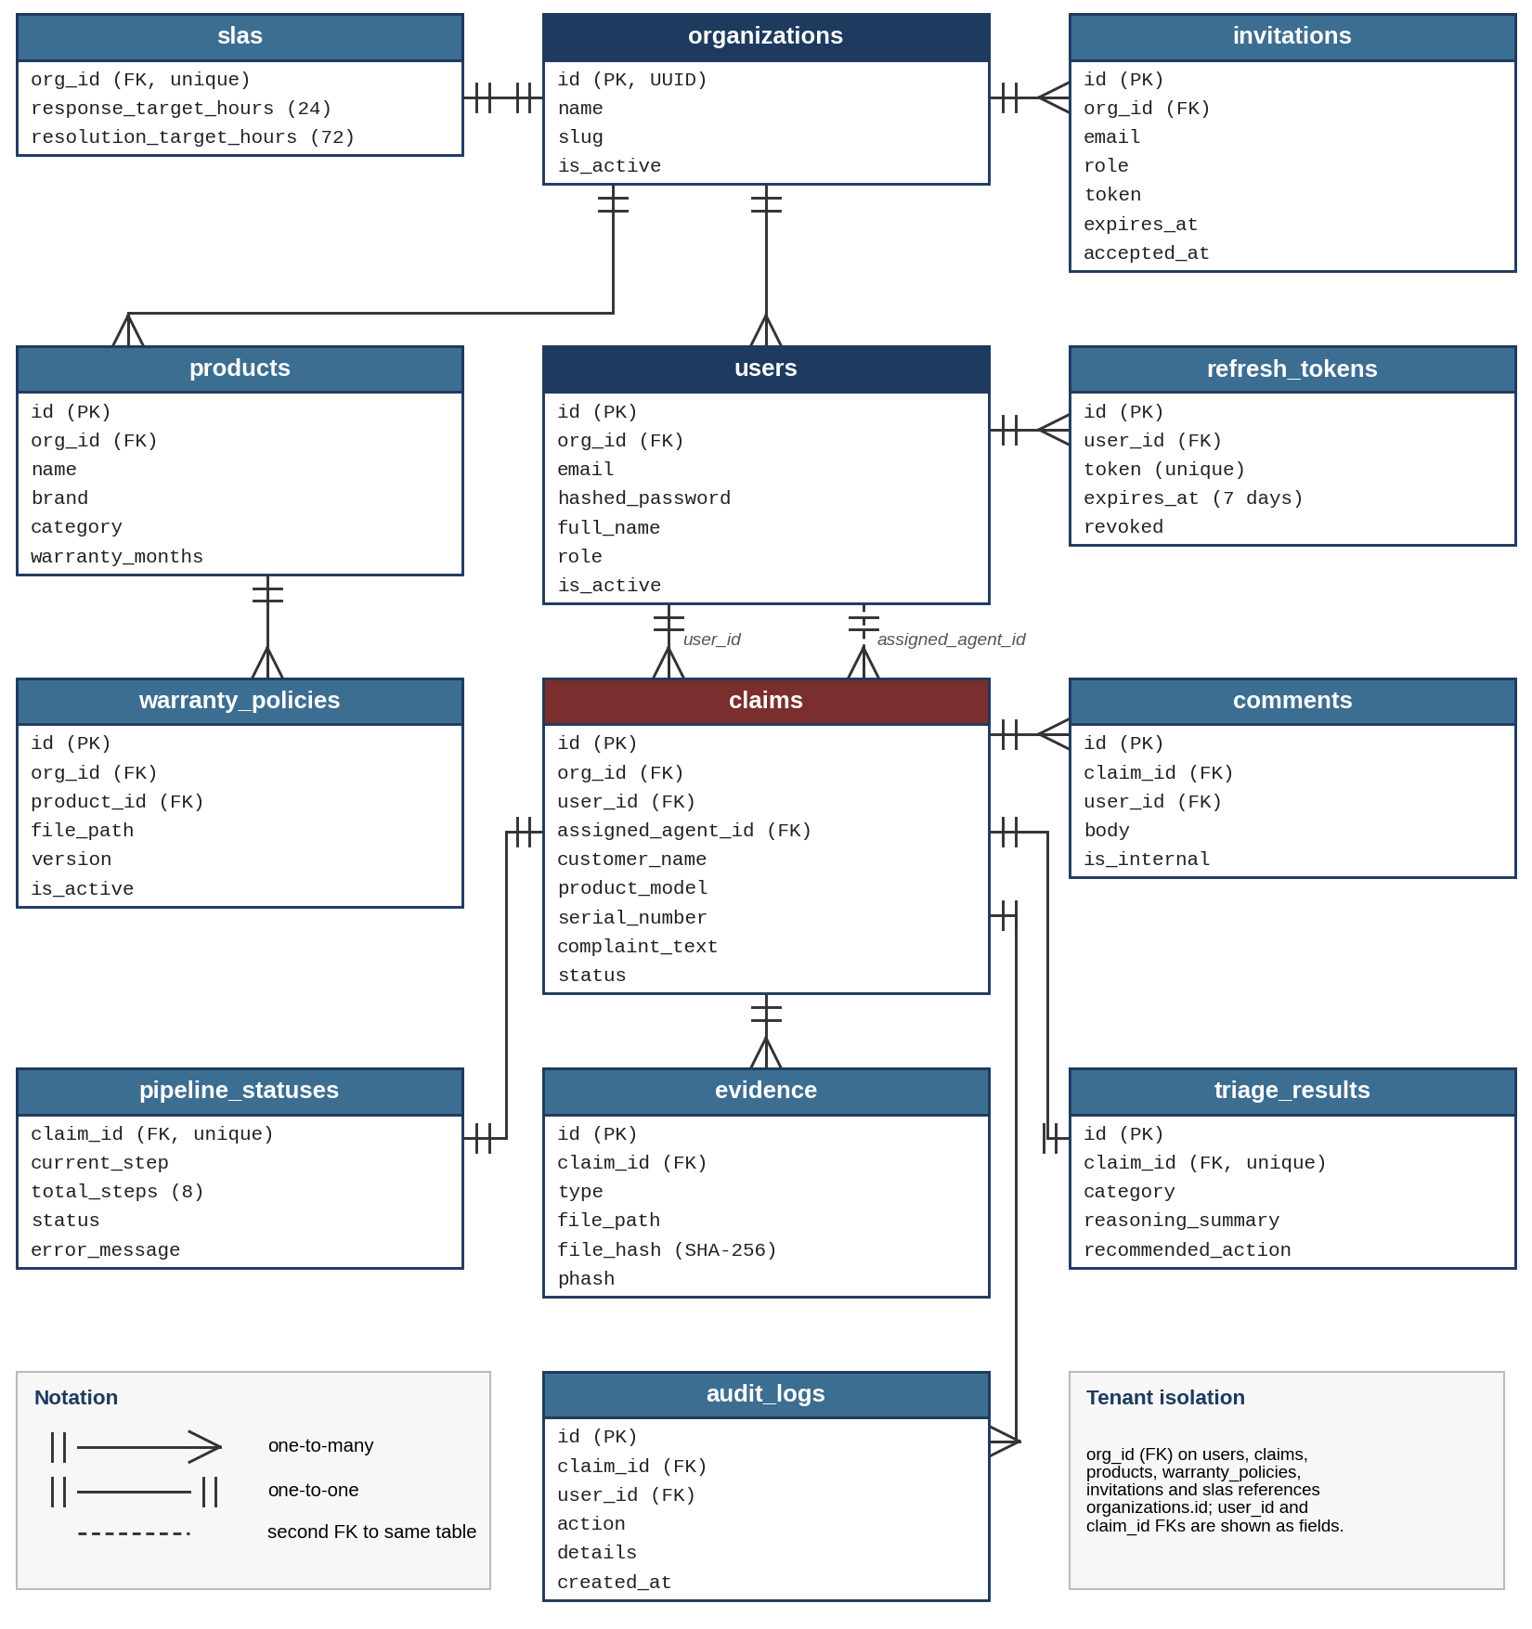
Figure 4.2.1 Schema Diagram

4.2.2 Normalization
The schema is designed up to Third Normal Form (3NF) to remove redundancy and update anomalies. In 1NF, every attribute is atomic: a user’s name, e-mail and role, or a claim’s model and serial number, are stored as single values without repeating groups. In 2NF, every non-key attribute depends on the whole primary key; dependent entities such as evidence, comments, audit logs and triage results reference their claim through a foreign key instead of repeating claim data. In 3NF, transitive dependencies are removed: brand, category and warranty duration are stored once in products rather than repeated in every claim, SLA targets are stored per organisation in slas, and organisation details live only in organizations. This design keeps storage compact, ensures consistent retrieval and supports efficient filtering by org_id, status, date and model.

4.3 Sequence Diagrams
The sequence diagram describes how the Customer, React frontend, FastAPI backend, background worker, storage and agent interact during a claim. The customer fills in the claim form and attaches evidence; the frontend validates file types and calls POST /api/v1/claims/ to create the claim with status submitted. For each file it calls POST /api/v1/claims/{id}/evidence, where the backend uploads the file to the Supabase bucket, computes the SHA-256 and perceptual hash and inserts an evidence record. The frontend then calls POST /api/v1/claims/{id}/pipeline/run; the backend sets the status to processing, enqueues the background task and returns 202 Accepted. While the worker executes the eight steps, the frontend polls GET
/api/v1/claims/{id}/pipeline/status or subscribes to the SSE stream. When the worker stores the TriageResult and an audit log entry and sets the status to triaged, the agent opens the claim through GET /api/v1/claims/{id} and approves or rejects it using PATCH /api/v1/claims/{id}/status, which updates the status and logs the corresponding audit action.
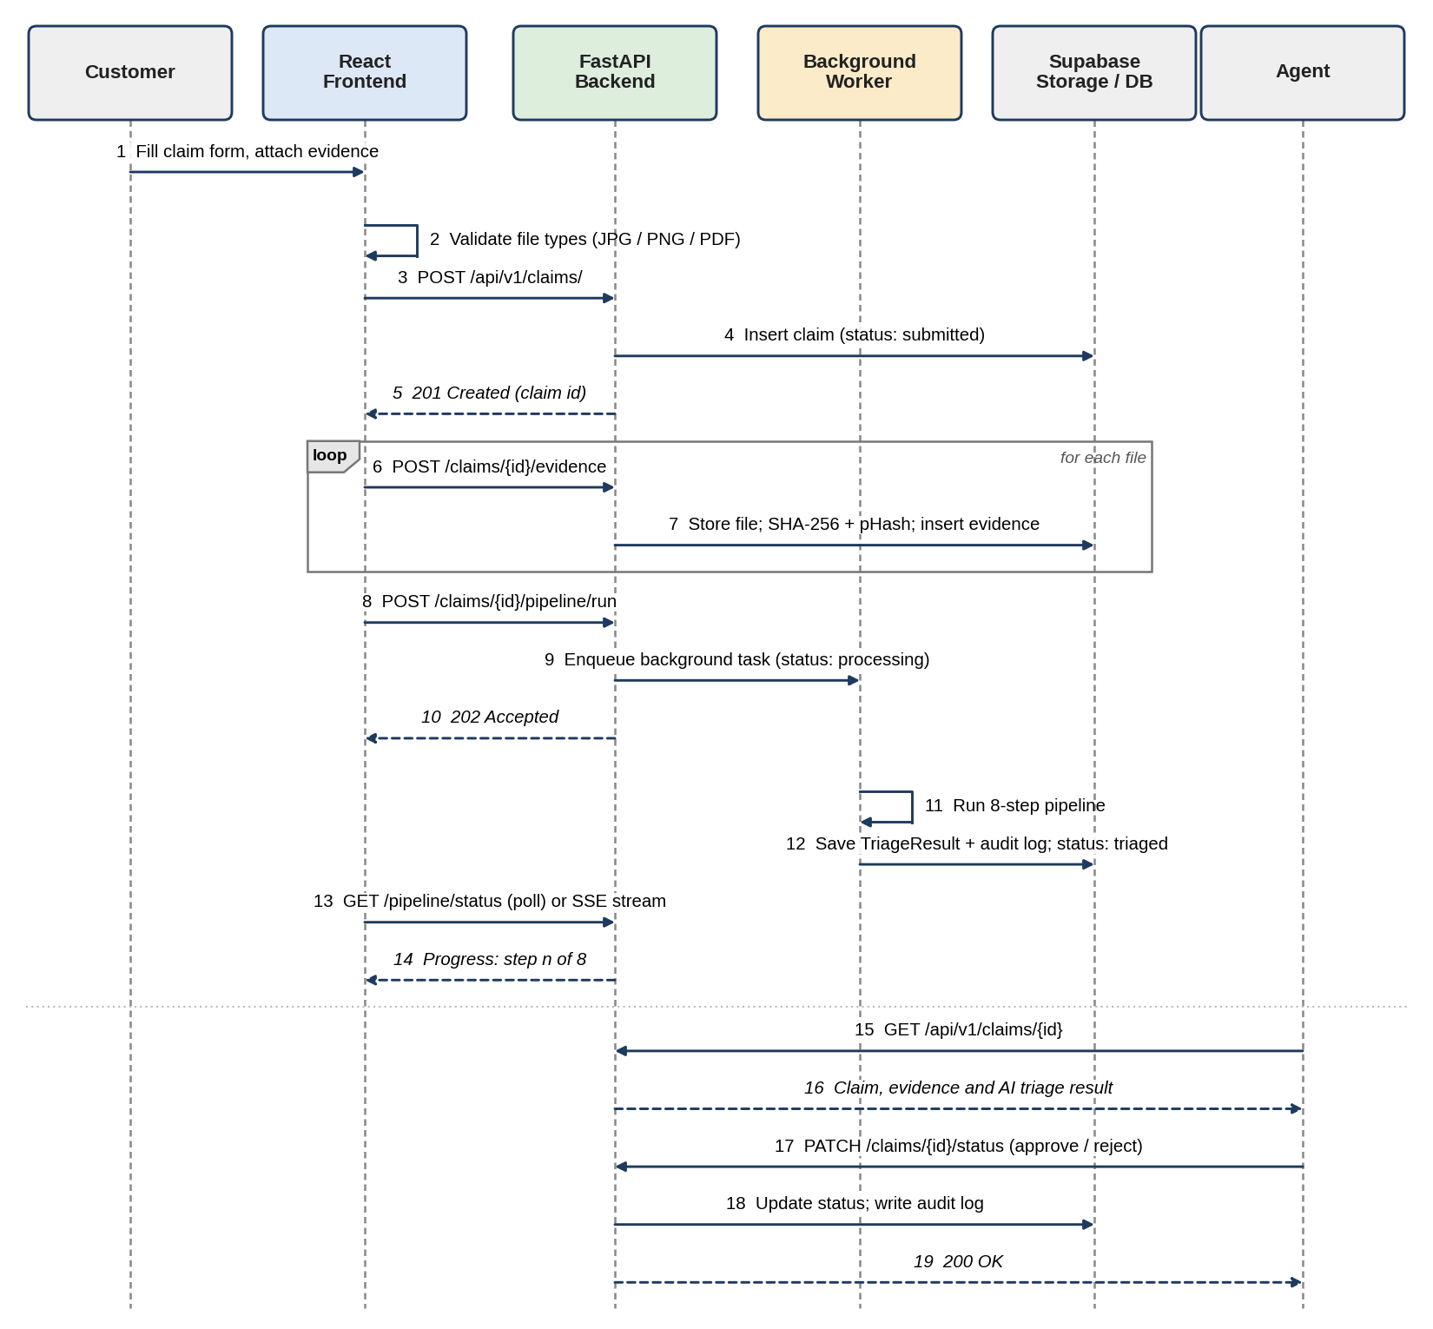
Figure 4.3 Sequence Diagram

4.4 Functionalities
WarrantyGuard AI integrates the following functional modules into a single warranty-triage ecosystem.

4.4.1 User Authentication and Access Control Module
Users register with e-mail, password and full name; new customers are assigned to the default organisation. Passwords are salted and hashed with bcrypt, access tokens are JWTs signed with HS256 that expire after 24 hours, and refresh tokens are cryptographically secure random strings stored in the database. Logging out revokes the refresh token, and changing a password revokes all active refresh tokens of that user. Role-based access is enforced by a require_role([...]) dependency on each endpoint.
ROLE-BASED ACCESS CONTROL MATRIX
Capability | Customer | Agent | Admin | Super  Admin
Submit claims and upload evidence to own claims | Yes | Yes | Yes | Yes
View own claims and public comments | Yes | Yes | Yes | Yes
View all organisation claims, evidence and triage results | No | Yes | Yes | Yes
Re-run pipeline (force), post internal comments | No | Yes | Yes | Yes
Approve / reject claims, bulk update | No | Yes | Yes | Yes
Analytics, audit logs, SLA overdue list | No | Yes | Yes | Yes
Manage product catalogue, users, invitations, organisation settings | No | No | Yes | Yes
Platform-wide access across organisations | No | No | No | Yes
TABLE 4.1

4.4.2 Claim Submission and Evidence Management Module
The claim form captures the customer name, product model, serial number and complaint. The backend verifies that the model exists in the organisation’s catalogue. Evidence (JPEG, PNG or PDF, up to 5 MB) is uploaded as multipart data; each file receives a SHA-256 digest for tamper evidence and, for photographs, a 64-bit perceptual hash. Download links are signed URLs that expire after 3600 seconds. If submission fails midway, a rollback deletes the claim
(only claims in submitted or processing state can be deleted), so that retries do not collide with orphaned hashes.

4.4.3 AI Triage Module
The module executes the eight steps listed in Table 3.1. Invoices are pre-scaled to a maximum of 1280 px with Lanczos resampling and OCR results are cached by file path and modification time. Regular expressions extract the purchase date, price, model and serial number from OCR text (see Appendix B). The complaint is parsed by spaCy to assign severity and intent. The rule engine checks that the purchase date plus the product’s warranty months has not elapsed and that the claimed, invoice and label models agree. Duplicate detection flags perceptual-hash distances of 2 bits or less among earlier valid claims of the same organisation. The RAG step embeds brand policy clauses with all-MiniLM-L6-v2 (normalised vectors) and searches a FAISS IndexFlatIP index for the two most relevant clauses. Finally the LLM receives claim metadata, OCR findings, rule results, duplicate flags and retrieved clauses and returns a JSON object with category, reasoning_summary and recommended_action.

4.4.4 Agent Dashboard and Search Module
Agents search claims by customer name, model or serial number with debounced input, filter by status and date range, sort by any column, paginate on the server
(skip, limit) and select multiple claims for bulk approval or rejection through
POST /api/v1/claims/bulk-update. Five KPI cards summarise total, pending, approved and rejected claims.

4.4.5 Claim Detail, Comments and Audit Module
The claim-detail page shows the AI Triage Intelligence card with status colours, a live eight-step progress bar, the complaint, device metadata, evidence with checksums, a full-size image viewer and an activity timeline. Agents can re-run triage, and both internal and public comments are supported; internal comments are hidden from customers. Every significant action (claim created, evidence uploaded, pipeline started and completed, status changed, approved, rejected) is recorded in the audit log.

4.4.6 Analytics, SLA and Notification Module
The statistics endpoint returns KPI counts, the distribution of triage categories and the claim volume of the last seven days, which are displayed with Recharts as a doughnut chart and a weekly stacked bar chart. The SLA service lists claims that are pending beyond the organisation’s resolution target (default 72 hours; response target 24 hours). Users can switch e-mail notification preferences on or off in Settings.

4.4.7 Administration and Multi-Tenant Management Module
Administrators update the organisation profile, maintain the product catalogue with warranty months, assign roles, invite team members through expiring invitation tokens (7 days) and review audit logs. Tenant isolation is enforced by scoping all queries to current_user.org_id, and customers are additionally limited to their own user_id. Brand policy corpora for Apple, HP, Lenovo, Dell, Asus, Acer and MSI are pre-seeded in app/storage/.
CHAPTER 5

IMPLEMENTATION

5.1 Overview of Implementation
WarrantyGuard AI is implemented as a three-tier web application with an additional AI processing layer. The frontend is a React 19 single-page application, the backend is a FastAPI service written in Python 3.11, and PostgreSQL on Supabase provides persistent storage together with an S3-compatible bucket for evidence files. The AI triage engine runs inside the backend process as a background task and uses PaddleOCR, spaCy, ImageHash,Sentence-Transformers with FAISS, and the Groq LLM API. The implementation emphasises low latency (decision in under two seconds once models are warm), security, tenant isolation and reproducible deployment.

5.2 Technological Stack

5.2.1 Frontend
The web interface is developed with React 19.2 and bundled with Vite 8.1, which provides fast builds and hot reloading. React Router DOM 7.18 handles declarative routing with ProtectedRoute guards that restrict pages by role. An Axios HTTP client attaches the JWT to every request and redirects to the login page on a 401 response. Recharts 3.10 renders the analytics charts and Lucide React provides icons. A custom design system with CSS variables, glassmorphism and micro-animations gives a consistent look. The interface contains the pages Landing, Login, Register, Dashboard, ClaimDetail, NewClaim, CustomerPortal, Analytics, AuditLogs, ProductCatalog, AdminPanel, UserManagement and Settings, together with shared components for layout, sidebar navigation, toast notifications and an error boundary.

5.2.2 Backend
The backend uses FastAPI with Uvicorn as the ASGI server. Pydantic v2 schemas validate and serialise requests and responses. The code is organised into api/v1/endpoints (auth, claims, comments, evidence, health, invitations, organizations, pipeline, policies, products, sla, sse and stats), core (configuration, database, middleware, rate limiting, security, storage and validators), models (SQLAlchemy ORM classes), schemas, services (OCR, NLP, rule engine, duplicate detection, RAG, GenAI report, audit, SLA and triage orchestrator) and tasks (the background pipeline runner and a thread-safe progress store). Security features include bcrypt hashing, JWT with revocable refresh tokens, OWASP security headers (nosniff, frame deny, XSS protection, Content-Security-Policy and HSTS), SlowAPI rate limiting (100 requests per minute in general and 5 per minute on login) and password-complexity and HTML-sanitisation validators.

5.2.3 Database and Storage Layer
PostgreSQL 15 (hosted on Supabase) stores all entities through SQLAlchemy 2.0, and Alembic manages four migrations. Evidence files are stored in the Supabase Storage bucket evidence and are served through signed URLs that expire after 60 minutes; a local ./app/storage directory acts as a fallback. The database is seeded with an HP organisation and more than 75 laptop models through seed.py, and create_users.py creates demo administrator and customer credentials.

5.2.4 AI and Machine-Learning Engine
OCR uses PaddleOCR PP-OCRv4 (PaddlePaddle 2.6.2). Complaint analysis uses spaCy en_core_web_sm. Perceptual hashing uses ImageHash with Pillow. Policy retrieval uses Sentence-Transformers all-MiniLM-L6-v2 and a FAISS CPU IndexFlatIP index over normalised vectors, which gives cosine-similarity search. The decision generator uses the Groq Python SDK with the openai/gpt-oss-120b model and requests structured JSON. Three performance optimisations are applied: (1) a background daemon thread pre-warms the OCR and embedding models at start-up, avoiding a 3–10 second cold start; (2) images larger than 1280 px are downscaled with Lanczos resampling, which cuts OCR time by more than 70%; and (3) OCR results are cached in memory using the file path and modification time as key. The perceptual-hash threshold was tightened from 5 bits to 2 bits (about 97% visual identity) after the looser value produced false positives on different products photographed on uniform backgrounds.

5.2.5 Deployment, Containerisation and CI/CD
The system is packaged with a multi-stage Docker architecture.
Dockerfile.base installs system libraries, PaddlePaddle, PaddleOCR, Sentence-Transformers, FAISS and spaCy and downloads the model weights at build time; the image is cached and published to GitHub Container Registry. Dockerfile.backend inherits from this base, copies the application and runs alembic upgrade head before starting Uvicorn. Dockerfile.frontend builds the Vite bundle in the first stage and serves it with nginx:1.27-alpine (gzip and SPA fallback) in the second stage. Docker Compose orchestrates local and production environments. GitHub Actions provides continuous integration (ruff and oxlint linting, pytest tests and a Vite production build on every push and pull request) and continuous deployment (build with layer caching, push images to GHCR and deploy over SSH on pushes to main). Secrets such as database credentials, JWT secret and API keys are supplied through environment variables.

SUMMARY OF TECHNOLOGIES USED
Category | Technology | Purpose
Backend framework | FastAPI, Uvicorn | Asynchronous REST API and ASGI server
ORM and migrations | SQLAlchemy 2.0, Alembic | Data access and schema versioning
Database | PostgreSQL 15 (Supabase) | Relational storage
Object storage | Supabase Storage (S3 API) | Invoice and photo evidence
OCR | PaddleOCR PP-OCRv4 | Invoice and label text extraction
NLP | spaCy en_core_web_sm | Complaint severity and intent
Embeddings | Sentence-Transformers  all-MiniLM-L6-v2 | Policy clause embeddings
Vector search | FAISS IndexFlatIP | Semantic policy retrieval
Perceptual hashing | ImageHash + Pillow | Duplicate and fraud detection
LLM | Groq SDK, openai/gpt-oss-120b | Structured decision and reasoning
Frontend | React 19.2, Vite 8.1, React  Router 7.18 | SPA, build and routing
Visualisation and icons | Recharts 3.10, Lucide React | Analytics charts and icons
Containers | Docker, Docker Compose | Reproducible builds and orchestration
CI/CD | GitHub Actions | Linting, testing, image build and deployment
Code quality | Ruff, Oxlint | Python and JavaScript linting
TABLE 5.1

5.3 Implementation Process
The implementation began with the backend foundation: the SQLAlchemy models, Pydantic schemas, configuration, database session handling and the initial Alembic migration on Supabase. The authentication module (registration, login, JWT and later refresh tokens) was built next, followed by claim and evidence endpoints with SHA-256 and perceptual hashing and Supabase upload. Phase 2 added multi-tenancy (organisations, products, RBAC, policies and invitations). The AI services were then developed and tested individually invoice OCR, label OCR, complaint NLP, rule engine, duplicate detection, policy RAG and GenAI report — and combined in the triage.py orchestrator. Phase 3 added revocable refresh tokens, security middleware and rate limiting; Phase 4 moved the pipeline to asynchronous background execution with a pipeline_statuses table, SSE progress streaming, SLA tracking and notification preferences; and Phase 5 added analytics, bulk operations and the finalised deployment pipeline.
In parallel, the React frontend was built page by page: layout and authentication context, landing and login, the new-claim wizard with client-side validation and rollback, the agent dashboard with filters and bulk actions, the claim-detail page with live progress, analytics, audit logs and the administration pages. Each page was integrated with the API through Axios. Testing was carried out at every stage, and the system was finally containerised and connected to the CI/CD pipeline.

5.4 Testing and Quality Assurance
The repository includes a layered test suite:
Unit and integration tests (tests/test_claims.py, tests/test_health.py) cover claim creation, multipart invoice upload, pipeline execution and status transitions, and verify duplicate detection by uploading identical images to two claims and asserting that the category is duplicate_evidence.
- Pipeline step verification (test_pipeline_8steps.py) executes and asserts each of the eight pipeline stages in isolation: evidence fetching, invoice OCR, label OCR, complaint NLP, rule engine, perceptual-hash comparison, FAISS policy retrieval and Groq summary generation.
Multi-phase end-to-end scripts (run_all_verifications.py, verify_phase3.py, verify_phase4.py, verify_phase5.py) simulate
registration, administrator promotion, asynchronous pipeline triggering (verifying sub-second 202 responses), status polling, SLA overdue detection and bulk updates.
- Continuous integration runs linting, pytest and the production build automatically on every push and pull request.
CHAPTER 6

RESULTS

6.1 Dashboard Output Screens
The landing page introduces the platform with an animated hero section, live engine badge, key metrics, a four-step pipeline walkthrough and a feature grid, and provides quick links to registration and login. The login screen supports JWT authentication with rate-limit error handling and one-click demo buttons for the administrator and agent accounts. After login, agents and administrators see the Agent Dashboard, which displays five KPI cards, a debounced search box, status and date filters, sortable columns, server-side pagination and checkboxes for bulk approval or rejection. Customers are directed to the Customer Portal, which shows their personal claim history with active and resolved counts and status badges. The results confirm that navigation is role-aware, that data is loaded correctly from the API and that every user sees only the data permitted by their role and organisation.
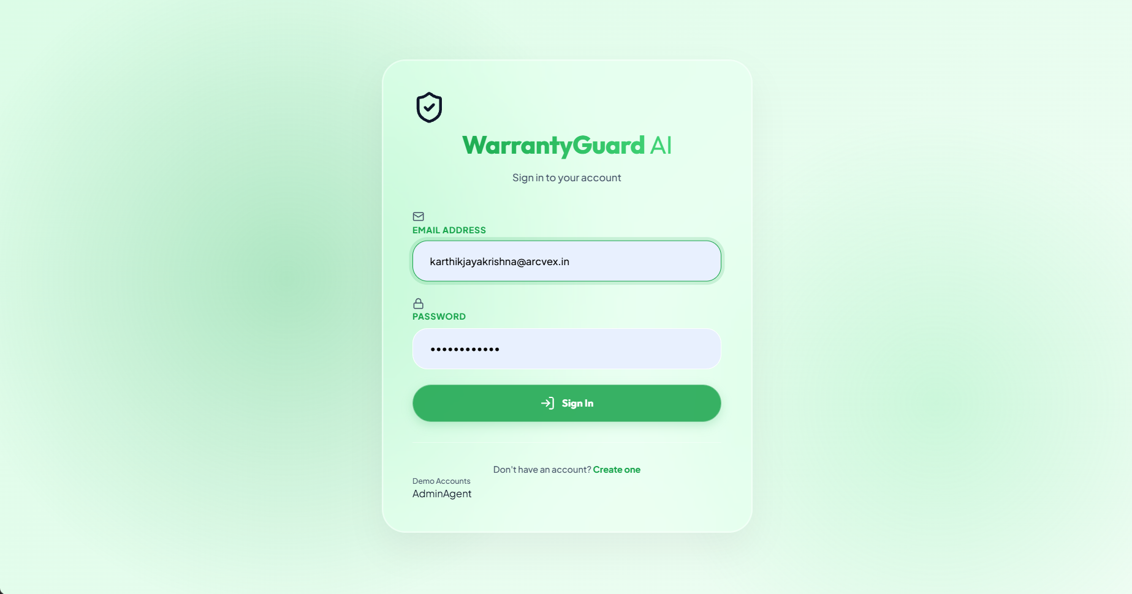
Figure 6.1.1 Landing Page and Login Screen
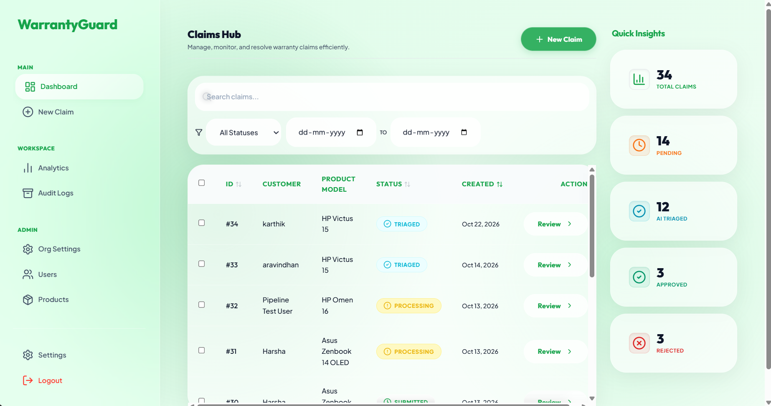
Figure 6.1.2 Agent Dashboard

6.2 Claim Submission Results
The New Claim page is a multipart wizard that collects the customer name, product model, serial number and complaint and accepts the invoice, label photo and product photo. The output confirms that files of invalid type are rejected on the client before upload, that valid files are uploaded and checksummed, and that the pipeline is triggered automatically, after which the user is redirected to the claim-detail page. When an upload failure was simulated, the rollback request removed the partially created claim so that a retry did not generate a duplicate-evidence alert. The backend returned 202 Accepted immediately after the pipeline request, confirming that triage does not block the user.
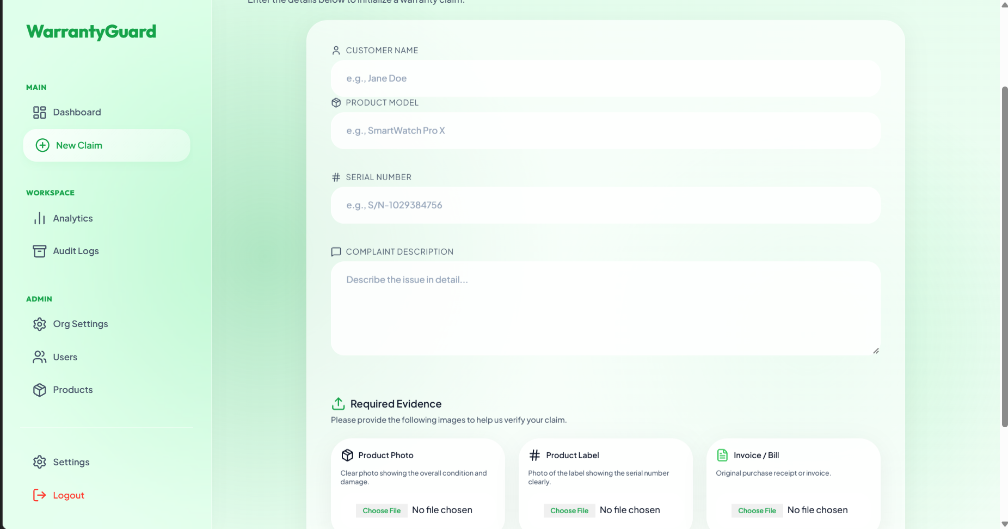
Figure 6.2.1 New Claim Submission Page

6.3 AI Triage and Claim Detail Results
The Claim Detail page presents the AI Triage Intelligence card with a colour-coded category (approved, rejected, needs manual review, duplicate evidence and the other categories), the reasoning summary and the recommended action. A live progress bar shows steps 1 to 8 as the pipeline advances through polling or the SSE stream. The evidence card lists each file with its SHA-256 and perceptual-hash values and opens a full-resolution viewer, and the activity timeline shows audit events with user attribution. In testing, uploading identical images to two claims resulted in the second claim being categorised as duplicate_evidence, and the pipeline step tests confirmed that each of the eight stages returns the expected output. According to the project’s measurements, OCR time dropped by more than 70% after image pre-scaling, models were available immediately after start-up because of background warming, and the end-to-end recommendation was produced in under two seconds, compared with the three-to-seven-day manual cycle — roughly an 80% reduction in resolution time.
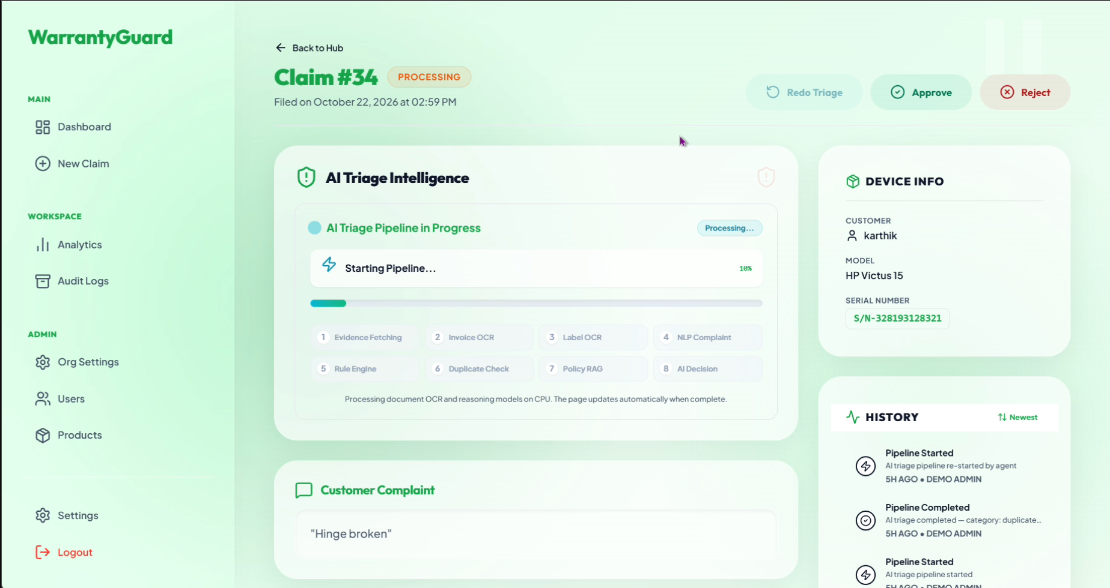
Figure 6.3.1 Claim Detail Page

6.4 Administration Management Results
The Analytics page shows a doughnut chart of triage-category distribution and a weekly stacked bar chart of claim volume, together with summary cards. The Audit Logs page lists every action in the organisation with search, claim badges, timestamps and user names. The Product Catalogue page lets administrators create, edit and delete supported models with category and warranty months, and the User Management page lists team members, assigns roles and sends invitations. The Admin Panel shows the organisation name, workspace slug and active plan. The results show that catalogue changes affect warranty validation immediately and that administrative functions are unavailable to non-administrators.
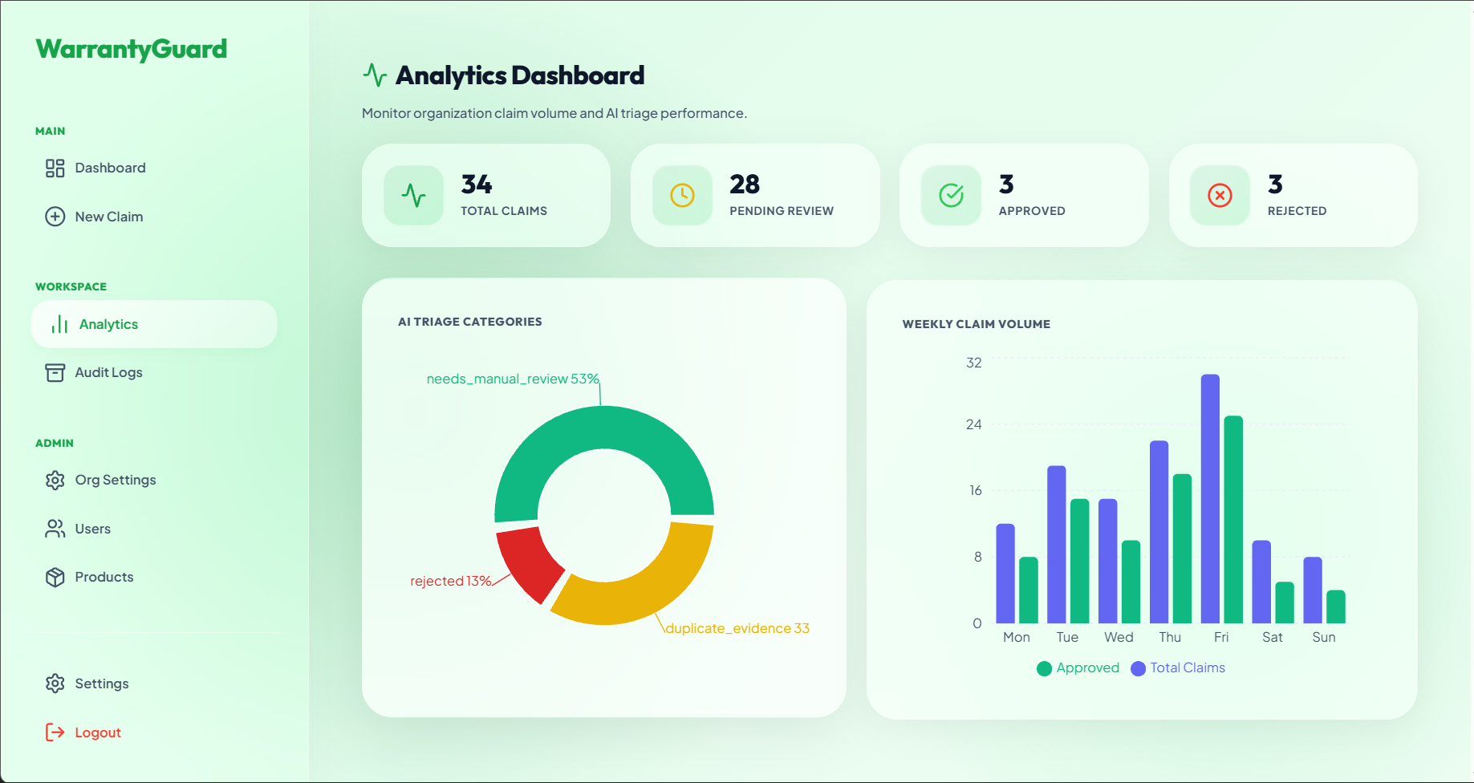
Figure 6.4.1 Analytics Dashboard
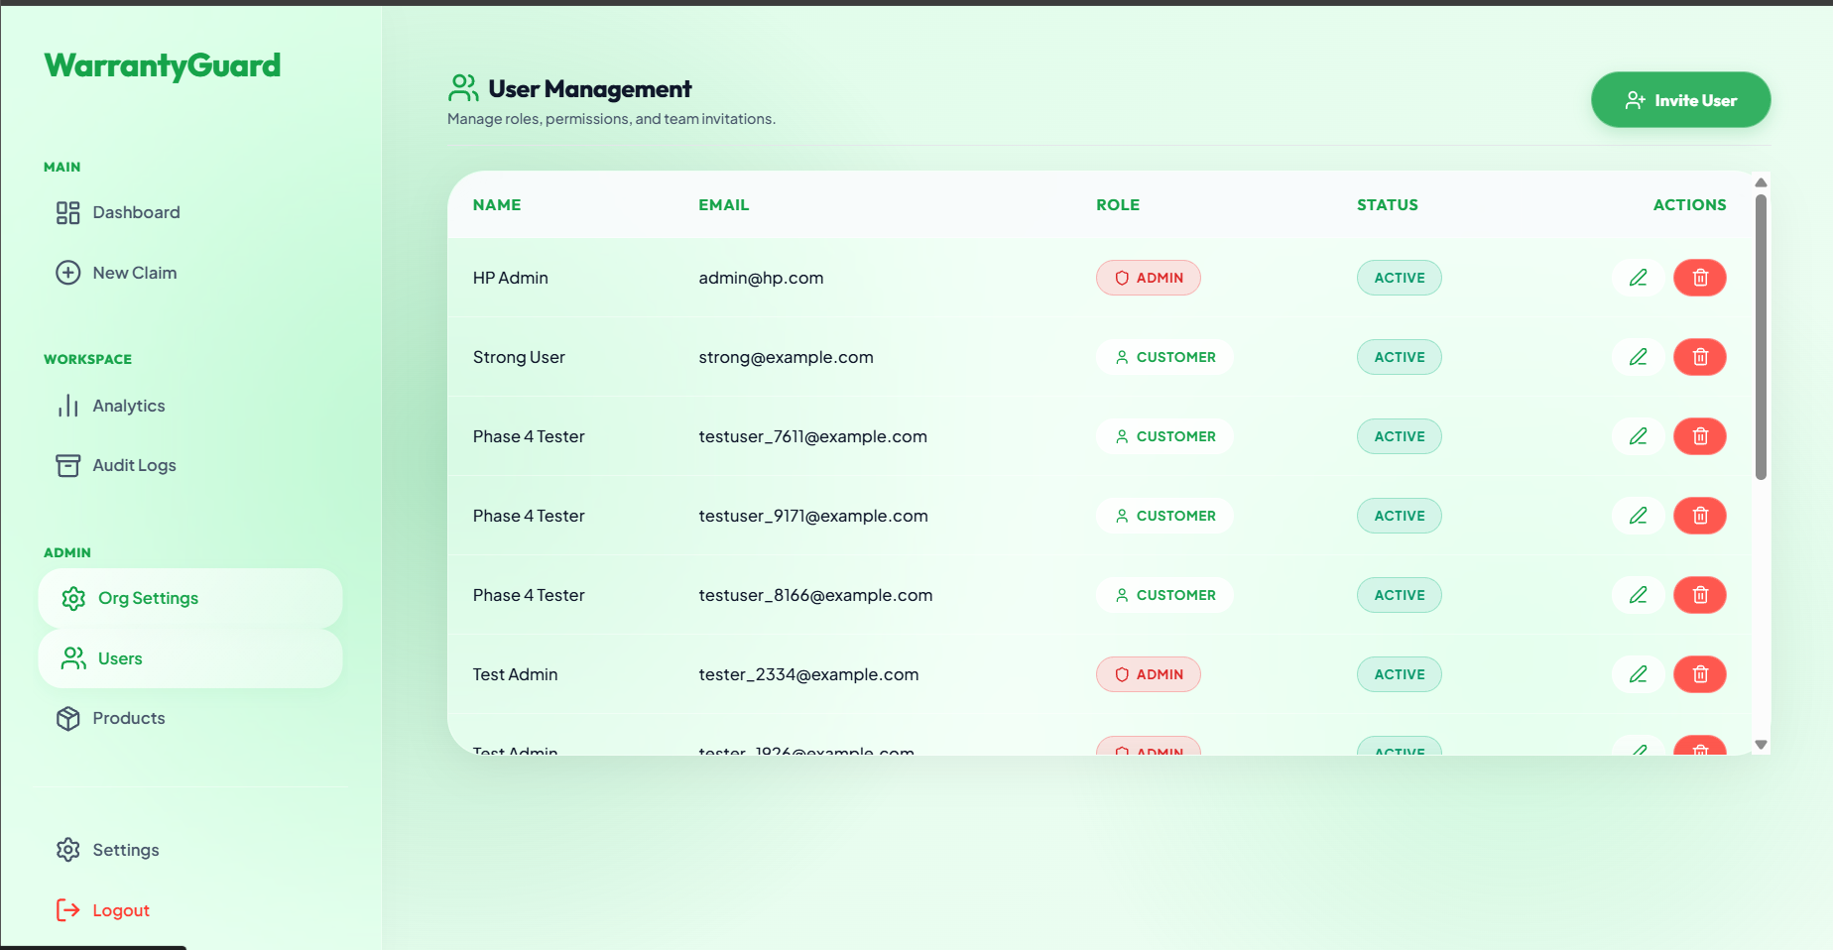
Figure 6.4.2 Product Catalogue and User Management

6.5 User Profile and Settings Results
The Settings page contains three tabs: profile information, password change with verification of the old password, and e-mail notification preferences. Changing a password revokes all existing refresh tokens, which forces re-authentication on other sessions. Security tests confirmed that the login endpoint is limited to five requests per minute, that responses carry the security headers, and that a customer cannot read another customer’s or another organisation’s claims.
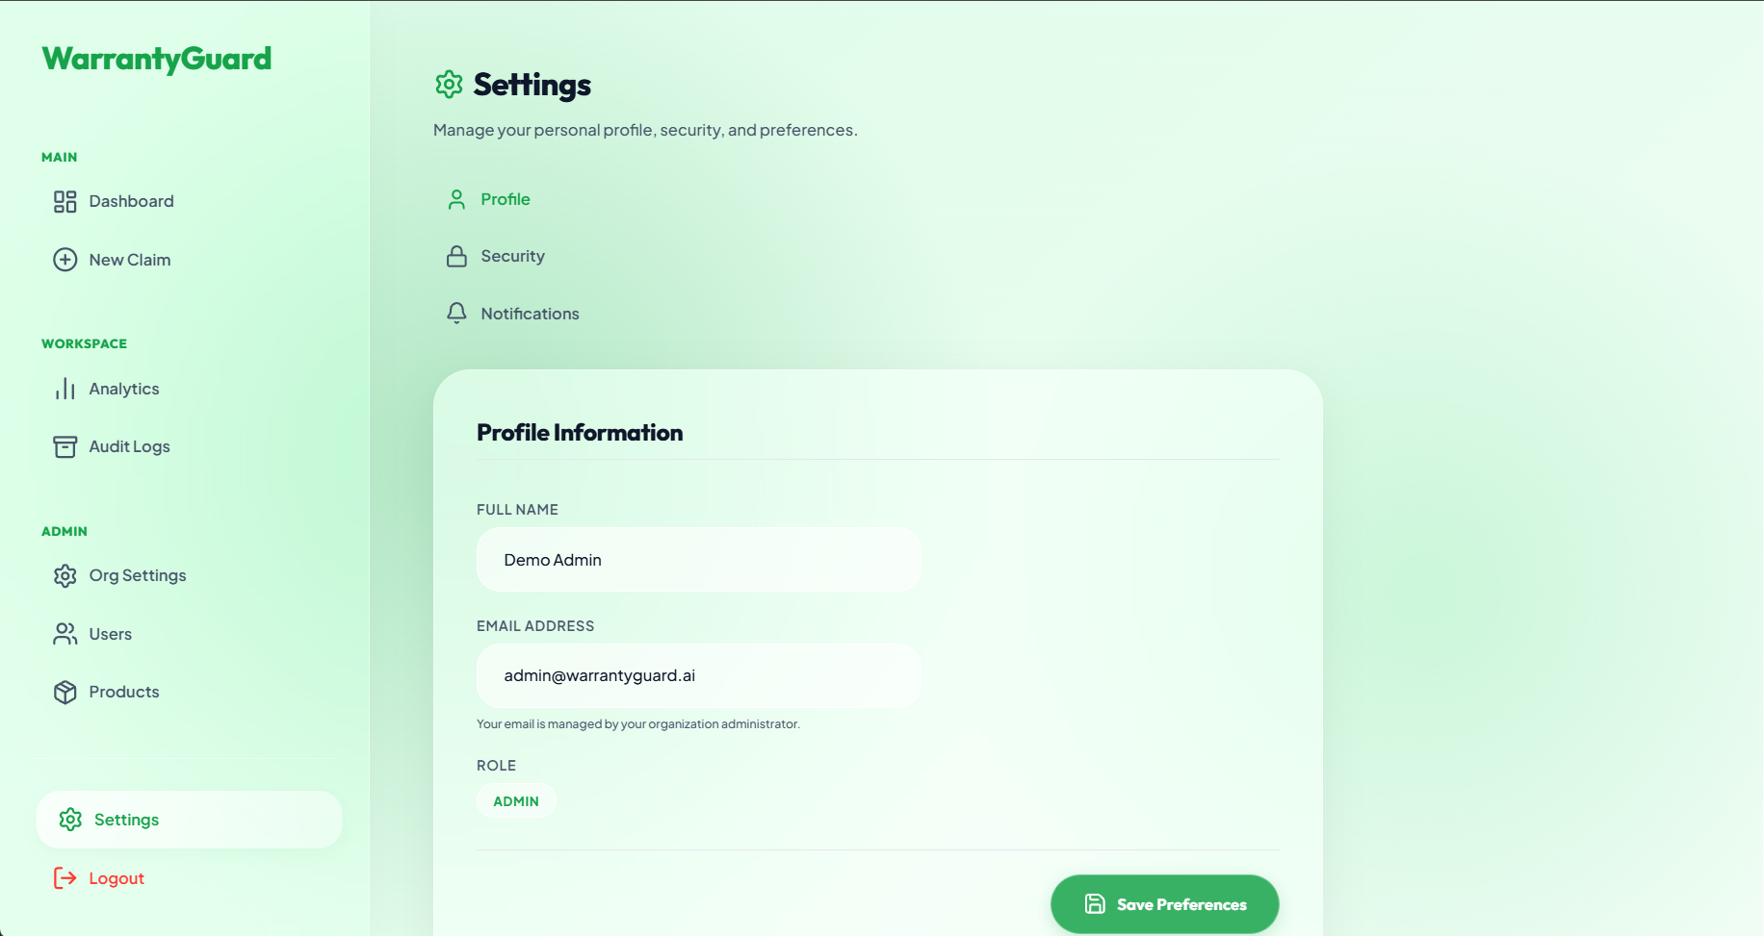
Figure 6.5.1 Settings Page

CHAPTER 7

CONCLUSION AND FUTURE ENHANCEMENT

7.1 Conclusion
WarrantyGuard AI was successfully designed and implemented as an automated, explainable and secure warranty-claim triage platform. By combining OCR, NLP, a rule engine, perceptual hashing, brand-partitioned RAG and an LLM into an eight-step pipeline, the system replaces slow manual verification with a recommendation that is produced in seconds and stored with its reasoning and audit trail. The multi-tenant architecture, role-based access control, token security, rate limiting and evidence checksums make the platform suitable for organisations that serve several brands. Customers gain transparency through live progress tracking, agents gain a command-centre dashboard with bulk operations, and administrators gain control over catalogues, teams and SLAs. Containerisation and CI/CD make the solution reproducible and deployable. Overall, WarrantyGuard AI achieves its objectives of reducing resolution time, blocking duplicate and forged evidence and keeping the human agent in control of the final decision.

7.2 Future Enhancements
Several enhancements can extend the platform. Fine-tuned or layout-aware document models could improve extraction from complex invoices in multiple languages and formats. Additional fraud signals such as EXIF metadata analysis, image-tampering detection and cross-organisation fraud rings could complement perceptual hashing. A personalised, confidence-calibrated decision score with automatic approval of low-risk claims could further reduce agent workload. Real-time e-mail, SMS and push notifications, a customer chat assistant, and integration with repair-centre logistics, courier tracking and ERP/CRM systems would complete the service lifecycle. Advanced analytics on defect trends, regional patterns and SLA performance, support for self-hosted LLMs for data-sensitive tenants, a mobile application and additional brand policy corpora can broaden adoption. With these improvements, WarrantyGuard AI can grow into a comprehensive warranty-operations platform.

APPENDIX

A. Tenant-isolation query (app/api/v1/endpoints/claims.py)
query = db.query(Claim).filter(Claim.org_id == current_user.org_id) if current_user.role == UserRole.customer: query = query.filter(Claim.user_id == current_user.id)

B. Extraction patterns used by the OCR services
Purchase date : \d{4}-\d{2}-\d{2} Price : \$\d+(?:\.\d{2})?
Invoice model : Model\s*[:\-]?\s*([A-Za-z0-9\-]+)
Serial number : (?:S/N|Serial(?: No)?\s*[:\-]?\s*)([A-Z0-9]+)
C. Password hashing (app/core/security.py)
bcrypt.hashpw(password.encode('utf-8'), bcrypt.gensalt())

D. Core Code Listings

D.1 Frontend UI & Client Architecture
D.1.1 Role-Based Routing & Session Provider (frontend/src/App.jsx)
import { BrowserRouter as Router, Routes, Route, Navigate } from 'react-router-dom';
import { AuthProvider, useAuth } from './context/AuthContext';
import Layout from './components/Layout';
import Dashboard from './pages/Dashboard';
import ClaimDetail from './pages/ClaimDetail';
import NewClaim from './pages/NewClaim';
import CustomerPortal from './pages/CustomerPortal';

const ProtectedRoute = ({ children, roles }) => {
const { isAuthenticated, loading, user } = useAuth();
if (loading) return <div className="loader">Loading...</div>;
if (!isAuthenticated) return <Navigate to="/login" replace />;
if (roles && user && !roles.includes(user.role)) return <Navigate to="/" replace />;
return children;
};

export default function App() {
return (
<AuthProvider>
<Router>
<Routes>
<Route element={<ProtectedRoute><Layout /></ProtectedRoute>}>
<Route path="/dashboard" element={<ProtectedRoute roles={['agent', 'admin']}><Dashboard /></ProtectedRoute>} />
<Route path="/portal" element={<ProtectedRoute roles={['customer']}><CustomerPortal /></ProtectedRoute>} />
<Route path="/claims/:id" element={<ClaimDetail />} />
<Route path="/new-claim" element={<NewClaim />} />
</Route>
</Routes>
</Router>
</AuthProvider>
);
}
D.1.2 Client Interceptor & Auth State (frontend/src/api.js & AuthContext.jsx)
// frontend/src/api.js
import axios from 'axios';
const api = axios.create({ baseURL: import.meta.env.VITE_API_URL || 'http://localhost:8000/api/v1' });

api.interceptors.request.use((config) => {
const token = localStorage.getItem('token');
if (token) config.headers.Authorization = `Bearer ${token}`;
return config;
});

api.interceptors.response.use(res => res, err => {
if (err.response?.status === 401 && !err.config?.url?.includes('/auth/')) {
localStorage.removeItem('token');
window.location.href = '/login';
}
return Promise.reject(err);
});
export default api;
D.1.3 Claim Intake & Multipart Submission (frontend/src/pages/NewClaim.jsx)
const handleSubmit = async (e) => {
e.preventDefault();
const files = [{ file: evidence.invoice, type: 'invoice' }, { file: evidence.photo, type: 'product_photo' }].filter(x => x.file);

// 1. Create Base Claim -> 2. Upload Evidence -> 3. Trigger 8-Step Pipeline
const { data: claim } = await api.post('/claims/', formData);
for (const ev of files) {
const fd = new FormData();
fd.append('file', ev.file);
await api.post(`/claims/${claim.id}/evidence`, fd, { params: { type: ev.type } });
}
await api.post(`/claims/${claim.id}/pipeline/run`);
navigate(`/claims/${claim.id}`);
};

D.2 Backend Gateway & Data Models
D.2.1 FastAPI Server & ML Pre-Warming Lifespan (app/main.py)
import os, threading
from contextlib import asynccontextmanager
from fastapi import FastAPI
from fastapi.middleware.cors import CORSMiddleware
from app.api.v1.router import api_router
from app.core.config import settings

def _warmup_ml():
from app.services.ocr_shared import get_ocr_engine
from app.services.policy_rag import get_embedder, init_index_for_brand
get_ocr_engine()
get_embedder()
init_index_for_brand("Generic")

@asynccontextmanager
async def lifespan(app: FastAPI):
os.makedirs(settings.STORAGE_PATH, exist_ok=True)
threading.Thread(target=_warmup_ml, daemon=True).start() # Eliminates cold starts
yield

app = FastAPI(title=settings.PROJECT_NAME, lifespan=lifespan)
app.add_middleware(CORSMiddleware, allow_origins=settings.CORS_ORIGINS, allow_methods=["*"], allow_headers=["*"])
app.include_router(api_router, prefix=settings.API_V1_STR)
D.2.2 Core Relational ORM Entities (app/models/claim.py & triage_result.py)
from datetime import datetime
from enum import Enum
from sqlalchemy import Column, Integer, String, Text, DateTime, ForeignKey, Enum as SQLEnum
from sqlalchemy.types import Uuid as UUID
from sqlalchemy.orm import relationship
from app.core.database import Base

class ClaimStatus(str, Enum):
submitted = "submitted"; processing = "processing"; triaged = "triaged"; approved = "approved"; rejected = "rejected"

class Claim(Base):
__tablename__ = "claims"
id = Column(Integer, primary_key=True, index=True)
org_id = Column(UUID(as_uuid=True), ForeignKey("organizations.id"), nullable=True)
user_id = Column(Integer, ForeignKey("users.id"))
customer_name = Column(String, index=True)
product_model = Column(String, index=True)
serial_number = Column(String, index=True)
complaint_text = Column(Text)
status = Column(SQLEnum(ClaimStatus), default=ClaimStatus.submitted)
created_at = Column(DateTime, default=datetime.utcnow)
evidence = relationship("Evidence", back_populates="claim")
triage_result = relationship("TriageResult", back_populates="claim", uselist=False)
class TriageResult(Base):
__tablename__ = "triage_results"
id = Column(Integer, primary_key=True)
claim_id = Column(Integer, ForeignKey("claims.id"), unique=True)
category = Column(String) # approved, rejected, duplicate_evidence, needs_manual_review
reasoning_summary = Column(Text)
recommended_action = Column(Text)
created_at = Column(DateTime, default=datetime.utcnow)
D.2.3 Claims Controller & Tenant Isolation (app/api/v1/endpoints/claims.py)
@router.post("/", response_model=ClaimResponse, status_code=201)
def create_claim(claim_in: ClaimCreate, db: Session = Depends(get_db), current_user: User = Depends(require_org)):
product = db.query(Product).filter(Product.org_id == current_user.org_id, Product.name.ilike(f"%{claim_in.product_model}%")).first()
if not product:
raise HTTPException(400, "Product model not found in organization catalog.")
claim = Claim(org_id=current_user.org_id, user_id=current_user.id, **claim_in.model_dump())
db.add(claim); db.commit(); db.refresh(claim)
return claim

D.3 8-Step AI Triage Pipeline & RAG
D.3.1 Sequential Pipeline Orchestrator (app/services/triage.py)
from app.services import (ocr_invoice, ocr_label, complaint_nlp, rule_engine,
duplicate_detection, policy_rag, genai_report)

def triage_claim(db: Session, claim_id: int, progress_callback=None):
claim = db.query(Claim).filter(Claim.id == claim_id).first()
data = {"id": claim.id, "product_model": claim.product_model, "serial_number": claim.serial_number, "complaint_text": claim.complaint_text}

# Steps 1-3: OCR Ingestion
if progress_callback: progress_callback(2, "OCR Invoice")
inv_data = ocr_invoice.extract_invoice_fields(get_path(claim, "invoice"))
lbl_data = ocr_label.extract_label_info(get_path(claim, "label_photo"))

# Steps 4-6: NLP, Rule Engine, and Perceptual Hash Duplicate Detection
data["complaint_nlp"] = complaint_nlp.parse_complaint(claim.complaint_text)
data["rule_data"] = rule_engine.validate_warranty(db, data, inv_data, lbl_data)
data["is_duplicate"] = any(duplicate_detection.detect_duplicates(ev.phash, db, claim.id) for ev in claim.evidence if ev.phash)

# Step 7: Brand-Partitioned Policy RAG
brand = db.query(Product).filter(Product.name.ilike(f"%{claim.product_model}%")).first().brand or "Generic"
data["policy_clauses"] = policy_rag.retrieve_policy_clauses(claim.complaint_text, brand=brand)

# Step 8: GenAI Vision / LLM Adjudication & DB Save
report = genai_report.generate_review_summary(data)
res = db.query(TriageResult).filter(TriageResult.claim_id == claim.id).first() or TriageResult(claim_id=claim.id)
res.category = report["category"]; res.reasoning_summary = report["reasoning_summary"]; res.recommended_action = report["recommended_action"]
db.add(res); claim.status = ClaimStatus.triaged; db.commit()
D.3.2 Deterministic Warranty Rule Engine (app/services/rule_engine.py)
def validate_warranty(db: Session, claim_data: dict, inv_data: dict, lbl_data: dict) -> dict:
product = db.query(Product).filter(Product.name.ilike(f"%{claim_data.get('product_model')}%")).first()
months = product.warranty_months if product else 12
p_date_str = inv_data.get("purchase_date")

# Expiration check
if p_date_str:
p_date = datetime.strptime(p_date_str, "%Y-%m-%d")
if datetime.now() > (p_date + relativedelta(months=months)):
return {"is_valid": False, "reason": f"Warranty expired ({months} mo. limit)"}

# Model cross-consistency check
if inv_data.get("model") and inv_data.get("model") != claim_data.get("product_model"):
return {"is_valid": False, "reason": "Invoice model does not match claimed product"}
return {"is_valid": True, "reason": "Warranty verified"}
D.3.3 Policy RAG Vector Retrieval (app/services/policy_rag.py)
from sentence_transformers import SentenceTransformer
import faiss

embedder = SentenceTransformer('all-MiniLM-L6-v2')
brand_indices, brand_docs = {}, {}

def retrieve_policy_clauses(complaint: str, brand: str = "Generic", top_k: int = 2) -> list:
if brand not in brand_indices:
init_index_for_brand(brand)
idx, docs = brand_indices[brand], brand_docs[brand]
q_vec = embedder.encode([complaint], convert_to_numpy=True).astype('float32')
_, indices = idx.search(q_vec, min(top_k, len(docs)))
return [docs[i] for i in indices[0] if i != -1]

REFERENCES
- Pressman, R. S., & Maxim, B. R., 2020, Software Engineering: A Practitioner’s Approach, 9th Edition, McGraw-Hill Education.
- Sommerville, I., 2015, Software Engineering, 10th Edition, Pearson Education.
- Elmasri, R., & Navathe, S. B., 2016, Fundamentals of Database Systems, 7th Edition, Pearson.
- Martin, R. C., 2017, Clean Architecture: A Craftsman’s Guide to Software Structure and Design, Prentice Hall.
- Du, Y., et al., 2020, “PP-OCR: A Practical Ultra Lightweight OCR System,”arXiv:2009.09941.
- Reimers, N., & Gurevych, I., 2019, “Sentence-BERT: Sentence Embeddingsusing Siamese BERT-Networks,” Proceedings of EMNLP-IJCNLP.
- Johnson, J., Douze, M., & Jégou, H., 2019, “Billion-scale similarity searchwith GPUs,” IEEE Transactions on Big Data, 7(3).
- Lewis, P., et al., 2020, “Retrieval-Augmented Generation forKnowledge-Intensive NLP Tasks,” Advances in Neural Information Processing Systems (NeurIPS), 33.
- Zauner, C., 2010, “Implementation and Benchmarking of Perceptual ImageHash Functions,” Master’s thesis, Upper Austria University of Applied Sciences.
- Ramírez, S., FastAPI Documentation, https://fastapi.tiangolo.com
- React Documentation, Meta Open Source, https://react.dev
- Supabase Documentation (PostgreSQL and Storage),https://supabase.com/docs
- Honnibal, M., & Montani, I., spaCy: Industrial-Strength Natural LanguageProcessing in Python, https://spacy.io
- Jones, M., Bradley, J., & Sakimura, N., 2015, “JSON Web Token (JWT),”RFC 7519, IETF.
- OWASP Foundation, OWASP Secure Headers Project,https://owasp.org/www-project-secure-headers/

