## **Digital Banking**

## Load Test Report

## Date: 12/01/2020

|  |  |  |  |  |
| --- | --- | --- | --- | --- |
| **Version** | **Date** | **Prepared/Modified By** | **Reviewed by** | **Approved By** |
| 1.0 | 12/01/2020 | Performance Testing Team | Perf Team | Perf Team |

Table of Contents

1. Purpose of testing………………………………………………………………………………………………………3
2. Performance Observations…………………………………………………………………………………………3
3. Test Run Information………………………………………………………………………………………………….3
4. Transactions Response Time………………………………………………………………………………………4
5. Use case Details………………………………………………………………………………………………………….4
6. Scenario Details………………………………………………………………………………………………………….4
7. Test Data Used……………………………………………………………………………………………………………5
8. Performance Graphs…………………………………………………………………………………………………..5
9. Error Details………………………………………………………………………………………………………………..6

## Purpose of Testing

The objective of this test run is to test the performance SLA’s (as mentioned below) of the Digital banking application with the scenario mentioned in section5. Also to ensure that there is no negative impact on the overall performance end-to-end

|  |  |  |  |  |
| --- | --- | --- | --- | --- |
| **KPI** | **Script Details** | | **SLA** | **Description** |
| **Transactions Response Time** | | All the scripts | 3-5 seconds | End user 90 percentile response time values received at the client side from PT tools |
| **Transaction Volume** | | DigitalBanking_S01_Deposit_Savings_V1 | 10 Per Hour | Overall volume to be achieved during the test steady state period. (Check the workload Mix document for more details) |
| DigitalBanking_S02_Withdraw_Savings_V1 | 20 Per Hour |
| DigitalBanking_S03_Deposit_Checking_V1 | 30 Per Hour |
| DigitalBanking_S04_Withdraw_Checking_V1 | 40 Per Hour |
| DigitalBanking_S05_Transfer_Between_Accounts_V1 | 50 Per Hour |
| **Transaction Error Rate** | | Per script | < 2% | Transactions error / failure % based on assertions and HTTP failures |
| **Server CPU** | |  | < 60% | Average CPU utilization |
| **Server Memory** | |  | < 80% | Average physical memory utilization |

## Performance test observations

* 90 percentile response time for the transactions are below the mentioned SLA of 3-5 seconds
* No errors (transactions / HTTP failures) observed during the test run
* Overall CPU and physical memory utilization values are normal
* No degradation observed for any of the transactions when comparing with previous release test results

## Test Run Information

|  |  |
| --- | --- |
| **Transaction Name** | **Minimum** |
| **Test Execution Window** | 30-11-2020 14:21:52 – 14:32:09 IST |
| **Test Execution Duration** | 10 minutes and 17 seconds |
| **Maximum Running Users** | 1 |
| **Total Throughput Bytes** | 2683,68,275 |
| **Total Hits** | 2,900 |
| **Average Hits Per Second** | 4.693 |
| **Error Count** | 0 |

## Transaction Response Time

Below table lists the overall transactions status of the business scenario executed in the test run

|  |  |  |  |  |  |  |  |  |
| --- | --- | --- | --- | --- | --- | --- | --- | --- |
| **Transaction Name** | **Minimum** | **Average** | **Maximum** | **Std. Deviation** | **90 Percent** | **Pass** | **Fail** | **Stop** |
| DB_S01_Deposit_T01_LaunchHome | 0.122 | 0.301 | 2.891 | 0.595 | 0.231 | 20 | 0 | 0 |
| DB_S01_Deposit_T02_Login | 0.295 | 0.346 | 0.616 | 0.065 | 0.369 | 20 | 0 | 0 |
| DB_S01_Deposit_T03_ClickDepositMenu | 0.084 | 0.14 | 0.233 | 0.034 | 0.174 | 20 | 0 | 0 |
| DB_S01_Deposit_T04_EnterAmount_Submit | 0.133 | 0.246 | 0.917 | 0.158 | 0.265 | 20 | 0 | 0 |
| DB_S01_Deposit_T05_Logout | 0.069 | 0.125 | 0.28 | 0.05 | 0.159 | 20 | 0 | 0 |

1. Use case Details

Below table lists the overall transactions status of the business scenario executed in the test run

|  |  |  |
| --- | --- | --- |
| **Script Name** | **Use Case Description** | **Document Path** |
| DigitalBanking_S01_Deposit_Savings_V1 | User deposits amount to savings account | Click Here |
| DigitalBanking_S02_Withdraw_Savings_V1 | User withdraws amount from Savings | Click Here |
| DigitalBanking_S03_Deposit_Checking_V1 | User deposits amount to checking account | Click Here |
| DigitalBanking_S04_Withdraw_Checking_V1 | User withdraws amount from checking account | Click Here |
| DigitalBanking_S05_Transfer_Between_Accounts_V1 | User transfers amount between accounts | Click Here |

1. Scenario Details

Below table lists the workload mix for the given application

|  |  |  |  |  |
| --- | --- | --- | --- | --- |
| **Use Case** | **Use Case Sub Type** | **Target Volume** | **User Load %** | **Total Distribution %** |
| **Deposits** | Family Savings | xx | 10 | 25 |
| Family Money Market | xx | 5 |
| Individual Savings | xx | 25 |
| Individual Money Market | xx | 10 |
| Family Standard Checking | xx | 10 |
| Family Interest Checking | xx | 25 |
| Individual Standard Checking | xx | 10 |
| Individual Interest Checking | xx | 5 |
| **Withdrawal** | Family Savings | xx | 10 | 25 |
| Family Money Market | xx | 5 |
| Individual Savings | xx | 25 |
| Individual Money Market | xx | 10 |
| Family Standard Checking | xx | 10 |
| Family Interest Checking | xx | 25 |
| Individual Standard Checking | xx | 10 |
| Individual Interest Checking | xx | 5 |
| **Transfer between accounts** | Between Accounts (Random, equal distribution) | xx | 100 | 5 |
| **Search Balance Web Service** | Searching for the balance (for external calls) | xx | 50 | 30 |
| View Checking | xx | 20 |
| View Savings | xx | 30 |
| **Create New Account** | Savings | xx | 60 | 10 |
| Checking | xx | 40 |
| **Other Transactions** | Load Dashboard | xx | 60 | 5 |
| Update Profile | xx | 20 |
| Find ATM Locations | xx | 20 |

## Test Data Details

Below table lists the test data utilized in the performance run

|  |  |  |
| --- | --- | --- |
| **Script Name** | **Test Data** | **Details** |
| DigitalBanking_S01_Deposit_Savings_V1 | P_UserName | User name for Login  (non-destructive, unique) |
| P_Password | Passwordfor Login  (non-destructive, unique) |

## Additional Performance Testing Graphs

**Running Users vs. Avg. Response Time:**

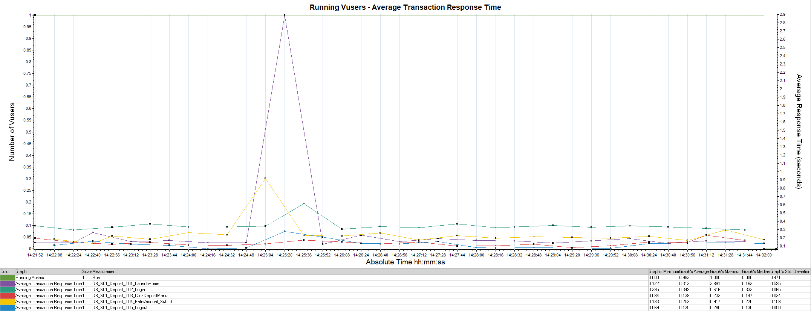

**Running Users vs. Hits Per Second:**

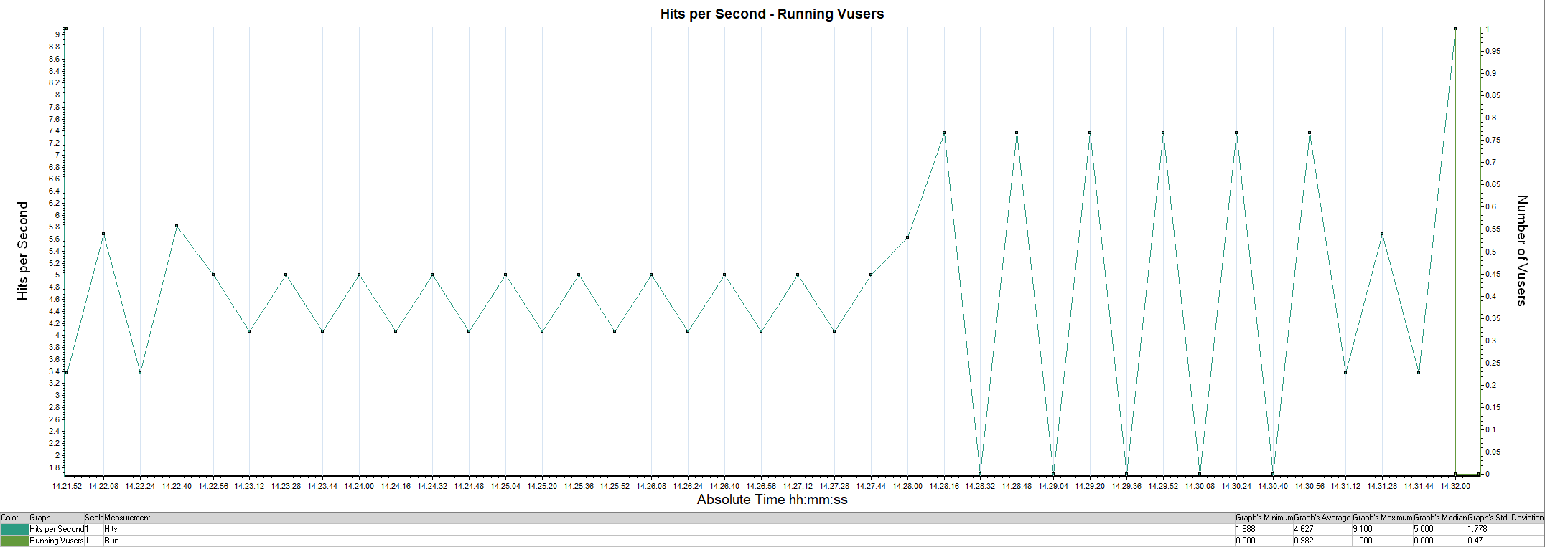

## Error Details

* No errors observed during the test