THE YIELD STRESS ON WET FOAM

Dhineshkumar Balasubramaniam
Immatrk. No : 21971603
dhineshcecfd@gmail.com

Abstract – Most of the common foams are two-phase medium of gas and liquid with a particular structure consisting of gas pockets trapped in a network of thin liquid films and plateau borders. When Foams have high yield stress, they are useful in fluid for carrying particles in applications ranging from the transport of cuttings in drilling and the placement of sands in cracks in oil producing reservoirs to increase the conductivity of reservoirs for secondary oil recovery. The rheology of wet foam gives the yield stress behavior but the behavior of the wet foam is difficult due to its complex structure and nature of the components. In 19th century, Joseph Plateau clearly described that, Wet foam is an example of soft matter with a very well defined structure.

Index Terms – Wet foams, Rheology, Plateau border, yield stress, surfactants.

INTRODUCTION

Foams are playing major roles in particles transporting like froth flotation, oil movement and so on. It is important to develop a constitutive rheological law, predicting the relation between macroscopic stress, strain and strain history. Foams exhibit linear viscoelastic behavior when they are subjected to small shear stresses and flow like viscous liquids when the shear stress is large enough to trigger bubble rearrangements. Foam elasticity comes from the deformation of bubbles from the perfectly sphere shape, in order to increase their packing density. During deformation, the stored surface energy is increased and this is responsible for viscoelastic properties of foam.

A well-developed science of dry, static (or quasi-static) foams is a valuable first step. Most common foams are quite dry when in equilibrium under gravity, and we can understand most of their properties when they are in this condition. These include the essential structure, as Plateau described it long ago, the statistics associated with that structure, its coarsening with time due to gas diffusion, its elastic and plastic properties, and the drainage of liquid through it when equilibrium is disturbed. In order to understand the behavior of wet foam, we have been using successful theories of dry foam, based on the assumption that fluid is mainly within the Plateau borders.

How Foams are formed?

Foam formation
Most of the common foams are a two-phase medium of gas and liquid with a particular structure consisting of gas pockets trapped in a network of thin liquid films and plateau borders. Some well known foams are bubble baths, dishwater

detergents and the foam head on beers. Many oils foam when trapped gas is suddenly released under conditions of an abrupt
drop in pressure. In some refiners in which the through-flow of gas at high temperature and pressure is required to crack hydrocarbons, the gas-liquid mixtures will foam strongly. The foam traps gas with gas fractions of 80% or higher. Clearly in such situations, in which it is desired that solid catalysts contact liquids, the production of foam is not wanted.

In other applications, foams are useful; for example foams which have a high yield stress and can be used in a fluid for carrying particles in applications ranging from the transport of cuttings in drilling and the placement of sands in cracks in oil producing reservoirs to increase the conductivity of reservoirs for secondary oil recovery. Obviously, bubble bath and shampoo companies should like to produce appropriate foams for dish and hair washing. Technologies which are impacted by foams and foaming are widespread.

Plateau's law
Plateau's laws describe the shape and configuration of soap films as follows:
- Soap films are made of entire (unbroken) smooth surfaces.
- The mean curvature of a portion of a soap film is everywhere constant on any point on the same piece of soap film.
- Soap films always meet in threes along an edge called a Plateau border, and they do so at an angle of arccos(−1/2) = 120°.
These Plateau borders meet in fours at a vertex, and they do so at an angle of arccos(−1/3) ≈ 109.47° (the tetrahedral angle).

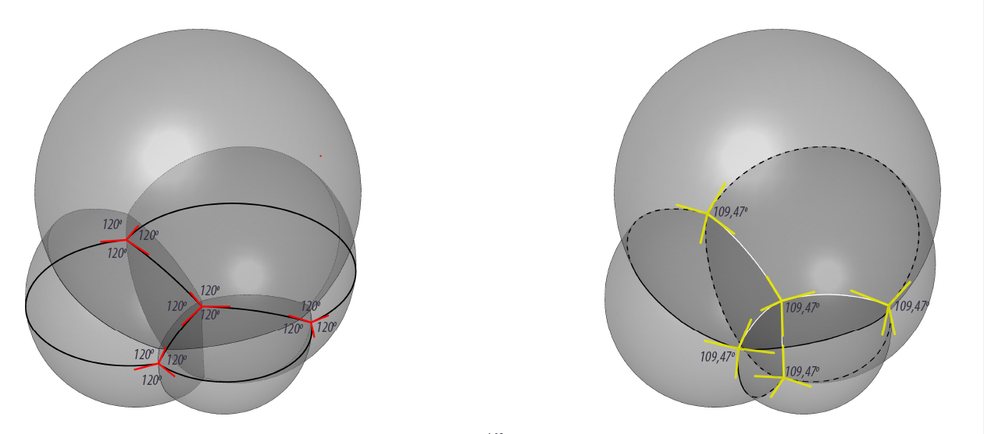
Fig. 1. Bubbles in a foam of soapy water obey Plateau's laws. (left) All Plateau surfaces intersect three by three in 120 degrees angle. (right) At every vertex the angle is close to 109.47 degrees, the tetrahedral angle.

Plateau Border
Plateau defines the border in foam, Where films meet along a line or curve, there is a liquid-filled interstitial channel. Plateau used the concept of a geometrical (fully dry or ideal) foam consisting of films of negligible thickness that are joined along lines and at points. Films are endowed with a free energy per unit area, which, if the film thickness is negligible, coincides with the film tension , leading to the total foam energy where S is the total film area.

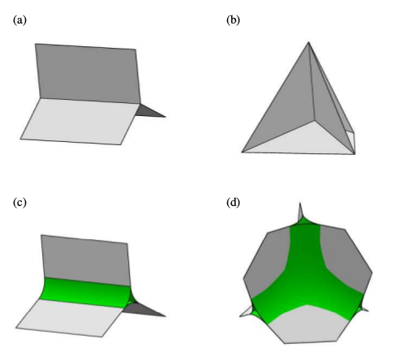

Figure 4: The elements of a foam, illustrating Plateau’s laws. In the dry limit, (a) three films meet in a single Plateau border and (b) four Plateau borders meet in a single junction. This junction is formed at the meeting point of six films in a tetrahedral-shaped wire frame, such as Plateau used to discover the laws which bear his name. When liquid is added to a foam, the Plateau borders (c) and junctions (d) become swollen, meeting the films with a zero contact angle.

Stability of Wet foams / Liquid foams
- Stability factors
Generally wet foams are only stable if they contain surfactants. Their most important effect is not simply that of lowering the surface tension, although it is closely related. Rather, it is the dynamical properties of the surface tension which serve to stabilize the films. The surface tension increases whenever a film is suddenly stretched locally, resulting in increased forces which oppose that tendency.

The other factor which makes foam more stable is dis-joining pressure. This expresses mutually repulsive force between the two faces of films, which makes foam film more thinning. The film thickness at equilibrium is achieved by determining the balance between dis-joining pressure and the bulk pressure of liquid. Latter decreases to large negative values as the liquid fraction of the foam decreases,and the Plateau borders shrink and increase in curvature.

If you are using Word, use either the Microsoft Equation Editor or the MathType add-on (http://www.mathtype.com) for equations in your paper (Insert | Object | Create New | Microsoft Equation or MathType Equation). “Float over text” should not be selected.

Units
Use either SI (MKS) or CGS as primary units. (SI units are strongly encouraged.) English units may be used as secondary units (in parentheses). This applies to papers in data storage. For example, write “15 Gb/cm² (100 Gb/in²).” An exception is when English units are used as identifiers in trade, such as “3½-in disk drive.” Avoid combining SI and CGS units, such as current in amperes and magnetic field in oersteds. This often leads to confusion because equations do not balance dimensionally. If you must use mixed units, clearly state the units for each quantity in an equation. Use the center dot to separate compound units, e.g., “A·m².”

Helpful Hints

Figures and Tables
Large figures and tables may span both columns. Place figure captions below the figures; place table titles above the tables. If your figure has two parts, include the labels “(a)” and “(b)” as part of the artwork. Please verify that the figures and tables you mention in the text actually exist. Do not put borders around the outside of your figures. Use the abbreviation “Fig.” even at the beginning of a sentence. Do not abbreviate “Table.” Tables are numbered with Roman numerals.
Figure axis labels are often a source of confusion. Use words rather than symbols. As an example, write the quantity “Magnetization,” or “Magnetization M,” not just “M.” Put units in parentheses. Do not label axes only with units. As in Fig. 1, for example, write “Magnetization (A/m)” or “Magnetization (Am⁻¹),” not just “A/m.” Do not label axes with a ratio of quantities and units. For example, write “Temperature (K),” not “Temperature/K.”
Multipliers can be especially confusing. Write “Magnetization (kA/m)” or “Magnetization (10³ A/m).” Do not write “Magnetization (A/m) × 1000” because the reader would not know whether the top axis label in Fig. 1 meant 16000 A/m or 0.016 A/m. Figure labels should be legible, approximately 8 to 12 point type.
TABLE I
Units for Magnetic Properties
Symbol | Quantity | Conversion from Gaussian and  CGS EMU to SI ª
Φ | magnetic flux | 1 Mx → 10⁻⁸ Wb = 10⁻⁸ V·s
B | magnetic flux density,  magnetic induction | 1 G → 10⁻⁴ T = 10⁻⁴ Wb/m²
H | magnetic field strength | 1 Oe → 10³/(4π) A/m
m | magnetic moment | 1 erg/G = 1 emu  → 10⁻³ A·m² = 10⁻³ J/T
M | magnetization | 1 erg/(G·cm³) = 1 emu/cm³  → 10³ A/m
4πM | magnetization | 1 G → 10³/(4π) A/m
σ | specific magnetization | 1 erg/(G·g) = 1 emu/g → 1 A·m²/kg
j | magnetic dipole  moment | 1 erg/G = 1 emu  → 4π × 10⁻¹⁰ Wb·m
J | magnetic polarization | 1 erg/(G·cm³) = 1 emu/cm³  → 4π × 10⁻⁴ T
χ, κ | susceptibility | 1 → 4π
χ_{ρ} | mass susceptibility | 1 cm³/g → 4π × 10⁻³ m³/kg
μ | permeability | 1 → 4π × 10⁻⁷ H/m  = 4π × 10⁻⁷ Wb/(A·m)
μ_{r} | relative permeability | μ → μ_{r}
w, W | energy density | 1 erg/cm³ → 10⁻¹ J/m³
N, D | demagnetizing factor | 1 → 1/(4π)
Vertical lines are optional in tables. Statements that serve as captions for the entire table do not need footnote letters.
ªGaussian units are the same as cgs emu for magnetostatics; Mx = maxwell, G = gauss, Oe = oersted; Wb = weber, V = volt, s = second, T = tesla, m = meter, A = ampere, J = joule, kg = kilogram, H = henry.

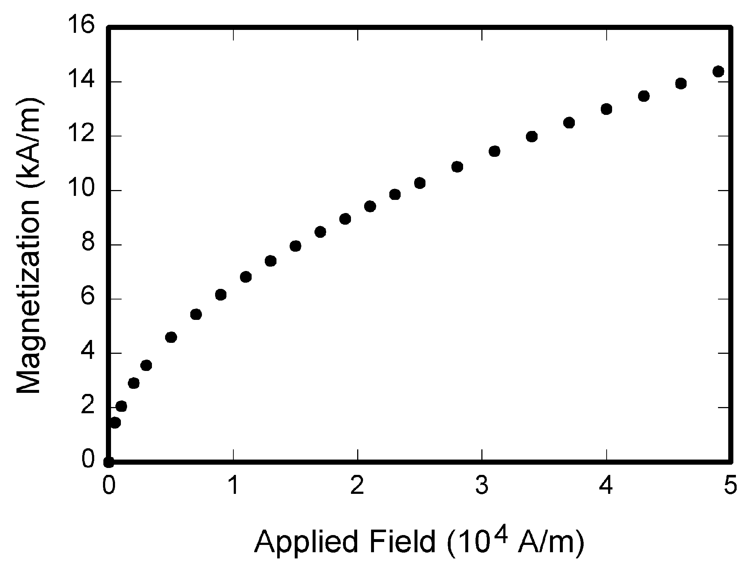
Fig. 1. Magnetization as a function of applied field. Note that “Fig.” is abbreviated. There is a period after the figure number, followed by two spaces. It is good practice to explain the significance of the figure in the caption.

References
Number citations consecutively in square brackets [1]. The sentence punctuation follows the brackets [2]. Multiple references [2], [3] are each numbered with separate brackets [1]–[3]. When citing a section in a book, please give the relevant page numbers [2]. In sentences, refer simply to the reference number, as in [3]. Do not use “Ref. [3]” or “reference [3]” except at the beginning of a sentence: “Reference [3] shows ... .”
Number footnotes separately in superscripts (Insert | Footnote). Place the actual footnote at the bottom of the column in which it is cited; do not put footnotes in the reference list (endnotes). Use letters for table footnotes (see Table I).
Please note that the references at the end of this document are in the preferred referencing style. Give all authors’ names; do not use “et al.” unless there are six authors or more. Use a space after authors’ initials. Papers that have not been published should be cited as “unpublished” [4]. Papers that have been accepted for publication, but not yet specified for an issue should be cited as “to be published” [5]. Papers that have been submitted for publication should be cited as “submitted for publication” [6]. Please give affiliations and addresses for private communications [7].
Capitalize only the first word in a paper title, except for proper nouns and element symbols. For papers published in translation journals, please give the English citation first, followed by the original foreign-language citation [8].

Abbreviations and Acronyms
Define abbreviations and acronyms the first time they are used in the text, even after they have already been defined in the abstract. Abbreviations such as IEEE, SI, ac, and dc do not have to be defined. Abbreviations that incorporate periods should not have spaces: write “C.N.R.S.,” not “C. N. R. S.” Do not use abbreviations in the title unless they are unavoidable.

Equations
Number equations consecutively with equation numbers in parentheses flush with the right margin, as in (1). First use the equation editor to create the equation. Then select the “Equation” markup style. Press the tab key and write the equation number in parentheses. To make your equations more compact, you may use the solidus ( / ), the exp function, or appropriate exponents. Use parentheses to avoid ambiguities in denominators. Punctuate equations when they are part of a sentence, as in

(1)

Be sure that the symbols in your equation have been defined before the equation appears or immediately following. Italicize symbols (T might refer to temperature, but T is the unit tesla). Refer to “(1),” not “Eq. (1)” or “equation (1),” except at the beginning of a sentence: “Equation (1) is ... .”

Other Recommendations
Use one space after periods and colons. Hyphenate complex modifiers: “zero-field-cooled magnetization.” Avoid dangling participles, such as, “Using (1), the potential was calculated.” [It is not clear who or what used (1).] Write instead, “The potential was calculated by using (1),” or “Using (1), we calculated the potential.”
Use a zero before decimal points: “0.25,” not “.25.” Use “cm³,” not “cc.” Indicate sample dimensions as “0.1 cm × 0.2 cm,” not “0.1 × 0.2 cm².” The abbreviation for “seconds” is “s,” not “sec.” Do not mix complete spellings and abbreviations of units: use “Wb/m²” or “webers per square meter,” not “webers/m².” When expressing a range of values, write “7 to 9” or “7-9,” not “7~9.”
A parenthetical statement at the end of a sentence is punctuated outside of the closing parenthesis (like this). (A parenthetical sentence is punctuated within the parentheses.) In American English, periods and commas are within quotation marks, like “this period.” Other punctuation is “outside”! Avoid contractions; for example, write “do not” instead of “don’t.” The serial comma is preferred: “A, B, and C” instead of “A, B and C.”
If you wish, you may write in the first person singular or plural and use the active voice (“I observed that ...” or “We observed that ...” instead of “It was observed that ...”). Remember to check spelling. If your native language is not English, please get a native English-speaking colleague to carefully proofread your paper.

Some Common Mistakes
The word “data” is plural, not singular. The subscript for the permeability of vacuum µ₀ is zero, not a lowercase letter “o.” The term for residual magnetization is “remanence”; the adjective is “remanent”; do not write “remnance” or “remnant.” Use the word “micrometer” instead of “micron.” A graph within a graph is an “inset,” not an “insert.” The word “alternatively” is preferred to the word “alternately” (unless you really mean something that alternates). Use the word “whereas” instead of “while” (unless you are referring to simultaneous events). Do not use the word “essentially” to mean “approximately” or “effectively.” Do not use the word “issue” as a euphemism for “problem.” When compositions are not specified, separate chemical symbols by en-dashes; for example, “NiMn” indicates the intermetallic compound Ni_{0.5}Mn_{0.5} whereas “Ni–Mn” indicates an alloy of some composition Ni_{x}Mn_{1-x}.
Be aware of the different meanings of the homophones “affect” (usually a verb) and “effect” (usually a noun), “complement” and “compliment,” “discreet” and “discrete,” “principal” (e.g., “principal investigator”) and “principle” (e.g., “principle of measurement”). Do not confuse “imply” and “infer.”
Prefixes such as “non,” “sub,” “micro,” “multi,” and “ultra” are not independent words; they should be joined to the words they modify, usually without a hyphen. There is no period after the “et” in the Latin abbreviation “et al.” (it is also italicized). The abbreviation “i.e.,” means “that is,” and the abbreviation “e.g.,” means “for example” (these abbreviations are not italicized).
An excellent style manual and source of information for science writers is [9]. A general IEEE style guide and an Information for Authors are both available at http://www.ieee.org/web/publications/authors/transjnl/index.html

Conclusion
A conclusion section is not required. Although a conclusion may review the main points of the paper, do not replicate the abstract as the conclusion. A conclusion might elaborate on the importance of the work or suggest applications and extensions.
Appendix
Appendixes, if needed, appear before the acknowledgment. This is an unnumbered section.
Acknowledgment
The preferred spelling of the word “acknowledgment” in American English is without an “e” after the “g.” Use the singular heading even if you have many acknowledgments. Avoid expressions such as “One of us (S.B.A.) would like to thank ... .” Instead, write “F. A. Author thanks ... .” Sponsor and financial support acknowledgments are placed here. This is an unnumbered section.
References
- G. O. Young, “Synthetic structure of industrial plastics (Book style with paper title and editor),” in Plastics, 2nd ed. vol. 3, J. Peters, Ed. New York: McGraw-Hill, 1964, pp. 15–64.
- W.-K. Chen, Linear Networks and Systems (Book style). Belmont, CA: Wadsworth, 1993, pp. 123–135.
- H. Poor, An Introduction to Signal Detection and Estimation. New York: Springer-Verlag, 1985, ch. 4.
- B. Smith, “An approach to graphs of linear forms (Unpublished work style),” unpublished.
- E. H. Miller, “A note on reflector arrays (Periodical style—Accepted for publication),” IEEE Trans. Antennas Propagat., to be published.
- J. Wang, “Fundamentals of erbium-doped fiber amplifiers arrays (Periodical style—Submitted for publication),” IEEE J. Quantum Electron., submitted for publication.
- C. J. Kaufman, Rocky Mountain Research Lab., Boulder, CO, private communication, May 1995.
- Y. Yorozu, M. Hirano, K. Oka, and Y. Tagawa, “Electron spectroscopy studies on magneto-optical media and plastic substrate interfaces (Translation Journals style),” IEEE Transl. J. Magn.Jpn., vol. 2, Aug. 1987, pp. 740–741 [Dig. 9th Annu. Conf. Magnetics Japan, 1982, p. 301].
- M. Young, The Techincal Writers Handbook. Mill Valley, CA: University Science, 1989.
- J. U. Duncombe, “Infrared navigation—Part I: An assessment of feasibility (Periodical style),” IEEE Trans. Electron Devices, vol. ED-11, pp. 34–39, Jan. 1959.
- S. Chen, B. Mulgrew, and P. M. Grant, “A clustering technique for digital communications channel equalization using radial basis function networks,” IEEE Trans. Neural Networks, vol. 4, pp. 570–578, Jul. 1993.
- R. W. Lucky, “Automatic equalization for digital communication,” Bell Syst. Tech. J., vol. 44, no. 4, pp. 547–588, Apr. 1965.
- S. P. Bingulac, “On the compatibility of adaptive controllers (Published Conference Proceedings style),” in Proc. 4th Annu. Allerton Conf. Circuits and Systems Theory, New York, 1994, pp. 8–16.
- G. R. Faulhaber, “Design of service systems with priority reservation,” in Conf. Rec. 1995 IEEE Int. Conf. Communications, pp. 3–8.
- W. D. Doyle, “Magnetization reversal in films with biaxial anisotropy,” in 1987 Proc. INTERMAG Conf., pp. 2.2-1–2.2-6.
- G. W. Juette and L. E. Zeffanella, “Radio noise currents n short sections on bundle conductors (Presented Conference Paper style),” presented at the IEEE Summer power Meeting, Dallas, TX, Jun. 22–27, 1990, Paper 90 SM 690-0 PWRS.
- J. G. Kreifeldt, “An analysis of surface-detected EMG as an amplitude-modulated noise,” presented at the 1989 Int. Conf. Medicine and Biological Engineering, Chicago, IL.
- J. Williams, “Narrow-band analyzer (Thesis or Dissertation style),” Ph.D. dissertation, Dept. Elect. Eng., Harvard Univ., Cambridge, MA, 1993.
- N. Kawasaki, “Parametric study of thermal and chemical nonequilibrium nozzle flow,” M.S. thesis, Dept. Electron. Eng., Osaka Univ., Osaka, Japan, 1993.
- J. P. Wilkinson, “Nonlinear resonant circuit devices (Patent style),” U.S. Patent 3 624 12, July 16, 1990.
- IEEE Criteria for Class IE Electric Systems (Standards style), IEEE Standard 308, 1969.
- Letter Symbols for Quantities, ANSI Standard Y10.5-1968.
- R. E. Haskell and C. T. Case, “Transient signal propagation in lossless isotropic plasmas (Report style),” USAF Cambridge Res. Lab., Cambridge, MA Rep. ARCRL-66-234 (II), 1994, vol. 2.
- E. E. Reber, R. L. Michell, and C. J. Carter, “Oxygen absorption in the Earth’s atmosphere,” Aerospace Corp., Los Angeles, CA, Tech. Rep. TR-0200 (420-46)-3, Nov. 1988.
- (Handbook style) Transmission Systems for Communications, 3rd ed., Western Electric Co., Winston-Salem, NC, 1985, pp. 44–60.
- Motorola Semiconductor Data Manual, Motorola Semiconductor Products Inc., Phoenix, AZ, 1989.
- (Basic Book/Monograph Online Sources) J. K. Author. (year, month, day). Title (edition) [Type of medium]. Volume (issue). Available: http://www.(URL)
- J. Jones. (1991, May 10). Networks (2nd ed.) [Online]. Available: http://www.atm.com
- (Journal Online Sources style) K. Author. (year, month). Title. Journal [Type of medium]. Volume(issue), paging if given. Available: http://www.(URL)
- R. J. Vidmar. (1992, August). On the use of atmospheric plasmas as electromagnetic reflectors. IEEE Trans. Plasma Sci. [Online]. 21(3). pp. 876–880. Available: http://www.halcyon.com/pub/journals/21ps03-vidmar

It is recommended that footnotes be avoided (except for the unnumbered footnote on the first page). Instead, try to integrate the footnote information into the text.

