THE YIELD STRESS ON WET FOAM

Dhineshkumar Balasubramaniam (21971603)

Abstract

Most of the common foams are two-phase medium of gas and liquid with a particular structure consisting of gas pockets trapped in a network of thin liquid films and plateau borders. When Foams have high yield stress, they are useful in fluid for carrying particles in applications ranging from the transport of cuttings in drilling and the placement of sands in cracks in oil producing reservoirs to increase the conductivity of reservoirs for secondary oil recovery. The rheology of wet foam gives the yield stress behavior but the behavior of the wet foam is difficult due to its complex structure and nature of the components. In 19th century, Joseph Plateau clearly described that, Wet foam is an example of soft matter with a very well defined structure.

Introduction

Foams are playing major roles in particles transporting like froth flotation, oil movement and so on. It is important to develop a constitutive rheological law, predicting the relation between macroscopic stress, strain and strain history. Foams exhibit linear viscoelastic behavior when they are subjected to small shear stresses and flow like viscous liquids when the shear stress is large enough to trigger bubble rearrangements. Foam elasticity comes from the deformation of bubbles from the perfectly sphere shape, in order to increase their packing density. During deformation, the stored surface energy is increased and this is responsible for viscoelastic properties of foam.

A well-developed science of dry, static (or quasi-static) foams is a valuable first step. Most common foams are quite dry when in equilibrium under gravity, and we can understand most of their properties when they are in this condition. These include the essential structure, as Plateau described it long ago, the statistics associated with that structure, its coarsening with time due to gas diffusion, its elastic and plastic properties, and the drainage of liquid through it when equilibrium is disturbed. In order to understand the behavior of wet foam, we have been using successful theories of dry foam, based on the assumption that fluid is mainly within the Plateau borders.

How Foams are formed?

Most of the common foams are a two-phase medium of gas and liquid with a particular structure consisting of gas pockets trapped in a network of thin liquid films and plateau borders. Some well known foams are bubble baths, dishwater detergents and the foam head on beers. Many oils foam when trapped gas is suddenly released under conditions of an abrupt drop in pressure. In some refiners in which the through-flow of gas at high temperature and pressure is required to crack hydrocarbons, the gas-liquid mixtures will foam strongly. The foam traps gas with gas fractions of 80% or higher. Clearly in such situations, in which it is desired that solid catalysts contact liquids, the production of foam is not wanted.

In other applications, foams are useful; for example foams which have a high yield stress and can be used in a fluid for carrying particles in applications ranging from the transport of cuttings in drilling and the placement of sands in cracks in oil producing reservoirs to increase the conductivity of reservoirs for secondary oil recovery. Obviously, bubble bath and shampoo companies should like to produce appropriate foams for dish and hair washing. Technologies which are impacted by foams and foaming are widespread.

Plateau's law

Plateau's laws describe the shape and configuration of soap films as follows:
- Soap films are made of entire (unbroken) smooth surfaces.
- The mean curvature of a portion of a soap film is everywhere constant on any point on the same piece of soap film.
- Soap films always meet in threes along an edge called a Plateau border, and they do so at an angle of arccos(−1/2) = 120°.
- These Plateau borders meet in fours at a vertex, and they do so at an angle of arccos(−1/3) ≈ 109.47° (the tetrahedral angle).

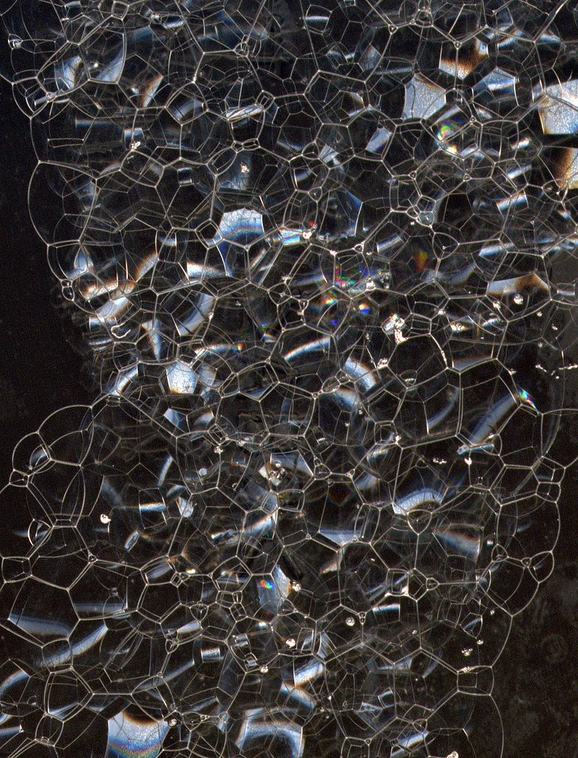
Plateau Border

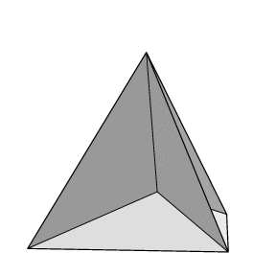
Plateau defines the border in foam, Where films meet along a line or curve, there is a liquid-filled interstitial channel. Plateau used the concept of a geometrical (fully dry or ideal) foam consisting of films of negligible thickness that are joined along lines and at points. Films are endowed with a free energy per unit area, which, if the film thickness is negligible, coincides with the film tension , leading to the total foam energy where S is the total film area.
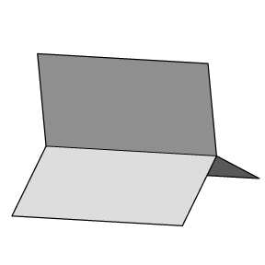

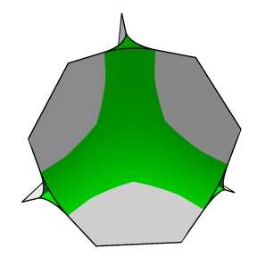
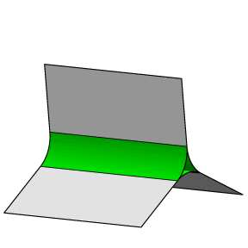

Wet foams (aka) liquid foams

The physical properties of a foam depend on its liquid fraction, Φ i.e. the volume ratio of liquid and gas. Dry foams refer to Φ less than about 0.05 (as generally holds for detergent foams), wet foams refer to Φ higher than about 0.15 (as in freshly poured beer). Values of liquid fraction higher than 0.36 correspond to bubbly liquids. In equilibrium under gravity, most common foams are quite dry.

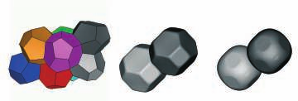
Figure 4: Foam structures can be computed using the Suface Evolver software (Brakke, 1992).
The examples shown here are the Waire-Phelan structure for Φ = 0 and Kelvin cells for
Φ = 0.01 and Φ = 0.10.

Generally wet foams are only stable if they contain surfactants. Their most important effect
is not simply that of lowering the surface tension, although it is closely related. Rather, it is the
dynamical properties of the surface tension which serve to stabilize the films. The surface tension
increases whenever a film is suddenly stretched locally, resulting in increased forces which oppose
that tendency.

The other factor which makes foam more stable is dis-joining pressure. This expresses mutually repulsive force between the two faces of films, which makes foam film more thinning. The film thickness at equilibrium is achieved by determining the balance between dis-joining pressure and the bulk pressure of liquid. Latter decreases to large negative values as the liquid fraction of the foam decreases,and the Plateau borders shrink and increase in curvature.

Foam Drainage

Whenever there is a finite amount of liquid in the foam, it is subject to gravity-driven drainage,
unless it has already come into equilibrium under gravity. In this state, there is a vertical profile
of liquid fraction. This is related to a variation of the local pressure in the liquid according to the
hydrostatic pressure law, necessary for equilibrium under gravity.
More generally, the liquid moves through the Plateau borders and junctions of the static foam structure (and to a lesser extent the films) in response to gravity and local pressure variations.

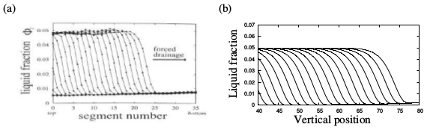
Figure 8: (a) The forced-drainage experiment, in which a solitary wave is observed to descend
through the foam, has greatly improved our understanding of liquid drainage through foams. In this
case the position of the wave-front was measured using conductivity. (b) The numerical solution
of a foam drainage equation allows us to verify the agreement between theory and experiment.

An understanding of this process, particularly in the limit of low liquid fraction, has been aided by the development of nonlinear foam drainage equations. The most striking example of drainage is the solitary wave-front which propagates down through the foam when liquid is added to the top at constant flow-rate. See figure 8. This is known as a forced drainage experiment. The velocity of the front is constant to a good approximation, and easily observed. This simple measurement is a good starting point in exploring drainage, and its dependence on the nature of surfactants (Saint-Jalmes and Langevin 2002).

Stress – Strain behavior

Foam is a complex fluid and it exploits various material properties under different strain rates. It behaves like elastic solids at low strain, behaves like plastic solids when strain increases and like liquid at very high strain.

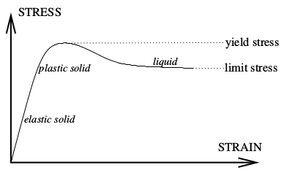

Figure 9: In an experiment in which the strain is slowly increased, the stress first increases linearly.
The slope is the elastic shear modulus. This increase continues until the plastic limit, at which the
first topological changes occur and the foam yields. The system shows hysteresis in the sense that
once the foam has yielded, the stress drops to a lower limit stress characterized by further intermittent topological changes and liquid-like behavior (flow). In practice, the difference between the limit stress and the yield stress is small, and both depend significantly upon the strain-rate.

The Yield Stress of a Foam

The life history of an liquid foam neglects one important aspect of liquid foam; their mechanical properties, which are remarkable, considering that the constituents of the foam (a gas and a dilute surfactants solution) behave individually as unexceptional and quite predictable fluids. A foam can flow like a liquid or remain motionless under stress like a solid. For example shaving cream lather is easy to spread, it offers little resistance to flow and gives the impression of having a low viscosity. Yet the stress due to gravity is not enough to cause shaving cream lather to flow in the hand or when it has been spread; the manifestation of what seems to be low viscosity depends on whether a parameter called yield stress has been exceeded.

The physical basis for the yield stress of a foam can be explained by a simple model in which a foam is treated as a two-dimensional honeycomb of hexagonal cells. When the cells are all the same size, the model satisfies the Plateau criteria for a real foam. Suppose the foam is subjected to a shearing force, its deformation under that force is straightforward as long as the volume of each cell can stay constant and films can continue to meet in threes at angles of 120 degrees. Then a critical strain is reached, when the cells are so deformed that some of the Plateau border have coalesced and the films between them have disappeared.

