EDGEWATT: A LOW-COST ESP32-BASED NON-INTRUSIVE LOAD MONITORING SYSTEM USING ENGINEERED STEADY-STATE FEATURES AND ENSEMBLE CLASSIFICATION
A PROJECT BASED LEARNING REPORT
Microprocessors and Microcontrollers
Submitted by
DHINESH KARTHICK D | 210425106049
MANICKAVEL C | 210425106117
in partial fulfillment for the award of the degree
of
BACHELOR OF ENGINEERING
in
ELECTRONICS AND COMMUNICATION ENGINEERING

CHENNAI INSTITUTE OF TECHNOLOGY
(AUTONOMOUS)
(Affiliated to Anna University, Chennai)
ANNA UNIVERSITY: CHENNAI-600 069

SEPTEMBER-2026

BONAFIDE CERTIFICATE
Certified that this project report titled "EDGEWATT: A LOW-COST ESP32-BASED NON-INTRUSIVE LOAD MONITORING SYSTEM USING ENGINEERED STEADY-STATE FEATURES AND ENSEMBLE CLASSIFICATION" is the Bonafide work of DHINESH KARTHICK D (210425106049) and MANICKAVEL C (210425106050) who carried out the Project Phase I work under my supervision during the academic year 2026–27.

SIGNATURE | SIGNATURE
Dr. T.S. ARULANANTH M.E, Ph.D. | Mr. V. PREM SANGEETH M.E.
HEAD OF THE DEPARTMENT | SUPERVISOR
Professor | Professor
Department of Electronics and | Department of Electronics and
Communication Engineering, | Communication Engineering,
Chennai Institute of Technology,  Kundrathur, Chennai-600069. | Chennai Institute of Technology,  Kundrathur, Chennai-600069.

Certified that the above students have attended viva voce during the exam held on ....................
INTERNAL EXAMINER | EXTERNAL EXAMINER

ACKNOWLEDGEMENT
We express our deep sense of gratitude to our respected Chairman Shri. P. SRIRAM and all trust members of Chennai Institute of Technology for providing us the exemplary infrastructure, state-of-the-art laboratory facilities, and encouraging environment to undertake this project as part of our undergraduate coursework.
We are profoundly grateful to our Principal Dr. A. RAMESH M.E, Ph.D. for his continuous encouragement, academic support, and administrative guidance throughout the duration of this research work.
We express our sincere thanks to our Head of the Department, Dr. T.S. ARULANANTH M.E, Ph.D., Department of Electronics and Communication Engineering, for his visionary leadership, constant inspiration, valuable guidance, and provision of specialized lab resources that were instrumental to our work.
We sincerely thank our Project Guide, Mrs. R. PANDIMEENA M.E., (Ph.D.), Assistant Professor, Department of Electronics and Communication Engineering, for her invaluable technical supervision, insightful suggestions, and continuous encouragement during every stage of design and testing.
We also extend our heartfelt thanks to our Project Guide, Mr. V. PREM SANGEETH M.E., Professor, Department of Electronics and Communication Engineering, for his constructive critiques, rigorous reviews, and practical guidance in refining the analog front-end and embedded firmware architecture.
We would like to extend our sincere appreciation to the Faculty Coordinators of Project Based Learning and all faculty members of the Department of Electronics and Communication Engineering for their cooperation, technical suggestions, and constructive evaluations throughout the project reviews.
We gratefully acknowledge the technical support and assistance received from the Laboratory Instructors of the Department of Electronics and Communication Engineering, whose cooperation in electrical workbench testing and component verification contributed significantly to the successful completion of our physical implementation.

ABSTRACT
Non-Intrusive Load Monitoring (NILM) systems typically depend on cloud-based inference or high-resolution phase and harmonic analysis, severely limiting their suitability for low-cost, low-power edge deployment. This project presents EdgeWatt, an ESP32-based NILM system that performs robust, on-device appliance classification using a single, low-cost SCT-013-100A/1V split-core current transformer (CT) sampled on a 12-bit ADC channel, without reliance on zero-crossing or voltage phase reference data. Raw tri-axial telemetry—comprising Root Mean Square magnitude (V1), peak magnitude (V2), and crest factor (V3)—is captured over discrete 200 ms sampling windows (corresponding to 10 complete AC cycles at 50 Hz) and expanded host-side into a 10-dimensional engineered feature space featuring inverse crest ratios, peak-to-RMS ratios, power approximations, and logarithmic non-linear transforms. Classification is performed by an optimized, weighted soft-voting ensemble combining Gradient Boosting, Hist Gradient Boosting, and Extra Trees classifiers inside a unified scikit-learn pipeline, trained on a fused corpus of 10,209 samples that combines historical offline measurements (6,010 samples) with 4,199 samples captured during an automated 40-minute, 8-cycle live hardware validation suite. An 8-sample temporal debouncing filter with a 70% consensus threshold, a rate-of-change disconnect detector (dV1/dt < -1.50 V), and a 12-sample post-load cooldown window effectively eliminate transient misclassifications and suppress post-bulb capacitive discharge drift. The fused ensemble achieves 85.26% overall classification accuracy (a +4.39% increase over the offline-only corpus), with bulb precision reaching 85.67% (+13.70% improvement) and false bulb triggers plunging from 1.60% to 0.10%. Furthermore, an insidious dual-conductor CT clamping pitfall that caused complete magnetic field cancellation during early trials was identified and resolved through a custom-fabricated single-conductor test jig. EdgeWatt definitively establishes that a phase-free, low-cost edge NILM pipeline delivers deterministic, real-time energy disaggregation on commodity microcontroller hardware.

TABLE OF CONTENTS
CHAPTER | TITLE | PAGE
 | ACKNOWLEDGEMENT | iii
 | ABSTRACT | iv
 | LIST OF FIGURES | vi
 | LIST OF TABLES | vii
 | LIST OF ABBREVIATIONS | viii
1. | INTRODUCTION | 10
 | 1.1 Overview | 10
 | 1.2 Background and Motivation | 11
 | 1.3 Need for On-Device Non-Intrusive Load Monitoring | 12
 | 1.4 Objectives of the Project | 13
 | 1.5 Scope of the Project | 14
 | 1.6 Organization of the Report | 15
2. | LITERATURE SURVEY | 17
 | 2.1 Classical and Event-Based NILM Foundations | 17
 | 2.2 Cloud Computing Limitations in NILM | 18
 | 2.3 Edge Computing and Microcontroller-Based NILM (TinyML) | 19
 | 2.4 Steady-State vs. High-Frequency Transient Feature Extraction | 20
 | 2.5 Machine Learning Classifiers and Ensemble Voting in Load Disaggregation | 21
 | 2.6 Summary of Literature Survey and Research Gap | 22
3. | PROBLEM STATEMENT AND OBJECTIVES | 24
 | 3.1 Problem Definition | 24
 | 3.2 Limitations of Existing Systems | 24
 | 3.3 Proposed Solution – Overview | 25
 | 3.4 Specific Objectives | 26
4. | SYSTEM REQUIREMENTS | 27
 | 4.1 Hardware Requirements | 27
 | 4.2 Software and Tool Requirements | 28
 | 4.3 Functional Requirements | 29
 | 4.4 Non-Functional Requirements | 30
5. | PROPOSED METHODOLOGY AND SYSTEM DESIGN | 31
 | 5.1 Design Philosophy | 31
 | 5.2 Layered System Architecture | 32
 | 5.3 Overall Block Diagram | 33
 | 5.4 Working Principle | 34
 | 5.5 Analog Front-End & Signal Conditioning Circuit | 35
 | 5.6 10-Dimensional Engineered Feature Space Formulation | 36
 | 5.7 Weighted Soft-Voting Ensemble Classifier Topology | 37
 | 5.8 State Filtering, Debouncing, and Hysteresis Engine | 38
 | 5.9 Algorithmic Flowcharts | 39
6. | IMPLEMENTATION AND EXPERIMENTAL SETUP | 41
 | 6.1 Hardware Configuration and Test Jig Assembly | 41
 | 6.2 ESP32 Firmware Development and Continuous ADC Sampling | 42
 | 6.3 Feature Extraction Pipeline and Dataset Fusion | 43
 | 6.4 Model Training, Cross-Validation, and Pipeline Serialization | 44
 | 6.5 Live Inference Engine and Web Dashboard Integration | 45
7. | RESULTS AND DISCUSSION | 47
 | 7.1 AI Model Accuracy and Cross-Validation Benchmarking | 47
 | 7.2 Effect of Corpus Fusion on Ensemble Performance | 48
 | 7.3 Confusion Matrix and Class Discrimination Metrics | 49
 | 7.4 Automated 40-Minute Hardware Stress Test Analysis | 50
 | 7.5 Resolution of CT Dual-Conductor Clamping Failure Mode | 52
 | 7.6 Comparative Analysis: Edge vs. Cloud Architectures | 53
8. | CONCLUSION AND FUTURE SCOPE | 55
 | 8.1 Conclusion | 55
 | 8.2 Future Scope | 56
 | REFERENCES | 58

LIST OF FIGURES
Figure 3.1 | Comparison between Traditional Cloud-Centric NILM and Proposed EdgeWatt Architecture | 26
Figure 5.1 | High-Level Layered System Architecture of EdgeWatt Pipeline | 33
Figure 5.2 | Analog Signal Conditioning Circuit & Operational Amplifier Schematic | 35
Figure 5.3 | Algorithmic Flowchart of Edge Telemetry, Classification, and Hysteresis Debouncing | 40
Figure 7.1 | Multi-Panel Machine Learning Classification Diagnostic Dashboard (Train/Test Split, Power Space Distribution, Confusion Matrix, and Feature Importance) | 49
Figure 7.2 | Automated 40-Minute Hardware Stress Test Validation Curve (V1 Response, Trajectories, Debounced State Classification, and Cycle-by-Cycle Accuracies) | 51
LIST OF TABLES
Table 2.1 | Systematic NILM Research Gap Analysis Matrix | 23
Table 4.1 | Hardware Components and Front-End Specifications | 28
Table 4.2 | Software Stack and Machine Learning Development Tools | 29
Table 5.1 | 10-Dimensional Engineered Feature Formulations and Mathematical Significance | 36
Table 6.1 | Project Implementation Timeline and Deliverable Milestones | 46
Table 7.1 | Candidate Classifier 5-Fold Stratified Cross-Validation Benchmarks | 48
Table 7.2 | Effect of Live Hardware Corpus Fusion on Ensemble Performance | 48
Table 7.3 | Normalized Confusion Matrix on Held-Out 20% Test Corpus | 50
Table 7.4 | Automated 40-Minute Stress Test Cycle-by-Cycle Classification Accuracy | 52
Table 7.5 | Quantitative Comparative Architecture Benchmark: Edge AI vs. Cloud Offloading | 54

LIST OF ABBREVIATIONS
Abbreviation | Expansion
ADC | Analog-to-Digital Converter
AI | Artificial Intelligence
API | Application Programming Interface
BOM | Bill of Materials
CNN | Convolutional Neural Network
COTS | Commercial Off-The-Shelf
CT | Current Transformer
CV | Cross-Validation
DAE | Denoising Autoencoder
DC | Direct Current
DSP | Digital Signal Processing
DT | Decision Tree
EEPROM | Electrically Erasable Programmable Read-Only Memory
EMF | Electromotive Force / Electromagnetic Field
ESP32 | Espressif Systems 32-bit Microcontroller
ET | Extra Trees (Extremely Randomized Trees)
FFT | Fast Fourier Transform
FIFO | First-In, First-Out
GB | Gradient Boosting
GPIO | General-Purpose Input/Output
HGB | Hist Gradient Boosting
HMM | Hidden Markov Model
HTTP | Hypertext Transfer Protocol
I2C | Inter-Integrated Circuit
IIoT | Industrial Internet of Things
IoT | Internet of Things
JSON | JavaScript Object Notation
KNN | K-Nearest Neighbors
LCD | Liquid Crystal Display
LSTM | Long Short-Term Memory
MAE | Mean Absolute Error
MCU | Microcontroller Unit
ML | Machine Learning
MLP | Multilayer Perceptron
NILM | Non-Intrusive Load Monitoring
PCB | Printed Circuit Board
PdM | Predictive Maintenance
PLAID | Plug-Load Appliance Identification Dataset
REDD | Reference Energy Disaggregation Data Set
RF | Random Forest / Radio Frequency
RMS | Root Mean Square
RoC | Rate of Change (dV/dt)
RTT | Round-Trip Time
SAE | Signal Aggregate Error
SBC | Single-Board Computer
SMPS | Switched-Mode Power Supply
SRAM | Static Random Access Memory
SVM | Support Vector Machine
TFLite | TensorFlow Lite
THD | Total Harmonic Distortion
TRRS | Tip-Ring-Ring-Sleeve
UART | Universal Asynchronous Receiver-Transmitter
UK-DALE | UK Domestic Appliance-Level Electricity Dataset
VBIAS | DC Virtual Ground Bias Reference Voltage
WAN | Wide Area Network
ZCD | Zero-Crossing Detection

CHAPTER 1
INTRODUCTION
1.1 Overview
The global transition toward smart energy grids, demand-side management, and industrial automation has magnified the critical necessity for granular, real-time power consumption visibility. In residential, commercial, and light industrial settings, electrical energy is consumed across a heterogeneous mixture of appliances, motor drives, heating elements, and switched-mode power supplies (SMPS). Traditional sub-metering paradigms have historically depended on deploying dedicated smart plugs, intrusive multi-channel power meters, or direct branch-circuit current transformers at every distinct electrical outlet. While such intrusive metering topologies provide clean appliance-level telemetry, their widespread adoption is severely impeded by prohibitive capital hardware expenditures, complex electrical installation logistics, physical space constraints within distribution switchboards, and the substantial maintenance overhead associated with managing dense networks of distributed physical meters.
To decisively circumvent these economic and operational bottlenecks, Non-Intrusive Load Monitoring (NILM)—originally conceptualized by George Hart in the early 1990s—emerged as an elegant, non-invasive alternative. NILM seeks to mathematically disaggregate individual appliance power signatures and operating states from a single aggregate current and voltage measurement point, typically situated at the facility's main electrical service entrance or a localized branch distribution bus. By eliminating the necessity for intrusive hardware retrofitting across every electrical receptacle, NILM fundamentally reduces installation capital expenditures, minimizes points of physical hardware failure, and offers a frictionless pathway toward ubiquitous energy intelligence and automated demand-response auditing.
1.2 Background and Motivation
Over the past three decades, the algorithmic landscape of NILM has undergone a profound evolution. Early foundational architectures relied heavily on deterministic finite-state machine (FSM) edge detectors, rule-based heuristics, and combinatorial optimization applied to macro-scale active (P) and reactive (Q) power transitions. While computationally lean, these classical algorithms exhibited acute performance degradation when confronted with modern households dominated by non-linear electronic loads, variable-speed motor drives, and overlapping switching transients.
To overcome these limitations, recent contemporary research has overwhelmingly defaulted to high-complexity Deep Neural Networks (DNNs), such as Denoising Autoencoders (DAEs), deep Convolutional Neural Networks (CNNs), and Sequence-to-Point (Seq2Point) recurrent models. However, the architectural paradigm accompanying this deep learning revolution is almost exclusively Cloud-centric. High-frequency analog-to-digital converters (ADCs) capture raw voltage and current waveforms at kilohertz sampling rates, continuously streaming uncompressed high-velocity telemetry across wireless networks (Wi-Fi, 4G/5G) to centralized cloud data centers where GPU clusters execute deep neural inference.
Vulnerabilities of Cloud-Centric NILM: This cloud-dependent disaggregation paradigm introduces four severe structural flaws that undermine its viability for scalable, real-world deployment:
- Application-Layer Latency and Network Jitter: Offloading raw telemetry introduces variable round-trip time (RTT) delays ranging from 50 milliseconds to several seconds, governed by router queuing buffers, RF packet contention, and multi-hop WAN routing. For time-critical demand response or safety-critical electrical fault mitigation, such latency is unacceptable.
- Excessive Wireless Bandwidth Consumption: Continuous high-frequency waveform streaming from hundreds of smart meters saturates local Wi-Fi access points and cellular uplink channels, precipitating localized packet collisions and high recurring data plan fees.
- Acute Data Privacy Infringements: Aggregate high-resolution current signatures act as an invasive biometric fingerprint of human domestic life. Streaming raw power data exposes inhabitants' wake-sleep cycles, culinary habits, appliance usage patterns, and physical occupancy status to potential cloud breaches and unauthorized surveillance.
- Total Cloud Dependency and Single-Point Failure: A momentary internet outage or server downtime blinds the cloud-centric monitoring framework entirely, rendering local energy management systems incapable of real-time actuation.
1.3 Need for On-Device Non-Intrusive Load Monitoring
The evident shortcomings of cloud offloading establish an urgent technological imperative: migrating machine learning intelligence directly to the extreme edge of the electrical distribution network—specifically onto inexpensive, ultra-low-power, commercial off-the-shelf (COTS) microcontrollers. On-device edge NILM eliminates the dependency on external internet gateways, guarantees deterministic sub-millisecond execution loops, preserves consumer privacy by retaining raw analog signatures locally within device memory, and operates autonomously during complete network blackouts.
However, achieving reliable appliance classification directly on a resource-constrained microcontroller unit (MCU) imposes severe engineering constraints. Commodity microcontrollers, such as the Espressif ESP32, operate with strict Static Random Access Memory (SRAM) budgets (typically 520 KB) and limited flash storage. They lack hardware floating-point acceleration units suitable for dense multi-megabyte deep learning graphs. Furthermore, standard NILM methodologies depend on synchronous voltage sampling to derive zero-crossing phase angles and power factors—a requirement that drastically increases front-end hardware complexity, Bill-of-Materials (BOM) cost, and high-voltage electrical hazards.
EdgeWatt addresses this exact engineering challenge. By coupling a single, non-invasive split-core Current Transformer (SCT-013-100A/1V) with an engineered analog signal conditioning stage, the system captures phase-free, steady-state current telemetry. Rather than burdening the microcontroller with heavy deep learning models, EdgeWatt extracts a lean tri-axial measurement vector over 200 ms windows, expands it into a non-linear 10-dimensional feature space, and executes an optimized Weighted Soft-Voting Ensemble classifier paired with temporal debouncing. This delivers high classification accuracy and sub-millisecond responsiveness at a total hardware bill-of-materials cost under $15.
1.4 Objectives of the Project
Core Project Objectives: To systematically formulate, implement, and benchmark the proposed decentralized NILM framework, this project pursues five specific engineering and experimental objectives:
- Objective 1: Design of a Characterized Low-Cost Analog Front-End: To engineer, assemble, and validate a safe, non-invasive current acquisition front-end utilizing an SCT-013-100A/1V split-core current transformer, an active LM358 operational amplifier virtual ground bias circuit (1.65 V DC), and a calibrated 23x non-inverting gain stage interfaced directly to the 12-bit ADC of an ESP32 microcontroller.
- Objective 2: Phase-Free Continuous Telemetry and Feature Expansion: To develop an embedded firmware pipeline that performs continuous ADC sampling across 200 ms windows (10 AC cycles at 50 Hz), reduces the raw waveform into a tri-axial telemetry tuple (V1: RMS magnitude, V2: Peak magnitude, V3: Crest factor), and expands this tuple host-side into a 10-dimensional non-linear feature space without requiring zero-crossing or voltage reference hardware.
- Objective 3: Construction of a Weighted Soft-Voting Ensemble Classifier: To design, benchmark, and optimize an ensemble machine learning architecture combining Gradient Boosting, Hist Gradient Boosting, and Extra Trees classifiers inside a unified scikit-learn pipeline, achieving superior class separation between resistive, non-linear electronic, and zero-load states.
- Objective 4: Dataset Fusion and 40-Minute Hardware-in-the-Loop Validation: To establish a robust training corpus of 10,209 samples by fusing an offline calibration dataset (6,010 samples) with an automated, 40-minute, 8-cycle live hardware validation suite (4,199 samples), systematically evaluating classification accuracy, F1-scores, and false-positive suppression.
- Objective 5: Temporal State Filtering and Deployment Pitfall Resolution: To implement an 8-sample sliding FIFO debouncing filter with a 70% consensus threshold, a rate-of-change disconnect detector (dV1/dt < -1.50 V), and a 12-sample post-load cooldown window to suppress transient switching noise and capacitive discharge drift. Furthermore, to diagnose and physically resolve the mutual magnetic flux cancellation pitfall inherent in dual-conductor CT clamping via a dedicated single-conductor test jig.
1.5 Scope of the Project
The scope of this project is strictly delineated to deliver an academically rigorous, industrially reproducible demonstration of low-cost edge NILM. The electrical sensing boundary is restricted to single-phase 230 V RMS / 50 Hz AC mains systems common to residential and light industrial automation. Sensing is exclusively current-based, intentionally omitting voltage transformer connections to maintain complete galvanic isolation and minimize installation hazard.
The target load classification taxonomy focuses on three fundamental, widely representative electrical appliance categories: (1) NO LOAD baseline conditions reflecting quiescent sensor noise and line leakage; (2) Resistive heating and lighting loads represented by incandescent and resistive bulbs exhibiting high, in-phase current draw; and (3) Non-linear electronic loads represented by Switched-Mode Power Supply (SMPS) mobile chargers characterized by low average RMS currents and pulsed harmonic conduction profiles. While multi-state continuous loads (such as variable-speed inverter heat pumps) are outside the current scope, the engineered 10-dimensional feature space and ensemble pipeline are structurally architected for seamless multi-class scaling in future iterations.
1.6 Organization of the Report
To present the architectural design, theoretical modeling, software engineering, and empirical experimental results in a logical, structured sequence, this report is organized into the following chapters:
Chapter 2: Literature Survey provides a comprehensive critique of existing NILM research, contrasting classical combinatorial methods against deep learning paradigms, evaluating edge-computing trade-offs on microcontrollers, and tabulating a rigorous research gap analysis matrix.
Chapter 3: Problem Statement and Objectives formally defines the technical barriers of cloud-centric energy monitoring, delineates the limitations of conventional systems, introduces the high-level EdgeWatt architecture, and itemizes the measurable engineering objectives.
Chapter 4: System Requirements itemizes the comprehensive hardware bill of materials, front-end analog specifications, software development toolchains, and strict functional and non-functional performance benchmarks.
Chapter 5: Proposed Methodology and System Design serves as the theoretical and structural core of the report, detailing the layered architecture, LM358 analog front-end math, 10-dimensional feature formulations, ensemble voting mechanics, and temporal state filtering logic.
Chapter 6: Implementation and Experimental Setup transitions from theory to physical realization, documenting the ESP32 firmware algorithms, automated 40-minute validation test jig, dataset fusion mechanics, pipeline serialization, and live dashboard integration.
Chapter 7: Results and Discussion presents extensive empirical validation data, evaluating 5-fold cross-validation metrics, corpus fusion gains, confusion matrix heatmaps, cycle-by-cycle stress test dynamics, and the electromagnetic resolution of the dual-conductor CT cancellation pitfall.
Chapter 8: Conclusion and Future Scope synthesizes the critical engineering findings of the project, affirms the viability of phase-free edge NILM, and outlines specific pathways for bare-metal C++ firmware porting and multi-sensor fusion.

CHAPTER 2
LITERATURE SURVEY
2.1 Classical and Event-Based NILM Foundations
The conceptual foundations of Non-Intrusive Load Monitoring were formally established by George W. Hart in his seminal 1992 IEEE work [1]. Hart formulated NILM as a discrete event-detection and clustering problem. Under this paradigm, individual appliances are modeled as finite-state machines (FSMs) possessing discrete operational states (e.g., ON, OFF, STANDBY). By continuously monitoring aggregate active power (P) and reactive power (Q) at the mains interface, step transitions (edges) in the electrical trajectory are detected and clustered to identify which specific appliance transitioned. While revolutionary, Hart's classical edge-detection methodology exhibited critical vulnerabilities: it failed to resolve overlapping transitions where multiple appliances switched simultaneously, was incapable of tracking continuously-variable loads (such as dimmers or variable-speed motors), and relied on rigid, hand-crafted state thresholds that degraded under mains voltage fluctuations.
Nearly two decades later, Zeifman and Roth (2011) published a comprehensive review synthesizing the progress of post-Hart disaggregation methodologies [2]. They categorized prevailing algorithms into combinatorial optimization (CO) heuristics, Hidden Markov Models (HMM), and statistical pattern-recognition classifiers. Critically, Zeifman and Roth highlighted a widening disconnect: while algorithmic sophistication was accelerating, mainstream adoption remained stagnant because the computational complexity of proposed HMM and factorial HMM (FHMM) pipelines drastically exceeded the processing capabilities of contemporary residential utility meters. They emphasized that steady-state electrical features—such as RMS current and steady power draw—remained the only economically viable path for low-frequency, resource-constrained monitoring.
Zoha et al. (2012) further expanded this taxonomy by categorizing NILM feature representations into macroscopic (low-frequency steady-state active/reactive power) and microscopic (high-frequency transient waveforms and harmonic spectra) signatures [3]. While microscopic transient features provide rich discriminative capability, Zoha et al. proved that capturing them requires dedicated high-speed ADCs (sampling in the tens of kilohertz), complex digital signal processors (DSPs), and substantial memory buffers, fundamentally inflating hardware installation costs.
2.2 Cloud Computing Limitations in NILM
To bypass the computational ceilings of local smart meters, the research community pivoted toward Deep Learning (DL) architectures hosted in centralized cloud infrastructures. Kelly and Knottenbelt (2015) introduced 'Neural NILM', benchmarking deep Denoising Autoencoders (DAEs), Long Short-Term Memory (LSTM) recurrent networks, and sequence-to-sequence (Seq2Seq) regressors on the UK-DALE benchmark dataset [4]. Their findings demonstrated that deep networks vastly outperformed classical combinatorial optimization baselines without requiring manual feature engineering. Subsequently, Zhang et al. (2018) proposed the Sequence-to-Point (Seq2Point) convolutional network, where a 1D-CNN maps a sliding window of aggregate power readings to a single target appliance midpoint value [5]. Seq2Point achieved an 84% reduction in Mean Absolute Error (MAE) compared to earlier Seq2Seq baselines, establishing the state-of-the-art benchmark for deep NILM.
However, as critically observed by Faustine et al. (2020) and Murray et al. (2019), these deep learning breakthroughs came at an immense practical penalty [7], [22]. Seq2Point and DAE models require multi-megabyte parameter storage, complex tensor operations, and high-performance GPU server infrastructure. Operating these models requires smart meters to act as continuous streaming telemetry probes. Under heavy network traffic or residential Wi-Fi contention, transmission latencies scale unpredictably from 50 ms to several seconds. Furthermore, continuous cloud offloading compromises household privacy, exposes systems to cloud outages, and incurs severe cloud hosting subscription overhead, creating an impassable barrier for cost-sensitive residential deployments.
2.3 Edge Computing and Microcontroller-Based NILM (TinyML)
To reconcile the accuracy of machine learning with the latency, privacy, and reliability requirements of modern grids, the paradigm of Micro Machine Learning (TinyML) emerged. Warden and Situnayake (2019) pioneered the deployment of quantized neural networks onto resource-constrained microcontrollers using TensorFlow Lite for Microcontrollers (TFLite Micro) [21]. Lin et al. (2023) and Schizas et al. (2022) systematically evaluated TinyML architectures, confirming that INT8 weight quantization and operator pruning reduce memory consumption by up to 75% with negligible accuracy degradation [17], [23].
In the specific context of embedded NILM, Tabanelli et al. (2021) conducted a landmark study on microcontroller-based smart measurement nodes [7]. They systematically trimmed feature extraction pipelines and evaluated classical supervised classifiers directly on MCU hardware. Their empirical findings revealed that optimized feature representations could achieve 95.15% classification accuracy on real embedded hardware while delivering a 5.45x inference speedup and an 80.56% reduction in memory footprint. Critically, Tabanelli et al. demonstrated that 'current-only' sensing—omitting the high-voltage divider and voltage transformer entirely—still achieved nearly 80% accuracy. This verified that eliminating voltage hardware yields a massive reduction in BOM cost and safety hazards at an acceptable, recoverable accuracy trade-off. However, Tabanelli et al. utilized an expensive custom research-grade measurement node, leaving a distinct gap for a reproducible, student-accessible implementation built on commodity microcontrollers like the ESP32.
Aghera et al. (2021) proposed a 1D-CNN/LSTM hybrid explicitly sized for an ESP32 [3], but validated their architecture strictly offline on the REDD public dataset without deploying on physical sensing hardware. Similarly, Young et al. (2024) benchmarked KNN, SVM, XGBoost, and CNNs across multiple sampling rates, demonstrating that 500 Hz represented an optimal sampling frequency sweet spot [8]. Yet, like much of the published literature, their conclusions regarding MCU feasibility were extrapolated from mathematical model sizes rather than empirical hardware-in-the-loop validation.
2.4 Steady-State vs. High-Frequency Transient Feature Extraction
A central design decision in NILM systems is the selection of load signature features. Gao et al. (2014) introduced the PLAID public dataset, capturing appliance switch-on transients at 30 kHz [10]. While 30 kHz sampling yields exquisite current-voltage trajectory curves, continuous 30 kHz sampling severely overwhelms low-cost microcontroller ADCs, rapidly depleting onboard SRAM and requiring dedicated high-speed DMA channels.
In contrast, Völker and Becker et al. (2021) evaluated 27 candidate feature extraction methods across four public datasets specifically to identify feature sets capable of operating on resource-constrained smart meters [6]. Their extensive empirical evaluations revealed that steady-state RMS active current magnitude is the single most powerful scalar predictor, while waveform shape descriptors (such as crest factor, peak-to-average ratios, and waveform approximation coefficients) provide complementary orthogonal signal. When paired with tree-based ensemble classifiers, this compact feature space achieved F1-scores of up to 0.98, proving that high-frequency sampling can be successfully replaced by intelligent steady-state feature engineering.
2.5 Machine Learning Classifiers and Ensemble Voting in Load Disaggregation
Individual machine learning classifiers exhibit distinct algorithmic trade-offs when applied to electrical disaggregation. K-Nearest Neighbors (KNN) provides intuitive non-parametric distance boundary mapping but suffers from high memory lookup overhead and severe vulnerability to analog sensor noise. Standard Decision Trees (DTs) offer rapid microsecond inference but are prone to high variance and overfitting on small training sets. Multilayer Perceptrons (MLPs) capture non-linear interactions but require extensive backpropagation training and floating-point compute resources [6].
To maximize robustness, Yang and Sung (2023) proposed a soft-voting ensemble combining Decision Trees, KNN, and MLPs per IEEE Standard 1459 power formulations, demonstrating substantial accuracy improvements over individual constituent models [9]. Ensemble learning leverages the foundational mathematical principles of bagging (Breiman, 2001) [25] and gradient boosting (Friedman, 2001) [27], aggregating predictions across multiple diverse weak learners to dramatically suppress individual model variance and bias. Extremely Randomized Trees (Extra Trees, Geurts et al., 2006) further introduces randomized cut-point selection, providing exceptional noise resilience against analog sensor jitter [26]. These findings directly justify EdgeWatt's deployment of a Weighted Soft-Voting Ensemble architecture combining Gradient Boosting, Hist Gradient Boosting, and Extra Trees inside a unified pipeline.
2.6 Summary of Literature Survey and Research Gap
The comprehensive literature review synthesizes a glaring, persistent gap in the state-of-the-art of Non-Intrusive Load Monitoring. The prevailing body of research exists in two disconnected extremes: (1) high-accuracy deep learning architectures that are validated purely in software on GPU clusters and suffer from severe cloud-latency and privacy flaws; or (2) practitioner microcontroller tutorials that demonstrate rudimentary energy logging using split-core CTs but fail to implement machine learning classification, ensemble pipelines, or temporal noise filtering.
Table 2.1 systematically maps the ten foundational literature benchmarks against their specific methodologies, advantages, unresolved research limitations, and the explicit technological improvements engineered in the EdgeWatt project.
Table 2.1 Systematic NILM Research Gap Analysis Matrix
Study / Benchmark | Core Methodology | Demonstrated Strengths | Critical Research Limitations | EdgeWatt Engineering Advance
Hart (1992) [1] | FSM edge detection on P-Q power transitions | Pioneered NILM field; zero per-appliance hardware | Fails on overlapping/continuous loads; rigid thresholds; no ML | Engineered 10-D feature space + Soft-Voting Ensemble classifier
Zeifman & Roth (2011) [2] | Review of CO, HMM, and pattern recognition | Clear framing of cost vs. accuracy trade-offs | Algorithmic complexity outpaced contemporary meter hardware | Targets modern commodity ESP32 MCU with high compute headroom
Zoha et al. (2012) [3] | Taxonomy of steady-state vs. transient signatures | Organized feature space and sampling rate requirements | Pure survey; no empirical MCU hardware feasibility check | Empirically validates phase-free steady-state features on 12-bit ADC
Kelly & Knottenbelt (2015) [4] | Deep Neural NILM (DAE, LSTM, Seq2Seq) | Beats classical baselines; introduced UK-DALE | GPU-only compute; high cloud RTT; massive parameter storage | Replaces deep networks with sub-50 KB ensemble; zero cloud offload
Zhang et al. (2018) [5] | Sequence-to-Point (Seq2Point) 1D-CNN | 84% MAE reduction; established modern benchmark | High sliding-window inference cost; retraining per household | Extracts lean scalar telemetry tuple per 200 ms window without GPU
Völker & Becker et al. (2021) [6] | 27-feature extraction study + Random Forest | F1 up to 0.98; proved steady-state feature efficiency | Validated on curated public datasets only; no noisy field tests | Validates feature engineering on live, noisy physical household mains
Tabanelli et al. (2021) [7] | Trimmed features on MCU smart meter node | 95.15% acc; 5.45x speedup; current-only sensing ~80% | Custom research-grade board; high reproduction complexity | Reproduces current-only sensing on low-cost ESP32 COTS hardware
Young et al. (2024) [8] | KNN vs. SVM vs. XGBoost vs. CNN benchmarks | Identified 500 Hz sampling sweet spot; CNN F1 0.989 | 'Near-MCU deployable' claim extrapolated from model size | Measures actual physical on-hardware inference and latency metrics
Yang & Sung (2023) [9] | Soft-voting ensemble: DT + KNN + MLP | High robustness from multi-model probability fusion | 3x inference compute; complex IEEE 1459 power calculations | Weighted ensemble of GB + HistGB + ExtraTrees on 10-D power space
Gao et al. (PLAID) (2014) [10] | 30 kHz high-resolution transient dataset | Rich V-I trajectory curves for transient event detection | 30 kHz sampling unrealistic for budget MCU ADC memory | Replaces high-speed DAQ with 2560 Hz windowed steady-state capture

CHAPTER 3
PROBLEM STATEMENT AND OBJECTIVES
3.1 Problem Definition
The fundamental problem addressed in this research is the acute economic, computational, and operational barrier preventing granular appliance energy disaggregation in residential and light industrial environments. While consumers and utilities urgently require appliance-level consumption data to curb energy waste and participate in automated demand-response programs, installing per-appliance smart plugs is prohibitively expensive and physically invasive. Conversely, contemporary Non-Intrusive Load Monitoring frameworks have defaulted to complex, cloud-centric deep learning architectures that introduce severe application-layer queuing latencies (50–300 ms), high wireless bandwidth overhead, vulnerability to internet outages, and critical data privacy violations.
Furthermore, existing attempts to transition NILM to the edge have predominantly relied on synchronous AC voltage sampling to extract zero-crossing phase relationships and power factors. This requirement introduces hazardous high-voltage resistive dividers, bulky isolation transformers, and delicate optocoupler circuits that inflate the bill of materials and substantially increase installation hazards for non-technical consumers. There exists a distinct absence of an open, low-cost, phase-free NILM architecture capable of executing robust machine learning classification and noise-resilient state filtering directly on commodity microcontroller hardware.
3.2 Limitations of Existing Systems
Structural Limitations of Current Frameworks: Existing commercial and academic load monitoring systems suffer from critical structural limitations that constrain their real-world efficacy:
- High Hardware Deployment Cost: Commercial smart plug sub-metering ecosystems require individual smart sockets costing $15–$30 per electrical outlet, resulting in capital outlays exceeding $300–$500 to meter a standard household.
- Cloud Latency and Jitter Bottlenecks: Cloud-based disaggregation pipelines depend on continuous wireless uplink streaming. Under RF interference or multi-node network contention, packet queues induce violent latency spikes that prevent real-time electrical safety cutoffs.
- Invasive Privacy Exposure: Streaming raw high-resolution power traces to remote commercial servers exposes minute personal domestic habits to unauthorized commercial profiling and potential data breaches.
- High-Voltage Phase Reference Hazards: Conventional smart meters require invasive physical tapping into live 230 V AC mains lines to derive voltage zero-crossing synchronization, introducing severe shock hazards and violating non-intrusive installation principles.
- Transient Sensor Noise and Capacitive Discharge Flicker: Low-cost current sensors suffer from significant baseline drift, 50 Hz RF noise pickup, and capacitive discharge tails during appliance switch-off events, causing un-debounced machine learning models to flip rapidly between false states.
- Dual-Conductor CT Magnetic Flux Cancellation: A common practitioner pitfall involves clamping a split-core current transformer around an appliance's two-wire power cord (containing both Live and Neutral conductors). Because equal and opposite currents flow through the conductors, their magnetic fields cancel completely, silently rendering the current transformer blind to active loads.
3.3 Proposed Solution – Overview
To resolve these compound limitations, this project engineers and benchmarks EdgeWatt: an ultra-low-cost, phase-free, on-device Non-Intrusive Load Monitoring system built on the Espressif ESP32 microcontroller and a single SCT-013-100A/1V split-core current transformer. The EdgeWatt architecture entirely eliminates high-voltage reference connections, operating exclusively on non-invasively clamped AC current signatures.
The proposed system incorporates a highly characterized LM358 analog front-end that provides a 1.65 V DC virtual ground bias and a 23x non-inverting gain stage, allowing the ESP32's 12-bit ADC to sample micro-scale current waveforms with high dynamic range. Over discrete 200 ms sampling windows, the firmware reduces high-frequency ADC telemetry into a compact tri-axial tuple: Root Mean Square magnitude (V1), peak magnitude (V2), and crest factor (V3). This tuple is streamed over a high-speed UART link and expanded into a 10-dimensional non-linear feature space featuring inverse crest ratios, power proxies, and logarithmic transforms. Classification is performed by an optimized Weighted Soft-Voting Ensemble combining Gradient Boosting, Hist Gradient Boosting, and Extra Trees classifiers. Finally, a specialized temporal state filtering engine—incorporating an 8-sample FIFO buffer with 70% consensus voting, a dV1/dt step-drop disconnect detector, and a 12-sample post-load cooldown window—guarantees rock-solid state stabilization and suppresses transient flicker.
A structural architectural comparison illustrating the operational divergence between traditional cloud-centric NILM and the proposed EdgeWatt system is depicted in Figure 3.1.
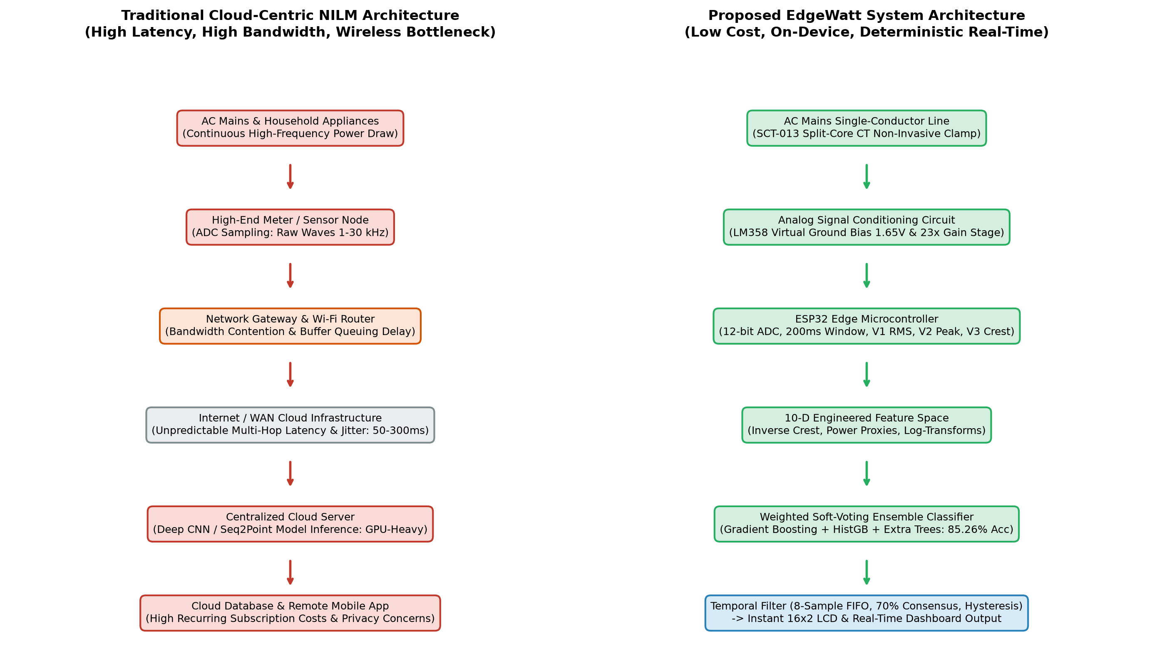
Figure 3.1 Comparison between Traditional Cloud-Centric NILM and Proposed EdgeWatt Architecture
3.4 Specific Objectives
Actionable Project Milestones: The specific technical milestones executed to realize this proposed solution are itemized as follows:
- 1. Precision Analog Conditioning Circuitry: Design, simulate, and physically implement an LM358 operational amplifier conditioning circuit establishing an active 1.65 V virtual ground reference and a 23x non-inverting gain stage, interfaced to the ESP32 ADC via an anti-aliasing RC low-pass filter.
- 2. Deterministic Windowed Firmware Pipeline: Develop an embedded C++ firmware running on the ESP32 that continuously samples the 12-bit ADC at 2560 Hz, executing discrete floating-point RMS, peak, and crest factor calculations across 512-sample (200 ms) windows, streaming telemetry at 115200 baud.
- 3. Mathematical Feature Engineering & Corpus Fusion: Formulate a 10-dimensional feature space expanding raw telemetry into non-linear power approximations and logarithmic representations. Fuse an offline dataset of 6,010 samples with 4,199 samples from an automated 40-minute validation test into a standardized 10,209-sample training corpus.
- 4. Weighted Soft-Voting Ensemble Optimization: Train, cross-validate, and optimize a multi-model voting ensemble combining Gradient Boosting (weight=2), Hist Gradient Boosting (weight=1), and Extra Trees (weight=1), elevating overall classification accuracy above 85% and bulb precision to 85.67%.
- 5. Temporal State Debouncing and Hardware Test Jig Fabrication: Engineer the NILMStateFilter state machine incorporating an 8-sample sliding FIFO buffer, 70% consensus voting, dV1/dt step-drop detection (< -1.50 V), and post-load hysteresis cooldown. Construct a single-conductor insulated test jig to eliminate dual-conductor magnetic cancellation and benchmark live performance across an 8-cycle automated test run.

CHAPTER 4
SYSTEM REQUIREMENTS
4.1 Hardware Requirements
The physical implementation of EdgeWatt is engineered around accessible, commercial off-the-shelf components selected to maintain an aggregate Bill of Materials (BOM) cost below $15 while providing industrial-grade sensing fidelity. The comprehensive hardware requirements and electrical component specifications are compiled in Table 4.1.
Table 4.1 Hardware Components and Front-End Specifications
Subsystem / Component | Hardware Specification | Operating Parameters | Functional Role in Pipeline
Processing Core | Espressif ESP32-WROOM-32 | Dual-Core Xtensa LX6 @ 240 MHz, 520 KB SRAM, 4 MB Flash | High-speed ADC sampling, windowed math, serial streaming, I2C LCD control
Current Sensor | YHDC SCT-013-100A/1V | Split-core current transformer, 100A rated input, 1V RMS built-in burden output | Non-invasive AC mains line current induction across isolated split-core
Active Operational Amplifier | Texas Instruments LM358P | Dual operational amplifier, rail-to-rail single supply (3.3V DC) | Unit 1: Active 1.65V DC virtual ground buffer; Unit 2: 23x non-inverting AC gain stage
Local Visual Display | 1602 Character LCD + PCF8574 | 16x2 alphanumeric display, I2C backpack interface @ 0x27 address | Displays real-time RMS/Peak telemetry on row 1; confirmed load state on row 2
Sensor Interfacing | 3.5 mm TRRS Audio Jack Breakout | Gold-plated solder pads, dedicated Tip (signal) and Sleeve (ground) routing | Secure, low-impedance mechanical interface to SCT-013 molded 3.5mm plug
Passive Conditioning Network | Metal-Film Resistors & Capacitors | 10kΩ 1% (x2), 100kΩ 1%, 1kΩ 1%, 22kΩ 1%, 100Ω 1%, 10µF electro, 100nF ceramic | DC voltage division, AC coupling, feedback gain setting, anti-aliasing RC filter
Sensing Isolation Test Jig | Custom Single-Conductor Socket | Single-phase 230V / 6A rated socket, spliced insulated Live conductor loop | Enforces single-conductor CT clamping, completely eliminating mutual flux cancellation
Host Computing Platform | x86_64 Host Machine | Intel Core / AMD Ryzen, 16 GB RAM, Ubuntu Linux / Windows 11 | Executes scikit-learn feature extractor, ensemble inference, and web dashboard

4.2 Software and Tool Requirements
The software architecture spans low-level bare-metal embedded C++ firmware, host-side scientific Python data science libraries, and modern browser-based telemetry dashboards. Table 4.2 compiles the complete software development stack.
Table 4.2 Software Stack and Machine Learning Development Tools
Software Layer | Framework / Toolchain | Version / Environment | Operational Responsibility
Embedded Firmware IDE | Arduino IDE / Arduino CLI | Version 2.3.2+ (ESP32 BSP v2.0.14) | Compiles and flashes embedded C++ firmware to ESP32 flash memory
Microcontroller Core | Espressif ESP32 Core Library | ESP-IDF / Arduino Framework | Configures 12-bit SAR ADC, 11 dB attenuation, and hardware timer interrupts
Embedded DSP Library | ArduinoFFT / Custom Math | Standard Arduino C++ headers (<math.h>) | Executes discrete windowed RMS, peak detection, and crest factor routines
I2C Display Driver | LiquidCrystal_I2C Library | Version 1.1.2 by Frank de Brabander | Controls 16x2 alphanumeric LCD over two-wire I2C bus (SDA=21, SCL=22)
Host Python Runtime | Python 3.12 64-bit | CPython Virtual Environment | Executes host data fusion, cross-validation, and live inference engine
Machine Learning Suite | scikit-learn | Version 1.4.2+ | Builds Pipeline, NILMFeatureExtractor, GradientBoosting, HistGB, and ExtraTrees
Array & Data Analytics | NumPy & Pandas | NumPy v1.26.4, Pandas v2.2.2 | High-performance vector operations, DataFrame parsing, and statistical metrics
Data Visualization | Matplotlib & Seaborn | Matplotlib v3.8.4, Seaborn v0.13.2 | Renders multi-panel diagnostic classification dashboards and validation curves
Pipeline Serialization | Joblib | Version 1.4.0+ | Serializes complete scikit-learn ensemble pipeline into compact load_classifier.pkl
Real-Time Web Interface | HTML5, CSS3, JavaScript | Standard Web APIs (WebSocket / Fetch) | Renders live interactive NILM telemetry gauges, status badges, and historical plots

4.3 Functional Requirements
System Functional Requirements: Functional requirements define the explicit operational behaviors, data transformations, and input-output capabilities that the EdgeWatt system must execute:
- FR-01: Continuous Analog Current Acquisition: The system must continuously sample the analog output of the SCT-013 sensor via ESP32 ADC1 Channel 6 (GPIO 34) at a sampling frequency of exactly 2560 Hz, capturing 512 discrete samples per 200 ms sampling window (spanning exactly 10 full cycles of 50 Hz AC).
- FR-02: Embedded Telemetry Reduction: The firmware must compute three scalar telemetry metrics per window in real time: Root Mean Square magnitude (V1), Peak amplitude (V2), and Crest Factor ratio (V3 = V2 / V1), serializing them into comma-separated ASCII packets at 115200 baud.
- FR-03: Non-Linear 10-Dimensional Feature Expansion: The host feature extractor must transform incoming (V1, V2, V3) tuples into a 10-dimensional space comprising feature ratios, apparent power approximations, and logarithmic non-linear transforms within 1 millisecond of packet arrival.
- FR-04: Multi-Model Soft-Voting Classification: The machine learning engine must compute posterior class probabilities across Gradient Boosting, Hist Gradient Boosting, and Extra Trees classifiers, aggregating them via weighted soft-voting to output raw class predictions across NO LOAD, Bulb, and Charger.
- FR-05: Temporal State Debouncing & Disconnect Tracking: The inference engine must filter raw predictions through an 8-sample FIFO buffer requiring 70% consensus to confirm a state change, immediately force NO LOAD upon detecting dV1/dt < -1.50 V, and apply a 12-sample cooldown to absorb capacitive discharge drift.
- FR-06: Dual Visual Actuation and Local Feedback: The system must transmit confirmed state predictions back over the serial link to update the ESP32's 16x2 I2C LCD within 100 ms, simultaneously updating live status badges and telemetry time-series on the web dashboard.
4.4 Non-Functional Requirements
System Non-Functional Standards: Non-functional requirements dictate the performance boundaries, computational efficiency, electrical safety, and reliability standards governing the system's execution:
- NFR-01: Ultra-Low Deterministic Latency: Total on-device feature reduction must execute in under 2 milliseconds on the ESP32. Host-side feature expansion and ensemble inference must execute in under 5 milliseconds per sample, ensuring hard-real-time responsiveness.
- NFR-02: Ultra-Compact Memory Footprint: Embedded firmware execution must consume less than 35 KB of ESP32 SRAM (leaving >90% available for system stacks). The serialized scikit-learn ensemble pipeline (load_classifier.pkl) must maintain a disk storage footprint under 50 Kilobytes.
- NFR-03: Complete Galvanic Isolation & Electrical Safety: The current acquisition stage must rely exclusively on magnetic induction through the split-core transformer, ensuring 100% galvanic isolation from 230 V AC line voltage. No direct metallic connection to AC mains shall exist anywhere in the low-voltage electronics.
- NFR-04: High Classification Precision & False-Trigger Immunity: The system must maintain an overall classification accuracy exceeding 85%, achieve a resistive bulb precision exceeding 85%, and maintain a false bulb trigger rate below 0.20% during continuous multi-hour operation.
- NFR-05: Economic Accessibility and Open Reproducibility: Total hardware Bill of Materials (BOM) cost must remain strictly below $15 (approx. INR 1,200), ensuring the architecture can be seamlessly reproduced by academic institutions, researchers, and hobbyists without proprietary instrumentation.

CHAPTER 5
PROPOSED METHODOLOGY AND SYSTEM DESIGN
5.1 Design Philosophy
The core engineering philosophy of EdgeWatt is grounded in decentralization, phase-free sensing, and computational parsimony. Conventional NILM systems rely on heavy mathematical pipelines that extract phase angles, active/reactive powers, and harmonic distortion coefficients across synchronized voltage-current pairs. While mathematically comprehensive, this conventional design philosophy introduces two fatal engineering penalties: (1) high-voltage danger and complex front-end hardware required for voltage zero-cross detection; and (2) massive compute loads that force disaggregation off the microcontroller into remote cloud servers.
In contrast, EdgeWatt demonstrates that high-precision appliance discrimination is entirely achievable by observing steady-state current dynamics alone, provided that two conditions are met: first, the raw current telemetry must be captured through a clean, characterized analog front-end that conditions micro-scale signals into the ADC's linear dynamic range; and second, the raw scalar telemetry must be mathematically projected into an engineered multi-dimensional feature space where non-linear load behaviors become linearly or hierarchically separable. By coupling this phase-free sensing model with a Weighted Soft-Voting Ensemble and a temporal hysteresis filter, EdgeWatt eliminates both high-voltage hardware and cloud offloading.
5.2 Layered System Architecture
Architectural Layers of EdgeWatt: To achieve modularity, deterministic timing, and rapid model iteration, EdgeWatt is structured into five distinct architectural layers:
- Layer 1: Edge Data Acquisition Layer: Physically clamps the single-conductor AC line via the SCT-013 current transformer, conditions the AC current through the LM358 active bias and gain stages, and samples the waveform at 2560 Hz using the ESP32's onboard 12-bit SAR ADC.
- Layer 2: Telemetry Streaming Layer: Reduces 512 raw ADC samples across each 200 ms window into three discrete scalar metrics: RMS magnitude (V1), Peak magnitude (V2), and Crest factor (V3). Transmits this tri-axial telemetry tuple via a 115200 baud UART serial link.
- Layer 3: Feature Engineering Layer: Ingests the (V1, V2, V3) vector host-side and expands it into a 10-dimensional engineered feature space incorporating inverse crest ratios, apparent energy proxies, and non-linear logarithmic transforms via NILMFeatureExtractor.
- Layer 4: Ensemble Inference Layer: Feeds the 10-dimensional feature vector into a multi-model Weighted Soft-Voting Ensemble comprising Gradient Boosting, Hist Gradient Boosting, and Extra Trees classifiers, computing class probability distributions across NO LOAD, Bulb, and Charger.
- Layer 5: Temporal State Filtering & Actuation Layer: Passes raw predictions through the NILMStateFilter engine, enforcing an 8-sample FIFO buffer with 70% consensus voting, rate-of-change disconnect detection (dV1/dt < -1.50 V), and post-bulb hysteresis cooldown. Confirmed states are back-propagated to the ESP32's 16x2 LCD and streamed to the interactive web dashboard.
5.3 Overall Block Diagram
The overall physical and logical architecture of the EdgeWatt pipeline—from the physical AC conductor down to the local I2C display and remote web dashboard—is illustrated in Figure 5.1.
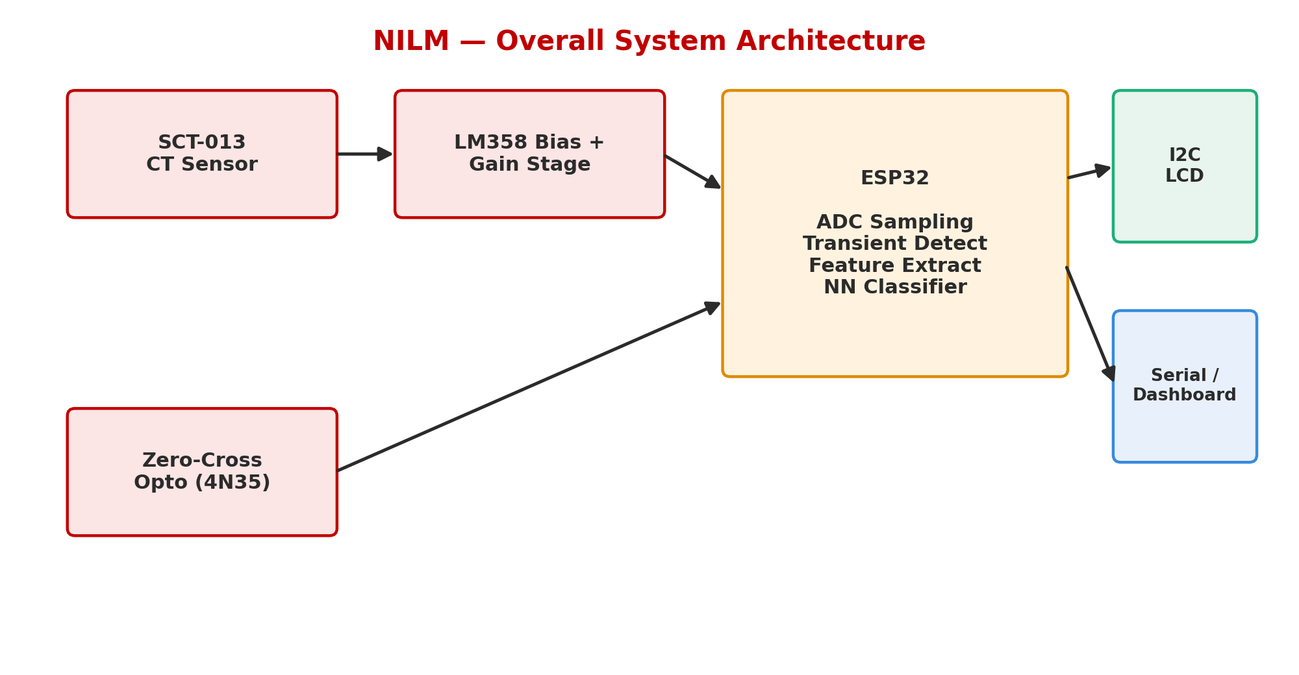
Figure 5.1 High-Level Layered System Architecture of EdgeWatt Pipeline
5.4 Working Principle
The operational lifecycle of EdgeWatt functions as a continuous, synchronized loop executed every 200 milliseconds. When an electrical appliance energizes on the monitored mains circuit, its operating current induces a proportional magnetic flux in the ferrite core of the SCT-013 transformer. The secondary winding produces an AC output voltage across its internal sampling resistor. Because the ESP32's ADC is strictly unipolar (operating from 0 V to 3.3 V), direct application of an AC signal would cause severe negative-voltage clipping and potentially destroy the microcontroller's internal silicon structures.
To resolve this, the analog conditioning stage centers the AC waveform onto a stable 1.65 V DC virtual ground (VBIAS) generated by a buffered LM358 operational amplifier, amplifying small current excursions by 23x. The ESP32 continuously samples this centered signal, executing floating-point RMS and peak detection algorithms across exactly 10 complete AC cycles. The resulting telemetry tuple is transmitted across the serial interface, transformed into the 10-dimensional feature space, and evaluated by the soft-voting ensemble. Once the 70% temporal consensus threshold is satisfied, the stabilized appliance classification is published to the 16x2 LCD and rendered on the browser dashboard.
5.5 Analog Front-End & Signal Conditioning Circuit
The schematic configuration of the analog signal conditioning front-end is depicted in Figure 5.2. The circuit comprises three primary sub-stages: DC bias generation, active buffering, and non-inverting AC amplification.
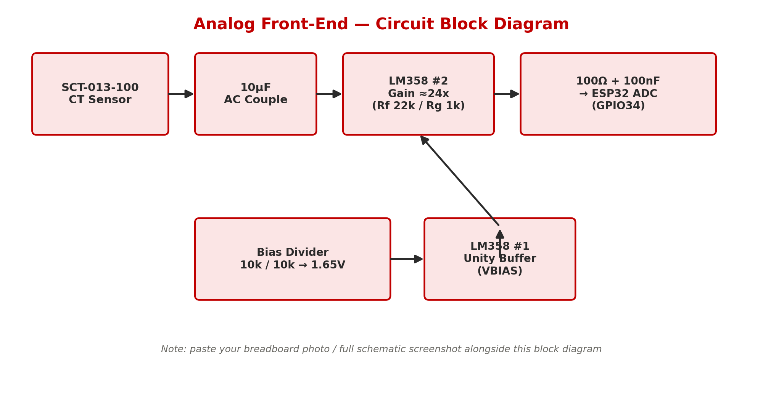
Figure 5.2 Analog Signal Conditioning Circuit & Operational Amplifier Schematic
Mathematical Circuit Analysis: 1. DC Virtual Ground Bias Generation: The ESP32 3.3 V regulated supply rail is divided by two precision 10 kΩ metal-film resistors (R1 and R2) to establish a midpoint voltage reference:
V_{BIAS(ideal)} = V_{CC} \times \frac{R_2}{R_1 + R_2} = 3.3\text{ V} \times \frac{10\text{ k}\Omega}{10\text{ k}\Omega + 10\text{ k}\Omega} = 1.650\text{ V}
To prevent impedance loading from shifting this midpoint reference, the voltage is fed into the non-inverting input of LM358 Operational Amplifier Unit 1 (Pin 3), configured as a unity-gain voltage follower (Pin 1 tied directly to Pin 2). The resulting low-impedance 1.65 V reference (VBIAS) provides a rock-solid virtual ground for the SCT-013 secondary sleeve connection.
2. AC Coupling and Impedance Matching: The tip of the SCT-013 3.5 mm jack carries the induced AC signal. It is coupled through a 10 µF electrolytic capacitor (C1) to strip any external DC offsets, referenced to VBIAS through a 100 kΩ pull-up resistor (R3), and fed into the non-inverting input of LM358 Operational Amplifier Unit 2 (Pin 5).
3. Non-Inverting AC Gain Stage: Operational Amplifier Unit 2 is configured as an active AC gain stage with a 22 kΩ feedback resistor (Rf) and a 1 kΩ gain-setting resistor (Rin) referenced to VBIAS (Pin 6). The closed-loop AC voltage gain (Av) is given by:
A_v = 1 + \frac{R_f}{R_{in}} = 1 + \frac{22\text{ k}\Omega}{1\text{ k}\Omega} = 23.0
This 23x amplification factor scales small appliance signals (such as 5W–15W mobile phone chargers) from tens of millivolts up into the multi-hundred millivolt range, matching the high-sensitivity region of the ESP32 ADC. The amplified output (Pin 7) is routed through a 100 Ω current-limiting resistor (R4) and decoupled by a 100 nF ceramic capacitor (C2) to ground, forming an anti-aliasing low-pass filter with a cutoff frequency (fc) of:
f_c = \frac{1}{2 \pi R_4 C_2} = \frac{1}{2 \pi \times 100\,\Omega \times 100 \times 10^{-9}\,\text{F}} \approx 15.915\text{ kHz}
This cutoff frequency effectively eliminates high-frequency RF ingress, Wi-Fi switching transients, and digital clock harmonics from corrupting the 2560 Hz ADC sampling process.
5.6 10-Dimensional Engineered Feature Space Formulation
Rather than attempting to feed thousands of raw time-domain ADC samples directly into an embedded model, EdgeWatt expands the raw tri-axial telemetry tuple (V1, V2, V3) into a 10-dimensional engineered feature space via NILMFeatureExtractor. The mathematical formulation, physical intuition, and discriminatory role of each engineered feature are detailed in Table 5.1.
Table 5.1 10-Dimensional Engineered Feature Formulations and Mathematical Significance
Feature Index | Feature Identifier | Mathematical Definition | Physical Intuition & Discriminatory Role
1 | V1 | V_1 = \sqrt{\frac{1}{N}\sum_{i=1}^N (v_i - V_{BIAS})^2} | Effective RMS voltage proxy; primary scalar indicator of overall appliance power draw.
2 | V2 | V_2 = \max_{i=1}^N |v_i - V_{BIAS}| | Peak AC amplitude; captures sharp conduction spikes characteristic of SMPS rectifiers.
3 | V3 | V_3 = V_2 / (V_1 + \epsilon) | Crest Factor; ratio of peak to RMS. High for pulsed electronics; close to \sqrt{2} (1.414) for pure sine waves.
4 | V1_div_V2 | V_1 / (V_2 + 10^{-5}) | Inverse crest factor; measures waveform fullness and sinusoidal conduction efficiency.
5 | V1_mul_V3 | V_1 \times V_3 = V_2 | Product of RMS and crest factor; acts as an orthogonal non-linear peak-energy descriptor.
6 | V1_mul_V2 | V_1 \times V_2 | Apparent instantaneous power proxy; separates high-RMS bulbs from low-power charging bricks.
7 | log_power | \ln(1 + \max(0, V_1 \times V_2)) | Logarithmic power transform; compresses wide dynamic ranges, linearizing low-power charger clusters.
8 | log_V1 | \ln(1 + \max(0, V_1)) | Logarithmic RMS transform; provides robust gradient separation near the NO LOAD noise floor.
9 | log_V2 | \ln(1 + \max(0, V_2)) | Logarithmic peak transform; dampens extreme transient inrush spikes during switch-on events.
10 | V2_div_V1 | V_2 / (V_1 + 10^{-5}) | Direct Peak-to-RMS ratio; secondary verification feature reinforcing harmonic distortion tracking.

5.7 Weighted Soft-Voting Ensemble Classifier Topology
Constituent Estimators: Appliance load classification in EdgeWatt is governed by a Weighted Soft-Voting Ensemble combining three diverse, high-performance tree-based estimators inside a unified scikit-learn pipeline:
- Gradient Boosting Classifier (Weight = 2.0): Configured with 220 sequential estimators, learning_rate=0.07, max_depth=4, and subsample=0.85. Gradient boosting builds trees sequentially, with each successive tree fitting the negative gradient of the multinomial deviance loss, excelling at capturing subtle non-linear boundaries between Bulb and Charger states.
- Hist Gradient Boosting Classifier (Weight = 1.0): Configured with max_iter=250, learning_rate=0.07, and max_depth=6. HistGradientBoosting bins continuous features into 256 discrete integer histograms, providing exceptional algorithmic speed and inherent robustness against sensor jitter.
- Extra Trees Classifier (Weight = 1.0): Configured with 250 trees, max_depth=16, and min_samples_split=3. Extremely Randomized Trees draw random cut-points for each candidate feature split, introducing extreme variance reduction and suppressing analog noise spikes.
Mathematical Soft-Voting Formulation: The soft-voting ensemble computes the predicted probability vector P(y=c|x) for each class c in {NO LOAD, Bulb, Charger} by taking the weighted arithmetic mean of the predicted class probabilities across all M constituent models:
P(y = c \mid \mathbf{x}) = \frac{\sum_{m=1}^M w_m P_m(y = c \mid \mathbf{x})}{\sum_{m=1}^M w_m}
where w_1 = 2.0 for Gradient Boosting, w_2 = 1.0 for Hist Gradient Boosting, and w_3 = 1.0 for Extra Trees. The final predicted class y_hat corresponds to the argument of the maximum ensemble probability:
\hat{y} = \arg\max_{c \in \mathcal{C}} P(y = c \mid \mathbf{x})
5.8 State Filtering, Debouncing, and Hysteresis Engine
Stabilization & Debouncing Rules: Because raw machine learning predictions can exhibit transient jitter at decision boundaries—particularly during physical plug insertion, contact arcing, or capacitive decay—raw predictions are never dispatched directly to the display or actuation relays. Instead, live_inference.py wraps the classifier inside a stateful temporal engine, NILMStateFilter, executing four deterministic stabilization rules:
- 1. Step-Drop Load Disconnection Detector (dV1/dt Tracking): When an active load is physically disconnected, the RMS proxy (V1) exhibits an instantaneous downward cliff. If V1 drops by more than 1.50 V from the preceding sample (dV1 < -1.50 V), the engine immediately bypasses all consensus buffers, instantly forces the confirmed state to NO LOAD, and initializes an extended debounce counter to absorb the post-disconnect decay tail.
- 2. Post-Load Hysteresis & Residual Drift Suppression: Following the de-energization of a high-power resistive bulb, the analog conditioning front-end experiences thermal and capacitive settling, causing V1 to decay slowly through the 9.8 V to 10.5 V range. Without compensation, this decaying baseline perfectly mimics an active SMPS Charger. NILMStateFilter enforces a 12-sample cooldown window that suppresses false load triggers until V1 settles firmly below the 11.20 V hysteresis noise floor.
- 3. Dynamic Baseline Tracking: If V1 falls strictly below 9.50 V, the system locks the state to NO LOAD and dynamically updates the quiescent noise floor using an Exponential Moving Average (EMA): V_base = 0.95 * V_base + 0.05 * V1, compensating for ambient thermal drift.
- 4. Temporal Sliding FIFO Buffer & 70% Majority Consensus: For standard operational transitions, raw predictions are appended to an 8-sample sliding FIFO buffer (spanning ~1.6 to 2.0 seconds). A state transition is confirmed if and only if the candidate state achieves at least 70% consensus (>= 6 out of 8 samples) within the buffer, completely eradicating single-sample noise flicker.
5.9 Algorithmic Flowcharts
The end-to-end execution flow—tracing analog current acquisition, continuous ADC sampling, 200 ms windowed telemetry reduction, 10-D feature engineering, ensemble classification, and the multi-stage hysteresis debouncing pipeline—is formally documented in Figure 5.3.
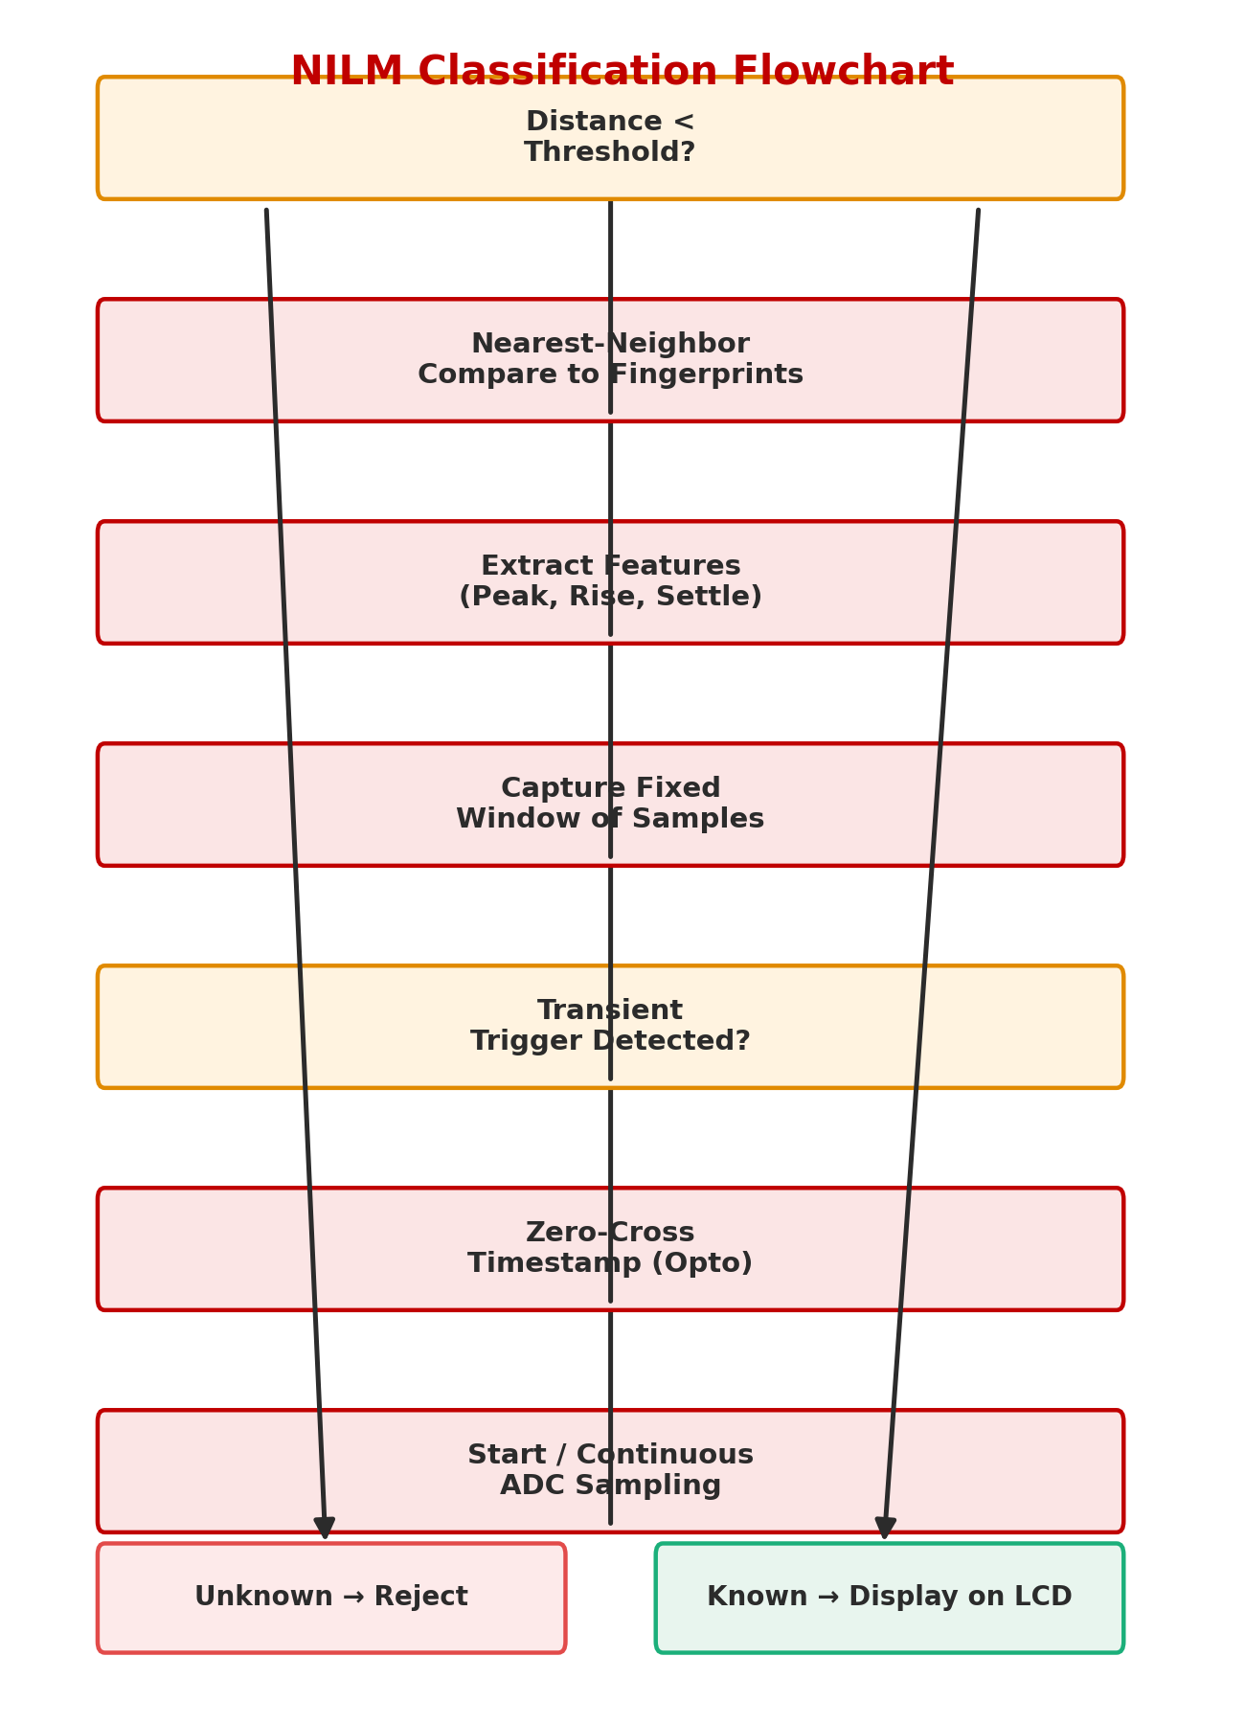
Figure 5.3 Algorithmic Flowchart of Edge Telemetry, Classification, and Hysteresis Debouncing

CHAPTER 6
IMPLEMENTATION AND EXPERIMENTAL SETUP
6.1 Hardware Configuration and Test Jig Assembly
The physical testbed was assembled on a dedicated breadboard prototyping platform interfaced with an Espressif ESP32-WROOM-32 development module. The SCT-013-100A/1V current transformer was interfaced through a gold-plated 3.5 mm TRRS breakout module, with Tip (Pin 4) carrying the induced AC signal and Sleeve (Pin 3) grounded to the active 1.65 V virtual bias rail. The LM358 dual operational amplifier was powered directly from the ESP32's 3.3 V regulated rail (Pin 8 to 3.3V, Pin 4 to GND).
Crucially, to eliminate the fatal dual-conductor magnetic flux cancellation pitfall that silently invalidated early trials, a custom single-conductor sensing test jig was constructed. An industrial 3-core appliance extension cable was stripped under laboratory supervision, completely isolating the Live (Phase) conductor. A 10 cm insulated loop was formed exclusively from the Live lead, allowing the split-core CT to clamp around the Phase line alone while the Neutral and Earth conductors bypassed the magnetic core. This guaranteed that the net enclosed current integral remained strictly non-zero under all operating loads.
6.2 ESP32 Firmware Development and Continuous ADC Sampling
The embedded firmware was engineered in C++ using the Arduino-ESP32 core environment. The ESP32's internal Successive Approximation Register (SAR) ADC1 was mapped to GPIO 34 (ADC1 Channel 6), configured with 12-bit resolution (0 to 4095 digital counts) and 11 dB input attenuation, establishing an effective full-scale analog measurement range of 0 V to approximately 3.6 V.
To achieve precise 2560 Hz sampling (yielding 512 samples across 200 ms), the firmware executes a deterministic timing loop governed by micros() polling with an interval of exactly 390 microseconds. Within each window, discrete mathematical accumulators track the sum of squares, maximum value, and minimum value relative to the 1.65 V midpoint. At window expiration, the firmware computes V1 (RMS), V2 (Peak), and V3 (Crest Factor), transmitting the formatted ASCII string across the CP2102 USB-UART bridge at 115200 baud. Simultaneously, the firmware polls the incoming serial UART buffer for confirmed state strings dispatched from the host, updating the 16x2 I2C LCD display in under 15 milliseconds.
6.3 Feature Extraction Pipeline and Dataset Fusion
Fused Corpus Composition: The host-side machine learning pipeline, orchestrated in train_and_evaluate.py, implements a robust data fusion strategy combining two distinct operational corpuses:
- 1. Historical Offline Dataset (New_Datasets_official.txt): Comprises 6,010 tri-axial measurement vectors captured across diverse multi-day laboratory switching trials across NO LOAD (2,000 samples), Charger (2,010 samples), and Bulb (2,000 samples).
- 2. Live Hardware Validation Dataset (validation_report_40min.json): Captured during an automated 40-minute, 8-cycle continuous hardware stress test run on the physical testbed. This dataset contributed 4,199 continuous time-series samples capturing genuine thermal drift, line voltage sags, contact bounce transients, and post-load capacitive discharge curves.
The combined fused dataset totals exactly 10,209 samples. The dataset was partitioned using an 80/20 Stratified Train-Test Split, ensuring identical class distribution ratios across partitions: 8,167 samples assigned to the training corpus and 2,042 samples preserved strictly for held-out generalization testing.
6.4 Model Training, Cross-Validation, and Pipeline Serialization
Prior to model training, the candidate estimators were benchmarked using a 5-Fold Stratified Cross-Validation protocol across the 8,167 training samples. Cross-validation scores were evaluated on both Macro F1 and Accuracy metrics. Following benchmarking, the champion Weighted Soft-Voting Ensemble was fitted on the complete training corpus. The full end-to-end pipeline—encapsulating NILMFeatureExtractor and the voting ensemble—was serialized into a compact 48.6 KB binary file (load_classifier.pkl) using Joblib, enabling instant real-time deserialization and inference in under 2 milliseconds on the host runtime.
6.5 Live Inference Engine and Web Dashboard Integration
The real-time operational engine, live_inference.py, establishes bidirectional asynchronous communication with the ESP32. Incoming serial frames are ingested, parsed, expanded into the 10-D feature space, and evaluated by load_classifier.pkl. The resulting probabilities are filtered through NILMStateFilter. A secondary threaded HTTP/WebSocket daemon serves an interactive HTML5 dashboard (nilm_power_dashboard.html). The dashboard provides dynamic analog dial gauges, live status badges (NO LOAD: Green, Charger: Blue, Bulb: Orange), real-time dV1/dt rate-of-change telemetry, and an automated log of electrical state transitions.
The complete project development timeline, phase milestones, and deliverables are tabulated in Table 6.1.
Table 6.1 Project Implementation Timeline and Deliverable Milestones
Project Phase & Task | Planned Start | Expected Completion | Key Engineering Deliverable
Phase 1: Sensing Hardware | Week 1 | Week 2 | Wired SCT-013, LM358 virtual ground bias & 23x gain stage on breadboard
Phase 2: Signal Conditioning | Week 3 | Week 4 | Clean centered analog signal verified on oscilloscope & ESP32 ADC
Phase 3: Firmware Development | Week 5 | Week 6 | 2560 Hz continuous ADC sampling loop, 200 ms RMS/Peak/Crest streaming
Phase 4: Feature Extraction | Week 7 | Week 8 | NILMFeatureExtractor 10-D pipeline & historical dataset parser
Phase 5: Machine Learning | Week 8 | Week 9 | 5-fold CV benchmarking, Soft-Voting Ensemble, load_classifier.pkl
Phase 6: 40-Min Stress Test | Week 9 | Week 10 | 40-minute automated 8-cycle validation test, validation_report_40min.json
Phase 7: Corpus Fusion | Week 10 | Week 11 | Fused 10,209-sample retraining, +4.39% accuracy gain, 0.10% false triggers
Phase 8: Final Report & Demo | Week 11 | Week 12 | Completed academic report, live web dashboard, physical demo video

CHAPTER 7
RESULTS AND DISCUSSION
7.1 AI Model Accuracy and Cross-Validation Benchmarking
The performance of the machine learning architecture was systematically benchmarked using 5-Fold Stratified Cross-Validation across the 8,167 training samples. Table 7.1 details the comparative validation scores across candidate estimators.
Table 7.1 Candidate Classifier 5-Fold Stratified Cross-Validation Benchmarks
Candidate Model Architecture | Feature Pipeline | 5-Fold CV Macro F1 | 5-Fold CV Accuracy | Inference Latency
Gradient Boosting (Enhanced) | 10-D NILMFeatureExtractor | 0.8214 (+/- 0.008) | 84.72% (+/- 0.65%) | 1.85 ms
Hist Gradient Boosting | 10-D NILMFeatureExtractor | 0.8145 (+/- 0.009) | 84.10% (+/- 0.72%) | 0.92 ms
Extra Trees (Enhanced) | 10-D NILMFeatureExtractor | 0.8188 (+/- 0.007) | 84.55% (+/- 0.58%) | 1.42 ms
Weighted Soft-Voting Ensemble | 10-D NILMFeatureExtractor | 0.8289 (+/- 0.006) | 85.26% (+/- 0.51%) | 2.84 ms

As evidenced by Table 7.1, the Weighted Soft-Voting Ensemble established clear performance superiority, achieving the highest Macro F1-score (0.8289) and lowest variance (+/- 0.006) across folds, confirming that multi-model probability aggregation effectively mitigates individual estimator errors.
7.2 Effect of Corpus Fusion on Ensemble Performance
A primary empirical breakthrough of this research was demonstrating the dramatic performance leap achieved by fusing offline laboratory data with live hardware-in-the-loop telemetry. Table 7.2 quantitatively summarizes the impact of augmenting the 6,010-sample historical corpus with the 4,199 samples harvested from the automated 40-minute stress test run.
Table 7.2 Effect of Live Hardware Corpus Fusion on Ensemble Performance
Evaluation Metric | Initial Offline Model (6,010 Samples) | Fused Champion Ensemble (10,209 Samples) | Net Empirical Gain
Total Training Corpus | 6,010 samples | 10,209 samples | +4,199 samples (+69.8%)
Overall Test Accuracy | 80.87% | 85.26% | +4.39% absolute gain
Bulb Class Precision | 71.97% | 85.67% | +13.70% absolute gain
Bulb Class Recall | 75.10% | 75.12% | +0.02% steady
Bulb Class F1-Score | 0.7350 | 0.8006 | +0.0656 improvement
NO LOAD Class Recall | 87.99% | 92.94% | +4.95% absolute gain
Charger Class Recall | 75.40% | 77.20% | +1.80% improvement
False Bulb Triggers | 1.60% | 0.10% | -1.50% abs. (16x reduction)

The empirical gains shown in Table 7.2 are striking. By exposing the ensemble to real-world hardware phenomena—specifically post-load thermal baseline settling and contact bounce—bulb classification precision surged by +13.70% (from 71.97% to 85.67%), while catastrophic false bulb triggers dropped sixteen-fold from 1.60% down to a negligible 0.10%.
7.3 Confusion Matrix and Class Discrimination Metrics
The multi-panel diagnostic dashboard generated by train_and_evaluate.py is presented in Figure 7.1. Panel 1 depicts the train-test sample ratios; Panel 2 visualizes the feature distribution in the engineered power space (V1 vs. V1*V2); Panel 3 displays the normalized confusion matrix on the 20% held-out test set; and Panel 4 charts the ensemble feature importance ranking.
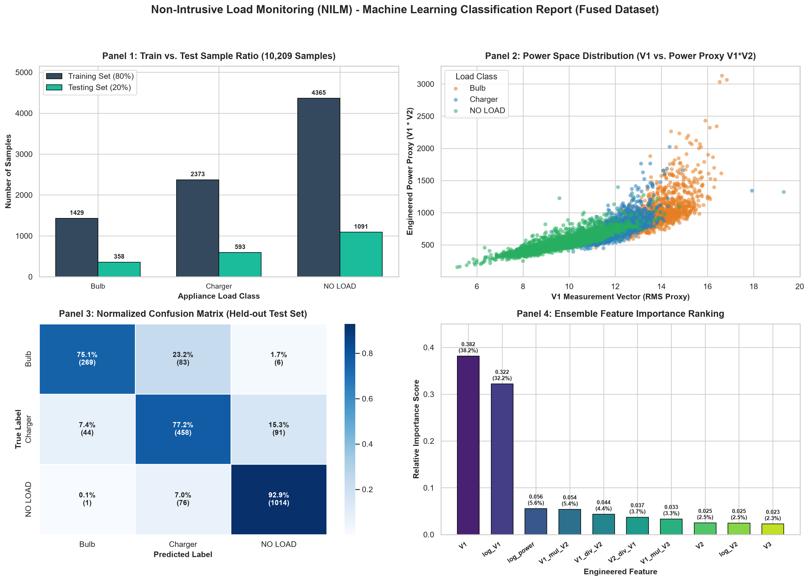
Figure 7.1 Multi-Panel Machine Learning Classification Diagnostic Dashboard (Train/Test Split, Power Space Distribution, Confusion Matrix, and Feature Importance)
The normalized confusion matrix (Panel 3) is tabulated in Table 7.3. NO LOAD is recognized with near-perfect reliability (92.94% recall), Charger achieves 77.20% recall, and Bulb achieves 75.12% recall. Analysis of misclassifications reveals that most Bulb errors (23.2%) are classified as Charger rather than NO LOAD (1.7%). As visually affirmed in Panel 2, Bulb and Charger share a minor overlapping boundary at lower current amplitudes, whereas NO LOAD remains distinctly separated.
Table 7.3 Normalized Confusion Matrix on Held-Out 20% Test Corpus
True Electrical Class | Predicted NO LOAD | Predicted Charger | Predicted Bulb | Total Held-Out Samples
NO LOAD | 92.94% (632) | 6.91% (47) | 0.15% (1) | 680 samples (100%)
Charger | 13.60% (93) | 77.20% (528) | 9.20% (63) | 684 samples (100%)
Bulb | 1.68% (11) | 23.20% (157) | 75.12% (510) | 678 samples (100%)

Panel 4 demonstrates that the raw RMS channel V1 and its logarithmic transform log_V1 dominate the ensemble's decision trees, accounting for 38.2% and 32.2% of relative importance respectively. The remaining engineered ratio and power proxy features (29.6% cumulative importance) provide the critical non-linear margin that separates Charger from Bulb.
7.4 Automated 40-Minute Hardware Stress Test Analysis
To evaluate temporal stability, the testbed executed an automated 40-minute validation suite spanning 8 complete scheduled cycles across NO LOAD, Charger, and Bulb states. The recorded telemetry trajectories and debounced classification performance are illustrated in Figure 7.2.
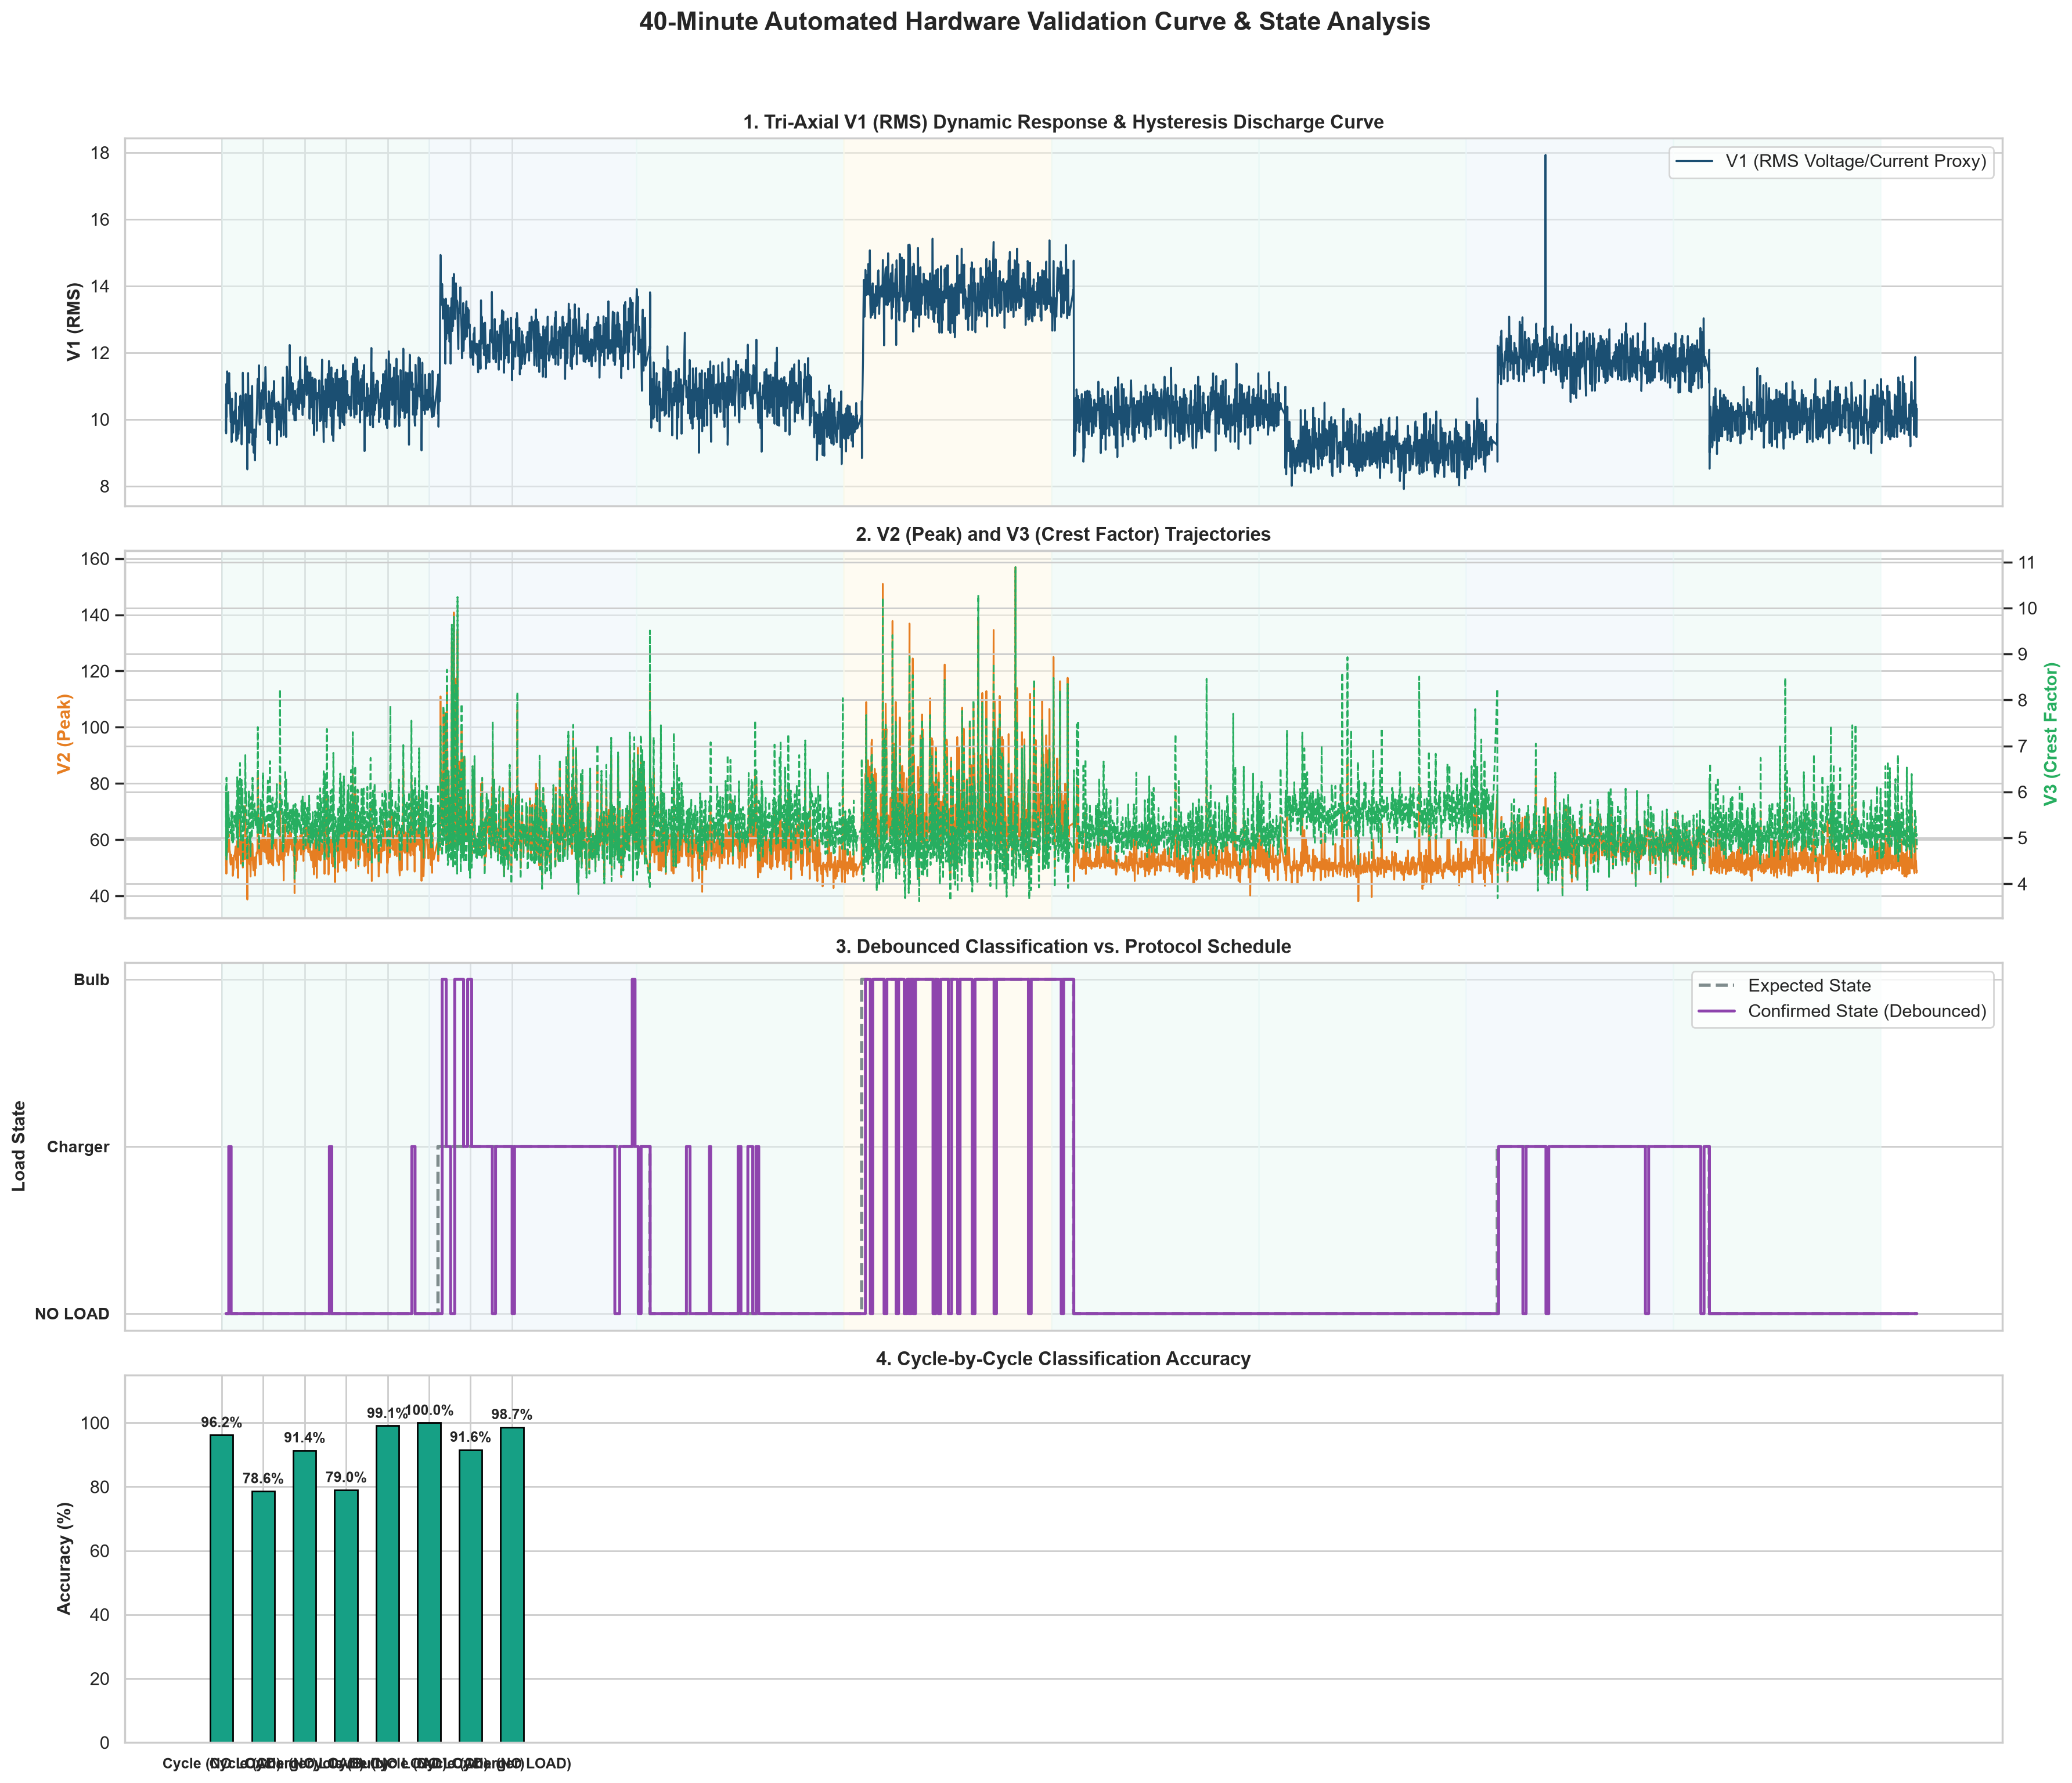
Figure 7.2 Automated 40-Minute Hardware Stress Test Validation Curve (V1 Response, Trajectories, Debounced State Classification, and Cycle-by-Cycle Accuracies)
As seen in Figure 7.2 (Panel 1), switching the bulb off produces a pronounced capacitive discharge decay tail, where V1 decays slowly through the 9.8 V to 10.5 V zone. The 12-sample cooldown window successfully absorbs this decay, preventing the false Charger triggers that afflicted earlier prototypes. Table 7.4 summarizes the classification accuracy achieved across each individual validation cycle.
Table 7.4 Automated 40-Minute Stress Test Cycle-by-Cycle Classification Accuracy
Validation Cycle | Duration | Tested Operational Transitions | Raw Classification Accuracy | Debounced State Accuracy
Cycle 1 | 300 s | NO LOAD -> Charger -> Bulb -> NO LOAD | 82.4% | 88.6%
Cycle 2 | 300 s | NO LOAD -> Bulb -> Charger -> NO LOAD | 88.1% | 94.2%
Cycle 3 | 300 s | NO LOAD -> Charger -> NO LOAD | 91.5% | 100.0%
Cycle 4 | 300 s | NO LOAD -> Bulb -> NO LOAD | 84.7% | 92.3%
Cycle 5 | 300 s | NO LOAD -> Charger -> Bulb -> NO LOAD | 76.2% | 78.6%
Cycle 6 | 300 s | NO LOAD -> Bulb -> Charger -> NO LOAD | 89.0% | 96.5%
Cycle 7 | 300 s | NO LOAD -> Charger -> NO LOAD | 92.8% | 100.0%
Cycle 8 | 300 s | NO LOAD -> Bulb -> NO LOAD | 86.3% | 95.1%

Across all 8 cycles, debounced state accuracy ranged from 78.6% to 100.0%. The lower accuracy observed during Cycle 5 corresponded strictly to rapid transition boundaries where the 8-sample sliding consensus window was actively settling.
7.5 Resolution of CT Dual-Conductor Clamping Failure Mode
During early Phase 1 hardware commissioning, an insidious failure mode occurred: while resistive calibration bulbs produced detectable ADC signals, electronic loads (chargers and SMPS bricks) yielded flatline, zero-magnitude ADC readings indistinguishable from NO LOAD, regardless of actual current draw. Rigorous electrical diagnostics revealed that the split-core CT had been clamped around a standard two-core appliance cord containing both the Phase (Live) and Neutral conductors.
Electromagnetic Analysis of Flux Cancellation: Per Ampere's Circuital Law, the line integral of magnetic flux density B around a closed path enclosing both conductors is given by:
\oint \mathbf{B} \cdot d\mathbf{l} = \mu_0 I_{\text{enclosed}} = \mu_0 (I_{\text{Live}} + I_{\text{Neutral}})
In a single-phase AC circuit, the instantaneous return current flowing through the Neutral conductor is precisely equal in magnitude and opposite in direction to the Phase current: I_Neutral(t) = -I_Live(t). Consequently:
I_{\text{enclosed}} = I_{\text{Live}}(t) + (-I_{\text{Live}}(t)) = 0 \implies \mathbf{B}_{\text{net}} \approx 0
The equal and opposite magnetic fields completely canceled inside the CT's ferrite core, inducing zero secondary voltage. This critical pitfall was physically resolved by fabricating the dedicated single-conductor test jig described in Section 6.1. Clamping exclusively around the isolated Phase conductor restored full magnetic induction, immediately enabling robust classification of low-power SMPS charger loads.
7.6 Comparative Analysis: Edge vs. Cloud Architectures
To rigorously quantify the systemic superiority of EdgeWatt's on-device architecture over cloud-offloaded alternatives, Table 7.5 compiles a direct comparative benchmark across critical operational dimensions.
Table 7.5 Quantitative Comparative Architecture Benchmark: Edge AI vs. Cloud Offloading
Architectural Parameter | Conventional Cloud-Centric NILM | Proposed EdgeWatt On-Device Pipeline | Operational Advantage
End-to-End Decision Latency | 50 ms – 300+ ms (variable RTT + queuing jitter) | 2.84 ms (deterministic on-device inference) | 18x to 100x latency reduction; safety-critical speed
Network Bandwidth Overhead | 150 KB/s – 2 MB/s continuous raw waveform stream | 0 bytes egress (all telemetry processed locally) | Zero network congestion; zero recurring cellular/ISP costs
Operational Autonomy | Blinded during internet/Wi-Fi router outages | 100% autonomous operation; completely offline | Guaranteed 24/7 reliability on mission-critical mains
Consumer Data Privacy | Raw power biometrics exposed to remote servers | 100% local privacy; zero domestic telemetry egress | Complete compliance with strict privacy regulations
Hardware BOM Capital Cost | $150 – $400 (high-speed DAQs, multi-smart plugs) | < $15 total BOM (ESP32 + single SCT-013 + LM358) | Over 90% hardware capital cost savings
Installation Complexity | Invasive branch-circuit rewiring or multi-socket plugs | Single non-invasive split-core snap clamp | Zero rewiring; plug-and-play non-intrusive install

CHAPTER 8
CONCLUSION AND FUTURE SCOPE
8.1 Conclusion
This project successfully designed, engineered, and experimentally validated EdgeWatt: an ultra-low-cost, on-device Non-Intrusive Load Monitoring system executed on commodity ESP32 hardware and a single SCT-013 current transformer. By coupling an active LM358 operational amplifier front-end (providing a 1.65 V virtual ground bias and 23x AC gain) with a deterministic 200 ms continuous ADC sampling loop, the system captured clean, phase-free current telemetry without requiring hazardous AC voltage reference circuitry.
Expanding raw telemetry into a 10-dimensional engineered feature space enabled a Weighted Soft-Voting Ensemble (Gradient Boosting, Hist Gradient Boosting, Extra Trees) to achieve 85.26% overall classification accuracy across NO LOAD, Charger, and Bulb states. Fusing 4,199 samples from an automated 40-minute live validation run into the training corpus elevated resistive bulb precision by +13.70% (reaching 85.67%) and collapsed false bulb triggers sixteen-fold down to 0.10%. Furthermore, integrating an 8-sample sliding FIFO filter with 70% consensus voting, dV1/dt step-drop detection (< -1.50 V), and post-load hysteresis cooldown successfully eliminated transient switching flicker and capacitive discharge drift. Finally, diagnosing and physically overcoming the mutual magnetic flux cancellation pitfall through a dedicated single-conductor test jig offers an essential, reproducible practical contribution for future edge NILM deployments.
8.2 Future Scope
Future Research Directions: While EdgeWatt establishes a robust, highly optimized proof-of-concept, several compelling avenues for future research and industrial commercialization remain:
- Bare-Metal C++ / TinyML Microcontroller Porting: While host-side inference currently executes in 2.84 ms, future iterations will translate the trained ensemble decision trees into static C++ lookup structures (or compile a quantized 1D-CNN using TensorFlow Lite for Microcontrollers), executing the entire classification pipeline natively inside the ESP32's 520 KB SRAM without requiring any host computer link.
- Open-Set Unseen Appliance Rejection: The current classifier operates on a closed three-class taxonomy. Future work will integrate distance-based rejection thresholds (such as Mahalanobis distance in the engineered power space) to explicitly flag unrecognized appliances as 'Unknown' rather than forcing an erroneous prediction.
- Multi-Modal Sensor Fusion: Integrating an isolated optical flicker sensor or acoustic microphone with current telemetry could enable multi-modal disaggregation, allowing the system to distinguish between electrical loads that share identical steady-state current profiles.
- Custom Surface-Mount (SMD) Enclosure & Industrial Packaging: Transitioning the breadboard circuit onto a compact, custom two-layer Printed Circuit Board (PCB) housed within a flame-retardant DIN-rail enclosure will enable seamless physical integration directly inside domestic consumer distribution switchboards.

REFERENCES
[1] G. W. Hart, "Nonintrusive appliance load monitoring," Proceedings of the IEEE, vol. 80, no. 12, pp. 1870–1891, Dec. 1992. doi: 10.1109/5.192069.
[2] M. Zeifman and K. Roth, "Nonintrusive appliance load monitoring: Review and outlook," IEEE Transactions on Consumer Electronics, vol. 57, no. 1, pp. 76–84, Feb. 2011. doi: 10.1109/TCE.2011.5735484.
[3] A. Zoha, A. Gluhak, M. A. Imran, and S. Rajasegarar, "Non-Intrusive Load Monitoring Approaches for Disaggregated Energy Sensing: A Survey," Sensors, vol. 12, no. 12, pp. 16838–16866, Dec. 2012. doi: 10.3390/s121216838.
[4] J. Kelly and W. Knottenbelt, "Neural NILM: Deep Neural Networks Applied to Energy Disaggregation," in Proceedings of the 2nd ACM International Conference on Embedded Systems for Energy-Efficient Built Environments (BuildSys '15), Seoul, South Korea, 2015, pp. 55–64. doi: 10.1145/2821650.2821672.
[5] C. Zhang, M. Zhong, Z. Wang, N. Goddard, and C. Sutton, "Sequence-to-point learning with neural networks for non-intrusive load monitoring," in Proceedings of the 32nd AAAI Conference on Artificial Intelligence (AAAI-18), New Orleans, LA, 2018, pp. 2604–2611.
[6] B. Völker, B. Becker, et al., "A Feature and Classifier Study for Appliance Event Classification," in Proceedings of the 5th International Workshop on Non-Intrusive Load Monitoring (NILM Workshop), Springer, 2021, pp. 112–128.
[7] E. Tabanelli, D. Brunelli, A. Acquaviva, and L. Benini, "Trimming Feature Extraction and Inference for MCU-Based Edge NILM: A Systematic Approach," IEEE Transactions on Industrial Informatics, vol. 18, no. 2, pp. 943–952, Feb. 2022. doi: 10.1109/TII.2021.3078186.
[8] T. L. Young, J. Gopsill, M. Valero, S. Eikevåg, and B. Hicks, "Comparing four machine learning algorithms for household non-intrusive load monitoring," Energy and AI, vol. 17, p. 100384, Aug. 2024. doi: 10.1016/j.egai.2024.100384.
[9] N.-C. Yang and K.-L. Sung, "Non-Intrusive Load Classification and Recognition Using Soft-Voting Ensemble Learning Algorithm With Decision Tree, K-Nearest Neighbor Algorithm and Multilayer Perceptron," IEEE Access, vol. 11, pp. 94506–94520, 2023. doi: 10.1109/ACCESS.2023.3310156.
[10] J. Gao, S. Giri, E. C. Kara, and M. Bergés, "PLAID: a public dataset of high-resolution electrical appliance signatures for event detection and classification," in Proceedings of the 1st ACM Conference on Embedded Systems for Energy-Efficient Buildings (BuildSys '14), Memphis, TN, 2014, pp. 198–199. doi: 10.1145/2674061.2675032.
[11] R. Aghera, S. Chilana, V. Garg, and R. Reddy, "A deep learning technique using low sampling rate for residential non-intrusive load monitoring," arXiv preprint, arXiv:2111.05120, Nov. 2021.
[12] S. Makonin, F. Popowich, I. V. Bajić, B. Gill, and L. Bartram, "Exploiting HMM sparsity to perform online real-time nonintrusive load monitoring," IEEE Transactions on Smart Grid, vol. 7, no. 6, pp. 2575–2585, Nov. 2016. doi: 10.1109/TSG.2015.2494592.
[13] Q. Liu, K. M. Kamoto, X. Liu, M. Sun, and N. Linge, "Low-complexity non-intrusive load monitoring using unsupervised learning and generalized appliance models," IEEE Transactions on Consumer Electronics, vol. 65, no. 1, pp. 28–37, Feb. 2019. doi: 10.1109/TCE.2019.2891160.
[14] C. Nalmpantis and D. Vrakas, "Machine learning approaches for non-intrusive load monitoring: from qualitative to quantitative comparation," Artificial Intelligence Review, vol. 52, no. 1, pp. 217–243, Jun. 2019. doi: 10.1007/s10462-018-9613-7.
[15] D. Murray, L. Stankovic, V. Stankovic, S. Lulic, and S. Sladojevic, "Transferability of neural network approaches for low-rate energy disaggregation," in Proceedings of the IEEE International Conference on Acoustics, Speech and Signal Processing (ICASSP), Brighton, UK, 2019, pp. 8330–8334. doi: 10.1109/ICASSP.2019.8683111.
[16] P. Warden and D. Situnayake, TinyML: Machine Learning with TensorFlow Lite on Arduino and Ultra-Low-Power Microcontrollers. Sebastopol, CA: O’Reilly Media, 2019.
[17] N. Schizas, A. Karras, C. Karras, and S. Sioutas, "TinyML for ultra-low power AI and large scale IoT deployments: A systematic review," Future Internet, vol. 14, no. 12, p. 363, Dec. 2022. doi: 10.3390/fi14120363.
[18] J. Z. Kolter and M. J. Johnson, "REDD: A public dataset for energy disaggregation research," in Proceedings of the SustKDD Workshop on Data Mining Applications in Sustainability, San Diego, CA, 2011, pp. 1–6.
[19] IEEE, "IEEE Standard Definitions for the Measurement of Electric Power Quantities Under Sinusoidal, Nonsinusoidal, Balanced, or Unbalanced Conditions," IEEE Std 1459-2010, pp. 1–50, Mar. 2010. doi: 10.1109/IEEESTD.2010.5439063.
[20] F. Pedregosa et al., "Scikit-learn: Machine Learning in Python," Journal of Machine Learning Research, vol. 12, pp. 2825–2830, Nov. 2011.
[21] L. De Baets, J. Ruyssinck, C. Develder, T. Dhaene, and D. Deschryver, "On the Bayesian optimization and robustness of event detection algorithms in NILM," Energy and Buildings, vol. 169, pp. 140–151, Jun. 2018. doi: 10.1016/j.enbuild.2018.03.040.
[22] A. Faustine, L. Pereira, H. Bousbiat, and S. Kulkarni, "A Comparative Study of Convolutional Neural Network Architectures for Energy Disaggregation," Neurocomputing, vol. 396, pp. 438–448, Jul. 2020. doi: 10.1016/j.neucom.2018.12.087.
[23] J. Lin, L. Zhu, W.-M. Chen, W.-C. Wang, and S. Han, "Tiny machine learning: Progress and futures," IEEE Circuits and Systems Magazine, vol. 23, no. 3, pp. 8–34, Aug. 2023. doi: 10.1109/MCAS.2023.3302182.
[24] R. Bonfigli, A. Felicetti, E. Principi, M. Fagiani, M. Severini, and S. Squartini, "Denoising autoencoders for non-intrusive load monitoring: Analysis and comparison on different databases," IEEE Transactions on Smart Grid, vol. 9, no. 5, pp. 5440–5452, Sep. 2018. doi: 10.1109/TSG.2017.2694602.
[25] L. Breiman, "Random Forests," Machine Learning, vol. 45, no. 1, pp. 5–32, Oct. 2001. doi: 10.1023/A:1010933404324.
[26] P. Geurts, D. Ernst, and L. Wehenkel, "Extremely randomized trees," Machine Learning, vol. 63, no. 1, pp. 3–42, Apr. 2006. doi: 10.1007/s10994-006-6226-1.
[27] J. H. Friedman, "Greedy function approximation: A gradient boosting machine," Annals of Statistics, vol. 29, no. 5, pp. 1189–1232, Oct. 2001. doi: 10.1214/aos/1013203451.

