Install docker on EC2 and explore the docker commands (docker images, containers, volumes, network)

Docker Installation

Docker Status

Docker pull images:

Run the container and listing :  
  
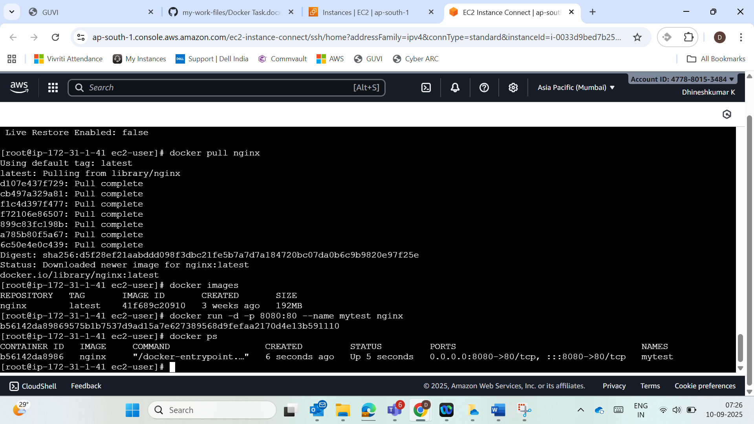

Docker Removing:  
  
Docker volume creation and listing and inspect:  
  
Volume deletion:  
  
Network Creation and checking:  
  
Network Deletion:

