Task Description:

Install Prometheus and Grafana on a Linux EC2 machine, connect Prometheus to Grafana, and create a dashboard to view metrics.

Step 1: I created one server and installed the Prometheus and Grafana

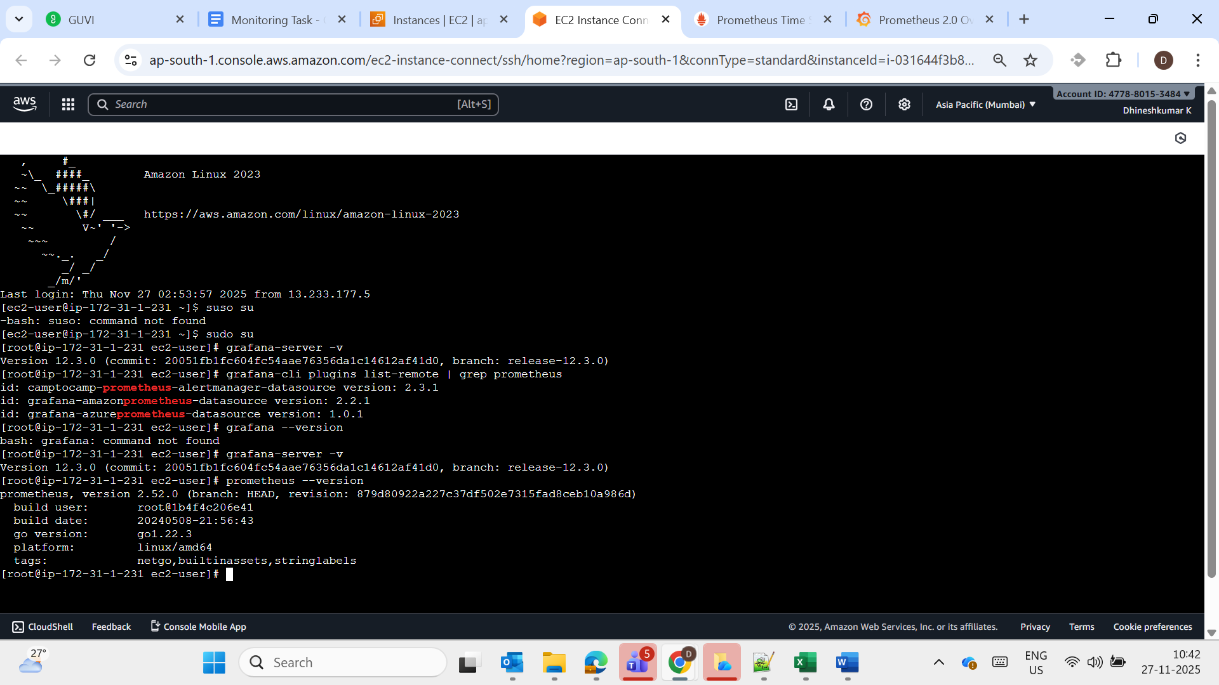

Using Publick IP login the Prometheus and Grafana UI

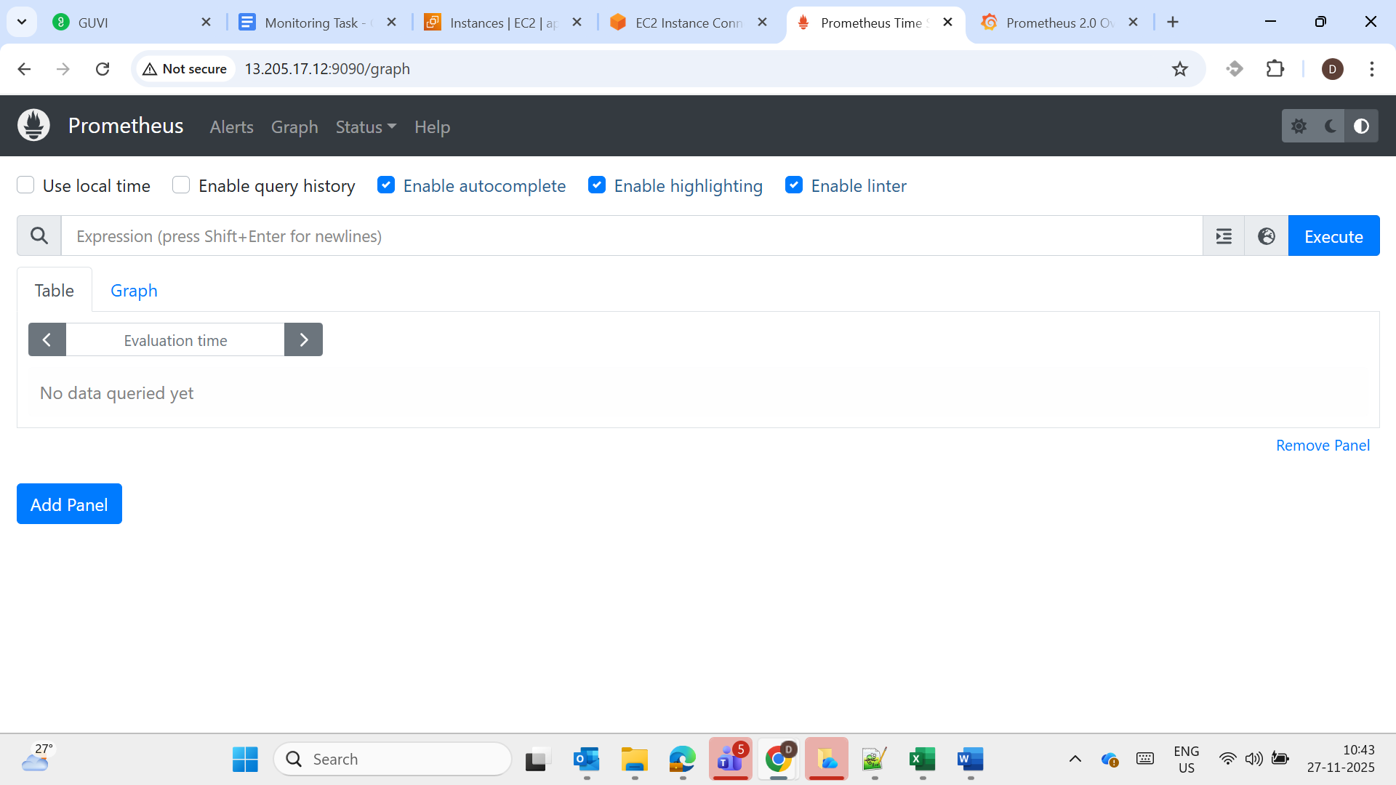

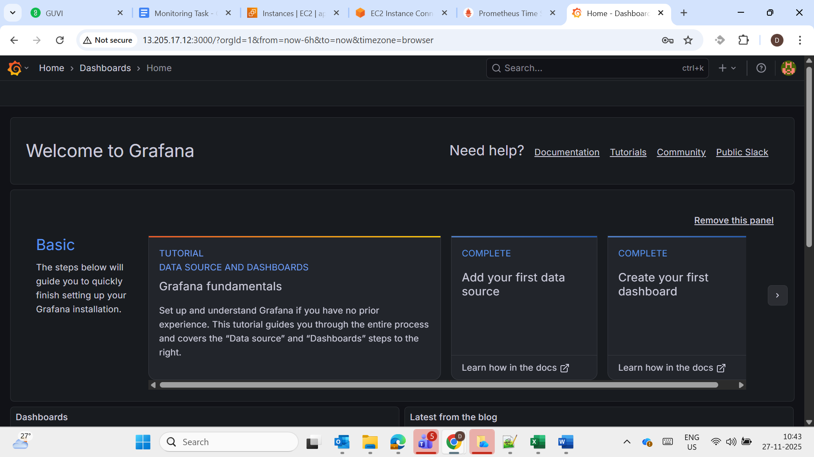

Connecting the Prometheus to Grafana – Adding Data Source for connection

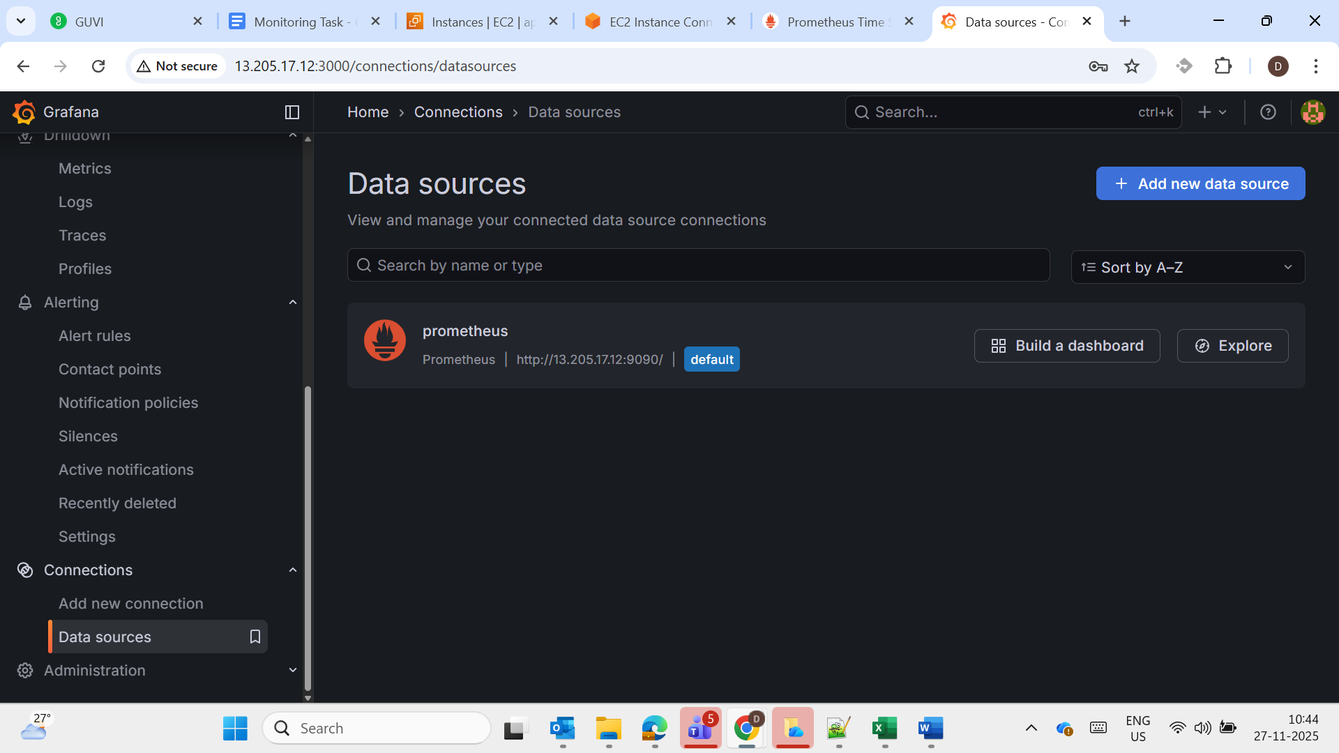

Dashboard:
