Task Description:

Create a simple script file and push it to repo. Create a project in Jenkins connected to your GitHub repository. When a commit is made to your repo, automatically build must get triggered from Jenkins and the output must be shared to me via email.

Steps:

Local sample bash script
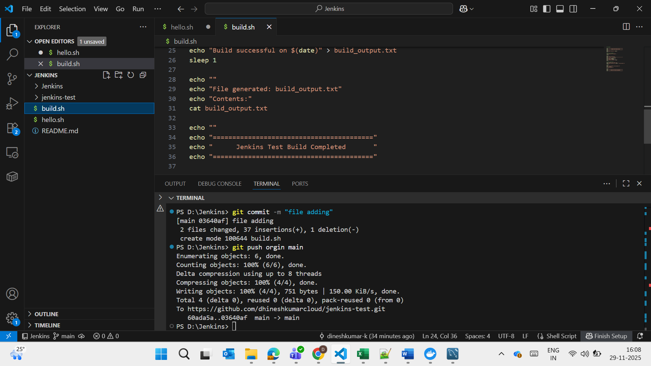

Pushed into the Github
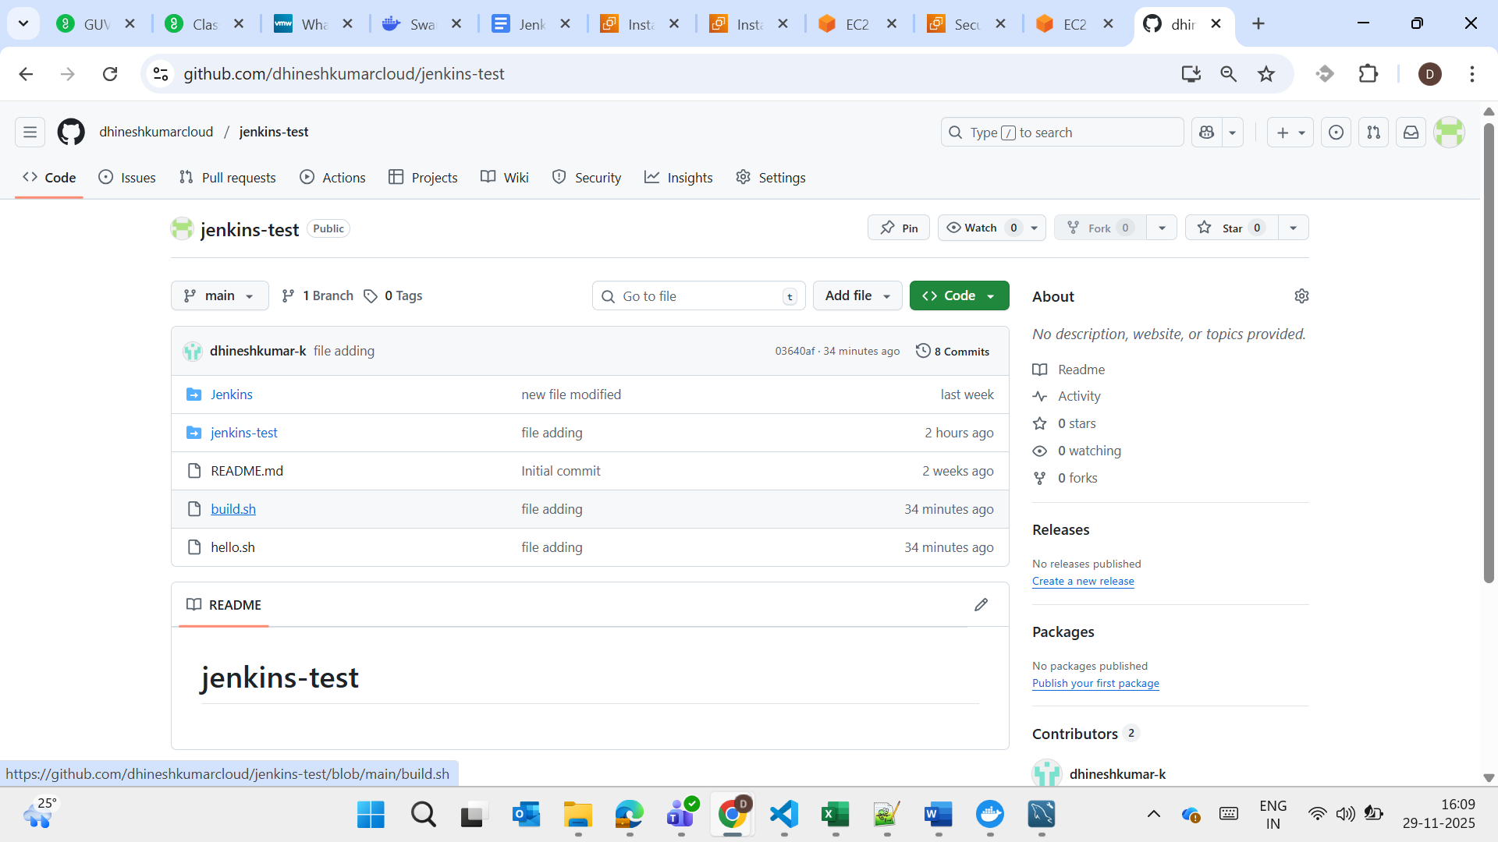

Created a Instance and installed Jenkins – Services running

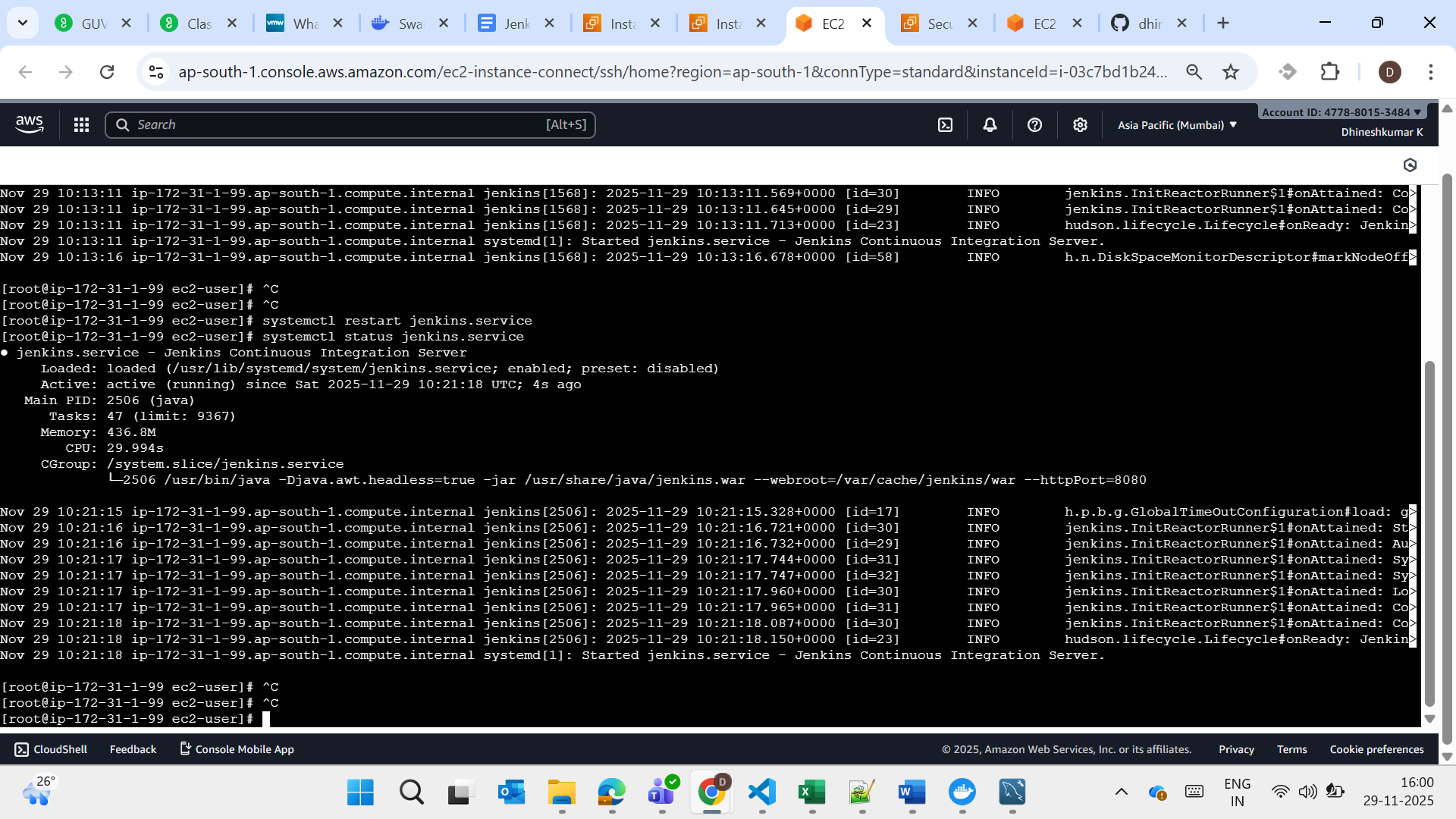

Steps for SMTP creation and github webhook for
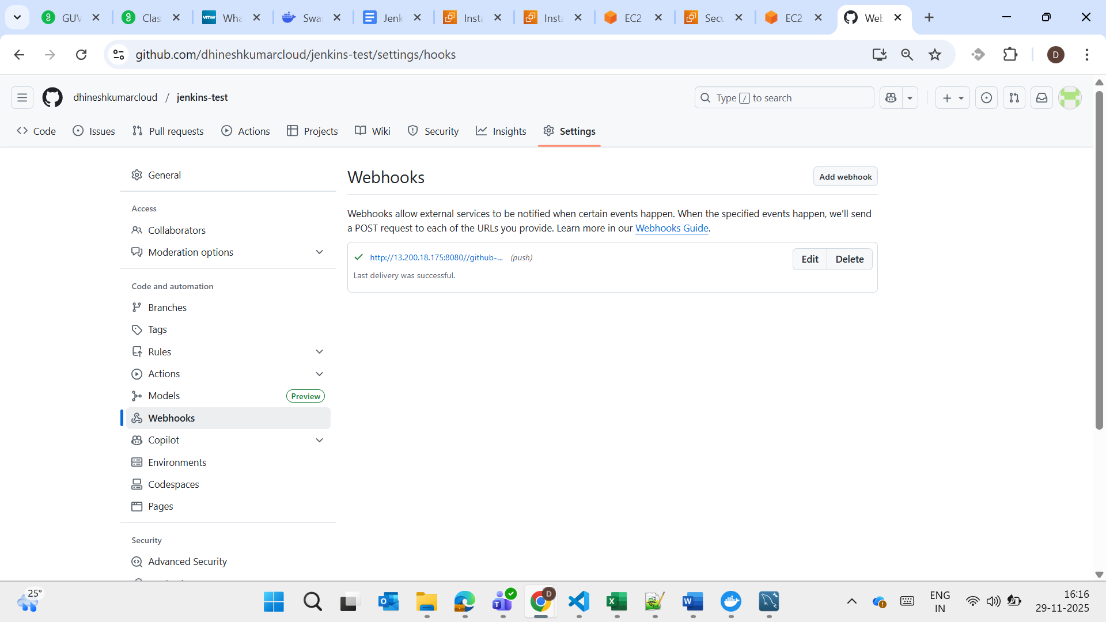

Jenkins Console Output
