ECR creation:
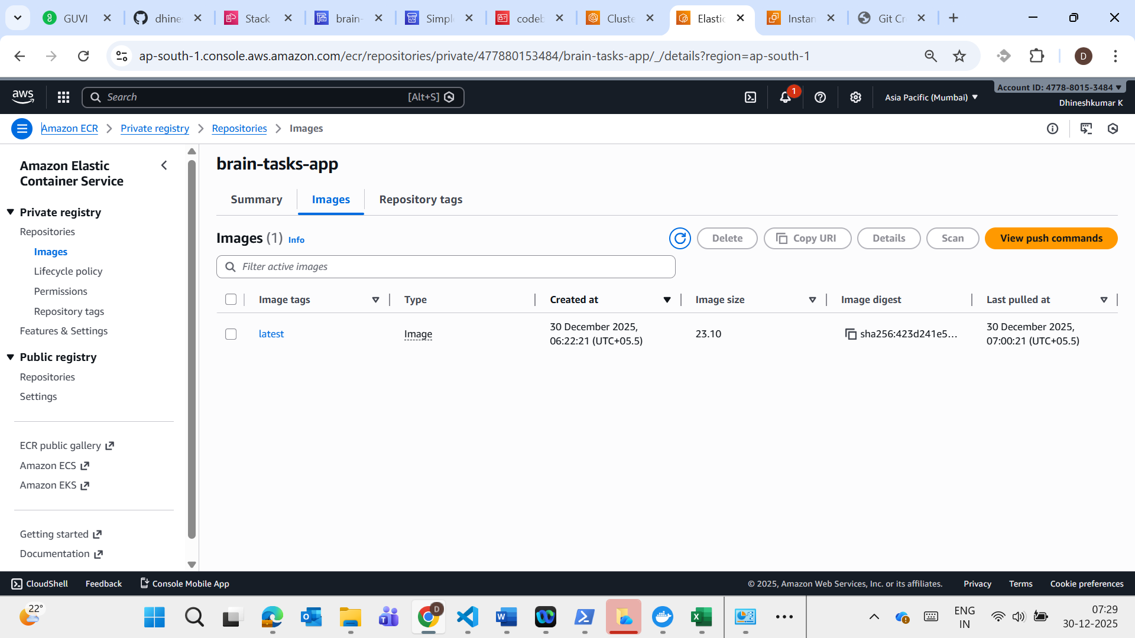

EKS Creation:
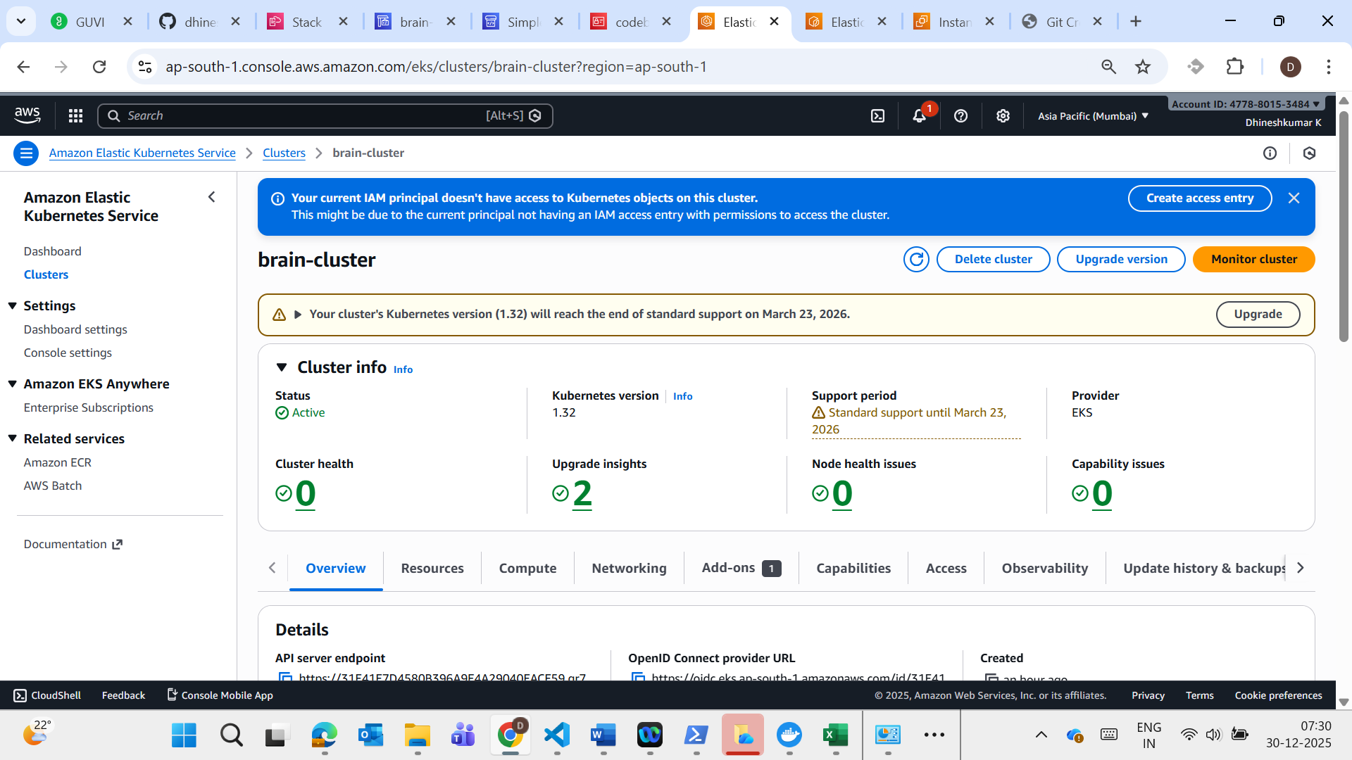

LB URL :
http:// a5fcc533db474442883b2878a46f1994-1200722401.ap-south-1.elb.amazonaws.com

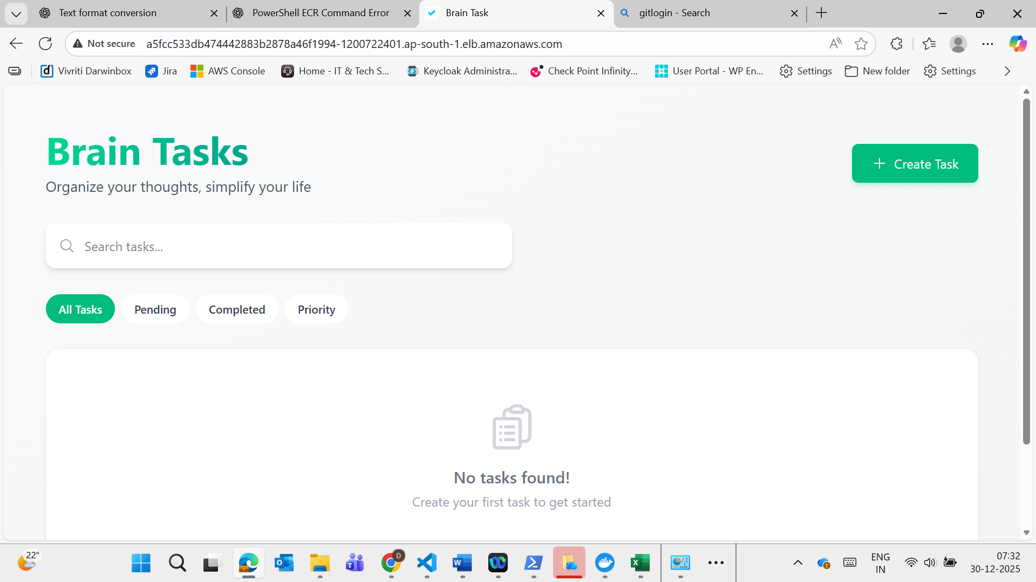

Code Pipeline Successful status

