Task Description:

Launch Linux EC2 instances in two regions using a single Terraform file.

Step :1 – create the main.tf and output.tf

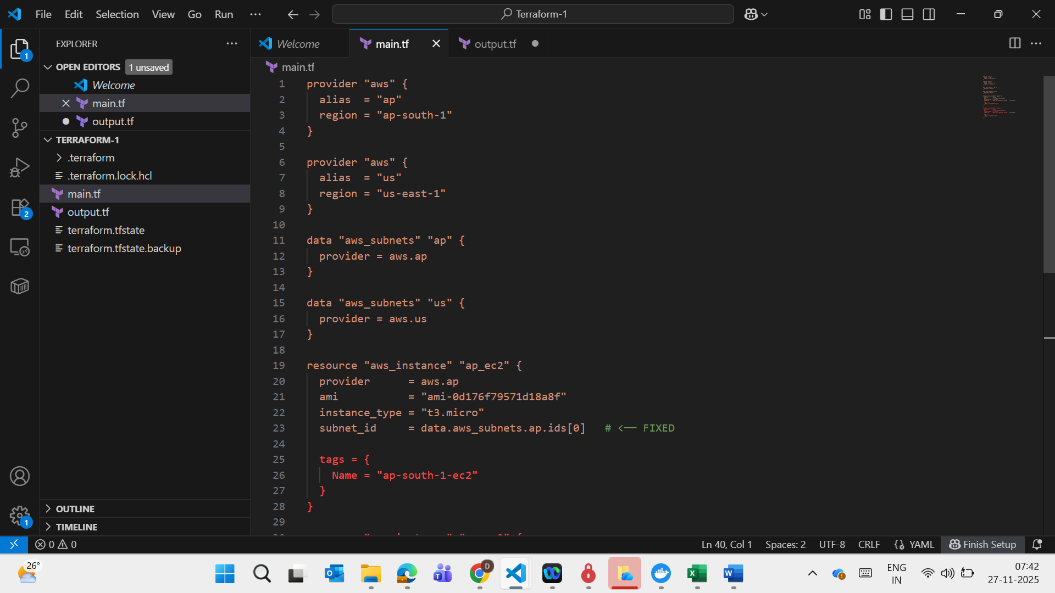

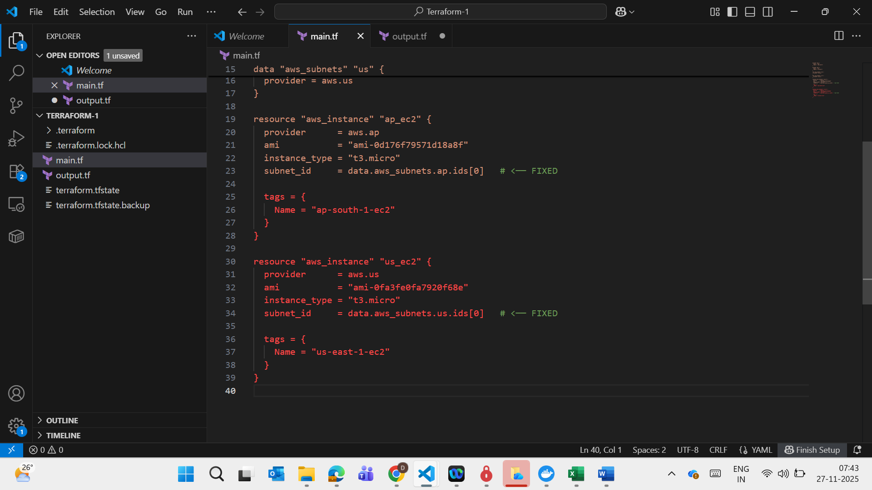

Output.tf

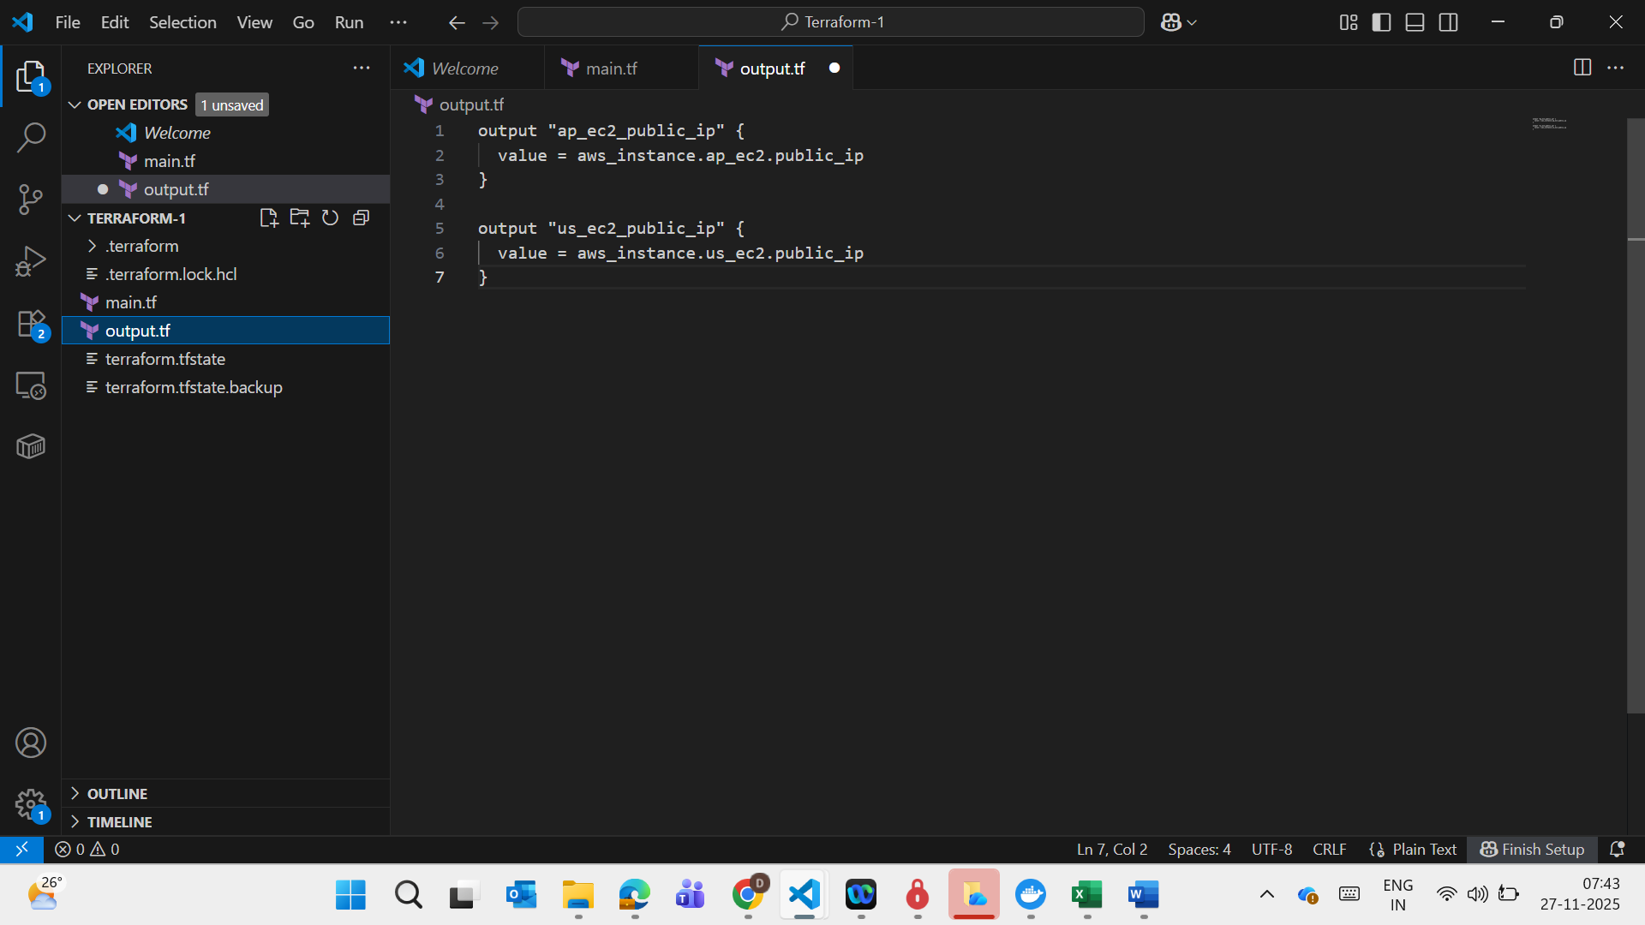

Output :

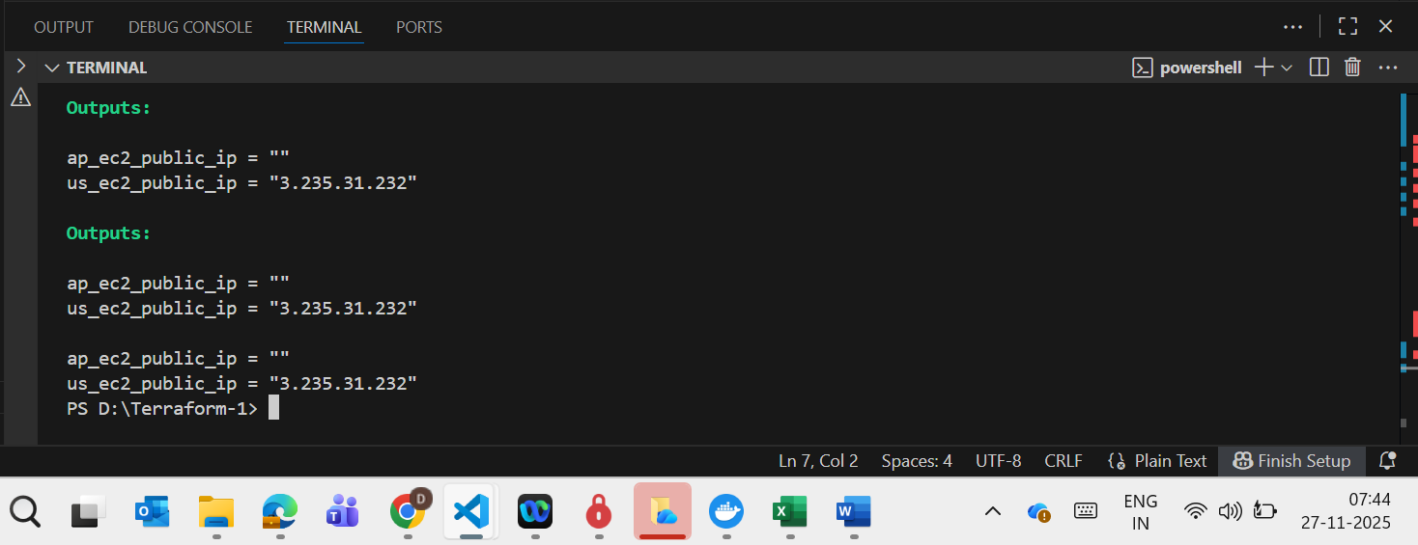

Output in Console:

Mumbai Region

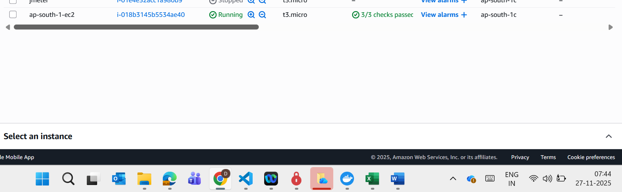

Virginia – second region

