Launch jenkins and explore creating projects and users.

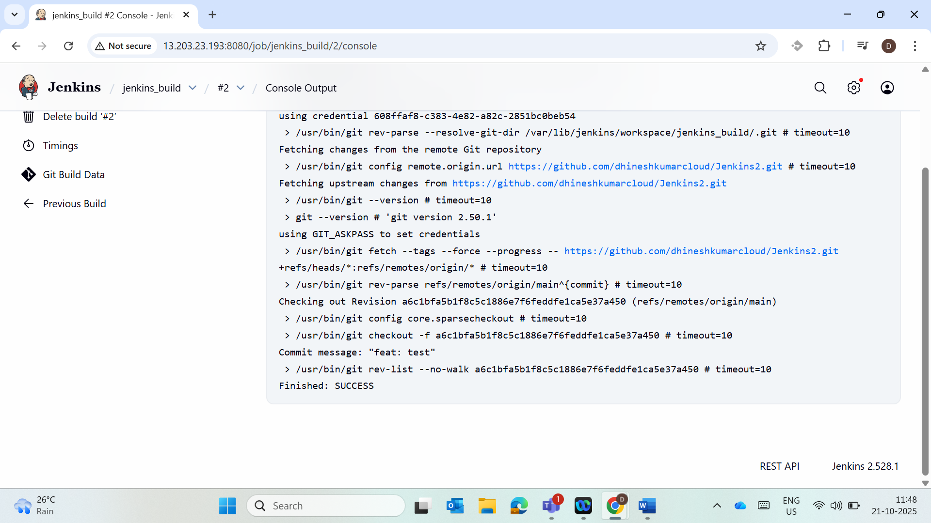

Test User creation

