Finding IP Adresses

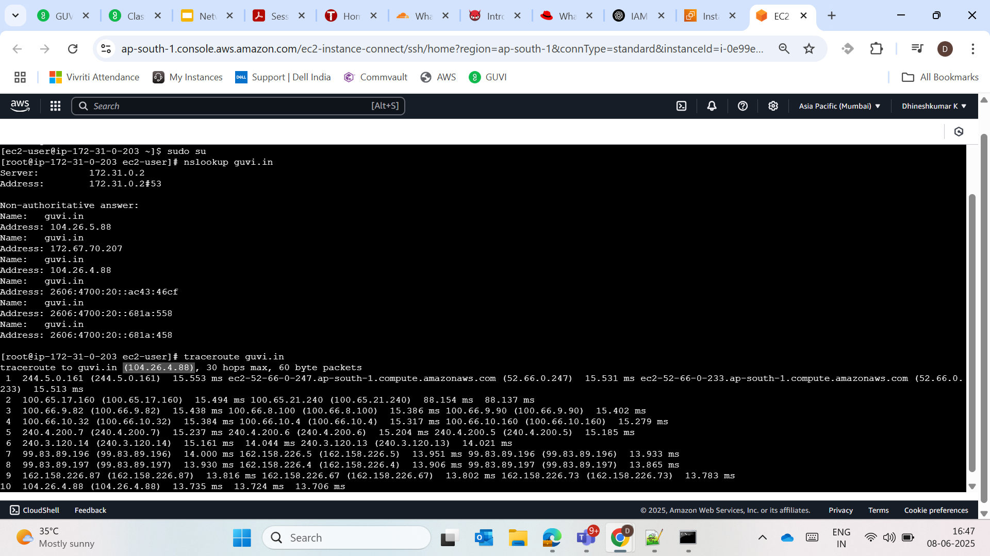

Storage

Testing Nodes

Port checking

Allowed port

